The Effect of Artificial Intelligent on Education

Ahmed Moslih Almoairfi

Table of Contents
Abstract 3
Chapter 1 3
Introduction 3
Background 3
Generative Artificial Intelligent 3
Bias in Artificial Intelligent 3
Exams in the Time of Artificial Intelligent 4
Problem Statement: 4
Research Objectives 4
Research scope. 5
Chapter 2 6
Critical Analysis: 6
Connections 6
Conflicts between the findings: 6
Synthesis Matrix for Literature Review: 6
Chapter 3 9
Research methodology 9
Expected Outcomes 10
Gantt chart 11
References: 12

Abstract
The improvement of AI appears in all domains, one of which is education. As AI improves other domains and fields, it also helps in improving education. On the other hand, there are some challenges in using AI in education. For example, the biased result from generative AI is used by students as a fact. Another change is the use of AI in exams and assessments. This study uses a mixed-methods approach that combines systematic literature review, Exploratory Research, Diagnostic Research, and Applied research to define the effect of generative AI on education and to solve the defined challenges.
Keywords: Artificial Intelligence, Generative AI, Bias on Generative AI.

Chapter 1

Introduction
Recently generative Artificial intelligence improved rapidly, which mimics human expression to generate new content. In the education field, Generative AI has its effect on students and educators. It helps educators in education and helps students in learning. But it has some effects and challenges. One of the challenges is students depend on AI in creating content and getting information. AI is not a trusted source and may be biased. Why can’t they depend on the generated information? Because the Generative AI creates content based on the data it is trained on, And as the internet is the source that contains biased and untrusted data, the result of GAI content may contain biased and untrusted information. Filtering the data is a solution to this issue.

Background

Generative Artificial Intelligent
Artificial intelligence now a day is trending. It started a long time ago, but it misses the powerful hardware that we have today. So after improving the hardware, the scientists now are able to implement their method.
Generative AI is one type of AI that can create content like (images – text – video).

Bias in Artificial Intelligent
One of the issues of the generative is bias on the result. The cause is that the content generated by AI is from the trained data. As AI trains on large amounts of data, from multiple sources, the result will not be trusted, and if the source contains bias the result be biased.

Exams in the Time of Artificial Intelligent
Involving AI tools in education will help educators and students in learning. But it has some flaws. As generative AI improves and mimics human writing, the student can use it in exams which will cause an incorrect evaluation for the student. This issue must be solved. This study will provide some solutions.

Problem Statement:
Generative AI recently improved exponentially; it has been used in all domains. One of these domains is education, which will enhance education when used optimally. However, there are some issues with using generative AI by students. Bias is one of these issues, as ChatGPT for example needs to train on a large amount of data to generate a better result, these data can produce biased content (Sukhpal et al., 2024). In addition to bias on generative AI, the content produced from unpermitted use of copyrighted material, violates its copyright, as highlighted by Emma (2025).
Students can use generative AI in assessments or exams, which makes it challenging to detect whether students use AI or not (Benjamin & Lucas, 2024).
This research aims to focus on these problems, examine the existing solutions, and define the strengths and weaknesses of these solutions, and how to enhance them.

Research Objectives
- To analyze the existing challenges in using Generative AI in education
- Determine the limitations of using Generative AI and how to avoid these limitations in case of improving education.
Define the root cause of bias result in Generative AI and the existing solutions.
Explain why generative AI violates the copyrights.
- Validate the existing solutions and define their strengths and weaknesses.
To reduce bias in generative AI content.
To mention the real source of the content and apply citation.

- Improve the existing solutions by recommending enhancement to the solution.
Clarify how can generative AI tool avoid biased data or how to filter the data before feeding the tool with biased data.
After the generative AI tool gets biased data how can AI differentiate between biased data and unbiased data?
Define clear steps on how generative AI tools can take care of copyrights and apply citations.

Research scope.
Analysis of Existing Challenges: try to identify the challenges of using AI in education and the root cause of each problem.
Evaluation of Current Solutions: evaluate each existing solution for current challenges. For example, if filtering the data can reduce bias on generative AI results, try to implement the solution the validate the result.
Development of a New Framework: after evaluating the solution, determine the founded issues in the current framework and provide a solution to these issues.
Validation in Diverse Contexts: validate the final solution by involvement of stockholder to get their feedback on the solution.

Chapter 2

Critical Analysis:

While AI enhances education and provides information, it also may have some effects on education. One of the weaknesses in searching about AI usage effects is that AI become widely used recently, which results in a lack of feedback and can’t measure long time effects. Some research lacks experimental data, there is no concrete solution for part of the mentioned issues. Nevertheless, there are some strengths. Firstly, some paper has clear questions that guide the research and cover the challenges, impacts and the benefits of AI.

Connections
- Unreliability of AI due to bias: While AI trained on biased data, the result will contain bias.
- The guiding role of teachers: Teachers need to guide students in using AI critically and teach them the ethics of using AI.
- Restructuring education methods: Involve AI more in the education process, enhance exam and assessment methods to reduce the use of AI.

Conflicts between the findings:

There is no clear conflict between the findings. Expect that one is more optimistic. One focuses on changing the education regulation while the other one focuses on enhancing and guiding the student to get the greatest benefit of AI.

Synthesis Matrix for Literature Review:

Study | Authors | Year | Research Design | Key Findings/Results | Methodology | Limitations
Transformative effects of ChatGPT on modern education: Emerging Era of AI Chatbots | Sukhpal Singh Gill | 2024 | Case study | To avoid ChatGPT issues, academic organizations need to restructure the learning methods, participate in providing the needed technology for all students, and finally train the teachers on how to use ChatGPT effectively. | Data collection: Mainly from previous literature and leading academics to seek the use of ChatGPT in education | Lack of primary data where the research doesn’t include any primary data collection and mainly depends on expert opinions.
Exploring the impact of ChatGPT: conversational AI in education | Anissa M. Bettayeb1 | 2024 | Survey | Convert teacher role from content delivery to guidance, Import AI emotional intelligence, ChatGPT can increase student engagement in learning. | Data collection: data collected via survey and depending on other research.  Comparing and filtering the resources. | The research doesn’t provide a concrete solution to the provided issue of AI. The time frame of the study is narrow, but it can’t be before 2022 because ChatGPT launched in 2022.
The effects of generative AI on initial language teacher education: The perceptions of teacher educators | Benjamin Luke Moorhouse,  Lucas Kohnke | 2024 | Case Study | Education will change drastically because of generative AI, start using AI tools in education like creating quizzes or other tasks to save time.  Assessment tasks need to be redesigned.  Teachers need to be involved more in using Generative AI tools. | Data collection: data was collected through interviews with field experts (English-language teachers)  Data Analysis: analyze by ChatGPT-4 to compare the result with human analyzation. | The limitation of the study group as they are all English teachers, they are all from Hong Kong and the sample size is small.
How do people react to political bias in generative artificial intelligence (AI)? | Uwe Messer | 2025 | Experimental | If the bias matches user beliefs he most likely will grand access event for sensitive features. On the other hand, if the result doesn’t match their beliefs they rated the developer negatively. | Data collection: Three experiments the first with a manipulated political bias the second one with a more realistic setting and finally with generated text.  Measurement:  The result is measured by counting the number of smartphones that will grant access to AI. | The way of measuring the influences is by granting access to smartphones can be improved.  The study only applied to the USA and it can be applied globally.
Perceived impact of generative AI on assessments: Comparing educator and student perspectives in Australia, Cyprus, and the United States | René F. Kizilcec, Elaine Huber, Elena C. Papanastasiou, Andrew Cram, Christos A. Makridis, Adele Smolansky, Sandris Zeivots, Corina Raduescu | 2024 | survey | The awareness changes between universities, and Cypriot student awareness is lower than in other universities.  Students use it mainly for coursework and fun while educators use it mainly for research and professional work.  Perceived impact is more likely for written assessment than a real-time presentation.  The Expected student use is for generating new content like writing essays and codes, revision and error-checking. | Data collection: an online survey in three universities  The participants were 767 as 680 students and 87 educators. The smaller number of participants in US at 8%  The measure: the Awareness and use of GAI, Perceived impact of GAI on assessment, and Expected student use of GAI. | The selected sample group is not random. First, they are selected from three universities, so they are all academic and represent only these three universities (are not global samples).  Secondly, the time of the study is at the beginning of AI and as it rapidly changes, the result also may change.
Student use of generative AI as a composing process supplement: Concerns for intellectual property and academic honesty | Emma Kostopolus | 2025 | Case Study | Educators need to guide the students in using generative AI.  The student should be critically aware of the use of generative AI. | Data collection: two case studies  The first case is generating images using AI tools as an alternative to image editor tools, but the image generation tool will use a third resource without mention.  Second case: using AI as translation software in translating. In this case, use own the content copy-rights but can’t content it to educator language. | The rapid change in technology mainly creates a solution or may complicate it.  There is no clear guide on how educators can help to solve the issue.

Chapter 3

Research methodology
The research will apply mixed research methodology to first analyze the effect of generative AI on the education and challenges face educators and students. After that explore the existing solutions, validate the solutions and what is the weakness of the solutions. Finally, how to improve these solutions.
Phase 1: Exploratory Research
The first phase aims to generalize the existing issues and challenges by exploring past studies and using surveys to ask the students and educators to get their perspectives. Also, by observing the education results with and without involving AI.
Data collection: Primary data is past studies. Secondary data is surveys with open-ended questions.
Phase 2: Diagnostic Research
In this phase, Define the main cause of the found issues and the available solutions.
Data collection: collect the available solutions from previous studies.
Data analysis: analyze the founded solutions, compare them, and provide the pros and cons of each one, finalize the result, which one is more suitable to solve the problem.

Phase 3: Applied research
After defining the problems and the possible solutions, in this phase define the weakness of the solution and how to improve it.
Development: Enhance the existing solutions by solving the defined issue.
Validation: Test the new solution by Academic educators. And get their feedback to make sure it satisfies teachers need.

Expected Outcomes
Analyze the issues that face educators and students in using AI and the challenges in the current solutions.
Define and evaluate the current solutions: examine each solution and report the weakness and how to improve it.
Initialize new solutions by solving the detected issues in previous frameworks.
Get educator feedback: After completing the solution, send it to an academic organization to get their feedback. If it solves the challenges or has other issues.

Gantt chart
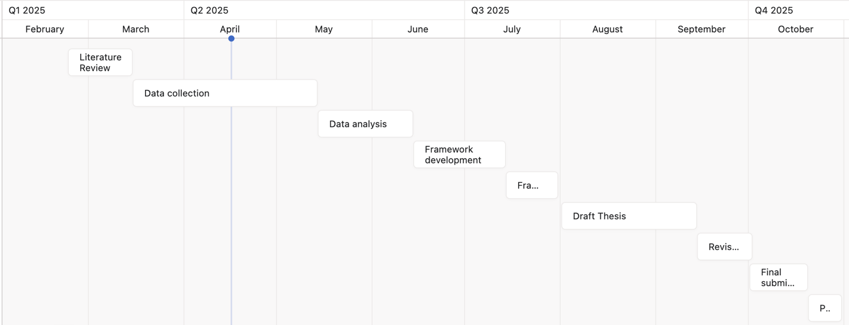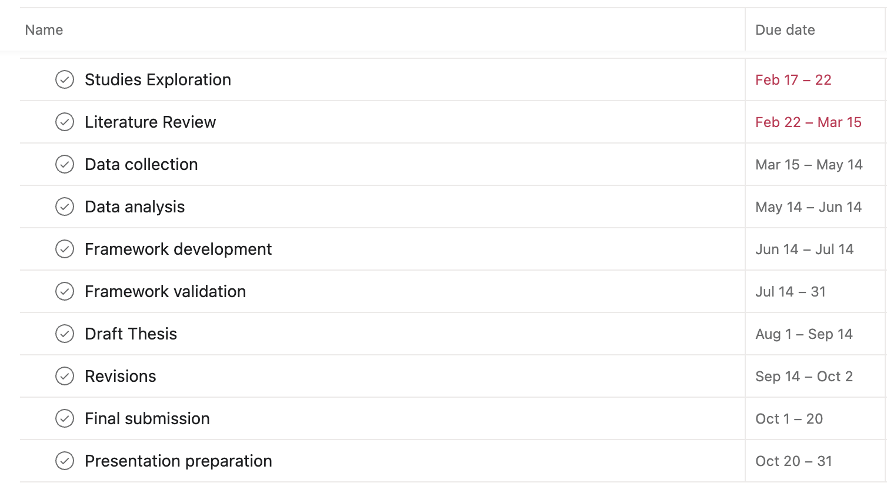

References:
Sukhpal Singh Gill, Minxian Xu, Panos Patros, Huaming Wu, Rupinder Kaur, Kamalpreet Kaur, Stephanie Fuller, Manmeet Singh, Priyansh Arora, Ajith Kumar Parlikad, Vlado Stankovski, Ajith Abraham, Soumya K. Ghosh, Hanan Lutfiyya, Salil S. Kanhere, Rami Bahsoon, Omer Rana, Schahram Dustdar, Rizos Sakellariou, Steve Uhlig, Rajkumar Buyya, (2024). Transformative effects of ChatGPT on modern education: Emerging Era of AI Chatbots, https://doi.org/10.1016/j.iotcps.2023.06.002.
Anissa M. Bettayeb, Manar Abu Talib, Al Zahraa Sobhe Altayasinah, Fatima Dakalbab. (2024). Exploring the impact of ChatGPT: conversational AI in education. https://doi.org/10.3389/feduc.2024.1379796.
Benjamin Luke Moorhouse, Lucas Kohnke, (2024). The effects of generative AI on initial language teacher education: The perceptions of teacher educators.
https://doi.org/10.1016/j.system.2024.103290.
Uwe Messer, (2025). How do people react to political bias in generative artificial intelligence (AI)?, https://doi.org/10.1016/j.chbah.2024.100108.
René F. Kizilcec, Elaine Huber, Elena C. Papanastasiou, Andrew Cram, Christos A. Makridis, Adele Smolansky, Sandris Zeivots, Corina Raduescu, (2024). Perceived impact of generative AI on assessments: Comparing educator and student perspectives in Australia, Cyprus, and the United States.
https://doi.org/10.1016/j.caeai.2024.100269.
Emma Kostopolus, (2025). Student use of generative AI as a composing process supplement: Concerns for intellectual property and academic honesty.
https://doi.org/10.1016/j.compcom.2024.102894

