CHAPTER ONE:
MARKETING

1
1.1 Introduction
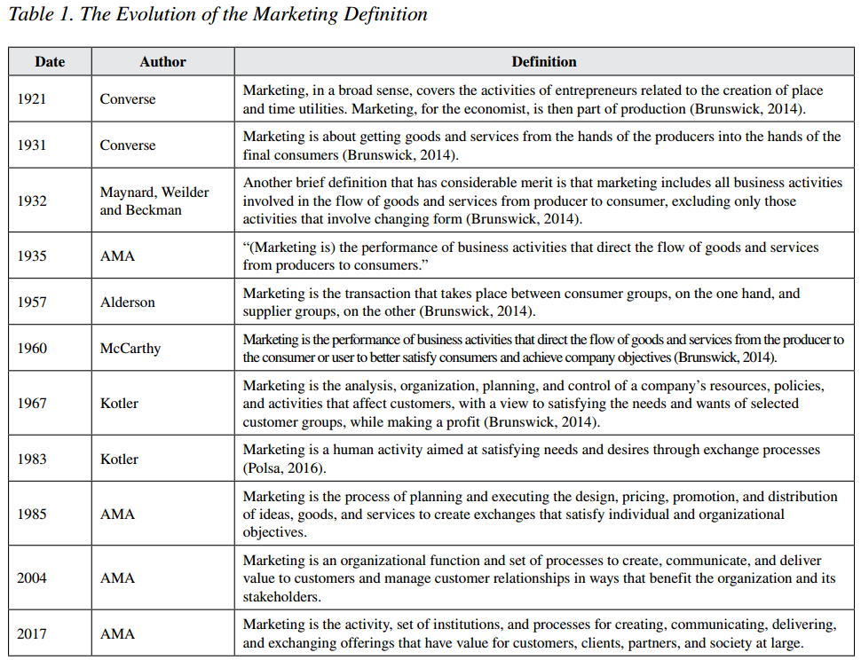
Technology has undergone a remarkable transformation in the past decade. It witnessed an impressive improvement and an astonishing shift that highly influenced the world in many different areas. Especially, with the invention of artificial intelligence. This development affected multiple aspects of life that enhanced human life in general. Some of these aspects include: Health, Education, Social Life, Entertainment, and a lot more. But, most importantly, Business field. It helped people develop new skills or improve existing ones. Such as marketing, communication, graphic design, content creation, and social media management, and other similar skills that are highly important for business growth.
(Ratchford, 2020). The history of academic research in marketing and its implications for the future.

2
Many years ago, people have used various ways to market their goods and flourish their own businesses using the most creative ways according to their available sources at the time, and the concept of marketing has developed accordingly through the years. However, the current era is different. Nowadays resources are much easier to access, and tools to put those resources to use became simpler to learn and master, and the chances to create new strategies to market came to be an available option thanks to technology development.
One of the most impressive market strategies is Digital Marketing. Digital marketing can be defined as the strategic use of online channels and digital technologies to promote and sell products or services. It refers to "The creation and dissemination of content through digital media channels—websites, landing pages, social media, email, and mobile applications—and the promotion of that content using a variety of strategies across paid, earned, and owned digital channels, including SEO, SEM, pay-per-click (PPC) advertising, content syndication, social, email, text, and more." Oracle.
In addition, Artificial Intelligence came to be such a distinguish part of digital marketing. Many entrepreneurs that rely on content creation has utilized artificial intelligence in their process of transforming their ideas into reality. Whether it was by sharing their thoughts with generative artificial intelligence applications such as ChatGPT. Or, by simply just asking artificial intelligence Chatbots - like Alexa for Amazon, Siri for Apple, Gemini for Google, or Meta AI for Meta - for help with new content ideas and suggestions for the trends that might strategically improve the project's performance.
Each and every day, digital marketing proves to be a substantial strategy in different ways. Both practically and financially. Starting from utilizing
3
artificial intelligence services that minimized the possibility of wasting both customers and Owners' time, to provide a positive easy experience and if so called, advertising. Which enabled business owners to enhance their profitability and guarantee customers' satisfaction.
Recently, the researcher noticed that the reliance on digital marketing as a strategy was not exclusive on large businesses owners only. Currently, even small businesses owners can use it on a daily basis through their journey, and it might help them with their growth process. Whether it was for help with creating content and marketing ideas and trends, or just for simply checking facts and statistics.
Moreover, the researcher finds it interesting how digital marketing became essential almost to every enterprise in The Kingdom of Saudi Arabia, and wondering what kind of effects would it have on these enterprises. Therefore, this study is conducted, and hopefully it will benefit any further researches about the same matter.

4
1.2 Statement of the problem
Given the rapid evolution of digital marketing in general, and the reliance of a considerable number of Saudi entrepreneurs on digital marketing, it became a place of interest to the researcher to observe the influence of this evolvement on The Kingdom of Saudi Arabia's market and enterprises.
As a result, the research discusses the impact of this reliance and measures the extent of this impact. In addition, it focuses on the entrepreneurs' opinions and motivations that caused this type of reliance. It also shows and explains a few of the methods and channels that serves the benefits of digital marketing strategies from the entrepreneurs to customers.
- Questions of the study:
- Are people familiar with the term Digital Marketing?
- Do entrepreneurs rely mostly on usual marketing or digital marketing?
- Does the majority of entrepreneurs rely on digital marketing?
- What made entrepreneurs decide to utilize digital marketing?
- Which region in Saudi Arabia relies the most on digital marketing?
- Who would be more likely to rely on it, male business owners or female business owners?
- In which year did the reliance on digital marketing started and/or increased in Saudi Arabia?
- How did digital marketing affect enterprises' profits?
- What is the more effective social media platform related to digital marketing?

5
1.3 Significance of the study
In the light of the recent remarkable advancement of technology in the Kingdom of Saudi Arabia specially on business field, this study aims to examines the outcomes of relying on digital marketing. In addition, this study's results might serve as a simple guidance for future and present entrepreneurs to make a serious decision based on other entrepreneurs' experience on how to effectively utilize appropriate digital marketing channels.
- Scientific Significance:
There are not as many studies on this topic in the Kingdom of Saudi Arabia as predicted. The reliance on digital marketing in the Kingdom of Saudi Arabia has become more common than any other marketing strategy in the present time. Ranging from large companies and reaching to small ones. Startups, so to speak. Therefore, this study slightly discusses the impacts it might have on enterprises and entrepreneurs themselves.
- Applied Significance:
This study examines to what extent does the digital marketing actually influences an enterprise. Moreover, it examines the profits and losses scale as a result of entrepreneurs' reliance on digital marketing. Hence, determining whether that influence is positive or negative.
The outcomes of this study might help entrepreneurs and researchers in the future understands the influences of relying on digital marketing and decide what could be the best way to take advantage of it.

6
1.4 Objectives of the study
The main concern of this study is to find out the range to what extent can an entrepreneurs' reliance affect an enterprise. Also, it aims to explore whether this influence is considered as a positive influence or a negative one.
There are multiple subsidiary goals for this study, including;
- Finding out to what degree are society members familiar with the term "Digital Marketing".
- Testing what is the most effective channel for the implementation of digital marketing.
- Testing what is the most efficient application on social media for achieving digital marketing's purposes.
- Examining a few of Saudi entrepreneurs as a sample to determine which gender uses digital marketing more on their enterprises.
- Slightly tracking the sample's enterprises' profits and loses to decide what kind of effect the implementation of digital marketing as a strategy does to an enterprise.

7

CHAPTER TWO:
PREVIOUS STUDIES

8
2.1 Literature Review
Now that the critical role of technology has been undeniable on businesses and their advancements, it is important to leverage technology. A local study by (Alshammari. A, 2024) on the Impact of digital marketing and E-Payments on Saudi online startup consumers discussed this aspect by TAM.
The Technology Acceptance Model (TAM) and Digital Marketing
TAM is an extremely valuable tool to understand how consumers adopt to recent technologies especially in areas like digital marketing. It shows a foundation to point out major factors that influences consumers' behavior towards technology. By doing so, businesses can improve their clients' experiences and interactions, which makes TAM a key tool in the present time.
His study has supporting dimensions for implicating digital marketing both theoretically and practically by combining the Technology Acceptance Model (TAM) and other theories. As well as strategies like Perceived Ease of Use, Attitude towards Using and Intention to Purchase Online which are influencing positively on online purchases. The study highlights the importance of security on customers' behavior since online shopping became widespread. In order to maintain customers' trust and loyalty, it is important to make them feel secure enough to make digital transactions, and interacting with digital marketing experience in general.
With the rapid digital development, understanding how clients perceive and interact with technology is an important factor for enterprises to expand in markets. In the world of digital marketing, user-friendly platforms require a small amount of training, leading to a higher adoption rate. Thus, making it more likely for businesses owners to utilize these tools in their marketing
9
strategies (Venkatesh et al, 2012). Moreover, (Yakaitis et al, 2023). Stated that as digital marketing technologies continue to evolve, guaranteeing the ease of use is a crucial part for gaining clients satisfaction and expanding worldwide.
Based on a Local study by (Salama. Mai, 2021) on the effectiveness of using artificial intelligence techniques in digital marketing through social media that was conducted on students of marketing communication departments in Saudi universities, the findings show that there was a difference in what degree are people familiar with artificial intelligence techniques and their opinions on the importance of using it as a digital marketing strategy.
In addition, it shows how did the role of using artificial intelligence grew recently. It became an effective tool to impact on public opinion, and educate the younger generation. As a result of the artificial intelligence implementation in digital marketing via social media apps.
Moreover, in relation to the extent of the impact of using artificial intelligence technologies in digital marketing, majority of the research sample indicated that it has a moderate impact, with a percentage of (55.5%), the rest indicated it has a strong impact with a percentage of (44.5%). Regarding the extent to which they noticed a difference in digital marketing activities via social media before and after using artificial intelligence technologies in terms of speed and interaction, most of them indicated that there was a difference of (96.8%), compared to (3.2%) who did not notice any difference.
Also, it showed that using artificial intelligence can be positive by enhancing public relationships' management, chat bots, and marketing through content creation. On the other hand, using artificial intelligence in digital marketing has its negative side as well. Including: legal and ethical challenges due to copyrights, misleading information, privacy violations and breaches, and the
10
replacement of workforce associated with social media apps.
A study by (Lahdensuo, S, 2018) showed that websites can help entrepreneurs track the pages that attracted people mostly, and provide a statistic on page views per visit. Which will lead to identifying the needs and attracting factors to a customer. More importantly, it helps with the promoting process of products and services. Also, using digital marketing through websites can lead to an increase in profits due to the understanding of a clients' needs, which can be observed by the time spent on the enterprise's website.
Nowadays, social media and websites of most enterprises are connected. Websites like Zid and Sella provide a pre-designed templet where contact information is accessible from almost every part of the page, and there is always a phone number written, links to social media accounts, the email address, and more detailed information that are usually available in the bottom of the page. As well as all the support service information and ratings, which leads to gaining more viewers, and expanding socially through digital marketing.
In order to determining profits doing so, the study results showed that four metrics were needed, which included; Click Through Rate (CTR), Cost Per Click (CPC), Customer Acquisition Cost (CAC) and Average Order Value (AOV). (Lahdensuo, S, 2018)
Social media management involves a various possibility of activities such as establishing strategies for identifying and attracting the target clients, and posting a company’s content in different social media platforms. Some of the applications that businesses can use to advertise include Facebook, Instagram, X (Twitter), Snap chat, TikTok, and more.

11
Facebook advertisement is one of the most popular approaches that is used to market on the internet. It is capable of reaching target clients based on factors such as location, gender, behaviors, interests. (Bowen & Ozuem, 2016). However, Facebook as a marketing strategy is not as common in Saudi Arabia as the rest of the world.
YouTube is also one of the most commonly social media platforms used to digital marketing. It proved itself given the large number of users on that platform. YouTube became a distinguish tool not only for entertainment and videos, but also as a promotion tool for new products and services. In addition, it serves as a popular search engine.
Twitter is representing a vast internet society, which means that all its members are free in posting Tweets and following other users. However, marketing through twitter should follow certain rules to achieve the intended goals, such as writing hashtags properly, maintaining particular ideas and values and encouraging friendly atmosphere that will establish a long-term relationship between a business owner and the customer.
Instagram is another worldwide used platform, a lot of Facebook users in particular. It mainly uses the forms of images and short videos, focusing on personality and people's highlighted moments of their lives. Instagram's user-friendly structure can encourage a lot of business owners to market through its posts. (Sotnikova, A, 2016).
Recently, TikTok emerged as a new popular platform on social media as a result of its addictive nature which makes it easy for users to watch random videos for a long period of time. It recommends trendy topics to its users, helping to capitalize on local trends and generate viral content for the platform. TikTok sends personalized recommendations to each of its users to
12
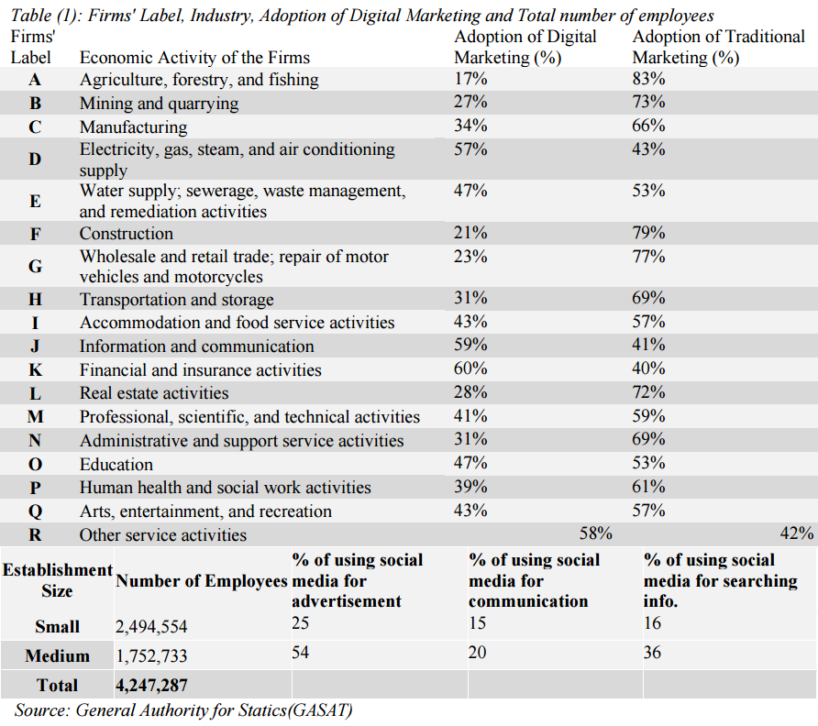
ensure they are always up to date on the latest content trends. Using these techniques, TikTok was able to become a widespread platform for both entertainment and marketing as much as the other apps. (Guarda, T, 2021). Table 2. Firms' Label, Industry, Adoption of Digital Marketing and Total Number of Employees.
According to the table above, a study by (Elrayah, M, 2021) shows that the small-size organizations in Saudi Arabia use social media for advertisements (25%), communication (15%), and searching for information (16%). On the other hand, the table shows that medium-sized organizations use social media for advertisements (54%), communication (20%), and searching for information (36%). This study also finds that the average of organizations in Saudi Arabia that uses social media for advertisement is about 80%. While 35% of organizations use social media for communication, and about 53% of organizations use social media for information searching purposes.
13

