Chapter 5 : Conclusion and Future Work

5.1 Introduction

This chapter gives a summary of the main results obtained from the research done, contribution of the new AI based accounting system to SMEs, and implications of the new accounting system on SMEs. This chapter also indicates the limitations of the study and suggestions for further research.

5.2 Summary of the Study

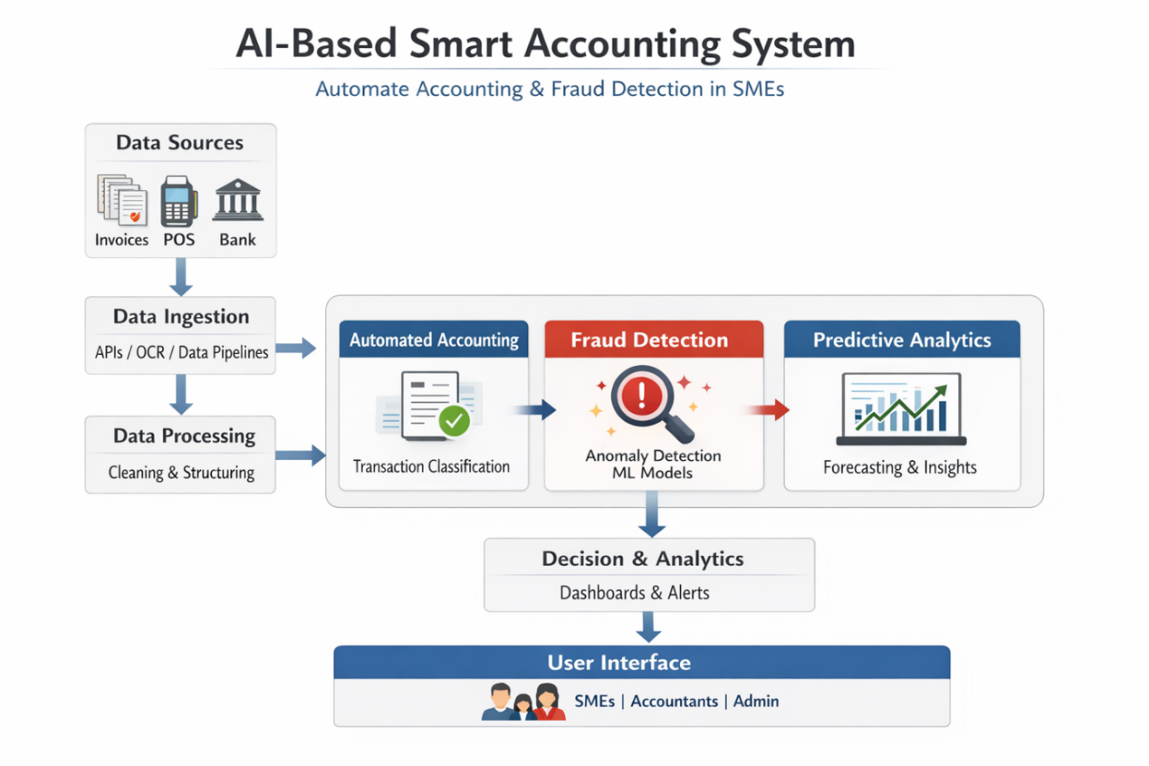
Figer 5.2 Summary of the Study

In this research, a smart accounting system has been proposed which combines accounting automation and fraud detection in real time by making use of machine learning, deep learning, and explainable AI methods. The system caters to the problems being faced by small and medium-sized enterprises, such as manual errors, lack of resources, and susceptibility to financial fraud.

The structure of the framework includes the following two modules:

An accounting automation module for processing invoices, classifying expenses, reconciliation of accounts, and preparing financial reports.
A fraud detection module with the help of a stacking ensemble approach comprising five base learners (Logistic Regression, Decision Tree, Random Forest, SVM, and KNN), with MLP used as the meta-learner.

The study has suggested a unique hybrid feature selection method which uses the filter approach initially and then the wrapper approach.

5.3 Key Findings

Experimental findings showed the efficiency of the offered solution:
The hybrid feature selection technique was able to decrease the size of the dataset by around 62% without losing predictive capability.
Baseline models worked with high accuracy varying from 97.5% to 99.1%.
The stacking-based ensemble model obtained the excellent F1-Score equal to 0.92 and showed better results than all other models used separately, providing an optimal ratio of precision and recall on highly unbalanced datasets.
Combining SHAP and LIME allowed to offer both global and local explanations that significantly increased interpretability and credibility of the whole system for non-technical users like accountants and SME owners.

The obtained findings prove the possibility of automated performance of routine accounting tasks and detection of fraud schemes in real-time mode.

5.4 Contributions of the Study

The current research makes several notable contributions to the domains of FinTech and Applied Artificial Intelligence:

Proposed Novel Stacking Ensemble Architecture: An innovative hybrid stacking ensemble that is a combination of conventional ML models with a specially-designed DL meta-model that is capable of processing SME accounting datasets.
Effective Hybrid Feature Selection Algorithm: A hybrid filtering-wrapping algorithm that is able to make modern complex AI algorithms feasible for deployment on SME devices.
Integration of Explainable AI in Practical Contexts: Efficient use of SHAP and LIME methods in the effort to bring together accurate and explainable AI models in accounting contexts.
End-to-End Smart Accounting Solution: An innovative approach that integrates automation and fraud detection in a single framework.

5.5 Practical Implications

The proposed model provides the SMEs with a cheaper solution to decrease the amount of manual labor, prevent financial losses associated with fraud (at least 5% per year), and improve their financial decisions. The transparency of the developed solution helps in gaining trust from the side of accountants that do not specialize in AI.

5.6 Limitations

Nevertheless, there are certain limitations associated with the research:

First of all, the main data source used for the assessment was Mendeley combined with some artificial data samples. More practical datasets of SMEs are required to be tested.
Real time streaming and implementation of the algorithm in live accounting software systems have not been performed.
There may be increased computational costs at the feature selection phase when dealing with extremely large data samples.

5.7 Future Work

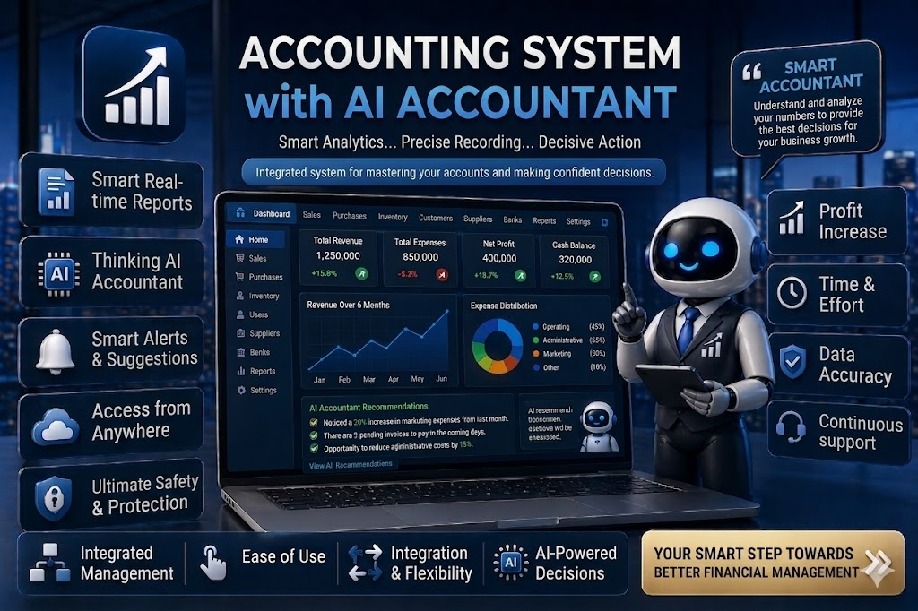

The following possible directions for further research are suggested:

Real-World Application: Deploy and test the framework as a cloud-based service-as-a-software solution in conjunction with widely used accounting software such as QuickBooks, Zoho Books, SAP, and others.
Data Integration from Multiple Sources: Utilize unstructured data such as invoices, emails, contracts by implementing advanced models of LLMs and Optical Character Recognition technology.
Continuous Learning: Implement continuous online learning functionality enabling the model to adjust to newly emerging cases of fraud without requiring complete retraining.
Integration with Blockchain: Integrate the system with blockchain technology to provide an audit trail and improve data security.
Generalization: Test the framework in different business environments and countries to study the ability to generalize.
Usability Studies: Perform empirical research involving owners of SMEs and accountants to study the usability of the proposed solution.

5.8 Concluding Remarks

In conclusion, the above-discussed thesis offered an advanced artificial intelligence-based smart accounting system capable of automating accounting practices and identifying fraud in SMEs. Due to its high accuracy, computational efficiency, and interpretability, the solution can be viewed as a milestone in the process of digital transformation of small business finances. It is expected that the discussed research will serve as an impetus for future investigations in the field.

