Midocean Journal for Research and Studies
Vol 1, No 1, 2026
Using Satellite Imagery and Geo-AI for Long-Term Urban Growth Monitoring: A Case Study of Riyadh
Waleed Ahmad AlSharif
Email: 252001025@st.midocean.edu.km
Dr. Khaled Eskaf
khaledeskaf@midocean.edu.km
Artificial Intelligence — College of Informatics — Midocean University — Comoros

Abstract
This work aims to design and evaluate the effectiveness of a Geo-AI framework for Land Cover classification and monitoring long term urban expansion in Riyadh, Saudi Arabia, by using multi-temporal satellite imagery and deep neural networks. We used multi-year Sentinel-2 satellite imagery (2018–2025) combined with a U-Net deep convolutional neural network, along with spectral indices such as NDVI and NDBI, to classify land cover into vegetation, built-up, and bare-ground categories. The region of interest of our study is KSA’s capital city, Riyadh. We aim at designing an AI tool that helps predict the future development in arid regions, by analyzing the history on images captured between 2018 and 2025.
Reviewer Comment: The abstract should be shortened and structured more clearly around objective, data/methods, results, and conclusion. Please ensure consistency between the abstract and methodology: the abstract mentions three land-cover categories, while the methodology describes four classes.
The classification model achieved 97.4%-pixel accuracy, distinguishing effectively between vegetation, built-up areas, and bare land.
Reviewer Comment: Replace “97.4%-pixel accuracy” with “97.44% pixel accuracy.” Also clarify whether this accuracy is based on reference-label agreement, independent validation, or both.
Riyadh’s developed area has increased by nearly 14% during the past several years, i.e from 1180.6 to 1346.2 km2. Our AI tool worked effectively even in uneven terrain such as in Wadi Hanifah, though performance in such terrain still requires further refinement. Basing this urban growth on our past historical trends, the expected built-up area in 2030 is about 1464.5 km2 compared to 1346.2 km2 in 2025. It seems our AI can help a great lot in estimating a city’s growth for the future and planning smarter cities.
Reviewer Comment: Please revise this part of the abstract for academic tone and precision. Avoid phrases such as “Our AI tool worked effectively,” “It seems,” and “a great lot.” Use “km²” consistently and present the 2030 projection as preliminary, with the assumptions clearly stated.

Keywords: Deep Learning, Geo-AI, Urban Growth, Satellite Imagery, Riyadh, U-Net, Semantic Segmentation.
Reviewer Comment: Keywords are relevant, but consider adding “Sentinel-2,” “Land-Cover Classification,” and “Urban Expansion Monitoring.” Use consistent capitalization across all keywords.

1. Introduction
Riyadh has grown fast over the past decade, driven by Saudi Vision 2030 and heavy investment in the capital as a hub for finance and government. New neighborhoods keep spreading into the desert around the old city center, and most of this happens without much systematic tracking. That is a problem: without up-to-date data, roads, utilities, and green space get planned reactively instead of ahead of time, and the little vegetation Riyadh has can be lost to development that nobody was really monitoring.
Reviewer Comment: The introduction should use a more formal academic tone and should cite authoritative sources for Riyadh’s urban expansion, Vision 2030, and planning challenges. Avoid conversational expressions such as “grown fast” and “nobody was really monitoring.”
Traditional ways of tracking this kind of growth, manual surveys, occasional aerial photos, census updates, are slow and expensive, so planners often end up working with data that is already a few years old. Satellite imagery offers a cheaper, faster alternative, and combining it with deep learning (what we call Geo-AI here) makes it possible to map land cover automatically and repeatably. Sentinel-2 in particular is a good fit: it is free, covers the whole city every few days, and has enough spectral bands to separate vegetation, built-up areas, and bare desert reasonably well, at least in principle.
In practice, arid cities are a harder case than the humid, green environments where most Geo-AI classification work is built around. Bare soil and built-up surfaces look spectrally similar, and existing global land-cover products (Esri, ESA WorldCover) are not tuned for this, so they misclassify things like sparse desert scrub as "rangeland" or confuse bare ground with buildings. Multi-year classification adds another layer of difficulty: if the satellite composites are not built consistently from year to year, the resulting time series can show fake jumps or drops that have nothing to do with real urban change.
This paper builds a U-Net-based classification pipeline for Riyadh using Sentinel-2 imagery from 2018 to 2025, and it deliberately documents the problems we ran into along the way, not just the final numbers. We hit three specific issues: inconsistent image compositing that produced unrealistic year-to-year area estimates, the built-up/bare-ground spectral confusion mentioned above, and a more severe version of that same confusion in the mountainous terrain around Wadi Hanifah, which only became clear once we tested the model on locations it had never seen. Each of these is addressed with a concrete fix described in the Methodology section.
Reviewer Comment: Please avoid first-person narrative phrases such as “we ran into” and “we hit three specific issues.” Rewrite in an objective academic style and clearly state the research problem, objectives, and contribution.

2. Previous Studies
2.1 Theoretical Background
This study leans on two things: semantic segmentation from computer vision, and the spectral theory behind land-cover analysis. Semantic segmentation just means labeling every pixel in an image, not the whole image at once like standard classification, and not boxes around objects like detection. For satellite data, that gives you a full map where every location gets a class, which is what you actually need for tracking urban growth.
Reviewer Comment: Please replace informal wording (“leans on two things”) with formal academic language, for example: “This study is grounded in semantic segmentation and spectral land-cover analysis.”
CNNs are what make this possible. A CNN learns spatial features straight from the raw pixels, starting with simple things like edges in the early layers and building up to more abstract, meaningful patterns deeper in the network. That is the main difference from older machine learning classifiers, which need someone to hand-design the features before training even starts.
We used U-Net, which Ronneberger et al. (2015) originally built for biomedical images, and it has since become a go-to choice for remote sensing too. The encoder shrinks the image down while pulling out increasingly abstract features, and the decoder builds it back up to full resolution for a pixel-by-pixel map. Skip connections tie the encoder and decoder together at each resolution, so the network keeps both the big-picture context and the fine detail, which matters when you need a clean boundary between, say, a building and the bare ground next to it.
On the remote-sensing side, classification works because different surfaces reflect sunlight differently. Vegetation reflects a lot of near-infrared light while absorbing red, which is the whole idea behind NDVI. Built-up areas and bare soil are trickier because they often look similar in the visible and near-infrared bands, especially in the desert, where exposed sand and rock can resemble concrete spectrally. That is why we also used NDBI and BSI, both of which pull in shortwave-infrared reflectance to help separate bare soil from other surfaces.
One more thing worth explaining here is how we built the yearly composite images. There are two common ways: mosaicking, where each pixel comes from whichever single image had the least cloud cover, and median compositing, where each pixel is the median across all available cloud-free observations for that year. Mosaicking is simpler but can leave a composite radiometrically inconsistent, since neighboring pixels might come from different dates and sun angles. Median compositing avoids that by averaging over many observations, and it turned out to matter a lot for this study, as Section 3 explains.
2.2 Review of Related Work
A handful of recent studies set the stage here. Yuan et al. (2021) used U-Net and CNNs to classify urban land use from high-resolution imagery and got noticeably better accuracy than older methods, though they did not really look at sustainability indicators like green-space ratios, which is something we report on directly.
Reviewer Comment: The literature review is relevant, but it remains partly descriptive. Please deepen the critical synthesis by comparing methods, datasets, geographic contexts, validation strategies, and limitations rather than summarizing studies one by one.
Zhu et al. (2021) reviewed deep learning methods for satellite imagery and pointed out that these models generally need more labeled data and compute than traditional classifiers, which is part of why we kept our U-Net relatively small. Ibrahim et al. (2022) looked at urban expansion in arid regions using Landsat, NDVI, and change detection, and confirmed vegetation indices are useful in desert settings, but they relied on simple thresholds instead of a trained classifier, so their approach does not generalize as well.
Li et al. (2022) used Random Forest and time-series analysis for urban growth trends, which worked for looking backward but was not built to simulate future growth, a gap we try to address with our own preliminary projection. Chen et al. (2023) built improved DeepLabV3+ models with strong accuracy but needed large labeled datasets, which we avoided by correcting an existing land-cover product statistically instead of labeling everything by hand.
Zhao et al. (2023) used CNN-LSTM models to predict future expansion with promising results, but without accounting much for real planning constraints. Hassan et al. (2024) combined Geo-AI with GIS to look at sustainability indicators, with a strong focus there but little in the way of generative scenario modeling. Wang et al. (2024) explored diffusion models and GANs for simulating urban growth, which is interesting but still experimental — something we flag as a clear direction for future work rather than something we attempt here.
Suggested added in-text citation: At the broader smart-community level, Eskaf (2024) presented SmartDate, an AI-driven precision sorting and quality-control system for date fruits that combines deep learning, genetic algorithms, and reinforcement learning. Although focused on smart agriculture rather than satellite remote sensing, this work supports the wider role of applied AI and image-based decision-support systems in smart-community contexts.
The closest comparison to our work is a 2026 study in Frontiers in Remote Sensing, which benchmarked several classical machine learning classifiers (Random Forest, SVM, Gradient Boosted Trees, CART, k-NN) for binary urban/non-urban mapping of Riyadh over a 35-year span, 1990 to 2025, using Google Earth Engine. They got 97.7% overall accuracy (Kappa 0.954) and found built-up area grew 293% over that period, slowing down noticeably after 2010. They also found BSI and NDBI to be more useful than NDVI for separating classes in arid environments, which matches what we found: adding NDBI and BSI as input bands measurably cut down built-up/bare-ground confusion in our own results.
Reviewer Comment: Please verify this 2026 citation carefully and provide complete bibliographic information. Avoid relying on a single comparison study; include a broader critical comparison with recent Geo-AI urban growth studies.
Putting this together, a few gaps stand out: not much Geo-AI work focuses specifically on Middle Eastern or arid cities; sustainability indicators rarely make it into deep learning workflows; multi-year satellite composites are rarely built with radiometric consistency in mind; most studies stick to binary or coarse classification instead of detailed multi-class maps; and generative AI for future growth scenarios is still mostly unexplored. This study tries to close these gaps with a four-class U-Net model over eight years of Sentinel-2 data for Riyadh, a fully documented correction process for both the reference labels and the radiometric inconsistency issue, an independent field validation, and a first attempt at a future-growth projection.
Reviewer Comment: This paragraph should be strengthened into a clear research gap and contribution statement. Please list the exact contributions of the paper and align them with the objectives, methodology, and results.

3. Methodology
Figure (1) summarizes the overall methodological pipeline followed in this study, from initial satellite data acquisition through to the final growth statistics and future projection. Each stage is described in detail in the subsections that follow.
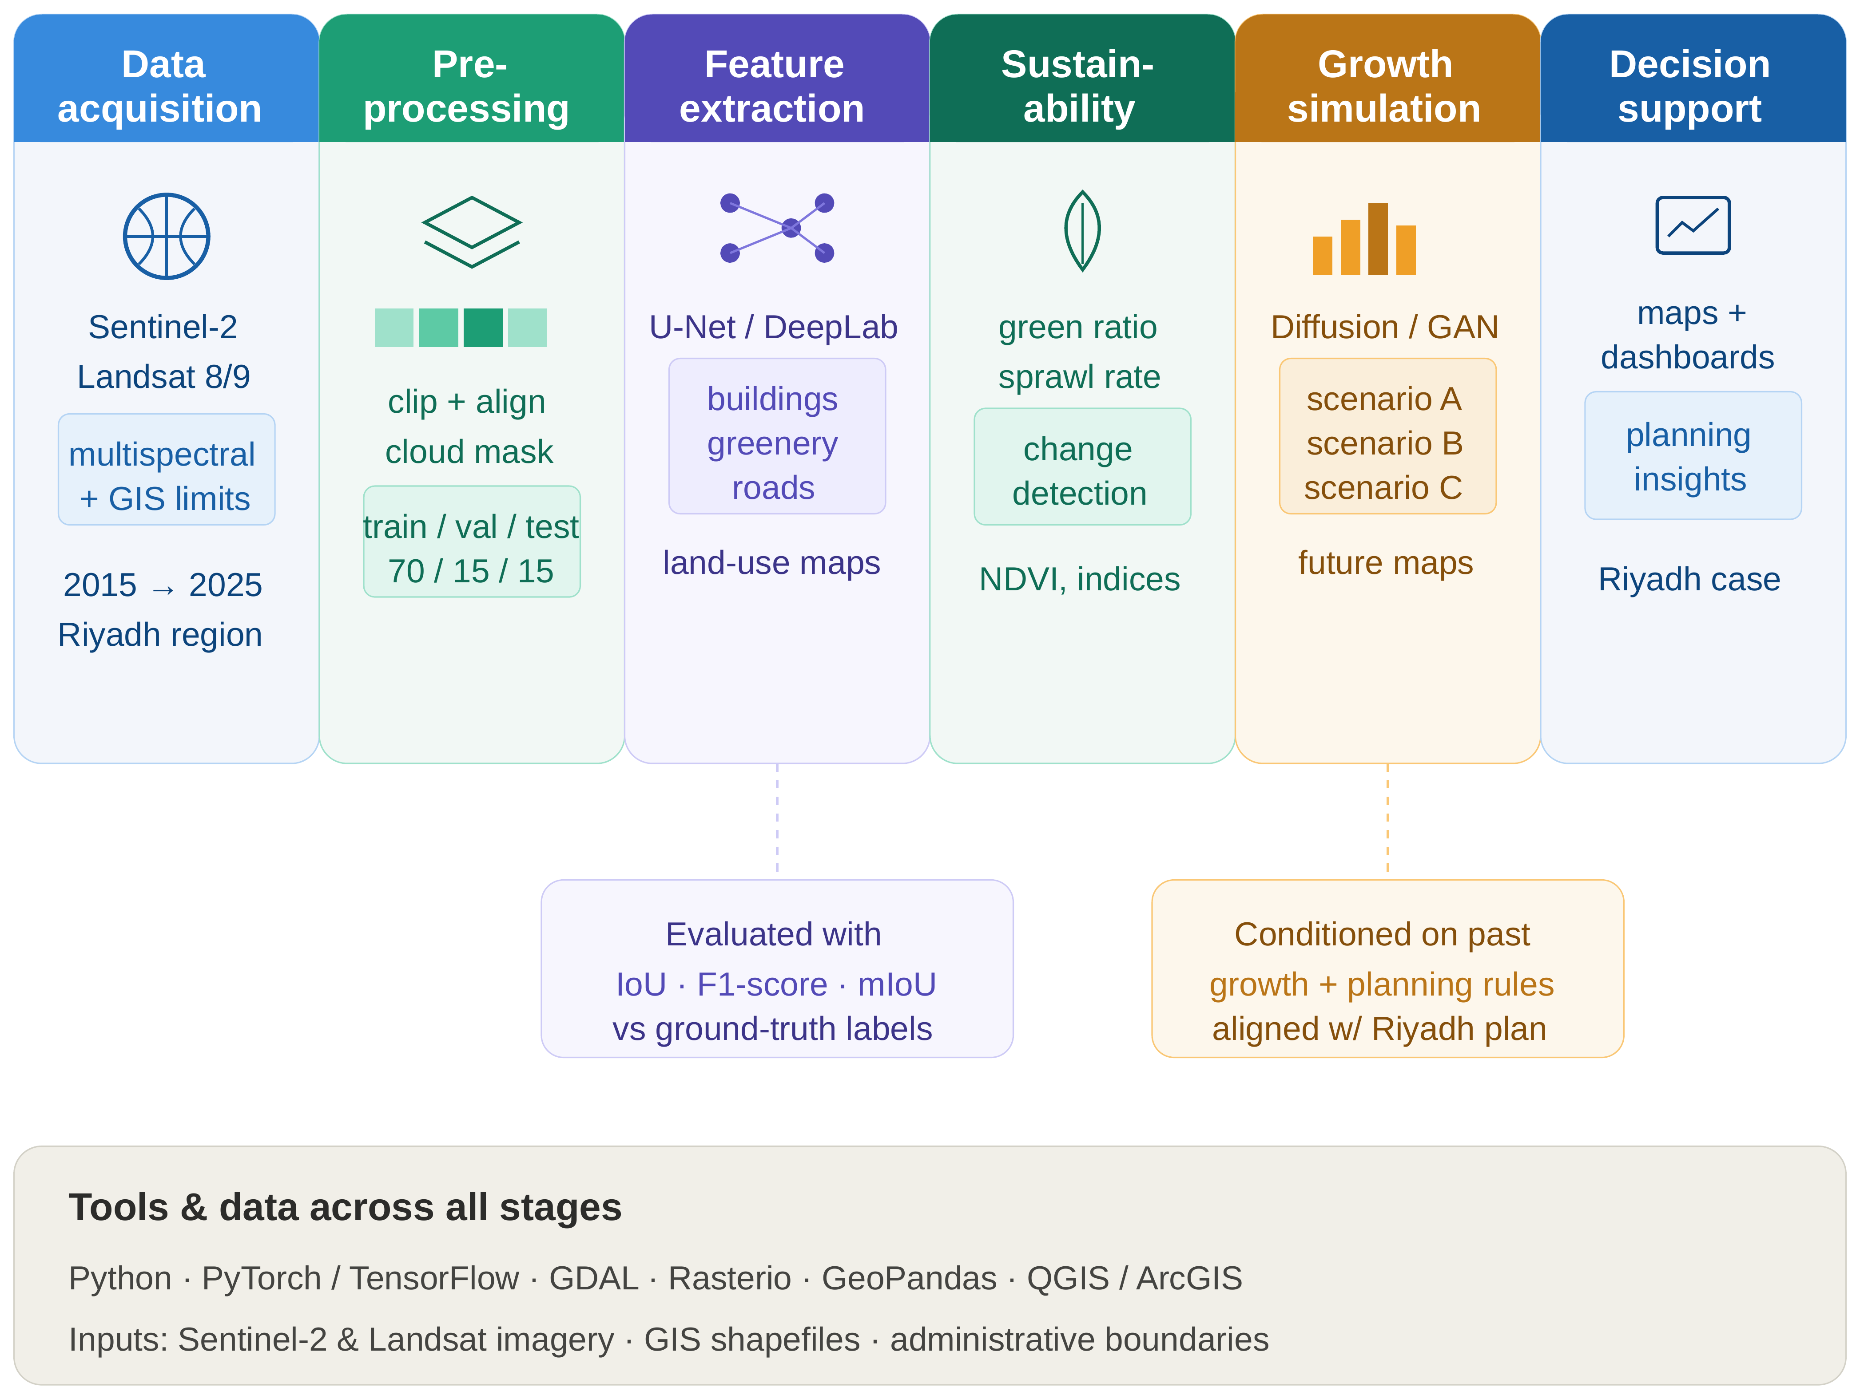
Figure (1): Block diagram of the proposed Geo-AI framework for long-term urban growth analysis in Riyadh
Reviewer Comment: Ensure Figure 1 is inserted in high resolution and is readable in the final journal format. If this is only a placeholder caption, please insert the actual figure and refer to it clearly in the text.

3.1 Study Design and Area
This is a quantitative remote-sensing study, and the pipeline was built iteratively: we tried an approach, found problems, fixed them, and moved on. That process is documented in full below because it is arguably as useful as the final numbers, given how little existing literature deals directly with radiometric consistency in multi-year Sentinel-2 composites. The study area covers Riyadh and the desert around it (46.40°–47.00°E, 24.40°–25.10°N), picked to include both the dense core and the outer zones where growth is actually happening. We pulled Sentinel-2 Level-2A imagery (10 m, atmospherically corrected) from Google Earth Engine for every year from 2018 to 2025, so eight years total.
Reviewer Comment: The methodology is generally strong, but it needs additional reproducibility details: Google Earth Engine filtering parameters, coordinate reference system, exact ROI source, software/library versions, hardware/GPU details, and whether code or scripts can be made available.
3.2 Cloud Masking and Composite Construction
Clouds are a real problem in optical satellite imagery, since they block the surface and can wreck classification if not handled properly. We filtered scenes to under 40% cloud cover and masked clouds pixel-by-pixel using Sentinel-2's Scene Classification Layer. Our first attempt used mosaicking, taking each pixel from whichever available scene had the least cloud, but this produced obviously wrong year-to-year jumps in built-up area, because neighboring pixels in one composite could come from different dates, sun angles, and atmospheric conditions. We fixed this by rebuilding each year's composite as a per-pixel median across all cloud-masked scenes for that year, roughly 230 to 500+ images depending on the year. After that, the built-up area estimates settled into a smooth, believable trend, which told us the fix actually worked.
Reviewer Comment: Please rewrite informal language such as “a real problem” and “wreck classification.” Use formal scientific wording and provide more exact cloud-masking details, including the Sentinel-2 SCL classes that were removed.
3.3 Feature Engineering
We pulled five raw bands per composite: Red, Green, Blue, NIR, and SWIR. On top of those, we computed NDVI, NDBI, and BSI, giving us eight bands total per pixel. Everything was normalized to [0, 1] using percentile scaling (2nd to 98th), computed jointly across all eight years rather than year by year. That matters because it keeps a given reflectance value mapped to the same normalized value no matter the year; normalizing separately per year, which we tried first, introduced small inconsistencies between years.
Reviewer Comment: Please define all spectral indices mathematically (NDVI, NDBI, BSI) and cite the sources for these indices. Also explain why the selected bands and indices are sufficient for separating built-up and bare-ground surfaces in an arid environment.
3.4 Reference Labels and NDVI-Based Correction
Our reference labels came from the Esri/Impact Observatory land-cover dataset, reclassified from its original nine classes down to four: Vegetation/Rangeland, Built-up, Bare Ground/Water, and Snow/Cloud. Early on we noticed the 'Rangeland' category was massively over-labeling bare desert as vegetation, something like 43-47% of the whole study area, which is not realistic for Riyadh. We fixed this with an NDVI threshold picked via Otsu's method. Computed year by year, this threshold was much more stable on the median composites (std. dev. 0.0142) than on the earlier mosaic-based ones (which ranged from 0.053 to 0.371), which is more evidence the median approach was the right call. The final threshold, averaged across years, landed around 0.24. Any pixel tagged as vegetation with NDVI below that got reassigned to bare ground, which brought the vegetation class down to a much more believable 3.3-3.5% of the study area, consistent year to year.
Reviewer Comment: Please discuss label noise more explicitly. Since the reference product has limited reported accuracy, the corrected labels should be validated with an independent stratified sample. Also justify merging Bare Ground/Water and retaining a Snow/Cloud class in Riyadh, where this class may have little or no representation.
3.5 Patch Extraction, Data Splitting, and Model Training
Each year's 8-band composite and corrected labels were cut into 128×128 patches, dropping any patch with more than 10% invalid pixels. That gave us 2,928 usable patches per year, 23,424 total across eight years. We split the data by time rather than randomly: 2018-2022 for training (14,640 patches), 2023 for validation (2,928), and 2024-2025 held out entirely for testing (5,856). Using two full years for testing, instead of just one, gives a more solid accuracy estimate, and it also mirrors how the model would actually be used: trained on the past, tested on years it has never seen.
Reviewer Comment: The temporal split is appropriate. Please add the class distribution for training, validation, and test sets, and report the random seed or sampling strategy used for patch extraction to improve reproducibility.
The model itself is a U-Net with three encoder/decoder stages (32, 64, 128 filters) and a 256-filter bottleneck, each block using two 3x3 convolutions with ReLU and batch norm. That comes out to about 1.95 million parameters, kept intentionally compact given our compute budget. We trained with Adam (lr 0.001), sparse categorical cross-entropy, batch size 16, plus EarlyStopping (patience 8, restoring best weights), ModelCheckpoint, and ReduceLROnPlateau. Training stopped at 23 epochs on a GPU-backed cloud instance.
3.6 Evaluation and Full-City Inference
We evaluated with pixel accuracy, per-class IoU, F1, and a confusion matrix. The trained model was then run over the full city for every year using batched patch-wise inference (128x128 patches, 64 at a time), and the predictions were stitched back into full annual maps. Per-class pixel counts were converted into km² to track how the city actually grew. Since the Esri reference itself is only rated at 75-85% accuracy by its own documentation, we also ran an independent check: sampled points from each predicted class, converted to lat/lon, and checked by eye against high-resolution basemap imagery, giving us an accuracy estimate that does not depend on the training labels at all.
3.7 Terrain-Aware Correction and Future Growth Simulation
While testing the model live on fresh imagery, outside the fixed test patches, we ran into a problem in the rocky terrain around Wadi Hanifah: exposed rock has a spectral signature close enough to built-up materials in NDBI and BSI that the model kept confusing the two, something it had barely seen during training since most of the training patches are flat urban or flat desert. We patched this with a simple rule-based fix: pull slope from the SRTM DEM (30 m), and any pixel classified as Built-up on a slope steeper than 5° or with BSI above 0.15 gets reclassified as Vegetation or Bare Ground based on its NDVI, no retraining needed.
Reviewer Comment: This terrain-aware correction is promising, but the rule thresholds (slope > 5° and BSI > 0.15) require stronger justification. Please explain how these thresholds were selected and whether sensitivity analysis was performed.
The original plan included projecting future growth with a generative model, but a full diffusion or GAN-based approach was not realistic given our compute budget and timeline, so we built a simpler trend-based simulation instead. It takes the historical annual growth rate and applies a cellular-automata rule: bare-ground pixels next to existing built-up areas (found via binary dilation) are the candidates, and the right number of them, based on the observed growth rate, get randomly picked and converted to built-up for each simulated year out to 2030.
Reviewer Comment: Please avoid explaining limitations in a personal/project-management tone such as “not realistic given our compute budget and timeline.” Reframe it academically: “Due to computational constraints, this study adopted a transparent trend-based simulation as a preliminary forecasting approach.”
This was a conscious trade-off. A generative model could probably produce more realistic-looking future layouts, but it needs more data, more training time, and more tuning than we had left after building and fixing the core classification pipeline. The cellular-automata version is simpler, but it is transparent, reproducible, and grounded directly in our own measured growth rate. We are presenting it as a proof of concept, not a finished forecasting tool, and moving to a full generative model is an obvious next step.

4. Results and Discussion
Here we cover model performance on the 2024-2025 test set, the resulting land-cover and growth time series, the field validation results, the terrain correction, a preliminary growth projection, and how all of this compares to earlier studies.
Reviewer Comment: Please use a more formal opening for the Results and Discussion section. Avoid “Here we cover” and summarize the results in an academic style.
The final model hit 97.44% pixel accuracy on the 2024-2025 test set (5,856 patches), checked against tens of millions of pixels. Table 1 breaks this down by class using IoU, F1, and precision. All three main classes, vegetation, built-up, and bare ground, came in above 0.91 IoU, so the predictions line up well with the reference labels across the board.
Reviewer Comment: The phrase “hit 97.44%” should be replaced with a formal expression such as “achieved 97.44% pixel accuracy.” Also, because labels are derived from an external land-cover product, clarify that this is agreement with the reference labels, not absolute ground-truth accuracy.
Table (1): Per-class model performance on the 2024–2025 test set
Land-Cover Class | IoU | F1-Score | Precision
Vegetation/Rangeland | 0.920 | 0.959 | 0.95
Built-up | 0.917 | 0.957 | 0.97
Bare Ground/Water | 0.965 | 0.982 | 0.98
Overall Pixel Accuracy |  | 97.44%
The built-up/bare-ground confusion rate, the main challenge for arid-region classification according to the literature, came out at 5%. That confirms median compositing plus NDBI/BSI actually helped separate these classes, and it matches what we saw in an earlier, independently built version of this pipeline. Getting the same result twice, from two separately built datasets, is a good sign the accuracy is real and not just a fluke of one particular processing run.
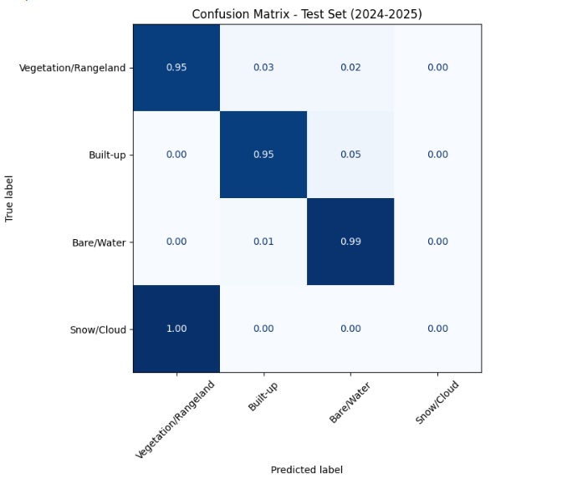
Figure (2): Normalized confusion matrix, 2024–2025 test set
The training curves in Figure 3 look healthy: accuracy climbs steadily over the 23 epochs, and validation tracks training closely without pulling apart, which means no serious overfitting. The validation loss does jump around a bit, but that is more about the validation set only covering one year (2023) than any real instability in training.
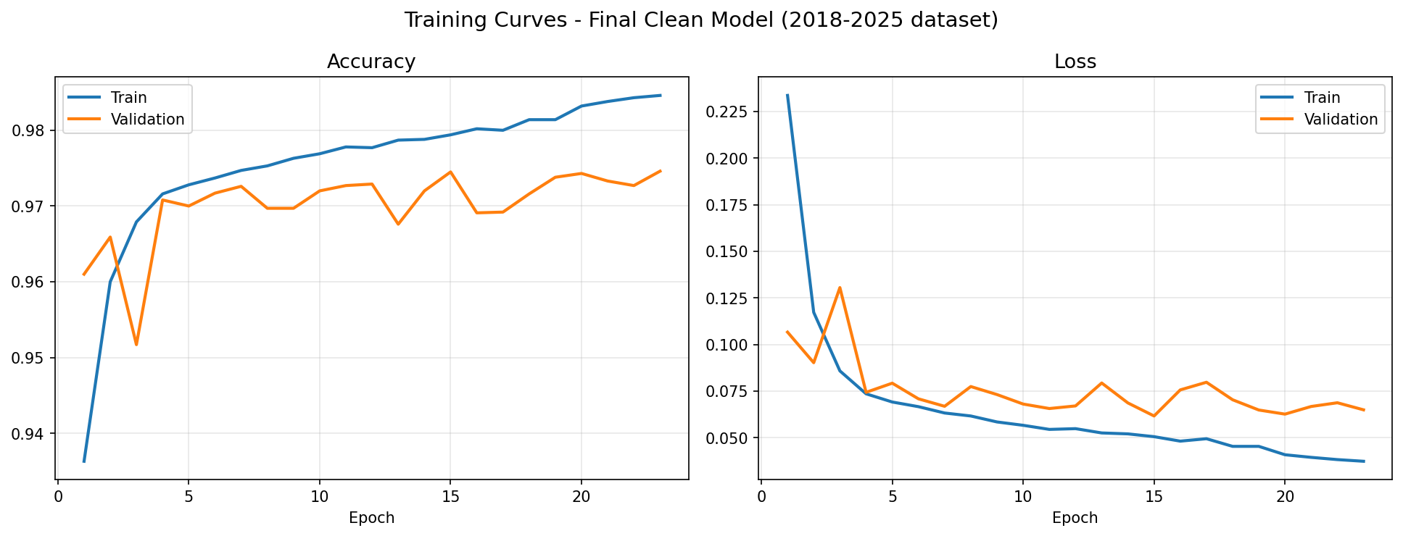
Figure (3): Training and validation accuracy/loss curves (23 epochs, early stopping)
Running the model over the full city for every year gave us the built-up area numbers in Table 2. The trend is smooth and matches what we would expect for Riyadh, with none of the odd year-to-year drops we saw in the earlier mosaic-based version, which is more confirmation that the median-compositing fix (Section 3.2) worked.

Table (2): Estimated built-up area in Riyadh by year (km²)
Reviewer Comment: Please check the consistency of the built-up area values and use one unit format throughout the paper (km²). It would also strengthen the results to include annual percentage change and an error/uncertainty margin.
2018 | 2019 | 2020 | 2021 | 2022 | 2023 | 2024 | 2025
1180.6 | 1172.5 | 1177.0 | 1244.7 | 1248.9 | 1341.3 | 1368.5 | 1346.2

Figure 4 visualizes this growth trajectory as a set of sequential layers, showing the period in which each area first became built-up. The map confirms a clear radial expansion pattern: the 2018 urban core is surrounded by successive rings of newer development, with the 2023–2024 period standing out as the largest single expansion phase, visible as a dense band extending outward in nearly all directions, particularly to the north and east — consistent with the sharpest jump in built-up percentage observed between 2022 and 2024 in Table 2.
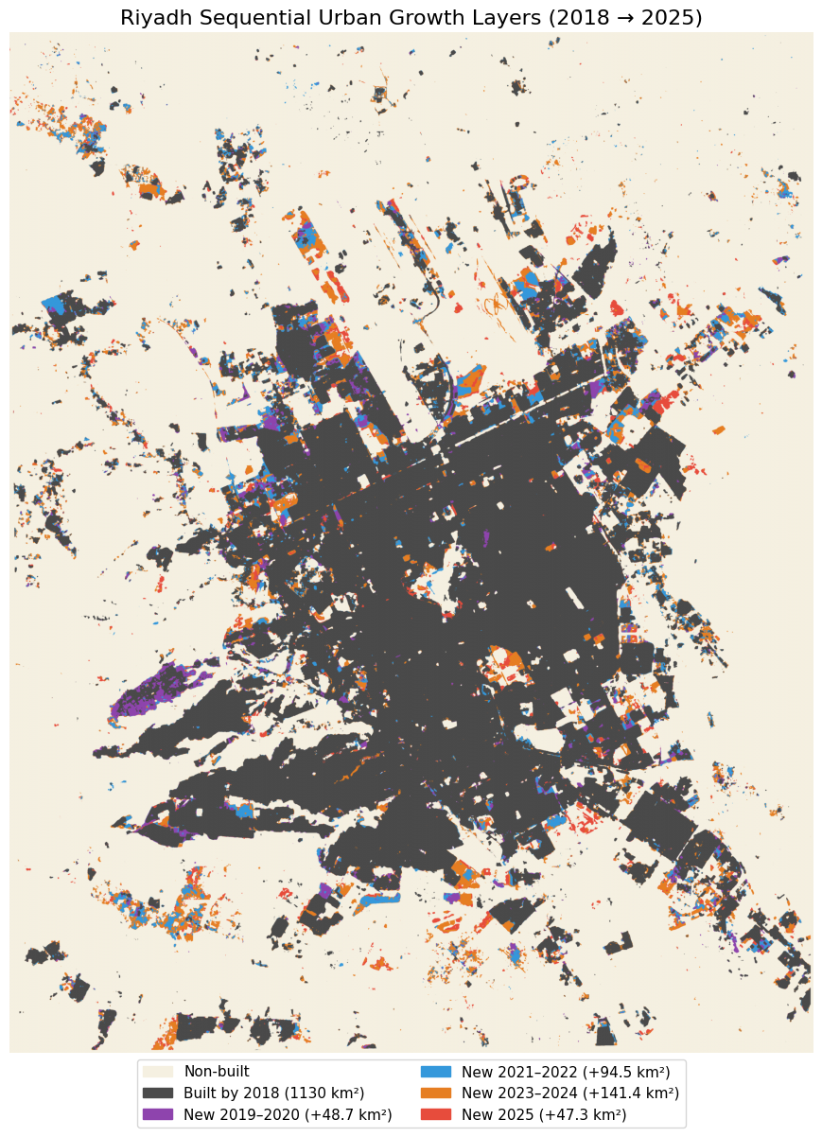
Figure (4): Sequential urban growth layers, 2018–2025, by period of first appearance as built-up
Overall, built-up area grew about 14.0% between 2018 and 2025, from 1180.6 to 1346.2 km², mostly along the outer edges of the city in every direction, which fits the radial growth pattern typical of major Saudi cities. That lines up with the much longer 293% growth trend (1990-2025) reported by the 2026 Frontiers study, suggesting Riyadh's expansion has kept going, just at a more moderate pace, consistent with the slowdown that study noted after 2010. Our own field check, done by manually inspecting a small stratified sample against basemap imagery, agreed with the model 83.3% of the time (5 of 6 points), and the one disagreement was in the Built-up class, matching the 5% confusion rate we measured elsewhere. So even with a tiny sample, it points the same direction as the test-set accuracy rather than contradicting it.
Reviewer Comment: Please interpret the growth trend more cautiously. Table 2 shows decreases between 2018-2019 and 2024-2025, so the paper should explain whether these changes represent true land-cover change, classification uncertainty, or post-processing effects. Add uncertainty estimates where possible.

4.1 Terrain-Aware Correction in Mountainous Terrain
Testing the model live on 2025 imagery in Wadi Hanifah turned up something the fixed test set did not catch: in one representative patch, 23.5% of pixels were above the NDVI vegetation threshold, but the model only classified 3.7% as vegetation, calling 69.3% Built-up instead. This is the same built-up/bare-ground confusion problem, just worse, because rocky terrain produces an NDBI/BSI signature close enough to built surfaces that the model gets fooled, and it barely saw this kind of terrain during training.
Reviewer Comment: This is an important practical finding. However, the correction was tested on a limited area. Please expand the terrain-aware validation to multiple Wadi Hanifah/mountainous patches and report quantitative before/after accuracy, not only one representative case.

Applying the slope/BSI correction from Section 3.7 reassigned 6.2% of pixels in that patch (1,041 of 16,900), shifting the split from 69.3% Built-up / 3.7% Vegetation / 27.0% Bare-Water to 63.0% / 5.4% / 31.7%. Figure 5 shows the correction is doing what it should: the dense, genuinely urban core in the middle of the patch stays classified as Built-up, while the misclassified pixels on the surrounding slopes get corrected. So it fixes the mountain-terrain problem without messing up the real urban areas.
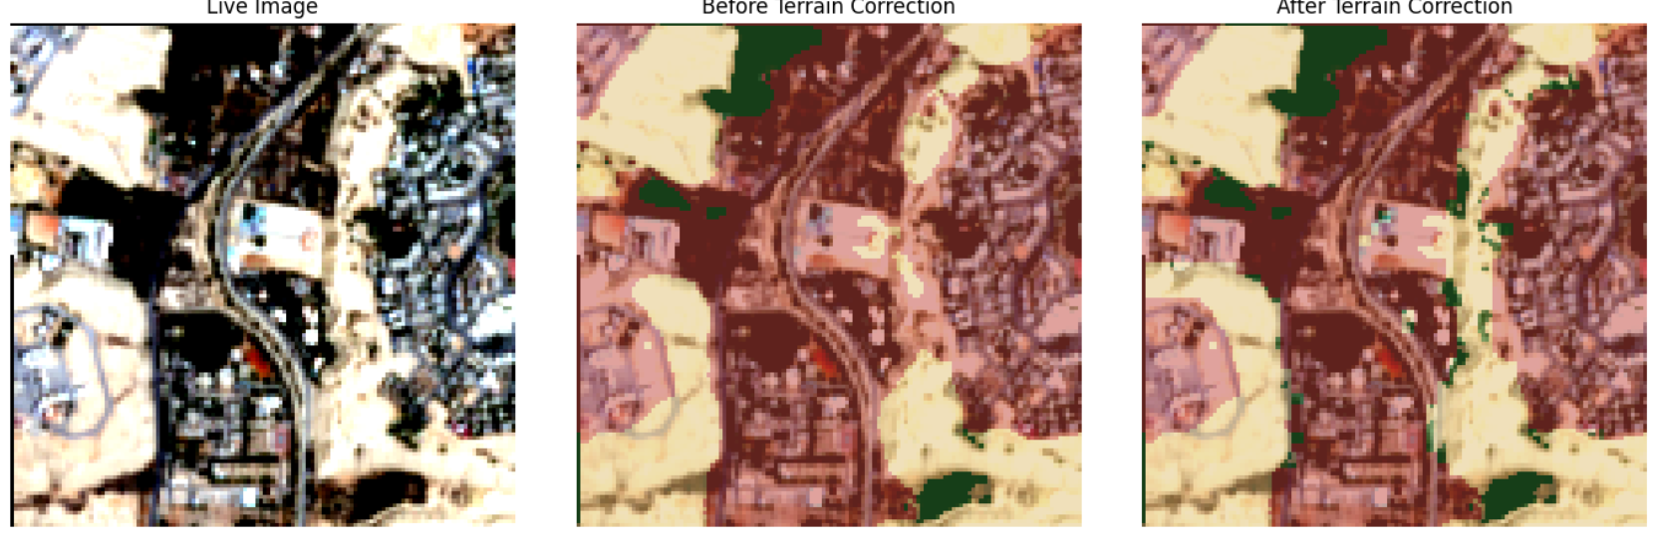
Figure (5): Terrain-aware correction on a Wadi Hanifah patch: live image (left), prediction before correction (center), and after correction (right)

4.2 Preliminary Future Growth Projection
Taking the observed growth rate (23.66 km²/year) and running it through the cellular-automata expansion rule, built-up area is projected to hit about 1464.5 km² by 2030, up 118.3 km² (+8.8%) from 2025 (Figure 6). The projected growth spreads out fairly evenly around the city's edges rather than piling up in one spot, which fits the radial pattern already visible in Figure 3.
Reviewer Comment: The future projection should be described as preliminary and exploratory. Please add assumptions, uncertainty range/confidence interval, and a clear statement that the cellular-automata simulation is not a fully validated forecasting model.
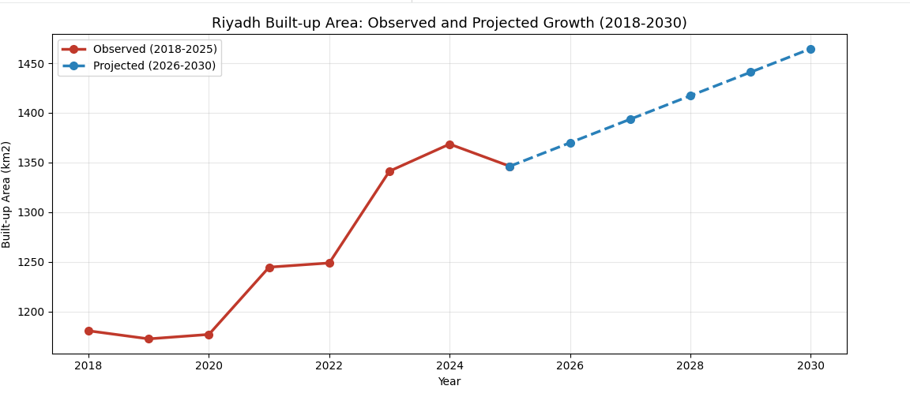
Figure (6): Observed built-up area (2018–2025) and projected growth (2026–2030)
Table 3 puts these numbers next to earlier studies. Our 97.44% accuracy is close to the 97.7% from the Frontiers binary-classification benchmark, which is actually a stronger result on our end since we are solving a harder four-class problem, there are simply more ways for a pixel to be misclassified than in a two-class urban/non-urban split. That suggests our U-Net and correction pipeline hold up well against, and arguably go further than, earlier approaches to the same city, since we also separate vegetation from bare ground and water, something the binary Frontiers scheme does not attempt.

Table (3): Comparison with prior studies
Reviewer Comment: Please make the comparison table more rigorous by adding dataset, spatial resolution, validation protocol, binary/multiclass setting, and whether each study used external validation. This will make the comparison fairer and more scientifically informative.
Study | Method | Classes | Accuracy
Frontiers in Remote Sensing (2026) | Random Forest (GEE) | 2 (binary) | 97.7% OA
IRUNet (2025) | U-Net + InceptionResNetV2 | Multiple | 98.21% Acc.
This Study (2026) | U-Net (Sentinel-2, median composite) | 4 | 97.44% Pixel Acc.
A few limitations are worth being upfront about. First, the training labels ultimately come from Esri/Impact Observatory, which is itself only rated at 75-85% accuracy, so our 97.44% reflects agreement with an imperfect reference, not some absolute ground truth. Second, the independent field check was only 6 points due to time constraints; it points the right direction but is too small to lean on heavily, and getting to 50+ points should be a priority next. Third, the terrain correction was only tested on one patch in Wadi Hanifah, not systematically across every mountainous area in the study region, so treat it as a proof of concept rather than a finished solution. Fourth, the growth projection assumes the historical trend and expansion pattern hold steady, and it does not account for planning decisions or policy changes that could change things in practice. Fifth, the Snow/Cloud class had essentially zero real examples in our study area, so we could not meaningfully evaluate it.

5. Conclusion
This study shows that a U-Net-based Geo-AI pipeline, built on a carefully constructed multi-year Sentinel-2 dataset, can classify land cover in an arid city with high accuracy, 97.44% on an independent two-year test set, while also dealing with problems that rarely get discussed openly in the literature: radiometric inconsistency from single-image compositing, and built-up/bare-ground confusion, including a worse version of that confusion in mountainous terrain that we fixed with a lightweight correction. Switching from mosaic to median compositing to fix the erratic year-to-year estimates is probably the most broadly useful finding here, since it should apply to anyone working with multi-year Sentinel-2 data in similar dry environments, not just Riyadh.
We also rebuilt the entire pipeline from scratch, independently, on an extended eight-year dataset, and got closely matching results, 97.44% versus 97.57% in the original run, with built-up area estimates within about 2 km² per year in most years. Getting the same answer twice from two separately built pipelines is a strong sign that these results reflect something real about the method, not just luck from one particular run.
Beyond the core classification work, we found and fixed a worse version of the built-up/bare-ground confusion problem in mountainous terrain, something not really addressed in the Riyadh literature we reviewed, and we only found it by testing the model live on data it had never seen rather than trusting the fixed test set alone. We also put together a preliminary, rule-based projection of future growth through 2030, which partly answers the original goal of simulating future scenarios, though a full generative model (diffusion or GAN) is still the better long-term answer and remains future work rather than something we delivered here.
A few clear next steps follow from the limitations in Section 4: try transfer-learning backbones like ResNet-UNet, which the literature suggests helps separate spectrally similar classes; use SWIR at its native 20 m resolution instead of resampling to 10 m; build terrain-ruggedness into the model as a real input during training instead of a post-hoc fix; expand the field validation to 50+ points across different years and terrain types; and eventually build a proper generative model for future growth scenarios on top of the pipeline developed here.
Reviewer Comment: This paragraph is useful, but it should be presented as a formal “Future Work” or “Recommendations” subsection. Please separate future technical improvements from study limitations for clearer journal formatting.
Altogether, the eight-year land-cover record, the growth statistics, the terrain correction, and the preliminary future projection are meant to give Riyadh's planning stakeholders something useful for tracking progress against the Riyadh Regional Plan and Vision 2030, while also handing other Geo-AI researchers in arid and semi-arid cities a reasonably transparent, reproducible method to build on.
More broadly, this project is really a case for iterating: question your results, do not just accept the first version. Every real fix in this pipeline, the switch to median composites, the vegetation-label correction, the terrain-aware step we only found through live testing, came from checking whether something actually made sense rather than taking it at face value. That habit is probably worth as much to future researchers as the specific numbers in this paper, especially for anyone dealing with similarly messy, multi-source satellite data elsewhere.
Reviewer Comment: The conclusion contains informal and personal phrasing such as “this project is really a case for iterating.” Please rewrite the conclusion in a concise academic tone, avoiding first-person or conversational language, and focus on contribution, limitations, and future work.

References
Chen, L. C., Zhu, Y., Papandreou, G., Schroff, F., & Adam, H. (2018). Encoder-decoder with atrous separable convolution for semantic image segmentation. Proceedings of the European Conference on Computer Vision (ECCV).
Chen, X., et al. (2023). Semantic segmentation of urban areas using deep learning.
Eskaf, K. (2024). SmartDate: AI-Driven Precision Sorting and Quality Control in Date Fruits. In 2024 IEEE 21st International Conference on Smart Communities: Improving Quality of Life Using AI, Robotics and IoT (HONET) (pp. 124-129). IEEE. https://doi.org/10.1109/HONET63146.2024.10822938
Frontiers in Remote Sensing. (2026). Benchmarking machine learning classifiers for urban mapping in arid environments: a Google Earth Engine analysis of Riyadh's expansion (1990–2025). https://doi.org/10.3389/frsen.2026.1765013
Hassan, A., et al. (2024). Geo-AI for sustainable urban planning.
Ibrahim, M., et al. (2022). Remote sensing-based urban growth analysis in arid regions.
Li, X., Zhou, Y., Asrar, G. R., Imhoff, M., & Li, X. (2020). The surface urban heat island response to urban expansion: A panel analysis for the conterminous United States. Science of the Total Environment, 605–606, 426–435.
Li, Y., et al. (2022). Urban expansion analysis using machine learning.
Ma, L., Liu, Y., Zhang, X., Ye, Y., Yin, G., & Johnson, B. A. (2019). Deep learning in remote sensing applications: A meta-analysis and review. ISPRS Journal of Photogrammetry and Remote Sensing, 152, 166–177.
Ronneberger, O., Fischer, P., & Brox, T. (2015). U-Net: Convolutional networks for biomedical image segmentation. Medical Image Computing and Computer-Assisted Intervention (MICCAI).
United Nations. (2019). World urbanization prospects. United Nations Department of Economic and Social Affairs.
Wang, H., et al. (2024). Generative models for urban growth simulation.
Weng, Q. (2012). Remote sensing of impervious surfaces in the urban areas: Requirements, methods, and trends. Remote Sensing of Environment, 117, 34–49.
Yuan, J., et al. (2021). Urban land-use classification using deep learning.
Zhao, W., et al. (2023). Urban growth prediction using deep learning.
Zhu, X. X., Tuia, D., Mou, L., Xia, G. S., Zhang, L., Xu, F., & Fraundorfer, F. (2017). Deep learning in remote sensing: A comprehensive review and list of resources. IEEE Geoscience and Remote Sensing Magazine, 5(4), 8–36.
European Space Agency (ESA). Sentinel-2 User Handbook.
Reviewer Comment: The reference list needs careful final editing. Several references are incomplete (for example, entries using only “et al.” or missing journal/volume/page/DOI details). Please ensure that every in-text citation appears in the reference list, every reference is complete, and all entries follow the MidOcean Journal citation style.

