Prediction of Water Tank Depletion Using Machine Learning
Waleed Alfaifi
Midocean University, UAE/Comoros
Email: 243001139@st.midocean.edu.km
Alternate Email: Eng_alfaifi@hotmail.com

Abstract
This paper presents the design and implementation of an intelligent water tank depletion prediction system that leverages Machine Learning (ML) techniques integrated with Building Management Systems (BMS). The study aims to optimize water refilling schedules in smart buildings and ensure sustainability. Using real-time data from water level and flow sensors, three algorithms—Linear Regression, Random Forest, and XGBoost—were tested. Results demonstrate that XGBoost achieved the best performance (R² = 0.90, MAE = 0.0300, RMSE = 0.0500), outperforming baseline models. The system offers a practical and scalable solution for resource efficiency, reducing operational costs and improving sustainability in water-scarce regions.
Keywords—Artificial Intelligence, Machine Learning, Smart Buildings, Water Tank Prediction, Building Management Systems.

I. Introduction
Efficient water management is a critical challenge in smart buildings, particularly in regions with limited water resources. Traditional reactive approaches to water refilling often lead to shortages, waste, and increased operational costs. While modern Building Management Systems (BMS) provide rich sensor data, most remain reactive rather than predictive. This work addresses this gap by applying AI-based predictive modeling for proactive water management.

II. Related Work
Research in smart water management has explored IoT-enabled monitoring, neural network-based forecasting, and anomaly detection. Studies have shown the potential of machine learning in optimizing energy and water systems, but few focus on seamless integration with existing BMS infrastructure. This work contributes by addressing real-time integration without additional hardware investments.
Recent works have also advanced AI-driven water management by proposing multi-layer architectures for smart water systems [5], real-time IoT-AI integration for leak detection and demand forecasting [6], federated learning techniques for water consumption prediction [7], AI-based hydraulic modelling as an alternative to traditional simulations [8], and blockchain-enhanced digital twin frameworks for secure rural water networks [9].

III. Methodology
The proposed system integrates BMS sensor data into a machine learning pipeline. Data preprocessing included cleaning, unit conversion (L/s to m³/h), and feature engineering (flow differentials, temporal features). Three ML models were implemented: Linear Regression, Random Forest, and XGBoost. Evaluation metrics included R², MAE, and RMSE.

IV. Results
Experimental results revealed significant differences among models. Linear Regression showed poor performance (R² = 0.0076). Random Forest improved accuracy (R² = 0.72, MAE = 0.0411, RMSE = 0.0747). XGBoost achieved the highest performance (R² = 0.90, MAE = 0.0300, RMSE = 0.0500). Feature importance analysis highlighted flow differentials and tank levels as the most influential factors.
Table I. Model Performance Comparison
Model | R² | MAE | RMSE
Linear Regression | 0.0076 | 0.127 | 0.2000
Random Forest | 0.7206 | 0.0411 | 0.0747
XGBoost | 0.9000 | 0.0300 | 0.0500

V. Discussion
The findings demonstrate that advanced ensemble methods, particularly XGBoost, can effectively capture non-linear and temporal patterns in water consumption. The system provides practical benefits including reduced water waste, optimized refill schedules, and lower operational costs. This confirms the value of integrating AI into existing BMS infrastructure.

VI. Conclusion and Future Work
This study validates the application of machine learning in predicting water tank depletion for smart building management. Future work will focus on extending the dataset to cover seasonal variations, implementing deep learning models such as LSTM, and scaling across multi-building environments.

Figures
Fig. 1. System Architecture Overview

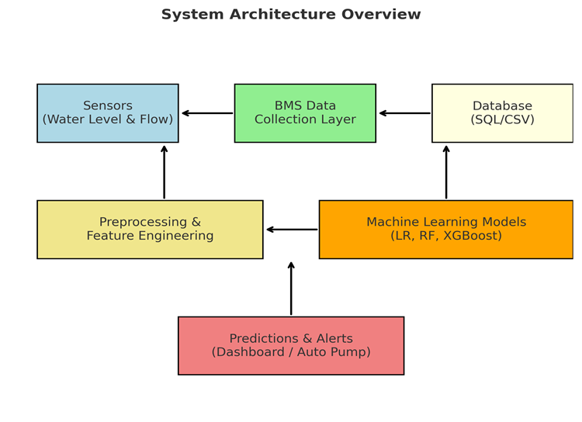
System Architecture Overview: Sensor data (water level and flow) is collected via the Building Management System (BMS), preprocessed and engineered into features, then fed into machine learning models (Linear Regression, Random Forest, XGBoost). Predictions trigger proactive alerts and automated refill scheduling.

Fig. 2. Model Performance Comparison (R²)

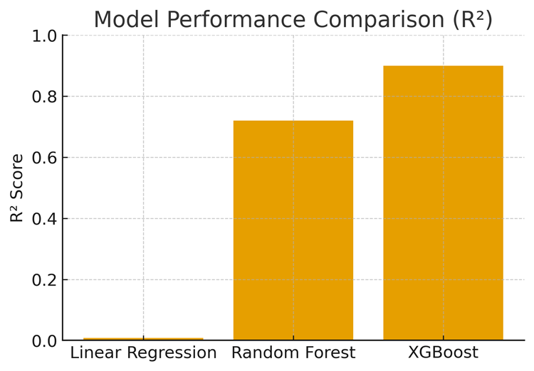

Fig. 3. Feature Importance (XGBoost)

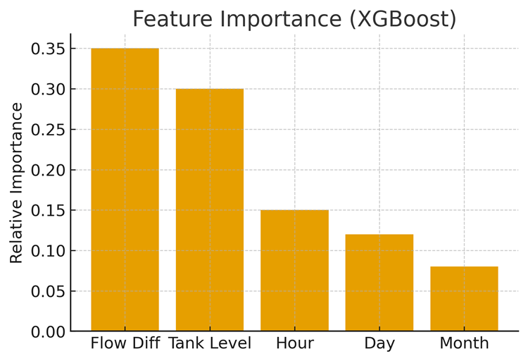

List of Figures
Fig. 1. System Architecture Overview
Fig. 2. Model Performance Comparison (R²)
Fig. 3. Feature Importance (XGBoost)

References
[1] A. Kumar and M. Singh, 'Linear Regression Models for Water Demand Forecasting in Smart Buildings,' Smart Infrastructure Journal, 2020.
[2] Y. Chen, X. Zhang, and L. Liu, 'Predicting Urban Water Consumption Using Artificial Neural Networks,' Journal of Water Resources, 2021.
[3] IBM, 'Smarter Water Management,' https://www.ibm.com/smarterplanet/us/en/water_management.
[4] Microsoft, 'AI & Sustainability Reports,' https://www.microsoft.com/sustainability.
[5] Y. Dai, et al., 'Smart Water Management: A Multi-Layer Framework,' Water, vol. 17, no. 13, p. 1932, 2025.
[6] M. Wijayaningtyas, et al., 'Integrating AI and IoT Technologies for Water Management,' BIO Web Conf., 2025.
[7] M. El Hanjri, et al., 'Federated Learning for Water Consumption Forecasting in Smart Cities,' arXiv preprint arXiv:2301.13036, 2023.
[8] J. F. Pons-Ausina, 'AI-based Hydraulic Modelling as Alternative to Traditional Simulation,' Water, vol. 17, no. 8, p. 1119, 2025.
[9] M. Homaei, et al., 'Smart Water Security with AI and Blockchain-Enhanced Digital Twins,' arXiv preprint arXiv:2504.20275, 2025.

