

AskMe Educational RAG System

Prepared By
Name: Amro Ismail Mohamed ID No.: 261001995
Name: Mohamed Alghazwani ID No.: 261002006

Submitted in fulfillment of the requirements for the degree Master of Science in Artificial Intelligence
At
Collage of Informatics
Midocean University
UAE
Supervisor Name: Hager Saleh
Collage of Informatics, Midocean University, Comoros
Email: hager.saleh@midocean.com

Acknowledgements
Special thanks to Dr. Hajer Saleh for her guidance, continuous support and constructive criticism throughout the inception, design and implementation of this master thesis project. Her domain expertise in Artificial Intelligence and Natural Language Processing has been essential to the development of the research methodology and the system architecture for the AskMe Midocean Chatbot.

Abstract
Higher education institutions face increasing pressure to deliver to students immediate, accurate, and 24/7 administrative and academic support. Traditional communication methods such as email or manual ticketing tend to be slow and come with high admin overhead. Standalone Large Language Models (LLMs) can communicate with humans in a natural way but they have hallucinations and static knowledge bounds which makes them untrustworthy for institutional regulations. AskMe Midocean Chatbot: A Domain Specific Conversational AI System for Students of Midocean University This thesis introduces AskMe Midocean Chatbot, a domain specific conversational AI system developed with Retrieval-Augmented Generation (RAG) to meet the requirements of students of Midocean University.
The system grounds LLM responses to official university documents, policies, and course catalogues utilizing deep neural architectures and vector database retrieval (ChromaDB). We present a framework composed of semantic chunking, multi-stage retrieval with cross-encoder re-ranking, and strict system guardrails to ensure faithfulness of responses. Under the RAGAS framework, the system performs well on groundedness and context precision, and eliminates hallucinated responses on queries in multiple languages.

List of Publications
[Draft/Pending] Ismail, A., Alghazwani, M., & Saleh, H. AskMe Midocean: Constructing a Knowledge-Grounded RAG System to Support University Students. Target Conference/Journal on Educational Technology and Artificial Intelligence, 2026.
Contents
List of Abbreviations iii
List of Figures iii
List of Tables iii
Chapter 1: Introduction and Overview 1
1.1 Overview 1
1.2 Problem Definition 1
1.3 Thesis Objectives 1
1.4 Thesis Contribution 2
1.5 Thesis Organization 3
Chapter 2: Background and Related Work 4
1 Background 4
1.1 Natural Language Processing (NLP) 4
1.1.1 Basic NLP Tasks and Taxonomy 4
1.1.3 End-to-End NLP Pipeline Architecture 4
1.2 Text Pre-processing & Normalization 5
1.3 Text Representation (Feature Extraction) 6
1.4 Deep Learning Models 8
1.5 Large Language Models (LLMs) 10
2 Related Work 20
References 26

List of Abbreviations
- Acc.: Accuracy
- ANN: Artificial Neural Network
- BPE: Byte-Pair Encoding
- CBOW: Continuous Bag-of-Words
- DPO: Direct Preference Optimization
- GRU: Gated Recurrent Unit
- LLM: Large Language Model
- LoRA: Low-Rank Adaptation
- LSTM: Long Short-Term Memory
- NLG: Natural Language Generation
- NLP: Natural Language Processing
- NLU: Natural Language Understanding
- PEFT: Parameter-Efficient Fine-Tuning
- RAG: Retrieval-Augmented Generation
- RLHF: Reinforcement Learning from Human Feedback
- TF-IDF: Term Frequency-Inverse Document Frequency

List of Figures
Figure ‎1.1: AskMe Educational RAG System 3
Figure 2.1: NLP pipeline 5
Figure 2.2 Text Representations (Word Embedding) 7
Figure 2.3 Long Short-Term Memory (LSTM) Networks 9
Figure 2.4 Gated Recurrent Unit 10
Figure 2.5 The Transformer - model architecture 12
Figure 2.6 LLM fine-tuning at a high level 13
Figure 2.7 LLM fine-tuning at a high level 14
Figure 2.8 RAG Example 15
Figure 2.9 RAG Pipeline Components 16
Figure 2.10 RAGAS 18

List of Tables
Table 1: Evaluation Metric 18
Table 2: Related Works Summary 23

Chapter 1: Introduction and Overview

1.1 Overview
Natural Language Processing (NLP) and Large Language Models (LLM) have changed the way educational institutions interact with the students. In the current education system like Midocean University, students need 24/7 immediate and accurate help for academic bylaws, admission standards, grading policies, course timetables and LMS navigation. Manual processes that provide high quality, personalized administrative and academic support result in a significant operational burden for university staff and faculty.

1.2 Problem Definition
The traditional communication channels universities rely on — email helpdesks, administrative ticketing systems, static web FAQs — are often plagued by response delays, inconsistent information, and administrative choke points. General-purpose LLMs (e.g. ChatGPT, Claude) have impressive natural language understanding and conversational abilities, but serious disadvantages exist in using them directly as academic support agents:
- Hallucination: LLMs trained on large datasets can produce statements that sound authoritative but are factually incorrect in relation to specific institutional rules, deadlines, or grading rubrics.
- Absence of Proprietary Domain Knowledge: Base models lack knowledge of internal and non-public Midocean University bylaws and academic regulations, including the constantly evolving ones.
- Bilingual and Dialectal Variations: Students may pose questions with a combination of Arabic and English, or employ local dialectal expressions, requiring specific semantic matching.

1.3 Thesis Objectives
This study primarily focuses on the design, implementation and systematic evaluation of AskMe Midocean, a domain-specific conversational AI chatbot powered with Retrieval-Augmented Generation (RAG) for the benefit of Midocean University students. The specific objectives are:
- Establish a pipeline for pre-processing and semantic chunking of Midocean University’s official academic regulations and course materials.
- Building a bilingual dense vector indexing framework (based on ChromaDB) for semantically returning high precision results for Arabic and English queries.
- Build a grounded generation pipeline with system guardrails and explicit metadata citations to reduce factual hallucination.
- Conduct a systematic evaluation of the retrieval and generation modules with the help of benchmark metrics (RAGAS framework).

1.4 Thesis Contribution
The main contributions of this thesis are:
- Bilingual RAG Framework: A Retrieval-Augmented Generation framework specialized for answering education queries in Arabic and English.
- Domain Specific Knowledge Base: An indexed data set of official Midocean University handbooks, bylaws and academic policies.
- Empirical Synthesis and Comparative Evaluation: Review of current NLP architectures in-depth from a theoretical perspective and comprehensive comparative review of recent educational chatbots implementations.

1.5 Thesis Organization

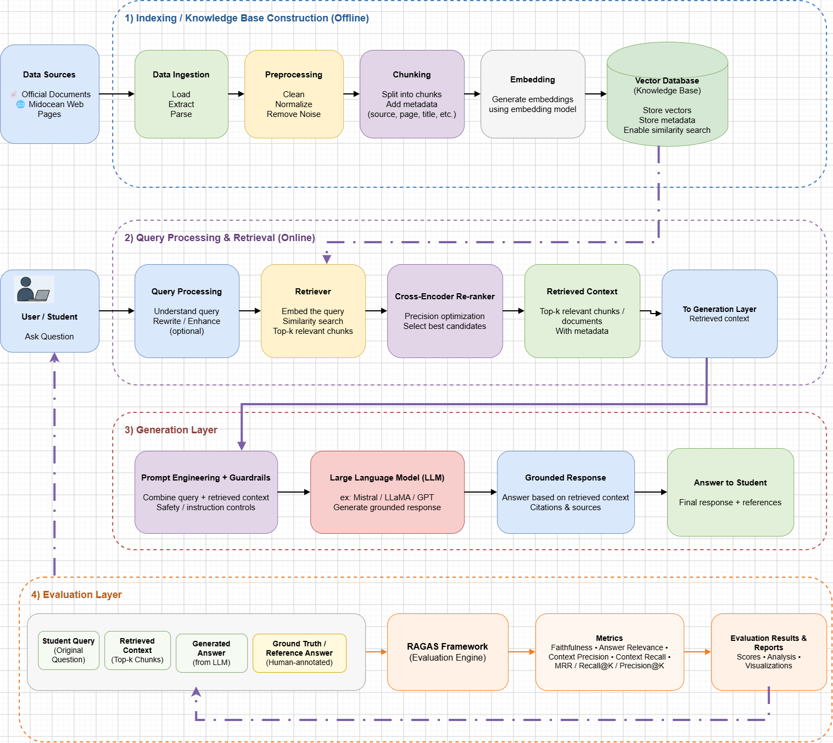

Figure ‎1.1: AskMe Educational RAG System

Chapter 2: Background and Related Work

1 Background

1.1 Natural Language Processing (NLP)
Natural Language Processing (NLP) is an interdisciplinary area of computer science, artificial intelligence and computational linguistics. It is about computers' ability to process, analyze and generate human language in a semantically rich way. Modern NLP tasks vary from simple text classification to complex generative and reasoning workflows [9].

1.1.1 Basic NLP Tasks and Taxonomy
Modern NLP tasks can be roughly classified into the following distinct functional areas:
- Natural Language Understanding (NLU): It is about analyzing the semantic intention, the syntactical structure and the contextual context from the text. Its main applications are text classification, named entity recognition (NER), sentiment analysis, and intent detection [9], [10].
- Natural Language Generation (NLG): Concentrates on creating coherent, grammatically correct and contextually relevant human text. Applications of interest include abstractive summarization, dialogue generation and automated report generation [9].
- Sequence-to-Sequence Processing: Takes an input sequence and generates an equivalent sequence in another domain or modality e.g. neural machine translation, speech recognition [11], [12].

1.1.3 End-to-End NLP Pipeline Architecture
The standard NLP workflow translates unstructured human discourse to numerical representations as shown in Figure 1.1:
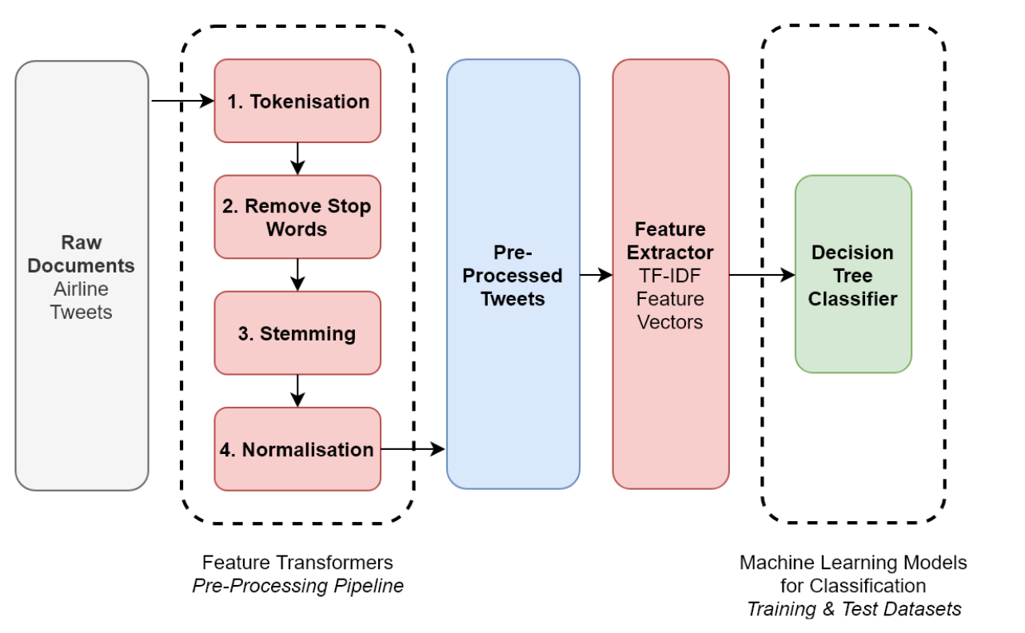
Figure 2.1: NLP pipeline
[oreilly.com]

1.2 Text Pre-processing & Normalization
Raw text data from real-world environments is inherently noisy; Pre-processing of text constitutes a mandatory preparatory phase of the pipeline that purifies raw corpora, reduces vocabulary redundancy and ensures uniform input structures for downstream machine learning algorithms [14], [22].
Linguistic Pre-processing Methods
- Tokenization: The fundamental operation of segmenting a continuous stream of text into discrete, indexable semantic units called tokens:
  - Word-Level Tokenization: Tokenizes text on white spaces and explicit punctuation marks. It is simple, but suffers from out-of-vocabulary words and complex compound words [14].
  - Subword-Level Tokenization: Rare words are decomposed into common sub-word units (e.g., Byte-Pair Encoding [BPE], WordPiece, Unigram). This method enables models to have small vocabulary sizes and generate arbitrary or out-of-vocabulary tokens [23].
- Stop-Word Removal: filter and remove the stop words (e.g. “the”, “is”, “at”, “which”) using standardized domain stop-word lists. Removing these words reduces the dimensionality and concentrates model parameters on semantically salient words [22].
- Normalization Strategies (Stemming vs. Lemmatization):
  - Stemming: Heuristic process It is a rule based (e.g. Porter Stemmer, Lancaster Stemmer) that chops off ends of words to reduce inflected words to a common base form. Stemming is a fast computational process, but often produces non-words due to over-stemming or under-stemming [14], [22].
  - Lemmatization: A semantically valid approach (e.g., WordNet Lemmatizer) which maps a token to its corresponding root form (or lemma) in the valid dictionary, considering the Part of Speech (POS) tag and the grammatical context of the token [14], [22].
- Text Regularization: It covers the conversion of characters to lowercase, removal of HTML tags, removal of non-alphanumeric symbols, expansion of contractions and handling of numerical entities [14], [22].

1.3 Text Representation (Feature Extraction)
Text inputs have to be converted into numerical representations as mathematical and machine learning models can only operate with numerical tensors. In modern NLP, feature extraction techniques are divided into sparse traditional representation and dense continuous representation [10], [24].
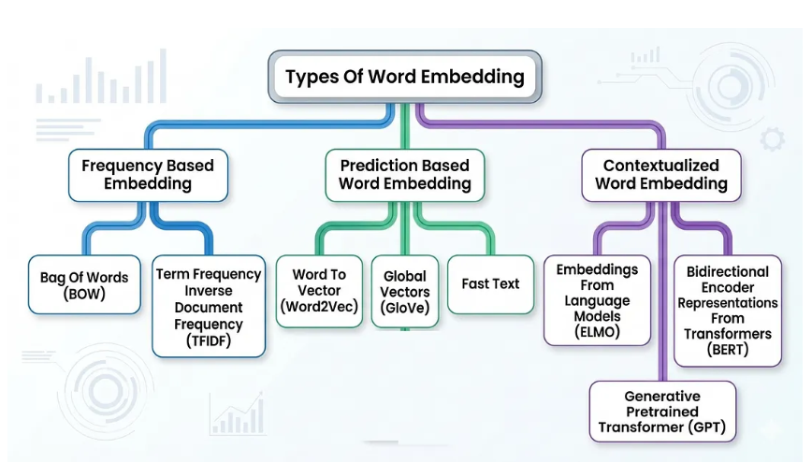
Figure 2.2 Text Representations (Word Embedding)
[medium.com]

1.3.1 Traditional Methods (Sparse Representations)
- Bag of Words (BoW): Maps a document to a high dimensional vector corresponding to the size of the vocabulary. Each vector index reflects the frequency of a word within the document. BoW ignores completely the order of tokens and the grammatical syntax [10].
- N-grams: Preserves local context by looking at a contiguous sequence of items (e.g. Unigrams, Bigrams, Trigrams). With n-grams models can distinguish between different phrases such as “not bad” vs. “bad” [10].
- Term Frequency-Inverse Document Frequency (TF-IDF): A statistical weighting scheme for the relative importance of a term within a given document, relative to its global frequency within an entire corpus. TF-IDF penalizes common generic words and emphasizes domain-specific keywords [10].

1.3.2 Distributed Representations (Static Word Embeddings)
Sparse models are high dimensional and do not capture semantics similarities between words (e.g. “cat” and “feline” are treated as completely orthogonal vectors). Distributed representations project words into small continuous real-valued vector spaces where semantically similar words are close to each other [24], [25].

- Word2Vec: a neural framework proposed by Mikolov et al. which learns word embeddings over two different shallow architectures:
  - Continuous Bag-of-Words (CBOW): Predicts a target word from the context tokens [24], [25].
  - Skip-gram: Predicts the tokens in the context of a single target word [24], [25].

- GloVe (Global Vectors): An unsupervised embedding algorithm that utilizes the global co-occurrence matrix to learn the embeddings, and thus combines the advantages of global matrix factorization methods and local context window methods [25].

- FastText: An extension of Word2Vec by Facebook AI Research, which represents words as bags of character n-grams. Rare, misspelt or out-of-vocabulary words are represented by aggregating subword vectors in FastText [23].

1.4 Deep Learning Models
Traditional Feedforward Neural Networks treat text instances as independent vectors, and do not capture sequential context and temporal dependencies. Recurrent architectures are explicitly designed for maintaining the state memory over sequential inputs [20], [11].

1.4.1 Long Short-Term Memory (LSTM) Networks
Standard Recurrent Neural Networks (RNNs) suffer from severe vanishing and exploding gradients during backpropagation through time preventing them from learning long-range context dependencies. To solve this problem, Hochreiter and Schmidhuber introduced the (LSTM) architecture. The LSTM architecture introduces a dedicated Cell State controlled by three specialized gating mechanisms as shown in Figure 2.3:
- Forget Gate: It takes the input and previous hidden state and decides what information to be thrown away from cell state [20].
- Input Gate: Determines which new candidate information to add to update the current cell state [20].
- Output Gate: Determines the fraction of the internal cell state to be emitted as the current hidden state output to downstream layers [20].

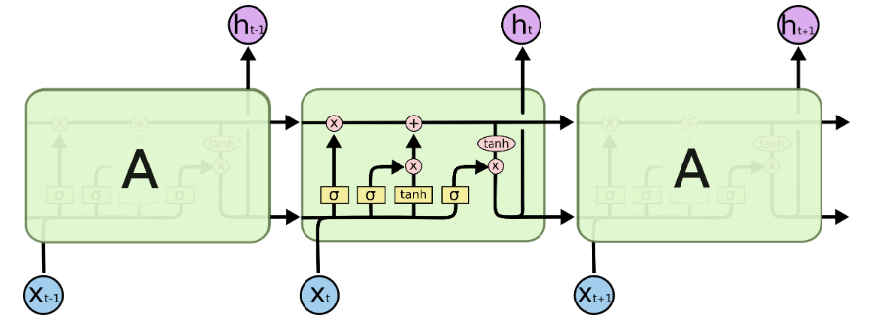
Figure 2.3 Long Short-Term Memory (LSTM) Networks
Understanding LSTM Networks - Christopher Olah (colah blog).

1.4.2 Gated Recurrent Unit (GRU)
GRUs is a simplified version of LSTM architecture. The GRU merges the cell and hidden state into a single hidden state. It has two gates (Figure 2.4):
- Reset Gate: Decides to what extent the previous hidden state memory needs to be dropped while calculating the candidate state values [11].
- Update Gate: It functions as an input and forget gate at the same time and determines the amount of new information to be added to the current memory state [11].

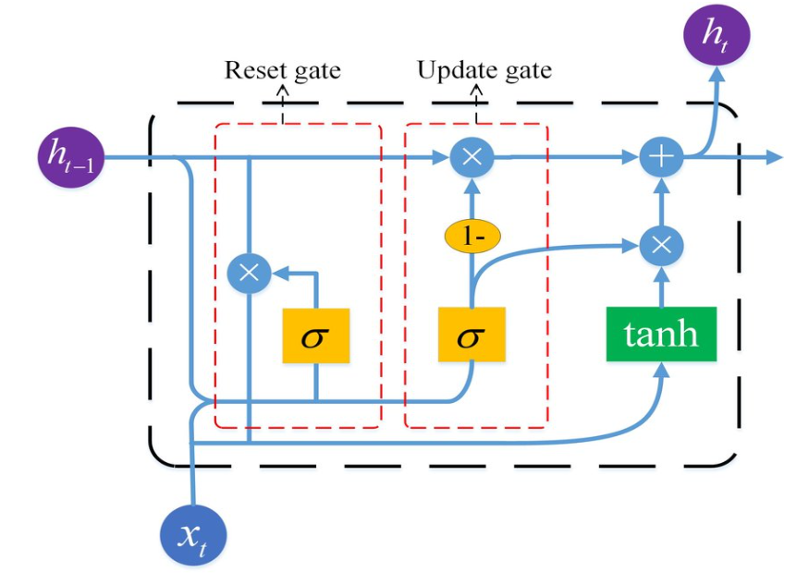
Figure 2.4 Gated Recurrent Unit

GRUs have fewer parameters than LSTMs, so they can be trained faster and require less computational memory, while performing comparably on many tasks.

1.5 Large Language Models (LLMs)
LLMs constitute a significant milestone in NLP, transitioning from narrow, task-specific models to broad, unified foundational architectures trained over enormous quantities of unstructured text. Rather than training separate pipelines for classification, translation and summarization, a single LLM learns general language capabilities, contextual reasoning and broad world knowledge that can be adapted to a wide range of downstream tasks [13].

1.5.1 Architectural Foundations of Large Language Models

1.5.1.1 The Transformer Paradigm
Modern LLMs are based on Transformer architecture. Prior to Transformers, long text sequences suffered from severe performance bottlenecks when processed sequentially by recurrent networks (e.g., LSTMs and GRUs). The Transformer removed recurrent connections and instead used Self-Attention Mechanisms which process all the words in a sequence at the same time in parallel [12].
This model uses self-attention to determine dynamically how much any token in a text is related to any other token. This allows the model to capture long-range contextual dependencies, resolve pronouns and understand complex syntactic relations irrespective of the distance between words in a document [12].

1.5.1.2 Transformer Taxonomy and Variations
The Transformer architectures (Figure 2.5) can be divided into three main classes depending on the implementation of the attention mechanism [12], [13]:
- Decoder-Only (Autoregressive Models): Great at generating text. The model predicts the next word in a sequence only from the previous words (causal masking). These models are at the heart of large generative assistant architectures such as GPT-4, LLaMA and Mistral [12], [13].
- Encoder-Only (Autoencoding Models): For understanding text in both directions. The model considers both the words before and after a target token. These models (BERT, RoBERTa) are good for document classification, named entity recognition and dense search retrieval but not text generation [21].
- Encoder-Decoder (Sequence-to-Sequence Models): The encoder processes the input prompt, and the decoder generates the output sequence. Such architectures (e.g., T5, BART) are useful for structural transformations such as machine translation and abstractive document summarization [12], [13].

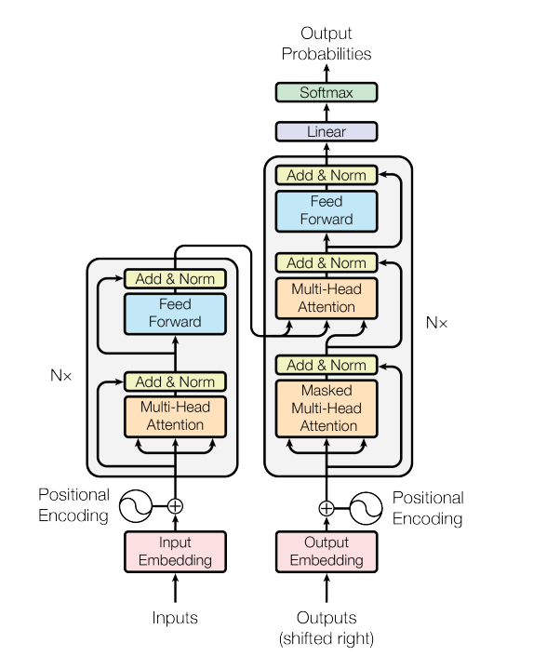
Figure 2.5 The Transformer - model architecture
[Attention Is All You Need Paper (ArXiv:1706.03762)]

1.5.2 Complete LLM Training & Alignment Lifecycle
Developing a production-ready LLM involves a structured multi-stage training pipeline, transforming raw, unstructured text into an aligned conversational system [13], [18].

1.5.2.1 Pre-training in a self-supervised manner
In the pre-training phase the base model ingests vast amounts of data, including trillions of words from books, academic papers, code repositories and web content. Pre-training involves self-supervised learning, where the model learns by trying to predict missing or next tokens, and does not require human annotated data. At this point the model accumulates a basic vocabulary, grammar, contextual understanding and knowledge of the world [13].

1.5.2.2 Supervised Fine-Tuning (SFT)

The model is good at predicting the likelihood of the next word, but not so good at following instructions or directly answering a user’s questions. Supervised Fine-Tuning, which fine-tunes the base model on curated datasets of high-quality instruction-response pairs, to teach the model to act as a helpful conversational assistant [13].

1.5.2.3 Parameter Efficient Fine Tuning (PEFT/LoRA)
Memory and computation intensive is fine-tuning a multi-billion parameter model by updating all the parameters. This is addressed with Low-Rank Adaptation (LoRA) (Figure2.6) which keeps the core weights of the base model frozen, while adding small lightweight adapter layers into the key attention modules. Fine-tuning training only these small adapters. This reduces the number of trainable parameters to more than 99 % while the performance is comparable to fine-tuning the full model [19].
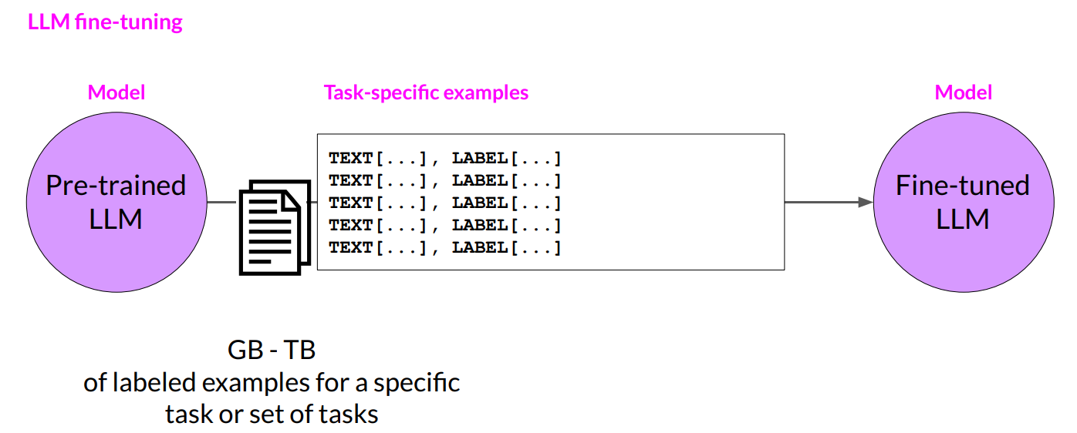
Figure 2.6 LLM fine-tuning at a high level
[Deeplearning.ai]

1.5.2.4 Approaches for Human Alignment
Models are aligned using data of human preferences. This helps keep model outputs helpful, truthful, and safe on of them is:
- RLHF (Reinforcement Learning from Human Feedback): - A separate Reward Model is trained on human preference rankings [13], [18].
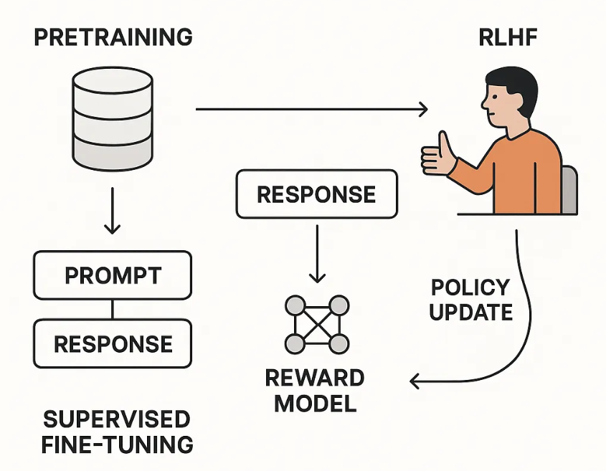
Figure 2.7 LLM fine-tuning at a high level
[medium.com]

1.5.3 External Knowledge Integration: Retrieval-Augmented Generation (RAG)

1.5.3.1 The Need for Grounded Retrieval
Large language models are naturally quite good at reasoning, but have inherent limitations; static training cutoffs, limited access to private institutional data, and a tendency to hallucinate, i.e. to generate plausible sounding but incorrect information. Retrieval augmented generation RAG [17] solves the problems by adding an external document retrieval pipeline to the generative LLM. Example for RAG in figure 2.8
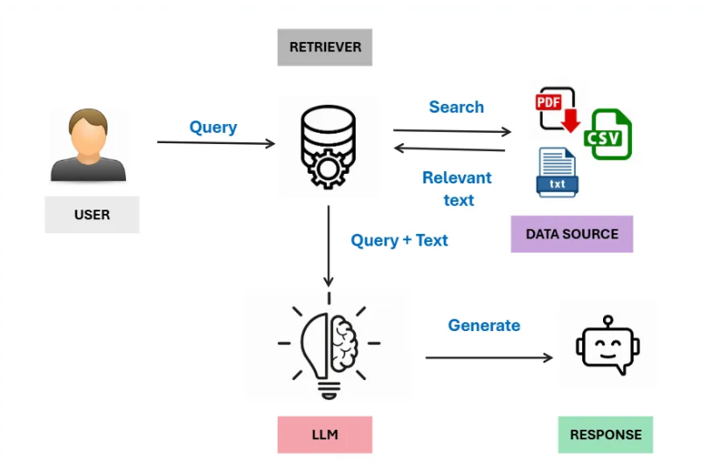
Figure 2.8 RAG Example
[medium.com]

1.5.3 Incorporating External Knowledge: Retrieval-Augmented Generation (RAG)

1.5.3.1 Why Grounded Retrieval is Required
Standalone LLMs, while powerful in their reasoning abilities, have inherent limitations tendency to generate plausible-sounding but incorrect information (hallucinations). Retrieval Augmented Generation RAG solves the issues by coupling LLM with an external document retrieval pipeline (Figure 2.9).

1.5.3.2 Advanced Institutional Document Pipeline
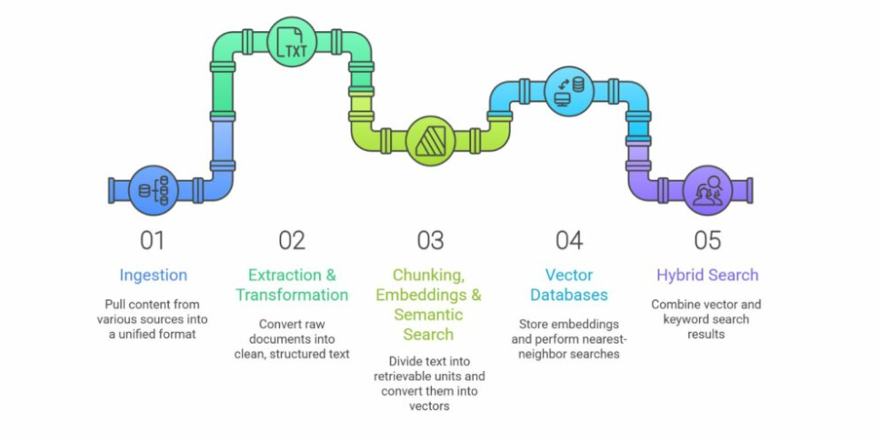
Figure 2.9 RAG Pipeline Components
[wearefram.com]

- Document Parsing and Semantic Chunking: Complex lists and formal clauses are found in structured institutional documents (academic regulations, bylaws, course catalogues, PDFs). Fixed size chunking can destroy meaningful context. Semantic Chunking Strategies split documents into sections according to headings, paragraphs, and logical boundaries, and thus each chunk contains a full administrative rule or concept [17].
- Vector Indexing & Dense Retrieval: Text chunks are transformed into high dimensional vector spaces, and then indexed in vector databases (e.g. Chroma DB, FAISS, Qdrant). As soon as a user asks a question, the system finds the most relevant passages according to their semantic similarity (e.g. Cosine Similarity) [10], [17].
- Re-Ranking Mechanisms for Accurate Retrieval: The initial retrieval stage frequently produces multiple candidate passages with keyword overlaps but no precise relevance. A secondary Cross-Encoder Reranker scores and re-orders the retrieved chunks, so that the exact regulatory passage is at the very top of the context window before it reaches the LLM [17].
- Contextual Prompt Building: The top-ranked passages are directly injected into prompt, but also the user query, so that the LLM has exactly the information it needs to produce the answer [17].

1.5.4 Hallucination mitigation, guard-rail and multi-language support

1.5.4.1 Prompting and Mitigating Hallucinations
Providing wrong information in an institutional setting can cause serious confusion. To prevent model hallucinations, strict guardrails are embedded into the system:
- Strict Context Guard Rails: System prompts explicitly instruct the LLM to respond based on the context passages obtained If the answer is not within the context the model is strictly conditioned to decline politely (e.g. “This information is not available in the provided documents”) [17].
- Citation & Source Attribution: Modern RAG architectures provide explicit metadata (file name, section title, page number) to every retrieved passage. The LLM is prompted to cite these sources directly in its answer, allowing users to check the validity of the answer against the official document [17].

1.5.4.2 Multilingual NLP for Various User Requests
Institutional settings often require bilingual support (e.g. Arabic and English) and have to cope with a variety of language registers from formal terminology to colloquial expressions:
- Multilingual Embedding Models: Uses specialized vector space models that can map different languages into shared semantic spaces, matching queries in one language to document passages in another [13].
- Cross-Lingual Language Understanding: Advanced multilingual LLMs can handle enquiries posed in local dialects or informal formats and accurately associate them with formal institutional documents [13].

1.5.5 Evaluation Frameworks for Knowledge-Grounded Systems
Evaluating document-grounded, conversational AI systems requires specialized metrics beyond standard classification measures [16], [15]. Frameworks like RAGAS (Figure 2.10) evaluate the pipeline across several key dimensions [15]:

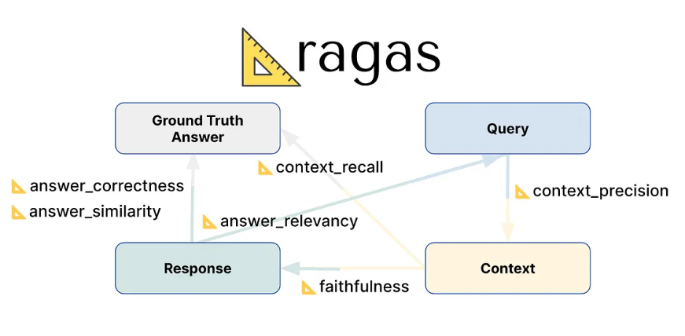
Figure 2.10 RAGAS
[medium.com]

Table 1: Evaluation Metric
Evaluation Metric | Evaluated Pipeline Stage | Objective & meaning
Faithfulness (Groundedness) [15] | Generated Response vs. Retrieved Context | No hallucination in the response All the claims made in the response are explicitly supported by retrieved official documents.
Answer Relevance [15] | Generated Response vs. User Query | Ensures the response directly answers the user's specific question without adding off-topic information.
Context Precision [15] | Retrieved Passages vs. User Query | Measures whether the vector store fetched relevant document sections while filtering out background noise.
System Latency & Performance [16] | End-to-End Pipeline | Tracks end-to-end response time to ensure fast and responsive performance for user interaction.

2 Related Work

[1] Long Nguyen et al. proposed a Unified Hybrid Retrieval-Augmented Generation (URAG) framework to improve accuracy and precision of university admission chatbots. The proposed architecture consists of a two-tiered system (Tier 1 FAQ search and Tier 2 document search) with ura-hcmut/ura-llama-7b as generator model with Chain-of-Thought (CoT) prompting, dangvantuan/vietnamese-embedding (Sentence-BERT) as embedding model and LangChain's semantic chunker. They trained on a dataset of 500 real-world admission questions (427 Factual and 73 Reasoning) collected from high school students in three university admission events at Ho Chi Minh City University of Technology (HCMUT), and supported by a knowledge base of 300 curated institutional documents. The URAG-D mechanism performed semantic chunking based on the sentence embedding similarity, extracted global context, re-wrote chunks for context relevance, and prepended succinct summaries. The URAG-F mechanism extracted and paraphrased question-answer pairs from documents to enrich the FAQ database. The results showed that the URAG-powered HCMUT Chatbot reached the highest overall accuracy (62.8%, 314/500 correct responses), outperforming state-of-the-art commercial models like GPT-4o (54.4%), Claude 3.5 Sonnet (50.2%) and Gemini 1.5 Pro (44.0%).

[2] Subash Neupane et al. investigated a chatbot system based on a Large Language Model (LLM), BARKPLUG V.2, providing a platform for academic institutions to improve user experience and campus resource access. The proposed architecture used retrieval-augmented generation (RAG) pipeline. OpenAI’s gpt-3.5-turbo was used as the generator model, text-embedding-3-large as the embedding model, Chroma DB as the vector database and LangChain’s similarity score threshold retriever. The data set was derived from web scrapes of 42 different campus departments and resources at Mississippi State University (MSU). This included academic departments, admissions, financial aid, housing and dining, etc. The data was preprocessed into smaller chunks using a recursive character text splitter. The evaluation steps included quantitative evaluation based on Retrieval Augmented Generation Assessment (RAGAS) framework and end to end evaluation and usability evaluation based on System Usability Scale (SUS) survey filled up by a panel of 50 students. The results show that BARKPLUG V.2 has a mean overall RAGAS score of 0.96 across various query categories, and an average SUS score of 67.75, which indicates high factual accuracy, retrieval accuracy and satisfactory user experience.

[3] Anna Ostrowska et al. researched an AI Teaching & Learning Assistant, a modular Moodle plugin, which is designed to provide hallucination-free educational support and promote deep conceptual understanding. The proposed architecture was based on a three-tier system (Presentation, Application and Data layers) with Gemini Flash 2.0 as the generator model and three interaction modes (Quick Answer, Deep Understanding, and Exam Coach), all-MiniLM-L6-v2 for intent recognition, ChromaDB as a vector database, and PostgreSQL and MinIO for hybrid data storage. The data set used was from course materials provided by teachers (PDF, DOCX, PPTX files from courses such as Natural Language Processing and Machine Learning). The data set was preprocessed with specific chunking strategies (512 characters for STEM, 1000 characters for humanities). Evaluation steps included a technical optimization with the Retrieval-Augmented Generation Assessment (RAGAS) framework, and a human feedback user study with 18 users (students and instructors) evaluating the system on a Likert scale (1-5). The results demonstrate that the system achieved high RAGAS faithfulness scores of up to 0.97 (STEM) and 0.98 (humanities), context recall of up to 1.00, high user resistance to hallucinations (4.44/5) and overall recommendation score (4.00/5).

[4] Defne Yigc et al. examined the usages, features, challenges, and ethical issues of large language model (LLM) based chatbots particularly ChatGPT in higher education context. They analyzed pre-trained Generative Pre-trained Transformer architectures (e.g. GPT-1, GPT-2, GPT-3, and GPT-4) and other LLM models such as BERT, T5, OPT, and LaMDA. They were trained on large corpora of text including the Toronto Book Corpus, Common Crawl, WebText, Wikipedia and public web documents. The main pre-processing and model design steps involved sequence-to-sequence learning, bidirectional context analysis, token prediction, masked language modelling (MLM), fine-tuning, and reinforcement learning from human feedback (RLHF). The results and findings suggested that LLMs substantially improved personalized education, automated grading, and syllabus design, but critical issues including algorithmic bias, hallucinated responses, data privacy threats, and academic honesty issues needed to be tackled via systematic guidelines and objective assessment frameworks.

[5] Dan et al. investigated an LLM-based chatbot system named EduChat for individualized, fair and compassionate intelligent education. They leverage pre-trained base large language models (e.g., LLMs such as BERT, LLaMA) and domain adapted architectures fine-tuned over system prompts and retrieval-augmented modules. They also used middle school and high school textbooks, Chinese poetry, psychology books, open-source bilingual instruction data sets (Alpaca, BELLE, GPT4All, OpenAssistant, FLAN-COT, Firefly), multi-turn dialogue data (MOSS, COIG, LIMA, ShareGPT), task-specific instruction data sets for retrieval-augmented open QA, translated Chinese emotional support dialogues (ESConv-zh), Socratic teaching dialogues and essay evaluation. Pre-processing was performed with semantic level de-duplication, cosine similarity embedding using sentence-transformers and removal of duplicates with similarity > 0.7 with GPU-accelerated CUDA execution. Results showed that EduChat achieves good performance on the C-Eval benchmark (40.7 and 49.3 with retrieval), outperforming base models of similar parameter scales like Chinese-Alpaca-13B, while effectively reducing hallucinations and providing specialized educational capabilities.

[6] Kulkarni et al. investigated a Reinforcement Learning (RL) based framework out of the Retrieval-Augmented Generation (RAG) pipeline to optimize the number of tokens passed to Large Language Models (LLMs) and reduce cost for domain chatbots. Answer Generation: They used an open API-based ChatGPT (gpt-35-turbo-16k-0613) model and an external policy-based agent (experimenting with an in-house BERT and a public GPT-2). They also used an in-house retrieval embedding model initialized from e5-base-v2, and GPT-4 as an automated reward evaluator. The dataset is a domain FAQ collection of 72 FAQs on credit card application processes and augmented with ~3.5k training, 1k validation and 1,014 testing English and Hinglish paraphrased queries generated using ChatGPT and manually tagged. Pre-processing consisted of concatenating the question and answer in each FAQ to generate vector embeddings, cosine similarity metrics and creating (State, Action, Reward) interaction trajectories sampled via Monte Carlo dropout to be used for policy gradient optimization. The results showed that the best performance was achieved by combining a similarity threshold with the in-house BERT policy model, which resulted in around 31% token savings while still maintaining high answer accuracy (1.0) and controlling the hallucinations in multi-turn conversations.

[7] Maksuda Khasanova et al. benchmarked various combinations of models and algorithms on commercial LLMs such as OpenAI’s GPT-4o and open-source models (e.g. LLaMA3, OpenChat-7b-v3.5-0106-fp16, Zephyr, Neural-Chat) running on Ollama. The architecture comprised of sentence transformers (all-MiniLM-L6-v2) for vector embeddings, FAISS for vector storage and different retrieval strategies such as Dense Retriever, Maximal Marginal Relevance (MMR), Hybrid (BM25 + Dense), MultiQuery Retriever and MultiVector Retriever. The study used three main university-provided institutional data sources: a 29-page PDF graduate admission guide, 38 website FAQs (FAQ1), and 11 admission-related FAQs from the International Affairs Office (FAQ2). For evaluation, they constructed two reference QA datasets, an automatic LLM-generated dataset (72QA pairs) and a human-tagged dataset (62QA pairs). The human-tagged dataset was manually constructed and annotated by international students and GKS scholars. Pre-processing steps involved conversion of institutional PDF documents and Excel FAQ sheets into text segments and tagging meta data to determine source. After splitting the texts into manageable chunks with two comparative strategies, Recursive Character Text Splitter (based on structure) and Semantic Chunker (based on semantic meaning). The chunks were then embedded into 384-dimensional dense vectors using the all-MiniLM-L6-v2 embedding model and indexed in an FAISS vector database using cosine similarity for top-k retrieval. The results indicated that although first GPT-4o had the highest baseline, an optimized open-source configuration (OpenChat-7b-v3.5-0106-fp16 with Recursive text splitting and a MultiQuery Hybrid Retriever) achieved the best overall performance with an average RAGAS score of 0.7377 on the human-tagged QA dataset and 0.7408 on the LLM-generated QA dataset outperforming GPT-4o. Semantic Chunking with Dense Retriever also consistently outperformed normal settings for factual grounding. Total latency was significantly lower for LLaMA3 models than for GPT-4o pipelines.

[8] Khan et al. implemented an educational virtual assistant based on Retrieval-Augmented Generation (RAG) framework to assist students by automatically providing information on university administrative procedures, admission guidelines, fees and campus facilities at Aligarh Muslim University. They experimented with two open-source large language models Meta-llama/Llama-2-7b-chat-hf and Mistralai/Mistral-7B-Instruct-v0.2, and the Sentence-transformers/all-mpnet-base-v2 embedding model for dense vector representation and semantic retrieval. This data was collected directly from the official university web domains (amu.ac.in and amucontrollerexams.com) and this data was in the form of structured as well as unstructured documents like PDFs, scanned files and JPEG images. The preprocessing steps included Optical Character Recognition (OCR) using pytesseract to convert scanned documents to editable format, cleaning out unnecessary layout formatting, noise, and non-relevant sections, and structuring the extracted text into an indexed knowledge base. Experimental results showed that Llama-2-7b-chat-hf surpassed Mistral-7B-Instruct-v0.2 with higher average BLEU scores at n-gram levels (BLEU-1 of 0.5720 and BLEU-2 of 0.4935).

Table 2: Related Works Summary
Paper | All Models | Datasets | Dataset Link | Limitation | Best Model | Results
[1] | GPT-4o  Gemini 1.5 ProHCMUT  Claude3.5 Sonnet | HCMUT university admissions | huggingface.co/ura-hcmut/ura-llama-7b | performance, especially on general queries outside of the admissions domain compared to larger models or third-party APIs. | HCMUT Chatbot | Accuracy=0.62
[2] | gpt-3.5-turbo  chroma  langchain | Scrapped 42 campus resources into a JSON file from the university site | Scrapped from www.msstate.edu | No Automatic Speech Recognition (ASR) capability | gpt-3.5-turbo | RAGAS score of 0.96
[3] | Gemini Flash2  GPT 4 -mini  Llama 3.1 | teacher-provided course PDF, DOCX, and PPTX documents | tinyurl.com/mrytc2dr | Not mentioned | Gemini Flash 2.0 | RAGAS score of 0.97
[4] | GPT1-2-3-4,  BERT, ROBERTa, ALBERT, ELECTRA, XLNet, T5, LaMDA | Wikipedia  Toronto Book Corpus  CC News | NA | Inaccuracies generated by AI (hallucinations), misinformation, threats to data privacy, plagiarism/cheating, and dissemination of biases | GPT-4 | Standardized Test Performance:  - AP Biology, AP Macroeconomics, etc.: 5/5  - AP English Literature: 2/5
[5] | EduChat | (1) pre-training corpus of textbooks, exam questions, (2) fine-tuning dataset of 500k open QA | https://github.com/ECNU-ICALK/EduChat  https://huggingface.co/ecnu-icalk | Hallucinations generation, knowledge gap in education and obsolete updates | EduChat (with Retrieval) | C-Eval Benchmark:  - EduChat (with Retrieval) Avg =49.3  - EduChat (Vanilla) Avg =40.7  - Chinese-Alpaca-13B Avg =33.3
[6] | BERT  GPT2  RAG | Credit Card FAQ Dataset (72 FAQs) | Not Public | Assumes the underlying RAG retriever and LLM weights are fixed. Prompt-guided evaluation is heavily dependent on GPT-4, which could introduce bias. | SimThr + policy (BERT) | Token Savings ≈31%  Accuracy = 1.0
[7] | GPT-4o  Ollama LLaMA3  OpenChat (latest, q6_K, fp16) | Internal University Admissions Guide (29-page PDF, FAQ1, FAQ2) | Not Public | Small size of evaluation datasets | openchat:7b-v3.5-0106-fp16 | - Average RAGAS Score =0.7377  - Answer Relevancy = 0.785  - BLEU-1 = 0.5720
[8] | - Llama-2-7bchat-hf  - Mistral-7BInstruct-v0.2 | Custom university dataset built from website pdfs, scanned documents and jpegs. | Not Public | Computational constraints ,  Needs high hardware resources | Llama-2-7b-chat-hf (integrated with RAG)

References
[1] URAG: Implementing a Unified Hybrid RAG for Precise Answers in
University Admission Chatbots -- A Case Study at HCMUT
https://arxiv.org/abs/2501.16276

[2] From Questions to Insightful Answers: Building an Informed Chatbot for University Resources
https://arxiv.org/abs/2405.08120

[3] From Surface Learning to Deep Understanding: A Grounded AI Tutoring System for Moodle
https://arxiv.org/html/2605.06963v1

[4] Large Language Model-Based Chatbots in Higher Education
https://advanced.onlinelibrary.wiley.com/doi/epdf/10.1002/aisy.202400429

[5] EduChat: A Large-Scale Language Model-based Chatbot System for Intelligent Education
https://arxiv.org/abs/2308.02773

[6] Reinforcement Learning for Optimizing RAG for Domain Chatbots
https://arxiv.org/abs/2401.06800

[7] Design and Performance Evaluation of LLM-Based RAG Pipelines for Chatbot Services in International Student Admissions
https://www.mdpi.com/2079-9292/14/15/3095

[8] Large Language Model based Educational Virtual Assistant using RAG Framework
https://www.sciencedirect.com/science/article/pii/S1877050925000511

[9] Chowdhury, Gobinda G., 2003
Chowdhury, Gobinda G. “Natural language processing”. Journal of Documentation 59 (1), 51–68., 2003.
[10] Manning, Christopher D., et al., 2008
Manning, Christopher D., Prabhakar Raghavan, and Hinrich Schütze. “Introduction to Information Retrieval”. Cambridge University Press., 2008.

[11] Cho, Kyunghyun, et al., 2014
Cho, Kyunghyun, Bart van Merriënboer, Caglar Gulcehre, Dzmitry Bahdanau, Fethi Bougares, Holger Schwenk, and Yoshua Bengio. “Learning Phrase Representations using RNN Encoder-Decoder for Statistical Machine Translation”. arXiv preprint arXiv:1406.1078., 2014.

[12] Vaswani, Ashish, et al., 2017
Vaswani, Ashish, Noam Shazeer, Niki Parmar, Jakob Uszkoreit, Llion Jones, Aidan N. Gomez, Łukasz Kaiser, and Illia Polosukhin. “Attention Is All You Need”. Advances in Neural Information Processing Systems (NeurIPS) 30, 5998–6008., 2017.

[13] Zhao, Wayne Xin, et al., 2023
Zhao, Wayne Xin, Kun Zhou, Junyi Li, Tianyi Tang, Xiaolei Wang, Yupeng Hou, Yingqian Min, Beichen Zhang, Junjie Zhang, Zican Dong, Yifan Du, Chen Yang, Yushuo Chen, Zhipeng Chen, Jinhao Jiang, Ruiyang Ren, Yifan Li, Xinyu Zheng, Zelai Chen, and Ji-Rong Wen. “A Survey of Large Language Models”. arXiv preprint arXiv:2303.18223., 2023.

[14] Kaur, Jaspreet, et al., 2016
Kaur, Jaspreet, and Jatinderkumar R. Saini. “Traditional and Nature-Inspired Techniques for Text Pre-Processing: A Review”. International Journal of Computer Applications 137 (10), 18–25., 2016.

[15] Es, Shahul, et al., 2023
Es, Shahul, Jithin James, Luis Espinosa-Anke, and Steven Schockaert. “Ragas: Automated Evaluation of Retrieval Augmented Generation”. arXiv preprint arXiv:2309.15217., 2023.

[16] Sokolova, Marina, et al., 2009
Sokolova, Marina, and Guy Lapalme. “A Systematic Analysis of Performance Measures for Classification Tasks”. Information Processing & Management 45 (4), 427–437., 2009.

[17] Lewis, Patrick, et al., 2020
Lewis, Patrick, Ethan Perez, Aleksandra Piktus, Fabio Petroni, Vladimir Karpukhin, Naman Goyal, Heinrich Küttler, Mike Lewis, Wen-tau Yih, Tim Rocktäschel, Sebastian Riedel, and Douwe Kiela. “Retrieval-Augmented Generation for Knowledge-Intensive NLP Tasks”. Advances in Neural Information Processing Systems (NeurIPS) 33, 9459–9474., 2020.

[18] Rafailov, Rafael, et al., 2024
Rafailov, Rafael, Archit Sharma, Eric Mitchell, Stefano Ermon, Christopher D. Manning, and Chelsea Finn. “Direct Preference Optimization: Your Language Model is Secretly a Reward Model”. Advances in Neural Information Processing Systems (NeurIPS) 36., 2024.

[19] Hu, Edward J., et al., 2021
Hu, Edward J., Yelong Shen, Phillip Wallis, Zeyuan Allen-Zhu, Yuanzhi Li, Shean Wang, Lu Wang, and Weizhu Chen. “LoRA: Low-Rank Adaptation of Large Language Models”. arXiv preprint arXiv:2106.09685., 2021.

[20] Hochreiter, Sepp, et al., 1997
Hochreiter, Sepp, and Jürgen Schmidhuber. “Long Short-Term Memory”. Neural Computation 9 (8), 1735–1780., 1997.

[21] Devlin, Jacob, et al., 2019
Devlin, Jacob, Ming-Wei Chang, Kenton Lee, and Kristina Toutanova. “BERT: Pre-training of Deep Bidirectional Transformers for Language Understanding”. Proceedings of NAACL-HLT, 4171–4186., 2019.

[22] Vijayarani, S., et al., 2015
Vijayarani, S., J. Ilamathi, and C. Nithya. “Preprocessing Techniques for Text Mining”. International Journal of Computer Science & Communication Networks 5 (1), 7–16., 2015.

[23] Bojanowski, Piotr, et al., 2017
Bojanowski, Piotr, Edouard Grave, Armand Joulin, and Tomas Mikolov. “Enriching Word Vectors with Subword Information”. Transactions of the Association for Computational Linguistics 5, 135–146., 2017.

[24] Mikolov, Tomas, et al., 2013
Mikolov, Tomas, Kai Chen, Greg Corrado, and Jeffrey Dean. “Efficient Estimation of Word Representations in Vector Space”. arXiv preprint arXiv:1301.3781., 2013.

[25] Pennington, Jeffrey, et al., 2014
Pennington, Jeffrey, Richard Socher, and Christopher D. Manning. “GloVe: Global Vectors for Word Representation”. Proceedings of EMNLP, 1532–1543., 2014.

