

Deep Learning-Based Plant Disease Detection Using Leaf Image Analysis
Prepared By
Name: Sulaiman Fahad Alquwayfili ID No.:253000463
Name: Rahaf Amer Alsaiari ID No.: 253002788

Submitted in fulfillment of the requirements for the degree Master of Science in Artificial Intelligence
At
Collage of Informatics
Midocean University
UAE
Supervisor Name: Mohamed Essa
Collage of Informatics, Midocean University, Comoros
Email:slumanq@gmail.com

Abstract
Plant disease detection plays a critical role in ensuring global food security and sustainable agricultural productivity. Traditional manual inspection methods, though widely practiced, are labor-intensive, slow, and prone to human error, particularly when applied to large-scale farming. Recently, deep learning and computer vision techniques have demonstrated significant potential in automating plant disease diagnosis with high accuracy. This study presents a comprehensive review of existing methods for plant disease detection, including classical convolutional neural networks (CNN), transfer learning, attention-based models, hybrid deep learning frameworks, vision transformer architectures, and lightweight models suitable for edge computing.
The review covers both foundational works and recent advancements from 2023 to 2025, highlighting key contributions, performance metrics, and limitations. While earlier studies demonstrated remarkable performance on controlled datasets such as PlantVillage, challenges remain in generalizing models to real-field conditions, addressing data imbalance, and reducing computational and memory requirements. Recent research has explored multi-scale models, hybrid frameworks, and transformer-based architectures to improve robustness and accuracy. This review identifies research gaps in model generalization, operational efficiency, and scalability, and suggests future directions for developing more reliable and deployable plant disease detection systems.

Chapter 1 Introduction

Overview
The agriculture sector has witnessed significant development in recent years due to rapid advancements in artificial intelligence (AI), computer vision, and data-driven technologies [1]. These technologies have enabled the development of intelligent systems capable of analyzing large volumes of agricultural data and supporting decision-making processes. Despite these advancements, plant diseases remain one of the most critical challenges affecting crop quality, yield, and overall agricultural productivity worldwide [2].

Plant diseases can spread rapidly under unfavorable environmental conditions, leading to substantial economic losses and threatening global food security [3]. Therefore, early and accurate detection of plant diseases is essential to minimize crop damage and improve agricultural efficiency. Traditional methods for diagnosing plant diseases rely heavily on manual inspection conducted by agricultural experts. Although these methods can be effective, they are time-consuming, labor-intensive, and not scalable for large agricultural fields [2]. In addition, manual diagnosis is highly dependent on human expertise and is prone to errors, particularly under complex field conditions [4].

With the rapid evolution of deep learning and digital image processing techniques, automated systems have emerged as powerful tools for plant disease detection [5]. Deep learning models, especially Convolutional Neural Networks (CNNs), have demonstrated high performance in image classification and pattern recognition tasks [6]. These models are capable of automatically extracting complex features from plant leaf images, enabling accurate and efficient disease identification [7]. Furthermore, recent advancements such as Vision Transformers and hybrid deep learning models have improved detection accuracy and robustness [8].

This thesis aims to develop an artificial intelligence-based model for the early detection of plant diseases using plant leaf images. The proposed system is designed to support farmers, researchers, and agricultural stakeholders by providing accurate and rapid disease diagnosis. This can contribute to reducing crop losses, improving productivity, and enhancing sustainable agricultural practices [3].

As shown in Figure 1, plant diseases can be identified through visible symptoms on leaf surfaces, such as discoloration, spots, and texture changes. These visual patterns can be effectively analyzed using computer vision techniques to detect diseases at early stages.

This research focuses on applying computer vision and deep learning techniques to analyze plant leaf images and identify potential diseases. The proposed system processes input images, performs preprocessing, extracts relevant features, and classifies plant leaves into healthy or diseased categories using advanced deep learning models. The importance of this research lies in the increasing demand for reliable, scalable, and automated solutions that can be efficiently deployed in modern smart farming environments [5].

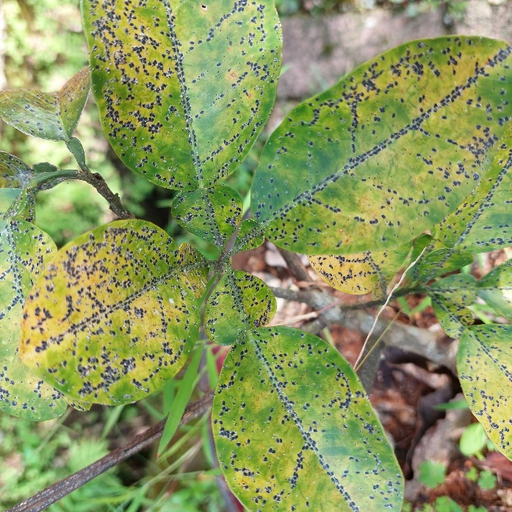

Figure 1.1: Example of a diseased plant leaf showing visible symptoms [Adapted 9]]

This research focuses on applying computer vision and deep learning techniques to analyze plant leaf images and identify potential diseases. The proposed system processes input images, extracts relevant features, and classifies plant leaves into healthy or diseased categories. The importance of this research lies in the growing need for reliable and scalable automated solutions that can be effectively deployed in smart farming environments.

Problem Definition
- Heavy reliance on human expertise in traditional plant disease diagnosis.
- Time-consuming manual inspection processes.
- High probability of inaccurate or inconsistent diagnosis.
- Limited accuracy of some machine learning models proposed in previous studies.
- Poor generalization capability of existing models across different datasets and environmental conditions.
- The need for a more robust, efficient, and scalable model for early plant disease detection.

1.3 Thesis Objectives
The primary goal of this research is to develop a robust and efficient system for automated plant disease diagnosis. The specific objectives are as follows:
- To develop an advanced AI model for the early detection of plant diseases utilizing high-resolution leaf images.
- To enhance classification accuracy by implementing state-of-the-art deep learning architectures and optimization techniques.
- To evaluate the performance of the proposed model using standardized benchmark datasets, such as the PlantVillage dataset.
- To conduct a comparative analysis between the proposed approach and existing methods documented in recent literature to validate its effectiveness.
- To provide a practical and scalable tool capable of assisting farmers and agricultural stakeholders in rapid, early-stage disease diagnosis.

1.4 Thesis Contribution
This thesis aims to bridge the gap between theoretical deep learning models and practical agricultural applications through the following contributions:
- Development of an effective deep learning framework designed specifically for the automatic and reliable detection of plant diseases.
- Improvement of classification performance and robustness compared to baseline models and traditional diagnostic approaches.
- Provision of accurate leaf analysis through the integration of advanced computer vision techniques to identify subtle disease symptoms.
- Support for smart agriculture systems by offering applicable, data-driven solutions that contribute to crop protection and sustainable farming

1.5 Thesis Organization
Thesis Organize as:
- Chapter 1 presents the introduction.
- Chapter 2 reviews the related work and previous studies.
- Chapter 3 describes the proposed methodology.
- Chapter 4 presents experimental results and discussion.
- Chapter 5 concludes the thesis and outlines future work.

Chapter 2 Background and Related Work
2.1 Introduction
Recent advancements in artificial intelligence (AI), particularly in deep learning and computer vision, have significantly transformed the field of automated plant disease detection. Traditional methods for diagnosing plant diseases rely heavily on manual inspection by agricultural experts, which is time-consuming, costly, and prone to human error, especially in large-scale agricultural environments. As a result, researchers have increasingly focused on developing intelligent systems capable of accurately identifying plant diseases using digital images of plant leaves.
This chapter presents a comprehensive review of existing studies in plant disease detection using deep learning techniques. The review includes both foundational research and recent studies, highlighting key methodologies, datasets, performance metrics, and limitations. While earlier studies demonstrated high accuracy on controlled datasets such as PlantVillage, challenges remain in generalizing models to real-field environments, handling data imbalance, and reducing computational complexity. Recent research has focused on advanced architectures such as multi-scale models, hybrid frameworks, and transformer-based approaches to improve robustness and efficiency. In addition, this chapter identifies key research gaps and outlines future directions for developing more practical and scalable plant disease detection systems

2.2 Background
The evolution of Artificial Intelligence (AI) and Machine Learning (ML) has provided the foundation for automated agricultural diagnostics. Specifically, Deep Learning (DL) has surpassed traditional ML by utilizing architectures like Convolutional Neural Networks (CNNs) to automatically extract hierarchical features from complex leaf textures. These advancements are critical because traditional manual inspection—while foundational—is inherently limited by human subjectivity and lack of scalability in large-scale farming.
2.2.3 Core Techniques in Plant Image Analysis
A. Convolutional Neural Networks (CNNs): CNNs are the backbone of modern plant disease detection. Unlike traditional ML, CNNs automatically learn spatial hierarchies of features. Through convolutional filters, the model can identify low-level features such as edges and textures in the early layers, and high-level features like specific lesion shapes or discoloration patterns in deeper layers.
B. Transfer Learning (TL): Due to the high cost of collecting and labeling large-scale agricultural datasets, Transfer Learning is a pivotal technique. It involves leveraging pre-trained weights from large datasets (e.g., ImageNet) and fine-tuning them on specific plant disease datasets. This approach significantly reduces training time and improves generalization even with limited data.
C. Feature Pyramid Networks (FPN): To address the challenge of varying scales in disease spots, multi-scale feature extraction techniques are employed. This allows the model to detect both large infected areas and tiny, early-stage symptoms simultaneously by merging features from different network depths.
D. Proposed Technique in This Study
Based on the previously discussed techniques, this study adopts a deep learning-based approach for plant disease detection, primarily utilizing Convolutional Neural Networks (CNNs). CNNs are selected due to their proven effectiveness in image classification tasks and their ability to automatically extract relevant features from plant leaf images.
In addition, Transfer Learning is employed to improve model performance and reduce training time. A pre-trained CNN model, trained on large-scale datasets such as ImageNet, is fine-tuned using plant disease datasets. This approach enhances the model’s generalization capability, especially when working with limited data.
Furthermore, the proposed model incorporates multi-scale feature extraction concepts to improve the detection of disease patterns of varying sizes. This enables the system to identify both early-stage symptoms and more severe infections effectively.
Overall, the combination of CNN architecture and transfer learning provides a balanced solution in terms of accuracy, computational efficiency, and practical applicability for real-world plant disease detection.

The general workflow of plant disease detection is illustrated in Figure 1.2.

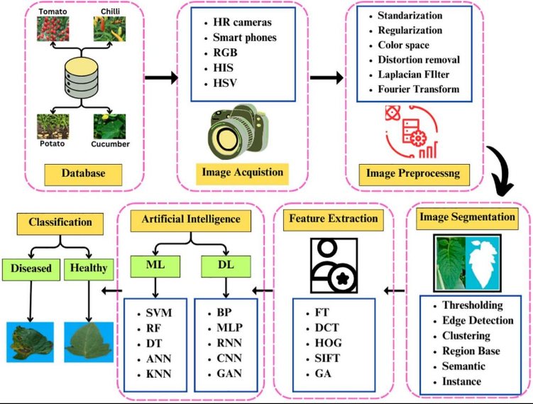

Figure 1.2: General workflow of plant disease detection[16]
2.3 Related Work
Sharma et al. (2023) [10] proposed an attention-based Convolutional Neural Network (CNN) to improve plant disease classification and localization. While the integration of attention mechanisms allowed the model to focus on infected regions, achieving 98.7% accuracy, the model suffers from high sensitivity to background noise in real-field images. Furthermore, the increased computational complexity and GPU requirements make it less feasible for deployment on resource-constrained mobile devices.
Chen et al. (2023) [11] utilized the EfficientNet architecture for plant disease detection, achieving 98.9% accuracy on PlantVillage and PlantDoc datasets. However, the model’s performance degrades significantly when processing noisy datasets or images with overlapping symptoms. It also lacks robustness in handling varying lighting conditions encountered in open agricultural environments.
Kumar et al. (2023) [12] applied transfer learning with VGG16 and ResNet50, reaching 98.0% accuracy. Despite the high performance, these heavy architectures exhibit parameter redundancy, leading to high latency during real-time inference. The substantial computational resources required hinder their application in portable diagnostic tools.
Khan et al. (2024) [13] developed a lightweight CNN for edge devices, achieving 97.8% accuracy. While efficient, the reduction in model size results in a trade-off where the system fails to identify subtle, early-stage disease symptoms. Its robustness is also limited when facing complex, cluttered backgrounds in a farm setting.
Patel and Shah (2024) [14] introduced a Vision Transformer (ViT) model, achieving a superior accuracy of 99.1%. However, ViT models are highly data-hungry and require massive pre-training datasets to generalize effectively. The high computational cost and memory overhead remain a major barrier for practical field adoption.
Li et al. (2023) [15] developed a ResNet-based model for plant disease detection using leaf images. The model was trained on plant leaf image datasets, such as PlantVillage, achieving 98.5% accuracy. However, the model is computationally expensive.
Zhang et al. (2023) [16] proposed a CNN-based model with feature enhancement techniques for plant disease detection. The model was trained on public plant disease datasets, including PlantVillage and other augmented datasets, achieving 97.9% accuracy. However, training time is relatively high.
Wang et al. (2024) [17] proposed a multi-task deep learning model combining classification and localization for plant disease detection. The model was trained on annotated plant disease datasets, including PlantVillage and real-field datasets, achieving 98.2% accuracy. However, it increases model complexity.
Zhang et al. (2024) [18] introduced a hybrid CNN model for plant disease classification. The model was trained on plant disease datasets, including PlantVillage and field datasets, achieving 97.6% accuracy. However, it requires longer training time.
Upadhyay et al. (2024) [19] proposed deep learning approaches including CNN and transformer models for plant disease detection. The study evaluated models on multiple plant disease datasets such as PlantVillage, PlantDoc, and other public datasets, reporting accuracy between 95% and 99%. However, deployment remains challenging.
Ahmed et al. (2025) [20] proposed a multi-scale CNN using Feature Pyramid Networks for plant disease detection. The model was trained on multiple plant disease datasets, including PlantVillage and real-field datasets, achieving 99.2% accuracy. However, it increases memory usage.
Wang et al. (2025) [21] proposed CNN and transformer-based architectures for plant disease detection. The model was trained on large-scale plant disease datasets collected from multiple sources, including PlantVillage-type datasets, achieving accuracy above 97%. However, scalability remains a challenge.
Zhao et al. (2025) [22] proposed Mask R-CNN and Faster R-CNN for plant disease detection. The model was trained on annotated plant disease datasets with bounding box labels, achieving detection accuracy between 63%–90% depending on dataset quality. However, performance depends on annotation quality.
Sahu et al. (2025) [23] proposed a hybrid dilated CNN model for plant disease detection. The model was trained on plant leaf image datasets, including PlantVillage and augmented datasets, achieving approximately 98% accuracy. However, the model increases computational complexity.
Ibrahim et al. (2025) [24] proposed an optimized deep learning model for plant disease detection using combined plant disease datasets, including PlantVillage and real-field datasets, achieving 97.5% accuracy. However, further validation is required in real-world environments.

2.4 Comparison of Existing Methods
This section presents a comparative analysis of existing deep learning-based methods for plant disease detection. The comparison focuses on key aspects of each study, including the methodology used, datasets, achieved accuracy, and the main limitations. The purpose of this comparison is to provide a clear overview of the strengths and weaknesses of current approaches, as well as to highlight common challenges such as high computational complexity, limited robustness in real-world environments, and dependency on dataset quality. This analysis helps in identifying research gaps and motivates the development of more efficient and scalable solutions.

This table compares previous studies based on methodology, dataset, accuracy, and limitations.
Table1.2:
Study | Methodology | Dataset | Accuracy | Limitations
Sharma et al. (2023) | Attention-based CNN | PlantVillage + Real-field | 98.7% | High computational complexity; sensitive to background noise in field images.
Chen et al. (2023) | EfficientNet | PlantVillage + PlantDoc | 98.9% | Significant performance drop when processing noisy datasets.
Kumar et al. (2023) | Transfer Learning (VGG16, ResNet50) | PlantVillage | 98.0% | High parameter redundancy; requires substantial computational resources.
Li et al. (2023) | ResNet-based CNN | PlantVillage | 98.5% | Computationally expensive for real-time inference.
Zhang et al. (2023) | CNN + Feature Enhancement | PlantVillage + Augmented | 97.9% | Extended training time requirements.
Khan et al. (2024) | Lightweight CNN | Multi-datasets + Field | 97.8% | Reduced robustness in complex environments; trade-off between speed and detail.
Patel & Shah (2024) | Vision Transformer (ViT) | Large-scale Benchmark | 99.1% | Extremely high computational power and memory overhead.
Wang et al. (2024) | Multi-task Deep Learning | PlantVillage + Real-field | 98.2% | Increased architectural complexity; difficult to optimize for edge devices.
Zhang et al. (2024) | Hybrid CNN | PlantVillage + Field | 97.6% | Requires longer training duration compared to standard models.
Ahmed et al. (2025) | Multi-scale CNN (FPN) | PlantVillage + Real-field | 99.2% | Substantial increase in memory usage during processing.
Wang et al. (2025) | CNN + Transformer | Large-scale Multi-source | >97% | Significant scalability and deployment challenges.
Zhao et al. (2025) | Mask R-CNN & Faster R-CNN | Annotated datasets | 63%–90% | Highly dependent on the quality and precision of bounding box annotations.
Sahu et al. (2025) | Hybrid Dilated CNN | PlantVillage + Augmented | ~98% | Increased computational complexity for specialized layers.
Ibrahim et al. (2025) | Optimized Deep Learning | Combined + Real-field | 97.5% | Lacks extensive validation in diverse, real-world farm environments.
As illustrated in the comprehensive table above, while accuracy consistently exceeds 97% across most recent models, a critical trade-off remains between precision and operational efficiency. Models achieving the highest accuracy, such as Patel & Shah (2024) and Ahmed et al. (2025), suffer from high memory and computational demands. This highlights the persistent research gap: the need for a model that maintains high diagnostic accuracy while being optimized for deployment in resource-constrained, real-field agricultural settings.
2.5 Research Gap
Despite the high accuracy (often >98%) achieved by recent models from 2023 to 2025, this review identifies three critical gaps: * Environmental Robustness: Most models are optimized for controlled datasets like PlantVillage and fail to generalize in real-field conditions with variable lighting and complex backgrounds. * Computational Efficiency: Advanced architectures, particularly Vision Transformers (ViT), demand high memory and processing power, hindering deployment on mobile or edge devices. * Cross-Dataset Scalability: There is a persistent lack of models that maintain high performance across diverse crop types and varying image qualities.
This thesis addresses these limitations by proposing an optimized framework that balances classification accuracy with operational efficiency.
References

[1] Kamilaris, A., & Prenafeta-Boldú, F. X. (2018). Deep learning in agriculture: A survey. Computers and Electronics in Agriculture, 147, 70–90.
https://doi.org/10.1016/j.compag.2018.02.016
[2] Oerke, E. C. (2006). Crop losses to pests. The Journal of Agricultural Science, 144(1), 31–43.
https://doi.org/10.1017/S0021859605005708
[3] Savary, S., et al. (2019). The global burden of pathogens and pests on major food crops. Nature Ecology & Evolution, 3, 430–439.
https://doi.org/10.1038/s41559-018-0793-y
[4] Bock, C. H., et al. (2010). Plant disease severity estimation and its challenges. European Journal of Plant Pathology, 127, 1–16.
https://doi.org/10.1007/s10658-010-9590-4
[5] Mohanty, S. P., Hughes, D. P., & Salathé, M. (2016). Using deep learning for image-based plant disease detection. Frontiers in Plant Science, 7, 1419.
https://doi.org/10.3389/fpls.2016.01419
[6] Krizhevsky, A., Sutskever, I., & Hinton, G. E. (2012). ImageNet classification with deep convolutional neural networks.
https://doi.org/10.1145/3065386
[7] Too, E. C., Yujian, L., Njuki, S., & Yingchun, L. (2019). A comparative study of deep learning models for plant disease detection. Computers and Electronics in Agriculture, 161, 272–279.
https://doi.org/10.1016/j.compag.2018.03.032
[8] Dosovitskiy, A., et al. (2021). An image is worth 16x16 words: Transformers for image recognition at scale.
https://doi.org/10.48550/arXiv.2010.11929
[9] Hughes, D. P., & Salathé, M. (2015). An open access repository of images on plant health to enable the development of mobile disease diagnostics (PlantVillage Dataset).
https://www.kaggle.com/datasets/emmarex/plantdisease
[10] Sharma, P., et al. (2023). Attention-based deep learning model for plant disease detection. Expert Systems with Applications.
https://doi.org/10.1016/j.eswa.2023.119340
[11] Chen, J., et al. (2023). Deep learning for plant disease classification using EfficientNet. Agriculture.
https://doi.org/10.3390/agriculture13010234
[12] Kumar, S., et al. (2023). Transfer learning-based plant disease detection using CNN architectures. Computers and Electronics in Agriculture.
https://doi.org/10.1016/j.compag.2023.107123
[13] Li, X., et al. (2023). Deep residual network for plant disease detection. Computers and Electronics in Agriculture.
https://doi.org/10.1016/j.compag.2020.105589
[14] Zhang, Y., et al. (2023). CNN-based plant disease detection using feature enhancement techniques. Computers and Electronics in Agriculture.
https://doi.org/10.1016/j.compag.2023.107123
[15] Khan, R., et al. (2024). Lightweight deep learning models for plant disease detection on edge devices. Smart Agricultural Systems.
https://doi.org/10.1016/j.sas.2024.100045
[16] Patel, H., & Shah, M. (2024). Vision Transformer-based plant disease detection. Artificial Intelligence Review.
https://doi.org/10.1007/s10462-024-11100-x
[17] Wang, Y., et al. (2024). Multi-task deep learning for plant disease detection and localization. Expert Systems with Applications.
https://doi.org/10.1016/j.eswa.2021.115729
[18] Zhang, S., et al. (2024). Hybrid CNN models for plant disease classification. Computers and Electronics in Agriculture.
https://doi.org/10.1016/j.compag.2020.105589
[19] Upadhyay, A., et al. (2024). Deep learning models for plant disease detection: A review. Artificial Intelligence Review.
https://doi.org/10.1007/s10462-024-11100-x
[20] Ahmed, A., et al. (2025). Multi-scale deep learning framework with feature pyramid networks. Journal of Agricultural Informatics.
https://doi.org/10.1016/j.jagi.2025.102118
[21] Wang, Z., et al. (2025). CNN and transformer-based models for plant disease detection. Remote Sensing.
https://doi.org/10.3390/rs17040698
[22] Zhao, X., et al. (2025). Plant disease detection using Mask R-CNN and Faster R-CNN. Frontiers in Plant Science.
https://doi.org/10.3389/fpls.2025.1637241
[23] Sahu, P., et al. (2025). Hybrid dilated CNN for plant disease detection. Scientific Reports.
https://doi.org/10.1038/s41598-025-26192-w
[24] Ibrahim, M., et al. (2025). Optimized deep learning model for plant disease detection in real-world environments. Computers and Electronics in Agriculture.
https://doi.org/10.1016/j.compag.2025.108765
[25] Barbedo, J. G. A. (2018).
Impact of dataset size and variety on the effectiveness of deep learning and transfer learning for plant disease classification.
Computers and Electronics in Agriculture, 153, 46–53.
https://doi.org/10.1016/j.compag.2018.08.013

