
Midocean University
College of Management
Department of Management

The Causes and Impact of Turnover of Saudi or Non-Saudi Employees, Who Registered In the General Organization for Social Insurance, (GOSI), On the Private and Public (Government) Sectors In the Kingdom of Saudi Arabia, (KSA).

Prepared by: Khaled Matar S. Al Anazi

Supervised by: Dr. Asma Abu Anzeh

Year: 2024

All Rights Reserved © 2024 Midocean University
Abstract

Employee Turnover is one the significant case that Human Resources, (HR) in worldwide are faced. It is an action that when employees are planning to leave their jobs by their own decision or when the organizations are planned to terminate the employees position. Where the turnover has two types:
Voluntary Turnover: Is happen when the employee is no longer want to work and want to leave his\her job by his\her choice for different response, such as, a new job opportunity, career change, relocation, or personal reasons. (An 2019)
Involuntary Turnover: This happens when an employee's position is terminated by organization, due to reasons for example, company restructuring or employee's poor performance. (An 2019)
Employee turnover, whether among Saudi or non- Saudi, is a significant issue on both the private and public sectors in the Kingdom of Saudi Arabia (KSA).
This study investigates the causes and impact of turnover among employees registered with the General Organization for Social Insurance (GOSI) on the both Saudi labor sector, the government sector (public) and the private sector.
Key factors contributing to turnover include economic fluctuations, organizational policies, employee satisfaction, opportunities for career development, and government-driven Saudization initiatives, which prioritize local employment over non- Saudi employees.
The research also highlights the differences in turnover trends between Saudi and non-Saudi employees, particularly in the context of Vision 2030 reforms, which aim to diversify the economy and reduce dependency on foreign labor.
The impact of turnover is analyzed in terms of organizational costs, productivity, and workforce stability, as well as broader economic implications for the KSA labor market.
Understanding these dynamics is crucial for developing effective retention strategies and aligning workforce planning with national goals.
The study offers recommendations to reduce turnover and enhance employee engagement, focusing on both workforce localization and sustainable of employment, serving both the public and private sectors.

List of Terminology

- Turnover: Is the rate that employee change his\her position or job
- Voluntary Turnover: It happened when the employee leave his\her position or job by his\her well
- Involuntary Turnover: It happened when the employee is terminated by the employer

List of Abbreviations

- KSA: Kingdom of Saudi Arabia.
- GOSI: General Organization for Social Insurance.
- HR: Human Resource
- MHRSD: Ministry of Human Resources and Social Development.
- ROI Return On Investment
- GAS General Authority for Statistics

Chapter 1

1.1 Introduction
Employee turnover refers to the rate at which workers leave organizations, thereby necessitating their replacement with new hires, an issue important to businesses and government institutions. Specifically in private and government sectors in the KSA. Indeed, high employee turnover can lead to significant financial losses, disruptions in productivity, operation, and weakened organizational culture in many countries. Saudi Arabia is no exception, as employee high turnover rates can pose serious challenges for Saudi companies, impacting productivity, morale, and overall organizational performance of the both sectors. With the labor market in the Kingdom made up of Saudi and a mix of non-Saudi. The government policy of Saudization, and economic issues such as fluctuating services prices and rapid modernization efforts, the turnover temporarily problem is only complicated further.

This research investigates the causes and effects of employee turnover among employees registered with GOSI in the public and private sectors (Morrice et al., 2021). GOSI, which operates the social insurance system of Saudi Arabia, provides a rich source of data about employment patterns across sectors and, therefore, forms an ideal focus for comprehending turnover within the Kingdom. The research will analyze the leading causes of turnover and measure the influence of turnover on organizational performance, employee morale, or productivity in both sectors based on data from GOSI.

The study also explores the difference in Saudi and non-Saudi turnover rates, pitting them against each other across the private and public sectors. The purpose is to develop recommendations for turnover reduction that will improve employee retention and be symbiotic with employers and employees in Saudi Arabia.

1.2 Problem Statement
One of employers' worst problems, especially in Saudi Arabia, is employee turnover (Alshareef et al., 2020). Turnover problems are particularly critical in the private sector, which tends to show much higher turnover rates than in the state or public sectors. This is mainly because job promotion, wages, and security differ significantly between these sectors. In addition, expatriates, who comprise a significant percentage of the Saudi Arabian workforce, have higher turnover ratios than Saudi nationals, primarily because of short-term contracts, visa restrictions, and limitations concerning career advancement. People working in the public sector have greater job security and more benefits, which lowers the rate of turnover.

In the public sector, though, turnover remains an issue despite all efforts to energize it, and among the younger crowd looking for more challenging jobs with better life-work balance, it still needs to be addressed. The Saudi government's Saudization policy, replacing expatriates with Saudi nationals in the workforce, further aggravates turnover challenges as companies seek to balance their needs for skilled expatriate labor against government requirements to hire more Saudis. It is, therefore, very significant to understand the causes of turnover in both sectors to devise effective strategies to improve employee retention and organizational performance. High turnover is often accompanied by high costs linked to recruitment and training activities, loss of institutional knowledge, reduced productivity levels, and poor morale among the remaining employees. In Saudi Arabia, however, the reliance on both Saudi and non-Saudi employees makes the issues even worse, each a different stumbling point in expectation and experience in the workforce.

1.3 Study Purposes
This paper researches the causes and effects of employee turnover in Saudi and non-Saudi employees registered in GOSI in the public and private sectors (Hani & Lopesciolo,2021). It will identify what elements of turnover are essential through analysis of the data concerning turnover and their relative strength of impact in the investigated public and private sectors. The study will also examine the effect of turnover on organizational performance, morale among employees, and overall productivity, suggesting how to improve employee retention strategies.

This study aims to identify the prime factor of turnover in the public and private sectors. It also investigates the differences in the separation rate between nationals and expatriates. Assess the turnover regarding its impact on organizational performance and employee morale. Additionally, suggestions should be made to reduce turnover and enhance employee retention in both sectors. It also renders the findings particularly useful to policymakers, human resource managers, and business leaders in Saudi Arabia who are interested in enhancing workforce stability and mitigating adverse impacts of workforce turnover on their organizations.

1.4 Study Importance
The significance of the study could provide a solution to a significant problem affecting both the private and public sectors in Saudi Arabia. High labor turnover has several negative impacts on organizations, including increased expenditures related to recruitment, training, and lost productivity. For individual employees, high turnover might lead to job insecurity, which results in low morale and dissatisfaction with the work environment. In a greater sense, this could lead to labor market instability when the turnover rates become high and make firms less competitive. Since the Saudi markets are witnessing a great expansion and openness to attract foreign investments from major economies, Saudi companies in both the private and public sectors will not be able to compete effectively if there is still a high turnover rate.

High labor mobility challenges the private sector in keeping a productive workforce. This is critical since Saudi Arabia depends on many expatriates, most of whom hold short-term contracts or face visa restrictions that reduce their longer-term employment opportunities. Many expatriates in Saudi Arabia would instead seek more long-term job opportunities elsewhere, creating that vicious circle of high turnover and heavy recruitment for companies in the private sector.

As can be seen, turnover in the public sector is less pronounced, with increased job security and an associated benefits package. Still, turnover remains an issue for some employees who may feel the public sector offers limited growth and professional development opportunities. Such employees are likely to head towards the private sector or abroad in search of more exciting career opportunities, thereby increasing the average turnover levels for the public sector.

The findings from this research will contribute to the existing literature on employee turnover in the KSA and ratify policymakers and business leaders with relevant information that representatives are eager to break this trend. This research paper will support organizations in both sectors in developing a more stable and productive working environment by identifying the leading causes of turnover and providing practical recommendations on reducing turnover and promoting better employee retention.

1.5 Study Questions
The researcher attempts to find answers to the following research questions:
- What causes employee turnover in the public and private sectors within Saudi Arabia?
- What are the perceived differences between the turnover rates of Saudi nationals and expatriates, and what are the causes for such a difference?
- What does employee turnover affect in terms of its consequences, such as organizational performance, employee morale, and productivity?
- What strategies might organizations of both public and private sectors put in place to minimize turnover and improve retention of workers?

Therefore, this research project will try to answer these questions. When established, it will comprehensively explain the 'why' behind turnover in Saudi Arabia and make specific, actionable recommendations to improve workforce stability.

1.6 Hypotheses of Research
The following hypotheses will be tested based on the study's objectives and the literature review on employee turnover.
- H1: Private sector turnover is much higher than in the public sector due to perceived job threats, pressures on performance, and more minor benefits.
- H2: Expatriates have higher turnover rates than Saudi nationals since the workforce is usually hired on temporary contracts, with limitations in obtaining a visa and limited career advancement.
- H3: Workers employed in private companies have more chances to quit due to dissatisfaction with compensation, career development prospects, and work/life balance.
- H4: Targeted retention strategies, such as enhancing job security, offering competitive remuneration packages, and offering career development opportunities, could be highly effective for all sectors.
These hypotheses will be tested with quantitative and qualitative data to analyze the pattern effectively and causes linked to turnover.

1.7 Theoretical Model
Therefore, this study uses key theoretical models to explain employee turnover and retention. These theoretical models provide a framework underlining how the different factors relating to job security, compensation, and career development affect employees ' decisions about future retention or exit in an organization for better opportunities.

1.7.1 Maslow's Hierarchy of Needs
Maslow's hierarchy of needs is a widely applied theory of motivation, dating back to 1943, and has been extended to study employee turnover comprehensively. The theory postulates that individuals have hierarchical motivational needs, with basic physiological needs (food, water, shelter) at the bottom and higher-order needs towards self-actualization. Maslow's theory (Omodan & Abejide,2022) about employee turnover states that people will stay longer with an organization should their basic level needs, such as a guarantee of job security, good remuneration packages, and safety in the workplace, be made available. On the contrary, according to this theory, employees would quickly leave an organization to look for other better opportunities when these fundamental needs are not considered. Therefore, this paper adopts Maslow's framework to analyze how unmet needs, especially in job security, compensation, and career development, lead to turnover in the public and private sectors.

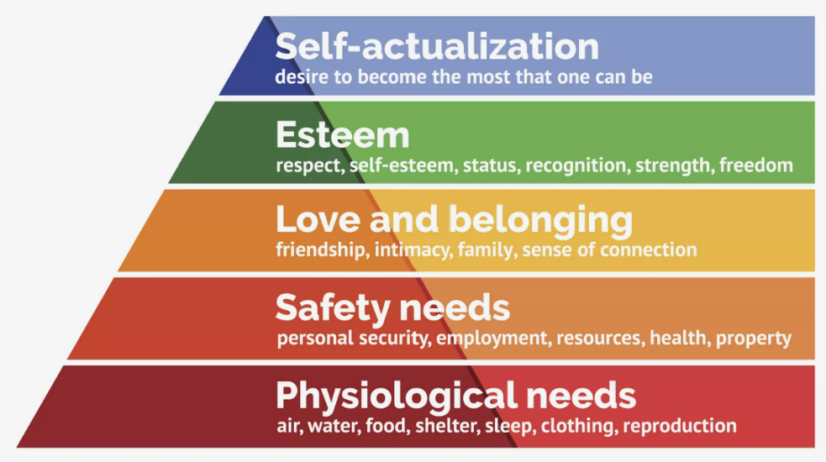
Picture1-1: Maslow's Hierarchy of Needs [Website1]
1.7.2 Herzberg's Two-Factor

In the Two-Factor Theory, Herzberg identifies two factors: hygiene and motivators (Alam, 2021). Hygiene factors create dissatisfaction if absent but do not lead to actual job satisfaction, including salary, job security, and working conditions. The motivators include, among others, recognition, career advancement, and personal growth, which drive job satisfaction and, subsequently, loyalty. In the light of Herzberg's theory, this suggests, in terms of employee turnover, that improved hygiene factors other words, increasing salary, and job security reduce dissatisfaction and, therefore, turnover, but for a feeling of satisfaction to be evoked and, thus long-term loyalty, organizations have to provide motivators, such as opportunities for career development.
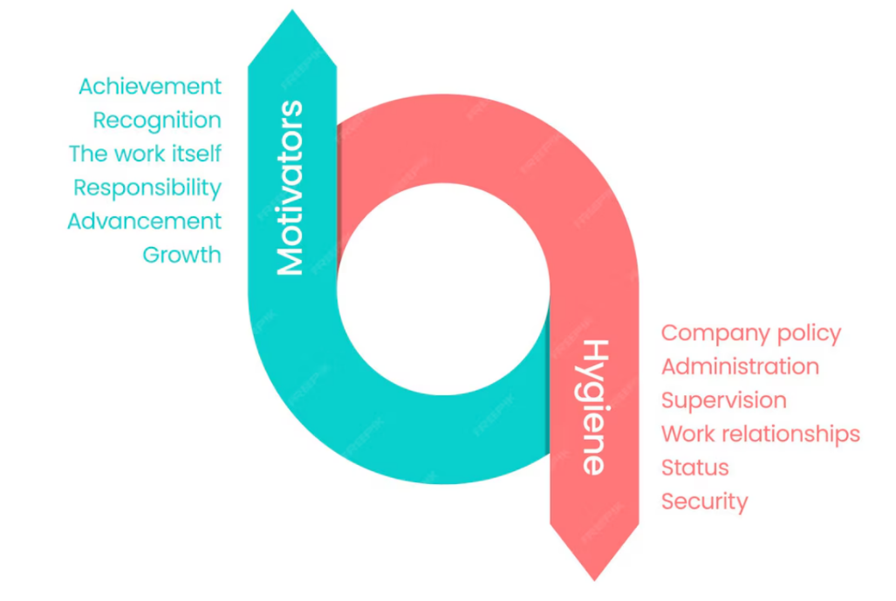
Picture 1-2: Herzberg’s Two Factor Theory [Website2]

1.7.3 Job Embeddedness Theory

According to Job Embeddedness Theory, proposed by (Mitchell et al., 2001), the reasons employees decide to continue to stay with an organization or not depend on how much they are embedded in their jobs and communities. It involves developing personal relationships, finding a fit, and acquiring career opportunities (Al-Ghazali, 2020). The results show that employees more embedded in their jobs and communities are less likely to quit, even if dissatisfaction arises. This study relies on the job embeddedness theory to explain how factors like job fit, social connections, and career opportunities influence the turnover rate in both public and private organizations. The focus is on the aspects that, when improved, will enhance job embeddedness, thereby reducing turnover.

Chapter 2
Chapter 2: Literature Review

2.1 Introduction
One of the main issues that almost every organization around the globe is facing nowadays is employee turnover (Hassan et al., 2023) due to its negative impact on productivity, financial stability, and organizational culture. The problem of turnover in KSA is influenced by the harmony between Saudi nationals and expatriates in the workforce and the unique flavor of the public and private sectors.
Relevant literature on employee turnover, focusing on its causes, consequences, and potential strategies to reduce turnover, especially in the labor market of Saudi Arabia, is reviewed in this chapter. This chapter starts with the definition of turnover, followed by a review of critical theoretical models, and then an analysis of global and Saudi Arabian trends.

2.2 Dependent Variable: Employee Turnover
Turnover measures the flow of leavers from an organization and their replacement by new employees during a given period. There are two types:
- Voluntary Turnover: a circumstance when the employee leaves of their own will, which can be because of pay dissatisfaction, career development problems, or inability to enforce work-life balance. (An 2019)
- Involuntary Turnover means any separation that employers force upon employees, such as for poor performance, downsizing, or changes in organizational strategy. (An 2019)
The dependent variable to be used is employee turnover, which focuses on the employees registered with GOSI in Saudi Arabia. The causes and patterns of Turnover in both the public and private sectors give insight into how Turnover interferes with an organization's stability and performance.

  - Independent Variables: Causes of Turnover
Employee turnover depends on the interaction of several independent variables, such as personal, organizational, and external factors:
- Job insecurity: Job insecurity due to short-term contracts, performance-based dismissals, and fluctuating economic situations is also haunting employees, especially in the private sector.

- Salaries and Benefits Packages: Competitive salaries and benefits packages are akin to other industries; there is an excellent tendency for workers to either continue or quit an organization. Government jobs generally have more job security and benefits, which impacts lower turnover than the private sector.

- Developmental opportunities: An organization's inability to help an employee grow in his career is one of the major influences on voluntary turnover. Employees in any sector may quit due to a lack of promotional or career-building opportunities.

- Work-Life Balance: An employee looks forward to a successful balance of his or her professional and personal lives. Organizations with rigid schedules or over-loaded work projects record higher turnover rates (Akinloye, 2022).
Organizational culture and job poor communications, a lack of recognition, and workplace cultural dissatisfaction contribute to higher turnover rates. Employees will be willing to continue with well-organized firms where the workplace culture is good, and their contributions are recognized.

2.4 Theoretical Framework of the Study
Several theoretical models explain employee turnover and retention. These frameworks explain how organizational factors interact with employees' needs to influence turnover.
2.4.1 Maslow's Hierarchy of Needs
Maslow's hierarchy of needs constitutes one of the most applied theories in understanding employee motivation and turnover. According to Maslow, individuals are first motivated to fulfill basic needs, such as job security and fair wages, before addressing higher-order needs, such as belonging, recognition, and self-actualization.
People working in industries with bad job security or inferior pay will leave, especially if their basic needs are unmet. Workers are more likely to quit, particularly when their basic needs have not been met. This study's application of Maslow's theory offers an understanding of why the turnover rate is different between the public and private sectors, as working with the government typically offers a higher level of stability with better benefits.

2.4.2 Herzberg's Two-Factor Theory Herzberg's
The two-factor theory identifies two factors: hygiene factors, which are aspects related to salary, job security, and working conditions, and motivators, including recognition and career advancement. Hygiene factors only prevent dissatisfaction if present but cannot make one feel satisfied with the job. On the other hand, motivators contribute to higher job satisfaction and retention. This theory suggests that organizations need to eliminate dissatisfaction factors and create motivating environments that will attract employees to commit and remain loyal in return.

2.4.3 Job Embeddedness Theory
Mitchell et al. (2001) popularized the Job Embeddedness Theory, which describes how employee retention depends upon the degree to which employees are embedded within their jobs and communities. Factors increasing embeddedness involve personal relationships, job fit, and career development opportunities. Turnover is considered less likely for people who feel more connected to their job or community, even if they are dissatisfied.

2.5 The Past Researches on Employee Turnover
Indeed, there is a good deal of empirical research into employee turnover across a wide array of industries and from different parts of the world. Such research explains turnover causes and consequences within various organizational settings. First, relevant research has been reviewed both in the global and Saudi Arabian contexts.

2.5.1 Labor Turnover
Global and Local Trends Generally speaking, industries with low job security and minimal career advancement opportunities - retail, hospitality, and customer service- are good examples of this, and they exhibit higher turnover rates globally. On the other hand, sectors like education and healthcare, which have intrinsic motivation and job security, usually have lower turnover rates. Due to geographical location, several other factors trigger turnover, which happens in Saudi Arabia, and Saudization policies are one of them. It guarantees the employment of Saudi nationals rather than expatriates (Lopesciolo et al., 2021). While these have promoted good job prospects for Saudi nationals, they have also facilitated the turnover of expatriates due to visa restrictions and temporary contract forcings.
2.5.2 Private vs. Government Sectors: A Comparison of Saudi Arabia's Turnover Rates
As such, studies indicate a higher turnover rate in Saudi Arabia, especially when comparing the private sector to the government sector. The reason is based on the fact that the government sector offers job security, stable benefits, and pensions, thus creating better retention factors for employees. In addition, private sector employees continue to be uncertain due to performance-based contracts with minimal benefits, thereby leading to their intention to leave an organization (Al Rashdi, 2020). Assert that the leading causes of turnover in the private sector are job insecurity, limited career growth, and remuneration.
For example, table 2-1 shows the total number of turnover of employees in both government and public sectors of the year 2023.
Table 2-1: Average Turnover in Government and Private Sectors in 2023
Government Sector | Saudi | Non-Saudi | Total
Government Sector | 9045.75 | 570.25 | 9616
Private Sector | Saudi | Non-Saudi | Total
Private Sector | 82293.75 | 84002.25 | 166296

As we can see in the table 2-1, statistics provided by General Authority for Statistics, (website3) and (website4), the total number of employees who discontinuation of work and was registered in GOSI and in the government sectors is 175,912 employee. However, in the government sector about 94% are Saudi, while 6% are Non-Saudi.
In the contrast in the private sector about 49.5% are Saudi, while 50.5% are Non-Saudi. Where there were different reasons why the employees are left their jobs such as:
- Joining a government job
- End of business relationship
- Expiry of the activity
- Reaching retirement age
- Termination under Article (80) of the Labor Law
- Termination of the contract during the training period Season
- Dismissal under Article (77) of the Labor Law
- Expiry of the employment contract.
- Natural death , etc
Note: More information in appendix section page 27- 30

Moreover, when to compare the rate of the turnover based on first quarter of 2024 between the government (public) and the private sectors, it can be seen from the picture:2-1 about 94.2% of the employee are Saudi, while 5.8% are Non-Saudi. Who left the position respectively.
In the contrast in the private sector about 44.48% are Saudi, while 55.51% are Non-Saudi. Who left the position respectively.
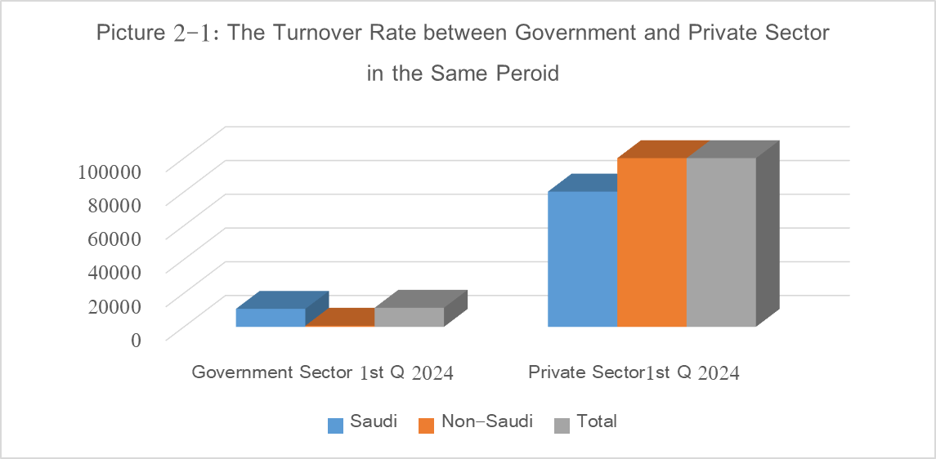
Picture 2-1: Compare the rate of turnover between Government and Private sector [Website3] & [Website4]

2.5.3 Major Findings on Saudi Organizations from Previous Studies
Several studies have targeted the tendency for turnover in Saudi organizations. For example, Al-Ahmadi's 2002 study reported that job satisfaction and career growth opportunities were significant predictors of turnover among Saudi nurses. Likewise, Achoui and Mansour (2007) also reported that lack of recognition, poor communication, and low wages are severe reasons for turnover in Saudi private firms. These findings indicate that more excellent retention strategies are needed in Saudi Arabia, which requires a more focused approach in industries where turnover is generally higher, such as health and construction.

2.6 Summary of Previous Works
The reviewed studies have shown that organizational and personal factors influence turnover in Saudi Arabia. Turnover rates are relatively low in the public sector due to prevailing job security and benefits, while in the private sector, higher turnover rates exist, driven by job insecurity, advanced career growth limitation, and dissatisfaction over compensation. It is observed that the turnover rates increase for expatriates and younger employees as they search for opportunities in more stable environments. These findings suggest that retention strategies must be carefully tailored to meet the needs of various employee groups.

2.7 Theoretical Framework of the Study
The present research used Maslow's Hierarchy of Needs, Herzberg's Two-Factor Theory, and Job Embeddedness Theory to describe employee turnover in Saudi Arabia's public and private sectors. These theories adequately underpin a complete framework that explains the relationship between job security, career development, organizational culture, and turnover. The study shall also use some statistics from the GOSI to examine turnover trends across the different demographic groupings and sectors to develop a fine-grained understanding of turnover trends in Saudi Arabia.

