
Midocean University
College of Management
Department/Major: Project Management

Effects of Manager’s Leadership Style on Project Management Success
“An applied Study on the Construction Projects in the Northern Region of Iraq”

BY
FATHY MOHAMMAD FATHY
Academic Number: 242000548

Supervised by:
Dr. Faisal Abdul Hamad Muhammad
Dr. Fayez Ali Jarad

March 2025

CHAPTER 1

INTRODUCTION

1.1.1 Background of Study
In today's increasingly complex and interconnected business landscape, effective project management has become paramount to organizational success (Ekemezie & Digitemie, 2024). Project success is greatly influenced by leadership styles, which impact motivation, team dynamics, and communication. To promote cooperation and creativity, effective leaders adapt their strategies to fit the demands of the team and the specific project requirements. Project managers who understand various leadership philosophies are better equipped to foster an environment that encourages goal achievement and overcomes obstacles (Malachowsky, 2018).
The literature on leadership acknowledges the diversity of leadership styles and their potential effects on management, organizational performance, and projects. A project's success depends on a variety of contextual elements as well as the chosen approach. According to an expanding body of research, leadership is one of the most important individual determinants of project performance and success (Siddiqui et al., 2023).
1.1.2 Study Effect
Academics and the professional community generally agree that managing people is a key component of project management. From large infrastructure projects to small-scale enterprises, project management is prevalent across numerous industries. Each project is unique, autonomous, and staged, with constraints on budget, time, and scope. Additionally, every project must have a defined goal that aligns with the organization's strategic objectives (Mičík, 2016). Effective leadership serves as the cornerstone for achieving successful outcomes.
The manner in which leaders engage with their teams, make decisions, and motivate individuals profoundly influences the overall performance and cohesion of project teams (Ahmed, et al., 2023). Each of the various leadership styles offers unique organizational and motivational concepts. When effectively applied within project teams, these approaches not only influence task productivity and efficiency but also enhance team members' intrinsic motivation and job satisfaction (Ahmed, et al., 2023).
Without effective leadership, organizations risk stagnation, losing direction, and progressing slowly. Therefore, it's critical to understand how leaders affect behavior, alter the course of events, and overcome resistance (Tao Xiangxing & Jonathan Musonda, 2021). The actual and perceived relationships of a typical project are complex. Figure 1-1 illustrates the common relationships between stakeholders and those around the project manager (Arora and Baronikian, 2013, 266). Among these intricate components, leadership is essential to success and accomplishing the intended outcomes. One may think of the leader as the one who directs the group and establishes the plan and vision required to accomplish these objectives (ادريس, 2024).

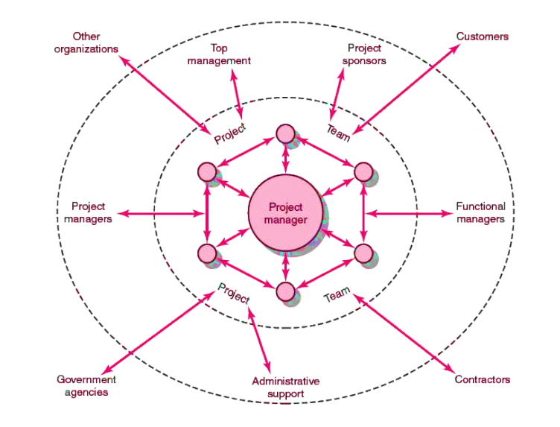

Figure 1-1: PM at the center of project complex
1.2 Problem Statement
There is a persistent failure of projects both locally and internationally due to the inability of organizations to apply appropriate leadership styles, project techniques, and methods. Most organizations and project managers tend to lay much emphasis on the technical and managerial aspects of the project. Consequently, there is an estimated project failure rate of about 34% successful to 66% globally unsuccessful projects (Logikal, 2020, 6), as shown in the figure 1-2.

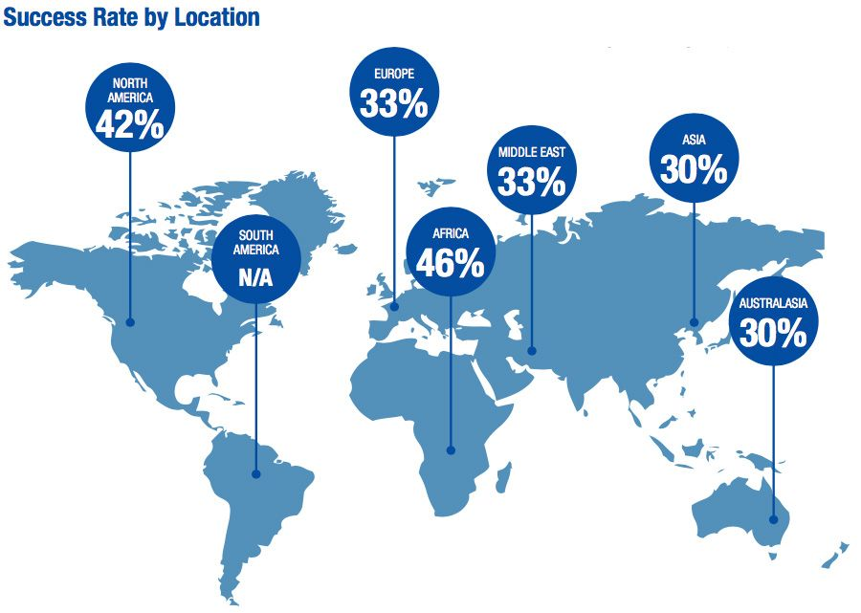

Figure 1-2: achieved or not completed all or most Projects across time, cost and quality objectives across world
These failures can be attributed to several critical factors, such as inadequate information on the relationship between leadership styles and project success, including when and how to apply the appropriate leadership style required for successful project completion (Adewuyi, 2023). Hence, it is expected that a project manager’s leadership style should significantly influence project performance (Kariuki, 2018).
One of the primary reasons many projects fail is a lack of attention to project complexity. Complexity is defined as the feature of a project that makes it difficult to comprehend and regulate its overall behavior, even when one possesses fairly complete knowledge about the project system (Mohamed, et al., 2022). To address this, it is essential to investigate the leadership styles of project managers and assess their impact on the quality performance of projects (Bonkoungou et al., 2022).
Furthermore, understanding how a project manager's leadership abilities affect the success of a construction project is crucial (Monika et al., 2016). The consequence of managers' lack of an effective leadership style often results in projects that are completed over budget, past schedule, and with unhappy clients and dissatisfied staff due to low morale and poor teamwork. Ultimately, the project will either fail or be significantly delayed (Hussain, 2018).
The enlarging scale of competition among corporations over the years has led to a growing need for effective leadership, which is essential for the successful accomplishment of project management. Undoubtedly, leadership directly or indirectly influences the effectiveness of a project; however, the necessary skills for project managers and the importance of leadership styles have not received sufficient attention (Paradise et al., 2010).
In accordance with the survey conducted by (Mannaz, 2014), the results revealed that corporations must focus more on the relationship between project management effectiveness and leadership style.

Figure 1-3: “Does organizations take leadership style in their consideration as a factor might lead to project failure?” (Mannaz, 2014,13)
1.3 Importance of Study
One of the main causes of project failure is inept leaders. However, scholars also think that a variety of leadership styles can lessen project failure. For instance, a lot of academics believe that transformational leadership is essential to project success. However, the success of the initiative has not been entirely attributable to transformational leadership, (Ali & Rasheed, 2020). In addition, leadership styles differ in assessing their impact on the success of projects and their degree of prevalence, as the authors analyzed in detail the abstracts and keywords of the 90 articles in the 21 Leadership Journal, ten categories were evaluated, the following are the most common categories found in the articles analyzed in Table 1-1.
Topic classification | Number of studies | Percentage
Authentic leadership | 25 | 22%
Transformational leadership | 40 | 36%
Servant leadership | 14 | 13%
Transactional leadership | 13 | 12%
Benevolent leadership | 5 | 4%
Paternalistic leadership | 5 | 4%
Charismatic leadership | 4 | 4%
Autocratic leadership | 3 | 3%
Collectivistic leadership | 1 | 1%
Empathetic leadership | 1 | 1%
Table 1-1: “Topic Classifications” (Hadziahmetovic, et al., 2023, 192).
Some articles have more than one topic classification, the authors have coded each category separately. The most often researched subjects, according to these findings, are authentic leadership and transformational leadership, followed by servant leadership. Collectivistic and Empathetic leadership, on the other hand, are the least researched leadership styles, (Hadziahmetovic, et al., 2023).
The study's conclusion that there is a strong correlation between leadership styles and the situations they handle and that each leader needs to strive to create a distinctive style that fits the skills, maturity, and capacities of a particular team of workers is another crucial finding. Leaders must understand how their leadership styles impact their followers since they play a significant role in influencing and changing the attitudes and behaviors of the organization's workforce, (نذير, 2023). Whereas, according to another study, 64.1% of crisis management readiness may be explained by transformational leadership practice (Abu rumman, 2016).
1.4 Study Objectives
Construction projects on Iraq one of the biggest work sectors on Iraq, so finding the best leadership style that should be implement by project managers will lead to improve the quality, saving cost, and reducing need time. Besides that, suitable leadership style will increase project’s team productivities, performance, and efficiency. The research aimed to evaluates the suitable manager’s leadership styles needed to accomplish project successfully, the objectives are stated as follows:
- To define distinct leadership styles needed for project managers to accomplish construction project management successfully.
- To assess the impacts of leadership styles on the efficiency and productivity of the project team.
1.5 Study Inquiries
In order to investigate the connection between project management success and leadership styles, and how an individual's leadership style impacts how he develops and accomplishes goals and takes into account the needs of his team and the potentials of stakeholders, (Iqbal, et al., 2022), with taking the fact that the construction Project is critically affected by the project manager, (Iqbal, et al., 2022). Whereas the style of transactional leadership style had significant positive effect on performance, transformational leadership style had positive but insignificant effect on performance, (Obiwuru, et al., 2011), As well as researching the dialectical relationship between the authoritarian leadership style and its impact, as authoritarian leadership negatively relates to task performance, (Wang, et al., 2019), while with higher individual power distance, authoritarian leadership has a significant impact on employee performance through employee job role clarity, (Nawaz, et al., 2022), in adding to the responsibility of the project managers of overseeing projects in a number of areas that are critical to their success, such as budget, timeline, quality, and safety standards (bt Zakaria, et al., 2015), therefore, our research poses a number of questions. They can be summed up as follows:
- which leadership traits work best for project management in the construction sector, in the north region of Iraq?
- how do authoritarian, transactional, and transformational leadership styles impact team performance and productivity?
- how do project results in terms of cost, schedule, and quality relate to leadership style?
- what impact can a leader's style have on the dynamics of a team and on an individual's performance under pressure?
These inquiries seek to offer a thorough grasp of the part that leadership plays in project success, which aids in the creation of efficient management techniques that are in line with the ever-changing circumstances of the workplace.

CHAPTER 2

2.1 LITERATURE REVIEW

2.1.1 Introduction
The effectiveness of project teams is greatly impacted by the leadership styles employed, with transformational and transactional leadership being crucial in promoting discipline, motivation, and teamwork. Because of its possible disadvantages, laissez-faire leadership needs to be carefully considered. The significance of context-specific leadership techniques in project management is shown by the situational adaptability of leadership styles. In order to maximize team dynamics and improve project outcomes, project managers can choose and modify their leadership techniques with the help of a deeper understanding of the subtle implications of different leadership styles as businesses continue to traverse complicated projects, (Ahmed, et al., 2023).
Leadership is a dynamic process in which one individual inspires others to help the group realize its goals. Although there is no universally accepted definition of leadership, it is important to remember that leadership is a process, and as such, it takes time for a leader to be able to influence their followers in the way that they want. It has been discovered that different leaders have varying effects on other leaders by displaying a variety of behaviors, abilities, and characteristics that have resulted in various leadership traits and styles, (Bonkoungou, et al., 2022).
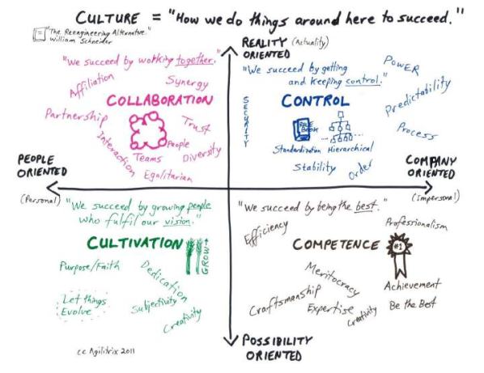
As the management level increases so too does the project success scores, (Martin & Edwards, 2016). To achieve the desired project outcomes, the implementation of project management requires a unique project leadership style that reflects the many management competencies and behaviors, (Bilal, et al., 2021). Schneider's model reflects the four basic cultures and the relationship between strategy and leadership style as shown in the figure below (Arora & Baronikian, 2013).

Figure 2-1: Schneider’s Core Cultures (Arora & Baronikian, 2013, 132)

Leadership Concept
The various qualities, attitudes, and actions that leaders employ to communicate with their subordinates are collectively referred to as their leadership style. Think of leadership as the pattern of managerial action intended to combine organizational or individual interests and impacts in order to accomplish specific goals. Every organization has a variety of leadership philosophies. Every leader has an own style.
Effective leaders will base their strategies on the situation, the people involved, and the desired result. The effectiveness of a leader and their eventual success are intimately tied to their capacity to modify their style in response to these factors, (Mgallah, 2024).
According to (Adewuyi, 2023), there is a connection between project success and leadership style, and it is crucial for a number of reasons. Project managers can select the best strategy for their particular projects by knowing how various leadership philosophies impact project results. Determine which approaches are most likely to result in success as well, so that training and development initiatives can improve the efficacy of leadership.
Additionally, it helps project teams understand how important leadership is to reaching project objectives, which promotes improved manager-team collaboration and communication. Creating better project management procedures, such as leadership development courses that encourage the use of successful approaches, can also help organizations. additionally, a thorough comprehension of the elements that affect project success and failure, opening the door for future improvements in methodology.
Decision-making abilities are equally crucial in project leadership. Projects often involve complex and uncertain situations, requiring leaders to make decisions under pressure. Effective decision-making involves problem-solving skills, analytical abilities, and judgement. Project leaders must be able to identify and analyze issues, evaluate potential solutions, and make decisions that best serve the project's objectives. This includes the ability to make tough decisions when faced with trade-offs between the often-competing demands of time, cost, scope, and quality. Furthermore, decision-making in project management is often a collaborative process. Leaders must therefore have the ability to facilitate group decision-making, encouraging input from team members, managing differing opinions, and building consensus. In addition, project leaders need the ability to anticipate future trends and scenarios, and plan accordingly. This forward-thinking approach is integral to risk management, contingency planning, and ensuring the project's sustainability and long-term success, (Fokina, et al., 2023).

Leadership Strategics
Project implementation is the process of taking abstract concepts from proposals and turning them into a realistic presentation while maintaining a high level of interest in the goals and making use of the time, money, and human resources available to produce high-quality results. Project implementation can be divided into four stages: the initiation phase, which involved analyzing the work plan; the planning phase, which takes into account the available resources in relation to the strict deadlines and goals; the implementation phase, which involves putting the ideas in the paper into action; and the closing phase, which compares the output to the input and identifies the successes, the difficulties, and ways to improve the project going forward. It goes without saying that effective leadership is essential during each of these stages and is crucial when moving from one to the next. Therefore, it is impossible to isolate leadership from any stage of project implementation, (Renzi, 2020).
According to Lategan and Fore, there are four components that are necessary for using effective project management leadership techniques: trust, effective teamwork, effective communication, and effective cooperation. the project team, internal clients, and the larger business can all benefit from effective communication. For the broader organization to align with its goals, effective cooperation is necessary. Within the internal project team, effective teamwork is achieved, and trust is exercised throughout the project's life cycle, (Lategan & fore, 2015).
leadership style according to (Malachowsky, 2018) is that Every team has a preferred leadership style, just as every person does. Leaders as people also tend to have a specific style. Every leadership experience stresses one of three things in addition to the mechanics of the leadership style itself: the team, the leader, or individual team members. It also emphasizes a strategy that puts harmony or productivity first. The (Institute Project Management, 2022) mentioned 10 types of leadership styles stated in the Figure 2-2.

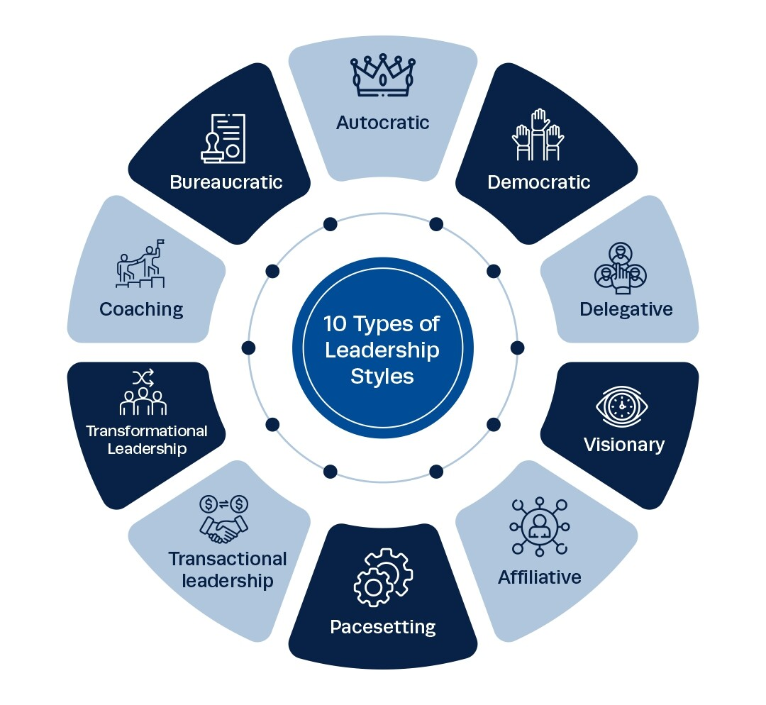

Figure 2-2: 10 Most Common Leadership Styles (Institute of Project Management, 2022)
in the “A Handbook of Leadership Styles” (Çizmeci, 2020, xi ) mentions 17 common types of leadership styles include: Ethical Leadership, Transformational Leadership, Transactional Leadership, Participative Leadership, Servant Leadership, Charismatic Leadership, Authentic Leadership, Spiritual Leadership, Implicit and Explicit Leadership, Autocratic Leadership, Democratic Leadership, Resonant Leadership, Digital Leadership, Cross-Cultural Leadership, Paternalistic Leadership, Complexity Leadership and Coaching Leadership, (Demirtas & Karaca, 2020), The important styles in engineering construction projects are summarized according to the Table 2-2 shown below (Gandu, et al., 2018, 5):

Nr. | Leadership style | Characteristics
1. | Autocratic or Authoritarian | - Little or no input from group members in decision making.  - Leaders make the decisions without consultation.  - Group leaders dictate all the work methods, milestone and processes.  - Group members are rarely trusted with decisions or important tasks.
2. | Democratic or Participative | - Group members are encouraged to share ideas and opinions, even though the leader retains the final say over decisions.  - Leader values group discussions and takes input from members  - Members of the group feel more engaged in the process.  - Creativity is encouraged and rewarded.  - Leader supports teamwork and directs subordinates
3. | Laissez-Faire or  Free-Rein | - Very little guidance from leaders  - Complete freedom for followers to make decisions  - Leaders provide the tools and resources needed  - The leader encourages team members to function independently and work out their problems by themselves,
4. | Transactional | - Contingent Reward: Contracts exchange of rewards for effort, promises rewards for good performance, recognizes accomplishments.  - Management by Exception (active): Watches and searches for deviations from rules and standards, takes correct action.  - Management by Exception (passive): Intervenes only if standards are not meet.
5. | Transformational | - Charisma: Provides vision and sense of mission, instills pride, gains respect and trust.  - Inspiration: Communicates high expectations, uses symbols to focus efforts, and expresses important purposes in simple ways.  - Intellectual Stimulation: Promotes intelligence, rationality, and careful problem solving.  - Individualized Consideration: Gives personal attention, treats each employee individually, coaches, and advises.  - Leaders wants to transform the team and organization.
6. | Bureaucratic | - Work strictly to rules and regulations  - Leaders supervise subordinates to ensure conformity with guidelines.
(Adapted from Bass, 1990, Avolio, 2004, Kandra, 2015, Liphadzi et al., 2015)
Figure 2-1: “Summary of basic characteristics of some leadership styles”
(Gandu, et al., 2018, 5)
2.1.4 Leadership Styles for Project Management
In this part from the chapter, the definition of the Autocratic, Transactional and Transformational styles that we select to use in our research will be explained.
2.1.4.1 Autocratic Leadership Style
One of the most frequently-used types of leadership at all times from past to present. However, there are serious difficulties in defining the concept. The idea that autocratic leadership is an incorrect and dangerous management style in dictatorships and there is no place for authoritarian leadership in a democratic system causes organizations to avoid authoritarian leadership. These ideas are due to an incorrect understanding of the meaning of autocracy and the autocratic leadership notion. Autocratic leadership can be the right kind of leadership at times when there is a shortage of time and where quick decisions need to be taken. The concept provides benefits to organizations when it is used by the correct person at the correct place (Çizmeci, 2020). Authoritarian leadership is most effective when a team is experiencing a crisis or when immediate action is required. This style is typically what people think of when they think of authority and leadership. It can lower morale and drive some of the best team members to look for opportunities elsewhere because it mainly depends on criticism and seldom emphasizes accomplishment. It is preferable to steer clear of or only briefly use this leadership style in the majority of organizational systems (Malachowsky, 2018); Nonetheless, autocratic leadership is abused and is perceived as authoritarian, domineering, and overbearing. As a result, team members get resentful of their inability to offer suggestions. Team members may become passively resistant as a result, necessitating constant pressure and guidance from the leader to complete tasks. Furthermore, a lack of innovative problem-solving skills brought on by authoritarian leadership can eventually hinder the group's success (Gandu, et al., 2018).
2.1.4.2 Transactional Leadership Style
Transactional leadership underlies most leadership models, which focus on exchanges between leaders and followers. It is an extrinsic-based motivation process by which leaders achieve their goals, while followers receive external rewards for job performance. An example of this type of leadership is the manager who offers rewards, such as promotions, extra pay, or time off, for employees who surpass their goals. Transactional leadership behaviors include interactive goal setting, contingent material reward, contingent personal reward and personal recognition (Tao Xiangxing & Jonathan Musonda, 2021). The emphasis of transactional leadership is on group performance, structure, and monitoring. Its foundation is a system of incentives and sanctions, whereby the team leader inspires team members to meet predetermined performance goals. This leadership approach works particularly well for reaching particular project objectives and benchmarks. Transactional leaders create well-defined organizational structures that specify roles, duties, and the team's line of command. They give clear directions, establish clear goals and performance expectations, and keep a careful eye on how activities are being completed. This can be especially helpful for projects with clearly defined tasks that leave little opportunity for error or ambiguity (Fokina, et al., 2023).
2.1.4.3 Transformational Leadership Style
The capacity to inspire and motivate team members to surpass their personal performance goals and realize a shared vision is a hallmark of transformational leadership, by establishing a compelling and distinct vision, coordinating it with the values and objectives of the team, and fostering a sense of dedication and purpose, transformational leaders motivate their groups. They are frequently dynamic individuals that set a good example and exhibit a great deal of enthusiasm and vigor for the endeavor. the ability of transformational leadership to promote innovation and excellent performance is one of its main advantages in project management (Korakis & Poulaki, 2025), Transformational leaders can encourage a culture of innovation and risk-taking by motivating and empowering their staff, which will allow them to investigate novel concepts and solutions. This can be especially helpful for intricate jobs that call for creative solutions. Additionally, transformational leaders place a high priority on mentoring and personal growth. They actively participate in the development of their team members, offering them feedback, encouragement, and support to help them grow and realize their full potential. This raises team morale and decreases turnover while also enhancing the team's capabilities and encouraging engagement and loyalty.
Additionally, transformative leadership can improve teamwork. These leaders can foster a sense of cohesion and collaboration within the team by encouraging common objectives and ideals. This can enhance communication and coordination and lessen conflict (Fokina, et al., 2023),
The transformational leader ensures that the transformation takes place when the required behavior is performed as a whole. When the leader applies these features and injects these features to the target audience, success will be inevitable and the transformation will be realized. The results obtained from the research show that there is a significant relationship between transformational leadership behaviors and organizational commitment and the hypothesis is confirmed. The target audience in transformational leadership is the focal point. If the target audience is endowed by the feeling that he/she is cared about, the dependence on the organization will increase and the “my mentality” will be completely transformed into “our mentality.”
In today’s world where technology is changing every day, competition is peaked and those who cannot keep up with innovation cannot survive, there is a need for transformational leaders who can pass this process successfully (Çizmeci, 2020).
2.2 Theoretical Basis of the Study
The theoretical basis of our study is searching the effects of a manager's leadership style on project management success is rooted in various leadership theories and concepts, which can be included as follows:
2.2.1 Leadership Theories
According to the handbook of leadership styles, (Çizmeci, 2020), there are three modern theories of leadership styles. In this research, we address the authoritarian, transformational, and Transactional leadership styles from the perspective of these three theories, which are:
2.2.1.1 Trait Theory: There are several attributes that set a leader apart from their followers, according to the theory of traits. To identify these traits, there are essentially four different kinds of studies. The first aims to investigate the qualities and abilities required of someone who plans to be an informal group leader or seek a career in leadership. Finding out how a leader's skills and traits contribute to his performance in his current capacity is the goal of the second kind of inquiry. In order to identify the skills and traits of top candidates who merit a promotion, the third kind of research is a lengthy study that takes many years to complete. Comparing effective leaders is the goal of the fourth category of research. These studies examine the distinctions and parallels between managers who achieve success and the skills and traits of managers who are unable to advance in their careers (Demirtas & Karaca, 2020).
2.2.1.2 Behavioral Leadership Theories: The 1940s saw the start of the investigation into this idea. According to behavioral theory, leaders are best described by their actions, and this theory makes the assumption that certain behaviors are what set them apart. An individual's leadership style is demonstrated by the way they handle problems, demonstrate their skills, and approach tasks (Mgallah, 2024).
The behavioral theory of leadership places more emphasis on a leader's actions than on their innate qualities. According to him, there are three primary types of leadership behaviors: task performance, which involves the leader's efforts to focus on the team's more concrete goals, like work quantity, quality, and efficiency; group maintenance behaviors, which involve the leader's actions to maintain social stability, cooperation, and group cohesiveness; and participation and decision-making. According to this leadership idea, leaders can be distinguished from their followers by their actions. With the conviction that exceptional leaders are created, not born, it places more emphasis on the behaviors of leaders than on their inner states or mental attributes. According to this view, instruction and observation could help people develop their leadership skills (Hussain, 2018).
2.2.1.3 Situational Leadership Theories: The theory of situational management and/or leadership was introduced in 1969. Originally known as the "Life Cycle Theory of Leadership" the situational approach's main goal is to steer clear of generic managerial theories that are predicated on shaky assumptions. In actuality, this theory contends that there is no one ideal way to lead and that effective leadership behavior should be contingent on the circumstances. It also identifies task behavior and relationship behavior as two crucial aspects of leader behavior. Consequently, situational theory entails acknowledging that managers' efficacy and efficiency are contingent upon the relationship between their management style and the circumstances in which they functioned. This is how situational analysis of organizational behavior encourages a more unique and practical perspective on management issues. It starts by analyzing actual problem scenarios that are characterized by a series of cause-and-effect interactions, after which it analyzes the data. In other words, there are several options, one of which might be suitable for the specific circumstance, rather than a single, universally applicable, and ideal course of action (Mbikoyezu, 2019).
2.2.2 Project Management Success Factors
Leadership styles can influence construction projects success criteria, project leader is required to have the technical skills to deal with the scope and cost of the project (Sahasrabuddhe, 2024), Company management and quality produced strongly influence the success of construction projects (Wulansari, et al., 2019), “Monitor & Control activities run throughout the project’s lifecycle” (European Commission, 2023, 16) ass shown in figure 2-3. Time savings, resource optimization, and the creation, execution, and assessment of a business strategy all depend on decision-making and problem-solving skills (Idris, et al., 2024), A project must meet the needs of end users and other stakeholders in addition to the three requirements of scope, money, and time in order to be successful (Mgallah, 2024).

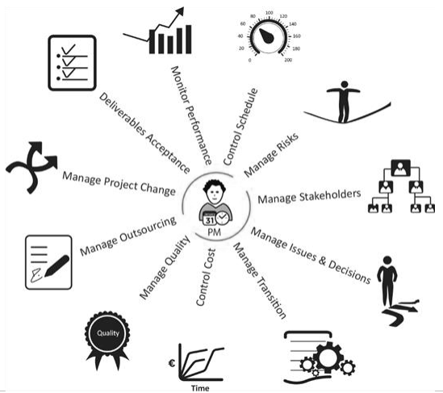

Figure 2-3: Monitor & Control activities (European Commission, 2023, 17)
2.2.3 Cultural Behaviors
In various societies, culture has a significant impact on how people view what makes for effective leadership. It is obvious that cultures have a significant impact on the many opinions and expectations that members of a society have about how things should be done. The findings demonstrate that the traits of successful leadership are more likely to correspond with the prevailing command and control paradigm in each culture independently (Jogulu & Wood, 2008), and our study acknowledges the impact of cultural factors on leadership effectiveness, particularly within the context of the construction sector in northern region of Iraq.
2.2.4 Quantitative and Qualitative Methods
To evaluate the connection between project outcomes and leadership styles, the study uses both quantitative (correlation, regression & one-way Anova analysis) and qualitative (interviews) methods, these theoretical frameworks guide the analysis of how different leadership styles can contribute to or detract from project management success, particularly in dynamic and challenging environments in the engineering construction sector in northern region of Iraq.

REFERENCES
Arabic References:
ادريس، عمار خيري سعيد. (2024). دراسة تحليلية لتأثير القيادة الإدارية على المشاريع التنموية. International Journal for Scientific Research، London، Vol (3) ، No (8).

نذير، حنان عبد الله. (2023). أثر تطبيق أساليب القيادة الموقفية على تحسين أداء المشاريع. Journal of Arts, Literature, Humanities and Social Sciences, (95) ، 159-203.

English References:
Abu Rumman, Sami Bashir. 2016. The Impact of Transformational Leadership on Crisis Management Preparedness. Jordanian Journal of Business Administration, 12(3), 713-729.

Adewuyi, A. S. (2023). RELATIONSHIP BETWEEN LEADERSHIP STYLE AND PROJECT SUCCESS. Retrieved from https://www.researchgate.net, June 2023, https://doi.org/10.13140/RG.2.2.12814.95042.

Ahmed, M. A., Naqi, S. M. A., & Cheema, S. M. (2023). Leadership styles and their influence on project team performance. sjesr, 6(2), 153-159.‏

Ali, M., & Rasheed, F. (2020). Transformational leadership and project success: The mediating role of effective-communication.‏ Retrieved from https://www.researchgate.net/publication/348168406.

Arora, M., & Baronikian, H. (2013). Leadership in Project Management (Second Edition). Leadership Publishing House.

Bilal, A., Siddiquei, A., Asadullah, M. A., Awan, H. M., & Asmi, F. (2021). Servant leadership: a new perspective to explore project leadership and team effectiveness. International Journal of Organizational Analysis, 29(3), 699-715.‏

Bonkoungou, W., Raisinghani, M. S., & Idemudia, E. C. (2022). A study of the impact of different styles of leadership on project quality performance: An empirical analysis. International Journal of Information Technology Project Management (IJITPM), 13(1), 1-14.‏

bt Zakaria, I. B., Mohamed, M. R. B., bt Ahzahar, N., bt Hashim, S. Z., & Iskandar, S. (2015). A study on leadership skills of project manager for a successful construction project. International Academic Research Journal of Social Science, 1(2).‏ 89-94.

Çizmeci, B. (2020). CHAPTER FIFTEEN DIGITAL LEADERSHIP. A Handbook of Leadership Styles. Cambridge Scholars Publishing, 351.‏

Demirtas, O., Karaca, M. (2020). A handbook of leadership styles. Cambridge Scholars Publishing.‏

Ekemezie, I. O., & Digitemie, W. N. (2024). Best practices in strategic project management across multinational corporations: a global perspective on success factors and challenges. International Journal of Management & Entrepreneurship Research, 6(3), 795-805.‏
European Commission. (2023). PM² Project Management Methodology Guide (Version 3.1). ISBN 978-92-68-10314-2. https://doi.org/10.2799/970188.

Fokina, O., Ivanovskaya, Z., Mottaeva, A., & Khubaev, A. (2023). The conceptual role of leadership in project management. In E3S Web of Conferences (Vol. 458, p. 04020). EDP Sciences.‏

Gandu, Y. J. (2018). ASSESSING IMPACT OF LEADERSHIP STYLES ON CONSTRUCTION PROJECTS OBJECTIVES. Retrieved from https://www.academia.edu/ 76325419.

Hadziahmetovic, N., Tandir, N., & Dzambić, A. (2023). A research review of leadership styles. International Journal of Academic Research in Economics and Management Sciences, 12(1), 188 – 206.

Hussain, M. (2018). Determinants of Leadership Styles on Project Performance. Retrieved from https://www.academia.edu/41925452, 2018.

Idris, J., Abdullah & Silahuddin. (2024). Innovative Leadership of Madrasah Aliyah Principals in Enhancing Educational Quality in Pidie, Aceh Province. Lentera Pendidikan: Jurnal Ilmu Tarbiyah dan Keguruan, 27(2), 300-318.‏

Institute of Project Management. (2022). Empowered Leaders, Empower Others [eBook]. Retrieved from https://www.instituteprojectmanagement.com.

Iqbal, S., & Hussain, S. M. (2022). The Impacts of Leadership Style on the Team Performance in The Construction Sector of Pakistan. Journal of Development and Social Sciences, 3(3), 727-733.‏

Jogulu, U., & Wood, G. (2008). Perceptions of effective leaders: cross cultural influences?. The International Journal of Knowledge, Culture, and Change Management, 8(1), 113–120.

Kariuki, J. T. (2018). The effect of project manager’s leadership style on performance of water projects in Kenya. European Scientific Journal, 14(17), 33-45.‏

Korakis, G., & Poulaki, I. (2025). A Systematic Literature Review on the Relationship Between Emotional Intelligence and Transformational Leadership—A Critical Approach. Businesses, 5(1), 4.‏

Lategan, T., & Fore, S. (2015). The impact of leadership styles on project success: case of a telecommunications company. Journal of Governance and Regulation, 4(3), 48-56.

LogiKal. (2020). 2020 Project Controls Survey Report. Retrieved from https://www.logikalprojects.com.

Malachowsky, S. A. (2018). Project team leadership and communication. Lintwood Press.‏

Mannaz. (2014). The business value of project leadership. Retrieved from https://www.mannaz.com.

Martin, H., & Edwards, K. I. S. A. (2016). The interaction between leadership styles and management level, and their impact on project success. Integrated solutions for infrastructure development, 3(2), 1-6.‏

Mbikoyezu, B. M., (2019). SITUATIONAL THEORY of MANAGEMENT. Retrieved from https://www.academia.edu/39766888.

Mgallah, M. (2024). Assessing the Impacts of Leadership Styles on the Success of Public Funded Projects in Tanzania. Retrieved from http://repository.out.ac.tz/id/eprint/4207.

Mičík, M. (2016). Leadership styles in project management.‏ Retrieved from https://www.researchgate.net/publication/318645991, 31 July 2018.

Mohamed, M., & Tran, D. Q. (2023). Exploring the relationships between project complexity and quality management approaches in highway construction projects. Transportation Research Record, 2677(5), 390-402.‏

Monika, M., Pradip, P., Rishikesh, P., & Bhagatsing, R. (2016). STUDY OF THE LEADERSHIP SKILL IN CONSTRUCTION PROJECT. International Journal of Science, Technology and Management. 5(3), 507-517.

Nawaz, K., Usman, M., Mulk, W. U., Ahmad, Z., & Shahzad, H. (2022). Impact of authoritarian leadership on employee performance and job role clarity. by moderating role of power distance. (In project line base company). Journal of Human Resource and Sustainability Studies, 10(3), 485-502.‏
Paradise, L. V., Ceballos, P. T., & Hall, S. (2010). Leadership and leader behavior in counseling: Neglected skills. International Journal for the Advancement of Counselling, 32, 46-55.‏

Renzi, T. M. (2020). The effect of leadership styles on project implementation. Open Journal of Leadership, 9(04), 198.‏

Sahasrabuddhe, S. S. (2024). The Role of Leadership in Project Success: A Case Study on Technology Implementation Projects.‏

Siddiqui, A. W., Ali, A., & Shaukat, M. B. (2023). Impact of Agile Project Management Methodology on IT Project Success: Exploring the Mediating role of Team Communication and Team Empowerment. City University Research Journal (CURJ), 13(2).‏

Wang, Z., Liu, Y., & Liu, S. (2019). Authoritarian leadership and task performance: the effects of leader-member exchange and dependence on leader. Frontiers of Business Research in China, 13, 1-15.‏

Wulansari, R., Setyowati, E. W., & Suryo, E. A. (2019). Analysis of the Influence of Project Manager’s Leadership Style on Human Resource Performance and Project Success.‏ International Research Journal of Advanced Engineering and Science, 4(2), 281–286.

Xiangxing, T., & Musonda, J. (2021). The Styles of Leadership and Project Success Relationship in the Construction Industry of Zambia. International Journal of Sciences, 10(06), 16-21.‏

