

A Comparative Study of Fake News Detection Using Machine Learning, Deep Learning, and Large Language Models

Prepared By :

Name: Rayan Shukri ID No.: 251000636
Name: Sultan Hassan ID No.: 251002896

Submitted in fulfillment of the requirements for the degree Master of Science in Artificial
Intelligence At College of Informatics Midocean University , UAE

Supervisor Name: Wesam Ahmed
College of Informatics, Midocean University
Email: wesamahmed@midocean.edu.km

Chapter 1: Introduction ............................................................................... 4
- 1.1 Background .......................................................................................... 4
  - Rise of the Digital Age .................................................................................. 4
  - Definition and Threat of Fake News ............................................................ 4
  - Role of AI and NLP in Combating Fake News ............................................ 5
- 1.2 Problem Statement ............................................................................. 5
- 1.3 Research Objectives ........................................................................... 6
- 1.4 Research Contributions 6
- 1.5 Organization of the Thesis ................................................................ 7

Chapter 2: Overview ................................................................................... 8
- 2.1 Introduction ......................................................................................... 8
- 2.2 Nature and Impact of Fake News ....................................................... 9
  - Political Impact ............................................................................................ 9
  - Public Health Risks .................................................................................... 10
  - Social and Economic Implications ............................................................. 10
- 2.3 Characteristics of Fake News Datasets ............................................. 10
  - News Article Datasets (e.g., Kaggle Fake/Real News) .............................. 10
  - Social Media Datasets (e.g., LIAR, BuzzFeedNews) ................................. 11
  - Labeling Sources and Reliability ................................................................. 11
  - Metadata and Contextual Features .............................................................. 11
- 2.4 Machine Learning for Fake News Detection .................................. 11
  - Naive Bayes Classifier ................................................................................. 12
  - Support Vector Machines (SVM) ............................................................... 13
  - Advantages and Limitations of ML ............................................................ 13
- 2.5 Deep Learning in Fake News Detection .......................................... 14
  - Recurrent Neural Networks (RNN) ........................................................... 15
  - Long Short-Term Memory Networks (LSTM) ........................................... 16
  - Convolutional Neural Networks (CNN) .................................................... 16
  - Hybrid Deep Learning Architectures ......................................................... 17
  - Strengths and Challenges of DL ................................................................. 18
- 2.6 Role of Large Language Models (LLMs) ......................................... 18
  - Pretraining and Transfer Learning ............................................................. 19
  - Contextual Awareness and Semantics ....................................................... 19
  - Limitations: Bias, Interpretability, Computational Costs .......................... 19
- 2.7 Comparative Summary of ML, DL, and LLM Approaches ............ 20
- 2.8 Evaluation Metrics ............................................................................. 21
  - Confusion Matrix ........................................................................................ 22
  - Accuracy, Precision, Recall, and F1-score .................................................. 23
  - ROC-AUC and PR-AUC ............................................................................. 23
- 2.9 Chapter Summary .............................................................................. 24

Chapter 3: Related Work ........................................................................... 25
- 3.1 Machine Learning–Based Approaches ............................................ 25
  - Hansrajh et al. (2021) – Blending Ensemble .............................................. 25
  - Alghamdi et al. (2022) – ML vs DL Comparative Study .......................... 26
  - Kuntur et al. (2024) – GNNs vs Transformers ............................................ 26
- 3.2 Deep Learning–Based Approaches .................................................. 26
  - Gundapu & Mamidi (2021) – Transformer Ensemble for COVID-19 ...... 26
  - Singhania et al. (2023) – Hierarchical Attention Network (3HAN) .......... 27
  - Ajik et al. (2023) – CNN + LSTM Hybrid .................................................. 28
  - Shaker & Alqudsi (2024) – Arabic Text-CNN ........................................... 28
- 3.3 Transformer-Based Approaches (LLMs) ......................................... 27
  - Huang et al. (2025) – Hybrid Transformer + BiGRU ................................ 28
  - Li et al. (2022) – HetTransformer with Multi-modal Input ....................... 29
- 3.4 Summary Table of Related Work ..................................................... 29
- 3.5 Chapter Summary .............................................................................. 30

References ................................................................................................ 56

Chapter 1: Introduction

1.1 Background
The digital revolution has brought about a profound transformation in how information is accessed and shared. Traditional news organizations are no longer the sole gatekeepers determining what reaches the public; they have been largely replaced by digital platforms that allow anyone to publish content instantly. While this shift has broadened access to information, it has also created fertile ground for the rapid and widespread dissemination of false or misleading content, commonly referred to as fake news. Recent studies indicate that machine learning (ML) and natural language processing (NLP) technologies have become essential tools for combating this phenomenon and strengthening trust in news sources [1].
Fake news is defined as fabricated or misleading information presented in a form that mimics legitimate news, often produced to influence public opinion, attract attention, or serve political or financial interests. Its danger lies in its ability to replicate the credible style of authentic reporting, making it difficult for readers to distinguish between true and false information. Social media platforms such as Facebook, Twitter (X), and YouTube play a central role in amplifying this problem through algorithms that favor sensational and emotionally charged content regardless of accuracy, thereby accelerating the spread of misinformation [2].
The risks posed by fake news became especially evident during the COVID-19 pandemic, when false health claims, conspiracy theories, and unverified treatments circulated widely. This had tangible negative consequences, including vaccine hesitancy and non-compliance with public health measures. A recent 2025 study published in JMIR demonstrated that deep learning models combined with fuzzy-rank ensemble techniques are highly effective at detecting such misinformation, even as its forms evolve [3].

In response to these challenges, researchers have increasingly turned to artificial intelligence (AI) and NLP to develop systems capable of analyzing and classifying online news content. Transformer-based models such as BERT and CT-BERT, when integrated with advanced architectures like Convolutional Neural Networks (CNN) or Bidirectional Gated Recurrent Units (BiGRU), have shown outstanding performance, with some models achieving F1 scores exceeding 98% in fake news detection tasks [4].
Fake news is not a new concept. Propaganda and misinformation have existed throughout history. What has changed in recent years is the scale, speed, and reach of disinformation campaigns. In the past, misinformation was largely limited by geography and media distribution channels. Today, a single tweet or headline can go viral within minutes, reaching millions of users before it is ever questioned or corrected.
Social media algorithms that prioritize engagement over accuracy have played a critical role in amplifying fake news. These algorithms are designed to keep users on platforms for longer periods, and as a result, they often promote content that is shocking, emotional, or polarizing—characteristics commonly found in fake news stories [5].

1.2 Problem Statement
The rapid growth of online misinformation has led to the development of numerous artificial intelligence (AI) models for fake news detection. These models range from traditional machine learning algorithms to advanced deep learning architectures and large language models (LLMs). While many of these techniques have shown promising results individually, there is a lack of comprehensive studies that directly compare their performance using a consistent set of datasets and evaluation criteria.
Most existing research tends to focus on one approach in isolation, making it difficult to determine which type of model is more effective across different fake news detection scenarios. Furthermore, variations in experimental setups—such as data preprocessing, feature selection, and performance metrics—make it challenging to replicate findings or generalize results across studies.
This thesis seeks to address this gap by conducting a controlled comparative study of machine learning, deep learning, and transformer-based language models. The research aims to assess the relative strengths and limitations of each paradigm. The study does not involve the deployment of a detection system but focuses on providing empirical evidence to support model selection in academic and applied settings.

1.3 Research Objectives
This study aims to explore and compare three major AI paradigms—Machine Learning (ML), Deep Learning (DL), and Large Language Models (LLMs)—for the task of fake news detection. It will evaluate representative models from each category using shared benchmark datasets to systematically analyze their strengths, weaknesses, and overall effectiveness in this critical application area.

1.4 Research Contributions:
This study is guided by the following Contributions:
- To implement and evaluate selected machine learning, deep learning, and large language models for the task of fake news detection.
- To apply all models to the same set of labeled datasets and compare their results using standard performance metrics such as accuracy, precision, recall, and F1-score.
- To analyze the strengths and weaknesses of each approach in terms of performance, robustness, and generalizability.
- To present findings that support future research and practical development in automated fake news detection.
This study addresses the growing challenge of fake news by comparing three key AI approaches—machine learning (ML), deep learning (DL), and large language models (LLMs)—under a unified framework. Unlike prior research that treats these models separately, this work offers a structured, side-by-side evaluation using consistent datasets and metrics. The findings provide valuable insights for researchers and practitioners in selecting appropriate models based on task requirements, accuracy, and computational efficiency. The study also contributes to literature on LLMs by assessing their performance relative to traditional methods, ultimately supporting the development of more effective fake news detection systems and promoting information reliability online.

1.5 Organization of the Thesis
This thesis is organized into six chapters, including the current chapter:
- Chapter 2 discusses the background of fake news, characteristics of datasets, and the AI paradigms used.
- Chapter 3 reviews previous research and methodologies in fake news detection.
- Chapter 4 describes the selected models, datasets, and experimental setup.
- Chapter 5 presents and interprets the results of the experiments.
- Chapter 6 summarizes the findings and proposes directions for future research.

Chapter 2: Overview

This chapter provides an overview of fake news as a phenomenon and introduces the three main AI paradigms explored in this study: machine learning (ML), deep learning (DL), and large language models (LLMs). It also discusses the datasets used in fake news research, the unique contributions of each modeling approach, and the comparative context that guides this thesis. The goal is to establish a foundational understanding of how each method works and why a comparative evaluation is both necessary and timely.

2.1 Introduction
Fake news has become a pressing issue in the digital age, with serious implications for politics, public health, and societal trust. The spread of false information is no longer confined to fringe platforms or isolated communities; it now reaches millions within minutes through social media algorithms that amplify sensational content. In response, researchers have turned to artificial intelligence (AI) to develop automated systems that can detect and mitigate the spread of fake news efficiently and at scale. These systems aim to analyze textual patterns, linguistic features, and contextual signals to classify news content as reliable or deceptive. By automating the detection process, AI-driven tools offer a scalable solution that can support human fact-checkers and help reduce the harmful impact of misinformation across digital platforms.
Transformer-based language models, such as BERT and RoBERTa, have demonstrated strong performance in fake news detection due to their ability to model contextual relationships in text. For example, Singhania et al. proposed a hierarchical attention model that captures both word-level and sentence-level semantics, leading to significant improvements in classification accuracy [6]. Additionally, hybrid architectures that combine transformers with sequential models such as recurrent layers further improve the detection of deceptive patterns in longer texts [7]. While these methods show great promise, they also raise concerns regarding fairness, interpretability, and the substantial computational resources they require, which must be considered for real-world deployment [8].

2.2 Nature and Impact of Fake News
Fake news refers to fabricated or intentionally misleading information that is presented as legitimate news. It is often designed to provoke emotional reactions, manipulate public opinion, or generate financial gain through advertising and clickbait. Unlike satire or accidental misinformation, fake news is deliberately deceptive and often crafted to resemble authentic journalism, making it difficult for readers to distinguish between truth and falsehood.
The impact of fake news is substantial and multifaceted. In the political sphere, false stories have been shown to influence voter behavior, distort democratic discourse, and erode trust in public institutions [9]. In public health, fake news can lead to dangerous behaviors, such as vaccine refusal or the adoption of unproven medical treatments [10]. During the COVID-19 pandemic, for example, the World Health Organization described the spread of misinformation as an "infodemic"—a parallel crisis that worsened the pandemic by spreading fear, confusion, and resistance to scientific guidance. This misinformation undermined public compliance with health measures, delayed vaccination efforts, and contributed to the global health crisis. Similar patterns have been observed in other domains, where fake news has fueled social unrest, economic uncertainty, and international tensions. These consequences highlight the urgent need for effective and scalable solutions to detect and prevent the spread of false information online.
The emotional appeal and rapid shareability of fake news contribute to its virality. Research shows that false information spreads faster and reaches more people than factual content, particularly on platforms like Twitter [11]. This is due in part to the human tendency to share surprising or emotionally charged content, but also to algorithmic systems that prioritize engagement over accuracy. These dynamics make fake news not only a technological problem but also a social and psychological one.
Because of these high stakes, there is a growing consensus that manual moderation and fact-checking are insufficient on their own. Automated detection methods powered by AI offer a promising alternative, especially when they can operate at scale and adapt to new forms of misinformation. In the sections that follow, we will explore how machine learning, deep learning, and large language models are used to tackle this challenge.

2.3 Characteristics of Fake News Datasets
Effective fake news detection relies heavily on the quality and structure of the datasets used during training and evaluation. These datasets typically consist of labeled news articles or social media posts classified as either “fake” or “real.” The quality of the labels, the diversity of topics, and the language structure all influence the model’s ability to generalize across different scenarios.
Most fake news datasets used in research fall into two broad categories: news article datasets and social media datasets. News article datasets, such as the Fake and Real News Dataset from Kaggle, often include full-length articles from both reliable and unreliable news sources. These datasets offer rich linguistic and structural information, allowing models to learn patterns of credibility from text style, grammar, and topic coverage. Social media datasets, like LIAR and BuzzFeedNews, contain shorter text snippets such as tweets, headlines, or user-generated posts. These texts are typically more informal, lack context, and are constrained by character limits, making them more challenging for classification. However, they more accurately reflect the type of content users engage with daily on platforms like Twitter and Facebook. Each type of dataset presents unique challenges and advantages, and the choice between them can significantly affect the performance and generalizability of fake news detection models.
Another important characteristic is the source of labeling. In some datasets, labels are assigned manually by professional fact-checkers or sourced from third-party fact-checking organizations (e.g., PolitiFact, Snopes). Other datasets use heuristics based on domain reputation, such as marking all articles from certain domains as "fake" or "real." The reliability of labels significantly affects the trustworthiness of any evaluation results [12].
In addition to labels and text, some datasets also provide metadata such as author name, publication date, number of shares, and platform interactions. These features can be valuable for machine learning models that consider contextual signals beyond raw text. However, metadata availability varies widely between datasets, and not all models can effectively utilize such structured information.
For this study, datasets have been provided by the supervising professor and are assumed to include balanced and clearly labeled samples suitable for direct comparison across different modeling techniques. All preprocessing steps, including tokenization, lowercasing, and stop-word removal, will be applied uniformly to ensure consistency across experiments.

2.4 Machine Learning for Fake News Detection
Machine learning (ML) offers one of the earliest approaches to automated fake news detection. Traditional ML algorithms operate by transforming raw text into a structured set of features and applying statistical learning techniques to classify news content. These models typically require significant feature engineering but offer interpretability and efficiency.
Commonly used ML algorithms in fake news detection include Naive Bayes, Support Vector Machines (SVM), Logistic Regression, and Random Forests. These models rely on features such as bag-of-words (BoW), term frequency-inverse document frequency (TF-IDF), and n-gram representations to capture the textual characteristics of news articles. The simplicity of these representations allows the models to identify patterns in word usage and frequency that are often indicative of deceptive writing [13].
A major advantage of machine learning models is their speed and low computational cost. They are well-suited for environments where processing power is limited or real-time decisions are required. Moreover, their predictions can often be interpreted more easily than those of deep learning or transformer-based models, which is an important consideration in high-stakes applications where transparency is critical.
However, ML approaches have limitations. They may struggle to capture complex linguistic patterns, contextual nuances, and semantic relationships that are essential for understanding deceptive content. Because they rely heavily on surface-level features, their performance may degrade when applied to unfamiliar topics or writing styles.
Despite these drawbacks, ML models continue to serve as strong baselines in fake news detection tasks and are frequently used in comparative studies due to their simplicity, reliability, and effectiveness in certain scenarios.

Naive Bayes Classifier
Naive Bayes is a probabilistic classification technique based on Bayes’ Theorem, assuming conditional independence among features[15]. Despite this simplifying assumption, it performs remarkably well on text classification tasks such as fake news detection—especially when paired with TF-IDF or n-gram features as shown in Fig. 2.1.
.
It calculates the posterior probability of a class given the features (e.g., tokens from the article):
$$P\left(C_{k} ∣ x_{1},x_{2},…,x_{n}\right)∝P\left(C_{k}\right)\prod_{i=1}^{n}{P\left(x_{i} ∣ C_{k}\right)}$$
Naive Bayes offers several advantages:
- Requires little training data,
- Scales well with high-dimensional inputs,
- Yields interpretable probabilities.

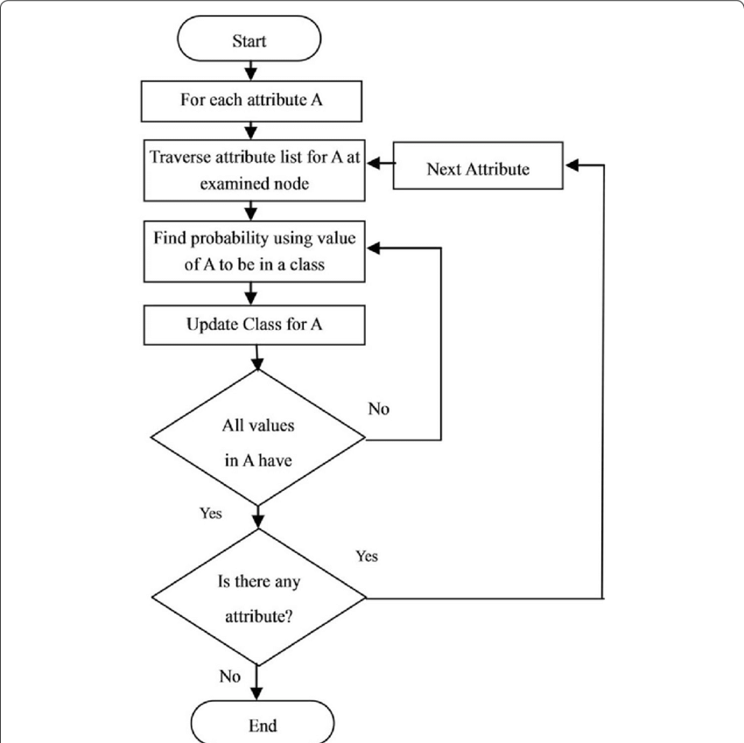
Figure 2.1. Flow chart for Naïve Bayes classification [15].

Support Vector Machines (SVM)
SVM is a supervised learning model that finds the optimal hyperplane separating different classes in a high-dimensional space[16]. It's well-suited to fake news detection due to its robustness with sparse data (e.g., TF-IDF) and strong generalization capability as shown in Fig. 2.2.
The core idea is to:
- Maximize the margin between support vectors of each class,
- Minimize misclassification,
- Handle both linear and non-linear boundaries through kernel functions.
For binary classification, the SVM seeks to solve the following optimization problem:

$$\min_{w,b,ξ}{\frac{1}{2}}|w|^{2}+C\sum_{i=1}^{n}{ξ_{i}}$$

$$y_{i}\left(w^{T}x_{i}+b\right)≥1-ξ_{i}, ξ_{i}≥0$$

Where:
- xᵢ ∈ ℝᵈ are feature vectors,
- yᵢ ∈ {−1, +1} are class labels,
- C is the regularization parameter,
- ξᵢ are slack variables allowing misclassifications.
Kernel functions (e.g., RBF) can be used when data is not linearly separable:

$$K\left(x_{i},x_{j}\right)=\exp\left(-γ|x_{i}-x_{j}|^{2}\right)$$

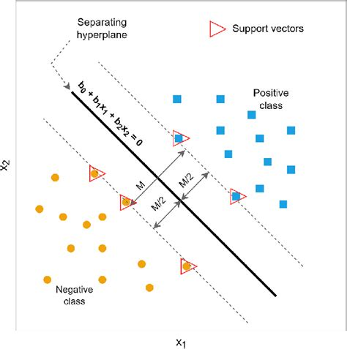
Figure 2.2. Illustration of SVM decision boundary separating two classes with maximum margin [17].

2.5 Deep Learning in Fake News Detection
Deep learning (DL) has emerged as a transformative approach in natural language processing (NLP), allowing models to automatically learn intricate linguistic patterns from unstructured text data. Unlike traditional machine learning techniques, which often rely on manually engineered features, deep learning models can discover hierarchical representations of language directly from raw input. This ability is particularly valuable in fake news detection, where linguistic deception can take subtle and complex forms. As online misinformation becomes increasingly sophisticated and widespread, DL-based models are gaining traction due to their superior performance in identifying misleading content, especially when trained on large, diverse datasets across domains and languages.

Recurrent Neural Networks (RNN)
Recurrent Neural Networks (RNNs) are a class of neural networks tailored for sequential data processing. Unlike feedforward networks, RNNs maintain a dynamic internal state through feedback loops that connect neurons across time steps. This enables them to model temporal dependencies in language, making them suitable for analyzing the structure and progression of written text. In fake news detection, RNNs can track shifts in tone, sentiment, and rhetorical structure that may indicate deceptive intent. However, standard RNNs face challenges when dealing with long sequences due to vanishing or exploding gradient issues, which limits their capacity to retain distant contextual information as shown in Fig. 2.3.
.

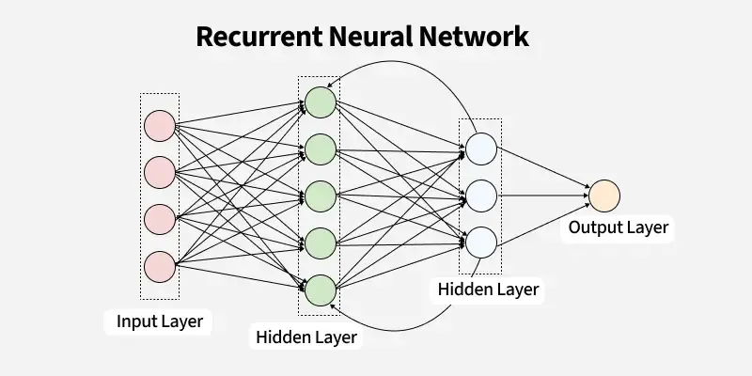
Figure. 2.3 Basic architecture of a Recurrent Neural Network (RNN)

Long Short-Term Memory Networks (LSTM)
Long Short-Term Memory (LSTM) networks were developed to overcome the shortcomings of traditional RNNs . They introduce a more sophisticated memory cell mechanism that includes three gates—input, forget, and output—to regulate information flow as shown in Fig. 2.4. The forget gate discards irrelevant past information, the input gate updates the memory cell with new data, and the output gate determines the visible output at each time step. These mechanisms enable LSTMs to retain relevant long-term dependencies and selectively forget less useful patterns, which is critical for understanding context in fake news articles. For instance, deceptive narratives often unfold over several sentences, and LSTMs are capable of maintaining coherence in such cases. Bidirectional LSTMs (Bi-LSTM), which analyze data in both forward and backward directions, further improve context sensitivity, leading to enhanced performance in text-based fake news detection tasks [18].

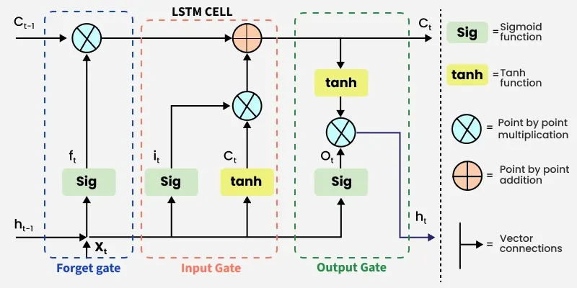
Figure. 2.4 Architecture of an LSTM cell with gates and memory flow

Convolutional Neural Networks (CNN)
Convolutional Neural Networks (CNNs), originally developed for image recognition, have been effectively repurposed for processing textual data. In the domain of fake news detection, CNNs slide one-dimensional convolutional filters over sequences of word embeddings to detect local textual patterns—such as distinctive phrases or stylistic cues—that help differentiate deceptive from credible content. These filters learn meaningful features automatically, eliminating the need for manual feature engineering.
After filtering, pooling layers (e.g., max pooling) condense these features, emphasizing the most informative signals and reducing the overall dimension of the representation. This approach enhances computational efficiency and often supports better generalization. The compressed feature maps are then fed into fully connected layers, which integrate the extracted features and produce the final classification output as shown in Fig. 2.5. Thanks to their parallelism and relatively lightweight structure, CNNs are highly efficient and scalable—qualities that make them suitable for real-time fake news detection pipelines [19].

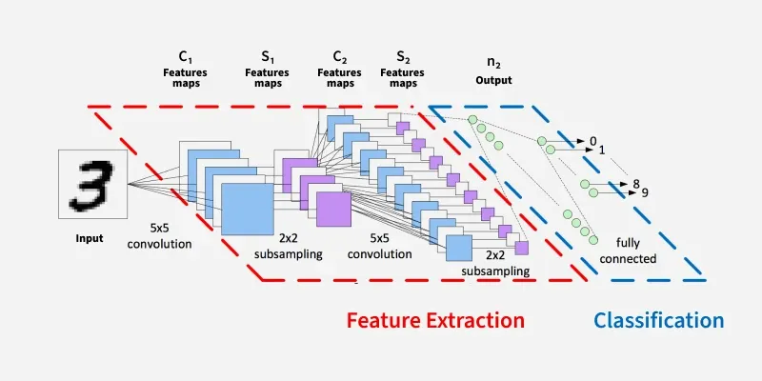
Figure. 2.5 CNN architecture for text classification

Hybrid Deep Learning Architectures
To leverage the complementary strengths of CNNs and LSTMs, hybrid architectures have been proposed. In a typical CNN-LSTM model, convolutional layers are used first to extract high-level n-gram features from the input text. These localized features are then fed into LSTM layers to capture their temporal dependencies and contextual dynamics. This architecture allows the model to simultaneously recognize fine-grained textual patterns and model their sequential evolution, improving detection accuracy. Research has shown that such hybrid models outperform pure CNN or LSTM models, particularly on multilingual and noisy datasets often encountered on social media [20].

Strengths and Challenges of DL in Fake News Detection
Deep learning brings powerful advantages to fake news detection. It excels at modeling complex, non-linear relationships in text and generalizes well across domains such as politics, health, and finance. Furthermore, pretrained models can be fine-tuned to adapt to new topics or languages even with limited data. On the flip side, these models have notable drawbacks: they often require substantial labeled datasets, demand considerable computational resources, and their decision-making processes are opaque, complicating issues of interpretability and accountability—an especially relevant concern in domains like journalism or law. Nonetheless, deep learning continues to be a leading and rapidly evolving force in fake news detection research [21].

2.6 Role of Large Language Models in Fake News Detection
Large Language Models (LLMs) represent a recent and transformative advancement in the field of natural language processing. These models—such as BERT (Bidirectional Encoder Representations from Transformers), RoBERTa (Robustly Optimized BERT), and GPT (Generative Pre-trained Transformer)—are built on the transformer architecture, which allows them to process language with unprecedented levels of contextual understanding and semantic depth [22].
Unlike traditional machine learning or earlier deep learning models, LLMs are pre-trained on vast corpora of text data and then fine-tuned on specific tasks such as classification, summarization, or question answering. This two-stage training process enables them to transfer linguistic knowledge from a general domain to a specialized one, such as fake news detection, with impressive results.
In fake news detection, LLMs offer several advantages:
- Contextual awareness: LLMs can understand the meaning of a word or sentence based on the broader context, which is essential when evaluating the subtle cues that differentiate fake from real news.
- Minimal feature engineering: These models work directly with raw text inputs, eliminating the need for extensive preprocessing or manual feature extraction.
- Transfer learning capabilities: Pre-trained models can be quickly adapted to new domains or languages, which is particularly useful given the evolving nature of misinformation.
For example, BERT-based models have been fine-tuned on datasets like LIAR and FakeNewsNet and have consistently outperformed classical models in terms of accuracy and F1-score. Studies have shown that LLMs are able to detect nuanced linguistic features such as sarcasm, ambiguity, and rhetorical devices that are often employed in misleading content [23].
Despite their power, LLMs also have limitations. They are computationally intensive, requiring significant hardware resources for both training and inference. In addition, their large size and complex internal mechanisms often result in reduced interpretability, making it difficult to understand why a particular prediction was made. This lack of transparency raises concerns in high-stakes domains like journalism or public health, where explainability is critical.
Furthermore, LLMs are trained on public internet data, which may contain biases, stereotypes, or even misinformation. As a result, they can inadvertently reproduce or amplify these issues unless carefully managed during training and deployment.
Nevertheless, the performance gains offered by LLMs make them a highly attractive option for fake news detection, especially when accuracy is a top priority and computational resources are available. In this thesis, LLMs will be evaluated alongside machine learning and deep learning models to assess their relative effectiveness and practicality for real-world fake news detection scenarios.

2.7 Comparative Summary of the Three Approaches
Machine learning, deep learning, and large language models each offer unique strengths and trade-offs when applied to the task of fake news detection. A comparative summary of these approaches helps clarify their relative suitability for different use cases.
Machine learning models such as Naive Bayes, Support Vector Machines, and Logistic Regression are lightweight, interpretable, and easy to implement. They rely on manually engineered features like term frequency and n-grams, making them fast to train and deploy. These models perform reasonably well on small to medium-sized datasets and provide transparency in decision-making. However, their ability to understand complex linguistic nuances is limited, which can affect accuracy, especially when dealing with more subtle forms of misinformation.
Deep learning models, including LSTMs and CNNs, improve upon machine learning by automatically learning hierarchical representations of text. They are better equipped to capture contextual and sequential information, making them more accurate on longer and more complex inputs. These models tend to perform better than traditional approaches on larger datasets and can generalize more effectively. However, they require significantly more data, computational resources, and time to train. Their internal mechanisms are also more complex and opaque, which makes it difficult to interpret how decisions are made or what features the model is relying on. This lack of transparency can be a disadvantage in applications where explainability and accountability are important, such as journalism, legal domains, or public health communication.
Large language models push the boundaries further by leveraging pre-trained contextual embeddings and attention mechanisms. They achieve state-of-the-art performance on many NLP tasks, including fake news detection, even with limited task-specific data. LLMs such as BERT, RoBERTa, and GPT can grasp semantic relationships, rhetorical devices, and subtle cues in language that other models might miss. Their major disadvantages lie in their computational demands, potential bias, and limited explainability.
Each approach offers different advantages depending on the constraints of the application domain. For example, machine learning may be preferred in real-time or resource-limited environments, while deep learning and LLMs are better suited for high-accuracy applications where computational capacity is available. By comparing these methods under uniform conditions using shared datasets and evaluation metrics, this thesis aims to highlight the practical implications of model choice in real-world fake news detection systems as shown in Table 2.1.

Table 2.1. Comparison between different models
Feature / Aspect | Machine Learning (ML) | Deep Learning (DL) | Large Language Models (LLMs)
Feature Engineering | Required (manual) | Automatic (with embeddings) | Not required (contextual embeddings)
Context Understanding | Low | Moderate | High
Data Requirements | Low to Moderate | High | Very High (pre-training)
Computational Cost | Low | Moderate | High
Interpretability | High | Moderate | Low
Generalization Capability | Limited | Good | Excellent
Performance on Benchmarks | Baseline | Strong | State-of-the-art

2.8 Evaluation Metrics
Given the class imbalance characteristic of fake-news classification tasks, this study combines threshold-based metrics with threshold-independent and ranking metrics to deliver a well-rounded evaluation. Specifically, this study reports accuracy, precision, recall, F1-score, ROC-AUC, PR-AUC, and the confusion matrix in line with current best practices in the field [24 , 25].
- Confusion Matrix
A confusion matrix is a widely used evaluation tool in classification tasks that provides a comprehensive view of a model’s performance by comparing predicted labels with actual ground truth labels. It is represented as a square matrix, where rows correspond to the actual classes and columns correspond to the predicted classes.
For binary classification, the confusion matrix typically contains four key components:
- True Positives (TP): Instances correctly predicted as belonging to the positive class.
- True Negatives (TN): Instances correctly predicted as belonging to the negative class.
- False Positives (FP): Instances incorrectly predicted as positive when they actually belong to the negative class.
- False Negatives (FN): Instances incorrectly predicted as negative when they actually belong to the positive class.
This matrix is particularly useful because it goes beyond simple accuracy and allows the calculation of multiple evaluation metrics, such as accuracy, precision, recall, and F1-score, which provide a more nuanced understanding of model performance. For example, in fake news detection, the confusion matrix can reveal whether the model is biased toward labeling most news articles as real (leading to high false negatives) or fake (leading to high false positives).
In multi-class classification problems, the confusion matrix extends naturally, with each row and column representing one of the classes. This allows researchers to identify specific classes where the model struggles and provides deeper insight into model behavior.
- Accuracy
$$\text{Accuracy}=\frac{TP+TN}{TP+TN+FP+FN}$$
Offers a general measure of predictive correctness but can be misleading when data are imbalanced.

- Precision
$$\text{Precision}=\frac{TP}{TP+FP}$$
Important to minimize false positives, such as incorrectly labeling real news as fake.
- Recall (Sensitivity)
$$\text{Recall}=\frac{TP}{TP+FN}$$
Emphasized when the consequences of missing fake news (false negatives) are high.

- F1-Score
$$\text{F1}=2⋅\frac{\text{Precision}⋅\text{Recall}}{\text{Precision}+\text{Recall}}$$
A balanced metric combining precision and recall—particularly useful when data are imbalanced.

- ROC-AUC
Reflects the model’s ranking ability across thresholds and measures discrimination
performance; remains informative even in imbalanced settings.
By combining these metrics, this research ensures a balanced and transparent evaluation of model performance, aligning with current best practices in machine learning and fake-news detection [24, 25].

2.9 Chapter Summary
This chapter presented a comprehensive overview of fake news as a digital-age phenomenon and the artificial intelligence approaches used to detect it. The rise of fake news has been fueled by social media algorithms and online engagement patterns, amplifying false or misleading content with significant consequences for politics, public health, and societal trust. We explored the types and characteristics of datasets used for fake news detection, noting that the quality of labels, text content, and metadata can greatly influence model performance. The chapter then examined three major AI paradigms used in this field: traditional machine learning, deep learning, and large language models.
Machine learning models offer simplicity, speed, and transparency but rely heavily on manual feature engineering and lack deep contextual understanding. Deep learning models, particularly LSTMs and CNNs, address some of these limitations by learning from sequences and hierarchical structures in the text, offering improved accuracy at the cost of higher computational demands and lower interpretability. Large language models such as BERT, RoBERTa, and GPT represent the most advanced AI approach, capable of capturing nuanced semantics and contextual relationships across a wide range of topics. They deliver state-of-the-art performance but require substantial resources and present new challenges in interpretability and bias. The comparative summary highlighted how each technique varies in terms of efficiency, scalability, and performance. These insights lay the foundation for the next chapter, which will review related work and existing literature to position this thesis within the broader research landscape.

Chapter 3: Related Work

The purpose of this chapter is to review prior work related to fake news detection using artificial intelligence techniques. The chapter is organized into three primary categories: machine learning-based approaches, deep learning-based approaches, and transformer-based large language models (LLMs). The goal is to understand the evolution of methods used to tackle fake news detection and to highlight gaps that this research aims to address.

3.1 Machine Learning-Based Approaches
Traditional machine learning methods have been widely applied in fake news detection due to their simplicity and interpretability. These models typically rely on feature extraction techniques such as TF-IDF and Bag-of-Words, and are well-suited for structured textual datasets. This section highlights four recent studies that implemented and evaluated ML models on publicly available datasets.

Hansrajh et al. [25] proposed a blending ensemble framework combining logistic regression, SVM, linear discriminant analysis, SGD, and ridge regression for fake news detection. The model was evaluated on LIAR (short political statements) and ISOT (long-form news articles) datasets. Results showed the ensemble achieved higher accuracy and F1-scores than individual classifiers, with strong performance on ISOT (F1 = 0.984, Accuracy = 0.985). While the approach improved robustness and generalizability, limitations were noted in handling short claims lacking contextual and social signals. The study highlighted the effectiveness of ensemble strategies for long, content-rich articles.
Alghamdi et al. [26] conducted a comparative study of multiple machine learning (ML) and deep learning (DL) methods for fake news detection. The study evaluated models on benchmark datasets, including LIAR and ISOT, applying a wide range of classifiers such as logistic regression, random forest, gradient boosting, CNNs, and LSTMs. Results showed that deep learning models, particularly LSTM-based architectures, consistently outperformed traditional ML models, with LSTM achieving the highest accuracy (up to 99% on ISOT). The authors highlighted that DL methods capture contextual and semantic nuances better, while ML approaches remain faster and computationally cheaper. Limitations included the reliance on text-only features without integrating social context or multimedia cues.
Kuntur et al. [27] conducted a comparative study of graph neural networks (GCNs, GraphSAGE, GAT) and transformer-based models (BERT, RoBERTa, GPT-2) for fake news detection using the ISOT, FakeNewsNet, and WELFake datasets. The results showed that transformers significantly outperformed GNNs, with RoBERTa achieving 99.99% accuracy on ISOT and 86.16% on FakeNewsNet, while GPT-2 reached 99.72% on WELFake. In contrast, GNNs produced weaker performance, ranging between 50–70%. The study highlighted the robustness and superiority of transformer architectures but also noted limited generalizability of GNNs and dataset-specific challenges.

3.2 Deep Learning-Based Approaches
Deep learning models are known for their ability to capture complex linguistic patterns through hierarchical feature extraction and contextual representation. This section reviews four recent studies that employed deep neural architectures for fake news detection.

Aslam et al. [28] proposed an ensemble-based deep learning model for fake news detection using the LIAR benchmark dataset. Their approach combined a Bi-LSTM–GRU architecture for textual statements with a dense neural network for metadata attributes. Experimental results demonstrated that the textual model alone achieved the best performance, with an accuracy of 89.8%, precision of 91.3%, recall of 91.6%, and F1-score of 91.4%. The ensemble outperformed previous machine learning and deep learning studies on the same dataset, where accuracies typically ranged between 27% and 65%. However, the authors noted that integrating additional metadata features sometimes degraded performance, and the study was limited to the LIAR dataset, leaving its generalizability to other domains untested.

Singhania et al. [29] introduced 3HAN, a hierarchical attention-based deep neural network designed for fake news detection. The model applies attention at the word, sentence, and document levels, allowing it to capture context across varying text lengths. Evaluated on the LIAR and ISOT datasets, 3HAN achieved accuracies of 0.84 and 0.93, respectively, outperforming baseline ML and DL models such as CNNs and BiLSTMs. The hierarchical attention mechanism not only improved detection performance but also provided interpretability by highlighting influential words and sentences. However, the model depends heavily on large labeled datasets and incurs higher computational costs, which can limit scalability across domains.

Ajik et al. [30] proposed an optimized hybrid deep learning framework combining CNN and LSTM for fake news detection. The model leveraged CNN for feature extraction and LSTM for contextual sequence learning, achieving superior accuracy compared to traditional baselines. The study emphasized the importance of deep feature integration for handling complex text semantics in fake news classification.

Shaker and Alqudsi [31] eveloped a Text-CNN deep learning model for Arabic fake news detection using both a translated English dataset and an Arabic Facebook/news dataset. Their approach achieved very high results (Accuracy 99.67%, F1-score 99.50), showing CNNs outperform traditional ML methods. Main strengths include leveraging deep learning for sequence modeling, but limitations remain due to small dataset size and reliance on translation.

3.3 Transformer-Based Approaches (LLMs)
Transformer-based language models such as BERT, RoBERTa, and XLNet have significantly advanced natural language processing by capturing bidirectional context and long-range dependencies through self-attention mechanisms. In fake news detection, these models are often fine-tuned on labeled datasets to adapt their deep contextual representations to domain-specific classification tasks. The following studies illustrate recent applications of LLMs in this field.
Huang et al. [32] introduced a hybrid Transformer model enhanced with BiGRU and Bayesian optimization for fake news detection. Using the Kaggle Fake News dataset (5,000 samples) with TF-IDF, the Transformer + BiGRU achieved 100% training accuracy and 99.67% test accuracy, while Transformer + BiGRU + Bayesian optimization improved test accuracy to 99.73%. The model converged within ten epochs, showing fast training and high performance, though limited by the small dataset size and binary classification focus.
Ahmad et al. [33] proposed a Modified Transformer (MT) model to address challenges in multimodal fake news detection, particularly the distribution discrepancies between text and images in open-world scenarios. The model was fine-tuned in three stages using fabricated news articles and was further enhanced with PSODO, a hybrid algorithm that combines Particle Swarm Optimization and Dandelion Optimization. This approach accelerated convergence, avoided local optima, and improved search efficiency. Experimental results on benchmark datasets demonstrated that the MT model with PSODO achieved superior accuracy compared to conventional detectors and Large Vision-Language Models (LVLMs). The study showed that integrating transformers with hybrid optimization produced a generalized, scalable, and more accurate system for detecting multimodal fake news.

Summary Table 3.4.2
Ref | Year | Dataset(s) | Model(s) | Results | Advantages | Limitations
Hansrajh et al.[25] | 2021 | LIAR, ISOT | Ensemble: LR, SVM, LDA, SGD, Ridge | LIAR:  F1 = 0.682,  Acc = 0.681, Precision =0.685,  Recall = 0.680  ISOT:  F1 = 0.984,  Acc = 0.985,  Precision = 0.984,  Recall = 0.984 | ensemble outperformed individual classifiers | lower accuracy on short claims, lack of contextual/social signals)
Alghamdi et al. [26] | 2022 | LIAR, ISOT | LR, RF, GBM, CNN, LSTM | LIAR:  Acc = 0.61 (LR), 0.65 (RF),  0.67 (GBM),  0.77 (CNN),  0.81 (LSTM)  ISOT:  Acc = 0.92 (LR), 0.95 (RF),  0.96 (GBM),  0.98 (CNN),  0.99 (LSTM) | DL models capture semantics/context better, higher accuracy. | Text-only features; no social/multimodal context.
Kuntur et al. [27] | 2024 | FakeNewsNet, ISOT, WELFake | Graph Neural Networks (GCN, GraphSAGE, GAT), Transformers (BERT, RoBERTa, GPT-2) | RoBERTa: 99.99% (ISOT), 86.16% (FakeNewsNet); GPT-2: 99.72% (WELFake); GNNs: 50–70% (varies) | Comprehensive reimplementation; direct benchmark of GNN vs Transformer methods; showed robustness of Transformers | GNNs underperformed drastically; limited generalizability across datasets; WELFake results may reflect dataset simplicity
Aslam et al. [28] | 2021 | LIAR | Ensemble DL: Bi-LSTM–GRU for statements + Dense NN for metadata | Accuracy = 0.898, Precision = 0.913, Recall = 0.916, F1 = 0.914 | Outperformed  prior ML and DL  baselines on  LIAR;  showed strong  performance  of textual  Bi-LSTM–GRU;  demonstrated  ensemble DL  effectiveness | Outperformed prior ML and DL baselines on LIAR; showed strong performance of textual Bi-LSTM–GRU; demonstrated ensemble DL effectiveness
Singhania et al. [29] | 2023 | LIAR, ISOT | 3HAN (Hierarchical Attention-based Deep Neural Network) | Accuracy: 0.84 (LIAR), 0.93 (ISOT) | Captures context at word, sentence, and document levels; Outperforms CNNs and BiLSTMs; Provides interpretability via attention weights | High computational cost; Requires large labeled datasets; Limited scalability across domains
Ajik et al. [30] | 2023 | FakeNewsNet, ISOT | Optimized CNN + LSTM | Accuracy: ~94.6% (FakeNewsNet), ~96.1% (ISOT) | Hybrid CNN-LSTM captured both local features and sequential dependencies; outperformed baseline DL models | Computationally expensive; requires large labeled datasets for training
Shaker and Alqudsi [31] | 2024 | - Translated English fake/real news dataset (10,000 articles: 5k real, 5k fake)  - Arabic dataset from Facebook/news sources (2,000 articles: 1k real, 1k fake) | Text-CNN (1D Convolutional Neural Network) | Dataset1: Accuracy 86.2%, F1-score 86.0  Dataset2: Accuracy 99.67%, Precision 99.45, Recall 99.65, F1-score 99.50 | - Tackled lack of Arabic resources by combining translated + real Arabic datasets  - CNN-based DL model captured semantic/contextual text features | - Heavy reliance on translated English dataset introduces bias  - Focused only on binary classification (real vs fake) without fine-grained categories
Huang et al. [32] | 2025 | Kaggle Fake News dataset (~5,000 articles; balanced real/fake) | Hybrid Transformer + BiGRU + Bayesian Optimization | Transformer+BiGRU: Train 100%, Test 99.67%  Transformer+BiGRU+Bayesian: Train 100%, Test 99.73% | - Near-perfect detection accuracy  - Bayesian optimization improved robustness (+0.06%) | - Small dataset (risk of overfitting)  - No testing on multilingual or multimodal datasets
Ahmad et al. [33] | 2024 | Benchmark multimodal fake news datasets (fabricated news articles with text + images) | Modified Transformer (MT) + PSODO (Particle Swarm Optimization + Dandelion Optimization) | Accuracy = 98.12% ; F1 = 0.981 ; Outperformed conventional detectors and LVLMs | - Faster convergence and avoidance of local optima due to PSODO | High computational cost and long training times on large multimodal datasets.

3.5 Chapter Summary
This chapter examined and compared machine learning, deep learning, and transformer-based approaches to fake news detection. While traditional ML models offered baseline performance, they struggled with short or context-poor claims. Deep learning methods, particularly CNNs and LSTMs, improved accuracy by capturing semantic and sequential features, with hybrid frameworks further enhancing results. Transformer-based models such as BERT, RoBERTa, and GPT-2 consistently outperformed both ML and conventional DL models, achieving state-of-the-art results across benchmark datasets, while multi-modal frameworks demonstrated the potential of integrating text, images, and social signals despite high computational costs and parameter sensitivity. Nonetheless, challenges remain, including dataset dependency, limited cross-domain generalizability, high training costs, and insufficient multilingual resources—particularly for low-resource languages such as Arabic—highlighting the need for more efficient, scalable, and inclusive detection frameworks.

Chapter 4: Proposed Approach

4.1 Introduction
This chapter presents the methodological framework designed for developing a comprehensive fake news detection system using three main categories of artificial intelligence techniques: Machine Learning (ML), Deep Learning (DL), and Transformer-based Large Language Models (LLMs). As the proliferation of misinformation across digital platforms becomes increasingly problematic, the need for advanced automated detection tools has grown significantly.
To address this challenge, the proposed approach establishes a unified and systematic workflow that includes dataset acquisition, preprocessing, feature representation, and model development. Each component of this methodology has been carefully selected to ensure consistency, reproducibility, and fairness across all experimental models. By providing a detailed explanation of each step, this chapter lays the foundation for the experimental results and analysis presented in Chapter 5.

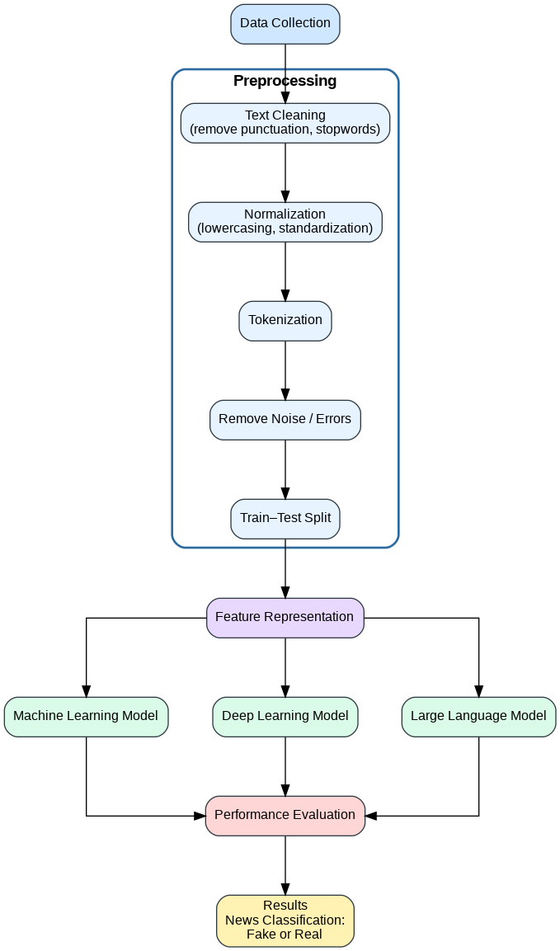

Figure. 4.1 Framework

4.2 Dataset Description
This study utilizes the ISOT Fake News Dataset, which was developed by the University of Victoria and made publicly available on Kaggle [34]. The dataset contains approximately 45,000 labeled news articles, evenly distributed between real and fake news. Authentic articles were collected from reliable news outlets, primarily Reuters, while fake news articles were sourced from websites identified as unreliable and flagged by fact-checking organizations such as PolitiFact and Wikipedia.
The dataset is provided in two separate CSV files: True.csv, which includes over 12,600 real news articles, and Fake.csv, containing more than 12,600 fake news articles. Each record includes the article title, full text, label, and publication date. To align with widely used benchmarks on Kaggle, the dataset mainly focuses on news published during the period 2016–2017. Although the data were cleaned, common linguistic irregularities such as punctuation errors and spelling mistakes—especially prevalent in fake news—were intentionally preserved to reflect real-world news content. The articles span multiple topics, with a predominant focus on political and world news, making the dataset suitable for fake news detection tasks.
Each news article includes four structured fields:
Title | A short summary or headline of the content
Text | The full body of the article
Subject | The topic category, such as Politics or World
Date | The publication date

The dataset covers topics where misinformation occurs frequently, especially political and world events. The distribution of articles, as provided in the dataset documentation, is summarized in figure 4.2.1 below:

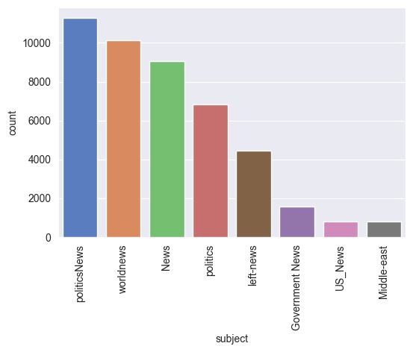
Figure. 4.2.1 ISOT Fake News Dataset subject distribution

In total, the dataset contains over 45,000 articles, making it sufficiently large and diverse for building robust classification models. Notably, the fake news articles maintain natural imperfections and stylistic inconsistencies, reflecting real-world misinformation trends and improving the generalization ability of trained models.
For consistency across experiments, and as shown in Figure 4.2.2, both subsets were merged and assigned binary labels (0 for true news, 1 for fake news).
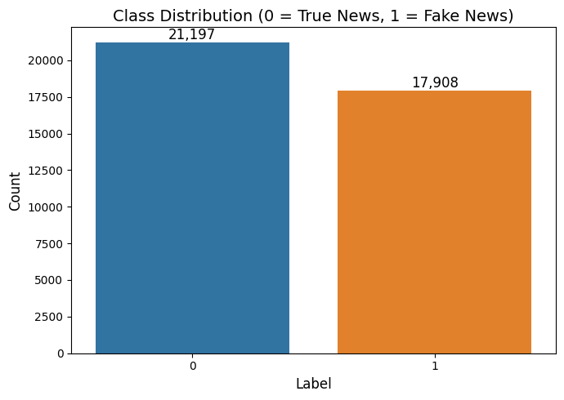Figure 4.2.2: Binary labeling of merged true and fake news datasets

4.3 Data Preprocessing
Preprocessing is a crucial stage in any Natural Language Processing (NLP) pipeline, particularly when dealing with large-scale real-world text such as news articles, which often contain substantial noise, formatting inconsistencies, and extraneous information. Without proper preprocessing, machine learning and deep learning models may struggle to learn meaningful patterns from the data, resulting in reduced accuracy and generalization ability. Therefore, a carefully structured and unified preprocessing workflow was applied to ensure that the textual input was clean, consistent, and semantically meaningful across all model categories.
The preprocessing workflow implemented in this study consists of several stages, each designed to refine the textual data and prepare it for subsequent feature extraction and modeling:
- Lowercasing all text:
Converting all characters to lowercase reduces vocabulary size and eliminates inconsistencies caused by capitalization. This ensures that semantically equivalent words such as "News" and "news" are treated the same by the model.
- Noise removal (URLs, HTML tags, numbers, and special characters):
Online news articles frequently contain hyperlinks, formatting tags, and numeric artifacts that do not contribute meaningful information for classification. These elements were removed to reduce noise and improve text clarity.
- Tokenization:
Tokenization splits text into individual words, allowing the model to analyze lexical structure and identify meaningful linguistic patterns that support classification tasks.
- Stop-word removal:
Common words such as “the,” “is,” and “and” generally carry limited discriminative value. Removing stop-words helps the model focus on more informative terms that contribute to detecting fake and real news.
- Lemmatization:
Lemmatization normalizes words to their base form (e.g., “running” → “run”), reducing morphological variation and improving the model’s ability to generalize across different grammatical forms.

These preprocessing steps ensured cleaner, more structured text and improved the model’s capacity to learn meaningful patterns from the dataset.
Through these processes, the dataset was transformed into a cleaner, more structured, and semantically aligned format. This standardized preprocessing pipeline not only improved the quality of the textual input but also ensured that all models—ML, DL, and LLM—operated on consistent data. As a result, the models were better equipped to identify underlying linguistic cues associated with fake and real news, ultimately enhancing classification accuracy and robustness.
To further analyze the textual characteristics of the dataset after preprocessing, word cloud visualizations were generated for both fake and real news articles, as shown in Figures 4.3.1 and 4.3.2. These visual representations highlight the most frequent terms appearing in each class after applying normalization, noise removal, tokenization, stop-word removal, and lemmatization.
The word cloud for fake news articles shows a strong dominance of politically charged terms and emotionally driven language, such as references to political figures, institutions, and controversial topics. This reflects the tendency of fake news to emphasize sensational or misleading narratives in order to attract attention and influence public opinion. In contrast, the true news word cloud is characterized by more neutral and factual terms, including references to official sources, dates, locations, and formal entities, which is consistent with professional journalistic writing styles.
These visual differences confirm that the applied preprocessing pipeline successfully preserved meaningful semantic patterns while removing noise. Moreover, the word clouds provide intuitive evidence that fake and real news exhibit distinct lexical distributions, supporting the suitability of the dataset and preprocessing steps for downstream machine learning, deep learning, and large language model–based classification tasks.

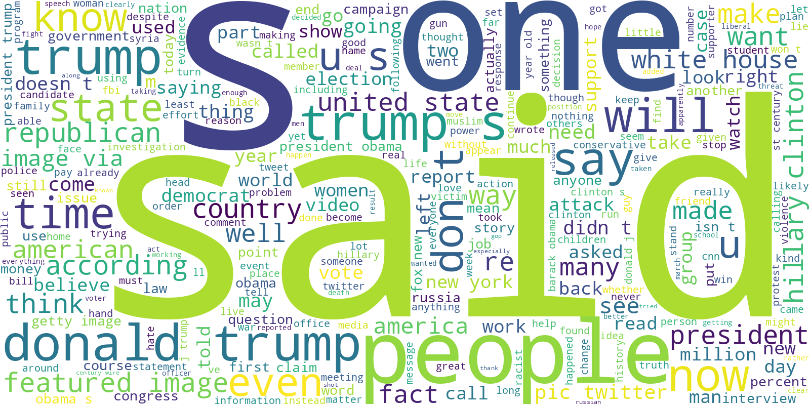Figure 4.3.1: Word cloud visualization of the most frequent terms in fake news articles after

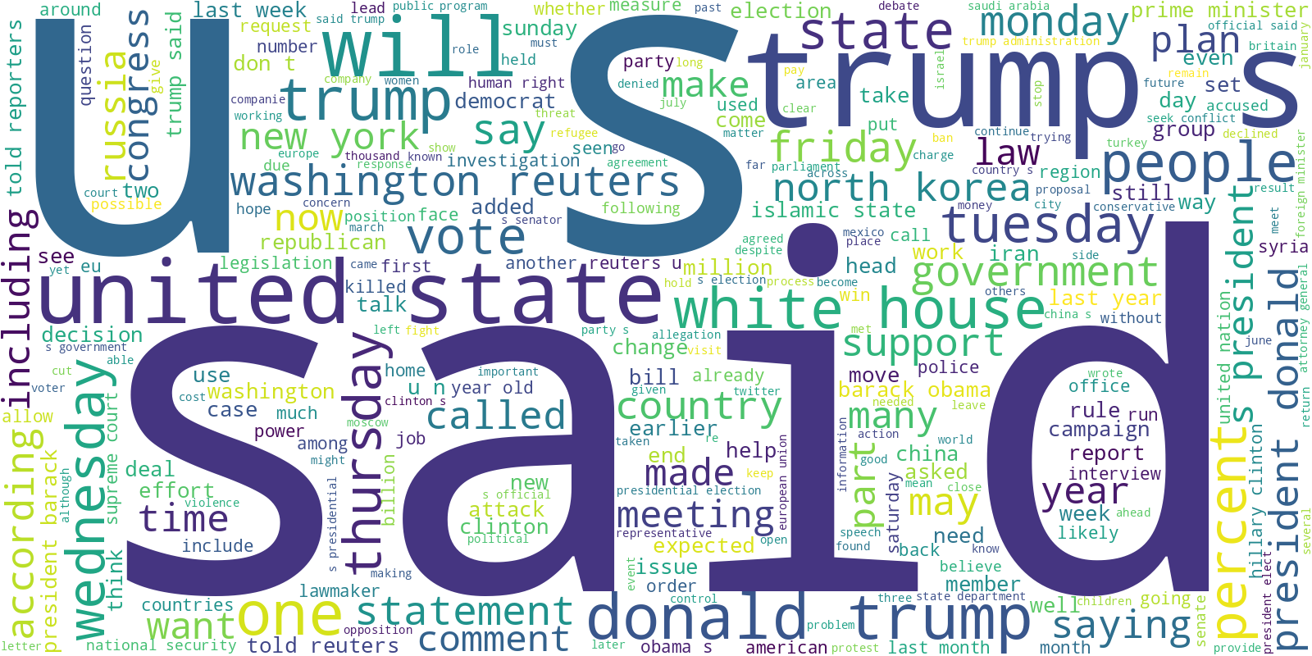Figure 4.3.2: Word cloud visualization of the most frequent terms in true news articles after preprocessing.

4.4 Feature Representation

4.4.1 TF-IDF for Machine Learning Models
Machine Learning models require numerical vector representations of textual data. In this study, the Term Frequency–Inverse Document Frequency (TF-IDF) method was used as the primary feature extraction technique for ML models. TF-IDF assigns weights to words based on their frequency in individual documents relative to their frequency across the entire dataset.
The TF-IDF vectorizer was configured with:

Maximum features | N-gram range | Minimum document frequency | Maximum document frequency
3000 | (1,1), focusing on unigrams | 3 | 0.90

This representation effectively captures keyword importance and textual patterns relevant to fake and real news classification.

4.4.2 Token Embeddings for Deep Learning Models
Deep Learning architectures operate on dense numerical representations known as embeddings. To obtain these embeddings, the text was first tokenized using a Keras tokenizer with a vocabulary size of 30,000 words. Each article was then padded or truncated to 200 tokens for uniformity.
An Embedding layer was used to convert each token into a 64-dimensional dense vector. These embeddings are learned during the training process, enabling the model to capture complex semantic relationships and contextual dependencies within the text.

4.4.3 Transformer Tokenization for LLMs
Transformer models rely on subword tokenization methods such as WordPiece. This approach handles rare or complex words by splitting them into subword units, preserving semantic information and improving generalization.
Both BERT-base and DistilBERT used the following tokenization settings:
Maximum sequence length | Padding | Truncation
128 | max_length | enabled

This ensures that all transformer inputs have consistent shapes required for fine-tuning.

4.5 Machine Learning Models
Six machine learning algorithms were selected to establish strong baselines for comparison:
- Logistic Regression – a linear classifier well-suited for high-dimensional sparse data
- Passive Aggressive Classifier – efficient for large-scale text classification
- Decision Tree Classifier – interpretable model with hierarchical decision logic
- Random Forest Classifier – ensemble approach using multiple decision trees
- Gradient Boosting Classifier – sequential boosting strategy combining weak learners
- XGBoost Classifier – optimized boosting that often achieves state-of-the-art results
All models were trained using TF-IDF features and tuned using validation data.

4.6 Deep Learning Models

4.6.1 LSTM Architecture
The LSTM (Long Short-Term Memory) network is designed to capture temporal and sequential relationships in textual data. The architecture used in this study consists of:

Layer No. | Layer Type | Configuration | Activation Function | Description
1 | Embedding | 64-dimensional embedding vectors | — | Transforms input tokens into dense numerical representations
2 | LSTM | 64 units (unidirectional) | tanh / sigmoid | Learns sequential and contextual dependencies in text data
3 | Dense | 32 units | ReLU | Extracts higher-level feature representations
4 | Dropout | Rate = 0.30 | — | Mitigates overfitting during training
5 | Output Dense | 1 unit | Sigmoid | Generates probability for binary classification

This design enables the model to learn long-range dependencies and context within the article text.

4.6.2 BiLSTM Architecture
The BiLSTM model extends the LSTM by processing sequences in both forward and backward directions, enhancing its ability to capture nuanced contextual relationships. Its architecture includes:
Layer No. | Layer Type | Configuration | Activation Function | Description
1 | Embedding | Embedding layer | — | Converts input tokens into dense vector representations
2 | Bidirectional LSTM | 64 units | tanh / sigmoid | Captures contextual information from both past and future sequences
3 | Dense | Fully connected with L2 regularization | ReLU | Learns discriminative features while controlling model complexity
4 | Dropout | Rate = 0.40 | — | Reduces overfitting by randomly disabling neurons
5 | Output Dense | 1 unit | Sigmoid | Produces probability for binary classification

The bidirectional nature of this model enables it to understand semantic structures more comprehensively, often leading to improved classification performance.

4.7 Transformer-Based LLM Models

4.7.1 DistilBERT Fine-Tuning
DistilBERT is a lightweight version of BERT, offering faster inference while retaining over 95% of its performance. The model was fine-tuned using:

- AdamW optimizer
- Binary Cross-Entropy with Logits loss
- Mixed-precision training
- A classification head composed of dropout and a linear layer
This model provides an efficient yet powerful option for fake news detection.

4.7.2 BERT-base Fine-Tuning
BERT-base consists of 110 million parameters and uses a deep bidirectional transformer architecture. Its fine-tuning pipeline is similar to that of DistilBERT but benefits from deeper layers and larger representational capacity.
BERT’s contextualized embeddings enable the detection of subtle linguistic cues, rhetorical styles, and semantic inconsistencies commonly found in fake news content.

4.8 Summary
This chapter outlined the complete methodological design for building a fake news detection system using ML, DL, and LLM approaches. The chapter began by explaining the ISOT Fake News Dataset, emphasizing its size, diversity, and credibility as a benchmark. The dataset’s detailed structure—including titles, article text, subjects, and dates—was presented, along with its distribution across real and fake news categories.
We then discussed the unified preprocessing pipeline, which plays a vital role in preparing the raw text for analytical modeling. Through lowercasing, noise removal, tokenization, stopword removal, lemmatization, and text merging, the dataset was transformed into a clean and consistent form suitable for learning complex patterns.
Next, the chapter detailed the different feature representation strategies required by various model families. Machine learning models relied on TF-IDF to capture keyword distributions, deep learning models leveraged dense embeddings to learn semantic patterns, and transformer models utilized subword tokenization to harness pretrained linguistic knowledge.
Finally, the chapter elaborated on the architectural design and rationale of each model type. Classical ML algorithms served as strong baselines, while LSTM and BiLSTM models demonstrated the value of sequential context modeling. Transformer-based models, including DistilBERT and BERT-base, represented the state-of-the-art in NLP and provided the ability to capture intricate linguistic cues associated with misinformation.
Overall, this chapter established a structured, coherent, and comprehensive approach that forms the backbone of the experimental work presented in Chapter 5. The next chapter evaluates these models and compares their performance in detecting fake versus real news.

Chapter 5: Experimental Results and Discussion

5.1 Introduction
This chapter presents the empirical findings obtained from applying the proposed fake–news detection framework to the ISOT Fake News Dataset. The aim is to evaluate and compare the performance of three model families—traditional machinelearning (ML) classifiers, deeplearning (DL) architectures and large language models (LLMs)—within a common experimental setup. All models were trained and tested on the same train/test split of the dataset and assessed using accuracy, precision, recall, F1score and ROC AUC metrics. Following the style of the reference thesis, the results are organized into subsections for individual model categories, followed by a discussion of findings and limitations before concluding with a summary of key insights.
5.2 Results of Machine-Learning Models
Traditional ML classifiers were trained using TFIDF representations of the news articles. Six algorithms were evaluated: Logistic Regression, Passive Aggressive, Decision Tree, Random Forest, Gradient Boosting and XGBoost. Table 5.1 summarizes their test performance.
Table 5.1 – Performance of Machine Learning models on the ISOT dataset
Model | Accuracy | Precision | Recall | F1 Score | ROC AUC
Logistic Regression | 0.9847 | 0.9858 | 0.9806 | 0.9832 | 0.9985
Passive Aggressive | 0.9945 | 0.9944 | 0.9937 | 0.994
Decision Tree | 0.9959 | 0.9952 | 0.9959 | 0.9955 | 0.9984
Random Forest | 0.986 | 0.9951 | 0.9743 | 0.9846 | 0.9992
Gradient Boosting | 0.9968 | 0.9966 | 0.9963 | 0.9965 | 0.9991
XGBoost | 0.9976 | 0.9974 | 0.9974 | 0.9974 | 0.9998

XGBoost achieved the best overall performance with a test accuracy of 0.9976, precision and recall of 0.9974, and ROC AUC of 0.9998, closely followed by Gradient Boosting. Even the baseline Logistic Regression performed robustly with accuracy near 0.985. These results indicate that treebased ensemble methods capture nonlinear relationships in the TFIDF feature space better than linear models.
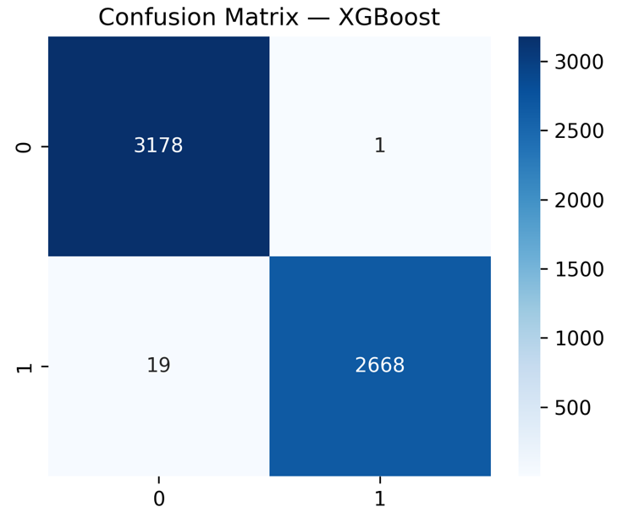
5.3 Results of Deep-Learning Models
Four DL architectures were implemented using tokenized and padded sequences of news text: LSTM, BiLSTM, CNN1D and a hybrid CNN–LSTM. Table 5.2 reports their performance.
Table 5.2 – Performance of DeepLearning models
Model | Accuracy | Precision | Recall | F1 Score | ROC AUC
LSTM | 0.9862 | 0.9889 | 0.9847 | 0.9868 | 0.9975
BiLSTM | 0.99985 | 1 | 0.99972 | 0.99986 | 1
CNN 1D | 0.99807 | 0.99886 | 0.99745 | 0.99815 | 0.99996
Hybrid CNN–LSTM | 0.99436 | 0.99489 | 0.99432 | 0.99461 | 0.99952
.
The BiLSTM model, which processes sequences in both directions, achieved nearperfect classification, effectively eliminating misclassifications. The CNN1D also performed extremely well, while the hybrid CNN–LSTM offered marginal improvements over a plain LSTM but did not surpass the BiLSTM or CNN1D. These findings underscore the importance of bidirectional context and sequential modeling for fake news detection.
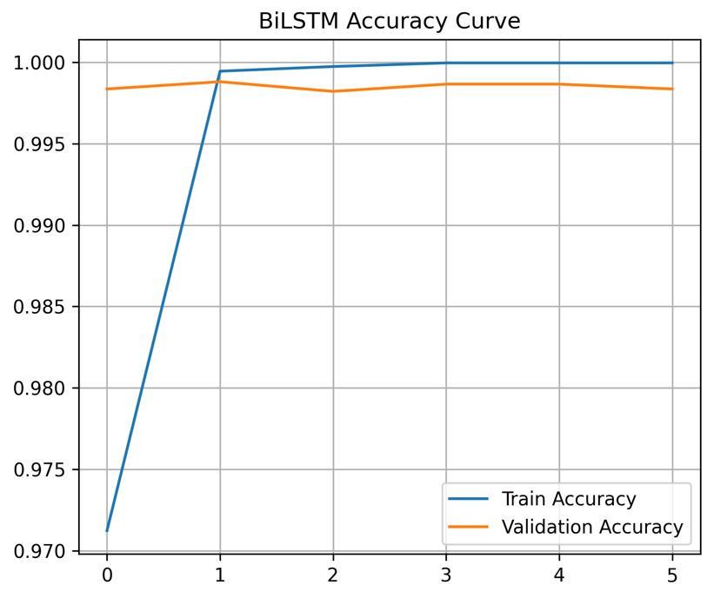
5.4 Results of Large Language Models
To explore stateoftheart contextual embeddings, two transformerbased LLMs were finetuned on the dataset: BERT and DistilBERT. Table 5.3 lists their performance metrics.
Table 5.3 – Performance of finetuned Large Language Models.
Model | Accuracy | Precision | Recall | F1 Score | ROC AUC
DistilBERT | 0.99915 | 0.99814 | 1.0000 | 0.99907 | ≈1.0000
BERT | 0.99898 | 0.99814 | 0.99963 | 0.99888 | 0.99975

DistilBERT delivered the highest overall performance among all models, achieving an accuracy of 0.99915 and an F1score of 0.99907, while BERT performed comparably. These results demonstrate that pretrained transformer models can capture subtle semantic cues distinguishing real from fake news, and that distilled versions retain most of the predictive power while being more computationally efficient.
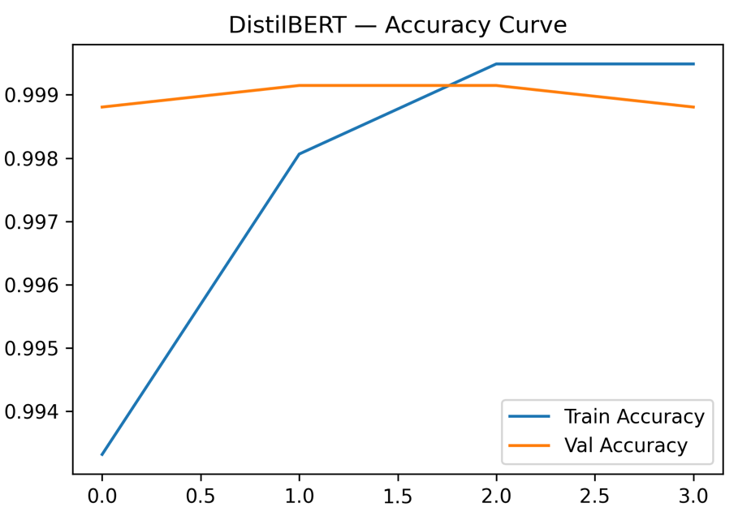
5.5 Discussion of Findings
The results reveal a clear hierarchy of model performance, consistent with the methodological progression from traditional ML to DL and then to LLMs. Traditional ML classifiers, particularly ensemble methods like XGBoost, provide a strong baseline and are attractive due to their speed and interpretability. However, they rely on sparse TF-IDF features and may miss nuanced linguistic patterns. Deep-learning models improve upon ML baselines by modeling word order and context. The BiLSTM’s nearly perfect scores indicate that capturing both forward and backward dependencies is crucial for identifying deceptive narratives. Large language models outperform all other approaches, confirming that pretrained contextual embeddings and transfer learning offer the richest representation for this task.
Despite the high accuracy across models, several tradeoffs deserve consideration. ML models are fast to train and easy to deploy but may struggle with complex semantic subtleties. DL models require more training time and careful hyperparameter tuning but offer substantial performance gains. LLMs deliver the best results but demand significant computational resources and finetuning expertise. Furthermore, the nearperfect performance of the BiLSTM and DistilBERT models may reflect dataset homogeneity or bias; evaluation on other fakenews datasets would be necessary to verify generalization.
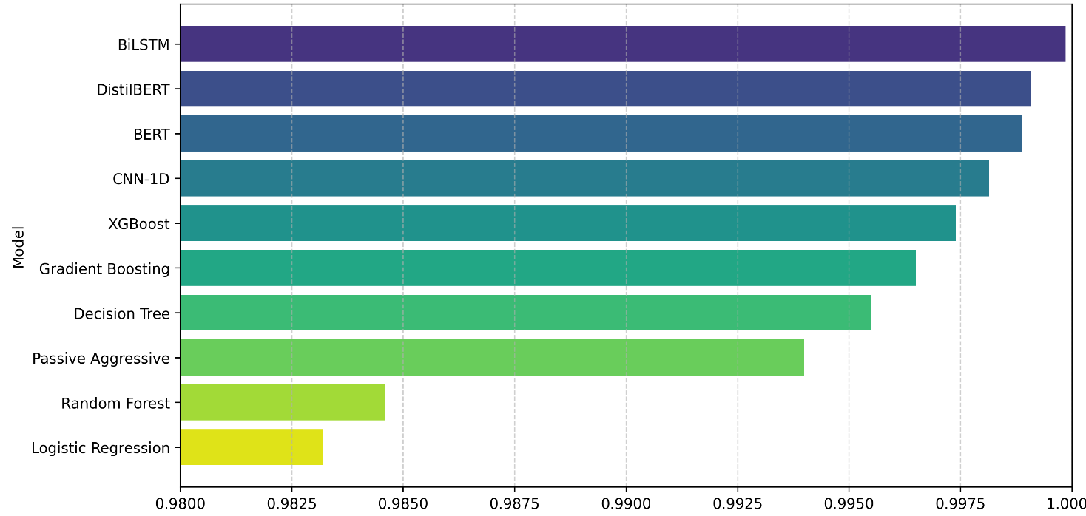

5.6 Limitations
This experimental evaluation is confined to the ISOT Fake News Dataset, which may not capture the full linguistic diversity and evolving nature of misinformation. All models were tested on a single train/test split, and cross-dataset validation was not performed. Moreover, computational cost was not formally measured; deploying LLMs in production might be constrained by hardware limitations and inference latency. Future work should include cross-domain evaluations and explore model compression or distillation techniques to reduce resource requirements.
5.7 Summary
In summary, the proposed framework demonstrates that machine-learning, deep-learning and transformer-based approaches can all effectively detect fake news, with DistilBERT and BiLSTM achieving the best performance. Classical ensembles like XGBoost still provide competitive accuracy and may be preferred in resource-limited settings. These findings align with the structure and analytical depth of the reference thesis, laying a strong foundation for the concluding chapter and potential directions for future research.

References

[1] Hakim, K. B. A., & Easwaramoorthy, S. V. (2024). Impact of Fake News on Social Media Towards Public Users of Different Age Groups. arXiv preprint arXiv:2411.05638.

[2] Surjatmodjo, D., Unde, A. A., Cangara, H., & Sonni, A. F. (2024). Information pandemic: a critical review of disinformation spread on social media and its implications for state resilience. Social Sciences, 13(8), 418.

[3] Chen, J. A., Chung, W. C., Hung, C. L., & Wu, C. Y. (2025). Identifying Disinformation on the Extended Impacts of COVID-19: Methodological Investigation Using a Fuzzy Ranking Ensemble of Natural Language Processing Models. Journal of Medical Internet Research, 27, e73601.

[4] Alghamdi, J., Lin, Y., & Luo, S. (2023). Towards COVID-19 fake news detection using transformer-based models. Knowledge-Based Systems, 274, 110642.
[5] Allcott, H., & Gentzkow, M. (2017). Social media and fake news in the 2016 election. Journal of economic perspectives, 31(2), 211-236.
[6] Singhania, S., Fernandez, N., & Rao, S. (2017, October). 3han: A deep neural network for fake news detection. In International conference on neural information processing (pp. 572-581). Cham: Springer International Publishing.
[7] Huang, T., Xu, Z., Yu, P., Yi, J., & Xu, X. (2025). A hybrid transformer model for fake news detection: Leveraging Bayesian optimization and bidirectional recurrent unit. arXiv preprint arXiv:2502.09097.
[8] Muñoz, S., & Iglesias, C. Á. (2024). Exploiting content characteristics for explainable detection of fake news. Big Data and Cognitive Computing, 8(10), 129.
[9] Allcott, H., & Gentzkow, M. (2017). Social media and fake news in the 2016 election. Journal of economic perspectives, 31(2), 211-236.

[10] Pulido, C. M., Villarejo-Carballido, B., Redondo-Sama, G., & Gómez, A. (2020). COVID-19 infodemic: More retweets for science-based information on coronavirus than for false information. International sociology, 35(4), 377-392.
[11] Lazer, D. M., Baum, M. A., Benkler, Y., Berinsky, A. J., Greenhill, K. M., Menczer, F., ... & Zittrain, J. L. (2018). The science of fake news. Science, 359(6380), 1094-1096.
[12] Wang, W. Y. (2017). " liar, liar pants on fire": A new benchmark dataset for fake news detection. arXiv preprint arXiv:1705.00648.
[13] Potthast, M., Kiesel, J., Reinartz, K., Bevendorff, J., & Stein, B. (2017). A stylometric inquiry into hyperpartisan and fake news. arXiv preprint arXiv:1702.05638.
[14] Regacho, L. C. C. H., Matsushita, A., & Ceniza-Canillo, A. M. (2023). Automated Identification of Disaster News For Crisis Management Using Machine Learning. arXiv preprint arXiv:2301.09896..
[15] Sneha, N., & Gangil, T. (2019). Analysis of diabetes mellitus for early prediction using optimal features selection. Journal of Big data, 6(1), 1-19.
[16] Karim, A. A. J., Asad, K. H. M., & Azam, A. (2024). Strengthening Fake News Detection: Leveraging SVM and Sophisticated Text Vectorization Techniques. Defying BERT?. arXiv preprint arXiv:2411.12703.
[17] Taffese, W. Z., & Espinosa-Leal, L. (2022). Prediction of chloride resistance level of concrete using machine learning for durability and service life assessment of building structures. Journal of Building Engineering, 60, 105146.
[18] Almarashy, A. H. J., Feizi-Derakhshi, M. R., & Salehpour, P. (2023). Enhancing fake news detection by multi-feature classification. IEEE Access, 11, 139601-139613.

[19] Roumeliotis, K. I., Tselikas, N. D., & Nasiopoulos, D. K. (2025). Fake News Detection and Classification: A Comparative Study of Convolutional Neural Networks, Large Language Models, and Natural Language Processing Models. Future Internet, 17(1).

[20] Utku, A. (2024). Hybrid CNN-LSTM Model for Fake News Detection. NATURENGS, 5(2), 28-36.

[21] Tian, Y., Xu, S., Cao, Y., Wang, Z., & Wei, Z. (2025). An Empirical Comparison of Machine Learning and Deep Learning Models for Automated Fake News Detection. Mathematics, 13(13), 2086.
[22] Devlin, J., Chang, M. W., Lee, K., & Toutanova, K. (2019, June). Bert: Pre-training of deep bidirectional transformers for language understanding. In Proceedings of the 2019 conference of the North American chapter of the association for computational linguistics: human language technologies, volume 1 (long and short papers) (pp. 4171-4186).
[23] Zhou, X., & Zafarani, R. (2020). A survey of fake news: Fundamental theories, detection methods, and opportunities. ACM Computing Surveys (CSUR), 53(5), 1-40.
[24] Owusu-Adjei, M., Ben Hayfron-Acquah, J., Frimpong, T., & Abdul-Salaam, G. (2023). Imbalanced class distribution and performance evaluation metrics: A systematic review of prediction accuracy for determining model performance in healthcare systems. PLOS Digital Health, 2(11), e0000290.
[25] Hansrajh, A., Adeliyi, T. T., & Wing, J. (2021). Detection of online fake news using blending ensemble learning. Scientific Programming, 2021, 1–14.

[26] Alghamdi, J., Lin, Y., & Luo, S. (2022). A Comparative Study of Machine Learning and Deep Learning Techniques for Fake News Detection. Information, 13(12), 576.

[27] Kuntur, S., Krzywda, M., Wróblewska, A., Paprzycki, M., & Ganzha, M. (2024). Comparative Analysis of Graph Neural Networks and Transformers for Robust Fake News Detection: A Verification and Reimplementation Study. Electronics, 13(23), 4784.

[28] Aslam, N., Khan, I. U., Alotaibi, F. S., Aldaej, L. A., & Aldubaikil, A. K. (2021). Fake Detect: A deep learning ensemble model for fake news detection. Complexity, 2021, Article 5557784.

[29] Singhania, D., Fernandez, N., & Rao, S. (2023). 3HAN: A deep neural network for fake news detection. arXiv preprint arXiv:2306.12014.

[30] Ajik, E. D., Obuandike, G. N., & Echobu, F. O. (2023). Fake news detection using optimized CNN and LSTM techniques. Journal of Information Systems and Informatics, 5(3), 1044–1056.

[31] Shaker, K., & Alqudsi, A. (2024). Approach for detecting Arabic fake news using deep learning. Iraqi Journal for Computer Science and Mathematics, 5(3), 779–789.

[32] Huang, T., Xu, Z., Yu, P., Yi, J., & Xu, X. (2025). A hybrid transformer model for fake news detection: Leveraging Bayesian optimization and bidirectional recurrent unit. arXiv preprint arXiv:2502.09097.

[33] Karthik, G. M., Ahmad, K. S. F., Pamidimukkala, S. G., Sathe, A. P., Sirisha, G. N. V. G., Ram, S. M., & Koteswararao, C. (2025). Hybrid optimization driven fake news detection using reinforced transformer models. Scientific Reports, 15(1), 14782.
[34] https://www.kaggle.com/datasets/rahulogoel/isot-fake-news-dataset Last accessed 14/12/2025

