MIDOCEAN UNIVERSITY

MANAGEMENT COLLEGE
Master of Public Administration

Project Title
The Role of Blockchain in GCC Banking Systems

Prepared By/
Hayat Mohammed Alsaad

Mentor/
Dr. Abdulhamid Alfaisal
Dr. Fayez Jarad

Year:
2024

Abstract
This study explores the transformative potential of blockchain technology within the banking sector of the Gulf Cooperation Council (GCC) countries. The GCC region, comprising Saudi Arabia, the United Arab Emirates, Qatar, Kuwait, Oman, and Bahrain, is renowned for its robust financial systems and rapid technological advancements. However, the banking sector faces persistent challenges such as lack of transparency, security risks, operational inefficiencies, high transaction costs, and limited financial inclusion. Blockchain, a decentralized digital ledger technology, offers a viable solution by enhancing transparency, security, and efficiency.
The research aims to provide a comprehensive analysis of blockchain's role in the GCC banking industry, examining its potential to improve existing processes, enhance security measures, reduce costs, and increase overall efficiency. It also addresses the challenges and limitations of integrating blockchain technology into traditional banking systems in the GCC context. Through a mixed-methods approach, including surveys, case studies, and literature reviews, the study evaluates how blockchain can enhance financial inclusion and streamline regulatory compliance.
The findings indicate that blockchain can significantly enhance transparency and trust by providing immutable transaction records, improve security through cryptographic protocols, and increase operational efficiency by automating processes. Furthermore, blockchain can facilitate financial inclusion by offering accessible banking solutions to underserved populations and simplify compliance with regulatory requirements. However, the study also identifies challenges such as scalability, interoperability, and regulatory uncertainty, necessitating collaborative efforts among banks, technology providers, and regulators.
This research provides strategic recommendations for banks and policymakers in the GCC to leverage blockchain technology effectively, fostering a more secure, efficient, and inclusive financial ecosystem. The adoption of blockchain is poised to transform the GCC banking sector, contributing to the region's economic growth and development.

Table of Contents
Abstract 2
Chapter 1: Introduction 5
Introduction 6
Problem Statement 7
Project Importance 10
Project Objectives 12
Project Concerns 15
Project Hypothesis 18
Chapter 2: Previous Studies 22
Introduction 23
Previous Studies 24
Project Theoretical Framework 29
Introduction 34
Study Tools 34
Study Limitations 35
Conclusion 37

Chapter 1: Introduction

Introduction

The Role of Blockchain in GCC Banking Systems

The banking sector in the Gulf Cooperation Council (GCC) countries is at the cusp of a digital transformation driven by the advent of blockchain technology. The GCC region, comprising Saudi Arabia, the United Arab Emirates, Qatar, Kuwait, Oman, and Bahrain, is known for its robust financial systems and rapid technological advancements. Blockchain, a decentralized digital ledger technology, has the potential to revolutionize traditional banking systems in the GCC by enhancing transparency, security, and efficiency.

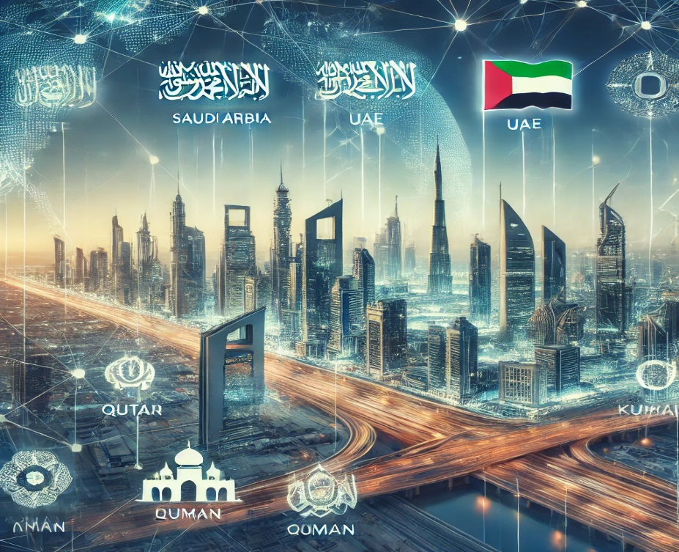

Background
Blockchain technology was first introduced as the underlying technology for Bitcoin in 2008. Since then, it has evolved beyond cryptocurrencies to various applications across industries, including finance. In the GCC banking sector, blockchain holds the promise of addressing long-standing issues such as fraud, inefficiencies, and high operational costs. By enabling secure, transparent, and immutable transaction records, blockchain can fundamentally change how financial institutions in the region operate.

Purpose of the Study

The purpose of this study is to provide a comprehensive analysis of blockchain technology's role in the GCC banking industry. This includes examining how blockchain can improve existing banking processes, enhance security measures, reduce costs, and increase overall efficiency. Additionally, the study will address the potential challenges and limitations of implementing blockchain technology in traditional banking systems within the GCC context.

Geographical Location of the Study

This research focuses on the implementation and impact of blockchain technology within the banking sectors of the Gulf Cooperation Council (GCC) countries. These countries present a unique context due to their rapidly evolving financial landscapes, supportive regulatory environments, and increasing emphasis on technological innovation. By examining the adoption of blockchain technology in GCC banks, this study aims to provide insights that are directly relevant to the region's specific regulatory frameworks and banking practices. The findings may also offer valuable lessons and potential applications for other regions with similar economic and technological profiles. This targeted geographical scope allows for a detailed and context-specific analysis while acknowledging the potential for broader applicability and adaptation in different global contexts.

Significance of the Study

Understanding the role of blockchain in banking is crucial for financial institutions in the GCC seeking to remain competitive in an increasingly digital world. This study will provide valuable insights for banks, policymakers, and technology developers, offering a detailed exploration of how blockchain can be integrated into banking operations. Furthermore, it will highlight the strategic benefits and potential risks associated with blockchain adoption, aiding stakeholders in making informed decisions.

Structure of the Proposal
This project proposal will be structured into several key sections:
- Problem Statement: Identifying the core issues in the current banking system that blockchain technology can address.
- Importance of the Problem: Discussing why solving these issues is critical for the banking industry.
- Project Objectives: Outlining the specific goals and outcomes of the project.
- Project Concerns: Highlighting the potential challenges and obstacles in implementing blockchain in banking.
- Project Hypothesis: Proposing hypotheses related to the impact of blockchain on banking operations.
- Previous Studies: Reviewing existing literature and studies on blockchain in banking.
- Project Theoretical Framework: Developing a theoretical framework to guide the study.
- Proposal: Presenting the proposed solutions and strategies for blockchain integration in banking.
- Study Tools: Describing the methodologies and tools used for the study.
- Project Limitations: Acknowledging the limitations and scope of the study.
By systematically exploring each of these sections, this project aims to provide a thorough understanding of blockchain's transformative potential in the GCC banking industry.

Problem Statement
The banking sector in the Gulf Cooperation Council (GCC) countries, a cornerstone of the region's economies, faces several persistent challenges that hinder its efficiency, security, and customer satisfaction. Despite significant advancements in technology, many banks in the GCC continue to rely on outdated systems and processes, resulting in issues that blockchain technology has the potential to address. This problem statement highlights the core issues within the current banking system in the GCC that necessitate the adoption of blockchain technology.
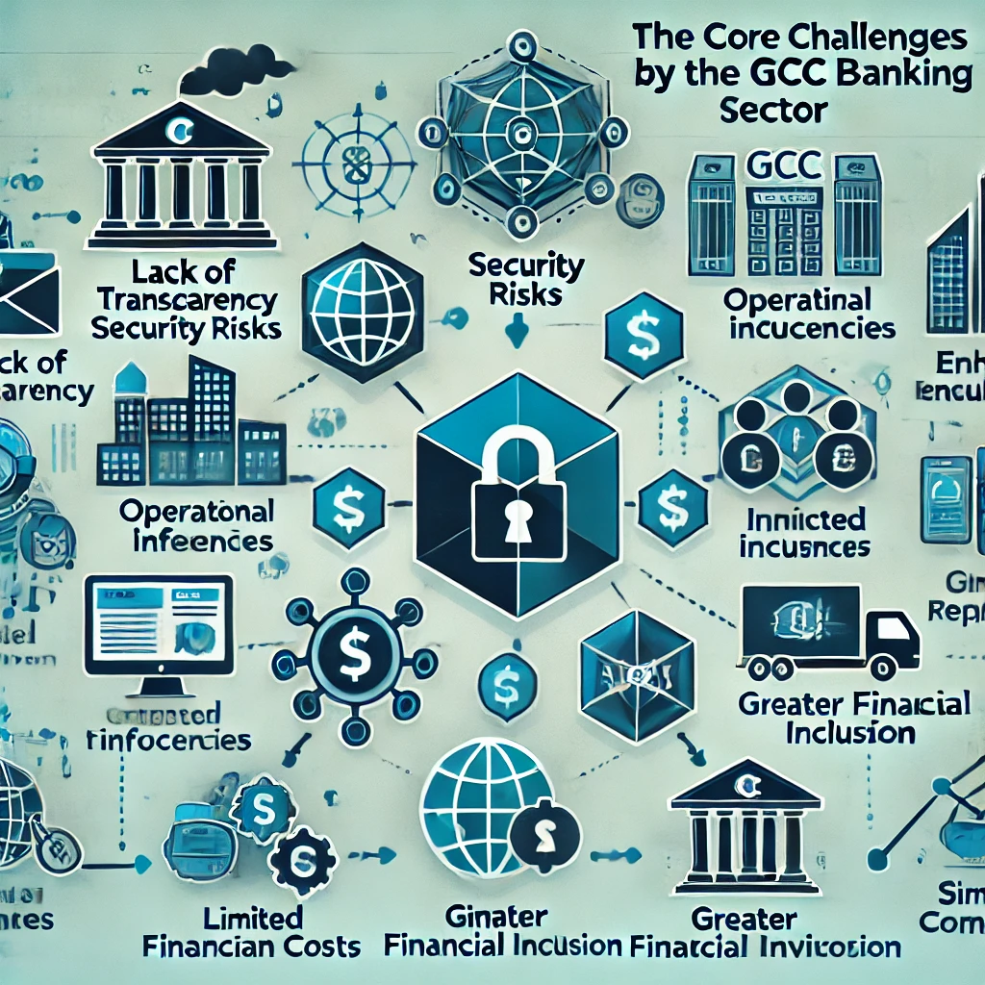
Core Issues in the Banking System
- Lack of Transparency: Traditional banking systems in the GCC often operate in silos, leading to a lack of transparency in transactions and processes. This opacity can result in misunderstandings, errors, and a general lack of trust among customers and stakeholders.
- Fraud and Security Risks: The centralized nature of traditional banking systems makes them susceptible to fraud, cyber-attacks, and data breaches. High-profile security incidents have eroded customer confidence and resulted in significant financial losses for banks in the GCC.
- Operational Inefficiencies: Legacy systems and manual processes contribute to inefficiencies in banking operations. These inefficiencies manifest as slow transaction times, high operational costs, and cumbersome regulatory compliance procedures.
- High Transaction Costs: Cross-border transactions and interbank settlements often involve multiple intermediaries, each adding to the transaction costs. These high costs can be a burden for both banks and their customers, especially in a region heavily involved in international trade and finance.
- Limited Financial Inclusion: Traditional banking services are not accessible to everyone, particularly in remote or underserved areas of the GCC. The lack of access to basic financial services exacerbates economic disparities and limits opportunities for economic growth.
- Complex Regulatory Environment: Banks must navigate a complex and ever-evolving regulatory landscape, which can be costly and time-consuming. Ensuring compliance with regulatory requirements often involves significant administrative overhead, particularly in a region with diverse regulatory frameworks.
Potential of Blockchain Technology
- Blockchain technology offers a decentralized, transparent, and secure alternative to traditional banking systems. By leveraging blockchain, banks can address the aforementioned issues through the following mechanisms:
- Enhanced Transparency: Blockchain’s decentralized ledger ensures that all transactions are recorded transparently and immutably, increasing trust and accountability among stakeholders.
- Improved Security: The cryptographic nature of blockchain provides robust security against fraud and cyber-attacks, reducing the risk of data breaches and unauthorized access.
- Increased Efficiency: Blockchain automates and streamlines processes, reducing the need for manual intervention and speeding up transaction times. This leads to lower operational costs and improved service delivery.
- Reduced Transaction Costs: Blockchain eliminates the need for intermediaries in transactions, thereby reducing transaction costs, particularly for cross-border payments and settlements.
- Greater Financial Inclusion: Blockchain-based financial services can reach underserved and unbanked populations, providing them with access to secure and affordable financial services.
- Simplified Compliance: Blockchain’s transparent and immutable records simplify compliance with regulatory requirements, reducing the administrative burden on banks.
The traditional banking system in the GCC is fraught with challenges that impede its efficiency, security, and inclusivity. Blockchain technology presents a viable solution to these problems, offering enhanced transparency, security, efficiency, and financial inclusion. This problem statement underscores the need for a thorough examination of how blockchain can transform the banking industry in the GCC, paving the way for a more robust and equitable financial system.

Project Importance
Enhancing Trust and Transparency in the GCC Banking Sector
Restoring customer confidence and improving transparency are critical for the financial institutions of the Gulf Cooperation Council (GCC) countries, where trust is a key pillar of the banking relationship. This study aims to demonstrate how blockchain technology can significantly enhance these elements by providing transparent, secure, and immutable transaction records.
- Restoring Customer Confidence: Transparency is essential for building and maintaining trust in financial institutions. The lack of transparency in traditional banking systems within the GCC has led to distrust among customers and stakeholders. Implementing blockchain technology can help banks provide transparent and immutable transaction records, thereby restoring and enhancing customer confidence.
- Reducing Fraud and Corruption: Fraud and corruption are significant issues in the GCC banking sector, leading to substantial financial losses and reputational damage. Blockchain’s decentralized and tamper-proof ledger can drastically reduce fraud and corruption, fostering a more secure and trustworthy financial environment.
Improving Operational Efficiency in GCC Banks
The operational efficiency of banks in the GCC is crucial for maintaining competitiveness in a rapidly evolving financial landscape. This study explores how blockchain technology can streamline banking processes, reduce costs, and improve service delivery.
- Streamlining Processes: Traditional banking processes in the GCC are often slow and cumbersome, leading to inefficiencies and higher operational costs. Blockchain technology can streamline these processes by automating transactions and reducing the need for manual intervention, resulting in faster and more cost-effective operations.
- Cost Reduction: High operational and transaction costs are a burden on both banks and their customers in the GCC. By eliminating intermediaries and automating processes, blockchain can significantly reduce these costs, making banking services more affordable and accessible.

Enhancing Security in the GCC Banking Industry
The security of banking operations is a top priority for GCC countries, where banks handle a significant volume of sensitive financial data. This study assesses how blockchain can enhance security measures and protect against cyber threats.
- Protecting Against Cyber Threats: The centralized nature of traditional banking systems makes them vulnerable to cyber-attacks and data breaches. Blockchain’s decentralized and cryptographic nature provides robust security, protecting sensitive financial data and reducing the risk of cyber threats.
- Ensuring Data Integrity: Maintaining the integrity of financial data is crucial for regulatory compliance and operational accuracy. Blockchain’s immutable ledger ensures that transaction records cannot be altered or tampered with, preserving the integrity of financial data.
Promoting Financial Inclusion in the GCC
Expanding access to financial services is vital for fostering economic growth and reducing inequality in the GCC region. This study highlights the potential of blockchain to enhance financial inclusion by providing secure and affordable banking solutions.
- Expanding Access to Financial Services: Millions of people in the GCC lack access to basic financial services, particularly in remote or underserved areas. Blockchain-based financial services can reach these populations, providing them with secure and affordable access to banking, payments, and other financial services.
- Empowering Economic Growth: Financial inclusion is a key driver of economic growth and development. By providing access to financial services, blockchain technology can empower individuals and businesses, fostering economic growth and reducing poverty in the GCC.
Navigating Regulatory Compliance in the GCC
The regulatory landscape in the GCC is complex and constantly evolving. This study examines how blockchain can simplify compliance processes and enhance accountability.
- Simplifying Compliance: Ensuring compliance with regulatory requirements can be time-consuming and costly for banks in the GCC. Blockchain’s transparent and immutable records simplify compliance processes, reducing the administrative burden on banks and ensuring adherence to regulatory requirements.
- Enhancing Accountability: Blockchain technology enhances accountability by providing a clear and auditable trail of transactions. This can assist regulators in monitoring and enforcing compliance, ultimately contributing to a more stable and trustworthy financial system.
Addressing the core issues in the GCC banking sector through blockchain technology is of paramount importance. Enhancing trust and transparency, improving operational efficiency, enhancing security, promoting financial inclusion, and simplifying regulatory compliance are critical for the sustainability and growth of the financial industry in the GCC. By leveraging blockchain, banks can overcome these challenges, paving the way for a more secure, efficient, and inclusive financial ecosystem. This will not only benefit the banking sector but also contribute to the broader goals of economic development and social equity in the GCC.

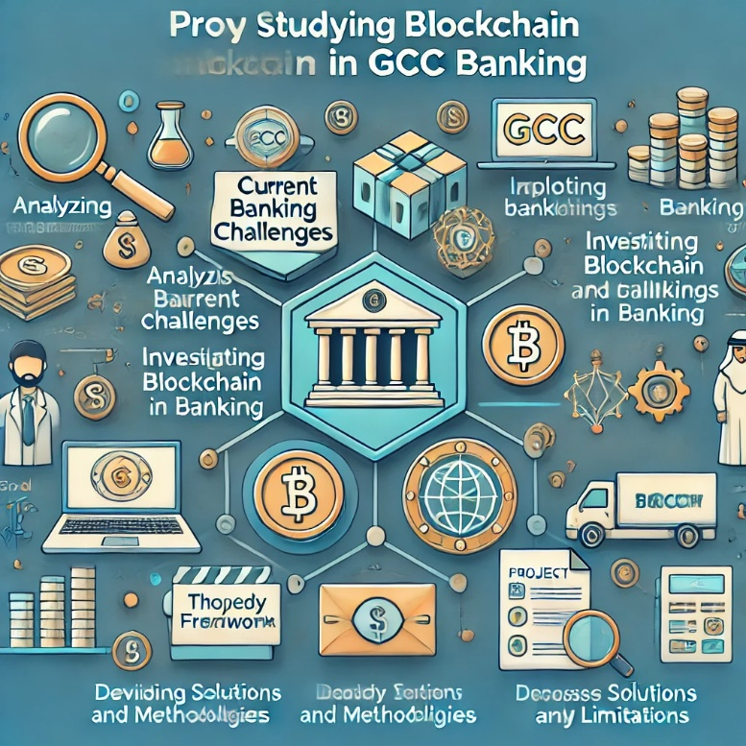
Project Objectives
The primary objective of this project is to explore and analyze the transformative potential of blockchain technology within the banking sector of the Gulf Cooperation Council (GCC) countries. This project aims to provide a comprehensive understanding of how blockchain can address current banking challenges and enhance overall efficiency, security, and accessibility in the GCC region. The specific objectives of this project are outlined below.
Objective 1: Analyze the Current Banking System in the GCC
- Evaluate Existing Challenges: Conduct a thorough analysis of the current banking system in the GCC to identify key issues such as lack of transparency, fraud, operational inefficiencies, high transaction costs, limited financial inclusion, and regulatory complexities.
- Assess Technological Infrastructure: Examine the existing technological infrastructure of banks in the GCC to understand the limitations and potential areas for blockchain integration.
Objective 2: Explore Blockchain Technology
- Understand Blockchain Fundamentals: Provide an in-depth overview of blockchain technology, including its principles, mechanisms, and various types (public, private, consortium blockchains).
- Identify Key Features: Highlight the key features of blockchain technology, such as decentralization, transparency, security, and immutability, that make it suitable for banking applications in the GCC.
Objective 3: Investigate Blockchain Applications in Banking
- Payment Systems: Explore how blockchain can streamline payment systems, reduce transaction times, and lower costs, particularly for cross-border transactions within the GCC.
- Smart Contracts: Examine the use of smart contracts in automating and securing various banking processes, such as loan agreements, insurance claims, and trade finance.
- KYC and AML: Investigate how blockchain can enhance Know Your Customer (KYC) and Anti-Money Laundering (AML) processes by providing a secure and immutable record of customer identities and transactions.
- Asset Management: Assess the potential of blockchain in improving asset management practices through transparent and secure record-keeping.
Objective 4: Evaluate the Benefits and Challenges of Blockchain Integration
- Benefits Analysis: Analyze the benefits of integrating blockchain technology into the banking sector, including enhanced transparency, improved security, operational efficiency, cost reduction, and increased financial inclusion.
- Challenges and Risks: Identify the challenges and risks associated with blockchain adoption, such as technological complexity, regulatory hurdles, scalability issues, and potential resistance from stakeholders.
Objective 5: Develop a Theoretical Framework
- Conceptual Model: Develop a conceptual model to illustrate the impact of blockchain technology on various aspects of banking operations in the GCC.
- Hypotheses Formulation: Formulate hypotheses related to the potential outcomes of blockchain integration in banking, providing a basis for empirical testing and validation.
Objective 6: Conduct a Literature Review
- Review Existing Studies: Conduct a comprehensive review of existing literature on blockchain technology and its applications in the banking sector, with a focus on the GCC region.
- Identify Gaps: Identify gaps in the current research and areas that require further investigation, providing a foundation for the proposed study.
Objective 7: Propose Solutions and Strategies
- Implementation Strategies: Propose practical strategies for banks in the GCC to implement blockchain technology, addressing technical, operational, and regulatory considerations.
- Policy Recommendations: Provide policy for regulators and policymakers in the GCC to facilitate the adoption of blockchain technology in the banking sector.
Objective 8: Define Study Tools and Methodologies
- Research Methods: Outline the research methods and tools to be used in the study, including qualitative and quantitative approaches.
- Data Collection: Describe the data collection methods, such as surveys, interviews, and case studies, to gather relevant information from banking professionals and stakeholders in the GCC.
Objective 9: Address Project Limitations
- Scope and Limitations: Clearly define the scope and limitations of the study, acknowledging any constraints that may impact the research findings.
- Future Research: Suggest areas for future research to build on the findings of this study and further explore the role of blockchain in GCC banking.
By achieving these objectives, this project aims to provide a comprehensive and insightful analysis of blockchain technology’s role in the GCC banking sector. The findings will offer valuable guidance for banks, policymakers, and technology developers, facilitating informed decision-making and strategic planning for blockchain adoption in banking.

Project Concerns
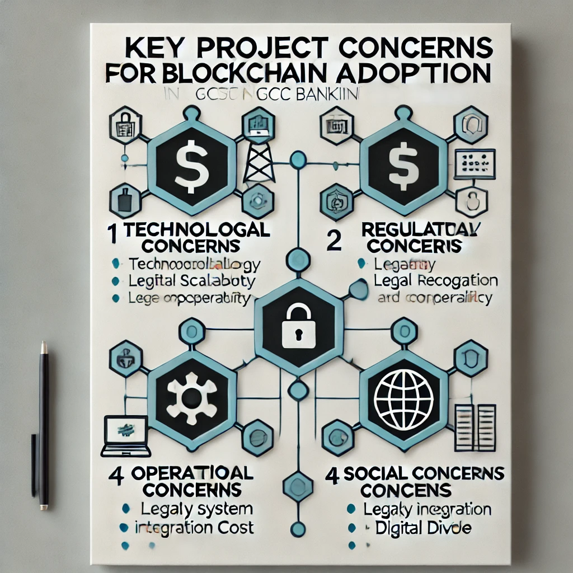
Implementing blockchain technology in the banking sector of the Gulf Cooperation Council (GCC) countries presents several concerns and challenges that must be carefully considered. These concerns span technological, regulatory, operational, and social aspects. Addressing these issues is crucial for the successful adoption and integration of blockchain in GCC banking operations. This section outlines the primary concerns associated with the project.
Technological Concerns
Scalability:
Issue: Blockchain networks, particularly public ones, face scalability issues due to their decentralized nature and the need for consensus among numerous nodes.
Impact: Scalability problems can lead to slow transaction times and reduced efficiency, which are critical for banking operations in the GCC that require high throughput.
Interoperability:
Issue: The lack of interoperability between different blockchain platforms and existing banking systems poses a significant challenge.
Impact: This can hinder seamless integration and data exchange between traditional banking systems and new blockchain-based solutions in the GCC.
Energy Consumption:
Issue: Blockchain, especially proof-of-work (PoW) based systems, can be highly energy-intensive.
Impact: High energy consumption raises environmental concerns and operational costs, which may be unsustainable for widespread adoption in banking.
- Regulatory and Legal Concerns
Regulatory Uncertainty:
Issue: The regulatory landscape for blockchain technology is still evolving, with different GCC jurisdictions having varying rules and guidelines.
Impact: Regulatory uncertainty can create compliance challenges and deter banks in the GCC from adopting blockchain solutions.
Legal Recognition:
Issue: Legal recognition of blockchain transactions and smart contracts is not yet universal across the GCC.
Impact: Without clear legal recognition, blockchain-based transactions and contracts may face enforceability issues, creating legal risks for GCC banks.
Data Privacy and Security:
Issue: Ensuring data privacy and security on a public blockchain while complying with regulations like GDPR is challenging.
Impact: Inadequate data protection can lead to legal penalties and loss of customer trust in the GCC banking sector.

- Operational Concerns
Integration with Legacy Systems:
Issue: Integrating blockchain technology with existing legacy banking systems in the GCC is complex and requires significant investment.
Impact: Integration challenges can lead to disruptions in banking operations and increased implementation costs.
Skill and Knowledge Gaps:
Issue: The adoption of blockchain technology requires specialized skills and knowledge that may be lacking in the current workforce.
Impact: A lack of expertise can slow down the implementation process and increase the risk of errors in GCC banks.
Cost of Implementation:
Issue: The initial cost of implementing blockchain solutions can be high, including hardware, software, and training expenses.
Impact: High costs may deter banks in the GCC from adopting blockchain technology, particularly smaller institutions with limited budgets.
- Social and Ethical Concerns
Digital Divide:
Issue: The adoption of blockchain technology may exacerbate the digital divide, leaving behind those without access to digital infrastructure.
Impact: Ensuring inclusive access to blockchain-based banking services is crucial to avoid increasing social inequality in the GCC.
Ethical Use of Technology:
Issue: The use of blockchain technology must be guided by ethical considerations to prevent misuse and ensure fair treatment of all stakeholders.
Impact: Ethical concerns, if not addressed, can lead to public backlash and loss of trust in blockchain solutions in the GCC banking sector.
Addressing the concerns outlined above is essential for the successful adoption and integration of blockchain technology in the GCC banking sector. By identifying and proactively managing these challenges, banks can leverage blockchain’s potential while mitigating risks and ensuring a smooth transition. This project will consider these concerns throughout its analysis and propose strategies to overcome them, contributing to a more robust and effective implementation of blockchain in GCC banking.

Project Hypothesis
The integration of blockchain technology into the banking sector of the Gulf Cooperation Council (GCC) countries is hypothesized to bring about significant improvements in transparency, security, operational efficiency, and financial inclusion. This section presents the specific hypotheses that will guide the research and analysis of blockchain’s impact on GCC banking.
Hypothesis 1: Enhanced Transparency
The implementation of blockchain technology in GCC banking will significantly enhance transparency in financial transactions and operations.
Rationale: Blockchain’s decentralized and immutable ledger ensures that all transactions are recorded transparently and can be audited in real-time. This transparency can reduce errors, fraud, and mismanagement, leading to greater trust among customers and stakeholders in the GCC.
Hypothesis 2: Improved Security
Blockchain technology will significantly improve the security of banking operations in the GCC by reducing the risk of fraud and cyber-attacks.
Rationale: The cryptographic principles underlying blockchain make it highly secure against unauthorized access and tampering. By decentralizing transaction records, blockchain reduces the single points of failure common in traditional banking systems, enhancing overall security.
Hypothesis 3: Increased Operational Efficiency
The adoption of blockchain technology will lead to increased operational efficiency in the GCC banking sector by streamlining processes and reducing transaction times.
Rationale: Blockchain automates many processes that are currently manual, reducing the time and cost associated with transactions. Smart contracts can further streamline operations by automatically executing agreements when predefined conditions are met.
Hypothesis 4: Reduced Transaction Costs
Blockchain technology will significantly reduce transaction costs for banks and their customers in the GCC, especially for cross-border transactions.
Rationale: By eliminating intermediaries and enabling direct peer-to-peer transactions, blockchain reduces the fees and delays associated with traditional banking methods, particularly in international payments and settlements.
Hypothesis 5: Enhanced Financial Inclusion
The implementation of blockchain-based financial services will enhance financial inclusion in the GCC by providing secure and affordable access to banking for underserved and unbanked populations.
Rationale: Blockchain’s decentralized nature allows for the creation of financial services that are accessible to people without access to traditional banking infrastructure. This can include mobile banking solutions and microfinance applications that reach remote and underserved areas in the GCC.
Hypothesis 6: Simplified Regulatory Compliance
technology will simplify regulatory compliance for GCC banks by providing transparent and immutable records of transactions.
Rationale: The ability to maintain an accurate and unalterable record of transactions can facilitate compliance with regulatory requirements, reducing the administrative burden on banks and improving the efficiency of regulatory reporting.
Hypothesis 7: Overcoming Technological Challenges
Despite its potential benefits, the adoption of blockchain technology in GCC banking will face significant technological challenges, including scalability and interoperability issues.
Rationale: Blockchain technology, while promising, is still evolving. Scalability remains a critical issue for public blockchains, and interoperability between different blockchain platforms and traditional banking systems needs to be addressed for seamless integration.
Hypothesis 8: Regulatory and Legal Adaptation
The successful integration of blockchain technology in GCC banking will require significant adaptations in regulatory and legal frameworks to address new challenges and ensure compliance.
Rationale: Current regulatory and legal frameworks are designed for traditional banking systems and may not fully address the unique aspects of blockchain technology. Adapting these frameworks is essential for fostering innovation while ensuring security and compliance.
These hypotheses provide a framework for investigating the impact of blockchain technology on the banking sector in the GCC. By testing these hypotheses, this project aims to provide empirical evidence on the potential benefits and challenges of blockchain integration in GCC banking. The findings will offer valuable insights for banks, policymakers, and technology developers, guiding strategic decisions and fostering the effective adoption of blockchain technology in the financial industry.

Some of question that needs to be addressed are:
- How does blockchain technology enhance transparency in banking transactions and operations?
This question aims to explore the mechanisms by which blockchain can make banking processes more transparent, thereby increasing trust among stakeholders.
- In what ways does blockchain improve the security of banking operations?
This question investigates how the cryptographic and decentralized nature of blockchain can mitigate security risks and reduce the incidence of fraud in banking.
- What is the impact of blockchain adoption on operational efficiency in the banking sector?
This question examines the potential for blockchain to streamline banking operations, reduce transaction times, and lower operational costs.
- How does blockchain reduce transaction costs for banks and their customers?
This question focuses on identifying the cost-saving benefits of blockchain by eliminating intermediaries and enabling direct transactions.
- Can blockchain-based financial services enhance financial inclusion for underserved populations?
This question evaluates the potential of blockchain to provide affordable and accessible financial services to unbanked and underserved communities.
- How does blockchain technology simplify regulatory compliance for banks?
This question looks into how the transparent and immutable nature of blockchain records can facilitate easier compliance with regulatory requirements.
- What are the technological challenges associated with blockchain adoption in banking?
This question identifies the primary technological barriers to blockchain implementation, such as scalability and interoperability issues.
- How must regulatory and legal frameworks adapt to support blockchain integration in the banking sector?
This question explores the necessary changes in regulatory and legal environments to accommodate and facilitate blockchain technology in banking.

Chapter 2: Previous Studies

Introduction
A comprehensive review of existing literature on blockchain technology in the banking sector provides valuable insights into its potential applications, benefits, and challenges. This section aims to explore and synthesize previous research findings, focusing on how blockchain can be integrated into banking operations within the Gulf Cooperation Council (GCC) countries. The unique economic and regulatory environments of the GCC present both opportunities and obstacles for blockchain adoption, making it crucial to understand the regional implications of global research.
Importance of Reviewing Previous Studies
- Understanding Blockchain's Transformative Potential: Previous studies have explored blockchain's ability to enhance transparency, security, and operational efficiency in banking. By reviewing these studies, we can identify how these benefits apply to the GCC context and address specific regional challenges.
- Identifying Regional Challenges and Opportunities: The GCC countries have distinct financial landscapes, regulatory frameworks, and technological readiness levels. Understanding how these factors influence blockchain adoption is essential for tailoring solutions that meet the specific needs of GCC banks.
- Learning from Global Case Studies: Examining successful blockchain implementations in banking sectors worldwide can provide valuable lessons and best practices for the GCC. This review will highlight relevant case studies and research that inform strategic decision-making for blockchain adoption in the region.
- Highlighting Research Gaps: By identifying gaps in the existing literature, this section will pinpoint areas where further research is needed, particularly concerning blockchain's impact on financial inclusion, regulatory compliance, and technological integration in the GCC banking sector.
Objectives of the Literature Review
- To analyze existing studies that discuss blockchain's role in improving transparency and trust within the banking industry.
- To assess research on blockchain's potential to enhance security measures and mitigate fraud in financial transactions.
- To evaluate findings on how blockchain can streamline banking operations, reduce costs, and improve efficiency.
- To explore the literature on blockchain's impact on financial inclusion, especially for underserved populations in the GCC.
- To examine the challenges and risks identified in previous research, including technological, regulatory, and operational concerns.
- To provide a foundation for the current study by synthesizing existing knowledge and identifying areas for further investigation.
By systematically reviewing previous studies, this section will lay the groundwork for understanding blockchain's transformative potential in the GCC banking sector. The insights gained will inform the project's analysis and recommendations, contributing to the development of a more efficient, secure, and inclusive financial system in the region.

Previous Studies
A thorough review of existing literature on blockchain technology in the banking sector provides valuable insights into its potential applications, benefits, and challenges. This section highlights key studies that have examined various aspects of blockchain technology in banking, offering a foundation for further research. The focus is on understanding how these findings can be applied to the unique context of the Gulf Cooperation Council (GCC) countries, where blockchain adoption is influenced by specific economic, regulatory, and technological factors.
Transparency and Trust
Study by Tapscott and Tapscott :
Title: "Blockchain Revolution: How the Technology Behind Bitcoin Is Changing Money, Business, and the World"
Key Findings: This seminal work discusses how blockchain can enhance transparency and trust in the financial sector. The authors argue that blockchain’s decentralized ledger can provide a single source of truth, reducing the risk of fraud and errors in financial transactions.
Relevance to GCC: For GCC banks, enhancing transparency is crucial for building trust with customers and regulators. Blockchain's ability to provide clear audit trails and immutable records aligns with the region's push for greater transparency in financial operations.
Research by Guo and Liang :
Title: "Blockchain application and outlook in the banking industry"
Key Findings: The study explores how blockchain can improve transparency in banking by providing an immutable and transparent ledger. The authors highlight that blockchain can help banks comply with regulatory requirements and reduce operational risks.
Relevance to GCC: The compliance aspect is particularly relevant for GCC countries, where regulatory frameworks are evolving to accommodate new technologies. Blockchain can support regulatory compliance by offering transparent transaction records that are easily auditable.
Security Improvements
Study by Swan :
Title: "Blockchain: Blueprint for a New Economy"
Key Findings: This book provides a comprehensive overview of blockchain’s potential to enhance security in various industries, including banking. It emphasizes blockchain’s cryptographic security features and their ability to protect against cyber-attacks and data breaches.
Relevance to GCC: In the GCC, where banks are often targets for cyber-attacks, blockchain's robust security features can significantly enhance data protection and reduce vulnerabilities.
Research by Zohar:
Title: "Bitcoin: under the hood"
Key Findings: The paper delves into the technical aspects of blockchain, focusing on its security mechanisms. It explains how blockchain’s decentralized and encrypted nature makes it more secure than traditional centralized systems.
Relevance to GCC: The decentralized nature of blockchain can help GCC banks mitigate the risks associated with centralized data storage and enhance overall security.
Operational Efficiency
Study by Pinna and Ruttenberg:
Title: "Distributed ledger technologies in securities post-trading: Revolution or evolution?"
Key Findings: This study examines the impact of distributed ledger technologies on the efficiency of securities post-trading processes. The authors find that blockchain can significantly reduce settlement times and operational costs in the banking sector.
Relevance to GCC: For GCC banks, reducing operational costs and settlement times is crucial for maintaining competitiveness in a fast-evolving financial landscape. Blockchain’s efficiency can drive significant improvements in these areas.
Research by Deloitte:
Title: "Blockchain: Enigma. Paradox. Opportunity."
Key Findings: Deloitte’s report discusses how blockchain can streamline banking operations by automating processes and reducing the need for intermediaries. The report highlights case studies where blockchain implementation has led to cost savings and improved efficiency.
Relevance to GCC: The GCC banking sector can benefit from blockchain’s ability to automate complex processes, reducing the reliance on intermediaries and lowering operational costs.
Financial Inclusion
Study by Narayanan et al:
Title: "Bitcoin and Cryptocurrency Technologies"
Key Findings: This book explores how blockchain technology can extend financial services to underserved populations. The authors argue that blockchain-based financial services can provide secure and affordable banking solutions to the unbanked.
Relevance to GCC: Financial inclusion is a critical goal for GCC countries, where access to banking services can be limited in remote areas. Blockchain offers innovative solutions to extend financial services to these underserved populations.
Research by World Bank:
Title: "Distributed Ledger Technology (DLT) and Blockchain"
Key Findings: The World Bank’s report highlights the potential of blockchain to enhance financial inclusion by offering decentralized financial services that do not require traditional banking infrastructure.
Relevance to GCC: For the GCC, where financial inclusion is a priority, blockchain’s ability to bypass traditional banking infrastructure can help bridge the gap for unbanked populations.
Regulatory Compliance
Study by Wüst and Gervais:
Title: "Do you need a blockchain?"
Key Findings: The study evaluates the suitability of blockchain for different applications, including regulatory compliance in banking. The authors conclude that blockchain can simplify compliance by providing a transparent and immutable record of transactions.
Relevance to GCC: Simplifying compliance is a significant advantage for GCC banks, where navigating complex regulatory environments can be challenging. Blockchain’s transparency can facilitate easier regulatory reporting and oversight.
Research by European Central Bank:
Title: "Distributed Ledger Technologies in Securities Post-Trading"
Key Findings: The report assesses the implications of blockchain for regulatory compliance in the banking sector. It finds that blockchain can enhance transparency and traceability, aiding in regulatory reporting and oversight.
Relevance to GCC: The GCC’s regulatory bodies can benefit from blockchain’s traceability features, enhancing their ability to monitor and enforce compliance.
Challenges and Risks
Study by Eyal and Sirer :
Title: "Majority is not enough: Bitcoin mining is vulnerable"
Key Findings: This paper discusses the security vulnerabilities of blockchain, particularly the 51% attack, where a group of miners can control the network. The authors highlight the risks associated with blockchain and the need for robust security measures.
Relevance to GCC: Understanding these risks is crucial for GCC banks to implement adequate security measures and ensure the integrity of blockchain systems.
Research by Atzori:
Title: "Blockchain Technology and Decentralized Governance: Is the State Still Necessary?"
Key Findings: The study explores the regulatory and governance challenges of blockchain adoption. It argues that while blockchain offers many benefits, its decentralized nature poses significant regulatory and governance challenges that must be addressed.
Relevance to GCC: The GCC must consider these governance challenges to create supportive regulatory frameworks that enable the safe and effective implementation of blockchain technology.
The existing literature on blockchain technology in banking provides a solid foundation for understanding its potential and challenges within the GCC context. These studies highlight the transformative potential of blockchain in enhancing transparency, security, operational efficiency, and financial inclusion while also acknowledging the technological, regulatory, and operational challenges that need to be addressed. This project will build on these findings to provide a comprehensive analysis of blockchain’s role in the GCC banking sector, offering new insights and practical recommendations for its implementation.

Project Theoretical Framework
The theoretical framework for this project provides a structured foundation for understanding the impact of blockchain technology on the banking sector within the Gulf Cooperation Council (GCC) countries. It integrates relevant theories, models, and concepts to explain how blockchain can address current banking challenges and enhance overall efficiency, security, and accessibility. This section outlines the key components of the theoretical framework for this study, focusing on the unique economic, regulatory, and technological environment of the GCC.
Blockchain Technology Theory
Decentralization Theory:
Concept: Decentralization is a core principle of blockchain technology, where control is distributed among multiple nodes rather than a central authority.
Application in GCC: In the GCC banking sector, decentralization can reduce reliance on central intermediaries, enhance security by eliminating single points of failure, and increase transparency through a distributed ledger, aligning with the region's emphasis on innovative financial solutions.
Cryptographic Security:
Concept: Blockchain uses advanced cryptographic techniques to secure transactions and ensure data integrity.
Application in GCC: The use of cryptographic security in GCC banking can protect sensitive financial data from cyber-attacks and unauthorized access, ensuring the privacy and integrity of transactions, which is critical for maintaining customer trust
Consensus Mechanisms:
Concept: Consensus mechanisms, such as Proof of Work (PoW) and Proof of Stake (PoS), are used to validate and record transactions on the blockchain.
Application in GCC: Consensus mechanisms ensure the accuracy and reliability of financial transactions in GCC banking, reducing the risk of fraud and errors, and supporting the region's push for secure and efficient financial systems.
Banking Theories
Transaction Cost Theory:
Concept: This theory explains how organizations seek to minimize the costs of transactions, including search, negotiation, and enforcement costs.
Application in GCC: Blockchain technology can reduce transaction costs in GCC banking by automating processes, eliminating intermediaries, and providing a transparent and immutable ledger for all transactions, contributing to more cost-effective banking operations.
Agency Theory:
Concept: Agency theory addresses the conflicts of interest that arise between principals (owners) and agents (managers) in an organization.
Application in GCC: Blockchain can mitigate agency problems in GCC banking by increasing transparency and accountability, reducing the opportunity for mismanagement and fraud, and aligning with the region's goals for enhanced corporate governance.
Financial Intermediation Theory:
Concept: This theory explains the role of financial intermediaries, such as banks, in reducing information asymmetry and facilitating efficient capital allocation.
Application in GCC: Blockchain technology can enhance financial intermediation in the GCC by providing a transparent and secure platform for transactions, reducing information asymmetry, and increasing trust among participants.

Models and Frameworks
Technology Acceptance Model (TAM):
Concept: TAM explores the factors that influence the acceptance and use of technology, including perceived usefulness and perceived ease of use.
Application in GCC: Understanding the factors that influence the acceptance of blockchain technology in GCC banking can help in developing strategies for successful implementation and adoption, ensuring alignment with the region's technological goals.
Diffusion of Innovations Theory:
Concept: This theory explains how, why, and at what rate new technologies spread through cultures.
Application in GCC: Analyzing the diffusion of blockchain technology in the GCC banking sector can provide insights into the barriers and drivers of adoption, helping to design effective implementation strategies that consider cultural and economic factors.
Institutional Theory:
Concept: Institutional theory examines how institutions (e.g., regulatory bodies, cultural norms) influence organizational behavior and decision-making.
Application in GCC: Understanding the institutional factors that affect blockchain adoption in GCC banking can help address regulatory and compliance challenges, ensuring a smoother transition to blockchain-based systems that align with regional norms and regulations.
Conceptual Model
Components:
Input: Blockchain technology features (decentralization, cryptographic security, consensus mechanisms)
Process: Integration with banking operations (payments, smart contracts, KYC/AML, asset management)
Output: Enhanced transparency, improved security, increased operational efficiency, reduced transaction costs, enhanced financial inclusion
Outcome: Greater customer trust, reduced fraud, lower operational costs, expanded access to financial services
Description: This model illustrates the process through which blockchain technology impacts various aspects of banking operations in the GCC, leading to improved outcomes and benefits for banks and their customers.
Hypotheses
Based on the theoretical framework, the following hypotheses are formulated to guide the research:
- Blockchain implementation will enhance transparency in GCC banking transactions and operations.
- Blockchain technology will improve the security of banking operations in the GCC.
- Blockchain adoption will increase operational efficiency in the GCC banking sector.
- Blockchain will reduce transaction costs for banks and customers in the GCC.
- Blockchain-based financial services will enhance financial inclusion in the GCC.
- Blockchain technology will simplify regulatory compliance for GCC banks.
- The adoption of blockchain in GCC banking will face significant technological challenges.
- Successful blockchain integration in GCC banking will require adaptations in regulatory and legal frameworks.
The theoretical framework provides a comprehensive structure for analyzing the role of blockchain in the banking sector within the GCC. By integrating relevant theories, models, and concepts, this framework offers a robust foundation for understanding how blockchain can address current banking challenges and enhance overall efficiency, security, and accessibility in the region. This framework will guide the research methodology, data collection, and analysis, ensuring a systematic and thorough investigation of blockchain’s impact on GCC banking.

Chapter 3: Project Proposal

Introduction
The integration of blockchain technology in the banking sector holds significant promise for enhancing transparency, security, efficiency, and financial inclusion. This chapter outlines the project proposal and methodology designed to explore and analyze the transformative potential of blockchain within the banking systems of the Gulf Cooperation Council (GCC) countries. The primary objective of this study is to investigate how blockchain can address key challenges faced by the GCC banking sector, offering targeted recommendations for banks, policymakers, and technology developers in the region.
To achieve this objective, the study will address research questions that focus on how blockchain enhances transparency, security, operational efficiency, and financial inclusion in the GCC banking sector. The research will employ a mixed-methods approach, combining both qualitative and quantitative methods to provide a comprehensive analysis. This includes a systematic literature review, surveys of banking professionals, case studies of blockchain implementation in GCC banks, and in-depth interviews with key stakeholders to gather diverse perspectives on blockchain adoption.
The study will be conducted in four phases: planning and preparation, data collection, data analysis, and reporting and dissemination. Through this structured approach, the research aims to offer strategic guidance for effective blockchain adoption in the GCC banking sector. By systematically exploring the outlined research questions, the study will provide valuable insights into the impact of blockchain technology, facilitating informed decision-making and promoting the effective integration of blockchain within the region's financial systems.

Study Tools
To conduct a comprehensive analysis of the role of blockchain technology in the banking sector of the Gulf Cooperation Council (GCC) countries, a variety of tools will be utilized for data collection, analysis, and presentation. These tools will ensure that the research is thorough, accurate, and efficient, taking into consideration the specific needs and context of the GCC region. This section outlines the key tools that will be used in the project.

Data Collection Tools

Study Limitations
While this research aims to provide a comprehensive analysis of blockchain's role in the banking sector of the Gulf Cooperation Council (GCC) countries, several limitations should be acknowledged. These limitations may impact the generalizability and validity of the findings and should be considered when interpreting the results.
Scope and Generalizability
Sample Size: The study's findings may be limited by the size and diversity of the sample of banking professionals surveyed or interviewed. A larger and more diverse sample across different GCC countries could provide more representative results and enhance the generalizability of the findings.
Geographical Limitations: The study's focus on the GCC region may limit the generalizability of its findings to other regions with different regulatory environments or banking practices. While the findings are tailored to the GCC, they may not fully apply to banking sectors in other regions.
Time Constraints: The study's timeframe may restrict the depth and breadth of the research, potentially limiting the scope of the findings. Rapid changes in blockchain technology and banking regulations may also impact the relevance of the findings over time.
Data Collection and Analysis
Response Bias: Participants' responses in surveys or interviews may be influenced by social desirability bias, leading to inaccurate or biased data. This bias could affect the validity of the findings, especially regarding perceptions of blockchain adoption in GCC banking.
Data Quality: The accuracy and reliability of secondary data sources, such as case studies and literature reviews, may vary, affecting the validity of the analysis. Ensuring the quality and relevance of these data sources is crucial for robust findings.
Interpretation Bias: The interpretation of qualitative data, such as interview transcripts or case study findings, may be subjective, potentially leading to biased conclusions. Efforts will be made to ensure objectivity and transparency in data analysis.
Technological and Regulatory Factors
Technological Constraints: The study's analysis of blockchain technology may be limited by the availability of technical expertise or access to blockchain platforms for testing and simulation. These constraints could affect the study's ability to evaluate blockchain's full potential in GCC banking.
Regulatory Changes: The rapidly evolving regulatory landscape for blockchain and banking in the GCC may render some findings outdated or irrelevant by the time of publication. Monitoring regulatory developments is essential to maintain the study's relevance.
External Factors
Market Dynamics: External factors, such as market trends, economic conditions, or technological advancements, may impact the relevance and applicability of the study's findings over time. These dynamics could influence blockchain adoption in GCC banking.
Competing Technologies: The emergence of new technologies or alternative solutions to blockchain in banking may affect the study's conclusions regarding the benefits and challenges of blockchain adoption.
Bias and Confounding Variables
Researcher Bias: The researchers' preconceptions or biases towards blockchain technology or banking practices may influence the study's design, analysis, and interpretation of results.
Confounding Variables: Unforeseen variables or factors not accounted for in the study's design may confound the results, affecting the validity of the findings.

Mitigation Strategies
- Transparent Reporting: Transparently report the study's methodology, data collection procedures, and analysis techniques to enhance the study's credibility and trustworthiness.
- Peer Review: Submit the research findings for peer review to obtain feedback and ensure the study's rigor and validity.
- Sensitivity Analysis: Conduct sensitivity analysis to assess the robustness of the findings to variations in key assumptions or parameters.
- Longitudinal Studies: Consider conducting longitudinal studies to track the long-term impact of blockchain adoption in banking and mitigate the impact of time constraints on the study's findings.
Despite these limitations, this study aims to provide valuable insights into the role of blockchain in the GCC banking sector. By acknowledging and addressing these limitations, the study's findings can be more effectively applied to inform banking practices, regulatory policies, and future research in this area.

Conclusion
The integration of blockchain technology in the GCC banking sector offers significant potential to enhance transparency, security, operational efficiency, and financial inclusion. The findings of this study indicate that blockchain can address many of the persistent challenges faced by banks in the region, such as fraud, inefficiencies, and high operational costs. By adopting blockchain, GCC banks can improve customer trust, streamline operations, and expand access to financial services for underserved populations.
However, the successful implementation of blockchain requires addressing several challenges, including technological constraints, regulatory uncertainties, and the need for skilled personnel. To overcome these obstacles, banks must invest in research and development, collaborate with stakeholders, and adapt regulatory frameworks to support blockchain adoption.
Ultimately, the strategic integration of blockchain technology can transform the GCC banking sector, paving the way for a more robust, secure, and inclusive financial ecosystem. By leveraging blockchain's capabilities, banks can enhance their competitiveness and contribute to the region's economic growth and development.
These recommendations and conclusion provide strategic guidance for banks and policymakers in the GCC to effectively integrate blockchain technology into their operations.

