

A Novel Stacking Framework for Student Success Prediction Using Combined Machine Learning and Deep Learning Approaches
Prepared By
Name: Rami Mohammad AbuLaban ID No.: 233000631
Name: Khaled Ayman Alnbrees ID No.: 241001469
Name: Mohammed nafeth mansour ID No.: 241000459
Name: Khalid Jamal Al Zaqzouq ID No.: 241001334
Submitted in fulfillment of the requirements for the degree Master of Science in Artificial Intelligence
At
Collage of Informatics
Midocean University
UAE
Supervisor Name: Wesam Ahmed
Collage of Informatics, Midocean University, Comoros
Email: wesamahmed@midocean.edu.km

Acknowledgements
Special thanks to Dr. Wessam Ahmed

Abstract

List of Publications

Table of Contents

List of Abbreviations xiv
List of Figures xvi
List of Tables xviii

Chapter 1: Introduction ................................................................................ 1
1.1 Problem Definition ..................................................................................... 2
1.2 Thesis Objectives ....................................................................................... 2
1.3 Thesis Contribution .................................................................................... 3
1.4 Thesis Organization.................................................................................... 4

Chapter 2: Overview....................................................................................... 5
2.1 Introduction ................................................................................................ 5
2.2 Artificial Intelligence (AI).......................................................................... 6
2.3 Machine Learning (ML)............................................................................. 6
2.4 Deep Learning (DL) ................................................................................... 7
2.5 Large Language Models (LLMs) .............................................................. 7
2.6 Explainable AI (XAI) ................................................................................. 8
2.7 Classification Techniques........................................................................... 8
2.8 Feature Selection........................................................................................ 9
2.9 Evaluation Metrics.....................................................................................10

Chapter 3: Related Work ………………………………………….……... 11
3.1 Introduction ..............................................................................................11
3.2 History ..................................................................................................... 11

Chapter 4: Proposed Approach ...............................................................
4.1 Introduction ............................................................................................
4.2 Dataset Description
4.3 Preprocessing Dataset
4.4 Feature Selection Phase
4.4.1 Feature Selection Method 1
4.4.2 Feature Selection Method 2
4.4.3 Comparative Analysis of Selected Features
4.5 Machine Learning Models
4.5.1 Traditional ML Models
4.5.2 Neural Network Models
4.6 Stacking Ensemble Model
4.7 Summary

Chapter 5: Experimental Results and Discussion ...................................

Chapter 6: Conclusion and Future Work ..............................................
7.1 Important Features ...............................................................................
7.3 Future Work .......................................................................................

References .................................................................................................... 27

List of Abbreviations
- Acc.: Accuracy
- ANN: Artificial Neural Network
- ANOVA: Analysis of Variance
- ROC: Receiver Operating Characteristic
- ML: Machine Learning
- DL: Deep Learning
- LLM: Large Language Model
- EDM: Educational Data Mining
- XAI: Explainable Artificial Intelligence
- SVM: Support Vector Machine
- RF: Random Forest
- DT: Decision Tree
- LSTM: Long Short-Term Memory
- CNN: Convolutional Neural Network
- NLP: Natural Language Processing
- RNN: Recurrent Neural Network
- LR: Logistic Regression
- KNN: K-Nearest Neighbors
- TP: True Positive
- TN: True Negative
- FP: False Positive
- FN: False Negative
- F1: F1 Score
- AUC: Area Under Curve
- SMOTE: Synthetic Minority Oversampling Technique

List of Figures
2.2 Artificial Intelligence (AI)……………………………………………….… | 6
2.3 Machine Learning (ML)…………………………………………………… | 6
2.4 Deep Learning (DL)……………………………………………………….. | 7
2.5 Large Language Models (LLMs)………………………………………….. | 7
2.6 Explainable AI (XAI) ……………………………………………………… | 8
2.7 Educational Data Mining (EDM) …………………………………………. | 8
2.8 Classification Techniques……………………………………………… | 9
2.9 Types of Learning Algorithms…………………………………………….. | 9
2.10 10 Feature Selection……………………………………………………… | 10
2.11 Trends in AI-based Student Analytics……………………………………. | 10

List of Tables
2.1 Student Performance Data Set Description …………………………
2.2 Students' Academic Performance Dataset Description ………………

Chapter 1 Introduction
In recent years, the evaluation and prediction of student academic performance have become essential in shaping modern educational systems. Accurate forecasting of student outcomes enables institutions to implement early interventions, reduce dropout rates, and optimize personalized learning pathways. With the widespread use of Learning Management Systems (LMSs), vast clickstream datasets are created, encompassing students’ interactions with course content, assignment submissions, discussion forums, and navigation paths. This interaction data provides valuable insights into student behaviors and their relationship with learning outcomes (Hernández-García et al., 2024) [1]. Artificial Intelligence (AI) techniques particularly Machine Learning (ML) and Deep Learning (DL) have demonstrated significant effectiveness in uncovering meaningful patterns in educational data. These models can teach complex relationships between student behavior and historical performance to classify academic outcomes with high precision (Guo, 2015) [2]. Among DL models, Artificial Neural Networks (ANNs) are especially powerful due to their ability to capture nonlinear dependencies. Isljamovic and Suknovic (2014) found that ANNs could predict student performance accurately based on features like previous grades, attendance, and participation [3]. The integration of Large Language Models (LLMs), such as OpenAI's GPT and Google’s BERT, has further advanced educational analytics by facilitating the analysis of unstructured data like student essays, forum discussions, and peer feedback (Alnasyan, 2024) [4]. Feature selection remains a critical step in developing robust predictive models of student performance. By identifying the most relevant attributes such as study habits, socioeconomic conditions, and emotional factors feature selection enhances model interpretability, mitigates overfitting, and reduces training time (Alshabandar et al., 2022) [5]. Explainable Artificial Intelligence (XAI) has become increasingly vital in educational contexts to ensure transparency and trust. Applying interpretability methods such as SHAP and LIME allows educators to understand how predictive models determine student outcomes, thereby supporting informed interventions (Abid et al., 2025) [6].By combining ML, DL and feature selection, this study aims to develop intelligent and interpretable models for classifying student performance. These tools contribute to a shift from reactive to proactive educational strategies, empowering institutions to make informed decisions that foster academic achievement and equity in learning.

Problem Definition
Despite the increasing availability of student data in academic institutions, many educational systems still struggle to identify students at risk of underperformance early enough to intervene effectively. Traditional evaluation methods often rely on post-exam results, which limit opportunities for timely support and personalized learning adjustments. Moreover, the complexity and diversity of educational data, including demographic, behavioral, attendance, and psychometric variables makes it challenging to isolate the most influential factors in predicting academic outcomes.
Including irrelevant or redundant features in predictive models can lead to overfitting, increased computational cost, and reduced interpretability. This highlights the need for efficient feature selection techniques that prioritize relevant attributes and support meaningful analysis. In parallel, classification algorithms based on machine learning (ML), deep learning (DL), and large language models (LLMs) offer powerful tools for forecasting student success, yet their effectiveness depends heavily on data quality and model transparency.
Therefore, this research addresses the pressing need to develop a data-driven classification framework that combines advanced prediction models, enabling institutions to make timely, evidence-based decisions and understand the underlying drivers of student achievement.

Thesis Objectives
Using artificial intelligence techniques, the core objective is to design and evaluate intelligent systems that leverage machine learning (ML), and deep learning (DL) models arranged in a stacking ensemble to classify students based on diverse academic, demographic, behavioral, and psychometric data. By integrating feature-selection methods, the study aims to isolate the most influential attributes driving academic success, thereby boosting accuracy, lowering computational cost, and minimizing overfitting. The stacking framework will combine the complementary strengths of multiple base learners and a meta-learner to deliver robust, reliable predictions. Ultimately, the goal is to support data-driven interventions, enable early identification of at-risk students, and contribute to fair and effective academic planning across educational institutions.

1.3 Thesis Contribution
This thesis contributes to the field of educational analytics by proposing an integrated framework for student-performance classification built on machine learning (ML) and deep learning (DL) models organized in a stacking ensemble. First, it introduces a robust data-preprocessing and feature-selection pipeline that pinpoints the most influential student attributes, boosting model accuracy while reducing computational cost. Second, it explores and systematically compares multiple ML and DL algorithms on real-world student records to benchmark their individual strengths. Third, it implements a stacking architecture that fuses the complementary capabilities of several base learners through a meta-learner, yielding more stable and accurate predictions than any single model alone. Together, these contributions provide a practical, scalable solution for early academic intervention and data-driven educational planning.

1.4 Thesis Organization
The remainder of the thesis is structured as follows:
Chapter 2 This chapter introduces core AI concepts such as ML, DL, LLMs, and XAI, and explains their roles in education and learning analytics. It then presents the foundations of Educational Data Mining (EDM), classification techniques, and types of learning algorithms. The importance of feature selection in predictive modeling is discussed. Finally, it highlights modern trends in AI-driven student analytics and their impact on proactive education.
Chapter 3 Examines recent academic research and comparative studies related to student performance prediction, machine learning applications in education, and the use of deep learning and language models. It identifies current research gaps that this thesis aims to address.

Chapter 4 Describes the research design and methodology, including data collection, preprocessing, algorithm selection, and the integration of feature selection techniques. It explains how different classification models and feature selection methods are applied and evaluated.

Chapter 5 Reports the experimental setup and presents results obtained from various classification models. The chapter includes a detailed performance analysis using accuracy, precision, recall, and F1-score. It also discusses the impact of feature selection on the model's performance.

Chapter 6 Summarizes the key findings, contributions, and implications of the study. It provides practical recommendations for educators and policymakers and outlines potential directions for future research in predictive analytics and educational AI systems.

Chapter 2 Overview
2.1 Introduction
Intelligence (AI) and its subfields contribute to Educational Data Mining (EDM). It begins by introducing essential AI concepts relevant to the education domain namely Machine Learning (ML), Deep Learning (DL), Large Language Models (LLMs), and Explainable AI (XAI) with clear illustrations of how each contributes to modern learning analytics.
Building upon this, the chapter delves into the core principles and methodologies of EDM, outlining how data-driven insights are extracted and utilized within academic environments. It then explores classification techniques, various types of learning algorithms (supervised, unsupervised, and reinforcement learning), and the critical role of feature selection in developing accurate, efficient, and interpretable predictive models.
The chapter concludes by highlighting recent trends in AI-based student analytics, demonstrating how the integration of advanced AI techniques enables a transition from traditional reactive educational practices to more proactive, personalized, and insight-driven approaches.

2.2 Artificial Intelligence (AI)
Artificial Intelligence (AI) is the broad science of mimicking human abilities. In the context of education, AI involves building systems that can perform tasks such as grading, tutoring, and personalizing learning without direct human intervention. AI serves as the foundation for more specific subfields like ML, DL, and LLM.
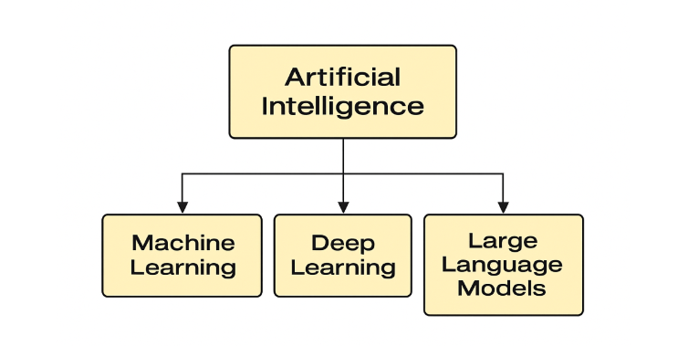
Fig. 1. Artificial Intelligence (AI)
2.3 Machine Learning (ML)
Machine Learning (ML) is a subset of AI that focuses on building systems that can learn from data and improve their performance over time without being explicitly programmed. In education, ML is commonly used to predict student outcomes, classify performance levels, and recommend learning resources [7].
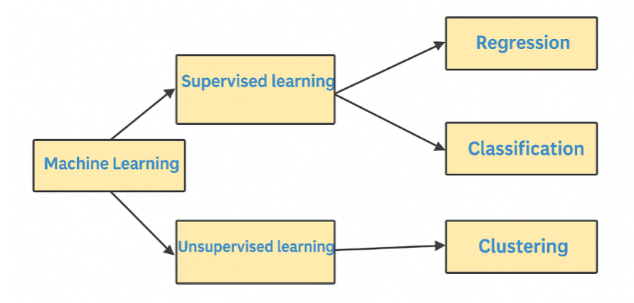
Fig. 2. Machine Learning (ML)
2.4 Deep Learning (DL)
Deep Learning (DL) is a specialized branch of ML that uses neural networks with multiple layers (deep networks) to model complex patterns in data. In educational applications, DL is used for tasks like handwriting recognition, speech-to-text processing, and analyzing visual learning behaviors [8].
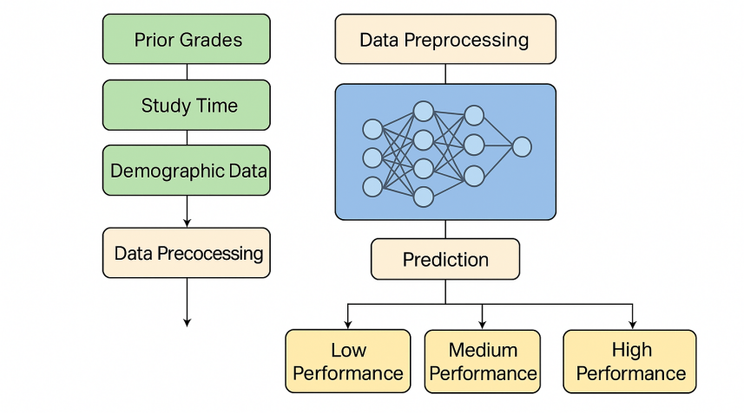
Fig. 3. Deep Learning (DL)
2.5 Large Language Models (LLMs)
Large Language Models (LLMs) like OpenAI's GPT and Google's BERT are advanced AI systems trained on vast amounts of text data. They are capable of understanding and generating human-like text. In education, LLMs are used to analyze student writing, conduct sentiment analysis, and generate automated feedback or tutoring responses [9].
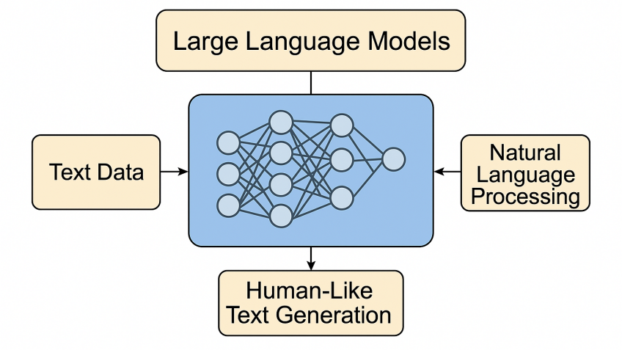
Fig. 4. Large Language Models (LLMs)

2.6 Explainable AI (XAI)
Explainable AI (XAI) refers to AI systems that offer transparent decision-making processes. XAI is crucial in education to ensure that predictions made by ML and DL models can be understood and trusted by educators and students. It helps in identifying which features influenced a prediction and supports ethical use of AI [10].
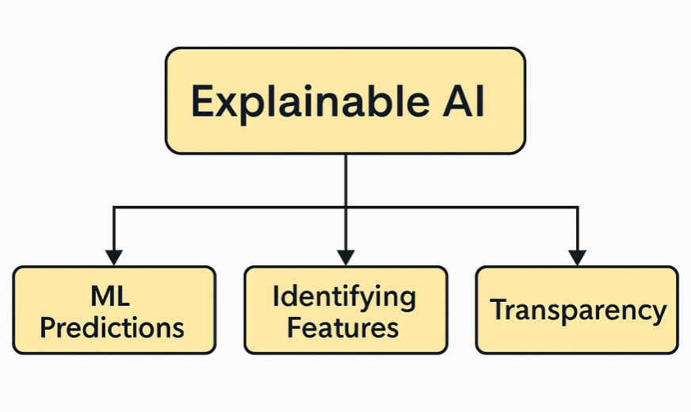
Fig. 5. Explainable AI (XAI)

2.7 Classification Techniques
Classification is a supervised learning technique used in EDM to predict student outcomes, such as pass/fail or grade categories. Common algorithms include Decision Trees, Support Vector Machines (SVM), Random Forests, and Neural Networks. These models can learn from historical data to classify new instances based on input features [11].

2.7.1 Machine Learning Techniques

Decision Tree (DT): A tree-structured classifier that splits the feature space using hierarchical decision rules, where each internal node represents a feature test, each branch represents an outcome, and each leaf node represents a class prediction. Decision trees are highly interpretable and can handle both numerical and categorical data without requiring feature scaling. However, they are prone to overfitting, especially with deep trees, and can be unstable as small changes in data may result in significantly different tree structures.
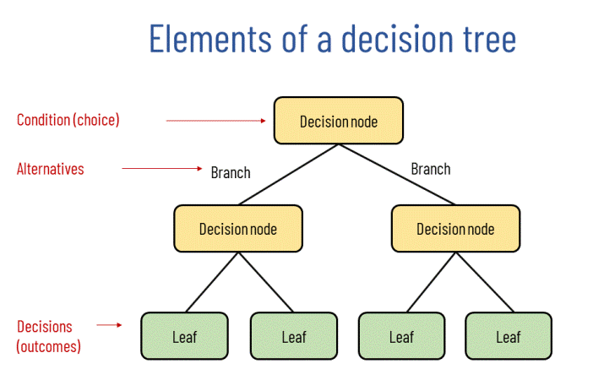

Fig. 6. Decision Tree

Random Forest (RF): An ensemble method that combines multiple decision trees through bootstrap aggregating (bagging), where each tree is trained on a random subset of the training data and features. The final prediction is determined by majority voting (classification) or averaging (regression) across all trees. Random forests reduce overfitting compared to individual decision trees, provide built-in feature importance measures, and are robust to outliers and missing values.
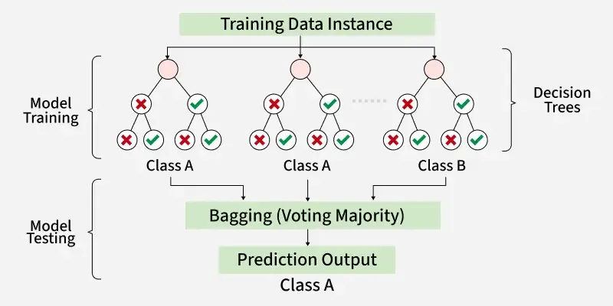
Fig. 7. Random Forest

K-Nearest Neighbors (KNN): A lazy learning algorithm that classifies instances based on the majority class among the k-nearest training samples in the feature space. KNN makes no assumptions about the underlying data distribution and can capture complex decision boundaries. However, it is computationally expensive during prediction, sensitive to the choice of k and distance metric, and performs poorly in high-dimensional spaces due to the curse of dimensionality.
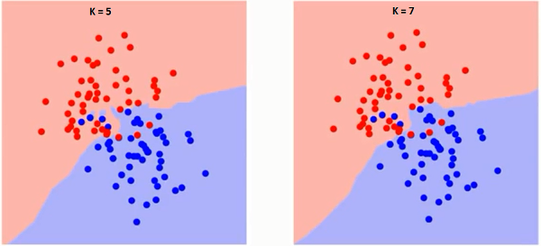
Fig. 8. KNN

Support Vector Classifier (SVC): A discriminative classifier that finds the optimal hyperplane to separate classes by maximizing the margin between different class boundaries. SVC can handle non-linearly separable data through kernel functions (polynomial, RBF, sigmoid) that map features into higher dimensional spaces. It is effective in high-dimensional spaces and memory efficiency but requires careful hyperparameter tuning and feature scaling.
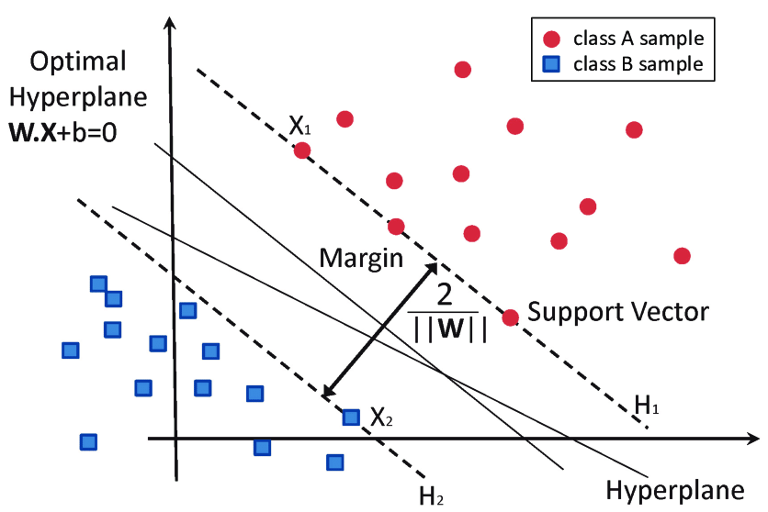
Fig. 9. SVC Algorithm

2.7.2 Deep Learning Techniques

Multi-Layer Perceptron (MLP): A feedforward artificial neural network consisting of multiple layers of interconnected neurons, including input, hidden, and output layers. Each neuron applies to a weighted linear combination of inputs followed by a non-linear activation function. MLPs can learn complex non-linear relationships through backpropagation training and are universal function approximators. They require careful architecture design, regularization techniques to prevent overfitting, and sufficient training data to achieve optimal performance.
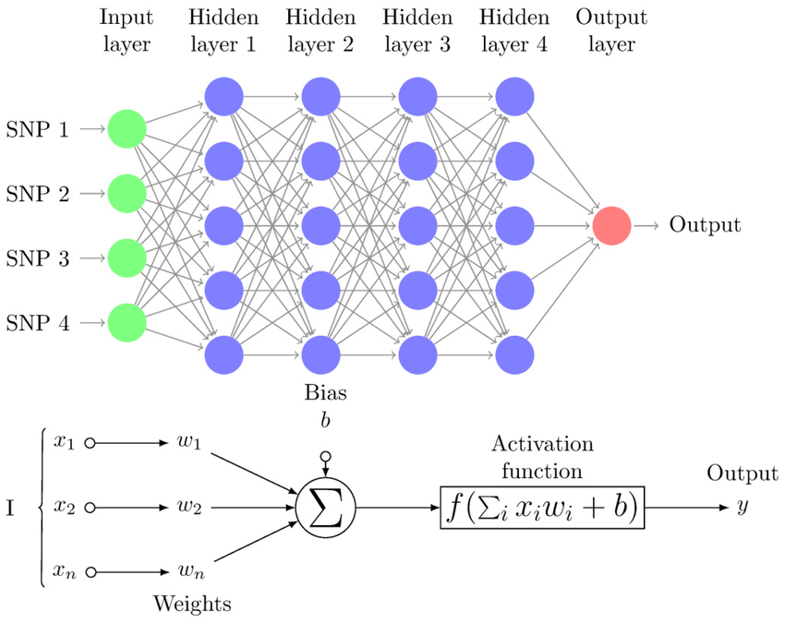
Fig. 10. MLP Diagram

Recurrent Neural Network (RNN): A neural network architecture designed for sequential data processing, where connections between nodes form directed cycles, allowing information to persist across time steps. RNNs maintain internal memory states that capture temporal dependencies in sequences, making them suitable for time-series analysis, natural language processing, and sequential decision-making tasks. However, traditional RNNs suffer from vanishing gradient problems in long sequences, often requiring advanced variants like LSTM or GRU for better performance.
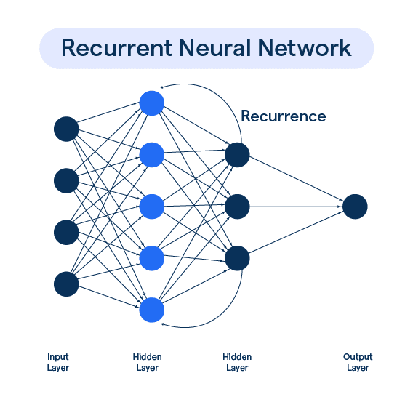
Fig. 11. RNN architecture Diagram.

2.8 Feature Selection
Feature selection is crucial in building efficient and interpretable models. By choosing the most relevant attributes (e.g., attendance, study time, prior grades), it enhances model performance and reduces complexity. Techniques include filter methods, wrapper methods, and embedded methods [12].
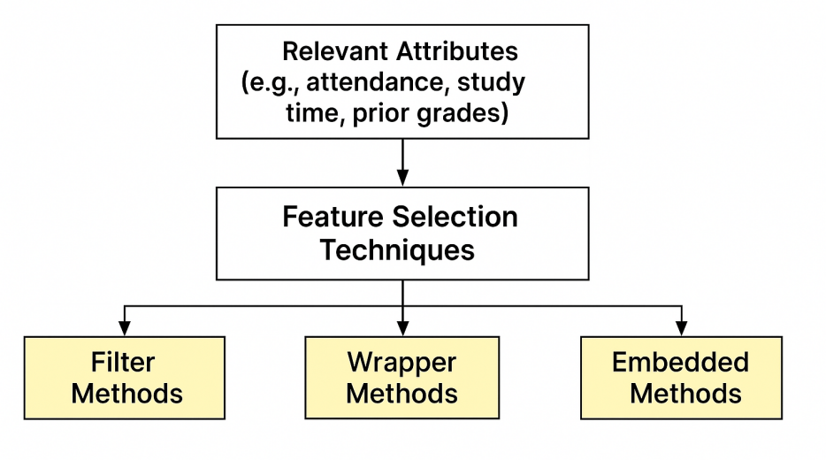
Fig. 6. Feature Selection

2.9 Evaluation Metrics
In machine learning classification tasks, evaluating model performance is essential to ensure that predictions are not only accurate but also meaningful in real-world contexts. The most widely used evaluation metrics including accuracy, recall, precision, and F1-Score are derived from the confusion matrix and are particularly valuable when dealing with imbalanced datasets (Opitz, 2024) [13].
2.9.1 Accuracy:
Accuracy measures overall correctness by comparing how many cases the model labeled right both true positives (TP) and true negatives (TN) against everything it attempted to classify, which also includes false positives (FP) and false negatives (FN). In other words, it answers the question: “Out of all predictions, what percentage did the model get right?” A value of 1 (100%) indicates perfect classification, whereas a value of 0 means every prediction was wrong. Although accuracy is intuitive and easy to interpret, it can be misleading when classes are highly imbalanced (e.g., 95% of samples belong to one class); in such cases, additional metrics like precision, recall, and F1-score provide a more balanced view of performance.

$$\text{Accuracy}=\frac{TP+TN}{TP+TN+FP+FN}$$

2.9.2 Recall (Sensitivity):
Recall, often called sensitivity or true-positive rate, indicates how completely a model captures the positive class. A high recall means the classifier misses very few genuine positives, making this metric crucial in contexts were overlooking a positive case (e.g., diagnosing a disease or flagging an at-risk student) carries serious consequences. However, emphasizing recall alone can raise the number of false positives, so it is usually interpreted alongside precision.

$$\text{Recall}=\frac{TP}{TP+FN}$$

2.9.3 Precision:
Precision also known as positive predictive value expresses the reliability of the model’s positive predictions, it tells you what proportion of items labeled as positive truly belong to the positive class. High precision means few false positives, which is vital in scenarios where wrongly identifying a negative case as positive (e.g., flagging a student as at-risk when they are not) would waste resources or cause unwarranted concern.
$$\text{Precision}=\frac{TP}{TP+FP}$$

2.9.4 F1-Score:
The F1-Score is the harmonic mean of Precision and Recall. It provides a single score that balances both concerns and is particularly helpful in scenarios with class imbalance.

$$\text{F1-Score}=2×\frac{\text{Precision}×\text{Recall}}{\text{Precision}+\text{Recall}}$$

Chapter 3 Related Work

3.1 Introduction
In recent years, the application of Artificial Intelligence (AI) techniques in education has grown rapidly, especially in the area of student performance classification. Researchers have explored various AI approaches ranging from traditional Machine Learning (ML) algorithms to advanced Deep Learning (DL) models and Large Language Models (LLMs) to analyze educational data and predict academic outcomes. This chapter presents a comprehensive review of existing literature focused on optimizing student performance classification. It highlights key datasets, methodologies, and findings from previous studies, and provides a comparative analysis of their strengths and limitations. The goal is to identify the most effective models and techniques that can enhance the accuracy and reliability of academic performance prediction.

3.2 History
Jing Wang and Yun Yu [14] conducted a study using behavioral data from an online learning platform, consisting of eleven interaction indicators such as login frequency and learning duration. They performed correlation analysis to select the most relevant features and developed a logistic regression model enhanced by Taylor expansion. The proposed model achieved higher prediction accuracy compared to traditional methods, identifying initiative and total learning time as key predictors. Advantages include its lightweight structure, strong interpretability, and efficient feature selection. However, a major limitation lies in the dataset's focus on online behaviors only, potentially excluding other influential academic or psychological factors.

Althaqafi et al. [15] conducted a study using the xAPI‑Edu‑Data dataset to predict student academic performance within Learning Management Systems (LMS). They applied resampling techniques (SMOTE and others) to address class imbalance, then developed and compared various ML models including SVM, Logistic Regression, Decision Tree, and an ensemble (stacking with Random Forest as meta‑learner). Their ensemble model achieved the highest weighted precision of 0.83, improving from 0.60 when using the original imbalanced data. The study highlighted the importance of data enrichment for performance prediction and the influence of student engagement features. Advantages include balanced class handling and robust ensemble learning; limitations involve dependency on LMS logs, raising questions on feature generalizability and real‑world adaptability.

Sandeepa and Mohottala [16] conducted a study using a real-world school dataset to evaluate multiple machine learning models such as multi-layer perceptron classifier (MLPC), decision tree, SVM, and others for predicting student academic performance. They trained and tested these models using 10-fold cross-validation and found that MLPC achieved the highest test accuracy of 86.46%. They highlighted that the MLPC excelled over other classical models and emphasized the importance of integrating explainable ML and feature selection approaches. Advantages include high predictive accuracy and the use of explainable techniques to improve model transparency; limitations involve potential overfitting indicated by the 99.65% training accuracy and dependency on a single school's dataset, which may affect generalizability.

Balaji et al. [17] conducted a study using a real-world educational dataset collected from secondary school students to evaluate multiple machine learning models including Decision Tree, Random Forest, Naïve Bayes, Support Vector Machine, and Logistic Regression for academic performance prediction. They addressed class imbalance issues using SMOTE and hyperparameter optimization via grid search. Their optimized Decision Tree model achieved the highest accuracy, improving from 90.9% to 93.4%, while Naïve Bayes saw the largest gain among models with accuracy rising from 77.3% to 83.3%. Advantages included clear interpretability, efficient handling of imbalance, and rigorous optimization; limitations involved reliance on a single school dataset limiting generalizability, and potential overfitting in the Decision Tree model.

Yuan et al. [18] conducted a study using a real-world dataset from edX to develop an integrated framework for predicting online learning performance. They first identified learning behavior patterns using clustering (e.g., low autonomy vs. motivated students), then applied machine learning models specifically XGBoost enhanced with SHAP-based feature analysis. The framework achieved nearly perfect prediction accuracy for autonomous learners and strong performance for motivated students, demonstrating superior results compared to models without behavior pattern analysis. Advantages include personalized modeling per behavior cluster, enhanced interpretability via SHAP, and better accuracy than traditional ML methods; limitations involve dependencies on clustering quality and potential overfitting within small or unbalanced clusters.

Arya et al. [19] conducted a study using the UCI ML Repository’s Portuguese student dataset to tackle issues like sample imbalance and lack of feature feedback. They developed a hybrid CNN–LSTM model to extract spatial and temporal patterns in student performance data. The model achieved 98.45% accuracy with a loss of 0.1989, outperforming standalone machine learning benchmarks. Advantages include its ability to capture both local feature correlations (via CNN) and sequence dependencies (via LSTM), as well as effective handling of data imbalance. Limitations involve dependency on a specific dataset and potential complexity overhead due to the hybrid architecture.

Adefemi et al. [20] conducted a study using public datasets (UCI, WOU, XAPI, and AV) to develop a hybrid CNN–LSTM model for predicting student academic performance across multiple educational contexts. They incorporated preprocessing techniques such as data balancing, missing value handling, and feature engineering. The hybrid model achieved exceptionally high accuracies for example, 99.67% on the UCI Portuguese dataset and 99.40% on the AV-Mathematics dataset surpassing all seven traditional classifiers evaluated. Advantages include broad dataset coverage, strong generalization, and significant performance improvements; limitations include high computational demands and less clarity on interpretability of the hybrid model.

Ben Said et al. [21] conducted a study using the Open University Learning Analytics Dataset (OULAD) to predict online learner performance during COVID‑19. They proposed a two‑pathway deep learning model that transforms clickstream time‑series into Gramian Angular Field images for input to CNN, and incorporates demographic and assessment data via fully‑connected layers. Their model achieved 92.7% accuracy, outperforming baseline approaches, and demonstrated the value of combining clickstream image representation with demographic features. Advantages include innovative time‑series imaging, robust performance, and clear handling of class imbalance via batch normalization. Limitations involve increased model complexity and reliance on image‑based encoding, which may impede interpretability in educational settings.

Junejo et al. [22] conducted a study using the Open University Learning Analytics (OULAD) dataset to develop a deep neural network model capable of forecasting student performance across multiple categories (Distinction, Pass, Fail, Withdrawn) early in the course. They proposed a multi-layer feedforward neural network that incorporates demographic, assessment, and clickstream features extracted from the first 20% of course data. Their model achieved approximately 25% higher accuracy than state-of-the-art baselines, significantly improving early-stage prediction. Advantages include multi-class classification early in the course, strong generalizability across temporal course progression, and superior performance over traditional ML and RNN-LSTM models; limitations involve potential bias from imbalanced class distributions and dependence on early-stage data quality.

Moubayed et al. [23] conducted a study using three global online course datasets collected from different regions to predict student performance at the course midpoint. They proposed hybrid CNN and RNN-LSTM models to process clickstream and time-series interaction data. The models outperformed optimized traditional ML methods in two datasets and showed comparable results in the third, demonstrating both effectiveness and robustness. Advantages include strong generalization to diverse contexts and improved performance over traditional models; limitations involve potential overfitting in small datasets and dependence on clickstream availability.

Neshaei et al. [24] conducted a study using multiple real-world knowledge tracing datasets (e.g., ASSISTments, EdNet) to evaluate large language models (LLMs) for learner performance prediction. They compared zero-shot prompting and fine-tuning approaches on LLMs like GPT-3 and GPT-4 against traditional Bayesian Knowledge Tracing (BKT). While LLMs did not surpass state-of-the-art BKT models, the fine-tuned LLM version matched BKT performance and surpassed naive baselines across metrics like accuracy and AUC. The study highlighted that LLMs’ sequence modeling abilities can be leveraged for knowledge tracing tasks. Advantages include simplified modeling without heavy feature engineering and competitive performance; limitations involve high computational cost and lack of interpretability compared to BKT approaches.

Zhang et al. [25] conducted a study using reading-comprehension datasets from the AutoTutor intelligent tutoring system in adult literacy courses to assess the predictive capacity of GPT‑4. They compared GPT‑4 against traditional models (BKT, PFA, SPARFA-Lite, tensor factorization, XGBoost), using five-fold cross-validation. While XGBoost outperformed GPT‑4 in accuracy, instructing GPT‑4 to tune XGBoost on its platform produced better results than local execution. They highlighted that GPT‑4 could select and configure strong traditional models and hyperparameters, though it was slightly less stable than grid-search. Advantages include leveraging GPT‑4’s reasoning for model selection and hyperparameter tuning; limitations involve lower raw predictive accuracy than XGBoost and reduced tuning stability.

Li et al. [26] conducted a study using a dataset of 5,278 student reflections collected across three academic terms from Kyushu University. They developed an LLM-based approach comparing single-agent and multi-agent strategies, combined with zero-shot and few-shot prompting, to automatically assess open-text reflections and predict academic performance. Their model using a single-agent with few-shot prompting achieved the highest match rate with human evaluations, and reflection scores generated by the LLM improved downstream performance prediction. Advantages include scalable automation for text assessment and enhanced predictive accuracy; limitations involve dependence on prompt design and potential bias from LLM-generated scores.

Savelka et al. [27] conducted a study using a dataset of student help requests collected from an introductory programming course to evaluate LLMs (GPT‑3.5 and GPT‑4) for classifying types of assistance requested. They evaluated both zero-shot prompting and a fine-tuned GPT‑3.5 model across various help categories (e.g., debugging, conceptual understanding). In zero-shot trials, GPT‑4 matched GPT‑3.5 across most categories and outperformed it in debugging-related queries; after fine-tuning, GPT‑3.5 achieved human-level performance, approximating inter-rater agreement. Advantages include effective classification of student intent without extensive annotation and strong performance across categories; limitations involve dependency on quality of prompt design and potential misclassification in ambiguous cases.

Lundgren [28] conducted a study using a dataset of 60 master-level political science essays to compare GPT‑4’s performance to human graders for assessment tasks. They evaluated GPT‑4’s ability to assign grades and measured inter-rater reliability against university instructors’ scores. GPT‑4’s mean grades closely matched human judgment, although it displayed a risk‑averse grading pattern and exhibited lower inter-rater consistency. Advantages include potential scalability, grading consistency, and reduced educator workload; limitations involve cautious grading biases and limited alignment with human variance.

Fernandes et al. [29] conducted a study using the ISABELA smartphone dataset, which includes passive (activity, location) and self-reported data from students before and during COVID-19. They evaluated various classifiers SVM, XGBoost, AdaBoost-SAMME with Random Forest, and an ensemble decision-level median voting pipeline comparing weekly vs. monthly data windows. Their best models achieved over 90% accuracy using weekly aggregated data. Advantages include real-world behavioral sensing and improved accuracy with weekly data; limitations involve potential privacy concerns and variability across contexts.

Yang et al. [30] conducted a study on predicting student academic performance using multi-source campus behavioral data (e.g., movement, study habits). They developed a hybrid model combining hypergraph convolution to capture higher-order relationships and TabNet for interpretable classification. Their method outperformed baseline approaches in precision, recall, and F1-score on real student data. Advantages include modeling complex student interactions and providing feature-level interpretability; limitations involve dependence on institution-specific behavior data and potential scalability challenges due to hypergraph computation complexity.

Peng et al. [31] conducted a study on predicting student performance in collaborative learning environments, focusing on team-based software engineering coursework. They built an interaction graph of student team activities and proposed CLGT (Collaborative Learning Graph Transformer) incorporating an interpretability module to visualize interaction patterns. Their model outperformed baseline graph and non-graph models, achieving higher accuracy and early identification of underperforming individuals. Advantages include leveraging social collaboration dynamics and providing interpretable results; limitations involve reliance on specific course settings and potential generalization issues to different disciplines.

Yang et al. [32] conducted a study using a heterogeneous educational dataset to evaluate student performance, integrating academic, behavioral, and social indicators. They proposed a dual hypergraph neural network that leverages framelet-based hypergraph convolutions to capture multi-level relationships among students and features. Their model achieved superior classification accuracy compared to conventional graph neural networks, showing a notable improvement in detecting at-risk learners. Advantages include capturing complex high‑order interactions and robustness to sparsity; limitations include increased computational demand and potential need for large datasets for stability.

Ref | Year | Datasets | Models | Results | Advantages | Limitations
Wang & Yu [14] | 2025 | Online learning behavioral data (11 interaction indicators) | Logistic Regression enhanced with Taylor Expansion | Outperformed traditional models in accuracy (exact % not specified) | Lightweight model, high interpretability, effective feature selection | Depends solely on online behavior data; may miss academic/personal factors
Althaqafi et al. [15] | 2025 | xAPI-Edu-Data (LMS logs: engagement, academic, cognitive) | SVM, Logistic Regression, Decision Tree, Ensemble (Stacking with RF) | Ensemble Precision = 0.83 (vs 0.60 without enrichment) | Handled class imbalance; ensemble improved accuracy; focused on engagement features | Depends on LMS-specific logs; may lack generalizability
Sandeepa & Mohottala [16] | 2025 | School-level behavioral, academic, and demographic dataset | MLPC, Decision Tree, SVM, etc | MLPC achieved 86.46% accuracy (test set) | High test accuracy; applied explainable ML and feature selection | Training accuracy (99.65%) suggests overfitting; single-site data limits generalizability
Balaji et al. [17] | 2024 | Secondary school academic dataset (demographic + behavioral) | Decision Tree, Random Forest, Naïve Bayes, SVM, Logistic Regression | Decision Tree accuracy increased from 90.9% to 93.4%; Naïve Bayes from 77.3% to 83.3% | Interpretable model; effective use of SMOTE and grid search; strong optimization | Single-site data; possible overfitting in Decision Tree
Yuan et al. [18] | 2024 | edX platform dataset with clickstream and demographic data | Clustering + XGBoost with SHAP feature importance | Nearly perfect accuracy for autonomous learners; strong accuracy for motivated cluster | Cluster-specific modeling; improved interpretability; better overall accuracy | Reliant on cluster quality; potential overfitting in small clusters
Arya et al. [19] | 2024 | UCI Portuguese student dataset | CNN–LSTM hybrid | 98.45% accuracy, loss = 0.1989 | Captures spatial and temporal patterns; handles imbalance | Specific to this dataset; hybrid model complexity
Adefemi et al. [20] | 2025 | UCI (Math & Portuguese), WOU, xAPI, AV | Hybrid CNN–LSTM architecture | Up to 99.67% accuracy (UCI-Por); 99.40% (AV-Math) | High accuracy across diverse datasets; robust preprocessing; generalizable | Heavy computation; model interpretability is limited
Ben Said et al. [21] | 2023 | Open University Learning Analytics Dataset (OULAD) | Dual-path CNN (clickstream images + FC layers) | 92.7% accuracy in online learner classification | Novel time-series imaging; combined multimodal (clickstream & demo) features; robust to imbalance | Complex architecture; image encoding reduces interpretability for educators
Junejo et al. [22] | 2024 | Open University Learning Analytics Dataset (OULAD) | Multi-layer neural network (MLP) | ~25% improvement over baselines; high early-stage predictive accuracy | Multi-category early prediction; temporal generalizability; strong performance gains | Imbalanced classes; quality dependency on early course data
Moubayed et al. [23] | 2024 | Three online course datasets from different regions | CNN + RNN-LSTM hybrid | Outperformed optimized ML in two datasets; comparable in third | Strong generalization; better accuracy than ML | Overfitting risk on smaller sets; requires clickstream data
Neshaei et al. [24] | 2024 | Real-world knowledge tracing sets (e.g., ASSISTments, EdNet) | Fine-tuned LLMs (e.g., GPT-3/GPT-4) | Matched Bayesian Knowledge Tracing performance on accuracy and AUC | Simplified modeling; competitive without manual features | High computational requirements; less transparent interpretability
Zhang et al. [25] | 2024 | AutoTutor reading-comprehension ITS (adult literacy) | GPT-4 prompting for model selection and hyperparameter tuning (XGBoost engine) | GPT-4–guided XGBoost outperformed local XGBoost; XGBoost alone had higher raw accuracy | Uses GPT-4 reasoning to select/tune models; human-like strategy without extensive trials | Raw accuracy slightly below direct XGBoost; tuning stability issues
Li et al. [26] | 2025 | 5,278 open-text student reflections (377 students over 3 terms) | Single-agent and multi-agent LLM strategies with zero/few-shot prompting | Few-shot single-agent strategy achieved highest agreement with human scoring; improved academic performance prediction | Automates qualitative text evaluation; supports performance prediction via reflection scoring | Prompt-dependence; risk of bias from LLM-generated assessments
Savelka et al. [27] | 2023 | Help-request logs from introductory programming class | GPT-3.5 (fine-tuned) and GPT-4 (zero-shot) | GPT-4 outperformed in debugging query classification; fine-tuned GPT-3.5 matched human agreement levels | Human-like intent classification; effective with minimal supervision | Relies on prompt quality; misclassifies ambiguous queries
Lundgren [28] | 2024 | 60 master-level political science essays | GPT-4 for grading | Mean GPT-4 grades matched instructor levels; lower inter-rater reliability | Scalable grading; consistent outcomes; less faculty burden | Grading bias; weaker alignment with human grading variance
Fernandes et al. [29] | 2022 | ISABELA smartphone data (activity, location, self-report) | SVM, XGBoost, AdaBoost-SAMME + RF ensemble | >90% accuracy with weekly windows | Real-life behavioral data; weekly aggregation improves results | Privacy/variability concerns; needs cross-context validation
Yang et al. [30] | 2025 | Multi-source campus behavior data (movement, study habits, online usage) | Hypergraph convolution + TabNet | Improved precision, recall, and F1 over baselines | Captures higher-order student interactions; interpretable feature analysis | Institution-specific data; scalability concerns due to hypergraph complexity
Peng et al. [31] | 2023 | Collaborative learning interaction logs (software engineering teams) | CLGT (Graph Transformer with interpretability module) | Outperformed baselines; early detection of struggling students | Models social interactions; interpretable; early-warning capability | Course-specific data; limited to collaborative projects; may not generalize
Yang et al. [32] | 2024 | Heterogeneous educational data (academic, behavioral, social features) | Framelet-based dual hypergraph neural network | Higher classification accuracy over standard GNNs; improved at-risk detection | Models high-order relationships; robust with sparse data | Higher computation cost; requires large data for model stability

Chapter 4 Proposed Approach
4.1 Introduction
This chapter describes the methodology that will be adopted to design, implement, and evaluate the proposed predictive framework. The approach will use two different feature selection techniques with diverse machine learning and deep learning models (MLP), which will then be combined in a stacking ensemble to enhance predictive performance. This structured methodology will ensure a systematic process from data preparation to model evaluation, providing a scalable framework to enhance the classification of student preferences as shown in Fig 7.
The proposed methodology will follow a comprehensive pipeline that begins with data collection and preprocessing, followed by feature engineering and selection phases. Subsequently, multiple machine learning models will be trained and evaluated, culminating in a stacking ensemble approach that combines the predictions of individual models to achieve superior performance.

4.2 Dataset Description

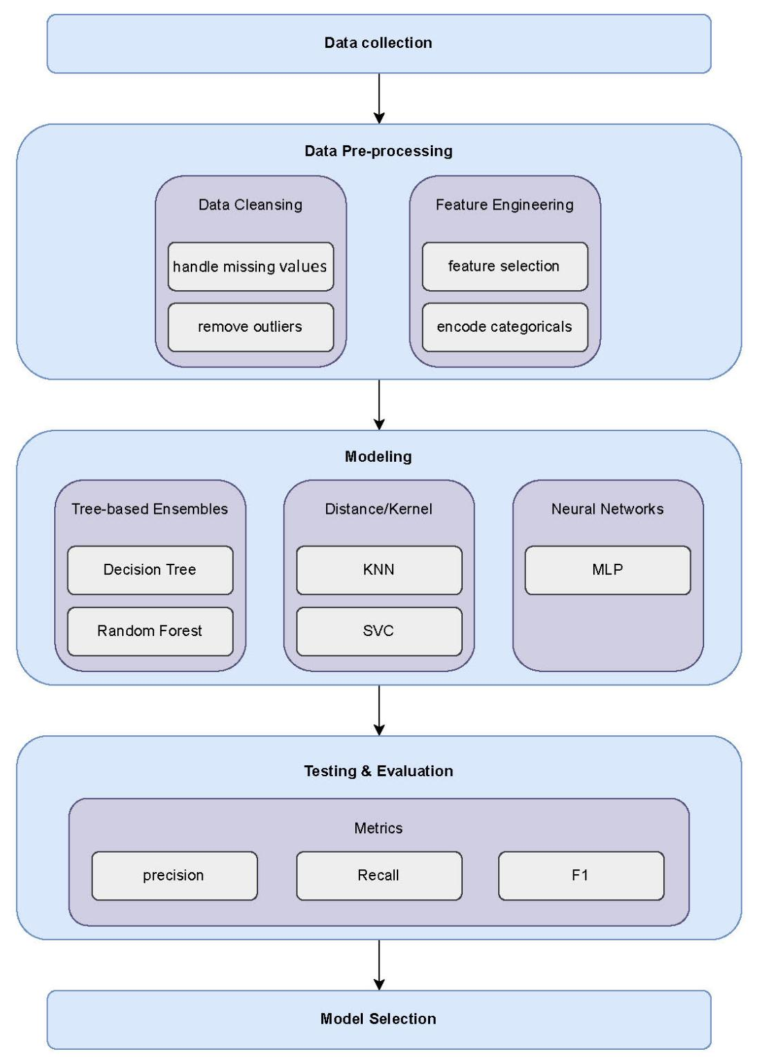
Fig. 7

4.3 Preprocessing Dataset
Data preprocessing will constitute a critical phase in the machine learning pipeline, ensuring that the raw data will be transformed into a format suitable for model training. The preprocessing methodology will encompass several key steps designed to improve data quality and model performance.
Missing Value Treatment: Missing values in the dataset will be identified and handled using appropriate imputation strategies. The data will be cleaned from any missing values to ensure completeness and reliability of the training process.
Outlier Detection and Removal: Outliers will be detected and removed from the dataset to prevent them from negatively impacting model performance. Statistical methods will be employed to identify data points that deviate significantly from the normal distribution of the feature values.
Data Normalization: Numerical features will be normalized to ensure all variables contribute equally to the model training process. Standard normalization techniques will be applied to transform features to have consistent scales, which is crucial for algorithms sensitive to feature scaling.
Categorical Encoding: Categorical features will be transformed into numerical representations using one-hot encoding. This technique will create binary columns for each category within a categorical variable, enabling machine learning algorithms to process categorical information effectively without assuming ordinal relationships between categories.

4.4 Feature Selection Phase
Feature selection will play a pivotal role in improving model performance by identifying the most informative features while reducing computational complexity and potential overfitting. This study will employ a comprehensive feature selection strategy combining multiple filter methods followed by wrapper methods.

4.4.1 Feature Selection Method 1: Filter Methods
Three distinct filter methods will be employed to capture different aspects of feature relevance:
Chi-Square Test: The chi-square statistical test will measure the independence between categorical features and the target variable. Features demonstrating significant association with the target variable will be considered relevant. The chi-square statistic will evaluate the relationship between each feature and the target class, providing a statistical foundation for feature relevance assessment.
Pearson Correlation Coefficient: This method will measure linear relationships between numerical features and the target variable. The Pearson correlation coefficient ranges from -1 to 1, where values closer to ±1 indicate stronger linear relationships. Features with significant correlation coefficients will be retained for further analysis.
Mutual Information: Mutual information will capture both linear and non-linear relationships between features and the target variable. It will measure the amount of information obtained about one variable by observing another variable. Higher mutual information values will indicate greater relevance of the feature for predicting the target variable.
From each method, the top 10 features will be selected based on their respective scoring criteria. These three sets of features will then be combined using a union operation to create a comprehensive feature pool that captures diverse aspects of feature relevance.

4.4.2 Feature Selection Method 2: Wrapper Methods
Following the filter methods, wrapper methods will be employed to refine the feature selection process. Wrapper methods will evaluate feature subsets based on their actual contribution to model performance, providing a more direct assessment of feature utility.
The wrapper method implementation will involve:
- Feature Subset Evaluation: Different combinations of features from the union set will be evaluated using a base classifier
- Performance Assessment: Each feature subset will be assessed based on cross-validation performance metrics
- Iterative Selection: Features will be iteratively added or removed based on their contribution to model performance
- Optimal Subset Identification: The feature subset yielding the best performance will be selected as the final feature set

4.4.3 Comparative Analysis of Selected Features
A comprehensive analysis will be conducted to compare the features selected by different methods. This analysis will include overlap analysis between different feature selection methods, feature importance rankings from various perspectives, validation of selected features through domain expertise, and assessment of feature redundancy and complementarity.

4.5 Machine Learning Models
The methodology will employ diverse machine learning approaches to capture different learning patterns and ensure robust performance across various data characteristics.

4.5.1 Traditional ML Models
Four traditional machine learning algorithms will be implemented and evaluated:
Decision Tree Classifier: A tree-based model that creates a hierarchical series of decision rules to classify instances. The implementation will use the DecisionTreeClassifier with random_state=42 for reproducibility. Decision trees will provide interpretable models and can capture non-linear relationships without requiring feature scaling.
Random Forest Classifier: An ensemble method that combines multiple decision trees using bootstrap sampling and feature randomization. The implementation will be used by RandomForestClassifier with n_estimators=100 and random_state=42. Random forests will reduce overfitting compared to individual decision trees while maintaining interpretability through feature importance measures.
Support Vector Classifier (SVC): A kernel-based method that finds the optimal hyperplane for class separation. The implementation will use SVC with probability=True to enable probability predictions and random_state=42. SVCs will be effective for high-dimensional data and can capture complex decision boundaries through kernel transformations.
K-Nearest Neighbors (KNN): A distance-based algorithm that classifies instances based on the majority class of their k nearest neighbors. The implementation will use KNeighborsClassifier with default parameters. KNN will be particularly effective for capturing local patterns in the data and provides non-parametric classification.

4.5.2 Neural Network Models
MLP (Multi-Layer Perceptron)
The MLP implementation will follow two approaches:
Scikit-learn MLPClassifier: A ready-to-use implementation will be configured with the following settings:
- random_state=42 for reproducibility
- max_iter=1000 to ensure convergence
- Default architecture with automatic parameter tuning
Custom MLP Architecture: A custom implementation will allow for flexible architecture design, customized activation functions, advanced optimization techniques, and fine-tuned hyperparameter control.
The MLP architecture will consist of:
- Input Layer: Neurons equal to the number of selected features
- Hidden Layers: One or more hidden layers with varying neuron counts
- Output Layer: Neurons corresponding to the number of target classes
- Activation Functions: ReLU for hidden layers, softmax for output layer
- Optimization: Adam optimizer with learning rate scheduling

4.6 Stacking Ensemble Model
The stacking ensemble methodology will combine predictions from multiple base models using a meta-learner to achieve superior performance compared to individual models.
Base Model Selection: The base models for the stacking ensemble will include Decision Tree Classifier, Random Forest Classifier, Support Vector Classifier, K-Nearest Neighbors, and Multi-Layer Perceptron. These models will be selected based on their diverse learning approaches and complementary strengths, ensuring the ensemble captures various aspects of the underlying data patterns.
Meta-Learner Implementation: The meta-learner will be trained on the predictions of base models to learn optimal combination strategies. A suitable algorithm such as Logistic Regression will be recommended for its simplicity and interpretability as the meta-learner.
Cross-Validation Strategy: To prevent overfitting in the stacking process, a cross-validation approach will be employed where base models will be trained using k-fold cross-validation, predictions will be generated for held-out folds, out-of-fold predictions will serve as features for the meta-learner, and the meta-learner will be trained on these meta-features.
Final Prediction Process: The final prediction will involve each base model generating predictions for new instances, base model predictions will be combined into a feature vector, and the meta-learner will process the feature vector to produce final predictions.

Model Evaluation: Model performance will be assessed using multiple metrics including:
- Accuracy: Overall classification correctness
- Precision: Proportion of positive predictions that are actually correct
- Recall: Proportion of actual positives correctly identified
- F1-Score: Harmonic mean of precision and recall
- Confusion Matrix: Detailed breakdown of prediction outcomes for each class
The evaluation process will include generating confusion matrices for detailed classification analysis using seaborn heatmaps, calculating weighted averages for multi-class classification scenarios, and conducting cross-validation to ensure robust performance estimation.

4.7 Summary
This methodology chapter presents a comprehensive approach that will be used to classify student preferences using machine learning and deep learning techniques. The methodology will encompass rigorous data preprocessing including missing value treatment, outlier removal, normalization, and categorical encoding using one-hot encoding. The systematic feature selection will combine filter methods (chi-square, Pearson correlation, and mutual information) with wrapper methods to identify the most informative features.
The proposed framework will ensure robust performance evaluation through multiple metrics and cross-validation strategies, while maintaining interpretability and scalability. The combination of diverse algorithms including traditional machine learning models (Decision Tree, Random Forest, SVC, KNN) and neural network approaches (MLP) through stacking ensemble methods will be designed to capture various aspects of student preference patterns, ultimately providing a reliable and accurate classification system.
The systematic approach outlined in this methodology will serve as a foundation for reproducible research and will provide a framework that can be adapted for similar classification tasks in educational data mining and student behavior analysis domains.

Chapter 5

Experimental Results and Discussion

Chapter 6 Conclusion and Future Work

References
[1] Hernández-García, Á., Cuenca-Enrique, C., del Río-Carazo, L., & Iglesias-Pradas, S. (2024). Exploring the relationship between LMS interactions and academic performance: A learning cycle approach. Computers in Human Behavior, 155, 108183.
[2] Guo, B., Zhang, R., Xu, G., Shi, C., & Yang, L. (2015, July). Predicting students’ performance in educational data mining. In 2015 International Symposium on Educational Technology (ISET) (pp. 125–128). IEEE.
[3] Isljamović, S., & Suknović, M. (2014). Predicting students’ academic performance using artificial neural network: A case study from Faculty of Organizational Sciences. The Eurasia Proceedings of Educational and Social Sciences, 1, 68–72.
[4] Alnasyan, B., Basheri, M., & Alassafi, M. (2024). The power of deep learning techniques for predicting student performance in virtual learning environments: A systematic literature review. Computers and Education: Artificial Intelligence, 6, 100231.
[5] Alshabandar, R., Hussain, A., Keight, R., Laws, A., Baker, T., & Radi, N. (2022). A flexible feature selection approach for predicting students’ academic performance in online learning. Computers and Electrical Engineering, 99, 107761.
[6] Abid, M., Elsharawy, A., & Fahmy, H. (2025). Explainable AI methods for predicting student grades and improving academic success. Journal of Information Systems and Education Management, 10(2), 45–59.
[7] Zhu, H. (2020). Big data and artificial intelligence modeling for drug discovery. Annual Review of Pharmacology and Toxicology, 60(1), 573–589.
[8] Rahmani, A. M., Yousefpoor, E., Yousefpoor, M. S., Mehmood, Z., Haider, A., Hosseinzadeh, M., & Ali Naqvi, R. (2021). Machine learning in medicine: Review, applications, and challenges. Mathematics, 9(22), 2970.
[9] Mosavi, A., Ardabili, S., & Várkonyi-Kóczy, A. R. (2019, September). List of deep learning models. In International Conference on Global Research and Education (pp. 202–214). Springer.
[10] Johnsen, M. (2024). Large language models (LLMs). Maria Johnsen.
[11] Dwivedi, R., Dave, D., Naik, H., Singhal, S., Omer, R., Patel, P., ... & Ranjan, R. (2023). Explainable AI (XAI): Core ideas, techniques, and solutions. ACM Computing Surveys, 55(9), 1–33.
[12] Li, J., Cheng, K., Wang, S., Morstatter, F., Trevino, R. P., Tang, J., & Liu, H. (2017). Feature selection: A data perspective. ACM Computing Surveys, 50(6), 1–45.
[13] Opitz, J. (2024). A closer look at classification evaluation metrics and a critical reflection of common evaluation practice. arXiv preprint arXiv:2404.16958.
[14] Wang, J., & Yu, Y. (2025). Machine learning approach to student performance prediction of online learning. PLOS ONE, 20(1), e0299018.
[15] Althaqafi, T., Saleem, F., & Al-Ghamdi, A. A. M. (2025). Enhancing student performance prediction: The role of class imbalance handling in machine learning models. Discover Computing, 28(1), 79.
[16] Sandeepa, A. G. R., & Mohottala, S. (2025, February). Evaluation of machine learning models in student academic performance prediction. In 2025 5th International Conference on Advanced Research in Computing (ICARC) (pp. 1–6). IEEE.
[17] Ahmed, E. (2024). Student performance prediction using machine learning algorithms. Applied Computational Intelligence and Soft Computing, 2024(1), 4067721.
[18] Yuan, J., Qiu, X., Wu, J., Guo, J., Li, W., & Wang, Y. G. (2024). Integrating behavior analysis with machine learning to predict online learning performance: A scientometric review and empirical study. arXiv preprint arXiv:2406.11847.
[19] Arya, M., Motwani, A., Prasad, K., Dewangan, B. K., Choudhury, T., & Chauhan, P. (2024). A CNN–LSTM-based deep learning model for early prediction of students’ performance. International Journal on Smart Sensing and Intelligent Systems, (1).
[20] Adefemi, K. O., Mutanga, M. B., & Jugoo, V. (2025). Hybrid deep learning models for predicting student academic performance. Mathematical and Computational Applications, 30(3), 59.
[21] Ben Said, A., Abdel-Salam, A. S. G., & Hazaa, K. A. (2024). Performance prediction in online academic course: A deep learning approach with time series imaging. Multimedia Tools and Applications, 83(18), 55427–55445.
[22] Junejo, N. U. R., Nawaz, M. W., Huang, Q., Dong, X., Wang, C., & Zheng, G. (2025). Accurate multi-category student performance forecasting at early stages of online education using neural networks. Scientific Reports, 15(1), 16251.
[23] Moubayed, A., Injadat, M., Alhindawi, N., Samara, G., Abuasal, S., & Alazaidah, R. (2023, December). A deep learning approach towards student performance prediction in online courses: Challenges based on a global perspective. In 2023 24th International Arab Conference on Information Technology (ACIT) (pp. 1–6). IEEE.
[24] Neshaei, S. P., Davis, R. L., Hazimeh, A., Lazarevski, B., Dillenbourg, P., & Käser, T. (2024). Towards modeling learner performance with large language models. arXiv preprint arXiv:2403.14661.
[25] Zhang, L., Lin, J., Borchers, C., Sabatini, J., Hollander, J., Cao, M., & Hu, X. (2024, June). Predicting learning performance with large language models: A study in adult literacy. In International Conference on Human–Computer Interaction (pp. 333–353). Springer Nature Switzerland.
[26] Li, G., Chen, L., Tang, C., Švábenský, V., Deguchi, D., Yamashita, T., & Shimada, A. (2025, June). Single-agent vs. multi-agent LLM strategies for automated student reflection assessment. In Pacific-Asia Conference on Knowledge Discovery and Data Mining (pp. 300–311). Springer Nature Singapore.
[27] Savelka, J., Denny, P., Liffiton, M., & Sheese, B. (2023). Efficient classification of student help requests in programming courses using large language models. arXiv preprint arXiv:2310.20105.
[28] Lundgren, M. (2024). Large language models in student assessment: Comparing ChatGPT and human graders. arXiv preprint arXiv:2406.16510.
[29] Fernandes, J., Silva, J. S., Rodrigues, A., Sinche, S., & Boavida, F. (2022). Automatically assessing students’ performance with smartphone data. arXiv preprint arXiv:2209.05596.
[30] Yang, Y., Zhao, S., An, S., Li, X., & Zhang, Y. (2025). Student academic performance prediction via hypergraph and TabNet. Journal of Big Data, 12(1), 119.
[31] Peng, T., Liang, Y., Wu, W., Ren, J., Pengrui, Z., & Pu, Y. (2023). CLGT: A graph transformer for student performance prediction in collaborative learning. In Proceedings of the AAAI Conference on Artificial Intelligence (Vol. 37, No. 13, pp. 15947–15954).
[32] Yang, Y., Shi, J., Li, M., & Fujita, H. (2024). Framelet-based dual hypergraph neural networks for student performance prediction. International Journal of Machine Learning and Cybernetics, 15(9), 3863–3877.

