
Midocean University
Management college
Master of Project Management

Exploring the Relationship Between Participant Training, Knowledge, and the Effectiveness of Risk Management Workshops in Project-Based Industries

Student \ Fawaz Hassan Almalki
ID \ 241000011

Supervisors \
Dr. Asma Abuanzeh

2024
Copyright Page
© 2024 Fawaz Hassan Almalki. All rights reserved.
This thesis is submitted for the fulfillment of the requirements for the degree of Master of PMP at Midocean University. No part of this work may be reproduced, stored in a retrieval system, or transmitted in any form or by any means - electronic, mechanical, photocopying, recording, or otherwise - without prior written permission from the author, except as permitted by law or as part of a citation in an academic work

Acknowledgments
More possible people than I can possibly wish to thank here have contributed to the completion of this thesis.
I wish to express my special appreciation to my supervisor Dr. Asma Abuanzeh. Without her inspiration, support and encouragement, this work would never have come to fruition. I have been very fortunate to have her as my supervisor.
I also appreciate the generous help of all the respondents who participated in my survey.
My deep gratitude and appreciation also go to my family and my family-in-law. Their love, support, and constant encouragement gave me a great deal of strength and determination that helped me during the time of writing this research.

Abstract
This research investigates the impact of training and knowledge levels of participants on the effectiveness of risk management (RM) workshops within project-based industries, including construction, IT, and engineering. Risk management workshops are widely used to identify, analyze, and mitigate project risks; however, their effectiveness is often influenced by the participants’ level of expertise and prior training. The study identifies a critical gap in the literature where human factors, such as participant preparedness, have been overlooked compared to the emphasis on technical tools and methodologies. By employing a mixed-methods approach, the research combines quantitative data from structured questionnaires with qualitative insights gathered through participant interviews. The population consists of professionals actively involved in risk management practices, including project managers, risk analysts, and engineers.
The study’s objectives include assessing the relationship between training levels and workshop outcomes, evaluating the influence of participant knowledge on risk analysis, and examining the effectiveness of different training interventions in enhancing participants' understanding of RM principles. The research framework integrates theories such as Adult Learning Theory and Competency Theory to examine how knowledge and training interventions influence workshop outcomes. The findings reveal statistically significant correlations between participants’ prior knowledge and the effectiveness of risk identification, analysis, and mitigation during workshops.
Results indicate that workshops with participants who possess higher levels of prior knowledge and training show improved outcomes in risk assessment and decision-making processes. Additionally, the study highlights the importance of tailored training interventions, suggesting that industry-specific and targeted programs significantly enhance participant performance compared to general risk management training.
Practically, the research provides actionable recommendations for organizations to design effective training modules that enhance cross-disciplinary collaboration and participant engagement in RM workshops. By optimizing the preparedness of workshop participants, the study contributes to reducing project delays, minimizing costs, and increasing overall project success rates. This study also underscores the importance of continuous professional development and knowledge sharing as vital components of successful risk management practices, advocating for a shift from purely technical approaches to incorporating human elements for better workshop outcomes.

Table of Contents
1. CHAPTER 1: INTRODUCTION 1
1.1. Introduction 1
1.2. Risk Management Workshops 1
1.3. Tools and Techniques used for RM 1
1.4. Recent Literature on Risk Management Workshops 2
1.5. Literature Gaps in the Application of Risk Management Workshops 3
1.6. Study Problem 4
1.7. Importance of Study 5
1.8. Objectives of The Study 6
1.9. Study Questions 6
1.10. Summary 7
2. CHAPTER 2: LITERATURE REVIEW 8
2.1. Introduction 8
2.2. Building the Research Gap 15
2.3. Theoretical Literature 21

List Of Tables
Table 1: Building the Research Gap 17

List of Figures
Figure 1: human Impactful for risk management workshops 4
Figure 2 : Risk management Human Factors 5
Figure 3: Responses of participants 10
Figure 4: future direction 11
Figure 5: Human Effectiveness 16

List of Abbreviation
RM: Risk Management
DRR: Disaster Risk Reduction
IRVM: Integrated Risk and Value Management
CBDRM: Community Based Disaster Risk Management
FMEA: Failure Mode and Effect Analysis
PMBOK: Project Management Body of Knowledge
VM: Value Management
IRVM: Integrated Risk Value Management
ABM: Agent Based Modeling
CSN: Constrain Satisfaction Network

CHAPTER 1: INTRODUCTION

Introduction
This section describes the important concepts regarding risk management (RM). It also talks about many tools and techniques which are used commonly in RM, specifically on their relevance and limitations in different phases of a project. Moreover, it reviews recent literature on the increasing use of risk management workshops, including their methodologies. Additionally, the chapter identifies a significant research gap in the literature which is followed by the study's main objectives and sub-objectives. The research objectives are then followed by research questions which highlight the main focus of this research.

Risk Management Workshops
Risks are inevitable, particularly in the dynamic construction industry (Forbes et al., 2008). In order to accomplish the goals and objectives of a project, it is necessary to proactively manage risks. Risk management (RM) is a critical strategy for optimizing decision-making. RM has the potential to mitigate the likelihood of potential hazards and their potential consequences, as well as to optimize the probability of chances (Karunathilake et al., 2020). The efficiency of both the venture and the organization can be improved by converting downside risk to upside risk through the use of a successful risk management application. The literature contains a number of RM procedures that have been proposed by professional bodies and researchers (Goh et al., 2013). Professional organizations have implemented systems to address challenges associated with its execution, as RM is of paramount importance. PMI (2004) implemented a five-step risk management framework that encompassed risk planning, risk recognition, risk evaluation, risk response, and risk control and monitoring (Benjamin et al., 2006). Simultaneously, AS/NZS (2004) introduced an RM process that encompasses the following: context establishment, risk recognition, examination, assessment, interventions, monitoring, and communication (Wong et al., 2020). Despite the differences in individual RM processes, they consistently incorporate risk identification, analysis, and response. The full benefits of RM should be realized by applying it in a systematic and exhaustive manner at all stages of the project's life cycle. Additionally, the appropriate selection of risk management instruments and techniques is crucial for the effective execution of risk management.

Tools and Techniques used for RM
The efficiency of RM in achieving project objectives can be enhanced by the prudent application of appropriate tools and techniques. In the construction and engineering sector, a diverse array of instruments and methodologies are accessible for risk management. The application of these tools and techniques in the construction and engineering industry has been the subject of numerous studies (Goh et al., 2013; Zhu et al., 2021). Checklists, brainstorming, probability impact matrices, subjective judgment, decision tree assessments, sensitivity assessments, and Monte Carlo simulations are the most frequently employed methods and tools (Abdelmageid, 2020). The selected RM tools and techniques must be compatible with the allocated resources and must also be in accordance with the project objectives. A single technique may not be suitable for all circumstances, and it may not be pertinent to every phase of an RM procedure (Akhavan et al., 2021). Despite the availability of numerous instruments and techniques, a literature review revealed that only a limited number of them are actively employed. Inventories, case-based approaches, and ideation are the most frequently employed risk identification methodologies. In the evaluation and analysis of risk, subjective judgment, intuition, and experience are frequently employed (Glette-Iversen et al., 2022).

Recent Literature on Risk Management Workshops
Risk management has become a vital component of organizational strategies across various industries, with workshops playing a significant role in ensuring a practical understanding of risk management processes (Hubbard, 2020). Over the years, research has shown that workshops tailored to risk management not only enhance organizational capabilities but also promote collaborative approaches to identifying, assessing, and mitigating risks. A few studies have discussed various dynamics of risk management workshops on the effectiveness of risk management (Settembre-Blundo et al., 2021).
A recent innovation in risk management training is the use of gamification techniques. Schönbohm and Jülich (2016) explored the application of gamified risk management workshops in German SMEs. The authors found that integrating gaming elements into the workshop format significantly improved participant engagement and understanding of risk management principles. The study concluded that gamification makes the traditionally complex subject of risk management more accessible and interactive, thereby increasing its applicability in real-world scenarios. The workshop model discussed included interactive role-playing and simulations, enhancing the practical skills of participants, especially in identifying and mitigating risks (Schönbohm & Jülich, 2016).
Barnaby (1984) researched the use of applied risk management tools within extension workshops in agriculture, focusing on the need for practical, hands-on methods in teaching risk management. The study showed the challenge of teaching theoretical risk concepts to farmers, who typically have little exposure to statistical and probabilistic thinking. By using applied workshops, which incorporated real-world examples from agricultural operations, the workshops bridged the gap between theory and practice. This practical approach allowed participants to better understand and manage risks associated with crop yields, weather events, and market volatility (Barnaby, 1984).
Abd-Karim and Lowe (2011) explored the concept of integrated risk and value management (IRVM) workshops in the context of large infrastructure projects in the UK. Their case studies showed how the simultaneous consideration of value and risk provided a comprehensive decision-making framework. The workshops allowed project teams to assess both the value drivers and risk factors in infrastructure projects, ensuring that decisions were not only cost-effective but also resilient to risks (Abd-Karim et al., 2011). Steynor et al. (2016) investigated the use of co-exploratory risk workshops in addressing climate-related risks in urban areas of Africa. Their research showed the value of interdisciplinary collaboration in risk management workshops. The workshops brought together participants from government, academia, and non-governmental organizations to collaboratively assess climate risks and develop risk mitigation strategies (Steynor et al., 2016).
Goh and Abdul-Rahman (2013) focused on the application of risk management workshops in public construction projects. The case study on a public construction project demonstrated how workshops ensured collaborative risk assessment, enabling more effective risk mitigation strategies and ultimately leading to smoother project delivery (Goh et al., 2013).
Awareness programs and workshops have been recognized as effective tools for disaster risk reduction (DRR). In their case study from Tamil Nadu, India, Asharose et al. (2015) demonstrated how workshops focusing on community-based disaster risk management (CBDRM) were used to educate local populations about potential risks and mitigation strategies. These workshops included participatory risk assessments that empowered communities to take ownership of their risk management strategies. By engaging local populations directly in the workshop process, the study highlighted how risk management workshops can be used to build more resilient communities in disaster-prone areas (Asharose et al., 2015).

Literature Gaps in the Application of Risk Management Workshops
Some of the more established RM methods and tools utilized in the construction sector today include failure modes and effect analysis (FMEA), decision tree examination, Monte Carlo simulation, sensitivity examination, and program and evaluation reviews (PERTs). However, these methods have limitations. For example, in order to be used effectively, these complex quantitative analyses - like FMEA and Monte Carlo simulations - often need a high degree of data confidence (Zeng et al., 2007). However, the majority of risk management strategies fall short in meeting the demands of recognizing, evaluating, and handling risks within a logical framework. When checklists and brainstorming are the only methods used, risks cannot be prioritized or evaluated by evaluating the likelihood and consequences of the risks. Because the only foci in PERT's sequence diagram of networks are project operations and events, the tool's use is thus restricted to time-associated concerns. While sensitivity analysis has shortcomings in identifying the best party to manage risks and in establishing suitable responses to risks, decision tree analysis excels in putting the implications of risk occurrence into practice. However, sensitivity analysis can only be used to a certain extent to evaluate the combined impact of several risk factors; it cannot indicate the likelihood that a risk will materialize (Perry & Hayes, 1985). According to Tang et al. (2007), it is necessary to methodically look at the general characteristics of RM from the viewpoints of different project participants (Tang et al., 2007). A workshop serves as one of the comprehensive ways that can offer a forum for different project stakeholders to have an integrated RM practice, as only a few techniques and tools can enable project teams to include the demands of proactive communication in their practice. An RM workshop offers a more thorough and uniform RM approach that concurrently takes into account risk planning, recognition, evaluation, and reaction by integrating a variety of tools, including brainstorming, checklists, probability impact matrices, subjective judgment, and risk registers. However, there aren't much research that look at using a workshop as a risk management technique. The use of a workshop as a productive forum in the early phases of RM was covered by Wood and Ellis (2003). All members of the project team can get together during the workshop to have a concentrated and intense discussion about potential risk problems (Wood & Ellis, 2003). Getting the team together in one location creates a creative atmosphere for discussing possible project hazards. According to Simister (2007), a workshop setting fosters creative thinking and gives participants a chance to examine other points of view that they may dismiss out of sight if they would be working alone.
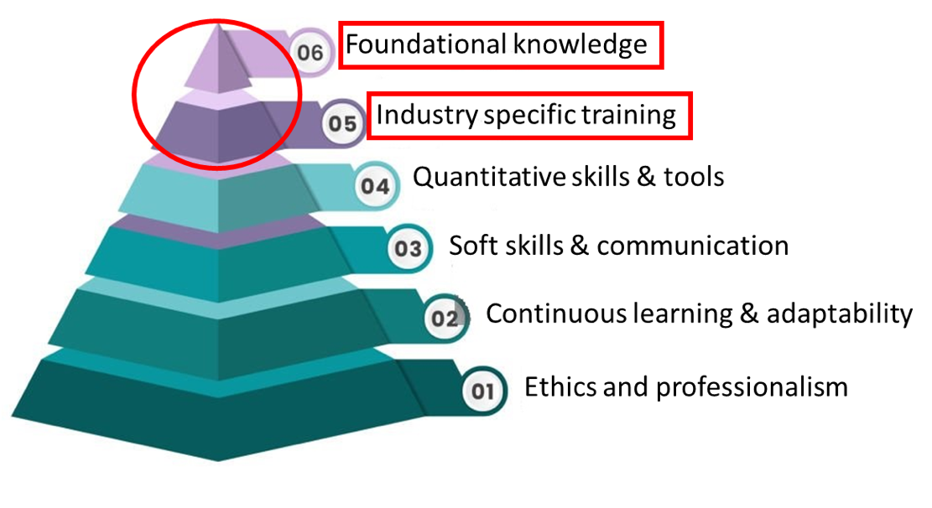
Figure 1: human Impactful for risk management workshops
Impactful human characteristics for risk management workshops with participant knowledge and prior training at the top (Authors own elaboration).

Study Problem
Risk management workshops in project-based industries, such as construction, IT, or engineering, are designed to identify, assess, and lessen project risks. However, the effectiveness of these workshops is not completely dependent on the content or the facilitation process. The participants’ level of training and prior knowledge directly influences how risks are identified, analyzed, and addressed. Individuals who are well-trained and knowledgeable about the project, industry-specific risks, and risk management tools can give better contributions, meaning more effective decision-making. Without sufficient training, participants may not be able to accurately assess risks or propose viable mitigation strategies, making the workshop less effective. Professionals with varying levels of experience, expertise, and familiarity with risk management practices usually attend workshops. Prior training can serve as a critical tool to bridge these knowledge gaps, which also ensures that participants engage at a higher level and contribute more meaningfully. For example, while an engineer may have deep technical expertise, they may not have a formal understanding of risk management principles, which can lead to ineffective participation. Prior knowledge and training can ensure that participants are on the same page, optimizing workshop outcomes.
Research has shown a link between risk management maturity and project success, but what is often overlooked is how participant preparation - both training and pre-existing knowledge - helps this maturity. Risk management is not just a procedural activity; it requires the active engagement of participants who understand not only the risks but also the project’s context, the business environment, and potential risk reduction strategies.
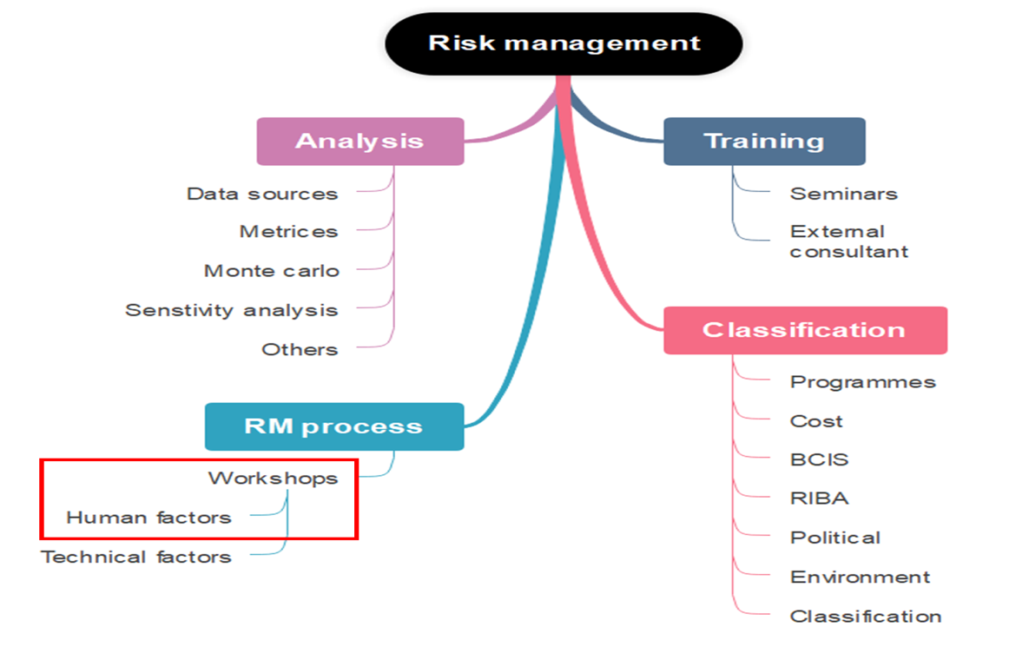
Existing literature, on risk management workshops, as described above predominantly focuses on the processes, tools, and methodologies used in workshops. However, little attention has been paid to the human factors involved in these processes, particularly how the training and knowledge levels of workshop participants impact the outcomes. This lack of focus on the human element leaves an important gap in understanding how to optimize these workshops from a participant-preparation perspective.

Figure 2 : Risk management Human Factors

Importance of Study
Scientific Importance:
- This study will try to look into an important gap in the field of risk management literature by studying the impact of participant training and knowledge on the effectiveness of risk management workshops, a topic that has been largely overlooked in existing research.
- This study will add into the scientific knowledge on the domain of human elements in the successful implementation of risk management workshops, which could potentially influence the success of risk management processes, shifting the focus from purely technical aspects to the role of participant preparedness.
- The study wants to enrich the existing theoretical bases of risk management practices in project-based industries by potentially incorporating an important element into effective risk management strategies.
- By providing empirical data on how training interventions affect workshop outcomes, this research helps develop evidence-based approaches to improve risk management strategies.
Practical Importance:
- The study will be a source of guidance for designing targeted training programs that could improve the ability of the participants to identify as well as reduce risks, meaning a better successful project management.
- By ensuring that participants are better prepared for risk management workshops, the research can help project-based industries avoid delays, reduce costs, and increase the likelihood of project success.
- The study can help to customize training to handle the unique risk profiles of different project-based industries. This could lead to the development of industry-specific training modules that equip participants to handle risks more relevant to their particular sector.
- Project-based industries mostly involve professionals from various different backgrounds (e.g., engineers, financial experts, managers). The research will be helpful in determining how training can enhance cross-disciplinary understanding, making sure that participants from different fields can collaborate in a better way during workshops with improved outcomes.
- By pinpointing the specific areas where participants lack knowledge or training, the study can help organizations avoid generalized, costly training programs. Instead, they can focus resources on filling the most critical knowledge gaps, making training more efficient and cost-effective.

Objectives of The Study
Main Objective:
To investigate the link between participant training, knowledge, and the effectiveness of risk management workshops in project-based industries, and how these factors impact risk identification, analysis, and reduction.
Sub-Objectives:
- To assess how participant training impacts the effectiveness of risk management workshops in improving risk identification and reduction.
- To understand the role of participant knowledge in contributing to the success of risk management workshops, particularly in risk analysis domain.
- To evaluate the effectiveness of knowledge level and different types of training interventions in enhancing participants' understanding of risk management principles and their ability to apply them during workshops.
- To make the outcomes widely known for the stakeholders and organizations for effective risk management decisions.

Study Questions
Following are the research questions for this study. What is the impact of participant knowledge and training on the effectiveness of risk management workshops in improving risk identification and reduction.
- What is the role of participant knowledge in contributing to the success of risk management workshops, particularly in risk analysis domain.
- What is the effectiveness of different types of training interventions in enhancing participants' understanding of risk management principles and their ability to apply them during workshops.
- To make the outcomes widely known for the stakeholders and organizations for effective risk management decisions.

Summary
Risk management is important for the success of projects. Many RM tools and techniques have been developed; their effectiveness often depends on how well they are applied in practice. Workshops have been shown to be a critical platform for addressing risks collaboratively, in a way that allows participants to engage in identifying and lessoning risks. However, the effectiveness of these workshops is influenced not only by the processes and tools used but also by the preparedness of the participants themselves. This section has brought attention to the role of human factors - specifically, participant training and knowledge (which have been mostly overlooked in previous studies) - in the success of risk management workshops. Although there is a lot of literature on RM processes and methodologies, there is also a big gap in understanding of training and prior knowledge of participants affects the identification, analysis, and management of risks. This chapter tries to focus on the human element and makes the stage for investigating how targeted training interventions can enhance the efficacy of RM workshops.

CHAPTER 2: LITERATURE REVIEW

Introduction
Several researchers have studied the effectiveness of risk management workshops and impact of different human factors in its effectiveness. Siew Goh et al. (2013) explored the effectiveness of risk management workshops in enhancing project risk management within the construction industry, focusing on RM workshops as a systematic and practical approach to managing risks. The study provides empirical evidence through a case study of a public construction project. This research is valuable because it moves beyond traditional, statistical forms of generalization and employs analytical generalization, a concept discussed by Yin (2011), allowing findings to be applied to similar contexts through logical extension. The findings validated previous studies by Wood and Ellis (2003) and Simister (2007), which emphasized that workshops significantly enhance risk understanding, facilitate team consensus, and improve decision-making by encouraging lateral thinking. The research confirmed these assertions, demonstrating how RM workshops serve as an effective platform for knowledge exchange and relationship building among stakeholders, ultimately leading to more effective risk management.
One of the key strengths identified was the RM workshop’s ability to create an energetic and focused environment, particularly beneficial for fragmented project teams. The workshops facilitated close interactions, enabling an in-depth analysis of risks from different stakeholders’ perspectives. This collaborative approach ensured that risks were evaluated comprehensively, taking into account the joint efforts of all participants rather than individual risk appetites, consistent with Wyk et al. (2008), who emphasized the importance of theory-practice convergence in risk management.
Several strengths of RM workshops were highlighted, such as improved communication between stakeholders, better alignment on roles and responsibilities, and collective intelligence gained through brainstorming sessions. The workshops were seen as opportunities for stakeholders to express their views on project risks, share knowledge, and achieve consensus on major risks. This demonstrates that RM workshops are effective not only as risk identification tools but also as mechanisms for building a shared understanding across diverse project teams.
However, the study also identified several limitations of the RM workshops that are relevant for future research. A major drawback was the resource-intensive nature of workshops, requiring significant time, money, manpower, and planning. Prolonged sessions tended to become less productive, and discrepancies in defining certain risk-related terms led to inconsistencies in risk evaluation. These findings align with previous studies that suggest RM techniques often face practical barriers in implementation, such as insufficient stakeholder commitment and resource constraints (Aven, 2016). Additionally, gaps in communication meant that the outputs of the workshop were not effectively disseminated to all stakeholders, reducing the overall impact of the RM initiative.
Another challenge observed was the lack of a structured follow-up mechanism for monitoring risks after the workshops. While the workshops succeeded in identifying and analyzing risks, the subsequent phases of risk management, such as treatment and monitoring, were inadequately addressed. This lack of follow-up reduced the overall effectiveness of the workshops, as many agreed actions and decisions were not implemented. This finding is consistent with the broader RM literature, which emphasizes that continuous monitoring and control are essential components of effective RM (Hillson, 2003).
In the context of Southeast Asia, the study noted that RM workshops could significantly enhance construction industry practices, particularly where RM practices are less developed. The findings suggest that the introduction of RM workshops can substantially improve understanding and application of RM in projects, thus contributing to better construction performance. This adds value to existing knowledge by providing empirical evidence of the feasibility of RM workshops in regions with less established RM practices.
The overall conclusions drawn suggest that RM workshops are a promising tool for enhancing project risk management, especially in their capacity to facilitate risk identification, analysis, and shared understanding. Despite limitations, such as the need for substantial resources and the potential issues with prolonged sessions, the workshops provide a structured approach to RM, particularly beneficial in industries like construction that involve numerous stakeholders with varying risk exposures. The study also emphasized the need for improved communication and follow-up mechanisms to ensure effective implementation of RM strategies identified during workshops.
However, the paper highlights several limitations in the workshop's execution, notably in the areas of incorporating positive risks, risk planning, monitoring, control, and communication. The results, while valuable, should be considered indicative rather than conclusive. Future research is needed to build on this foundational work. Specifically, there is a call for additional studies to investigate the practical applications of RM workshops, aiming to validate and refine their effectiveness in managing risks. By expanding the sample size and employing rigorous scientific methodologies, subsequent research can address the identified limitations, ultimately enhancing the understanding of how RM workshops can improve risk management practices.
Schönbohm and Jülich (2016) explored the effectiveness of gamified risk management workshops in small and medium-sized enterprises (SMEs) in Germany. The study aimed to determine whether game elements such as points, leaderboards, and time limits could motivate participants and enhance their engagement in risk management processes. The authors tested five hypotheses related to the potential benefits of gamification in risk management, including motivation, the influence of cognitive biases, decision-making improvement, structured process implementation, and practical knowledge application. The study's findings supported most of the hypotheses. Game elements were found to drive competition and enhance motivation among participants (H1). Although participants responded positively to these game mechanics, the impact of receiving and giving feedback (H2) was less prominent. The authors observed that feedback did not significantly motivate participants, which they suggested may depend on the social orientation or competitive nature of the group. Nevertheless, discussions among teams improved decision-making (H3), with participants expressing that group discussions enhanced their understanding of risks and minimized cognitive biases, such as groupthink and authority bias.
The workshop's structured design, incorporating gamified elements, facilitated a clear and replicable risk management process (H4). Participants appreciated the structured approach, with the use of levels and leaderboards helping break down the process into manageable steps. This made the risk management process more engaging and comprehensible for participants. The study also highlighted that participant valued the safe learning environment provided by the workshop, where they could apply risk management tools without fear of failure, thus improving their practical knowledge (H5).
While the study provided valuable insights, the authors acknowledged certain limitations, including a small sample size, potential bias due to researcher observation, and the lack of a control group. Despite these constraints, the results indicated that gamification has the potential to enhance risk management processes in SMEs by improving engagement, knowledge retention, and decision-making. The study concluded by recommending further research with larger sample sizes and the exploration of long-term effects of gamified risk management workshops.
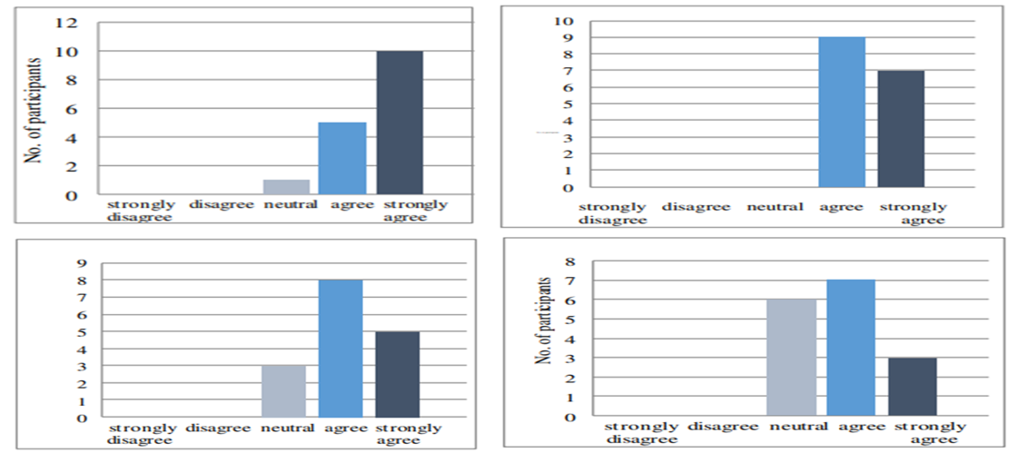
In the context of risk management workshop literature, this study contributes to understanding how gamification can be used as an innovative tool to address challenges in traditional risk management workshops.
Figure 3: Responses of participants
Responses of participants after the workshop on (a) effectiveness of workshop, (b) the discussions in and between the groups improved general decision making, (c) Got knowledge in workshop, (d) enhanced my skills towards risk management.
Tavakolan and Mohammadi (2017) explored the application of risk management workshops within the context of large construction projects, using the Ahwaz Urban Railway project in Iran as a case study. Their study highlights the significance of RM workshops in identifying, assessing, and responding to risks in complex construction environments.
The study outlined the comprehensive approach used in their risk management workshop. The workshop incorporated brainstorming sessions, fuzzy failure mode and effect analysis (FMEA), and multiple-choice questions to identify and prioritize risks, as well as determine appropriate responses. This method enabled project stakeholders to systematically assess various risk factors such as likelihood, impact, and detection rates, allowing for a better understanding of the risks facing the project. The combination of these techniques - particularly the inclusion of fuzzy sets - was designed to address some of the shortcomings of traditional RM methods, such as the inability to account for the interdependence of risks and the lack of detection capabilities in failure mode analysis.
One of the key contributions of the workshop model presented by Tavakolan and Mohammadi is its ability to foster a collaborative environment. By involving key stakeholders in the RM process, including contractors, consultants, and owners, the workshop helped align perceptions of risk across different parties. This collaborative aspect was particularly important in a project as complex as the Ahwaz Urban Railway, which involved multiple parties and high levels of uncertainty. Through group discussions and collective decision-making, the workshop not only improved the identification of critical risks but also enhanced communication and team cohesion, which are essential for the successful management of large-scale projects.
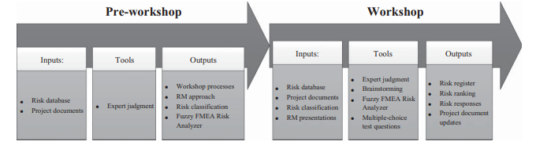
Despite the strengths of the workshop model, Tavakolan and Mohammadi acknowledge several limitations in their study. One of the main challenges identified is the time and resource investment required to conduct such workshops. Gathering key stakeholders and maintaining their engagement throughout the process can be costly and time-consuming, which may limit the feasibility of this approach in smaller projects or organizations with limited budgets. Additionally, the workshop was constrained by time, preventing a full implementation of the Project Management Body of Knowledge (PMBOK) RM framework, particularly in the areas of risk monitoring and controlling. This limitation suggests that while workshops can be effective for risk identification and assessment, they may not be as useful for long-term risk tracking and management.

Figure 4: future direction
In terms of future direction, Tavakolan and Mohammadi suggest that further research is needed to validate the effectiveness of RM workshops in different contexts. While their study provides valuable insights into the application of workshops in the construction industry, the generalizability of their findings to other industries or project types remains unclear. Additional case studies across different sectors could help determine whether the benefits of RM workshops - such as improved communication, better risk identification, and enhanced stakeholder engagement - are universally applicable or specific to certain types of projects.
The study also points to the need for better tools and methodologies for risk monitoring and controlling in RM workshops. While the authors successfully demonstrated the use of fuzzy FMEA for risk assessment, they did not provide a robust solution for ongoing risk management throughout the project lifecycle. Future research could focus on developing integrated tools that combine risk identification, assessment, and monitoring into a single framework, making it easier for project managers to track risks over time and adjust their mitigation strategies as needed.
The success of the workshop relied heavily on the skills of the facilitators, particularly in guiding discussions, managing time effectively, and keeping participants engaged. Future studies could explore the role of facilitation in greater detail, examining how different facilitation styles or techniques influence the outcomes of RM workshops. Additionally, developing standardized training programs for facilitators could help improve the consistency and quality of RM workshops across different projects and industries.
Abd-Karim et al. (2011) explored the integration of risk management and value management (VM) through the use of Integrated Risk and Value Management (IRVM) workshops. The study focused on four case studies from infrastructure projects in the UK, including projects in the rail and water industries. The authors argue that RM and VM are complementary processes that, when combined, can optimize project outcomes by reducing risks and enhancing value. Despite the wide use of RM and VM individually, their joint application remains underexplored, particularly in the infrastructure sector. The methodology adopted in the paper revolves around case studies and the implementation of IRVM workshops, which utilized brainstorming, risk identification, and quantitative risk assessment techniques. These workshops brought together multi-disciplinary teams and followed structured processes such as the job plan. The goal of these workshops was to increase collaboration among stakeholders, identify potential risks, and explore value improvement opportunities. The case studies involved infrastructure projects such as carriage washer renewal, station enhancement, water treatment, and wastewater incineration projects, all of which faced complex risks and value challenges.
Findings from the study show that IRVM workshops can effectively manage risk and value considerations simultaneously. For example, in the water treatment project, the IRVM workshop identified key business risks and generated options to mitigate these risks while enhancing project value. Similarly, the station enhancement project saw the use of brainstorming techniques to identify key risks and value improvements, leading to cost savings and a clearer understanding of project constraints. However, the study also identifies several limitations. The most significant limitation is the heavy reliance on the availability of time and resources, which makes IRVM workshops less feasible for smaller projects or organizations with limited budgets. Additionally, the authors note that while the workshops were effective in the identification and assessment of risks, they were less successful in ongoing risk monitoring and controlling throughout the project lifecycle. This suggests that the IRVM process, while beneficial in the early stages of project development, might require complementary tools for later phases.
In terms of future directions, the authors recommended further research on standardizing the IRVM process across different industries and project types. They argue that IRVM workshops could benefit from more structured guidelines to ensure consistency in their application. Moreover, additional case studies in sectors other than infrastructure would help validate the broader applicability of the IRVM approach.
In their 2015 study, Asharose et al. explored the role of awareness workshops as an educational tool for risk management within the context of community resilience. The authors emphasized the critical role of education in empowering communities, particularly in vulnerable areas like Tamil Nadu, India, where disasters are frequent. Asharose et al. begin by recognizing that the impacts of disasters differ by location and community vulnerability, suggesting that education should be localized and tailored to the specific risks faced by a community. To this end, their research underscores the importance of community-based approaches in disaster education, as these methods are more effective in engaging at-risk populations. The authors also draw attention to the gap between available knowledge and its dissemination, advocating for the use of educational tools like workshops to bridge this divide.
The article focuses on a case study from Devanampattinam, a coastal village in Tamil Nadu that was heavily affected by the 2004 Indian Ocean tsunami and subsequent cyclones. The workshop, which aimed to educate participants on DRR and mitigation strategies, involved a range of activities including lectures, field trips, and group discussions. The methodology was designed to not only transfer knowledge but also to engage participants in the creation of their own disaster response strategies, such as hazard maps and evacuation plans. The study’s findings indicated a significant improvement in participants' understanding of risk management and preparedness. For example, before the workshop, only 53% of participants recognized the receding of seawater as a natural warning sign of a tsunami. After the workshop, 100% of participants answered this question correctly. Similarly, awareness of flood insurance schemes rose from 0% to 90% by the workshop's conclusion. In the broader context of disaster education, Asharose et al. stressed the importance of sustained efforts. They argued that workshops, while effective, are not a one-off solution. Building a disaster-resilient community requires long-term engagement and the establishment of local DRR groups to ensure continuity in risk reduction activities. The authors also highlighted the need for collaboration between local governments, NGOs, and educational institutions to ensure that DRR education is both comprehensive and sustainable.
Walls et al. (2010) explored the application of stakeholder engagement in food risk management through a detailed evaluation of an iterative workshop approach. The study highlighted the growing need for broader stakeholder involvement in policy decisions, particularly in areas involving complex risk management like food safety. The authors recognized that while the benefits of public engagement are often assumed, there is little empirical evidence to support the efficacy of these processes. Consequently, their research aimed to provide a rigorous evaluation of a stakeholder engagement initiative, filling a gap in the literature by critically assessing the impact of such engagements on policy development and decision-making.
The authors underscore the broader societal trend towards more inclusive decision-making, where traditionally, policy decisions were made by accountable agents such as politicians and experts. This shift, from a “deficit model” of communication - where information flows unidirectionally from experts to the public - to a more interactive model involving a wider array of stakeholders, is argued to restore public trust in policy-makers. However, this transition presents practical challenges. The authors highlight the lack of clarity in best practices for stakeholder engagement and call for more structured and critical evaluations.
In their study, the authors adopted a multi-method, multi-criteria approach to evaluate two workshops conducted as part of the European Union-funded SAFEFOODS project. These workshops sought to gather stakeholder feedback on a novel food risk management model, designed to increase transparency and stakeholder involvement in the risk analysis process. The workshops were held in 2005 and 2007 and involved participants from a variety of sectors, including industry, regulatory bodies, and consumer advocacy groups.
The key focus of the article was the methodology used to evaluate the workshops. Drawing from previous work by Rowe and Frewer (2000), the authors applied a normative framework based on five criteria: representativeness, influence, transparency, resource accessibility, and task definition. Each of these criteria was meticulously assessed through participant questionnaires, observer ratings, and informal discussions, offering a comprehensive evaluation of the stakeholder engagement process. The criterion of representativeness examined whether the workshop participants were a fair representation of the broader community affected by food risk management. While participants generally agreed that the workshops were representative, the study observed under-representation of key groups such as retailers and national food safety authorities, which could affect the legitimacy and buy-in of the risk management model.
Influence, another critical criterion, concerned whether the participants felt their input would genuinely impact the SAFEFOODS model. While participants were optimistic, the study highlighted the challenge of ensuring that stakeholders’ contributions are effectively incorporated into policy decisions. The authors also addressed the issue of transparency, noting that while the workshops were designed to be open and inclusive, some participants felt unclear about the objectives and processes at play. This suggests that greater efforts are needed to clarify roles, expectations, and outcomes in future stakeholder engagements.
The criterion of resource accessibility revealed that participants felt they had adequate information and resources to contribute meaningfully, though improvements were noted between the first and second workshops, with more timely dissemination of materials and better-prepared discussion sessions. Task definition was another area where improvements were seen between the two workshops. Participants in the second workshop reported greater clarity on their role in evaluating the risk management model, though there were still concerns about the practical application of the model without detailed case studies.
The iterative nature of the workshops, where feedback from the first session was used to refine the second, demonstrated the importance of adaptive learning in stakeholder engagement. The evaluation provided key recommendations for future engagements, including better representation of stakeholders, more structured facilitation of discussions, and clearer definitions of tasks and objectives.
Bellora-Bienengräber et al. (2023) explored the effectiveness of risk assessments in risk workshops by examining the role of calculative cultures, which are organizational attitudes toward using and interpreting analytical risk assessment techniques. They specifically compared two calculative cultures: quantitative enthusiasm and quantitative skepticism. Quantitative enthusiasm considers risk assessments as accurate numerical representations of reality, while quantitative skepticism views these assessments as learning tools that help shape judgments, especially when dealing with complex or hard-to-quantify information.
The methodology used in this study involved agent-based modeling (ABM) to simulate risk workshops. In these simulations, participants, modeled as agents, exchanged risk-related information and adjusted their risk assessments based on the evolving discussion. The ABM approach allowed the authors to simulate cognitive processes, which were modeled using ECHO, a constraint satisfaction network (CSN). This network captured how individuals make sense of the information, prioritize it, and form judgments based on their cognitive model. The authors contrasted workshops dominated by quantitative skepticism, where judgments are more flexible and holistic, with those dominated by quantitative enthusiasm, where participants rely on more rigid, numerical evaluations.
Their findings showed that the prevailing calculative culture in an organization has a substantial impact on how effective risk workshops are. In environments dominated by quantitative skepticism, risk assessments tend to stagnate, leading to lengthy discussions that may not necessarily improve the accuracy of risk evaluations. However, these cultures also allow for better understanding of complex risks, particularly those difficult to quantify. By contrast, quantitative enthusiasm cultures encourage a more gradual refinement of risk assessments based on probabilistic models, where discussions proceed in a more structured and steady manner. This calculative culture provides a more straightforward path to evaluating risks, although it might overlook qualitative insights.
The study also found that prioritizing participants who express concern about particular risks (often high-risk items) improved the accuracy of assessing those high risks but led to the overestimation of low risks. Furthermore, the researchers found that discussions in workshops dominated by quantitative skepticism were more susceptible to sudden, unpredictable shifts in opinion, especially when new information contradicted previously held beliefs.
The limitations of the study are primarily tied to its reliance on simulations rather than real-world workshops. The ABM model focused on assessing a single risk at a time, meaning that the complexity of managing multiple, interrelated risks was not fully explored. Additionally, the study did not take into account organizational dynamics such as individual motivations, hidden agendas, or power structures, which can influence the outcomes of real-world risk workshops. The authors also noted that the simulations were limited to synchronous discussions, so their findings may not apply to asynchronous environments (e.g., risk assessments done via email).
In terms of future directions, the authors suggest that future research should explore how mixed calculative cultures - where organizations might exhibit traits of both quantitative skepticism and quantitative enthusiasm - affect risk workshop outcomes. They also recommended investigating how asynchronous workshops or dispersed participants affect risk assessments, as time delays and selective attention to information might significantly alter discussions. Additionally, more empirical studies are needed to validate their findings, especially through field studies in organizations with diverse calculative cultures. Research could also explore the effects of individual personality traits, such as introversion or extroversion, on the dynamics of risk workshops. Finally, the authors highlight the need to study the broader implications of calculative cultures beyond risk workshops, potentially extending their research to other organizational decision-making processes.

Building the Research Gap
The literature surrounding risk management workshops provides a fragmented understanding of how such interventions contribute to project outcomes, particularly in the areas of risk identification, analysis, and reduction. While multiple studies demonstrate the utility of RM workshops in enhancing collaboration and improving decision-making, they tend to either focus heavily on the technical aspects or emphasize surface-level engagement techniques, leaving a significant gap in exploring the human factors - particularly participant training and knowledge - that underpin workshop effectiveness.
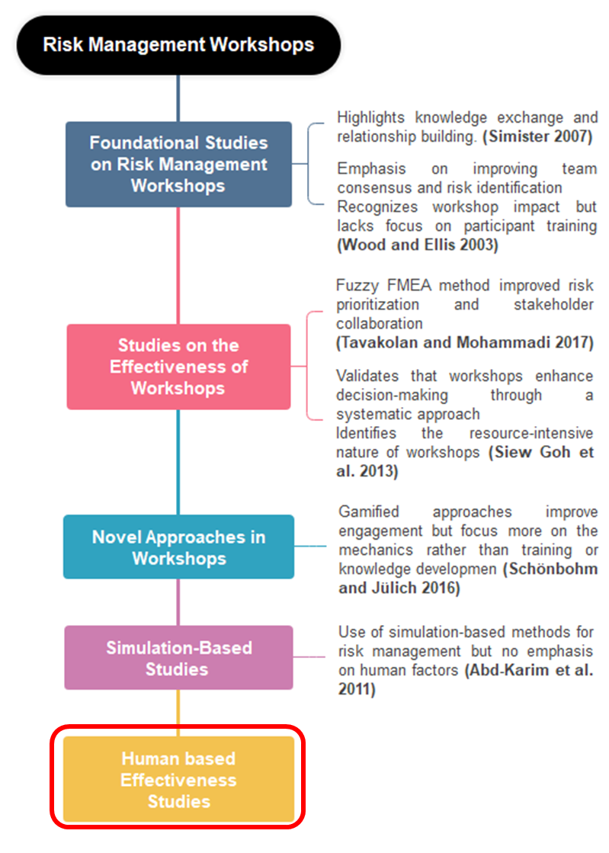
One dominant theme in the literature is the focus on structured methodologies within RM workshops, which often overlooks the role of participant knowledge. Tavakolan and Mohammadi (2017), for example, used fuzzy failure mode and effects analysis (FMEA) to structure RM workshops for large-scale construction projects. However, their emphasis on technical assessment tools limits the understanding of how well participants grasp and apply risk management principles. On the other hand, Schönbohm and Jülich (2016) explored the gamification of RM workshops in SMEs, enhancing engagement through interactive, game-based methods. However, the study did not delve into whether this increased engagement translated into a deeper understanding of risk management concepts or improved long-term outcomes in risk reduction. In contrast, Abd-Karim et al. (2011) combined RM with value management (VM) in workshop settings, demonstrating how cross-disciplinary approaches can enhance the effectiveness of risk identification processes. While the integration of RM and VM provided a more comprehensive risk analysis framework, the study implicitly assumed that participants had sufficient baseline knowledge to engage meaningfully in these activities, an assumption that has yet to be thoroughly tested in the literature. Finally, many studies, including Goh et al. (2013), validated RM workshops as tools for enhancing collaboration and improving team consensus in risk identification. However, these studies often rely on simulations or hypothetical scenarios, with limited application in real-world project-based industries.
Figure 5: Human Effectiveness
Collectively, the literature shows that RM workshops are effective tools for improving risk identification and enhancing collaboration, but the emphasis has often been on the technical or engagement aspects without delving into human factors including the critical role of participant knowledge and training. Schönbohm and Jülich (2016) highlighted the importance of engagement but did not connect it to long-term learning outcomes. Tavakolan and Mohammadi (2017) provided technical rigor through FMEA but neglected how participants' knowledge influences the effectiveness of these methods. Abd-Karim et al. (2011) integrated multi-disciplinary approaches but left unexamined how training impacts cross-disciplinary collaboration in RM workshops.
Thus, the current study tries to tackle these gaps by investigating the relationship between participant training, knowledge, and the effectiveness of RM workshops, aiming to enhance not only the understanding of how these factors influence risk identification but also how they impact risk reduction and analysis in complex, project-based environments.

Author | Title  Table 1: Building the Research Gap | Methodology | Findings | Limitations | Future Direction
Wyk et al. 2016 | Effectiveness of Risk Management Workshop | Case study approach using passive observation, interviews, and documentation reviews to assess the RM workshop’s effectiveness in managing project risks. | RM workshops facilitate communication, consensus-building, and proactive risk management among project team members. They enhance understanding of project risks and improve overall RM performance regarding time, cost, and quality. | Limitations in risk planning, risk monitoring, and communication were noted. The results are indicative rather than conclusive due to limited generalizability. | Further research is needed to validate the effectiveness of RM workshops, particularly through a larger sample size and rigorous methodologies. Studies should aim to address limitations and explore mechanisms for improved RM practices.
Schönbohm, A. & Jülich, A. (2016) | On the Effectiveness of Gamified Risk Management Workshops – Evidence from German SMEs | Quasi-experimental action research, focus groups, surveys, observation s | Gamification enhances risk management in SMEs by improving engagement, motivation, and decision-making. Game elements like points and leaderboards were motivating. Discussions minimized cognitive biases and improved decision-making. | Small sample size (16 participants), potential participant and observer bias, lack of control group, no consideration of age or gender factors. | Larger sample size studies, long-term effects of gamification, different player types' impact, IT-supported interaction formats.
Tavakolan & Mohammadi (2017) | Risk Management Workshop Application: A Case Study of Ahwaz Urban Railway Project | Case study, risk management workshop using fuzzy FMEA, brainstorming, and multiple-choice techniques. | RM workshop facilitated collaboration among stakeholders, identified critical risks, and enhanced team communication. Fuzzy FMEA allowed nuanced risk assessment. | High resource and time investment required for conducting workshops, did not fully implement PMBOK RM framework, and lack of consideration of risk interrelationships. | Future research should explore risk interdependencies, incorporate positive risks (opportunities), validate workshops across different industries, and develop better risk monitoring tools.
Abd-Karim et al. (2011) | Integrating Risk and Value Management using IRVM Workshops: Case Studies in Infrastructure Projects in UK | Case studies, IRVM workshops, brainstorming, risk identification, quantitative risk assessment. | IRVM workshops effectively integrated RM and VM, reducing risks while improving value. Case studies demonstrated cost savings and better project outcomes. | Resource and time-intensive, making it less feasible for smaller projects. Limited effectiveness in risk monitoring and controlling throughout project lifecycle. | Standardization of IRVM process across industries, further research on broader applicability, and use of advanced decision-making tools like scenario planning.
Bellora-Bienengräber et al. (2023) | The effectiveness of risk assessments in risk workshops: the role of calculative cultures | Agent-based modeling (ABM) with ECHO (constraint satisfaction network), simulations of risk workshops comparing calculative cultures. | Quantitative skepticism leads to longer discussions and sudden shifts in opinion, while quantitative enthusiasm results in gradual changes; prioritizing concerned participants improves high-risk assessments but overestimates low risks. | Single risk focus, no consideration of organizational dynamics or asynchronous environments; results are based on hypothetical simulations rather than real-world scenarios. | Research on mixed calculative cultures, asynchronous risk workshops, broader studies in different industries, and exploration of individual traits in risk workshop dynamics.
Asharose, Saizen, & Chakkalathundiyil, (2015) | Awareness Workshop as an Effective Tool and Approach for Education in Disaster Risk Reduction: A Case Study from Tamil Nadu, India | Conducted a one-day workshop in a coastal village; included lectures, field trips, group discussions, hazard mapping, and pre/post-evaluation tests. | Significant improvement in disaster awareness (e.g., recognition of tsunami warning signs increased from 53% to 100%); increased awareness of flood insurance and alternative livelihoods. | Limited participation of men; small sample size (30 participants out of a village population of 9,000); economic constraints hindered broader participation. | Suggests sustained, long-term efforts through local DRR groups; calls for continued education and the establishment of disaster management clubs in schools.
John Walls, Gene Rowe, Lynn Frewer | Stakeholder engagement in food risk management: Evaluation of an iterated workshop approach | Multi-method, multi-criteria evaluation using participant questionnaires, observer ratings, and informal discussions. The evaluation framework was based on five key criteria: representativeness, influence, transparency, resource accessibility, and task definition. | The evaluation demonstrated that stakeholder workshops could improve transparency & inclusiveness of risk management processes. There was an increase in participant satisfaction between the first and second workshops, especially regarding resource accessibility and influence. The workshops provided useful feedback for refining the food risk model. | Some stakeholder groups were underrepresented, such as retail and food safety authorities. Additionally, the workshops lacked detailed case studies, which limited the practical application of the proposed model. The facilitation in some sessions allowed dominant participants to overshadow others. The independence of the evaluation could have been stronger, as one author had a dual role. | Future engagements should ensure broader stakeholder representation, use detailed case studies to clarify practical applications, and improve the transparency of how participant input impacts decision-making. Independence in evaluation processes should also be emphasized, and micro-dynamics such as power imbalances in group discussions need further investigation.

Theoretical Literature
For the study on how training and knowledge levels of participants in risk management workshops impact the outcomes, many theoretical areas can guide tis particular research. These areas provide the main theories and concepts that talk about the focus of the study and help frame the approach to understanding the phenomena. Here’s an outline of potential theoretical areas that could be relevant:
Adult Learning Theory (Andragogy):
  - Premise: Adult learning theory, as articulated by Malcolm Knowles, says that adults are self-directed and expect to take responsibility for decisions. Adult learning programs must accommodate this characteristic. This theory can help explain why and how the level of training impacts the effectiveness of risk management workshops, as it suggests that adults integrate learning with their existing knowledge base and practical experience.
  - Application: Examining how training programs for risk management align with adult learning principles could provide insights into their effectiveness in enhancing participant engagement and learning outcomes.
Competency Theory:
  - Premise: Competency theory talks about the skills and behaviors that can lead to successful performance in a job role. In the direction of risk management, specific competencies related to risk identification, analysis, and mitigation are critical.
  - Application: This theory can be used to assess which competencies are most impacted by training and knowledge levels, and how these competencies influence the success of risk management workshops.
Knowledge Management Theory:
  - Premise: This theory states the processes of creating, sharing, using, and managing the knowledge and information of an organization. It emphasizes the value of shared knowledge as a resource.
  - Application: The theory can be applied to know how knowledge sharing in workshops affects risk management practices and outcomes, and how the depth of individual knowledge contributes to the collective knowledge pool.
Group Dynamics Theory:
  - Premise: Group dynamics theory explores the behavioral and psychological processes occurring within a social group. In the context of workshops, how group members interact can significantly affect the learning environment and the outcomes of group activities.
  - Application: Understanding the dynamics in risk management workshops can help identify how participant training and knowledge levels influence group interactions and decision-making processes.
Behavioral Decision Theory:
  - Premise: This theory examines the decision-making processes used by individuals, particularly the biases and heuristics that influence judgments. It is relevant in understanding how people perceive and respond to risks.
  - Application: Exploring how training and knowledge impact participants' decision-making in risk management can elucidate how biases are mitigated or exacerbated in workshop settings.
Systems Theory:
  - Premise: Systems theory states that understanding the interdependent structures of dynamic systems is essential to understanding the system as a whole. This can be applied to organizational practices and learning environments.
  - Application: Applying systems theory to risk management workshops could help analyze how various elements (such as training, knowledge, organizational culture, and workshop design) interact to produce outcomes.
These theoretical frameworks provide main basis for analyzing how training and knowledge influence the effectiveness of risk management workshops. They not only guide the development of your research questions and methodology but also help in interpreting the results within a broader conceptual context.

