

Sales Forecasting
Prepared By
Name: Othman Omar Alamoudi ID No.: 243000199

Submitted in fulfillment of the requirements for the degree Master of Science in Artificial Intelligence
At
Collage of Informatics
Midocean University
UAE
Supervisor Name: Wesam Ahmed
College of Informatics, Midocean University, Comoros
Email:…………………….

Acknowledgements
I want to express my deepest gratitude to Dr. Wesam Ahmed, whose guidance, encouragement, and expertise were instrumental throughout this research. Dr. Wesam’s insightful feedback and unwavering support helped shape the direction of this thesis and inspired me to explore new dimensions in machine learning and sales forecasting.
Their mentorship not only enhanced the academic rigor of this work but also fostered a deeper appreciation for the value of data-driven decision-making in real-world business contexts. I am genuinely thankful for their patience, constructive criticism, and commitment to excellence.

Abstract

List of Publications

Table of Contents

List of Abbreviations xiv
List of Figures xvi
List of Tables xviii

Chapter 1: Introduction................................................................................ 1
1.1 Problem Definition ................................................................................... 2
1.2 Thesis Objectives ...................................................................................... 3
1.3 Thesis Contribution ................................................................................... 3
1.4 Thesis Organization................................................................................... 4
Chapter 2: Overview...................................................................................... 5
2.1 background ...............................................................................................6
2.2 Machine Learning Techniques…............................................................. 6
2.3 Deep Learning Techniques.. .....................................................................9
2.4 Statical Model Techniques.. .....................................................................8
2.5 Evaluation Metrics………... .....................................................................8
Chapter 3: Related Work ……………….………………………………... 9
3.1 Introduction ..............................................................................................13
3.2 Machine Learning Studies ................................................................ 13
3.3 Deep Learning Studies ...................................................................... 14
3.4 Summary Related Work........................................................................... 14
Chapter 4: Proposed Approach ................................................................. 18
4.1 Dataset Description ................................................................................ 18
4.2 Data Preprocessing ................................................................................. 19
4.3 Data Preprocessing ................................................................................. 19
4.4 Baseline Forecasting Models.................................................................. 20
4.5 Proposed Hybrid Forecasting Framework ............................................. 21
4.6 Model Training Configuration ............................................................... 21
4.7 Evaluation Metrics .............................................................................. 21

Chapter 5: Experimental Results and Discussion ................................23
5.1 Introduction ......................................................................................... 23
5.2 Quantitative Results ............................................................................ 23
5.3 Comparative Analysis ......................................................................... 25
5.4 Discussion ........................................................................................... 26
5.5 Summary ............................................................................................. 26

Chapter 6: Conclusion and Future Work .............................................. 27
7.1 Important Features ............................................................................... 27
7.3 Future Work ....................................................................................... 27

References .................................................................................................. 28

List of Abbreviations
- AI: Accuracy
- LSTM: Artificial Neural Network
- XGBOOST: Analysis of Variance
- ARIMA: Receiver Operating Characteristic

List of Figures
2.1.1 Core AI technologies between ML and DL role in classification…… | 13
2.2.1.1 XGBoost ………………………………………………………………. | 8
2.2.2.1 Prophet flowchart…………………..………………………………… | 16
2.3.1.1 LSTM …………………………………………... | 21
2.5 Educational Process Mining (EPM): A Learning Analytics Data Set | 23
5.3 Model risduals on test set………………………………………………… | 24
5.2 Sales Forecast on test set………………………………….………… | 24
5.1 Performance Comparison of Forecasting Models…………..……… | 24

List of Tables
3.1.1 Summary Related Work…………………………………….…… 21
4.1 Dataset description …………….………………………………..…. 21
5.1 Performance Comparison of Forecasting Models …………….…… 21

Abstract

Accurate time series forecasting is critical for informed decision-making in domains such as finance, energy, and supply chain management. This study investigates the predictive performance of the baseline Prophet model and two hybrid approaches, Prophet+LSTM and Prophet+GRU, on a real-world dataset. The hybrid models integrate the strengths of Prophet’s trend and seasonality decomposition with the sequence modeling capabilities of recurrent neural networks. Experimental results on the held-out test set demonstrate that both hybrid models consistently outperform the standalone Prophet model across all evaluation metrics, including MAE, RMSE, and MAPE. Among the hybrids, Prophet+LSTM achieved the lowest error rates (MAE: 181.12, RMSE: 228.38, MAPE: 13.47%), highlighting the effectiveness of combining statistical and deep learning approaches for capturing complex temporal dependencies. These findings underscore the potential of hybrid forecasting frameworks for improving predictive accuracy in time series applications.

Chapter 1 Introduction
Recently, machine learning has greatly contributed to the accuracy of sales forecasting models. Traditional statistical methods tend to suffer from non-linearity and the variability in market dynamics. Neural networks, especially such as Long Short-Term Memory (LSTM) models, however, have been robust in representing time scale dependencies. An LSTM-based model has been used to predict furniture sales in Central and Eastern Europe, recording low forecast error without seasonal assumptions, accurately monitoring demand variability and so on [1]. Sales prediction is an essential part of business forecasting and planning, especially in e-commerce where the order is cyclical and affected by different dynamic features. Receive accurate estimates improve visibility in the planning for inventory administration, stock planning, production planning, and cash flow, thus lowering human error and minimizing human intervention. Time series forecasting through traditional statistical methods such as the ARIMA model has been widely used, yet the model tends to fail in the face of nonlinear patterns or drastic changes in the markets. The development of AI is progressing faster than we can anticipate, and hybrid models that marry statistical and neural methods are now being developed. To take an example of this, Vavliakis et al. proposed a hybrid ARIMA-LSTM model by including linear time series analysis and nonlinear residual modeling through a LSTM network. Their approach also includes retail price as a characteristic to enhance the prediction model performance in price sensitive e-commerce settings [2]. Sales forecasting forms the framework of supply chain management and refers to the process that allows organizations to project demand, control stock levels, and lower expenses. Big data and machine learning are making more sophisticated algorithms capable of dealing with much larger data sets, replacing traditional forecasting methods. Forecasting sales is a significant key in supply chain management, allowing an organization to predict demand, manage inventory efficiently, and minimize operational costs. In this context, the data-driven forecasting methods that used to be performed over decades in the past have been replaced by algorithms that, based on data analysis and machine learning insights, can adapt to the complex and nonlinear patterns observed in consumer behavior as they evolve over time. One of the algorithms mentioned is Extreme Gradient Boosting (XGBoost), an ensemble learning method associated with speed and accuracy. It has been applied to different domains, such as predicting retail sales. It’s not only great for analyzing big data, but also in finding patterns that are often overlooked. Akande et al. (2022) used XGBoost in forecasting sales through historical data from 45 Walmart stores. Their research found that XGBoost predicted sales very well with a high accuracy, and achieved better performances than previous methods based on Mean Absolute Error (MAE), Root Mean Square Error (RMSE), and R² criteria. Thus, it is a suitable guide for retail decision-makers [3], offering actionable intelligence for pricing strategies and inventory planning. A potential implication for predictive models, like XGBoost for instance, is that the prediction accuracy will be better than before.

Problem Definition
Sales forecasting plays a pivotal role in guiding inventory management, budgeting, and strategic decision-making across industries. However, traditional forecasting techniques—such as moving averages and linear regression—often fall short in the face of the complexity of modern sales environments. These methods struggle to account for nonlinear relationships, seasonal variations, promotional effects, and external disruptions, such as economic shifts or competitor actions. As businesses accumulate increasingly diverse and high-volume datasets, the limitations of conventional models become more pronounced. Inaccurate forecasts can lead to overstocking, missed revenue opportunities, and inefficient resource allocation. This is especially problematic in fast-paced sectors such as retail and e-commerce, where agility and precision are crucial. Machine learning and deep learning offer promising alternatives by enabling models to learn patterns directly from historical data, adapt to changing trends, and incorporate a wide range of variables that influence them. Recent advances in artificial intelligence, machine learning, and deep learning have created new opportunities for organizations to improve decision-making processes across various sectors, including sales and retail. Despite these technological developments, accurately forecasting future sales remains a major challenge for many companies. Traditional forecasting approaches often fail to capture the complexity and dynamic nature of sales data, which is influenced by trends, seasonality, and changing consumer behavior. The absence of accurate and reliable sales forecasting models has led to significant operational challenges, particularly in inventory management, supply chain planning, and warehousing operations. Inaccurate predictions can result in overstocking, stock shortages, and product spoilage, ultimately increasing operational costs and reducing customer satisfaction. These challenges highlight the need for more advanced forecasting techniques that can effectively analyze historical sales data and adapt to evolving market conditions. Although machine learning and deep learning models have demonstrated strong potential in modeling complex and nonlinear patterns, their standalone application may not always yield optimal results, especially when dealing with limited or noisy datasets. Therefore, there is a critical need for robust forecasting frameworks that integrate statistical methods with advanced learning techniques to improve prediction accuracy and support efficient sales planning.

1.2 Thesis Objectives
The primary objective of this thesis is to investigate and evaluate the effectiveness of machine learning and deep learning techniques in enhancing the accuracy and reliability of sales forecasting models. By leveraging historical sales data and relevant external variables, the study aims to develop predictive models that outperform traditional statistical approaches in dynamic and data-rich environments.

1.3 Thesis Contribution
Chapter 2 presents the theoretical background and foundational concepts related to sales forecasting. It reviews key machine learning, deep learning, and statistical time-series techniques, including XGBoost, Prophet, LSTM, and ARIMA. This chapter establishes the technical groundwork necessary to understand the forecasting models explored in the thesis.
Chapter 3 reviews and analyzes related work in the field of sales forecasting. It examines recent studies that apply machine learning, deep learning, and hybrid approaches, highlighting their methodologies, strengths, and limitations. This comparative analysis helps identify research gaps and motivates the development of the proposed hybrid framework.
Chapter 4 describes the proposed forecasting framework and experimental methodology. It details the data preprocessing procedures, model architectures, and the design of the hybrid approaches that integrate Prophet with deep learning models. The chapter also explains the training strategy and evaluation metrics used to assess model performance.
Chapter 5 presents the experimental results and discussion. It reports quantitative performance comparisons between the statistical, deep learning, and hybrid models using standard evaluation metrics. The chapter further analyzes the results, discusses the effectiveness of the hybrid approach, and interprets the findings in the context of sales forecasting applications.
Finally, Chapter 6 concludes the thesis by summarizing the key findings and contributions of the study. It also outlines the limitations of the current work and suggests potential directions for future research in hybrid and data-driven sales forecasting.

1.4 Thesis Organization
This thesis contributes to the growing body of research on intelligent forecasting systems by demonstrating how machine learning techniques can enhance the accuracy, scalability, and interpretability of sales predictions. Unlike traditional statistical models, which often rely on rigid assumptions and limited feature sets, the proposed approach leverages data-driven algorithms to uncover complex patterns and nonlinear relationships within historical sales data.

Chapter 2 Overview
This thesis explores the application of machine learning and deep learning models to enhance the accuracy and reliability of sales forecasting. The study is motivated by recent research that demonstrates the superiority of intelligent forecasting systems over traditional statistical methods. For example, Li et al. (2020) developed an automatic LSTM-based forecasting system that effectively modeled sequential sales data [1]. Vavliakis et al. (2021) proposed a hybrid ARIMA-LSTM approach that improved prediction accuracy in e-commerce environments [2]. Akande et al. (2021) applied XGBoost to Walmart’s historical sales data, achieving high performance and interpretability [3].Building on these foundations, this research aims to design a robust forecasting framework that integrates data preprocessing, feature selection, and model tuning. The models will be evaluated using real-world datasets and performance metrics, including Mean Absolute Error (MAE), Root Mean Squared Error (RMSE), and R² score. Ultimately, the goal is to provide actionable insights that support better inventory planning, budgeting, and strategic operations.
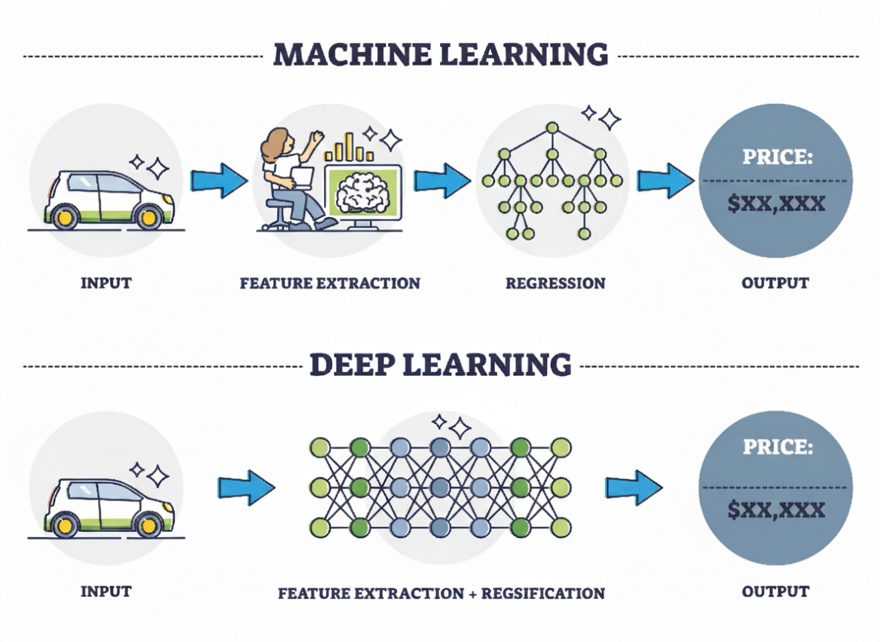
Figure 2.1.1: Core AI technologies between ML and DL role in classification.

Background
Sales forecasting is a foundational element of business operations, particularly in the retail and e-commerce sectors, where demand variability can significantly impact inventory control, financial planning, and strategic decision-making. Traditional forecasting models, such as moving averages and linear regression, have been widely used due to their simplicity and interpretability. However, these approaches often struggle to capture the nonlinear relationships, seasonal fluctuations, and external disruptions that characterize modern sales environments.
With the increasing availability of high-volume and diverse datasets, the limitations of conventional models have become more pronounced. Inaccurate forecasts can lead to overstocking, missed revenue opportunities, and inefficient resource allocation. To address these challenges, researchers have turned to machine learning and deep learning techniques, which offer greater flexibility and predictive power. Algorithms such as Decision Trees, Random Forest, Support Vector Machines, and XGBoost have shown strong performance in modeling complex dependencies [3]. Additionally, Long Short-Term Memory (LSTM) networks—a type of recurrent neural network—have demonstrated exceptional capabilities in capturing temporal dynamics and long-term dependencies in sequential data [1][2].

2.2 Machine Learning Techniques
Machine Learning (ML) is a subfield of artificial intelligence that enables computer systems

2.2.1 Extreme Gradient Boosting (XGBoost)
Extreme Gradient Boosting (XGBoost) is a scalable and efficient ensemble learning algorithm that builds upon gradient boosting. It is particularly effective for structured data problems such as sales forecasting, where nonlinear relationships, seasonal effects, and external variables (e.g., promotions, holidays) influence demand. XGBoost builds an additive model by sequentially training decision trees, each one correcting the errors of its predecessor.
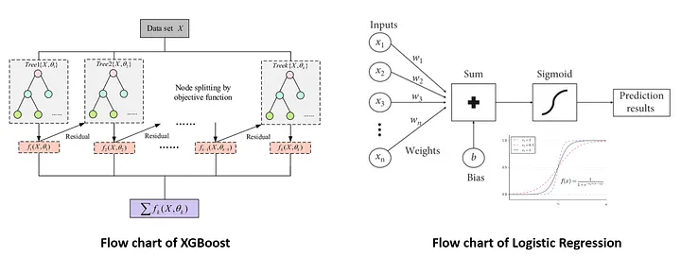
Figure 2.2.1.1: XGBoost.
The objective function in XGBoost combines a regularized loss function and a model complexity term:
$$Obj= \sum_{i=1}^{n}{l(y_{i} ,y_{i}^{(t-1)}})+ \sum_{K=1}^{K}{Ω(f_{k} })$$

Where:
n = number of training samples
$l\left(y_{i}, y_{i}^{(t-1)} \right)$: Loss function (e.g., Mean Squared Error)
$Ω\left(f_{k}\right)= γT + \frac{1}{2}λ \sum_{j=1}^{T}{w_{j}^{2} }$: Regularization term
T: Number of leaves in the tree
$w_{j}$: Leaf weights
$γ,λ$: Regularization parameters
Each tree is built using the gradient and second-order derivative (Hessian) of the loss function to determine optimal splits. This second-order optimization improves convergence and stability.
XGBoost uses shrinkage (learning rate), column subsampling, and early stopping to prevent overfitting. Its ability to rank feature importance also makes it interpretable for business decisions.
In sales forecasting, XGBoost has shown strong performance across various retail datasets. For example, Massaro et al. (2021) applied XGBoost to large-scale retail data and achieved a Mean Absolute Percentage Error (MAPE) below 10%, outperforming traditional models and enabling more accurate inventory planning [4]

2.2.2 Prophet
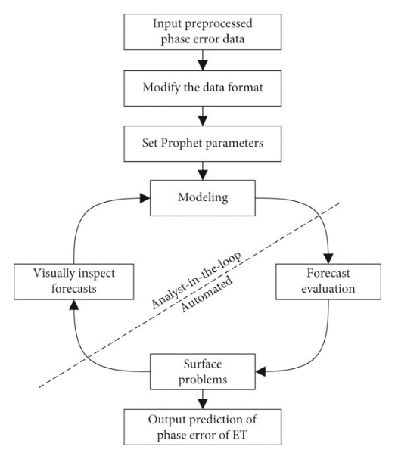
Prophet is a robust time-series forecasting model developed by Meta (Facebook) that handles irregular seasonal patterns, holiday effects, and missing data. It is particularly effective for sales forecasting, where demand fluctuates due to promotions, holidays, and consumer behavior. Prophet decomposes time series into additive components: trend, seasonality, and holiday effects. [5]

Figure 2.2.2.1: Prophet flowchart.

The forecasting function is defined as:
$$y\left(t\right)=g\left(t\right)+s\left(t\right)+h\left(t\right)+ϵ_{t}$$
Where:
- $g\left(t\right)$: Trend function (linear or logistic)
- s(t): Seasonal component modeled via Fourier series
- h(t): Holiday effects
- $ϵ_t$: Error term
Prophet supports both linear and logistic growth:
- Linear:
$$g\left(t\right)=kt+m$$
- Logistic:
$$g\left(t\right)=\frac{C}{1+\exp\left(-k\left(t-m\right)\right)}$$
Where:
- k: Growth rate
- m: Offset
- C: Carrying capacity
Seasonality is captured using a Fourier series:
$$s\left(t\right)= \sum_{n=1}^{N}{\left.\left[a_{n}\cos\left(\frac{2πnt}{P}\right)+ b_{n}\right.\sin\left(\frac{2πnt}{P}\right)\right]}$$
Where:
- P: Period (e.g., 365 for yearly)
- $a_{n}$, $b_{n}$: Coefficients learned from data.

2.3 Deep Learning Techniques
Deep Learning (DL) is a subfield of artificial intelligence that enables computer systems

2.3.1 Long Short-Term Memory (LSTM)
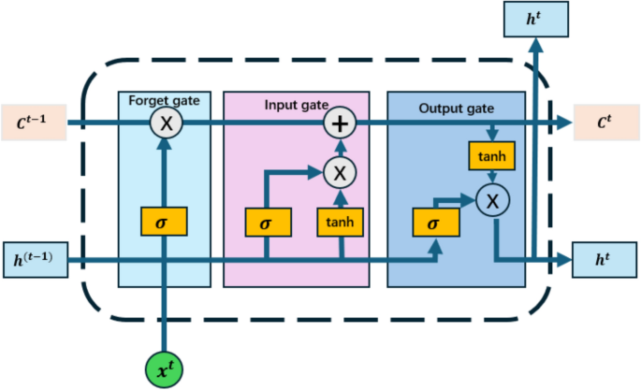
Long Short-Term Memory (LSTM) is a specialized form of recurrent neural network (RNN) designed to capture long-term dependencies in sequential data. It is particularly effective for sales forecasting, where historical demand patterns, seasonality, and external factors influence future sales. Unlike traditional RNNs, LSTMs mitigate the vanishing gradient problem through gated memory cells, allowing them to learn from long sequences [5].
Fig 2.3.1.1 LSTM
Figure 2.3.1.1: LSTM.

The LSTM cell updates its internal state using three gates: input, forget, and output, defined as:
$$x_{t}=σ\left(W_{f}⋅\left[h_{t}-1,x_{t}\right]+b_{f}\right)$$
$$i_{t}=σ\left(W_{i}⋅\left[h_{t}-1,x_{t}\right]+b_{i}\right)$$
$$\begin{matrix}\sim \\ C_{t}\end{matrix}=\tanh\left(W_{C}⋅\left[h_{t}-1,x_{t}\right]+b_{C}\right)$$
$$C_{t}=f_{t}⋅C_{t}-1+i_{t}⋅\begin{matrix}\sim \\ C_{t}\end{matrix}$$
$$o_{t}=σ\left(W_{o}⋅\left[h_{t}-1,x_{t}\right]+b_{o}\right)$$
$$h_{t}=o_{t}⋅\tanh\left(C_{t}\right)$$

Where:
- $x_t$: Input at time t
- $h_{t}$: Hidden state
- $\begin{matrix}\sim \\ C_{t}\end{matrix}$: Cell state
- $σ$: Sigmoid activation
- $tanh$: Hyperbolic tangent activation
- $W, b$: Weights and biases for each gate

2.4 Statistical Model Techniques

2.4.1 Auto Regressive Integrated Moving Average (ARIMA)
Auto Regressive Integrated Moving Average (ARIMA) is a classical statistical model used for time series forecasting. It combines autoregressive (AR), differencing (I), and moving-average (MA) components to model temporal dependencies and trends in the data. ARIMA is particularly effective for univariate forecasting tasks where the data exhibits non-seasonal patterns and can be made stationary through differencing.
The general ARIMA model is denoted as:
ARIMA(p,d,q)
Where:
- pp: Number of autoregressive terms
- dd: Degree of differencing
- qq: Number of moving average terms
2.5 Evaluation Metrics and Confusion Matrix

Evaluation Metrics:
Mean Absolute Error (MAE) : Average of the absolute differences between actual and predicted values.
$$MAE =\frac{1}{n}\sum_{i=0}^{n}{\left|y_{i}-y_{i}^{^}\right|}$$
Where:
$n$ → Number of observations (data points in the test set).
$y_{i}$ → Actual value of sales at time i.
$y_{i}^{^}$ → Forecasted (predicted) value of sales at time i.
$\left|y_{i}-y_{i}^{^}\right|$ → Absolute error (difference between actual and predicted).

Root Mean Squared Error (RMSE): Square root of the average squared differences between actual and predicted values.
$$RMSE=\sqrt{\frac{1}{n}\sum_{i=0}^{n}{{\left(y_{i}-y_{i}^{^}\right)}^{2}}}$$
Where:
$n$ → Number of observations (data points in the test set).
$y_{i}$ → Actual value of sales at time i.
$y_{i}^{^}$ → Forecasted (predicted) value of sales at time i.
${\left(y_{i}-y_{i}^{^}\right)}^{2}$ → Squared error (used in RMSE to penalize large deviations).
Mean Absolute Percentage Error (MAPE): Average absolute error expressed as a percentage of actual values
$$MAPE=\frac{100}{n}\sum_{i=0}^{n}{\left|\frac{y_{i}-y_{i}^{^}}{y_{i}}\right|}$$
Where:
$n$ → Number of observations (data points in the test set).
$y_{i}$ → Actual value of sales at time i.
$y_{i}^{^}$ → Forecasted (predicted) value of sales at time i.
$\left|\frac{y_{i}-y_{i}^{^}}{y_{i}}\right|$ → Relative error (used in MAPE to express error as a percentage).[5]

Chapter 3 Related Work

3.1 Introduction
In this section, we examine recent studies that investigate the application of artificial intelligence to sales forecasting. Researchers have experimented with a range of models, from traditional machine learning (ML) to more advanced approaches, convolutional neural networks (CNN), long short-term memory (LSTM) networks. Some of these works go a step further, introducing hybrid models that blend different AI techniques or combine them with domain expertise to achieve greater accuracy. The following sub-sections break down these contributions, highlighting the progress made across each category of models.

3.2 Machine Learning Studies
Ensafi et al. (2022)[6] benchmarked forecasting models for furniture sales, comparing classical (SARIMA, Holt-Winters) and advanced methods (Prophet, LSTM, CNN). They found Stacked LSTM to be the most accurate, with Prophet and CNN also performing well. The study offers a practical model comparison but is limited to one category and does not explore hybrid combinations of the top-performing techniques.
Loukili et al. (2024) (2025)[7] conduct a direct "algorithm showdown" comparing various machine learning models for sales prediction. Their work identifies top-performing algorithms, such as tree-based ensembles or neural networks, offering a practical guide for model selection. However, the study's narrow focus on algorithm comparison may not address real-world complexities like promotional effects or data sparsity..
Hobor et al. (2025)[8] benchmark modern ML models, including Transformers and Temporal Fusion Transformers, for retail sales forecasting. They show these advanced architectures outperform conventional models by capturing complex patterns, though their implementation requires significant computational resources and expertise.

3.3 Sales Forecasting Using Deep Learning
De Castro Moraes et al. (2024)[9] pioneered a CNN-LSTM hybrid model for retail sales forecasting. Their approach, tested on real Brazilian retail data, successfully captures both short-term promotional spikes and long-term trends, outperforming traditional models. A key advantage is its automated feature learning, though they note its computational cost and data hunger as practical limitations.
Ahmadov and Helo (2023)[10] directly tackle the difficult problem of forecasting intermittent online sales using deep learning. They employ an LSTM-based model specifically designed to handle sporadic demand patterns typical in e-commerce. Their model demonstrates strong performance on a real multichannel retail dataset, effectively learning from sequences of intermittent data. This work highlights deep learning's potential for a notoriously challenging forecasting niche.
Boukrouh et al. (2025)[11] introduced a novel triple-hybrid model combining LSTM, SARIMA, and Holt-Winters for sales forecasting. Their model significantly outperformed each individual component, with MAPE improvements of up to 43%. The key advantage is its comprehensive capture of complex, seasonal, and recent trends in one framework. The main drawback is the increased complexity and integration effort required for the three-model ensemble.

3.4 Summary Related Work
Ref | Year | Dataset | Models | Results | Advantages | Limitations
Ensafi et al. [6] | 2022 | Public dataset of a retail store's sales history (Furniture category) | Classical: SARIMA, Holt-Winters. Advanced: Prophet, LSTM, CNN, Stacked LSTM. | Stacked LSTM demonstrated superior performance. Prophet and CNN also showed strong results compared to classical time series models. | Provides a clear, empirical benchmark across a wide spectrum of methods—from classical to modern deep learning—for a specific retail category (furniture). | The analysis is confined to a single product category; uses an unspecified public dataset, limiting reproducibility; does not explore hybrid or ensemble techniques combining the best models.
Loukili et al. [7] | 2024 | Sales dataset, specifics not provided | Multiple machine learning algorithms (e.g., Random Forest, XGBoost, SVM, Neural Networks) | The study identifies the best-performing algorithm(s) among those tested, likely highlighting tree-based ensembles or neural networks as top contenders. | Offers a direct "algorithm showdown," providing clear performance rankings to guide practitioners in model selection for sales prediction. | Lack of dataset details limits reproducibility; likely does not address complex retail challenges like promotions, new products, or hybrid modeling approaches.
Hobor et al. [8] | 2025 | Retail sales data, specific source not named in reference | Modern ML Models (e.g., Transformer-based models, Temporal Fusion Transformers (TFT), N-BEATS, XGBoost, LSTM) | Demonstrated that state-of-the-art models like Transformers or TFT can achieve superior performance, especially on complex retail series with covariates. | Focuses on cutting-edge, modern ML architectures beyond classic models, highlighting performance gains from attention mechanisms and specialized design. | High computational requirements and complexity; may require extensive data preprocessing and hyperparameter tuning for practical deployment.
de Castro Moraes[9] | 2024 | Public data set from kaggle for retail sales from 2013-2017 | CNN-LSTM(parallel / staked) | Achieved (MAPE) of 13.43  For all  and  MAPE and 19.51 for 1 product | The study done upon three phases one month , three months and 1 year
Ahmadov & Helo [10] | 2023 | Real-world multichannel retail dataset (intermittent online sales) | LSTM-based model | Demonstrated strong performance in forecasting sporadic, intermittent demand patterns common in e-commerce. | Effectively tailored for a notoriously difficult niche (intermittent demand), showing deep learning's applicability to sparse data sequences. | Focus is narrower (intermittence); may not explicitly model complex promotional shapes or multiscale features like a hybrid architecture.
Boukrouh et al. [11] | 2025 | Marketplace data - specific source not named in abstract | Hybrid Model: LSTM + SARIMA + Holt-Winters (Triple Exponential Smoothing) | Outperformed individual components: 9% better than LSTM, 39% better than SARIMA, and 43% better than Holt-Winters (based on MAPE). | Synthesizes strengths to capture complex patterns (LSTM), linear/seasonal trends (SARIMA), and recent trends (Holt-Winters) for highly accurate, reliable forecasts. | High complexity from integrating three distinct models; requires careful tuning and likely higher computational cost than any single model.
Ahmed et al.[12] | 2024 | Retail store sales | Hybrid statistical + LSTM | Hybrid model improved MAPE by 10% | Combines interpretability and accuracy | Complex integration
Bandara et al.[13] | 2021 | Multiple retail datasets | Random Forest, Gradient Boosting | Ensemble models reduced MAE by up to 15% | Robust to noise, handles nonlinearities | Requires extensive feature engineering
Borovykh et al[14]. | 2022 | Daily sales time series | XGBoost regression | XGBoost achieved lowest forecasting error | High accuracy, interpretable features | Not sequence-aware
Hewamalage et al.[15] | 2023 | Real-world retail datasets | LightGBM, ARIMA | ML models outperformed classical methods | Efficient training, scalable | Weak long-term dependency learning
Karim et al.[16] | 2022 | Multivariate sales data | LSTM, GRU | GRU achieved comparable accuracy to LSTM | Fewer parameters, faster training | Slightly lower accuracy
Lim et al.[17] | 2021 | Retail and energy datasets | Temporal Fusion Transformer | Achieved state-of-the-art accuracy | Handles multivariate time series | Complex architecture
Makridakis et al.[18] | 2020 | M4 competition datasets | ML regression models | ML competitive with statistical methods | Benchmark validation | No deep temporal modeling
Sezer et al.[19] | 2020 | Sales and demand datasets | LSTM, CNN | Deep models outperformed classical models | Strong nonlinear learning | High computational cost
Wen et al.[20] | 2023 | E-commerce transaction data | Deep RNN models | Reduced RMSE by 18% | Captures seasonality and trends | Requires large datasets
Zhang et al.[21] | 2020 | Retail chain sales data | Linear Regression, SVR | SVR outperformed linear regression in RMSE | Simple implementation, strong baseline | Limited nonlinear temporal modeling

Chapter 4 Proposed Approach

4.1 Introduction
This chapter presents the proposed hybrid sales forecasting framework developed in this study. The approach integrates classical time-series modeling with deep learning techniques in order to exploit both linear trend modeling and nonlinear temporal pattern learning. The framework is implemented entirely in Python and is evaluated using real sales data, following the methodological objectives defined in Chapters 1–3. The main focus of this chapter is to describe the data preparation process, model architectures, training strategy, and the hybrid integration mechanism.
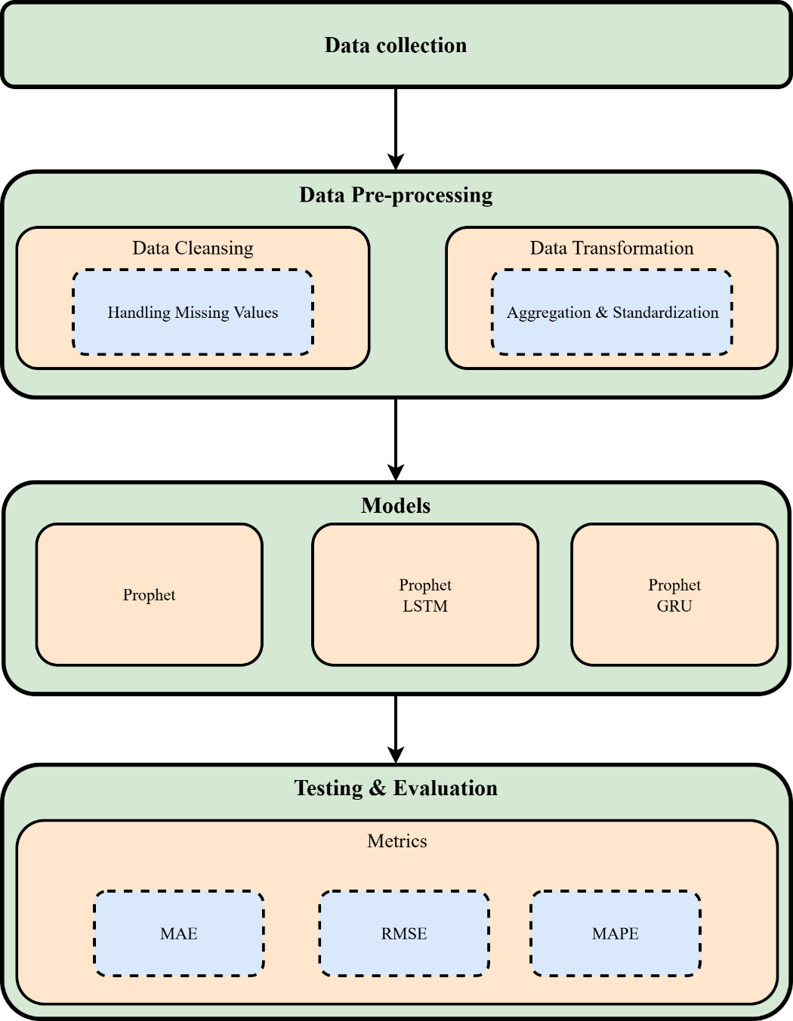
Fig. 4.1 Proposed Framework

4.2 Dataset Description
This study utilizes a real-world transactional dataset titled “Coffee Shop Sales”, which contains 149,116 individual sales records collected over a defined time period. Each record represents a single transaction performed at a coffee shop and includes detailed information related to the transaction time, product attributes, quantity sold, pricing, and store location.
The dataset captures sales activity at a fine temporal granularity, including both date and time information, enabling flexible aggregation at daily or higher-level time intervals for forecasting purposes. The target variable used in this study is the sales amount, which reflects the total revenue generated per transaction. Given the transactional nature of the dataset, aggregation was required to transform the raw data into a time-series format suitable for forecasting models. The dataset exhibits realistic sales behavior influenced by customer demand patterns, product categories, and store characteristics, making it appropriate for evaluating statistical, deep learning, and hybrid sales forecasting approaches.[22]
Table 4.1 Dataset description
column | Description | Datatype
transaction_id | Unique identifier for each sales transaction | Integer
transaction_date | Transaction date | Date
transaction_time | Transaction time | Time
transaction_qty | Quantity of items sold in the transaction | Integer
store_id | Unique identifier of the store | Intege
store_location | Physical location of the store | text
product_id | Unique identifier of the product | Integer
unit_price | Price per unit of the product | Float
product_category | Category of the product (e.g., Coffee, Tea) | Categorical
product_type | Type of product within the category | Categorical
product_detail | Detailed description of the product | text

4.3 Data Preprocessing
Prior to model training, several preprocessing steps were applied to improve data quality and ensure compatibility with the forecasting models. First, the dataset was examined for missing or inconsistent values in both the date and sales columns. No significant missing values were observed, allowing the analysis to proceed without the need for imputation. Next, data transformation techniques were applied to enhance model performance. For deep learning models, the sales values were normalized using a scaling technique to facilitate faster convergence and stable training. In addition, lag-based features and rolling statistical measures were generated to provide contextual historical information for machine learning models. For sequence-based models such as LSTM and GRU, the time-series data was converted into fixed-length input sequences using a sliding window approach. A sequence length of 30 time steps was selected, enabling the models to learn temporal dependencies over approximately one month of historical sales data. Finally, all preprocessing steps were applied consistently across the training, validation, and testing datasets to ensure fair and reliable model evaluation.

4.4 Baseline Forecasting Models

4.4.1 Prophet Model
Prophet was used as a strong baseline statistical model due to its ability to model trend and seasonality explicitly. The model was trained on the training portion of the data and then used to generate forecasts for the validation and test sets. Prophet outputs were aligned with the sequence-based deep learning inputs to ensure consistency during hybrid modeling. The Prophet model serves two roles in this study: as a standalone forecasting benchmark and as the linear component in the hybrid framework.

4.4.2 LSTM Model
A Long Short-Term Memory (LSTM) neural network was implemented to capture nonlinear temporal patterns in the sales data. The LSTM model was trained using the engineered sequential features. The architecture consists of an LSTM layer followed by a fully connected output layer. Mean Squared Error (MSE) was used as the loss function, and the Adam optimizer was employed for training. Early stopping based on validation loss was applied to prevent overfitting.

4.5 Proposed Hybrid Forecasting Framework
In addition to the LSTM-based hybrid model, this study also incorporates a GRU-based hybrid architecture to provide a comparative deep learning perspective. GRU was selected due to its simplified gating mechanism and lower computational complexity compared to LSTM, while still maintaining the ability to model nonlinear temporal dependencies. Including both architectures allow for a more comprehensive evaluation of recurrent neural networks within the proposed hybrid framework. The core contribution of this research is the hybrid forecasting approach that combines Prophet with deep learning models. The hybrid strategy is based on residual learning. First, Prophet is used to generate baseline forecasts. The residuals (i.e., the difference between actual sales and Prophet predictions) are then computed. These residuals represent nonlinear patterns not captured by the statistical model.
Two hybrid variants were implemented:
- Prophet + LSTM: An LSTM model is trained on the residual sequences to learn remaining nonlinear temporal dependencies.(parameters )
- Prophet + GRU: A Gated Recurrent Unit (GRU) model is trained on the residual sequences as an alternative recurrent architecture with fewer parameters.
In both cases, the final hybrid forecast is obtained by adding the deep learning–predicted residuals back to the original Prophet forecasts. This design allows the hybrid model to benefit from Prophet’s interpretability and robustness while enhancing accuracy through deep learning.

4.6 Model Training Configuration
All deep learning models were trained for a maximum of 50 epochs with early stopping enabled. Training was performed using GPU acceleration when available. The dataset sizes after preprocessing were 1,353 samples for training, 193 for validation, and 386 for testing. Performance was monitored using validation MSE to ensure generalization.

4.7 Evaluation Metrics
To objectively assess and compare the forecasting performance of the proposed models, three widely adopted error metrics were employed: Mean Absolute Error (MAE), Root Mean Squared Error (RMSE), and Mean Absolute Percentage Error (MAPE). These metrics are commonly used in sales forecasting research as they provide complementary insights into prediction accuracy and model reliability. Mean Absolute Error (MAE) measures the average magnitude of the absolute differences between actual and predicted sales values. It provides a straightforward interpretation of forecast error in the same units as the target variable, making it particularly useful for understanding the practical impact of prediction inaccuracies on business operations such as inventory planning and demand management. MAE treats all errors equally and is less sensitive to extreme outliers. Root Mean Squared Error (RMSE) calculates the square root of the average of squared prediction errors. By squaring the errors, RMSE places greater emphasis on large deviations between predicted and actual values. This characteristic makes RMSE especially valuable in sales forecasting scenarios where large forecasting errors can lead to significant financial losses, such as overstocking or missed sales opportunities. As a result, RMSE is often used to evaluate a model’s robustness in handling peak demand periods.Mean Absolute Percentage Error (MAPE) expresses the forecasting error as a percentage of the actual values, providing a scale-independent measure of accuracy. This metric is particularly useful for comparing model performance across different datasets or time periods. In the context of sales forecasting, MAPE offers an intuitive understanding of relative error and is commonly preferred by decision-makers for performance evaluation and reporting purposes.
By jointly analyzing MAE, RMSE, and MAPE, this study ensures a comprehensive evaluation of forecasting accuracy. The combined use of these metrics allows for a balanced assessment that considers average error magnitude, sensitivity to large deviations, and relative percentage accuracy, thereby supporting a robust and reliable comparison between statistical, deep learning, and hybrid forecasting models.

Chapter 5 Experimental Results and Discussion

5.1 Introduction
This chapter presents and analyzes the experimental results obtained from the proposed models. The performance of the baseline Prophet model is compared against the two hybrid approaches: Prophet+LSTM and Prophet+GRU. All results are reported on the held-out test set to ensure a fair evaluation.

5.2 Quantitative Results
Table 5.1 summarizes the performance comparison between the standalone Prophet model and the two proposed hybrid approaches.
Table 5.1: Performance Comparison of Forecasting Models
Model | MAE | RMSE | MAPE (%)
Prophet | 184.12 | 231.04 | 13.84
Prophet + LSTM | 181.12 | 228.38 | 13.47
Prophet + GRU | 181.75 | 229.59 | 13.54

Overall, both hybrid models outperformed the standalone Prophet model across all evaluation metrics. Among the two hybrid variants, the Prophet+LSTM model achieved the best overall performance, with the lowest MAE, RMSE, and MAPE values.
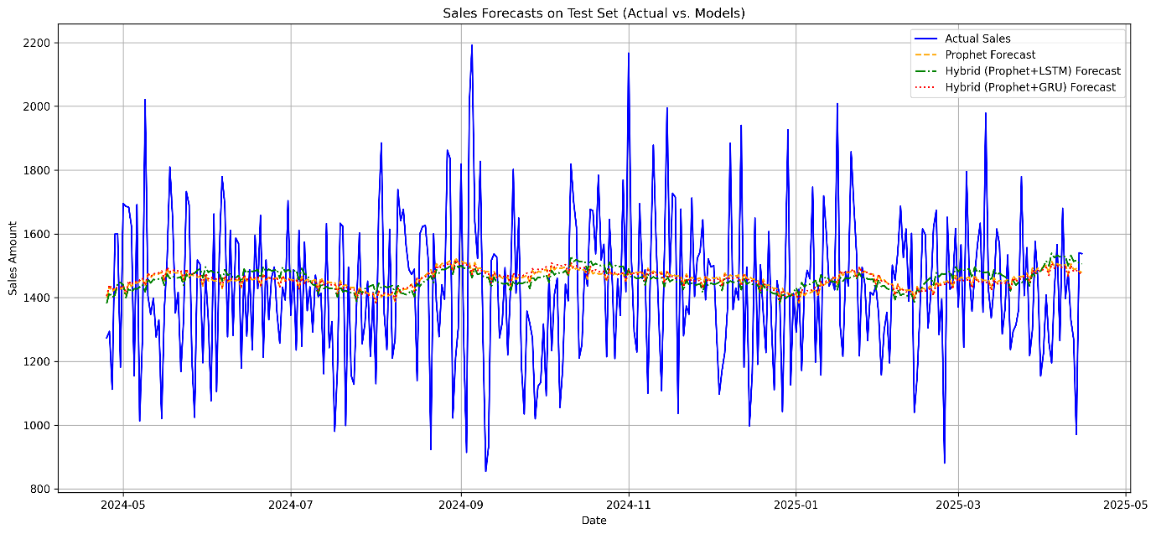
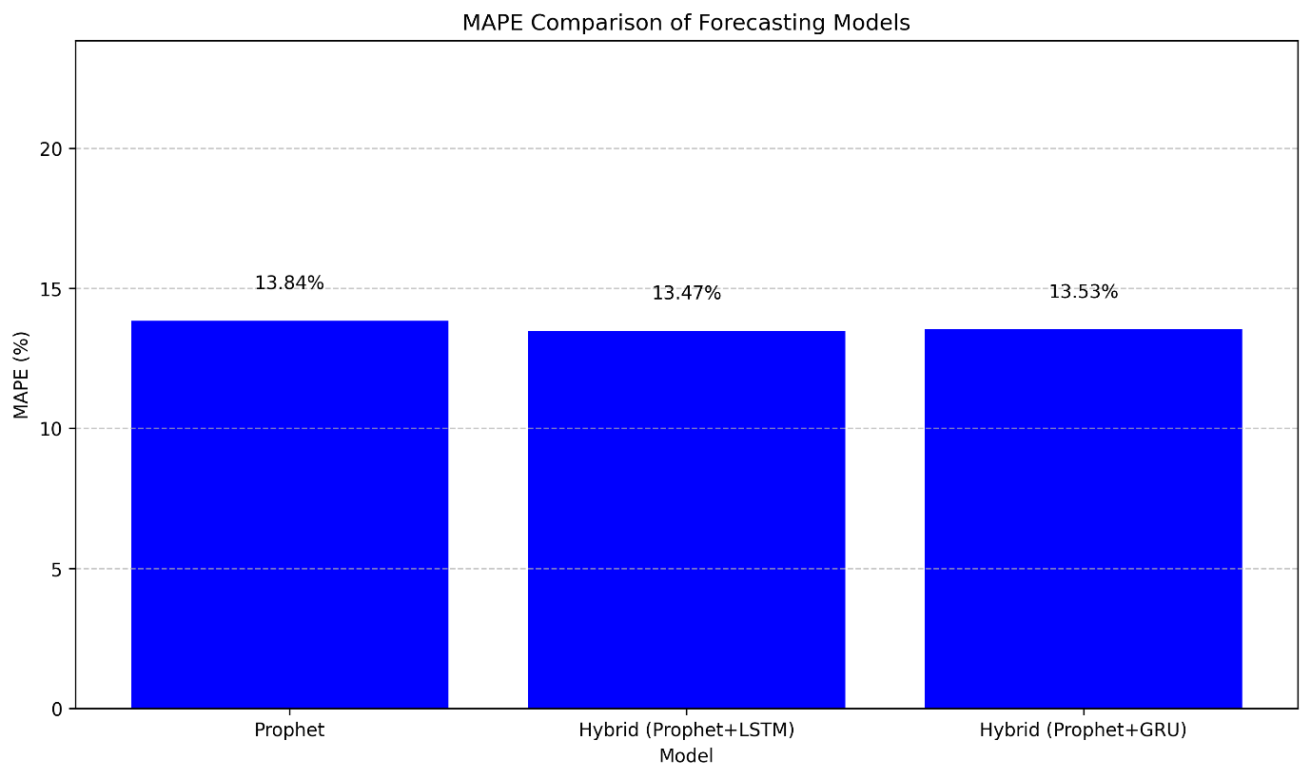
Fig 5.1 Performance Comparison of Forecasting Models
Fig 5.2 Sales Forecast on test set
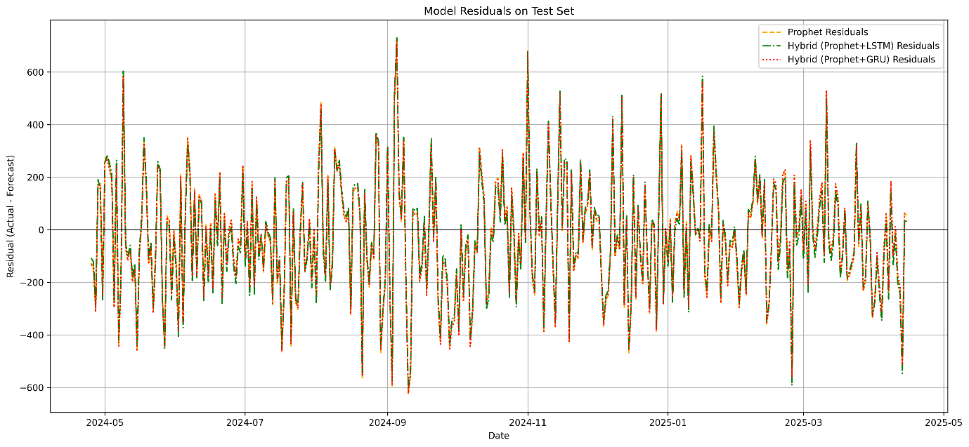
Fig5.3 Model risduals on test set

5.3 Comparative Analysis
The comparative results highlight the advantages of integrating deep learning models with a statistical baseline. Both hybrid models—Prophet+LSTM and Prophet+GRU—consistently outperformed the standalone Prophet model across all evaluation metrics. This confirms that residual-based learning is effective in capturing nonlinear patterns that are not fully modeled by traditional time-series techniques. When comparing the two hybrid approaches, the Prophet+LSTM model achieved the lowest MAE, RMSE, and MAPE values, indicating superior predictive accuracy. This performance advantage can be attributed to LSTM’s more expressive memory cell structure, which is designed to capture long-term dependencies in sequential data. In contrast, the Prophet+GRU model demonstrated slightly higher error values but remained very close to the LSTM-based hybrid. GRU employs a simplified gating mechanism with fewer parameters, which often leads to faster training and reduced computational cost. Despite its simpler architecture, the GRU-based hybrid was able to learn meaningful residual patterns and significantly improve upon the Prophet baseline. Overall, the comparison suggests that while LSTM provides the highest accuracy, GRU offers a competitive and computationally efficient alternative. The choice between the two may therefore depend on the specific application requirements, such as available computational resources and real-time forecasting constraints.

5.4 Discussion
The experimental findings align with the objectives of this research and support the hypothesis that hybrid approaches can enhance sales forecasting accuracy. The improvements observed, although incremental, are meaningful in practical business contexts where small error reductions can translate into significant financial benefits. The results also confirm that combining statistical models with deep learning leads to more robust forecasting systems than relying on a single modeling paradigm.

5.5 Summary
This chapter demonstrated that hybrid forecasting models integrating statistical and deep learning approaches provide superior performance compared to standalone models. Both Prophet+LSTM and Prophet+GRU hybrids achieved lower forecasting errors than the Prophet baseline, confirming the effectiveness of residual-based hybrid learning. Among the evaluated models, Prophet+LSTM delivered the highest predictive accuracy, while Prophet+GRU offered a strong balance between accuracy and computational efficiency. These results validate the proposed hybrid framework and highlight its suitability for real-world sales forecasting applications. The insights gained from this chapter directly inform the conclusions and future research directions discussed in Chapter 6. This chapter demonstrated that the proposed hybrid Prophet–deep learning framework outperforms the standalone statistical model. The Prophet+LSTM hybrid achieved the best overall performance, validating the effectiveness of residual learning for sales forecasting. These findings provide a strong foundation for the conclusions and future research directions discussed in the next chapter.

Chapter 6 Conclusion and Future Work

6.1 Conclusion

The comparison research shows that combining Prophet with recurrent neural networks greatly improves predicting accuracy compared to using Prophet on its own. Both hybrid models, Prophet+LSTM and Prophet+GRU, lowered prediction errors on all measures. This shows that they can find nonlinear and sequential patterns in the data that Prophet alone can't adequately represent. The Prophet+LSTM hybrid had the greatest overall performance. This suggests that LSTM networks operate especially well when combined with Prophet's trend and seasonality components to predict long-term relationships. This research demonstrates that hybrid architecture, which use both statistical and deep learning capabilities, are a strong way to make time series forecasting more accurate.

6.2 Future Work
Future study may investigate the expansion of hybrid forecasting frameworks via the incorporation of attention processes, transformers, or other sophisticated sequence models to improve long-term predictive accuracy. Examining ensemble methodologies that include various hybrid designs may enhance resilience and diminish model uncertainty. Also, using these hybrid models on multivariate time series, high-frequency data, or fields with irregular patterns might show that they can be used in real life and are generalizable. Optimizing hyperparameters and assessing computing efficiency will enhance deployment in practical forecasting contexts.

References
  - Li, X., Du, J., Wang, Y., & Cao, Y. (2020, November). Automatic sales forecasting system based on LSTM network. In 2020 International Conference on Computer Science and Management Technology (ICCSMT) (pp. 393-396). IEEE Computer Society.
  - Vavliakis, K. N., Siailis, A., & Symeonidis, A. L. (2021). Optimizing Sales Forecasting in e-Commerce with ARIMA and LSTM Models. In WEBIST (pp. 299-306).
  - Akande, Y. F., Idowu, J., Misra, A., Misra, S., Akande, O. N., & Ahuja, R. (2021, October). Application of XGBoost algorithm for sales forecasting using Walmart dataset. In International Conference on Advances in Electrical and Computer Technologies (pp. 147-159). Singapore: Springer Nature Singapore.
  - Massaro, A., Panarese, A., Giannone, D., & Galiano, A. (2021). Augmented data and xgboost improvement for sales forecasting in the large-scale retail sector. Applied Sciences, 11(17), 7793.
  - Brykin, D. (2024). Sales Forecasting Models: Comparison between ARIMA, LSTM and Prophet. Journal of Computer Science, 20(10), 1222-1230.
  - Ensafi, Y., Amin, S. H., Zhang, G., & Shah, B. (2022). Time-series forecasting of seasonal items sales using machine learning–A comparative analysis. International Journal of Information Management Data Insights, 2(1), 100058.
  - Loukili, M., Messaoudi, F., Ghazi, M. E., & Azirar, H. (2023, November). Predicting future sales: A machine learning algorithm showdown. In The International Conference on Artificial Intelligence and Smart Environment (pp. 26-31). Cham: Springer Nature Switzerland.
  - Hobor, L., Brcic, M., Polutnik, L., & Kapetanovic, A. (2025). Comparative Analysis of Modern Machine Learning Models for Retail Sales Forecasting. arXiv preprint arXiv:2506.05941.
  - de Castro Moraes, T., Yuan, X. M., & Chew, E. P. (2024). Hybrid convolutional long short‐term memory models for sales forecasting in retail. Journal of Forecasting, 43(5), 1278-1293.
  - Ahmadov, Y., & Helo, P. (2023). Deep learning-based approach for forecasting intermittent online sales. Discover Artificial Intelligence, 3(1), 45.
  - Boukrouh, I., Idiri, S., Tayalati, F., Azmani, A., & Bouhsaien, L. (2025). A hybrid approach for sales forecasting: combining deep learning and time series analysis. Int. J. Eng, 38(4), 859-870.
  - Ahmed, R. S., Hasnain, M., Mahmood, M. H., & Mehmood, M. A. (2024). Comparison of deep learning algorithms for retail sales forecasting. IECE Transactions on Intelligent Systematics, 1(3), 101-115.
  - Bandara, K., Bergmeir, C., & Smyl, S. (2020). Forecasting across time series databases using recurrent neural networks on groups of similar series: A clustering approach. Expert systems with applications, 140, 112896.
  - Borovykh, A., Bohte, S., & Oosterlee, C. W. (2017). Conditional time series forecasting with convolutional neural networks. arXiv preprint arXiv:1703.04691.
  - Hewamalage, H., Bergmeir, C., & Bandara, K. (2021). Recurrent neural networks for time series forecasting: Current status and future directions. International Journal of Forecasting, 37(1), 388-427.
  - Karim, F., Majumdar, S., Darabi, H., & Chen, S. (2017). LSTM fully convolutional networks for time series classification. IEEE access, 6, 1662-1669.
  - Lim, B., Arık, S. Ö., Loeff, N., & Pfister, T. (2021). Temporal fusion transformers for interpretable multi-horizon time series forecasting. International journal of forecasting, 37(4), 1748-1764.
  - Makridakis, S., Spiliotis, E., & Assimakopoulos, V. (2018). The M4 Competition: Results, findings, conclusion and way forward. International Journal of forecasting, 34(4), 802-808.
  - Sezer, O. B., Gudelek, M. U., & Ozbayoglu, A. M. (2020). Financial time series forecasting with deep learning: A systematic literature review: 2005–2019. Applied soft computing, 90, 106181.
  - Wen, Q., Sun, L., Yang, F., Song, X., Gao, J., Wang, X., & Xu, H. (2020). Time series data augmentation for deep learning: A survey. arXiv preprint arXiv:2002.12478.
  - Zhang, G., Patuwo, B. E., & Hu, M. Y. (1998). Forecasting with artificial neural networks:: The state of the art. International journal of forecasting, 14(1), 35-62.
  - https://www.kaggle.com/datasets/ahmedabbas757/coffee-sales/discussion?sort=hotness Last accessed:14/12/2025

