Literature Review
Pneumonia Classification from Chest X-ray Images Using Convolutional Neural Networks
Pneumonia keeps being one of those diseases that never really goes away, still taking lives all over the world, mostly small children under five and older people who already have weak lungs or something like that. Chest X-rays are still the main way doctors try to figure out what’s going on inside, mostly because they’re cheap and everywhere, but reading them isn’t always so simple. Sometimes two radiologists can look at the same image and see totally different things, and in many hospitals, especially rural ones, there just aren’t enough trained people to check every scan. That’s kind of where deep learning comes in, or more exactly, convolutional neural networks, CNNs, which sound complicated but basically try to learn patterns from thousands of images. In the last few years, many research teams have tried using CNNs to automatically tell if an X-ray shows pneumonia or not, and some even try to say if it’s bacterial or viral, which is tricky but interesting, and sometimes confusing because the images overlap or blur in strange ways.
In this review, we looked at three published studies that, well, seem to stand out as clear examples of what’s being done right now. Each one takes a different route—one compares several pretrained models side by side, other mixes them together in some ensemble method that’s supposed to be smarter, and the last one stretches the idea further by adding COVID-19 into the classification problem. When you put them all together, you start to see a kind of snapshot of the field, not perfect but useful, showing what’s working, what’s half-working, and maybe what’s still a bit lost in translation.

Introduction:

1.1 Problem Definition:
Pneumonia remains one of the most serious respiratory diseases worldwide, posing a significant threat to global health. According to global health reports, pneumonia is a leading cause of death among children under five years old and elderly populations, especially in regions with limited access to advanced medical care. Early and accurate diagnosis is critical for effective treatment; however, this remains a challenging task in clinical practice. Chest X-ray imaging is the most common diagnostic tool for pneumonia due to its availability and low cost. Although chest X-rays are widely used, interpreting them is often difficult and depends heavily on the radiologist's expertise. As a result, different specialists often disagree on diagnoses when they look at the same medical image, which can lead to diagnostic errors. Furthermore, healthcare systems, especially those in resource-limited settings, often grapple with a scarcity of seasoned radiologists, thereby exacerbating delays in both diagnosis and subsequent treatment. The core issue, at its most fundamental level, is the absence of diagnostic systems that are both efficient and precise, and that can scale effectively to analyze extensive datasets of medical imagery. [17] Manual interpretation is not only labor-intensive but also susceptible to human error, particularly when distinguishing subtle visual discrepancies between healthy and pneumonia-affected lung tissue. Recent investigations have focused on the application of artificial intelligence, specifically deep learning methodologies like Convolutional Neural Networks (CNNs), for the automated detection of pneumonia. Previous research has shown that deep learning models have demonstrated considerable efficacy in the classification of chest X-ray images. For instance, CNN-based methodologies have achieved accuracies surpassing 98%, as evidenced by studies such as those conducted by Buriboev et al. In 2025 and Ahmed et al. (2023), sophisticated architectures such as DenseNet, ResNet, and EfficientNet have exhibited considerable efficacy in feature extraction from medical images, thereby enhancing diagnostic precision. The application of artificial intelligence in this domain is substantiated by its capacity to: automatically identify intricate patterns within medical images, diminish reliance on human interpretation, augment diagnostic consistency and accuracy, and furnish scalable solutions suitable for extensive healthcare infrastructures. Consequently, the central issue addressed by this research is the necessity for an intelligent, automated system capable of accurately identifying pneumonia from chest X-ray images, thereby circumventing the constraints inherent in conventional diagnostic methodologies. Through the utilization of deep learning techniques, this study endeavors to improve diagnostic performance, assist medical professionals, and contribute to a more efficient healthcare system. [17]

1.2 Thesis Objectives:

The primary goal of this dissertation is to create an automated pneumonia detection system, leveraging chest X-ray images and deep learning methodologies. This investigation , seeks to enhance diagnostic precision through the application of CNN models and transfer learning strategies. Furthermore, the research endeavors to refine model performance via data augmentation techniques and assess the efficacy of the proposed model using established evaluation metrics, including accuracy, precision, recall, and the F1-score.

1.3 Thesis Contributions:

1.4 Thesis Organization:

The current dissertation is organized into separate chapters. Chapter 1 introduces the main research question, outlines the specific goals, and provides an overview of how the study is structured. Chapter 2 offers the necessary background and reviews existing research on pneumonia detection, with a focus on deep learning methods and the overall methodological approach.

Proposed Framework:

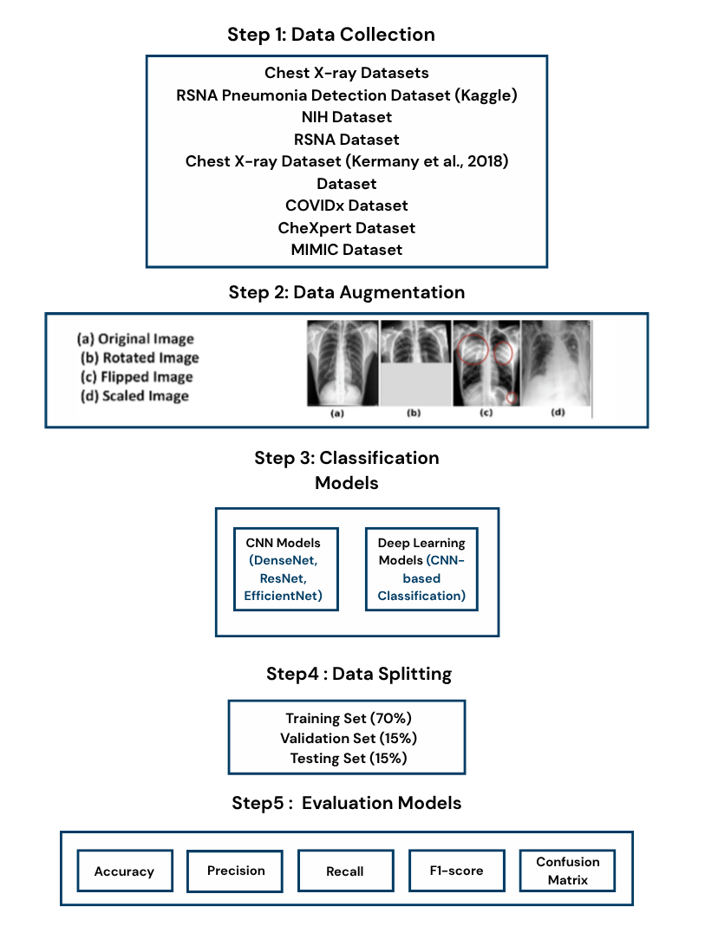

Background:
1.Artificial intelligence (AI)
Artificial Intelligence (AI) constitutes a domain within computer science dedicated to the creation of systems capable of executing functions generally associated with human intelligence, encompassing learning, reasoning, problem-solving, perception, and decision-making processes. These AI systems are designed to simulate cognitive operations by employing algorithms and computational models, which facilitate the processing of large datasets, the identification of patterns, and the generation of well-informed predictions or decisions. [15]
Artificial intelligence in its broadest sense, encompasses several specialized areas, such as machine learning, deep learning, natural language processing, and computer vision.
These methodologies empower machines to enhance their capabilities through experiential learning, as opposed to being constrained by fixed, pre-established rules. Machine learning methods enable systems to learn from data, while deep learning models, such as neural networks, can independently discern complex features within high-dimensional datasets, as seen in image processing. Artificial intelligence is generally divided into two categories: narrow AI, which is tailored for specific applications like medical image classification, and general AI, which seeks to emulate human cognitive abilities across diverse domains. In application, AI has found extensive use in healthcare, assisting with functions such as disease diagnosis, medical image analysis, and clinical decision support. For instance, AI models have demonstrated considerable efficacy in identifying diseases like pneumonia from chest X-ray images by detecting subtle patterns that may elude human specialists. [15]

2.Machine learning
Machine Learning (ML), a branch of artificial intelligence, centers on creating algorithms and models. These systems can identify patterns in data, enabling them to make predictions or decisions without explicit programming. Instead of adhering to fixed rules, machine learning models improve over time, learning from both their experiences and the data they analyze. [16]
Machine learning methods are typically classified into three main categories: supervised learning, which involves training models on labeled datasets; unsupervised learning, where models identify patterns in unlabeled data; and reinforcement learning, wherein models acquire knowledge through environmental interaction. These approaches enable machines to autonomously uncover significant patterns and relationships within extensive datasets. [16]

3.Types of Machine Learning

3.1Supervised Learning
Supervised learning, a subset of machine learning, involves training models on labeled datasets; these datasets pair each input with a corresponding output. The primary objective of supervised learning is to develop a mapping function capable of accurately forecasting outputs for novel, previously unobserved data. [16]
In this methodology, the model acquires knowledge through examples presented during the training phase, specifically by minimizing the disparity between predicted outputs and their corresponding actual labels. Supervised learning is a common approach in both classification and regression tasks. In classification, such as identifying pneumonia from chest X-ray images, the model assigns input data to predefined categories, like "normal" and "pneumonia." This method is crucial in medicine, allowing for the creation of precise diagnostic systems that rely on labeled medical data. [16]

4.1 CNN:
A subset of deep learning models are engineered for the analysis of structured grid data, particularly images. Convolutional Neural Networks (CNNs), first proposed by Yann LeCun and his team, have become widely used in computer vision. This is because they can automatically extract hierarchical features from input images. [8]
The architecture of CNNs is characterized by convolutional layers, which are responsible for capturing spatial features; pooling layers, which serve to diminish dimensionality; and fully connected layers, which facilitate classification. This layered configuration empowers CNNs to discern intricate patterns, including edges, textures, and shapes, thereby rendering them exceptionally effective in medical image analysis, such as the detection of pneumonia from chest X-rays (LeCun et al., 1998). [8]

4.2 DenseNet
DenseNets a particular breed of deep neural networks, first appeared in 2017, thanks to Gao Huang and his colleagues. Their goal was to refine the flow of information and the way gradients traveled through these deep networks. The core concept of DenseNets hinges on the use of dense connections. In these connections, each layer gets input from all the layers before it. This encourages the reuse of features and reduces redundancy. As a result, this architecture helps to solve common problems in deep learning, like vanishing gradients, and it also makes better use of parameters. DenseNets have demonstrated considerable efficacy in image classification applications, proving particularly valuable in medical image analysis, including the identification of pneumonia within chest X-ray images. The DenseNet architecture is characterized by dense blocks, wherein numerous convolutional layers are interconnected, and transition layers, which serve to diminish the dimensionality of feature maps via pooling and convolutional operations. This design facilitates the alleviation of the vanishing gradient problem and enhances parameter efficiency. [9]

4.3 ResNet
ResNet a deep convolutional neural network architecture, They developed it to tackle the difficulties of training extremely deep CNNs. The defining characteristic of ResNet is its incorporation of residual connections, or skip connections. These connections allow the network to learn residual mappings, rather than attempting to learn the entire transformation. This architectural design choice helps gradients flow more easily during training, which reduces problems like vanishing gradients and performance issues in deep networks. ResNet facilitates the successful training of exceptionally deep models, thereby establishing itself as a crucial architecture within computer vision, particularly in the domain of medical image classification. [10]
The ResNet architecture is structured with convolutional layers succeeded by residual blocks; these blocks incorporate shortcut connections that bypass one or more layers, thereby enhancing gradient propagation. Subsequently, fully connected layers are employed for the purpose of classification. [10]

4.4 EfficientNet
Efficient Net is a family of CNN architectures designed to optimize accuracy while simultaneously reducing computational requirements. Unlike traditional models that adjust depth, width, or resolution independently, EfficientNet employs a compound scaling method, which methodically balances these three dimensions. [11]
Therefore, this method allows the model to perform better while using fewer parameters and requiring less computational power. EfficientNet has been shown to be very effective in different image classification tasks, including its use in medical imaging, such as detecting pneumonia.The EfficientNet architecture integrates convolutional layers, mobile inverted bottleneck blocks (MBConv), and squeeze-and-excitation (SE) layers, which together enhance feature representation. These elements are uniformly scaled to optimize both performance and efficiency. [11]

4.5 MobileNet:
MobileNet is a type of lightweight convolutional neural network (CNN) architecture that is made to work well on devices with limited resources, like mobile and embedded systems. MobileNet is different from other CNNs because it uses depthwise separable convolutions, which break the standard convolution into two steps: depthwise convolution and pointwise convolution. [18]

4.6Vision Transformer (ViT)
[12] Vision Transformers (ViTs) represent a deep learning architecture that employs transformer models for the purpose of image analysis. In contrast to convolutional neural networks, ViTs segment images into fixed-size patches, subsequently processing these patches as sequences. This approach facilitates the model's ability to comprehend global relationships within the image. The ViT architecture is characterized by several fundamental components. [12]
First, images are split into patches and converted into embeddings using a patch embedding layer. These embeddings are then processed by multiple transformer encoder layers, which include multi-head self-attention mechanisms and feed-forward neural networks. In addition, positional encoding is used to preserve spatial information in the image. Finally, a classification layer is applied to produce the output prediction, ViTs have demonstrated strong performance in computer vision tasks and are increasingly used in medical image analysis. [12]

4.7 Swin Transformer

The Swin Transformer is different from regular transformers because it uses a shifted window-based self-attention mechanism that limits attention computation to local windows while still allowing cross-window connections. This means that the Swin Transformer processes the image in multiple stages with progressively lower spatial resolution, which is similar to how CNN extract features while keeping the benefits of transformer-based models. The Swin Transformer is made up of several important parts. First, there is a patch partitioning layer, then a linear embedding layer. The model then uses multiple Swin Transformer blocks, which include window-based multi-head self-attention (W-MSA) and shifted window multi-head self-attention (SW-MSA), as well as feed-forward networks (MLP layers). [19]

5.1 Accuracy
Accuracy is an evaluation metric that measures the proportion of correctly classified instances out of the total number of instances in a dataset. [13]

5.2 Precision
Precision is a metric that measures the proportion of correctly predicted positive instances out of all instances predicted as positive by the model. [14]

5.3 Recall
Recall is a metric that measures the ability of a model to correctly identify all actual positive instances in a dataset. [14]

5.4 F1 Score
The F1-score is a metric that combines precision and recall into a single value by calculating their harmonic meaning, providing a balance between them. [13]

2.2 Related Work

1-Binary Classification of Pneumonia in Chest X-ray Images Using Convolutional Neural Networks

[1] Buriboev et al. (2025) proposed an enhanced pneumonia classification framework utilizing a CNN model trained using a supervised learning approach on datasets preprocessed with a modified CLAHE algorithm. The quality of chest X-ray images by introducing an adaptive contrast enhancement technique and applying preprocessing methods to enhance image features using 5,856 images from the Chest X-Ray Images (Pneumonia) dataset. The main contribution of integrating adaptive contrast enhancement with CNN-based classification. The results demonstrated the effectiveness of combining image enhancement techniques with deep learning models for pneumonia detection, with an accuracy of 98.7%.

2- Efficient and Accurate Pneumonia Detection Using Deep Learning

[2] Saber et al. (2025) proposed a multi-scale, transformer-based method for detecting pneumonia using chest X-ray images. This classification approach was built on a deep learning framework. The transformer-based TransUNet model allowed for accurate lung segmentation, and ResNet models were used to extract multi-scale features relevant to pneumonia classification. The effectiveness of the methodology was evaluated using publicly available chest X-ray datasets, specifically the Kermany and Cohen datasets. The model's performance showed accuracies of 93.75% and 96.04% on the two datasets. The results suggest that using transformer models with deep learning methods for detecting pneumonia

3-Pneumonia Image Classification Using DenseNet
[3] Bundea et al.(2024) investigated the use of deep learning techniques for pneumonia classification using chest X-ray images. The discussion analyzed chest X-ray images depicting both normal and pneumonia-affected lungs. To enhance dataset diversity, several preprocessing procedures were implemented, including resizing, normalization, and data augmentation methods like image flipping and rotation. The researchers utilized DenseNet, a deep convolutional neural network (CNN) including DenseNet121, DenseNet169, and DenseNet201, to classify chest X-ray images into two categories: normal and pneumonia engineered to facilitate feature propagation and mitigate the vanishing gradient issue. The model's objective was to extract pertinent features from the chest X-ray images and subsequently categorize them as either pneumonia or normal. The results demonstrated the efficacy of DenseNet classification techniques with deep learning models for pneumonia ,achieving an accuracy of 97% for Pneumonia.

4-Deep Convolutional Neural Network for Pneumonia Detection Using Chest X-ray Images

[4] An et al. (2024) proposed a deep learning approach for pneumonia detection using chest X-ray images. The research developed an ensemble model that EfficientNetB0 and DenseNet121 with attention mechanisms to improve feature and classification performance. The model classify chest X-ray images into normal, viral pneumonia, and bacterial pneumonia categories. The experimental results showed that the proposed model achieved an accuracy of about 98.4%, the effectiveness of ensemble deep learning models for pneumonia detection.

5-Pneumonia Disease Detection Using Chest X-rays and Machine Learning

[5] Usman et al. (2025) proposed a deep learning model to classify pneumonia using chest X-ray images. Their research aimed to improve an automated system that could tell the difference between pneumonia and normal conditions in these images. The RSNA pneumonia dataset, comprising thousands of annotated chest X-ray images, served as the foundation for this investigation. To enhance the dataset's quality, several preprocessing procedures were implemented, encompassing image normalization and data augmentation strategies. Subsequently, the efficacy of two deep learning models was assessed: a convolutional neural network (CNN) and a transfer learning model, specifically ResNet-50.The empirical findings indicated that the ResNet-50 model attained an accuracy of approximately 96.2%, thereby illustrating the efficacy of deep learning models in the identification of pneumonia within medical imaging data.

6-Joint Diagnosis of Pneumonia and Other Lung Diseases Using Deep Learning from Chest X-ray Images

[6] Ahmed et al. (2023) proposed a convolutional neural network (CNN) model for the diagnosis of lung diseases using chest X-ray images. The model was trained to classify images , including pneumonia, and COVID-19, The experimental results that the proposed model achieved an accuracy of approximately 98.7%, demonstrating the potential of deep learning techniques for automated medical image analysis.

7-Detection of Pneumonia from Chest X-ray Images Utilizing MobileNet Model

[7] Al-Reshan et al. (2023) proposed a deep learning method for classifying pneumonia using chest X-ray images.The study focused on developing to a system between chest X-ray scans showing pneumonia and normal.The researchers used datasets chest X-ray images of both healthy and pneumonia-affected lungs, several preprocessing techniques were applied, including image , normalization, and data augmentation methods such as rotation and flipping to increase dataset diversity and reduce. Convolutional neural network (CNN) architectures were then use to extract deep features from the chest X-ray images and perform the classification task. The experimental results showed that the proposed model demonstrated an accuracy of approximately 95%, demonstrating the effectiveness of deep learning approaches detecting pneumonia from chest X-ray images and supporting computer in medical imaging.

Comparative Summary

Study | CNN Models | Dataset(s) | Public / Private | Classification Task | Best Accuracy | Best Performer
Buriboev et al. (2025) | CNN | RSNA Pneumonia Dataset | Public | Binary | Accuracy  97% | CNN
Saber et al. (2025) | ResNet,  Attention | Chest X-ray Pneumonia Dataset | Public | Binary | Accuracy  97% | ResNet,
Bundea et al., 2024 | DenseNet | Chest X-ray Pneumonia Dataset | Public | Binary (normal vs. pneumonia) | Accuracy  97% | DenseNet
An et al., 2024 | Deep CNN, Transfer Learning | Chest X-ray Pneumonia Dataset | Public | Binary (normal vs. pneumonia) | Accuracy  97% | CNN
Usman et al., 2025 | CNN,  ResNet-50 | RSNA Pneumonia Dataset | Public | Binary (normal vs. pneumonia) | Accuracy  98% | ResNet-50
Ahmed et al., 2023 | Deep CNN | Chest X-ray Pneumonia Dataset | Public | Binary, multi class | Accuracy  98.72% | CNN
Al-Reshan et al., 2023 | CNN,  MobileNet | Chest X-ray Pneumonia Dataset | Public | Binary (normal vs. pneumonia) | Accuracy  97% | MobileNet

References

[1] Buriboev, A. S., et al. (2025).
Binary classification of pneumonia in chest X-ray images using convolutional neural networks. Sensors, 25(13), 3976.
https://doi.org/10.3390/s25133976

[2] Saber, A., et al. (2025).
Efficient and accurate pneumonia detection using deep learning. Sensors, 25(23), 7233.
https://doi.org/10.3390/s25237233

[3] Bundea, M., et al. (2024).
Pneumonia image classification using DenseNet.
Information, 15(10), 611.
https://doi.org/10.3390/info15100611

[4] An et al., (2024)
Deep convolutional neural network for pneumonia detection using chest X-ray images.
Diagnostics, 14(4), 390.
https://doi.org/10.3390/diagnostics14040390

[5] Usman, C., et al. (2025).
Pneumonia disease detection using chest X-rays and machine learning. Algorithms, 18(2), 82.
https://doi.org/10.3390/a18020082

[6] Ahmed, M. S., et al. (2023).
Joint diagnosis of pneumonia and other lung diseases using deep learning from chest X-ray images. Diagnostics, 13(15), 2562.
https://doi.org/10.3390/diagnostics13152562

[7] Al-Reshan, M. S. A., et al. (2023).
Detection of pneumonia from chest X-ray images utilizing MobileNet model. Healthcare, 11(11), 1561.
https://doi.org/10.3390/healthcare11111561

[8] LeCun, Y., Bottou, L., Bengio, Y., & Haffner, P. (1998). Gradient-based learning applied to document recognition. Proceedings of the IEEE.

[9] Huang, G., Liu, Z., Van Der Maaten, L., & Weinberger, K. Q. (2017). Densely Connected Convolutional Networks. CVPR.

[10] He, K., Zhang, X., Ren, S., & Sun, J. (2016). Deep Residual Learning for Image Recognition. CVPR.

[11] Tan, M., & Le, Q. V. (2019). EfficientNet: Rethinking Model Scaling for Convolutional Neural Networks. ICML.

[12] Dosovitskiy, A., Beyer, L., Kolesnikov, A., Weissenborn, D., Zhai, X., Unterthiner, T.,
Dehghani, M., Minderer, M., Heigold, G., Gelly, S., Uszkoreit, J., & Houlsby, N. (2020).
An Image is Worth 16×16 Words: Transformers for Image Recognition at Scale.
arXiv preprint arXiv:2010.11929.

[13] Sokolova, M., & Lapalme, G. (2009). A systematic analysis of performance measures for classification tasks. Information Processing & Management.
[14] Powers, D. M. W. (2011). Evaluation: From Precision, Recall and F-measure to ROC, Informed Ness, Markedness & Correlation. Journal of Machine Learning Technologies.

[15] Russell, S., & Norvig, P. (2021).
Artificial Intelligence: A Modern Approach (4th ed.). Pearson.

[16] Mitchell, T. M. (1997).
Machine Learning. McGraw-Hill.

[17] World Health Organization (WHO). (2023).
Pneumonia.
https://www.who.int/news-room/fact-sheets/detail/pneumonia

[18] Howard, A. G., Zhu, M., Chen, B., Kalenichenko, D., Wang, W.,
Weyand, T., Andreetto, M., & Adam, H. (2017).
MobileNets: Efficient Convolutional Neural Networks for Mobile Vision Applications.

[19] Liu, Z., Lin, Y., Cao, Y., Hu, H., Wei, Y., Zhang, Z., Lin, S., & Guo, B. (2021).
Swin Transformer: Hierarchical Vision Transformer using Shifted Windows.
Proceedings of the IEEE/CVF International Conference on Computer Vision (ICCV).

