
Midocean University
College of Management
Division / Master of Business Administration

Research Title
The Role of Leadership and Organizational Culture in Enhancing Safety and Performance in Power and Desalination plants in Saudi Arabia

Prepared by / Eng. Talal Khaled Alfakeih
Academic number: 251002578

Supervised by /
Dr. Al Faisal Abdulhamid
Dr. Fayez Jrad

Academic Year
2025

Chapter One – Introduction

Introduction:
Industrial facilities such as power generation and desalination plants operate in environments where both safety and productivity must be balanced every day. These workplaces deal with complex processes, hazardous materials, and equipment that operates continuously, leaving very little room for mistakes. Technical systems are essential, but they represent only one part of the operational equation. True success also depends on the people who run those systems and how effectively teams interact, communicate, and respond to challenges. Through years of working as an operations engineer, I have seen cases where well-designed systems still suffered from incidents or operational delays simply because leadership was weak or the organizational culture did not reinforce safe work behavior.
Saudi Arabia presents a clear example of this reality. As population growth and industrial expansion continue, the demand for electricity and desalinated water has risen sharply. These services are critical for national development and everyday life, which means that operational reliability and safety must remain high at all times. Under such pressure, even minor technical failures or human errors can escalate into serious accidents, cost the organization valuable resources, or disrupt the supply of essential services.
Leadership and organizational culture play a major role in preventing such outcomes. They influence how employees think, how decisions are made, and how rules are followed. When leaders demonstrate commitment to safety and performance, teams are more likely to adopt the same priorities. Alternatively, when leadership is unclear or inconsistent, workers may take shortcuts, hesitate to report hazards, or lose motivation. As Guldenmund (2000) noted, what employees believe and value often determines how safety procedures are applied, regardless of formal policy.
The interaction between leadership and culture is not one-directional. Leaders introduce expectations, but culture can either support or resist change. A workplace that prioritizes productivity over caution can undermine even the best leadership intentions. Conversely, when leaders champion transparency, open communication, and accountability, a stronger and safer culture gradually develops around those values (Schein, 2010).
This issue is particularly important in the context of Saudi Arabia’s Vision 2030, which encourages modernization, operational excellence, and sustainable development in sectors such as energy and water. Strengthening leadership approaches and improving organizational culture within power and desalination facilities is therefore not only a management initiative but also a contribution to national progress.

Research Problem and Questions:

Research Problem (declarative):
Although industrial facilities have advanced considerably, there is still insufficient clarity regarding the combined effect of leadership behavior and organizational culture on safety compliance and operational performance. This gap is particularly evident in Saudi Arabia’s power and desalination plants. Many facilities invest heavily in modern systems and engineered controls, yet actual outcomes still rely on human judgment, communication, and shared values. Professional field observations show that technical malfunction is seldom the primary cause of performance failure. Instead, issues are commonly linked to communication gaps, unpredictable leadership practices, or cultural environments where safety is not embedded as a fundamental value (Reason, 1997).
Power generation and desalination are vital services supporting Saudi Arabia’s infrastructure, which makes reliability and risk control essential. Although Vision 2030 continues to improve systems and technology, human factors especially leadership practices and cultural norms have received less systematic attention. These facilities depend on multidisciplinary teams, and the way leaders communicate expectations and reinforce shared values directly affects how work is carried out.
However, Saudi work environments carry cultural attributes that influence leadership effectiveness, such as hierarchical authority structures, indirect communication, reluctance to express disagreement and deference to senior decision-makers. When such dynamics limit upward communication, safety-related feedback may be delayed or suppressed. Under these conditions, leadership becomes a central mechanism for encouraging transparency, accountability, and safe behavior.
My motivation for conducting this study developed through professional exposure to these conditions. First-hand experience revealed how employee behavior, communication flow, and safety outcomes changed when leadership style or cultural norms shifted. These patterns indicated the need for a more focused examination of how leadership and culture interact within Saudi industrial operations.
Similar situations have been recorded in multiple Gulf-region industries, where hierarchical culture and communication patterns resemble those observed in Saudi Arabia. Yet, academic research specifically exploring the combined effects of leadership and culture in high-risk environments remains limited. While global evidence connects leadership and culture to safety performance (Zohar, 2010; Clarke, 2013), much of it originates from Western contexts and may not mirror Middle Eastern structures or workforce expectations. Strategies implemented without contextual adaptation risk becoming ineffective.
Therefore, this research aims to address this knowledge gap by analyzing how leadership practices and organizational culture shape operational safety and performance in Saudi Arabia’s power and desalination plants. The study seeks to produce context-appropriate insights that support safer workplaces, stronger leadership models, and more resilient operational outcomes.

Main Research Question:
To what degree do leadership behaviors and workplace culture influence safety compliance and operational performance within power and desalination plants in Saudi Arabia?
This overarching question explores how leadership and cultural values shape critical outcomes such as employee safety behavior, communication, and operational reliability in high-risk organizational environments.

Sub-questions:
- Which leadership styles are most commonly practiced within Saudi power and desalination plants?
This question identifies dominant leadership patterns such as transformational, transactional, or servant leadership and establishes a basis for understanding their effect on workplace behavior and communication.
- How do leadership behaviors affect safety compliance and employee accountability?
The question explores how leaders influence risk awareness, commitment to procedures, and ownership of safety responsibilities, particularly where operational errors may produce serious consequences.
- What cultural characteristics are most prevalent in Saudi Arabia’s power and desalination plants?
Focuses on shared workplace norms including hierarchy, communication styles, and multicultural dynamic and whether these traits support or hinder safety and performance goals.
- In what ways does organizational culture influence teamwork, motivation, and risk-taking behavior?
Examines how cultural values affect employee collaboration and decision-making, and whether strong safety-based culture leads to safer operational outcomes.
- What is the combined effect of leadership and organizational culture on plant performance?
Investigates whether alignment between leadership and culture enhances operational results, or whether misalignment reduces efficiency and safety.
- Which leadership and cultural practices are most strongly associated with high safety and operational performance?
Seeks to identify practical models and observable patterns from successful facilities to guide improvement across the sector.

Field of the Study:
This research focuses on power generation and desalination plants located within the western region of Saudi Arabia. The scope includes major utility facilities operated by the Saudi Water Authority (SWA) in Yanbu and Shoaiba, Marafiq Company in Yanbu, and the independent water and power plants run by the Saudi Electricity Company (SEC) and NOMAC in Rabigh and Shoaiba. These facilities form an essential part of the region’s electricity and water supply infrastructure, making them an appropriate environment in which to explore how leadership practices and organizational culture influence safety and operational efficiency.
The selection of these facilities was guided by three primary considerations:
- Strategic national importance
The plants included in the study are among the Kingdom’s largest producers of electrical power and desalinated water. Their uninterrupted operation is crucial to economic continuity, industrial stability, and residential demand especially given the increasing consumption of utilities within Saudi Arabia.
- Variation in management context and workplace culture
The facilities represent a mix of government-owned and private/independent operators. This diversity provides different leadership models, communication structures, and organizational cultures offering a richer field for comparison and analysis.
- Researcher access and contextual familiarity
The researcher’s direct professional experience within this sector supports deeper observation, contextual understanding, and practical credibility. Familiarity with operations, safety procedures, work priorities, and human-factor challenges strengthens the interpretive value of this research.
Moreover, the western region constitutes one of the most active industrial zones in the country, serving economic hubs such as Yanbu Industrial City, Rabigh Refinery Complex, and Makkah and Madina regions demand. Studying this specific geographical area therefore enhances the relevance and applicability of the findings to other industrial settings across the nation. The selected sample represents a diverse workforce with multiple nationalities and layered decision-making structures. This diversity makes it well-suited for examining how leadership and culture translate into real safety behaviors and operational performance.

The Importance of The Research:
The significance of this research stems from its alignment with Saudi Arabia’s Vision 2030 which places strong emphasis on industrial development, operational reliability, and workplace safety. As demand for electricity and desalinated water continues to rise, utility providers must ensure uninterrupted production while minimizing risk. Technology alone cannot guarantee that outcome human behavior, leadership quality, and organizational culture remain decisive factors in how safely and efficiently plants operate. Through professional experience within this sector, the researcher has observed how differences in leadership communication, decision-making style, and cultural expectations can influence operational outcomes on a daily basis.
The study gains further relevance from its geographical context. Facilities in the western region including the Saudi Water Authority (SWA) in Yanbu and Shoaiba, Marafiq in Yanbu, and Saudi Electrical Company (SEC) and NOMAC plants in Rabigh represent essential pillars of the national water and power supply chain. Insights from these environments may be applied to strengthen leadership capability, reinforce safety practices, and support cultural development initiatives within the sector. Because these plants share operational similarities with utilities across the Gulf region, the study may also serve as a wider regional reference.
Although researches on leadership and safety is well-established internationally, much of the existing literature reflects Western work structures and communication norms. Studies in the Arab region frequently address leadership or workplace behavior separately, yet rarely explore how leadership and culture interact as combined drivers of performance. Limited academic attention has been directed toward the power and desalination sector specifically despite its high operational risk and complex workforce structure. Addressing this gap, the present study connects theoretical models with real operational environments to create a more context-sensitive understanding of safety and performance.
The knowledge generated may support plant managers, engineers, safety professionals, and HR departments in designing leadership development programs, engagement strategies, and culturally compatible safety systems. On a broader level, the study aligns with national priorities for economic sustainability, workforce development, and operational excellence. Policymakers may also benefit from its findings, particularly when shaping workforce standards or strengthening safety governance across the utility sector.
In the long term, the research may serve as a reference for future empirical work exploring the interaction between leadership, culture, safety, and performance in high-risk environments. By connecting established leadership theories (Bass, 1985; Burns, 1978) with organizational culture research (Schein, 2010) and safety-performance studies (Clarke, 2013; Zohar, 2010), this research adds value both academically and practically. The findings offer guidance for researchers and industry leaders aiming to improve performance while maintaining strong safety standards in critical infrastructure operations.

The Objectives of The Research:
The aim of this research is to understand how two internal organizational forces leadership style and workplace culture shape safety behavior and overall operational effectiveness in power and desalination plants. These facilities operate under pressure, around complex machinery, and with teams who must make safe and correct decisions every day. For that reason, leadership and culture are not secondary variables, they often become the difference between a smooth shift and an avoidable incident.

Main Objective:
To explore how leadership practices and the surrounding organizational culture influence safety conduct and operational outcomes in Saudi Arabian power and desalination plants, and to clarify how both factors reinforce or weaken each other inside the workplace.

Specific Objectives:
- Identify which leadership styles are most common and most productive in this sector.
The research seeks to determine whether transformational, transactional, or other leadership forms fit best within utility environments, and which of them employees respond to most positively.
- Examine the effect of leadership on safety adherence and personal responsibility.
This involves looking at how leaders communicate expectations, enforce rules, and encourage workers to report risks or unsafe conditions.
- Describe the cultural characteristics that exist in these organizations.
The study aims to map out shared beliefs, values, and daily habits inside power and desalination plants and determine whether they support or hinder safe work practices.
- Evaluate how organizational culture influences teamwork, behavior, and production performance.
Strong cultures support motivation and coordination, whereas weak cultures can lead to silence and unsafe practices. This objective examines how these cultural differences influence outcomes.
- Analyze how leadership and culture interact, and what happens when they align or conflict.
A highly safety-oriented culture paired with strong leadership may improve performance, while inconsistency between the two can result in confusion, reduced compliance, or operational inefficiencies.
- Develop practical recommendations for improving leadership and culture in this field.
The research aims to propose real, applicable steps for managers, safety officers, engineers, and policymakers to enhance safety outcomes and maintain high plant performance.

Research Hypotheses:
To investigate how leadership and organizational culture shape safety behavior and operational output in Saudi Arabian power and desalination facilities, a series of testable hypotheses were formulated. These hypotheses reflect the study’s intention to examine not only the individual effect of each variable but also their combined influence within real industrial settings. The hypotheses are developed based on established theories in the field of organizational behavior. Applying them to a technically demanding, round-the-clock operational sector allows the study to yield insights that are both analytically strong and practically meaningful.

Main Hypotheses ($H_{1}$):

$H_{1}$: Leadership practices and organizational culture together have a measurable and meaningful effect on safety outcomes and operational performance in power and desalination plants in Saudi Arabia.
This main hypothesis represents the central assumption of the research that the human and managerial environment within a plant contributes noticeably to how safely and efficiently the organization functions.

Sub-Hypotheses:

Causal-Focused Hypotheses:
- $H_{1}$–1: Strong and consistent leadership behaviors enhance employee safety compliance in power and desalination facilities.
Here, the expectation is that when leaders communicate clearly, lead by example, and uphold safety expectations, employees respond with higher adherence to procedures and greater willingness to report hazards.
- $H_{1}$–2: A well-defined and supportive organizational culture improves operational performance within power and desalination plants.
This hypothesis reflects the assumption that when values are shared, teamwork is strong, and decision-making is aligned with organizational goals, daily operations become smoother, more coordinated, and more productive.

Correlation-Based Hypotheses:
- $H_{1}$–3: Leadership style is significantly associated with the level of safety performance in plant operations.
This hypothesis is correlational rather than causal. It examines whether safety outcomes differ based on the prevailing leadership style in the plant, whether transformational, transactional, or a blend of both.
- $H_{1}$–4: Positive cultural characteristics are linked to increased employee engagement in high-risk industrial workplaces.
Under this hypothesis, elements such as trust, communication transparency, cooperation, and learning orientation are expected to reinforce motivation and active participation among workers.

Null Hypotheses ($H_{0}$):
To preserve analytical neutrality, the following null assumptions are also tested:
$H_{0}$–1: There is no significant relationship between leadership practices and safety compliance in power and desalination plants.
$H_{0}$–2: Organizational culture does not significantly influence operational performance in power and desalination plants.
These null hypotheses provide comparison ground for statistical testing and help ensure that conclusions are drawn only where evidence is strong and measurable.

Theoretical Model:
The conceptual foundation of this research is built on two well-established frameworks: Transformational Leadership Theory as developed by Burns (1978) and expanded by Bass (1985), and Organizational Culture Theory as articulated by Schein (2010). When considered together, these theories offer a comprehensive explanation of how managerial style and shared cultural values shape employee behavior, decision-making, and ultimately the safety and performance levels of industrial operations. Their integration is particularly relevant in environments where technical complexity and operational risk are constant features such as power generation and water desalination facilities.
The model proposes that leadership practices and organizational culture function as the main drivers of safety compliance and operational performance. Leadership influences how individuals engage with procedures, communicate concerns, and commit to safety expectations. On the other hand, culture defines what behaviors are accepted, rewarded, or discouraged inside the workplace. When these two elements reinforce one another, they are expected to create a system where safe behavior becomes the norm and operational activities run more efficiently. However, when leadership signals contradict cultural norms, miscommunication, resistance, and procedural deviations may arise, reducing both performance reliability and safety discipline.
This framework is applied with consideration to the Saudi Arabian context. Workplace features such as hierarchical authority, power distance, and a multinational workforce influence how leadership is perceived and how organizational culture develops. Because of this, leadership must operate in a way that aligns with cultural expectations rather than working against them. The model therefore provides the basis for the study’s hypotheses and guides the statistical analysis conducted in later chapters.
Figure 1 visually presents the conceptual structure of the research, illustrating how leadership and organizational culture influence safety compliance and operational performance, and how these relationships interact within the industrial environment examined in this study.

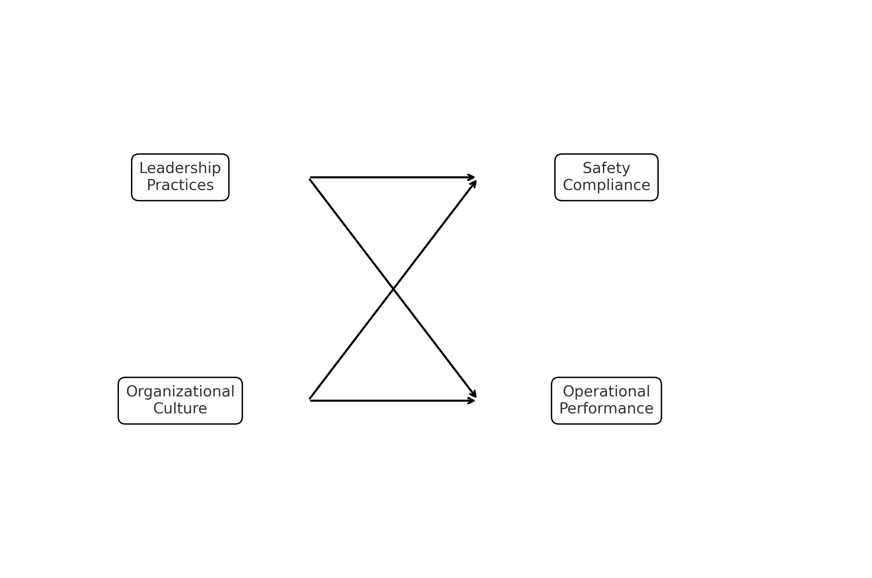
Figure 1: Theoretical Model - Relationship Between Leadership, Organizational Culture, Safety Compliance and Operational Performance

Chapter Two – Literature Review

Introduction:
This chapter presents a review of scholarly work related to leadership, organizational culture, workplace safety, and operational performance in industrial organizations. The goal is to establish a solid theoretical base for the research and to highlight the academic gap that supports the need for this study. The discussion explains how leadership behaviors and cultural characteristics influence safety compliance and overall plant performance, with a specific focus on power and desalination facilities in Saudi Arabia.
Industrial sectors such as electricity generation and seawater desalination rely on highly integrated systems and operate under demanding and potentially hazardous conditions. In these settings, the human elements such as communication, decision-making, supervision, and teamwork can be just as significant as machinery and technology. Studies across different countries and industries show that leadership approach and organizational culture strongly affect employee behavior, motivation, and safety outcomes. However, much of the current knowledge comes from Western settings, where workplace expectations and organizational structures are not always comparable to those in the Middle East.
Within Saudi Arabia, national development plans such as Vision 2030 place strong emphasis on improving operational reliability, workforce development, and sustainable industrial performance. This has increased interest in the role of leadership and workplace culture in strengthening safety management and productivity. Although leadership and culture are known to shape workplace outcomes, little empirical work has focused on how they operate specifically within power and desalination plants. This gap exists despite the strategic importance of these facilities in supporting national energy and water security.
For this reason, the chapter is structured to progressively build understanding. It begins by defining safety and operational performance as key outcome variables in industrial environments. It then examines leadership and organizational culture as two major influencing factors. The review also considers the role of safety climate and communication as potential mediators that may connect leadership and culture to performance outcomes. Finally, previous research is analyzed to identify what is known, what remains unclear, and where this study contributes new insight. The chapter concludes with the theoretical framework and conceptual model used to guide the analysis in later chapters.

Dependent Variables: Safety and Operational Performance:
Across high-risk sectors such as power production and seawater desalination, two measures are commonly used to evaluate organizational success. These are safety performance and operational performance, both of which reflect how efficiently and safely plants operate in demanding environments. In addition, these facilities operate through tightly linked technical systems where a single mistake can trigger serious consequences. For this reason, the quality of outcomes is shaped not only by machines and processes, but also by leadership behavior, employee awareness, and the prevailing organizational culture. In other words, performance and safety are human-organizational results just as much as they are technical ones.

Safety Performance:
Safety performance reflects how effectively an organization prevents incidents, manages hazards, and encourages safe behavior among its workforce. It encompasses compliance with procedures, reporting unsafe acts, and the adoption of preventive practices rather than reactive ones. According to Reason (1997), safety failures usually arise from a chain of latent organizational weaknesses instead of a single mistake. These weaknesses, such as unclear communication, limited supervision, or normalized risk-taking, can line up like openings in the Swiss Cheese Model and result in incidents.
Zohar (2010) highlighted that safety climate is a critical factor in evaluating safety outcomes. This refers to how employees collectively perceive the value that management places on safety. When supervisors demonstrate commitment to protecting workers and actively support hazard reporting, employees respond with safer choices, more vigilance, and greater willingness to speak up (Clarke, 2013; Alzahrani & Eltayeb, 2021).
Saudi-based research reinforces the connection. Almutairi et al. (2020) reported that when workers were encouraged to raise concerns and participate in decision-making, incident frequency dropped. Almalki et al. (2019) similarly found that a supportive safety culture improved rule adherence in water and power operations. These studies demonstrate that technical systems alone cannot guarantee safety but it must be driven by leadership, communication, and cultural reinforcement.
Within the context of this research, safety performance is therefore understood as an outcome influenced by shared values and leadership actions. It reflects whether employees choose to work safely, participate in safety programs, and feel comfortable reporting hazards.

Operational Performance:
Operational performance describes an organization’s ability to meet production targets consistently, economically, and with minimal shutdown. In desalination and power plants, it includes reliability of output, resource efficiency, maintenance scheduling, and the ability to respond quickly to system disruptions. Although performance is often measured numerically, human cooperation and communication play an equally important role.
Neely et al. (2005) and Richard et al. (2009) argue that true performance assessment should extend beyond output levels to include innovation, productivity, and resilience. Leadership contributes to this through motivation, strategic guidance, and clear direction where well-structured communication ensures tasks are executed correctly and efficiently. Bass and Riggio (2006) note that transformational leaders, in particular, elevate performance by aligning team goals with organizational objectives and promoting engagement.
Research evidence echoes this view. Alqaralleh and Al-Tarawneh (2020) found that leadership which emphasizes safety also improves operational flow and reduces machine shutdown. Meanwhile, Alotaibi and Campbell (2022) showed that cultural dimensions especially power distance and collectivism influence decision-making and collaboration in Saudi water facilities. This suggests that high performance depends not only on equipment, but also on cultural alignment, clarity, and employee commitment.
Given the national importance of water and electricity services in Saudi Arabia, operational stability has strategic value. Disruption affects communities, industry, and economic continuity. Therefore, in this research, operational performance is defined as a combined outcome of leadership quality, cultural structure, and safety effectiveness.

Interdependence Between Safety and Operational Performance:
Although safety and performance are often measured separately, they are closely linked in practice. Safe work environments reduce interruption, mechanical failure, and human error which naturally enhances productivity. Conversely, high-performing plants tend to maintain strong safety discipline and risk control systems because reliability depends on accident-free operation.
Studies in high-risk industries show that organizations with robust safety cultures usually outperform those that treat safety and productivity as competing priorities (Clarke, 2013; Hale et al., 2010). This connection is particularly relevant in Saudi desalination and energy facilities where reliability and risk prevention are national necessities. When safety is integrated into operational planning, plants run more consistently and with fewer disruptions.
For this study, safety and operational performance are therefore treated as complementary dependent variables. Both are influenced by leadership style and organizational culture, and both improve when employees trust leadership, communicate openly, and share accountability.

Independent Variables: Leadership and Organizational Culture:
Leadership and organizational culture are two of the strongest drivers shaping safety behavior and operational output in industrial plants. In settings such as power generation and desalination facilities, leadership directs how procedures are communicated and enforced, while culture influences how workers interpret those procedures and apply them in daily tasks. In practice, the two concepts act together to determine how people behave, collaborate, and respond to operational pressure. This section reviews literature related to both variables, with particular consideration of how they function within Saudi Arabia’s industrial environment.

Leadership:
Leadership represents the process through which individuals guide and influence others toward the achievement of shared goals. In high-risk plants, leadership cannot be reduced to oversight alone. It must also create positive working relationships, support transparent communication, and encourage employees to take shared responsibility for safety (Northouse, 2019).

Transformational Leadership
Among leadership theories, transformational leadership receives significant attention due to its strong association with motivation, safety, and productivity. Initially discussed by Burns (1978) and later extended by Bass (1985), this approach focuses on inspiration, growth, and innovation. Transformational leaders typically:
- Gain trust and credibility by acting as role models (Idealized Influence).
- Communicate a motivating vision that aligns individuals toward common goals (Inspirational Motivation).
- Support new ideas, challenge assumptions, and encourage creative solutions (Intellectual Stimulation).
- Show genuine concern for employee development and needs (Individualized Consideration) (Bass & Riggio, 2006).
Research shows that this approach is associated with improved safety involvement, stronger communication, and better compliance with work procedures. Clarke (2013) and Kapp (2012) both reported that participative and motivational leadership enhances safety climate and employee commitment.
Saudi-based studies provide similar evidence. Alzahrani and Eltayeb (2021) observed a strong link between transformational leadership and worker safety behavior in construction settings. Almutairi et al. (2020) also noted that leader visibility and engagement contributed to reductions in incidents in industrial plants. Together, these studies suggest that leaders who communicate clearly, encourage participation, and foster trust are more successful at establishing safe and high-performing work environments.

Transactional, Servant, and Ethical Leadership
Transactional leadership operates differently. Rather than inspiring change, it relies on structured supervision, reward systems, and rule enforcement. Bass (1985) states that transactional leadership reinforces expectations and discipline, helping employees follow procedures. Although transactional leadership alone may not create innovation, research shows that combining it with transformational principles results in stronger compliance and performance outcomes (Mullen et al., 2017).
Other leadership styles are also relevant in industrial environments. Servant leadership places employee well-being and development at the center (Greenleaf, 1977). Ethical leadership is grounded in fairness, responsibility, and transparency (Brown & Treviño, 2006). Studies such as Clarke (2012) and Wu et al. (2018) indicate that when leaders value integrity and worker welfare, employees communicate more openly and engage more actively in safety management.

Leadership Dynamic in Saudi Industrial Plants
Leadership takes on additional weight in Saudi Arabia due to cultural diversity among employees and traditionally hierarchical management systems. Clear communication, participation, and trust-building can help leaders navigate these dynamics effectively. Transformational attributes such as empowerment, shared responsibility, and safety ownership appear especially useful in bridging cultural differences and improving operational reliability in power and desalination plants.

Organizational Culture:
Organizational culture reflects the shared norms, values, and assumptions that shape how work is understood and carried out. Schein (2010) describes culture across three layers:
- Visible, tangible elements such as layouts, procedures, and safety reminders (Artifacts).
- The stated principles and strategies the organization claims to endorse (Espoused Values).
- Deep, often unspoken assumptions that drive behavior and decisions (Underlying Beliefs).
A healthy culture where safety is recognized as a core value is linked to stronger communication, fewer accidents, and more reliable operation (Zohar, 2010; Guldenmund, 2000).

Cultural in the Saudi Work Context
National values strongly influence organizational culture in Saudi Arabia. Research based on Hofstede’s cultural dimensions suggests that strong respect for authority and preference for group harmony can influence employee behavior. In workplaces with relatively high-power distance, workers may avoid questioning decisions or addressing risks unless leaders clearly invite open communication and feedback (Hofstede, 2001; Alotaibi & Campbell, 2022). At the same time, collectivist tendencies can strengthen team cooperation when aligned with supportive leadership.
Empirical findings in Saudi industrial settings reinforce this. Almalki et al. (2019) reported that open communication and visible leadership support enhanced performance in water and power operations. Alqaralleh and Al-Tarawneh (2020) also found that cultures encouraging learning and transparency led to better compliance and safer behavior.

Leadership-Culture Interaction
Leadership and culture are not separate forces but they shape each other. Leaders influence culture through decisions, values, and the behaviors they reward while culture affects how people respond to leadership direction (Schein, 2010). In safety-critical industries, alignment between cultural norms and leadership behavior is essential. When leadership encourages accountability, transparency, and proactive learning and when the workforce interprets those efforts positively therfore performance improves. When inconsistency exists, communication weakens and risk levels rise.
In Saudi desalination and power plants, this interaction is critical. Effective leaders do more than enforce policies, they help cultivate a culture where safe practices are valued, communication is open, and employees take responsibility for operational outcomes.

Mediating Influence of Safety Climate and Communication:
A growing strand of literature suggests that leadership and organizational culture rarely impact safety or performance in a straight, linear manner. Instead, their influence is often channelled through intermediate mechanisms most notably safety climate and communication quality. These variables shape how workers interpret leaders’ intentions and how cultural expectations are translated into daily behaviour at operational sites.

Safety Climate as a Behaviour-Shaping Mechanism:
Safety climate generally reflects the collective impression employees hold regarding how seriously their organization treats safety-related matters (Zohar, 2010). Employees shape this perception gradually through everyday experiences. They observe how supervisors address unsafe actions, whether safety discussions take place regularly, and if the organization genuinely supports transparent reporting.
When workers genuinely believe that safety is valued, not simply written in manuals, they tend to act accordingly. They follow procedures more consistently, speak up about hazards, and support colleagues in risky situations. In this way, safety climate becomes the psychological medium through which leadership and culture affect real behaviour on the ground.
Scholars have repeatedly highlighted this connection:
- Clarke (2013) reported that transformational leadership strengthens safety climate, which in turn increases proactive safety behavior.
- Wu et al. (2018) similarly observed that leadership influence becomes more powerful when employees perceive strong safety commitment.
- Kapp (2012) confirmed that supervisors shape safety outcomes indirectly by shaping the group’s shared perception of safety importance.
These findings collectively show that leadership alone does not guarantee safer practices but employees must feel and see that safety matters to everyone.
In the Saudi industrial context, where multilingual teams and hierarchical systems may inhibit open communication, safety climate becomes even more influential. It helps ensure that expectations are interpreted consistently regardless of nationality, rank, or department.

Communication as a Translating Pathway:
Communication functions as a parallel mechanism linking leadership and culture to real-world outcomes. In fast-paced industrial settings, unclear or delayed communication can escalate small problems into major operational failures. Thus, how information flows upward, downward, and laterally directly affects both safety and production continuity.
Transformational leaders typically improve communication by:
- Articulating a clear safety vision.
- Inviting feedback and worker participation.
- Reinforcing messages through behaviour, not only policy.
- Ensuring information moves in both directions (Bass & Riggio, 2006).
Communication is further strengthened when the surrounding culture promotes openness rather than fear of criticism. In such environments, employees are more willing to report near-misses, discuss unsafe practices, or suggest improvements without hesitation.
Empirical evidence reinforces this view:
- Hale et al. (2010) stressed that two-way communication amplifies the impact of organizational policies on safety behaviour.
- Mullen et al. (2017) found that strong communication systems significantly enhanced the positive effects of transformational leadership.
- Regional studies also note that communication can soften the effects of power distance, giving frontline workers more voice in safety decisions.

Significance for Power and Desalination Operations in Saudi Arabia:
In large-scale utility plants, where desalination units, turbines, maintenance teams and control systems operate simultaneously, continuity relies heavily on accurate information flow. A single unreported abnormality can halt production or create safety exposure. In such environments, safety climate and communication serve as stabilizers that ensure leadership expectations and cultural values are actually enacted at the operational level.
These mediating factors therefore form a critical part of this study’s conceptual model. They represent the mechanisms through which leadership and culture are translated into everyday decisions, work habits, and ultimately safety and performance outcomes.

Summary of Previous Studies:
Research linking leadership, organizational culture, safety, and performance has grown steadily over the past two decades. Most of the foundational evidence originates from international settings, particularly North America and Europe but a number of studies have also emerged from the Gulf region, including Saudi Arabia. These regional contributions are especially valuable, as they reflect cultural and operational realities that differ from Western contexts. However, despite the increasing volume of work, research specifically targeting power and desalination facilities remains limited, leaving room for deeper sector-focused investigation.
In Saudi Arabia, several studies have highlighted the influence of leadership on workplace safety. Alzahrani and Eltayeb (2021), for example, reported that transformational leadership improved safety performance in construction environments. Although this sector is not identical to power and desalination operations, both industries share similar risk profiles, making the findings transferable. Almutairi et al. (2020) presented similar results, noting that leaders who engaged directly with employees and maintained visibility in safety matters helped reduce incident rates. Their work emphasizes that safety outcomes are shaped as much by leadership behavior as by technical systems.
Organizational culture has attracted equal attention in the literature. Almalki et al. (2019) observed that cultural strength and safety climate played a direct role in improving performance in Saudi water and power projects. Their findings suggest that plant outcomes are strongest when employees share consistent values regarding communication, responsibility, and safety expectations. Alotaibi and Campbell (2022), examining the National Water Company, used Hofstede’s cultural framework to show that high power distance and uncertainty avoidance shaped how workers interpreted leadership decisions. Their study reinforces the argument that cultural alignment is essential when leadership seeks to influence safety behavior.
Beyond Saudi Arabia, regional studies have produced related insights. Alqaralleh and Al-Tarawneh (2020), researching manufacturing plants in Jordan, found that active leadership engagement positively affected compliance and safety behavior. However, Their findings highlighted leadership effects, yet culture was not assessed as a moderating variable. This research extends the discussion by including that missing dimension.
Global literature provides the theoretical foundation supporting these regional findings. Clarke (2013) demonstrated through meta-analysis that transformational and transactional leadership both influence safety performance, with the transformational approach encouraging greater proactive participation. Zohar’s (2010) work on safety climate remains central to the field, emphasizing that employees’ perception of safety priority strongly predicts behavior. Complementing this, Schein (2010) described culture as something created and reinforced by leadership actions over time, while Reason’s (1997) Swiss Cheese Model illustrates how accidents emerge when cultural and procedural weaknesses align.
In general, previous studies confirm that leadership and organizational culture shape safety and performance outcomes. However, many investigations examined these elements separately, rather than as interconnected variables, and few addressed the combined effect within continuous-operation environments like power and desalination. These facilities operate under constant load, where a single safety oversight can affect national service continuity, making the study context both critical and unique.
The present research responds directly to this gap by examining leadership and culture together within major water and power plants in west region of Saudi Arabia. By focusing on how both variables work jointly to influence safety and operational performance. Therefore, this study offers sector-specific insight aligned with ongoing national industrial goals under Vision 2030.

Theoretical Framework of the Study:
High-risk facilities such as power generation and desalination plants operate within environments where technical performance and human behavior must coexist in balance. Although machinery, monitoring systems, and automated controls have advanced considerably in recent years, many operational disruptions still trace back to human-driven factors rather than equipment alone. For this reason, the current research is anchored in two complementary theoretical foundations: Transformational Leadership Theory and Organizational Culture Theory. Together, these frameworks clarify how leadership behaviors and shared workplace values influence safety practices and overall operational performance.

Transformational Leadership Theory:
Transformational leadership was originally proposed by Burns (1978) and further developed by Bass (1985), who described it as a leadership approach driven by influence, encouragement, and empowerment rather than direct control. Leaders who adopt this style inspire others with a clear vision, demonstrate integrity in their actions, promote creativity and problem-solving, and provide tailored guidance to support employees’ development and involvement (Bass & Riggio, 2006).
Such traits are particularly relevant in power and desalination plants, where coordinated teamwork and safety-driven decision-making directly affect production continuity. Research has repeatedly shown that leaders who practice transformational behaviors tend to strengthen employee trust, raise morale, and promote safe operational conduct. Clarke (2013), for instance, demonstrated that transformational leadership enhances employees’ sense of responsibility toward safety, while Alzahrani & Eltayeb (2021) found similar results within Saudi industrial settings. These findings suggest that when leaders model safety-aligned behavior, encourage dialogue, and empower staff to report hazards, safety performance improves significantly.

Organizational Culture Theory:
According to Schein (2010), every organization develops a layered cultural structure composed of visible elements, formal values, and deeply rooted assumptions. The outer observable layer includes safety procedures, communication patterns, and work practices. Beneath this lies the organization’s stated values, policies, and commitments. The deepest layer underlying assumptions reflects unspoken beliefs that guide everyday reactions, risk perception, teamwork, and compliance behavior.
In many Gulf-region workplaces, including Saudi Arabia, certain cultural features are especially prominent such as respect for hierarchy, strong group loyalty, and formal communication structures. While these traits can support unity and discipline, they may also prevent employees from reporting unsafe behavior or questioning decisions made by superiors. Hofstede (2001) and Alotaibi & Campbell (2022) note that high power-distance cultures often require leaders to be proactive if they wish to encourage transparency and safety reporting. A culture that genuinely treats safety as a core value creates faster response times, more accurate reporting, and improved operational stability.

Integrating the Two Theories:
This study adopts an integrated perspective in which leadership and culture are not treated as separate influences but as interacting elements that shape behavior collectively. Leaders model the norms that define the organizational environment, while culture determines how leadership is interpreted and responded to at ground level (Bass, 1985; Schein, 2010). When leadership behavior reinforces cultural values that emphasize openness, responsibility, and learning, the organization tends to see stronger safety compliance and improved operational performance. However, when leadership expectations contradict cultural habits such as discouraging feedback in a hierarchical setting, performance may weaken, even when safety rules exist.
Therefore, the theoretical framework guiding this study assumes that leadership and organizational culture work jointly to influence safety and operational outcomes. Alignment between the two creates a supportive climate for communication, risk management, and continuous improvement. Misalignment increases the likelihood of errors, reduced reporting, and operational inefficiency.

Conceptual Model of the Study:
The conceptual model (Figure 2) illustrates how leadership practices and organizational culture act as independent variables influencing safety compliance and operational performance. It also demonstrates the reciprocal connection between leadership and culture, acknowledging that strong safety compliance contributes to improved operational results in power and desalination facilities in Saudi Arabia.

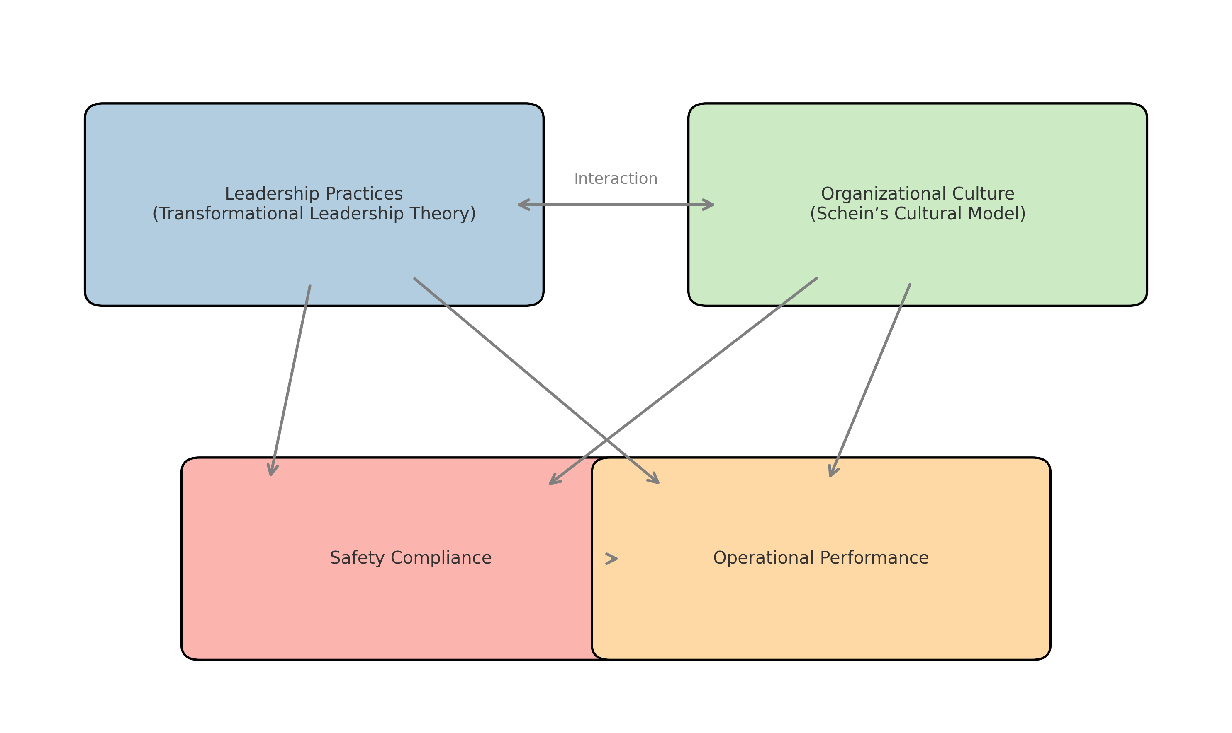
Figure 2: Theoretical Framework of the Study

