“The Role of IoT in Monitoring Patients with Diabetes in COVID-19”

Research Methodology

Prepared By
Name: Mohammed Ayidh Almalki ID No. 251002537

Submitted in fulfillment of the requirements for the degree Master of Science in Artificial Intelligence
At
Collage of Informatics
Midocean University
UAE
Supervisor Name: Dr. Amjad Qataish
Collage of Informatics, Midocean University

Project Methodology

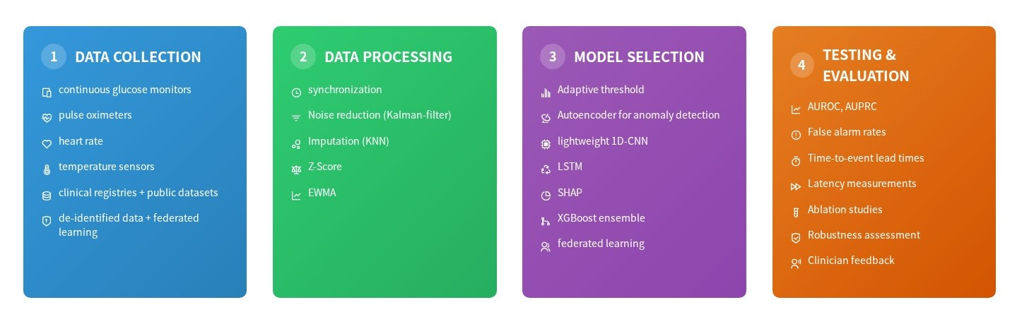

- Data Collection

  - Utilize multimodal sensor data from diabetic patients, including continuous glucose monitors, pulse oximeters, heart rate, and temperature sensors.
  - Integrate diversity by matching clinical partner registries with public datasets (e.g., PhysioNet).
  - Ensure all clinical data is de-identified and privacy concerns are met through training in a federated learning function

- Data Processing :

  - Synchronize sensor streams and resample at a consistent frequency.
  - Implement noise reduction strategies using Matlab Kalman filters and/or median smoothing.
  - Impute missing values using KNN-type latent based techniques.
  - Normalize data against the patient’s baseline.
  - Create sliding windows with extracted features, such as z-scores with EWMA interval trend indicators and rate-of-change indicators

- Model / Method Selection:
  - Model: A lightweight 1D-CNN + LSTM capable of running on edge devices (e.g., Raspberry Pi) with inference latency less than 100 ms.
  - Personalization: Patient-specific alerts through adaptive dynamic thresholding of z-scores and EWMA values.
  - Anomaly Detection: When data and labels permit, an autoencoder will provide non-discriminatory anomaly detection.
  - Robustness: Utilize federated learning and XGBoost to create ensembles, enhancing robustness across institutional strategies and making the system "anti-fragile".
  - Explainable Alerts: Alerts will include an additional level of explanation via clinical usage by generating explainable alerts through SHAP

- Testing and Evaluation :
The system will be evaluated based on the following metrics:
  - Prediction Performance: AUROC (Area Under the Receiver Operating Characteristic) and AUPRC (Area Under the Precision-Recall Curve).
  - False Alarms: Measured per patient-day.
  - Time-to-Event Lead Times.
  - Latency: Measured on edge devices to ensure real-time feasibility (<100ms).
  - Ablation Studies: Compare static thresholds, dynamic thresholds, and hybrid AI models.
  - Robustness: Assessment on noisy and missing data.
  - Clinician Feedback: Surveys to evaluate usefulness and interpretability of alerts

Project Timeline :

  - Weeks 1–6: Data Collection and Preparation
  - Weeks 7–8: Model Building and Training
  - Weeks 9–10: Testing and Evaluation
  - Week 11: Final Adjustments and Reporting

