A Comprehensive Review of Deep Learning Methods for Diabetic Retinopathy Classification
Asraa Alwattar – Rahaf Barakat
ORCID ID: 253001066 / 253002370
Master of Science in Artificial Intelligence – College of Informatics – Midocean University – Union of the Comoros
Email: esraawattar96@gmail.com
Supervisor: Dr. (Wesam Ahmed) College of Informatics – Midocean University – Union of the Comoros

Abstract:
Diabetic retinopathy (DR) is a major cause of preventable vision loss, making early and accurate automated screening essential for supporting timely clinical intervention. Recent advances in artificial intelligence, particularly deep learning and transfer learning, have improved the analysis of retinal fundus images through convolutional neural networks, transformer-based models, and hybrid frameworks. This survey provides a comprehensive review of deep learning techniques for diabetic retinopathy classification and a critical analysis of prior studies on the evolution of deep learning architectures, their performance, strengths, and limitations. The survey covers Vision Transformers (ViTs), hybrid architectures, ensemble learning strategies, and transfer learning approaches. However, several challenges remain, including class imbalance, limited dataset diversity, computational complexity, lack of external validation, and insufficient explainability for clinical adoption. The survey also highlights future research directions, including explainable artificial intelligence, lightweight models, multi-dataset validation, self-supervised learning, and clinically robust hybrid architectures. Overall, this paper provides a structured overview of current research trends and supports the development of more accurate, interpretable, and reliable DR classification systems.

Keywords: Diabetic Retinopathy, Deep Learning, Hybrid Deep Learning, Transfer Learning, Medical Image Classification

الملخص:
يُعد اعتلال الشبكية السكري أحد الأسباب الرئيسية لفقدان البصر الذي يمكن الوقاية منه، مما يجعل التشخيص الآلي المبكر والدقيق ضرورة مهمة لدعم التدخل العلاجي في الوقت المناسب. وقد أسهمت التطورات الحديثة في الذكاء الاصطناعي، وخصوصًا التعلم العميق والتعلم بالنقل، في تحسين تحليل صور قاع العين من خلال الشبكات العصبية الالتفافية، والنماذج المعتمدة على المحولات، والأطر الهجينة. تقدم هذه الدراسة المسحية مراجعة شاملة لتقنيات التعلم العميق المستخدمة في تصنيف اعتلال الشبكية السكري، إضافة إلى تحليل نقدي للدراسات السابقة حول تطور معماريات التعلم العميق وأدائها ونقاط قوتها وحدودها. وتتناول الدراسة نماذج المحولات البصرية (ViTs)، والمعماريات الهجينة، واستراتيجيات التعلم الجماعي (Ensemble Learning)، وأساليب التعلم بالنقل. ومع ذلك، ما تزال هناك تحديات مهمة تشمل عدم توازن الفئات، ومحدودية تنوع البيانات، والتعقيد الحسابي، وضعف التحقق الخارجي، والحاجة إلى نماذج أكثر قابلية للتفسير لدعم اعتمادها سريريًا. كما تستعرض الدراسة اتجاهات بحثية مستقبلية واعدة، منها الذكاء الاصطناعي القابل للتفسير، والنماذج خفيفة الوزن، والتحقق باستخدام بيانات متعددة، والتعلم ذاتي الإشراف، والمعماريات الهجينة الأكثر قابلية للتطبيق سريريًا. وبشكل عام، تقدم هذه الورقة نظرة عامة منظمة على اتجاهات البحث الحالية وتدعم تطوير أنظمة تصنيف أكثر دقة وقابلية للتفسير وموثوقية لاعتلال الشبكية السكري.
الكلمات المفتاحية: اعتلال الشبكية السكري، التعلم العميق، التعلم العميق الهجين، التعلم بالنقل، تصنيف الصور الطبية

1. Introduction
Diabetic retinopathy (DR) is one of the most common complications of diabetes mellitus and remains a leading cause of preventable blindness among the working-age population worldwide. The disease gradually damages retinal blood vessels, often without noticeable symptoms during its early stages. Therefore, early screening and accurate diagnosis are essential to prevent irreversible vision loss and improve patient outcomes. However, conventional diagnosis relies on the manual examination of retinal fundus images by ophthalmologists, a process that is time-consuming, labor-intensive, and subject to inter-observer variability, making large-scale screening challenging. Recent progress in artificial intelligence (AI) has opened new possibilities for automated medical image analysis, with machine learning (ML) and deep learning (DL) techniques playing an increasingly central role in retinal disease screening. Researchers have explored a wide range of architectures for this task, including convolutional neural networks (CNNs), transformer-based models, and hybrid frameworks that combine multiple learning paradigms. Transfer learning has further accelerated progress by allowing models pretrained on large-scale image datasets to be adapted to retinal fundus images, achieving strong classification performance even when labeled medical data is limited. More recently, transformer-based architectures have attracted growing interest for their ability to capture both local and global contextual information through self-attention mechanisms, while hybrid frameworks that integrate deep feature extractors with machine learning classifiers have shown further gains in accuracy and robustness. Despite this progress, several challenges remain unresolved: many existing studies rely on a single dataset, suffer from class imbalance, demand substantial computational resources, or lack sufficient interpretability for clinical deployment. Moreover, differences in preprocessing techniques, feature extraction strategies, classification algorithms, and evaluation protocols make direct comparison across studies difficult. A comprehensive review of these advances is therefore essential to consolidate the current state of the field, identify open research gaps, and outline promising directions for future work.
This survey presents a comprehensive review of recent machine learning, deep learning, transfer learning, transformer-based, and hybrid approaches for diabetic retinopathy classification. The reviewed studies are analyzed according to the datasets used, image preprocessing techniques, feature extraction strategies, classification algorithms, evaluation metrics, reported performance, and existing limitations.

2. Background and Theoretical Foundations
Diabetic retinopathy (DR) is one of the leading causes of preventable vision loss worldwide, making early diagnosis essential for effective treatment and improved clinical outcomes. Recent advances in artificial intelligence (AI), particularly deep learning, transfer learning, transformer-based architectures, and hybrid frameworks, have significantly improved the automated analysis and classification of retinal fundus images. These approaches have enhanced feature extraction, classification accuracy, and model generalization, making them increasingly valuable for computer-aided diagnosis. This section presents the fundamental concepts and techniques that form the basis of modern diabetic retinopathy classification systems.
2.1 Diabetic Retinopathy Classification
Diabetic retinopathy (DR) classification aims to automatically determine the severity stage of retinal damage using fundus images. According to the International Clinical Diabetic Retinopathy (ICDR) grading system, DR is commonly categorized into five classes: No DR, Mild, Moderate, Severe, and Proliferative DR. Accurate classification is essential for early diagnosis, timely treatment, and reducing the risk of permanent vision loss. Automated classification systems have become increasingly important in supporting ophthalmologists, improving large-scale screening programs, and enabling timely clinical decision-making.
2.2 Machine Learning Approaches for DR
Before the widespread adoption of deep learning, diabetic retinopathy classification relied primarily on classical machine learning (ML) pipelines built on handcrafted image features. These approaches typically extract descriptors of retinal texture, vessel structure, and lesion shape, such as local binary patterns, histograms of oriented gradients, and morphological or color-based features, and feed them into supervised classifiers including Support Vector Machines (SVM), Random Forest, K-Nearest Neighbors (KNN), and Naïve Bayes. For example, Al Fahad and Khan (2025) evaluated a classical feature-based ML framework combining texture and gradient descriptors with several supervised classifiers on the Kaggle DR dataset, finding that SVM, Random Forest, and Bayesian Network classifiers achieved the most competitive accuracy among the methods tested. Classical ML approaches remain relevant in settings where annotated data is scarce, computational resources are limited, or model transparency is a clinical priority, since handcrafted features can often be directly related to recognizable retinal abnormalities. However, their performance is generally bounded by the expressive power of manually designed features, which motivated the shift toward deep learning methods capable of learning discrimination representations directly from raw images as shown at the figure 1 below:

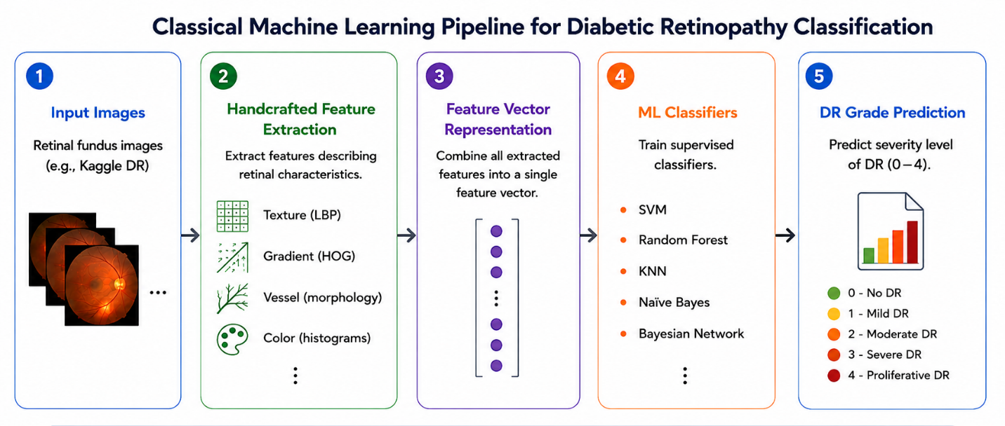

Figure 1. Classical machine learning pipeline for diabetic retinopathy classification.

2.3 Deep Learning Approaches for DR
Deep learning, and convolutional neural networks (CNNs) in particular, has become one of the most widely adopted paradigms for diabetic retinopathy classification, offering the ability to automatically learn discriminative features directly from retinal fundus images without relying on the handcrafted feature engineering described above. Convolutional Neural Networks (CNNs), including widely adopted architectures such as ResNet, DenseNet, EfficientNet, and the more recent ConvNeXt family, have demonstrated remarkable performance in extracting hierarchical visual representations. Among these architectures, ConvNeXt combines the strengths of traditional CNNs with modern architectural design principles inspired by vision transformers, resulting in improved feature extraction capability, better generalization, and competitive classification performance. These advantages have made ConvNeXt an increasingly promising backbone for retinal image analysis and diabetic retinopathy classification.
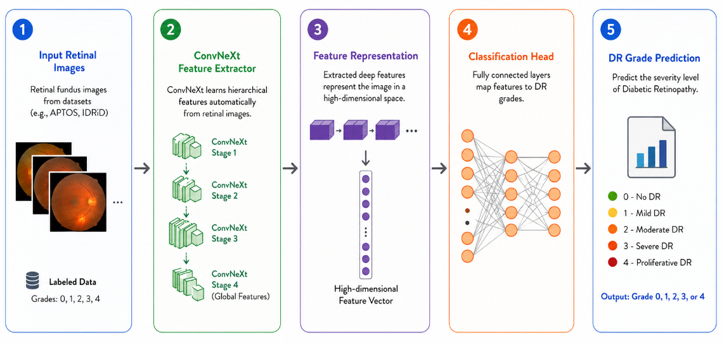

Figure 2. Deep learning pipeline for diabetic retinopathy classification using ConvNeXt.
2.4 Transfer Learning in Medical Imaging
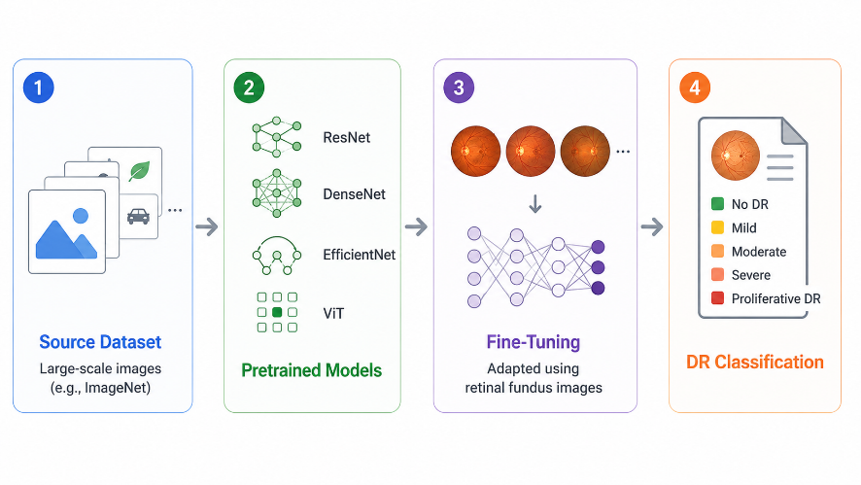
Transfer learning has become one of the most effective strategies in medical image analysis, particularly when large annotated retinal datasets are unavailable. Instead of training deep neural networks from scratch, pretrained models learned from large-scale datasets such as ImageNet are fine-tuned using retinal fundus images. This approach reduces training time, accelerates convergence, improves feature representation, and often achieves higher classification accuracy with limited medical data. Consequently, transfer learning has become a fundamental component of many recent diabetic retinopathy classification frameworks, especially those based on modern CNN and transformer architectures as shown in Figure 3 below:

Figure 3. Transfer Learning Workflow in Medical Image Analysis for Diabetic Retinopathy Classification
2.5 Transformer-Based Models
Transformer-based architecture has recently attracted considerable attention in medical image analysis because of their self-attention mechanism, which enables the extraction of both local and global image features. Among these models, the Swin Transformer has gained particular attention due to its hierarchical architecture and shifted-window self-attention mechanism, which efficiently
captures fine-grained retinal lesions while preserving global contextual information. Other transformer-based models, including Vision Transformer (ViT) and DINOv2, have also demonstrated promising performance in diabetic retinopathy classification. These architectures complement conventional CNN models by providing richer feature representations and improved contextual understanding, leading to enhanced classification performance as shown in Figure 4 below:

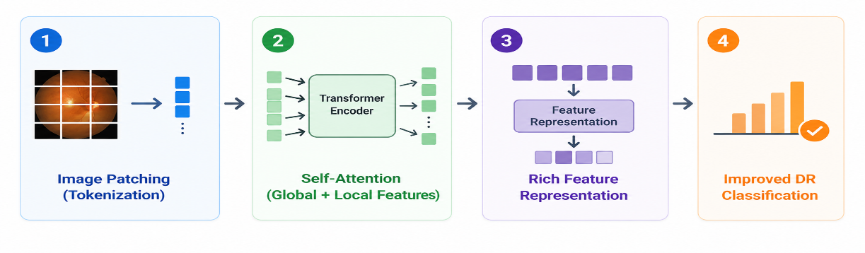

Figure 4. Transformer-Based Architecture for Diabetic Retinopathy Classification
2.6 Hybrid Deep Learning Frameworks
Hybrid deep learning frameworks combine the strengths of multiple artificial intelligence techniques to improve diabetic retinopathy classification. These frameworks typically integrate CNN-based models for detailed local feature extraction, transformer-based architectures for capturing global contextual information, and machine learning classifiers such as Support Vector Machine (SVM), Random Forest, or XGBoost for final prediction.
Recent studies have shown that hybrid CNN–Transformer frameworks can provide complementary feature representations through feature fusion, resulting in improved robustness, better generalization, and higher classification accuracy than single-model architectures. Consequently, hybrid approaches have emerged as one of the most promising research directions for automated diabetic retinopathy classification as shown in Figure 5 below:

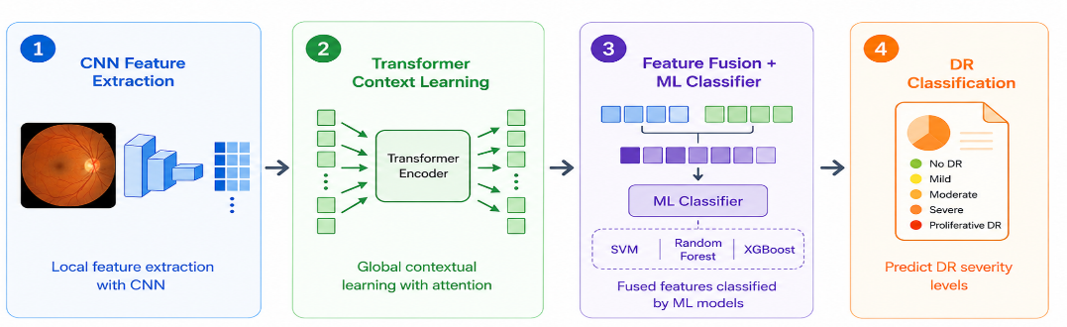

Figure 5. Hybrid Deep Learning Framework for Diabetic Retinopathy Classification
2.7 Evaluation Metrics
The performance of diabetic retinopathy classification models is commonly assessed using several quantitative evaluation metrics. Accuracy measures the overall proportion of correctly classified samples, whereas Precision, Recall (Sensitivity), Specificity, and F1-score provide a more comprehensive assessment of classification performance, particularly for imbalanced datasets. In addition, the Confusion Matrix and the Area Under the Receiver Operating Characteristic Curve (AUC-ROC) are widely used to evaluate model reliability, diagnostic effectiveness, and overall clinical applicability.

2.7.1 Confusion Matrix
The confusion matrix summarizes the classification results by comparing predicted labels with the corresponding ground-truth labels. It consists of four outcomes: True Positive (TP), True Negative (TN), False Positive (FP), and False Negative (FN), which are used to calculate various evaluation metrics. In medical image classification, the confusion matrix provides valuable insight into the types of prediction errors made by the model and helps assess its diagnostic reliability.
- TP: Positive samples correctly classified.
- TN: Negative samples correctly classified.
- FP: Negative samples incorrectly classified as positive.
- FN: Positive samples incorrectly classified as negative.

2.7.2 Performance Metrics
The performance of diabetic retinopathy classification models is evaluated using several metrics derived from the confusion matrix. Each metric provides a different perspective on the classifier’s effectiveness and is particularly important when dealing with imbalanced medical datasets.
- Accuracy $Accuracy=\frac{TP+TN}{TP+TN+FP+FN}$
- Precision $Precision=\frac{TP}{TP+FP}$
- Recall (Sensitivity) $Recall=\frac{TP}{TP+FN}$
- Specificity $Specificity=\frac{TN}{TN+FP}$
- F1-score $F1=2×\frac{Precision×Recall}{Precision+Recall}$
In addition, the Area Under the Receiver Operating Characteristic Curve (AUC-ROC) is widely used to evaluate a model’s ability to distinguish between different classes. Higher AUC values indicate better discriminative performance and greater reliability for clinical decision support.
3. Previous Studies
This section reviews recent studies on diabetic retinopathy classification using artificial intelligence techniques, including machine learning, deep learning, transfer learning, transformer-based models, and hybrid frameworks as shown in Table 1. The reviewed studies focus on different datasets, image preprocessing techniques, feature extraction methods, and classification algorithms proposed to improve diagnostic accuracy. This review highlights the main contributions, strengths, and limitations of existing approaches while identifying current research trends and the remaining challenges in developing accurate, robust, and clinically applicable diabetic retinopathy classification systems.
Jiwani et al. (2022) proposed a simple CNN-based model for binary diabetic retinopathy classification using the IDRiD dataset, which, despite lower accuracy than other models, remains a valuable benchmark study with accuracy about 75%.
Fayyaz et al. (2023) introduced a hybrid approach in which AlexNet and ResNet101 were used for feature extraction, ant colony optimization for feature selection, and SVM for classification, attaining an accuracy of about 93% and confirming the effectiveness of combining CNN-based feature extraction with SVM.
Lin and Wu (2023) proposed a revised ResNet-50 architecture aimed at reducing overfitting and improving stability; while robust, its test accuracy of 74.32% was lower than that of several more recent architectures.
Mohanty et al. (2023) compared a hybrid VGG16 and XGBoost model with DenseNet121 for diabetic retinopathy detection and classification, concluding that DenseNet121 outperformed the hybrid model with an accuracy of about 74.3%.
Patil et al. (2023) employed ResNet-50 with transfer learning and Test-Time Augmentation on the APTOS dataset, validated on EyePACS, demonstrating a high accuracy of 97.87% together with a strong Quadratic Weighted Kappa and emphasizing the role of augmentation in improving classifier reliability.
Ali and Dawood (2023) proposed a ResNet-50-based transfer learning system for diabetic retinopathy classification on the APTOS 2019 dataset, obtaining an accuracy of 98.3% and confirming the applicability of transfer learning to retinal images, though without external validation.
Das et al. (2023) developed the DRFEC framework and evaluated twenty-six pretrained deep learning models on EyePACS, with EfficientNetB4 obtaining the highest validation accuracy of around 79.11% while exposing overfitting problems in some architectures.
Youldash et al. (2024) studied six pretrained CNN models, including EfficientNet and RegNet variants, on the APTOS and Saudi clinical datasets, achieving high accuracy of 96% on binary classification but comparatively weaker results on the multi-class task. The main value of this study lies in its external clinical validation.
Shamrat et al. (2024) proposed DRNet13, a deep neural network specifically designed for fundus image analysis, which surpassed fifteen pretrained CNNs with an accuracy of roughly 96-97%, although the results were obtained from a single dataset and at a notable computational cost.
Jabbar et al. (2024) developed a lesion-based hybrid model that combined deep learning for feature extraction with machine learning classifiers such as SVM, Random Forest, Decision Tree, and Linear Regression, reaching an accuracy of around 94%.
Guefrachi et al. (2024) proposed a multistage deep learning training method for diabetic retinopathy screening using transfer learning networks such as ResNet152-V2 and InceptionResNet-V2, with the best result presented through a graphical interface and a reported accuracy of around 97%, though with an associated risk of overfitting.
Akhtar et al. (2025) proposed a deep learning model called RSG-Net for diabetic retinopathy grading, designed for both four-stage multi-class classification and binary classification using the Messidor-1 dataset. By combining image cropping, Gaussian-blur denoising, histogram equalization, resizing, and augmentation, the model achieved strong results, reporting 99.36% testing accuracy for the four-stage task and 94.2% for the binary task, although its generalization beyond the evaluation dataset remained limited.
Wu et al. (2025) introduced mBRSET, a portable retinal fundus image dataset collected in real clinical settings using handheld retinal cameras, and benchmarked ConvNeXt V2, DINOv2, and Swin V2 on the dataset, reporting best F1-scores of 80.33 for the three-class task and 87.4 for the binary task. This study is notable for highlighting the difficulty of achieving strong performance on real-world noisy data.
Grzybowski and Jin (2026) examined artificial intelligence-based medical devices for diabetic retinopathy screening within the European Union, using a framework that enhanced fundus images through resizing, normalization, and augmentation to balance the classes, and reported accuracy levels around 80% across heterogeneous data sources and reporting standards.

Table 1: Comparative Study of Diabetic Retinopathy Detection Methods
Authors | Year | Method / Model | Dataset | Results | Limitations
Jiwani et al. (2022) | 2022 | CNN (binary) | EyePACS / IDRiD | ~75% | Moderate accuracy
Fayyaz et al. (2023) | 2023 | AlexNet + ResNet101 + SVM | Fundus images | ~93% | Small feature set
Lin & Wu (2023) | 2023 | Revised ResNet-50 (CNN) | Kaggle DR images | 74.32% | Low test vs. train
Mohanty et al. (2023) | 2023 | ResNet-50 / DenseNet121 | Kaggle DR | ~74.3% | Low test accuracy
Patil et al. (2023) | 2023 | ResNet-50 + TTA | APTOS + EyePACS | 97.87% | Multi-class imbalance
Ali & Dawood (2023) | 2023 | ResNet-50 (transfer learning) | APTOS 2019 | 98.3% | No external validation
Das et al. (2023) | 2023 | 26 pretrained DL nets (DRFEC) | Kaggle EyePACS | ~79.11% | Low validation accuracy
Youldash et al. (2024) | 2024 | EfficientNetV2, RegNetX | Kaggle EyePACS | ~96% | Class imbalance
Shamrat et al. (2024) | 2024 | Deep Learning (DRNet13) | Fundus images | ~96-97% | Computational cost
Jabbar et al. (2024) | 2024 | GoogleNet + ResNet + ML | Fundus dataset | ~94% | Limited validation detail
Guefrachi et al. (2024) | 2024 | Deep Learning (ResNet152-V2) | Kaggle DR dataset | ~97% | Overfitting risk
Akhtar et al. (2025) | 2025 | Deep Learning (RSG-Net) | EyePACS | 94.2% | Limited generalization
Wu et al. (2025) | 2025 | ConvNeXt V2, DINOv2, SwinV2 | mBRSET | 80.33  87.4 | Limited dataset size
Grzybowski & Jin (2026) | 2026 | AI DR devices (CNN) | EU datasets | ~80% | Heterogeneous data and reporting

4. Challenges and Limitations
Despite the significant progress achieved in diabetic retinopathy classification, several challenges remain. One of the most critical issues is class imbalance, where severe diabetic retinopathy cases are underrepresented compared with normal and mild cases, leading to reduced classification performance for minority classes. Another challenge is the limited diversity of publicly available retinal image datasets, as many studies rely on a single dataset, restricting model generalization across different clinical settings and imaging devices.
In addition, variations in image quality, illumination conditions, and acquisition protocols continue to affect the reliability of automated classification systems. Recent deep learning and transformer-based models also require substantial computational resources, making their deployment in real-world healthcare environments more difficult. Furthermore, many models lack interpretability, limiting clinicians’ trust in automated diagnostic decisions. Although hybrid frameworks have shown promising results, the integration of modern transformer architectures with traditional machine learning classifiers remains relatively underexplored. Addressing these challenges is essential for developing accurate, efficient, explainable, and clinically applicable diabetic retinopathy classification systems.

5. Future Directions
Future research on diabetic retinopathy classification should focus on developing more accurate, efficient, and clinically applicable artificial intelligence models. A promising direction is the development of hybrid frameworks that combine convolutional neural networks, transformer-based architectures, and machine learning classifiers to improve feature extraction and classification performance.
Another important direction is the design of lightweight deep learning models that maintain high diagnostic accuracy while requiring fewer computational resources. Such models can facilitate deployment on portable retinal cameras, mobile devices, and other resource-constrained healthcare environments.
Future studies should also utilize larger and more diverse retinal image datasets from different populations and clinical settings. External validation across multiple datasets can improve model generalizability and reliability, while advanced techniques for addressing class imbalance can enhance the detection of minority diabetic retinopathy stages.
Finally, explainable artificial intelligence (XAI) is expected to play a key role in future diagnostic systems by providing interpretable predictions and visual explanations that increase clinicians' trust and support reliable clinical decision-making. Continued advances in these areas will contribute to the development of accurate, transparent, and clinically deployable diabetic retinopathy classification systems.

6. Conclusion
This survey reviewed recent advances in artificial intelligence techniques for diabetic retinopathy classification, with particular emphasis on deep learning, transfer learning, transformer-based models, and hybrid frameworks. The reviewed studies demonstrate that these approaches have significantly improved classification accuracy and robustness, while highlighting persistent challenges such as class imbalance, limited dataset diversity, computational complexity, and limited model interpretability. Overall, this survey provides a comprehensive overview of current research trends and identifies promising future directions, including explainable artificial intelligence (XAI), and lightweight deep learning models to support the development of accurate, reliable, and clinically applicable diabetic retinopathy classification systems.

References
Akhtar, S., Aftab, S., Ali, O., Ahmad, M., Khan, M. A., Abbas, S., & Ghazal, T. M. (2025). A deep learning based model for diabetic retinopathy grading. Scientific Reports, 15, 3763.
Al Fahad, N., & Khan, R. U. (2025). Classical machine learning based diabetic retinopathy detection using handcrafted features. Ingénierie des Systèmes d'Information, 30(12), 3201–3206.
Ali, A. A., & Dawood, F. A. A. (2023). Deep learning of diabetic retinopathy classification in fundus images. Journal of Engineering, 29(12), 139–152.
Das, D., Biswas, S. K., & Bandyopadhyay, S. (2023). Detection of diabetic retinopathy using convolutional neural networks for feature extraction and classification (DRFEC). Multimedia Tools and Applications, 82(19), 29943–30001.
Fayyaz, A. M., Sharif, M. I., Azam, S., Karim, A., & El-Den, J. (2023). Analysis of diabetic retinopathy (DR) based on deep learning. Information, 14(1), 30.
Grzybowski, A., & Jin, K. (2026). Artificial intelligence-based medical devices for diabetic retinopathy screening in the European Union. Ophthalmology and Therapy, 15(2), 569–589.
Guefrachi, S., Echtioui, A., & Hamam, H. (2024). Diabetic retinopathy detection using deep learning multistage training method. Arabian Journal for Science and Engineering, 49(2), 1079–1096.
Jabbar, A., Liaqat, H. B., Akram, A., Sana, M. U., Azpíroz, I. D., de la Torre Díez, I., & Ashraf, I. (2024). A lesion-based diabetic retinopathy detection through hybrid deep learning model. IEEE Access, 12, 40019–40036.
Jiwani, N., Gupta, K., & Afreen, N. (2022). A convolutional neural network approach for diabetic retinopathy classification. In 2022 IEEE 11th International Conference on Communication Systems and Network Technologies (CSNT) (pp. 357–361). IEEE.
Lin, C.-L., & Wu, K.-C. (2023). Development of revised ResNet-50 for diabetic retinopathy detection. BMC Bioinformatics, 24, 157.
Mohanty, C., Mahapatra, S., Acharya, B., Kokkoras, F., Gerogiannis, V. C., Karamitsos, I., & Kanavos, A. (2023). Using deep learning architectures for detection and classification of diabetic retinopathy. Sensors, 23(12), 5726.
Patil, M. S., Chickerur, S., Abhimalya, C., Naik, A., Kumari, N., & Maurya, S. (2023). Effective deep learning data augmentation techniques for diabetic retinopathy classification. Procedia Computer Science, 218, 1156–1165.
Shamrat, F. M. J. M., Shakil, R., Sharmin, S., Ovy, N. H., Akter, B., Ahmed, M. S., Ahmed, M. Z., Ahmed, K., Bui, F. M., & Moni, M. A. (2024). An advanced deep neural network for fundus image analysis and enhancing diabetic retinopathy detection. Healthcare Analytics, 5, 100303.
Wu, C., Restrepo, D., Nakayama, L. F., Zago Ribeiro, L., Shuai, Z., Barboza, N. S., Sousa, M. L. V., Fitterman, R. D., Pereira, A. D. A., Regatieri, C. V. S., Stuchi, J. A., Malerbi, F. K., & Andrade, R. E. (2025). A portable retina fundus photos dataset for clinical, demographic, and diabetic retinopathy prediction. Scientific Data, 12, 323.
Youldash, M., Rahman, A., Alsayed, M., Sebiany, A., Alzayat, J., Aljishi, N., Alshammari, G., & Alqahtani, M. (2024). Early detection and classification of diabetic retinopathy: A deep learning approach. AI, 5(4), 2586–2617.

