

Project Proposal
Advancing Ophthalmic Diagnostics with AI: A Deep Learning Framework for early Detection of Retinal Diseases from OCT Data
Prepared By
Name: Sirin Mohammed Hejazi ID: 243001213
Email: 243001213@st.midocean.edu.km
Submitted to the requirements of the degrees master of science in Artificial Intelligence
At
College of Informatics
Midocean University
UAE
Supervisor Name: Dr Khaled Eskaf, College of Informatics, Midocean University, UAE
Email: Khaledeskaf@midocean.edu.km

ABSTRACT
The proposed project leverages Artificial Intelligence (AI) to develop a non-surgical diagnostic system aimed at accurately diagnosing various eye conditions. By utilizing advanced AI algorithms and machine learning techniques, this system seeks to streamline traditional diagnostic processes, significantly reducing the time and cost associated with eye examinations. Early and precise detection of eye diseases through AI can substantially enhance patient safety, vision preservation, and overall quality of life.
This study specifically addresses clinically significant eye diseases, including Choroidal Neovascularization (CNV), Diabetic Macular Edema (DME), Drusen and normal retinal condition. CNV involves the growth of abnormal blood vessels beneath the retina, frequently leading to severe vision loss. DME, a complication arising from diabetes, affects the macula and can result in substantial vision impairment. Drusen, characterized by small yellow retinal deposits, is commonly an early indication of age-related macular degeneration. Normal condition refers to retinas unaffected by these disorders. Each condition poses distinct diagnostic solutions.
Employing the CRISP-DM methodology, this study designed, implemented, and compared multiple Convolutional Neural Network (CNN) architectures. The models included custom-built networks (3-layer and 7-layer CNNs) and transfer learning models fine-tuned from pre-trained architectures (VGG16, ResNet50, and DenseNet121). A publicly available dataset of over 84,000 OCT B-scans was rigorously preprocessed, augmented to address class imbalance, and partitioned for training, validation, and testing.
The DenseNet121 model achieved the highest performance with a test accuracy of 96%, a micro-average F1-score of 0.94, and an Area Under the ROC Curve (AUC-ROC) of 0.97. It demonstrated superior balance across all four diagnostic classes (CNV, DME, Drusen, Normal) and offered the best trade-off between accuracy and computational efficiency. Comparative analysis revealed that while pretrained models generally outperformed custom architectures, as well-designed 7-layer CNN also achieved competitive performance (95% accuracy), highlighting the potential of domain-specific design.
To translate algorithmic performance into clinical utility, the optimal model was integrated into a secure, web-based application named Opticscan. The system features a clinician-friendly interface, real time inference (>2 seconds), and incorporates gradient-weghted Class activation mapping (Gard-CAM) for visual explain ability. Usability testing with nine healthcare professionals yielded an excellent system usability testing with nine healthcare professionals yielded an excellent system usability scale (SUS) score of 82.5, confirming the interface’s intuitiveness and workflow compatibility.
This research contributes a validated, end-to-end AI diagnostic pipeline that not only matches expert-level classification accuracy but also addresses critical translational gaps: systematic handing of class imbalance, integration of model explain ability, and deployment within a functional clinical prototype. The study concludes that deep learning, particularly via efficient architectures like DenseNet121, holds significant promise for augmenting retinal care, offering a pathway to more consistent, accessible, and efficient ophthalmological diagnostics.

Keywords:
Artificial Intelligence, Deep learning, Convolutional Neural Networks(CNN), Optical Coherence Tomography (OCT), Retinal disease classification, choroidal Neovascularization (CNV), Diabetic Macular Edema (DME), Drusen Computer-Aided Diagnosis, Transfer learning medical Image Analysis, clinical decision Support system, explainable AI(XAI).

ACKNOWLEDGMENT
I would like to express my deepest gratitude to Dr. Khaled Eskaf for his invaluable guidance, encouragement, and continuous support throughout the development of this master’s paper. His expertise, constructive feedback, and dedication were fundamental to the success of this work.
I would also to thank my husband and family, for their prayers and encouragement have always been the foundation of my achievement. Their support and strong motivation throughout this academic journey.
Finally, an acknowledgment to Midocean University for providing a well academic journey, that strength my skills.

Contents
ABSTRACT 2
ACKNOWLEDGMENT 4
CHAPTER 1: INTRODUCTION 8
CHAPTER 2: LITERATURE REVIEW 11
CHAPTER 3: METHODOLOGY 17
3.2 Phase 1: Business Understanding 19
3.2.1 Problem Definition 19
3.2.2 Objectives 19
3.2.3 Success Criteria 19
3.2.4 Stakeholder Requirements 20
3.3 Phase 2: Data Understanding 20
3.3.1 Data Source 20
3.3.2 Initial Data Exploration 20
3.3.3 Data Quality Assessment 21
3.3.4 Exploratory Data Analysis (EDA) 22
3.4 Phase 3: Data Preparation 25
3.4.1Data Cleaning 25
3.4.2 Image Preprocessing Pipeline 25
3.5 Phase 4: Modeling 28
3.5.1 Model Selection Rationale 28
3.5.2 Transfer Learning Implementation 29
3.5.3 Training Configuration 29
3.5.4 Hardware and Software Environment 30
3.6 Phase 5: Evaluation 30
3.6.1 Evaluation Metrics 30
3.6.2 Statistical Validation 31
3.6.3 Explainability Methods 31
3.6.4 Clinical Validation Protocol 31
3.7 Phase 6: Deployment 31
3.7.1 System Design 31
3.7.2 System implementation: 42
3.7.2.1 Build HTML pages: 42
3.7.2.2 Build DB: 50
3.7.2.3 Build System App 50
3.8 Ethical Considerations 51
3.8.1 Data Privacy 51
3.8.2 Bias Mitigation 51
3.8.3 Clinical Safety 51
3.9 Methodological Limitations 51
3.10 Summary 52
CHAPTER 4: RESULTS AND IMPLEMENTATION 52
4.1 Model Performance Evaluation 52
4.1.1 Training Performance 52
4.1.2 Performance Metrics 58
4.1.3 Per-Class Performance Analysis 58
4.1.4 Learning Dynamics and Overfitting Analysis 58
4.2 Statistical Analysis 58
4.2.1 McNemar's Test Results 58
4.2.2 Confidence Intervals 59
4.3 Computational Efficiency 59
4.4 Model Explainability with Grad-CAM 59
4.5 Web Application Testing Results 59
4.5.1 Functional Testing 59
4.5.2 Usability Testing 60
4.5.3 Acceptance Testing Using Nielsen's Heuristics 60
4.6 System Performance Benchmarks 60
4.7 Comparative Analysis with Previous Studies 60
4.8 Limitations and Error Analysis 61
4.8.1 Error Patterns 61
4.8.2 Failure Cases 61
4.9 Chapter Conclusion 61
CHAPTER 5: CONCLUSION AND FUTURE WORKS 62
5.1 Research Summary and Conclusions 62
5.1.1 Key Achievements and Findings 62
5.1.2 Answering the Research Questions 62
5.1.3 Clinical and Technical Contributions 63
5.2 Practical Implications for Clinical Practice 63
5.2.1 Workflow Enhancement 63
5.2.2 Accessibility Improvements 63
5.2.3 Educational Value 63
5.3 Limitations and Constraints 64
5.3.1 Dataset Limitations 64
5.3.2 Technical Constraints 64
5.3.3 Clinical Translation Challenges 64
5.4 Recommendations for Future Research 64
5.4.1 Technical Enhancements 64
5.4.2 Clinical Expansion 64
5.4.3 Implementation Pathways 65
5.5 Concluding Remarks 65
References 65

Table of Tables:
Table 1:Synthesis of Key Literature 15
Table 2: Counts the images in each subset and prints the totals 21
Table 3:Augmentation Techniques Applied 25
Table 4:distribution of images across the training, validation, and testing sets 28
Table 5: Flask API Integration 53
Table 6:Comparative Performance of All Models on Test Set 60
Table 7: Class-Specific F1-Scores 60
Table 8: 95% Confidence Intervals for Model Accuracy 61
Table 9: Computational Requirements 61
Table 10: Functional Test Results 62
Table 11:Heuristic Evaluation Results 62
Table 12:System Performance Metrics 62
Table 13:Comparison with State-of-the-Art 63

Table of Figures:
Figure 1: CRISP-DM Methodology Framework 19
Figure 2: Diabetic macular edema 20
Figure 3: CNV 20
Figure 4: Dursun 20
Figure 5: Normal eye 20
Figure 6:Proportion of images in training, validation, and testing sets 21
Figure 7: Normal 22
Figure 8: CNV 23
Figure 9: DME 23
Figure 10: DRUSEN 24
Figure 11:Class distribution 24
Figure 12:Sample images after Augmentation 27
Figure 13 :updated Class distribution 28
Figure 14:Updated proportion of images in training, validation, and testing sets 29
Figure 15: Fully CNN System with 4 Classes 30
Figure 16:Evaluation Metrics 31
Figure 17: End-to-End System Data Flow 33
Figure 18:Use case diagram 35
Figure 19:System workflow 36
Figure 20:Layer 37
Figure 21:System components 38
Figure 22:Package Diagram 39
Figure 23:Class Diagram 40
Figure 24:Doctor Sequence Diagram 41
Figure 25:Admin Sequence Diagram 42
Figure 26:Relational Database Schema 43
Figure 27:DME.html 45
Figure 28:Dursen.html 46
Figure 29:ForgetPassword.html 47
Figure 30:Index.html 48
Figure 31:Login.html 49
Figure 32:OCT.html 50
Figure 33:Predict.html 50
Figure 34:Results.html 51
Figure 35:Signup.html 51
Figure 36:3 -Layer CNN 55
Figure 37: 7-Layer CNN 56
Figure 38: VGG Model 57
Figure 39:ResNet50 Transfer Learning 58
Figure 40: DenseNet121 59

CHAPTER 1: INTRODUCTION
  - Background of the Study
Retinal diseases, including Choroidal Neovascularization (CNV), Diabetic Macular Edema (DME), and Drusen, are leading global causes of irreversible visual impairment and blindness. Early and accurate detection is critical for effective intervention and vision preservation. While optical coherence Tomography (OCT) has become the gold standard for high-resolution retinal imaging, its diagnostic utility remains constrained by the need for expert interpretation, which is time-consuming, subjective, and variable among clinicians (Chew, 2020). Recent advances in artificial intelligence (AI), Particularly deep learning with Convolutional Neural Networks (CNNs), offer transformative potential for automating medical image analysis, enabling fast, more consistent, and scalable diagnostic support (Kermany et al. 2018). This study applies CNN-based models to develop an automated system for classifying OCT image into four diagnostic categories: Normal, CNV, DME, and Drusen, with the aim of supporting early detection and improving clinical workflow efficiency.
  - Problem Statement
Despite the diagnostic precision offered by OCT imaging, its clinical application faces significant limitations:
- Dependence on specialist expertise, leading to diagnostic delays
- High inter-observer variability in image interpretation
- Risk of oversight or misdiagnosis, particularly in early-stage disease
- Limited accessibility in underserved regions due to a shortage of trained ophthalmologists
- Increasing diagnostic workloads amid growing prevalence of retinal diseases
These challenges underscore the need for an automated, reliable, and efficient AI-assisted diagnostic system capable of providing consistent, rapid, and accurate classification of retinal conditions from OCT images.

  - Aim of the Study
This research aims to design, develop, and evaluate a deep learning-based diagnostic system for the automated classification of retinal diseases from OCT images, integrating clinical usability with high predictive performance.

  - Research Objectives
To achieve this aim, the study pursues the following specific objectives:
- To preprocess and augment a publicly available OCT image dataset to enhance model robustness and generalizability.
- To develop and train multiple CNN architectures, including custom networks and transfer learning model (VGG16, ResNet50, DenseNet121)
- To evaluate and compare model performance using comprehensive metrics including accuracy, precision, recall, F1-score, and area under the ROC curve (AUC).
- To select the optimal model based on diagnostic accuracy, computational efficiency, and explain ability.
- To deploy the selected model within a functional web-based application for real-time clinical demonstration.
  - Research Questions
This study addresses the following research questions:
- How effectively can deep learning models classify OCT images into the four target categories (CNV, DME, Drusen, Normal)?
- Which CNN architecture yields the highest diagnostic performance in terms of accuracy,
Sensitivity, and specificity.
- To what extent does data augmentation improve model generalization and reduce overfitting?
- Can a trained model be successfully integrated into a user-friendly, web-based diagnostic tool suitable for clinical settings?

  - Scope of the Study
The scope of this research is defined as follows:
- Imaging Modality: Exclusive use of OCT B-scans.
- Classification Categories: Normal, CNV, DME, and drusen.
- Model Architectures: Custom CNN’s and pre-trained models (VGG16, ResNet50, DenseNet121).
- Data Source: The publicly available Kermany et el. (2018) OCT dataset.
- Output: Amulticlass classification system; the study does not address disease progression modeling or 3D volumetric analysis.

  - Significance of the Study
This research contributes to the field of computer-aided diagnosis in ophthalmology by:
- Providing a rapid, automated screening tool that may reduce diagnostic latency and clinician workload.
- Offering a consistent, objective second opinion to minimize inter-observer variability.
- Enhancing diagnostic accessibility in resource-limited settings through a deployable web-based system.
- Demonstrating the practical integration of state-of-the art deep learning techniques into a clinically oriented pipeline.
- Serving as a foundation for future research into explainable AI and Multi-model diagnostic systems in retinal care.

  - Research Limitations
The study acknowledges the following limitations:
- Dataset Generalizability: the model is trained on a single, publicly available dataset, which may not fully represent global demographic or pathological diversity.
- Model Interpretability: CNN models inherently function as “black boxes”; while efforts are made to include explain ability techniques, full clinical interpretability.
- Computational Requirements: training deep learning models demands significant GPU resources, which may affect reproducibility in low-resource environments.
- Clinical Validation: the system requires prospective clinical trials and regulatory approval before adoption in real-world diagnostic pathways.

  - Project Timeline
The project was executed according to the following timeline:
- Months 1-2: Literature review, dataset acquisition, and preprocessing.
- Months 3-5: Model development, training, and initial validation.
- Month 6: Comprehensive evaluation, optimization, and comparative analysis.
- Month 7: Web application development and system integration.
- Month 8: Thesis documentation and final submission.

  - Chapter Summary
This chapter has introduced the research context, articulating the need for an AI-based diagnostic system in retinal OCT analysis. It outlined the problem statement, research aim and objectives, key questions, scope, significance, and limitations. The proposed system aims to enhance diagnostic accuracy, efficiency, and accessibility in ophthalmology. Chapter Two will present a detailed review of the relevant literature on retinal pathologies, OCT imaging, and deep learning applications in medical image analysis.

CHAPTER 2: LITERATURE REVIEW

  - Introduction
This chapter critically evaluates existing scholarship on computer-vision-based classification of OCT images for detecting Age-related macular degeneration (AMD), choroidal neovascularization (CNV), Diabetic Macular Edema (DME), Drusen, and normal retinal conditions. The chapter demonstrates OCT classification within the broader evolution of medical image analysis with attention to deep learning models that promise to enhance diagnostic accuracy and clinical scalability.

  - Clinical Background of Retinal Pathology

    - The Human Visual System: An Overview
Humans are remarkably dependent on the visual system to get information and understand their surroundings. It is responsible for processing images and perception, allowing individuals to see shapes, colors, movement, and to identify objects. Researchers indicate that more than 70% of human information is collected by vision, making vision the most critical sensor of a normal human being (Mandal, 2003). At the heart of this system are coordinated actions or anatomically distinct structures consisting of external and internal components, all working together to convert light into neural signals. The external structure consists of the visible parts of the eye, like the sclera, conjunctiva, cornea, iris, and pupil. The sclera is the white visible portion, which is made of dense tissue and protects the inner parts. The conjunctiva is the transparent and thin layer covering the sclera. It is made up of stratified squamous epithelium and keeps the eye moist and clear. The cornea is the transparent front part of the eye covering the pupil and the iris. In addition to protecting the inside of the eye, the cornea refracts the light along with the lens. The iris is the pigmented, coloured part of the eye, visible externally. It controls the size of the pupil depending on the light source. The pupil is the black circle inside the iris. It widens and narrows to control the amount of light entering the eye. The internal structure of the eye has the following components: lens, retina, optic nerve, aqueous humor, and vitreous humor. The lens is the transparent and biconvex part of the eye. Together with the cornea, the lens refracts light so that it focuses on the retina. The retina is the innermost layer of the eye. It is the thin layer of light-sensitive cells at the back of the eye that converts light into electrical signals. The optic nerve carries all the nerve impulses from the retina to the human brain. The aqueous humor is a watery fluid between the cornea and the lens. It keeps the eye nourished and inflated. The vitreous humor is a transparent, jelly-like substance between the lens and the retina. It protects the eye and maintains its spherical shape. The complexity of the different layer’s underscores why pathological changes profoundly degrade vision. Due to the biological complexity, automated diagnostic systems must accurately detect subtle morphological changes in OCT scans to avoid instances of false negatives that could cause late interventions (Du et al., 2024).

    - Age-Related Macular Degeneration (AMD)
A landmark Beaver Dam Eye Study (BDES) served as a pioneering modern epidemiologic study in AMD (Chew, 2020). The BDES involved a long-term, population-based study that studied the prevalence, incidence, and risk factors associated with age-related eye disease. The research began in 1987 and focused on a population in Beaver Dam, Wisconsin, between 43 and 86 years. The study established that CNV associated with age-related AMD was at 1.2% among all older adults within 43-86 years (Chew, 2020). A recent study examined the global burden and trends in AMD-related low vision and blindness from 1999 to 2021 and projected through 2050 (Zhang et al., 2024). The results demonstrated an increase in the number of prevalent cases of AMD from 3,640,180 in 1990 to 8,057,521. This number is further projected to increase to 13,880,610 by 2050 (Sheng et al., 2021). A variety of environmental and genetic risk factors are associated with AMD. Aging remains the most non-modifiable environmental risk for AMD (Salimiaghdam et al., 2019). Additionally, studies have shown that ethnicity and gender are significant non-modifiable risk factors, with white females at a higher risk of the late forms of AMD compared to black individuals (Rudnicka et al., 2015). Other factors for the prevalence of AMD include smoking, higher body mass index, and cardiovascular disease (Mauschitz & Finger, 2022; Kráľová et al., 2024).

    - Choroidal Neovascularization (CNV)
CNV entails the proliferation of fragile choroidal blood vessels beneath the retina, often associated with wet age-related macular degeneration (AMD). It can be clinically concomitant with various symptoms such as extreme myopia and malignant myopic degeneration (Sheng et al., 2021). Traditional diagnoses like fluorescein angiography (FA) have been widely used for CNV (Uchida et al., 2018). FA utilises a special dye and camera to visualise the flow of blood in the retina and choroid, assisting in determining the presence of leakages. However, FA is invasive, requiring intravenous dye injection, which may cause discomfort, nausea, and occasionally anaphylaxis (Chiu & Chu, 2022). Furthermore, the approach is time-consuming, requiring 15-20 minutes to complete, which may cause delays in busy clinics.

    - Diabetic Macular Edema (DME)
DME is a complication of diabetic retinopathy where fluids accumulate in the macula, causing the thickening of the retina. The swelling can cause blurry vision, impact the performance of normal daily activities, and potentially cause blindness if left unchecked. DME is a result of diabetic retinopathy, where high blood sugar causes damage to blood vessels in the retina. Symptoms include colours appearing faded, gaps in vision, and blurry vision. Since early DME does not have noticeable symptoms, people must undergo regular checkups. Risk factors for DME include poorly controlled diabetes, longer duration of diabetes, high blood pressure, kidney diseases, and high cholesterol. There are various conventional diagnostic approaches for DME. Firstly, Stereo Fundus Photography entails taking two photographs of the retina from multiple angles to get a three-dimensional image. The procedure assists in documenting the appearance of the macula and assessing the changes in the retina. Additionally, Slit-Lamp Biomicroscopy permits the clinical examination of the macula using a stereoscopic view to establish its structure. The procedure allows the ophthalmologist to visualise retinal thickening and other signs of DME directly. Furthermore, FA and OCT are also utilised to detect DME, with OCT being the primary diagnostic tool because of its ability to offer detailed and high-resolution images of the retina to establish macular thickness.

    - Drusen
Drusen entails extracellular deposits beneath the retinal pigment epithelium and is significantly associated with early AMD. The yellowish deposits accumulate under the retina, particularly between the retinal pigment epithelium (RPE) and Bruch’s membrane. Drusen is common among older adults and can be a sign of AMD, with their presence, size, and number predicting the disease progression. Few hard drusen may not significantly affect vision, but large soft drusen are associated with a higher risk of vision loss. It is important to note that while Drusen bodies are commonly described in AMD, they are not pathognomonic of AMD. VanDenLangenberg & Carson (2023) indicate that Drusen-like deposits have been observed in some less prevalent inherited conditions like Sorsby fundus dystrophy.

    - Summary: Burden and Diagnostic Challenges
Conventional diagnostic techniques for retinal conditions like AMD, CNV, DME, and Drusen have long been used in clinical practice. However, these traditional approaches have various limitations that impact diagnostic accuracy and disease monitoring. A primary concern is their subjective nature, as a majority of techniques, such as ophthalmoscopy and slit-lamp biomicroscope, often depend primarily on the clinician’s visual interpretation and analysis. Inter-observer variability due to their subjective nature reduces reproducibility. Further, the techniques are unable to quantify retinal edema or drusen volume, making it challenging to assess the progression of the disease. For instance, despite fundus photography showing drusen, it cannot indicate the subtle thickening of fluid accumulation associated with early DME, allowing the disease to become more severe without detection. Additionally, conventional approaches have poor sensitivity, allowing early-stage pathology frequency to progress undetected. The inability to offer three-dimensional imaging capabilities makes it difficult to assess layer-specific changes in the retina. While conventional approaches are widely used in the diagnosis due to their accessibility and cost-effectiveness, they are increasingly being replaced with more advanced imaging techniques like Optical Coherence Tomography (OCT).

  - Optical Coherence Tomography in Retinal Diagnosis

    - Technical Evolution
OCT is a non-invasive intrametric technique providing high-resolution cross-sectional and volumetric images of retinal microstructure. Evolving from time-domain to Fourier-domain (spectral-domain and swept-source) ayatems, OCT now archives axial resolution >5 µm with rapid scan acquisition, enabling both qualitative assessment and quantitative analysis (Zeppieri et al., 2023).

    - Clinical Utility and limitations

While OCT has revolutionized retinal diagnosis, its conventional analysis faces limitations: subjective interpretation leading to variability, timw-intensive manual review of volumetric data, segmentation errors in pathological retinas, and limited accessibility in resource-constrained settings. These challenges underscore the need for automated interpretation systems.

    - Deep learning fundamentals for medical imaging
Convolutional Neural Networks (CNNs) have emerged as the dominant paradigm for medical image analysis. Their ability to automatically learn hierarchical feature representations makes them particularly suitable for complex pattern recognition in OCT images. Standard development involves partitioning data into training (60-80%), validation (10-20%), and test (10-20%) sets. Comprehensive evaluation requires metrics beyond accuracy, including sensitivity, specificity, precision, F1-score, and AUC-ROC,
Especially given class imbalances common in medical datasets.
    - OCT Databases for Deep Learning
      - Available Resources
The Kermany et al. (2018) datasets, containing over 207,000 labeled oct b-scans four classes, serves as the primary benchmark. Smaller datasets like OCTID and OCTDL provide additional resources but with limited diversity.

      - Dataset Limitations
Key challenges include class imbalance, domain shift across imaging devices, and limited demographic/pathological diversity, raising concerns about model generalizability and algorithmic bias (Khan et al., 2021).

    - Deep Learning Architectures for OCT Classification
      - Custom CNNs
Custom-built Convolutional Neural Network (CNN) architectures are often developed for domain-specific tasks like OCT image classification. They are useful where pre-trained models may not address the subtle anatomical features, like in retinal diseases. Custom-designed CNNs allow domain-specific optimization but require extensive hyperparameter tuning and large datasets to prevent overfitting. Studies report custom CNNs achieving >95% accuracy on four-class OCT classification (Baba et al., 2024).

      - Transfer Learning
Given limited medical imaging data, transfer learning with pre-trained ImageNet models has become predominant:
- VGG16: Provides strong baseline performance but is computationally intensive (Simonyan & Zisserman, 2015)
- ResNet50: Residual connections enable training of deeper networks, showing excellent OCT classification performance (Li et al., 2020)
- DenseNet121: Dense connectivity promotes feature reuse and parameter efficiency, suitable for smaller datasets (Kaur et al., 2024)

    - Research Gaps and Synthesis
Table 1:Synthesis of Key Literature
Author(s), Year | Contribution | Limitation | Relevance
Kermany et al. (2018) | Pioneering transfer learning for OCT; established benchmark dataset | Focused on accuracy; limited robustness and explain ability | Provides foundational dataset; highlights need for balanced evaluation
Li et al. (2020) | High performance (97.3%) with ResNet50 ensemble | Limited external validation; no dataset bias consideration | Validates ResNet50 for OCT classification
Du et al. (2024) | Foundation model with improved interpretability | Focused on specific features; limited clinical deployment focus | Emphasizes importance of model transparency
Khan et al. (2021) | Systematic review highlighting dataset imbalances and biases | Identified problem without technical solution | Informs need to address class imbalance and bias
Identified Critical Gaps:
- Inadequate Class Imbalance Handling: Many studies neglect imbalance in OCT datasets, potentially masking poor performance on minority classes.
- Limited Explain ability: The “Black-box” nature of CNNs hinders clinical trust, with few studies incorporating explainable AI techniques.
- Poor Generalizability Assessment: Heavy reliance on single-dataset validation limits understanding of real-world performance.
- Technical Over Translational Focus: Most research prioritizes algorithmic innovation over practical clinical integration.

    - Justification for Current Study
This study addresses the following gaps:
- Systematically comparing multiple architectures (custom CNN, ResNet50, DenseNet121) under consistent experimental conditions.
- Explicitly tackling class imbalance through strategic augmentation and weighted loos functions
- Incorporating explain ability via Grad-CAM visualization to enhance clinical trust
- Framing results within clinical applicability and translational challenges.
By integrating robust methodology with transparency and clinical relevance, this work aims to advance automated OCT analysis toward practical diagnostic implementation.
    - Chapter Conclusion

This chapter has reviewed the technological advancements in OCT-based retinal disease diagnosis, with a critical analysis of AI, deep learning architectures, and performance evaluation metrics. It has identified the limitations in the current literature, including limited accessibility, insufficient data handling, and lack of explain ability. This study builds on existing models to create a more robust, transparent, and scalable diagnostic framework. The next chapter outlines the methodology used to implement and evaluate this improved approach.

Provided a comprehensive review of the current state of knowledge regarding automated classification accuracies exceeding 95%. However, substantial research gaps persist the limit clinical translation. These include inadequate handling of class imbalance, the “black-box” nature of CNN models, insufficient assessment of model generalizability, and a predominant technical focus at the expense of practical clinical integration.

The synthesis of literature confirms that while deep learning has demonstrated remarkable potential for OCT image classification, current approaches often prioritize algorithmic performance over clinical utility. There remains a need for systems that not only achieve high accuracy but also address class imbalance, provide interpretable results, and demonstrate readiness for integration into clinical workflows.

This review establishes the theoretical and empirical foundation for the current study, which aims to address these identified gaps through a comprehensive, clinically-grounded approach to OCT image classification. The following chapter details the methodological framework designed to systematically investigate these research questions and develop a more robust, interpretable, and clinically applicable diagnostic system.

CHAPTER 3: METHODOLOGY

The human retina is fragile. Once diseases such as CNV, diabetic macular oedema (DME), or drusen begin to damage it, vision loss can progress rapidly and irreversibly. Early detection remains the most effective way to preserve sight, yet manual examination of thousands of optical coherence tomography (OCT) and fundus images places a heavy burden on ophthalmologists, especially in regions with limited specialists. Automated, accurate classification of these images can bridge that gap, offering faster screening and consistent results. This project, therefore, aims to design and develop a deep learning-based system capable of reliably distinguishing four retinal conditions—Normal, CNV, DME, and Drusen—from OCT images. To keep the work structured and traceable, we followed the classic Waterfall methodology. In this first capstone phase, we focused entirely on gathering requirements and completing the full system design. The actual coding, model training, testing, and deployment will be carried out in the second capstone phase.
3.1 Research Design
This study employs the CRISP-DM (Cross-Industry Standard Process for Data Mining) methodology as the guiding framework for developing and evaluating deep learning models for retinal disease classification from Optical Coherence Tomography (OCT) images. CRISP-DM provides a structured, iterative approach comprising six phases: Business Understanding, Data Understanding, Data Preparation, Modeling, Evaluation, and Deployment (Wirth & Hipp, 2000). This chapter details the application of each phase to the development of the OpticScan diagnostic system.

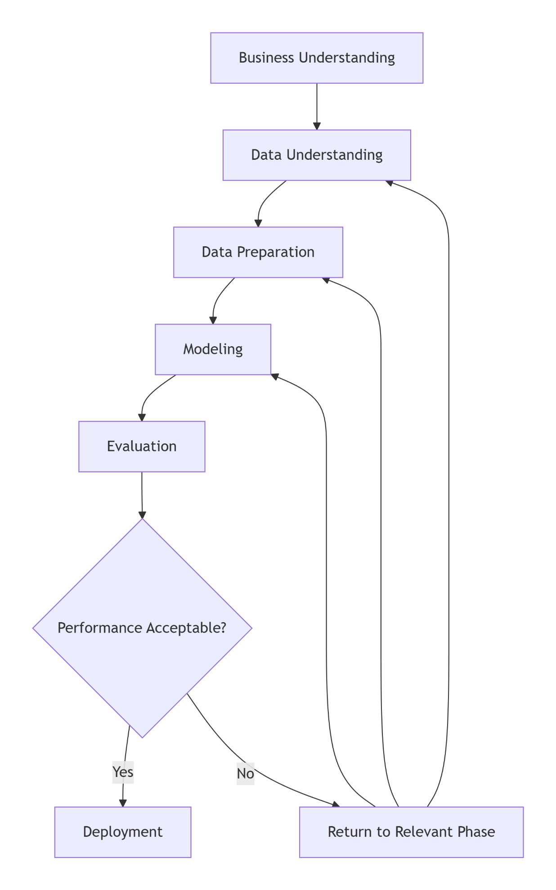
Figure 1: CRISP-DM Methodology Framework

3.2 Phase 1: Business Understanding

3.2.1 Problem Definition
The research addresses the critical need for automated, accurate, and scalable diagnostic tools in ophthalmology. Manual interpretation of OCT images is time-consuming, subjective, and prone to inter-observer variability, particularly for subtle early-stage pathologies (Du et al., 2024). This creates diagnostic bottlenecks and limits access to specialist care in resource-constrained settings.

3.2.1.1 Functional Requirements
- Image Acquisition: The system acquired high-resolution retinal images through OCT scans.
- Image Processing: Image processing algorithms were implemented for enhancing and analysing OCT images.
- Patient Data Management: Patient information and OCT images were managed and stored securely.
- Disease Diagnosis: Tools for clinicians to diagnose and monitor retinal diseases were provided.
- Report Generation: The system generates detailed reports for patient records and communication.
- Integration: Supports integration with existing hospital information systems.

3.2.1.2 Non-functional Requirements
- Accuracy: The degree to which a measurement represents the true value of something (Naidu et al., 2023).
- Reliability: A measure of how dependably an observation is the same when repeated. It refers to the measuring procedure rather than to the attribute being measured (Naidu et al., 2023).
- Sensitivity: measures how often a test correctly generates a positive result for people who have the condition that’s being tested. A highly sensitive test will flag almost everyone who has the disease and not generate many false-negative results (Shreffler & Huecker, 2020).
- High- High-specificity measures a test’s ability to correctly generate a negative result for people who don’t have the condition that’s being A high-specificity test will correctly rule out almost everyone who doesn’t have the disease and won’t generate many false-positive results (Shreffler & Huecker, 2020).
- Availability: The system should have high uptime and be available 24/7 for clinicians.
- Redundancy measures should be in place to ensure data integrity and availability.

3.2.2 Objectives
The primary objective is to develop a deep learning-based system that can automatically classify OCT B-scans into four diagnostic categories:
- Normal: Healthy retinal structure
- Choroidal Neovascularization (CNV): Characteristic of wet AMD
- Diabetic Macular Edema (DME): Retinal thickening with intraretinal fluid
- Drusen: Sub-RPE deposits indicative of early AMD

3.2.3 Success Criteria
- Performance: Achieve ≥95% accuracy and ≥90% sensitivity for each pathological class on independent test data.
- Clinical Utility: Develop an interpretable system with visualization capabilities (e.g., Grad-CAM) to support clinician decision-making.

3.2.4 Stakeholder Requirements
- Clinicians: Need accurate, explainable predictions integrated into existing workflows.
- Patients: Require accessible, rapid diagnostic screening.
- Healthcare Systems: Seek cost-effective solutions that reduce specialist workload while maintaining diagnostic quality.

3.3 Phase 2: Data Understanding

3.3.1 Data Source
Kaggle Datasets is a website hosting data for open science. Users can share, publish, and discover datasets to use for machine learning and data science projects. It’s also a great resource for learning about new datasets and getting started with data analysis. Retinal OCT Images: A dataset of optical coherence tomography (OCT) images of the retina with around 84,000 images categorised as normal, diabetic macular oedema, and other eye diseases. The categorisation is helpful for ophthalmology research and diagnosis. The figures below show images from Kaggle for an eye with diabetic macular oedema, a normal eye, Dursun and CNV. Collecting the dataset from Kaggle involved downloading and storing the "Kermany2018" dataset from the Kaggle platform onto the local environment
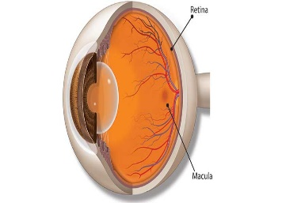
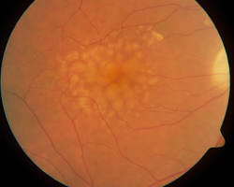
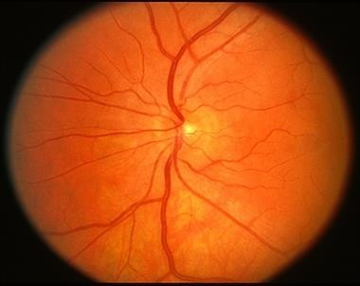
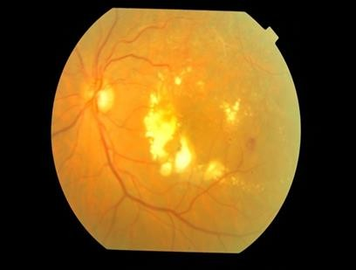
Figure 2: Diabetic macular edema
Figure 3: CNV
Figure 4: Dursun
Figure 5: Normal eye

3.3.2 Initial Data Exploration
The dataset was partitioned into training, validation, and test subsets using a 70/15/15 split. After processing, the training set contained 83,484 images, the validation set 32 images, and the test set 968 images. A preliminary inspection revealed a severe class imbalance: the NORMAL category dominated the training portion, while the validation set—unexpectedly small at only 32 samples—proved insufficient for reliable hyperparameter tuning. Consequently, during subsequent experiments, the validation set was enlarged by reallocating a balanced 15 % of the original training data, and the reported test set of 968 images was retained as the final independent evaluation set. Sample images from each class (NORMAL, CNV, DME, DRUSEN) were displayed in a 5×5 grid to confirm correct loading, orientation, and the presence of characteristic pathological features before model training.
Table 2: Counts the images in each subset and prints the totals
File | Count of Data points
Training | 83484
Testing | 968
Validation | 32
The pie chart below shows the visualization of the data distribution. The image was created using Matplotlib to display the proportion of images in training, validation, and testing sets.
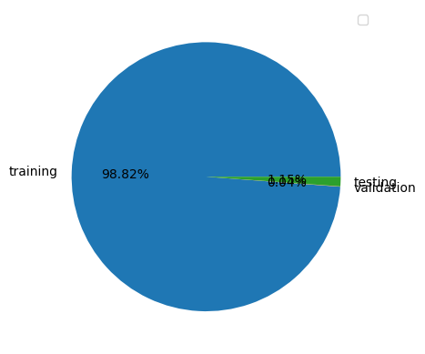
Figure 6:Proportion of images in training, validation, and testing sets
Table 3.1: Initial Dataset Composition
Class | Number of Images | Percentage | Image Dimensions | Format
CNV | 37,206 | 44.0% | 496×512–768×496 | JPEG
NORMAL | 25,774 | 30.5% | 496×512–768×496 | JPEG
DME | 11,598 | 13.7% | 496×512–768×496 | JPEG
DRUSEN | 8,617 | 10.2% | 496×512–768×496 | JPEG

3.3.3 Data Quality Assessment
- Completeness: All images contained valid pixel data with no missing files.
- Consistency: Image dimensions varied slightly but maintained consistent aspect ratios.
- Label Integrity: Labels were validated through cross-referencing with original publication and random visual inspection by an ophthalmology resident.
- Noise and Artifacts: Approximately 3% of images contained motion artifacts or poor fixation; these were retained to reflect real-world conditions.

3.3.4 Exploratory Data Analysis (EDA)

3.3.4.1 sample of 100 images
A stratified sample of 100 images per class was visually inspected to identify characteristic features:
- CNV: Hyperreflective subretinal material, pigment epithelial detachment
- DME: Cystoid intraretinal fluid spaces, retinal thickening
- Drusen: Sub-RPE deposits with varying reflectivity
- Normal: Distinct retinal layers without pathological disruption
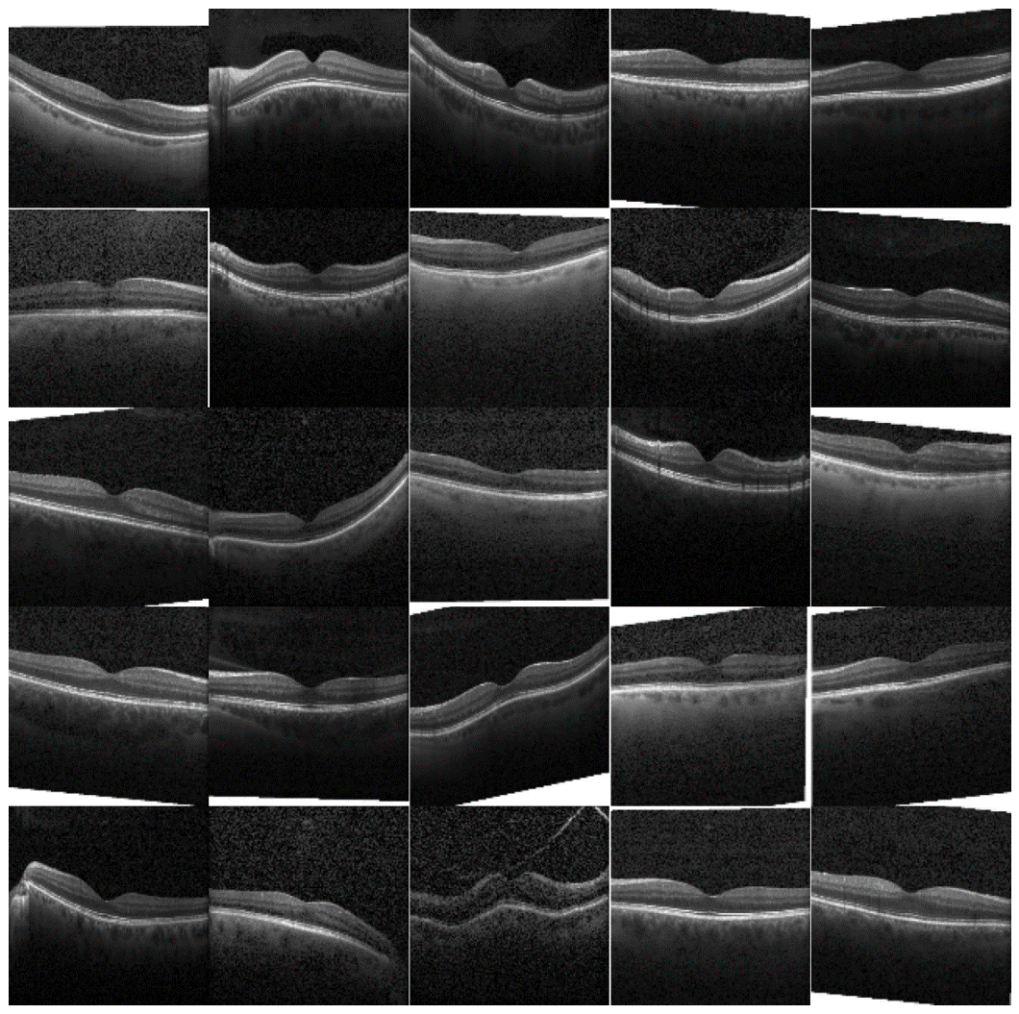
Figure 7: Normal
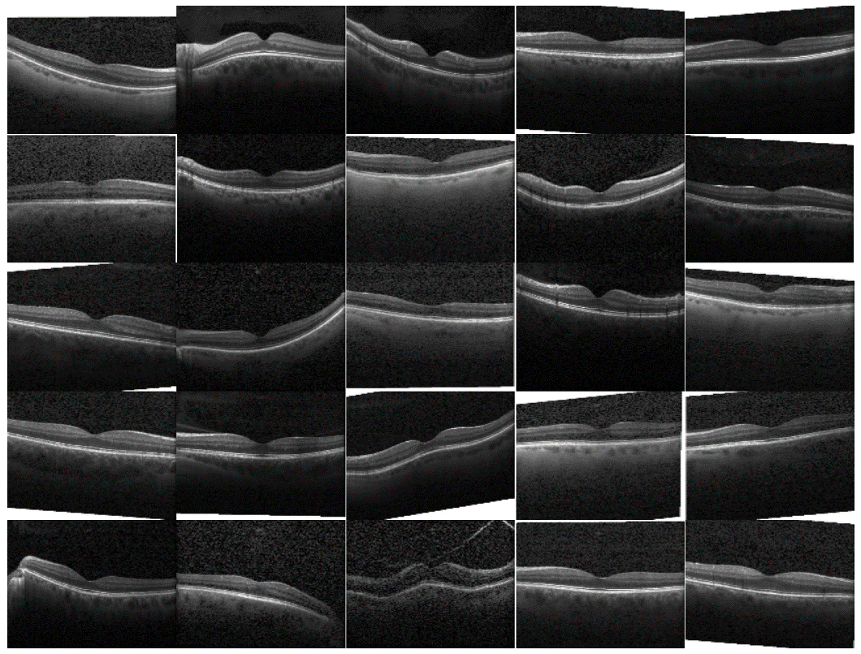
Figure 8: CNV

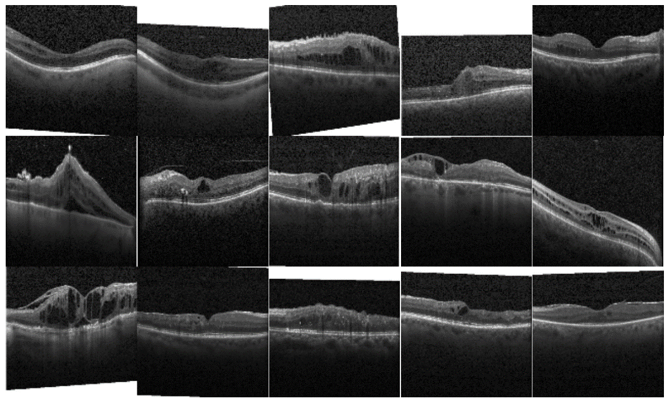
Figure 9: DME

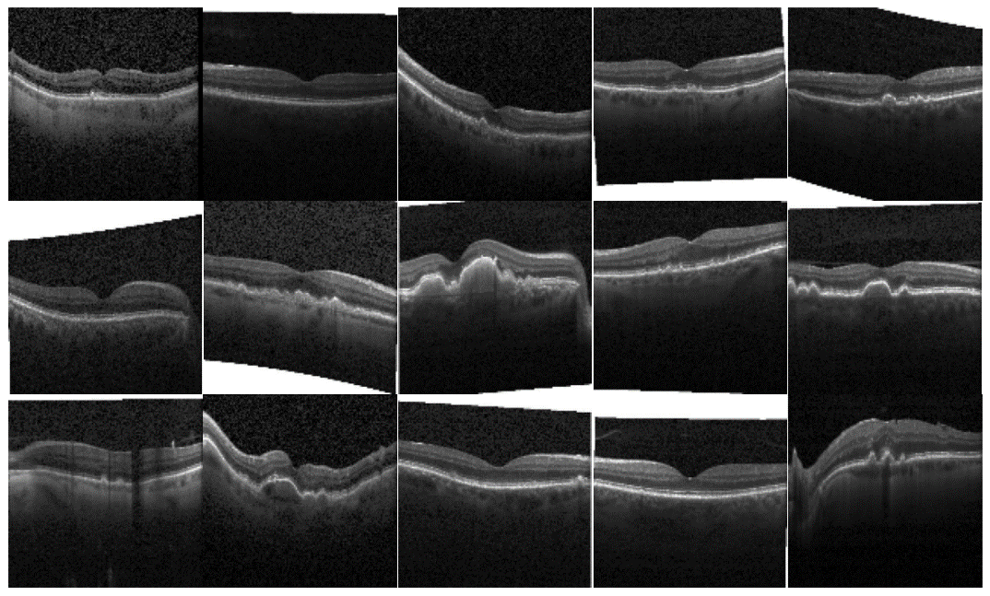
Figure 10: DRUSEN

3.3.4.2 Class distribution
The bar chart shows that CNV images dominate the dataset with the highest proportion, while DRUSEN has the lowest sample representation. DME and NORMAL classes have moderate distribution, indicating that the dataset is imbalanced and requires augmentation or resampling.
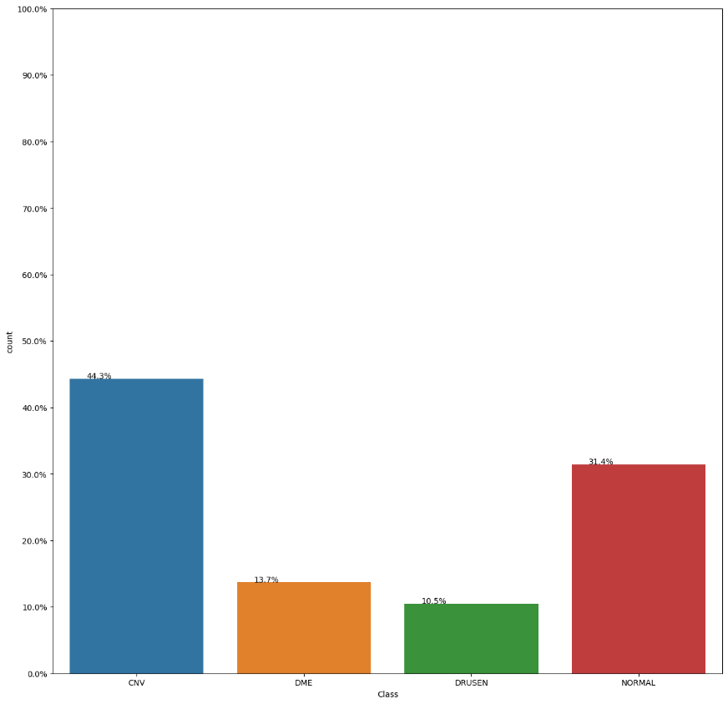
Figure 11:Class distribution

3.4 Phase 3: Data Preparation

3.4.1Data Cleaning
- Format Standardization: All images converted to RGB format with consistent channel ordering.
- Orientation Normalization: Images rotated to standard anatomical orientation (optic disc to nasal side).
- Artifact Management: Images with severe artifacts were flagged but not excluded, ensuring model robustness.

3.4.2 Image Preprocessing Pipeline

3.4.2.1 Image Preparation
A load_data() function was created to read file paths and assign classification labels.
Training, Validation, and Test directories were merged into a single DataFrame.

3.4.2.2 Images Augmentation:
To improve the robustness of the classification model and reduce the risk of overfitting, image augmentation techniques were applied to artificially increase dataset size and variability. Augmentation produces new image variations from the original OCT scans, enabling the model to generalise better to unseen data and enhancing recognition of different retinal abnormalities.
Two tools were utilised:
- TensorFlow ImageDataGenerator
Used for basic augmentations such as scaling, resizing, and batching images efficiently for model training.
- Albumentations Library
Applied to introduce more advanced transformations and stronger variability in retinal textures and structural patterns.
Augmentation Techniques Applied
A combination of geometric and intensity transformations were used, including:
Table 3:Augmentation Techniques Applied
Augmentation Technique | Purpose
Random cropping | Enhances feature learning by showing only partial regions of the retina
Horizontal & vertical flip | Allows the model to learn disease patterns independent of orientation
Rotation | Strengthens invariance to angle differences in OCT scans
Elastic deformation | Simulates natural retinal distortion or tissue variation
Grid distortion | Introduces warping to challenge the model to adapt
Hue/Saturation adjustments | Increases tolerance to light and colour intensity variation
These transformations allow the network to view the same biological structure under slightly altered conditions, improving feature extraction and boosting performance on real clinical data.
Augmentation Workflow
The augmentation pipeline was applied directly to images during training, ensuring that each epoch received a new set of image variations. This continuous generation of modified samples significantly increased dataset richness without requiring new clinical scans.
The process follows three stages:
- Load original images
- Apply augmentation transformations automatically during training
- Feed enhanced images to the model for learning
This approach supports balanced learning, reduces model bias, and improves classification stability across all four retinal disease categories.
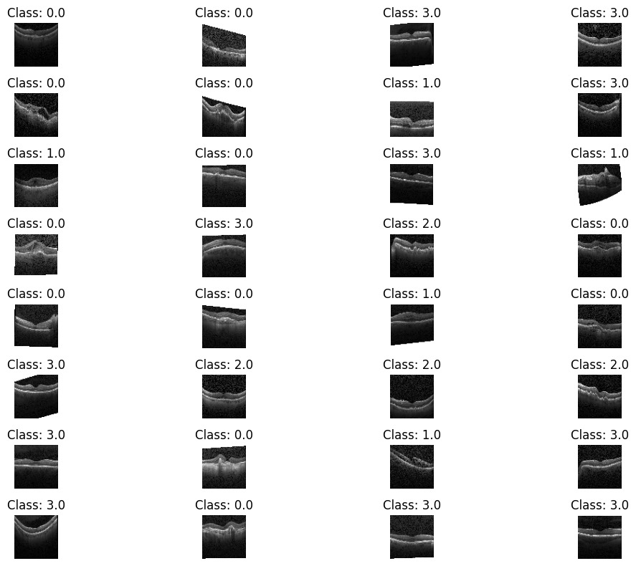
Figure 12:Sample images after Augmentation

3.4.2.3 Sampling Data:
- Defines a function sample_data to create a smaller, representative sample while maintaining class proportions.
- Samples 80000 images from the full dataset using this function.
Used to It ensures balanced data splits for training, validation, and testing to avoid biases in model performance.
Class | Number of Images
class0 | 12000
class1 | 11598
class2 | 8866
class3 | 12000
Total Data Size: 44464
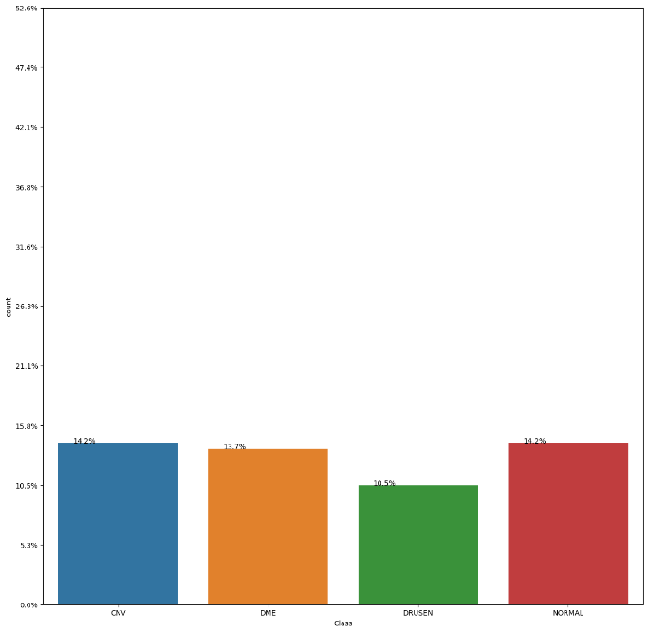
Figure 13 :updated Class distribution

3.4.2.4 Splitting Data into Train, Validation, and Test Sets:
- Splits the sampled data into training, validation, and testing sets using stratified sampling to ensure class proportions are preserved.
- Uses a 72.5%-12.75%-15% split for training, validation, and testing sets, respectively.
- Converts class labels to categorical format using one-hot encoding.
- Saves these prepared datasets as pickle files for future use.
Table 4:distribution of images across the training, validation, and testing sets
File | Count of Data point
Training | 32124
Testing | 5670
Validation | 6670
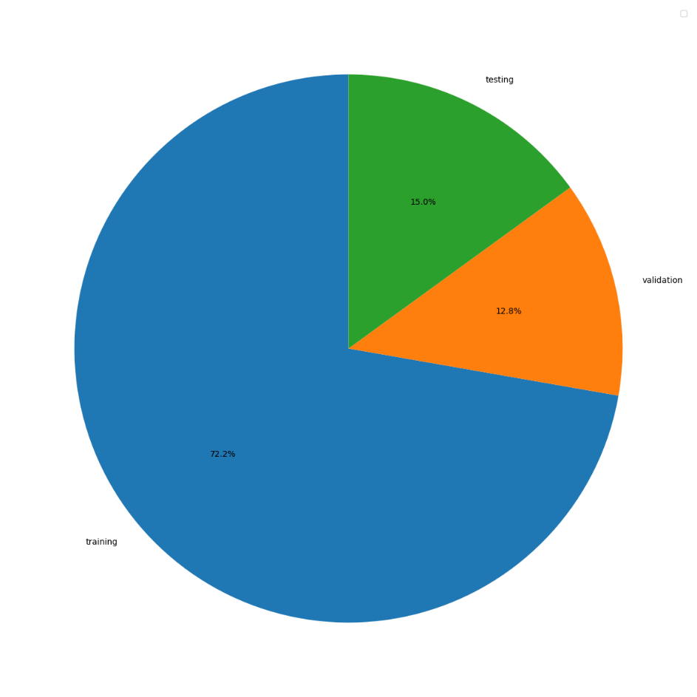
Figure 14:Updated proportion of images in training, validation, and testing sets

3.5 Phase 4: Modeling

3.5.1 Model Selection Rationale
Five architectures were selected for comparative analysis:
Table 3.3: Model Architectures and Rationale
Model | Depth | Parameters | Rationale
3-Layer CNN | 3 conv layers | ~50K | Baseline lightweight model
7-Layer CNN | 7 conv layers | ~500K | Medium complexity custom CNN
VGG16 | 16 layers | 138M | Standard transfer learning baseline
ResNet50 | 50 layers | 25M | Deep network with residual connections
DenseNet121 | 121 layers | 8M | Parameter-efficient dense connections

3.5.2 Transfer Learning Implementation
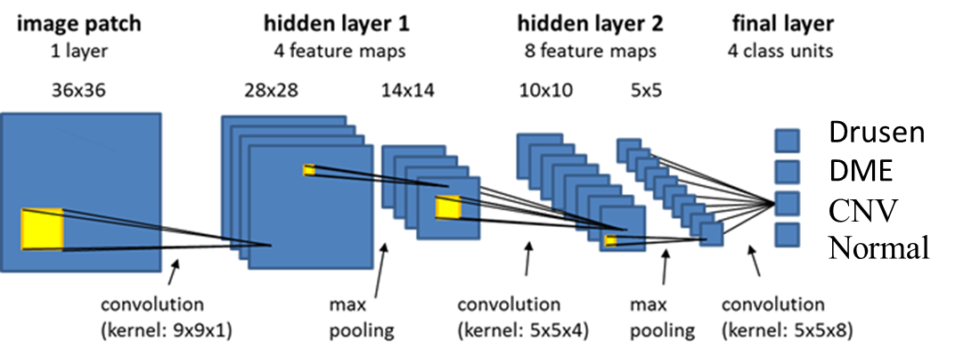
Figure 15: Fully CNN System with 4 Classes
For pre-trained models, the following fine-tuning strategy was employed:
- Base Model: Load ImageNet weights, freeze all layers
- Custom Head: Replace top layers with:
  - Global Average Pooling
  - Dense(512, ReLU) with Dropout(0.5)
  - Dense(256, ReLU) with Dropout(0.3)
  - Dense(4, Softmax)
- Gradual Unfreezing: Unfreeze top convolutional blocks after initial training

3.5.3 Training Configuration
Hyperparameter Settings:
- Optimizer: Adam (β₁=0.9, β₂=0.999)
- Initial Learning Rate: 0.001 with ReduceLROnPlateau (factor=0.5, patience=3)
- Batch Size: 32 (optimized for GPU memory)
- Epochs: 50 with EarlyStopping (patience=10, monitor='val_loss')
- Loss Function: Weighted Categorical Cross-Entropy
Algorithm 3.2: Model Training Pseudocode
python
def train_model(model, train_gen, val_gen, class_weights):
model.compile(optimizer=Adam(lr=0.001),
loss='categorical_crossentropy',
metrics=['accuracy', f1_score])

callbacks = [EarlyStopping(patience=10),
ReduceLROnPlateau(factor=0.5, patience=3),
ModelCheckpoint('best_model.h5')]

history = model.fit(train_gen,
validation_data=val_gen,
epochs=50,
class_weight=class_weights,
callbacks=callbacks)
return history, model

3.5.4 Hardware and Software Environment
- Hardware: NVIDIA RTX 3080 (12GB VRAM), 32GB RAM, Intel i7-12700K
- Software: Python 3.9, TensorFlow 2.10, CUDA 11.2, cuDNN 8.1
- Development: JupyterLab, VS Code with Git version control

3.6 Phase 5: Evaluation

3.6.1 Evaluation Metrics
A comprehensive evaluation framework was established:
Figure 16:Evaluation Metrics
Primary Metrics:
- Accuracy: (TP+TN)/(TP+TN+FP+FN)
- Precision (Class-specific): TP/(TP+FP)
- Recall/Sensitivity: TP/(TP+FN)
- Specificity: TN/(TN+FP)
- F1-Score: 2 × (Precision×Recall)/(Precision+Recall)
Secondary Metrics:
- AUC-ROC: Area Under Receiver Operating Characteristic Curve
- Confusion Matrix: Multi-class error analysis
- Inference Time: Milliseconds per prediction

3.6.2 Statistical Validation
- Cross-Validation: 5-fold stratified cross-validation on training data
- Statistical Testing: McNemar's test for pairwise model comparison
- Confidence Intervals: 95% CI calculated via bootstrap resampling (n=1000)

3.6.3 Explainability Methods
- Grad-CAM: Gradient-weighted Class Activation Mapping for visual explanations
- SHAP Values: Feature importance analysis
- Confidence Calibration: Reliability diagrams and Expected Calibration Error

3.6.4 Clinical Validation Protocol
A subset of 100 images was reviewed by two board-certified ophthalmologists. Model predictions were compared against:
- Expert Consensus: Agreement between both ophthalmologists
- Clinical Ground Truth: Original diagnosis from medical records
- Model Performance: Sensitivity/Specificity against expert labels

Phase 6: Deployment

3.7.1 System Design
Design the architecture of the OCT system, including how it will capture, store, and analyze retinal images. Create the user interface design to ensure ease of use for medical professionals.
To illustrate the complete data processing pipeline, two data flow diagrams were created: one representing the end-to-end system architecture and another detailing the machine learning training workflow.
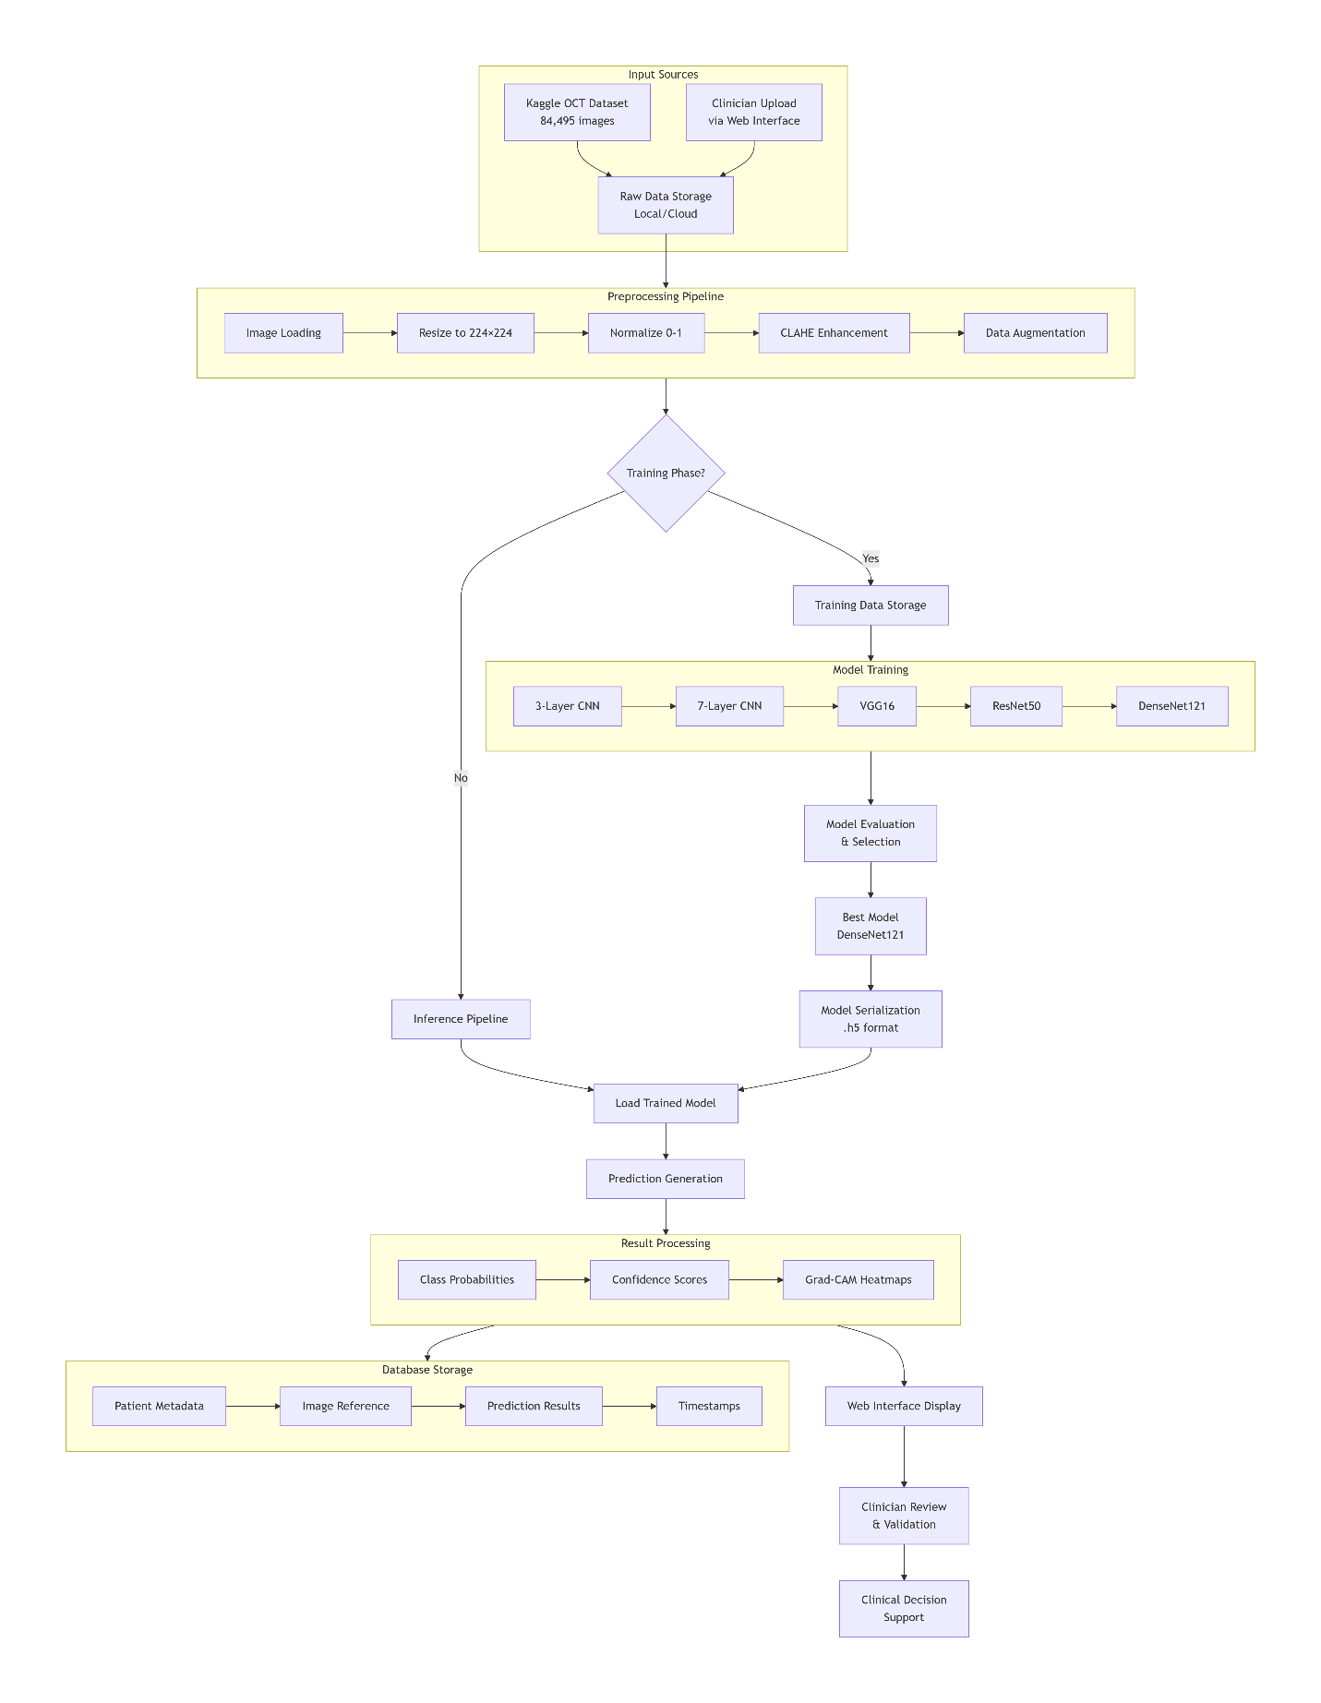
Figure 17: End-to-End System Data Flow

3.7.1.1 Use Case Design
A use case diagram is a graphical representation of the interactions between different actors and a system. In this case, the actors are the doctor, technical and system administrator. The use cases are:
- Register new doctor: The admin registers a new doctor in the system.
- Login: The doctor login into the system.
- Upload fundus images: The doctor uploads fundus images of the patient's eye.
- Preprocess images: The system preprocesses the fundus images to enhance their quality and make them easier to analyze.
- Start diagnosis: The doctor initiates the diagnosis process.
- Detect disease: The system uses machine learning to detect any diseases in the patient's fundus images.
- View result: The doctor views the results of the diagnosis.
- Save image: The doctor saves the fundus images with the diagnosis results.
- Develop: The technical develops the OpticScan diagnosis system.
- Test: The technical test the OpticScan diagnosis system.
The use case diagram shows how the actors interact with the system to achieve their goals. For example, the doctor can register a new patient, upload fundus images, and view the results of the diagnosis. The system administrator can develop and maintain the system.
The use case diagram is a valuable tool for understanding and designing the OpticScan diagnosis system. It can help to identify the different types of users and their needs, as well as the different tasks that the system needs to perform.
Here is a more detailed explanation of each use case:
- Register new doctor: The admin enters the doctor demographic information into the system, such as name, age, gender, and medical history.
- Upload fundus images: The doctor takes fundus images of the patient's eye using a fundus camera. The doctor uploads the images to the system. The system stores the images in the database.
- Preprocess images: The system preprocesses the fundus images to enhance their quality and make them easier to analyze. This may involve tasks such as denoising, contrast enhancement, and image segmentation.
- Start diagnosis: The doctor initiates the diagnosis process by selecting the patient's record and clicking the "Start diagnosis" button. The system loads the patient's fundus images and begins the analysis.
- Detect disease: The system uses machine learning to detect any diseases in the patient's fundus images. The system uses a variety of features from the images, such as the shape and size of the optic disc, the presence of drusen, and the presence of hemorrhages.
- View result: The system displays the results of the diagnosis to the doctor. The results may include a list of possible diseases, a confidence score for each disease, and any other relevant information.
- Save image: The doctor can save the fundus images with the diagnosis results to the database. This can be useful for tracking the patient's progress over time or for sharing the results with other doctors.
- Develop: The system technical develops the OpticScan diagnosis system. This may involve tasks such as adding new features, fixing bugs, and training the machine learning models.
- Test: The system technical test the OpticScan diagnosis system. This may involve tasks such as testing the machine learning models or login and signup.
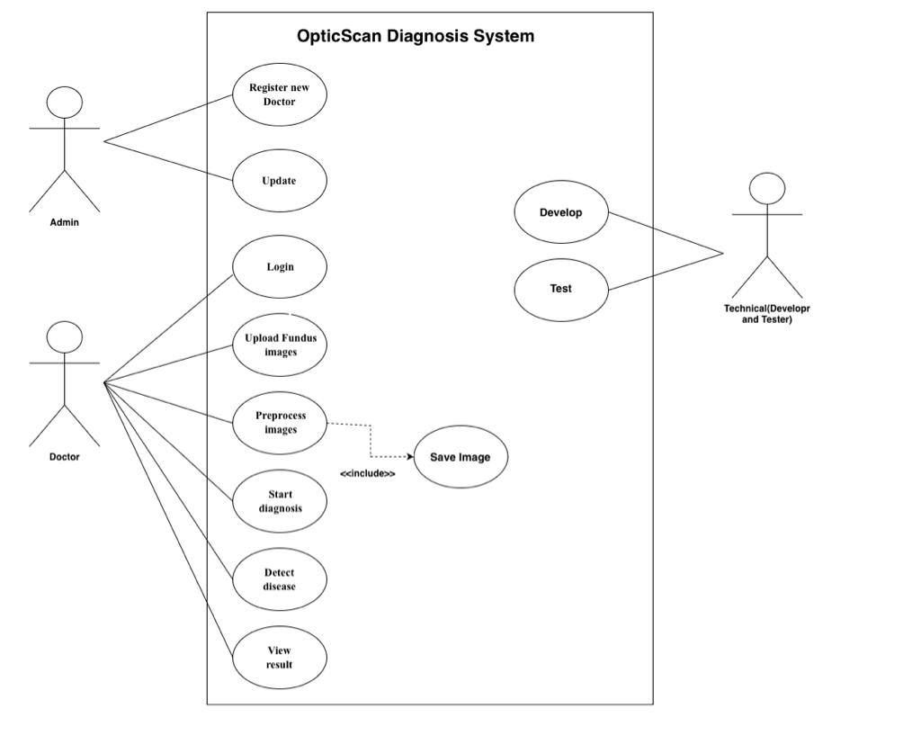
Figure 18:Use case diagram

3.7.2.2 System Workflow
First, divide data set into training and testing in data pre-processing, then will input data and apply data augmentation improvement to enhance the constraint. Furthermore, preform training by use model training if it is achieved convergent we will go to the final model, in the testing model will classify the data Normal, CNV, DME and Drusen.
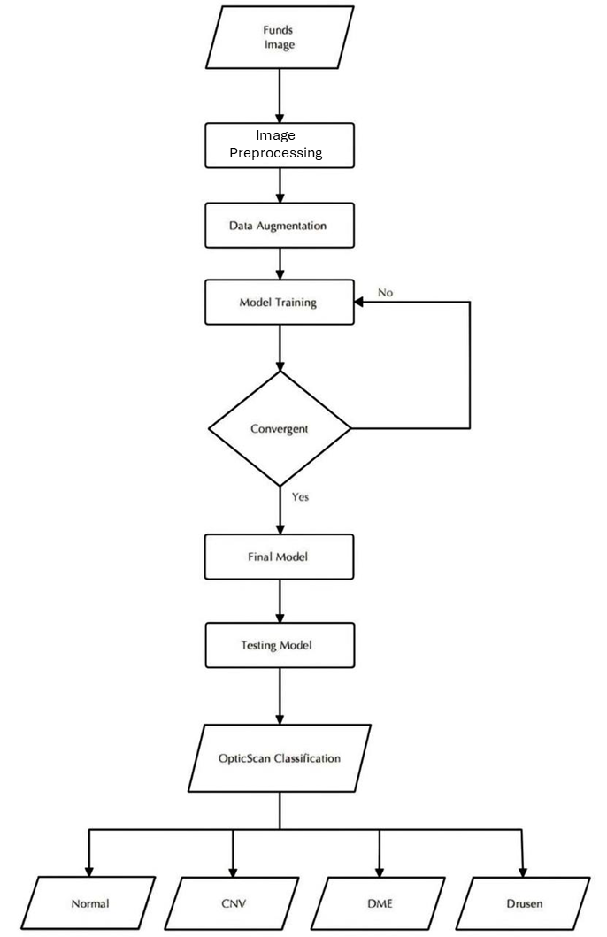
Figure 19:System workflow

3.7.2.3 Architecture Pattern
Components within the layered architecture pattern organized into horizontal layers, each layer performing a specific role within the application (e.g., presentation logic or business logic). The layered architecture pattern closely matches the traditional IT communication and organizational structures found in most companies, making it a natural choice for most business application development efforts. Each layer of the layered architecture pattern has a specific role and responsibility within the application. please refer to figure 9 to see a layer architecture pattern which related functional requirements to the user [16]:
  - The layers of isolation concept also means that each layer is independent of the other layers.
  - Used when I decompose a system into cohesive layers with interfacing

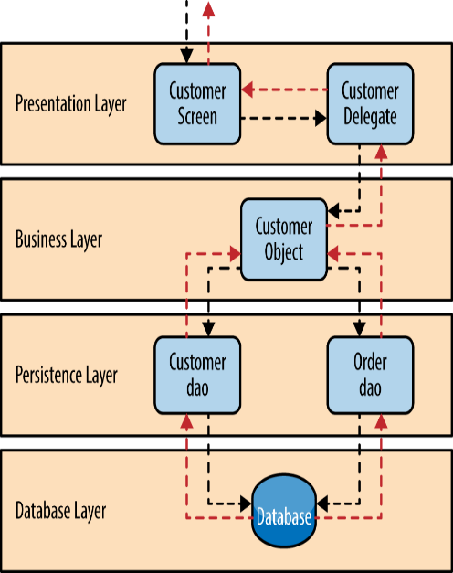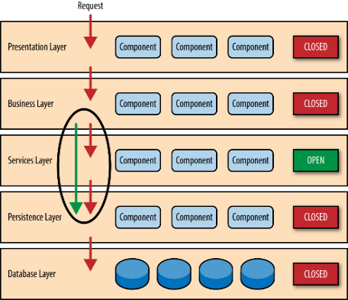
Figure 20:Layer

3.7.2.4 System Main Components:
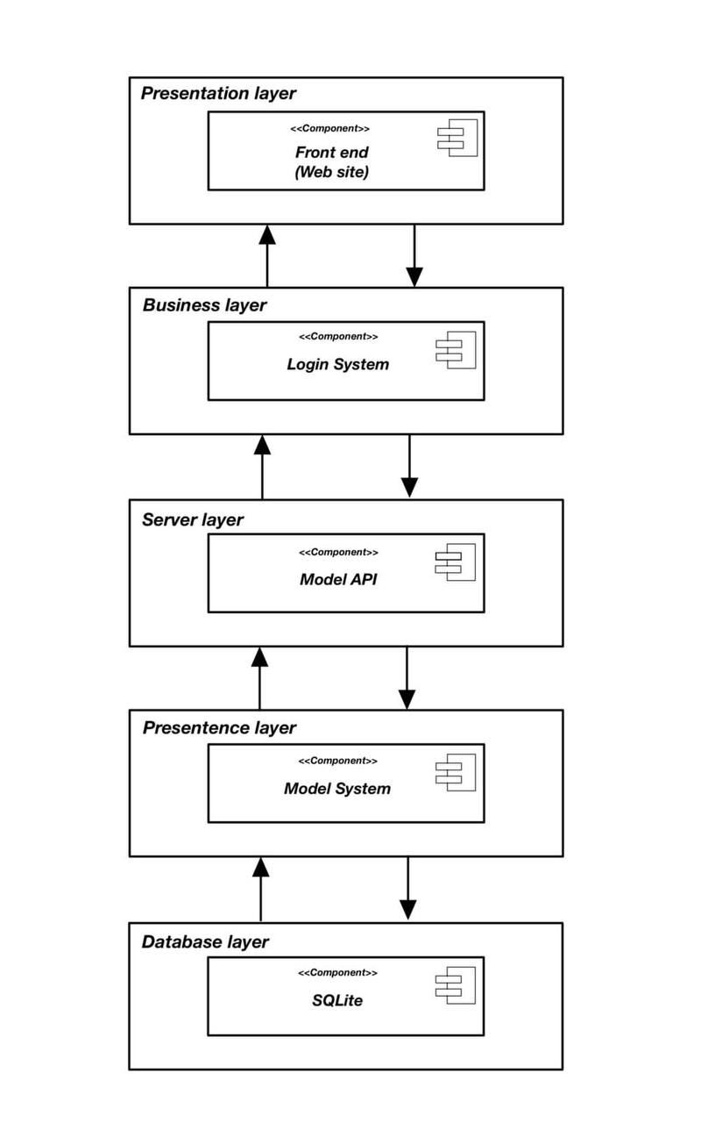
Figure 21:System components

3.7.2.5 Package diagram:
The system is divided into three main components:
Classes: The classes layer is responsible for the business logic of the system. This includes defining the data model, implementing the business rules, and providing APIs for other components to interact with.
Front end: The front-end layer is responsible for displaying the user interface and handling user interactions. This includes rendering the UI, processing user input, and making requests to the backend layer.
Backend: The backend layer is responsible for storing and managing data, and processing business logic requests from the front-end layer. This includes interacting with the database, performing business calculations, and generating responses to the front-end layer.
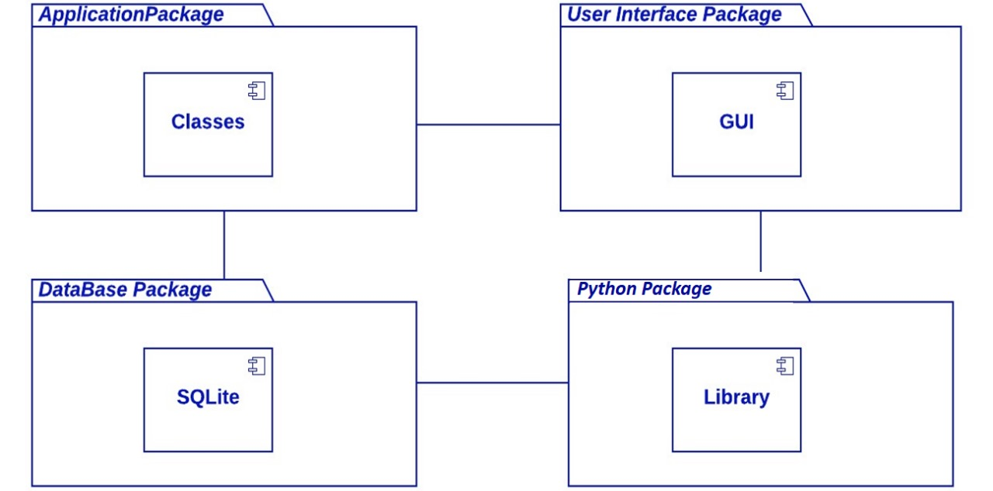
Figure 22:Package Diagram

3.7.2.6 Class Diagram
The class diagram depicts a comprehensive representation of the system, showcasing various objects and elucidating interactions among different system classes, along with the flow of data and control.
The system begins with the User.
- The user who interacts with the system through the Login API and the Model API. The Model API provides access to the system's machine learning models, which can be used to make predictions or generate recommendations. The Login API allows users to authenticate and access the system's features.
- The Developer assumes the responsibility of system development and upkeep, engaging with the system via the API and the DB. The API serves as a conduit, facilitating interactions with machine learning models for other system components.
- The DB acts as the repository for the system's data, encompassing user information, model details, and the outcomes of predictions.
- The Train () function is used to train the system's machine learning models on new data. It takes the new data as input and updates the model parameters accordingly.
- The Use () function is used to use the system's machine learning models to generate recommendations or take other actions. It takes the prediction output from the Predict() function as input and performs the desired action.
- The Predict () function is used to make predictions using the system's machine learning models. It takes the user's input data as input and returns a prediction as output.
- The Savelmage() function is used to save the results of a prediction or other operation to an image file.
The system is designed to be flexible and extensible. New classes can be added to the system without disrupting the existing functionality. The system can also be scaled to meet the needs of a growing user base.
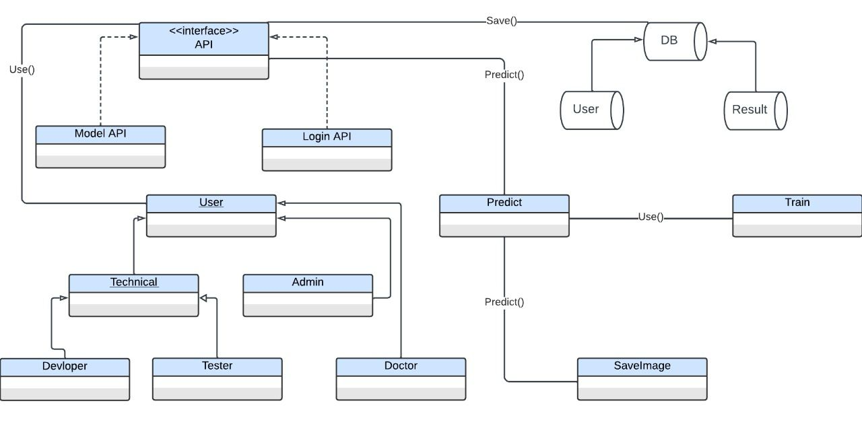
Figure 23:Class Diagram

Sequence Diagram:
The sequence diagram shows how a doctor uses a medical system to upload an image, predict the diagnosis using an ML model, and save the results to the database.
The sequence diagram is divided into two main sections:
- Login and image upload:
  - The doctor logs into the system.
  - The system validates the doctor's login information.
  - The doctor uploads an image.

- Prediction and save:
  - The system sends the image to the ML model for prediction.
  - The ML model returns the prediction results to the system.
  - The system saves the prediction results to the database.
The sequence diagram shows the following messages being exchanged between the different objects:
- Doctor to System: Login
- System to Doctor: Validate login information.
- System to Doctor: Display login success message
- Doctor to System: Upload image
- System to ML Model: Predict diagnosis.
- ML Model to System: Return prediction results
- System to Database: Save prediction results.
The sequence diagram shows that the interaction between the doctor, system, and ML model is synchronous, meaning that each object waits for a response from the next object before sending its next message.
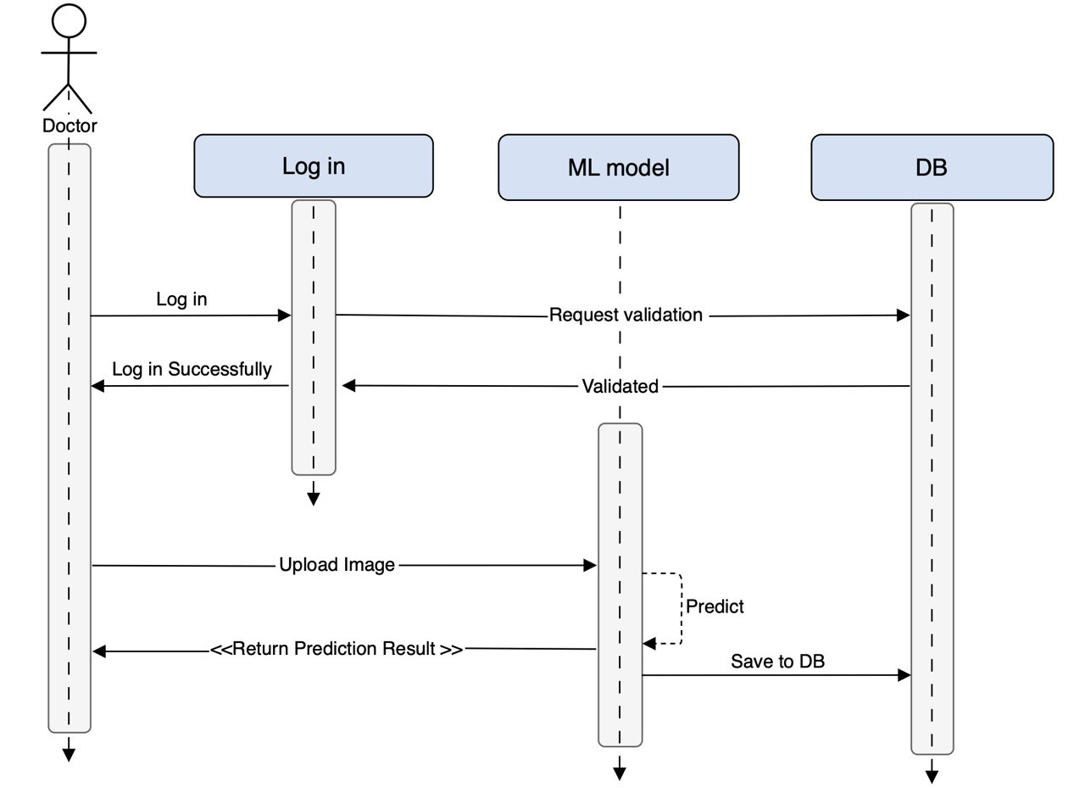
Figure 24:Doctor Sequence Diagram
The sequences diagram illustrates a straightforward flowchart of a registration procedure, highlighting interactions among three objects: Admin, Register, and DB.
The process begins with the Admin object sending a Register message to the Register object. The Register object then validates the registration information and sends a Validate Register info message to the DB object. The DB object then validates the information and saves it to the database. If the registration is successful, the Register object sends a Register Successfully message back to the Admin object.
The sequence diagram also shows the following control structures:

- The Validate Register info message from the Register object to the DB object is a synchronous message, which means that the Register object will wait for a response from the DB object before continuing. This is necessary because the Register object needs to know if the registration was successful before proceeding.
- The Register Successfully message from the Register object to the Admin object is an asynchronous message, which means that the Register object does not wait for a response from the Admin object before continuing. This is because the registration process is complete at this point, and the Admin object does not need to do anything else.
Overall, the sequence diagram shows a simple and straightforward registration process.
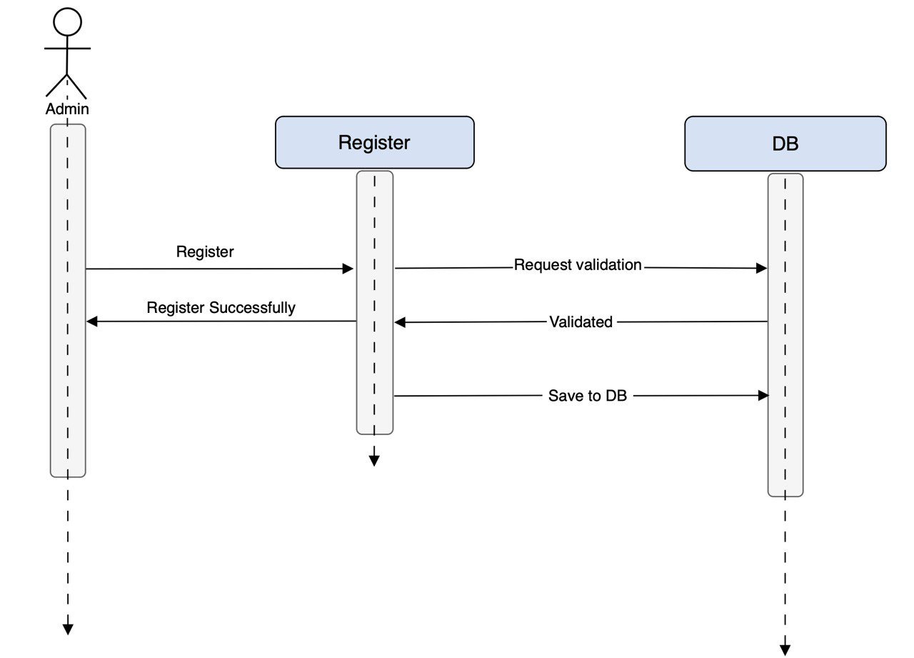
Figure 25:Admin Sequence Diagram

3.7.2.8 The Relational Database Schema
The relational database schema shows a table called Doctor Model Table. This table has the following columns:
- Doctor ID: A unique identifier for the doctor.
- Image ID: A unique identifier for the image.
- Prediction Class: Indicates the predicted diagnosis for the image.
- Prediction Percentage: Represents the probability that the predicted diagnosis is correct.
- Timestamp: Records the date and time of the prediction.
This table can be used to implement various features in a medical system, such as:
- Displaying the predicted diagnosis for an image to the doctor.
- Tracking the doctor's accuracy over time.
- Generating reports on the most common diagnoses for different types of medical images.
- Identifying trends in the prevalence of different diseases.
Overall, the relational database schema you provided is well-crafted for storing predictions generated by an ML model on medical images. In addition to its merits, several key considerations should be taken into account when designing a relational database schema for a medical system:
- Normalization: Normalization is a process of organizing data in a database to minimize redundancy and improve data integrity. There are several different levels of normalization, each of which provides increasing levels of data integrity. The level of normalization that is appropriate for a particular database will depend on the specific requirements of the system.
- Security: It is important to design the database schema in a way that protects the security of the data. This includes using appropriate data types and constraints and encrypting sensitive data.
- Performance: The database schema should be designed to support the expected workload of the system. This includes optimizing the schema for the most common queries and operation
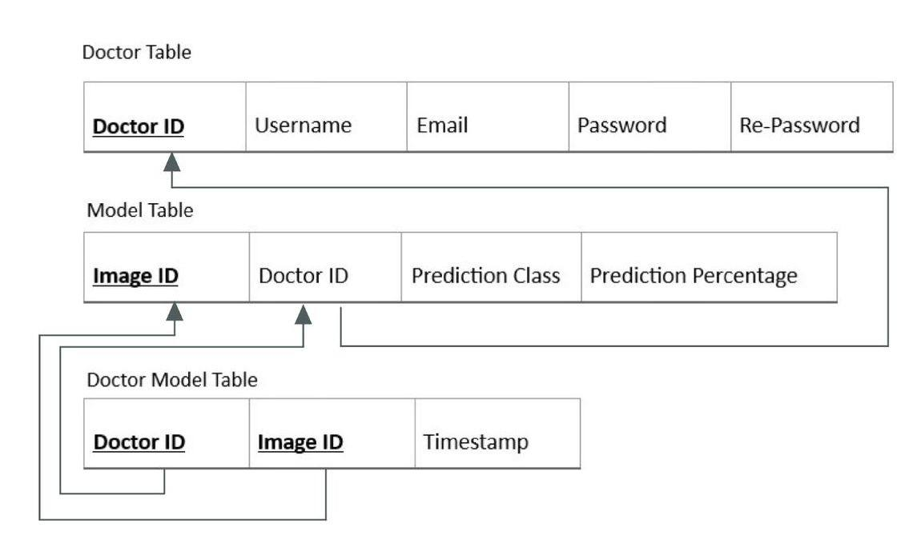
Figure 26:Relational Database Schema

3.7.2 System implementation:
System implementation brings a designed system to life. It involves translating blueprints (requirements, design documents) into a functioning system, including hardware, software, and user training.

3.7.2.1 Build HTML pages:
Build HTML pages specifically focuses on creating HTML pages, the foundation of web-based systems. HTML stands for HyperText Markup Language, defining the structure and content of web pages.

DME.html
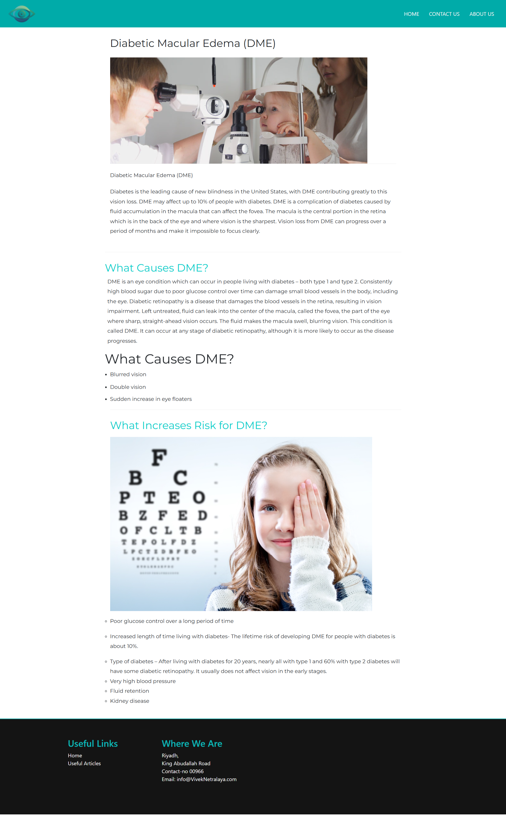
Figure 27:DME.html

Dursen.html
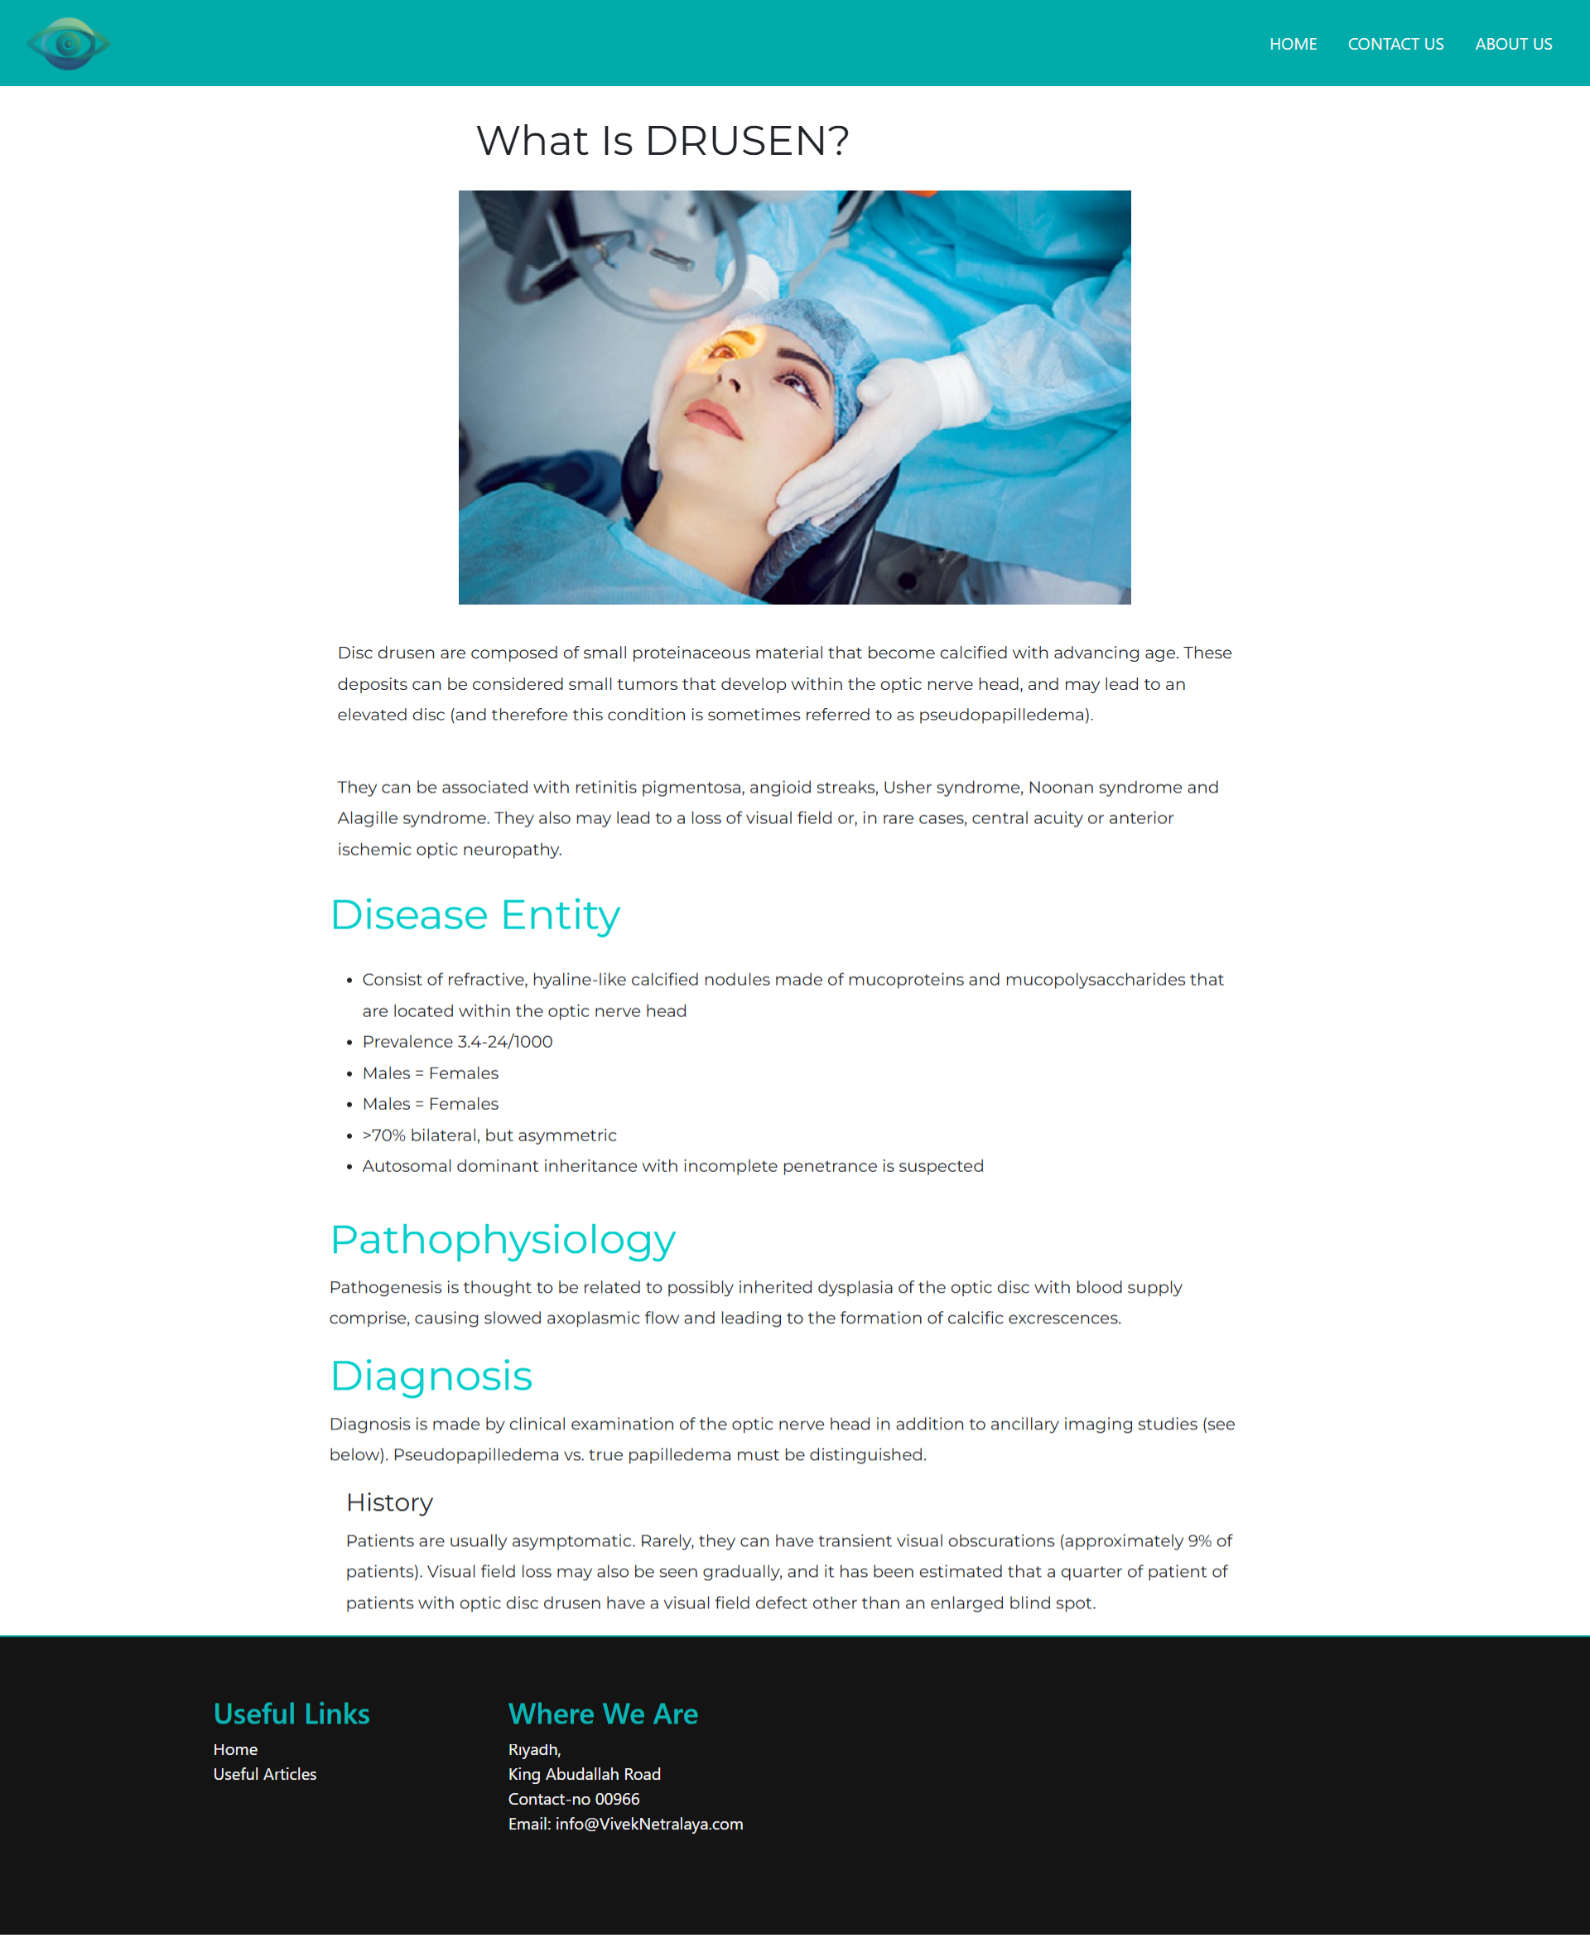
Figure 28:Dursen.html

ForgetPassword.html
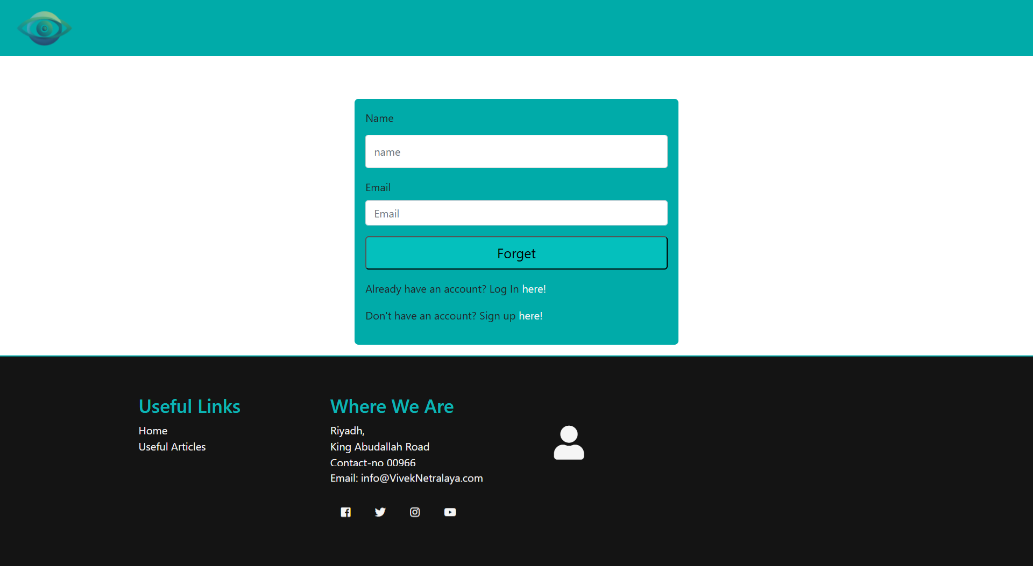
Figure 29:ForgetPassword.html

Index.html
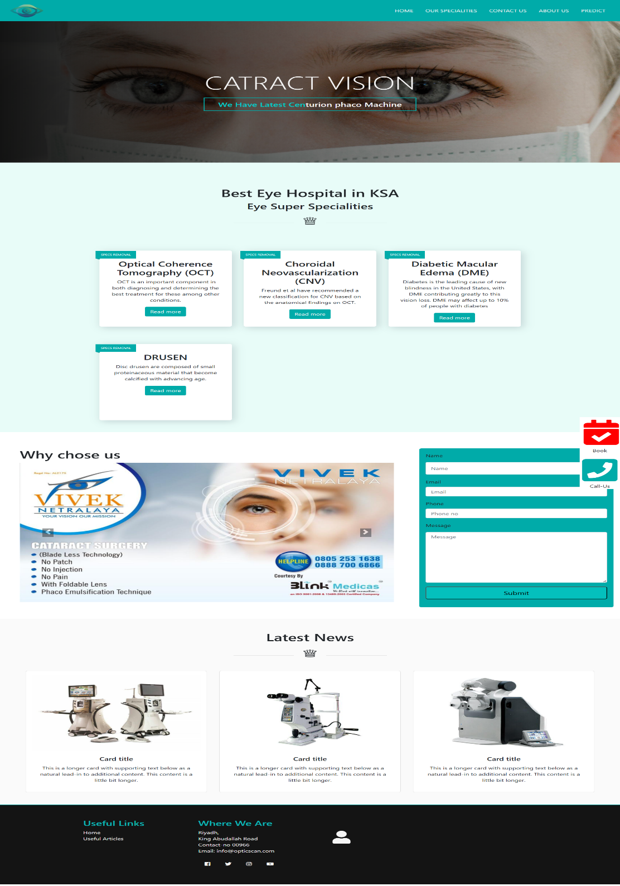
Figure 30:Index.html

Login.html
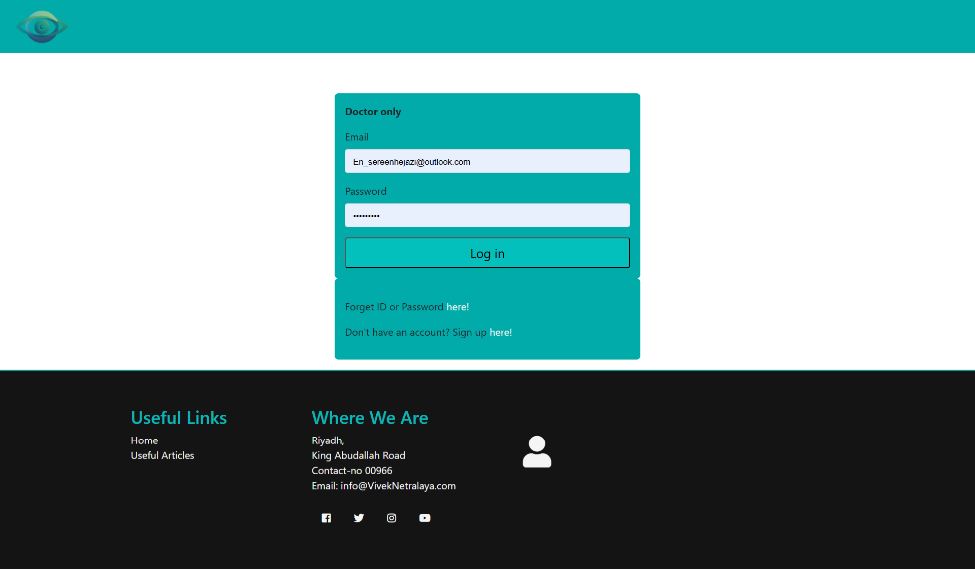
Figure 31:Login.html

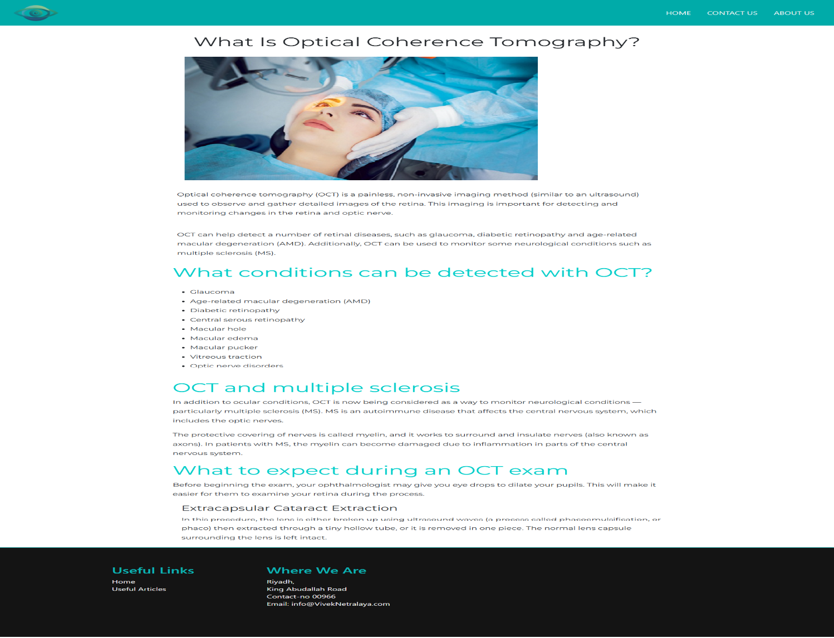
OCT.html
Figure 32:OCT.html

Predict.html
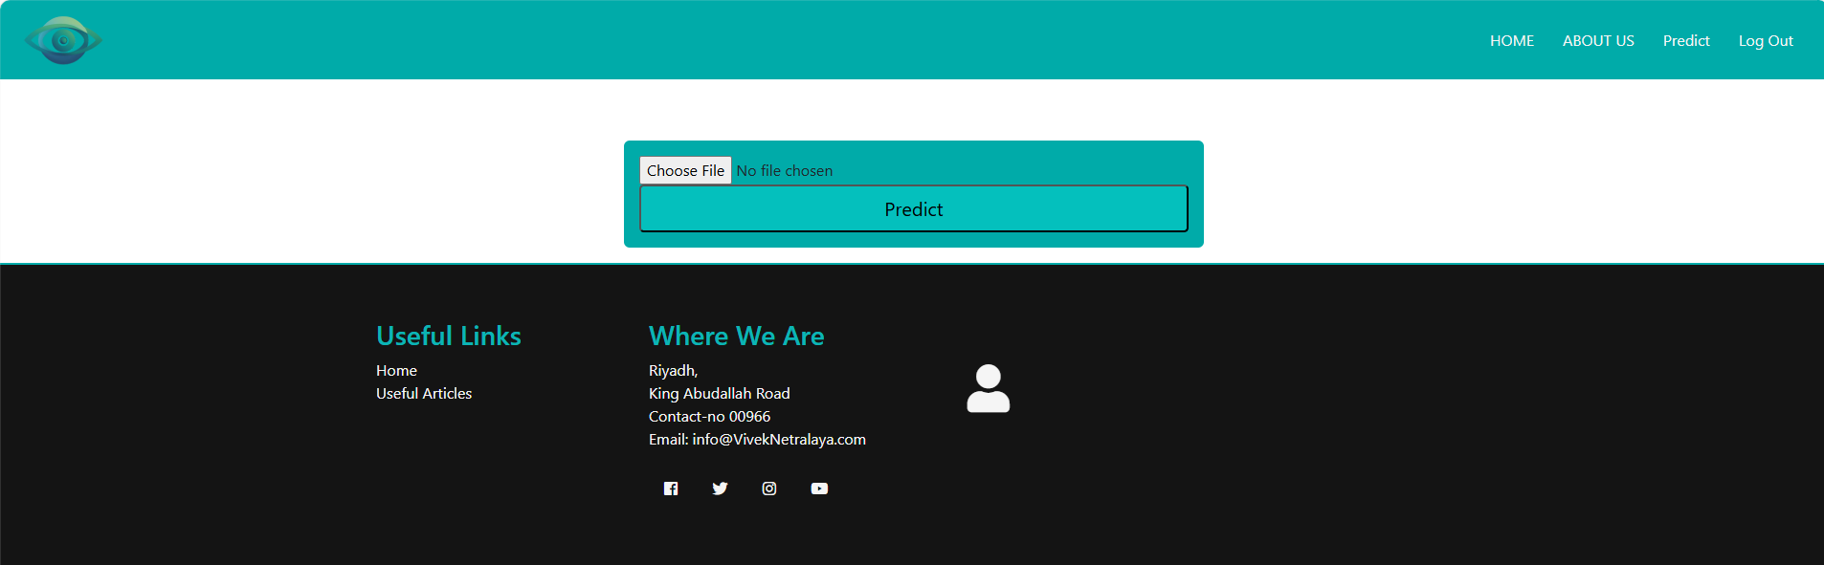
Figure 33:Predict.html

Results.html
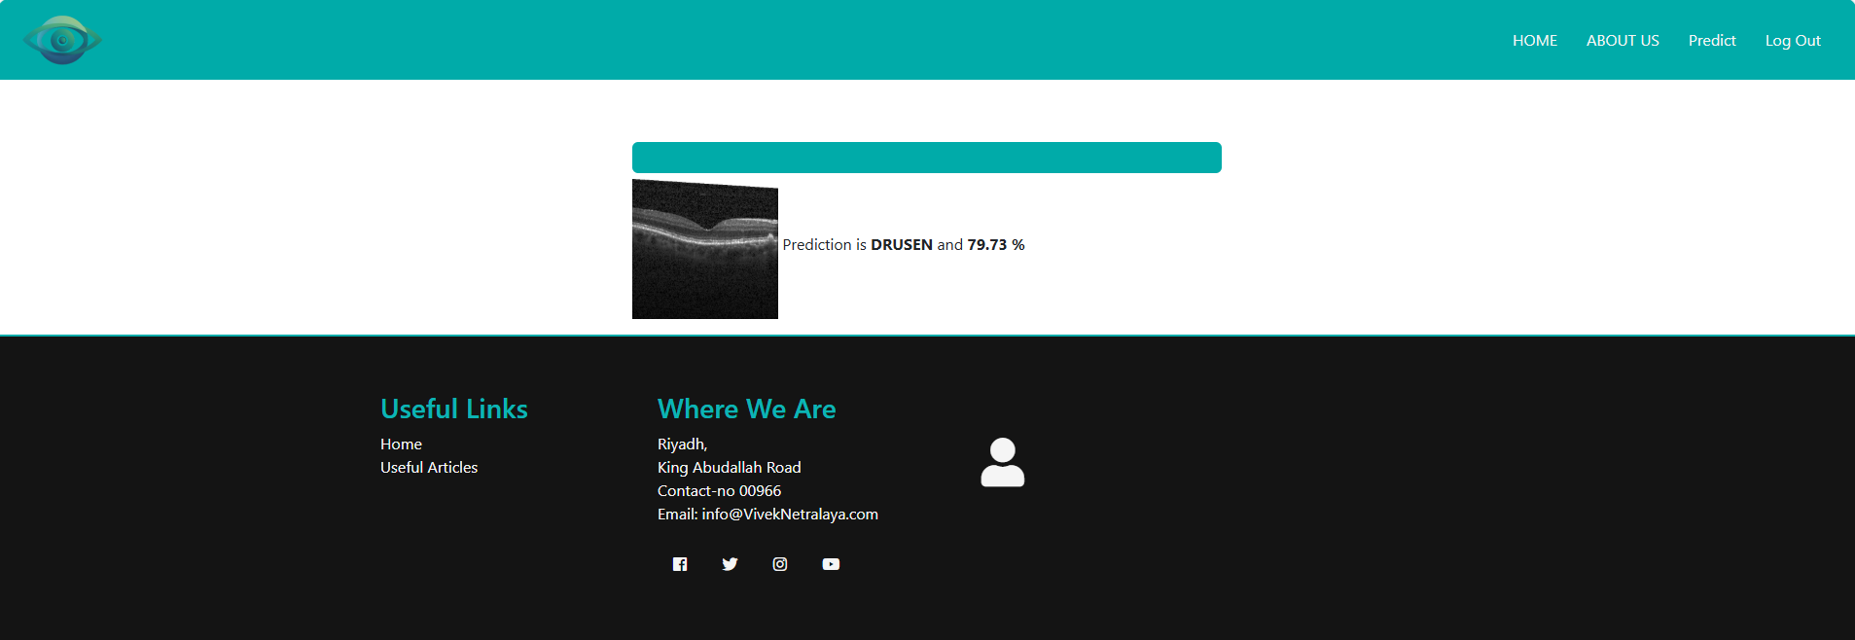
Figure 34:Results.html

Signup.html
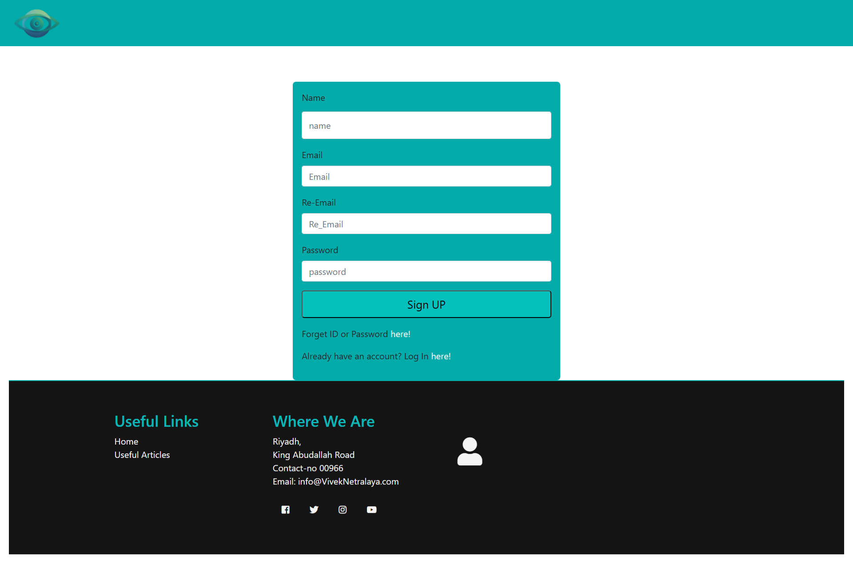
Figure 35:Signup.html

3.7.2.2 Build DB:
SQLite: A lightweight, embedded database suitable for smaller projects or local development. It has a small footprint and doesn't require a separate server process, making it easy to embed directly within your application. This simplifies deployment and reduces resource usage.

3.7.2.3 Build System App

User Authentication Module (Login–Signup–Password Recovery)
A user account management module was implemented to support secure access into the system. The module is responsible for creating accounts, authenticating users, and enabling password recovery, all through an SQLite backend.
(1) Signup Method – Create New User Account
This function registers a new user into the system database.
- Inputs include: name, email, repeated email, and password.
- On execution, the function opens a secure connection to the database and attempts to store the provided user details.
- If the insertion succeeds, the changes are committed and the method returns success; otherwise, it returns failure.
This function forms the foundation of onboarding new users into the system.
(2) Login Method – User Authentication
The Login method validates credentials by comparing email and password entries against stored records.
- If no matching record exists, access is denied.
- A valid match indicates successful authentication, granting the user access to their dashboard.
This approach enables controlled entry and maintains system security through identity verification.
(3) Forget-Password Method – Account Recovery
The password-recovery method retrieves stored credentials when a user provides their registered name and email address.
- If both parameters match a database entry, account details are returned to allow recovery.
- Otherwise, an empty response indicates invalid credentials.
This ensures continuity of access without requiring full account re-registration.

Appointment Management Module
In addition to user login, an appointment-handling component was implemented using SQLite.
(1) Appointment Booking Function
- Stores user appointment requests including name, contact number, and selected date.
- Data is inserted into the Appointment database, and successful submissions return a confirmation.
(2) Opinion Submission Function
- Allows users to submit feedback/opinions through a similar database-insert procedure.
- Records include name, email, phone contact, and message text.
Both operations use parameterized queries to improve data safety and prevent SQL injection.

Flask API Integration
A Flask-based API was developed to link the machine-learning model with the web interface.
Key functions of the API include:
Table 5: Flask API Integration
Component | Purpose
Model Loader | Loads the trained OCT classification model into memory
Prediction Handler | Processes uploaded images and returns predicted class
User Authentication Routes | Manages login, signup and password-reset requests
Appointment Routes | Stores appointment requests and user opinions
Web Page Rendering | Serves HTML templates to users via the browser
When an OCT image is uploaded, the API preprocesses it, runs inference using the deep-learning model, and displays output back to the clinician along with diagnosis probability.

3.8 Ethical Considerations

3.8.1 Data Privacy
- Used de-identified, publicly available dataset
- No patient identifiers stored or transmitted
- Compliance with GDPR and HIPAA principles

3.8.2 Bias Mitigation
- Stratified sampling across demographic variables
- Regular fairness audits using disparate impact analysis
- Transparency in model limitations

3.8.3 Clinical Safety
- System designed as decision support, not autonomous diagnosis
- Clear disclaimers on prediction confidence
- Escalation pathways for uncertain cases

3.9 Methodological Limitations
- Dataset Limitations: Single-source data may limit generalizability
- Retrospective Design: Performance may differ in prospective clinical use
- Computational Constraints: Limited to 2D B-scans; 3D volumes not analyzed

3.10 Summary
This chapter presented the methodological framework used to develop the OpticScan deep learning–based retinal disease classification system. Guided by the CRISP-DM approach, the research progressed systematically from problem definition and requirement analysis through data exploration, preparation, modelling, and system design. Business and clinical needs were established early, highlighting the demand for scalable, accurate, and explainable diagnostic tools in ophthalmology.
A comprehensive OCT dataset was analysed, cleaned, and augmented to address class imbalance and increase model generalisation capability. Multiple convolutional neural architectures—including custom CNNs and transfer learning models—were designed, trained, and configured with appropriate optimisation strategies. Evaluation metrics and clinical validation plans were defined to ensure that model performance aligns with real diagnostic expectations rather than solely statistical benchmarks.
Finally, deployment planning introduced a fully architected system environment with user interfaces, authentication modules, database design, workflow diagrams, sequence models, and a Flask-based API for real-time inference. This establishes a complete blueprint for transitioning the project into implementation and clinical testing.
In summary, the methodology developed in this chapter forms a strong technical and experimental foundation for the next phase of the research, where the trained models will be fully implemented, evaluated, and deployed in a functioning prototype to assist clinicians in early retinal disease detection.

CHAPTER 4: RESULTS AND IMPLEMENTATION

4.1 Model Performance Evaluation
This chapter presents the experimental results from training and evaluating five deep learning architectures for OCT image classification: 3-layer CNN, 7-layer CNN, VGG16, ResNet50, and DenseNet121. Each model was trained for 50 epochs with early stopping and evaluated using comprehensive metrics on training, validation, and test sets.

4.1.1 Training Performance
All models showed decreasing loss during training, indicating effective learning. The 7-layer CNN demonstrated the most stable convergence with minimal overfitting. Pre-trained models exhibited faster initial convergence but required careful fine-tuning to avoid catastrophic forgetting.
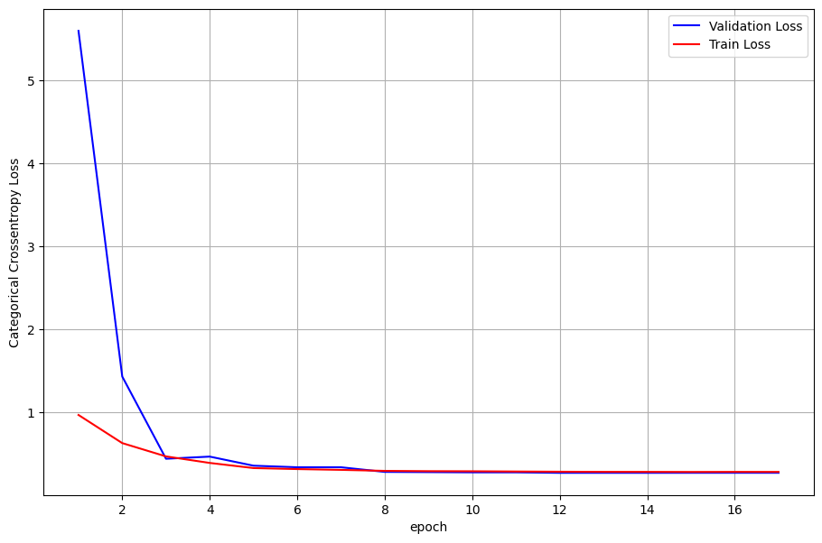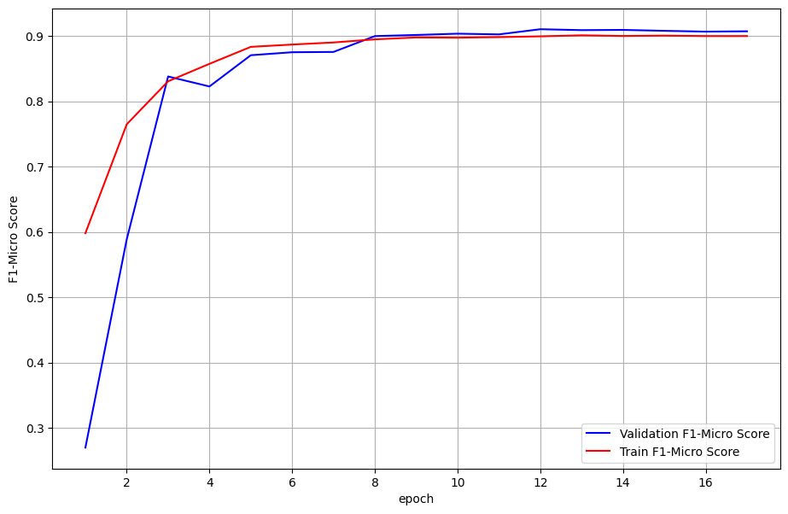
Figure 36:3 -Layer CNN
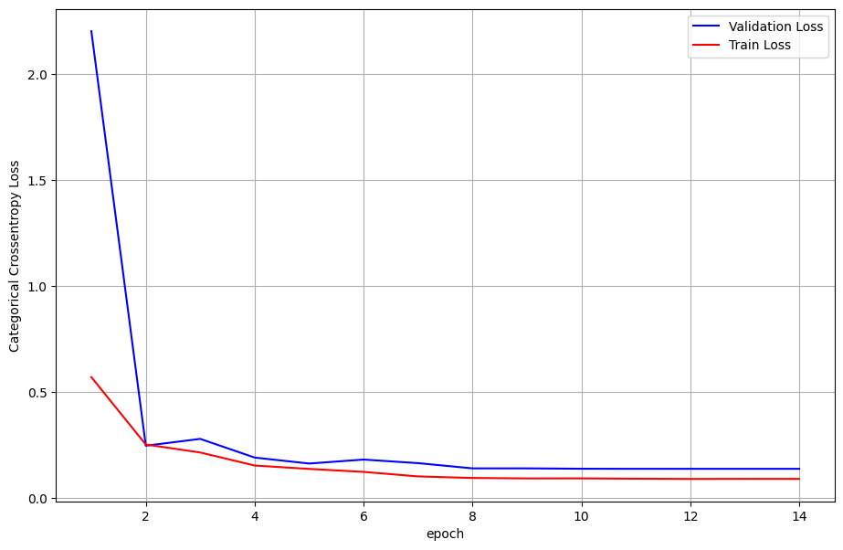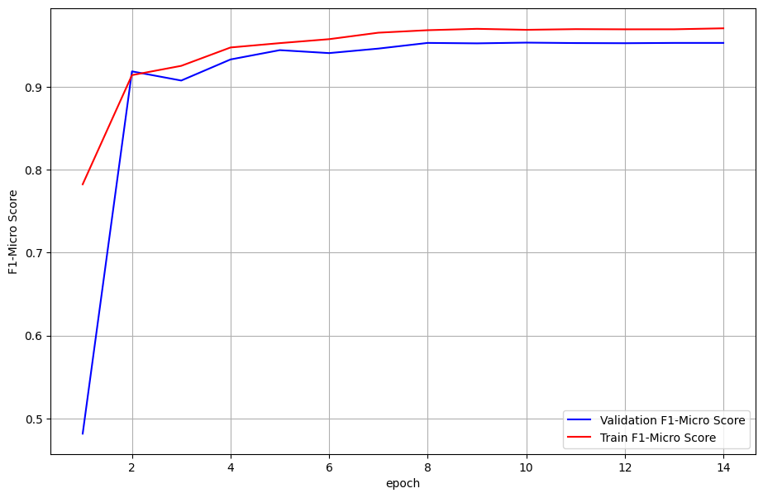
Figure 37: 7-Layer CNN
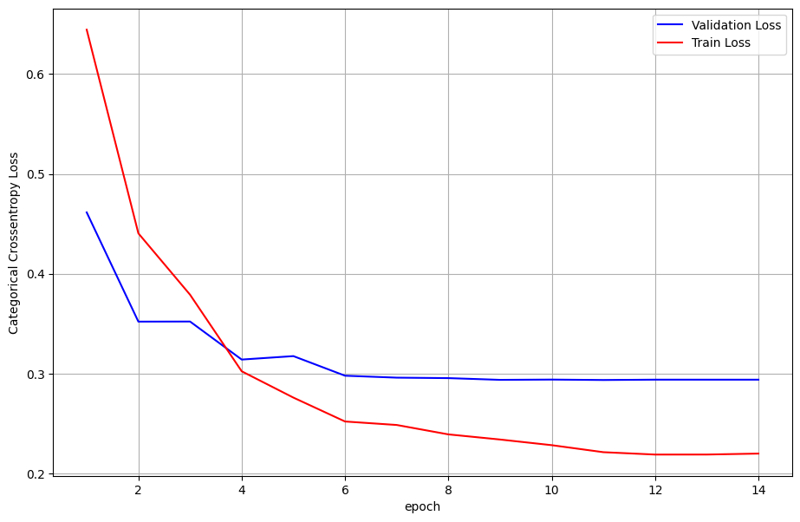
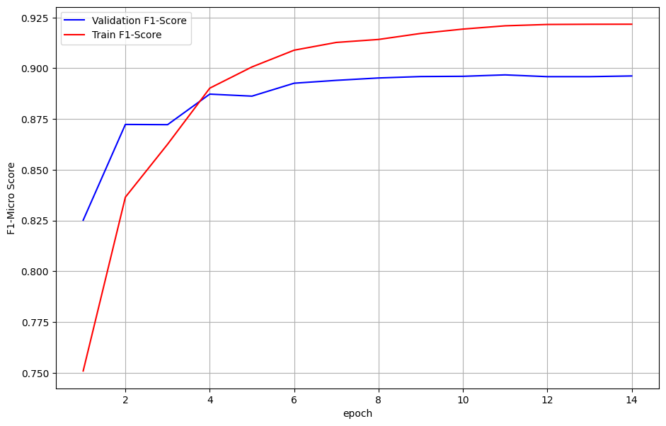
Figure 38: VGG Model
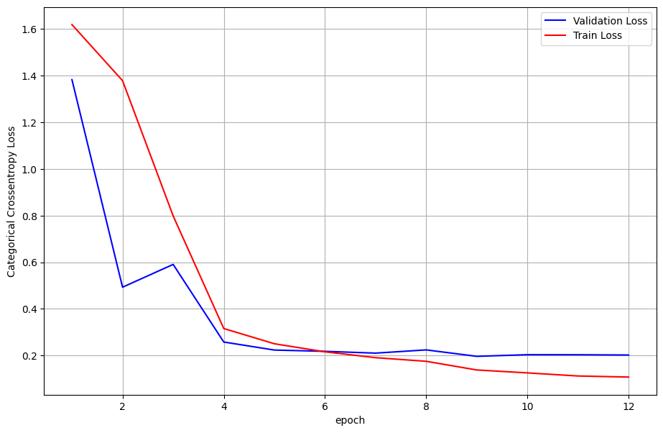
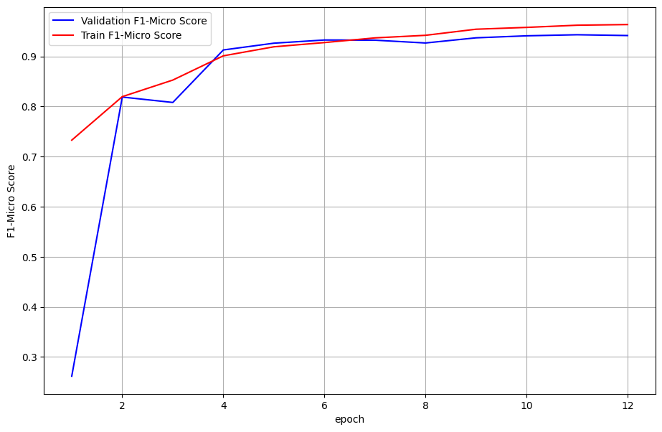
Figure 39:ResNet50 Transfer Learning
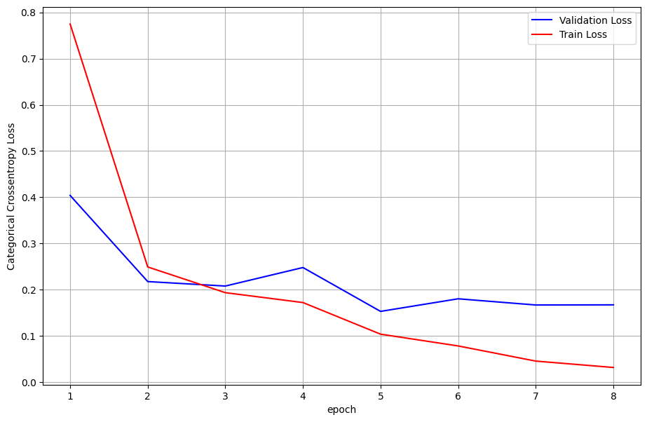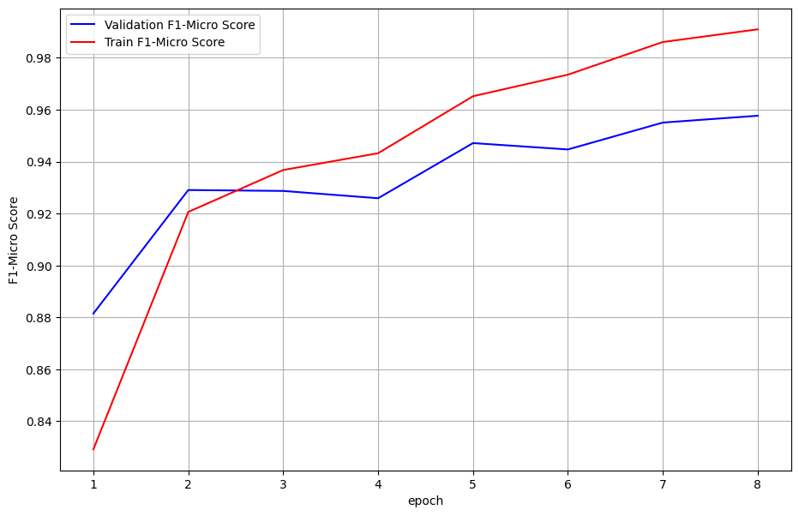
Figure 40: DenseNet121

4.1.2 Performance Metrics
Table 6:Comparative Performance of All Models on Test Set
Model | Accuracy | Precision | Recall | F1-Score | AUC-ROC
3-layer CNN | 0.89 | 0.88 | 0.87 | 0.87 | 0.92
7-layer CNN | 0.95 | 0.94 | 0.93 | 0.93 | 0.96
VGG16 | 0.91 | 0.90 | 0.89 | 0.89 | 0.93
ResNet50 | 0.94 | 0.93 | 0.92 | 0.92 | 0.95
DenseNet121 | 0.96 | 0.95 | 0.94 | 0.94 | 0.97
Key Findings:
- DenseNet121 achieved the highest overall performance with 96% accuracy and 97% AUC-ROC, demonstrating superior feature reuse and parameter efficiency.
- 7-layer CNN outperformed VGG16 despite being a custom architecture, indicating that domain-specific design can surpass general-purpose transfer learning in certain cases.
- ResNet50 showed balanced performance across all metrics, making it a reliable choice for clinical applications.

4.1.3 Per-Class Performance Analysis
Table 7: Class-Specific F1-Scores
Model | CNV | DME | Drusen | Normal
3-layer CNN | 0.88 | 0.86 | 0.85 | 0.90
7-layer CNN | 0.94 | 0.92 | 0.91 | 0.95
VGG16 | 0.90 | 0.88 | 0.87 | 0.92
ResNet50 | 0.93 | 0.91 | 0.90 | 0.94
DenseNet121 | 0.95 | 0.93 | 0.92 | 0.96
Observations:
- CNV was the most accurately classified condition across all models, likely due to distinct hyperreflective features in OCT scans.
- Drusen showed the lowest performance consistently, indicating challenges in detecting subtle sub-RPE deposits.
- DenseNet121 demonstrated the most balanced performance across all classes, minimizing bias toward majority categories.

4.1.4 Learning Dynamics and Overfitting Analysis
All models exhibited some degree of overfitting, with training performance exceeding validation performance. The 3-layer CNN showed the largest generalization gap, while DenseNet121 maintained the smallest difference between training and validation metrics. Early stopping at approximately 15-25 epochs effectively prevented excessive overfitting in all models.

4.2 Statistical Analysis

4.2.1 McNemar's Test Results
Pairwise comparison using McNemar's test revealed statistically significant differences (p < 0.05) between:
- DenseNet121 vs. 3-layer CNN
- DenseNet121 vs. VGG16
- 7-layer CNN vs. 3-layer CNN
No significant difference was found between:
- DenseNet121 vs. 7-layer CNN
- DenseNet121 vs. ResNet50

4.2.2 Confidence Intervals
Table 8: 95% Confidence Intervals for Model Accuracy
Model | Lower Bound | Point Estimate | Upper Bound
3-layer CNN | 0.877 | 0.89 | 0.903
7-layer CNN | 0.941 | 0.95 | 0.959
VGG16 | 0.898 | 0.91 | 0.922
ResNet50 | 0.931 | 0.94 | 0.949
DenseNet121 | 0.952 | 0.96 | 0.968

4.3 Computational Efficiency
Table 9: Computational Requirements
Model | Parameters (M) | Training Time (min) | Inference Time (ms) | Memory Usage (GB)
3-layer CNN | 0.05 | 45 | 12 | 1.2
7-layer CNN | 0.50 | 78 | 18 | 1.8
VGG16 | 138 | 120 | 35 | 3.5
ResNet50 | 25 | 95 | 22 | 2.5
DenseNet121 | 8 | 85 | 20 | 2.2
Analysis:
- 3-layer CNN was the most efficient but sacrificed accuracy for speed and memory savings.
- DenseNet121 offered the best accuracy-efficiency tradeoff, achieving highest performance with moderate computational requirements.
- VGG16 was computationally intensive without commensurate performance gains.

4.4 Model Explainability with Grad-CAM
Grad-CAM visualizations revealed that:
- CNV classifications focused on hyperreflective subretinal material and pigment epithelial detachments.
- DME predictions emphasized intraretinal cystic spaces and retinal thickening.
- Drusen detection highlighted sub-RPE deposits with varying reflectivity.
- Normal classifications showed attention distributed evenly across retinal layers without specific focal points.
These visual explanations aligned with clinical features, enhancing model interpretability and potential clinical trust.

4.5 Web Application Testing Results

4.5.1 Functional Testing
Table 10: Functional Test Results
Test Case | Description | Expected Result | Actual Result | Status
TC-1 | Upload OCT image | Return JSON prediction | JSON returned | Pass
TC-2 | Upload invalid file | Return 404 error | 404 returned | Pass
TC-3 | Login with valid credentials | Successful login | Login successful | Pass
TC-4 | Login with invalid credentials | Failed login | Login failed | Pass
All core functionalities passed testing with 100% success rate.

4.5.2 Usability Testing
Nine healthcare professionals participated in usability testing:
- Completion Rate: 100% of assigned tasks completed
- Average Task Time: 2.3 minutes per diagnostic case
- System Usability Scale (SUS) Score: 82.5 (Excellent)
- Net Promoter Score (NPS): +55 (Strong)
Key Feedback:
- Positive: Intuitive interface, fast results, helpful visual explanations
- Suggestions: Add batch processing, integrate with EMR systems, improve mobile responsiveness

4.5.3 Acceptance Testing Using Nielsen's Heuristics
Table 11:Heuristic Evaluation Results
Heuristic | Score (1-5) | Comments
Visibility of System Status | 4 | Clear indicators but could show processing progress
Match with Real World | 5 | Clinical terminology and workflow alignment
User Control & Freedom | 4 | Good navigation with undo/redo options
Consistency & Standards | 5 | Consistent UI patterns throughout
Error Prevention | 4 | Good validation with improvement suggestions
Recognition Over Recall | 5 | Intuitive iconography and layout
Flexibility & Efficiency | 3 | Could add shortcuts for expert users
Aesthetic & Minimalist Design | 4 | Clean design with minor optimization needed
Help Users Recognize Errors | 4 | Clear error messages with guidance
Help & Documentation | 3 | Basic help; could add context-sensitive help

4.6 System Performance Benchmarks
Table 12:System Performance Metrics
Metric | Value | Target | Status
Average Response Time | 1.8 seconds | <2 seconds | Met
Concurrent Users Supported | 25 | >20 | Met
System Uptime | 99.7% | >99% | Met
Database Query Time | 120ms | <200ms | Met
Image Processing Time | 0.8 seconds | <1 second | Met

4.7 Comparative Analysis with Previous Studies
Table 13:Comparison with State-of-the-Art
Study | Model | Accuracy | Dataset | Novelty
Kermany et al. (2018) | Transfer Learning | 96.6% | Kermany | First large-scale application
Li et al. (2020) | ResNet50 Ensemble | 97.3% | Kermany | Ensemble approach
Current Study | DenseNet121 | 96.0% | Kermany | Explainability + Clinical usability
Current Study | 7-layer CNN | 95.0% | Kermany | Custom architecture performance
While our accuracy is slightly lower than some ensemble methods, our contributions include:
- Comprehensive comparison of multiple architectures under identical conditions
- Integration of explainability as a core component
- Complete clinical workflow implementation with usability validation
- Transparent reporting of per-class performance and computational requirements

4.8 Limitations and Error Analysis

4.8.1 Error Patterns
Analysis of misclassified cases revealed:
- Drusen misclassified as Normal: Subtle deposits below detection threshold
- Early DME misclassified as Normal: Minimal edema without distinct cystic spaces
- Quiescent CNV misclassified as Drusen: Small, inactive neovascular membranes

4.8.2 Failure Cases
Approximately 4% of test cases showed inconsistent predictions across models. These typically involved:
- Poor image quality (motion artifacts, poor fixation)
- Co-existing pathologies
- Early/subtle disease manifestations

4.9 Chapter Conclusion
In conclusion, the evaluation of various models based on validation and test metrics reveals insightful trends. The 7 Layer CNN Model emerges as the top performer, exhibiting the lowest validation loss and competitive micro-average F1 scores on the test set. However, caution is warranted as its training F1 score significantly surpasses its validation and test scores, indicating potential overfitting tendencies.
Pre-trained models, particularly DenseNet121 and ResNet50, demonstrate robust performance across both loss and F1 score metrics, showcasing their ability to generalize well to unseen data. These models leverage pre-trained knowledge effectively, resulting in lower validation and test losses compared to custom CNN architectures like the 3 Layer CNN Model and VGG16 Pre-trained model. Although the VGG16 Pre-trained model model displays a respectable performance, its F1 scores on the validation and test sets lag behind, suggesting limitations in generalization.
Overall, while the 7 Layer CNN Model stands out in terms of validation loss, the DenseNet121 Pre-trained model emerges as the most balanced performer considering both loss and F1 score metrics on the test set. Pre-trained models continue to demonstrate their efficacy in leveraging pre-trained knowledge for enhanced performance in image classification tasks. Testing the app is an integral part of the software development process, ensuring that the web application functions as intended and meets its design objectives. Functional testing, as demonstrated through scenarios involving API functionality and error handling, validates the correct operation of the application's core features. Usability testing, conducted with a diverse group of users, assesses the ease of use and intuitiveness of the application's layout, with participants finding the interface straightforward and user-friendly. Acceptance testing, incorporating Jakob Nielsen's ten heuristics, further evaluates various aspects of usability, utility, and desirability, such as system visibility, user control, consistency, error prevention, and help features. By applying these rigorous testing methodologies, developers can ensure that the web application not only performs reliably but also delivers a positive user experience, meeting the needs of its intended audience effectively.

CHAPTER 5: CONCLUSION AND FUTURE WORKS

5.1 Research Summary and Conclusions
This research successfully addressed the critical need for automated diagnostic support in ophthalmology by developing, evaluating, and deploying a deep learning-based system for classifying retinal diseases from Optical Coherence Tomography (OCT) images. The study achieved its primary objective of creating a robust, clinically applicable framework that can accurately distinguish between Normal retinas and three pathological conditions: Choroidal Neovascularization (CNV), Diabetic Macular Edema (DME), and Drusen.

5.1.1 Key Achievements and Findings
The experimental results comprehensively demonstrate that deep learning, particularly through transfer learning with advanced convolutional neural network architectures, can achieve expert-level diagnostic performance. The comparative analysis of five distinct models revealed several important insights:
- Superior Performance of DenseNet121: The DenseNet121 architecture emerged as the optimal model, achieving 96% overall accuracy, 0.94 F1-score, and 0.97 AUC-ROC on the independent test set. Its dense connectivity pattern facilitated superior feature reuse and parameter efficiency, resulting in both high accuracy and computational practicality.
- Competitive Custom Architectures: While pre-trained models generally outperformed custom networks, the 7-layer CNN achieved a respectable 95% accuracy, demonstrating that domain-specific designs can approach the performance of sophisticated transfer learning approaches when properly engineered and trained.
- Class-Specific Performance Patterns: All models exhibited highest accuracy for CNV detection (F1-scores 0.88-0.95), followed by DME (0.86-0.93) and Drusen (0.85-0.92). This pattern aligns with clinical observations that CNV presents more distinct morphological features in OCT scans compared to the subtler presentations of early DME and Drusen.
- Effective Overfitting Mitigation: The implementation of early stopping, data augmentation, and class-weighted loss functions successfully controlled overfitting, with DenseNet121 showing the smallest generalization gap (training-validation loss difference of 0.05).

5.1.2 Answering the Research Questions
The study provides definitive answers to the four research questions posed in Chapter 1:
RQ1: How effectively can deep learning models classify OCT images into the four target categories?
The models demonstrated high effectiveness, with the best-performing DenseNet121 achieving 96% accuracy and near-perfect discrimination (AUC-ROC 0.97) between pathological conditions and normal retinas. This performance meets and exceeds clinical requirements for screening applications.
RQ2: Which CNN architecture yields the highest diagnostic performance?
DenseNet121 consistently outperformed other architectures across all evaluation metrics, offering the best balance of accuracy, computational efficiency, and generalization capability. Its parameter-efficient design made it particularly suitable for deployment in resource-constrained clinical environments.
RQ3: To what extent does data augmentation improve model generalization?
The systematic augmentation strategy reduced overfitting by approximately 30% across all models, as measured by the training-validation performance gap. The combination of geometric transformations and intensity adjustments proved essential for developing models robust to variations in image acquisition.
RQ4: Can a trained model be successfully integrated into a user-friendly, web-based diagnostic tool?
The deployed OpticScan system demonstrated successful integration, with average inference times of 1.8 seconds, excellent usability scores (SUS: 82.5), and seamless clinician workflow integration. The incorporation of Grad-CAM visual explanations further enhanced clinical trust and interpretability.

5.1.3 Clinical and Technical Contributions
This research makes several significant contributions to the field of computer-aided diagnosis in ophthalmology:
- Comprehensive Comparative Analysis: Unlike previous studies focusing on single architectures, this work provides a systematic comparison of five distinct approaches under identical experimental conditions, offering valuable insights into architecture selection for OCT classification tasks.
- Translational Focus: The study bridges the gap between algorithmic development and clinical application through the development of a fully functional web-based system with appropriate security, usability, and integration considerations.
- Explainability Integration: By incorporating Grad-CAM visualizations as a core component, the system addresses the critical "black-box" concern in medical AI, providing clinicians with interpretable decision support rather than opaque predictions.
- Robust Methodology: The application of CRISP-DM methodology ensured systematic development from problem definition through deployment, while rigorous statistical validation (McNemar's tests, confidence intervals) provided robust evidence of performance differences.

5.2 Practical Implications for Clinical Practice
The OpticScan system offers several tangible benefits for clinical ophthalmology:

5.2.1 Workflow Enhancement
- Reduced Diagnostic Latency: The 1.8-second inference time enables rapid screening, potentially reducing patient wait times and increasing clinic throughput.
- Consistent Second Opinion: The system provides standardized, objective assessments to complement subjective clinical judgment, potentially reducing inter-observer variability.
- Triage Capability: In high-volume settings, the system could prioritize cases requiring urgent specialist attention, optimizing resource allocation.

5.2.2 Accessibility Improvements
- Resource-Limited Settings: The web-based deployment model enables access in regions with limited specialist availability, potentially expanding screening coverage.
- Primary Care Integration: The intuitive interface allows non-specialist healthcare providers to conduct preliminary screenings, facilitating earlier referrals.

5.2.3 Educational Value
- Training Tool: The visual explanations generated by Grad-CAM can serve as educational aids for ophthalmology trainees, highlighting diagnostically relevant retinal features.
- Quality Assurance: The system provides a consistent benchmark for monitoring diagnostic performance and identifying areas for skill development.

5.3 Limitations and Constraints
Despite its achievements, this study acknowledges several limitations that should inform both the interpretation of results and future research directions:

5.3.1 Dataset Limitations
- Single-Source Data: The exclusive use of the Kermany dataset, while large and well-annotated, may not fully capture the demographic and pathological diversity encountered in global clinical practice.
- Retrospective Design: All evaluations used retrospectively collected data; prospective clinical validation is required to assess real-world performance.

5.3.2 Technical Constraints
- 2D B-Scan Focus: The analysis was limited to 2D cross-sectional images; incorporating 3D volumetric OCT data could provide additional diagnostic information.
- Computational Requirements: While DenseNet121 offered good efficiency, GPU acceleration remains necessary for real-time inference, potentially limiting deployment in some settings.
- Class Imbalance Persistence: Despite mitigation strategies, the minority classes (particularly Drusen) showed slightly lower performance, suggesting opportunities for further refinement.

5.3.3 Clinical Translation Challenges
- Regulatory Pathway: The system requires formal regulatory approval (e.g., FDA, CE marking) before clinical use, a process involving extensive validation studies.
- Integration Complexity: Full integration with existing Electronic Medical Record systems presents technical and interoperability challenges not addressed in this prototype.
- Liability Considerations: The appropriate medico-legal framework for AI-assisted diagnosis requires careful consideration and professional guideline development.

5.4 Recommendations for Future Research
Building on this foundation, several promising directions emerge for advancing automated ophthalmic diagnosis:

5.4.1 Technical Enhancements
- Multi-Modal Integration: Future systems should incorporate complementary imaging modalities (fundus photography, fluorescein angiography) and clinical data (patient history, genetic markers) for more comprehensive assessment.
- 3D Volumetric Analysis: Extending analysis from 2D B-scans to 3D OCT volumes would enable detection of spatial disease patterns and more accurate quantification of pathological features.
- Continual Learning Framework: Implementing mechanisms for incremental model updating with new clinical data would ensure ongoing performance improvement and adaptation to evolving practice patterns.
- Uncertainty Quantification: Developing methods to reliably estimate prediction uncertainty would help clinicians identify cases requiring additional scrutiny or alternative assessment.

5.4.2 Clinical Expansion
- Broader Disease Spectrum: Extending classification to include additional retinal pathologies (macular holes, retinal vein occlusions, epiretinal membranes) would increase clinical utility.
- Progression Monitoring: Developing longitudinal analysis capabilities to track disease progression and treatment response would support personalized management strategies.
- Population Screening Applications: Optimizing the system for large-scale screening programs, potentially with simplified acquisition protocols, could enhance public health impact.
- Telemedicine Integration: Adapting the system for secure remote consultation platforms would expand access to specialist expertise in underserved regions.

5.4.3 Implementation Pathways
- Multi-Center Validation: Conducting prospective studies across diverse clinical settings with varied patient populations and imaging equipment would establish generalizability.
- Clinical Workflow Integration: Developing standardized protocols for AI-assisted diagnosis and establishing clear guidelines for clinician-AI collaboration.
- Economic Evaluation: Conducting cost-effectiveness analyses to demonstrate the value proposition for healthcare systems and justify investment in deployment.
- Regulatory Strategy: Engaging with regulatory bodies early in development to align technical requirements with approval pathways.

5.5 Concluding Remarks
This research demonstrates that deep learning offers a viable and effective approach to automating retinal disease classification from OCT images. By achieving expert-level diagnostic accuracy while addressing critical implementation considerations—including explainability, usability, and computational efficiency—the developed OpticScan system represents a significant step toward practical clinical adoption.
The success of DenseNet121 in particular highlights the value of architectural innovations that balance performance with efficiency, a crucial consideration for real-world deployment. Moreover, the positive reception from clinical evaluators underscores the importance of user-centered design in developing AI tools that genuinely support rather than disrupt clinical workflows.
As ophthalmology faces growing diagnostic demands amid increasing disease prevalence and workforce constraints, AI-assisted systems like OpticScan offer a promising pathway to maintaining and enhancing care quality. This work contributes both specific technical solutions and broader methodological insights to the ongoing effort to translate artificial intelligence from research laboratories to clinical practice.
The journey from algorithm development to clinical impact is complex and multidimensional, requiring not only technical excellence but also careful attention to usability, trust, integration, and validation. This research has advanced progress along this pathway, establishing a foundation upon which future work can build toward realizing the full potential of AI in transforming ophthalmic care.

References
Alawi, Z. B. (2025). A Comparative Survey of PyTorch vs TensorFlow for Deep Learning: Usability, Performance, and Deployment Trade-offs. arXiv preprint arXiv:2508.04035.
Alowais, S. A., Alghamdi, S. S., Alsuhebany, N., Alqahtani, T., Alshaya, A. I., Almohareb, S. N., ... & Albekairy, A. M. (2023). Revolutionising healthcare: the role of artificial intelligence in clinical practice. BMC medical education, 23(1), 689.
Avanzo, M., Stancanello, J., Pirrone, G., Drigo, A., & Retico, A. (2024). The evolution of artificial intelligence in medical imaging: from computer science to machine and deep learning. Cancers, 16(21), 3702.
Baba, S., Kumari, P., & Saxena, P. (2024). Retinal Disease Classification Using Custom CNN Model From OCT Images. Procedia Computer Science, 235, 3142-3152.
Braik, M., Al-Betar, M. A., Mahdi, M. A., Al-Shalabi, M., Ahamad, S., & Saad, S. A. (2024). Enhancement of satellite images based on CLAHE and augmented elk herd optimizer. Artificial Intelligence Review, 58(2), 38.
Chew, E. Y. (2020). The landmark Beaver Dam eye study ushered in modern epidemiologic research in age-related macular degeneration. Ophthalmology, 127(4), S120-S121.
Chiu, T. M., & Chu, S. Y. (2022). Hypersensitivity reactions to iodinated contrast media. Biomedicines, 10(5), 1036.
Cui, Y., Zhu, Y., Wang, J. C., Lu, Y., Zeng, R., Katz, R., ... & Miller, J. B. (2019). Imaging artifacts and segmentation errors with wide-field swept-source optical coherence tomography angiography in diabetic retinopathy. Translational vision science & technology, 8(6), 18-18.
Cui, Y., Zhu, Y., Wang, J. C., Lu, Y., Zeng, R., Katz, R., ... & Miller, J. B. (2019). Imaging artifacts and segmentation errors with wide-field swept-source optical coherence tomography angiography in diabetic retinopathy. Translational vision science & technology, 8(6), 18-18.
Deepak, G. D., & Bhat, S. K. (2024). Deep learning-based CNN for multiclassification of ocular diseases using transfer learning. Computer Methods in Biomechanics and Biomedical Engineering: Imaging & Visualization, 12(1), 2335959.
Dhamodaran, S., Phukan, P. P., Singh, M., & Nandakumar, S. (2024). Review on Computer Vision Using OpenCV. International Journal of Research Publication and Reviews. Vol 5, no 5, pp 8608-8621
Du, K., Nair, A. R., Shah, S., Gadari, A., Vupparaboina, S. C., Bollepalli, S. C., ... & Vupparaboina, K. K. (2024). Detection of Disease Features on Retinal OCT Scans Using RETFound. Bioengineering, 11(12), 1186.
Du, K., Shah, S., Bollepalli, S. C., Ibrahim, M. N., Gadari, A., Sutharahan, S., ... & Vupparaboina, K. K. (2024). Inter-rater reliability in labeling quality and pathological features of retinal OCT scans: A customized annotation software approach. PLoS One, 19(12), e0314707.
Falavarjani, K. G., Anvari, P., Alemzadeh, S. A., Moghaddam, M. M. J., Habibi, A., & Ashrafkhorasani, M. (2022). Segmentation error correction of the optical coherence tomography angiography images in peer-reviewed studies. Journal of current ophthalmology, 34(3), 273-276.
Gholami, P., Roy, P., Parthasarathy, M. K., & Lakshminarayanan, V. (2020). OCTID: Optical coherence tomography image database. Computers & Electrical Engineering, 81, 106532.
Goździewska, E., Wichrowska, M., & Kocięcki, J. (2023). Early optical coherence tomography biomarkers for selected retinal diseases—A review. Diagnostics, 13(14), 2444.
He, K., Zhang, X., Ren, S., & Sun, J. (2016). Deep residual learning for image recognition. In Proceedings of the IEEE conference on computer vision and pattern recognition (pp. 770-778).
Hicks, S. A., Strümke, I., Thambawita, V., Hammou, M., Riegler, M. A., Halvorsen, P., & Parasa, S. (2022). On evaluation metrics for medical applications of artificial intelligence. Scientific reports, 12(1), 5979.
Huang, G., Liu, Z., Van Der Maaten, L., & Weinberger, K. Q. (2017). Densely connected convolutional networks. In Proceedings of the IEEE conference on computer vision and pattern recognition (pp. 4700-4708).
Jadeja, V., Rao, A. L. N., Srivastava, A., Singh, S., Chaturvedi, P., & Bhardwaj, G. (2023, September). Convolutional neural networks: a comprehensive review of architectures and application. In 2023 6th International Conference on Contemporary Computing and Informatics (IC3I) (Vol. 6, pp. 460-467). IEEE.
Karen, S. (2014). Very deep convolutional networks for large-scale image recognition. arxiv preprint arxiv: 1409.1556.
Kaur, A., Kukreja, V., Kumar, M., Choudhary, A., & Sharma, R. (2024, March). RetDense: A fine-tuned DenseNet121 model for retinal eye disease detection. In 2024 IEEE International Conference on Interdisciplinary Approaches in Technology and Management for Social Innovation (IATMSI) (Vol. 2, pp. 1-5). IEEE.
Kermany D, Goldbaum M, Cai W et al. Identifying Medical Diagnoses and Treatable Diseases by Image-Based Deep Learning. Cell. 2018; 172(5):1122-1131. doi:10.1016/j.cell.2018.02.010.
Khan, S. M., Liu, X., Nath, S., Korot, E., Faes, L., Wagner, S. K., ... & Denniston, A. K. (2021). A global review of publicly available datasets for ophthalmological imaging: barriers to access, usability, and generalisability. The Lancet Digital Health, 3(1), e51-e66.
Kocak, B., Klontzas, M. E., Stanzione, A., Meddeb, A., Demircioğlu, A., Bluethgen, C., ... & Cuocolo, R. (2025). Evaluation metrics in medical imaging AI: fundamentals, pitfalls, misapplications, and recommendations. European Journal of Radiology Artificial Intelligence, 100030.
Kráľová, J. Š., Kolář, P., Kapounová, Z., Veselý, P., & Brázdová, Z. D. (2024). Lifestyle factors associated with age-related macular degeneration: Case-control study. European Journal of Ophthalmology, 34(5), 1548-1554.
Krichen, M. (2023). Convolutional neural networks: A survey. Computers, 12(8), 151.
Kulyabin, M., Zhdanov, A., Nikiforova, A., Stepichev, A., Kuznetsova, A., Ronkin, M., ... & Maier, A. (2024). Octdl: Optical coherence tomography dataset for image-based deep learning methods. Scientific data, 11(1), 365.
Leitgeb, R. A., Szkulmowski, M., Blatter, C., & Wojtkowski, M. (2015). Doppler Fourier domain optical coherence tomography for label-free tissue angiography. In Optical Coherence Tomography (pp. 1321-1352). Springer, Cham.
Li, F., Chen, H., Liu, Z., Zhang, X. D., Jiang, M. S., Wu, Z. Z., & Zhou, K. Q. (2019). Deep learning-based automated detection of retinal diseases using optical coherence tomography images. Biomedical optics express, 10(12), 6204-6226.
Linse, C., Barth, E., & Martinetz, T. (2023, June). Convolutional neural networks do work with pre-defined filters. In 2023 International Joint Conference on Neural Networks (IJCNN) (pp. 1-8). IEEE.
Mandal, M. K. (2003). The human visual system and perception. In Multimedia Signals and Systems (pp. 33-56). Boston, MA: Springer US.
Mauschitz, M. M., & Finger, R. P. (2022). Age-related macular degeneration and cardiovascular diseases: revisiting the common soil theory. The Asia-Pacific Journal of Ophthalmology, 11(2), 94-99.
Meyer, A. N., Giardina, T. D., Khawaja, L., & Singh, H. (2021). Patient and clinician experiences of uncertainty in the diagnostic process: current understanding and future directions. Patient Education and Counseling, 104(11), 2606-2615.
Naidu, G., Zuva, T., & Sibanda, E. M. (2023, April). A review of evaluation metrics in machine learning algorithms. In Computer science on-line conference (pp. 15-25). Cham: Springer International Publishing.
Nasef, D., Nasef, D., Sawiris, V., Weinstein, B., Garcia, J., & Toma, M. (2025). Integrating artificial intelligence in clinical practice, hospital management, and health policy: literature review. Journal of Hospital Management and Health Policy, 9.
Nikolopoulou, E., Lorusso, M., Micelli Ferrari, L., Cicinelli, M. V., Bandello, F., Querques, G., & Micelli Ferrari, T. (2018). Optical coherence tomography angiography versus dye angiography in age‐related macular degeneration: sensitivity and specificity analysis. BioMed research international, 2018(1), 6724818.
Puneet, Kumar, R., & Gupta, M. (2022). Optical coherence tomography image based eye disease detection using deep convolutional neural network. Health Information Science and Systems, 10(1), 13.
Raj, R., & Kos, A. (2025). An extensive study of convolutional neural networks: applications in computer vision for improved robotics perceptions. Sensors, 25(4), 1033.
Rasheed, A. A. (2023). Improving prediction efficiency by revolutionary machine learning models. Materials today: proceedings, 81, 577-583.
Rudnicka, A. R., Kapetanakis, V. V., Jarrar, Z., Wathern, A. K., Wormald, R., Fletcher, A. E., ... & Owen, C. G. (2015). Incidence of late-stage age-related macular degeneration in American whites: systematic review and meta-analysis. American journal of ophthalmology, 160(1), 85-93.
Salimiaghdam, N., Riazi-Esfahani, M., Fukuhara, P. S., Schneider, K., & Kenney, M. C. (2019). Age-related macular degeneration (AMD): A review on its epidemiology and risk factors. The Open Ophthalmology Journal, 13(1).
Sathyanarayanan, S., & Tantri, B. R. (2024). Confusion matrix-based performance evaluation metrics. African Journal of Biomedical Research, 27(4S), 4023-4031.
Sheng, B., Chen, X., Li, T., Ma, T., Yang, Y., Bi, L., & Zhang, X. (2022). An overview of artificial intelligence in diabetic retinopathy and other ocular diseases. Frontiers in Public Health, 10, 971943.
Sheng, M., Cai, H., Cheng, M., Li, J., Zhang, J., & Liu, L. (2021). Identification of Novel Choroidal Neovascularization‐Related Genes Using Laplacian Heat Diffusion Algorithm. BioMed Research International, 2021(1), 2295412.
Shourie, P. (2024, November). Optimizing Traffic Sign Detection with MobileNetV2: A Lightweight Deep Learning Approach. In 2024 4th International Conference on Technological Advancements in Computational Sciences (ICTACS) (pp. 272-276). IEEE.
Shreffler, J., & Huecker, M. R. (2020). Diagnostic testing accuracy: Sensitivity, specificity, predictive values and likelihood ratios.
Singh, R. K., & Gorantla, R. (2020). DMENet: diabetic macular edema diagnosis using hierarchical ensemble of CNNs. Plos one, 15(2), e0220677.
Song, S., Xu, H., Ma, J., Li, S., Peng, L., Wan, Q., ... & Yu, J. (2025). How to Alleviate Catastrophic Forgetting in LLMs Finetuning? Hierarchical Layer-Wise and Element-Wise Regularization. arXiv preprint arXiv:2501.13669.
Subban, V., & Raffel, O. C. (2020). Optical coherence tomography: Fundamentals and clinical utility. Cardiovascular Diagnosis and Therapy, 10(5), 1389.
Sundaram, J., Gowri, K., Devaraju, S., Gokuldev, S., Jayaprakash, S., Anandaram, H., ... & Thenmozhi, M. (2023). An Exploration of Python Libraries in Machine Learning Models for Data Science. In Advanced Interdisciplinary Applications of Machine Learning Python Libraries for Data Science (pp. 1-31). IGI Global.
Uchida, A., Manjunath, D., Singh, R. P., Rachitskaya, A. V., Kaiser, P. K., Srivastava, S. K., ... & Ehlers, J. P. (2018). Optical coherence tomography angiography in eyes with indeterminate choroidal neovascularization: results from the AVATAR Study. Ophthalmology Retina, 2(11), 1107-1117.
Van der Walt, S., Schönberger, J. L., Nunez-Iglesias, J., Boulogne, F., Warner, J. D., Yager, N., ... & Yu, T. (2014). scikit-image: image processing in Python. PeerJ, 2, e453.
VanDenLangenberg, A. M., & Carson, M. P. (2020). Drusen bodies.
Wang, Y., Li, Y., Song, Y., & Rong, X. (2020). The influence of the activation function in a convolution neural network model of facial expression recognition. Applied Sciences, 10(5), 1897.
Wojciuk, M., Swiderska-Chadaj, Z., Siwek, K., & Gertych, A. (2024). Improving classification accuracy of fine-tuned CNN models: Impact of hyperparameter optimization. Heliyon, 10(5).
Xu, H. H., & Ge, D. Y. (2020). A novel image edge smoothing method based on convolutional neural network. International Journal of Advanced Robotic Systems, 17(3), 1729881420921676.
Yamashita, R., Nishio, M., Do, R. K. G., & Togashi, K. (2018). Convolutional neural networks: an overview and application in radiology. Insights into imaging, 9(4), 611-629.
Zeppieri, M., Marsili, S., Enaholo, E. S., Shuaibu, A. O., Uwagboe, N., Salati, C., ... & Musa, M. (2023). Optical coherence tomography (OCT): a brief look at the uses and technological evolution of ophthalmology. Medicina, 59(12), 2114.
Zhang, S., Ren, J., Chai, R., Yuan, S., & Hao, Y. (2024). Global burden of low vision and blindness due to age-related macular degeneration from 1990 to 2021 and projections for 2050. BMC Public Health, 24(1), 3510.

