

Title

Early Mental Health Risk Detection from Social Media Posts

Name: Ghurmallah Alqarni ID No.: 253000384
Name: Ahmad Hamad ID No.:

Submitted in fulfillment of the requirements for the degree Master of Science in Artificial Intelligence
At
Collage of Informatics
Midocean University
UAE
Supervisor Name: Dr. Hager Saleh
Collage of Informatics, Midocean University, Comoros
Email:

Acknowledgements

Abstract

List of Publications

Table of Contents

List of Abbreviations xiv
List of Figures xvi
List of Tables xviii

Chapter 1: Introduction and Overview......................................................................................................... 1
1.2 Problem Definition ................................................................................... 2
1.3 Thesis Objectives ..................................................................................... 3
1.4 Thesis Contribution .................................................................................. 4
1.5 Thesis Organization................................................................................... 5

Chapter 2: Background and Related Work…………………………... 31

Chapter 3: Proposed Approach ............................................................... 78
4.1 Introduction ............................................................................................ 78

Chapter 4: Experimental Results and Discussion ................................... 86

Chapter 5: Conclusion and Future Work .............................................. 127
7.1 Important Features ............................................................................... 127
7.3 Future Work ....................................................................................... 129

References .................................................................................................. 130

List of Abbreviations
- Acc.: Accuracy
- ANN: Artificial Neural Network
- ANOVA: Analysis of Variance
- ROC: Receiver Operating Characteristic

List of Figures
2.1 Educational Data Mining Process ……………………………………… | 7
2.2 Applications of Educational Data Mining ……………………………… | 8
2.3 Distribution of Papers that used different attributes for PSP problem …. | 19
2.4 Student Performance Data Set …………………………………………... | 21
2.5 Educational Process Mining (EPM): A Learning Analytics Data Set … | 23

List of Tables
2.1 Student Performance Data Set Description ………………………… 21
2.2 Students' Academic Performance Dataset Description ……………… 23

Chapter 1

Introduction

1.1 Overview
Mental health is an essential component of overall well-being, influencing how individuals think, feel, and behave in their daily lives. Mental health disorders, including depression, anxiety, stress, and suicidal ideation, have become major public health concerns worldwide. According to the World Health Organization (WHO), millions of people experience mental health conditions each year, many of whom remain undiagnosed or do not receive timely intervention. As a result, early identification of individuals at risk has become an important research area for healthcare professionals and researchers.
In recent years, the rapid growth of social media platforms, such as Twitter (X), Reddit, Facebook, and Instagram, has transformed the way people communicate and express their emotions, opinions, and personal experiences. Many users openly share their thoughts, emotions, and daily experiences through online posts, often revealing indicators of their psychological well-being. Consequently, social media has become a valuable source of textual data for studying mental health conditions and identifying early warning signs of psychological distress.
Natural Language Processing (NLP), together with Machine Learning (ML) and Deep Learning (DL), has significantly advanced the automatic analysis of textual data. NLP techniques enable computers to process and understand human language, while ML and DL models automatically learn meaningful patterns from textual information to classify users according to their mental health status. Recent advances in transformer-based language models have further improved the performance of text classification tasks by capturing contextual and semantic relationships more effectively than traditional approaches.
Although considerable progress has been achieved, accurately detecting mental health risks from social media remains challenging. Social media posts are often short, informal, ambiguous, and contain abbreviations, slang expressions, emojis, and spelling variations. In addition, datasets are frequently imbalanced, and the linguistic characteristics of users vary across different platforms. These challenges highlight the need to develop and evaluate robust computational models for accurate and reliable early mental health risk detection.
This thesis investigates approaches for the early detection of mental health risks from social media posts, with a particular focus on Machine Learning and Deep Learning techniques. The study reviews existing approaches, evaluates different text representation methods and classification models, and compares their effectiveness using publicly available benchmark datasets. The findings are expected to provide a comprehensive understanding of current techniques and identify the most effective approaches for early mental health risk detection.

1.2 Problem Definition
The increasing prevalence of mental health disorders has created an urgent need for effective methods that enable early identification of individuals at risk. Traditional mental health assessment primarily depends on clinical interviews, self-report questionnaires, and professional evaluations. Although these approaches provide reliable diagnoses, they often require considerable time, financial resources, and access to healthcare services. Consequently, many individuals experiencing mental health problems remain undiagnosed or receive treatment only after their conditions have significantly worsened, reducing the effectiveness of early intervention.
The widespread use of social media has created new opportunities for identifying early signs of mental health conditions through users' online textual expressions. However, automatically detecting mental health risks from social media remains a challenging task. Social media posts are typically short, informal, and highly unstructured, often containing slang, abbreviations, emojis, misspellings, and context-dependent expressions. These characteristics increase the complexity of text analysis and make accurate mental health risk detection more challenging.
Although numerous computational approaches have been proposed for early mental health risk detection from social media posts, several challenges remain. Previous research has employed various Machine Learning and Deep Learning models, along with different datasets, preprocessing techniques, text representation methods, and classification algorithms, making it difficult to determine the most effective approach. In addition, many studies focus on specific mental health conditions or evaluate only a limited number of models, resulting in inconsistent findings across the literature.
Therefore, there is a need for a comprehensive evaluation of computational approaches for early mental health risk detection from social media posts, with particular emphasis on Machine Learning and Deep Learning techniques. This study addresses this need by reviewing and comparing existing techniques, analyzing their strengths and limitations, and identifying the most effective approaches for accurate and reliable early mental health risk detection.

1.3 Thesis Objectives
The main objective of this thesis is to investigate effective computational approaches for the early detection of mental health risks from social media posts, with a particular focus on Machine Learning and Deep Learning techniques.
To achieve this objective, the study aims to:
- Review existing research on early mental health risk detection using social media data and identify the strengths and limitations of current approaches.
- Examine text preprocessing techniques and text representation methods commonly used for analyzing social media posts in mental health detection tasks.
- Evaluate different Machine Learning and Deep Learning models for classifying social media posts related to mental health conditions.
- Compare the performance of the selected models using standard evaluation metrics, including accuracy, precision, recall, F1-score, and AUC.
- Identify the most effective techniques for early mental health risk detection by analyzing the experimental results and comparing the strengths and weaknesses of different approaches.
- Provide recommendations for future research to improve the performance, robustness, and practical applicability of artificial intelligence techniques for mental health risk detection.

1.4 Thesis Contribution
This thesis contributes to the field of early mental health risk detection from social media posts by providing a comprehensive evaluation of computational approaches, with a particular focus on Machine Learning and Deep Learning techniques. The main contributions of this study are as follows:
- Providing a comprehensive review of recent studies on early mental health risk detection using social media data, highlighting current trends, challenges, and research gaps.
- Presenting a comparative analysis of commonly used text preprocessing techniques, text representation methods, and classification models for mental health risk detection.
- Evaluating the performance of Machine Learning and Deep Learning models using benchmark datasets and standard evaluation metrics, including accuracy, precision, recall, F1-score, and AUC.
- Identifying the strengths and limitations of different approaches to determine the most effective techniques for early mental health risk detection.
- Providing practical recommendations that may assist researchers in selecting suitable artificial intelligence techniques for future mental health detection studies.

1.5 Thesis Organization
This thesis is organized into five chapters, each addressing a specific aspect of the research.
Chapter 1 introduces the research by presenting the study overview, problem definition, research objectives, thesis contributions, and the overall organization of the thesis.
Chapter 2 provides the background and related work. It introduces the fundamental concepts of Natural Language Processing (NLP), Machine Learning (ML), and Deep Learning (DL), discusses text preprocessing and text representation techniques, presents commonly used evaluation metrics, and reviews recent studies on early mental health risk detection using social media data.
Chapter 3 describes the research methodology. It presents the datasets used in the study, data preprocessing procedures, feature extraction methods, the selected Machine Learning and Deep Learning models, the experimental setup, and the evaluation metrics used to assess model performance.
Chapter 4 presents the experimental results and discussion. It compares the performance of the selected models, analyzes the experimental findings, discusses their strengths and limitations, and compares the results with those reported in previous studies.
Chapter 5 concludes the thesis by summarizing the main findings, highlighting the contributions of the study, discussing its limitations, and providing recommendations for future research.

Chapter 2 Background and Related Work

2.1 Natural Language Processing (NLP)
Natural Language Processing (NLP) is a branch of Artificial Intelligence (AI) that enables computers to process, analyze, understand, and generate human language. It combines techniques from computer science, linguistics, and machine learning to transform unstructured textual data into structured representations that can be analyzed computationally. NLP provides the foundation for many text mining and text classification applications, including sentiment analysis, emotion recognition, and mental health risk detection from social media posts [6].

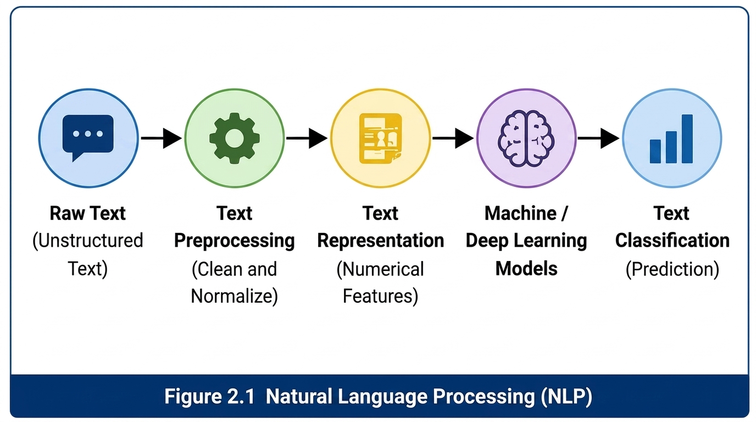

2.1.1 NLP Pipeline
The Natural Language Processing (NLP) pipeline refers to a sequence of processing stages that transform raw textual data into structured information suitable for computational analysis and classification. Although the implementation may vary depending on the application, a typical NLP pipeline consists of data collection, text preprocessing, feature representation, model training, text classification, and performance evaluation. This pipeline enables machine learning and deep learning models to effectively analyze textual information and generate meaningful predictions [6].
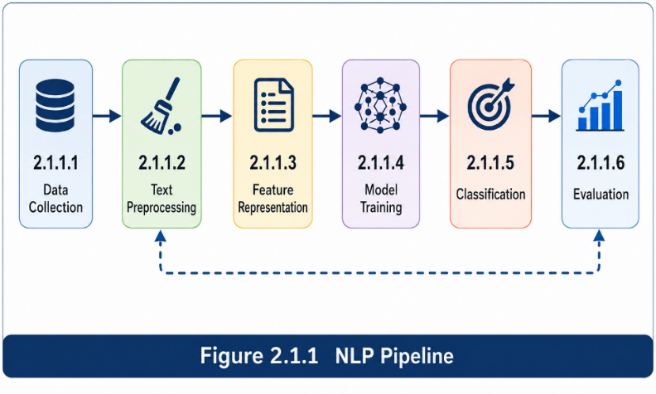

2.2 Text Preprocessing
Text preprocessing is the process of cleaning, normalizing, and transforming raw textual data into a consistent format before feature extraction and model training. The objective of preprocessing is to reduce textual noise, eliminate irrelevant information, standardize the input data, and improve the effectiveness of machine learning and deep learning algorithms for text classification [2].
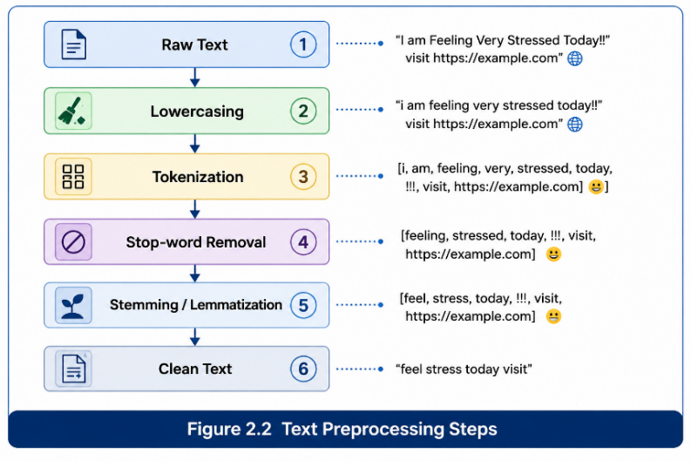

2.2.1 Tokenization
Tokenization is the process of dividing textual data into smaller units, known as tokens, which may represent words, subwords, or sentences. This process converts continuous text into manageable linguistic units that can be processed by Natural Language Processing algorithms and machine learning models [2].
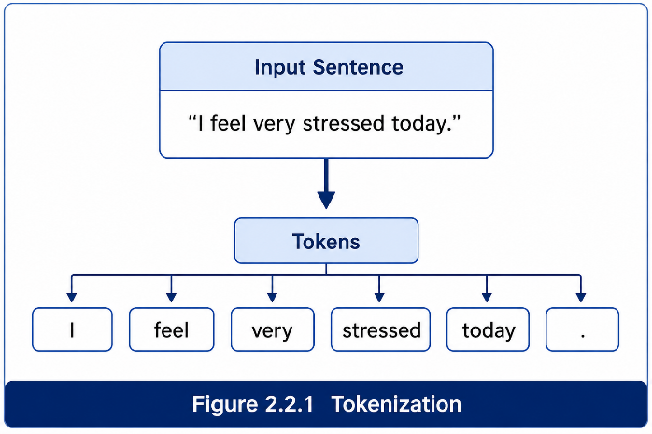

2.2.2 Stop-word Removal
Stop-word removal is a preprocessing technique that eliminates frequently occurring words with limited semantic value, such as articles, conjunctions, and auxiliary verbs. Removing these words reduces data dimensionality, decreases computational complexity, and allows classification models to focus on more informative textual features [6].
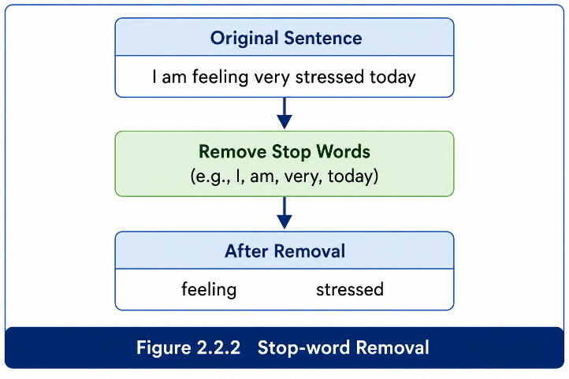

2.2.3 Stemming
Stemming is a text normalization technique that reduces inflected or derived words to their root or stem form. By grouping words with similar morphological structures into a common representation, stemming decreases vocabulary size and improves the efficiency of text classification algorithms [4].
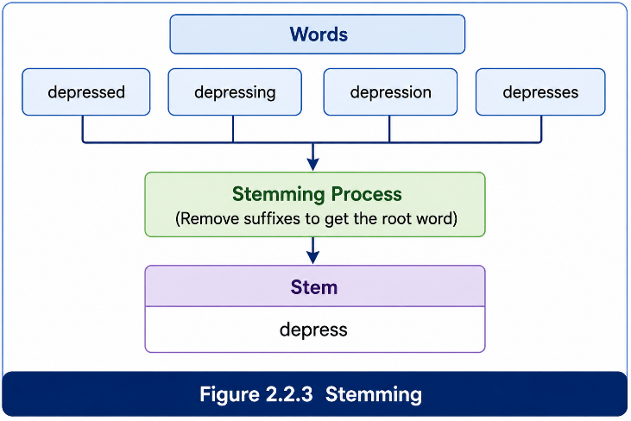

2.3.1 Bag-of-Words (BoW)
Bag-of-Words (BoW) is a traditional text representation technique that converts documents into numerical vectors based on the occurrence or frequency of words within a predefined vocabulary. Each document is represented independently of word order, making BoW computationally efficient but unable to capture contextual or semantic relationships between words [6].
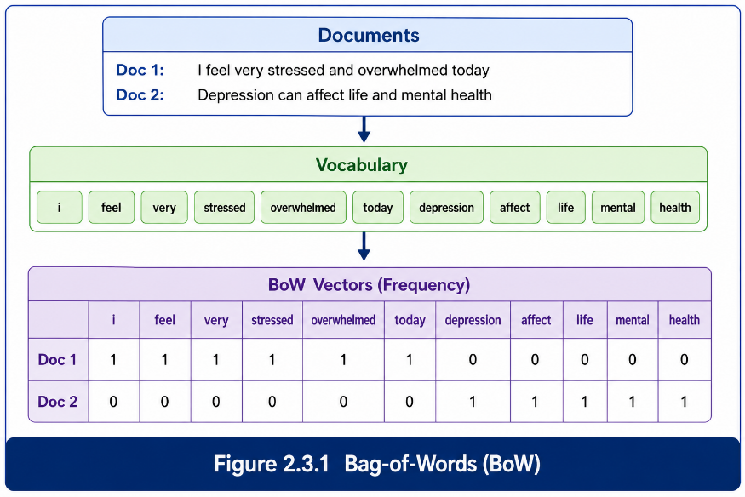

2.3.2 N-grams
N-grams are text representation units consisting of consecutive sequences of words extracted from textual data. A unigram represents a single word, a bigram represents two consecutive words, and a trigram represents three consecutive words. Compared with the Bag-of-Words model, N-grams preserve limited local word-order information and can capture short contextual patterns within text [15].
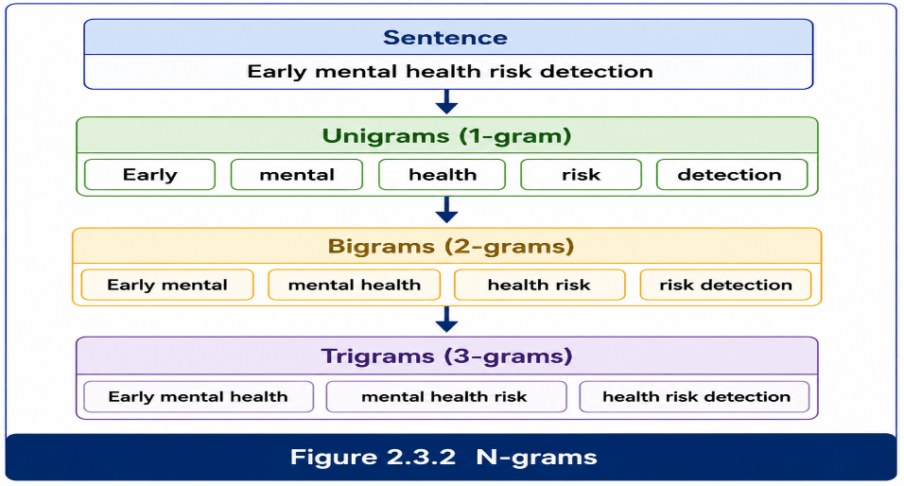

2.3.3 Term Frequency–Inverse Document Frequency (TF-IDF)
Term Frequency–Inverse Document Frequency (TF-IDF) is a statistical text representation technique that assigns a weight to each term according to its frequency within a document and its rarity across the entire document collection. Words that appear frequently in a specific document but infrequently in other documents receive higher weights, enabling the representation to emphasize discriminative textual features while reducing the influence of common words [1].
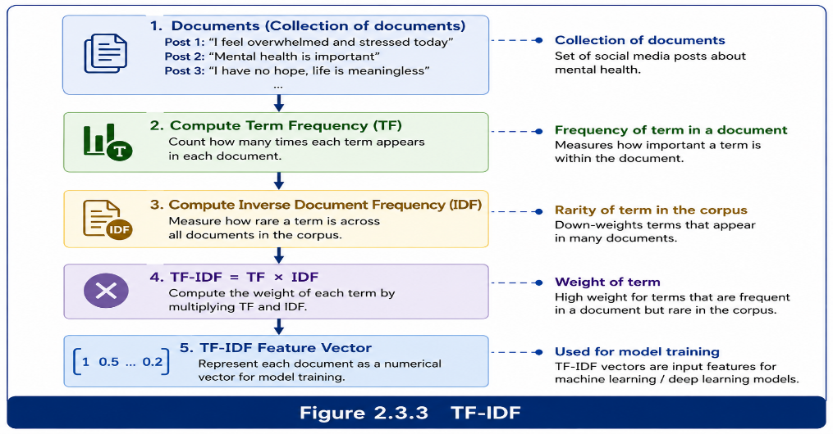

2.3.4 Word2Vec
Word2Vec is a distributed word embedding technique that learns dense numerical vector representations by analyzing the contextual relationships between words in a text corpus. Words that occur in similar contexts are mapped to nearby positions in the embedding space, enabling semantic similarities to be captured more effectively than traditional frequency-based representations [2].
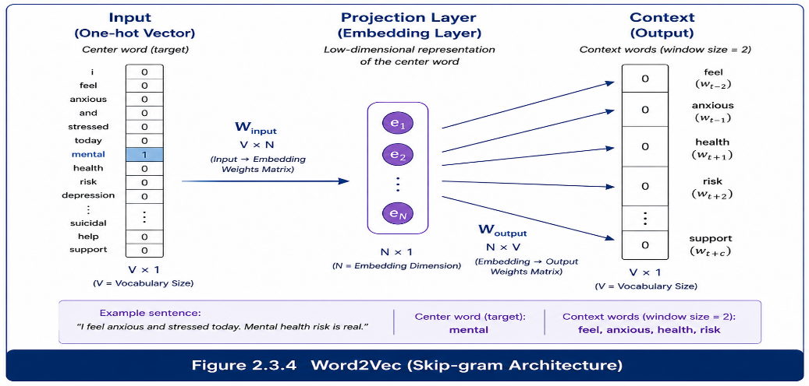

2.3.5 GloVe
Global Vectors for Word Representation (GloVe) is a distributed word embedding method that generates dense vector representations by learning global word co-occurrence statistics from a large text corpus. Unlike local context-based embedding techniques, GloVe captures semantic relationships by considering the overall distribution of words across the corpus [3].
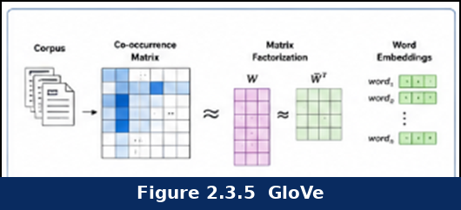

2.3.6 FastText
FastText is a distributed word embedding technique that extends Word2Vec by representing words as collections of character-level subword units. This approach enables the model to generate meaningful vector representations for rare, misspelled, and previously unseen words, making FastText particularly suitable for processing informal social media text [3].
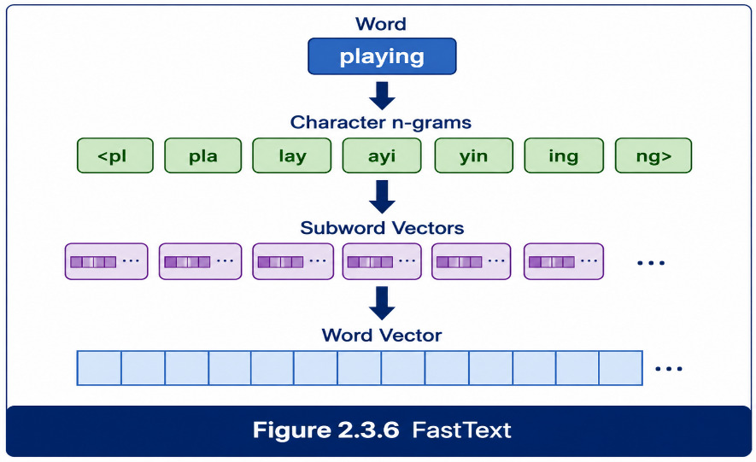

Chapter 4 Proposed Approach (Methodology)

Chapter 5: Experimental Results and Discussion

Chapter 6 Conclusion and Future Work

References
[1] Bokolo, B. G., & Liu, Q. “Deep Learning-Based Depression Detection from Social Media: Comparative Evaluation of ML and Transformer Techniques.” Electronics, vol. 12, no. 21, 4396, 2023.
[2] S. Almutairi, M. Abohashrh, H. H. Razzaq, M. Zulqarnain, A. Namoun and F. Khan, "A Hybrid Deep Learning Model for Predicting Depression Symptoms from Large-Scale Textual Dataset," in IEEE Access, vol. 12, pp. 168477-168499, 2024, doi: 10.1109/ACCESS.2024.3496741. keywords: {Depression; Accuracy; Social networking (online); Feature extraction; Long short term memory; Support vector machines; Deep learning; Blogs; Predictive models; Convolutional neural networks; Mental health; Deep learning; convolution neural network;long short-term memory; attention mechanism; depression detection}
[3] Rastogi, A., Liu, Q., & Cambria, E. “Stress Detection from Social Media Articles: New Dataset Benchmark and Analytical Study.” 2022 International Joint Conference on Neural Networks, IJCNN, 2022.
[4] Bae, Yi Ji, Midan Shim, and Won Hee Lee. "Schizophrenia detection using machine learning approach from social media content." Sensors 21.17 (2021): 5924.‏
[5] Roy, Arunima, et al. "A machine learning approach predicts future risk to suicidal ideation from social media data." NPJ digital medicine 3.1 (2020): 78.‏
[6] Rastogi, K., Rani, R., Prakash, K. B., & Gupta, D. (2022). Stress detection using natural language processing and machine learning over social interactions. Journal of Big Data, 9, 33.
[7] Sharma, S. K., Gaur, A., Gupta, D., & Wang, L. (2022). Machine learning-based proactive social-sensor service for mental health monitoring using Twitter data. Journal of Innovation & Knowledge, 7(4)
[8] Figuerêdo, J. S. L., Maia, A. L. L. M., & Calumby, R. T. (2022). Early depression detection in social media based on deep learning and underlying emotions. Online Social Networks and Media, 31, 100225. https://doi.org/10.1016/j.osnem.2022.100225
[9] Kumar, A., Sharma, A., & Arora, A. (2022). A hybrid deep learning approach for depression prediction from user tweets using feature-rich CNN and bi-directional LSTM. Multimedia Tools and Applications, 81, 23649–23685.
[10] Kerasiotis, M., Ilias, L., & Askounis, D. (2024). Depression Detection in Social Media Posts Using Transformer-Based Models and Auxiliary Features. Social Network Analysis and Mining, 14, 196.
[11] Renjith, Shini, Annie Abraham, Surya B. Jyothi, Lekshmi Chandran, and Jincy Thomson. “An Ensemble Deep Learning Technique for Detecting Suicidal Ideation from Posts in Social Media Platforms.” Journal of King
[12] Rabani, Syed Tanzeel, Akib Mohi Ud Din Khanday, Qamar Rayees Khan, Umar Ayoub Hajam, Ali Shariq Imran, and Zenun Kastrati. Detecting Suicidality on Social Media: Machine Learning at Rescue.” Egyptian Informatics Journal, vol. 24, no. 2, 2023, pp. 291–302. https://doi.org/10.1016/j.eij.2023.04.003
[14] Hasan, K., & Saquer, J. (2024). A Comparative Analysis of Transformer and LSTM Models for Detecting Suicidal Ideation on Reddit. Proceedings of ICMLA 2024.
[15] Qasim, A., Mehak, G., Hussain, N., Gelbukh, A., & Sidorov, G. (2025). Detection of Depression Severity in Social Media Text Using Transformer-Based Models. Information, 16(2), 114.

