Classification of Plant Diseases
Ghufran Mohammed
Artificial Intelligence, Midocean University
Dr. Hager Saleh

Abstract

Keywords:

Table of Contents
Classification of Plant Diseases 1
Abstract 2
1. Introduction 4
2. Related Work 5
3. Methodology 7
4. Implementation 9
5. Performance Evaluation 10
6. Conclusion 11
7. References 12

Introduction

Related Work
In [1] Grünig et al. applied Deep neural networks (DNN) to predict plant diseases. They created a dataset consisting of environmental data and historical plant disease data. The model is trained on multiple data sources, which gives strength to the model. The model is characterized by high accuracy in the prediction and integration of different data sources. The limitation of this model is historical data requirements. Finally, the model achieved an accuracy of 85%, which helped manage plant diseases.

In [2] Sharma et al. applied Convolutional Neural Networks (CNNs) to classify plant diseases. They used the PlantVillage dataset containing more than 50,000 diverse images of diseased and healthy plant leaves. That gives a large training set by the dataset. This model works with a layered structure to extract the classification. This model gives very accurate results and provides automated diagnosis which makes it practical to implement in the real world. The Limitations of this model are low-resolution images, and it requires a large dataset. This model achieved 98% accuracy which shows great results.

In [3], Akshai and Anitha used a deep learning (DL) model using (CNN) to classify plant diseases. They collected them from local agricultural sources. The dataset contained thousands of images. The model is adaptive to a variety of plant species, making it suitable for various crops. It is also compatible with a mobile application, which has enhanced its use in science. The model has an accurate performance. One of the limitations of this application is that it relies on high-quality images. However, the model achieved an accuracy of 94%, which gives it reliability in the real world.

In [4] Chen, Zhang, and Nanehkaran applied Deep Learning with a lightweight neural network to identify plant diseases. They used the PlantVillage dataset, which contains more than 50,000 images and many types, to train the model. The computational efficiency of this model was improved by reducing the computational requirements, speeding up the inference time, and giving more accurate results. This model is considered good, but its limitations include not working with new types of diseases. However, it showed 96% accuracy results, which were effectively used to reduce computational resources.

In [5] Suresh et al. developed the DeepPlantNet model, which uses deep learning to classify diseases from plant leaf images. The plant dataset used to train the model was collected from different sources, which gave the possibility of scaling to different plants. One of the main limitations of this model is that training the data requires large computational resources and needs to be updated with new data to maintain a high level of accuracy. This model achieved an accuracy of up to 97%, which confirmed its effectiveness in classifying diseases.

In [6], Subasi, Gulam, and Sadikoglu use deep learning to build a model to detect maize leaf diseases. They collected a dataset from local sources consisting of maize leaf images and trained the model on these images. The advantage of this model is that it is a mobile-based system and can be used in real-time. This makes it practical and easy to use for farmers. The model was limited to maize leaves and relied on the accuracy of the image quality. However, it achieved a performance of 92%.

In [7] Kaur et al. developed a mobile application to detect maize leaf diseases using deep learning algorithms. They used a dataset from agricultural research centers to train the model. The model can be used in real time to give immediate results, so the model is practical for farmers. The model has accurate results of 93%, but the performance is affected by environmental factors such as lighting conditions.

 | Methodology | Dataset | Advantages | Limitations | Results
  Author
Grünig et al. (2021) | DNN to predict disease incidence | consisting of environmental data and historical plant disease data. | High accuracy data and analyzes complex datasets | Data quality affects accuracy and historical data requirements | Successful predictions for disease with an accuracy of 85%
Sharma et al. (2022) | CNNs for image classification of plant diseases | PlantVillage dataset. | High accuracy, automates detection | Requires large datasets, low-resolution images | High classification accuracy 98% achieved
Akshai & Anitha (2021) | CNN models trained on leaf images | collected dataset from local agricultural sources | efficient classification | Sensitivity to overfitting and depend on high-quality images | classification  accuracy of 94%
Chen et al. (2023) | Deep transfer learning with lightweight network | PlantVillage dataset and additional images from online sources. | Faster training, reduced resource needs | Performance dependent on base model so not working with new types of diseases | Effective disease identification showed 96% accuracy
Suresh et al. (2023) | DeepPlantNet for disease classification | collected from different sources | High accuracy and efficiency and possibility of scaling to different plants | Requires substantial resources and large computational resources | classification performance achieved an accuracy of up to 97%
Subasi et al. (2022) | Mobile-based system using DL | Collected dataset for maize plant leaf diseases. | Practical application for farmers | Internet access required, light condition issues and image quality | Successful real-time disease detection 92% accuracy
Kaur et al. (2023) | Mobile-based system for disease detection | Custom dataset for maize plant leaf diseases. | Quick diagnosis, user-friendly | Accuracy may vary in diverse conditions | Effective classification with accurate results of 93%

Methodology
In this research potato datasets are used and taken from the PlantVillage Kaggle images dataset. We have focused on three categories of potato diseases: early blight, late blight, and healthy plants. The dataset is divided into 80:20 subsets and organized for training and validation purposes. where 80% of the images are used for training and 20% of the images are used for testing the potato dataset. The potato leaf dataset containing a total of 2152 images is used in the study. The sample of the potato leaves is shown in Fig 1. Tab. 1 represents the number of training and testing images of the datasets.
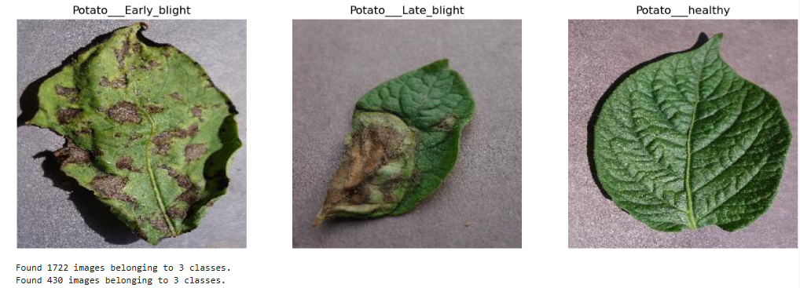
Figure 1: Sample image of potato leaf diseases, early blight, late blight and healthy
  Image Dataset and class
  Image Dataset
  Image Dataset
  Image Dataset
Potato___Early_blight | 1000 | 800 | 200
Potato___Late_blight | 1000 | 800 | 200
Potato___healthy | 152 | 121 | 31
Table 1: Potato leaf datasets
During the preprocessing stage, some techniques applied to this model included cropping, zooming, random rotation, horizontal flips, and frequent transformations due to diversity in training data to ensure the model is generalized and reduces overfitting. All the images are resized to 128 X 128 pixels. Resized images of the potato dataset are shown in Fig 2
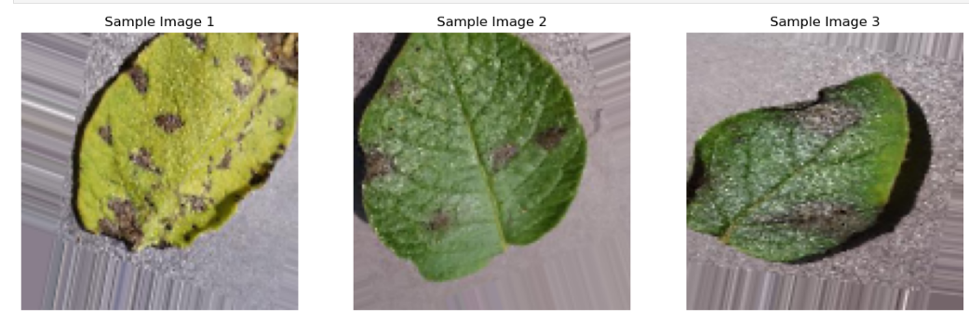Figure 2: Resized potato leaf dataset
The model is based on deep learning CNN to classify plant diseases using images. Build on based three convolutional layers. Each of these layers is followed by a max pooling layer to decrease the spatial dimensions gradually and build a hierarchy of features. To go from feature maps to a fully connected neural network, the model included a flattening layer that led to a softmax layer for classification you can see in Fig 3.
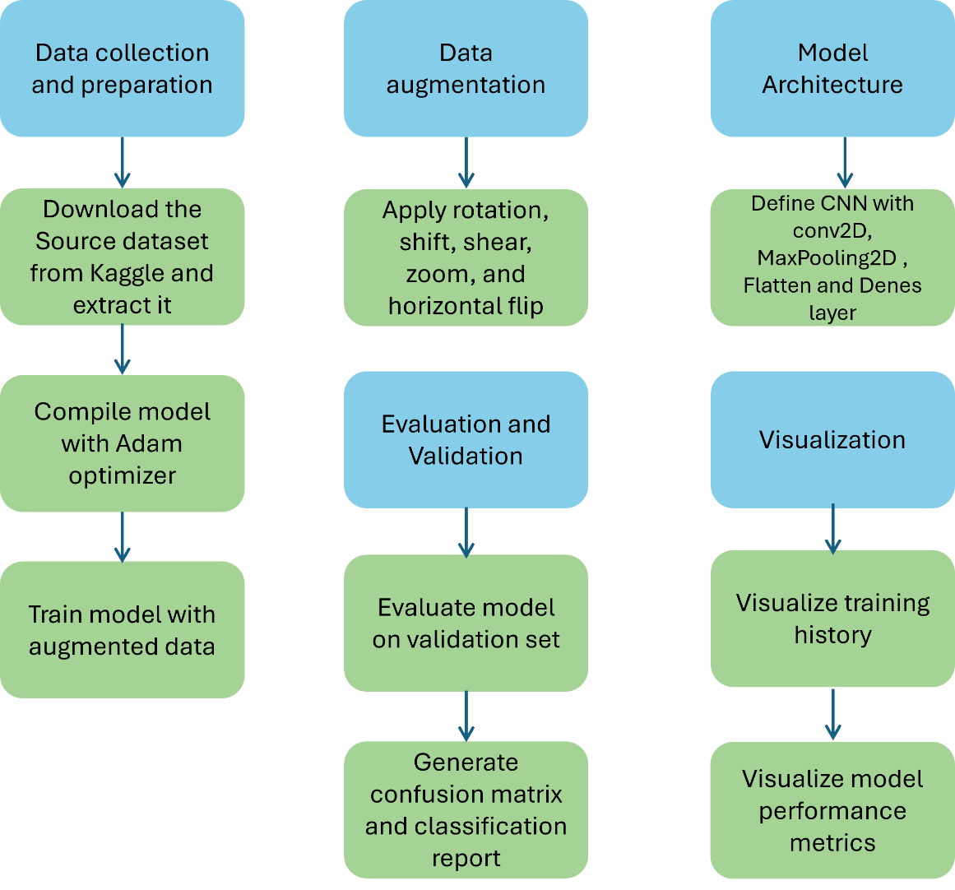
Figure 3: Model architecture

Implementation
To apply the model with machine learning image classifiers for plant disease, we have used Python libraries such as TensorFlow, Keras, NumPy, Matplotlib, and Seaborn. This model is trained for potato datasets. Tab.2 presents the hyper-parameters configurations of the CNN model architecture as shown in Fig 3. The model was compiled and optimized with a learning rate of 0.0001 and a cross-entropy loss.
Parameter | Value
Optimizer | Adam and learning rate = 0.0001
Loss | Categorical Crossentropy
Batch Size | 32
Metrics | Accuracy
Activation Function | ReLU (for hidden layers)  Softmax (for output layer)
Table 2: CNN model training parameters

Training (Accuracy & Loss) Graphs of the CNN Model
The model for the designed CNN models to classify potato datasets was trained for 50 epochs. The validation accuracy achieved 97.44% through monitoring performance metrics such as accuracy on training and validation datasets. The training graphs show model accuracy and loss in Figs 4 for the respective models.

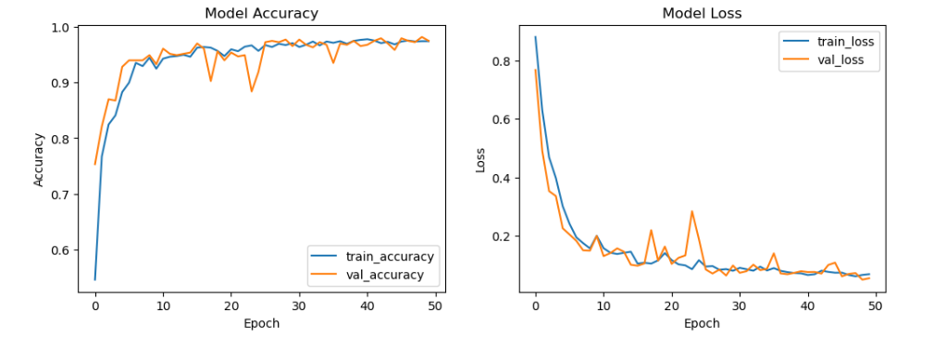Figure 4: Training–progress graphs (CNN model trained with potato dataset)

Performance Evaluation
In this study, we use the Precision, accuracy, recall, and F1 scores to calculate and evaluate the performance of the model as shown in Table 3. We create a confusion matrix to see the classification performance across different classes in Fig 5.
Visualization
The accuracy and loss curves are used to assess the progress of the training. A heat map of the confusion matrix provided insights into the classification capabilities of the model.
Classifier | Accuracy | Precision | Recall | F1-Score
CNN | 0.95 | 0.94 | 0.95 | 0.94
Table 3: Performance result of CNN classifier on potato dataset
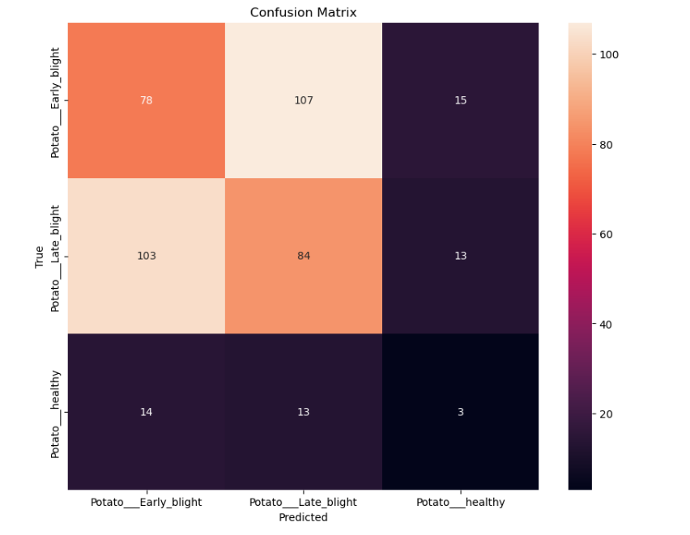Figure 4: Confusion matrix obtained for training using potato dataset

Conclusion

References
- Grünig, Marc, et al. "Applying deep neural networks to predict incidence and phenology of plant pests and diseases." Ecosphere 12.10 (2021): e03791.
- Sharma, Rahul, et al. "Plant Disease Diagnosis and Image Classification Using Deep Learning." Computers, Materials & Continua 71.2 (2022).
- Akshai, K. P., and J. Anitha. "Plant disease classification using deep learning." 2021 3rd International Conference on Signal Processing and Communication (ICPSC). IEEE, 2021.
- Chen, J., Zhang, D., & Nanehkaran, Y. A. "Identifying plant diseases using deep transfer learning and enhanced lightweight network." IEEE Access 11 (2023): 10286031.
- Suresh, J., Barath, S., Kumar, D. V. S., Janakiraman, P., & Sekar, D. R. "An Effective Approach for Plant Leaf Diseases Classification Based on a Novel DeepPlantNet Deep Learning Model." IEEE Access 11 (2023): 10410019.
- Subasi, A., Ghulam, A., & Sadikoglu, F. "A Mobile-Based System for Maize Plant Leaf Disease Detection and Classification Using Deep Learning." IEEE Access 10 (2022): 9855925.
- Kaur, H., Ghosal, S., & Singh, V. "A Mobile-Based System for Maize Plant Leaf Disease Detection and Classification Using Deep Learning." Frontiers in Plant Science 14 (2023): 1079366.

