

المملكة العربية السعودية
جامعة ميدأوشن
كلية الإدارة
قسم إدارة الأعمال

التنوع والتحديات التي تواجهها الإدارات لتعظيم الفوائد في منظمات القطاع الخاص السعودي

بادي سلطان عبد الله العتيبي
الرقم التعريفي: 241001017
MGM-697: المشروع النهائي

تحت إشراف
د. الفيصل عبد الحميد محمد حسن
أطروحة مقدمة استكمالاً لمتطلبات الحصول على درجة الماجستير في إدارة الأعمال
2025

Kingdom of Saudi Arabia
Midocean University
College of Business Administration
Business Administration Department

Diversity and Challenges Faced by Managements to Maximize Benefits in the Saudi Private Organizations

Badi Sultan Abdullah Otaibi
ID: 241001017
MGM-697: Final Project

Under the Supervision of
Dr. Alfaisal Hasan
Thesis Submitted in Partial Fulfillment of the Requirements for The Master’s Degree in Business Administration
2025

Certificate of Originality
I am honoured to declare that this research paper titled “Diversity and Challenges Faced by Managements to Maximize Benefits in the Saudi Private Organizations” my own work and to the best of my knowledge. It contains no materials previously published or written by another person, nor material which to a substantial extent has been accepted for the award of any degree or diploma at Midocean University or any other educational institute, except where due acknowledgement, is made in the thesis. I also declare that the intellectual content of this thesis is the product of my own work, except to the extent that assistance from others in the project’s design and conception or style, presentation and linguistic is acknowledged. I also verified the originality of contents through plagiarism software.

Signature
Badi S. Otaibi
________________
(2025)

Acknowledge
Praise be to Allah, Lord of the Worlds, I would not have reached this moment to write this acknowledge without Allah's Guidance Almighty, so, Praise is to Allah for his grace.
- To all those who supported me even by prayer or supplication to Allah, thank you.
- To all those who have inspired me, even unintentionally, thank you.
- To who believed that I could fulfil this dream, who supported me, who paved the road for me, who convinced me that the more obstacles, the greater the success, to my inspiring and supportive family, thank you.
- To the fantastic person who put me on the right path, who corrected my mistakes, who supported me when I was despairing, who raised my self-confidence, to the leader of the road, to my virtuous supervisor, dr. Alfaisal Hasan, thank you.

Dedication
In such situations, people are usually grateful to those who inspired or supported them, forgetting that they are the true heroes and deserve gratitude as well.
Although I owe this moment to people whose virtue and support cannot be ignored, I would like to tell myself some notes.
To Badi, to me!
 Thank you for making our dream come true.
- But remember! It would not have been possible without Allah's will.
 Thank you for doing your best to achieve our goal.
- But remember! There are many supporters who didn’t complain.
Thank you for making the effort and facing the hardships!
- But remember! Who asks for the glory must stay up nights.
Thank you for ignoring the malevolent and inhibitor!
- But remember! They were unintentionally motivating us.
Thank you for believing that we can!
- But remember! It is just a start.
Thank you for reaching this moment!
- But remember! This is not all.
This is not all.

الملخص
إن تعظيم التنوع في القوى العاملة في القطاع الخاص السعودي يعد أمرًا بالغ الأهمية بالنسبة للحكومة السعودية لتحقيق أهداف برنامج التحول الوطني والاقتصادي ورؤية المملكة 2030. الهدف العام لهذه الدراسة هو استقصاء التحديات التي تواجهها الإدارات لتعظيم فوائد التنوع في مؤسسات القطاع الخاص السعودي. اعتمدت الدراسة على أربعة أبعاد رئيسية: تحديد أبعاد التنوع في المجتمع السعودي، الوضع الفعلي الحالي للتنوع في مكان العمل في مؤسسات القطاع الخاص السعودي، التحديات التي تواجه تعزيز التنوع في القطاع الخاص، وحقيقة مبادرات التوطين التي تبنتها الحكومة السعودية لتعظيم فوائد التنوع في القوى العاملة.
لتحقيق هذه الأهداف، قامت الدراسة أولاً بمراجعة عدة أنواع من الأدبيات والدراسات ذات الصلة لفهم نظرية التنوع في مكان العمل وتقنياته، وأنماطه، وأنواعه، وأدواته، وفوائده. ولتحقيق أهداف البعدين الأولين من الدراسة المتعلقين بجوانب التنوع في المجتمع السعودي والوضع الفعلي الحالي للتنوع في مؤسسات القطاع الخاص، قامت الدراسة بمراجعة وتحليل ومناقشة البيانات الواردة في التقارير الرسمية الصادرة عن الهيئة العامة للإحصاء (GAStat)، ووزارة الخدمة المدنية (MCS)، والهيئة العامة للتأمينات الاجتماعي(GASI)، والمركز الوطني للمعلومات (NIC). أشارت نتائج هذا التحليل إلى أن المجتمع السعودي يتمتع بأبعاد متعددة للتنوع، بما في ذلك الجنس، والعمر، والتعليم، والعرق، والإعاقة، وغيرها. كما أشارت نتائج المناقشة إلى أن هذا التنوع غير موجود فعليًا في مؤسسات القطاع الخاص السعودي؛ حيث تعتمد هذه المؤسسات بشكل شبه كامل على العمالة غير السعودية.
ولتحقيق أهداف البعدين الآخرين، نشرت الدراسة استبيانًا إلكترونيًا منظمًا على 76 مديرًا في شركات تابعة للقطاع الخاص ومسجلة في السوق المالية السعودية. شملت العينة فئات مختلفة من المديرين مثل المديرين العامين، ومديري الموارد البشرية، ومديري الفروع، ومديري المصانع، ومديري التسويق في 30 قطاعًا مختلفًا مثل التعليم، والصحة، والبتروكيماويات، والاتصالات، وغيرها. وهدف الاستبيان إلى استكشاف وجهات نظر المشاركين حول التحديات التي تواجه تعزيز التنوع في القطاع الخاص السعودي، بالإضافة إلى آرائهم حول سياسات التوطين التي تتبعها الحكومة السعودية لتعظيم تنوع القوى العاملة.
أشارت نتائج الاستبيان إلى وجود تحديين رئيسيين يعيقان تنوع القوى العاملة في القطاع الخاص: الاعتماد المفرط على العمالة الأجنبية، وعدم توفر فرص عمل مناسبة للنساء السعوديات في القطاع الخاص. وأظهرت النتائج أن السبب الرئيسي لاعتماد القطاع الخاص على الموظفين الأجانب هو انخفاض تكلفتهم مقارنة بتكلفة توظيف السعوديين. ولم تشير النتائج إلى أن الموظفين السعوديين يفتقرون إلى المهارات والكفاءات اللازمة لتلبية متطلبات القطاع الخاص. كما أكدت النتائج أن السياق الاجتماعي السعودي يحول دون عمل النساء في معظم الوظائف في القطاع الخاص. من ناحية أخرى، أشارت النتائج إلى وجود عدة قصور في مبادرات التوطين التي تنفذها الحكومة السعودية. وخلصت الدراسة إلى ضرورة إعادة هيكلة وتصميم برامج التوطين بالتنسيق مع القطاع الخاص لتعظيم فوائد التنوع في مكان العمل.

الكلمات المفتاحية: التنوع في مكان العمل، إدارة التنوع، رؤية السعودية 2030، التوطين، التنوع في السعودية، العمالة غير السعودية، القطاع الخاص، النساء السعوديات.

Abstract
Maximising workplace diversity in the Saudi private sector is crucial for the Saudi government to achieve the objectives of the National and Economic Transformation Program and the Saudi Vision 2030. The overall aim of this study is to investigate the challenges faced by managements to maximise the benefits of diversity in the Saudi private sector organisations. The study was based on four main dimensions: determining the dimensions of diversity of the Saudi population, the current actual situation of diversity in the workplace in Saudi private sector institutions, the challenges faced by promoting diversity in the private sector, and the reality of Saudization initiatives adopted by the Saudi government to maximize the benefits of diversity in the workforce.
To accomplish these goals, the study first reviewed several kinds of related literature and studies to understand the theory of diversity in the workplace and its techniques, paradigms, types, tools and benefits. In order to achieve the objectives of the first two dimensions of the study related to the aspects of diversity in the Saudi population and the current actual situation of diversity in private sector organizations, the study reviewed, analyzed and discussed the data of the official reports issued by the Saudi General Authority for Statistics (GAStat), the Ministry of Civil Service (MCS), the General Authority for Social Insurance (GASI) and the Saudi National Information Center (NIC). The results of that analysis indicated that the Saudi population has many dimensions of diversity, including sex, age, education, race, disability and others. The results of the discussion also indicated that this diversity does not actually exist in Saudi private sector institutions because they depend almost entirely on non-Saudi labour.
To achieve the objectives of the other two dimensions, the study published an online structured questionnaire on 76 managers in companies belonging to the private sector and registered in the Saudi stock market. The sample included different categories of managers such as general managers, human resources managers, branch managers, factory managers and marketing managers in 30 different sectors such as education, health, petrochemicals, telecommunications and others. The questionnaire aimed at exploring the perspectives of participants in the challenges faced by promoting diversity in the Saudi private sector as well as their views on the Saudization policies of the Saudi government to maximise workplace diversity.
The results of the questionnaire pointed to two main challenges that hinder workforce diversity in the private sector: the excessive reliance on foreign labour and the lack of appropriate job opportunities for Saudi women in the private sector. The results indicated that the main reason for the private sector dependence on foreign employees is the low cost compared to the cost of employing Saudis. The results did not suggest that Saudi employees don’t have the skills and competencies necessary to meet the requirements of the private sector. The results also confirmed that the Saudi social context prevents women from working in most private-sector jobs. On the other hand, the results indicated that there are several shortcomings in the Saudization initiatives implemented by the Saudi government. The study concluded that Saudization programs should be restructured and redesigned in coordination with the private sector to maximise the benefits of diversity in the workplace.

Keywords: Diversity in the Workplace, Diversity Management, Saudi Vision 2030, Saudization, Diversity in Saudi Arabia, Non-Saudi Employees, Private Sector, Saudi Women.

Table of Contents
Certificate of Originality …………………………………………………………………... |  |  |  | 2
Acknowledge ……………………………………………………………………………… |  |  |  | 3
Dedication …………………………………………………………………………………. |  |  |  | 4
الملخص ...…………………………………………………………………………………… |  |  |  | 6
Abstract ……………………………………………………………………………………. |  |  |  | 8
Table of Contents ………………………………………………………………………….. |  |  |  | 10
List of Tables ……………………………………………………………………………… |  |  |  | 12
List of Figures ……………………………………………………………………………... |  |  |  | 14
 | CHAPTER ONE: INTRODUCTION ……………………………………………... |  |  | 16
 | I.I | Background of the Study ………………………………………………….. |  | 18
 | I.II | Statement of the Problem …………………………………………………. |  | 20
 | I.III | Research Hypothesis ……………………………………………………… |  | 21
 | I.IV | Research Objectives ………………………………………………………. |  | 21
 | I.V | Research Outline ………………………………………………………….. |  | 21
 | CHAPTER TWO: RESEARCH METHODOLOGY ……………………………... |  |  | 24
 | II.I | Data Sources ……………………………………………………………… |  | 25
 | II.II | Research Tools ……………………………………………………………. |  | 25
 | II.III | Sampling ………………………………………………………………….. |  | 27
 | CHAPTER THREE: THEORETICAL FRAMEWORK ………………………….. |  |  | 29
 | III.I | Literature Review …………………………………………………………. |  | 30
 |  | III.I. I | Diversity Definitions and dimensions ………………………… | 30
 |  | III.I. II | Benefits of Diversity ………………………………………….. | 32
 |  | III.I.III | Diversity Management Definition ……………………………. | 31
 |  | III.I. IV | Diversity Management Paradigms ……………………………. | 34
 |  | III.I. V | Significance of Workforce Diversity Management …………... | 39
 |  | III.I. VI | Workforce Diversity Management Techniques ………………. | 41
 | III.II | Diversity in Saudi Arabia …………………………………………………. |  | 43
 |  | III.II.I | Demographic Features of Saudi Population …………………... | 43
 |  | III.II.II | Challenges of Diversity in Saudi Arabia ……………………… | 51
 | III.III | Previous Related Studies ………………………………………………….. |  | 55
 | CHAPTER FOUR: RESULTS & DISCUSSION …………………………………. |  |  | 56
 | IV. I | Results of Statistical Reports ……………………………………………... |  | 58
 | IV.II | Results of the Questionnaire ……………………………………………… |  | 65
 | IV.III | Findings & Discussion ……………………………………………………. |  | 94
 |  | IV.III.I | The current status of diversity ………………………………… | 94
 |  | IV.III.II | Challenges of diversity in the Saudi private sector …………… | 95
 |  | IV.III.III | Saudization Policies …………………………………………... | 96
 |  | IV.III.IV | Possible solutions and recommendations ……………………... | 98
Conclusion ………………………………………………………………………………… |  |  |  | 99
References …………………………………………………………………………………. |  |  |  | 101
Appendixes ………………………………………………………………………………... |  |  |  | 107

List of Tables
Table 1 | : The Educational Status of Saudis According to Their Age Group. | 47
Table 2 | : Saudis with Disabilities by Their Age Group and Sex. | 48
Table 3 | : Saudis with Disabilities by Their Age Group and Educational Status | 49
Table 4 | : Saudis with Disabilities According to Their Work / Job Status. | 50
Table 5 | : Total Employees by Sex, Nationality and Adopted Regulations | 58
Table 6 | : Total Employees by Sex, Nationality and Sector. | 59
Table 7 | : Average Monthly Wages per Paid employee by Sex and Nationality. | 61
Table 8 | : Total Unemployment Rate of Population (15 +) by Sex and Nationality. | 61
Table 9 | : Total Employed persons by Sex, Nationality and Age group. | 62
Table 10 | : Distribution of Labour Force by Sex, Nationality & Educational Level. | 64
Table 11 | : The participants’ gender | 65
Table 12 | : The participants’ age | 66
Table 13 | : The participants’ nationality. | 67
Table 14 | : The participants’ business sector. | 68
Table 15 | : The participants’ administrative position. | 69
Table 16 | : The participants’ preferred language. | 70
Table 17 | : Reliability Analysis Cronbach’s Alpha. | 70
Table 18 | : General attitude’s balance, according to Likert’ 5-point scale. | 71
Table 19 | : The participants’ responses to Statement 1. | 72
Table 20 | : The weighted mean of the participants’ responses to statement 1. | 73
Table 21 | : The weighted mean of the participants’ responses to statements 2 and 3. | 75
Table 22 | : The weighted mean of the participants’ responses to statement 9. | 76
Table 23 | : The weighted mean of the participants’ responses to statement 10. | 77
Table 24 | : The weighted mean of the participants’ responses to statements 4 and 7. | 79
Table 25 | : The weighted mean of the participants’ responses to statement 8. | 80
Table 26 | : The weighted mean of the participants’ responses to statement 6. | 81
Table 27 | : The weighted mean of the participants’ responses to statement 5. | 83
Table 28 | : The mean and general attitude of responses to statements 11 -15. | 87
Table 29 | : The weighted mean of the participants’ responses to statement 16. | 88
Table 30 | : The weighted mean of the participants’ responses to statement 17. | 89
Table 31 | : The weighted mean of the participants’ responses to statement 18. | 90
Table 32 | : The weighted mean of the participants’ responses to statement 19. | 91
Table 33 | : The weighted mean of the participants’ responses to statement 20. | 92

List of Figures
Figure 1 | : Gardenswartz & Rowe (1994) Four Layers of Diversity Model. | 31
Figure 2 | : Population by Nationality (Saudi/ Non-Saudi) and Administrative Area. | 44
Figure 3 | : Saudi Population Pyramid. | 45
Figure 4 | : Total Employed persons by Sex and Age group. | 63
Figure 5 | : Distribution of Saudi Citizens Labour Force by the Educational Status. | 64
Figure 6 | : The frequency of participants’ responses to statement 1. | 73
Figure 7 | : The frequency of participants’ responses to statement 2. | 74
Figure 8 | : The frequency of participants’ responses to statement 3. | 74
Figure 9 | : The frequency of participants’ responses to statement 9. | 76
Figure 10 | : The frequency of participants’ responses to statement 10. | 77
Figure 11 | : The frequency of participants’ responses to statement 4. | 78
Figure 12 | : The frequency of participants’ responses to statement 7. | 78
Figure 13 | : The frequency of participants’ responses to statement 8. | 80
Figure 14 | : The frequency of participants’ responses to statement 6. | 81
Figure 15 | : The frequency of participants’ responses to statement 5. | 82
Figure 16 | : The frequency of participants’ responses to statement 11. | 84
Figure 17 | : The frequency of participants’ responses to statement 12. | 85
Figure 18 | : The frequency of participants’ responses to statement 13. | 85
Figure 19 | : The frequency of participants’ responses to statement 14. | 86
Figure 20 | : The frequency of participants’ responses to statement 15. | 86
Figure 21 | : The frequency of participants’ responses to statement 16. | 88
Figure 22 | : The frequency of participants’ responses to statement 17. | 89
Figure 23 | : The frequency of participants’ responses to statement 18. | 90
Figure 24 | : The frequency of participants’ responses to statement 19. | 91
Figure 25 | : The frequency of participants’ responses to statement 20. | 93

CHAPTER ONE
INTRODUCTION
Diversity in the workplace has become a business imperative, not just a banner raised by companies to gain community sympathy and trust. Promoting diversity in the workplace has many tangible and intangible benefits at the level of employees, organisation and country. At the individual level, diversity in the workplace promotes mutual respect among individuals and creates a synergistic work environment Stockdale & Crosby (2004). Although it may be challenging to achieve an ideal working environment, employees working in diverse teams or groups recognise the strengths and talent that this diversity brings. Accepting differences among team members leads employees to find their similarities, so when there are common goals, cooperation and synergies prevail over conflicts and tend to reinforce similarities to achieve the common objectives Grobler (2005).
The benefits of diversity in the workplace at the organisation level include enhancing business reputation as it is reflected in building an excellent reputation for the company. According to Koonce (2017), there is no doubt that this reputation is reflected in increasing profitability and creating new jobs for workers. Companies that promote diversity in their workforce grow their business reputation both inside and outside the organisation and gain the respect of their employees before their customers. Companies and organisations that engage in fair recruitment and appreciation of diversity attract diverse talent and win the loyalty of customers who prefer to do business with socially responsible organisations (Ashton, 2010). Moreover, diversity in the workplace is a vital factor affecting the organisation's ability to expand and access foreign markets. According to Agócs & Burr (1996), organisations that show respect for practices of diversity in the workplace are most able to spread horizontally and expand into new markets in foreign countries. Diverse business environments allow organisations to multinational business strategies and techniques that enable them to target new customer groups as well as gain and share experiences that enhance productivity and increase profitability.
At the country level, promoting diversity in the labour market guarantees many benefits such as reducing unemployment, increasing economic participation rates of the population, and attracting foreign direct investment. According to Wagner (2019), governments that promote workplace diversity policies can increase the economic empowerment of marginalised workers. In every country, there are many individuals marginalised by racism, discrimination against persons with disabilities or ageing. This unfair and illegal discrimination has serious economic consequences because it increases unemployment and wastes human and financial resources (Boshnak, Alsharif & Alharthi, 2023). Economies that support diversity in the workplace and fight policies of discrimination against minorities contribute to increasing employment rates for women, people with disabilities and the elderly, thereby reducing unemployment and increasing economic participation rates of the population. On the other hand, diverse work environments develop expertise and competencies, making them attractive to foreign direct investment and multinational companies (Kossek, Lobel & Brown, 2006).
Saudi Arabia has a promising economy, a vast labour market, and an ambitious vision for national and economic transformation. This vision aims to diversify Saudi federal income sources and transform its economy from an oil-based economy to a knowledge-based economy (Abaker et al., 2019). This shift requires attracting foreign direct investment, increasing economic participation rates for the Saudi population, reducing unemployment and creating new jobs. These objectives cannot be achieved without promoting diversity practices in the workplace to ensure employment opportunities for Saudi women, people with disabilities and the elderly. Despite the great efforts of the Saudi government to achieve this, it faces many challenges, especially in the private sector, which depends heavily on foreign labour and does not provide employment opportunities for Saudi women, the elderly or people with disabilities (Al-Rasheed, 2018).
I.I. Background of the Study
The increasing globalisation of the world at all levels has not only eroded the borders between countries but has also created a less stressful global labour movement. There is no doubt that business has been affected by globalisation and its aftermath. Many organisations achieved significant gains due to the smooth labour movement through the promotion of cultural and administrative diversity among their staff, as well as the ease of expansion and spread among the various countries of the world, which contributed to the spread of multinational companies and organisations. While globalisation has contributed to the enhancement of this diversity and the ease of movement of workers, it has also contributed significantly to the emergence of heterogeneity factors in the labour market and among individuals within organisations. These factors include demographic changes, increasing employment of women, efforts to involve immigrants, employment of minorities with disabilities, and growing demand for the labor force. These factors have certainly created heterogeneity among individuals in the work environment in terms of gender, age, competence, language, culture, religious beliefs, social customs and many others.
The heterogeneity of individuals in the work environment created the so-called diversity phenomenon, which, according to Stockdale & Crosby (2004), can be defined as recognising, accepting and understanding individual differences regardless of age, sex, race, class, sexual orientation, physical ability or Spiritual practice and so on. Grobler (2005) adds to this definition that although everyone is unique, he or she shares any number of environmental and biological characteristics. Recognising this diversity and heterogeneity requires more interaction between people of different backgrounds in the workplace. According to Koonce (2017), people no longer work and live in isolated environments, but they become involved in a competitive economic system with a global framework. Therefore, it is imperative for-profit and nonprofit organisations to be more diversified to gain a competitive advantage and to be able to survive in this economic system. No doubt, increasing diversity in the workplace is an essential issue for the management in terms of working to benefit from it and face the challenges that result from it.
On the other hand, Ashton (2010) argues that diversity is based on two main dimensions. The first dimension includes the differences that can be realised during the first encounter and that do not require interaction between individuals such as age, sex, sexual orientation, etc. The second dimension represents differences that are not difficult to be distinguished without interaction between individuals such as religious beliefs, spiritual practices, education, ethnic background, cultural ideologies and others. There is no doubt that the workplace is a fertile environment for interaction between individuals that allows the emergence of these differences’ essence. This diversity may cause a problem for an institution by fueling differences and conflicts among individuals in the workplace, in contrast, it may lead to a competitive advantage for the organisation by enriching the diversity of technology, expertise and science. All these factors point to the challenge faced by the organisations' management in extracting the essence and management of diversity and directing it to improve the efficiency of individuals and the performance of organisations.
In practice, Agócs & Burr (1996) believe that the performance of homogeneous groups is not as effective as heterogeneous groups. Heterogeneous groups may perform less effectively at the beginning of work together but may need time to adjust to working together. If this adjustment is achieved, they will outperform their peers in homogeneous groups. Agócs & Burr argue that the heterogeneous groups do not show great innovation and their ideas are often old and identical, while varied groups avoid collective thinking and instead, they promote learning, creativity and sharing experiences because they have a wide range of backgrounds and skills. Organisations can enhance their performance through diversity in their human capital. If this is one of the most significant benefits that organisations can achieve from the variety in the workplace, it puts them in the face of a massive challenge of how to manage these individuals. Therefore, organisations are required to create and provide an appropriate working environment through which to develop positive organisational and functional attitudes among individuals in the workplace. Individuals should feel comfortable and non-discriminatory in the workplace.
I.II. Statement of the Problem
Although Saudi society has many dimensions of diversity such as sex, race, education, nationality, disability, etc., the Saudi labour force does not represent this diversity effectively, especially in the private sector because of its dependence mainly on foreign labour. The Saudi government has adopted many policies since the 1980s intending to reduce reliance on foreign workers and replace Saudi employees with them, which is known as Saudization policies. These policies have already paid off in the public sector, which is run by the Saudi government, but the situation remains quite different for private sector organisations. Currently, Saudi Arabia adopts ambitious visions of national and economic transformation, foremost of which is the Saudi Vision 2030. These visions cannot bear fruit without increasing the economic participation rates of the Saudi population. Hence the problem that this study tries to address, where many of the challenges faced by the diversity managements in the private sector, which prevent the real representation of the dimensions of Saudi diversity in these organisations.
I.III. Research Hypothesis
This study is based on the following two hypotheses:
Hypothesis 1: Identifying the dimensions of Saudi diversity and the actual status of workforce diversity in the private sector.
Hypothesis 2: Determining challenges that hinder the utilisation of workplace diversity in the private sector.
I.IV. Research Objectives
Based on the previous hypotheses, the study tries to achieve the following objectives:
Objective 1: To know the dimension of diversity in the Saudi population.
Objective 2: To explore the current status of workforce diversity in the private sector.
Objective 3: To find out the factors that hinder the employment of Saudi citizens in private sector organisations.
Objective 4: To explore what is needed to maximise the participation of Saudi citizens in the private sector?
I.V. Research Outline
This research consists of preliminaries and four chapters. The preliminaries include the certificate of originality, declaration, dedication, acknowledgements, abstract, table of contents, list of tables and list of figures. The first chapter, the introduction, aims to acquaint the reader with the importance of research, objectives and hypothesis in addition to the statement of the problem. It consists of five sub-sections: the study background, the statement of the problem, research hypothesis, research objectives and the research outline. The second chapter discusses the research methodology. It provides a detailed description of the primary and secondary data sources in addition to the research tools used to collect the data. This chapter also includes sampling techniques and data analysis tools.
The third chapter provides the study’s theoretical framework, which consists of two main sections: literature review and an academic discussion of diversity in Saudi Arabia. The first section, the literature review, discusses the definitions related to the concept of diversity, its dimensions and importance, and the idea of managing diversity, its origin, importance, techniques and paradigms. The second section discusses the diversity in Saudi Arabia and the demographic characteristics of the population as well as a presentation of the data obtained from the General Authority for Statistics, Ministry of Civil Service and the General Organization for Social Insurance regarding the demographic characteristics of the population in Saudi Arabia and workers in the public and private sectors. This section also includes an introduction of the challenges that hinder maximising the diversity in the Saudi private sector workforce. The third section represents a discussion of some previous related studies.
The fourth chapter presents and discusses the results obtained through data sources and research tools. This chapter is designed in three main sections: the results of statistical reports, the results of the questionnaire and the findings. The first section, the results of the statistical reports, reviews the data contained in the official statements issued by the General Authority for Statistics, the Ministry of Civil Service, the General Authority for Social Insurance and the National Information Center regarding the current situation of the Saudi labor force in the public and private sectors and the dimensions of the labor force diversity in the Saudi private sector. The second section, the results of the questionnaire, reviews, and discusses the participants’ responses to the survey. This section is divided into four sub-parts. The first part presents the challenges related to the excessive employment of non-Saudis, the second part discusses the challenges associated with the low levels of Saudi women employment in the private sector, the third part discusses the positive and negative aspects of Saudization policies and the fourth part discusses proposed solutions to increase the diversity of Saudi private sector organizations. The third section, the findings, draws the study's conclusions by exploring and analysing the results and data regarding the dimensions of the diversity of the Saudi population, the current status of diversity in private sector organisations, and the challenges faced by management to maximise the benefits of diversity. Finally, this section provides recommendations and solutions to be taken to promote diversity in Saudi private sector institutions.

CHAPTER TWO
RESEARCH METHODOLOGY
This study is quantitative research based on analysing the data collected by the research tools and primary data sources. According to Strauss & Corbin (2008), every research should include a clear, disciplined and systematic approach (planned, structured and general) to discover the best results. According to McGivern (2006), quantitative methods emphasise statistical, numerical, or mathematical analysis and objective measurements of data collected through surveys, questionnaires and polls or by processing or manipulating the pre-existing statistical data and reports using computational techniques. Vogt (2007) adds that quantitative research aims to explain a particular phenomenon by collecting numerous data and disseminating it to groups of people.
According to Mugenda (1999), the objective of quantitative research studies is to find the relationship between something (independent variable) and another (dependent variable) within a society. Quantitative research deals with numbers, objective attitude and logic and focuses on detailed thinking rather than divergent thinking (Vogt, 2007). Quantitative studies are characterised by being based on larger sample sizes representing the population. Data are collected using structured research tools and are highly reliable and, therefore, can be replicated. Quantitative research requires that the researcher have a clearly defined research question about any necessary objective answers, besides, to carefully design all aspects of the study before data collection (McGivern, 2006).

II.I. Data Sources
It should be noted that this study, in pursuit of achieving its goals, depends on two main types of quantitative data. The first type is the pre-existed statistical data from the official report issued by the Saudi General Authority for Statistics (GAStat), the Ministry of Civil Service (MCS), the General Organization for Social Insurance (GOSI), and the Saudi National Information Center (NIC). Analysing these data aims at exploring the dimensions of diversity in the Kingdom of Saudi Arabia in addition to the current actual situation of labour force diversity in the Saudi private sector. The second type is data collected using the questionnaire as a research tool. Analysing these data aims at identifying the challenges that hinder the utilisation of workplace diversity in the private sector from maximising the benefits of diversity.
II.II. Research Tool
The study depends on using an online structured questionnaire for collecting data. According to Bethlehem (2009), the questionnaire is a ubiquitous data collection tool in survey research, especially for significant queries. Using questionnaires for data collection are usually adopted by research workers, individuals, public and private organisations and even governments (Converse & Presser, 1986). Questionnaires typically consist of a set of standard questions called elements or data that follow a fixed system for collecting individual data on one or more topics. Surveys are sent to the target sample, and their responses are usually received by mail or online (Marsden & Wright, 2010). A structured questionnaire is a document consisting of a set of standardised questions with a fixed outline that is carefully formulated and arranged to collect data from the target sample. Using structured questionnaire is closely related to quantitative research as it is the primary measurement tool in survey research or data collection on the demographic characteristics of a community (De Leeuw, Hox & Dillman, 2012).
According to Marsden & Wright (2010), the most critical characteristic of questionnaires as a data collection tool is that it is more affordable to collect quantitative data, especially self-administered questionnaires. Bethlehem (2009) adds that surveys are a practical way of collecting data where they can be directed to selected groups and managed in different ways, in addition to the possibility of choosing and designing various questions. They provide a way to collect massive amounts of data on any subject. The questionnaires are also quick and easy and can target a broad and diverse audience. They can be designed and sent online in more than one language, and the responses will be received in a short time (De Leeuw et al., 2012).
The questionnaire is designed using Google Forms and includes three sections. The first section addresses the participants’ background information that provides for their names, nationality, age, gender, company, sector and position. The second section includes 20 statements based on Likert’s 5-point scale that can be classified into four categories, and each one consists of five items. The first category addresses the participants’ perceptions of the reasons for the excessive employment of non-Saudi workers in the Saudi private sector. The second category is designed to find out their attitudes toward the reasons for the low employment of Saudi women in private sector organisations. The third category tries to explore the participants’ perspectives toward the Saudization policies that the Saudi Government adopts to encourage the private sector organisations to employee Saudis. The last group seeks to find out the possible and suggested solutions and recommendations maximise benefits of diversity in the private sector from the participants’ point of view. The third section of the questionnaire includes three open-ended questions that allow the participants to express their opinions about the factors and challenges that hinder employing Saudis in private sector organisations. The survey is designed in both Arabic and English languages where the participant can easily to access the appropriate version according to his or her preferred language.
II.III. Sampling
To achieve its objective and obtain more reliable and valuable results, the study targeted the managers of a large group of Saudi private sector companies registered in the Saudi Stock Exchange. Therefore, the study adopted the judgement (or purposive) Sampling technique. According to Black (2009), purposive or selective sampling is one of the non-probability sampling methods that occurs when the targeted sample is selected by the researcher's judgment. Using targeted sampling enables the researcher to save time and money by obtaining a representative sample using sound judgment. Saunders (2011) adds that judgement sampling is useful when only limited numbers of people can act as primary data sources due to the nature of the research design, its goals and objectives. In this case, the researcher can use his own judgment to choose the type of individuals who can participate in the study.
Black (2009) argues that according to the type of cases, purposive sampling can be divided into six categories that include the typical case, extreme or deviant case, critical case, heterogeneous or maximum variation sampling, homogeneous sampling and theoretical sampling. According to the nature of the study, a combination of heterogeneous and homogeneous sampling is used in this study. According to Quinlan et al. (2019), heterogeneous or extreme variation samples depend on the judgment of the researcher in selecting participants with diverse characteristics. This is done to ensure that there is maximum variation within the raw data. Homogeneous samples focus on a specific subgroup in which all the sample members are similar, such as a particular profession or level in the organisation hierarchy.
A set of criteria for sample selection was developed for this study. Firstly, all its members should be managers of private sector companies registered in the Saudi Stock Exchange. Targeting managers provides an opportunity to obtain unbiased and relevant data. Targeting employees was not expected to produce consistent and fair results regarding the challenges of private sector employment as well as the positive and negative aspects of Saudization policies. Second, the sample should belong to a variety of sectors to ensure maximum variability within the primary data. Target sectors for the sample included retail, petroleum, petrochemicals, education, health, contracting, construction, dairy products, food and beverage, banking services, pharmacy and telecommunications. Third, the sample targeted both male and female participants to avoid biased results regarding the challenges of employing Saudi women in the private sector. Fourth, to obtain unbiased data regarding the challenges of the excessive employment of non-Saudis in private sector organisations, the study targeted participants from different nationalities.

CHAPTER THREE
THEORETICAL FRAMEWORK
This chapter provides the theoretical framework of the study and is divided into three main sections. The first section is the literature review, which discusses the definitions related to the concept of diversity, its dimensions and importance, and the concept of managing diversity, its origin, importance, techniques and paradigms. The second section discusses the variety in Saudi Arabia and the demographic characteristics of the population as well as a presentation of the data obtained from the General Authority for Statistics, Ministry of Civil Service and the General Organization for Social Insurance regarding the demographic characteristics of the population in Saudi Arabia and workers in the public and private sectors. This section also includes an introduction of the challenges that hinder maximising the diversity in the Saudi private sector workforce. The third section represents a discussion of some previous related studies.

III. I Literature Review
III.I.I. Diversity Definitions and Dimensions
Many may think that diversity in the workplace will have one clear definition, but the meaning of diversity in the workplace can vary from person to person, from author to author, from organisation to organisation and from state to state. In some organisations, diversity primarily focuses on gender, race, disability, religious beliefs and spiritual practices, while the concept extends in other organisations to include sexual orientation, social and economic status, IQ, and level of education. In this section, the study presents different models for the definitions and dimensions of diversity.
Wellner (2000) believes that diversity refers to a large number of individual differences among people that include many different human characteristics such as age, race, creed, religion, national origin, and sexual orientation. Gardenswartz & Rowe (1994) presented a four- layers model illustrating the characteristics of diversity. This model is similar to an onion which has layers so that if one is peeled reveals the core. Gardenswartz & Rowe called these layers the organisational, external, internal and personal dimensions.
According to this model, organisational dimensions represent the outer layer and include attributes such as management status, trade union affiliation, work position, seniority, people division, content/area of ​​work, and job class classification. Gardenswartz & Rowe believe that these characteristics that represent the outer layer of diversity are under the control of the organisation in which the individual works. People can influence this layer in limited capacity because power lies with the organisation in which the person works. The next layer is the external dimensions. The external dimension represents those characteristics that deal with individual life choices. The individual exercises a higher level of control over this characteristic than the organisational dimension. The features of this class are recreational habits, personal habits, religious beliefs, spiritual practices, educational background, work experience, social status, appearance, geographical location and income. This leads to the third layer, in which the individual exercises the least control, the internal dimensions.
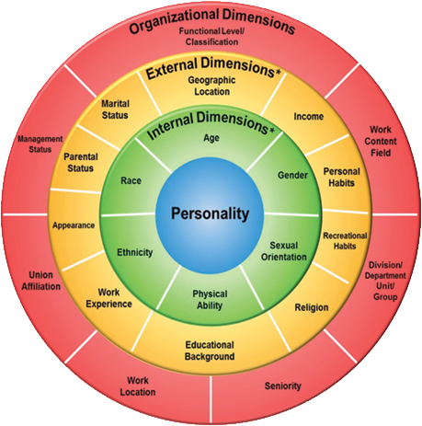
In the internal dimension of diversity, the individual has no control over these characteristics. These characteristics are set at birth, such as age, ethnicity, race, sex and physical ability. Winstanley, Eagle & Robbins (2006) argue that these characteristics are often the sources of prejudice and discrimination. The fourth layer, the personality, which is the essence of the four layers model of diversity, is personal. The personality is described as characteristics and stable characteristics of the individual perceived as determining an absolute consistency in the way that the person behaves in any particular situation and over time. Fassinger (2008) believes that an individual's personality is affected by the other three levels of the model. The other layers help shape the individual's perception, behaviour, action and disposition, as the individuals interact with the world around them.

Figure 1: Gardenswartz & Rowe (1994) Four Layers of Diversity Model
III.I.II. Benefits of Diversity
According to Fassinger (2008), diversity brings together people from different backgrounds and dimensions who have an essential skill that promotes organisational growth and stimulates competition. Diversity can be positively reflected in multiple areas of the workplace to achieve benefits on many levels, such as enhancing employee relationships, gaining a strategic advantage for the enterprise and tapping into new markets. Chavez & Weisinger (2008) argue that in a diverse environment where people have the opportunity to interact and exchange ideas, organisational growth and health are improved. Individuals feel significant ownership of the organisation when they realise that their thoughts and cultures are appreciated. Thus, in addition to improving positive staff relationships, diversity can provide a strategic advantage for the organisation. Numerous pieces of literature discussing diversity in the top management teams have shown superior positive results in the decision-making process (Daily, Dalton & Cannella, 2003; Fassinger, 2008; Mannix & Neale, 2005). The reason for this excellence in decision-making is that the diverse team has views and alternative views, giving their approach to solving the problem a wide range of options and possibilities that are difficult to be established within a homogeneous team (Daily et al., 2003). Another reason is that diversity helps to combine different experiences and perspectives that stimulate innovation and productivity (Wong, 2008 - p. 390). Wong adds that the strategic advantage given by diversity to the organisation may be the drive to enter new markets and gain new clients that were previously unavailable. According to Perkins, Thomas, and Taylor (2000), many companies, such as IBM, Toyota and Coca-Cola, are working to enhance diversity to capitalise on new markets and gain new customers who suffer from lack of services. Toyota, for example, has traded salespeople who speak different languages ​​to serve its diverse customer base to sell its Longo Toyota car. Another example is that Coca-Cola has relied on its diversity to develop a market in a Hispanic community for one of its new products. The variety of the labour force can help the organisation by providing new markets that have not been developed in advance while ensuring that existing markets are maintained.
III.I.III. Diversity Management Definition
According to Llopis (2011), managing diversity is more than just a multicultural issue; it involves embracing many different types of people, representing different things, representing different cultures, generations, ideas and thinking. Effective workplace diversity management policies have been proven to help Creative thinking processes and innovation. Diversity management, part of human resources management, involves identifying, disseminating and aligning individual staff characteristics. Successful diversity management helps managers increase the employee's knowledge and experience to better achieve organisational goals (Allen, Dawson, Wheatley & White, 2004).
Shen, Chanda, D'netto & Monga (2009) believe that the management of labour diversity involves creating an organisational climate in which the heterogeneous labour force performs its best potential; Or preference for any particular segment of the labour force to facilitate the achievement of corporate objectives in the best way. Thus, diversity management refers to regulatory actions aimed at increasing the integration of staff from different backgrounds into the organisation's structure through specific policies and programs. Organisations adopt diversity management strategies in response to the growing diversity of labour forces around the world.
There are many outstanding features to manage the diversity of the workforce effectively. First, diversity management requires creating an organisational environment in which people of diverse backgrounds and cultures can coexist and work together to enhance cooperation and enrich innovation and productivity (Wilson & Iles, 1999). Diversity management makes people work best without being affected by the specific differences between them (Tung, 1993). Diversity management aims to eliminate any discrimination among people at all. The primary motivation for diversity management must be the organisational goals of the institution, which must be accomplished to the best (Snape & Redman, 2003).
III.I.IV. Diversity Management Paradigms
Ely & Thomas (1996) put forward a question on managing diversity in the workplace that states, "Why should companies be concerned about diversity?" The authors argue that until recently, managers' answer to this question was that discrimination is legally and morally wrong. While today's managers believe in something else. These managers believe that a more diversified workforce enhances organisational effectiveness, raises morale, enhances productivity and provides greater access to new sectors of the market. Although this demonstrates their belief in the usefulness of diversity, Ely & Thomas believe that the positive effects of diversity are still absent, and efforts have rarely spurred organisational efficiency. Instead, many attempts to increase diversity in the workplace have been counterproductive, sometimes exacerbating staff tensions and hindering the company's performance. It is, therefore, necessary to introduce new paradigms to understand and benefit from diversity. There must be a unique way to unleash the powerful benefits of a diverse workforce. Flood & Romm (1996) believe that while these models must ensure increased profitability, they must go beyond financial measures to include learning, creativity, flexibility, organisational and individual growth, and the ability to adapt quickly and successfully to market changes. On the hand, the desired transformation requires a fundamental shift in the attitudes and behaviour of the Organization's leadership. This will only be achieved when senior managers abandon the underlying assumption and imperfections of diversity and replace it with a broader understanding.
The Discrimination-and-Fairness Paradigm: Roberson (2006) believes that the paradigm of discrimination and fairness is the dominant way to understand diversity, where it usually focuses on equal opportunities, fair treatment, and compliance with equal employment and employment requirements. The underlying logic of this paradigm implies that the organisational structure of the organisation must be structured to reflect the society in which it operates most closely. It requires administrative processes that ensure that all employees are treated equally and respectfully and that some do not give an unfair advantage to others (Ely & Thomas, 1996). The paradigm of discrimination and fairness goes beyond mere attention to figures as companies that work with this philosophical orientation often set career guidance and development programs specifically for women and people of colour in their ranks and train other staff to respect cultural differences. The most important institutions of this paradigm are military institutions that tend to ignore all differences between people in the name of justice (Flood & Romm, 1996). This paradigm is a common choice for management in these institutions where they find it easy for them to say that all are equal, and their backgrounds and experiences do not affect their potential contribution in the organisation (Dass & Parker, 1999).
Although the paradigm of discrimination and fairness contributes to increasing diversity of the population in the organisation and often succeeds in promoting fair treatment, it also has significant limitations. The first of these reasons is based to some extent on the implicit assumption that "we are all alike" or "we aspire to be identical." Under this concept, it is undesirable to diversify the labour force to influence the work or culture of the organisation. The company must operate as if each person had the same gender, gender and nationality (Dass & Parker, 1999). Leaders who manage diversity under this theory are unlikely to explore how people's differences generate a potential variety of practical ways to work, lead, market, manage, and learn. The discrimination-and-fairness paradigm is not limited to everyone insisting on being identical, but with emphasis on equal treatment, it presses staff to make sure that significant differences are not considered (Ely & Thomas, 1996).
The Access-and-Legitimacy Paradigm: If the paradigm of discrimination and fairness depends primarily on subverting differences in favour of maintaining harmony, the model of access and legitimacy depends on accepting and celebrating differences (Dobbs, 1996). It was the first appearance of this theory in the 1980s and 1990s where the competitive climate and the ability of new ethnic groups to acquire consumers (Ely & Thomas, 1996). The logic of this paradigm implies the need for a more diversified workforce to reach different sectors. To better understand and serve customers and gain legitimacy with them, companies need staff with multilingual skills.
Companies that apply this theory seek to match the demographics of their workforce with those of consumers or target customers. Most of the companies that adopt this paradigm in managing its diversity are consumer product companies, operating in an increasingly diverse business environment that targets different segments of consumers and customers (Jones, Moore, Stanaland & Wyatt, 1998). This paradigm has created professional and managerial jobs for previously marginalised groups such as women, colourants and minorities. The most important strength of this theory is that it helps companies understand and support market-based motivations and competitive advantage (Kossek, Lobel & Brown, 2006). On the other hand, the biggest weakness of the Access and Legitimacy Paradigm is that corporate leaders are pushing staff with specialised capabilities to reach different sectors of the market without trying to understand what those capabilities really are and how they can be integrated into the company's core business (Ely & Thomas, 1996).
According to Ragins (2012), companies that pursue this paradigm may achieve success and ostensible prosperity only, but after a while, they will discover that they are highly fragile from inside because they do not try to understand the diversity of their workforce and integrate it to promote innovation and productivity. When businesses consider the experience of employees useful only to reach new markets, they may feel exploited (Kossek et al., 2006). Access and legitimacy model can lead some employees to feel exploited. Over time, many individuals assigned to this position have become devalued and used because they have begun to think that opportunities in other parts of the organisation are close to them (Jones et al., 1998). The larger organisation is often regarded as more limited or specialised, although many have actually started their careers in the mainstream market before moving to private markets where their cultural backgrounds were initially recognised. Also, many of these people say that when companies need to downsize or narrow their marketing, individual departments are often the first to go (Ely & Thomas, 1996). This position creates fragile and ultimately intolerable career paths for staff in different departments.
Connecting Diversity to Work Perspectives Paradigm: There is no doubt that many companies that have adopted one of the two previous paradigms to guide diversity efforts in the workplace have discovered, after a while, that they are not achieving the desired benefit of their diversity (Ely & Thomas, 1996). In fact, employees often make choices and decisions based on their cultural backgrounds because of their affiliations and identities. They have to evolve their view of diversity so that they integrate the opinions of employees in the main work and redefine markets, products, strategies and business practices as well as rethink the key tasks of the company (Subeliani & Tsogas, 2005). This paradigm, which aims to integrate employees' views into the work, is called the Connecting Diversity to Work Perspectives Paradigm, which is a learning-and-effectiveness paradigm for managing diversity. By adopting this paradigm, companies can achieve the real benefits of diversity (Jones et al., 1998). When the views of the employees, according to their background and affiliation, are integrated into the company's main work, these individuals feel respected and not just "brought in as a garment" (Richard, 2000). This enhances the employee's sense of ownership and promotes cooperation, innovation and productivity.
According to Kossek et al., (2006), if the paradigm of discrimination and fairness is about assimilation, whose aim is to create a representative demographic workforce that treats its members correctly, the model of access and legitimacy has an almost opposite concept of differentiation, where the goal is to place different people whose demographic characteristics coincide with Characteristics of essential components and markets. In contrast, the paradigm of connecting diversity to work perspectives is quite the opposite. While assimilation seeks to achieve similarity and differentiation seeks in the opposite direction, the integration paradigm goes beyond them entirely as it aims to make equal opportunities for all individuals (Subeliani & Tsogas, 2005). This paradigm involves the principle of justice through recognition of differences among people and recognises the value of this and allows the institution to absorb differences between employees so that they learn and grow because of them. In fact, with the full model, members of the organisation can say, we are all in the same team, with our differences - not despite them (Jones et al., 1998).

III.I.V. Significance of Workforce Diversity Management
The diversity is human nature and diversity in the workplace is a fact that cannot be denied or ignored. Organisations that try to ignore diversity and promote homogenous groups in their labour force risk their presence in the market and achieving strategic and competitive advantages that will enable them to survive (Tatli, 2011). As long as diversity is necessary and essential, it must be managed effectively to make the most benefit of it properly. There are many reasons for the significance of managing diversity effectively in the workplace. These reasons include:
Ability to Deal with Diverse Market: The culturally diverse workforce management gives the company a great opportunity to better assess the needs and attitudes of various consumers. There is no doubt that diversity enhances the company's efficiency in dealing with the market and targeting multiple groups of consumers, so effective management of diversity in the workplace improves the company's competitive advantage in reaching new markets and targeting different groups of consumers and customers (Syed & Özbilgin, 2009).
Support Better Decision-making: Effective diversity management promotes people's sense of respect and appreciation, regardless of their cultural differences, and thus develop a sense of ownership. There is no doubt that the employee's sense of ownership of the institution pays him to provide his best and enhance the means of innovation. The heterogeneous administrative groups whose members interact positively make better decisions as they have a wide range of choices, attitudes and perspectives. When varied people's knowledge and experience are combined to solve a problem, they are creative and innovative (Bunderson & Sutcliffe, 2002). There is no doubt that this is beneficial to the Organization by supporting better decision-making.
Building Better Human Relations: The main objective of managing diversity in the workplace is to develop and nurture a common organisational culture that allows individuals with different backgrounds the opportunity to coexist peacefully and cooperate to achieve innovation (Syed & Özbilgin, 2009). This prevailing climate and organisational culture create better human relations and establish a comprehensive regulatory and management efficiency.
Prevent Unnecessary Turnover: Having proper diversity management at work reduces the staff dissatisfaction, especially those who may feel discriminated against by cultural differences and ideological affiliations (Tatli, 2011). In the event of growing resentment, many employees will often look for opportunities to leave the organisation, and therefore there will be a massive turnaround due to poor management of diversity. The organisation may lose its investment in the workforce, with other harmful consequences for the organisation. In fact, employees leave the organisation when they are not comfortable and are duly taken care of by management (Syed & Özbilgin, 2009).
Building Good Intentions of the Institution: Companies with proper management of workforce diversity build good intentions in society (Tatli, 2011). As such, talented people in the community from different backgrounds and cultures are drawn towards them to seek suitable work. Such companies do not face the problem of scarcity of skilled, educated and gifted human capital.

III.I.VI. Workforce Diversity Management Techniques
Many studies and literature have addressed the techniques that must be met with ineffective management of diversity in the workplace. These techniques include:
The Ability to Create Awareness of Diversity: Diversity management in the organisation must be able to create awareness among staff as they have differences between them regarding age, sex, education, culture, race, religion and so on (Ivancevich & Gilbert, 2000). The presence of this awareness will contribute to enhancing people's understanding of each other in a more friendly and rational way.
The Ability to Create Conditions for a Shared Organizational Culture: Diversity management must have the capacity to develop multicultural training programs that create room for climate development and shared organisational culture (Griffin, 2013). The existence of this climate will create a working environment in which the diverse workforce can coexist comfortably, calmly and happily, thus enhancing cooperation and innovation.
Designing Special Care programs for the Diverse Workforce: Effective diversity management must create and design special care programs that take into account the diversity of staff, such as programs for the care of the elderly, particular agendas for women's convenience, and agendas that respect and suit the variety of spiritual practices (Cascio, 2015).
Designing Career Development Programs: Employees should feel relevant to the organisation to enhance their sense of ownership. Therefore, diversity management must develop mechanisms to identify strengths and weaknesses and to devise and design career development programs for each individual so that the organisation can benefit from the distinctive features of the diverse workforce. In fact, people should be evaluated for their teams and their diversity (Cascio, 2015).
Provide Examples in Non-discrimination: If the company tries to create a healthy environment for cooperation, innovation and peaceful coexistence among individuals with diverse cultural backgrounds, diversity management must set an example in non-discrimination by avoiding any discrimination between people on the basis of age, culture and gender in particular (Ivancevich & Gilbert, 2000).

III.II. Diversity in Saudi Arabia
Saudi Arabia is the largest country in the Middle East and the second-largest Arab country and the twelfth largest in the world in terms of the surface area with ​​2,149,690 square kilometres. In terms of population, Saudi Arabia ranks No. 41 among the world's population with a population of 32,552,336 citizens in 2023, according to the General Authority for Statistics (GAStat). Saudi Arabia is the birthplace of Islam, one of the world's largest religions, and sometimes referred to as the "the land of the Two Holy Mosques". This is due to the two holy mosques in Islam, namely the Prophet's Mosque in Medina and the Holy Mosque in Mecca. These features make it an essential Islamic country in the world where the attention of Muslims from all over the world. Saudi Arabia's position on Muslims has affected its population diversity. Throughout history, many Muslims from all over the world migrated to it for trade or to live near the holy sites, which are very important to Muslims. These several migrations from South, East and Central Asia, North and Central Africa, Turkey, and some European regions under the Ottoman Empire constituted a considerable diversity among the population of Saudi Arabia. For a deeper understanding of the dimensions of diversity in Saudi Arabia, this section discusses the demographic features of the people of Saudi Arabia.
III.II.I. Demographic Features of Saudi Population
The population of the Kingdom of Saudi Arabia is estimated at 32,552,336 inhabitants, compared with 31,742,308 in 2017 with an average annual growth rate of 2.52 %. The Saudi population is divided into two main categories: Saudi citizens and non-Saudi residents. The Saudi citizens represent 62.69% of the total population (i.e. 20,408,362), while the non-Saudi residents represent 37.31% of the total population (i.e. 12,1439,744). The Saudi citizens population is classified into 10,396,914 males (i.e. 50.94%), and 10011448 females (i.e. 49.06%). The total inhabitants, Saudi and non-Saudi, are distributed in varying proportions to 13 administrative districts. Makkah Al-Mukaramah region in the west of Saudi Arabia, represents the highest percentage in terms of population density by 26.29% (4516577 Saudi and 4041189 non-Saudi), while Riyadh region in the centre of Saudi Arabia is the second in terms of population density at 24.25% (4658322 Saudi and 3557962 non-Saudi). It is noteworthy that the Riyadh region holds the largest proportion of Saudi citizens, while non-Saudi residents occupy a large proportion of the population density in the region of Makkah Al-Mukaramah because of the region's great spiritual status among Muslims from all over the world. The Eastern Province occupies the third place with a population density of 15.05% (3140362 Saudi and 175,996 non-Saudi). It is noteworthy that the eastern region has seen significant growth in population growth in the last five decades, both on the level of Saudi citizens or non-Saudi residents because of the region's economic growth, where it is located most of the petroleum and petrochemical industries. The following chart (figure 2) shows the Population by Nationality (Saudi/ Non-Saudi) and Administrative Area in 2022, according to (GAStat, 2023).

Source: General Authority for Statistics (GAStat). from: https://www.stats.gov.sa/ar/258
Figure 3 shows the age structure of the population. These statistics show that the proportion of those under the age of 15 years of the total population of the Kingdom amounted to 24.7% and the proportion of the population in the age group of work 15 - 64 years was 72.1%. The proportion of the population in the age group 65 years and over amounted to 3.2%. The male kingdom had the corresponding proportions (21.9 %, 75.2% and 3% respectively). As for the female population of the Kingdom, the corresponding percentages (21.5%, 62.1% and 3.6% respectively). As for the Saudi citizens, the corresponding percentages were (30.3 %, 65.5 % and 4.2 % respectively) with an increase in the proportion of the age group under 15 years and age group over 64 years compared to the corresponding rates of the total population, while there is a decline in the age group 15-64 years, which represents the working-age group. While the corresponding percentages were for non-Saudi residents (15.2 %, 81.2 and 1.6 % respectively). The high proportion of non-Saudis aged 15-64 years is because the majority of non-Saudis coming to the Kingdom are of working age.

Source: General Authority for Statistics (GAStat). from: https://www.stats.gov.sa/ar/258
Another feature of the population's main demographic profile is the educational situation. Table 1 shows the educational status of Saudi citizens according to their age group. The results in the educational status table indicate that 809,362 Saudi citizens are illiterate (5.2%). This is a relatively large proportion, given that 56.33% of them are under 64 years of age, i.e., of working age. In contrast, we find that 189,406 Saudi citizens are the only ones who obtained a degree after the university by 1.1%, while the number of those who received university or higher education was 3027824 (18.79%) while those who did not receive any education, either primary or higher, reached 2810555 (17.44%) and the number of those who could not have a university education was 13084288 (81.21%).

Age Groups | Educational Status
Age Groups | Total | Ph. D. | Master | Higher Diploma | Bachelors | Pre-Univ. Diploma | Secondary/  Equivalent | Pre-Secondary. Diploma | Intermediate | Primary | Read & Write | Illiterate
10 - 14 | 1884540 | 0 | 0 | 0 | 0 | 0 | 4619 | 165 | 7114 | 1023978 | 840871 | 7793
15 - 19 | 1790895 | 0 | 0 | 0 | 789 | 5240 | 431866 | 10068 | 1141501 | 168952 | 22141 | 10338
20 -24 | 2019006 | 0 | 670 | 2161 | 230596 | 81822 | 1447536 | 11819 | 164931 | 50917 | 21702 | 6852
25 - 29 | 1938330 | 1715 | 20162 | 7219 | 716468 | 159872 | 780088 | 17443 | 124782 | 66768 | 36663 | 7150
30 - 34 | 1749111 | 3872 | 31015 | 7384 | 595929 | 134047 | 641815 | 18586 | 167277 | 92853 | 45374 | 10959
35 - 39 | 1528991 | 4026 | 23275 | 7281 | 488887 | 104678 | 484857 | 14951 | 176210 | 126038 | 83305 | 15483
40- 44 | 1285260 | 7029 | 15042 | 5658 | 340460 | 77219 | 328614 | 9050 | 187629 | 179544 | 108845 | 26170
54 - 49 | 1070746 | 6509 | 9982 | 1384 | 206127 | 51039 | 234676 | 11504 | 177052 | 168728 | 151215 | 52530
50 - 54 | 853700 | 3363 | 6211 | 2133 | 121017 | 34338 | 141417 | 11728 | 132719 | 155574 | 153434 | 91766
55 - 59 | 656601 | 5889 | 3502 | 1515 | 66633 | 24525 | 75096 | 5457 | 88535 | 125378 | 159796 | 100275
60 - 64 | 479864 | 1796 | 4593 | 0 | 39151 | 13418 | 36049 | 5090 | 45755 | 87363 | 120014 | 126635
65+ | 855068 | 2670 | 3245 | 105 | 32361 | 13339 | 27394 | 6106 | 46940 | 111664 | 257833 | 353411
Total | 16112112 | 36869 | 117697 | 34840 | 2838418 | 699537 | 4634027 | 121967 | 2460445 | 2357757 | 2001193 | 809362
Table 1: The Educational Status of Saudis According to Their Age Group.
Source: General Authority for Statistics (GAStat). from: https://www.stats.gov.sa/ar/258
Another dimension of diversity among Saudi citizens is a disability. According to the 2022 survey of the General Organization for Statistics, the total number of Saudi disabled is 1445,723 (8.07% of the total number of Saudi citizens). Males represent 52.24% of the total number of disabled persons (755,235), while the number of females is 690488 with 47.76%. Table 2 shows the population of Saudi citizens with disabilities by their age group and sex. Table 3 shows the population of Saudis with disabilities by their age group after age ten and their educational status.
Age Groups | Total | Females | Males
0 - 4 | 26520 | 13387 | 13133
5 - 9 | 47087 | 19157 | 27930
10 - 14 | 59855 | 26123 | 33732
15 - 19 | 54430 | 26568 | 27862
20 - 24 | 61390 | 25844 | 35546
25 - 29 | 61565 | 21881 | 39684
30 - 34 | 69534 | 26798 | 42736
35 - 39 | 73422 | 25118 | 48304
40 - 44 | 81264 | 31772 | 49492
45 - 49 | 84270 | 35885 | 48385
50 - 54 | 115606 | 60200 | 55406
55 - 59 | 122823 | 65787 | 57036
60 - 64 | 137728 | 66960 | 70768
65 - 69 | 122508 | 63911 | 58597
70 - 74 | 106912 | 59204 | 47708
75 - 79 | 85990 | 48114 | 37876
80+ | 134819 | 73779 | 61040
Total | 1445723 | 690488 | 755235
Table 2: Saudis with Disabilities by Their Age Group and Sex.
Source: Disability Survey 2022 _General Authority for Statistics.
Age Groups | Educational Status
Age Groups | Total | University / Higher | Pre-Univ. Diploma | Secondary/  Equivalent | Intermed. | Primary | Read & Write | Illiterate
10 - 14 | 59855 | 0 | 0 | 0 | 5285 | 36829 | 12968 | 4773
15 - 19 | 54430 | 0 | 0 | 14069 | 22958 | 8772 | 1241 | 7390
20 -24 | 61390 | 7344 | 2700 | 30368 | 6369 | 2874 | 2031 | 9704
25 - 29 | 61565 | 15520 | 4410 | 22789 | 3758 | 3743 | 1289 | 10056
30 - 34 | 88114 | 25641 | 6976 | 25144 | 9250 | 9396 | 2743 | 8964
35 - 39 | 54842 | 12307 | 3836 | 17287 | 6612 | 6358 | 2355 | 6087
40- 44 | 98748 | 27817 | 7859 | 22310 | 10811 | 13745 | 5571 | 10635
54 - 49 | 66786 | 14907 | 5511 | 12026 | 11167 | 9254 | 5122 | 8799
50 - 54 | 148198 | 22982 | 6655 | 20960 | 15166 | 31350 | 18348 | 32737
55 - 59 | 90231 | 10715 | 4664 | 10741 | 8211 | 13508 | 13964 | 28428
60 - 64 | 173804 | 12238 | 6988 | 14518 | 16661 | 25509 | 32729 | 65161
65+ | 414153 | 11748 | 7155 | 11507 | 12984 | 38357 | 70795 | 261607
Total | 1372116 | 161219 | 56754 | 201719 | 129232 | 199695 | 169156 | 454341
Table 3: Saudis with Disabilities by Their Age Group and Educational Status.
Source: Disability Survey 2022 _General Authority for Statistics.
These citizens are divided into two categories. The first category includes 726,873 Saudis with one disability, while the second category includes 718,8850 of those who suffer from more than one disability. Table 4 shows the number of Saudi citizens with disabilities according to their type of work or job.
severity | Total | Other | Retired | Housewife | Student | Unemployed  Never Worked | Unemployed  Ever Worked | Work without pay | Paid | Employer not hired | Employer employs
Mild | 516975 | 27374 | 99421 | 152968 | 40174 | 26298 | 13125 | 1125 | 140780 | 8168 | 7542
Severe | 175661 | 12213 | 29123 | 52643 | 22640 | 11942 | 4444 | 1192 | 38498 | 1784 | 1182
Extreme | 34237 | 4455 | 4097 | 10455 | 3992 | 2586 | 166 | 648 | 7139 | 302 | 397
Total | 726873 | 44042 | 132641 | 216066 | 66806 | 40826 | 17735 | 2965 | 186417 | 10254 | 9121
Table 4: Saudis with Disabilities According to Their Work / Job Status.
Source: Disability Survey 2022 _General Authority for Statistics.
The previous data illustrates the diversity of Saudi Arabian population from several dimensions including gender (male and female), age (including different age groups), educational status, marital status, nationality (Saudi citizen and non-Saudi resident) and disability status. However, this diversity is not adequately represented in the Saudi labour market, especially private sector organisations. Several studies indicate that the dependence of the Saudi private sector on foreign labour as well as the nature of the conservative Saudi society are the main reasons that hinder real diversity in the private sector.

III.II.II. Challenges of Diversity in Saudi Arabia
According to Ramady (2010), Saudi Arabia's diversity efforts are unusually focused on the inclusion of Saudi nationals in the workplace, rather than the usual concerns about the relative lack of opportunities for ethnic minorities in the working population. This is because the private sector in Saudi Arabia is dominated by expatriate workers despite the high unemployment rate among Saudis. Zamberi Ahmed (2011) argues that the other issue of great diversity is the involvement of women in the Saudi workplace and how this is aligned with the country's conservative traditions. This section discusses the issue of over-reliance on foreign labour as well as the challenges of hiring Saudi women as the most significant challenges to maximise diversification in the Saudi private sector.
III.II.II.I. The Excessive Reliance on Expatriate Workers: The employment sector in Saudi Arabia has undergone many changes over the past few years, for example, the difference in the economy and technological advances has changed the way many companies rely on employment. This certainly creates many challenges for the recruitment process within Saudi Arabia. At the forefront of these challenges is the excessive dependence of private sector organisations on foreign workers, despite increasing unemployment among Saudis. According to Mellahi (2007), the Saudi labour market can be described as a highly dependent market for foreign workers, particularly in the private sector. This is mainly due to the very high demand for workers in the oil sector as well as the vast area of Saudi Arabia, which requires large infrastructure projects that require temporary workers working for the duration of the project only and therefore does not provide safe jobs for Saudis.
Another reason for the excessive reliance on foreign workers is the disparity between education outcomes and the needs of the private sector. According to Abaker et al. (2019), The personal and professional characteristics of Saudi graduates indicate a mismatch between the requirements of the private sector and the skills of the available Saudi workers. According to data from the Ministry of Education, 65.3% of the 129,000 Saudi graduates in 2014 graduated from the Humanities and Social Sciences Branch, and only about 16.8% graduated from engineering and science, which are among the most relevant with highly skilled sectors. Tlaiss & Elamin (2016) add that based on data from the Department of Statistics, the private sector has the highest concentration of workers in both wholesale and retail, followed by construction and industry. In 2015, the proportion of Saudi workers in these sectors was significantly lower than in those with high skilled labour. For example, the Saudi labour force in the construction sector was 15.8%, while in information technology, it was 49.5%.
The decline in the number of Saudi workers in labour-intensive sectors is due to the apparent disconnect between the needs of these sectors and the outputs of education and training they receive. The reason for this may also be partly because of the long working hours in the labour-intensive industries, which discourages Saudis from working there (Alhejji & Garavan, 2016). One way to overcome this problem is to continue to strengthen vocational training programs for Saudis. This initiative has been pursued for years, but so far, it has not made that remarkable change (Alfalih, 2022).
Moreover, Budhwar & Mellahi (2016) point out that the main reason for the Saudi private sector organisations’ dependence on expatriate labour is the large discrepancy between the wages of Saudi and foreign employees. The General Authority for Statistics reports that the average monthly salary for non-Saudi male employees is 3980 riyals per month and for females is 2900 riyals per month while the monthly average wage for Saudi employees is 10503 riyals per month for males and 9442 riyals per month for females. Alharthi et al. (2023) add that although the average monthly wage of foreign workers is meagre compared to the cost of hiring Saudis, non-Saudi employees work more hours and do not require certain working conditions. There is no doubt that these factors significantly affect the rate of productivity in private sector organisations that aim to reduce the cost and increase profitability. As a result, the Saudi government has tended to implement many of the so-called Saudization policies to employ Saudis in private sector jobs.
As a result, the Saudi government has recently taken significant steps to reform its education, immigration and labour policies and regulations to address this problem. These policies included a series of incentives, financial penalties and privileges based on the size of the employer and the percentage of employees of Saudi nationals such as Nitaqat, Taqat, Wage Protection Program, Incentive Program and Human Resources Fund. These measures seem to be insufficient and more needs to be done, especially to encourage employers to hire more Saudi youth and help them to adhere to the corporate culture and discipline and prepare to work initially in relatively low-level jobs.
III.II.II.II. Challenges of Hiring Saudi Women: according to Hamdan (2017), not surprisingly, cultural norms and legal restrictions (on female mobility, employment, etc.) impose high costs on hiring women, making Saudi men and expatriate workers more cost-effective alternatives. This diagnosis corresponds to the demand side failure in the labour market. Specifically, the actual cost of hiring women exceeds their wage rate; this “cost wedge” reduces women's employment, and in equilibrium, fewer women work (Naseem & Dhruva, 2017). Other challenges faced by the female workforce are culture about women's guardianship. The ban on leadership, which has always been the biggest challenge to women's employment, was lifted only a year ago. Transportation to and from work is also more expensive for female employees. Traditional workplaces were not designed to accommodate women, especially in the private sector, and this discouraging candidate for referral to apply (Alfalih, 2022). Other companies had to invest in separate workplaces that not all companies could afford. Lack of suitable jobs, lack of experience, language barriers, long hours of work, and the need to balance family responsibilities are other challenges for women's employment. The Labor Code prohibits women from working in hazardous occupations, and now specific sectors have been identified that will be reserved only for working women (Hamdan, 2017).

III.III. Previous Related Studies
Bozhko (2014): “Managing diversity at the organisational level‏”. That thesis aimed to gain a deeper understanding of culturally diverse organisations, individuals, who wish to attract and retain them, and of course, how to manage this multicultural organisation. The researcher analysed different ethnic groups represented in organisations as minorities and often suffered because of their diversity. The study made recommendations to such groups about what they could change to get a better job. My study's conclusion shows that difference can be accepted in any organisation; it's just a matter of managers' desire and the company's goals and objectives.
Patrick & Kumar (2012): “Managing Workplace Diversity: Issues and Challenges”. The study examined the potential barriers to workplace diversity and suggested strategies to enhance workplace diversity and inclusiveness. It was based on a survey of 300 IT employees. The study concluded that successfully managing diversity can lead to more committed, better satisfied, better performing employees and potentially better financial performance for an organisation.
Abaker, Al-Titi & Al-Nasr, (2019): “Organizational policies and diversity management in Saudi Arabia”. The purpose of that paper was to report empirical research conducted in Saudi Arabia on the impacts of organisational policies and practices on the diversity management of the Saudi private sector. The Saudization policy and views of key respondents have been tested and discussed. Primary data were collected through questionnaire surveys from the most significant 11 private sector organisations. The findings suggest that Saudization, retention, pay with benefits and health insurance policies significantly affect the diversity management in the Saudi private sector.

CHAPTER FOUR
RESULTS & DISCUSSION
This chapter presents and discusses the results obtained through data sources and research tools. This section is designed in three main parts: the results of statistical reports, the results of the questionnaire and the findings. The first section, the results of the statistical reports, reviews the data contained in the official reports issued by the General Authority for Statistics, the Ministry of Civil Service, the General Authority for Social Insurance and the National Information Center regarding the current situation of the Saudi labor force in the public and private sectors and the dimensions of the labor force diversity in the Saudi private sector. Discussing these data aims to investigate the first hypothesis of the study; identifying the dimensions of Saudi diversity and the actual status of workforce diversity in the private sector. This section addresses the study’s objectives 1 and 2, where it will conclude to determine the dimension of diversity in the Saudi population and identify the current status of workforce diversity in the private sector.
The second section, the results of the questionnaire, reviews and presents the results of the participants’ responses to the survey. This section aims to examine the second hypothesis of the study by identifying challenges that hinder the utilisation of workplace diversity in the private sector from maximising the benefits of diversity. This section is divided into four sub-parts. The first part discusses the challenges related to the excessive employment of non-Saudis, the second part discusses the problems associated with the low levels of Saudi women employment in the private sector, the third part discusses the positive and negative aspects of Saudization policies and the fourth part discusses proposed solutions to increase the diversity of Saudi private sector organizations. This discussion aims to achieve the fourth and third objectives of the study as it concludes to find out the factors that hinder the employment of Saudi citizens in private sector organisations and identify what is needed to maximise the participation of Saudi citizens in the private sector. The third section, the findings, draws the study's conclusions by discussing and analysing the results and data regarding the dimensions of the diversity of the Saudi population, the current status of diversity in private sector organisations, and the challenges faced by management to maximise the benefits of diversity. Finally, this section provides recommendations and solutions to be taken to promote diversity in Saudi private sector institutions.

IV.I. Results of Statistical Reports
The statistical reports shed light on the general status of the Saudi labour force and its diversity according to the dimensions of sex, nationality, religion, disability and education in both public and private sectors. The report issued by the General Authority for Statistics, which draws information from the data of the Ministry of Civil Service and the General Authority for Social Insurance, indicates that the total number of employees in Saudi Arabia reached 12,765,241 in the first quarter of 2023. Saudis represent 24.38% of this number, while non-Saudis represent 75.62%. On the other hand, females represent 17.8%, while males represent 82.2 % of the total number of workers in Saudi Arabia. Table 5 shows the total number of employees in the Kingdom of Saudi Arabia by sex, nationality and regulations, whether the Ministry of Civil Service, the General Authority for Social Insurance or the National Information System for the domestic workers in the first quarter of 2023.
Regulations | Non-Saudi |  | Non-Saudi |  | Total
Regulations | Male | Female | Male | Female | Male | female | Total
Civil Service | 699,742 | 479,175 | 26,168 | 22,952 | 725,910 | 502,127 | 1,228,037
Social Insurance | 1,336,400 | 596,712 | 6,513,607 | 226,788 | 7,850,007 | 823,500 | 8,673,507
Domestic Worker | 0 | 0 | 1,918,424 | 945,273 | 1,918,424 | 945,273 | 2,863,697
Total | 2,036,142 | 1,075,887 | 8,458,199 | 1,195,013 | 10,494,341 | 2,270,900 | 12,765,241
Table 5: Total Employees by Sex, Nationality and Adopted Regulations (2023, 1st Quarter)
Source: Labour Market 2023_ General Authority for Statistics.
As shown in the previous table, the total number of Saudi employees is 3,112,029, or 24.38% of the total number of employees in Saudi Arabia. This percentage is tiny given that Saudi citizens accounted for about 62.69% of the total population. This shows that almost all non-Saudi residents are in Saudi Arabia only for work. On the other hand, the table also indicates the low representation of women in the Saudi labour market. While men hold 82.2 % of jobs, only 17.8% remain for women. The proportion of women is relatively high when compared to the proportion of male and female Saudi citizens. Saudi women account for 34.57% (1,075,887) of the total number of Saudi employees, while Saudi men account for 65.43% (2,036,142). It is also noteworthy that the Saudi citizens, whether male or female, do not work in domestic work, which number 2,863,697, or about 22.4% of the total employees in Saudi Arabia.
Sector | Saudi |  | Non-Saudi |  | Total
Sector | Male | Female | Male | Female | Male | female | Total
Public | 880,352 | 531,994 | 48,338 | 31,261 | 928,690 | 563,255 | 1,491,945
Private | 1,155,790 | 543,893 | 6,491,437 | 218,479 | 7,647,227 | 762,372 | 8,409,599
Domestic Worker | 0 | 0 | 1,918,424 | 945,273 | 1,918,424 | 945,273 | 2,863,697
Total | 2,036,142 | 1,075,887 | 8,458,199 | 1,195,013 | 10,494,341 | 2,270,900 | 12,765,241
Table 6: Total Employees by Sex, Nationality and Sector (2023, 1st Quarter).
Source: Labour Market 2023_ General Authority for Statistics.
The percentages differ markedly concerning the nationality of employees between the public and private business sectors. While the number of Saudi employees is 1,412,346 or 94.66% of the total number of employees in the public sector, non-Saudi employees represent only 5.34% (79,599). This is due to the Saudization policies pursued by the Saudi government since the mid-1980s. Saudization policies aim to replace non-Saudi workers with Saudi citizens gradually. These policies started in the public sector since the eighties of the last century and reached a peak in 2016, where there are very few foreign employees with qualifications or experience that are not available in Saudi Arabia. Recently, the Saudi government has tended to impose Saudization policies on the private sector through various remuneration programs aimed at encouraging private sector institutions to employ Saudi nationals and also by denying non-compliant institutions some government services.
Nevertheless, these policies have not paid off in the private sector. According to the data in the previous table, Saudi employees represent only 20.21% (1,699,683) of the total number of employees in the Saudi private sector. The number of non-Saudi employees is 6,709,916 (79.79%). This is due to many reasons, including the inadequate compensation of non-Saudi employees compared to Saudi employees. Also, the fact that non-Saudi employees are not native; therefore, they do not often have social obligations such as their Saudi counterparts so they can work longer hours. There are also some areas that require specific qualifications or professional competencies that may not be available in Saudi employees or that the number of Saudis qualified for these jobs is not enough.
Concerning the difference between the wages of Saudi and non-Saudi employees, Table 7 shows the vast difference between the average salaries of employees in the Saudi labour market by sex and nationality. These data indicate that the average monthly wages of non-Saudi male employees are 37.89% of the average monthly salaries of Saudi male employees while the average wages of non-Saudi female employees is 30.71% of the average wages of Saudi female employees while the main average monthly wages between non-Saudi and Saudi employees is 37.58%. This vast companion between the average wages of Saudis and non-Saudis is pushing many private sector organisations to hire non-Saudis to increase profitability and reduce expenses.
Nationality | Male | Female | Average
Saudi | 10,503 | 9,442 | 10,299
Non-Saudi | 3,980 | 2,900 | 3,872
Table 7: Average Monthly Wages per Paid employee by Sex and Nationality (SR).
Source: Labour Market 2023_ General Authority for Statistics.
This is undoubtedly reflected in the unemployment rate among Saudis. While unemployment rates among Saudi males (+15) are 6.6 % and females reach 31.7%, unemployment among non-Saudis is low at 0.4 % among males and 2.4% among females. This is illustrated in Table 8, which shows the unemployment rate among the population in Saudi Arabia by sex and nationality according to the latest reports issued by the General Authority for Statistics in 2023.
Nationality | Male | Female | Total Average
Saudi | 6.6 | 31.7 | 12.5
Non-Saudi | 0.4 | 2.5 | 0.6
Table 8: Total Unemployment Rate of Population (15 +) by Sex and Nationality (%).
Source: Labour Market 2023_ General Authority for Statistics.
Given the age group as another dimension of the diversity that Saudi Arabia has and its representation in the Saudi labour market, it is noticeable that there is a clear difference between the age group representation rates related to nationality in Saudi jobs. While Saudi citizens occupy the majority of jobs in the under 25 age group, the employment rate of non-Saudis in the age group above 25 years increases significantly. Table 9 shows the total employed in the Saudi labour market by sex, nationality and age groups.
Age group | Saudi |  | Non-Saudi |  | Total
Age group | Male | Female | Male | Female | Total
15-19 | 41,825 | 11,110 | 870 | 145 | 53,950
20-24 | 254,521 | 76,789 | 203,530 | 7,312 | 542,152
25-29 | 365,462 | 171,105 | 993,257 | 38,668 | 1,568,492
30-34 | 378,344 | 197,092 | 1,348,539 | 55,628 | 1,979,603
35-39 | 323,950 | 213,988 | 1,200,926 | 50,852 | 1,789,716
40-44 | 239,655 | 172,773 | 939,510 | 37,641 | 1,389,579
45-49 | 166,187 | 108,171 | 694,972 | 23,364 | 992,694
50-54 | 125,509 | 58,762 | 531,144 | 13,675 | 729,090
55-59 | 72,155 | 27,758 | 323,219 | 7,992 | 431,124
64-60 | 17,901 | 8,330 | 183,768 | 5,059 | 215,058
65+ | 9,957 | 3,165 | 111,961 | 2,051 | 127,134
Other | 40,676 | 26,844 | 8,079 | 7,353 | 82,952
Domestic worker | 0 | 0 | 1,918,424 | 945,273 | 2,863,697
Total | 2,036,142 | 1,075,887 | 8,458,199 | 1,195,013 | 12,765,241
Table 9: Total Employed persons by Sex, Nationality and Age group.
Source: Labour Market 2023_ General Authority for Statistics.
Figure 4 shows the representation of males and females in the Saudi labour market according to their age group. It is clear from the figure that, despite the convergence of male and female representation in the age groups under 25 and over 50, there is a significant disparity between the rates of employment of women and men, which peaks in the age group of 30-34 years.

Figure 4: Total Employed persons by Sex and Age group.
Source: Labour Market 2023_ General Authority for Statistics.
Table 10 addresses another dimension of diversity in Saudi Arabia: education. The data indicated in the following table can be summarised in the fact that the lower the level of education than secondary school, the more representation of non-Saudi employees. While the higher the level of education secondary or university, the higher the rate of representation of Saudi citizens. This may be due to the large proportion of non-Saudi workers who work in domestic labour or middle and lower jobs in private sector companies. While the percentage of representation of Saudis and non-Saudis among those with a higher level of education than university (Master or PhD). These data also indicate that the Saudi citizen can quickly get a suitable job in case he gets an appropriate educational level. In contrast, when a Saudi citizen does not have a higher level of education, the advantage will go to the non-Saudi worker with less salary and benefits.
Education | Saudi |  | Non-Saudi
Education | Male | Female | Male | Female
Illiterate | 0.2 | 0.3 | 0.8 | 1.1
Read & Write | 1.1 | 1.3 | 3.3 | 3.7
Pre-primary | 0.5 | 0.4 | 2.9 | 3.0
Primary | 6.1 | 2.7 | 18.1 | 29.7
Intermediate | 9.2 | 2.6 | 26.9 | 25.6
Secondary | 40.9 | 15.9 | 21.5 | 14.3
Diploma | 10.6 | 8.3 | 6.9 | 6.3
Bachelor | 28.9 | 65.3 | 16.9 | 12.5
Master | 1.9 | 2.6 | 1.7 | 1.4
PH.D. | 0.6 | 0.8 | 0.9 | 2.4
Total | 100 | 100 | 100 | 100
Table 10: Distribution of Labour Force by Sex, Nationality and Educational Level (%).
Source: Labour Market 2023_ General Authority for Statistics.
Figure 5 shows the percentage distribution of the Saudi citizens' labour force according to the educational status. The figure reveals that more than 82 % of the total working force have secondary education or higher and about 2 % have higher diploma or master’s degree.

Figure 5: Distribution of Saudi Citizens Labour Force by the Educational Status.
Source: Labour Market 2023_ General Authority for Statistics.
IV.II. Results of the Questionnaire
The questionnaire was sent to 88 persons representing the managers of a group of private sector companies listed on the Saudi Stock Exchange operating in the Eastern Province of Saudi Arabia. Seventy-six responses were received from the participants with 86.36%. The demographic characteristics of the participants indicate that there is an acceptable diversity in terms of gender, nationality, age, business sector and the administrative position of the company. Table 1 refers to the participants’ gender which includes 59 male participants by 77.6% and 17 female participants by 22.4%. Since women represent less than 32 % of the total Saudi employees in the private sector, this percentage is considered reasonably acceptable. This gender diversity helps the study to obtain more reliable and less biased results regarding the challenges of employing Saudi women in private sector companies.

Gender
 |  | Frequency | Percent | Valid Percent | Cumulative Percent
Valid | Male | 59 | 77.6 | 77.6 | 77.6
Valid | Female | 17 | 22.4 | 22.4 | 100.0
Valid | Total | 76 | 100.0 | 100.0
Table 11: The participants’ gender.
The participants also have an acceptable diversity in terms of their age, as shown in table 11. The results show that the participants’ minimum age was 29 years while their maximum age was 54 years with a variable rate of 30.655 and a range of 25 years. Of course, this diversity gives the study’s results more credibility and reliability.

Statistics
Age
N | Valid | 76
N | Missing | 0
Variance |  | 30.655
Range |  | 25
Minimum |  | 29
Maximum |  | 54
Percentiles | 25 | 39.00
Percentiles | 50 | 41.50
Percentiles | 75 | 46.75

Table 12: The participants’ age.
Concerning nationality, the results indicate that participants from 15 different nationalities responded to the questionnaire, as shown in table 12. The Saudis ranked first among the participants with 41 participants by 53.9%, while the Egyptians came in second place with 10 participants and 13.20%. It is worth mentioning that the Saudization policies applied by the Saudi government to private sector companies require that Saudi employees occupy administrative and leadership positions, which explains the high percentage of Saudis participation.

Nationality
 |  | Frequency | Percent | Valid Percent | Cumulative Percent
Valid | American | 1 | 1.3 | 1.3 | 1.3
Valid | Australian | 1 | 1.3 | 1.3 | 2.6
Valid | Egyptian | 10 | 13.2 | 13.2 | 15.8
Valid | French | 1 | 1.3 | 1.3 | 17.1
Valid | German | 3 | 3.9 | 3.9 | 21.1
Valid | Indian | 6 | 7.9 | 7.9 | 28.9
Valid | Jordanian | 2 | 2.6 | 2.6 | 31.6
Valid | Moroccan | 2 | 2.6 | 2.6 | 34.2
Valid | Pakistani | 1 | 1.3 | 1.3 | 35.5
Valid | Palestinian | 2 | 2.6 | 2.6 | 38.2
Valid | Philippines | 1 | 1.3 | 1.3 | 39.5
Valid | Saudi | 41 | 53.9 | 53.9 | 93.4
Valid | Spanish | 1 | 1.3 | 1.3 | 94.7
Valid | Sudanese | 1 | 1.3 | 1.3 | 96.1
Valid | Syrian | 3 | 3.9 | 3.9 | 100.0
Valid | Total | 76 | 100.0 | 100.0
Table 13: The participants’ nationality.
The responses included participants from 30 different business sectors, as shown in table 13. There is no doubt that each business sector has its own peculiarities and requirements concerning the quality of its employees and employment policies, so the study aimed at the most significant possible number of business sectors to obtain more reliable results. The most participated business sector was the retail one with ten responses while health, banking, education and telecommunication sectors followed ordinally.
Business Sector
 |  | Frequency | Percent | Valid Percent | Cumulative Percent
Valid | Banking | 5 | 6.6 | 6.6 | 6.6
Valid | Cars | 3 | 3.9 | 3.9 | 10.5
Valid | Cement Industry | 1 | 1.3 | 1.3 | 11.8
Valid | Clothes | 3 | 3.9 | 3.9 | 15.8
Valid | Telecommunication | 4 | 5.3 | 5.3 | 21.1
Valid | Conferences Organiser | 1 | 1.3 | 1.3 | 22.4
Valid | Construction | 3 | 3.9 | 3.9 | 26.3
Valid | Dairy Products | 1 | 1.3 | 1.3 | 28.9
Valid | Education | 5 | 6.6 | 6.6 | 6.6
Valid | Express Mail | 1 | 1.3 | 1.3 | 36.8
Valid | Fertilizers | 1 | 1.3 | 1.3 | 40.8
Valid | Food & Beverage | 4 | 5.3 | 5.3 | 21.1
Valid | Furniture | 2 | 2.6 | 2.6 | 46.1
Valid | General Service | 1 | 1.3 | 1.3 | 47.4
Valid | Health | 6 | 7.9 | 7.9 | 55.3
Valid | Higher Education | 2 | 2.6 | 2.6 | 57.9
Valid | Hotels | 2 | 2.6 | 2.6 | 60.5
Valid | Insurance | 3 | 3.9 | 3.9 | 64.5
Valid | Manufacturer | 1 | 1.3 | 1.3 | 65.8
Valid | Optical | 1 | 1.3 | 1.3 | 67.1
Valid | Paper Manufacture | 1 | 1.3 | 1.3 | 68.4
Valid | Perfumes &Cosmetics | 2 | 2.6 | 2.6 | 73.7
Valid | Petrochemicals | 3 | 3.9 | 3.9 | 77.6
Valid | Pharmacy | 3 | 3.9 | 3.9 | 77.6
Valid | Restaurants | 2 | 2.6 | 2.6 | 80.3
Valid | Retail | 10 | 13.2 | 13.2 | 93.4
Valid | Smart Energy | 1 | 1.3 | 1.3 | 94.7
Valid | Social Services | 1 | 1.3 | 1.3 | 96.1
Valid | Textiles | 2 | 2.6 | 2.6 | 98.7
Valid | Women Care | 1 | 1.3 | 1.3 | 100.0
Valid | Total | 76 | 100.0 | 100.0
Table 14: The participants’ business sector.
The participants’ administrative positions indicated 12 different areas such as HR managers, general managers and branch managers as shown in table 14.
Administrative Position
 |  | Frequency | Percent | Valid Percent | Cumulative Percent
Valid | Branch Manager | 20 | 26.3 | 26.3 | 26.3
Valid | Sales Manager | 1 | 1.3 | 1.3 | 27.6
Valid | Duty Manager | 1 | 1.3 | 1.3 | 28.9
Valid | Factory Manager | 2 | 2.6 | 2.6 | 57.9
Valid | General Manager | 17 | 22.4 | 22.4 | 53.9
Valid | General Relation Manager | 1 | 1.3 | 1.3 | 55.3
Valid | HR Assistant Manager | 2 | 2.6 | 2.6 | 57.9
Valid | HR Manager | 28 | 36.8 | 36.8 | 94.7
Valid | Marketing Manager | 1 | 1.3 | 1.3 | 96.1
Valid | Nursing Supervisor | 1 | 1.3 | 1.3 | 97.4
Valid | Operation Manager | 1 | 1.3 | 1.3 | 98.7
Valid | Regional Manager | 1 | 1.3 | 1.3 | 100.0
Valid | Total | 76 | 100.0 | 100.0
Table 15: The participants’ administrative position.
The last demographic feature addressed by the questionnaire was the participants’ preferred language as it was designed in both English and Arabic. Table 15 shows that 42 participants (55.3 %) responded in Arabic, while 34 participants (44.7 %) responded in English.
Preferred Language
 |  | Frequency | Percent | Valid Percent | Cumulative Percent
Valid | Arabic | 42 | 55.3 | 55.3 | 55.3
Valid | English | 34 | 44.7 | 44.7 | 100.0
Valid | Total | 76 | 100.0 | 100.0
Table 16: The participants’ preferred language.

All these features regarding the diversity of the participants’ demographic characteristics indicate that the study tried in all ways to obtain results with a high standard of reliability and credibility.
Regarding the questionnaire’s 20 statements that aimed at exploring the participants’ attitudes toward the study’s hypothesis, the reliability test showed 73.6 % on Cronbach’s Alpha scale, as shown in table 15. According to Bonett & Wright (2015), Cronbach’s Alpha coefficient of 70 % or higher is acceptable for social research as it indicates a considerable internal consistency among the survey’s items.
Case Processing Summary
 |  |  | N |  | %
Cases | Valid |  | 76 |  | 100.0
Cases | Excluded |  | 0 |  | .0
Cases | Total |  | 76 |  | 100.0
Reliability Statistics
Cronbach's Alpha |  | N of Items
.736 |  | 20

Table 17: Reliability Analysis Cronbach’s Alpha.
To analyse and discuss the participants' responses to the questionnaires’ statement, an estimated balance based on the Likert’s five-point scale was adopted according to the following table. This balance will help to identify the participants’ general attitude toward each statement by calculating the responses’ weighted mean.
Response | Weighted Mean | General Attitude
Strongly disagree | From 1 to 1.80 | Strongly disagreement
Disagree | From 1.81 to 2.60 | Disagreement
Neutral | From 2.61 to 3.40 | Neutral
Agree | From 3.41 to 4.20 | Agreement
Strongly agree | Over 4.20 | Strongly agreement

Table 18: General attitude’s balance, according to Likert’ 5-point scale.
The congruence between Saudi education outcomes and private sector requirements: the first statement of the questionnaire addressed the participants’ point of view about the congruence between Saudi education outcomes and private sector requirements. Table 17 shows the participants’ responses to this statement.
Statement 1: There is no congruence between Saudi education outcomes and private sector requirements.
 |  | Frequency | Percent | Valid Percent | Cumulative Percent
Valid | Strongly Disagree | 19 | 25.0 | 25.0 | 25.0
Valid | Disagree | 28 | 36.8 | 36.8 | 61.8
Valid | Neutral | 3 | 3.9 | 3.9 | 65.8
Valid | Agree | 20 | 26.3 | 26.3 | 92.1
Valid | Strongly Agree | 6 | 7.9 | 7.9 | 100.0
Valid | Total | 76 | 100.0 | 100.0
Table 19: The participants’ responses to Statement 1.
Figure 6 shows the frequency of the participants’ responses to this statement, while table 18 shows the weighted mean of the responses. Since the weighted mean indicates less than 2.6(precisely 2.55), the results show that the participants don’t consider that there is a congruence between the Saudi education outcomes and the requirements of the private sector which means that this statement cannot be considered a reason for the excessive reliance of the private sector organisation on recruiting non-Saudi employee.
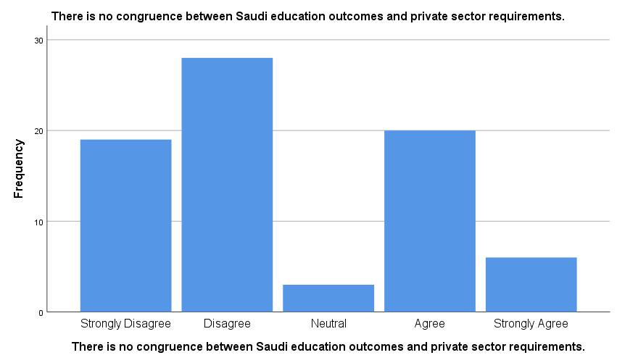

Figure 6: The frequency of participants’ responses to statement 1
Statistics
There is no congruence between Saudi education outcomes and private sector requirements.
N | Valid | 76
N | Missing | 0
Mean |  | 2.55
Table 20: The weighted mean of the participants’ responses to statement 1
Statements 2 and 3 addressed the participants’ attitudes toward the association of Saudi employee with financial rewards and privileges more than the institution itself which means that they usually move from company to another in search of increased remuneration. Figures 7 and 8 show the frequency of the participants’ responses to statements 2 and 3.
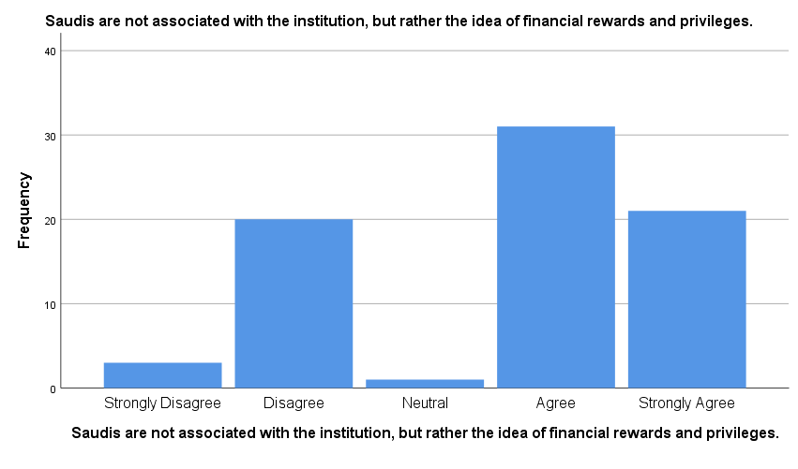
Figure 7: The frequency of participants’ responses to Statement 2.
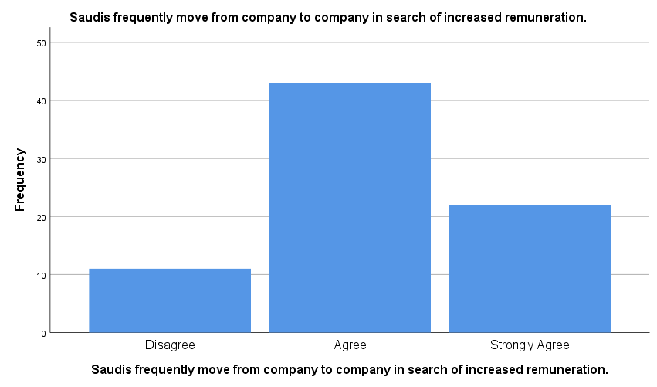

Figure 8: The frequency of participants’ responses to Statement 3.
The following table shows the weighted mean of the participants’ reactions with statements 2 and 3.
Descriptive Statistics
 | N | Mean
Statement 2 | 76 | 3.62
Statement 3 | 76 | 4.00
Valid N (listwise) | 76
Table 21: The weighted mean of the participants’ responses to statements 2 and 3.
Since the mean of both statements shows between 3.41 and 4.20 as in table 19, the results indicate the participants’ agreement with the statements. These results mean that Saudi employees do not associate with the institutions rather than the financial rewards and privileges, so they usually move from company to another seeking higher remuneration. Such factors affect private sector organisations’ stability and increase workforce turnover. Statement 9 asked the participants if they think that employing non-Saudis contributes to reducing the labour workforce turnover in private sector organisations. Figure 9 shows the participants’ responses to this statement and table 20 shows the weighted mean of their point of views.
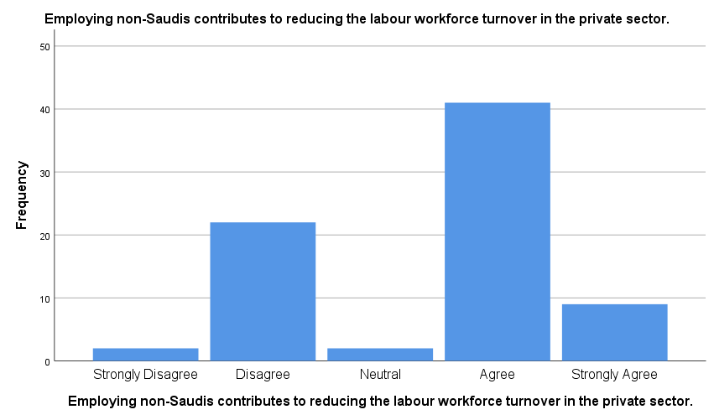
Figure 9: The frequency of participants’ responses to Statement 9.
Descriptive Statistics
 | N | Mean
Employing non-Saudis contributes to reducing the labour workforce turnover in the private sector. | 76 | 3.43
Valid N (listwise) | 76
Table 22: The weighted mean of the participants’ responses to statement 9.
As shown in Table 20, the weighted mean indicates 3.43 (between 3.41 and 4.20). This average means that the participants’ general attitude indicates their agreement that employing non-Saudis help to reduce the workforce turnover in private sector organisations. Of course, such results lead the belief that hiring non-Saudis help private companies to increase their stability and productivity. This belief has been asked to the participants in the tenth statement. Figure 10 shows their responses to the impact of employing non-Saudis on increasing stability and productivity in the private sector companies.
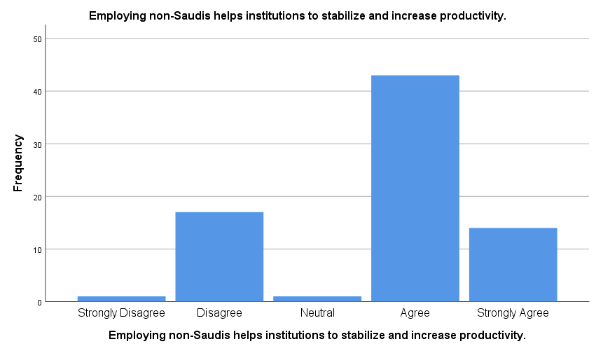
Figure 10: The frequency of participants’ responses to statement 10.
Since the mean of these responses indicates an average between 3.41 and 4.20 (precisely 3.68) as shown in table 21, the results show the participants’ agreement that employing non-Saudis help private companies to stabilise and increase productivity.
Descriptive Statistics
 | N | Mean
Employing non-Saudis helps institutions to stabilise and increase productivity. | 76 | 3.68
Valid N (listwise) | 76
Table 23: The weighted mean of the participants’ responses to statement 10.
To understand what makes the participants believe that employing non-Saudi help private institutions to increase their stability and productivity, statements 4 and 7 conduct a comparison between Saudi and non-Saudi employees in terms of their skills and experience. Statement 4 asked the participants if the available Saudi candidates do not match the requirements of the private sector while statement 7 asked them if the non-Saudi employees have skills and experience that are not available in the Saudi candidates. Figure 11 shows the responses for statement 4 while figure 12 shows the participants’ point of view about statement 7.
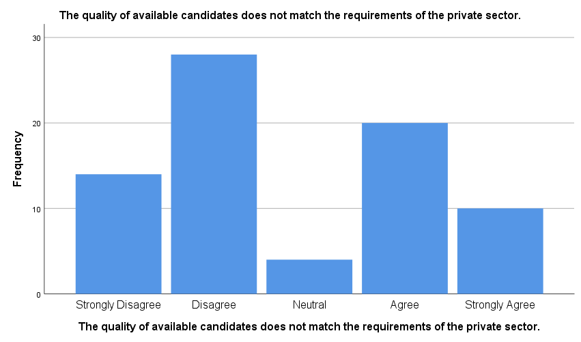
Figure 11: The frequency of participants’ responses to statement 4.
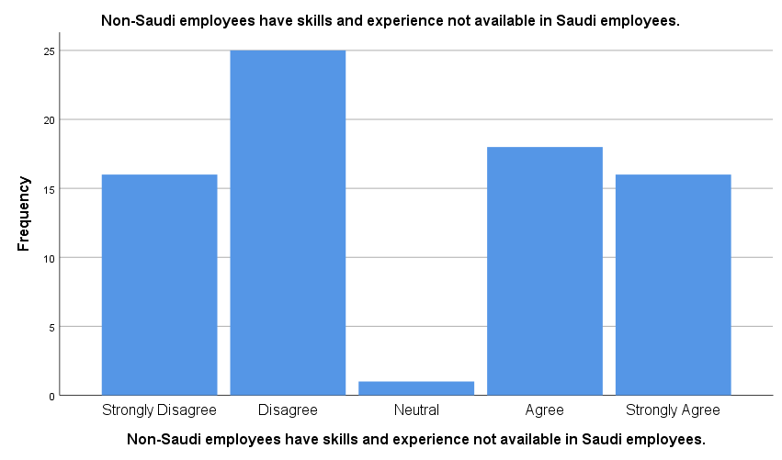
Figure 12: The frequency of participants’ responses to statement 7.
The mean of the participants’ responses to these statements shows a better and deeper understanding. As in table 22, the two means are very close, and both indicate values between 2.61 and 3.40. These values mean that the participants’ general attitude is neutral as they do not agree or disagree that the skills and experience are not the reasons for the private companies’ excessive reliance on employing non-Saudis rather than Saudis.
Descriptive Statistics
 | N | Mean
The quality of available candidates does not match the requirements of the private sector. | 76 | 2.79
Non-Saudi employees have skills and experience not available in Saudi employees. | 76 | 2.91
Valid N (listwise) | 76
Table 24: The weighted mean of the participants’ responses to statements 4 and 7.
Statement 8 addressed another possible reason that motivates private sector companies to employ non-Saudis instead of Saudis as it asked the participants if they believe that non-Saudi employees have no social connections that prevent them from working more hours. Figure 13 shows their responses to this statement.
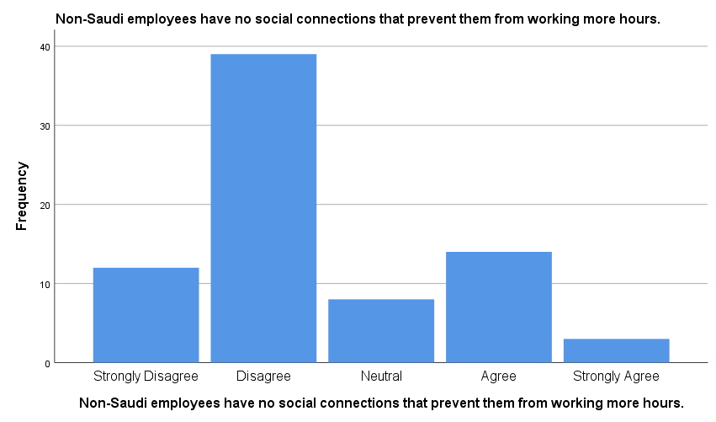

Figure 13: The frequency of participants’ responses to statement 8.
It is clear that the majority of the participants do not agree with this assumption. The mean in table 23 proves that this statement cannot be considered a significant reason for the excessive reliance of private sector on employing non-Saudis. The weighted mean indicates 2.43 (between 1.81 and 2.60) which means that the participants’ general attitude is disagreement.
Descriptive Statistics
 | N | Mean
Non-Saudi employees have no social connections that prevent them from working more hours. | 76 | 2.43
Valid N (listwise) | 76
Table 25: The weighted mean of the participants’ responses to statement 8.
Another possible reason is discussed in statement 6, as it asked the participants if they think that private organisations tend to employ non-Saudi because they are cheaper than their Saudi counterpart. They show a firm agreement with this assumption as shown in figure 14 while table 24 reveals that the mean is 4.32 which means that the general attitude is firmly agreement.
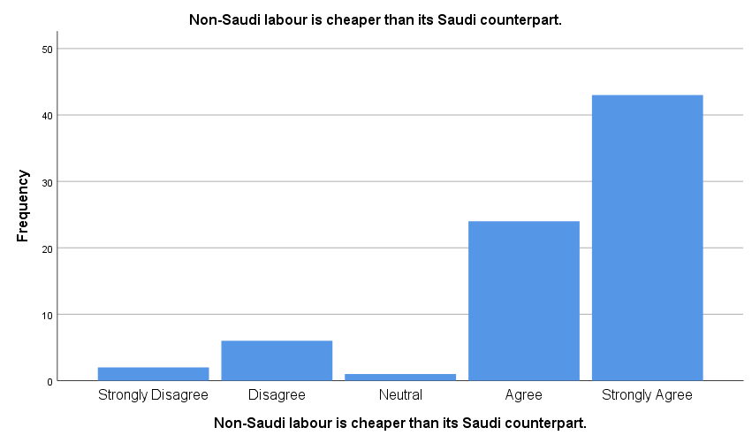
Figure 14: The frequency of participants’ responses to statement 6.

Descriptive Statistics
 | N | Mean
Non-Saudi labour is cheaper than its Saudi counterpart. | 76 | 4.32
Valid N (listwise) | 76
Table 26: The weighted mean of the participants’ responses to statement 6.
These results largely correspond to the results of the statistical reports issued by the Saudi General Authority for Statistics (as mentioned earlier in Table 7), which show the vast difference in the average monthly wages between Saudi and non-Saudi employees in the private sector. These results mean that the most effective factor for the excessive reliance of private companies on employing non-Saudis is the low cost of recruiting foreign workers compared with the value they will pay when using Saudis.
Another possible challenge that hinders diversity in the workforce in the Saudi private sector organisations is the Saudi social context as a reason for the low employment rates of Saudi women in the private sector. This challenge is addressed in the questionnaire in statement 5 which asked the participants if they think that Saudi social context does not allow women to work in most private-sector jobs. Figure 15 shows the participants’ responses to this statement.
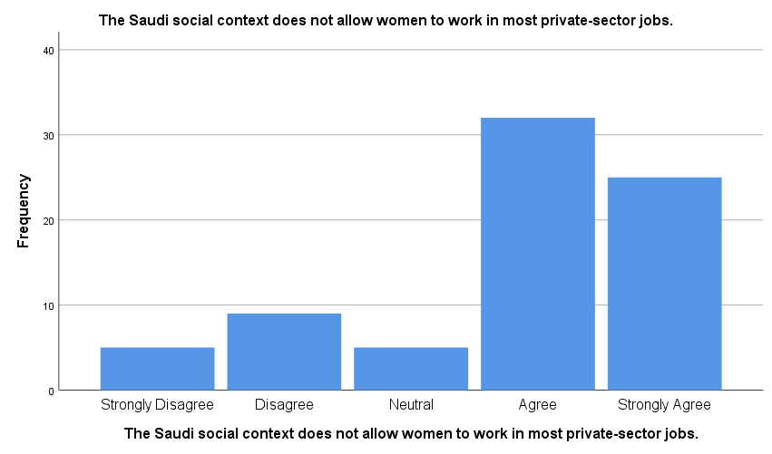
Figure 15: The frequency of participants’ responses to statement 5.
It is evident from the previous figure that the majority of the participants showed their agreement that the social context of Saudi Arabia prevents women from working in most private-sector jobs. This agreement can be emphasised by the weighted mean that is shown in table 25 which indicates 3.83 (between 3.41 and 4.20). this rate means that the general attitude is agreement.

Descriptive Statistics
 | N | Mean
The Saudi social context does not allow women to work in most private-sector jobs. | 76 | 3.83
Valid N (listwise) | 76
Table 27: The weighted mean of the participants’ responses to statement 5.
These results explain the low employment rate of Saudi women in the private sector that is shown in table 6, according to the report of the General Authority for Statistics. The report that showed that the female Saudi employees are 543,893 which present 6.5 % of the total employees of the private sector organisations.
The study also addressed the participants' views on the Saudization policies implemented by the Saudi government to resettle Saudi nationals in private sector jobs. Statements from 11 to 15 cover this theme of the study. One of the main adverse claims that are often made to Saudization policies is that they focus on quantitative aspects rather than qualitative indicators. This issue is discussed in statement 11 of the questionnaire (figure 16). Another claim that is addressed in statement 12 (figure 17) is that Saudization initiatives do not take place through dialogue and agreement between the production parties. Statement 13 (figure 18) tried to find out if private companies can avoid the employment restrictions that Saudi government adopts by temporarily hiring Saudis. Statements 14 (figure 19) and 15 (figure 20) discussed the participants’ views on the rewards of Saudization program and the outcomes of the vocational training programs adopted by the Saudi government as part of Saudization initiatives. Table 26 shows the weighted mean of each statement that indicates the participants’ general attitudes.

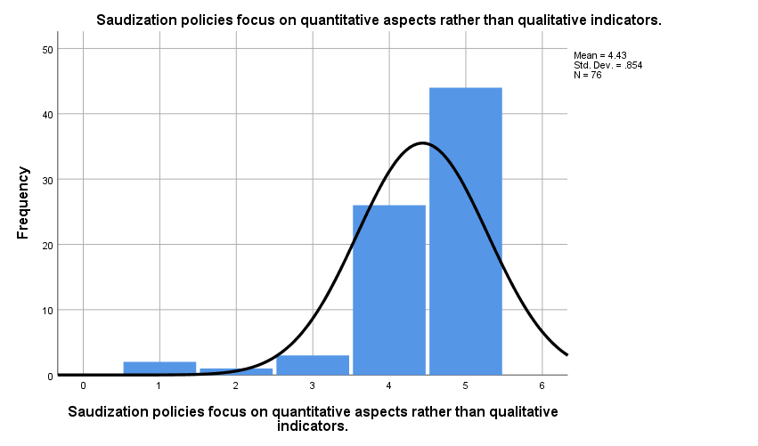
Figure 16: The frequency of participants’ responses to statement 11.
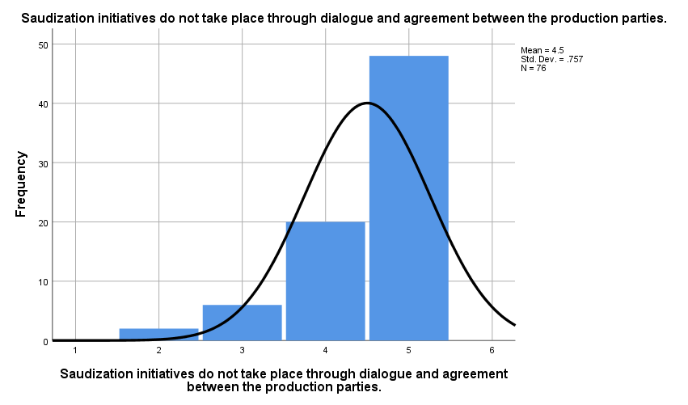
Figure 17: The frequency of participants’ responses to statement 12.
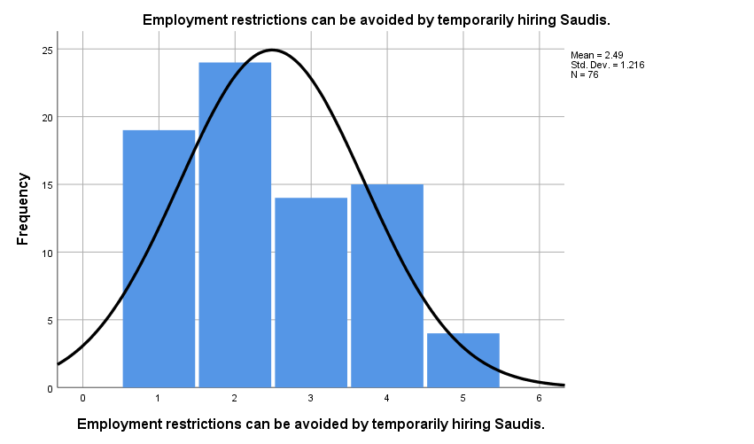
Figure 18: The frequency of participants’ responses to statement 13.
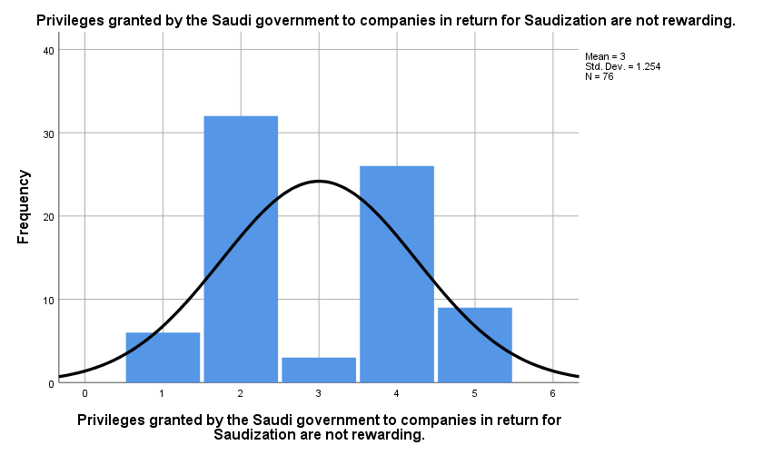
Figure 19: The frequency of participants’ responses to statement 14.
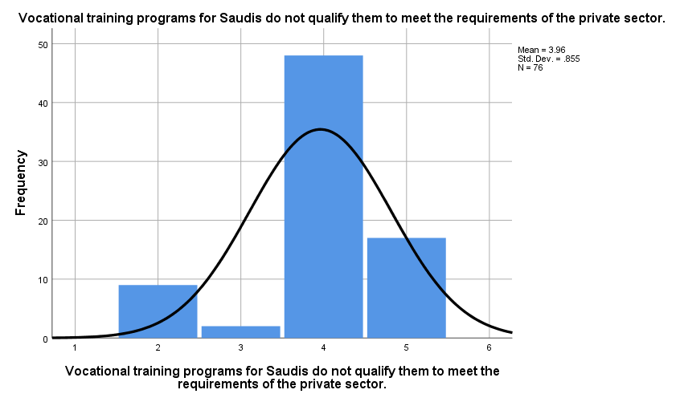
Figure 20: The frequency of participants’ responses to statement 15.
Statement | 11 | 12 | 13 | 14 | 15
N | 76 | 76 | 76 | 76 | 76
Mean | 4.43 | 4.50 | 2.49 | 3.00 | 3.96
General Attitude | Strongly agreement | Strongly agreement | Disagreement | Neutral | Agreement
Table 28: The mean and general attitude of the participants’ responses to statements 11 -15.
As seen in figure 16 and table 26, the participants strongly agree that Saudization policies focus on quantitative aspects rather than qualitative indicators as the mean is 4.43 (over 4.20). Figure 17 shows that they also strongly agree that Saudization initiatives do not take place through dialogue and agreement between the production parties. This general attitude is evident in table 26 that shows the mean at 4.50 (over 4.20). On the other hand, they disagree that private sector organisations cannot avoid the employment restrictions adopted by Saudi government as seen in figure 18 and table 26 that shows the mean between 1.81 and 2.60 (precisely 2.49). Figure 19 and the mean in table 26 show that the participants’ general attitude toward the rewards that Saudi government presents to the private sector companies as a part of its Saudization initiatives is neutral (the mean is 3.00, i.e. between 2.61 and 3.40). The results in figure 20 and the mean in table 26 indicate that the participants agree that the outcomes of the vocational training programs do not qualify Saudis to meet the requirements of the private sector (the mean is 3.96, i.e. between 3.41 and 4.20). All these results and their implications will be discussed in the next section.
The last five statements of the questionnaire addressed the participants’ attitudes toward the possible and suggested solutions and recommendations to maximise benefits of diversity in the private sector. Statement 16 asked the participants if they think that Saudi government should conduct discussions and conversations with the private sector organisations to formulate the Saudization policies. Figure 21 shows their responses to this suggestion while table 27 shows that the mean of their responses is 4.75 (over 4.20). This rate indicates that the participants’ general attitude is firmly agreement.
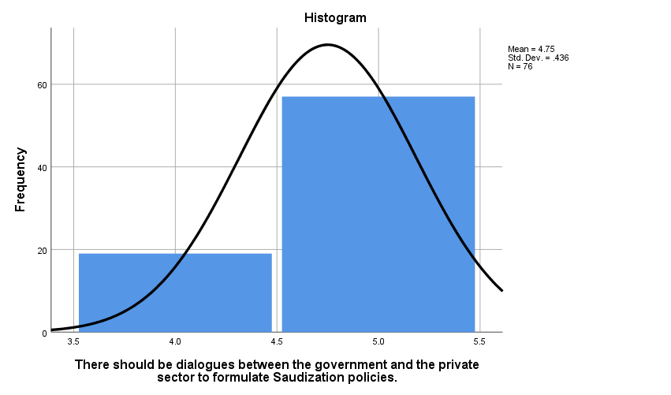
Figure 21: The frequency of participants’ responses to statement 16.

Descriptive Statistics
 | N | Mean
There should be dialogues between the government and the private sector to formulate Saudization policies. | 76 | 4.75
Valid N (listwise) | 76
Table 29: The weighted mean of the participants’ responses to statement 16.
Statement 17 tried to find out if the participants think that Saudi government should prohibit employing non-Saudi women in the private sector as a measure to force the private sector to engage Saudi women and maximise their economic participation. Since the mean in table 28 indicates 4.29 (over 4.20) and the frequency in figure 22 shows the participants’ agreement, the general attitude toward this suggestion is firmly agreement.
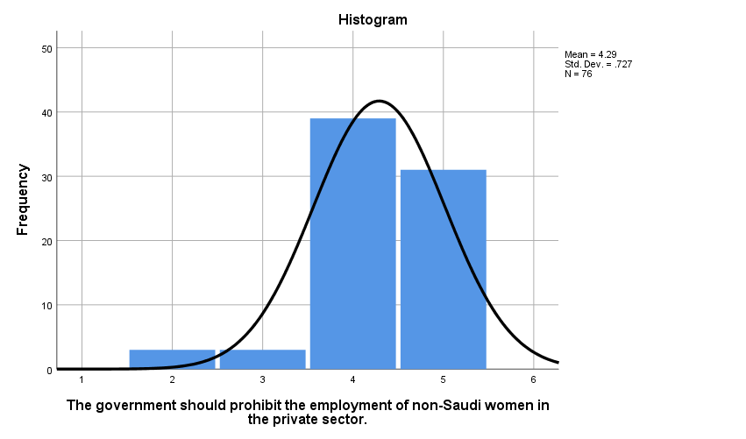
Figure 22: The frequency of participants’ responses to statement 17.
Descriptive Statistics
 | N | Mean
The government should prohibit the employment of non-Saudi women in the private sector. | 76 | 4.29
Valid N (listwise) | 76
Table 30: The weighted mean of the participants’ responses to statement 17.
Another possible solution to maximise the effectiveness of Saudization initiatives is discussed in statement 18 that asked the participants if they think that private sector officials should participate in designing the vocational training programs to qualify Saudis to meet the requirements of the private companies. As seen in figure 23, the majority of the participants show their strong agreement with this suggestion and the mean in table 29 reached 4.66 (over 4.20), which confirms that their general attitude is firmly agreement.
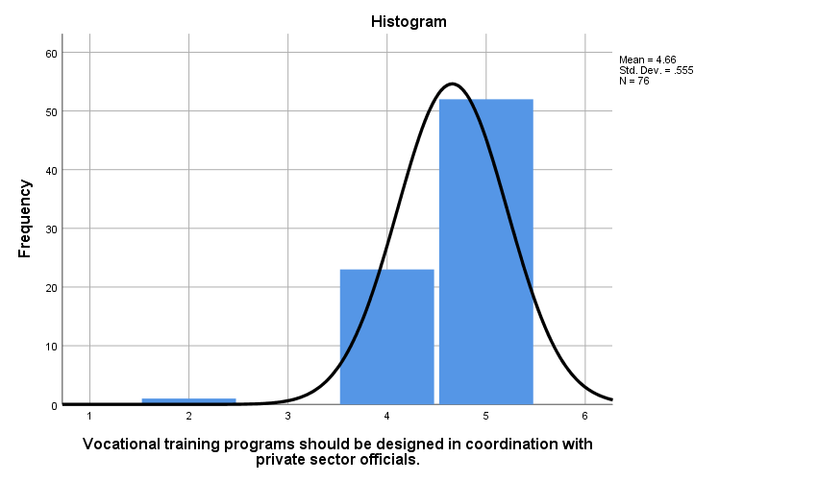
Figure 23: The frequency of participants’ responses to statement 18.
Descriptive Statistics
 | N | Mean
Vocational training programs should be designed in coordination with private sector officials. | 76 | 4.66
Valid N (listwise) | 76
Table 31: The weighted mean of the participants’ responses to statement 18.
Statement 19 asked the participants if they think that establishing an administrative body to provide private sector companies with qualified Saudi employees will be useful in maximising the participation of Saudi citizens. Figure 24 shows the frequency of their responses that is clarified by the mean in table 30. Since the mean is 3.45 (between 3.41 and 4.20), the participants’ general attitude is agreement.
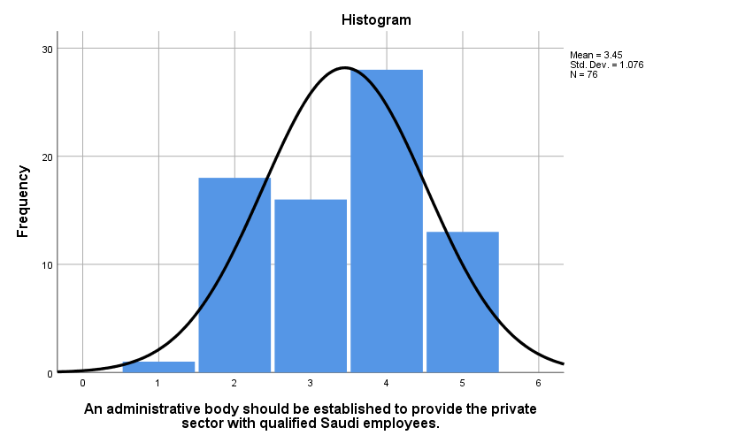
Figure 24: The frequency of participants’ responses to statement 19.
Descriptive Statistics
 | N | Mean
An administrative body should be established to provide the private sector with qualified Saudi employees. | 76 | 3.45
Valid N (listwise) | 76
Table 32: The weighted mean of the participants’ responses to statement 19.
The last item of the questionnaire (statement 20) asked the participants if they think that the private sector organisations should be motivated by facilitating services and reducing taxes to employ Saudis instead of foreign workers. None of the participants disagreed with this suggestion as seen in figure 25. Also, the mean in Table 31 shows that their general attitude is strong agreement as it refers to 4.57 (over 4.20). This result should be compared with the result figure 19 and table 26 related to the participants’ responses to statement 14 that asked them if they think that the privileges granted by the Saudi government to private companies in return for employing Saudis are rewarded. Their general attitude toward statement 14 is neutral which means that while a considerable part of them sees that the privileges are rewarded, the other part sees them are not rewarded. This result with the result of statement 20 indicates that there is a problem related to the quality of the rewards that make some believe that they are sufficient while the others do not.
Descriptive Statistics
 | N | Mean
The private sector should be motivated to employ Saudis by facilitating services and reducing taxes. | 76 | 4.57
Valid N (listwise) | 76
Table 33: The weighted mean of the participants’ responses to statement 20.
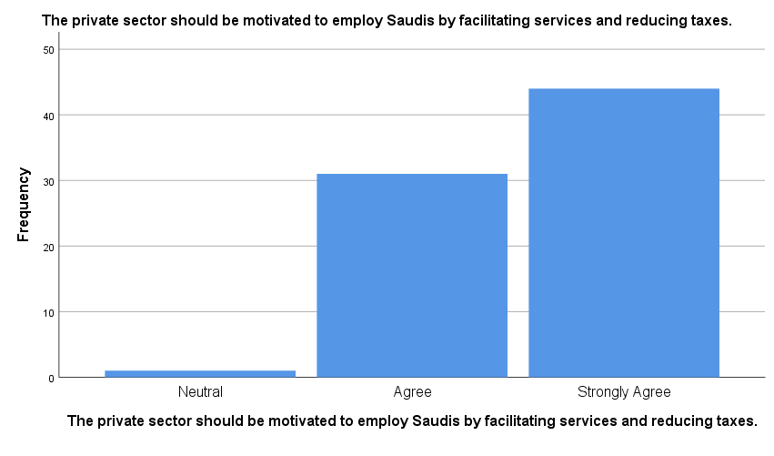
Figure 25: The frequency of participants’ responses to statement 20.
After presenting the questionnaire’s results in this section, the next part discusses their findings and implications in addition to comparing them with the previous related studies’ results.

IV.III. Findings & Discussion
This section identifies the findings of the study based on the previous results and discusses them and their implications. It consists of four parts to classify the results according to the study’s objectives. The first part presents a discussion of the findings related to the current status of diversity in the private sector and the second one discusses the results related to the main challenges that hinder diversity in the workforce in the Saudi private companies. The third and fourth parts discuss the findings related to the Saudization policies that aim at maximising the benefits of diversity in the workforce. The third part analyze the weaknesses and shortcomings of these adopted policies while the fourth one presents the possible and suggested solutions and recommendations.
IV.III. I. The current status of diversity: the findings of the statistical reports issued by the official Saudi authorities lead to say that there is no actual diversity in the workforce regarding the private sector organisations. These results coincide with the results of the study of Abaker et al. (2019) which indicated that the regulatory policies in Saudi Arabia negatively affect the diversity of the workplace in the Saudi private sector. While their study pointed to the ineffectiveness of Saudization policies in maximising diversity in the workplace, the present study concludes that the main reasons for the lack of actual diversity in the Saudi private sector are due to two main factors, according to the analysis of the official statistical reports’ results. The first reason is the over-dependence of the Saudi private sector on foreign labour rather than the Saudis as the results show that more than 79% of the total private-sector workers are non-Saudis (Table 6). The second reason is the low rates of employing Saudi women in private sector companies, where the results indicate that Saudi women working in the private sector are less than 6.5% of the total workers.
There is no doubt that such a situation will not create real diversity in the Saudi workforce in the private sector. The failure of private sector companies to rely primarily on Saudi labour does not allow Saudi employees to prove their competence or develop their skills. Since there are very few jobs available to Saudis in the private sector and often because of Saudization policy restrictions, corporate administrations employ them in non-vital and ineffective positions. On the other hand, excessive dependence on foreign labour in the private sector may be one of the reasons for the low employment of Saudi women, especially in a conservative society where many women prefer not to work in a mixed environment or at least with non-Saudi employees.
IV.III.II. Challenges of diversity in the Saudi private sector: the study’ findings conclude with two main challenges that hinder workplace diversity in the Saudi private sector. The first challenge is that the private sector relies mainly on foreign labour rather than employing Saudis. The results also concluded that the reason for this excessive reliance on non-Saudi workers is not the incompatibility of education outcomes with the requirements of the private sector or because Saudi employees do not have the necessary competence and skills to work in these institutions. These findings differ from the results of the study conducted by Alhejji & Garavan (2016) which indicated that one of the main reasons for the Saudi private sector reliance on non-Saudi employees is the incompatibility of Saudi education outputs with the requirements of the private sector. On the other hand, the current study’s findings conclude that the main reason behind the excessive dependence on foreign labour is the low cost compared to the cost of employing Saudis.
There is no doubt that private sector companies aim to achieve the highest rates of productivity and profitability in the first place and therefore, they are looking for the lowest cost labour and the highest productivity. These findings are in line with results of the official reports’ data, which indicate that the average monthly wages for non-Saudi employees are 37.89% for males and 30.71% for females. These findings also coincide with the results of the study conducted by Budhwar & Mellahi (2016) that pointed to the significant difference between the cost of foreign labour and Saudis as one of the reasons for the private sector to employ non-Saudis.
The second challenge is the marked decline in Saudi women's employment in the private sector. The findings conclude that private sector companies do not provide sufficient job opportunities for women in general and Saudi women in particular. The number of women employed in the private sector represents 9.06% of the total number of employees, whereas Saudi women account for only 6.5% of the total number of jobs in the private sector. The study’s findings conclude that the Saudi social context prevents Saudi women from working in most private-sector jobs. It can be noted that this social context encompasses the nature of the conservative Saudi society. These findings are consistent with the results of the study conducted by Hamdan (2017) which indicates that many Saudi women do not prefer to work in mixed environments or with non-Saudi employees. This context also includes the nature of the Saudi woman, who requires a lot of work-offs and work interruption due to multiple times of pregnancy and childbirth. This feminine nature makes the cost of hiring Saudi women relatively high, forcing private companies to hire males if possible or relying on non-Saudi women. These findings are in line with the results of the study conducted by Al-Rasheed (2018) which indicated that the actual cost of hiring Saudi women far exceeds wage rates due to frequent breaks in labour for pregnancy, childbirth or childcare.
IV.III.III. Saudization Policies: the study’s findings conclude that there are many shortcomings in the Saudization policies adopted by the Saudi government to maximise the employment of Saudi citizens. These shortcomings include that Saudization policies focus on quantitative aspects rather than qualitative indicators. These findings coincide with the results of Abaker et al. (2019) which confirms that Saudization initiatives oblige the private companies to employ a specific number or percentage of Saudis and do not care, in any way, to the quality of these jobs. These policies lead the private organisations to employ Saudis in some positions and jobs just to overcome or avoid the employment restrictions. Such jobs and positions do not allow Saudi employees to develop their skills and show their competency.
Another shortcoming related to the Saudization initiatives is the absence of dialogues and discussions with the private sector to formulate their regulations. These findings are in line with the results of Naseem & Dhruva (2017) that confirm that the Saudi government take and implement the Saudization policies without any discussions with the private sector representatives. Undoubtedly, taking these measures and decisions in this way loses them realism and effectiveness, making it easy for private companies to circumvent them in one way or another. Although the current results indicated that it is not easy for private organisations to temporarily employ Saudis to avoid employment restrictions, they can manipulate them by using Saudis in marginalised or ineffective jobs.
The absence of private sector representatives from the Saudization policy decision-making process makes the vocational training programs adopted by the Saudi government to supply the private sector with qualified Saudi employees ineffective. There is no doubt that the requirements of the private sector, which targets productivity and profitability at the first place, are different from those of the government sector, which is mainly committed to providing jobs for citizens in addition to filling the deficit in service jobs through the employment of Saudis. This difference between the requirements and policies of the private sector and the government sector requires the active participation of private companies in the decision-making process to activate vocational training programs to ensure outputs meet their needs.
The findings also conclude to another shortcoming related to Saudization initiatives which is the quality of the Saudi government's incentives to motivate the private sector to hire Saudis. The results indicated that while some private companies see that these privileges are rewarding, the others think they are not. This situation led the study to believe that the problem lies in the quality of rewards. These findings are consistent with the results of Abaker et al. (2019) that indicated that the private companies are rewarded by obtaining additional work visas to recruit non-Saudi employees in case they abide by the prescribed rates of hiring Saudis. Although such reward benefits private organisations to recruit more foreign workers at low cost, some believe it adds another value to hiring non-Saudis as they have to pay the high wages of Saudi employees. These weaknesses and shortcomings related to Saudization initiatives require the Saudi government to seek appropriate solutions.
IV.III.IV. Possible solutions and recommendations: the findings conclude to some possible solutions and recommendations to maximise Saudi workplace diversity in the private sector. These solutions include the necessary to private companies’ participation in the decision-making process related to Saudization initiatives. The Saudi government should also prohibit employing non-Saudi women in the private sector to increase their employment rate and economic participation. The study also found that vocational training programs should be designed in association with private organisations’ representatives. An administrative authority should be established to provide the private sector with qualified Saudi employees. This authority should give its approval to the private company to recruit any foreign workers in case they could not provide the appropriate Saudi candidate. Finally, the study recommends a re-evaluation of incentives offered to the private sector in return for employing Saudis, such as the government to pay part of the monthly wages of Saudi employees, reduce taxes or facilitate government services.
Conclusion
Diversity in the workplace has many benefits at all levels, whether individuals, institutions or countries. Although the Kingdom of Saudi Arabia has considerable diversity in its population, it has not achieved the desired benefits so far, especially in the private sector. Maximising workplace diversity in private sector institutions is a critical challenge for the Saudi government. This challenge represents a significant obstacle to Saudi Arabia's 2030 vision and its national and economic transformation program. The Saudi’s benefits of diversity in the workplace will not only attract foreign direct investment and target new markets but also reduce unemployment rates among Saudis, create job opportunities for women and increase the population’s economic participation rate.
The Saudi government must address the challenges that hinder maximising workplace diversity in the private sector which are the excessive dependence of private companies on foreign labour and the lack of appropriate job opportunities for Saudi women. To meet these challenges, the government must work to develop its Saudization policies. First, the employment of non-Saudi women in the private sector should be banned. Second, an administrative authority should be established to oversee vocational training programs for Saudis in coordination with private sector officials. The powers of this committee should include providing private sector companies with qualified Saudi candidates. The approval of that authority for work visas of foreign employees must also be necessary after verifying that the appropriate Saudi alternative is not available. Third, the reward program offered by the Saudi government for employing Saudis in the private sector should be reviewed. The recruitment of one Saudi employee cannot be equivalent to the approval of four foreign employees. Incentives should be financial, such as paying part of the wages of Saudi employees for a fixed period, reducing taxes or facilitating government services. Fourth, the government should allow the private sector to participate in the decision-making process regarding Saudization initiatives.

References
Abaker, M. O. S. M., Al-Titi, O. A. K., & Al-Nasr, N. S. (2019). Organisational policies and diversity management in Saudi Arabia. Employee Relations: The International Journal, 41(3), 454-474.‏
Agocs, C., & Burr, C. (1996). Employment equity, affirmative action and managing diversity: assessing the differences. International journal of manpower, 17(4/5), 30-45.‏
Alfalih, A. A. (2022). How to develop diversity management competencies in the private sector in Saudi Arabia. SAGE Open, 12(2), 21582440221102448.‏
Alhejji, H. A., & Garavan, T. N. (2016). Human resource development in the middle east. In Global Human Resource Development (pp. 160-179). Routledge.‏
Allen, R., Dawson, G., Wheatley, K., & White, C. S. (2004). Diversity practices: Learning responses to modern organisations. Development and Learning in Organizations: An International Journal, 18(6), 13-15.‏
Al-Rasheed, M. (2018). Modern Woman in the Kingdom of Saudi Arabia: Rights, Challenges, and Achievements. Journal of Middle East Women’s Studies, 14(3), 351–353.
Ashton 2010, the dimensions of diversity. Retrieved from:
http://ashtonfourie.com/blog1/2010/05/18/the-dimensions-of-diversity/
Bethlehem, J. (2009). Applied survey methods: A statistical perspective (Vol. 558). John Wiley & Sons.‏
Black, K. (2009). Business Statistics: Contemporary decision making. John Wiley & Sons.‏
Bonett, D. G., & Wright, T. A. (2015). Cronbach's alpha reliability: Interval estimation, hypothesis testing, and sample size planning. Journal of Organizational Behavior, 36(1), 3-15.‏
Boshnak, H. A., Alsharif, M., & Alharthi, M. (2023). Corporate governance mechanisms and firm performance in Saudi Arabia before and during the COVID-19 outbreak. Cogent Business & Management, 10(1), 2195990.‏
Budhwar, P. S., & Mellahi, K. (Eds.). (2016). Handbook of human resource management in the Middle East. Edward Elgar Publishing.‏
Bunderson, J. S., & Sutcliffe, K. M. (2002). Comparing alternative conceptualisations of functional diversity in management teams: Process and performance effects. Academy of management journal, 45(5), 875-893.‏
Cascio, W. F. (2015). Managing human resources. McGraw-Hill.‏
Chavez, C. I., & Weisinger, J. Y. (2008). Beyond diversity training: A social infusion for cultural inclusion. Human Resource Management: Published in Cooperation with the School of Business Administration, The University of Michigan and in alliance with the Society of Human Resources Management, 47(2), 331-350.‏
Converse, J. M., & Presser, S. (1986). Survey questions: Handcrafting the standardised questionnaire (No. 63). Sage.‏
Daily, C. M., Dalton, D. R., & Cannella Jr, A. A. (2003). Corporate governance: Decades of dialogue and data. Academy of management review, 28(3), 371-382.‏
Dass, P., & Parker, B. (1999). Strategies for managing human resource diversity: From resistance to learning. Academy of Management Perspectives, 13(2), 68-80.‏
De Leeuw, E. D., Hox, J., & Dillman, D. (2012). International handbook of survey methodology. Routledge.
Dobbs, M. F. (1996). Managing diversity: Lessons from the private sector. Personnel Administration, 25(3), 351-367.‏
Ely, R. J., & Thomas, D. A. (1996). Making differences matter: A new paradigm for managing diversity. Harvard Business Review, 74(5), 79-90.‏
Fassinger, R. E. (2008). Workplace diversity and public policy: Challenges and opportunities for psychology. American Psychologist, 63(4), 252.‏
Flood, R. L., & Romm, N. R. (1996). Diversity management. In Critical Systems Thinking (pp. 81-92). Springer, Boston, MA.‏
Gardenswartz, L., & Rowe, A. (1994). Diverse teams at work. Chicago: Irwin.‏
Griffin, R. W. (2013). Fundamentals of management. Cengage Learning.‏
Grobler, P. A. (2005). Human resource management in South Africa. Cengage Learning EMEA.‏
Hamdan, A. (2017). Saudi Arabia: Higher Education Reform since 2005 and the Implications for Women. Education in the Arab World, 197.‏
Ivancevich, J. M., & Gilbert, J. A. (2000). Diversity management: Time for a new approach. Public personnel management, 29(1), 75-92.‏
Jenner, L. (1994). Diversity management: what does it mean? Hr. Focus, 71(1), 11-11.‏
Jones, E., Moore, J. N., Stanaland, A. J., & Wyatt, R. A. (1998). Salesperson race and gender and the access and legitimacy paradigm: does difference make a difference? Journal of Personal Selling & Sales Management, 18(4), 71-88.‏
Koonce, R. (2017). Redefining Diversity: It's Not Just the Right Thing to Do. It Also Makes Good Business Sense. Retrieved on August 29.‏
Kossek, E. E., Lobel, S. A., & Brown, J. (2006). Human resource strategies to manage workforce diversity. Handbook of workplace diversity, 53-74.‏
Llopis, G. (2011). Diversity management is the key to growth: Make it authentic. Forbes, June, 13(201), 1.‏
Mannix, E., & Neale, M. A. (2005). What differences make a difference? The promise and reality of diverse teams in organisations. Psychological science in the public interest, 6(2), 31-55.‏
Marsden, P. V., & Wright, J. D. (Eds.). (2010). Handbook of survey research. Emerald Group Publishing.‏
McGivern, Y. (2006). The practise of market and social research. Pearson Education, UK.‏
Mellahi, K. (2007). The effect of regulations on HRM: private sector firms in Saudi Arabia. The International Journal of Human Resource Management, 18(1), 85-99.‏
Mugenda, O. M. (1999). Research methods: Quantitative and qualitative approaches. African Centre for Technology Studies.‏
Naseem, S., & Dhruva, K. (2017). Issues and Challenges of Saudi Female Labor Force and the Vision 2030. International Journal of Economics and Financial Issues, 7(4), 23-27.‏
Perkins, L. A., Thomas, K. M., & Taylor, G. A. (2000). Advertising and recruitment: Marketing to minorities. Psychology & Marketing, 17(3), 235-255.‏
Quinlan, C., Babin, B., Carr, J., & Griffin, M. (2019). Business research methods. South-Western Cengage.‏
Ragins, B. R. (2012). Understanding diversified mentoring relationships: Definitions, challenges and strategies. In Mentoring and diversity (pp. 35-65). Routledge.‏
Ramady, M. A. (2010). The Saudi Arabian Economy: Policies, Achievements, and challenges. Springer Science & Business Media.‏
Richard, O. C. (2000). Racial diversity, business strategy, and firm performance: A resource-based view. Academy of management journal, 43(2), 164-177.‏
Robbins, S. P. (2001). Organisational Behaviour: global and Southern African perspectives. Pearson South Africa.‏
Roberson, Q. M. (2006). Disentangling the meanings of diversity and inclusion in organisations. Group & Organization Management, 31(2), 212-236.‏
Saunders, M. N. (2011). Research methods for business students, 5/e. Pearson Education, India.‏
Shen, J., Chanda, A., D'netto, B., & Monga, M. (2009). Managing diversity through human resource management: An international perspective and conceptual framework. The International Journal of Human Resource Management, 20(2), 235-251.‏
Snape, E., & Redman, T. (2003). Too old or too young? The impact of perceived age discrimination. Human Resource Management Journal, 13(1), 78-89.‏
Stockdale, M. S., & Crosby, F. J. (2004). The psychology and management of workplace diversity. Blackwell Publishing.‏
Subeliani, D., & Tsogas, G. (2005). Managing diversity in the Netherlands: a case study of Rabobank. The international journal of human resource management, 16(5), 831-851.‏
Syed, J., & Özbilgin, M. (2009). A relational framework for the international transfer of diversity management practices. The International Journal of Human Resource Management, 20(12), 2435-2453.‏
Tatli, A. (2011). A multi‐layered exploration of the diversity management field: diversity discourses, practices and practitioners in the UK. British Journal of Management, 22(2), 238-253.‏
Tlaiss, H. A., & Elamin, A. (2016). Human resource management in Saudi Arabia. In the handbook of human resource management in the Middle East. Edward Elgar Publishing.‏
Tung, R. L. (1993). Managing cross‐national and intra‐national diversity. Human Resource Management, 32(4), 461-477.‏
Vogt, W. P. (2007). Quantitative research methods for professionals (pp. 117-118). Boston: Pearson/Allyn and Bacon.‏
Wagner, R. (2019, February 11). The History of Diversity in the Workplace. Retrieved from https://bizfluent.com/about-5463620-history-diversity-workplace.html
Wellner, A. (2000). How Do YOU Spell Diversity? Training, 37(4).‏
Wilson, E. M., & Iles, P. A. (1999). Managing diversity–employment and service delivery challenges. International Journal of Public Sector Management, 12(1), 27-49.‏
Winstanley, C. A., Eagle, D. M., & Robbins, T. W. (2006). Behavioural models of impulsivity in relation to ADHD: translation between clinical and preclinical studies. Clinical psychology review, 26(4), 379-395.‏
Wong, S. (2008). Diversity—Making space for everyone at NASA/Goddard Space Flight Center using dialogue to break through barriers. Human Resource Management: Published in Cooperation with the School of Business Administration, The University of Michigan and in alliance with the Society of Human Resources Management, 47(2), 389-399.‏
Zamberi Ahmad, S. (2011). Businesswomen in the Kingdom of Saudi Arabia: characteristic, growth patterns and progression in a regional context. Equality, diversity and Inclusion: An International Journal, 30(7), 610-614.‏

Appendixes
Appendix 1: The Questionnaire
Challenges Faced by Diversity Managements to Maximize Benefits in Saudi Private Organizations
- Personal Information
- Name: …………………………………………… Gender: ………………….
- Nationality: ……………………………………… Age: …………………….
- Company: ……………………………………… Sector: ………………….
- Position: …………………………………………
- Based on Likert’s five scale points, please check the most appropriate scale according to your point of view.
No. | Statement | 1 | 2 | 3 | 4 | 5
1 | There is no congruence between Saudi education outcomes and private sector requirements.
2 | Saudis are not associated with the institution, but rather the idea of financial rewards and privileges.
3 | Saudis frequently move from company to company in search of increased remuneration.
4 | The quality of available candidates does not match the requirements of the private sector.
5 | The Saudi social context does not allow women to work in most private-sector jobs.
6 | Non-Saudi labour is cheaper than its Saudi counterpart.
7 | Non-Saudi employees have skills and experience not available in Saudi employees.
8 | Non-Saudi employees have no social connections that prevent them from working more hours.
9 | Employing non-Saudis contributes to reducing the labour workforce turnover in the private sector.
10 | Employing non-Saudis helps institutions to stabilise and increase productivity.
11 | Saudization policies focus on quantitative aspects rather than qualitative indicators.
12 | Saudization initiatives do not take place through dialogue and agreement between the production parties.
13 | Employment restrictions can be avoided by temporarily hiring Saudis.
14 | Privileges granted by the Saudi government to companies in return for Saudization are not rewarding.
15 | Vocational training programs for Saudis do not qualify them to meet the requirements of the private sector.
16 | There should be dialogue between the government and the private sector to formulate Saudization policies.
17 | The government should prohibit the employment of non-Saudi women in the private sector.
18 | Vocational training programs should be designed in coordination with private sector officials.
19 | An administrative body should be established to provide the private sector with qualified Saudi employees.
20 | Saudization policies focus on quantitative aspects rather than qualitative indicators.

