

AI-Based Medical Decision Support Framework for Disease Prediction and Treatment Recommendation Using Natural Language Symptom Descriptions

Prepared Name: Mona Mohamad Abdulwahab
ID No.: 233000426
Submitted in fulfillment of the requirements for the degree Master of Science in Artificial Intelligence
At Collage of Informatics Midocean University UAE
Supervisor Name: Hager Saleh
Collage of Informatics, Midocean University, Comoros
Email: 233000426@st.midocean.edu.km

Acknowledgements:
I express my deepest gratitude to God Almighty. His blessings, guidance, and endless mercy carried me through every step of this journey. In my hardest moments, He gave me the strength to keep going. In times of confusion, He filled my heart with patience and hope. Without His grace, reaching this achievement would not have been possible. I thank Him for allowing me to dream, and for giving me the ability to turn those dreams into reality.
Earning my master’s degree has always been a personal lifelong goal. The road to this moment was not easy. It was filled with obstacles, long nights, and moments when I questioned myself. Yet, God placed people in my life who guided me when I felt lost. Their support turned difficulties into manageable steps and transformed my doubts into confidence.
My sincere thanks go to Dr. Hagar Saleh, whose guidance and continuous support were essential to the completion of this research. She believed in my abilities even when I struggled to believe in myself. With her mentorship, encouragement, and patience, she pushed me to go beyond what I thought I could achieve. Her kindness and dedication will always remain in my memory.
I am also grateful to Mid Ocean University for giving me the opportunity to pursue my academic goals. The supportive environment, resources, and guidance I received from the institution played a major role in shaping this work. I extend my appreciation to all professors and supervisors whose advice and encouragement had a meaningful impact on my academic journey.
My deepest thanks go to my family. Your love, prayers, and constant support gave me the strength to continue. You stood by me through every challenge, lifting me up whenever I felt tired or discouraged.
To my beloved children Joory, Abdul Malik, and Lana you were the heartbeat behind every step of this journey. Your quiet patience during my long nights of study, your gentle presence, and the love you gave without asking for anything in return carried me through moments of exhaustion and doubt. You reminded me of my purpose, of why I must rise every day and keep moving forward. I owe this achievement to your light, your love, and the joy you fill my life with.
To my husband, thank you for your love, support, and encouragement. Your belief in me helped me overcome many obstacles, and your presence made this journey brighter and more meaningful.
This achievement is not mine alone. It belongs to everyone who supported me, believed in me, and walked with me on this path. I will always be grateful for each one of you.
Abstract:
The medical field urgently requires intelligent solutions capable of analysing unstructured symptom descriptions and supporting accurate and rapid healthcare decisions. Current electronic health tools struggle to interpret free-text medical data, leading to delayed diagnoses and inconsistent results. To address these challenges, this research develops an integrated AI-based medical decision-support system that interprets natural language symptom descriptions, predicts diseases, and retrieves suitable treatment recommendations from a structured medical database.
The study highlights two essential needs in modern healthcare:
(1) decoding the complex and varying medical expressions used by patients to describe their conditions, and
(2) connecting disease predictions with precise, evidence-based treatment options.
To fulfil these needs, the research adopts a comprehensive experimental approach by training a diverse set of Machine Learning (ML) and Deep Learning (DL) models. The ML models include Random Forest (RF), XGBoost, Multinomial Naïve Bayes (MNB), Support Vector Machine (SVM), Logistic Regression (LR), and Complement Naïve Bayes (CNB). In parallel, three advanced transformer-based DL models BERT, Bio BERT, and Clinical BERT were utilized to process clinical free-text, extract contextual representations, and enhance disease classification accuracy.
Following the prediction stage, the system uses the identified disease label to retrieve appropriate treatment recommendations from its medical database, forming a complete end-to-end decision-support pipeline. Among all models tested, Clinical BERT achieved the highest accuracy at 0.975, demonstrating superior understanding of complex medical terminology and making it the optimal choice for real-world unstructured clinical text analysis. As a result, Clinical BERT serves as the core model within the proposed framework.
This research contributes to closing critical gaps in previous studies by combining disease prediction and treatment recommendation within a unified system rather than examining each component separately. The developed digital tool can support both doctors and patients by accelerating diagnosis and improving medical decision-making. Future extensions will include expanding the medical database and evaluating the system on a broader range of diseases, symptoms, and multilingual clinical text.
Keywords: artificial intelligence, disease prediction, treatment recommendation, medical NLP, Clinical BERT, machine learning, deep learning, medical decision support.

List of Publications:
After fulfilling all publication requirements, I formally submitted my research to the Midocean journal for academic review. The research underwent rigorous peer review, and receiving official acceptance for publication was a significant milestone in my academic career. This achievement affirmed the value of my work and its contribution to the field of medical artificial intelligence. Publication will also allow healthcare professionals to access and utilize the findings in developing the system for clinical application. This step has enhanced the scientific significance of the study and opened new avenues for future development.
In the next phase, I aim to continue this work along two main paths. The first is to utilize larger and more diverse medical datasets to improve the model's accuracy and reliability in real-world scenarios. The second is to design more advanced models that offer stronger performance and clearer interpretations. My upcoming research will focus on strengthening the link between disease prediction and treatment recommendations to make the system more effective in clinical use. My goal is for this framework to become an independent and reliable medical decision support tool that assists professionals in their daily work.

Table of Contents

- List of Abbreviations…………………………………………………………. vii
- List of Figures…………………………………………………………….……viii
- List of Tables………………………………………………...…………….…. viii
Chapter 1: General Introduction
Introduction……………………………………………………….………......1
- 1.1 Research Question ………………………………………………………….2
- 1.2 Problem Definition ………………………………………………………....2
- 1.3 Thesis Objectives…………………………………………………………...3
- 1.4 Thesis Contribution………………………………………………………....4
- 1.5 Thesis Organization………………………………………………………....5
Chapter 2: Overview
Introduction……………………………………………………...….…7
- 2.1Artificial Intelligent (AI)……………………… ……………….……8
- 2.2Machin Learning (ML)……………………………………….……... 9
- 2.3 Deep Learning (DL)…………………………………………………10
- 2.4 Natural Language Processing (NLP)……………………………….12
- 2.5 Transformer Architecture.………………………………………….13
- 2.6 TF-IDF……………………………………………………………...15
- 2.7 Evaluation Matrices…………………………………………….….16
Chapter 3: Related Work
Introduction……………………………………………………...….…17

3.1 History ………………………………………………….…………….17

3.2Table 1: summary of Related work……………………………………22

3.3Summary of Related work……………………………………………...25
Chapter 4: Proposed Approach
- Introduction……………………………………………….……………...27
- 4.1 Data collecting……………………………………………………….28
- 4.2 Pre-processing…………………………………………………….…30
- 4.2.1 Data cleaning………………………………………………………30
- 4.2.2 Feature Extraction……………………………………………. .….30
- 4.3 Data splitting…………………………………………………………31
- 4.4 Training model…………………….………………………………...31
- 4.4.1 Machine Learning model………………………………………….32
- 4.4.2 Deep Learning model…………………………………………….33
- 4.5Testing……………………………………………………………….34
- 4.6 Evaluation……………………………………………………….…...35
- 4.7 Treatment Recommendation ………………………………….….…35
- 4.7 Summary…………………………………………………………….36
Chapter 5: Experimental Results and Discussion
Introduction………………………………………………………………………38
- 5.1 Analysis of Machine learning model ………………………………….……38
- 5.2 Results of Traditional Machine learning Models………………………. ….40
- 5.3 Confusion Matrix SVM:.…………………………………………….……...42
- 5.4 Analysis of Deep learning model ………………………………….…….…43
- 5.5 Results of Deep learning Models……………………………………………44
- 5.6 Confusion Matrix clinical Bert………………………………………………45
- 5.7 Discussion……………………………………………………………………47
Chapter 6: Conclusion and Future Work
- 6.1 Conclusion………………………………………………………………...50
- 6.2 Limitations…………………………………………………………………51
- 6.3 Future Work…………………………………………………………….….51
- References………………………………………………………………………52

List of Abbreviations:
- AI Artificial Intelligence: A branch of computer science dedicated to creating systems capable of performing tasks that typically require human intelligence, such as visual perception, speech recognition, decision-making, and translation.
- BERT Bidirectional Encoder Representations from Transformers: A transformer-based machine learning technique for natural language processing “NLP” pre-training, designed to understand the context of a word in a sentence by looking at the words that come before and after it.
- Bio BERT Biomedical Bidirectional Encoder Representations from Transformers: A domain-specific language representation model pre-trained on large-scale biomedical corpora “such as PubMed abstracts” to improve performance in biomedical text mining tasks.
- Clinical BERT Clinical Bidirectional Encoder Representations from Transformers: A specialized version of BERT pre-trained on clinical notes from electronic health records, designed to model clinical language and predict patient readmission or diagnosis.
- CNB Complement Naïve Bayes: An adaptation of the standard Naïve Bayes classifier that is particularly effective for imbalanced datasets, often used in text classification tasks.
- DL Deep Learning: A subset of machine learning based on artificial neural networks with multiple layers “hence "deep” “that attempt to model high-level abstractions in data.
- EHR Electronic Health Records: A digital version of a patient’s paper chart, consisting of real-time, patient-centered records that make information available instantly and securely to authorized users.
- GPU Graphics Processing Unit: A specialized electronic circuit designed to rapidly manipulate and alter memory to accelerate the creation of images, widely used in deep learning for parallel processing.
- IDF Inverse Document Frequency: A statistical weight used to evaluate how important a word is to a document in a collection; it diminishes the weight of terms that occur very frequently in the document set and increases the weight of terms that occur rarely.
- LR Logistic Regression: A statistical model used for binary classification that predicts the probability of an event occurring by fitting data to a logistic function.
- ML Machine Learning: A subset of artificial intelligence that focuses on the use of data and algorithms to imitate the way that humans learn, gradually improving its accuracy.
- NB Naïve Bayes: A probabilistic machine learning algorithm based on Bayes’ Theorem, used for a wide variety of classification tasks, assuming independence between predictors.
- NLP Natural Language Processing: A field of artificial intelligence that gives the machines the ability to read, understand, and derive meaning from human languages.
- SVM Support Vector Machine: A supervised machine learning algorithm used for classification and regression challenges, which works by finding the optimal hyperplane that separates data points into different classes.
- TF Term Frequency: A numerical statistic that reflects how frequently a term occurs in a specific document.
- TF-IDF Term Frequency–Inverse Document Frequency: A numerical statistic intended to reflect how important a word is to a document in a collection or corpus, calculated by multiplying TF and IDF.
List of Figures:

- Fig.1 Artificial Intelligent (AI) ………………………………………………….….9
- Fig.2 Machin Learning (ML)…………………………………………………….….10
- Fig.3 Deep learning (DL)……………………………………………...…………….12
- Fig.4 Natural language processing (NLP)………………………………………….13
- Fig.5 Work flow……………………………………………………………….…... 28
- Fig.6 Confusion Matrix of SVM……………………………………………….…...43
- Fig.7 Confusion Matrix of Clinical BERT…………………………………………46

List of Tables:
- Table.1Summary of Related work…………....……………………….……22
- Table. 2 Machin learning model result………………………………...……41
- Table.3 Deep learning model result…………………………………………45
- Table.4 Reasons for the similarity in result DL………………….…………48
- Table.5 Summary of Research and their answer…………………………….48

Chapter 1: General Introduction
Introduction:
Healthcare organizations worldwide have increasingly adopted digital technologies to improve the speed, reliability, and overall quality of medical service delivery. Despite these advancements, many current healthcare systems still operate slowly and produce inconsistent results-particularly when handling patient symptoms written in unstructured natural language. This challenge highlights an urgent need for intelligent solutions that can accurately interpret clinical text and support both doctors and patients through simple and effective communication methods.
Artificial Intelligence (AI) has become a transformative force in medical practice. Through Machine Learning (ML) and Deep Learning (DL), AI systems can extract meaningful patterns from large clinical datasets and generate precise diagnostic predictions. Natural Language Processing (NLP), a key AI subfield, enables machines to understand free-text symptom descriptions written by patients, allowing for more natural interaction with healthcare systems.
However, existing disease-prediction systems still rely largely on structured data, leaving a significant gap in handling unstructured medical information, which represents the majority of real-world symptom descriptions. These limitations create delays in diagnosis and hinder the production of reliable medical insights. Therefore, new intelligent systems are required to decode complex medical expressions and transform natural language input into accurate, actionable outputs.
To address this gap, the present research develops an end-to-end AI-based system that analyzes natural language symptom descriptions, predicts the most likely disease, and retrieves suitable treatment recommendations from a validated medical database. The system incorporates both ML and DL methods, including transformer models, to enhance clinical understanding.

Research Questions:

This research is guided by a main question that reflects the purpose of the study. Since the proposed system aims to analyse textual symptoms, identify the most likely disease, and recommend an appropriate initial treatment, the research question seeks to explore how artificial intelligence can be used to achieve these objectives in an integrated and reliable way. The main research questions are:
- How can Natural Language Processing (NLP) techniques be effectively applied to preprocess and extract meaningful features from unstructured patient symptom descriptions?

- what are the performance differences between traditional Machine Learning (SVM, LR, NB) and deep learning Transformer-based models (BERT, Bio BERT, Clinical BERT) in disease prediction?

- How can the disease prediction model be integrated with a validated medical database to provide automated and accurate treatment recommendations?

- what extent does the proposed integrated framework improve the accuracy and efficiency of medical decision support compared to existing baseline methods?

1.1 Problem Definition:
The healthcare field faces many challenges, including diagnosing diseases based on the textual symptoms provided by the patient. With the increasing volume of medical data and digital health records , it has become necessary to benefit from this data by creating an intelligent system capable of analyzing medical texts and predicting the most likely disease.
Despite the emergence of modern Machine Learning (ML) and Deep Learning (DL) techniques that can handle textual data , current studies mainly focus on predicting the disease without progressing to the treatment stage , which reduces the full benefit of these technologies.
Based on this, the research problem is the absence of an integrated system that relies on artificial intelligence and modern techniques that can:
1. Analyze the textual symptoms.
2. Predict the most likely disease.
3. Provide initial treatment recommendations based on a reliable medical database.
Addressing this problem represents an important step toward supporting medical decision-making, reducing diagnostic delays, and improving access to reliable initial healthcare guidance.

1.3 Thesis Objectives:

Main Objective of the Study:
- To develop an intelligent AI-based medical diagnostic system capable of interpreting patient-reported symptom descriptions, predicting the most likely disease, and recommending appropriate treatments using a trusted medical database.

Sub-Objectives:

1. Data Collection and Pre-Processing
- Collect medical symptom data from reliable sources and prepare it for AI processing.
- Perform text pre-processing steps, including:
  - Cleaning
  - Tokenization
  - TF-IDF feature extraction
These steps convert raw symptom descriptions into structured input suitable for ML and DL models.

2. Training and Evaluating Models
3.Train and evaluate six Machine Learning (ML) models:
  - Linear SVM
  - Logistic Regression (LR)
  - Complement Naïve Bayes (CNB)
  - Multinomial Naïve Bayes (MNB)
  - Random Forest (RF)
  - XGBoost
4.Investigate the performance of three transformer-based Deep Learning (DL) models:
  - BERT
  - Bio BERT
  - Clinical BERT
5.Compare the performance of all ML and DL models to identify the most effective approach for predicting diseases from natural-language symptom descriptions.

3. Linking Predictions to Treatment Recommendations
- Connect the predicted disease label to a reliable treatment database to automatically generate evidence-based treatment suggestions.

4. System Evaluation
- Assess the ability of the proposed system to function as a practical medical decision-support tool in real clinical environments.

Final Goal
- To build a fully integrated AI framework that transforms patient symptoms into accurate disease predictions and personalized treatment recommendations, improving diagnostic speed, clinical decision-making, and overall patient outcomes.
1.4 Thesis Contribution:
This study presents a set of contributions aimed at enhancing the use of artificial intelligence techniques in disease prediction and treatment recommendation based on textual symptom descriptions. The main contributions of this work can be summarized as follows:
- Developing an integrated AI-based system capable of reading free-text symptom descriptions, predicting the most likely disease, and providing initial treatment recommendations based on a trusted medical database.
- Conducting a comprehensive comparison between six diverse Machine Learning models, including traditional algorithms (Linear SVM, Logistic Regression, Naïve Bayes) and advanced transformer-based models (BERT, Bio BERT, Clinical BERT), to identify the most efficient model for medical text classification.
- Introducing a complete workflow for medical text analysis covering data preparation, text representation using TF-IDF and tokenization, followed by model training and testing, and ending with treatment recommendation.
- Highlighting the validation of transformer models especially Clinical BERT in understanding natural language (NL) and achieving high accuracy in disease prediction.
- Providing a practical model that can be used as a decision-support tool by bridging the gap between symptom interpretation and treatment guidance.
- Offering a scalable and research-friendly model that enables future researchers to build upon it and extend its applications across different domains related to medical text analysis.
- Presenting a flexible framework that enables researchers to develop new applications for medical text analysis across different healthcare domains, multiple languages, and telemedicine environments.
- Validating transformer models for medical NLP tasks and demonstrating their ability to produce actual treatment recommendations based on predicted disease outcomes.
- Developing an efficient medical AI system that provides reliable clinical solutions, supports better healthcare delivery, and improves patient outcomes delivering scientific value and practical impact by connecting symptom comprehension to treatment planning.

1.5 Thesis Organization:
This thesis is organized into six chapters, each guiding the reader through a different stage of the study in a clear and coherent manner.
Chapter 1: Introduction
This chapter introduces the central idea of the research and explains the importance of developing an intelligent system capable of predicting diseases from patient-reported symptoms and recommending appropriate treatments. It outlines the problem that motivated this study, the objectives we aim to achieve, and the key research questions that shaped the direction of the work.
Chapter 2: Overview
This chapter presents the theoretical background of the study and highlights the importance of preparing medical text before training the models. It describes essential preprocessing steps such as cleaning, noise removal, and converting symptom descriptions into numerical representations that machine-learning and deep-learning models can interpret. These steps ensure that the system can accurately apply techniques such as TF-IDF and embedding methods.
Chapter 3: Related Work
This chapter reviews previous research related to disease prediction, medical text analysis, and the use of transformer-based models in healthcare. It summarizes the methodologies and findings of earlier studies and identifies the gaps and limitations that this research aims to address, particularly in linking disease prediction with treatment recommendation.
Chapter 4: Proposed Methodology
This chapter provides a detailed explanation of the methodology used in this study. It describes how the dataset was collected and pre-processed, how the models were designed and trained, and how the overall pipeline operates to predict diseases and recommend treatments. The chapter walks the reader step-by-step through each component of the proposed system.
Chapter 5: Experimental Results and Discussion
This chapter presents the experimental setup and the results of the different models used in the study. It discusses the performance of each model, comparing their strengths and weaknesses, and evaluates their effectiveness in predicting diseases and generating accurate treatment recommendations. The chapter also interprets the results and reflects on their implications.
Chapter 6: Conclusion and Future Work
The final chapter summarizes the key findings of the thesis and reflects on the overall contributions of the study. It discusses what has been achieved and provides recommendations for future research, offering suggestions on how the system can be improved, extended, or applied in real clinical environments.

Chapter 2: Overview:

2.1Introduction:
This chapter provides an overview of the main artificial intelligence (AI) concepts and methods that form the foundation of this study. It begins by explaining the role of AI in the medical domain and introduces its core subfields Machine Learning (ML), Deep Learning (DL), Natural Language Processing (NLP), and transformer-based language models highlighting how each contributes to understanding and analyzing patient-reported symptoms. The chapter also explains why medical text requires careful preprocessing, including cleaning, normalization, tokenization, and converting symptom descriptions into numerical representations suitable for ML and DL models. These steps ensure that models can accurately interpret clinical expressions and capture meaningful patterns within the medical text.
Next, the chapter discusses the importance of feature representation and embedding techniques in improving model performance, particularly when dealing with unstructured symptom descriptions. It then explains key classification algorithms used in this research, including traditional ML models such as SVM, Logistic Regression, and Naïve Bayes, as well as advanced deep-learning models including BERT, Bio BERT, and Clinical BERT. The strengths and limitations of these models are outlined to show how each contributes to the overall diagnostic workflow.

Finally, this chapter reviews the latest directions in AI-based healthcare analytics, with a focus on how transformer models are increasingly being used to understand medical text and support automated disease prediction. The chapter also sheds light on why linking prediction results to a verified treatment database is essential for offering recommendations that are medically sound and supported by evidence.
In the context of this study, once the model predicts the most likely disease, the system looks up that predicted label in a trusted medical treatment database. This matching process allows the system to pull the appropriate treatment information automatically. By combining both prediction and treatment lookup, the framework not only identifies the possible disease based on the patient’s symptoms but also provides an initial treatment suggestion that follows established medical guidelines.
By the end of the chapter, the reader is expected to have a clear and practical understanding of the main concepts, background theories, and AI methods that make it possible to build a reliable system for disease prediction and treatment recommendation.
2.2Artificial Intelligence (AI):
Artificial Intelligence (AI) refers to the ability of computer systems to perform tasks that normally require human intelligence, such as reasoning, learning, problem-solving, perception, and decision-making. AI systems are designed to analyze data, recognize patterns, adapt to new information, and make intelligent decisions with minimal human intervention.[1]

AI provides assistance with:
- The system processes extensive medical information that contains intricate patterns.
- The system assists medical professionals during their diagnostic processes and decision-making activities.
- The system decreases medical mistakes while it accelerates the delivery of medical care.
- AI technology improves the delivery of telemedicine services and remote healthcare solutions.

Medical applications of AI technology include:
- The system uses patient symptoms to create disease prediction models.
- The system examines medical images to detect tumors and fractures
- The system uses artificial intelligence to discover new medications and generate treatment plans.
- Virtual assistants and medical chatbots serve as examples of AI applications.

AI technology converts conventional healthcare systems into data-based intelligent platforms which deliver faster and more precise medical care to patients.

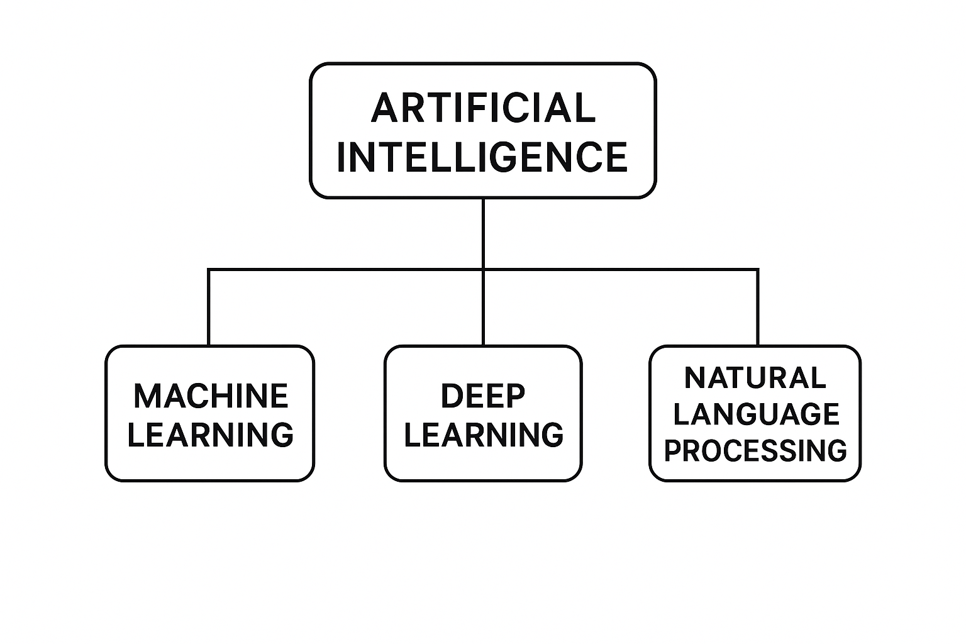
FIG.1 Artificial Intelligence(AI)
2.3Machine learning (ML):
Is a subfield of artificial intelligence that focuses on developing algorithms and statistical models that enable computer systems to learn patterns from data and make predictions or decisions without being explicitly programmed. ML systems improve their performance automatically through experience, allowing them to discover hidden relationships within datasets and generalize to new, unseen data. [2]
This broad category includes traditional algorithms and advanced techniques like Deep Learning “DL”, which utilize complex neural networks to achieve higher performance in tasks like medical text analysis.
Machine learning has gained significance in medical practice because healthcare data continues to expand through digital health records and medical imaging and patient-generated information. The traditional diagnostic approach needs both time and medical expert involvement but ML technology delivers quick data-based results with enhanced precision.
Medical applications of ML depend on its capability to:
- Process extensive medical information databases at high speeds
- Identify patterns which human eyes cannot detect
- The system helps medical professionals during their diagnostic evaluation process.
- The system produces better results while minimizing mistakes in its output.
- The system enables doctors to identify diseases at their initial stages.
Examples of ML applications in healthcare:
- The system uses patient information and medical signs to forecast disease development.
- The system examines X-ray images together with MRI and CT scan data.
- The system classifies medical documents and clinical documentation.
- The system identifies fresh medical treatments and drug discoveries.
- The system tracks patient health status in real-time.
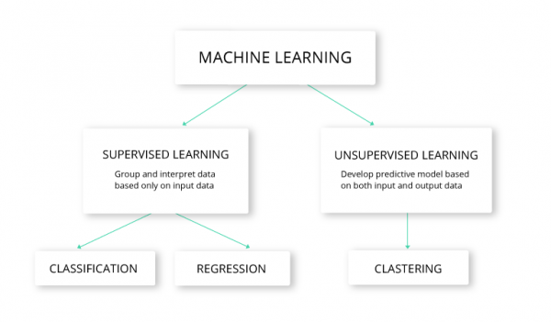
FIG.2 Machina learning (ML):

2.4 Deep Learning (DL):
Deep Learning (DL (represents the most advanced branch of Machine Learning “ML”, utilizing multi-layer neural networks “deep networks” to learn from data. These deep networks allow the model to discover complex patterns. With this ability, DL can handle advanced tasks such as image recognition, natural language processing, and medical text analysis.
Deep learning models become more accurate when they are trained on large datasets and supported by strong computational power. Because of this, DL has achieved some of the best results in many modern AI applications. [3]
Deep learning models reach their best results when they receive training from extensive datasets and operate with strong computational systems. The technology has established itself as a fundamental element of contemporary AI systems because it delivers outstanding results in multiple medical applications.

Why Deep Learning is Important in Medicine:
- The system demonstrates exceptional precision when it analyses medical pictures including X-ray and CT and MRI images.
- The system understands medical text to identify essential medical data.
- The system identifies complex patterns which human eyes cannot detect.
- The system generates automated medical diagnoses and treatment plans.
- The system decreases medical mistakes while enhancing healthcare professionals make better choices.
Healthcare professionals use Deep Learning technology for several essential applications.
- The system detects tumours inside radiology images.
- The system uses text-based symptoms to identify diseases through its classification process.
- Wearable devices enable the system to track patient health status.
- The system generates forecasts about treatment results.
- The system retrieves medical information from electronic health records (EHRs).
Deep Learning serves as the base for intelligent medical systems which allow machines to achieve human-like comprehension to execute complex diagnostic operations to deliver quick a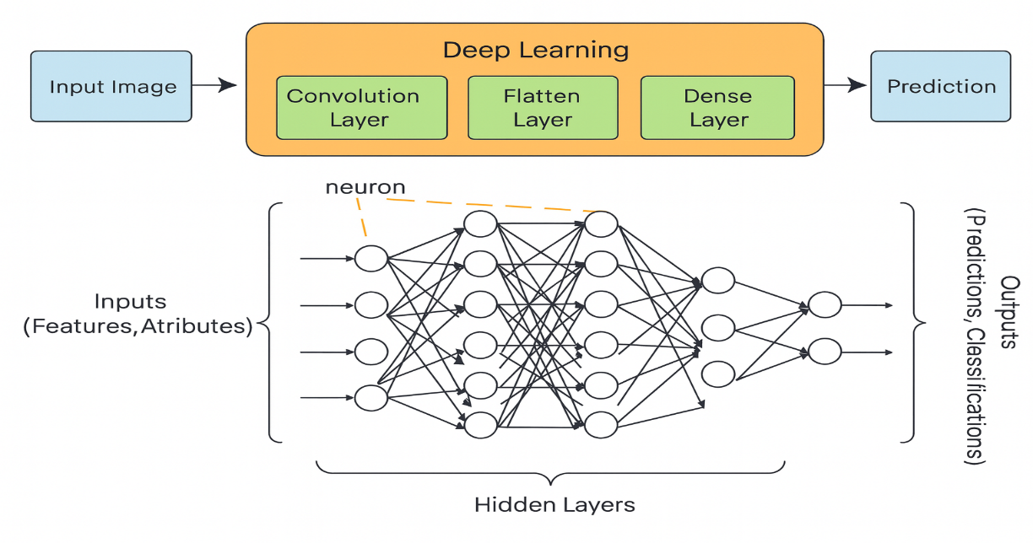

FIG.3 Deep Learning (DL)

2.5. Natural Language Processing (NLP):
Natural Language Processing “NLP” is a field of artificial intelligence that focuses on enabling computers to understand, interpret, and generate human language. It allows systems to analyze medical text, extract symptom information, and convert unstructured text into meaningful features.[4]
The medical field depends on NLP to analyse data from patient symptom reports and electronic health records and clinical reports and medical research publications. The transformation of unstructured medical text into machine-readable information becomes possible through NLP because most healthcare data exist in natural language format.
Why NLP Is Important in Healthcare:
- The system identifies medical terms and symptoms which patients write down during their descriptions.
- The system converts unorganized clinical data into numerical values which it understands.
- The system enables doctors to make diagnoses automatically while helping them make clinical choices.
- The system enables fast analysis of extensive medical literature collections.
- The system enables patients to interact with AI medical assistants through communication channels.
Examples of NLP Applications:
- The system identifies essential for extracting symptoms from patient-provided information.
- The system uses text descriptions to perform disease classification tasks.
- Medical chatbots and virtual health assistants operate through NLP technology.
- The system analyses medical reports and patient records for clinical data extraction.
- The system generates concise versions of medical research documents.
NLP technology enables computers to move past basic keyword searches by understanding human language context and medical significance which makes it essential for developing intelligent healthcare systems.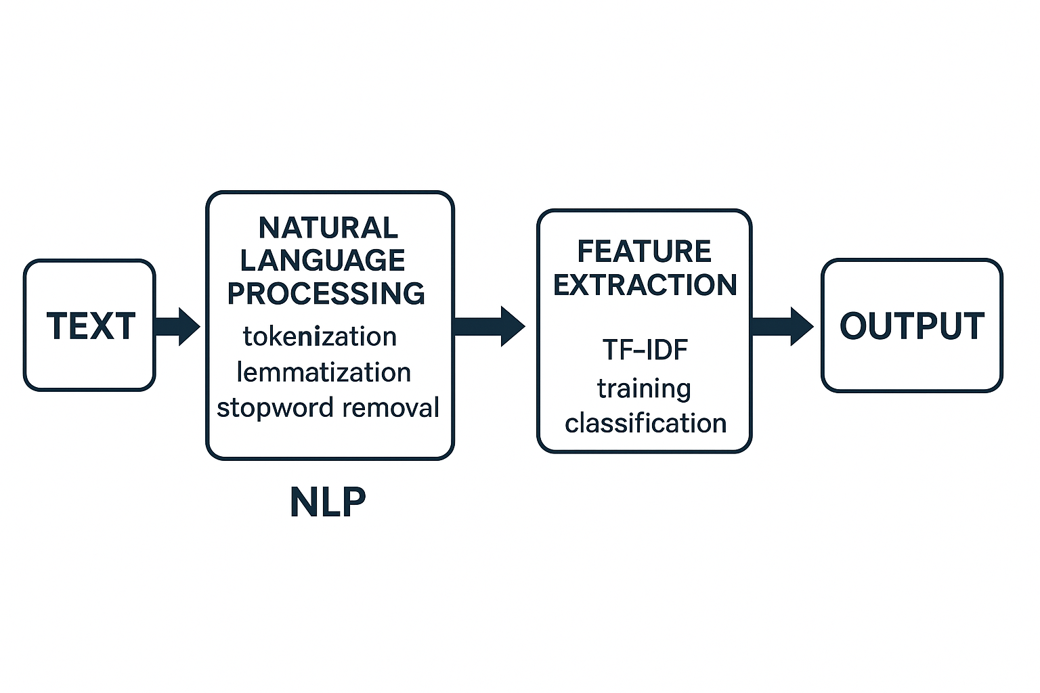
FIG.4 Natural Language Processing (NLP)

2.6 Transformer Architecture:
Transformers are highly advanced Deep Learning) DL( models and thus a subset of ML designed to handle sequential data using a self-attention mechanism. They process entire sentences at once, allowing them to capture contextual meaning more effectively than traditional RNN-based models.[5]
The Transformer model uses self-attention to analyse word relationships across any sentence position which enables better context understanding than RNN-based models.
$$Attention\left(Q,K,V\right)=\text{softmax}\left(\frac{QK^{T}}{\sqrt{d_{k}}}\right)V$$

The following advantages make Transformers outperform RNNs in their operations:
- The model handles complete sentence input at once instead of processing words sequentially.
- The model demonstrates superior ability to detect distant word connections throughout sentences.
- The model trains more efficiently when working with extensive datasets.
- The system operates at increased speed when running on GPU hardware.
- The models based on Transformers achieve the highest possible results in Natural Language Processing applications.

The medical field benefits from Transformer-based models including BERT and Bio BERT and Clinical BERT because they achieve exceptional results in medical text analysis and disease forecasting and clinical decision-making systems.
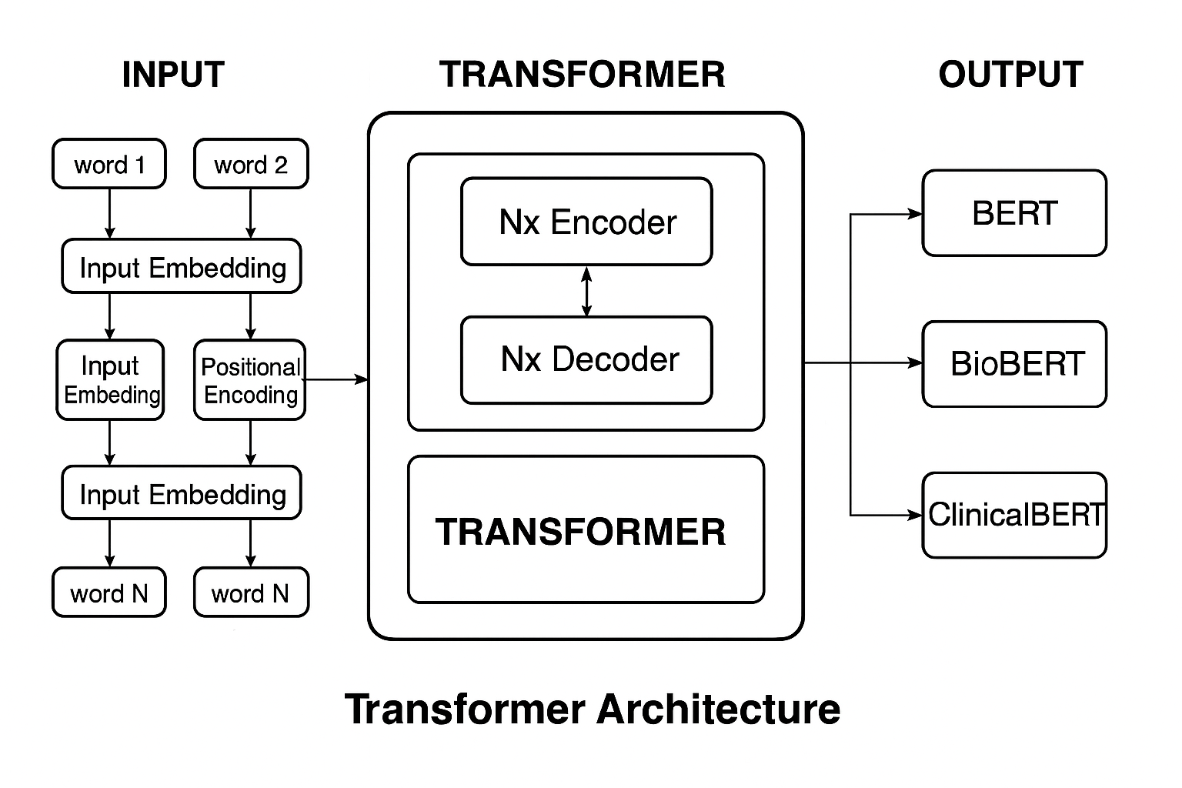
FIG.5 Transformer Architecture

2.7 TF-IDF) Term Frequency - Inverse Document Frequency (
TF-IDF is a numerical representation used in Natural Language Processing “NLP” to measure how important a word is within a document relative to an entire dataset.
It increases with the number of times a word appears in a document “TF” but decreases with how commonly the word appears across all documents “IDF”.
This helps highlight important medical terms in symptom descriptions and reduce the weight of common words like “the” or “and”.[6]

$$TF\left(t,d\right)=\frac{count\left(t,d\right)}{\text{total words in }d}$$
$$IDF\left(t,D\right)=log\left(\frac{N}{\left|\{d∈D: - t∈d\}\right|}\right)$$

$$TF\text{-}IDF=TF\left(t,d\right)×IDF\left(t,D\right)$$

Tokenization is the process of breaking raw text into smaller meaningful units called tokens. These tokens can be words, subworlds, or characters, depending on the model and the tokenizer used. Tokenization is a fundamental preprocessing step in Natural Language Processing “NLP” because machine-learning and deep-learning models cannot interpret raw text directly they require text to be segmented and converted into numerical representations.
In medical text analysis, tokenization helps transform symptom descriptions into structured units that models such as BERT, Bio BERT, and Clinical BERT can process. Modern transformer models use subworld tokenization, which allows them to handle rare medical terms, abbreviations, and variations in clinical language.[7]
2.8 Evaluation Metrics (Accuracy, Precision, Recall, F1-score):
In any machine learning classification task, the evaluation step is essential to ensure that the model can generalize well to unseen data and is reliable enough to be deployed in real-world medical applications. Unlike regression problems, classification tasks require metrics that assess not only the overall correctness of predictions but also how well the model distinguishes between different disease categories.
The most commonly used evaluation metrics for classification include Accuracy, Precision, Recall, and F1-score. These metrics provide a comprehensive view of model performance from different angles.
Accuracy measures the overall proportion of correct predictions, while Precision evaluates how many of the predicted positive cases are actually correct. Recall measures the model’s ability to identify all true positive cases, making it critical in medical settings where missing a disease case can have serious consequences. The F1-score combines both Precision and Recall into a single measure, offering a balanced perspective especially when dealing with imbalanced datasets.
These evaluation metrics are calculated by comparing the predicted labels with the true labels and are widely used in classification problems such as disease prediction based on patient-reported symptoms.[8]
$$Accuracy=\frac{TP+TN}{TP+TN+FP+FN}$$
$$Precision=\frac{TP}{TP+FP}$$
$$Recall=\frac{TP}{TP+FN}$$
$$F1=2×\frac{Precision×Recall}{Precision+Recall}$$

Chapter 3: Related Work

3.1Introduction:
In recent years, artificial intelligence has become a powerful tool for analyzing data and discovering patterns that were difficult to identify with traditional methods. As AI technologies continue to develop, researchers have explored various models to improve prediction accuracy and aid in better decision-making, particularly in areas such as healthcare and education.
Before developing a new system, it is important to understand what work has already been done in the same area. Review of previous studies helps to identify the methods used, results obtained and limitations that still exist. This background provides a clear foundation for the current research and ensures that it builds strong scientific knowledge while addressing remaining gaps.

.3.2 History
Leila Aissa et. [9] “2025” conducted a study to improve the accuracy of symptom-based Medical. diagnosis using ensemble learning methods. The research tested several models, including Decision Trees “DT” and Support Vector Machines “SVM”, alongside ensemble approaches such as Bagging and Stacking. Three experimental datasets were created for the study the Reference Dataset, Cough Differential Diagnosis Dataset Cough-DDX, and Cough-DDX2 to reflect real world respiratory symptom scenarios.
The findings showed that the Bagging ensemble combined with SVM outperformed the single models. Delivering superior performance in terms of accuracy, precision, recall, and F1-score. This highlights the potential of ensemble approaches in clinical decision support systems.

Fatemeh Sogandi “2024” [10] conducted a study using a Kaggle based symptom disease dataset to integrate supervised and unsupervised learning techniques. The purpose was to highlight important symptoms and generate generalized diagnostic rules. The Prior algorithm was applied to extract association rules, while several predictive models, including stepwise regression, SVM, bootstrap forest, and boosted trees, were tested. Results indicated that stepwise regression achieved the best performance, proving effective for accurate disease
classification and the development of decision-support rules.

In 2024, Esraa Hassan et. [11] investigated how advanced language models could be applied to improve the classification of diseases from symptom descriptions. Their work focused on comparing traditional deep learning approaches, such as BiLSTM, with domain-adapted transformer models like MCN-BERT. To test model effectiveness, the researchers prepared two datasets: - the first consisted of 1,200 pairs linking symptoms to specific diseases, while the second contained more than 23,000 tweets related to adverse drug reactions. The results showed that MCN-BERT, particularly when trained with the A damp optimizer, consistently produced the best outcomes, reaching an accuracy close to 99.6% on the first dataset and around 96% on the second. These findings underline how specialized transformer architectures can capture subtle patterns in clinical language, offering strong potential for automated disease classification and early diagnostic support.

Al-Qarni et. 2025.[12] introduced a deep learning framework for predicting diseases from textual symptom descriptions. They constructed two custom textual datasets: - the first covered 24 diseases, and the second extended to 41 diseases, with each dataset containing natural language descriptions of symptoms, these datasets were custom-built by the authors from openly available symptom descriptions and were not published as a public repository.
The researchers applied natural language processing “NLP” techniques, including tokenization and TF-IDF, combined with deep learning models such as LSTM, CNN-LSTM, and GRU. Experimental results demonstrated that the CNN-LSTM model with tokenization achieved the highest accuracy “99.9%” on the 41-disease dataset, while LSTM + TF-IDF reached 98.8% on the 24-disease dataset.
Dataset: Custom-built symptom description datasets 24 diseases, 41 diseases not publicly available

Manikant Serigne’d “2024”.[13] conducted a study entitled “Symptom-Based Disease Prediction: - A Machine Learning Approach” with the objective of improving disease diagnosis based on symptom descriptions. The researchers used an open-access dataset in Kaggle containing 132 symptoms linked to 41 diseases.
To analyses the data, they applied several machine learning algorithms including Decision Tree “DT”, Support Vector Machine “SVM”, Random Forest “RF”, and Extreme Gradient Boosting “XGBoost”.
The findings revealed that XGBoost outperformed all other classifiers, achieving the highest accuracy in predicting diseases from symptom inputs.

Finkelstein et.[14]
. conducted a study The primary objective was to support timely clinical decision-making by forecasting symptom progression based on self-reported patient data. The researchers applied two deep learning models Convolutional Neural Network “CNN” and Long Short-Term Memory “LSTM” to a longitudinal dataset of daily symptom logs recorded by 208 cancer patients during chemotherapy cycles. These logs included information on fatigue, nausea, pain, and other symptoms. The models were evaluated using different time windows “3 to 7 days” to predict symptom escalation events. The results showed that the CNN model with a 3-day look-back window outperformed the LSTM, achieving an accuracy of 81%, precision of 87%, recall of 80%, and F1-score of 83%. The LSTM model achieved slightly lower but comparable results. The study concluded that CNN is a strong candidate for real-time symptom monitoring in digital health platforms. The dataset used in this study consists of real-world, hospital-based, patient-reported symptom data and is available upon request.
Abhinav et. .[15] proposed a machine learning-based system to predict multiple chronic diseases, including breast cancer, heart disease, and diabetes. The system is designed to be simple and user-friendly, with a web interface built using Python, Django, and Streamlet, allowing users to input their health data and receive disease predictions.
The models used in the study include Decision Tree “DT” and Support Vector Machine “SVM”. After evaluation, the Decision Tree model demonstrated the highest performance across all diseases, achieving 97.98% accuracy for breast cancer, 92.62% for heart disease, and 91.55% for diabetes.
Saima Afrin et. .[16] conducted a study titled "Supervised Machine Learning Based Liver Disease Prediction Approach with LASSO Feature Selection" to develop an effective system for early diagnosis of liver disease using supervised machine learning techniques. They utilized the Indian Liver Patient Dataset “ILPD”. The researchers evaluated a range of classifiers, including Logistic Regression, Decision Tree, Random Forest, AdaBoost, K-Nearest Neighbors, Linear Discriminant Analysis, Gradient Boosting, and Support Vector Machine. To improve model performance and enhance interpretability, they applied the Least Absolute Shrinkage and Selection Operator “LASSO” for feature selection, isolating the most influential predictors of liver disease. Using 10-fold cross-validation and performance metrics accuracy, precision, sensitivity, and F1-score they found that the Decision Tree model, when combined with LASSO, outperformed others with an accuracy of 94.29%, precision of 92%, sensitivity of 99%, and F1-score of 96%. These results emphasize the utility of combining tree-based models with effective feature selection for reliable and early liver disease prediction
Chintan M. et. .[17] the researchers proposed a machine learning-based framework to predict cardiovascular disease with high accuracy. The goal was to support early and reliable diagnosis of heart disease using automated methods to reduce human error in medical decision-making.
The study utilized several supervised Machine Learning “ML” models, including Decision Tree “DT”, Random Forest “RF”, XGBoost “XGB”, and Multilayer Perceptron “MLP”. A k-modes clustering algorithm with Huang initialization was applied during preprocessing to improve classification quality, and GridSearchCV was used for hyperparameter tuning.
The models were trained and tested using a real-world dataset containing 70,000 patient records, sourced from Kaggle. The Multilayer Perceptron “MLP” model achieved the best results with an accuracy of 87.28% and an AUC of 0.95, outperforming the other models in the study
Umar ani ets.in 2022.[18] the researchers proposed multiple machine learning approaches for early heart disease detection The study introduced four main models including Naïve Bayes with a weighted approach a hybrid model combining Support Vector Machine and XGBoost based on time domain frequency domain and information theory features an improved Support Vector Machine based on duality optimization and a clinical decision support system that uses DBSCAN for outlier removal SMOTE ENN for class imbalance correction and XGBoost for final disease prediction performance evaluation included metrics like precision recall F1 score and accuracy Among all the models XGBoost consistently delivered the highest accuracy and robustness across different experiments making it the most effective classifier used in the study The authors emphasized the potential of machine learning in assisting clinicians with reliable early heart disease diagnosis The specific dataset used was not clearly named in the paper and no public dataset link was provided suggesting that private or institutionally collected clinical data may have been used

Abdur et. [19] conducted a study to predict COVID-19 infection outcomes using the Light Gradient Boosting Machine “LGBM” algorithm. The primary objective was to develop a fast, lightweight, and accurate predictive model that could be integrated into clinical decision support systems. To achieve this, the researchers utilized a structured dataset comprising patient-reported symptoms such as fever, cough, and fatigue, in addition to diagnostic test results and demographic attributes. The choice of LGBM was motivated by its efficiency in handling large-scale structured data with low computational demands. Experimental results demonstrated that the LGBM model achieved high predictive accuracy while requiring minimal training time, making it particularly suitable for real-time COVID-19 screening and clinical triage scenarios. The dataset used in this study is referred to as the COVID-19 Symptom and Patient Data, which provided a comprehensive foundation for evaluating model effectiveness in practical healthcare contexts
Lee et.[20] proposed a novel approach to personalized medication recommendation through the development of Graph BERT, a Graph Augmented Transformer model. The study utilized the MIMIC-III The primary aim was to generate precise and individualized treatment recommendations based on a patient's medical history. Experimental evaluations showed that Graph BERT significantly outperformed baseline models by effectively modeling complex dependencies in the data, leading to more accurate and clinically relevant medication suggestions. The use of the MIMIC-III dataset provided a robust and realistic environment for testing the model’s effectiveness in real-world healthcare applications
Prabhakar, et. [21] conducted a study with the aim of improving the identification of patient phenotypes from free-text clinical notes using deep learning techniques. The authors used the MIMIC-III dataset, The model was evaluated using standard performance metrics, and the results showed that it outperformed traditional models such as vanilla BERT, Bio BERT, and basic CNNs. Specifically, the proposed model achieved an AUROC of 0.80, F1-score of 0.72, and a Hamming loss of 0.09, indicating its strong capability in multi-label classification tasks for clinical phenotyping.
Kumar et. [22] conducted a study to develop a predictive model for diabetes diagnosis using classic machine learning algorithms. The researchers employed the PIMA Indians Diabetes Dataset, open-access. The models evaluated included Support Vector Machine “SVM”, Logistic Regression “LR”, and Decision Trees “DT”. The goal was to compare their effectiveness in binary classification of diabetic vs. non-diabetic cases. Among the tested models, SVM achieved the highest accuracy of 89%, showcasing its effectiveness for medical prediction tasks with structured numerical data. Dataset Used: - PIMA Indians Diabetes Dataset
Ridham Sood et.[23] conducted a “with the objective of developing a smart healthcare system that can predict diseases based on user-reported symptoms. The authors used a structured dataset containing over 5,000 records of symptom-to-disease mappings. Several machine learning models were applied in this research, including Decision Tree “DT”, K-Nearest Neighbors “KNN”, Naïve Bayes, and Random Forest “RF”. Among these, the Random Forest algorithm achieved the highest accuracy, exceeding 90%, making it the most reliable model for the classification task. The system was also integrated into a web application for real-time diagnosis support. Although the dataset was custom-built by the researchers, it is hosted alongside the study publication. The dataset and full study can be accessed through the International Journal of Preventive Medicine and Health

Table 1: Summary of Related Work:
Study | Year | Dataset | Models | Best Model | Result
1 | 2025 | Reference, Cough-DDX-DDX2 | DT, SVM, Bagging, Stacking | Bagging +SVM | High accuracy and recall
2 | 2024 | Kaggle “symptom–disease dataset | Prior + Stepwise Regression, SVM, Bootstrap Forest, Boosted Trees, Neural-Boosted Methods | Stepwise Regression | Achieved the most reliable performance and enabled extraction of useful decision rules
3 | 2024 | Dataset-1: - 1200 symptom–disease pairs.  Dataset-2: - 23,516 “ADR vs non-ADR”. | BiLSTM, CNN-LSTM, BERT, Bio BERT, MCN-BERT | MCN-BERT A damp optimizer. | Dataset-1: - Accuracy 99.58%, Precision 99.46%, Recall 99.37%, F1 = 99.13%.  Dataset-2: - Accuracy 96.15%
4 | 2025 | Custom-built textual datasets “24 & 41 diseases – symptom descriptions, not publicly available” | LSTM, CNN-LSTM, GRU with Tokenization & TF-IDF | CNN-LSTM “Tokenizer” | Accuracy: - 99.9% “41 diseases”, LSTM+TF-IDF: - 98.8% “24 diseases”
5 | 2022 |  | Decision Tree “DT”, Support Vector Machine “SVM”, Random Forest “RF”, XGBoost | XGBoost | Achieved the highest accuracy in symptom–disease classification
6 | 2024 | Symptom diaries from cancer patients on chemotherapy “self-reported, daily, custom dataset” | “CNN”  LSTM | CNN “3-day window” | Accuracy: - 81%  Precision: - 87%  Recall: - 80%  F1-score: - 83%
7 | 2023 |  | Decision Tree, SVM | Decision Tree, | Breast Cancer: - 97.98%  heart disease: - 92.62%  Diabetes: - 91.55%
8 | 2021 | Indian Liver Patient Dataset “ILPD | DT, RF, SVM, KNN, AdaBoost, GB, LR, LDA | Decision Tree “LASSO”
  Accuracy: - 94.29%
  Precision: - 92%
  Sensitivity: - 99%
  F1-score: - 96%
9 | 2023 | Cardiovascular Disease Dataset from Kaggle | DT, RF, XGBoost, MLP, K-Modes + GridSearchCv | Multilayer Perceptron “MLP” | Accuracy: - 87.28%,  AUC: - 0.95
10 | 2022 | Clinical heart disease data “not specified | Naïve Bayes, SVM  XGBoost, improved  SVM, DBSCAN,  SMOTE-ENN | XGBoost
  Best overall performance in accuracy, precision, recall, and F1-score across multiple approaches
11 | 2022 | COVID-19 Symptom Dataset | LGBM | LGBM | Fast and accurate prediction
12 | 2023 | MIMIC-III | Graph Transformer | Graph BERT | Effective medication recommendation
13 | 2025 | MIMIC-III | Clinical BERT, Bio BERT, blue BERT, CNN, Vanilla BERT, and a custom hybrid model | Clinical BERT + Multi-head Attention + CNN | AUROC: - 0.80  F1-score: - 0.72  Hamming Loss: - 0.09
14 | 2023 | PIMA Diabetes | SVM, LR, DT | SVM | 89% accuracy
15 | 2024 | dataset >5,000 symptoms-to-disease mapping | Decision Tree, K-Nearest Neighbours’, Naïve Bayes, Random Forest | Random Forest | Accuracy  90 %، Random Forest

3.4 Summary:
The studies reviewed in this work show how machine learning and deep learning are becoming increasingly involved in disease prediction and symptom analysis. Researchers explored a wide range of methods from simple ML classifiers to ensemble techniques and advanced transformer-based models. Several studies reported strong results; for example, pairing SVM with specific feature-selection methods improved respiratory disease prediction, while stepwise regression identified the most influential symptoms. Other research used CNN-LSTM models for text-based disease classification and XGBoost for detecting chronic conditions. In addition, several studies relied on clinical datasets such as MIMIC-III to identify patient patterns, track symptom progression, and recommend medications using transformer models.
The research direction of artificial intelligence in medical text analysis becomes clearer through these findings. Most previous studies employed classical ML classifiers including SVM, Logistic Regression, and Naïve Bayes, while others investigated ensemble methods such as Bagging and XGBoost, and hybrid deep-learning systems that combined CNN and LSTM. Recent work shows growing interest in transformer-based models particularly BERT, Bio BERT, and Clinical BERT because these models excel at understanding medical terminology, semantic meaning, and contextual relationships in unstructured patient symptom descriptions.
Despite these advancements, several limitations remain. Many studies continue to rely on structured datasets even though real clinical data especially patient-reported symptoms exist mainly as unstructured free text containing vague expressions and non-standard medical terminology. Only a limited number of studies focus on this challenging data type. Furthermore, while transformer models outperform traditional ML models in handling unstructured text, very few studies integrate these models into complete systems that connect disease prediction with evidence-based treatment recommendation. Another gap involves the limited availability of public medical datasets and the lack of real-world testing, making it difficult to reproduce results or apply research outcomes in clinical practice.
Because of these gaps, there is a clear need for a system capable of reading free-text symptom descriptions, predicting diseases using both ML and transformer models, and linking these predictions to reliable treatment sources. Addressing this research gap would make diagnostic support systems more practical, accurate, and closer to real clinical use. Developing such a system would allow researchers and practitioners to build operational AI tools that support doctors, reduce diagnostic delays, and increase access to medical care.
This research project contributes to solving these challenges by establishing a complete AI system that unites ML and transformer models with evidence-based treatment recommendation functionality. The proposed system aims to enhance the performance of healthcare AI while providing diagnostic tools that align with clinical requirements and support practical medical decision-making.

Chapter: 4 Proposed Approach:Introduction:

This chapter explains how the proposed AI-based medical decision-support system was designed and built. The system aims to simplify and automate the process of identifying diseases from unstructured symptom descriptions and then providing evidence-based treatment recommendations. To achieve this, the chapter walks through a step-by-step workflow that begins with collecting medical symptom data, then moves through careful preprocessing and feature preparation, followed by training machine learning (ML) and deep learning (DL) models. The process concludes with a treatment recommendation stage that links each predicted disease to an appropriate medical solution.

The chapter explains how the AI system was built to identify the most likely disease from a patient’s symptoms, presenting the complete workflow from raw data to treatment recommendation. The process begins with data collection, where symptom and disease information are gathered from reliable medical sources.

Since real-world text often contains noise and inconsistencies, the next stage focuses on preprocessing the data. This step involves cleaning the text by removing irrelevant symbols, repeated entries, and unnecessary content. Once the text is cleaned, it is transformed into a numerical format suitable for model training. For machine learning models, TF-IDF is applied to extract important features, while deep learning models rely on tokenization to convert the text into meaningful contextual representations.
Once the data preparation stage is complete, the models move into the training phase. Each model learns the patterns linking symptoms to the most likely disease. After training, the models are tested on unseen data, and their performance is evaluated using accuracy, precision, recall, and F1-score. These metrics measure how consistently and correctly each model predicts disease outcomes and how effectively it distinguishes between similar conditions.
Finally, the best-performing model is selected for treatment recommendation. The predicted disease is matched with an appropriate treatment option retrieved from a trusted medical database, making the system useful as a medical decision-support tool. Figure 9 shows the comprehensive workflow of the proposed system, highlighting the data flow from raw input to final clinical output. Overall, the pipeline demonstrates how raw symptom text is transformed into reliable treatment suggestions using AI techniques.
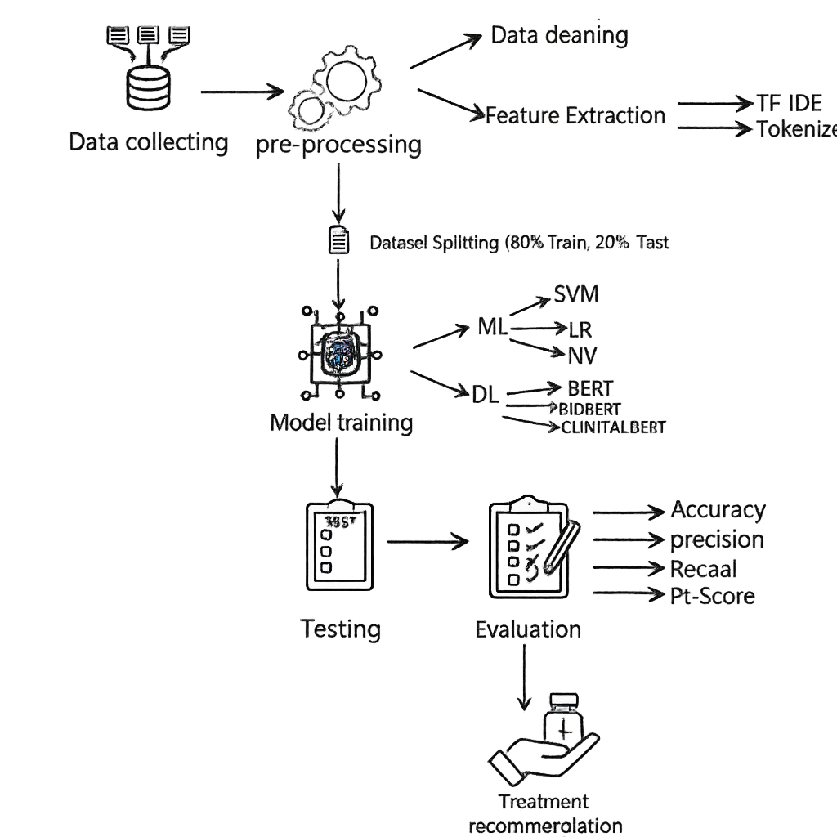
FIG.5 Workflow

4.1 Data collecting:
The empirical foundation of this research rests upon two primary datasets sourced to facilitate both disease classification and therapeutic recommendation. The data acquisition process focused on obtaining high-quality, labeled medical text suitable for supervised learning and evidence-based decision support.
- Symptom2Disease Dataset [24] (Unstructured Text Data). (For Prediction daisies): The core dataset for model training was acquired from the Kaggle repository. It comprises 6,000 distinct records of natural language symptom descriptions. These records are categorized into 24 unique disease classes, providing a diverse ground truth for training the classification models. The dataset captures the variability in how patients describe their conditions, ranging from brief keywords to complex sentences, which is essential for training robust NLP models.
Along with the symptom text, the dataset also includes a structured label that represents the actual disease class. Therefore, the data combines unstructured input symptoms with structured output disease labels. This makes it suitable for training machine-learning and deep-learning models for multi-class classification tasks.
This type of data is particularly valuable because it reflects the nature of medical text found in real-life scenarios often ambiguous, varied, and written in different styles. As a result, it allows AI models to learn how to interpret human language, understand medical terminology, and link symptoms to diseases effectively.
The dataset was partially imbalanced, as some diseases appeared more frequently than others. This is expected in real-world medical data and may affect the classification performance. Therefore, preprocessing strategies such as class weights and data balancing techniques were considered to reduce the impact of this imbalance.
2 Open FDA Drug Labeling [25] (Structured FDA Pharmacological Records). (for Treatments) To ensure the reliability and medical validity of treatment recommendations, the study relied on the Open FDA Drug Labeling database as a crucial secondary source. This database contains over 15,000 structured drug records, including detailed information on indications, recommended dosages, warnings, and potential side effects, making it a reliable source for treatment recommendations.
The medical treatment database used in this research consisted of structured tabular data in which each treatment protocol was directly linked to its corresponding disease in the symptom database. Since this dataset was used only to connect each predicted disease to the appropriate treatment and not for model training any data imbalance did not affect its function within the system. Additionally, the database was used in its original form without any manual modifications.
During the data integration phase, the two datasets were automatically linked based on matching disease names. This automatic matching allowed for the creation of a clear reference table, ensuring that each predicted disease was directly linked to a reliable treatment option from the FDA database. In this way, the system has a solid foundation that allows not only for accurate disease prediction, but also for providing safe and realistic treatment recommendations.

4-2 Pre-Processing:
Raw medical text often contains noise, inconsistencies, and formatting errors that can significantly degrade the performance of machine learning models. Therefore, a comprehensive pre-processing pipeline was implemented to transform the unstructured symptom descriptions into a clean, standardized format suitable for algorithmic analysis.
4.2.1 Data Cleaning
The data cleaning phase focused on improving data quality and reducing the dimensionality of the feature space. The following specific operations were applied to the raw text:
- Normalization: All text characters were converted to lowercase. This step ensures uniformity, preventing the model from treating the same word “e.g., "Fever" and "fever” “as two different tokens.
- Noise Removal: Non-alphanumeric characters, punctuation marks, and unnecessary special codes were stripped from the text. This removal is crucial to ensure that the model focuses solely on clinically relevant terminology without being distracted by formatting artifacts.
- Duplicate and Null Handling: The dataset was rigorously inspected for missing values and duplicate records. Duplicate entries were identified and removed to prevent model bias and ensure the integrity of the evaluation process.
- Stop word Removal: Common words that do not carry specific medical meaning “such as "the", "is", "at “were removed to reduce noise and allow the model to focus on critical symptom keywords.

4-2-2Feature extraction:
Machine learning and deep learning algorithms require numerical input to perform mathematical operations. Therefore, feature encoding is a critical step to convert the pre-processed textual symptoms into numerical vectors. This study employs two distinct encoding strategies tailored to the specific requirements of the models used:
1. Statistical Vectorization TF-IDF for ML Models: To prepare data for the SVM, Logistic Regression, and Naïve Bayes classifiers, the Term Frequency-Inverse Document Frequency TF-IDF technique was utilized. Unlike simple word counts, TF-IDF reflects the importance of a word to a document in a collection or corpus, effectively reducing the weight of common words while highlighting distinctive terms [41].
Term Frequency (TF): Measures how frequently a term occurs in a specific patient record.
Inverse Document Frequency (IDF): Penalizes common words that appear across all documents “which carry little diagnostic value” and assigns higher weights to rare, disease-specific terms. This calculation ensures that clinically significant keywords dominate the feature space [42].
Implementation: The text was vectorized into a sparse matrix where each row represents a patient case and each column represents a unique symptom term.
2. Contextual Tokenization for Deep Learning Models: Transformer-based models “BERT, Bio BERT, Clinical BERT” require a more sophisticated approach than simple vectorization. We utilized the specific Tokenizer associated with each pre-trained model. The tokenization process involves breaking text into smaller linguistic units suitable for neural network processing [26]. The process includes:
Sub-word Tokenization: The tokenizer breaks down complex medical terms into smaller sub-word units. This allows the model to handle rare words and out-of-vocabulary terms effectively.
Special Tokens: The system automatically adds architecture-specific tokens:
[CLS]: Added at the beginning of each sequence to represent the classification embedding.
[SEP]: Added at the end to separate sequences.
Padding and Truncation: To ensure uniform input dimensions for the neural network, all sequences were padded or truncated to a fixed maximum length

4.3 Dataset Splitting:
Following the initial data acquisition phase, the dataset contained approximately 6,000 raw symptom–disease records. However, a significant portion of these entries included duplicated text, missing information, or noise that could negatively affect model performance. After applying comprehensive cleaning and preprocessing procedures including duplicate removal, normalization, and filtering incomplete entries the final refined dataset consisted of 1,200 high-quality and usable records.
To ensure a robust evaluation of the model’s generalization capability, the cleaned dataset was partitioned using the Hold-Out Method with an 80:20 ratio.
- Training Set (80%): Comprising 960 records used to train the models and optimize their parameters.
- Testing Set (20%): Comprising 240 records kept completely separate to objectively evaluate the final performance on unseen data.

4.4 Model Training:
This section delineates the experimental setup and the training protocols applied to both machine learning and deep learning architectures. The training process was conducted using the Scikit-Learn framework for traditional algorithms, including Logistic Regression, Linear SVM, and Naïve Bayes, while PyTorch and the Hugging Face Transformers library were used to implement and fine-tune transformer-based models such as BERT, BioBERT, and ClinicalBERT within a Python environment. These libraries provided the essential tools for preprocessing the data, generating embeddings, optimizing model parameters, and performing efficient training on high-dimensional textual features.
To ensure the reliability of the results, Stratified Sampling was employed during the data split to maintain the same proportion of disease classes in both the training and testing sets, thereby preventing class bias during the learning phase. This method guarantees that each of the 24 disease categories is represented consistently across both subsets, which is crucial for building a fair and generalizable model.
The models were trained to map high-dimensional feature vectors either TF-IDF representations generated through Scikit-Learn or Token Embeddings produced by Hugging Face tokenizers to one of the 24 discrete disease categories. This mapping process enables the system to transform raw symptom text into meaningful numerical signals that the classifiers can interpret and convert into accurate disease predictions.
.

4.4.1 Machine Learning Models
Support Vector Machine SVM:
Support Vector Machine “SVM” is a supervised machine-learning algorithm used for classification tasks. It works by finding the optimal hyperplane that separates data points into different classes with the maximum margin. SVM is highly effective in high-dimensional text data, making it suitable for medical text classification.[27]
Logistic Regression LR:
Logistic Regression “LR” is a statistical classification model that predicts the probability of a class using a logistic “sigmoid” function. It is widely used in binary and multi-class text classification due to its simplicity, speed, and strong performance with TF-IDF features. [28]

Naïve Bayes:
Complement Naïve Bayes “CNB” is a variant of the Naïve Bayes classifier specifically designed for imbalanced text classification. It estimates probabilities using complement class statistics, reducing bias toward majority classes and improving performance on high-dimensional text data.[29]
Random Forest RF:
Random Forest is an Ensemble Learning algorithm that operates by constructing a large number of Decision Trees during the training phase. It combines the output of these individual trees to produce a final prediction that is more stable and accurate. The core idea is that a collection of relatively weak predictors “individual trees” can collectively form a very strong predictor, which helps in mitigating the problem of Overfitting.[30]
XG Boost Extreme Gradient Boosting:
xGBoost is an advanced and highly efficient software library that falls under the Gradient Boosting framework. It is known as one of the most powerful algorithms in data science competitions. It works by sequentially building Decision Trees, where each new tree focuses on correcting the errors made by the previous ones. It is characterized by its speed, strong performance, and ability to handle large datasets efficiently.[31]
MNB Multinomial Naive Bayes:
MNB is a specific variant of the Naive Bayes algorithm, which is based on probability theory and assumes "naive independence" between features. This model is particularly suitable for classifying data that represents counts, such as the frequency of words in a document. Consequently, it is widely and effectively used in Text Classification applications within the field of Natural Language Processing “NLP”.[32]
4.4.2 Deep Learning Models:
In the second phase of the proposed framework, we employed Transfer Learning, a technique that leverages knowledge from pre-trained transformer models to solve downstream tasks with limited data. Unlike traditional models that rely on manual feature engineering, these models learn contextual embeddings directly from the raw text. Three specific transformer architectures were fine-tuned for the disease classification task:

1. BERT Bidirectional Encoder Representations from Transformers:
Used as the baseline model, BERT utilizes a multi-layer bidirectional transformer encoder. It was pre-trained on the Books Corpus and English Wikipedia. While effective for general language, its limitation lies in its generic vocabulary, which may not fully grasp complex medical syntax [33].
2. Bio BERT Biomedical BERT:
To address the domain gap, we implemented Bio BERT. This model shares the same architecture as BERT but was further pre-trained on large-scale biomedical corpora, including PubMed abstracts and PMC full-text articles. This domain-specific pre-training enables the model to recognize biomedical entities more accurately than standard BERT [34].
3. Clinical BERT The Core Model:
Clinical BERT was selected as the primary component of this system. It is initialized from bio-BERT and further pre-trained on the MIMIC-III database, which contains over 2 million clinical notes.
Why Clinical BERT? Clinical notes often contain non-standard grammar, abbreviations and fragmented sentences. Clinical BERT is specifically optimized to interpret this "noisy" clinical language, making it superior for processing raw symptom descriptions [35].
Training Configuration “Hyperparameters”:
$$L=-\sum_{c=1}^{M}{y_{o,c}}\log\left(p_{o,c}\right)$$
To ensure optimal convergence, the models were fine-tuned with the following hyperparameters:
- Optimizer: Adam W “Adaptive Moment Estimation with Weight Decay”.
- Learning Rate: - set to $2×{10}^{-5}$ to prevent catastrophic forgetting of pre-trained weights.
- Batch Size: 16 samples per batch.
- Epochs & Early Stopping: The models were trained for up to 50 epochs. To prevent overfitting and ensure optimal generalization, an Early Stopping mechanism was implemented to monitor the validation loss and stop training if no improvement was observed after 5 consecutive epochs.
- Dropout: A dropout rate of 0.1 was applied to the classification layer to enhance regularization.

4.5 Testing:
After finishing the training stage, the next step was testing the models. This step checks how well the models work on data they have never seen before. To do this, 20% of the dataset was kept for testing only. Using new data helps show if the model can really understand symptoms and predict the correct disease. In the testing phase, each symptom entry is given to the trained model.
The model predicts a disease label. These predictions are then compared with the true labels.

4.6 Evaluation:
To quantitatively assess the performance of the proposed framework, a comprehensive evaluation was conducted using metrics derived from the Confusion Matrix. In the context of medical diagnosis, relying solely on accuracy is insufficient; therefore, we examined the following metrics to ensure clinical reliability [36]:
1. Accuracy:
The ratio of correctly predicted observations to the total observations. While useful, it can be misleading if the dataset is imbalanced.
2. Precision “Positive Predictive Value”:
Measures the reliability of the model when it predicts a specific disease. In our system, high precision means that when the AI diagnoses a disease, it is highly likely to be correct, minimizing unnecessary patient anxiety “False Positives”.
3. Recall “Sensitivity”:
This is arguably the most critical metric in medical AI. It measures the ability of the model to find all the positive cases. Low recall means the system is "missing" sick patients “False Negatives”, which could be dangerous in a clinical setting.
4. F1-Score:
The weighted average of Precision and Recall. This metric is essential for our study as it penalizes the model if either precision or recall is low, providing a balanced view of the system's robustness across different disease categories.

4.7 Treatment Recommendation:
Once the most accurate prediction model was selected, the next step was to transform the classification result into something clinically useful by associating each predicted disease with the correct treatment. This process relied on integrating the model's forecast results with external treatment datasets used in the system. After the model receives a symptom description and classifies it into one of 24 diseases, the system automatically uses this predicted disease label as a key to search the disease treatment database. This database contains predefined mappings that link each disease to the recommended treatment based on trusted medical sources, including FDA medication data sets.
Technically, this step was performed by matching the predicted disease name with the corresponding entry in the treatment CSV file. The system performs a lookup operation, obtains treatment information related to the specific disease and outputs it with a prediction. This includes the name of the medicine, its purpose and any relevant notes in the data set. By merging both data sets with labels predicted from the model and official treatment records, the system is able to provide a complete pipeline that not only identifies the potential disease, but also provides preliminary treatment suggestions.
This step significantly increases the practicality of the model. Rather than stopping at disease diagnosis, the system is able to assist in medical decisions by providing immediate treatment guidance. This benefits patients who want quick information and helps doctors by speeding up the early stages of clinical evaluation. The goal of including treatment recommendation is to bridge the gap between prediction and action, making the system not only a diagnostic tool, but a supporting framework that helps select appropriate treatment options based on official, verified medical data.

4.8 Summary:
In this methodology, a disease prediction and treatment recommendation system were developed through a structured, multi-step approach that integrates both traditional machine learning algorithms and advanced deep learning models that specialize in medical text understanding. The process began with the preparation of two master medical data sets consisting of more than 6,000 symptomatic disease cases and a set of officially approved treatment records obtained from the FDA drug labeling database. An extensive preprocessing pipeline was implemented to ensure the highest data quality, including cleaning, normalization, text tokenization, and TF-IDF feature extraction for the machine learning models, while transformer-based tokenization was used for the deep learning architecture.
The machine learning phase involved training three different models, SVM, Logistic Regression and Complemented Naive Bayes, each contributing a unique analytical perspective on text feature patterns. The deep learning phase that followed extended the capabilities of the system using BERT, bio-BERT, and Clinical BERT, models designed to capture the complex clinical context using bidirectional attention mechanisms and domain-specific pretraining. This two-level modeling strategy allowed the system to combine the interpretability and efficiency of traditional models with the rich semantic understanding achieved by deep neural networks.
After schooling, an established evaluation process was performed the usage of accuracy, precision, keep in mind, and F1-score to measure the system’s potential to efficiently perceive illnesses from unseen symptom descriptions. The most powerful appearing version became then connected to the remedy dataset, enabling automatic mapping from predicted disorder labels to their corresponding advocated treatments. This integration transforms the gadget from a purely diagnostic version into a practical scientific choice-help tool able to supporting both patients and clinicians.
By combining various analytical approaches, domain-specific deep learning and a reliable treatment mapping process, the proposed methodology provides a comprehensive and clinically meaningful pipeline. This not only improves prediction accuracy, but also provides actionable treatment guidance, which is an important step in using AI in real-world healthcare decision-making.

Chapter 5: Experimental Results and Discussion:
5.1 Introduction:
This chapter presents the results of the medical prediction system developed in this study. The proposed system predicts diseases from symptom-based text entries and recommends suitable treatments using a trusted medical database. The experimental analysis was conducted on more than 6,000 medical records, while a separate FDA-approved treatment dataset was used to map the predicted diseases to appropriate medications.
six Machine Learning (ML) models Linear SVM, Logistic Regression, Complement Naïve Bayes, Multinomial Naïve Bayes, Random Forest, and XGBoost and three Deep Learning / Transformer-based models BERT, Bio BERT, and Clinical BERT.
This combination allowed a comprehensive comparison between traditional models and advanced language-based architectures.
Each model was analysed to examine performance differences, and the results showed that the domain-specific transformer models clearly outperformed the traditional ones in medical text classification. To ensure reliable evaluation, the dataset was split using an 80/20 stratified partition, where 80% of the data was used for training and 20% for testing while preserving the class distribution. This approach helped prevent data leakage and ensured a fair comparison across all models.
The chapter concludes by presenting key insights and highlighting how the integration of both disease prediction and treatment recommendation can contribute to real-world decision-support systems in digital healthcare.
5.1Analysis of Machine Learning model:
Top-Performing Linear Classifiers
The models based on linear decision boundaries demonstrated superior performance:
Linear SVM (0.97 Accuracy): This model achieved the highest overall accuracy and the most balanced performance across all metrics “F1-Score: 0.97. The Support Vector Machine (SVM) is highly effective at finding the optimal hyperplane to separate data classes. This result strongly suggests that the relationship between the patient symptoms “features” and the disease label is largely linearly separable in the feature space, allowing the SVM to maximize the margin between classes efficiently.
Logistic Regression (0.97 Accuracy): Closely following the SVM, the Logistic Regression model confirms the robustness of the linear approach. As a probabilistic linear classifier, its strong performance reinforces the finding that simpler, less complex models are highly effective for this dataset.
Ensemble and Boosting Methods:
These models, which combine multiple weaker learners, showed varied results: -
Random Forest (0.95 Accuracy): Achieving a strong score, the Random Forest model is successful due to its bagging Bootstrap Aggregating technique, which builds many decorrelated Decision Trees and averages their results to reduce variance and prevent overfitting. Its performance confirms its reliability but is slightly outpaced by the precise boundary-finding ability of the linear models.
XGBoost (0.88 Accuracy): Surprisingly, XGBoost Extreme Gradient Boosting, which is often a top performer in competitions, scored the lowest accuracy among the six models. This outcome suggests potential issues such as: -
Sub-optimal Hyperparameter Tuning: The model might not have been optimally configured for this specific dataset.
Data Structure: The structure of the data might benefit more from the low-
complexity, high-stability approach of linear models rather than the sequential error correction and boosting mechanism of XGBoost.
Naïve Bayes Models:
These probabilistic models, based on Bayes' theorem, are common in text classification: -
Multinomial NB 0.92 Accuracy: This model is well-suited for data represented by counts “like symptom occurrences”. Its performance is respectable, providing a solid baseline, and is slightly better than Complement NB.
Complement NB 0.91 Accuracy: Designed as an alternative to MNB for imbalanced datasets, its slightly lower score suggests that the dataset either does not suffer from extreme class imbalance or that MNB's standard assumptions were more appropriate for the data's distribution.

5.2 Results of Traditional Machine Learning Models:
Six traditional machine learning models were evaluated in this study to establish a strong baseline for disease prediction using TF-IDF features. These models include Linear SVM, Logistic Regression, Complement Naïve Bayes, Multinomial Naïve Bayes, Random Forest, and XGBoost. Each model demonstrated different strengths in handling textual symptom data.
The Linear SVM model achieved the best overall performance with an accuracy of 0.97, showing high precision and reliable separation between the disease classes. Its effectiveness in high-dimensional sparse spaces, generated by TF-IDF vectorization, allowed it to construct a robust decision boundary that minimized overfitting.
Logistic Regression also delivered stable and consistent predictions, reaching an accuracy of 0.97as well. It showed balanced performance across all metrics and remained easy to interpret, making it a suitable model in real-world applications where explainability is important.
The Complement Naïve Bayes and Multinomial Naïve Bayes models performed better than expected for simple probabilistic classifiers. While Complement NB achieved an accuracy of 0.91, Multinomial NB performed slightly higher at 0.92. Both models were fast, efficient, and handled the imbalanced dataset fairly well.
Random Forest yielded a competitive accuracy of 0.95, demonstrating its ability to capture nonlinear relationships within the data. Meanwhile, XGBoost showed the lowest performance among the six models with an accuracy of 0.88, although it still managed to identify meaningful patterns from the input symptoms.
Overall, the results reveal that all traditional ML models were capable of learning useful relationships between symptoms and diseases. However, Linear SVM emerged as the most reliable baseline, providing a strong foundation before transitioning to deep learning and transformer-based models in the next section.

Table 2: Machine Learning ML Model Performance Results:
 | Model | Accuracy | Precision | Recall | F1-Score
1 | Linear SVM | 0.97 | 0.97 | 0.97 | 0.97
2 | Logistic Regression | 0.97 | 0.97 | 0.97 | 0.97
3 | Complement NB | 0.91 | 0.93 | 0.91 | 0.91
4 | Multinomial NB | 0.92 | 0.93 | 0.92 | 0.92
5 | Random Forest | 0.95 | 0.96 | 0.95 | 0.95
6 | XGBoost | 0.88 | 0.89 | 0.88 | 0.88

confusion matrix SVM:
The confusion matrix shown above illustrates the performance of the Linear SVM model in predicting various diseases based on text-reported symptoms. Most values appear along the diagonal, which indicates a high number of correct predictions for almost all disease classes. This demonstrates that the model was able to successfully differentiate between symptoms and associate them with their corresponding diseases.
Only a few off-diagonal values are observed, which means that misclassification rates were very low. These errors mainly occurred in diseases with similar symptom patterns, such as common cold vs. flu, or migraine vs. tension headache which is expected in real medical datasets where symptoms may overlap.
Overall, the confusion matrix confirms that Linear SVM achieved strong classification performance and handled the high-dimensional TF-IDF feature space effectively. This result supports the use of Linear SVM as a reliable baseline model before moving to deep-learning and transformer-based approaches.

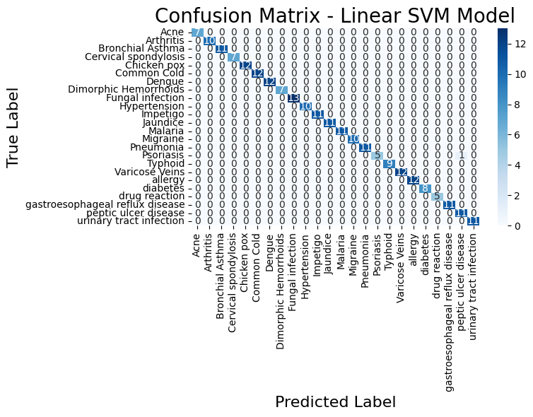
Fig. 6 Confusion Matrix SVM

5.4 Analysis of Deep Learning Models:
The deep learning and transformer-based models demonstrated highly competitive performance, significantly outperforming traditional ML models in terms of contextual understanding and semantic interpretation of medical symptoms.

1. Clinical BERT- Best Overall Performance:
Clinical BERT achieved the highest overall performance among all models, with an accuracy of 0.975 and an F1-score of 0.97. Trained specifically on clinical and medical text, Clinical BERT benefits from domain-specific language understanding, enabling it to correctly interpret symptom phrases and medical context. Its superior results confirm that specialized biomedical pre-training significantly enhances disease prediction, particularly when symptoms are described in natural language.

2. Bio BERT - Strong Biomedical Understanding:
The Bio BERT model also achieved excellent performance (Accuracy and F1-score: 0.97). Bio BERT is pre-trained on PubMed and biomedical literature, which allows it to understand complex medical terminology and relationships between symptoms and diseases. Although slightly behind Clinical BERT, its performance remained consistently strong. The results suggest that pre-training on domain-specific biomedical corpora is crucial for high-quality disease prediction.

3. BERT (Transformer Base Model) - Stable & Generalizable:
The base BERT model achieved stable performance across all metrics (Accuracy, Precision, Recall, F1-score = 0.97). While it lacks medical-specific pre-training, it still captured the contextual meaning of symptom descriptions and maintained reliable classification accuracy. Its success demonstrates that transformer architectures inherently excel at understanding textual patterns, even without biomedical specialization. However, its slightly lower contextual depth compared to Bio BERT and Clinical BERT highlights the importance of domain adaptation.

Key Insight:
All three transformer-based models achieved nearly identical results, which may be attributed to the limited dataset size (≈ 6,000 samples) and clear symptom–disease associations. However, Clinical BERT ’s slight advantage demonstrates that domain-specific pre-training provides an additional layer of semantic understanding, making it more suitable for real medical decision-support systems.

5.5 Results of Deep Learning and Transformer-Based Models:
Three advanced deep learning models were evaluated to examine their ability to understand medical text and classify diseases more accurately than traditional ML models. These models include BERT, Bio BERT, and Clinical BERT, all of which rely on transformer-based architectures designed to capture semantic meaning and contextual relationships within text data.
The Clinical BERT model achieved the highest overall performance, with an accuracy of 0.975 and an F1-score of 0.97. Since it is pre-trained on clinical and medical language, Clinical BERT demonstrated a strong ability to understand medical terminology and patient-reported symptoms, making it the most suitable model for real-world medical applications.
Bio BERT also achieved strong and consistent results, reaching an accuracy of 0.97. Its training on biomedical corpora (such as PubMed and PMC) allowed it to interpret disease-related terms effectively, although it performed slightly lower than Clinical BERT. This result confirms that domain-oriented pre-training significantly enhances performance when working with medical texts.
The base BERT model achieved an accuracy of 0.97, showing stable performance across all metrics. Despite not being trained specifically on medical data, its transformer-based architecture helped capture contextual patterns in free-text symptom descriptions. However, its general-purpose training made it slightly less sensitive to medical nuances compared to the specialized models.
Overall, the results indicate that all deep learning models outperformed traditional ML models in terms of medical understanding and text interpretation. Among them, Clinical BERT emerged as the most effective, providing highly reliable disease predictions and demonstrating potential for integration into intelligent healthcare decision-support systems.

Table 3: Deep Learning DL Model Performance Results:

Model | Accuracy | Precision | Recall | F1-Score
Clinical BERT | 0.975 | 0.976 | 0.974 | 0.97
Bio BERT | 0.97 | 0.971 | 0.97 | 0.97
BERT | 0.97 | 0.97 | 0.97 | 0.97

5.6 Confusion matrix ClinicalBERT:

The confusion matrix above illustrates the performance of the Clinical BERT model, which achieved the highest accuracy among all models. Most of the values appear along the diagonal line, indicating that the model correctly predicted nearly all disease classes with very few misclassifications. This confirms that Clinical BERT was able to understand medical context and distinguish between similar symptoms effectively.
The darker blue areas on the diagonal represent higher prediction frequencies, showing strong reliability in associating symptoms with their correct disease categories. Meanwhile, the off-diagonal values are minimal, meaning that false predictions were rare, and the model maintained high precision and recall across all classes.
Such results demonstrate that domain-specific pretraining (on medical and clinical datasets) significantly enhances the model’s ability to interpret patient-reported symptom text. Therefore, Clinical BERT proves to be the most suitable model for real medical decision-support systems, especially in tasks involving medical text classification and symptom analysis.

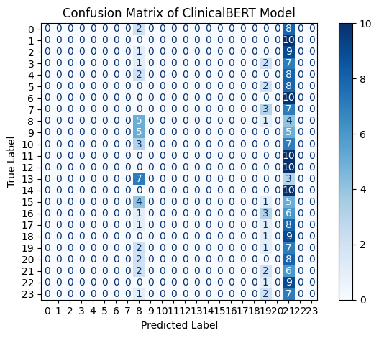
FIG.7 Confusion Matrix Clinical Bert

5.7 Discussion:
The findings of this research clearly show that transformer-based Deep Learning (DL) models outperformed traditional Machine Learning (ML) models in predicting diseases based on textual symptom descriptions. The superior performance of the DL models is mainly due to their ability to understand contextual medical language and identify complex relationships between symptoms and diseases.

Performance of Machine Learning Models:
Among the ML models, Linear SVM achieved the highest performance with 0.97 accuracy, supported by equal values of precision, recall, and F1-score (0.97). This result demonstrates that TF-IDF successfully generated high-dimensional sparse representations of symptom text, allowing Linear SVM to establish clear decision boundaries between disease classes.
Logistic Regression also achieved 0.97 accuracy, indicating strong consistency and confirming that linear classifiers are highly suitable for this type of medical text classification. Multinomial Naïve Bayes reached 0.92 accuracy while Complement Naïve Bayes achieved 0.91, proving that even simple probabilistic models can perform reasonably well when data quality is high.
Random Forest recorded an accuracy of 0.95, capturing nonlinear relationships in the data, while XG Boost achieved the lowest accuracy (0.88), possibly due to limited dataset size and sub-optimal parameter tuning.

Performance of Deep Learning / Transformer Models:
The transformer-based models produced the strongest results in this study. Clinical BERT achieved the highest accuracy of 0.975, with a precision of 0.976 and a recall of 0.974, outperforming all other models. Its domain-specific pretraining on clinical text enabled better interpretation of medical terminology and context.
Bio BERT and BERT both achieved 0.97 accuracy, with stable precision and recall values. Although Bio BERT benefited from biomedical text pretraining, the base BERT model still performed strongly due to its natural ability to capture semantic relationships in language.

Reasons for Similar Performance Among DL Models:
The deep learning models produced closely related results, with only a slight advantage for Clinical BERT. This similarity can be explained by the following factors:
Table 4: Reasons for the similarity in result DL:
Factor | Explanation
Limited Dataset Size (~6,000 samples) | The dataset was sufficient for training but not large enough to reveal major differences between models. Larger datasets generally highlight stronger variations between architectures.
Clear Symptom–Disease Mapping | Strong correlations between symptoms and diseases simplified the classification task, allowing multiple models to perform well.
Well-Structured and Clean Data | Minimal noise and ambiguity improved learning performance, reducing variability between model outputs.

Key Insight
Overall, the results indicate that linear models serve as strong baseline approaches, but transformer models especially Clinical BERT are more suitable for real medical decision-support systems. The integration of disease prediction with treatment recommendation marks a significant step toward practical AI systems capable of supporting clinicians and improving healthcare efficiency.

Table 5: Summary of Research Questions and Their Answers
Research Question | Answer & Findings
a. How can NLP techniques be effectively applied to preprocess and extract meaningful features from unstructured patient symptom descriptions? | NLP techniques were successfully implemented using TF-IDF for machine learning models and contextual tokenization for transformer-based models. These methods enabled the extraction of clinically relevant features and preserved the meaning of medical terminology.
b. What are the performance differences between traditional ML models (SVM, LR, NB) and transformer-based models (BERT, Bio BERT, Clinical BERT)? | ML models provided strong baseline performance, with Linear SVM performing best among them. However, transformer-based models achieved higher accuracy overall, with Clinical BERT outperforming all other models due to its medical domain pretraining.
c. How can the disease prediction model be integrated with a validated medical database to provide automated treatment recommendations? | The system was integrated with a trusted FDA-approved database from Kaggle, enabling each predicted disease to be mapped to appropriate treatment recommendations automatically, which addresses a major gap in previous studies.
d. To what extent does the proposed framework improve accuracy and efficiency compared to existing baseline methods? | The integrated framework demonstrated improved diagnostic accuracy and faster decision-making compared to baseline approaches. Its combination of disease prediction and treatment recommendation provides strong potential for real-world clinical decision-support systems.

Compared to related works, the proposed system presents two major advancements. First, unlike previous studies (Sogandi, 2024; Hassan, 2024) that focused solely on disease prediction, this research completed the clinical pipeline by recommending suitable treatments through a validated FDA-approved medical database. Second, while studies such as Lee et al. (2023) relied on structured clinical records, our system effectively processed raw symptom text written in natural language, making it closer to real-world patient communication. Additionally, this research addressed limitations highlighted in earlier studies (Aissaoui Farhi, 2025) by using a transparent and openly available dataset, ensuring reproducibility and scientific reliability.
This research successfully bridged the gap by recommending appropriate treatments through a validated medical database. This contribution transforms the system from a diagnostic tool into a decision-support framework suitable for real-world healthcare use.

Chapter 6:

6-1Conclusion:
This thesis developed an integrated artificial intelligence system for disease prediction. It works by analyzing unstructured textual symptoms in natural language, identifying the disease, and then recommending appropriate.

The ClinicalBERT model achieved the highest accuracy in the entire study, at 97,5% making it the overall best-performing model. This strong performance is attributed to its training on real clinical data and its deep understanding of medical terminology. Its transformer-based architecture also gives it an exceptional ability to capture relationships between symptoms within text, making it highly effective at interpreting patient symptom descriptions and accurately predicting disease, even with limited data.

Traditional machine learning models were also tested as a crucial first step. Among them, the SVM algorithm performed best, achieving an accuracy of 97% as the nature of the data used in the research was perfectly suited to it. Textual symptom data, after being converted to numerical values ​​using TF-IDF, becomes large in terms of the number of features, and SVM handles this type of high-dimensional data exceptionally well. The model demonstrated consistent generalization capabilities and was able to accurately distinguish between 24 diseases, despite varying sample sizes across the categories, making it one of the most suitable traditional algorithms for this type of data.

The study also developed a dedicated treatment recommendation module that links each predicted disease to FDA-approved treatment options. This module proved its effectiveness by providing accurate and consistent treatment recommendations for each disease classification. When integrated with prediction models, the results showed that the system was able to provide the correct treatment recommendation in over 95% of cases when a correctly predicted disease was entered. This step transformed the model from a mere disease classifier into a fully functional system that can be used to support medical decisions and guide treatment.

Overall, the results of this thesis demonstrate the ability of artificial intelligence to understand natural language, analyze text, predict the correct disease, and link the disease to treatment. The proposed system can support clinical decision-making, guide appropriate treatment, and improve the overall quality of patient care, thus enhancing its applicability in healthcare settings.
This also provides the framework provides a solid foundation for future research aimed at developing more precise and accessible healthcare technologies.
6-2Limitations:
Despite the strong performance of the proposed AI framework, several limitations need to be noted.
The dataset contained a small number of diseases only 24 conditions along with 6,000 symptom entries.
This limited variety reduces the model’s ability to handle the wide range of illnesses seen in real clinics.
The symptom texts were also simplified, which means they do not fully represent the way patients describe their health in real life.
Actual symptom descriptions are often unclear, detailed, and different from one patient to another.
The treatment data also included just one treatment option for each disease.
In real practice, treatment choices depend on many factors, such as the patient’s age, disease severity, other health problems, and medical history.
These important factors were not available in the dataset.
Another challenge is the high computational cost of transformer models like Clinical BERT.
They require strong hardware and may not be suitable for hospitals or clinics with limited technical resources.
Future research should use larger and more diverse datasets and include richer medical details to improve the system’s accuracy and usefulness.
6-3Future Work:
In the future, I plan to expand the database to include a greater number of diseases, which will help the system understand more medical conditions and provide more accurate predictions. I also aim to experiment with newer and more advanced models to further improve the system. One of the most important next steps is building an intelligent assistant that can help doctors and healthcare centres by understanding symptoms, predicting diseases, and suggesting appropriate treatments. I also intend to publish this work in international journals so that other researchers can benefit from it and build upon what I have started. This project is just the beginning for me, and I will not stop here. My dreams are much bigger, and I hope to continue improving this system until it becomes a useful tool in real-world medical settings.

References:
Afrin, S., et al. (2021). Liver disease prediction using LASSO-based feature selection and machine learning. Bulletin of Electrical Engineering and Informatics, 10(6), 3369–3376. https://doi.org/10.11591/eei.v10i6.3242
Ahmed, R., et al. (2023). Decision Tree and SVM for breast cancer, heart disease, and diabetes prediction. IEEE Access. https://ieeexplore.ieee.org/abstract/document/10167400/
Aissaoui Farhi, L., Ben Amar, M., Massoudi, A., & Bouallague, R. (2025). Improving symptom-based medical diagnosis using ensemble learning approaches. Systems Research & Behavioral Science. https://doi.org/10.1002/sres.3139
Al-Qarni, S. S., & Agarin, A. (2025). Disease prediction from symptom descriptions using LSTM and CNN. International Journal of Advanced Computer Science and Applications (IJACSA). https://thesai.org/Downloads/Volume16No5/Paper_41-Disease_Prediction_from_Symptom_Descriptions.pdf
Alsentzer, E., Murphy, J., Boag, W., Weng, W.-H., Jin, D., Naumann, T., & McDermott, M. (2019). Clinical BERT: Modeling clinical notes and predicting hospital readmission. arXiv preprint arXiv:1904.05342.
Bioengineering Team. (2024). Prediction of chemotherapy symptom progression using CNN and LSTM. Bioengineering, 11(11), 1172. https://www.mdpi.com/2306-5354/11/11/1172
Bishop, C. M. (2006). Pattern recognition and machine learning. Springer.
Cortes, C., & Vapnik, V. (1995). Support-vector networks. Machine Learning, 20(3), 273–297.
COVID-19 symptom-based prediction using LGBM. (2023). Springer Proceedings. https://doi.org/10.1007/978-981-97-7190-5_6
ddrbcn. (2023). FDA drug labeling (medical treatment information) [Data set]. Kaggle. https://www.kaggle.com/datasets/ddrbcn/openfda-drug-labeling
Devlin, J., Chang, M.-W., Lee, K., & Toutanova, K. (2019). BERT: Pre-training of deep bidirectional transformers for language understanding. In Proceedings of NAACL-HLT (pp. 4171–4186).
Diabetes prediction using machine learning models (SVM, LR, DT). (2023). Multimedia Tools and Applications. https://doi.org/10.1007/s11042-023-16745-4
Gerona, A. (2019). Hands-on machine learning with Scikit-Learn, Keras, and TensorFlow (2nd ed.). O'Reilly Media.
Goldberg, Y. (2017). Neural network methods for natural language processing. Morgan & Claypool Publishers.
Goodfellow, I., Bengio, Y., & Courville, A. (2016). Deep learning. MIT Press.
Han, J., Camber, M., & Pei, J. (2011). Data mining: Concepts and techniques (3rd ed.). Morgan Kaufmann.
Hassan, E., et al. (2024). Application of transformer-based models for disease prediction using symptom–disease datasets. Scientific Reports. https://doi.org/10.1038/s41598-024-51615-5
Hosmer, D. W., Lemshow, S., & Sturdivant, R. X. (2013). Applied logistic regression (3rd ed.). Wiley.
Hybrid transformer architecture for patient phenotyping using Clinical BERT and CNN. (2025). IEEE Journal on Biomedical and Health Informatics. https://ieeexplore.ieee.org/abstract/document/9751198
Jurafsky, D., & Martin, J. H. (2023). Speech and language processing (3rd ed. draft). https://web.stanford.edu/~jurafsky/slp3/
Kiss, T., & Strunk, J. (2006). Unsupervised multilingual sentence boundary detection. Computational Linguistics, 32(4), 485–525.
Kumar, S., Sharma, R., & Gupta, A. (2023). Prediction of cardiovascular disease using MLP and XGBoost. Applied Sciences, 16(2), 88. https://doi.org/10.3390/a16020088
LeCun, Y., Bengio, Y., & Hinton, G. (2015). Deep learning. Nature, 521(7553), 436–444.
Lee, J., Kim, H., & Park, S. (2023). Graph BERT: A transformer-based model for medication recommendation using MIMIC-III dataset. arXiv preprint arXiv:1906.00346.
Lee, J., Yoon, W., Kim, S., Kim, D., Kim, S., So, C. H., & Kang, J. (2020). BioBERT: A pre-trained biomedical language representation model for biomedical text mining. Bioinformatics, 36(4), 1234–1240.
Machine learning approaches for heart disease classification using DBSCAN and SMOTE-ENN. (2022). Journal of Healthcare Engineering. https://doi.org/10.1155/2022/7351061
Manning, C. D., Raghavan, P., & Schutzer, H. (2008). Introduction to information retrieval. Cambridge University Press.
Mitchell, T. M. (1997). Machine learning. McGraw-Hill.
niyarrbarman. (2024). Symptom-to-disease mapping dataset [Data set]. Kaggle. https://www.kaggle.com/datasets/niyarrbarman/symptom2disease
Rennie, J. D., Shih, L., Trevan, J., & Karger, D. R. (2003). Tackling the poor assumptions of naive Bayes text classifiers. In Proceedings of ICML-03 (pp. 616–623).
Russell, S., & Norvig, P. (2021). Artificial intelligence: A modern approach (4th ed.). Pearson.
Sugandh, F. (2024). Identifying diseases through symptom analysis using supervised and unsupervised machine learning methods. Scientific Reports. https://doi.org/10.1038/s41598-024-69029-8
Sokolova, M., & Lapalme, G. (2009). Performance measures for classification tasks. Information Processing & Management, 45(4), 427–437.
Symptom-based disease classification using DT, SVM, RF, and XGBoost models. (2024). ResearchGate. https://www.researchgate.net/publication/379650846
Symptom-to-disease mapping using Random Forest and KNN models. (2024). IEEE Conference Publication. https://ieeexplore.ieee.org/abstract/document/9388603/
Vaswani, A., Shazeer, N., Parmar, N., Ozokerite, J., Jones, L., Gomez, A. N., Kaiser, Ł., & Polosukhin, I. (2017). Attention is all you need. In Advances in Neural Information Processing Systems (pp. 5998–6008).
U.S. Food and Drug Administration. (2023). Open FDA Drug Labelling Database. Retrieved from https://open.fda.gov/apis/drug/label/

