Chapter 4: Implementation and Results
4.1 Introduction to the Chapter
This chapter covers the practical implementation stages of the study, starting with setting up the working environment and loading the data, through the implementation of the baseline models, and concluding with the development of the proposed model based on DistilBERT and the evaluation of its performance.
The chapter presents the results obtained during the training and testing phases, along with their analysis and comparison, with the aim of evaluating the proposed model’s ability to improve email classification performance and priority determination compared to traditional models.
All experiments were conducted using the dataset prepared in the previous chapter, with the same training, validation, and test sets used for all models to ensure a fair comparison. All experiments were also conducted within a standardized software environment, with training settings kept as consistent as possible, so that any differences in results would stem from the models used rather than from differences in execution conditions.
The implementation consisted of two main phases. The first phase involved building baseline models using traditional machine learning algorithms: Logistic Regression for the classification task and Linear SVM for the prioritization task. The second phase involved building the proposed model using DistilBERT according to a multi-task learning approach, so that the model could perform both tasks simultaneously.
To ensure a comprehensive evaluation of the model, this chapter did not limit itself to presenting training results alone; it also included a performance evaluation using the holdout test set, performed threshold tuning to improve multi-class classification results, and utilized Explainable AI (LIME) to explain the model’s decisions.
The chapter concludes with a comprehensive comparison of all models used, along with an analysis of the results and a demonstration of the extent to which the proposed model achieved the study’s objectives.
4.2 Experimental Environment
To ensure that all experiments were conducted efficiently, a development environment that supports deep learning model training and processing of large-scale text data was used. All stages of the study were implemented in Python due to its specialized libraries for natural language processing, machine learning, and deep learning.
The study utilized the Google Colab platform as the primary implementation environment, as it provided support for graphics processing units (GPUs), which helped accelerate the training of the DistilBERT model compared to implementation using only the central processing unit (CPU).
Table (4.1): Libraries Used in the Study
Library | Usage
Pandas | Data loading and processing
NumPy | Numerical Operations
Scikit-learn | Implementing Baseline Models and Evaluation
Transformers | Loading the DistilBERT Model and Tokenizer
PyTorch | Building and Training the Model
Matplotlib | Plotting Training Curves and Results
LIME | Explaining Model Decisions (Explainable AI)

Table 4.1 shows that the project implementation relied on a set of software libraries, each of which performed a specific function within the implementation stages.
I also leveraged the parallel processing capabilities provided by PyTorch, along with mixed-precision training, to reduce training time and optimize the use of GPU resources without compromising model quality.
To ensure the study’s reproducibility, the best model from training was saved, along with the tokenizer files, class labels, and priority levels, so that the model can be reloaded later and used directly in the testing phase or in the practical application developed to display the model’s results.

4.3 Data Preparation for Implementation
After completing data preparation and creating the training, validation, and test sets, the actual implementation phase began by loading the previously prepared files. All models used in the study relied on these files to ensure that comparisons were made using the same data.
First, the Training Set, Validation Set, and Holdout Test Set files were loaded, and then the data integrity was verified by reviewing the number of samples and column names and ensuring there were no missing values that could affect the training process.
The data was then preprocessed according to the type of model used. In the baseline models, the final text column (Cleaned_Text) was used to extract TF-IDF features, while the same column was later used in the DistilBERT model after being passed through the Tokenizer to convert the text into Token IDs and Attention Masks.
All labels associated with each message—including multi-class labels (Category Labels) and priority labels (Priority Label)—were also loaded for later use during the training and evaluation of the various models.
Upon completion of this stage, the data were ready for the implementation of the baseline models, which serve as the reference point for comparison with the proposed model in subsequent sections.
4.4 Implementation of Baseline Models
4.4.1 Introduction
The baseline models represented the first phase of the practical experiments in this study, and their goal was to establish a baseline against which the performance of the proposed model could later be compared.
To achieve this, two traditional machine learning algorithms were used: Logistic Regression was used for the category classification task, while the Linear Support Vector Machine (Linear SVM) was used for the priority classification task.
Both models relied on the same dataset prepared in the previous chapter, and the same training, validation, and test sets were used to ensure a fair comparison with the proposed model.
4.4.2 Feature Extraction Using TF-IDF
Before training the baseline models, it was necessary to convert the texts into a numerical representation that machine learning algorithms could process.
Therefore, the TF-IDF Vectorizer was used to extract features from the Cleaned_Text column, where each message was converted into a numerical vector representing the importance of the words within the message relative to all other messages in the dataset.
During implementation, the training data was used to build the vocabulary, and then the same vocabulary was used to transform the validation and test data. This was done to prevent any information from the test data from leaking into the training phase and to maintain the impartiality of the evaluation process.
The same parameters were used across all experiments, ensuring that all baseline models were built on the same text representation.
4.4.3 Training the Logistic Regression Model
After extracting the TF-IDF features, I began training the Logistic Regression model to perform the class classification task.
Since a single message may belong to more than one category, the model was used within a One-vs-Rest (OvR) framework, where a separate classifier was trained for each of the six categories, and then the results of all classifiers were combined to obtain the final classification for each message.
During training, the model relied solely on the training data, while the validation data was used to monitor performance before moving on to the final evaluation phase using the test set.
After training was complete, the model was used to make predictions on the test data, and then all performance metrics for the class classification task were calculated.
4.4.4 Results of the Logistic Regression Model
The evaluation results showed that the model performed well on the category classification task, confirming the ability of TF-IDF combined with logistic regression to identify general patterns within emails. The table shows the final evaluation results for the model.
Table (4.2): Logistic Regression Results for Category Classification
Value | Metric
0.6840 | Subset Accuracy
0.8751 | Macro F1-score
0.8711 | Micro F1-score
0.0691 | Hamming Loss
0.8280 | Jaccard Score
Analysis of Results
The results indicate that the model achieved a relatively high Macro F1-score, demonstrating its ability to classify different categories with acceptable accuracy.
In contrast, the Subset Accuracy score was lower compared to the other metrics, which is expected in multi-label classification tasks, as this metric considers a prediction correct only if the model successfully predicts all categories associated with the message without any errors.
The Hamming Loss value also showed that the number of errors at the individual classification level was limited; however, the model still relies primarily on word frequency without taking advantage of the contextual relationships between words, which represents one of the main limitations of this type of model.
Although the model achieved good results, it was considered in this study as a baseline for comparison with the proposed model, rather than the goal of the study.
4.4.5 Summary of Phase Implementation
This phase represents the first practical experiment in the study, in which texts were converted into numerical vectors using TF-IDF, followed by training a Logistic Regression model to classify multi-class categories and evaluating it using the test set.
The results provided a baseline that can be used later to assess the extent of improvement achieved by the proposed DistilBERT-based model, which will be further explored in the next section through the implementation of a Linear SVM model for the priority ranking task.
4.4.6 Implementation of the Linear SVM Model for Priority Level Determination
After completing the evaluation of the Logistic Regression model for the class classification task, the study moved on to implementing the second baseline model, the Linear Support Vector Machine (Linear SVM), to perform the task of determining the priority level of emails.
This model relied on the same TF-IDF representation used in the previous experiment, ensuring that any difference in performance was due to the algorithm used rather than a difference in the data representation method.
At the start of the implementation, the training data was used to build the model, which was then evaluated using the validation set to monitor performance; finally, the independent test set (Holdout Test Set) was used for the final evaluation.
Since the prioritization task in this study is a single-label multi-class classification problem, the model was responsible for assigning each message to one of three priority levels (High, Normal, or Low), such that the model produces only one classification per message.
4.4.7 Results of the Linear SVM Model
After training was complete, the model was evaluated using the final test set, and all performance metrics for the prioritization task were calculated. The next table shows the results achieved by the model.
Table (4.3): Linear SVM Results for Priority Level Determination
Value | Metric
0.9079 | Accuracy
0.9092 | Precision
0.9079 | Recall
0.8695 | Macro F1-score
The evaluation was not limited to general metrics; the model’s performance was also analyzed at each priority level to gain a more accurate understanding of its strengths and weaknesses.
The results showed that the model performed well in classifying messages with Normal and Low priorities, while performance declined when classifying messages with High priority, particularly in terms of Recall, which was approximately 0.69.
This indicates that the model was unable to detect all high-priority messages, which is to be expected given the small number of such messages compared to the other priority levels within the dataset.
Analysis of Results
The results indicate that the Linear SVM model achieved a high overall accuracy exceeding 90%, confirming the model’s effectiveness in handling email data after it was represented using TF-IDF.
However, a detailed analysis revealed performance variations across different priority levels. The model achieved stable results for the most frequently occurring categories in the data, while its ability to detect high-priority messages declined, which was directly reflected in the Macro F1-score.
This decline is more closely related to the nature of the data than to the algorithm itself, as the “High” category was the least numerous compared to the other categories, making it harder for the model to adequately learn its characteristics.
These results highlight a fundamental limitation of traditional models, as they rely heavily on statistical features extracted from words without taking advantage of the contextual relationships between the message’s words, which may affect their ability to distinguish between messages that are similar in wording but differ in meaning.

4.4.8 Summary of the Results of the Baseline Models
After completing the implementation of the two baseline models, the study now has a clear reference point that can be used for comparison with the proposed model. Here is the table that summarizes the results of the reference models.
Table (4.4): Summary of Reference Model Results
Task | Model | Key Performance Indicators
Category Classification | Logistic Regression | Macro F1 = 0.8751, Hamming Loss = 0.0691, Subset Accuracy = 0.6840
Priority | Linear SVM | Accuracy = 0.9079, Macro F1 = 0.8695
Stage Analysis
The results of the baseline models showed that traditional machine learning algorithms are capable of achieving good performance when processing emails after representing them using TF-IDF. However, these models still rely on the statistical properties of the text and do not take advantage of linguistic context or semantic relationships between words, which may limit their ability to handle emails that require a deeper understanding of the content.
Therefore, in the next phase, the study moved on to implementing the proposed DistilBERT-based model to leverage contextual representations of text and use multi-task learning to perform both category classification and priority ranking tasks within a single model, and then directly compare its performance with the baseline results presented in this section.
4.5 Implementation of the Proposed DistilBERT Model
4.5.1 Introduction
After completing the implementation of the baseline models and determining their performance levels, the study moved on to implementing the proposed DistilBERT-based model, which represents the main contribution of this thesis.
Unlike the baseline models, which relied on feature extraction using TF-IDF and then training a separate model for each task, the proposed model relied on a single language model capable of automatically extracting features from texts and performing both category classification and priority ranking simultaneously through a multi-task learning approach.
The same training, validation, and test sets used in the baseline models were employed to ensure that the comparison among all models was fair and based on the same data.
4.5.2 Data Preprocessing for the Model
Before beginning training, the data was preprocessed in accordance with the requirements of the DistilBERT model.
The model used the `Cleaned_Text` column as the source of the text used for training, while category classifications and priority levels were used as target values (labels).
Since transformer models do not directly handle raw text, the DistilBERT Tokenizer was used to convert each message into a numerical representation that includes:
- Token IDs.
- Attention mask.
The maximum message length (Maximum Sequence Length) was also set so that all messages had a uniform length within each training batch, with padding applied to short messages and truncation applied to long messages as needed.
After the tokenization process was completed, the data was converted into PyTorch Dataset objects and then into a DataLoader to facilitate training and batch management.
4.5.3 Model Training
After preparing the data, the proposed model was built using the Transformers library.
The model relied on a pre-trained version of DistilBERT as a shared feature extraction layer, and two independent output layers were added to perform the two tasks.
The first layer was dedicated to the category classification task, producing the probability of belonging to each of the six categories, while the second layer was dedicated to the priority level determination task, producing the probability of belonging to one of the three priority levels.
As a result, the model can process the message only once and then output the results of both tasks simultaneously.
4.5.4 Preparing the Training Process
After building the model, all the necessary components were prepared to begin training.
This stage included:
- Defining the loss functions for each task.
- Selecting a weight optimization algorithm (Optimizer).
- Setting the learning rate.
- Specifying the batch size.
- Determining the number of training epochs.
- Enabling training using a graphics processing unit (GPU).
I also used Mixed Precision Training to reduce memory consumption and speed up the training process, while maintaining model stability during weight updates.
To ensure that the best version of the model was retained, the model that achieved the best performance on the validation set during training was saved and subsequently used in all evaluation processes.
4.5.5 Training Hyperparameters
Training relied on a set of fixed settings, which were used throughout the model fine-tuning process.
Table (4.5): Training Settings for the Proposed Model
Value | Setting
DistilBERT-base-uncased | Pre-trained Model
256 | Maximum Sequence Length
PyTorch | Framework
DistilBERT Tokenizer | Tokenizer
16 | Batch Size
5 | Number of Epochs
2 × 10⁻⁵ | Learning Rate
AdamW | Optimizer
BCEWithLogitsLoss | Category Loss
Cross-Entropy Loss | Priority Loss
Enabled | Mixed Precision
Best Validation Model | Early Model Saving
Model Type | Multi-task Learning
Category Output | Multi-label (6 Classes)
Priority Output | Single-label (3 Classes)
Phase Analysis
This phase marks the beginning of the proposed model’s implementation, as the study shifted from relying on traditional feature extraction to using a pre-trained language model capable of directly learning contextual representations of texts. Furthermore, training the model using a multi-task learning approach allowed for the execution of both category classification and priority assignment tasks within a single architecture, using the same training data as the baseline models.
These steps prepared the model for the fine-tuning process, which involves updating the model’s weights using the study data and monitoring its performance on the validation set until the optimal version is achieved, as will be discussed in the following section.
4.5.6 Model Training
After completing the model setup and data preparation, the fine-tuning process for the DistilBERT model began using the training set, while monitoring performance on the validation set after the end of each epoch.
The training process involved gradually updating the model’s weights by passing through batches of data; the text was used after being converted to token IDs and attention masks, while category classifications and priority levels were used as ground truth.
In each training epoch, the loss function for the category classification task and the loss function for the prioritization task were calculated, and the two values were combined to obtain a total loss value used to update the model’s weights.
After each epoch, the model was evaluated using the validation set, and a set of performance metrics was calculated to track the model’s progress and select the best version before moving on to the final testing phase.
4.5.7 Monitoring the Training Process
The study did not rely solely on the loss value to evaluate training progress; rather, performance metrics specific to each task were also calculated at the end of each epoch.
For the class classification task, the Macro F1-score and Hamming Loss were calculated, while for the prioritization task, Accuracy and the Macro F1-score were calculated.
This allowed for a more comprehensive monitoring of the model’s performance and ensured that a decrease in the loss value was accompanied by an actual improvement in classification quality.
These metrics also helped identify the optimal point at which to save the model before any decline in performance occurred on the validation set.
4.5.8 Saving the Best Model
After each training cycle, the model’s current results were compared with those of the best model previously obtained on the validation set.
When the model achieved an improvement in the evaluation metrics, a copy of it was saved, along with the tokenizer files, class labels, and priority levels, so that the model could be reused later without the need for retraining.
All subsequent experiments, including evaluation using the test set and practical application, relied on this saved version of the model.
4.5.9 Training Results
The training process demonstrated a steady improvement in the model's performance across successive epochs. As training progressed, the training loss consistently decreased, while the validation performance improved in terms of both category classification and priority classification. These results indicate that the proposed multi-task DistilBERT model successfully learned meaningful contextual representations from the email data, enabling it to perform both tasks simultaneously using a shared encoder.
The best validation performance was achieved during the fourth training epoch, where the model obtained the lowest validation loss together with the highest overall validation performance. The corresponding training and validation metrics are presented in Table 4.6.
Table (4.6): Training and Validation Performance Across Training Epochs
Epoch | Training Loss | Validation Loss | Category Macro F1 | Priority Macro F1
1 | 0.6249 | 0.3340 | 0.9315 | 0.8919
2 | 0.2649 | 0.2317 | 0.9578 | 0.9217
3 | 0.1866 | 0.2195 | 0.9655 | 0.9206
4 | 0.1340 | 0.2051 | 0.9677 | 0.9350
5 | 0.0944 | 0.2458 | 0.9677 | 0.9314
4.5.10 Analysis of Training Results
The training results indicate that the proposed model gradually converged throughout the learning process. Both the continuous reduction in training loss and the improvement in the validation metrics demonstrate that the model effectively learned the underlying semantic patterns present in the email dataset.
Furthermore, the multi-task learning framework enabled the DistilBERT encoder to learn a shared contextual representation that simultaneously supports category classification and priority prediction without requiring separate deep learning models for each task. This shared representation improves computational efficiency while maintaining high predictive performance for both tasks.
Although the training loss continued to decrease during the fifth epoch, the validation loss increased from 0.2051 to 0.2458, while the Priority Macro F1-score slightly decreased from 0.9350 to 0.9314. This behavior suggests the onset of overfitting after the fourth epoch. Consequently, the model obtained at Epoch 4 was selected as the best checkpoint and saved for the subsequent threshold tuning and final evaluation stages.
4.6 Model Evaluation Using the Holdout Test Set
4.6.1 Introduction
After completing model training and selecting the best-performing checkpoint based on the validation results, the proposed model was evaluated using the independent Holdout Test Set.
Unlike the training and validation datasets, the holdout test set was completely excluded from both the training process and the threshold optimization stage. Consequently, the obtained results provide an unbiased assessment of the model's ability to generalize to previously unseen email messages.
The saved model from the best validation epoch was used to generate predictions for all test samples. The predicted probabilities were converted into final classifications using the optimized threshold that had previously been selected during the validation stage through the threshold tuning process. Performance metrics were then calculated separately for both category classification and priority classification.
4.6.2 Evaluation of the Category Classification Task
The first evaluation focused on the multi-label category classification task. Each email in the holdout test set was processed by the trained DistilBERT model to obtain the probability of belonging to each of the six predefined categories.
These probabilities were converted into binary category labels using the optimized threshold selected during the validation stage, after which the predicted labels were compared with the corresponding ground-truth labels.
The next table will present the final results of the category classification task.
Table (4.7): Final Category Classification Performance on the Holdout Test Set
Metric | Value
Macro F1-score | 0.9672
Hamming Loss | 0.0175
Macro Precision | 0.99
Macro Recall | 0.95
Optimized Threshold | 0.60

Analysis of Results
The experimental evaluation demonstrates that the proposed multi-task DistilBERT model achieved excellent performance on the category classification task. The model obtained a Macro F1-score of 0.9672 while maintaining a very low Hamming Loss of 0.0175, indicating highly accurate multi-label predictions with very few incorrect label assignments.
These results demonstrate the effectiveness of deep contextual language representations in capturing semantic relationships within email content. Compared with the baseline machine learning models presented earlier in this study, the proposed model provides superior classification performance and better generalization on previously unseen data.
4.6.3 Evaluation of the Priority Classification Task
The second evaluation focused on the priority classification task. Since priority prediction is a single-label classification problem, the model assigned each email to the priority class with the highest predicted probability. The predicted priorities were then compared with the ground-truth labels to compute the evaluation metrics. The final priority classification results are presented in Table 4.8.
Table (4.8): Final Priority Classification Performance on the Holdout Test Set
Metric | Value
Accuracy | 0.9529
Macro F1-score | 0.9327
Macro Precision | 0.94
Macro Recall | 0.93
Recall for High-Priority | 0.8627

Analysis of Results
The proposed multi-task DistilBERT model also demonstrated excellent performance in priority classification. The model achieved an overall Accuracy of 0.9529 together with a Macro F1-score of 0.9327, indicating balanced performance across all priority classes.
More importantly, the model achieved a Recall of 0.8627 for the High priority class, showing its strong capability to identify urgent emails while minimizing the risk of overlooking critical messages. These findings confirm the effectiveness of the shared multi-task architecture in learning priority-related features alongside category information without requiring a separate model.
4.6.4 Overall Performance Analysis
The final evaluation demonstrates that the proposed multi-task DistilBERT model successfully performs both category classification and priority prediction using a single unified architecture.
This confirms the effectiveness of the multi-task learning strategy, where a shared encoder learns contextual representations that benefit both tasks simultaneously.
Compared with the traditional TF-IDF-based baseline models presented earlier in this study, the proposed model consistently achieved superior performance across nearly all evaluation metrics.
Furthermore, integrating both tasks within a single model reduces computational complexity while maintaining high predictive accuracy, making the proposed approach suitable for practical email management systems.
4.6.5 Test Phase Results
The results presented in this section represent the final evaluation of the proposed model on the independent holdout test set using the optimized threshold selected during the validation stage.
These results serve as the official benchmark for assessing the model's generalization capability and provide the reference performance used in the subsequent comparative analyses.
By evaluating the model on previously unseen data, the reported metrics offer an objective assessment of its effectiveness for real-world email classification and priority prediction tasks.
4.7 Threshold Tuning
4.7.1 Introduction
During the validation stage, it was observed that the performance of the proposed model for category classification was directly influenced by the threshold used to convert predicted probabilities into final classification labels.
In multi-label classification tasks, the model does not directly assign a class label. Instead, it produces an independent probability for each category. A threshold is therefore required to determine whether a category should be assigned to an email. Categories with predicted probabilities greater than or equal to the threshold are selected, whereas those below the threshold are excluded.
Initially, the default threshold value of 0.50 was used. However, the default threshold does not necessarily provide the best performance for every dataset. Therefore, a threshold tuning process was conducted to identify the optimal threshold that maximizes classification performance while minimizing prediction errors.

4.7.2 Threshold Tuning Methodology
Threshold tuning was performed after training the DistilBERT model using the checkpoint that achieved the best performance on the validation set. The objective was to optimize the decision threshold without modifying the trained model or its architecture.
The range of threshold values was evaluated incrementally, and the performance obtained at each threshold was compared. The optimal threshold was selected according to two evaluation metrics:
- Macro F1-score
- Hamming Loss
These metrics were selected because they provide a more reliable evaluation of multi-label classification performance than overall accuracy. Macro F1-score measures balanced performance across all categories, while Hamming Loss quantifies the proportion of incorrect label assignments.
4.7.3 Experimental Results
The experimental evaluation demonstrated that changing the decision threshold noticeably affected the classification performance. Lower threshold values increased the number of predicted labels, improving class detection but introducing more false positive predictions. Conversely, higher threshold values reduced prediction errors but also increased the risk of missing relevant categories.
After evaluating all candidate threshold values, the optimal threshold for category classification was found to be:
Threshold = 0.60
This threshold was subsequently adopted during the final evaluation of the proposed model.

Table (4.9): Optimal Threshold Values Selected for the DistilBERT Multi-task Model
Task | Threshold | Best Metric | Score
Multi-label Category Classification | 0.60 | Macro F1-score | 0.9681
Multi-label Category Classification | 0.60 | Hamming Loss | 0.0171
Priority Classification (High Priority) | 0.50 | High Recall | 0.8571
Priority Classification (High Priority) | 0.50 | Macro F1-score | 0.9350
The threshold tuning process was conducted on the validation dataset to determine the optimal decision thresholds for both classification tasks. A threshold value of 0.60 produced the best performance for multi-label category classification, achieving a Macro F1-score of 0.9681 and a Hamming Loss of 0.0171. For priority classification, the default threshold (0.50) provided the best balance between overall classification performance and the recall of the High priority class, resulting in a High Recall of 0.8571 and a Macro F1-score of 0.9350.
4.7.4 Analysis of Results
The experimental results indicate that the default threshold value (0.50) was not the optimal choice for the dataset used in this study. Increasing the threshold to 0.60 reduced the number of incorrect label assignments, leading to a lower Hamming Loss and a higher Macro F1-score.
This improvement can be explained by the fact that increasing the threshold made the model more conservative when assigning category labels. Consequently, only predictions with higher confidence were accepted, reducing false positive classifications while maintaining a high ability to identify the correct categories.
These findings demonstrate that selecting an appropriate decision threshold is an important step in improving the performance of multi-label classification models. They also indicate that relying on the default threshold does not necessarily produce the best classification results.

4.7.5 The Effect of Threshold Tuning on Model Performance
After applying the optimized threshold, the model was re-evaluated on the same validation dataset using identical experimental settings. The results showed a slight improvement in the performance of the category classification task.
Specifically, threshold tuning resulted in:
- A slight increase in the Macro F1-score.
- A slight reduction in the Hamming Loss.
- An overall improvement in category classification performance.
This improvement was achieved without retraining the model or modifying its architecture. Instead, it resulted solely from optimizing the decision threshold used to convert predicted probabilities into final classification labels. As shown in Table 4.10, increasing the threshold from 0.50 to 0.60 produced a slight improvement in the Macro F1-score (from 0.9677 to 0.9681) and a slight reduction in the Hamming Loss (from 0.01713 to 0.01710). These results demonstrate that threshold tuning is an effective post-processing technique for improving classification performance during the inference stage.
Table (4.10): Effect of Threshold Tuning on Category Classification Performance
Metric | Before Threshold Tuning | After Threshold Tuning | Difference
Threshold | 0.50 (Default) | 0.60 | +0.10
Macro F1-score | 0.9677 | 0.9681 | +0.0004
Hamming Loss | 0.01713 | 0.01710 | −0.00003
Section Analysis
This stage demonstrates that improving model performance does not necessarily require retraining the model or modifying its architecture. Instead, performance can also be enhanced by optimizing inference-time parameters, such as the decision threshold. The experimental results showed that threshold tuning slightly improved the quality of category classification while preserving the same trained model. Although the improvement was modest, it confirms that optimizing the decision threshold can enhance prediction quality with minimal computational cost. This finding highlights the practical value of threshold optimization as a simple and computationally efficient post-processing technique for improving the robustness and practical applicability of real-world email classification systems.
4.8 Explainable Artificial Intelligence (XAI)
4.8.1 Introduction
Although the proposed DistilBERT multi-task model achieved excellent predictive performance, transformer-based deep learning models are generally regarded as black-box models because they provide predictions without explicitly explaining the reasoning behind those decisions.
To improve the transparency and trustworthiness of the proposed system, an Explainable Artificial Intelligence (XAI) stage was incorporated into this study. Rather than improving the predictive performance of the model, this stage aimed to explain how the trained model reached its predictions and identify the textual features that influenced its decisions.
Among the available XAI techniques, Local Interpretable Model-agnostic Explanations (LIME) was selected because it provides local explanations for individual predictions without requiring any modification to the trained model. LIME is model-agnostic and can therefore be applied to deep learning models such as DistilBERT while preserving the original model architecture.
4.8.2 Implementing LIME
After completing the training process and selecting the best-performing DistilBERT model, the LIME framework was integrated with the proposed system to generate explanations for individual email predictions.
For each selected email sample, the original message was first passed through the trained DistilBERT model to obtain the prediction probabilities. LIME then generated multiple perturbed versions of the same message by selectively masking or removing different words. Each perturbed instance was subsequently processed by the trained model to obtain new prediction probabilities.
Based on these predictions, LIME fitted a local surrogate model around the original instance to estimate the contribution of each word to the final prediction. Positive contributions indicate that a word increases the confidence of the predicted class, whereas negative contributions indicate that the word reduces the confidence of that prediction.
Several representative email samples were analyzed using this procedure to investigate the behavior of the proposed model and understand the textual evidence supporting its decisions. Figure 4.8 illustrates the overall workflow of applying LIME to explain the predictions generated by the proposed DistilBERT model.
Figure )4.1): The workflow of the LIME explanation process for the proposed DistilBERT model
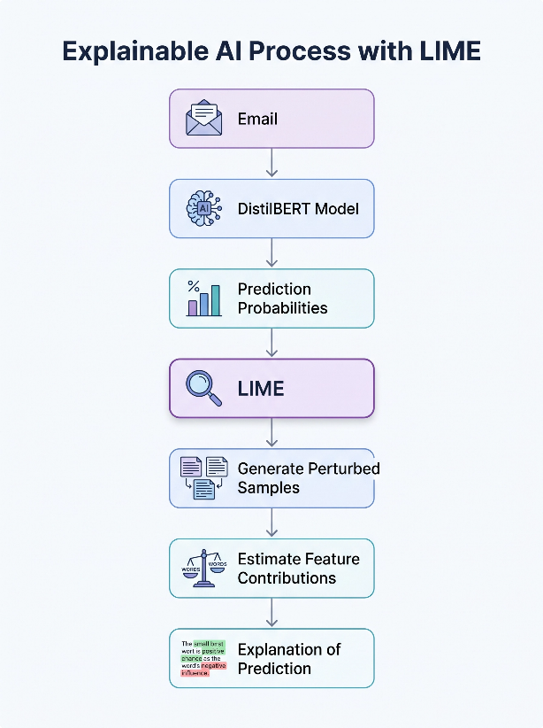
Figure 4.1 shows the workflow of the LIME explanation process for the proposed DistilBERT model. The diagram illustrates the sequential stages of the Explainable AI (XAI) framework: starting with the input email, followed by the DistilBERT model prediction, generating perturbed samples via LIME, estimating individual feature (word) contributions, and ultimately delivering the visual explanation of the model's prediction.
4.8.3 Interpretation Results
The generated LIME explanations showed that the proposed model primarily relied on semantically meaningful words and domain-specific terms that were directly related to the content of the email.
For example, words associated with financial matters, legal documents, meetings, contracts, human resources, or urgent requests consistently contributed positively to the corresponding predicted categories. In contrast, common or context-independent words generally had little influence on the final prediction.
The explanations also revealed that the influential words differed across email samples, demonstrating that the model relied on the contextual meaning of each message rather than applying a fixed list of predefined keywords. This behavior is consistent with the contextual language understanding capabilities of transformer-based models.
4.8.4 Analysis of LIME Results
The LIME explanations provided valuable insights into the prediction behavior of the proposed model by identifying the words that contributed most strongly to individual classification decisions.
The generated explanations generally indicated that the model based its predictions on meaningful contextual information rather than on random or irrelevant words. This observation provides evidence that the model learned meaningful semantic representations from the training data instead of relying solely on superficial lexical patterns.
Furthermore, reviewing multiple representative email samples showed that the explanations were generally consistent with the semantic content of the messages. This increased confidence in the model's predictions and demonstrated that the proposed approach is suitable for applications requiring a certain level of transparency and interpretability.
At the same time, LIME also revealed several cases in which particular words exerted a disproportionately strong influence on the final prediction. Such observations provide useful diagnostic information that can help researchers understand prediction errors, identify potential sources of bias, and guide future improvements to the classification model.
4.8.5 The Importance of Using XAI in the Study
The objective of incorporating LIME was not to improve the predictive accuracy of the proposed model but rather to provide interpretable explanations for its decisions after the training process had been completed.
The use of Explainable Artificial Intelligence provided several practical benefits, including:
- Increasing the transparency of the proposed model.
- Explaining the reasoning behind individual predictions.
- Demonstrating that the model relies primarily on meaningful contextual words.
- Supporting the reliability and credibility of the experimental results.
- Facilitating the analysis of both correctly and incorrectly classified emails.
Consequently, the XAI stage complemented the quantitative evaluation by providing qualitative insights into how the proposed model reached its predictions. This additional interpretability increases users' confidence in the proposed system and improves its suitability for practical decision-support applications.
Section Analysis
Although DistilBERT remains an inherently black-box deep learning model, the application of LIME provided local explanations that significantly improved the interpretability of individual predictions. The generated explanations demonstrated that the model primarily relied on semantically meaningful words related to the email content and priority rather than on arbitrary or irrelevant features.
Moreover, the LIME analysis offered a practical mechanism for investigating both correct and incorrect predictions, allowing researchers to better understand the model's behavior beyond conventional quantitative evaluation metrics. Therefore, the XAI stage added an important interpretability layer to the proposed framework, complementing the performance evaluation and increasing confidence in deploying the model within real-world email management systems.
4.9 Final Model Comparison
4.9.1 Introduction
After completing the baseline experiments, training the proposed DistilBERT multi-task model, optimizing the decision threshold using the validation dataset, and evaluating the final model on the independent holdout test set, a comprehensive comparison was conducted between the proposed model and the best-performing baseline models.
The objective of this comparison is to quantify the performance improvements achieved by the proposed approach under identical experimental conditions. All models were evaluated using the same holdout test set and the same evaluation metrics to ensure a fair and objective comparison.
Since this study addresses two different prediction tasks, the comparison is presented separately for category classification and priority classification. In addition to the quantitative comparison presented in the tables, graphical visualizations are provided to facilitate the interpretation of the differences between the proposed model and the baseline model.
4.9.2 Comparison of Category Classification Results
Table 4.11 compares the performance of the best traditional machine learning model (Linear SVM with TF-IDF features) and the proposed DistilBERT multi-task model on the category classification task.
Table (4.11): Comparison of Category Classification Results
Metric | Linear SVM | DistilBERT | Improvement
Macro F1-score | 0.9269 | 0.9672 | +0.0403
Hamming Loss | 0.0370 | 0.0175 | −0.0195
The comparison clearly shows that the proposed DistilBERT model achieved higher classification performance while substantially reducing classification errors.
As illustrated in Figure 4.2, the proposed model achieved a noticeably higher Macro F1-score than Linear SVM, demonstrating its superior ability to classify emails across all categories, including minority classes.
Figure (4.2): Comparison of Category Classification Macro F1-score between Linear SVM and DistilBERT.
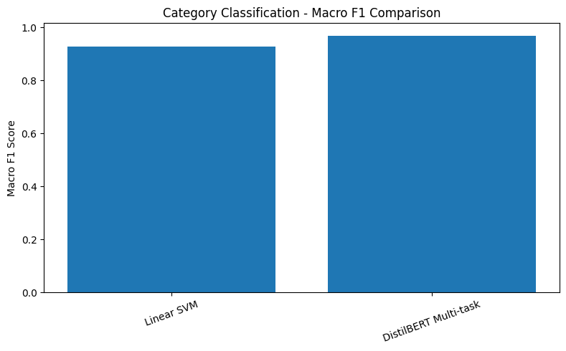
Likewise, Figure 4.3 shows that DistilBERT achieved a considerably lower Hamming Loss, indicating fewer incorrect label assignments during multi-label classification.
Figure 4.3: Comparison of Hamming Loss for Category Classification.
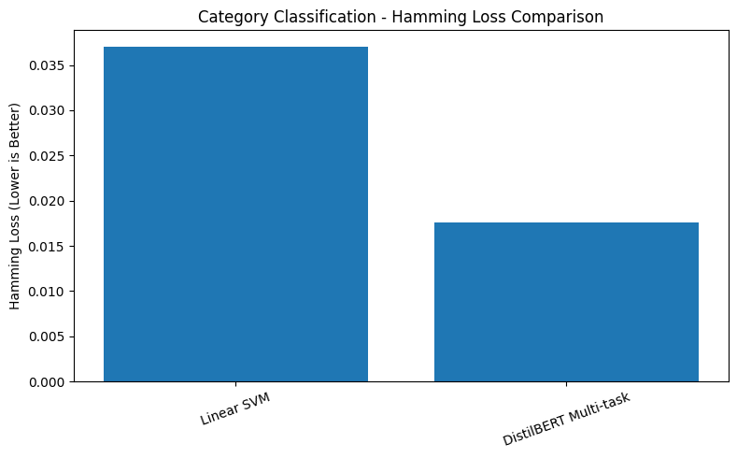

Analysis of Results
The proposed DistilBERT model consistently outperformed the strongest traditional baseline model on the category classification task.
The Macro F1-score increased from 0.9269 to 0.9672, indicating more balanced performance across all six email categories. Simultaneously, the Hamming Loss decreased from 0.0370 to 0.0175, representing a substantial reduction in label-wise prediction errors.
These improvements can be attributed to DistilBERT's contextual language representations, which capture semantic relationships between words more effectively than the statistical TF-IDF representation used by Linear SVM.
4.9.3 Comparison of Prioritization Results
Table 4.12 presents the comparison between Linear SVM and the proposed DistilBERT model for the priority classification task.
Table (4.12): Comparison of Prioritization Results
Metric | Linear SVM | DistilBERT | Improvement
Accuracy | 0.9079 | 0.9529 | +0.0450
Macro F1-score | 0.8695 | 0.9327 | +0.0632
Recall (High Priority) | 0.6900 | 0.8627 | +0.1727
The superiority of the proposed model is further illustrated in the graphical comparisons.
Figure (4.4): Comparison of Priority Classification Macro F1-score.
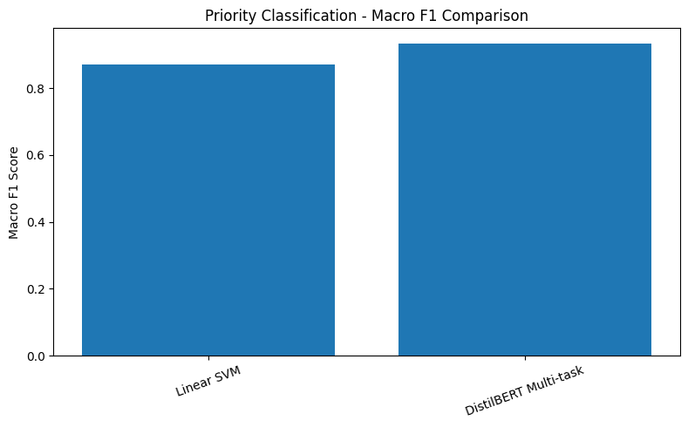
As shown in Figure 4.4, DistilBERT achieved a higher Macro F1-score than Linear SVM, indicating better balanced performance across all priority classes.
Furthermore, Figure 4.5 demonstrates a significant improvement in High Priority Recall, where DistilBERT successfully detected a substantially larger proportion of urgent emails than the baseline model.
Figure (4.5): Comparison of High Priority Recall.
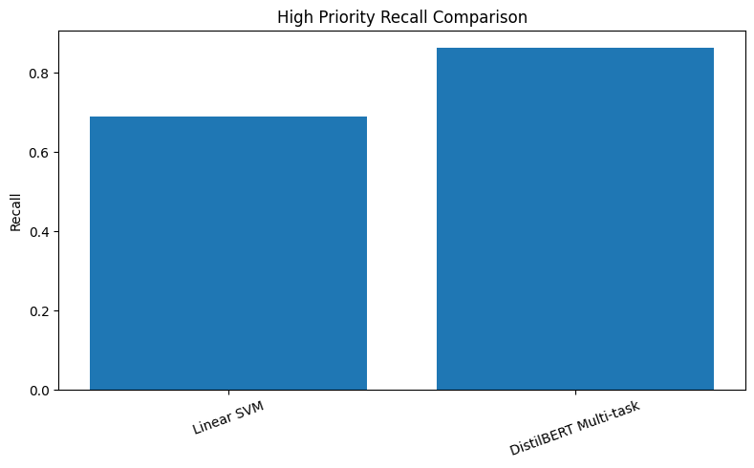
Analysis of Results
The proposed DistilBERT model achieved higher performance across all evaluation metrics compared with Linear SVM.
The largest improvement was observed in the recall of the High Priority class, increasing from 0.6900 to 0.8627. This improvement is particularly important in practical email management systems because missing urgent emails may delay critical decisions or business operations.
In addition, the improvements in Accuracy and Macro F1-score demonstrate that the proposed model maintained balanced predictive performance across all priority levels rather than improving only the majority of classes.
4.9.4 Comparison of Model Architectures
Besides achieving higher predictive performance, the proposed model also provides architectural advantages over the traditional machine learning approaches.
Table (4.13): Comparison of the Baseline Models and the Proposed DistilBERT Model
Element | Traditional Baseline Models | Proposed DistilBERT Model
Number of Models | Two independent models | One unified model
Text Representation | TF-IDF | Contextual Embeddings
Feature Extraction | Manual | Automatic
Learning Strategy | Independent Learning | Multi-task Learning
Shared Representation | No | Yes
Feature Engineering Required | Yes | No
Context Understanding | Limited | High

Comparative Analysis
Unlike the traditional approaches, which required separate models for category classification and priority prediction, the proposed DistilBERT architecture performs both tasks simultaneously using a unified multi-task learning framework.
Moreover, DistilBERT automatically learns contextual representations directly from raw email text, eliminating the need for manual feature engineering while providing a deeper semantic understanding of the message content. Consequently, the proposed framework simplifies the deployment pipeline and offers a more practical solution for intelligent email management.
4.9.5 Overall Conclusion of the Comparison
The comparative evaluation clearly demonstrates that the proposed DistilBERT multi-task model consistently outperformed the strongest traditional baseline model across both classification tasks.
For category classification, the proposed model achieved a higher Macro F1-score and significantly reduced Hamming Loss, indicating both higher classification quality and fewer prediction errors.

For priority classification, the proposed model improved Accuracy, Macro F1-score, and, most importantly, High Priority Recall, substantially reducing the likelihood of missing urgent emails.
Taken together, the quantitative results presented in Tables 4.11–4.13 and the graphical comparisons shown in Figures 4.10–4.13 consistently demonstrate the superiority of the proposed DistilBERT framework over the traditional Linear SVM baseline.
Overall, these findings confirm that integrating contextual language representations with multi-task learning provides a more accurate, efficient, and practically deployable solution for intelligent email classification and priority prediction.
Section Analysis
The comparative evaluation demonstrates that the proposed DistilBERT multi-task model consistently outperformed the strongest traditional baseline model across both classification tasks. The improvements were evident not only in the numerical evaluation metrics but also in the graphical comparisons, which clearly illustrate the gains in classification quality and the reduction in prediction errors.
Furthermore, the proposed architecture combines category classification and priority prediction within a single unified model while eliminating the need for manual feature engineering. This combination of higher predictive performance, improved interpretability of the results through graphical visualization, and simplified deployment makes the proposed framework well suited for real-world intelligent email management systems.
Table (4.14): Summary of Final Experimental Results
Experiment | Main Result
Logistic Regression | Category Macro F1 = 0.8751
Linear SVM | Category Macro F1 = 0.9269
DistilBERT Multi-Task | Category Macro F1 = 0.9672
Priority Classification | Accuracy = 0.9529
Threshold Tuning | Best Threshold = 0.60
Explainable AI | LIME Successfully Applied
Prototype | Successfully Implemented
Table 4.14 summarizes the principal experiments conducted throughout this chapter together with the corresponding key outcomes. This table provides an overall view of the experimental workflow before presenting the discussion of the results obtained.
Figure (4.6): Overall Experimental Pipeline
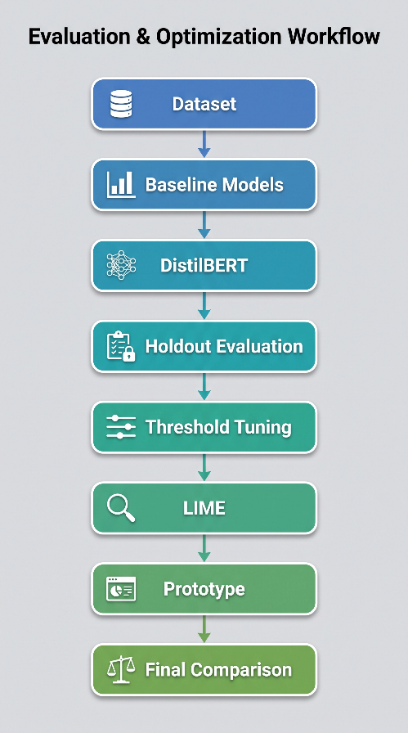
Figure 4.5 illustrates the sequence of experiments conducted after data preparation, starting with the baseline models, followed by the proposed DistilBERT model, holdout evaluation, threshold tuning, explainability analysis using LIME, prototype implementation, and the final model comparison.
4.10 Discussion
4.10.1 Introduction
The purpose of this study was to develop an intelligent email management model capable of simultaneously performing two tasks: multi-label email category classification and priority classification within a unified architecture. To evaluate the effectiveness of the proposed approach, its performance was compared with traditional machine learning baseline models using the same datasets and evaluation metrics.
The experimental results demonstrated that the proposed DistilBERT multi-task model consistently outperformed the baseline approaches across both tasks. This section discusses the factors that contributed to these improvements and explains the results in relation to the adopted model architecture and the overall experimental methodology.
4.10.2 Discussion of Category Classification Results
The proposed model achieved superior performance in the category classification task compared with the baseline models. This improvement can primarily be attributed to the contextual language representations learned by DistilBERT.
Unlike TF-IDF-based approaches, which represent documents as independent word-frequency vectors, DistilBERT captures semantic relationships between words according to their surrounding context. Consequently, the model was able to distinguish between emails containing similar vocabulary but conveying different meanings or administrative purposes.
Furthermore, the use of contextual embeddings enabled the model to better represent emails containing multiple topics simultaneously, which is particularly important for multi-label classification problems such as the one investigated in this study. This capability explains the observed improvement in Macro F1-score together with the reduction in Hamming Loss, indicating more accurate prediction of multiple categories with fewer classification errors.
4.10.3 Discussion of Prioritization Results
The proposed model also demonstrated superior performance in the priority classification task compared with the Linear SVM baseline.
One of the most practically significant findings was the considerable improvement in detecting High Priority emails. Since these messages typically require immediate attention, improving their detection directly increases the effectiveness of intelligent email management systems.
The contextual representations learned by DistilBERT enabled the model to identify linguistic patterns associated with urgency more effectively than traditional statistical representations, resulting in improved overall classification performance while maintaining balanced performance across all priority classes.
4.10.4 The Impact of Multi-Task Learning
An important contribution of this study lies in adopting a multi-task learning framework.
Instead of developing two independent models, a single DistilBERT encoder was shared between the category classification and priority classification tasks, while each task employed its own prediction head.
This shared representation enabled the model to learn common semantic features useful for both tasks simultaneously. Besides simplifying the overall system architecture, this design reduced model redundancy and improved learning efficiency without sacrificing predictive performance.
The experimental results therefore suggest that learning related tasks jointly can improve both effectiveness and computational efficiency compared with training separate models.
4.10.5 Effect of Threshold Tuning
Threshold tuning represented an effective post-processing stage following model training.
The experimental results showed that replacing the default decision threshold with an optimized threshold slightly improved the category classification performance without modifying the trained model or repeating the training process.
Although the numerical improvement was relatively small, the experiment demonstrated that carefully selecting inference-time parameters can produce measurable improvements in prediction quality with virtually no additional computational cost. This finding highlights the practical value of threshold optimization for real-world deployment.
4.10.6 Role of Explainable Artificial Intelligence
Model performance alone is insufficient for many real-world applications that require transparency and user trust.
For this reason, LIME was employed to explain individual model predictions after training. The generated explanations showed that the model relied primarily on meaningful words and phrases directly related to the email content rather than arbitrary or irrelevant terms.
These explanations increased confidence in the proposed model by demonstrating that its decisions were supported by interpretable linguistic evidence. In addition, LIME facilitated the analysis of both correctly classified and misclassified examples, providing useful insights for future model improvement.
4.10.7 Achievement of the Study’s Objectives
The experimental findings indicate that the proposed approach successfully achieved the objectives defined at the beginning of this research.
Specifically, the proposed system successfully:
- performed multi-label category classification and priority classification within a single model;
- outperformed the baseline machine learning models across the principal evaluation metrics;
- reduced classification errors for category prediction;
- improved the detection of High Priority emails;
- enhanced model interpretability through the integration of Explainable Artificial Intelligence techniques.
Collectively, these achievements demonstrate that the proposed framework provides an effective and practical solution for intelligent email management applications.
4.10.8 Summary of the Discussion
Overall, the experimental findings demonstrate that combining DistilBERT with a multi-task learning framework provides substantial advantages over traditional machine learning approaches.
The observed improvements resulted from the model's ability to learn contextual semantic representations, jointly optimize related tasks, refine prediction decisions through threshold tuning, and provide interpretable predictions using LIME.
Taken together, these characteristics enabled the proposed model to achieve a strong balance between predictive accuracy, computational efficiency, and interpretability, making it well suited for intelligent email management systems operating in practical environments.
4.11 Chapter Summary
This chapter presented the implementation process and experimental evaluation of the proposed intelligent email management system.
It began by describing the implementation environment, data preparation procedures, and the development of the baseline machine learning models, which served as reference systems for performance comparison. The chapter then presented the design and implementation of the proposed DistilBERT-based multi-task model, including the training procedure, validation strategy, and final model selection.
The evaluation conducted on the independent Holdout Test Set demonstrated that the proposed model consistently outperformed the baseline models in both category classification and priority classification. These improvements were further supported through threshold tuning, which enhanced category classification performance during the inference stage without requiring additional training.
To improve model transparency, Explainable Artificial Intelligence techniques based on LIME were incorporated to interpret individual predictions and identify the textual features that influenced the model's decisions. The generated explanations confirmed that the proposed model relied primarily on meaningful contextual information when performing classification.
Finally, comprehensive comparisons between the baseline models and the proposed framework demonstrated that the DistilBERT multi-task architecture achieved superior predictive performance while simultaneously simplifying the overall system by performing both tasks within a single model. These findings confirm that the proposed approach successfully fulfilled the objectives of this study and provided a practical foundation for developing intelligent email management systems capable of accurate, reliable, and interpretable email classification and prioritization.

