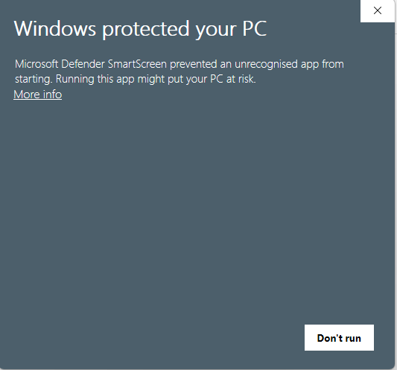
- This message indicates that Windows Defender SmartScreen has blocked an unknown application from running on your computer. Windows Defender SmartScreen is part of Windows Defender that acts as a tool to protect against malware and untrusted applications when they are attempted to be executed.

- i use services like '' VirusTotal '' to analyze the executable file across multiple antivirus engines to detect malware

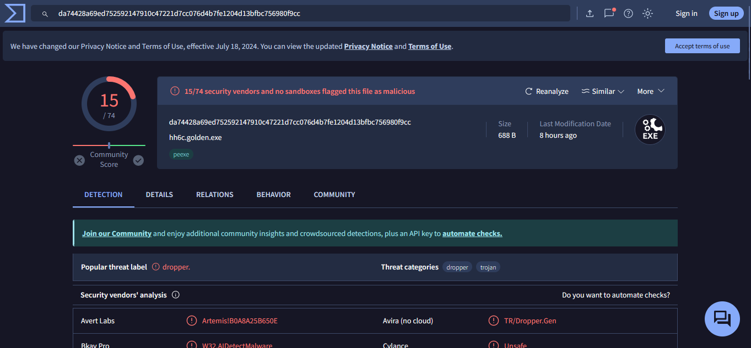

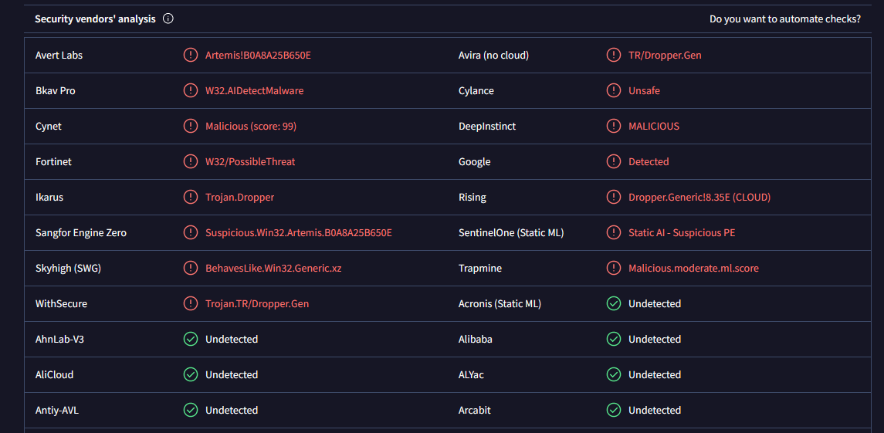

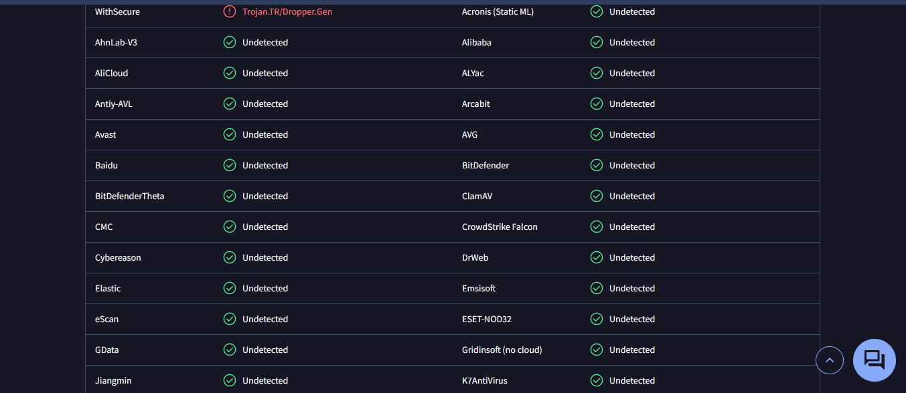

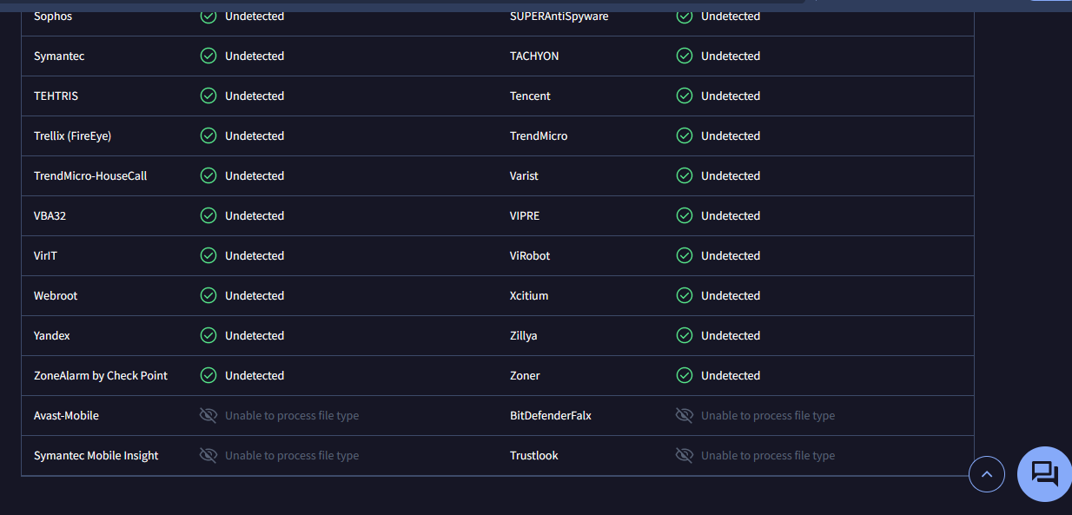

We can assess suspicious executable files to determine if they contain malware using services like VirusTotal. This service works by analyzing the file across a variety of antivirus engines and other security tools. After the analysis, the results will indicate if any malware or other threats have been detected.
Based on the analysis results, appropriate actions can be taken such as deleting the file or conducting further investigations if necessary. It is always important to prioritize the security of your device and personal information, and using the right tools for scanning and analysis is crucial to safeguard against security threats.

