
جامعة ميدأوشن
كلية الإدارة
قسم إدارة المشاريع

إعادة تدوير النفايات باستخدام الطاقة المجددة
Recycling Waste Using Renewable Energy
Prepared by:
Mohammed Ali Mohajer
Mohammed Awad Omar
Supervised by:
Mr. Walid Suliman
Second semestre 2023

Table of Contents
General Introduction: 3
1 Understanding Waste and Renewable Energy: 4
1.1 Definitions and Types of Waste: 4
1.2 Overview of Renewable Energy Sources: 6
1.3 Advantages and Limitations of Renewable Energy for Waste Recycling: 7
2 Waste Recycling Process Using Renewable Energy: 10
2.1 Waste Collection and Sorting: 10
2.2 Energy Conversion Technologies for Waste Recycling: 11
2.3 Examples of Waste Recycling Projects and Initiatives Using Renewable Energy: 13
3 Environmental and Economic Benefits of Recycling Waste Using Renewable Energy: 14
3.1 Reduction of Greenhouse Gas Emissions and Pollution: 14
3.2 Conservation of Natural Resources and Energy: 15
4 Case Studies and Best Practices: 16
4.1 Examples of Countries and Regions Successfully Implementing Waste Recycling Using Renewable Energy: 16
4.2 Innovative Initiatives and Emerging Technologies in Waste Recycling: 17
Conclusion 26
Reference: 27

General Introduction:
Waste management is a critical issue facing our global society today. With the ever-increasing population and consumption patterns, the generation of waste has reached unprecedented levels. Improper waste disposal and management pose significant environmental, social, and economic challenges. To address these challenges, recycling waste has emerged as an essential practice to reduce the burden on landfills, conserve resources, and mitigate environmental impacts. In parallel, the growing demand for clean and sustainable energy has led to an increased focus on renewable energy sources. Renewable energy, derived from sources like sunlight, wind, water, and biomass, offers a promising alternative to traditional fossil fuels.
The aim of this report is to explore the concept of recycling waste using renewable energy in-depth. It examines the interplay between waste management practices and renewable energy technologies, highlighting the benefits, challenges, and opportunities associated with this integrated approach. Through a comprehensive analysis, this report seeks to contribute to the understanding and advancement of sustainable waste management practices and renewable energy utilization.

Understanding Waste and Renewable Energy:

Definitions and Types of Waste:
To comprehend the concept of recycling waste using renewable energy, it is essential to understand the definitions and various types of waste. Waste refers to any discarded material or substance that is no longer useful or required. It can be categorized into different types, including municipal solid waste (household waste), industrial waste, hazardous waste, electronic waste (e-waste), construction and demolition waste, and agricultural waste. Each type of waste presents unique challenges and requires specific recycling and disposal methods.

Household waste:
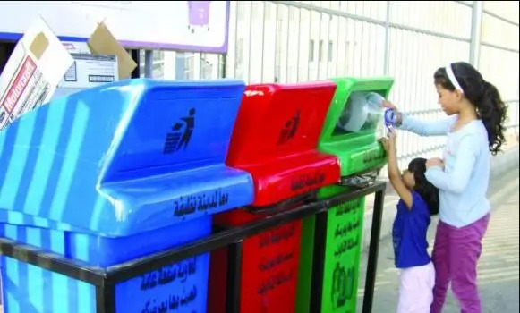

Electronic waste (e-waste):
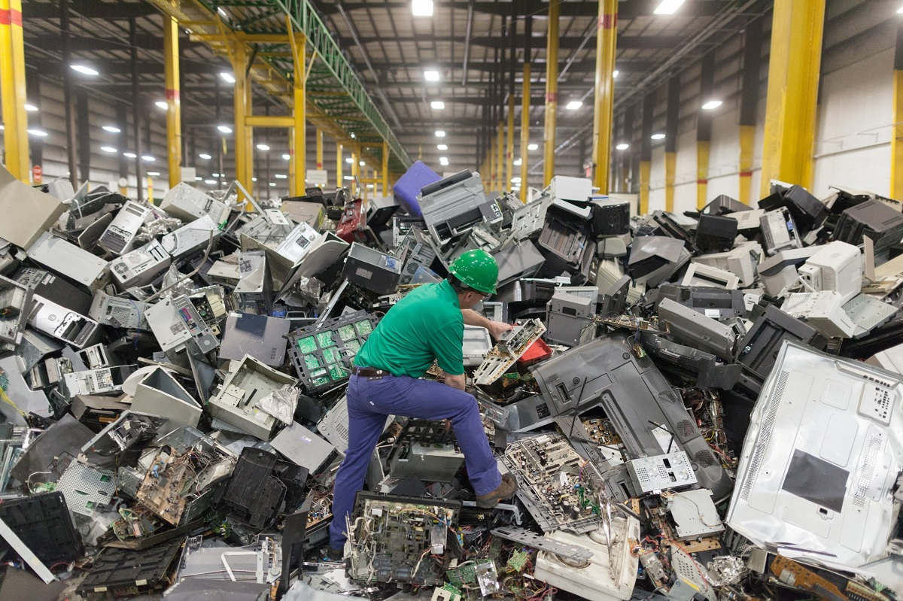

Overview of Renewable Energy Sources:
Renewable energy sources are derived from natural processes that are replenished continually and sustainably. Here is a brief overview of the main renewable energy sources:
- Solar Energy: Solar power harnesses the energy from the sun through solar photovoltaic (PV) panels or solar thermal systems, converting sunlight into electricity or heat.
- Wind Energy: Wind turbines capture the kinetic energy from the wind and convert it into electrical energy. Wind power is a widely used and rapidly growing renewable energy source.
- Hydropower: Hydropower involves harnessing the energy of flowing or falling water to generate electricity. It can be derived from rivers, tides, or ocean currents.
- Geothermal Energy: Geothermal energy utilizes the heat stored beneath the Earth's surface. It is harnessed through geothermal power plants, which convert the heat into electricity.

Advantages and Limitations of Renewable Energy for Waste Recycling:
Renewable energy offers several advantages when applied to the recycling of waste:
- Lower Carbon Footprint: Renewable energy sources have significantly lower greenhouse gas emissions compared to fossil fuels, reducing the overall carbon footprint of waste recycling operations.
- Resource Conservation: Renewable energy reduces the need for conventional energy sources, such as coal or natural gas, preserving valuable fossil fuel reserves for essential applications.
- Potential Synergies: Waste recycling operations often generate organic waste or byproducts that can be used as feedstock for certain renewable energy technologies, such as anaerobic digestion or biomass power plants.
However, there are some limitations and considerations to be aware of when integrating renewable energy into waste recycling:
- Intermittency: Some renewable energy sources, such as solar and wind, are intermittent in nature, dependent on weather conditions. This intermittency may require additional energy storage or backup systems to ensure a consistent power supply for waste recycling operations.
- Cost and Infrastructure: The initial investment costs for renewable energy technologies can be higher compared to conventional energy systems. The availability of suitable infrastructure and transmission networks may also impact the feasibility of implementing renewable energy solutions.
- Regional Variations: The suitability and availability of different renewable energy sources can vary based on geographical location, climate conditions, and local resources. This may influence the choice of renewable energy technologies for waste recycling on a regional level.

Waste Recycling Process Using Renewable Energy:

Waste Collection and Sorting:
The first crucial step in the waste recycling process is the collection and sorting of waste materials. Effective waste collection systems involve the systematic collection of waste from households, commercial establishments, and industrial sites. The waste is then transported to recycling centers or sorting facilities.
At these facilities, advanced sorting technologies are employed to separate different types of waste materials. Manual sorting and automated processes such as conveyor belts, optical sorting systems, and magnetic separators are utilized to categorize waste into specific streams. This segregation ensures that recyclable materials are separated from non-recyclable or hazardous waste, enabling efficient recycling and resource recovery.

Energy Conversion Technologies for Waste Recycling:
Once waste materials are sorted, energy conversion technologies come into play to process and transform them into usable forms, often utilizing renewable energy sources. Some key technologies include:
- Anaerobic Digestion: Anaerobic digestion is a process that breaks down organic waste in the absence of oxygen, producing biogas (primarily composed of methane) and nutrient-rich digestate. Biogas can be used as a renewable energy source for electricity and heat generation, while digestate can be used as a nutrient-rich fertilizer.
- Waste-to-Energy (WtE): Waste-to-energy technologies involve the combustion or gasification of non-recyclable waste materials to produce heat or electricity. Renewable energy sources such as biomass or biogas can be co-fired with the waste to enhance energy generation and reduce environmental impacts.
- Biomass Conversion: Biomass waste, including agricultural residues and wood waste, can be converted into biofuels, such as biodiesel or biogasoline, through various processes like pyrolysis or fermentation. These biofuels can serve as renewable alternatives to fossil fuels.
- Solar and Wind Power: Renewable energy sources like solar and wind power can be directly utilized to power waste recycling operations. Photovoltaic panels or wind turbines can be installed on-site to generate electricity, reducing reliance on the grid and fossil fuel-based energy.
Here is a picture of the waste recycling process.
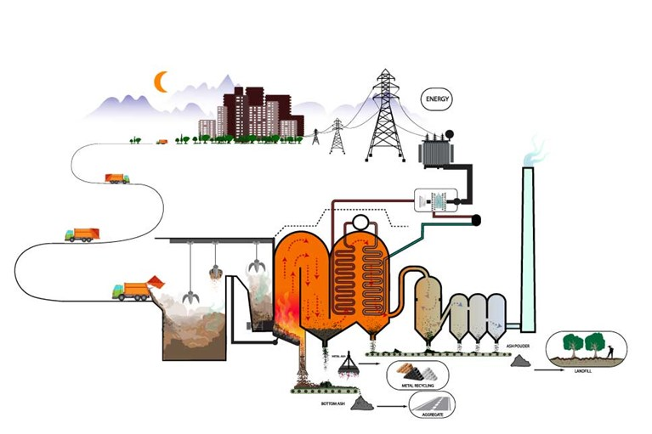

Examples of Waste Recycling Projects and Initiatives Using Renewable Energy:
Numerous projects and initiatives worldwide showcase the successful integration of waste recycling and renewable energy. Here are a few examples:
- Waste-to-Energy Plants: Waste-to-energy plants, such as the Klemetsrud Waste-to-Energy Plant in Norway and the Bykilian Plant in Germany, utilize municipal solid waste as fuel to generate heat and electricity, reducing landfill use and producing renewable energy.
- Anaerobic Digestion Facilities: The Centralized Anaerobic Digestion Facility in Vancouver, Canada, processes organic waste from the city's food and yard waste collection program, generating biogas used to produce renewable natural gas for transportation.
- Solar-Powered Recycling Centers: Solar-powered recycling centers, like the Island Recovery Integrated Recycling Center in Hawaii, utilize solar panels to generate electricity for sorting, processing, and storing recyclable materials.
- Biogas from Landfill Sites: Landfill gas recovery projects, such as the Puente Hills Landfill in California, capture methane emitted from decomposing waste and convert it into renewable energy for power generation.

Environmental and Economic Benefits of Recycling Waste Using Renewable Energy:

Reduction of Greenhouse Gas Emissions and Pollution:
Recycling waste using renewable energy offers several environmental benefits, including a significant reduction in greenhouse gas emissions and pollution:
- Greenhouse Gas Reduction: By diverting waste from landfills and utilizing renewable energy sources, the recycling process emits fewer greenhouse gases compared to traditional waste disposal methods like landfilling or incineration. This contributes to mitigating climate change and reducing carbon footprints.
- Air and Water Pollution Reduction: Recycling waste minimizes the release of harmful pollutants into the air and water. Landfills and incinerators can produce toxic gases, leachate, and ash that can contaminate the environment. Utilizing renewable energy technologies reduces these pollutants, leading to improved air and water quality.

Conservation of Natural Resources and Energy:
Recycling waste using renewable energy helps conserve valuable natural resources and reduces energy consumption:
Resource Conservation: Recycling waste reduces the demand for raw materials, conserving natural resources such as timber, minerals, and metals. By reusing and recycling materials, we can extend their lifespan and minimize the need for extracting and processing virgin resources.
Energy Savings: Recycling waste requires less energy compared to extracting and manufacturing materials from scratch. Utilizing renewable energy sources further reduces the reliance on fossil fuels, leading to energy savings and a more sustainable energy mix.

Case Studies and Best Practices:

Examples of Countries and Regions Successfully Implementing Waste Recycling Using Renewable Energy:
Several countries and regions have successfully implemented waste recycling initiatives using renewable energy. Here are a few notable examples:
- Sweden: Sweden is renowned for its efficient waste management system. The country has achieved a recycling rate of over 99% for household waste. Waste-to-energy plants, equipped with advanced air pollution control technologies, generate heat and electricity from non-recyclable waste.
- Germany: Germany has made significant strides in waste recycling using renewable energy. The country has implemented an extensive waste sorting and recycling infrastructure, coupled with numerous biogas and biomass plants. These facilities convert organic waste into biogas, providing renewable energy for heat and power generation.
- Singapore: Despite limited land availability, Singapore has developed a robust waste management system. The country focuses on waste-to-energy technologies, such as the Tuas Nexus Integrated Waste Management Facility, which converts municipal solid waste into electricity and produces industrial-grade steam.
- California, United States: California has adopted innovative approaches to waste recycling using renewable energy. The state emphasizes anaerobic digestion facilities, such as the East Bay Municipal Utility District's wastewater treatment plant, which converts organic waste into biogas for electricity generation.

Innovative Initiatives and Emerging Technologies in Waste Recycling:
The field of waste recycling continues to witness innovative initiatives and emerging technologies. Here are a few notable examples:
- Advanced Sorting Technologies: Advanced sorting technologies, such as robotic systems and artificial intelligence, are revolutionizing waste recycling. These technologies can identify and separate recyclable materials more accurately, enhancing the efficiency and quality of recycling processes.
- Chemical Recycling: Chemical recycling, also known as feedstock recycling, aims to convert waste plastics back into their original chemical building blocks or fuels. This emerging technology offers a potential solution for recycling difficult-to-recycle plastics, reducing plastic waste and enabling resource recovery.
- Circular Economy Models: Several organizations and communities are implementing circular economy models to achieve more sustainable waste management. These models emphasize waste prevention, product design for recyclability, and the establishment of closed-loop systems that promote resource conservation and minimize waste generation.

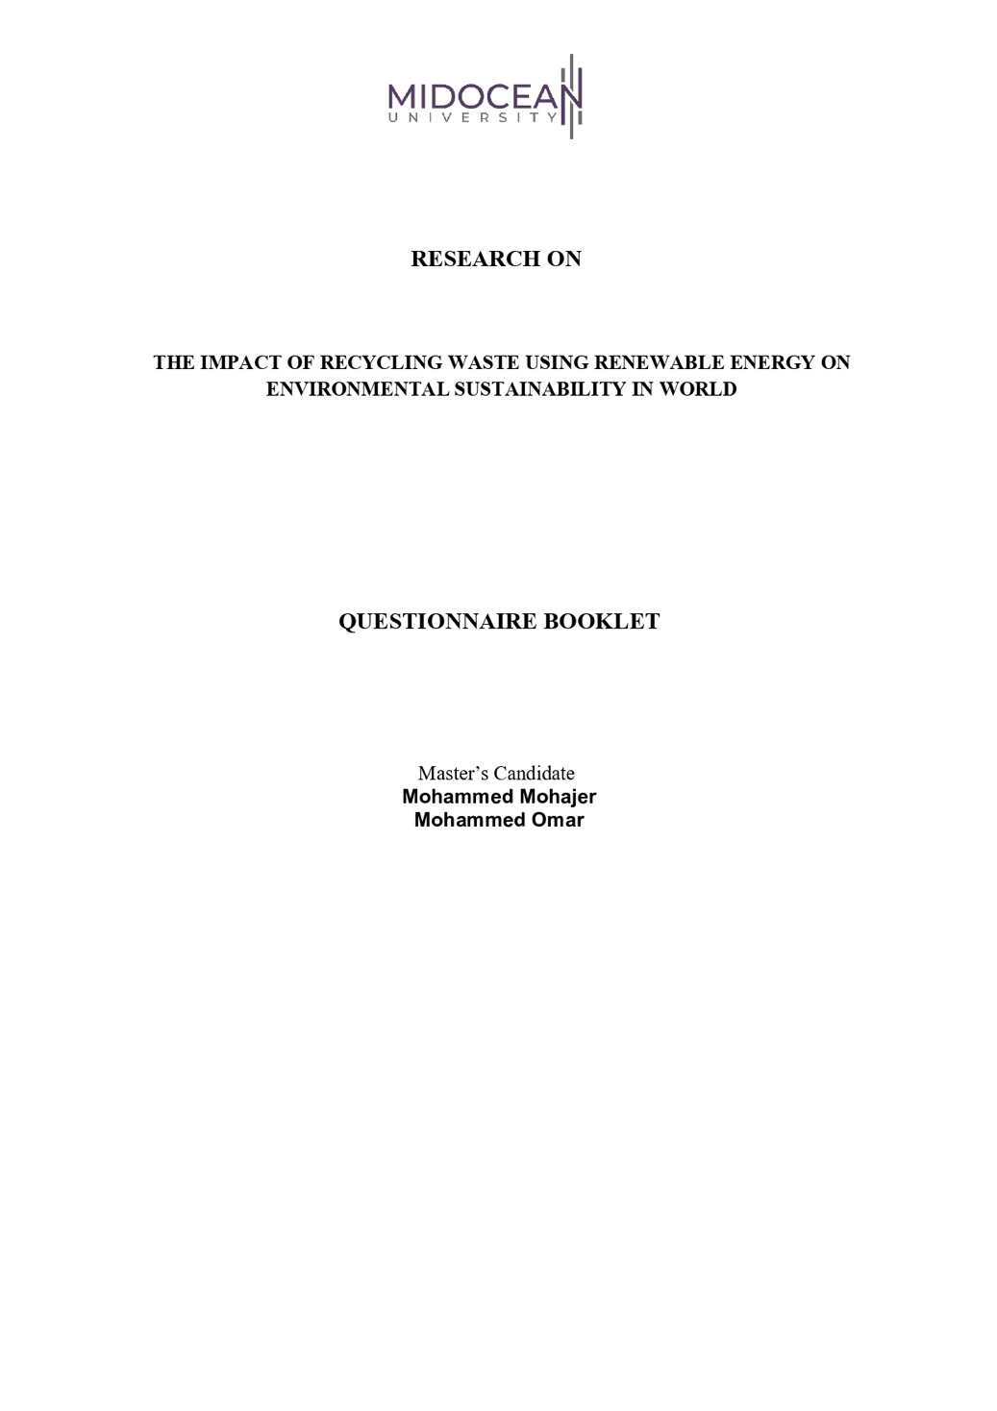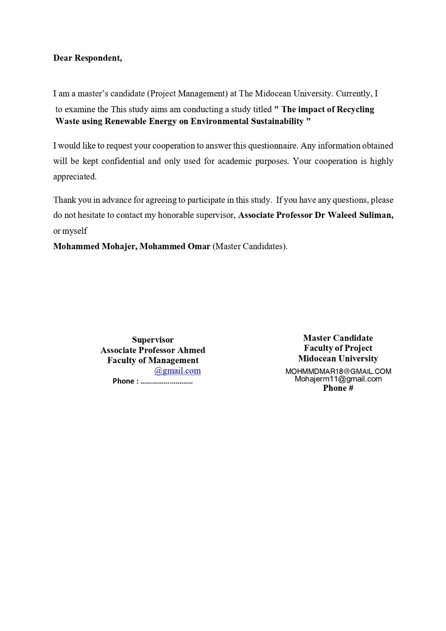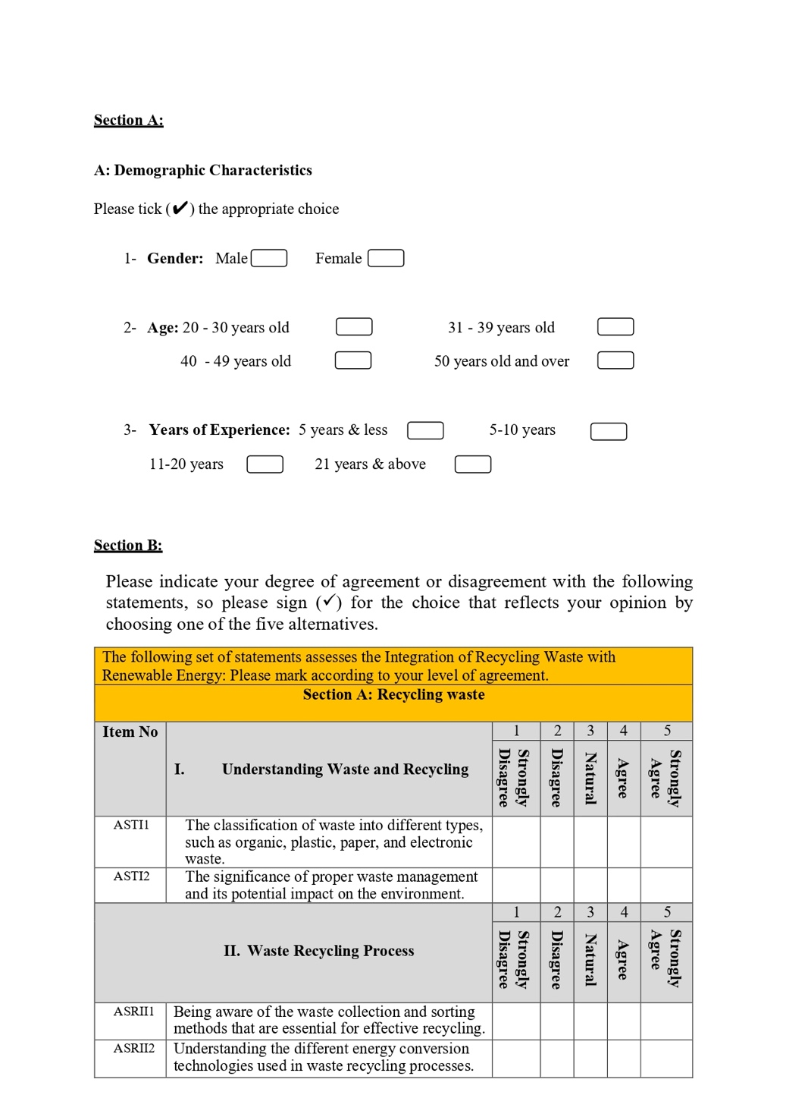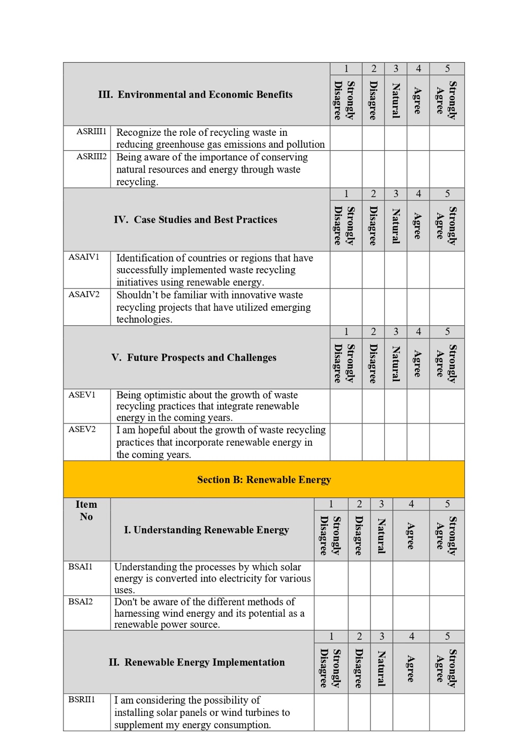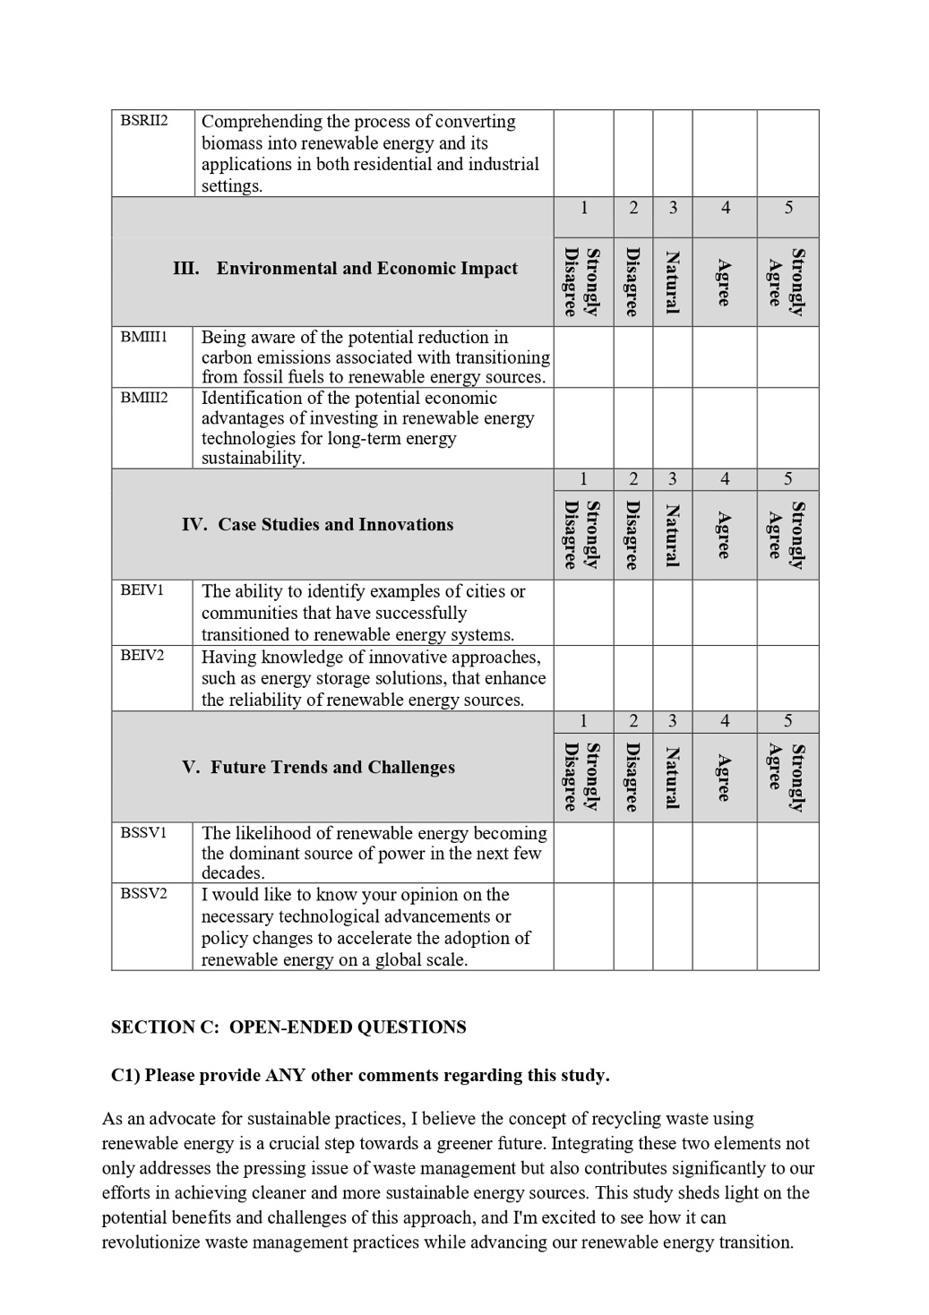
Conclusion
In conclusion, this report highlights the importance of recycling waste using renewable energy sources. By integrating effective recycling practices with renewable energy technologies, it is possible to reduce greenhouse gas emissions, preserve natural resources, create new economic opportunities, and improve air and water quality.
However, there are challenges to consider, such as technical and logistical complexities, high initial costs, and public awareness. Overcoming these challenges requires collaboration among governments, industries, and civil society to promote waste recycling using renewable energy
In conclusion, combining waste recycling with the use of renewable energy is a promising approach for a sustainable future. It can reduce environmental impacts, promote resource conservation, and facilitate the transition to a greener and circular economy. To fully realize these benefits, continued investment in research, development, and implementation of innovative waste recycling and renewable energy technologies is essential.

Reference:
University of Tartu. (n.d). Definition and Classification of Waste [Chapter 11]. In Waste Management: A Reference Handbook. Retrieved from https://sisu.ut.ee/waste/book/11-
United Nations. (n.d.). What is Renewable Energy? Retrieved from https://www.un.org/en/climatechange/what-is-renewable-energy
Liu, W., Liu, G., & Yang, H. (2020). Energy Efficiency Evaluation and Analysis of the Transportation Sector Based on DEA Cross-Efficiency and Malmquist Index Methods. Energies, 13(11), 2906. Retrieved from https://www.mdpi.com/1996-1073/13/11/2906/htm
BBVA. (n.d.). 5 Best Recycling Practices from Around the World. Retrieved from https://www.bbva.com/en/sustainability/5-best-recycling-practices-from-around-the-world/



