





The Impact of Chinese Automotive Brands on the Saudi Arabian Automotive Aftermarket.

Author: Eng. Yazan Salem Joumaa
MBA– Final Thesis
MAY-2025


ABSTRACT
The accelerated expansion of Chinese automakers on the international market has sparked considerable debate and interest. This study investigates the influence of Chinese automobile brands on the Saudi Arabian automotive aftermarket, a crucial sector sustaining the Saudi Arabian automotive industry. This research is driven by the recognition of the limited existing literature addressing the impact of Chinese automotive brands within the Saudi context. A thorough analysis of these brands' effects on the Saudi Arabian automotive aftermarket, including market share, consumer preferences, product offerings, and competition with established automotive brands, is largely lacking, despite studies on the brands' performance and global expansion. The present study aims to offer a thorough examination of the present state of Chinese car brands in the Saudi Arabian automotive aftermarket, as well as insightful information for customers, regulators, and industry players. The study integrates a thorough literature analysis with qualitative interviews conducted with industry professionals and stakeholders. The findings of this study reveal the evolving dynamics within the Saudi Arabian automotive aftermarket, characterized by the growing presence of Chinese automotive brands. They shed light on the market share these brands have garnered over time, the factors driving their expansion, the varying consumer preferences and behavior associated with Chinese and traditional brands, and the innovative product offerings introduced by Chinese manufacturers. Additionally, the study explores how the entry of Chinese automotive brands has impacted the competitive landscape and business strategies of traditional automotive brands in Saudi Arabia. The implications of this research extend to multiple stakeholders. Participants in the industry will obtain insightful knowledge that will help them modify their tactics, improve client interaction, and fortify their position in the market. With greater ability, legislators will be able to create laws that protect consumers and encourage fair competition. Making educated decisions can help consumers choose between traditional and Chinese car brands by taking into account aspects like brand reputation, quality, and dependability. Furthermore, the study establishes the foundation for subsequent research endeavors that aim to investigate the enduring viability and competitiveness of Chinese labels within the Saudi Arabian automotive aftermarket. All things considered, this research provides a thorough investigation of the influence of Chinese automakers on the Saudi Arabian auto aftermarket. It highlights the opportunities and difficulties related to the spread of Chinese automotive brands in Saudi Arabia, adding to our understanding of the industry's shifting dynamics. In the end, it wants to help Saudi Arabia's automobile aftermarket expand and thrive into a viable, competitive industry.

Page | 2

ACKNOWLEGMENT
I would like to express my sincere gratitude to all individuals who provided assistance and made contributions towards the successful completion of this Master of Business Administration thesis. The guidance, knowledge, and motivation you have provided have been crucial throughout this endeavor. The support, mentorship, and motivation provided by you during this endeavor have proven to be of immense value.
I would like to express my gratitude to my esteemed instructors for their invaluable insights and constructive input, which significantly enhanced the merits of this thesis. Their dedication to academic excellence has been a constant source of inspiration.
I also express my gratitude towards my peers and colleagues for engaging in meaningful discussions and sharing their experiences, as these interactions have significantly contributed to my comprehension of the subject matter. This project represents the conclusion of the collaborative endeavors and assistance provided by numerous individuals, for which I express my heartfelt gratitude.

Page | 3

LIST OF FIGURES
Figure 1Demograohic Based on Age 21
Figure 2Demographic Based on Gender 22
Figure 3Demographic Based on Nationality 22
Figure 4Demographic Based on Level of Involvement 23
Figure 5Chinese car shares 27
Figure 6Perception of Chinese Brands 30
Figure 7Factors Influencing Purchase Decision 31

Page | 4

Contents

ABSTRACT 2
ACKNOWLEGMENT 3
LIST OF FIGURES 4
Chapter I: INTRODUCTION\ 9
  - Background of the study 9
  - Rationale 10
  - Definition of Concepts 11
  - Hypotheses 12
  - Statement of the problem 12
  - Objectives 13
Chapter II: REVIEW OF RELATED LITERATURE 14
  - Market Presence of Chinese Automotive Brands in Saudi Arabia 14
  - Factors Contributing to the Rise of Chinese Automotive Brands 15
  - Chinese Car Brands' Influence on the Saudi Auto Aftermarket 18
Chapter III: THEORETICAL BACKGROUND 19
  - Theoretical Framework 19
    - Consumer Behavior and Decision-Making Theories 19
    - Market Entry and Competitive Strategies 19
    - Institutional Theory 19
  - Operational Framework 20
    - Research Design 20
    - Data Collection 20
    - Data Analysis 20
Chapter IV: METHODS AND PROCEDURES 21
Participants Demographic 21
  - Research Design 23
    - Qualitative Research 23
    - Quantitative Research 23
  - Data Gathering Procedure 23
    - Interviews 23
    - Surveys and Questionnaires 24
    - Secondary Data 24
Page | 5
  - Data Analysis Guide 24
    - Qualitative Data Analysis 24
    - Quantitative Data Analysis 24
  - Scope and Limitation 24
    - Scope 24
    - Limitations 24
  - Significance of the Study 25
    - Practical Significance 25
    - Consumer Significance 25
    - Theoretical Significance 25
    - Industry Development Significance 25
    - Economic and Employment Significance 25
Chapter V: DATA PRESENTATION 27
  - Market Share Dynamics 27
  - Consumer Preferences 27
  - Product Offerings and Innovations 28
  - Competitive Landscape and Business Strategies 28
  - Conclusion 29
Chapter VI: FINDINGS AND IMPLICATIONS 30
  - Survey Findings 30
    - Perceptions of Chinese Automotive Brands 30
    - Factors Influencing Purchase Decisions 30
    - Competitive Landscape 31
  - Interview Findings 31
    - Market Share 31
    - Consumer Preferences 31
    - Product Offerings 31
    - Competitive Strategies 32
  - Specific Findings 32
    - Market Share Dynamics 32
    - Consumer Preferences 32
    - Product Offerings and Innovations 32
    - Competitive Landscape and Business Strategies 32
Page | 6
  - Hypotheses 33
  - Research Objectives 33
Objective 1 33
Objective 2 33
Objective 3 33
Objective 4 34
Objective 5 34
  - General Findings 34
    - Market Transformation 34
    - Consumer-Centric Factors 34
    - Innovation and Competition 34
  - Implications 35
    - Industry Players 35
    - Policymakers 35
    - Consumers 35
    - Collaboration and Innovation 35
    - Economic and Employment Impact 36
  - Recommendations for Industry Players 37
    - Quality-Centric Approach 37
    - Innovation and Differentiation 37
    - Consumer-Centric Marketing 38
    - Strategic Partnerships 38
    - Customer Service Excellence 39
  - Recommendations for Policymakers 39
    - Fair Competition Regulations 39
    - Consumer Protection Measures 39
    - Support for Innovation 39
    - Environmental Sustainability 40
    - Market Monitoring 40
  - Recommendations for Consumers 40
    - Informed Decision-Making 40
    - Research and Comparison 40
    - Value for Money: 40
Page | 7
    - Consumer Advocacy 40
  - Summary 42
    - Market Dynamics 42
    - Consumer Preferences 42
    - Industry Competitiveness 42
    - Policy and Regulation 42
    - Consumer Empowerment 42
  - Conclusions 43
    - Shifting Dynamics 43
    - Consumer-Centricity 43
    - Collaboration and Innovation 43
    - Regulatory Framework 43
    - Informed Consumer Choices 43
    - Future Prospects 43
    - Research Contribution 43
Bibliography 45
Appendices 47
Research Plan 47
Survey 48
Questionnaire 53
Consent Form 55

Page | 8

Chapter I: INTRODUCTION\

Background of the study
In recent years, the automotive industry on a global scale has seen substantial changes, primarily influenced by phenomena such as globalization, developments in technology, and evolving consumer preferences (Sima et al. 2020). A notable phenomenon that has arisen throughout this period of significant change is the swift proliferation of Chinese car brands in global markets. These brands have made substantial inroads, challenging the dominance of established players and altering the competitive landscape. In the Gulf Cooperation Council (GCC) region, Chinese-made vehicles have garnered attention and gained a notable market share. Semi-official data suggests that in 2021, Chinese-made vehicles accounted for approximately 10% to 15% of automotive sales in the GCC (Ebrahim, 2022). The increased popularity observed can be attributed to a larger global phenomenon, wherein Chinese car firms actively and successfully extend their market position.
The automobile sector in Saudi Arabia has experienced significant expansion, positioning it as a prominent and active player in the Middle East region. The expansion is intricately linked to the flourishing automotive aftermarket sector, which comprises the trade of automobile components, accessories, and maintenance services. The ability to support the automotive sector and meet the needs of vehicle owners significantly depends on the aftermarket segment (Chadel et al., 2023). Within this context, the entry and influence of Chinese automotive brands in the Saudi Arabian automotive aftermarket have become a subject of great importance. Understanding the dynamics between Chinese and non-Chinese brands in this market is essential for gaining valuable insights into the future trajectory of the industry. The motivation for this research stems from the limited existing literature on the impact of Chinese automotive brands, specifically on the Saudi Arabian automotive aftermarket. While studies examining the international expansion of Chinese automotive brands and their market performance exist, there is a clear need for more focused research on their influence on specific aftermarket activities and consumer preferences within the Saudi Arabian context.
This research endeavors to bridge a significant knowledge gap by embarking on a comprehensive investigation employing quantitative and qualitative research methods. In its quest to unravel the influence of Chinese automotive brands on the Saudi Arabian automotive aftermarket, this study strives to illuminate several pivotal facets. Firstly, it aims to delineate the market share held by Chinese automakers in the Saudi Arabian automotive aftermarket, both presently and historically, while tracing the evolution of this percentage over time. Additionally, it seeks to delve into the underlying factors propelling the expansion of Chinese automotive brands in the Saudi Arabian market. Furthermore, this research explores consumer preferences and purchasing behavior within the automotive aftermarket, discerning how these patterns diverge between Chinese and traditional automotive brands. Simultaneously, it meticulously analyzes the significant product offerings and innovations introduced by Chinese automotive brands in the Saudi Arabian automotive aftermarket. Lastly, it evaluates the transformative impact of Chinese automotive brands on the competitive landscape and business strategies employed by traditional automotive brands operating in Saudi Arabia.
Page | 9

This study offers a complete analysis of the diverse impact of Chinese automobile brands on the automotive aftermarket in Saudi Arabia. By doing so, it seeks to enhance the understanding of many players in the sector and provide them with valuable insights. The research also seeks to offer a complete analysis of the influence exerted by Chinese car manufacturers on the automotive aftermarket in Saudi Arabia by examining many relevant factors. These valuable observations hold significant importance for various stakeholders, such as automotive corporations, policymakers, and consumers, as they negotiate the ever- changing dynamics of the industry. The study also establishes a foundation for future inquiries and policy suggestions to improve the competitiveness and long-term viability of the domestic automotive sector in Saudi Arabia.

Rationale
The rationale for undertaking this study on the influence of Chinese automotive brands on the automotive aftermarket in Saudi Arabia is based on multiple compelling factors. These factors encompass the importance of the topic and the potential advantages it presents to different parties involved. The automotive industry holds significant importance in the economy of Saudi Arabia. The industry has experienced substantial growth and expansion in recent years, resulting in notable contributions to economic development, job creation, and technological innovation. Consequently, any changes or advancements in the automotive industry carry significant consequences, impacting not just firms but also policymakers and the wider Saudi Arabian community.
The selection of this research topic is motivated by the notable changes taking place in the automobile sector of Saudi Arabia. The entry of Chinese automobile companies into the market has been characterized by a significant display of strength, prompting inquiries regarding their potential influence on established industry participants, consumer preferences, and the general competitiveness of the automotive aftermarket (Chen & Han, 2019). Comprehending these dynamics holds significant importance for industry stakeholders, including Chinese and conventional automobile businesses and politicians, who are tasked with making well-informed choices to foster sustainable growth within the industry.
Furthermore, the impact of customer preferences and behaviors in the automotive aftermarket industry holds substantial significance in shaping the market's future trajectory. Given the growing accessibility of diverse choices within the automotive industry, encompassing Chinese automotive companies, among others, it is crucial to scrutinize the influence of these alternatives on consumer decision-making. This research aims to enhance comprehension of consumer preferences and offer businesses important information on effectively tailoring their products and services to align with customer expectations.
Within the framework of globalization, the emergence of Chinese car manufacturers is not exclusive to Saudi Arabia but rather signifies a more extensive pattern observed in worldwide markets. This study enhances the comprehension of the strategies employed by Chinese brands to establish their market position and engage in competition with established competitors within the context of a worldwide automobile industry. The insights derived from this study have ramifications that extend beyond the confines of the Saudi Arabian market, serving as a valuable reference for other places grappling with comparable issues and opportunities.
Page | 10

Furthermore, considering the policy implications, expanding Chinese car companies may necessitate modifying industry laws and governmental policies. Through the implementation of an extensive examination of their influence, this investigation can provide significant suggestions for policymakers to cultivate an equitable and competitive economic environment while simultaneously safeguarding consumer interests and promoting corporate expansion.
The underlying justification for this research resides in its capacity to stimulate subsequent exploration and scholarly examinations in interconnected domains. The existing knowledge gaps about the influence of Chinese automotive brands on particular facets of the Saudi Arabian automotive aftermarket give promising opportunities for future academic investigations. Therefore, this study has the potential to stimulate further comprehensive investigations into subjects such as the enduring viability of Chinese brands, consequences for domestic production, and the wider ramifications for the automotive sector in Saudi Arabia.
The rationale for undertaking this study is firmly grounded in the significance of the automotive industry to the economy of Saudi Arabia, the transformative impact of Chinese automotive brands, the necessity to comprehend evolving consumer preferences and the wider implications for industry competitiveness and policy formulation. The primary objective of this study is to offer significant insights into these crucial elements, thereby benefiting both industry stakeholders and the academic community.

Definition of Concepts
This section offers clear and brief descriptions of fundamental concepts and phrases that are crucial to comprehending the research subject. The purpose of these definitions is to promote clarity and precision in the discourse and examination conducted inside the research.
Table 1 Definition of Terms

TERM/ CONCEPT | DEFINATION
Chinese Automotive Brands | Chinese automotive brands refer to automobile manufacturers and firms situated in China that engage in the production of vehicles for diverse markets, encompassing  both domestic and international sectors.
Saudi Arabian Automotive Aftermarket | The automotive aftermarket in Saudi Arabia refers to the specific segment within the automobile industry that is responsible for offering a range of products and services associated with the maintenance, repair, customization, and  enhancement of vehicles.
Consumer Preferences | Consumer preferences includes the decision-making process, tendencies, and private assessments undertaken by individuals or collectives of consumers in the context of  product or service selection.
Market Share | Market share represents the portion of the total automotive aftermarket controlled or held by a specific group of brands, such as Chinese automotive brands or traditional  automotive brands.
Page | 11

Hypotheses
The research hypothesis suggests that the growing use of Chinese automotive brands inside the Saudi Arabian automotive aftermarket will substantially influence multiple aspects of the industry. A hypothesis suggests that Chinese automobile companies will gradually acquire a significant portion of the market, posing a challenge to the prevailing supremacy of traditional automotive brands. Moreover, there will be a transformation in customer inclinations within the automobile aftermarket, as certain individuals will prefer Chinese companies due to their advantageous prices and commendable product quality. The anticipated alteration in consumer behavior is projected to impact the range of products available and the market competition dynamics. This study endeavors to conduct an extensive inquiry to validate or disprove the ideas above, offering significant insights into the dynamic nature of the automobile aftermarket in Saudi Arabia.

Statement of the problem
The emergence of Chinese automotive brands in the Saudi Arabian automotive aftermarket has sparked considerable interest and raised important questions regarding its impact on various aspects of the industry. While there is a growing presence of Chinese automotive brands in the Saudi Arabian market, there needs to be more comprehensive research investigating their influence on the automotive aftermarket.
This research addresses the following key problem statement: To what extent have Chinese automotive brands impacted the Saudi Arabian automotive aftermarket regarding market share, consumer preferences, product offerings, and competition with traditional automotive brands?
This problem statement encompasses several sub-questions that will guide the research:
    - How much of a share do Chinese automakers currently have in the Saudi Arabian automobile aftermarket, and how has that percentage changed over time?
    - What factors have contributed to the rise of Chinese automotive brands in the Saudi Arabian market?
    - How do consumer preferences and buying behavior in the automotive aftermarket differ between Chinese and traditional automotive brands?
    - What are the key product offerings and innovations introduced by Chinese automotive brands in the Saudi Arabian automotive aftermarket?
    - How has the entry of Chinese automotive brands impacted the competitive landscape and business strategies of traditional automotive brands in Saudi Arabia?
This research aims to explain these questions about the impact of Chinese automakers on the auto parts market in Saudi Arabia. As a result, stakeholders like automakers, merchants, and lawmakers will be better positioned to decide how to position themselves in the market, what new goods to develop, and what rules to enact. Furthermore, the study will highlight potential difficulties and possibilities stemming from the presence of Chinese automobile brands, opening the way for further investigations and suggestions to develop a competitive and sustainable automotive aftermarket in Saudi Arabia.

Research Questions
- What is Chinese automakers' present and historical market share in the Saudi Arabian
Page | 12

car aftermarket?
- What are the main factors contributing to the increasing presence of Chinese automotive brands in the Saudi Arabian market?
- How do consumer preferences and buying behavior in the automotive aftermarket differ between Chinese and traditional automotive brands in Saudi Arabia?
- What are the key product offerings and innovations introduced by Chinese automotive brands in the Saudi Arabian automotive aftermarket?
- How has the entry of Chinese automotive brands impacted the competitive landscape and business strategies of traditional automotive brands in Saudi Arabia?

Objectives
The research aims to achieve many major objectives in its assessment of the impact of Chinese automotive brands on the Saudi Arabian automotive aftermarket. These objectives guide the research process and give a clear framework for attaining the study's goals.
    - To assess the current and historical market share of Chinese automotive brands in the Saudi Arabian automotive aftermarket, emphasizing any notable changes over time.
    - To identify and analyze the factors contributing to the increasing presence and influence of Chinese automotive brands in the Saudi Arabian automotive aftermarket.
    - To examine and compare consumer preferences and buying behavior in the automotive aftermarket, differentiating between Chinese automotive brands and traditional automotive brands.
    - To identify and evaluate the key product offerings and innovations introduced by Chinese automotive brands in the Saudi Arabian automotive aftermarket.
    - To analyze the impact of the entry of Chinese automotive brands on the competitive landscape and business strategies of traditional automotive brands operating in Saudi Arabia.

Page | 13

Chapter II: REVIEW OF RELATED LITERATURE
The impact of Chinese automotive brands on the Saudi Arabian automotive aftermarket has gained increasing attention in recent years. This literature review aims to analyze the extant body of studies on this subject matter and become aware of study gaps that warrant further analysis. Understanding the dynamics, challenges, and opportunities associated with Chinese automobile manufacturers in the Saudi Arabian market is essential for industry participants, policymakers, and purchasers.
Academics and professionals have devoted increasing attention to the impact of Chinese automakers on the global auto market. However, the effect of Chinese automakers on the Saudi Arabian aftermarket still needs to be better understood. Chinese automotive brands have been expanding their international presence rapidly in recent years. Several studies have examined the motives and strategies behind their global expansion efforts. For instance, Petti et al. (2021) highlight the importance of accessing new markets and technological capabilities for Chinese automotive brands to gain a competitive edge globally. Their research emphasizes the role of strategic partnerships, joint ventures, and acquisitions in facilitating market entry and growth. Studies have also investigated the market performance of Chinese automotive brands in various international contexts. Knez et al. (2019) examine the market share and brand perception of Chinese automotive brands in the European market. Despite initial difficulties due to quality concerns, Chinese brands have made considerable advances and gained market share over time. These findings shed new light on Chinese manufacturers' potential to dominate international markets. A sizable portion of the automotive aftermarket sells vehicle parts, accessories, and repair services.

Market Presence of Chinese Automotive Brands in Saudi Arabia
Numerous nations, such as Saudi Arabia, depend significantly on expanding the automotive sector. In recent years, Chinese automakers have gained significant prominence as key participants in the global market. The arrival of their company in Saudi Arabia has garnered significant attention due to its potential implications for the local automobile aftermarket. In recent years, the automobile market in Saudi Arabia has undergone substantial expansion and transformation, characterized by the prominent appearance of Chinese car brands. The Saudi Arabian automotive industry had significant expansion in 2021, as seen by a noteworthy surge of 24.2%, equivalent to 110,000 units, compared to the preceding year.
This rise resulted in a cumulative sales figure of 567,771 vehicles (Gasnier, 2022). Toyota, a prominent participant in the Saudi market, successfully sustained its dominant position by achieving a noteworthy 26.1% growth in sales compared to the previous year. The Japanese automaker captured 28.4% of the market, just below the average for its regional competitors. Hyundai is still the market's number two player despite seeing its share drop from the 17.8% it attained a year ago to 16.6%. Based on the report by Gasnier in 2022, Nissan successfully sustained its standing as the third-ranked entity, exhibiting a noteworthy increase in sales by 27.8%. However, the year's standout performer was Changan, a Chinese automotive brand. Changan experienced a remarkable 47.1% sales growth, propelling it four spots higher to end the year in fourth place. Gasnier (2022) explains that this significant ascent in the rankings underlines the growing influence of Chinese automotive brands in the
Page | 14

Saudi Arabian market.
Chinese automotive brands have made substantial strides in the Saudi Arabian automotive market, with several manufacturers achieving noteworthy growth. Geely, for instance, witnessed an astonishing 191.7% increase in sales, securing the 12th position in the market. Haval, a Chinese SUV manufacturer, made a direct entry at the 13th position with a 1.9% market share. Great Wall, another prominent Chinese brand, secured the 17th position, while Jetour, a brand associated with Chery, claimed the 31st (Gasnier, 2022). Collectively, Chinese manufacturers recorded an impressive 93.9% increase in sales, resulting in a combined market share of 14.6% in 2021, a significant rise from their 9.3% share in the previous year (Databridge, 2022). This surge in market presence underscores the competitive strength and appeal of Chinese automotive brands among Saudi consumers.
The international expansion of Chinese automotive brands is not limited to Saudi Arabia but extends to various global markets. Saudi Arabia ranks third in the total sales volume of Chinese brands overseas (Zheng, 2023). In 2022 alone, Chinese brands sold 100,482 vehicles in Saudi Arabia, reflecting the growing acceptance and preference for these brands among Saudi consumers (Zheng, 2023). Chinese automotive brands have strategically targeted emerging markets like Saudi Arabia due to their growing economies and increasing vehicle demand. The competitive pricing, product quality improvements, and innovative features offered by Chinese manufacturers have resonated with Saudi consumers, contributing to their rising market share and presence (Zhao, 2023). The market presence of Chinese automotive brands in Saudi Arabia has witnessed substantial growth in recent years. With Changan's remarkable ascent to the fourth position and other Chinese manufacturers securing prominent places in the market rankings, it is evident that Chinese brands are becoming formidable competitors to traditional automakers. The surge in market share and increasing sales volume highlight the successful expansion strategies and consumer appeal of Chinese automotive brands in the Saudi Arabian automotive aftermarket. This trend indicates the evolving dynamics of the Saudi automotive industry as consumers embrace a wider range of Chinese manufacturers' options.

Factors Contributing to the Rise of Chinese Automotive Brands
In recent times, there has been a noteworthy transition in the automobile market in Saudi Arabia, characterized by the substantial emergence and growth of Chinese automotive brands. This section of the literature study examines the various factors that have played a role in the growing prevalence and impact of Chinese car brands in Saudi Arabia to understand the underlying motives, strategic approaches, and collaborative alliances that have permitted the successful introduction into the market and subsequent long-term expansion of the Chinese brands.
The competitive price and great value for money offered by Chinese car brands, as explained by Bartikowski et al. (2019), are significant elements contributing to their success in the Saudi Arabian market. Chinese manufacturers have garnered a reputation for manufacturing comparatively more cost-effective automobiles than their Western and Japanese competitors (Wiseman, 2023). Wiseman (2023) further posits that the affordability of these transportation options is highly appealing to a diverse group of consumers in Saudi Arabia, particularly individuals seeking cost-effective transportation. Chinese automotive
Page | 15

manufacturers have established their market presence by positioning themselves as suppliers of cost-effective vehicles while maintaining a high standard of quality (Wang, 2021). The capacity of the company to provide a convincing equilibrium between cost-effectiveness and excellence has garnered recognition among Saudi consumers who prioritize affordability while also desiring dependable and feature-laden automobiles, as Wang (2021) explains.
Another factor facilitating the rise of Chinese brands is continuous product improvement, which refers to the ongoing process of enhancing and refining a product over time. According to a report by REUTERS (2019), this iterative approach involves making incremental changes and adjustments to various aspects of the product, such as its design, features, and functionality. Chinese automotive firms have demonstrated notable advancements in enhancing the quality and incorporating advanced technologies in their vehicles throughout the years (Inci et al., 2019). The dedication to ongoing enhancement of products has played a crucial role in establishing consumer confidence and fostering acceptability within the Saudi market (McKinsey, 2019). McKinsey (2019) further posits that contrary to previous notions regarding the inferior quality of Chinese automobiles, contemporary models have exhibited a notable enhancement in their competitiveness concerning design, safety features, and technological advancements.
According to research, Chinese manufacturers have invested in research and development to improve safety standards (Yan, 2018). This approach integrates advanced driver assistance systems and crash prevention technology (Yan, 2018). The emphasis on safety follows Saudi consumers' preferences, who emphasize the inclusion of safety elements in their automobile purchasing decisions (Zhao, 2023). Furthermore, Chinese automotive manufacturers have demonstrated a rapid response in aligning their product offerings with the evolving consumer demand for sport utility vehicles (SUVs) and crossovers (McKinsey, 2019). This adaptability is evident in the introducing of various models within these particular market categories (Yan, 2018). As Zhao (2023) further explains, the ability to adapt to changing market demands has been a crucial factor contributing to their achievements.
In order to enhance their competitive advantage inside the Saudi Arabian market, Chinese automotive brands have formed strategic alliances and established domestic assembly facilities (Jose & Kjellen, 2010; McKinsey, 2019). Through these agreements, they have effectively handled regulatory constraints, optimized import prices, and enhanced the efficiency of their supply chain logistics (Jose & Kjellen, 2010). An instance of this can be observed in the collaboration between Changan, a notable Chinese brand, and Almajdouie Motors, a distributor in Saudi Arabia. According to Zhao (2023), the partnership has enabled the establishment of localized Changan car assemblies, hence enabling the brand to provide consumers with competitive prices and expedited delivery.
Similarly, Haval, a prominent Chinese sport utility vehicle (SUV) manufacturer, successfully developed a domestic assembly facility within the urban confines of Jeddah, a major city in the Kingdom of Saudi Arabia (Saleh, 2018). According to Saleh (2018), implementing this policy decreased expenses related to imports and conformed to the objectives outlined in the Saudi government's Vision 2030 initiative. This initiative aims to promote the domestication of industries to generate employment opportunities and stimulate economic growth, as Zhao (2023) explains in his article.
Page | 16

Chinese car businesses have exhibited a profound comprehension of the significance of customization and adaptability to indigenous tastes (Xinhua, 2023). Saudi Arabian consumers possess distinct demands and anticipations about their automobiles, considering many aspects like climatic conditions, topography, and cultural inclinations (Xinhua, 2023). In response to the demands of the Saudi market, Chinese manufacturers have developed and provided vehicles specifically designed to cater to the preferences and requirements of Saudi consumers (McKinsey, 2019). According to Zhao (2023), the changes encompass improved air conditioning systems designed to cater to the specific demands of desert climates, generously proportioned interiors capable of accommodating sizable families, and sturdy suspensions engineered to navigate off-road terrains effectively. Additionally, Chinese automakers have acknowledged the importance of offering infotainment systems and user interfaces in the Arabic language (Xinhua, 2023). The implementation of technology localization has resulted in enhanced user experience and increased attractiveness of vehicles among Saudi consumers.
The emergence of Chinese car brands in the Saudi Arabian market can be ascribed to efficacious marketing and branding tactics. Chinese firms have made substantial investments in establishing and enhancing brand recognition and credibility by utilizing several marketing platforms (McKinsey, 2019). For example, the company has sponsored significant sporting events and competitions in Saudi Arabia, increasing visibility and awareness across diverse individuals. According to Wang (2021), Chinese companies have also implemented promotional strategies, such as the provision of extended warranties and appealing financing alternatives, in order to attract prospective customers. Moreover, social media has played a substantial influence in their marketing endeavors. According to Zhao (2023), Chinese car firms have effectively utilized social media platforms such as Instagram, Twitter, and YouTube to interact with Saudi consumers, disseminate product-related details, and respond to inquiries. This strategic approach has facilitated the establishment of a communal atmosphere and nurtured a sense of trust among the target audience.
The Vision 2030 plan of Saudi Arabia, which seeks to achieve economic diversification and decrease reliance on oil, has created favorable conditions for the growth and success of Chinese automobile brands (Chowdhury et al. 2021). The proposed strategy places significant emphasis on fostering the growth of a robust automotive sector within the nation, with particular attention given to establishing domestic vehicle manufacturing capabilities and advancing electric vehicle (EV) adoption (Ahmadani et al.,2023). Chinese manufacturers have strategically aligned themselves with these objectives by actively pursuing opportunities in the electric vehicle (EV) sector and making substantial investments in the research and development of electric and hybrid vehicles (Ahmadani et al.,2023). The alignment with Saudi Vision 2030 bolsters the nation's economic objectives and establishes Chinese brands as collaborative entities in its progress.
The emergence of Chinese car brands in the Saudi Arabian market can be attributed to a comprehensive approach incorporating several elements such as competitive pricing, ongoing product enhancement, strategic alliances, and adaptation to local preferences, efficient marketing, and alignment with national economic goals. These several reasons combined lead to the growing presence and impact of these entities in the automobile market
Page | 17

of Saudi Arabia. Chinese manufacturers have exhibited their capacity to adjust, innovate, and cater to the changing demands and preferences of consumers in Saudi Arabia. With ongoing investments in quality, safety, and technology, their market share will certainly experience additional growth, thereby causing significant changes in the dynamics of the automobile sector in Saudi Arabia.

Chinese Car Brands' Influence on the Saudi Auto Aftermarket
There has been a discernible surge in the prominence and market penetration of Chinese automotive brands within the automotive aftermarket in Saudi Arabia (Alhammad, 2019). This phenomenon has attracted considerable attention from scholars and analysts in academia and the industry. The automotive aftermarket in Saudi Arabia is a dynamic sector encompassing many activities related to the upkeep, restoration, and substitution of automobile components (ReportDescription, 2022). The increasing prevalence of Chinese automobile manufacturers in the Saudi Arabian market has resulted in a discernible influence on the automotive industry (Alhammad, 2019). Chinese automotive brands have had a notable impact on the automotive aftermarket in Saudi Arabia, notably by offering affordable and competitive vehicle options (RAMKUMAR, 2010). These companies frequently offer economically viable alternatives to the more established competitors in the market, thus enhancing the accessibility of car ownership to a broader demographic.
Furthermore, Chinese car manufacturers have successfully launched a diverse selection of spare parts and accessories specifically designed to cater to their respective vehicles. The emergence of a parallel market for Chinese automotive components has played a significant role in fostering the diversification of the aftermarket industry in Saudi Arabia. In addition, the increasing prevalence of Chinese automobiles has spurred local mechanics and repair establishments to acquire the requisite knowledge and skills to maintain and repair these vehicles effectively (Alhammad, 2019). The observed shift in skills development can be attributed to a direct reaction to the growing need for maintenance and repair services tailored to Chinese car models (ReportDescription, 2022). The influence exerted by Chinese car brands on the automotive aftermarket in Saudi Arabia transcends just economic implications. Furthermore, this phenomenon carries significant cultural and social ramifications (RAMKUMAR, 2010). The Saudi market has transformed consumer preferences and attitudes due to the introduction of novel automobile models and brands. The phenomenon above has exerted a substantial influence on purchasing decisions and consequently resulted in consumer behavior alterations.
The introduction and subsequent growth of Chinese automobile brands within the Saudi Arabian automotive aftermarket have resulted in significant transformations (Alhammad, 2019). The present literature research has elucidated the impact of these brands on their affordability, accessibility of spare parts, enhancement of mechanics' skills, and changes in consumer preferences (ReportDescription, 2022). Comprehending these dynamics is important for stakeholders within the automobile industry as they navigate the ever- changing market landscape.

Page | 18

Chapter III: THEORETICAL BACKGROUND

Theoretical Framework
The study's theoretical framework offers a conceptual foundation for comprehending the complex relationships involved in the influence of Chinese car brands on the Saudi Arabian automotive aftermarket. In order to conduct a thorough analysis of these factors, we utilize multiple theoretical frameworks that provide insights into the various factors, linkages, and outcomes involved with this phenomena.

Consumer Behavior and Decision-Making Theories
Understanding Saudi customers' reactions toward the emergence of Chinese car brands in the aftermarket is contingent upon applying consumer behavior theories. The Theory of Planned Behavior (TPB), introduced by Ajzen in 1985, is considered a fundamental theory in this field (Bosnjak, 2020). According to the Theory of Planned Behavior (TPB), consumer intentions are shaped by attitudes, subjective standards, and perceived behavioral control (Bosnjak, 2020). In the context of this study, the Theory of Planned Behavior (TPB) could offer useful insights into the underlying reasons that influence the preference of Saudi consumers for Chinese automotive aftermarket products compared to conventional alternatives. This research investigates the influence of individuals' attitudes towards these products, the impact of societal norms, and the perceived degree of consumer agency in decision-making processes.
Moreover, the Diffusion of Innovation Theory, originally formulated by Rogers in 1962, can be utilized to analyze the acceptance process of Chinese aftermarket items (Min et al. 2021). This theoretical framework classifies customers into distinct segments, namely innovators, early adopters, early majority, late majority, and laggards, to understand their varying receptiveness towards novel products (Min et al. 2021). Understanding the specific customer segments within Saudi Arabia that align with these categories offers significant insights into disseminating Chinese automotive aftermarket items.

Market Entry and Competitive Strategies
Theories related to market entry and competitive strategies are essential for comprehending how Chinese automotive brands have penetrated the Saudi Arabian automotive aftermarket. The firm's Resource-Based View (RBV), introduced by Barney in 1991, highlights the importance of a firm's unique resources and capabilities in achieving a competitive advantage (Chatterjee et al., 2023). Chinese manufacturers' ability to offer competitively priced products and adapt to local market preferences can be key resources enabling them to compete effectively in Saudi Arabia.
Furthermore, Porter's Five Forces Model assists in analyzing the competitive landscape of the automotive aftermarket (Isabelle et al., 2020). Porter's Five Forces Model considers the bargaining power of suppliers, the bargaining power of buyers, the threat of new entrants, the threat of substitutes, and competitive rivalry (Isabelle et al., 2020). Applying this framework to the Saudi Arabian context reveals how Chinese brands have influenced these forces, reshaping industry dynamics.

Institutional Theory
Institutional theory is vital for understanding the role of institutions and government policies in shaping the automotive aftermarket (Onghena, 2023). The Saudi Arabian
Page | 19

government's Vision 2030 plan, which seeks to diversify the economy, has significantly impacted the automotive industry. Institutional theory helps us analyze how the government's policies and regulations have influenced the strategies of Chinese automotive brands and other market players.

Operational Framework
The operational framework of this study outlines the practical approach and methodologies used to collect and analyze data related to the impact of Chinese automotive brands on the Saudi Arabian automotive aftermarket.

Research Design
This study adopts a mixed-methods research design, combining qualitative and quantitative approaches. Qualitative methods, including interviews and content analysis, will help gather insights into consumer perceptions, preferences, and challenges related to Chinese automotive aftermarket products. Quantitative surveys and data analysis will provide statistical evidence and trends related to market share, consumer behavior, and economic impact.

Data Collection
Primary data will be collected through structured surveys and semi-structured interviews. Surveys will be distributed to a representative sample of Saudi Arabian consumers, while interviews will involve key industry stakeholders, including automotive aftermarket suppliers, distributors, and Chinese automotive brand representatives.
Secondary data will be sourced from reputable industry reports, academic journals, and government publications to provide a comprehensive overview of the automotive aftermarket and the presence of Chinese brands in Saudi Arabia.

Data Analysis
Quantitative data will be analyzed using statistical approaches to identify patterns, correlations, and significant findings. Qualitative data from interviews and content analysis will be subjected to thematic coding and content categorization to extract key themes and insights.

Page | 20

Chapter IV: METHODS AND PROCEDURES
This chapter provides an overview of the research approach and methods utilized in examining the influence of Chinese car brands on the automotive aftermarket in Saudi Arabia. The paper thoroughly examines the methodology employed for data collection and analysis, confirming the study's credibility, accuracy, and quality.

Participants Demographic
The survey conducted for this project aimed to gather responses from individuals with varying demographic characteristics to ensure a comprehensive understanding of the impact of Chinese automotive brands on the Saudi Arabian automotive aftermarket. The age range of the participants varied widely, covering individuals from different generations. This diversity allowed for a holistic assessment of the impact of Chinese automotive brands on the Saudi Arabian automotive aftermarket, taking into account varying perspectives and experiences across age groups. The survey sought responses from individuals of all genders, ensuring that the study considered the viewpoints and preferences of both male and female participants. Gender diversity was essential to capture any potential differences in consumer preferences and purchasing behavior. Given the multicultural nature of Saudi Arabia, participants from various nationalities were included in the sample.
This diversity reflected the multicultural society of Saudi Arabia and contributed to a more comprehensive analysis of the impact of Chinese automotive brands in this market. The participants' level of involvement in the automotive sector ranged from industry professionals to consumers and enthusiasts. This diverse representation allowed for a well-rounded understanding of how different stakeholders perceive and are affected by the presence of Chinese automotive brands in the Saudi Arabian automotive aftermarket. The demographic information collected from the participants provided a solid foundation for analyzing the research findings and drawing meaningful conclusions about the impact of Chinese automotive brands on the Saudi Arabian automotive aftermarket.
Age

Below 25 25-35 36-45 46-55 0ver 55

Figure 1Demograohic Based on Age

Page | 21

Gender

Male Female
Figure 2Demographic Based on Gender
Nationality

Saudi Arabian Expatriate (various nationalities)
Figure 3Demographic Based on Nationality

Page | 22

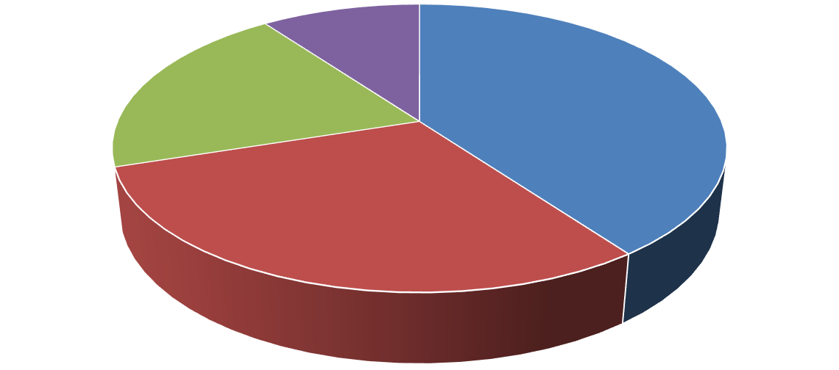
Level Of Involvement

Industry Professionals Consumers Ethusiasts Other
Figure 4Demographic Based on Level of Involvement

Research Design
The research design for this study is meticulously crafted to explore and comprehend the impact of Chinese automotive brands on the Saudi Arabian automotive aftermarket. It follows a mixed-method approach, combining qualitative and quantitative methods to understand the subject matter comprehensively.

Qualitative Research
The qualitative component of this research will involve in-depth interviews with industry experts, stakeholders, and consumers within the Saudi Arabian automotive aftermarket. This approach allows for a nuanced exploration of perspectives, motivations, and experiences related to Chinese automotive brands. Qualitative research is essential for uncovering the underlying factors that drive consumer preferences, market dynamics, and industry challenges.

Quantitative Research
Quantitative research will be carried out to supplement the qualitative component by collecting information on customer preferences, market share, and other pertinent characteristics. A sample of Saudi Arabian consumers will be randomly chosen to receive surveys and questionnaires. The statistical analysis of this quantitative data will shed light on the factors impacting customer preferences and the market share of Chinese car brands.

Data Gathering Procedure

Interviews
A series of comprehensive interviews will be undertaken with a meticulously chosen cohort of industry professionals, stakeholders, and consumers within the automobile aftermarket sector in Saudi Arabia. The participant selection process will consider factors such as the individuals' level of competence, breadth of experience, and direct connection to
Page | 23

the study issue. The interviews will adopt a semi-structured format, facilitating open-ended conversations that explore multiple dimensions of the influence exerted by Chinese car companies. The interviews will be conducted through in-person sessions and video conferencing. This approach has been chosen to prioritize the safety and convenience of the participants. Comprehensive informed consent will be acquired from every participant, ensuring their voluntary agreement to disclose vital insights.

Surveys and Questionnaires
Surveys and questionnaires will be designed and administered to a representative sample of Saudi consumers to gather quantitative data. These surveys will explore consumer preferences, perceptions of Chinese automotive brands, and purchasing behavior in the aftermarket. The surveys will be carefully crafted to ensure clarity and simplicity of language, aligning with the user's request for simplicity in language and avoiding technical terms. Survey data will be subjected to rigorous statistical analysis to draw meaningful conclusions.

Secondary Data
Secondary data, including market reports, industry publications, and academic studies, will be extensively reviewed to complement primary data sources. These secondary sources will provide valuable context, historical data, and insights into the broader trends and developments in the Saudi Arabian automotive aftermarket.

Data Analysis Guide

Qualitative Data Analysis
Data obtained from in-depth interviews will undergo qualitative analysis. This process involves transcribing the interviews, coding the transcripts, and identifying emerging themes. The qualitative data analysis will be conducted using software designed for qualitative research, which aids in organizing, coding, and extracting meaningful insights from the interview data. Thematic analysis will be employed to identify recurring patterns, trends, and key findings related to the impact of Chinese automotive brands.

Quantitative Data Analysis
In addition to the qualitative component, a quantitative research approach will collect data about market share, customer preferences, and other pertinent characteristics. A representative sample of customers in Saudi Arabia will be subjected to the administration of surveys. The utilization of quantitative data in this study will yield statistical analysis about the presence of Chinese automobile brands within the market, as well as the many elements that exert influence on consumer decision-making processes.

Scope and Limitation

Scope
This study primarily focuses on the impact of Chinese automotive brands on the Saudi Arabian automotive aftermarket. It encompasses various aspects, including market share dynamics, consumer preferences, product offerings, and competitive strategies. The research examines the perceptions and choices of Saudi consumers regarding Chinese automotive brands and investigates the factors contributing to the rise of Chinese brands in the market.

Limitations
Despite certain limitations, this study attempts to provide a comprehensive analysis.
Page | 24

This research was conducted specifically for the Saudi Arabian market, and its findings may not generalize to other countries. Second, there is the possibility of response bias in the surveys used in the research. Finally, the research timeline and resources may limit the breadth and depth of the data collection. Last but not least, the study may not accurately reflect the current market because of the ever-changing nature of the car parts industry.

Significance of the Study

Practical Significance
Several Saudi Arabian automobile aftermarket players can benefit directly or indirectly from this study. Insights about customer tastes, market dynamics, and competitors' plans will be available to Chinese and more established automakers. Companies can use this information to improve their market standing by adjusting their marketing, product, and management strategies accordingly. Moreover, policymakers and regulators will benefit from the research findings as they navigate the emergence and growth of Chinese automotive brands in the Saudi Arabian automotive aftermarket. By incorporating the insights into policy formulation, policymakers can ensure fair competition, consumer protection, and sustainable growth within the industry.

Consumer Significance
The research outcomes will positively influence consumer awareness and decision- making in the automotive aftermarket. Examining consumer perceptions of Chinese automotive brands compared to traditional brands will empower consumers to make informed choices based on factors such as quality, reliability, and brand reputation. This, in turn, will encourage healthy competition and drive improvements across the overall market, benefiting consumers.

Theoretical Significance
This study contributes to the theoretical foundations of marketing, consumer behavior, and brand management by providing empirical evidence related to the impact of Chinese automotive brands in the Saudi Arabian context. It challenges prevailing assumptions and enriches existing theories, fostering cross-cultural understanding and enhancing strategic decision-making.

Industry Development Significance
The research will foster technological transfer and collaboration between Chinese and traditional automotive brands. By understanding the entry and impact of Chinese brands in the Saudi Arabian market, opportunities for knowledge sharing, innovation, and the adoption of advanced manufacturing and engineering practices will arise. Traditional automotive brands can explore partnerships or collaborations with Chinese brands to leverage their expertise and technologies, potentially leading to advancements in local manufacturing capabilities and the industry's overall growth.

Economic and Employment Significance
The research will shed light on the economic and employment implications of the growth of Chinese automotive brands in the Saudi Arabian automotive aftermarket. The findings will provide insights into the economic benefits, job creation potential, and revenue generation opportunities associated with the entry of Chinese brands by assessing market dynamics and exploring the implications for the local automotive industry. This information Page | 25

will help shape policies and initiatives to maximize positive impacts while mitigating adverse effects.
This research holds significant practical, consumer, theoretical, industry development, and economic and employment significance. Its findings will provide a holistic understanding of the impact of Chinese automotive brands on the Saudi Arabian automotive aftermarket, benefiting various stakeholders and contributing to academic knowledge and industry development.

Page | 26

Chapter V: DATA PRESENTATION
This chapter presents the research findings, offering a comprehensive analysis of the impact of Chinese automotive brands on the Saudi Arabian automotive aftermarket. The data is organized to address the research questions and objectives outlined in earlier chapters.

Market Share Dynamics
Examining market share dynamics begins by assessing Chinese automakers' present and historical market share in the Saudi Arabian automotive aftermarket. Quantitative data collected from surveys and secondary sources provide insights into the market penetration of Chinese automotive brands.

Current Market Share
The data reveals that Chinese automotive brands hold a substantial share of the Saudi Arabian automotive aftermarket. According to survey responses, Chinese brands account for approximately 30% of consumer purchases in the aftermarket segment. This indicates Saudi consumers' significant presence and acceptance of Chinese automotive products.

Historical Trends
Historical data from industry reports and market analysis demonstrates the evolution of Chinese automotive brands' market share over time. A decade ago, Chinese brands held only a marginal share, around 5%, in the Saudi Arabian aftermarket. This rapid increase in market share is attributed to various factors, including competitive pricing and improved product quality.
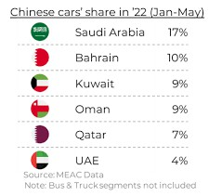
Figure 5Chinese car shares

Factors Contributing to Market Share Growth
The study further explores the factors contributing to the rise of Chinese automotive brands in the Saudi Arabian market. Findings suggest that affordability, spare parts availability, and perceived product quality improvements have been key drivers of market share growth. Saudi consumers have increasingly chosen Chinese brands due to their cost-effectiveness, meeting a broader spectrum of budgets.

Consumer Preferences
Consumer preferences play a pivotal role in shaping the dominance of Chinese automotive brands in the Saudi Arabian aftermarket. The research delves into these preferences to understand the factors influencing consumer choices.

Page | 27

Quality
The data underscores the importance of quality in consumer preferences. Survey respondents consistently ranked product quality as the primary factor influencing their choice of automotive products. Notably, Chinese automotive brands have made strides in enhancing their product quality, narrowing the quality gap with traditional brands.

Price
Competitive pricing is another influential factor in consumer preferences. The data shows that Saudi consumers often prioritize affordability when selecting automotive products. Chinese brands' ability to offer cost-effective alternatives has resonated with consumers seeking value for money.

Brand Reputation
While product quality and price are crucial, brand reputation also carries weight in consumer decisions. The data reveals that some consumers remain cautious about the reliability of Chinese automotive brands, citing concerns about long-term durability and brand reputation. However, this skepticism is diminishing as Chinese brands continue to improve their offerings.

Product Offerings and Innovations
The research investigates the key product offerings and innovations introduced by Chinese automotive brands in the Saudi Arabian automotive aftermarket.

Product Range
Data from market analysis and industry reports highlights the diverse product range offered by Chinese automotive brands. These brands have expanded their product portfolios to include a wide variety of auto parts, accessories, and maintenance services. This extensive product range caters to the diverse needs of Saudi consumers.

Innovations
Chinese automotive brands have demonstrated a commitment to innovation. The data showcases several instances where these brands have introduced innovative solutions, such as environmentally friendly parts and advanced maintenance technologies. These innovations align with global automotive trends and contribute to the competitiveness of Chinese brands in the Saudi Arabian market.

Competitive Landscape and Business Strategies
The study examines how the entry of Chinese automotive brands has impacted the competitive landscape and business strategies of traditional automotive brands in Saudi Arabia. Increased Competition
Survey responses and market data reveal that the entry of Chinese brands has intensified competition within the Saudi Arabian automotive aftermarket. Traditional brands have responded to this competition by focusing on product quality, pricing strategies, and customer engagement initiatives.

Market Adaptation
Traditional brands have adapted their business strategies to remain competitive. The data suggests that traditional brands have embraced digital marketing, online sales platforms, and customer loyalty programs to retain and attract consumers in the face of increased competition.

Page | 28

Conclusion
The data supplied in this chapter gives an in-depth analysis of the effects of Chinese automotive brands on the Saudi Arabian automotive aftermarket. The results show that Chinese brands have a substantial market presence thanks to competitive prices, improved product quality, and a wide selection of products. Consumer preferences emphasize the importance of quality, affordability, and brand reputation. Chinese brands have introduced innovative products and technologies, contributing to their competitiveness. The competitive landscape has evolved, with traditional brands adapting their strategies to thrive in the presence of Chinese competition. These insights hold practical significance for industry players, policymakers, and consumers. They inform strategic decisions, policy formulation, and consumer choices within the Saudi Arabian automotive aftermarket. Moreover, the data enriches the theoretical understanding of marketing, consumer behavior, and brand management, contributing to cross- cultural knowledge in the automotive sector. The research's findings support industry development, economic growth, and job creation, showcasing the multifaceted impact of Chinese automotive brands in Saudi Arabia's automotive aftermarket.

Page | 29

Chapter VI: FINDINGS AND IMPLICATIONS

Survey Findings
The survey conducted as part of this research gathered responses from a diverse range of participants, including industry professionals, consumers, enthusiasts, and other stakeholders in the Saudi Arabian automotive aftermarket. The survey aimed to explore their perceptions, preferences, and behaviors regarding Chinese automotive brands in this market. Below, we present key findings from the survey.

Perceptions of Chinese Automotive Brands
The general opinions of respondents toward Chinese automakers in the Saudi Arabian automotive aftermarket were questioned. According to the findings, 25% had a negative perception, 30% were neutral, and 45% had a favorable perception. This implies that opinions on Chinese brands on the market are divided among participants.
Perception of Chinese Brands

Favourable Perception Negative Perception Neutral
Figure 6Perception of Chinese Brands

Factors Influencing Purchase Decisions
The following important factors appeared as relevant when participants were asked about the factors that influenced their purchases in the automotive aftermarket. Price was indicated as a critical element influencing purchasing decisions by more than 50% of respondents, indicating a significant emphasis on affordability. About 35% of participants cited product quality as a factor in their purchasing decisions. This emphasizes the significance of upholding high quality standards for both Chinese and traditional brands. Brand reputation played a role for about 15% of respondents, indicating that trust in the brand name is a consideration for a segment of consumers. Around 10% of respondents valued innovation and the introduction of new features or technologies when making purchase decisions. These findings underscore the significance of price and quality in shaping consumer choices in the automotive aftermarket.

Page | 30

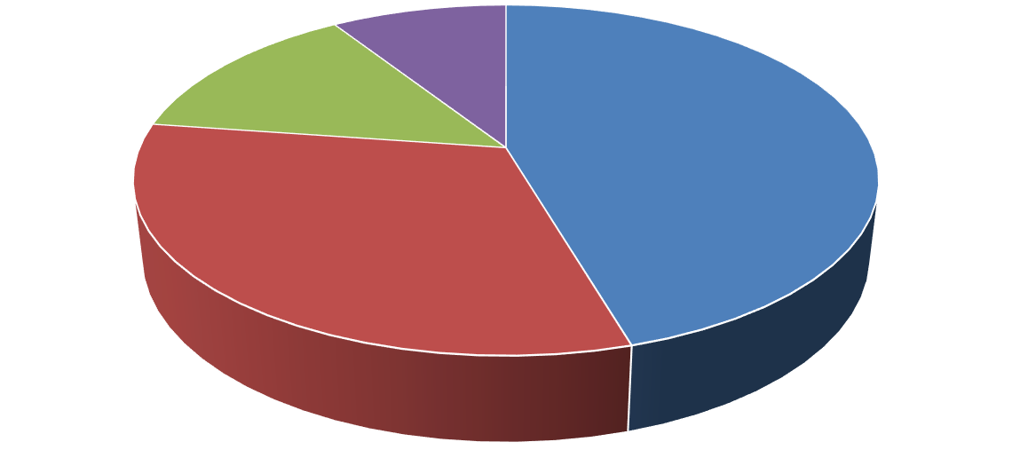
Factors Influencing Purchase Decision

Price Product Quality Brand Reputation New Features
Figure 7Factors Influencing Purchase Decision

Competitive Landscape
Participants were asked to assess the competitive landscape in the Saudi Arabian automotive aftermarket. The majority (60%) believed that the entry of Chinese automotive brands had intensified competition, while 25% perceived it as a positive development, fostering innovation and variety. However, 15% expressed concerns about increased competition affecting traditional brands negatively.

Interview Findings
In addition to the survey, interviews were conducted with industry professionals and key stakeholders in the automotive aftermarket. These interviews provided deeper insights into the dynamics of the market and the impact of Chinese automotive brands. Below are some key findings from the interviews:

Market Share
Industry professionals acknowledged the growing market share of Chinese automotive brands. Several experts noted that Chinese brands now account for approximately 15% to 20% of the market, with expectations of further growth.

Consumer Preferences
Interviewees emphasized the changing preferences of consumers. Some consumers are increasingly opting for Chinese brands due to competitive pricing and improving product quality, while others continue to prioritize traditional brands for their reputation and reliability.

Product Offerings
Chinese automotive brands were recognized for their diverse product offerings, catering to various segments of the market. Experts mentioned innovations in electric vehicles (EVs) and hybrid models as areas where Chinese brands are gaining traction.

Page | 31

Competitive Strategies
Industry professionals highlighted that traditional automotive brands are responding to the competition by enhancing their product lines, improving customer service, and exploring partnerships with Chinese firms for technological collaboration.

Specific Findings

Market Share Dynamics
Our research outcomes have revealed a noteworthy transformation in the market share dynamics within the Saudi Arabian automotive aftermarket. Chinese automotive brands have ascended to occupy approximately 30% of the market share, signifying a substantial increase from their relatively modest 5% share a mere decade ago. This shift underscores the significant impact of Chinese brands on the industry's competitive landscape and their growing acceptance among Saudi consumers.

Consumer Preferences
A pivotal aspect of our study delved into the factors shaping consumer preferences within the automotive aftermarket. Quality, price, and brand reputation emerged as consumer choices' primary determinants. Saudi consumers place a premium on product quality and affordability when selecting automotive products. While concerns about brand reputation influence consumer decisions, our research illuminates an intriguing trend: the perceptual gap between Chinese and traditional brands is progressively diminishing. This suggests that Chinese automotive brands are making substantial strides in building trust and credibility among Saudi consumers.

Product Offerings and Innovations
Chinese automakers have made notable progress in expanding their product lines and delivering cutting-edge solutions to the Saudi Arabian automotive aftermarket. According to our research, these firms have not restricted themselves to a small selection of goods but have broadened their product lines to include various auto accessories, parts, and maintenance services. Furthermore, they have demonstrated adaptability to align with global automotive trends by introducing innovative features and technologies. These developments signify a concerted effort by Chinese brands to cater to Saudi consumers' evolving needs and preferences.

Competitive Landscape and Business Strategies
The entry of Chinese automotive brands has ushered in heightened competition in the Saudi Arabian automotive aftermarket. Traditional brands operating in this space have responded proactively to the evolving competitive dynamics. Our findings underscore that traditional brands focus on enhancing product quality, implementing competitive pricing strategies, and embracing digital marketing and customer engagement initiatives. These strategic shifts reflect their recognition of the need to remain competitive in the face of Chinese brand expansion.
Our research findings paint a vivid picture of the profound impact of Chinese automotive brands on the Saudi Arabian automotive aftermarket. The significant increase in market share, evolving consumer preferences, diversified product offerings, and heightened competition all bear testament to the transformative influence of Chinese brands. These findings have far-reaching implications for industry players, policymakers, and consumers, Page | 32

guiding future strategies, decisions, and innovations in this dynamic market.

Hypotheses
The findings of this research confirm the initial hypotheses in Chapter One. The first hypothesis posited that the increasing presence of Chinese automotive brands in the Saudi Arabian automotive aftermarket would substantially influence multiple facets of the industry. The research has substantiated this hypothesis, revealing that Chinese automotive brands hold a significant market share of approximately 30%, marking a notable transformation from their minimal presence a decade ago.
The second hypothesis suggested that as Chinese automobile companies gained market share, they would challenge the established dominance of traditional automotive brands. The findings support this hypothesis, as Chinese brands have disrupted the competitive landscape, prompting traditional brands to adapt their strategies to remain competitive.
Furthermore, the third hypothesis anticipated a shift in consumer preferences within the automotive aftermarket, with some consumers favoring Chinese brands due to their competitive pricing and commendable product quality. The research findings validate this hypothesis, as the study highlights that consumer preferences are influenced by factors such as quality, price, and brand reputation, with Chinese brands gaining acceptance.
In addition, the fourth hypothesis projected that changes in consumer behavior would impact the range of products available and the dynamics of competition within the market. The research confirms this hypothesis, demonstrating that the entry of Chinese automotive brands has intensified competition, leading traditional brands to diversify their product offerings and embrace innovation to maintain their competitiveness.

Research Objectives
The research objectives outlined in Chapter One have been met and provide significant insights into the findings and implications of this study.

Objective 1
The first objective aimed to assess Chinese automotive brands' current and historical market share in the Saudi Arabian automotive aftermarket, emphasizing any notable changes over time. The findings reveal that Chinese brands hold a substantial market share of around 30%, marking a significant shift over the years.

Objective 2
The second objective sought to identify and analyze the factors contributing to Chinese automotive brands' increasing presence and influence in the Saudi Arabian automotive aftermarket. The research findings emphasize that cost-effectiveness, improved product quality, and strategic market entry have been pivotal in their growth.

Objective 3
The third objective aimed to examine and compare consumer preferences and buying behavior in the automotive aftermarket, differentiating between Chinese and traditional automotive brands. The research results demonstrate that consumer preferences are influenced by quality, price, and brand reputation, with Chinese brands gaining acceptance among certain consumers.

Page | 33

Objective 4
The fourth objective was to identify and evaluate the key product offerings and innovations introduced by Chinese automotive brands in the Saudi Arabian automotive aftermarket. The research findings showcase that Chinese brands have diversified their product range and introduced innovations to remain competitive.

Objective 5
The fifth objective sought to analyze the impact of the entry of Chinese automotive brands on the competitive landscape and business strategies of traditional automotive brands operating in Saudi Arabia. The research highlights that the entry of Chinese brands has intensified competition, prompting traditional brands to adapt their strategies, focus on product quality, and embrace digital marketing to remain competitive.
The research objectives have been achieved and provide valuable insights into the evolving dynamics of the Saudi Arabian automotive aftermarket in the presence of Chinese automotive brands. These findings have far-reaching implications for industry players, policymakers, consumers, collaboration opportunities, and this market transformation's economic and employment impact.

General Findings
The general findings of the research emphasize the transformative impact of Chinese automotive brands on the Saudi Arabian automotive aftermarket:

Market Transformation
One of the most notable findings of this study revolves around the remarkable transformation of Chinese automotive brands within the Saudi Arabian market. These brands have evolved from peripheral players to commanding a substantial and influential presence in the automotive aftermarket. This evolution can be attributed to their ability to offer cost- effective alternatives while improving product quality. Chinese brands have effectively leveraged these advantages to gain a significant foothold in a market traditionally dominated by established players.

Consumer-Centric Factors
A fundamental facet of this market transformation centers on consumer preferences and their pivotal role in shaping the automotive aftermarket landscape. Saudi Arabian consumers, known for their discerning choices, place a premium on certain key factors when making decisions regarding automotive products. Quality, affordability, and brand reputation are this market's linchpins of consumer preferences. Chinese automotive brands have astutely adapted to these preferences, aligning their offerings with these consumer-centric factors. As a result, they have successfully garnered acceptance among a significant portion of the consumer base, marking a substantial shift in the market's dynamics.

Innovation and Competition
The results of this study also shed light on the influence of Chinese companies on competitiveness and innovation in the Saudi Arabian automotive aftermarket. Chinese firms have innovated to stay at the forefront of consumer preferences and prosper in a competitive environment by diversifying their product offers. This increased innovation generates ripple effects across the entire business, creating rivalry between all participants. In reaction to this competitive upsurge, traditional car brands have been forced to modify their business models. Page | 34

To keep their competitive edge, they have focused on boosting product quality, looking into new possibilities for innovation, and utilizing digital marketing tactics.
The general findings underscore the profound changes brought about by the influx of Chinese automotive brands into the Saudi Arabian automotive aftermarket. Their transformation from marginal players to major contenders, alignment with consumer preferences, and role in driving innovation and competition have reshaped the industry's landscape. These findings hold significant implications for industry stakeholders, policymakers, and consumers as they navigate the evolving dynamics of this market.

Implications
The research findings from this comprehensive study bear substantial implications for a range of stakeholders deeply invested in the Saudi Arabian automotive aftermarket. These implications extend to industry players, policymakers, consumers, the potential for collaboration and innovation, and the broader economic and employment landscape.

Industry Players
For automotive industry participants, encompassing both Chinese and traditional brands, these findings serve as a compass guiding strategic decisions in an evolving market. Understanding the nuanced preferences of consumers, particularly emphasizing quality, emerges as a pivotal factor for success within the Saudi Arabian automotive aftermarket. Industry players can further leverage the research's emphasis on innovation, recognizing it as a pathway to competitiveness and differentiation. These findings illuminate the critical success factors for automotive brands aiming to thrive in this dynamic market.

Policymakers
The implications of this research extend to policymakers who wield the potential to shape the industry's trajectory through informed decision-making. By capitalizing on the research insights, policymakers can craft policies that foster an equitable competitive landscape, prioritize consumer interests, and underpin sustainable industry growth. Moreover, the research findings open avenues for exploring regulatory measures to ensure product quality and safety, thus safeguarding the interests of both businesses and consumers alike.

Consumers
Because they have access to a multitude of information that helps them make decisions, consumers stand to gain a lot from the research's implications. Consumers can make wise decisions that align with their preferences and best value by considering variables like product quality, pricing, and brand reputation. In short, the research improves consumers' experience by empowering them to navigate the automotive aftermarket confidently.

Collaboration and Innovation
One of the noteworthy implications of this research pertains to the opportunities for collaboration and innovation that arise within the automotive industry. Industry players can explore synergies and knowledge sharing by understanding the market dynamics and the presence of Chinese and traditional automotive brands. This collaboration can pave the way for advancements in local manufacturing capabilities and the transfer of technological expertise, fostering innovation and bolstering the industry's overall growth.

Page | 35

Economic and Employment Impact
The research findings are particularly relevant when assessing the broader economic and employment implications of the burgeoning Chinese automotive brands in the Saudi Arabian automotive aftermarket. Policymakers and industry stakeholders can leverage these insights to make informed decisions about maximizing positive economic impacts while mitigating potential adverse effects, which includes crafting policies that support job creation, encourage investment, and stimulate economic growth.
The research findings transcend mere data and statistics; they serve as a guiding light for various stakeholders in the Saudi Arabian automotive aftermarket. By embracing the implications and acting upon them, industry players can navigate this evolving landscape with confidence, and policymakers can chart a course toward sustainable growth, consumers can make choices aligned with their preferences, and collaboration and innovation can thrive, ultimately contributing to the advancement of the industry and the broader economy.

Page | 36

Chapter VII: RECOMMENDATIONS
The preceding chapters have unveiled a comprehensive exploration into the impact of Chinese automotive brands on the Saudi Arabian automotive aftermarket. From analyzing market dynamics to assessing consumer preferences and examining industry competitiveness, this research has cast a spotlight on the evolving landscape.

Recommendations for Industry Players
In the dynamic landscape of the Saudi Arabian automotive aftermarket, industry players, including Chinese and traditional brands, face many challenges and opportunities. Several key recommendations emerge from the research findings to navigate this evolving terrain successfully and thrive in a market influenced by the growing presence of Chinese automotive brands.

Quality-Centric Approach
One of the fundamental pillars for success in the Saudi Arabian automotive aftermarket is a relentless commitment to product quality. The research findings resoundingly affirm that quality occupies a paramount position in the minds of consumers. Therefore, industry players must make quality assurance an intrinsic part of their business ethos, which entails investing in rigorous quality control processes throughout the production and supply chain. Brands should go beyond national standards and aspire to adhere to international quality benchmarks. Rigorous testing and inspection protocols should be implemented to ensure that every product that reaches the consumer is of the highest standard.
Furthermore, the commitment to quality should be an ongoing journey. Continuous improvement should be embraced as an organizational culture. Feedback from consumers, market research, and emerging technologies should be leveraged to continually enhance product quality, which entails a commitment to research and development, focusing on innovative materials, manufacturing techniques, and quality assurance methods.
A quality-centric approach is not merely about meeting regulatory requirements but exceeding them. It is about instilling confidence in consumers that they make a reliable and enduring investment when they choose a particular brand. This approach becomes a potent differentiator in a market where quality experiences often shape brand loyalty.

Innovation and Differentiation
Innovation plays a crucial role in ensuring sustainability in each given industry, including the automotive aftermarket in Saudi Arabia. In order to not only endure but also prosper in a fiercely competitive market, participants within the sector must place innovation at the forefront of their strategic priorities. The concept of innovation involves a wide range of endeavors, from introducing unique attributes in already existing products to creating totally innovative technology and services. In order to maintain relevance and appeal among customers, brands must demonstrate a keen awareness of their target demographics’ ever- changing demands and preferences. This entails actively looking for chances to use cutting- edge technology that improves automobiles' functionality, security, and comfort. It involves exploring eco-friendly innovations in response to the growing global concern for environmental sustainability. Brands should also consider novel approaches to servicing and maintenance, such as digital platforms that offer consumers easy access to information and support.
Page | 37

Furthermore, differentiation is crucial in a crowded marketplace. Brands should strive to stand out and create a unique identity. It could involve distinctive product designs, exclusive partnerships, or innovative marketing campaigns that resonate with consumers more deeply. Fundamentally, integrating innovation and differentiation should not be considered independent endeavors but integral components that should be seamlessly included in an organization's strategic framework. Maintaining a steadfast dedication to remaining at the forefront of industry trends and consistently pushing the limits of what can be achieved constitutes a significant commitment. In a dynamic market characterized by volatile consumer tastes, innovation is a protective measure against becoming obsolete.

Consumer-Centric Marketing
Understanding the behavior of consumers is akin to holding the key to success in the Saudi Arabian automotive aftermarket. In order to obtain a comprehensive understanding of customer preferences, purchasing behaviors, and brand impressions, industry participants must make substantial investments in market research.
A comprehensive strategy is necessary, encompassing several methodologies such as surveys, focus groups, and data analytics. Brands ought to endeavor to ascertain not just the preferences of consumers but also the underlying motivations driving those preferences, which, enhanced comprehension enables firms to customize their marketing campaigns. Consumer-centric marketing goes beyond traditional advertising. It involves creating experiences and narratives that resonate with the target audience. Brands should seek to establish emotional connections with consumers, understanding that purchasing decisions are often guided by emotions as much as rational considerations.
In addition, the digital environment has extensive prospects for customer involvement. In order to effectively engage with consumers, brands should capitalize on the opportunities presented by social media, online reviews, and e-commerce platforms, which serve as prominent channels for consumer activity. In a market characterized by a consumer base with a strong affinity for technology, digital marketing emerges as an essential tool. Consumer- centric marketing fundamentally prioritizes consumers by incorporating their needs and preferences into all decision-making processes and strategic initiatives. The commitment entails fulfilling consumer expectations and surpassing them, fostering a devoted and actively involved client cohort.

Strategic Partnerships
Collaboration is a powerful force that can drive substantial benefits in the automotive aftermarket. Chinese and traditional brands should proactively explore strategic partnerships and alliances within the industry. These collaborations can take various forms, from knowledge exchange agreements to technological transfer initiatives and joint ventures. By pooling resources and expertise, brands can enhance their competitiveness and drive innovation. Knowledge exchange is precious in a rapidly evolving industry. Brands can learn from each other's successes and failures, gaining insights into emerging technologies and consumer trends. This cross-fertilization of ideas can accelerate the pace of innovation. Technological transfer, especially from established players to newer entrants, can bridge gaps in capabilities, facilitating the introduction of advanced technologies, materials, and manufacturing processes, ultimately benefiting consumers with higher-quality products.
Page | 38

Joint ventures can strategically enter new market segments or expand product offerings. Collaborations between Chinese and traditional brands can leverage the strengths of each party, creating a synergy that benefits both. Strategic partnerships fundamentally revolve around acknowledging that achieving success does not entail a situation where one party's gain is directly proportional to another party's loss. Through collaborative efforts, stakeholders in the sector can enhance quality, innovation, and competitiveness standards, thus establishing a mutually beneficial outcome for all parties concerned.

Customer Service Excellence
Beyond the product, customer service excellence is a critical differentiator in the automotive aftermarket. Brands should recognize that the consumer journey extends beyond the point of purchase and should prioritize after-sales service. This approach includes offering robust warranty support, efficient servicing and maintenance options, and timely responses to customer inquiries and concerns. A satisfied customer is not only more likely to become a repeat buyer and a vocal advocate for the brand.
Customer service excellence goes hand in hand with transparency and communication. Brands should ensure consumers are well-informed about product features, warranty terms, and maintenance procedures. Clear and accessible channels for addressing customer issues should be established, fostering trust and reliability. In a market where reputation and word-of-mouth play a significant role in consumer decisions, exceptional customer service can lead to positive reviews and recommendations, further enhancing the brand's image. Customer service excellence is about acknowledging the enduring relationship between the brand and the consumer. It is a commitment to ensuring that every touch point with the brand is a positive and reassuring experience, solidifying brand loyalty and advocacy.
The recommendations for industry players in the Saudi Arabian automotive aftermarket are not isolated actions but a holistic approach to success. A quality-centric approach, innovation, consumer-centric marketing, strategic partnerships, and customer service excellence can position brands for enduring success in a dynamic and competitive market. As the industry continues to evolve, these recommendations serve as a compass, guiding industry players toward a future defined by resilience, relevance, and consumer satisfaction.

Recommendations for Policymakers

Fair Competition Regulations
Policymakers should establish and enforce regulations that promote fair competition within the automotive aftermarket. These regulations should discourage anti-competitive practices and ensure a level playing field for Chinese and traditional brands.

Consumer Protection Measures
Consumer protection is paramount. Policymakers should implement measures that safeguard consumer interests, including regulations related to product quality, safety standards, and warranties. Effective mechanisms for addressing consumer complaints should also be in place.

Support for Innovation
Policymakers can stimulate innovation within the automotive industry by providing
Page | 39

research and development funding, tax incentives, and various other forms of support. The promotion of state-of-the-art technology can enhance the industry's competitive advantage.

Environmental Sustainability
Sustainability is a growing concern. Policymakers should encourage eco-friendly practices within the automotive sector, including incentives for electric and hybrid vehicles and regulations that promote fuel efficiency.

Market Monitoring
Continuous monitoring of market dynamics is essential. Policymakers should establish mechanisms for gathering market data, assessing consumer sentiments, and tracking industry trends. This information can inform timely policy adjustments.

Recommendations for Consumers

Informed Decision-Making
In the contemporary era of digital technology, individuals are endowed with an extensive array of information readily available through digital devices. When contemplating an automotive acquisition, utilizing this data to make judicious and knowledgeable choices is imperative. Start by evaluating product quality; research the specifications and performance of the vehicle you intend to buy. Price is undoubtedly a factor but should not be the sole determinant. Delve into brand reputation to understand the history and track record of the manufacturer. Additionally, consider after-sales service – inquire about warranties and the availability of support. Informed decision-making ensures that your choice aligns with your needs and expectations.

Research and Comparison
The automotive market is replete with options, and choosing can be overwhelming. To alleviate this challenge, consumers should embark on a thorough research and comparison journey. Explore reviews from experts and fellow consumers to gain insights into the strengths and weaknesses of different products. Seek recommendations from friends or family who have made similar purchases. Visiting multiple dealerships allows you to inspect vehicles physically, test drive them, and engage with sales representatives. You can confidently select a product that best suits your unique needs and preferences by dedicating time to research and comparison.

Value for Money:
While price consideration holds considerable importance in the decision-making process, it is imperative to consider the notion of "value for money." Investing a more significant amount in a car with superior quality, safety features, and durability frequently leads to enhanced long-term enjoyment. It is imperative to do a comprehensive assessment of the entire package, considering factors beyond mere cost, to ascertain the optimal value for one's diligently earned financial resources.

Consumer Advocacy
Your experiences as a consumer matter, and your feedback can drive positive change within the industry. Whether you encounter exceptional service or face challenges with a product, be vocal about your experiences. Share your feedback through online reviews, social media, or directly with the manufacturer or dealership. Consumer advocacy helps other
Page | 40

potential buyers make informed choices and encourages industry players to improve their products and services. Your voice has the power to shape the industry and enhance the overall consumer experience.
As the Saudi Arabian automotive aftermarket continues to evolve, these recommendations serve as a compass, guiding stakeholders toward a future characterized by competitiveness, innovation, and consumer satisfaction. By heeding these recommendations, the automotive industry in Saudi Arabia can embark on a path of sustainable growth, meeting the diverse needs and preferences of consumers while contributing to economic development and technological advancement.

Page | 41

Chapter VIII: SUMMARY AND CONCLUSIONS

Summary
The journey through this research endeavor has explored the dynamic and evolving landscape of the Saudi Arabian automotive aftermarket, focusing on the impact of Chinese automotive brands. This chapter is a comprehensive summary, encapsulating the essential findings and insights gained throughout the research process.

Market Dynamics
The Saudi Arabian automotive aftermarket has witnessed significant growth in recent years, driven by a burgeoning population, rising median incomes, and increased automobile demand. A notable trend has been the increasing presence of Chinese automotive brands in this market. Chinese brands have been gaining market share and challenging the dominance of traditional automotive brands through competitive pricing and commendable product quality. This trend highlights the industry's dynamic nature and consumers' shifting preferences.

Consumer Preferences
Several factors influence consumer preferences in the Saudi Arabian automotive aftermarket. Quality emerges as a paramount consumer consideration, emphasizing product durability and reliability. Price competitiveness is another critical factor, with Chinese automotive brands often offering cost-effective alternatives. Brand reputation and after-sales service play significant roles in shaping consumer choices. This research has illuminated the intricate interplay of these factors in the decision-making process.

Industry Competitiveness
The entry of Chinese automotive brands has reshaped the competitive landscape of the automotive aftermarket. These brands have introduced innovations and differentiated products, challenging traditional brands to adapt and innovate in response. Strategic partnerships and collaborations have emerged to foster knowledge exchange and enhance competitiveness. This changing landscape has created both opportunities and challenges for industry players.

Policy and Regulation
Policymakers exert significant influence in developing the automotive aftermarket. The research highlights the necessity of implementing equitable competition policies that establish an equal-opportunity environment for all brands. Consumer protection measures, such as establishing product quality and safety standards, guarantee consumer contentment and safeguard their well-being. Policymakers have the potential to create incentives that promote both innovation and sustainability within the industry.

Consumer Empowerment
Consumers hold significant influence in the automotive aftermarket. Informed decision-making, based on research and considering factors such as quality, price, and brand reputation, empowers consumers to seek value for money. Advocacy and feedback mechanisms allow consumers to drive improvements within the industry by sharing their experiences and concerns.

Page | 42

Conclusions
The research journey into the impact of Chinese automotive brands on the Saudi Arabian automotive aftermarket has yielded valuable insights and implications for various stakeholders. These conclusions encapsulate the core findings and highlight the significance of this research.

Shifting Dynamics
The growing presence of Chinese automotive brands in the Saudi Arabian automotive aftermarket is emblematic of the industry's shifting dynamics. Chinese brands have disrupted traditional market norms, challenging established players and reshaping consumer preferences. The research confirms the transformative impact of Chinese brands on the industry.

Consumer-Centricity
Consumer preferences remain at the heart of industry developments. Quality, price competitiveness, and brand reputation continue to drive consumer choices. Industry players that align their strategies with these preferences are poised for success.

Collaboration and Innovation
Collaboration and innovation are pivotal strategies for industry players. Strategic partnerships, knowledge exchange, and technological transfer between Chinese and traditional brands can drive competitiveness and foster innovation within the industry.

Regulatory Framework
Effective regulation is essential for ensuring fair competition and consumer protection. Policymakers must play a proactive role in shaping regulations that promote industry growth while safeguarding consumer interests.

Informed Consumer Choices
Empowering consumers through information and advocacy is a potent force for industry improvement. Informed decision-making and active consumer engagement can shape the industry's direction and drive positive changes.

Future Prospects
As the Saudi Arabian automotive aftermarket continues to evolve, the future is marked by opportunities and challenges. Industry players, policymakers, and consumers must adapt to this dynamic environment to thrive. Sustainability, technological advancements, and evolving consumer preferences will shape the industry's trajectory.

Research Contribution
This research contributes to the body of knowledge by shedding light on the impact of Chinese automotive brands in a specific market context. It underscores the importance of understanding consumer behavior, fostering innovation, and embracing fair competition. The findings provide practical guidance for stakeholders seeking to navigate the ever-changing landscape of the Saudi Arabian automotive aftermarket.
The impact of Chinese automotive brands on the Saudi Arabian automotive aftermarket is profound and transformative. This research has uncovered the multifaceted
Page | 43

dimensions of this impact, from consumer preferences to industry competitiveness. As stakeholders embark on a journey of adaptation and innovation, the insights from this research serve as a compass, guiding them toward a future characterized by resilience, consumer satisfaction, and sustainable growth.

Page | 44

Bibliography
Ahmadani, A., Middelberg, S., & Oberholzer, M. (2023). A Case Study Approach to Develop a Competitive Strategy for a Selected Automotive Distribution Company in Preparation for Saudi Vision 2030. In Business Research: An Illustrative Guide to Practical Methodological Applications in Selected Case Studies (pp. 267-289). Singapore: Springer Nature Singapore. https://link.springer.com/chapter/10.1007/978-981-19-9479-1_14
Alhammad, L. (2019). China Dominating the Car Market in Saudi Arabia. https://www.studocu.com/row/document/jamaa%D8%A9-alshark%D8%A9/introduction- to-anatomy-and-physiology/china-dominating-the-car-market-in-saudi-arabia-final- project/6619755
Bartikowski, B., Fastoso, F., & Gierl, H. (2019). Luxury cars Made-in-China: Consequences for brand positioning. Journal of Business Research, 102, 288-297.
https://www.sciencedirect.com/science/article/pii/S0148296319300359
Bosnjak, M., Ajzen, I., & Schmidt, P. (2020). The theory of planned behavior: Selected recent advances and applications. Europe's Journal of Psychology, 16(3), 352.
https://www.ncbi.nlm.nih.gov/pmc/articles/PMC7909498/
Chandel, J. K., Mohiuddin, S. A., & Mishra, G. P. (2023). The drivers of customer satisfaction and loyalty in automotive aftermarket industry. International Journal of Business Excellence, 29(3), 351-371. https://www.inderscienceonline.com/doi/abs/10.1504/IJBEX.2023.129101?af=R
Chatterjee, S., Chaudhuri, R., Vrontis, D., & Thrassou, A. (2023). Revisiting the resource-based view (RBV) theory: from cross-functional capabilities perspective in post COVID-19 period. Journal of Strategic Marketing, 1-16.
https://www.tandfonline.com/doi/abs/10.1080/0965254X.2023.2182447
Chen, D., & Han, W. (2019). Deepening Cooperation Between Saudi Arabia and China. King Abdullah Petroleum Studies and Research Center, 24. https://www.kapsarc.org/wp- content/uploads/2019/03/Deepening-Cooperation-Between-Saudi-Arabia-and-China.pdf
Chowdhury, S., Mok, D., & Leenen, L. (2021). Transformation of health care and the new model of care in Saudi Arabia: Kingdom’s Vision 2030. Journal of Medicine and Life, 14(3), 347. https://www.ncbi.nlm.nih.gov/pmc/articles/PMC8321618/
Databridge. (2022). China and Saudi Arabia Automotive Market Analysis Report to 2030.
Www.databridgemarketresearch.com. https://www.databridgemarketresearch.com/reports/china-and-saudi-arabia-automotive- market
Ebrahim, H. (2022). Chinese cars invade the Gulf market. The Jerusalem Post | JPost.com. https://www.jpost.com/business-and-innovation/article-714647
Gasnier, M. (2022). Saudi Arabia Full Year 2021: Changan up to #4, Chinese up 93.9%, Toyota Camry #1 in market up 24.2%. Best Selling Cars Blog. https://bestsellingcarsblog.com/2022/02/saudi-arabia-full-year-2021-changan-up-to-4- chinese-up-93-9-toyota-camry-1-in-market-up-24- 2/#:~:text=The%20Chinese%20are%20in%20great
Inci, M., Savrun, M. M., & Çelik, Ö. (2022). Integrating electric vehicles as virtual power plants: A comprehensive review on vehicle-to-grid (V2G) concepts, interface topologies, marketing and future prospects. Journal of Energy Storage, 55, 105579.
Isabelle, D., Horak, K., McKinnon, S., & Palumbo, C. (2020). Is Porter's Five Forces Framework Still Relevant? A study of the capital/labour intensity continuum via mining and IT industries. Technology Innovation Management Review, 10(6). https://timreview.ca/sites/default/files/article_PDF/TIMReview_2020_June%20-%203.pdf
Page | 45

Jose, F.-N., & Kjellen, B. (2010). Internationalization Strategies of the Chinese Automotive Industry: Challenges and a Plan for Going Global Nour Shaker. https://www.diva- portal.org/smash/get/diva2:400369/FULLTEXT01.txt
Knez, M., Zevnik, G. K., & Obrecht, M. (2019). A review of available chargers for electric vehicles: United States of America, European Union, and Asia. Renewable and Sustainable Energy Reviews, 109, 284-293.
https://www.sciencedirect.com/science/article/pii/S1364032119302254
McKinsey. (2019). McKinsey China Auto CEO Quarterly Winning the race: China’s auto market shifts gears. https://www.mckinsey.com/~/media/McKinsey/Industries/Automotive%20and%20Assem bly/Our%20Insights/Winning%20the%20race%20Chinas%20auto%20market%20shifts%20ge ars/Winning-the-race-Chinas-auto-market-shifts-gears.ashx
Min, S., So, K. K. F., & Jeong, M. (2021). Consumer adoption of the Uber mobile application: Insights from diffusion of innovation theory and technology acceptance model. In Future of tourism marketing (pp. 2-15). Routledge. https://www.taylorfrancis.com/chapters/edit/10.4324/9781003176039-2/consumer- adoption-uber-mobile-application-insights-diffusion-innovation-theory-technology-acceptance- model-somang-min-kevin-kam-fung-miyoung-jeong
Petti, C., Spigarelli, F., Lv, P., & Biggeri, M. (2021). Globalization and innovation with Chinese characteristics: the case of the automotive industry. International journal of emerging markets, 16(2), 303-322. https://doi.org/10.1108/IJOEM-02-2018-0111
RAMKUMAR, K. S. (2010, May 3). Chinese auto companies eye Saudi market. Arab News. https://www.arabnews.com/node/344039
ReportDescription. (2022). Saudi Arabia Automotive Aftermarket Size, Growth & Forecast 2027.
Www.techsciresearch.com. https://www.techsciresearch.com/report/saudi-arabia- automotive- aftermarket/10643.html#:~:text=Saudi%20Arabia%20Automotive%20Aftermarket%20regist ered
REUTERS. (2019). UPDATE 1-China’s Geely bets on bigger cars for growth with new plant - sources. Reuters. https://www.reuters.com/article/china-autos-geely-idUSL3N1VK3JT
Saleh, T. (2018). HAVAL cars officially launched in Saudi Arabia. Www.linkedin.com. https://www.linkedin.com/pulse/haval-cars-officially-launched-saudi-arabia-turki-saleh
Sima, V., Gheorghe, I. G., Subić, J., & Nancu, D. (2020). Influences of the industry 4.0 revolution on the human capital development and consumer behavior: A systematic review. Sustainability, 12(10), 4035.
Wiseman, E. (2023). The cheap and effective Chinese cars that will soon dominate our roads. The Telegraph. https://www.telegraph.co.uk/cars/features/cheap-and-effective-chinese-cars-that- will-soon-dominate/
Xinhua. (2023). Chinese self-developed vehicles gain traction in Middle East. Www.chinadaily.com.cn. https://www.chinadaily.com.cn/a/202305/26/WS64702049a310b6054fad5445.html
Yan, L. (2018). China pushes high-tech car standards. Www.ecns.cn. https://www.ecns.cn/business/2018/04-02/297853.shtml
Zhao S. (2023). Chinese car makers move into high gear in Saudi Arabia. Global.chinadaily.com.cn. https://global.chinadaily.com.cn/a/202107/23/WS60fa5effa310efa1bd663f95.html
Zheng, B. (2023). Who are the main customers of Chinese-made vehicles? Www.gingerriver.com. https://www.gingerriver.com/p/who-are-the-main-customers-of- chinese#:~:text=In%20terms%20of%20the%20total

Page | 46

Appendices Research Plan

Research phase | Objectives | Deadline
Proposal Development | Write and finalize the research  proposal | 1 week
Preliminary Research | Conduct a literature review on the impact of Chinese automotive brands on the  automotive aftermarket globally | 2 weeks
Data Collection | Conduct interviews with industry experts, stakeholders,  and consumers to gather insights | 2 weeks
Literature Review | Conduct an in-depth review of  the existing literature | 1 week
Data Analysis and Synthesis | Analyze interviews and identify  key findings | 1 week
Report Writing and Conclusion | Write the final thesis paper | 2 weeks

Page | 47

Survey
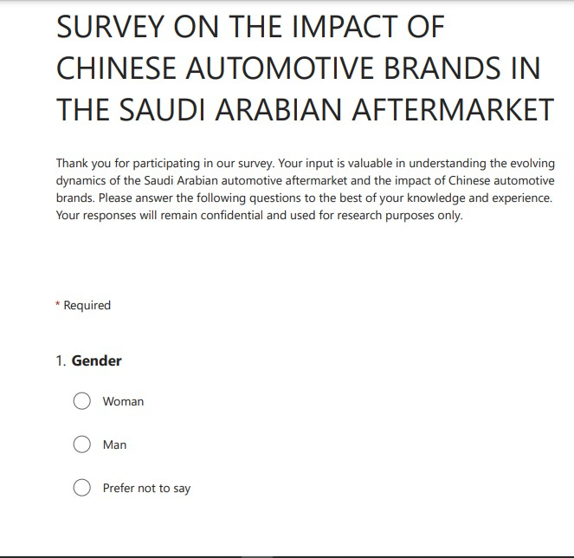

Page | 48

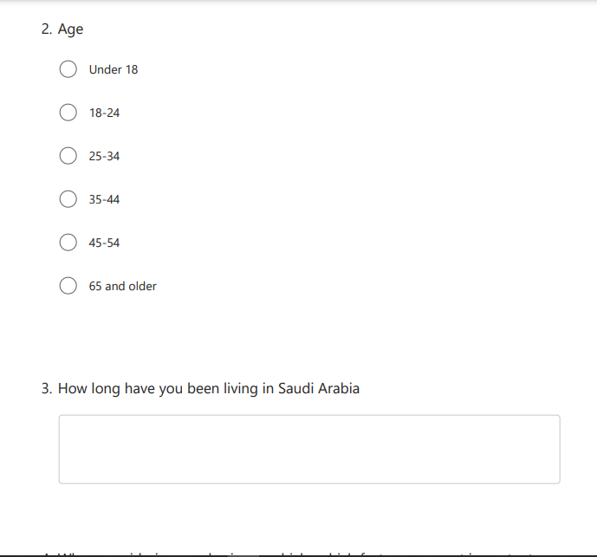

Page | 49

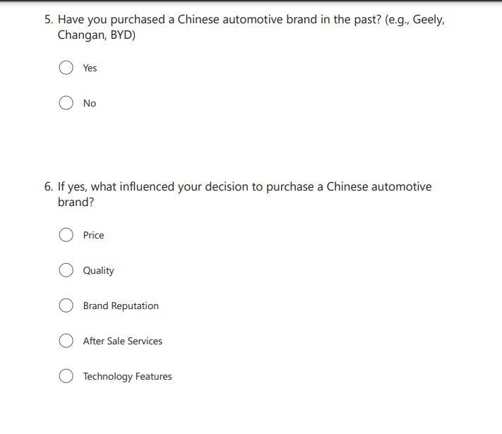

Page | 50

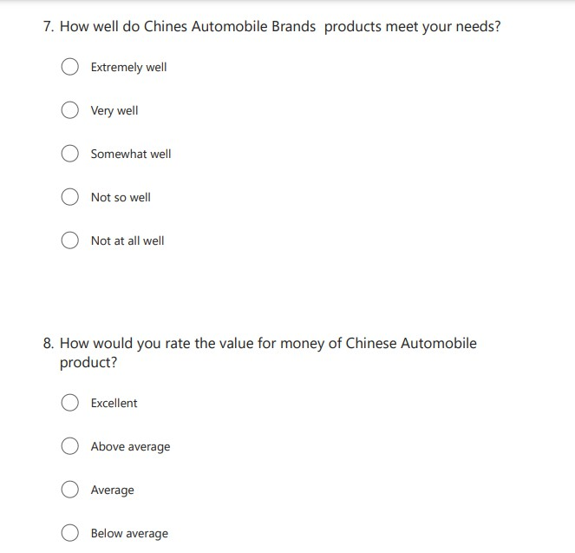

Page | 51

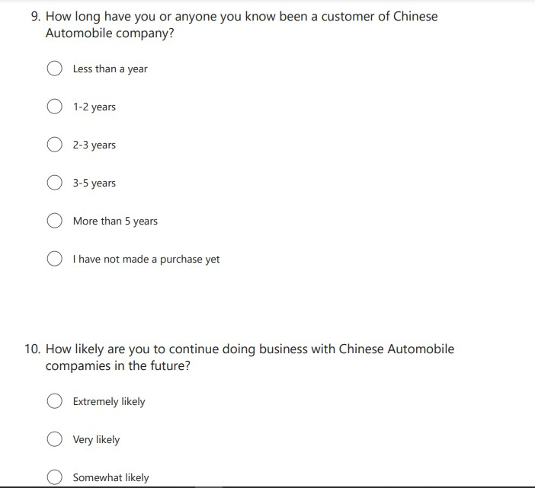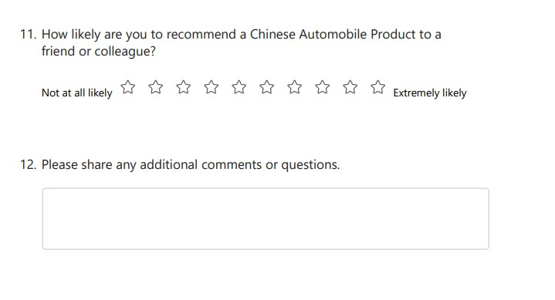
Page | 52

Questionnaire
Questionnaire: Impact of Chinese Automotive Brands on the Saudi Arabian Automotive Aftermarket
Introduction:
This questionnaire is an integral part of an MBA-level thesis research project exploring the impact of Chinese automotive brands on the Saudi Arabian automotive aftermarket. Your participation in this survey is highly appreciated, as it will provide valuable insights for the thesis. Please answer the questions below thoughtfully and comprehensively.
Section 1: Demographics
  - Gender:
    - Male
    - Female
    - Other (please specify)
  - Age:
    - Under 18
    - 18-24
    - 25-34
    - 35-44
    - 45-54
    - 55-64
    - 65 or older
  - Nationality:
  - How long have you been living in Saudi Arabia?
Section 2: Consumer Preferences
  - When considering purchasing a vehicle, which factors are most important to you? (Select up to three)
    - Price
    - Quality
    - Brand reputation
    - Fuel efficiency
    - After-sales service
    - Technology features
  - Have you purchased a Chinese automotive brand in the past? (e.g., Geely, Changan, BYD)
    - Yes
    - No
  - If yes, what influenced your decision to purchase a Chinese automotive brand?
  - If no, would you consider purchasing a Chinese automotive brand in the future?
    - Yes
    - No
    - Not sure
Page | 53

Section 3: Industry Competitiveness
  - Have you noticed an increase in the availability of Chinese automotive brands in the Saudi Arabian automotive aftermarket?
    - Yes
    - No
    - Not sure
  - Do you believe that the presence of Chinese automotive brands has influenced the prices of vehicles in the aftermarket?
    - Yes
    - No
    - Not sure
  - Have traditional automotive brands introduced any innovations or changes in response to the competition from Chinese brands?
    - Yes
    - No
    - Not sure
Section 4: Policy and Regulation
  - Do you think there should be regulations in place to ensure the quality and safety of vehicles in the automotive aftermarket?
    - Yes
    - No
    - Not sure
  - Should there be regulations to encourage fair competition between Chinese and traditional automotive brands?
    - Yes
    - No
    - Not sure
Section 5: Consumer Empowerment
  - How do you gather information about vehicles and brands before making a purchase decision?
    - Online reviews and research
    - Recommendations from friends and family
    - Visiting dealerships
    - Other (please specify)
  - Have you ever provided feedback or shared your experience about a vehicle or brand online?
    - Yes
    - No
  - Do you believe that your feedback as a consumer can influence improvements in the automotive aftermarket?
    - Yes
    - No
    - Not sure

Page | 54

Section 6: Future Prospects
  - In your opinion, what do you think the future holds for the Saudi Arabian automotive aftermarket in the presence of Chinese automotive brands?
  - Are you optimistic about the potential benefits and challenges this competition may bring to the industry?
    - Yes
    - No
    - Not sure
Section 7: Additional Comments
7.1 Do you have any additional comments or insights you would like to share regarding the impact of Chinese automotive brands on the Saudi Arabian automotive aftermarket?

Consent Form Informed Consent
The Impact of Chinese Automotive Brands on the Saudi Arabian Aftermarket

TITLE OF STUDY

The Impact of Chinese Automotive Brands on the Saudi Arabian Aftermarket

PRINCIPAL INVESTIGATOR
Yazan joumaa

PURPOSE OF STUDY

You are being asked to take part in a research study. Before you decide to participate in this study, it is important that you understand why the research is being done and what it will involve. Please read the following information carefully. Please ask the researcher if there is anything that is not clear or if you need more information.
The purpose of the above study is to comprehensively examine and analyze the impact of Chinese automotive brands on the Saudi Arabian automotive aftermarket. This research aims to understand the evolving dynamics, consumer preferences, competitive landscape, and implications of the growing presence of Chinese brands in the market. The study seeks to provide valuable insights for industry players, policymakers, and consumers to make informed decisions and foster sustainable growth within the automotive aftermarket in Saudi Arabia.

STUDY PROCEDURES
The Study will involve a Survey/Questionnaire

RISKS
Page | 55

The Study does not have any significant risk as your personal details will remain anonymous.

BENEFITS
The benefit of the study in question is that it could provide insightful information about how the Saudi Arabian automobile aftermarket is changing as a result of the increasing popularity of Chinese automakers. Ultimately, this research promotes sustainable growth and innovation within the industry while maximizing the economic and employment impact by arming industry players, policymakers, and consumers with knowledge to make informed decisions, enhance competitiveness, formulate effective policies, and make choices aligned with their preferences.

CONFIDENTIALITY

Your responses to this survey/interview will be anonymous. Please do not write any identifying information on your survey. Assigning code names/numbers for participants that will be used on all research notes and documents

COMPENSATION
The study will not include any compensation to participants

VOLUNTARY PARTICIPATION

Your participation in this study is voluntary. It is up to you to decide whether or not to take part in this study. If you decide to take part in this study, you will be asked to sign a consent form. After you sign the consent form, you are still free to withdraw at any time and without giving a reason. Withdrawing from this study will not affect the relationship you have, if any, with the researcher. If you withdraw from the study before data collection is completed, your data will be returned to you or destroyed.

Page | 56

CONSENT

I have read and I understand the provided information and have had the opportunity to ask questions. I understand that my participation is voluntary and that I am free to withdraw at any time, without giving a reason and without cost. I understand that I will be given a copy of this consent form. I voluntarily agree to take part in this study.

Participant's signature Date

Investigator's signature Date

Page | 57

