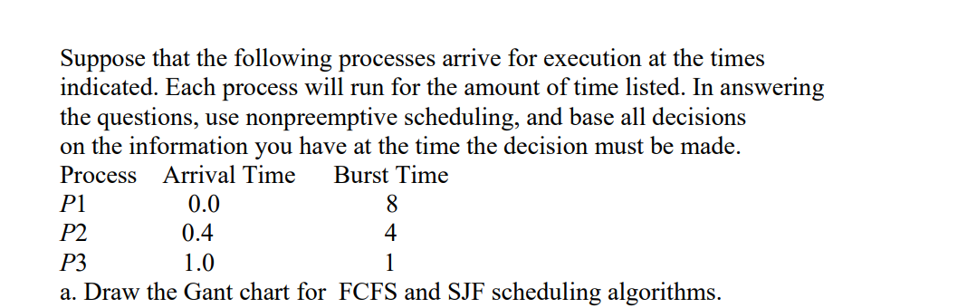

P1 | P2 | P3
0 8 12 13

- Average turnaround for these processes:
( 8 + (12 - 0.4) + (13 - 1)) / 3 = 10.53

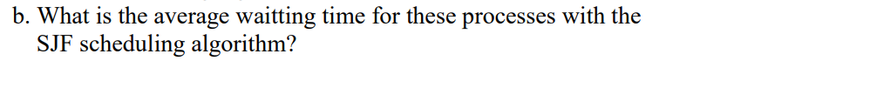
P1 | P3 | P2
0 8 9 13
- Average turnaround for these processes: ( 8 + (9 - 1) + (13 – 0.4)) / 3 = 9.53

