

Explainable Deep Learning for Bean Leaf Disease Classification Using Attention and Grad-CAM
Prepared By
Name: Lama Al-alsubaie ID No: 252001246

Submitted in fulfillment of the requirements for the degree Master of Science in Artificial Intelligence
At
Collage of Informatics
Midocean University
UAE
Supervisor Name: Wisam Ahmed
Collage of Informatics, Midocean University, Comoros

Acknowledgements

I would like to express my sincere gratitude to everyone who supported me throughout the journey of completing this thesis.
I am deeply thankful to my family for their endless support, patience, and encouragement. I would like to extend special thanks to my brother, Abdullah, who has been a constant source of strength and support, always standing by my side throughout this journey.
I would also like to express my heartfelt appreciation to Dr. Wissam for her valuable guidance, continuous support, and insightful feedback, which greatly contributed to the completion of this thesis.
May God reward them all abundantly.

Contents
ii
Acknowledgements iii
List of Abbreviations v
List of Figures vi
List of Tables vii
List of Equations viii
Chapter 1 Introduction 1
1.1 Overview 1
1.2 Problem Definition 1
1.3 Thesis Objectives 1
1.4 Thesis Contribution 2
1.5 Thesis Organization 2
Chapter 2 Background and Related Work 4
2.1 Introduction 4
2.2 Machine Learning Approaches for Plant Disease Detection 4
2.3 Deep Learning for Plant Disease Classification 8
2.4 Attention Mechanisms in Deep Learning 12
2.5 Explainable Artificial Intelligence (XAI) 13
2.6 Evaluation Metrics 16
2.7 Related Work 18
2.8 Chapter Summary 23
References 24

List of Abbreviations
Acc.: Accuracy
ANN: Artificial Neural Network
CNN: Convolutional Neural Network
DL: Deep Learning
ML: Machine Learning
XAI: Explainable Artificial Intelligence
Grad-CAM: Gradient-weighted Class Activation Mapping
ViT: Vision Transformer
RF: Random Forest
SVM: Support Vector Machine
KNN: K-Nearest Neighbor
SE: Squeeze-and-Excitation
CBAM: Convolutional Block Attention Module
GAP: Global Average Pooling
ReLU: Rectified Linear Unit
IoU: Intersection over Union
F1-score: Harmonic Mean of Precision and Recall
ROC: Receiver Operating Characteristic
AUC: Area Under Curve
mAP: Mean Average Precision

List of Figures
Figure 1General machine learning pipeline for plant disease detection 4
Figure 2 Support Vector Machine (SVM) 5
Figure 3 K-Nearest Neighbor (KNN) 6
Figure 4 Random Forest (RF) 7
Figure 5 Deep Learning pipeline for plant disease detection 8
Figure 6 CNN architecture 9
Figure 7 AlexNet architecture 10
Figure 8 Comparison of popular CNN architectures 11
Figure 9 Types of attention mechanisms 12
Figure 10 Black-box vs Explainable AI 14
Figure 11 XAI taxonomy 15
Figure 12 Grad-CAM heatmap 15
Figure 13 Proposed Approach........................................................................................................23

List of Tables
Table 1 Summary of Previous Studies……………………………………………22

List of Equations
Equation 1 Accuracy 16
Equation 2 Precision 17
Equation 3 Recall 17
Equation 4 F1- score 17

Chapter 1 Introduction

1.1 Overview
The plant leaf disease classification has gained much significance because it has enhanced agricultural productivity and food security. Automated image-based detection has become more precise than the traditional manual-based methods due to the rapid development of the deep learning concept. CNNs (ResNet and VGG) have demonstrated good results in feature extraction of leaf images, leading to accurate disease classification [1]. Also, attention mechanisms improve model performance by highlighting the most important areas of the leaf, which raises the representation of features, and their reliability [1]. With these improvements, deep learning models are still mostly uninterpretable and black-box systems, and this decreases user trust, particularly in high-stakes applications such as agriculture. To address this shortcoming, Explainable Artificial Intelligence (XAI) algorithms have been created to give descriptive and interpretable explanations of model decisions. Recent methods, including Vision Transformers with Grad-CAM++, employ self-attention to attain global features, and produce heatmaps to indicate disease-affected regions [2]. The approaches are practical to be applied in real-life since they enhance both the model transparency and the classification performance.

1.2 Problem Definition
The deficiency in the proper diagnosis of bean leaf diseases is still a problem because manual diagnosis is time-consuming and can be erroneous. Deep learning models are very accurate but cannot be interpreted, and they do not localize disease regions clearly, which is a limitation to their practicality.

1.3 Thesis Objectives
This paper will come up with a explainable deep learning model that can correctly classify bean leaf diseases. The main aim is to come up with a robust model that uses Convolutional Neural Networks (CNNs) or Vision Transformers to demonstrate a high performance in classification. Moreover, the research aims at incorporating attention mechanisms so as to boost the capability of the model to concentrate on the pertinent disease-affected areas in leaf images. A second important goal is to implement Explainable Artificial Intelligence (XAI) methods, e.g., Grad-CAM or Grad-CAM++, to give visual explanations of the model predictions. Besides, the model will be tested on the basis of performance measures such as accuracy, precision, recall, and F1-score and compared to the current approaches. In the end, the study will provide a credible and interpretable solution that can be used in practice in agriculture.

1.4 Thesis Contribution
This thesis has the following main contributions:
- Developing a CNN-based model for bean leaf disease classification with high accuracy.
- Integrating attention mechanisms to improve focus on disease-affected regions.
- Applying Grad-CAM/Grad-CAM++ for visual explanation of model predictions.
- Evaluating the model using standard metrics and comparing it with existing approaches.
- Achieving a balance between accuracy and interpretability for practical use.

1.5 Thesis Organization
The rest of the thesis is organized in the following way:
Chapter 2 discusses the theoretical background and the work that is pertinent to this research are in. It discusses machine learning and deep learning methods of plant disease sensing, essential concepts of explainable artificial intelligence (XAI), attention techniques, and prior research in the area.
Chapter 3 describes the proposed methodology in detail. It covers the description of the dataset, methods of preprocessing content, how the deep learning model was designed, how attention mechanisms were added, and how Grad-CAM was used to interpret the model.
The chapter 4 gives the results and discussion of the experiment. It compares the performance of the proposed model with standard metrics and compares it with the existing methods and analyzes the visualization results produced by explainability methods.
Chapter 5 is the final chapter of the thesis, summarizing the key findings, addressing limitations of the research, and pointing to potential avenues of future research.

Chapter 2 Background and Related Work

2.1 Introduction
This chapter introduces the theory and literature related to the classification of bean leaf disease. It talks about machine learning and deep learning methods, and explainable artificial intelligence methods like attention mechanisms and Grad-CAM. Another important aspect of the chapter is that it points out past research and outlines research gaps that this thesis fills.

2.2 Machine Learning Approaches for Plant Disease Detection
2.2.1 Overview of Machine Learning
Machine learning (ML) is a type of algorithm that allows systems to acquire patterns based on data and conduct classification or prediction without needing to be explicitly programmed. ML techniques have been extensively used in plant disease detection, where the extracted features (colored, textured, and shaped images) are used to classify the leaf images as healthy or diseased [3]. The ML workflow usually involves image acquisition, preprocessing, feature extraction and classification and is a structured pipeline that comprises automated diagnosis.
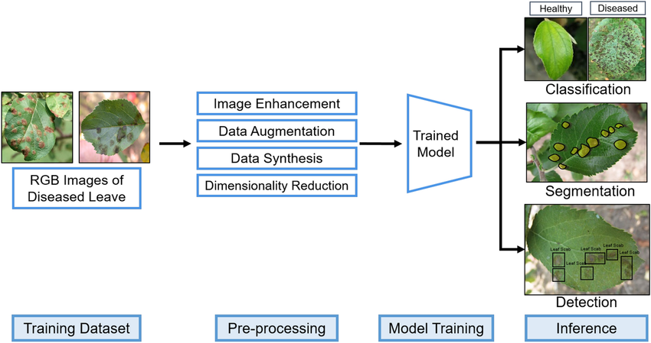
Figure 1 General machine learning pipeline for plant disease detection

Early plant disease detection systems have been implemented using machine learning techniques as it is relatively simple and has relatively low computational demands. But they do not work as well with complicated image patterns and changing environmental parameters.
2.2.2 Traditional Classification Algorithms
Support Vector Machine (SVM)
Support Vector Machine (SVM) is a supervised learning algorithm, which builds an optimal hyperplane to divide data points of various classes.

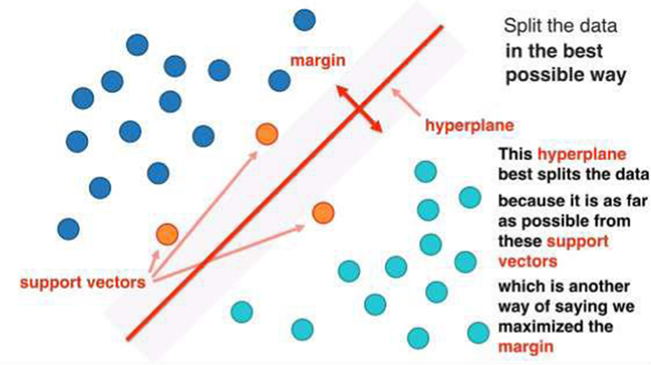
Figure 2 Support Vector Machine (SVM)
SVM has found widespread application in agricultural tasks where it has been used to discriminate between infected and healthy leaf with high levels of accuracy with small training samples. Its resistance to noises and capability of processing nonlinear data with the help of kernel functions make it popular [4].
K-Nearest Neighbor (KNN)
K-Nearest Neighbor (KNN) is a non-parametric classification algorithm with a classification of a data point according to the most common classification of its immediate neighbors.
KNN is easy to apply and does not need a training stage and so is applicable to small data sets. It has been used in detecting plant diseases to categorize leaf images using measures of similarity. Nevertheless, it is extremely sensitive to the selection of kand and susceptible to noisy data and unbalanced datasets [4].
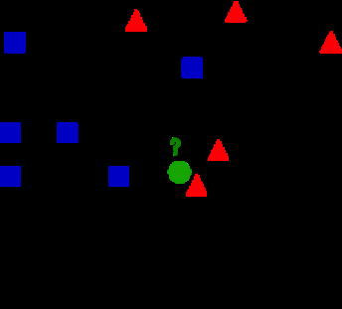
Figure 3 K-Nearest Neighbor (KNN)
Random Forest (RF)
Random Forest (RF) is an ensemble learning algorithm, which integrates a number of decision trees in order to enhance classification.
RF is reputed to be a robust model, capable of working with large datasets, and free of overfitting. It has been effectively used in other agricultural classification problems such as plant disease detection and land cover analysis [4].
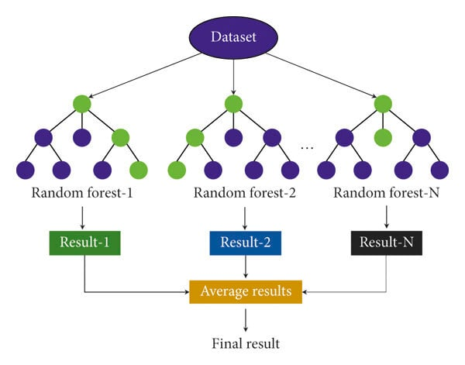
Figure 4 Random Forest (RF)
2.2.3 Limitations of Machine Learning Approaches
Although traditional machine learning methods have their benefits, they have a number of limitations. Their dependence on handcrafted features, necessitating domain knowledge and possibly not scaling identically to other datasets or environmental settings, is one of the main disadvantages [3]. Changes in lighting, background complexity and orientation of leaves can greatly influence quality of feature extraction.
Furthermore, ML models can usually be difficult to handle complicated patterns of the visual representation, including several infections on the same leaf or overlapping disease symptoms. Research has revealed that the models can work well in controlled conditions but have lower accuracy in the real world setting . Also, the algorithms (KNN, decision trees) may be unstable and susceptible to minor shifts in the data [5].
The constraints of the visual method of disease identification are even more acute in the particular example of bean leaf disease classification since diseases like angular leaf spot and rust are not easily observed or identified using the eye. The classic ML algorithms might not be able to recognize such fine-grained patterns resulting in misclassification.
Thus, although machine learning methods offer a baseline of detection in plant diseases, they have limitations that precipitate the need to utilize more sophisticated methods like deep learning, which learns features hierarchically by default on raw images.

2.3 Deep Learning for Plant Disease Classification
2.3.1 Overview of Deep Learning
Deep learning (DL) is a machine learning subfield that allows models to automatically discover hierarchical representations of features, based on raw data, in multiple hidden layers. In contrast to traditional methods, which are based on manually designed features, deep learning models extract both low-level and high-level features directly out of input images, which makes them extremely useful in image-based tasks, e.g. plant disease classification [6], [7].
Deep learning has demonstrated tremendous potential in the field of agriculture, where it can be used to identify and classify plant diseases by examining leaf images and determining the visual symptoms of the disease, including discoloration, spots, and changes in texture.
Deep learning models make use of multiple layers to learn increasingly abstract features which are more effective at classification than the traditional machine learning methods [7].
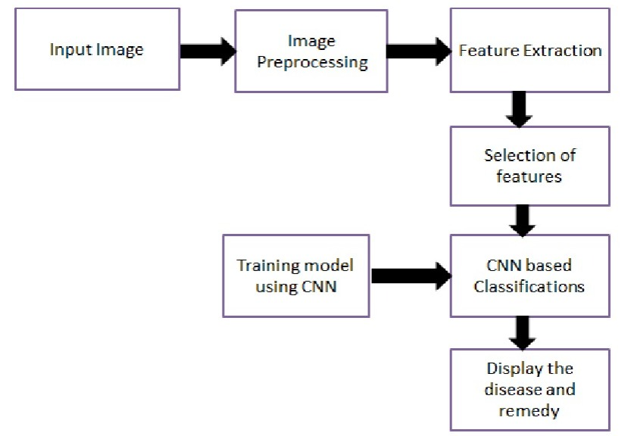
Figure 5 Deep Learning pipeline for plant disease detection

2.3.2 Convolutional Neural Networks (CNNs)
The most popular deep learning models applicable in image classification tasks are the Convolutional Neural Networks (CNNs). The CNNs have different layers, such as convolutional, pooling, and fully connected layers, which collaborate to produce and learn spatial features of images [8].
The CNN architectures have two key properties, local connectivity and weight sharing, that minimize the number of parameters and enhance the computational efficiency. The convolutional layers are used to extract features, pooling layers to shrink spatial dimensions, and fully connected layers to classify using the extracted features [8].
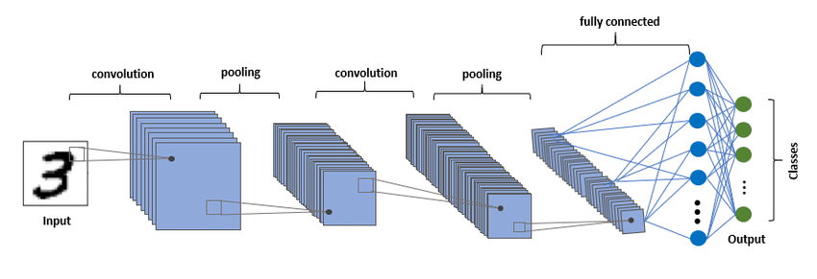
Figure 6 CNN architecture
When applied to plant disease detection, CNNs can detect the slightest visual variations between disease and healthy leaves, which is why they are quite appropriate when detecting bean leaf disease.
2.3.3 CNN Architectures (AlexNet, VGG, ResNet, EfficientNet)
AlexNet
One of the earliest deep CNN models that was quite successful in image classification is AlexNet. It is made of five convolutional layers, then three fully connected layers and it proposed new tricks, like ReLU activation and dropout, to enhance training performance [9]. It showed the power of deep learning when it comes to image recognition at scale.
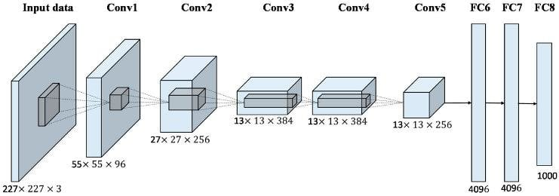
Figure 7 AlexNet architecture
VGG
VGG networks further enhanced the AlexNet by adding depth to the network and using small convolutional filters (3x3). VGG16 is one of the models, which has 16 layers and is characterized by simplicity and high results in the image classification task. Nevertheless, they have many parameters, thus making them costly to calculate [9].
ResNet
ResNet (Residual Network) proposed the concept of residual learning by introducing skip connections, which enable easier passage of the gradient in the course of training. The innovation solves the vanishing gradient issue and can be used to train very deep networks including ResNet-50 and ResNet-101 [9]. ResNet has demonstrated higher performance in most image classification problems.
EfficientNet
EfficientNet is a contemporary CNN architecture, which employs a compound scaling approach to balance network depth, width, and resolution. It is efficient and can be applied in real-life applications since it is highly accurate with fewer parameters than the conventional architectures [10]. Medical, agricultural image analysis tasks have been extensively examined with EfficientNet.
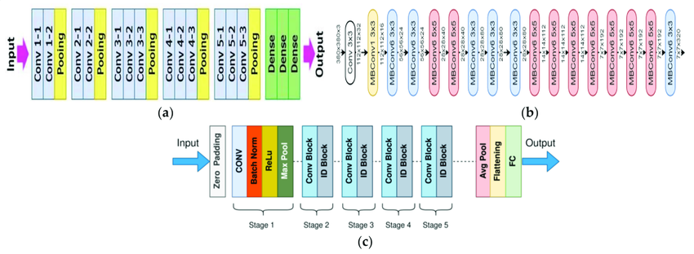
Figure 8 Comparison of popular CNN architectures
Since the traditional CNN constructions like VGG use sequential convolutional layers, ResNet uses residual connections to enhance gradient flow. EfficientNet, on the contrary, uses compound scaling and MBConv blocks to provide greater performance with reduced parameters.
2.3.4 Advantages of Deep Learning over Traditional Methods
Deep learning has a number of benefits compared to the conventional machine learning models in plant disease classification.
To begin with, deep learning models are able to extract features automatically without manually engineering the features, so there is no need of feature engineering. This enables them to be able to capture more complex patterns and variations of leaf images [6], [7].
Second, deep learning models are more accurate because they can learn hierarchical representations of data. This is especially crucial in the field of plant disease detection where subtle visual differences are to be detected.
Third, deep learning models can be scaled and are able to work with large datasets, enhancing their generalization during real-world applications. Moreover, data augmentation and transfer learning are other techniques that can be used to improve performance [8].
Lastly, deep learning models are less susceptible to environmental changes like lighting, background, and noise, which are typical issues in agricultural image data.

2.4 Attention Mechanisms in Deep Learning
2.4.1 Concept of Attention Mechanism
The idea of attention mechanisms is based on the human visual perception where the focus is placed on the most pertinent aspects of information and other details of the information are neglected. Attention applies to the features in a deep learning model to assign varying levels of importance to enhance representation and decision-making. The model does not process all features equally, but focuses on informative regions, thus improving performance in complex tasks like image classification [11].
2.4.2 Types of Attention (Spatial, Channel, Self-Attention)
The mechanisms of attention can be divided into spatial, channel, and self-attention.
- Spatial Attention pays attention to the location of important features by weighting spatial locations.
- Channel Attention focuses on what features are important by weighting feature maps using global pooling.
- Self-Attention captures global dependencies between different regions of the input, enabling the model to understand long-range relationships and contextual information [12].
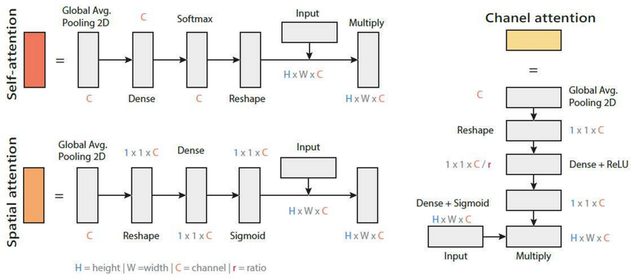
Figure 9 Types of attention mechanisms

2.4.3 Role of Attention in Image Classification
Attention mechanisms amplify the ability of images to be classified by boosting the localization of features and minimizing the effects of irrelevant information. Attention modules can be useful in highlighting discriminative areas in images whereas traditional CNNs might fail to capture subtle patterns. It results in accuracy, strength and generalization particularly in complex datasets [13].
In Image-based tasks, attention enables the model to pay attention to important visual patterns instead of the background noise, which is crucial in fine-grained classification problems.

2.4.4 Integration of Attention with CNN Models
CNN architectures are usually complemented with attention mechanism, which enhances the extraction of features. Convolutional layers are augmented with modules including Squeeze-and-Excitation (SE) and Convolutional Block Attention Module (CBAM) that can improve channel and spatial representations [13].
Research has demonstrated that the combination of CNNs and attention mechanisms can enhance the performance of classification and the interpretability of features by highlighting the important areas and repressed irrelevant data [12], [14].
Attention serves to make the model concentrate on the infected regions of the leaf, and predicting more dependable, and interpretable predictions.

2.5 Explainable Artificial Intelligence (XAI)
2.5.1 Importance of Explainability in AI
Explainable Artificial Intelligence (XAI) is an approach to improve transparency and interpretability of complex machine learning models, especially deep neural networks. Although these models are very high performers, they tend to be black boxes and hence their decision-making processes are not easily understood [15]. Such untrustworthiness decreases the adoption in such essential areas as healthcare and agriculture.
XAI can be used to overcome these issues, as it offers information about the manner in which models make predictions and the factors that affect choices. It is also used to identify any biases, enhance reliability, and enable regulatory mandates like explainability and accountability [15], [16]. Consequently, explainability will be crucial to establishing trustful AI systems and facilitating human-AI interaction.
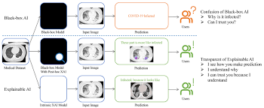
Figure 10 Black-box vs Explainable AI
2.5.2 Categories of Explainable AI Techniques
XAI techniques can be categorized based on their design and functionality. A single categorization is a distinction between model-specific and model-agnostic methods [16]. Model-specific approaches are specific to a given model (e.g., CNN-based visualization approaches), whereas model-agnostic approaches like LIME and SHAP can be used with any model.
The other significant classification is according to the timing of the explanation:
- Post-hoc methods: used after training.
- Intrinsic methods: inbuilt within the model.
Additionally, explanations can be:
- Global: characterizing the model behavior on the whole.
- Local: explaining individual predictions [17]
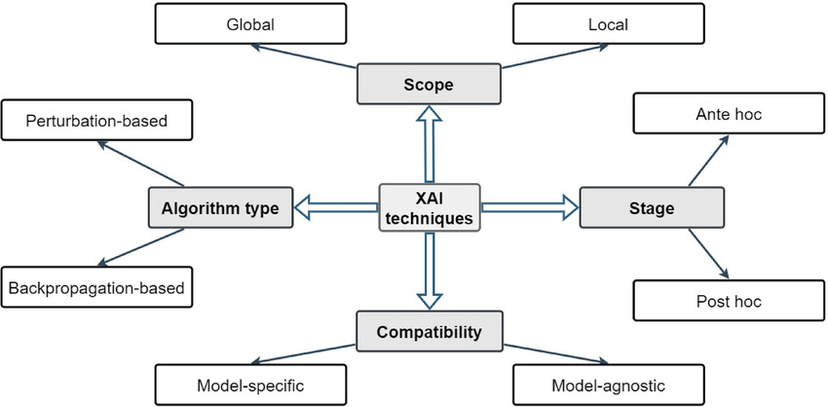
Figure 11 XAI taxonomy

2.5.3 Gradient-weighted Class Activation Mapping (Grad-CAM)
Grad-CAM is a popular XAI methodology in understanding CNN-based models. It produces heatmaps that indicate important areas in an image that aid a particular classification decision [18].
The approach involves computing gradients of a target class in terms of feature maps in the last convolutional layer, and summing them to obtain a localization map.
Grad-CAM provides intuitive visual explanations by highlighting regions that positively influence predictions.
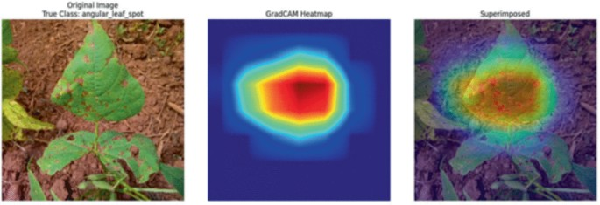
Figure 12 Grad-CAM heatmap

2.5.4 Applications of Grad-CAM in Image Classification
Grad-CAM has found extensive use in image classification tasks because it can be used to give visual explanations. In an autonomous system, it detects significant objects, whereas in medical imaging, it marks abnormal spots [18].
Grad-CAM can be used in the classification of plant diseases to identified infected areas on leaves, enabling users to check model predictions. This enhances the transparency of models, assists with decision-making and adds user trust. It is also useful in rooting out errors in models, which are shown through wrong attention patterns.

2.6 Evaluation Metrics
The assessment metrics play a crucial role in evaluating the performance and effectiveness of the classification models in the detection of plant diseases. In the work, a number of conventional metrics are employed to assess the offer explainable deep learning model, such as accuracy, precision, recall, and F1-score.

The most widely applied metric is the accuracy (Acc.), which is the proportion of correctly classified samples to the total samples. It can be expressed as:
$$Accuracy=\frac{TP+TN}{TP+TN+FP+FN}[19]$$

Equation 1 Accuracy

where $TP$(True Positive) and $TN$(True Negative) represent correctly classified instances,
FN (False Negative) are instances misclassified. Even though accuracy gives an overall picture of the performance of the model, it might be inadequate in the case of imbalanced datasets.
Precision is the ratio of the number of positive samples that are correctly predicted out of all predicted positive samples:
$$Precision=\frac{TP}{TP+FP}[19]$$
Equation 2 Precision

This measure is significant in reducing false alarms particularly when healthy leaves are classified as diseased.

Recall (Sensitivity) is used to assess the capability of the model to correctly classify all real positive cases:
$$Recall=\frac{TP}{TP+FN}[19]$$
Equation 3 Recall

High recall means that most of the diseased leaves would be properly identified which is vital in agriculture.
F1-score is the the harmonic mean of precision and recall, which offers a fair assessment:
$$F1=\frac{2TP}{2TP+FP+FN}[19]$$
Equation 4 F1- score
Moreover, Receiver Operating Characteristic (ROC) curve and Area Under the Curve (AUC) are employed to assess the classification at various threshold values. An increased AUC is an indication of an improved model discrimination.
The evaluation metrics will offer an overall evaluation of the model performance, both in terms of accuracy and reliability in bean leaf disease classification and in the support of the interpretability of the proposed approach.

2.7 Related Work
Deep learning methods and specifically the usage of Convolutional Neural Networks (CNNs) in the detection of plant leaf diseases has emerged as a crucial component in the contemporary agricultural field. The methods offer a scalable and effective solution to the conventional methods, which involve the human experts in visual identification. The research below investigates different approaches to plant leaf disease detection and classification based on deep learning and each of them leads to the development of the sphere of agricultural automation.
Gill et al. [20] created a deep learning sequential model to classify bean leaf diseases with a dataset of 2,134 images with three disease classes. The experiment was aimed at determining the usefulness of CNN-based models in enhancing timely detection of plant diseases. The model was evaluated by conventional evaluation measures and proved to be very competent in identifying disease patterns. The results support the appropriateness of deep learning methods in agricultural applications with an accuracy of more than 90.
Singh et al. [21] have studied how the transfer learning with the pre-trained CNN models, such as MobileNetV2, EfficientNetB6, and NasNet, can be used to classify the bean leaf diseases using 1,295 images. This paper has highlighted how model selection and optimization can be used to enhance the performance of classification in the case of limited computational resources. EfficientNetB6 was the most effective among the tested models as it detected disease classes more accurately than other models and therefore it is applicable in practical cases with an accuracy rate of 91.74.

Serttaş and Deniz [22] used a convolutional neural network built on the ResNet50 framework and trained using transfer learning to identify bean leaf diseases using a rather small dataset. The paper proved the ability of deep learning models to perform highly even when small quantities of data are available. The method was able to measure complex visual characteristics of leaf diseases that facilitated correct classification. This outcome demonstrates that transfer learning is significant in the agricultural image analysis task, which attains an accuracy of 98.33.
Girmaw and Muluneh [23] was developed with the purpose of classifying common bean leaf diseases, such as leaf rust and brown leaf spot, based on 1,766 images. The work compared the model proposed to some pre-trained models and showed better results. The model successfully acquired disease specific characteristics and enhanced reliability of classification. The performance in the evaluation was found to be highly consistent at the various levels with an accuracy of 98% (training), 97.2% (validation), and 96% (testing).
Wang et al. [24] proposed a hybrid deep learning model that uses a combination of several CNN models and conventional machine learning classifiers to improve kidney bean leaf disease detection. The model combined the task of extracting features and classifying them to enhance robustness and the accuracy of prediction. This method helped to overcome weaknesses of single-model systems by taking advantage of the complementary advantages of various algorithms. These findings revealed better detection performance and classification accuracy with the accuracy of 96.26 and F1-score of 0.97.
Alexnet convolutional neural network was used by Fang et al [25] to categorize bean leaf diseases such as angular leaf spot and rust. The research showed that it was difficult to discriminate between visually similar classes of diseases and this may influence the model performance. Notwithstanding these constraints, the model in computerized disease recognition had good potential. The results propose that more refinement of the model structure can be done to increase the classification accuracy under real life settings with a precision of 95.4 and a validation rate of 78.2.
Salau et al [26] created an end-to-end convolutional neural network model that is used to detect diseases in faba bean leaves after proper data preprocessing methods. The paper has highlighted the significance of preprocessing to enhance the performance of the models and the elimination of noise in image data. The model was able to determine disease patterns and learn effectively. The results suggest that the similar agricultural issues can be successfully addressed with the help of CNN-based methods with the training accuracy of 98.14.
The deep learning models that Sahu et al [27] suggested to classify the bean leaf diseases based on a dataset of 1,296 images were categorized into three classes: angular leaf spot, bean rust, and healthy leaves. Visualization methods were also used in the study to analyze the CNN behavior and enhance localization of the diseases. The findings showed that the performance of GoogleNet was better than VGG16 in the classification, as the former had an accuracy of 95.31.
Abed et al [28] created a robotic vision system with a deep learning to detect the disease of wheat leaves at an early stage in the uncontrolled environment. The model relied on U-Net as a leaf detector and on various CNN as classifier. DenseNet121 had the highest result performance on both binary and multi-class classification. The system showed great efficiency and reliability in detecting the disease with an accuracy of 98.31, and multi-class accuracy of 91.01.
Noviyanto et al [29] suggested a variant of CNN architecture that was based on DenseNet121 to classify bean leaf disease with a set of 1,295 images of three classes. The model also added more convolutional layers and optimization methods to improve the capability of feature extraction and classification. The proposed model was contrasted with other models of transfer learning and demonstrated better performance with the accuracy of 96.90 and the F1-score of 97.
Mallick et al[30] proposed a transfer learning-based deep learning method to identify the mung bean leaf diseases and pests. The objective of the model was to overcome the fact that small datasets are limited and enhance the efficiency of classification in field-based agricultural applications. The system was able to recognize several types of diseases and it proved to be robust in various environments showing its practical use in crop monitoring with an average accuracy of 93.65.
Kursun et al [31] suggested a deep learning model, which consists of U-Net to perform segmentation and several CNNs to perform classification of bean leaf diseases, including angular leaf spot and rust. The research indicated how it is critical to concentrate on the areas that have the disease to enhance the performance of the classification. The best result with DenseNet201 was on segmented images, where the level of identifying the disease pattern was the highest with 100 percent classification accuracy.
Elfatimi et al [32] created a deep learning model that depends on the MobileNet architectures to classify bean leaf diseases using a dataset consisting of 1,296 images. Various combinations were compared in the study to establish the most effective architecture in terms of speed and accuracy. The model showed high accuracy in the recognition of healthy and diseased leaves in controlled conditions with a training and test accuracy of more than 97 and 92 respectively.
Elfatimi et al [33] examined how the various datasets vary in terms of their ability to detect bean leaf diseases using MobileNet. The model has been tested on several datasets of different complexity levels and its capacity to generalize was determined. The results emphasized the need to focus on the quality of datasets to enhance the performance of the models and make them more robust. The suggested method continued to attain good classification patterns, with an accuracy of over 92.
Mehta et al [34] suggested a federated learning architecture that would be combined with convolutional neural networks (CNNs) to identify the presence of bean leaf diseases and estimate the severity of the diseases. The research solved the problem of data privacy because it allowed a distributed model training among the clients with no sharing of raw data. The model described four types of diseases and rated the severity using a percentage. The outputs showed a steady and high level of performance throughout the datasets, with good accuracy between 97 and 98 percent with good level of precision, recall and F1-score values.

Table 1 Summary of Previous Studies

REF | Year | Model | Dataset | Key Findings (Accuracy) | Limitations
Gill et al. [20] | 2023 | Sequential CNN model | Classify bean leaf diseases | 90% | Limited dataset diversity; may not generalize well to real-world conditions
Singh et al. [21] | 2023 | Transfer Learning (MobileNetV2, EfficientNetB6, NasNet) | 1295 images, 3 classes | 91.74% | Performance depends on dataset quality; limited robustness in complex environments
Serttaş and Deniz [22] | 2023 | ResNet50 (Transfer Learning) | Bean dataset | 98.33% | Small dataset size may cause overfitting
Girmaw and Muluneh [23] | 2024 | CNN vs pre-trained models | Common Bean Leaf Disease Dataset (Ethiopia) | 96% | Dataset collected in specific region → limited generalization
Wang et al. [24] | 2025 | Hybrid (CNN + ML) | KBLD dataset | 96.26% | Complex model architecture increases computational cost
Fang et al. [25] | 2025 | AlexNet CNN | Open dataset (3 classes) | 95.4% | Difficulty distinguishing similar disease classes; lower validation accuracy
Salau et al. [26] | 2023 | End-to-end CNN | Custom Faba Bean dataset | 98.14% | Relies heavily on preprocessing; lacks real-world validation
Sahu et al. [27] | 2021 | GoogleNet vs VGG16 | Multiple datasets (LifeCLEF, etc.) | 95.31% | Dataset heterogeneity may affect consistency of results
Abed et al. [28] | 2023 | U-Net + CNN | Wheat dataset | 98.31% | Focused on wheat → limited applicability to bean crops
Noviyanto et al. [29] | 2024 | Modified DenseNet121 | 1295 images, 3 classes | 96.90% | Model complexity may require high computational resources
Mallick et al. [30] | 2023 | Transfer Learning | Mung Bean dataset | 93.65% | Small dataset size limits generalization
Kursun et al. [31] | 2023 | U-Net + DenseNet201 | 60 images dataset | 100% | Very small dataset → unrealistic performance (overfitting risk)
Elfatimi et al. [32] | 2022 | MobileNet | Uganda dataset (1296 images) | 97% / > 92% | Performance may drop in uncontrolled environments
Elfatimi et al. [33] | 2024 | MobileNet (multi-dataset) | 3 datasets | > 92% | Dataset differences affect consistency and model stability
Mehta et al. [34] | 2023 | Federated Learning + CNN | Distributed datasets | 97–98% | Lack of dataset transparency; complex implementation

2.8 Chapter Summary
Based on the reviewed literature, it is evident that deep learning models, particularly CNNs, achieve high performance in plant disease classification. However, most existing approaches lack interpretability and fail to provide clear explanations for their predictions. In addition, limited attention has been given to integrating attention mechanisms with explainable techniques.
Therefore, this study proposes an explainable deep learning framework that combines CNN models with attention mechanisms and Grad-CAM to improve both classification accuracy and model interpretability in bean leaf disease detection. The next chapter presents the proposed methodology in detail.
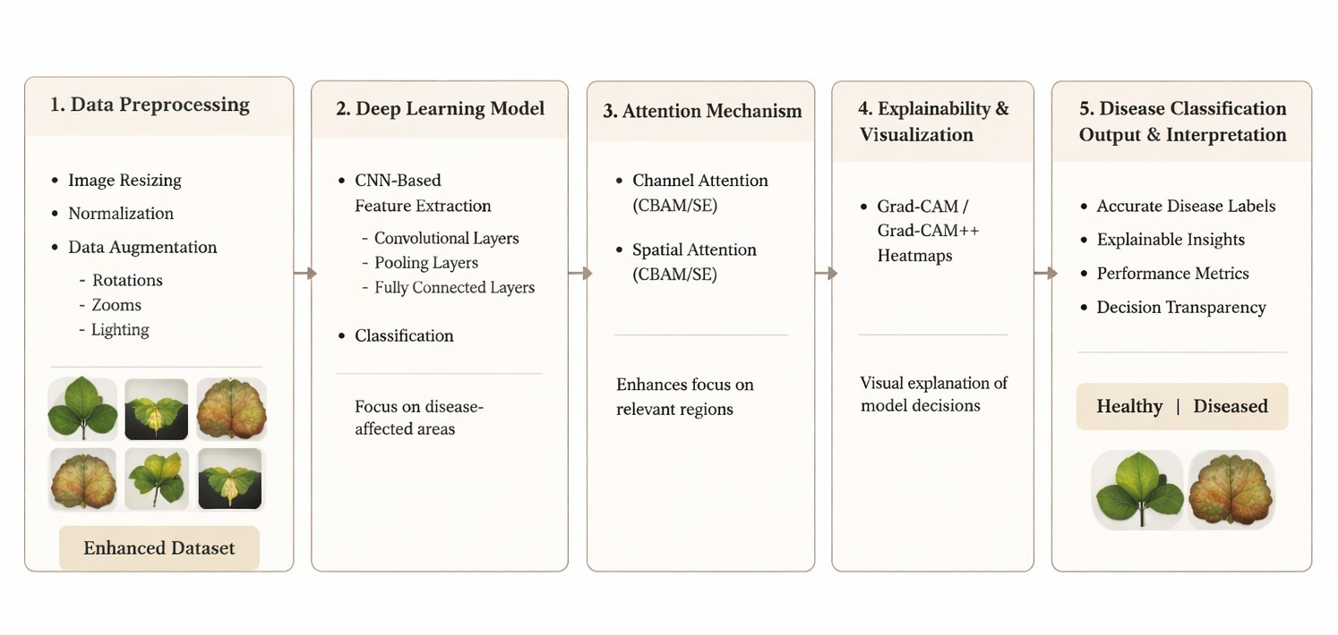

Figure 13 Proposed Approach

References
[1] Wei, K., Chen, B., Zhang, J., Fan, S., Wu, K., Liu, G., & Chen, D. (2022). Explainable deep learning study for leaf disease classification. Agronomy, 12(5), 1035.
[2] Potharaju, S., Singh, A., Singh, D., Tambe, S. N., Kantipudi, P. M., & Kiranmai, B. (2026). An explainable vision transformer model with transfer learning for accurate bean leaf disease classification. Scientific Reports, 16(1), 10402.
[3] Nyawose, T., Maswanganyi, R. C., & Khumalo, P. (2025). A review on the detection of plant disease using machine learning and deep learning approaches. Journal of Imaging, 11(326).
[4] Noi, P. T., & Kappas, M. (2018). Comparison of Random Forest, k-Nearest Neighbor, and Support Vector Machine classifiers for land cover classification using Sentinel-2 imagery. Sensors, 18(1), 18.
[5] Arsenovic, M., Karanovic, M., Sladojevic, S., Anderla, A., & Stefanovic, D. (2019). Solving current limitations of deep learning based approaches for plant disease detection. Symmetry, 11(7), 939.
[6] Saleem, M. H., Potgieter, J., & Arif, K. M. (2019). Plant disease detection and classification by deep learning. Plants, 8(11), 468.
[7] Das, P. K., Rupa, S. S., Pumrin, S., Das, U. C., & Hossen, M. K. (2024). Deep learning for plant disease detection and classification: A systematic analysis and review. Current Applied Science and Technology, 24(4), e0259016.
[8] Vaz, J. M., & Balaji, S. (2021). Convolutional neural networks (CNNs): Concepts and applications in pharmacogenomics. Molecular Diversity, 25, 1569–1584.
[9] Ashraf, N. (2021). Exploring CNN architectures: AlexNet, VGG, and ResNet. Pakistan Institute of Engineering and Applied Sciences.
[10] Ucan, M., Kaya, B., Aygun, O., Kaya, M., & Alhajj, R. (2025). Comparison of EfficientNet CNN models for multi-label chest X-ray disease diagnosis. PeerJ Computer Science, 11, e2968.
[11] Cano-Ortiz, S., Sainz-Ortiz, E., Lloret Iglesias, L., Martínez Ruiz del Árbol, P., & Castro-Fresno, D. (2024). Leveraging a deep learning generative model to enhance recognition of minor asphalt defects. Scientific Reports.
[12] Wang, Z., & Ghaleb, F. A. (2023). An attention-based convolutional neural network for intrusion detection model. IEEE Access.
[13] Ullah, Z., Hong, M., Mahmood, T., & Kim, J. (2025). Systematic integration of attention modules into CNNs for accurate and generalizable medical image classification. Mathematics, 13, 3728.
[14] Liu, Y., Zhang, J., Liu, H., & Zhang, Y. (2025). A Dual-Structured Convolutional Neural Network with an Attention Mechanism for Image Classification. Electronics, 14(19), 3943.
[15] Patil, D. (2024). Explainable artificial intelligence (XAI): Enhancing transparency and trust in machine learning models. Hurix Digital.
[16] Iseal, S., Owen, J., & Daniel, S. (2023). Techniques and approaches in explainable artificial intelligence (XAI).
[17] Aysel, H. I., Cai, X., & Prugel-Bennett, A. (2025). Explainable artificial intelligence: Advancements and limitations. Applied Sciences, 15(13), 7261.
[18] Learn AI. (2024, July 22). Grad-CAM (gradient-weighted class activation mapping). Medium. https://medium.com/@divakar1591/grad-cam-gradient-weighted-class-activation-mapping-8e1aeaf96d94
[19] Powers, D. M. W. (2011). Evaluation: From precision, recall and F-measure to ROC, informedness, markedness & correlation. Journal of Machine Learning Technologies, 2(1), 37–63.

[20] Gill, K. S., Anand, V., Gupta, R., & Pahwa, V. (2023). Bean leaf disease classification and visualization using deep learning techniques on sequential model. In 2023 International Conference (pp. 1-6). IEEE.
[21] Singh, V., Chug, A., & Singh, A. P. (2023). Classification of beans leaf diseases using fine-tuned CNN model. Procedia Computer Science, 218, 348–356.
[22] Serttaş, S., & Deniz, E. (2023). Disease detection in bean leaves using deep learning. Communications Faculty of Sciences University of Ankara Series A2-A3 Physical Sciences and Engineering, 65(2), 115–129.
[23] Girmaw, D. W., & Muluneh, T. W. (2024). Deep convolutional neural network model for classifying common bean leaf diseases. Discover Artificial Intelligence, 4, Article 96.
[24] Wang, Y., Wang, Q., Su, Y., Jing, B., & Feng, M. (2025). Detection of kidney bean leaf spot disease based on a hybrid deep learning model. Scientific Reports, 15, Article 11185.
[25] Fang, H., Sun, Y., Kim, T.-H., Xu, J., & Deng, Q. (2025). The role of deep learning in enhancing crop sustainability: A study on AlexNet’s application in detecting bean leaf disease. Frontiers in Plant Science, 16, 1637241.
[26] Salau, A. O., Ali, M., & Zhang, X. (2023). Faba bean disease detection using deep learning techniques. Procedia Computer Science, 218, 344-349.
[27] Sahu, P., Chug, A., Singh, A. P., Singh, D., & Singh, R. P. (2021). Deep learning models for beans crop diseases: Classification and visualization techniques. International Journal of Modern Agriculture, 10(1), 2305–7246.
[28] Abed, S. H., Al-Waisy, A. S., Mohammed, H. J., & Al-Fahdawi, S. (2023). A modern deep learning framework in robot vision for automated bean leaves diseases detection. Multimedia Tools and Applications.
[29] Noviyanto, N., Sunyoto, A., & Ariatmanto, D. (2024). Innovative solutions for bean leaf disease detection using deep learning. In Proceedings of the IEEE International Conference on Artificial Intelligence and Mechatronics Systems (AIMS) (pp. 1–6). IEEE.
[30] Mallick, M. T., Biswas, S., Das, A. K., Saha, H. N., Chakrabarti, A., & Deb, N. (2023). Deep learning based automated disease detection and pest classification in Indian mung bean. Multimedia Tools and Applications, 82, 12017–12041.
[31] Kursun, R., Bastas, K. K., & Koklu, M. (2023). Segmentation of dry bean (Phaseolus vulgaris L.) leaf disease images with U-Net and classification using deep learning algorithms. European Food Research and Technology, 249, 2543–2558.
[32] Elfatimi, E., Eryigit, R., & Elfatimi, L. (2022). Beans leaf diseases classification using MobileNet models. IEEE Access, 10, 1–12.
[33] Elfatimi, E., Eryigit, R., & Shehu, H. A. (2024). Impact of datasets on the effectiveness of MobileNet for beans leaf disease detection. Neural Computing and Applications, 36, 1773–1789.
[34] Mehta, S., Kukreja, V., & Vats, S. (2023). Bean leaf disease diagnosis in the age of federated learning and CNN: A severity analysis approach. In Proceedings of the 2023 Second International Conference on (pp. 1–6). IEEE.

