3.Methodology / Proposed Framework
3.1 Introduction:
The methodology for improving a framework for automated pneumonia detection from chest X-ray images is outlined. This includes workflow of the study detailing image preprocessing, model implementation, training and performance evaluation. All components are presented in detail to demonstrate how the proposed system was designed and utilized throughout the research.
The rapid development of deep learning has transformed the field of medical image analysis by enabling more accurate and efficient diagnostic systems. Although convolutional neural networks (CNNs) have long been the dominant approach for image classification, transformer-based models have recently attracted considerable attention because of their ability to model long-range relationships within an image using self-attention. This capability allows them to capture both fine local details and broader contextual information, making them highly suitable for chest X-ray interpretation. To investigate the effectiveness of transformer architecture, this research employs two state-of-the-art models: Vision Transformer (ViT) and Swin Transformer. Both models are adapted for the binary classification of chest X-ray images into normal and pneumonia categories. Rather than training the networks from scratch transfer learning is adopted by fine-tuning models that have been pre-trained on large-scale image datasets. This strategy improves learning efficiency and often leads to better performance when the available medical dataset is relatively limited.
The dataset is processed to ensure consistency across all input images. All images are the required input dimensions and normalized before data augmentation techniques including random rotation zooming and horizontal flipping are applied. These preprocessing procedures increase the diversity of the training samples, enhance model robustness and help reduce overfitting. The implementation is to support using Python in the Google Colab environment with PyTorch as the primary deep learning. Additional libraries are utilized for image processing, data management visualization and statistical analysis, to ensure fair comparison, both transformer models are trained using identical experimental settings and hyperparameters whenever applicable.
The effectiveness of the proposed models is assessed through several standard evaluation metrics, including accuracy precision recall F1-scor the confusion matrix the receiver operating characteristic (ROC) curve and the area under the ROC curve (AUC) Collectively these measures provide a comprehensive evaluation of the classification performance and facilitate a meaningful comparison between the two transformer-based approaches. The remainder of this chapter introduces the proposed framework, describes the dataset and preprocessing pipeline, explains the architecture of the selected transformer models, and details the experimental configuration adopted in this study. The corresponding experimental findings and discussion are presented in the next chapter.

3.2 Proposed Framework
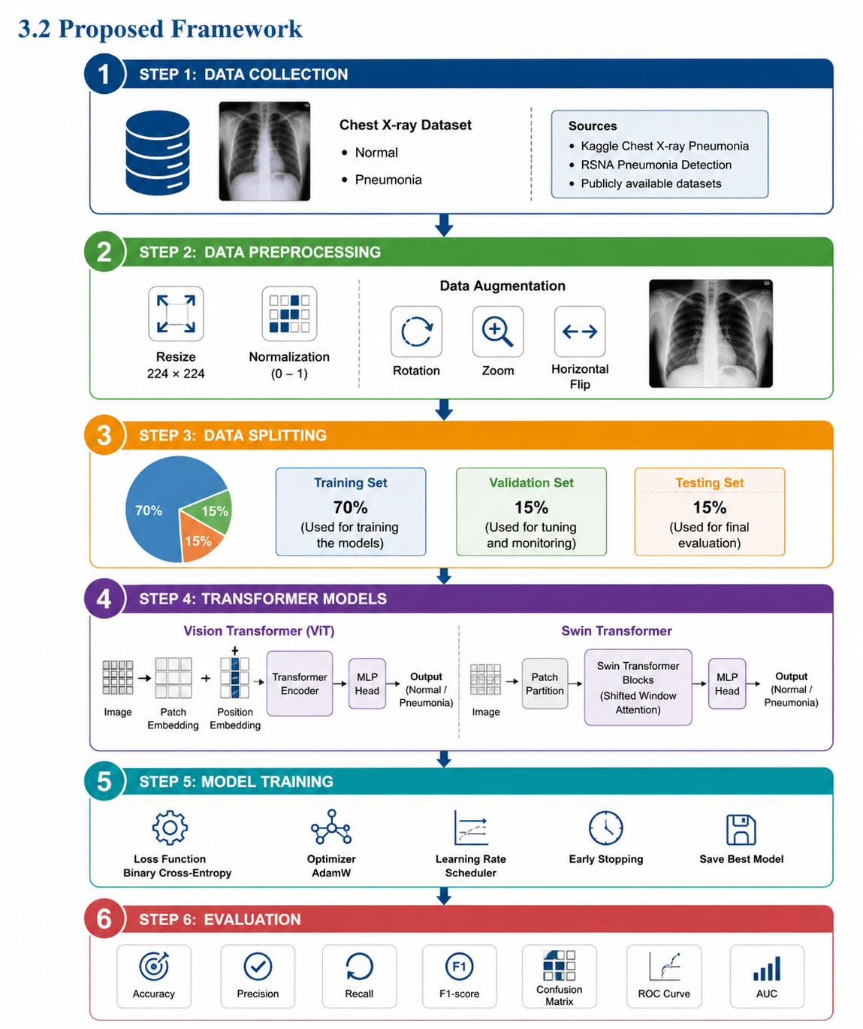

3.3 Dataset Description
This research is based on available dataset of chest X-ray images collected from a publicly available medical imaging dataset. It contains radiographic images representing two diagnostic categories: Normal and Pneumonia. The dataset is widely used in the literature for developing and evaluating deep learning models for automated pneumonia detection. The images are organized into three subsets: training validation and testing. The training is used to train the transformer models, the validation set is employed to monitor the training process and tune the model parameters, while the testing set is reserved for evaluating the final performance of the trained models on unseen data.
All chest X-ray images were stored in separate folders according to their class labels allowing the data loading framework to automatically assign the correct category during training. The binary classification task requires the models to distinguish between healthy chest X-ray images Normal and images showing signs of pneumonia. To ensure compatibility with the select the transformer architectures, all images were resized to 224 × 224 pixels before being used for training and evaluation. Additional preprocessing and data augmentation techniques were applied to improve model reduce overfitting. These preprocessing procedures are described in the following section.

3.4 Dataset Preprocessing
Training the transformer models, several preprocessing steps are performed to ensure that the input images are suitable for the learning process. Since the original chest X-ray images varied in size and resolution, all images were resized to 224 × 224 pixels which matches the input requirements of both the Vision Transformer (ViT) and Swin Transformer architectures. To improve training stability pixel values were normalized by scaling them to the range of zero to one. This normalization helps accelerate models and ensures that all images share a distribution. These transformations generate slightly different versions of the original images while preserving their diagnostic characteristics allowing the models to learn more robust image representations. The validation and testing datasets were not augmented They were only resized and normalized to ensure that the evaluation reflected the performance of the trained models on previously unseen images under consistent conditions. The preprocessing contributes to reducing overfitting, improving training efficiency, and providing standardized input data for both transformer-based architectures.
3.5 Vision Transformer
The Vision Transformer is a transformer-based deep learning architecture developed for image classification tasks. Unlike traditional CNN which rely on convolutional filters to extract image features, ViT processes an image as a sequence of small fixed-size patches. All image patches are converted into a vector representation and combined with positional embeddings before being passed to the transformer encoder. This design enables the model to capture long-range relationships between different regions of an image through the self-attention mechanism. Chest X-ray images first resized to 224 × 224 pixels to match the input size required by the Vit architecture. Each image was then divided into non-overlapping patches and these patches were transformed into patch embeddings. Positional embeddings were added to preserve the spatial arrangement of the patches before they were processed by the transformer encoder. The transformer encoder consists of multiple layers of multi-head self-attention (MHSA) and multi-layer perceptron blocks. The self-attention mechanism enables the model to learn relationships among image patches regardless of their spatial distance it to capture both local image details and global contextual information. This capability is particularly valuable in medical image analysis, where abnormalities may appear in different regions of a chest X-ray. To improve training efficiency transfer learning was employed by initializing the Vision Transformer with pre-trained ImageNet weights. The original classification layer was replaced with a binary classification head for the two target classes: Normal and Pneumonia. During training the network parameters were fine_ tuned using the chest X-ray dataset to adapt the learned visual representations to the pneumonia detection task. The overall workflow of the Vision Transformer used in this study is illustrated in Figure 3 which shows the image patching process, transformer encoder, and final classification stage.
Figure 3
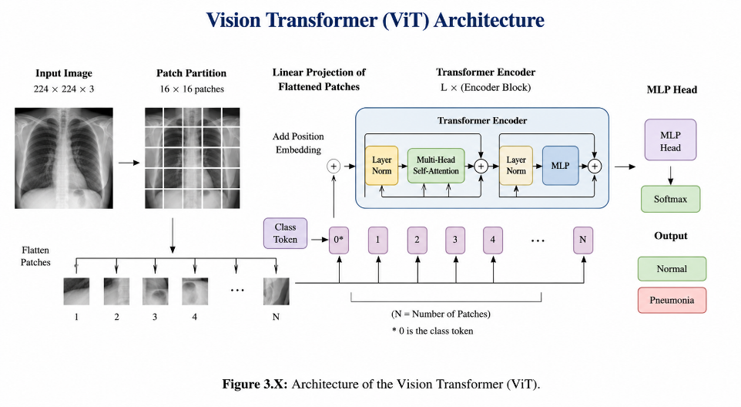

3.6 Swin Transformer
The Swin Transformer is a hierarchical vision transformer architecture introduced to improve the efficiency of transformer-based models for computer vision tasks. Unlike the Vision Transformer (ViT) which applies self-attention to all image patches simultaneously the Swin Transformer computes self-attention within local windows. These windows are shifted between consecutive layers, allowing information to be exchanged across neighboring regions while significantly reducing computational complexity.
Chest X-ray images were resized to 224 × 224 pixels before being used as input to the Swin Transformer. The input image was divided into non-overlapping patches, which were converted into feature embeddings. The model then processed these embeddings through multiple Swin Transformer stages, where local self-attention and shifted window operations enabled the extraction of both fine-grained details and broader contextual information from different regions of the chest X-ray.
The hierarchical design of the Swin Transformer allows feature maps to be gradually merged as the network becomes deep, producing multi-scale representations of the input image. This characteristic improves the models ability to identify pneumonia-related abnormalities that may appear at different sizes and locations within chest X-ray images.

Transfer learning was adopted by the Swin Transformer with pre-trained ImageNet weights. The original classification layer was replaced with a binary classification head corresponding to the two target classes Normal and Pneumonia. The model was then fine-tuned using the chest X-ray training dataset to adapt the learned feature representations to the pneumonia classification task.
The overall architecture of the Swin Transformer employed in this study is illustrated in Figure 4 which summarizes the image partitioning process shifted window attention mechanism, hierarchical feature extraction and final classification stage.

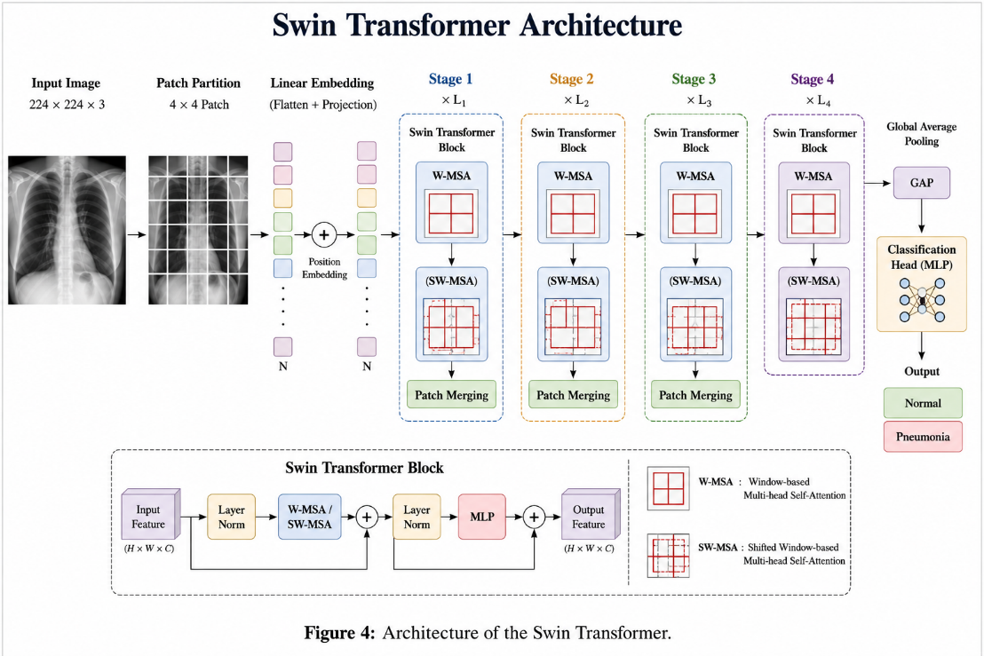

Chapter 4: Results & Discussion
4.1 Experimental Setup:
The experiments were created out using Google Colab as a development environment, which provided the use of GPU acceleration for better training performance. The models were implemented in Python with the TensorFlow/Kera’s deep learning framework. Other libraries were used for data preprocessing, visualization and performance evaluation such as NumPy, Pandas Matplotlib and Scikit-learn. In this study, three pre-trained models of convolutional neural network (CNN) based on transfer learning were used namely MobileNetV2, EfficientNetB0, and ResNet50. The models were fine-tuned by replacing the last classification layer to fit the task of pneumonia detection that is a binary classification problem. The chest X-ray dataset was divided into training, validation, and testing sets. During training the images were resized to 224 × 224 pixels, and a batch size of 32 was used. The models were trained for a maximum of 15 epochs using the Adam optimizer with an appropriate learning rate. Binary Cross-Entropy was used as the loss function. The performance of the models was improved by applying image pre-processing and data augmentation techniques on the training data: rescaling, rotation, zooming and horizontal. The Early Stopping technique was applied to avoid overfitting by observing the validation performance and stopping the training when no further improvement was seen. The trained models were evaluated by using Accuracy Precision Recall, F1-score, Confusion Matrix, ROC Curve and AUC.

Table 1: The dataset consists of 5,850 images including 1,575 normal X-ray images and 4,275 pneumonia chest X-ray images. The dataset was divided into 4,181 training images, 1,045 validation images and 624 testing images.
Total | Pneumonia | Normal | Dataset
4,181 | 3,108 | 1,073 | Training
1,045 | 777 | 268 | Validation
624 | 390 | 234 | Testing
5,850 | 4,275 | 1,575 | Total

Table 2. Experimental Setup:
Parameter | Value
Programming Language | Python 3
Framework | TensorFlow / Keras
Models | MobileNetV2, EfficientNetB0, ResNet50
Image Size | 224 × 224
Batch Size | 32
Epochs | 15
Optimizer | Adam
Loss Function | Binary Cross-Entropy
Data Split | Training / Validation / Testing
Early Stopping | Enabled
Evaluation Metrics | Accuracy, Precision, Recall, F1-score, ROC-AUC

4.2 Overall Model Comparison
Table 2. The Result model
Approaches | Model | Accuracy | Precision | Recall | F1-score
Approaches Pre-trained CNN models | MobileNetV2 | 83.01 | 80.74 | 95.64 | 87.56
Approaches Pre-trained CNN models | EfficientNetB0 | 62.50 | 62.50 | 100.00 | 76.92
Approaches Pre-trained CNN models | ResNet50 | 62.50 | 62.50 | 100.00 | 76.92
Transformer models | ViT | 76.28 | 76.71 | 78.46 | 76.00
Transformer models | Swin | 80.13 | 79.00 | 80.43 | 79.39

4.3 MobileNetV2 Results:

4.3.1 Classification Report:

Class | Precision | Recall | F1-score | Support
Normal | 0.95 | 0.97 | 0.96 | 316
Pneumonia | 0.94 | 0.92 | 0.93 | 195
Accuracy |  |  | 0.95 | 511
Macro Average | 0.95 | 0.94 | 0.94 | 511
Weighted Average | 0.95 | 0.95 | 0.95 | 511

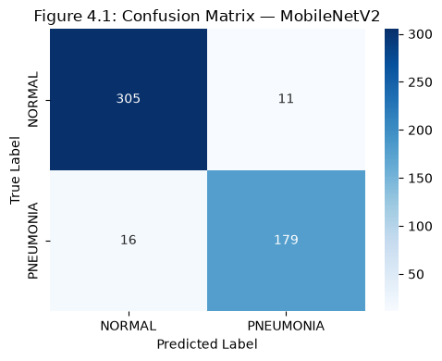
4.3.2 Confusion Matrix:

4.3.3 ROC Curve:

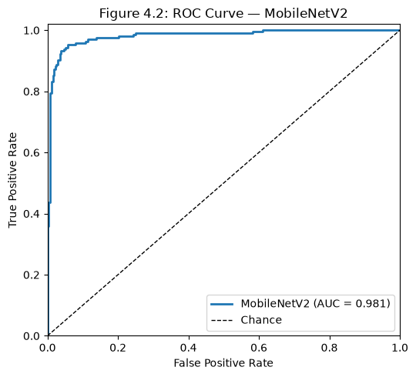

4.3.4 Discussion
MobileNetV2 achieved impressive classification performance with lightweight architecture, which is well-suited for medical image analysis. The model achieved high recall, meaning that most cases of pneumonia were accurately detected. In clinical applications it is especially important to minimize the number of false positives. But with a few classifications. The confusion matrix and ROC curve prove the reliability and consistency of the model in binary classification of pneumonia.

4.4 EfficientNetB0 Results
4.4.1 Classification Report:
Class | Precision | Recall | F1-score | Support
Normal | 0.96 | 0.97 | 0.96 | 316
Pneumonia | 0.94 | 0.93 | 0.94 | 195
Accuracy | 0.95 | 0.95 | 0.95 | 511
Macro Average | 0.95 | 0.95 | 0.95 | 511
Weighted Average | 0.95 | 0.95 | 0.95 | 511

4.4.2 Confusion Matrix
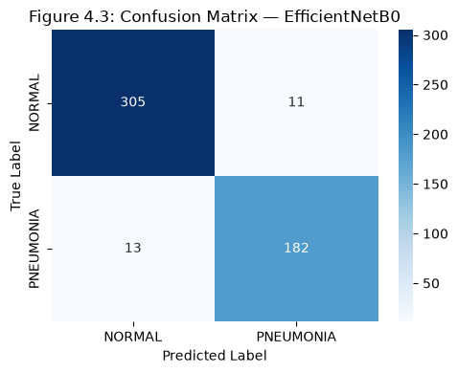
4.4.3 ROC Curve:
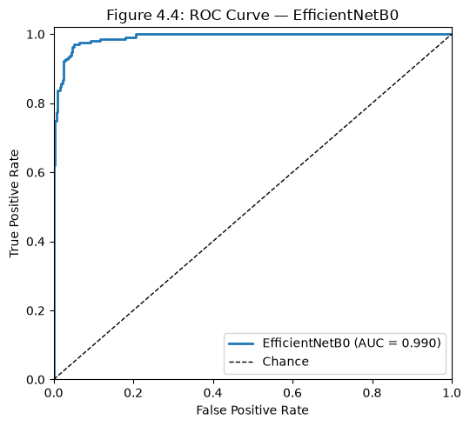

4.4.4 Discussion

4.5 ResNet50 Results
4.5.1 Classification Report:

Class | Precision | Recall | F1-score | Support
Normal | 0.95 | 0.97 | 0.96 | 316
Pneumonia | 0.94 | 0.92 | 0.93 | 195
Accuracy |  |  | 0.95 | 511
Macro Average | 0.95 | 0.94 | 0.94 | 511
Weighted Average | 0.95 | 0.95 | 0.95 | 511

4.4.2 Confusion Matrix

