

Deep Learning Framework for Galaxy Morphology Classification and Analysis
Prepared By
Name: Ahmad Yousef Alkahlout ID No.: 253000753
Name: Mohmmed Taleb Mohammed ID No.: 252000097

Submitted in fulfillment of the requirements for the degree Master of Science in Artificial Intelligence
At
College of Informatics
Midocean University
UAE
Supervisor Name: Dr. Mohamed Essa
College of Informatics, Midocean University, Comoros
Email: 253000753@st.midocean.edu.km / 252000097@st.midocean.edu.km

Acknowledgements

We would like to thank our supervisor, Dr. Mohamed Essa, for his continuous guidance and valuable feedback. His comments challenged us to put the maximum efforts and to ensure success on this research.

We are also thankful to the faculty members at the College of Informatics, Midocean University, for providing a supportive academic environment that inspired independent thinking and research development.

Finally, we would like to express our appreciation to our families for their patience, encouragement, and support during this journey.

Abstract
Classification of galaxy morphology continues to be one of the essential topics in astrophysics, as the galaxy shape allows obtaining information about the galaxy formation process and its evolution. Due to the increasing availability of data on galaxies obtained from SDSS and DECaLS surveys, the amount of galaxy images has considerably increased. In this regard, manual visual classification becomes increasingly ineffective in the case of extensive research, highlighting the increasing relevance of automation using deep learning algorithms.

Earlier works have shown that deep learning models can demonstrate good results in galaxy image classification. At the same time, many of them focus on classification accuracy, while other essential factors, such as interpretability, robustness, and prediction uncertainty, may be considered separately.

In this research, a deep learning framework for galaxy morphology classification is explored using CNNs together with transfer learning models such as ResNet and EfficientNet. The Galaxy10 DECaLS dataset is used as the main dataset because it contains labeled galaxy images and has been used in several studies in this field. To support a broader representation of galaxy morphology, the study also considers Galaxy Zoo vote-fraction annotations as an extension from single-label classification toward confidence-aware morphology analysis.

The framework evaluates classification performance using common measures such as accuracy and F1-score. It also examines robustness by applying controlled perturbations to the input images and observing how the predictions change under different conditions. In addition, Monte Carlo Dropout is used to estimate prediction uncertainty, while Grad-CAM is used to identify the image regions that have the greatest influence on the model’s decision.

The primary goal of this research is not only the creation of an accurate classification algorithm but also building a robust and interpretable methodological approach for working with astronomical images.

Contents
i
Acknowledgements ii
Abstract iii
List of Abbreviations v
List of Figures vi
List of Tables vii
Chapter 1: Introduction 1
1.1 Overview 1
1.2 Problem Definition 3
1.3 Thesis Objectives 4
1.4 Thesis Contribution 5
1.5 Thesis Organization 6
Chapter 2: Background and Related Work 7
2.1 Introduction 7
2.2 Background 8
2.3 Related work 13
2.4 Related Work Summary 19
Chapter 3: Proposed Approach (Methodology) 22
3.1 Input (Datasets) 23
3.1.1 Galaxy10 DECaLS Dataset 23
3.1.2 Galaxy Zoo Challenge Dataset 24
3.1.3 Relationship Between the Two Datasets 25
3.2 Preprocessing 26
3.3 Research Validity and Experimental Control 27
3.4 Model Architecture 28
3.4.1 Baseline CNN 28
3.4.2 Transfer-Learning Backbones 29
3.4.3 GCNN D16 29
3.4.4 MaxViT 30
3.4.5 Swin Transformer 30
3.4.6 ConvNeXt / ConvNeXtV2 31
3.4.7 YOLO Classification Family 32
3.4.8 FocalNet 32
3.4.9 EVA-02 33
3.4.10 Ensemble and Hierarchical Prediction 33
3.5 Training and Evaluation 34
Chapter 4: Experimental Results and Discussion 36
Chapter 5: Conclusion and Future Work 37
References 38

List of Abbreviations
- AI: Artificial Intelligence.
- CNN: Convolutional Neural Network.
- DL: Deep Learning.
- DECaLS: Dark Energy Camera Legacy Survey.
- GAN: Generative Adversarial Network.
- Grad-CAM: Gradient-weighted Class Activation Mapping.
- MCD: Monte Carlo Dropout.
- ML: Machine Learning.
- RA: Right Ascension.
- SDSS: Sloan Digital Sky Survey.
- XAI: Explainable Artificial Intelligence.
- F1-score: Harmonic mean of precision and recall.
- ViT: Vision Transformer.
- VGG19: Visual Geometry Group 19.
- DCGAN: Deep Convolutional Generative Adversarial Network.
- CvT: Convolutional Vision Transformer.
- S-PLUS: Southern Photometric Local Universe Survey.
- CANDELS: Cosmic Assembly Near-infrared Deep Extragalactic Legacy Survey.
- S0: Lenticular Galaxy.

List of Figures
Figure 1.1 Example of galaxy morphology complexity relevant to automated galaxy classification studies 1
Figure 2. 1 Hubble morphological classification scheme illustrating elliptical, spiral, and barred spiral galaxies. 8
Figure 2.2 Example galaxy images from different morphological classes used in automated classification studies 10
Figure 2.3 Schematic overview of a deep learning pipeline for galaxy morphology classification 11
Figure 2.‎ 4 Example of a saliency map highlighting discriminative regions in galaxy morphology classification 14
Figure ‎3.1 Overall proposed galaxy morphology methodology framework. 23
Figure ‎3.2 Controlled Galaxy10 DECaLS foundation used in the proposed methodology. 25
Figure ‎3.3 Galaxy Zoo Challenge hierarchical extension used in the proposed methodology 26
Figure ‎3.4 Data preparation and preprocessing workflow. 27
Figure ‎3.5 Baseline CNN architecture used as an initial supervised reference model. 29
Figure ‎3.6 Transfer-learning backbones used during early comparative stages. 29
Figure ‎3.7 GCNN D16 symmetry-aware architecture concept. 30
Figure ‎3.8 MaxViT hybrid convolution-attention architecture concept. 30
Figure ‎3.9 Swin Transformer shifted-window attention concept. 31
Figure ‎3.10 ConvNeXt/ConvNeXtV2 modern convolutional backbone concept. 31
Figure ‎3.11 YOLO classification pipeline used as an efficient model family. 32
Figure ‎3.12 FocalNet focal modulation architecture concept. 32
Figure ‎3.13 EVA-02 transformer branch used in the vote-fraction stage. 33
Figure ‎3.14 Per-question ensemble strategy for hierarchical vote-fraction prediction 33
Figure ‎3.15 Reliability-oriented evaluation layer of the proposed methodology. 35

List of Tables
Table ‎2.1 Comparison of related studies in galaxy morphology classification 19
Table ‎3.1: Galaxy10 DECaLS split used in the main classification experiments. 24
Table ‎3.2 Galaxy Zoo Challenge labeled split and official unlabeled test set role. 24

Chapter 1: Introduction

1.1 Overview
Galaxy morphology classification is an important topic in astronomy because the visible structure of a galaxy can tell us a great deal about how that galaxy formed and how it changed over time. As astronomical research developed, scientists found that features such as shape, brightness distribution, spiral arms, and central bulges could provide useful clues about the physical nature and evolutionary history of galaxies. For this reason, morphology classification has remained a central task in astrophysical research [1].
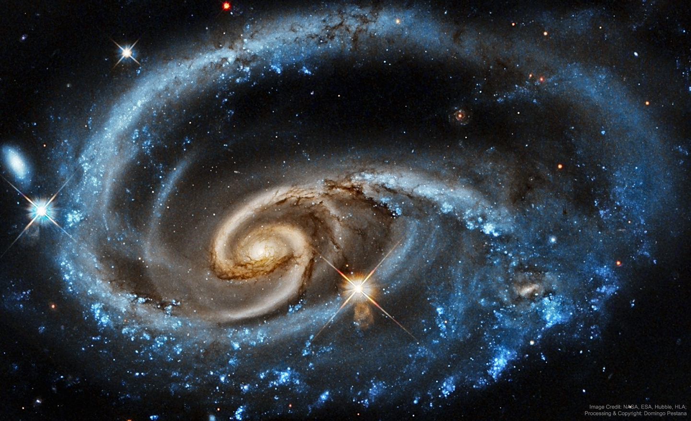
Figure 1.1 Example of galaxy morphology complexity relevant to automated galaxy classification studies. Source: NASA/Hubble.
As shown in Figure 1.1, there is significant variation within galaxy images. There are cases where galaxies show very distinguishable structures while others may be more complex or less distinct. There could be differences in the form, direction, brightness, or internal properties of the galaxies that may make classification difficult, especially when the lines between different types of galaxies are blurred.

Traditionally, the classification of galaxies was done manually using visual inspection by astronomers. Although this technique helped advance morphological study, it was labor-intensive and required a lot of time. Advances in astronomy have led to major sky surveys such as SDSS and DECaLS, greatly increasing the number of available galaxy images. As a result, manual classification has become more difficult and time-consuming [1].

As a result, there has been a lot more interest in machine learning techniques in recent times. The use of deep learning and convolutional neural networks (CNNs) shows promise for galaxy classification because they can learn features from unprocessed images. Several previous studies have reported encouraging results and have shown that CNN-based methods can perform at a level that is comparable to human classification in some tasks [2].

At the same time, there is growing interest in looking beyond classification accuracy alone. In scientific applications, it is not enough for a model to produce a correct label most of the time. They also need to understand whether the model is focusing on meaningful features of the galaxy, whether its predictions remain reliable when imaging conditions change, and whether its confidence is reasonable when the image is ambiguous. For this reason, explainability and robustness have become important parts of modern research in galaxy morphology classification [3].
The current study explores galaxy morphology classification in terms of deep learning with emphasis placed on both predictability and other aspects like robustness, uncertainty estimation, and interpretability. The primary data source for this analysis will be the Galaxy10 DECaLS galaxy morphology dataset because of its availability in labeled form to conduct supervised deep learning experiments. In doing so, it is intended to investigate the extent to which all the mentioned aspects can be utilized in creating an effective solution for automated galaxy morphology classification [3].

Some recent publications have explored several ways of classifying galaxies using deep learning, including semi-supervised learning techniques, augmentation-driven approaches, and transformer-based architectures. These directions are relevant to the current thesis in a selective way. The thesis does not treat each of them as a separate research problem but uses selected modern architectures and preprocessing strategies where they support the broader aim of building a reliable galaxy morphology framework that considers predictive ability, interpretability, robustness, and uncertainty estimation [8].

In particular, in such a context, the value of deep learning model application in astronomical studies cannot be reduced only to high prediction capability. The use of such models can bring additional benefits like a better understanding of the process behind their decisions, stability in different image settings, and, finally, the representation of the uncertainty associated with galaxy structure classification. Therefore, galaxy morphology classification in the thesis will be addressed from the angle of its performance, reliability, and interpretability [13].

1.2 Problem Definition
Many deep learning studies have applied deep learning for galaxy morphology classification, yet the majority of them pay attention only to accuracy and F1-score measures. Though these measures provide certain information, they do not cover all the aspects important for scientific analysis.

One of these aspects is interpretability. For example, it would be interesting to see how deep learning model interprets galaxy morphology. When classifying the galaxy as spiral, one wants to check that this result is based on spiral structure and central bulge rather than any other feature present in the image.

The second issue refers to variability of galaxy images observed with different conditions. Differences in illumination, noise, contrasts and so on can influence the picture significantly. Therefore, the classification performed by the model will demonstrate poor results in case the image is altered in any way. Scientific applications require robust and reliable prediction even for changed images.

Uncertainty may also become a critical factor for galaxy morphology classification since some galaxies may lack morphological features while the others can contain features corresponding to several classes. As a result, labeling only by final class may be not enough. The more helpful information the model provides about the uncertainty degree, the more confident in its predictions the scientist will be.

Another related issue is that representing each galaxy using only a single final class label may not fully capture the ambiguity of some morphological cases. Certain galaxies may show mixed or transitional structures, and in such cases, a confidence-aware or vote-fraction representation can provide more information than a hard class label alone. This motivates the need for a methodology that can begin with controlled class-label classification while also allowing a broader representation of morphology when richer annotations are available.

Based on the above, the main problem considered in this thesis can be formulated as follows: current deep learning solutions for galaxy morphology classification provide accurate predictions but fail to provide a unified framework for classification, which includes interpretability, robustness, and prediction uncertainty.

It means that there is a significant difference between achieving high classification accuracy and creating a reliable classification model, which explains its decisions and prediction uncertainty degree. Therefore, a more complex solution should be suggested that will satisfy all three criteria at once.

Thus, the first research question of this study is:
What solution can provide robust galaxy morphology classification using deep learning and be interpretable, robust, and uncertainty-aware at the same time?

For testing the solution, the Galaxy10 DECaLS dataset is used as a primary source of labeled images suitable for deep learning experiments.

1.3 Thesis Objectives
The main objectives of this research can be summarized as follows:
- Develop baseline CNN models for galaxy morphology classification and evaluate their ability to learn structural features directly from astronomical images.
- Apply transfer learning techniques using pretrained architecture such as ResNet and EfficientNet to enhance model performance and generalization, especially when working with limited training data.
- Extend the methodology from controlled hard-label classification toward confidence-aware morphology analysis using Galaxy Zoo vote-fraction annotations where appropriate, in order to better represent ambiguous or transitional galaxy structures.
- Evaluate classification performance through standard quantitative metrics, including accuracy and F1-score, to determine how well the models classify between different galaxy types.
- Analyze model robustness by introducing controlled perturbations to the images and observing how prediction performance changes under varying observational conditions.
- Combine uncertainty estimation into the classification pipeline using Monte Carlo Dropout, to better understand how confident the model is when predicting ambiguous or transitional galaxy morphologies.
- Use explainable AI techniques, particularly Grad-CAM, to interpret the model’s decisions and verify whether the network focuses on scientifically meaningful structures when classifying galaxy images.

1.4 Thesis Contribution
This research offers several key contributions to the study of automated galaxy morphology classification:

- A structured evaluation of deep learning architectures:
The work provides a systematic assessment of different deep learning models applied to galaxy morphology classification, including both baseline CNNs and transfer‑learning models. This helps clarify how various architectures perform on astronomical image data.
- A confidence-aware extension of the classification framework:
The study extends the methodology from controlled class-label galaxy morphology classification toward a broader vote-fraction-based representation. This supports the analysis of ambiguous galaxy morphologies and connects standard classification with a more informative hierarchical view of galaxy structure.
- A robustness evaluation procedure:
The study introduces a method for examining how model performance changes under controlled variations in the input images. This robustness analysis highlights the sensitivity of the models to observational differences and helps determine how stable their predictions are.
- Integration of uncertainty estimation into the classification pipeline:
The study incorporates uncertainty estimation to better understand how confident the model is when predicting ambiguous or transitional galaxy morphologies. This supports a more reliable interpretation of model predictions beyond the final class label.
- Use of explainable AI techniques for scientific interpretation:
The study applies Grad-CAM to support interpretability and to examine whether the model focuses on meaningful galaxy structures during classification. This helps connect classification performance with scientifically relevant visual evidence.

1.5 Thesis Organization
The rest of this thesis is organized as follows.
Chapter 2 discusses the theoretical background and relevant research areas.
Chapter 3 presents the proposed methodology.
Chapter 4 analyzes the experimental results.
Chapter 5 concludes the study and suggests directions for future work.

Chapter 2: Background and Related Work

2.1 Introduction
The following section gives a brief introduction of the background information and previous works about galaxy morphology classification using deep learning approaches. First, this section introduces some basic terminologies in terms of galaxy morphology classification along with its history from visual inspection to the application of automatic methods. Then, various existing studies that use deep learning to process galaxy images are presented briefly.

As mentioned in Chapter 1, there is an increased number of works done in recent years regarding galaxy morphology classification thanks to the availability of large-scale image databases due to astronomical surveys. In parallel with the increasing number of works, deep learning models, specifically convolutional neural networks, have proven their ability to capture meaningful features of images, thus they become a promising choice for galaxy morphology classification.

However, at the same time, most existing works concentrate on accuracy of galaxy morphologies classification. Although accuracy is one of the crucial criteria in evaluating any classification model, in scientific domains, other aspects including generalization capabilities, uncertainty quantification, and explainability are also very important in applying deep learning algorithms.

Therefore, in addition to focusing on performance measures, this chapter will discuss previous approaches in detail in terms of methodology, datasets used, and evaluation metrics in order to identify their advantages and disadvantages as well as potential research gaps for future investigations.

2.2 Background
Galaxy morphology studies date back to the early 20th century when Hubble proposed one of the first galaxy classification schemes [4]. According to this classification, galaxies were divided into several basic morphological types like elliptical, spiral, and irregular galaxies. Hubble's contribution laid the groundwork for further exploration and research of galaxy morphology and development.

An illustrative representation of the Hubble galaxy classification scheme can be found in Figure 2.1. It illustrates the connection between elliptical galaxies and the two basic branches of spiral galaxies – normal spirals and barred spirals. Later, de Vaucouleurs elaborated Hubble's classification by introducing more categories, including S0 lenticular galaxies and other morphological distinctions [5].

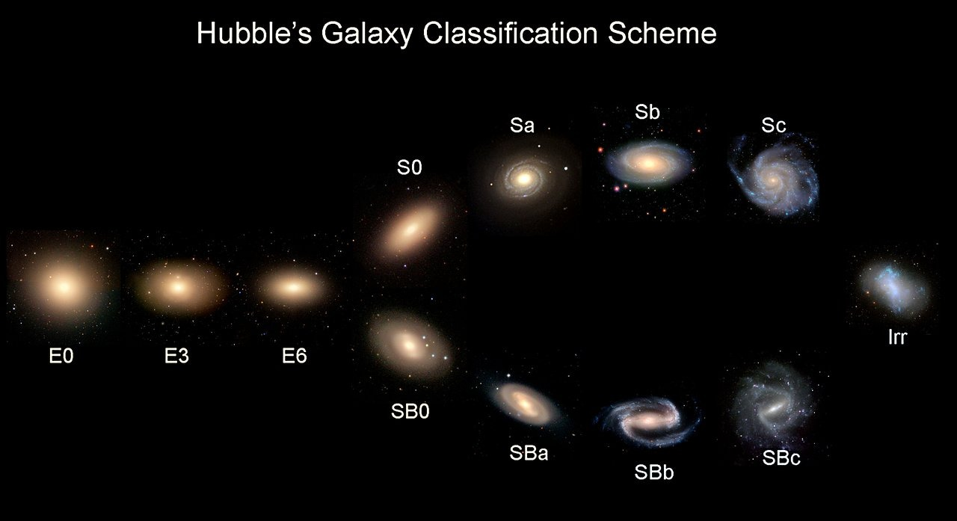
Figure 2. 1 Hubble morphological classification scheme illustrating elliptical, spiral, and barred spiral galaxies.
Source: Adapted from Hubble (1936) [4].

For many years, The process of galaxy classification was based on the manual visual analysis of galaxy images until relatively recently. It relied on the judgement of astronomers who identified the basic structural features of galaxies and assigned them particular classification labels. Even though this traditional method of galaxy classification remains valid to some extent, it became rather impractical due to the increasing number of galaxy observations.

The issue of manually classifying large amounts of galaxy images became evident with the rise of modern surveys. The Sloan Digital Sky Survey (SDSS) produced a large quantity of images that could not be classified manually easily and efficiently [6]. As an alternative solution, the Galaxy Zoo project was initiated. It provided an opportunity for the public to participate in galaxy classification. It demonstrated that citizen science could be used to classify large volumes of galaxy images.

An important characteristic of Galaxy Zoo-style datasets is that they do not only provide a final visual class but can also represent the degree of agreement among classifiers through vote fractions. This is useful in galaxy morphology research because some galaxies may not belong clearly to a single class. Instead, their visual structure may contain mixed or transitional features. For this reason, vote-fraction annotations can provide a richer representation of morphology than hard labels alone, especially when the aim is to study uncertainty and ambiguous cases.

As mentioned earlier, there has been a steady increase in the volume of astronomical data due to survey projects like the Dark Energy Camera Legacy Survey (DECaLS). Thus, the problem of automatic galaxy classification has become urgent, and researchers started employing deep learning approaches to solve it.

Currently, several approaches including artificial intelligence, machine learning, and deep learning have been actively used in the sphere of astronomical image analysis. Machine learning helps to train models via available training data, while deep learning includes the application of multilayered neural networks for pattern extraction. These techniques can be beneficial in solving the problem of galaxy morphology classification due to the presence of numerous visual characteristics that cannot be coded manually. Indeed, as can be seen from Figure 2.2, there is a large visual diversity of galaxies that makes automated classification rather challenging.

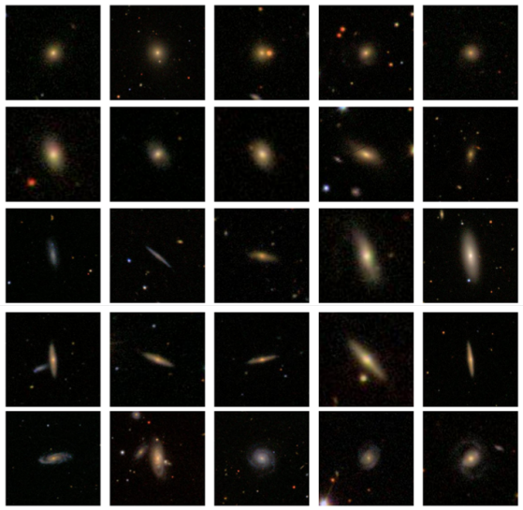
Figure 2.2 Example galaxy images from different morphological classes used in automated classification studies. Source: Adapted from Zhu et al. (2019) [19]
Figure 2.2 gives examples of galaxy images from diverse morphological classes. These examples show the high degree of variability of visual characteristics, thus making the task of classification a difficult one for a computer vision algorithm.

As follows from the above discussion, the problem of automated galaxy classification can be viewed as a typical problem of image classification. Therefore, in order to detect specific galaxy morphological features, the model should learn to see particular image patterns. In this regard, the application of deep learning approaches, and particularly CNNs, may prove effective since such models allow detecting specific visual structures in images.

In modern approaches to galaxy morphology classification, many researchers use CNN-based models due to their superior performance. For instance, Dieleman et al. found that such models can provide classification accuracy at the level of human performance. Thus, CNNs showed quite promising results when employed for predicting galaxy morphologies in [2].

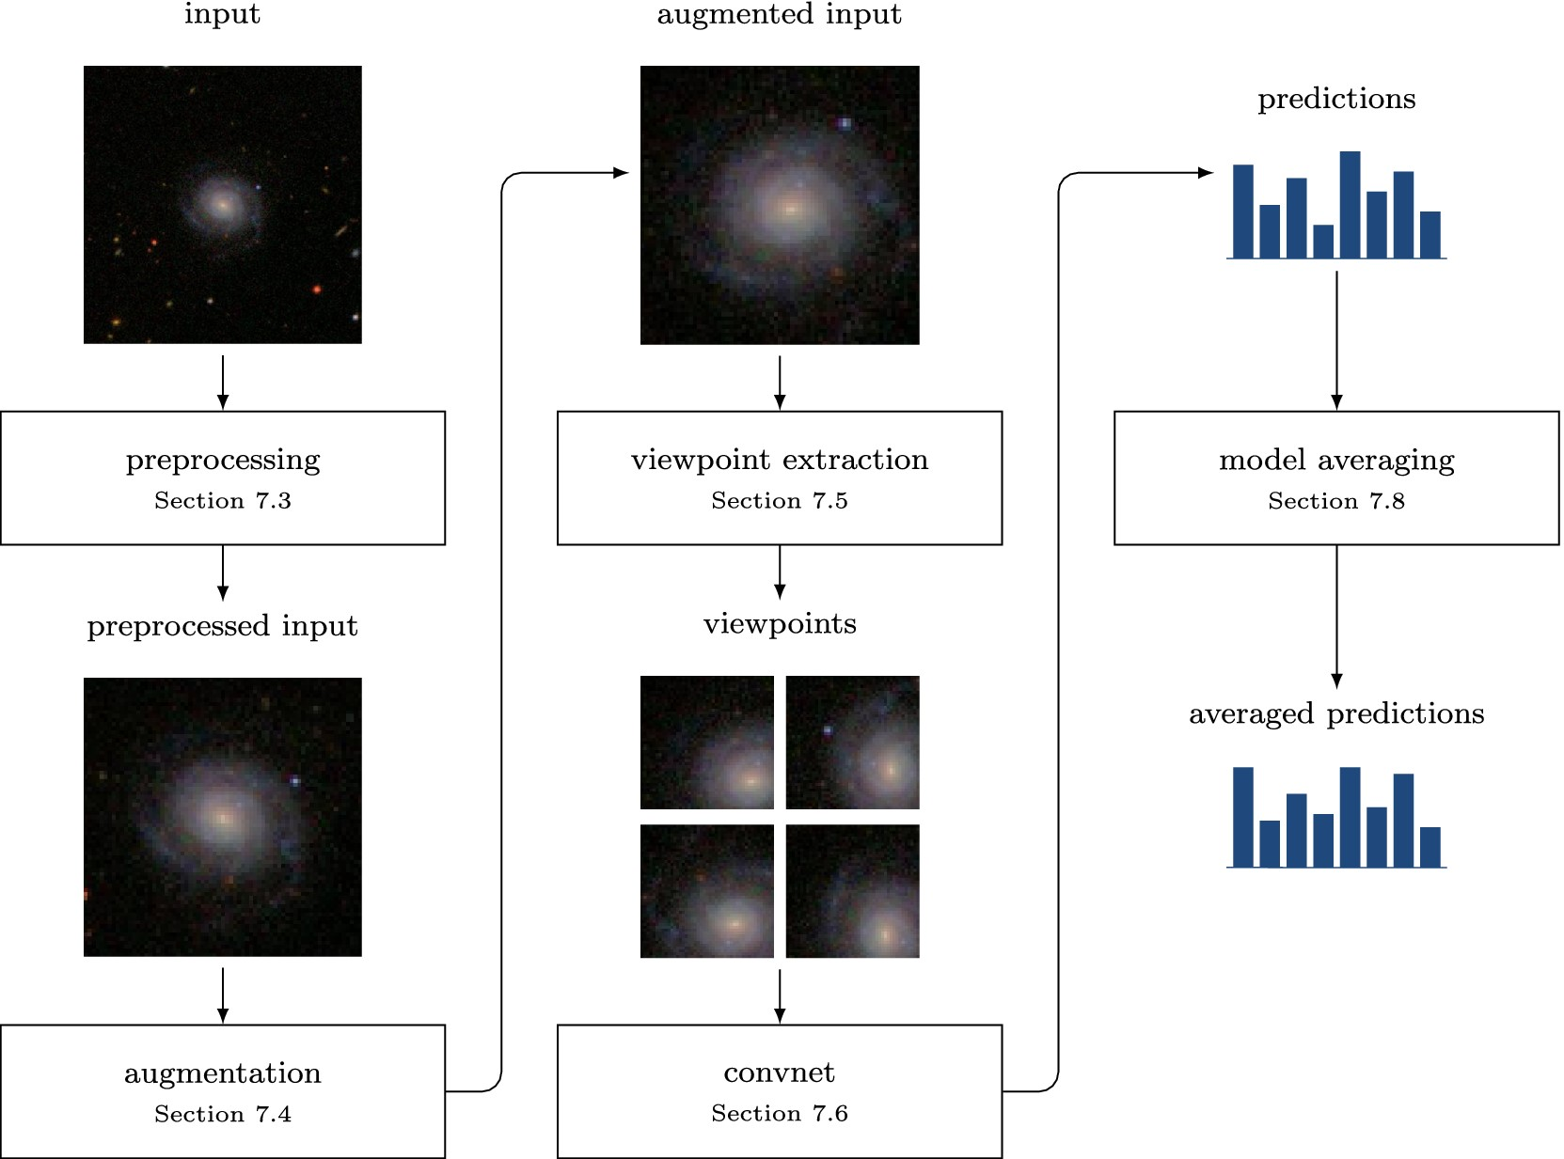
Figure 2.3 Schematic overview of a deep learning pipeline for galaxy morphology classification. Source: Adapted from Dieleman et al. (2015) [2]
Figure 2.3 shows the basic steps involved in creating a model for galaxy morphology classification using a deep learning approach. This figure demonstrates the process of classifying the galaxy's image by applying a sequence of learning operations from input to output.

Apart from the use of CNNs in the process of galaxy morphology classification, researchers have developed other approaches to improve the accuracy of models. One such approach is related to the use of transfer learning methods for pre-training existing models on galaxy images and improving their performance in cases where labeled data are few. Transformer-based models are another direction that allows detecting more complicated visual structures. Some researchers also apply the semi-supervised approach to learning in order to rely less on the labeled data. All this means that currently used methods of galaxy morphology classification do not limit themselves to one solution but seek to develop new models based on varied approaches.

At present time, the development of computer vision algorithms goes beyond simple CNN approaches to more sophisticated architecture of visual recognition systems. The fact is that in galaxy morphology classification, there are visual features that can be detected locally while other ones require analyzing the whole image structure. Thus, modern vision architectures can be considered as a good direction in building classification models that meet the requirements of complex astronomical imagery

Recently, researchers pay considerable attention to model interpretability issues. XAI becomes widely adopted in many scientific areas. The main advantage of explainable AI techniques is the possibility of identifying image parts affecting the model's decision-making processes [3].

2.3 Related work
The reviewed literature indicates that there have been great strides made in the field of galaxy morphological classification. Nonetheless, it is apparent that majority of these prior works have mainly focused on one aspect of the problem. There are those who prioritize accuracy, those who consider the importance of interpretability, and even those who talk about uncertainties and limitations in the data.

Walmsley et al. [1] Walmsley investigated the morphological classification of galaxies on a larger scale using machine learning techniques on current astronomical datasets. The use of the Galaxy Zoo DECaLS dataset allowed the researchers to utilize morphological classifications provided by many citizen scientists. The authors developed a deep learning model called Zoobot, which integrates convolutional neural network and probability approaches to estimate the entire distribution of answers provided by volunteers for about 300,000 galaxies. The model provided good agreement with human classification efforts and demonstrated good prediction accuracy, even regarding complicated morphological patterns. The main advantage of the investigation under analysis is the creation of one of the biggest morphological catalogs created using deep learning techniques. However, the use of volunteer-generated answers can be considered the main disadvantage of the methodology employed in this research.

The relevance of this line of work to the current research is that it treats galaxy morphology as a probabilistic or distribution-based problem rather than only a fixed class-label problem. This is important because the current thesis begins with controlled hard-label classification using Galaxy10 DECaLS but also considers a broader Galaxy Zoo-based vote-fraction setting to support confidence-aware morphology analysis. In this way, previous Galaxy Zoo-based studies provide a useful background for extending galaxy classification beyond a single-label decision.

Dieleman et al. [2] In their paper, Dieleman et al. proposed a deep learning framework for galaxy morphological classification using rotation-invariant CNNs. The study applied images from the Galaxy Zoo data set and was aimed at developing new CNN architecture which would allow classifying galaxies irrespective of their rotational orientation. With the introduction of rotation symmetry to the architecture of the network, it was able to better learn the morphological patterns, including spiral arms and bulge characteristics of galaxies, directly from the pixel-level data. According to the authors, the proposed method reached human-like accuracy levels in morphological classification, achieving about 91% of prediction accuracy. An obvious advantage of this approach is in its ability to handle rotational variability, characteristic of many astronomical images. However, as compared to standard CNN models, additional complexity arises due to the introduction of the new property.

Bhambra et al. [3] conducted research on the explainability of deep learning models which were used in the classification of galaxies based on their morphology. In this research, different explainable artificial intelligence approaches such as Grad-CAM and saliency maps were used to illustrate image areas that contributed towards the prediction made by deep learning models. Through galaxy images obtained from large sky surveys such as Galaxy Zoo and DECaLS, it was shown that deep neural networks were able to recognize different morphological structures within galaxies such as spiral arms, galactic core structures, and even asymmetry. This research illustrates that using explainability techniques, it is possible to learn more about the internal functioning of deep learning models.
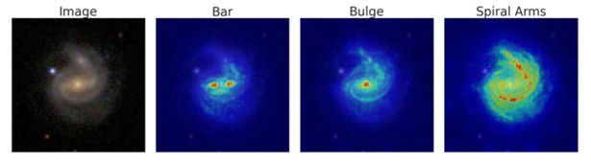
Figure 2.‎ 4 Example of a saliency map highlighting discriminative regions in galaxy morphology classification.
Source: Adapted from Bhambra et al. (2022) [3].
As shown in Figure 2.4, saliency maps highlight the regions of the galaxy image that contribute most strongly to the model's prediction. In many cases, the visualization confirms that the neural network focuses on key morphological structures such as spiral arms, bars, or the central bulge. This provides an additional layer of reliability by allowing astronomers to verify whether the classification decision is based on meaningful physical features. In this thesis, a similar explainability approach will be used to evaluate whether the proposed deep learning framework focuses on relevant morphological structures when classifying galaxy images.

Domínguez Sánchez et al. [7] esearched the application of deep convolutional neural networks in improving the accuracy of galaxy morphology classification using images captured by the Sloan Digital Sky Survey (SDSS). The model they created aimed at being able to recognize the important attributes used to differentiate between certain types of galaxies like elliptical and spiral galaxies. With the aid of the large number of images provided by the SDSS survey, the CNN model managed to classify the images with a success rate of about 95%. One strength of the work by Dominizes Sanches is that the CNN does not depend on a predefined set of features, as it can learn important morphological characteristics directly from the pixel data.

Luo et al. [8] believed problems related to galaxy morphological classification in situations when there are not many labeled samples available a frequent situation in the field of astrophysics. They developed an innovative semi-supervised deep learning algorithm that uses convolutional neural network and GAN models. In this case, the experiments were conducted using the Galaxy10 DECaLS dataset, and the classification accuracy obtained was around 84%. One positive point about this study is the reduced need for big fully labeled samples due to the simultaneous application of both labeled and unlabeled data. Such an innovation will be particularly beneficial in astronomy due to the time consumption involved in the process of labeling. On the other hand, one drawback of such an algorithm is its instability.

Yao et al. [9] focused on improving galaxy morphology classification through data augmentation when there is limited data for training. In this study, the Galaxy10 DECaLS dataset was used, in which a few-shot-learning-inspired augmentation technique was applied to enhance image diversity within the training set. This research indicated that with their augmentation technique, the robustness of their models could be increased to achieve up to 95% accuracy rate. One major advantage of this research is that they managed to show that augmentation can be effective without requiring changes to the core classification problem. On the other hand, one major limitation of this study is that overuse of augmentation or unrealistic augmentation might lead to spurious patterns.

Le et al. [10] carried out a comparative study of several deep learning models for galaxy morphology classification. The researchers employed the Galaxy10 DECaLS dataset to test customized CNN algorithms against the transfer learning algorithm models like ResNet and EfficientNet. It is demonstrated that the EfficientNet model produced an accuracy score of about 87%, which is considered among the best-performing models tested in the paper. The main advantage of this study lies in the fact that it presents a comparative analysis between several architectures under identical experimental conditions. In addition, experimental research was limited to utilization of just one dataset, implying its potential applicability to other astronomical survey data.

Xie et al. [11] conducted research on the challenge of classifying galaxy morphology with the use of a deep convolutional neural network inspired by the VGG19 architecture. For experimentation, the researchers applied the Galaxy10 DECaLS dataset, which contains labeled galaxy images taken through extensive astrophysical observation processes. Leveraging transfer learning techniques, the researcher were able to train the VGG19 model to recognize hierarchical visual features to distinguish between the different types of galaxies. As a result, the proposed approach managed to achieve about 84.5% accuracy, showing that the application of deep CNNs is adequate for this type of problem. At the same time, the authors identified that models like VGG19 have a relatively high number of parameters, which might be responsible for overfitting.

Cheng [12] explored the effectiveness of using Vision Transformers (ViT) to classify galaxy morphology. Specifically, the Galaxy10 DECaLS dataset was used to investigate whether transformer models outperform regular CNNs in terms of their ability to find global features within images. By leveraging the self-attention mechanism, the model in question highlighted key areas of the galaxy to increase overall accuracy up to 86%. An interesting outcome of this research is that transformers can detect dependencies throughout the whole image rather than within specific parts only. A downside observed by Cheng was the significant amount of training data needed.

Cao et al. [13] came up with a combination approach to deep learning where the researcher merged CNNs with elements from transformers to classify the morphology of galaxies. For this research, Cao used galaxy images from the Galaxy Zoo database. Specifically, CvT architecture was used because the model integrates local feature detection in CNNs and global feature detection in transformer architectures. The achieved accuracy was around 98%, thus making it one of the most effective models among those that have been reviewed in this analysis. One strength of this research paper is that it uses both architectural designs, hence can detect patterns in galaxies using a wide range of approaches. However, the improvement made in the model makes it complex, thus requiring more computational resources.

Urechiatu et al. [14] focused on the potential usefulness of convolutional neural networks (CNNs) in improving automated classifications of galaxy morphology. For the experiment, the authors used a dataset consisting of 10,000 images of galaxies taken from the Galaxy Zoo 2 database, which is known to contain labeled images provided by many volunteers. Specifically, to build the algorithm, the authors came up with a CNN architecture which they expected to be able to distinguish morphological traits better and applied a number of methods to preprocess and augment data. As a result, the accuracy in classification reached 92%. However, despite high effectiveness in recognizing simple structures of galaxies, the models failed to work properly when dealing with complicated morphologies.

Bom et al. [15] explored analyzing deep learning algorithms' capabilities for performing morphological classification of galactic objects with the help of imaging data obtained during the S-PLUS sky survey. However, apart from relying on the data set described above, the researchers suggest including other sources of information in the analysis, namely morphological catalogs resulting from other big astronomical projects. According to the study, CNNs that can detect morphological features in input images could be useful tools to accomplish the proposed task. Namely, it means that a neural network should be capable of detecting certain morphological characteristics of galaxies' core, light distribution in galaxies, as well as possible spirals. As a result, the network can recognize different types of galaxies accurately enough, with the accuracy of classification being 92% to 95%. Therefore, CNNs can be considered effective tools for accomplishing the described tasks, given proper training of the network. Still, certain observational conditions may impact CNNs' work negatively.

Wei et al. [16] used transformer architecture to analyze galaxy morphology classification. The experiment was done on the Galaxy10 DECaLS dataset, which consists of galaxy images labeled after extensive surveys done by astronomers. This experiment used (ViT), where self-attention is used to recognize global patterns within the galaxy images. The results obtained show an accuracy rate of about 94%, thus the applicability of the transformer architecture to such tasks. One major strength of using this architecture to classify galaxy morphologies is that it can learn long-range dependencies in data. On the other hand, transformers need huge datasets to perform at their best.

Almeida et al. [17] examined the role of transfer learning in enhancing galaxy morphology classification using deep convolutional neural networks. This research utilized data from the Galaxy Zoo project, which contains images labeled using massive citizen scientist inputs for galaxy morphology. Using the transfer learning method, fine-tuning the pre-trained ResNet model allowed the neural network to learn to recognize the differences between galaxy morphologies, such as spirals and ellipticals. Based on the study findings, the transfer learning method used yielded an average of about 92% accuracy, showing the usefulness of transfer learning with large datasets of natural images to improve results in astrophysics. However, one challenge in performing such transfer learning is the class imbalance in the dataset since morphological differences will be harder to learn by the neural network.

Zhang et al. [18] explored the utilization of a new machine learning approach to classify galaxy morphology. This novel technique was a combination of the convolutional neural network and attention mechanisms. The Galaxy10 DECaLS dataset was used, containing labeled galaxy images obtained from various astronomical researches. The use of the attention mechanism made it possible for the model to focus more on the key features in the images. The accuracy achieved in the study was around 96%, which shows that the technique might improve classification effectiveness.

2.4 Related Work Summary
It is seen from the analyzed literature that DL is a promising method for classifying galaxies according to morphological types. The above-mentioned literature employs various techniques, including classical CNN models, transfer learning, semi-supervised learning, attention-based methods, and transformer architecture among others. In general, the considered literature proves that application of DL to galaxy morphology classification yields promising results provided that a large set of astronomical images is available.

However, even with the common high performance of deep learning techniques, each technique has its advantages and drawbacks. For example, some papers are oriented towards improving the accuracy, whereas others pay more attention to other aspects of galaxy morphology classification, such as interpretability, estimation of uncertainties, or the influence of training data insufficiency. In most cases, these features were investigated separately without creating an integrative approach.

The comparison of the selected studies is presented in Table 2.1.

Table ‎2.1 Comparison of related studies in galaxy morphology classification
Ref | Author | Year | Technique Used | Accuracy | Dataset | Comparison with This Research
[1] | Walmsley et al. | 2022 | Bayesian Deep Learning (Zoobot) | Not explicitly reported | Galaxy Zoo / DECaLS | Reference for uncertainty-aware galaxy classification
[2] | Dieleman et al. | 2015 | Rotation-Invariant CNN | ~91% | Galaxy Zoo | Baseline CNN architecture for morphology prediction
[3] | Bhambra et al. | 2022 | Grad-CAM & Saliency Mapping | Not focus of study | Galaxy Zoo / DECaLS | Reference study for explainable AI evaluation
[7] | Domínguez Sánchez et al. | 2018 | Deep Convolutional Neural Network (CNN) | ~95% | SDSS Galaxy Dataset | Deep learning benchmark for galaxy morphology classification
[8] | Luo et al. | 2025 | Semi-supervised Learning (GAN-based) | ~84% | Galaxy10 DECaLS | Semi-supervised learning reference under limited labels
[9] | Yao et al. | 2024 | DCGAN Data Augmentation | Up to ~95% | Galaxy10 DECaLS | Data augmentation reference for improving model generalization
[10] | Le et al. | 2025 | EfficientNetB5 Transfer Learning | ~87% | Galaxy10 DECaLS | Transfer learning architecture benchmark
[11] | Xie et al. | 2024 | VGG19 Transfer Learning | ~84.5% | Galaxy10 DECaLS | CNN transfer learning baseline comparison
[12] | Cheng | 2022 | Vision Transformer | ~86% | Galaxy10 DECaLS | Transformer-based architecture comparison
[13] | Cao et al. | 2024 | Convolutional Vision Transformer (CvT) | ~98% | Galaxy Zoo CANDELS | Hybrid CNN–Transformer performance benchmark
[14] | Urechiatu et al. | 2024 | Convolutional Neural Network (CNN) | ~92% | Galaxy Zoo 2 | CNN-based classification improvement reference
[15] | Bom et al. | 2024 | Deep Neural Network (CNN-based) | ~92–95% | S-PLUS astronomical survey | Baseline CNN architecture for morphology prediction
[16] | Wei et al. | 2024 | Vision Transformer (ViT) | ~94% | Galaxy10 DECaLS | Transformer-based architecture comparison
[17] | Almeida et al. | 2024 | Transfer Learning (ResNet CNN) | ~92% | Galaxy Zoo | Deep learning benchmark for galaxy morphology classification
[18] | Zhang et al. | 2024 | CNN with Attention Mechanism | ~96% | Galaxy10 DECaLS | CNN with attention mechanism benchmark

Although recent studies have reported promising results in galaxy morphology classification, several important challenges remain. Many existing models achieve good accuracy, but they do not always provide enough information about how stable their predictions are when image conditions change. In addition, interpretability and uncertainty estimation are still not fully included in many classification frameworks.

Another issue is that some studies depend heavily on large, labelled datasets, while future astronomical surveys may continue to produce data at a scale that makes full labelling difficult. Differences in image quality, brightness, noise, and observational conditions can also affect model performance and reliability.

For these reasons, there is still a need for a framework that does more than classify galaxy images accurately. A more useful approach should also consider robustness, uncertainty, and interpretability together. This is the main gap that motivates the current research, which aims to study galaxy morphology classification through a framework that combines these important aspects in one setting.

In addition to the limitations discussed above, much of the existing work still separates classification performance, uncertainty, robustness, and interpretability into different research directions. Another remaining challenge is the gap between hard-label classification datasets and richer vote-fraction representations of galaxy morphology. This motivates the present research to connect controlled class-label classification with a broader confidence-aware framework that can also consider ambiguity, reliability, and interpretability within the same methodological setting.

Chapter 3: Proposed Approach (Methodology)

This chapter presents the methodology used to develop the proposed confidence-aware framework for galaxy morphology classification and vote-fraction analysis. The framework integrates two connected galaxy morphology datasets, task-specific preprocessing, multiple deep learning model families, experimental-control procedures, and reliability-oriented evaluation through robustness, uncertainty estimation, and interpretability analysis. The overall methodology is illustrated in Figure 3.1.
The central methodological idea of this thesis is to connect controlled hard-label galaxy morphology classification with a broader confidence-aware hierarchical formulation. The framework first builds a classification foundation using Galaxy10 DECaLS, then extends the same research direction to Galaxy Zoo Challenge vote-fraction prediction. Robustness, uncertainty estimation, and explainability are treated as integral components of the framework rather than optional post-processing steps.
Methodologically, the framework addresses three related but distinct task settings. The first setting is ten-class hard-label galaxy morphology classification using Galaxy10 DECaLS. The second setting is a high-confidence binary morphology stage derived from Galaxy Zoo vote fractions, focusing on the coarse Smooth versus Featured distinction. The third setting is full vote-fraction prediction using the Galaxy Zoo Challenge hierarchy, where each galaxy is represented by a 37-dimensional target vector. Treating these settings separately helps preserve the validity of each task while allowing the overall framework to move from controlled classification toward confidence-aware hierarchical morphology analysis.
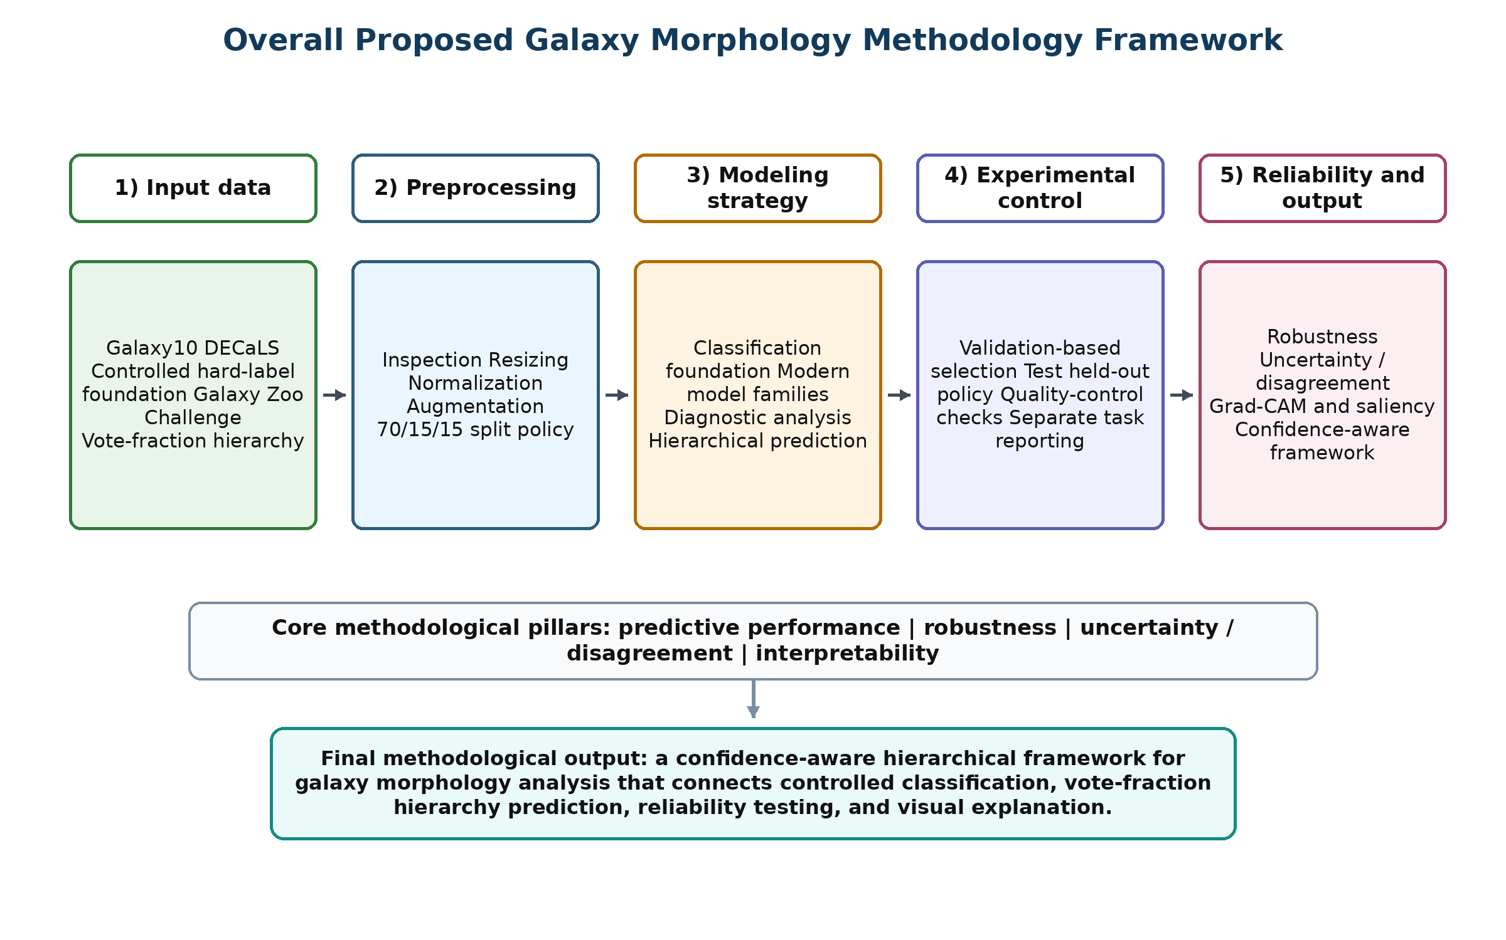
Figure ‎3.1 Overall proposed galaxy morphology methodology framework.

3.1 Input (Datasets)
Two connected datasets were used in this study. Galaxy10 DECaLS was used as the controlled dataset for ten-class hard-label galaxy morphology classification. Galaxy Zoo - The Galaxy Challenge was used as a broader Galaxy Zoo-based dataset for vote-fraction hierarchical prediction. The two datasets serve different methodological roles while remaining part of the same galaxy morphology research direction.

3.1.1 Galaxy10 DECaLS Dataset
Galaxy10 DECaLS is a supervised galaxy image dataset derived from the Dark Energy Camera Legacy Survey. It contains 17,736 galaxy images, each assigned to one of ten morphology classes. Each image has an original resolution of 256 × 256 × 3 pixels. This dataset was used to establish the main controlled classification foundation, evaluate different model families, and study ambiguity patterns between visually similar morphology groups.
The main Galaxy10 DECaLS experiments used an approximately 70% / 15% / 15% split. The training subset was used for parameter learning, the validation subset for model selection and controlled refinement, and the test subset for final held-out evaluation only.
Table ‎3.1: Galaxy10 DECaLS split used in the main classification experiments.
Subset | Images | Approx. ratio | Role
Training | 12,415 | 70% | Parameter learning
Validation | 2,660 | 15% | Model selection and refinement decisions
Testing | 2,661 | 15% | Held-out final evaluation
Total | 17,736 | 100% | Full labeled Galaxy10 DECaLS dataset

3.1.2 Galaxy Zoo Challenge Dataset
Galaxy Zoo - The Galaxy Challenge was introduced to extend the methodology from hard-label classification to vote-fraction-based hierarchical morphology prediction. The labeled training portion contained 61,578 galaxy images associated with the training_solutions_rev1.csv annotation file. Each labeled image was represented by 37 vote-fraction target outputs corresponding to the Galaxy Zoo morphology hierarchy.
The labeled portion was divided into training, validation, and internal testing partitions using an approximately 70% / 15% / 15% split. The official Kaggle test images were treated separately because their ground-truth labels were not available. They were not used for model training, validation selection, hyperparameter tuning, or internal test evaluation. They were used only at the final prediction-submission stage.

Table ‎3.2 Galaxy Zoo Challenge labeled split and official unlabeled test set role.
Galaxy Zoo subset | Images | Approx. ratio | Role
Training | 43,104 | 70% | Parameter learning for 37-output prediction
Validation | 9,237 | 15% | Model selection and ensemble design
Internal testing | 9,237 | 15% | Held-out internal evaluation
Labeled total | 61,578 | 100% | Images with vote-fraction annotations
Official Kaggle test | 79,975 | Not part of labeled split | Unlabeled images used only for final submission prediction

The high-confidence binary stage was constructed using a fixed confidence threshold of θ = 0.90 applied to the first-level Galaxy Zoo vote fractions. This threshold was used as a methodological filtering rule to retain samples with strong vote agreement for the Smooth or Featured categories. The threshold was not selected using the test set, and the resulting binary subset was treated as a separate methodological stage within the broader hierarchical framework.

3.1.3 Relationship Between the Two Datasets
The use of two datasets is part of the methodological design. Galaxy10 DECaLS provides a controlled selected setting for ten-class hard-label classification. Galaxy Zoo Challenge extends the same galaxy morphology direction into a broader vote-fraction hierarchy. Therefore, the second dataset is not a replacement for the first dataset; it is a methodological extension from single-label classification toward confidence-aware vote-fraction modeling.
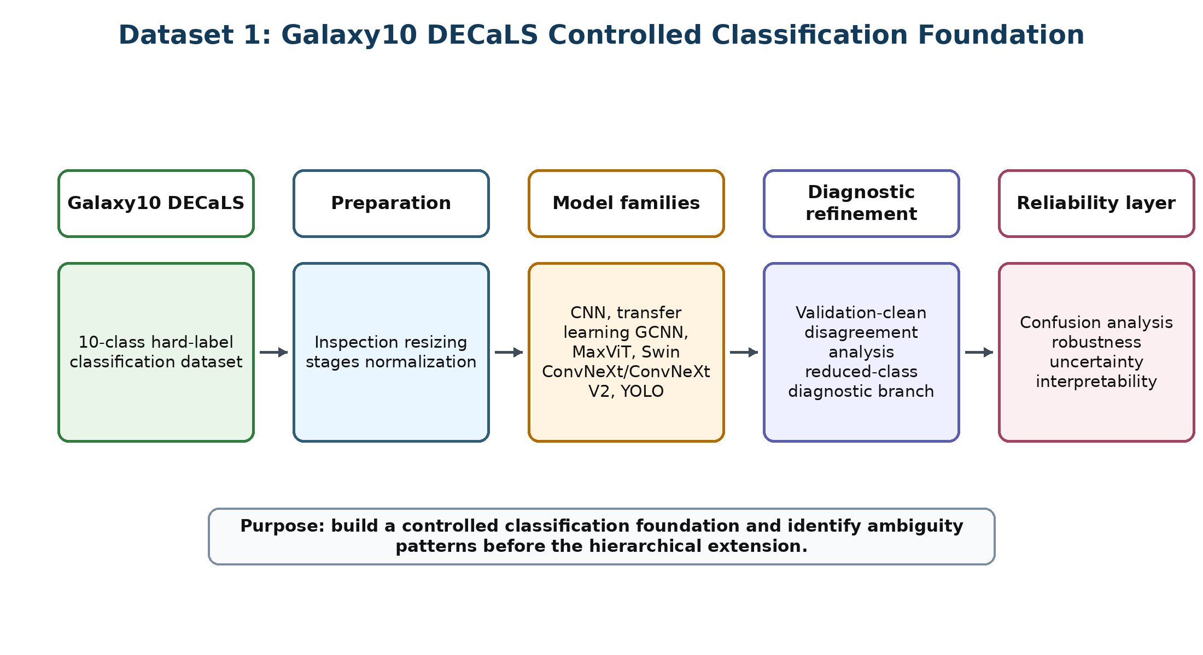
Figure ‎3.2 Controlled Galaxy10 DECaLS foundation used in the proposed methodology.

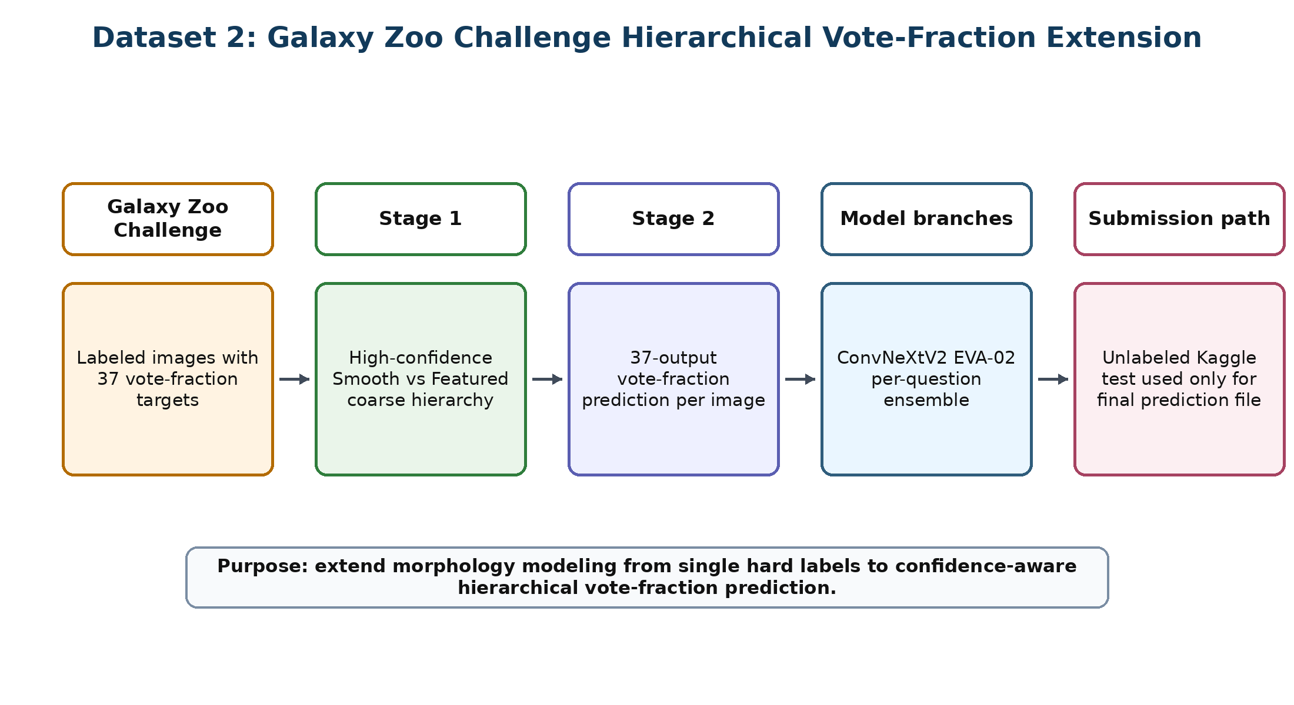
Figure ‎3.3 Galaxy Zoo Challenge hierarchical extension used in the proposed methodology.

This design also prevents the two datasets from being interpreted as competing alternatives. Galaxy10 DECaLS supports controlled class-label learning and diagnostic analysis, while Galaxy Zoo Challenge supports a richer representation of morphology through soft vote-fraction targets. Therefore, the two datasets contribute complementary evidence to the same research objective rather than representing unrelated experimental directions.

3.2 Preprocessing
Preprocessing was adapted to the task and model family while preserving the separation between training, validation, and testing data. The Galaxy10 DECaLS branch required image resizing, normalization, and augmentation for classification. The Galaxy Zoo branch required vote-fraction target preparation for the high-confidence binary stage and the full 37-output prediction stage.
Images were prepared at several resolutions during the experimental development, including 64 × 64, 128 × 128, 160 × 160, 224 × 224, and 256 × 256. Smaller sizes supported early baseline development, while larger sizes preserved more detailed galaxy morphology. For pretrained models, ImageNet-style normalization was used where required:
x_norm = (x − μ) / σ
Training-time augmentation included transformations that preserve the semantic meaning of galaxy morphology, such as horizontal and vertical flips. Augmentation was applied to the training data only and was not used to alter validation or test labels.
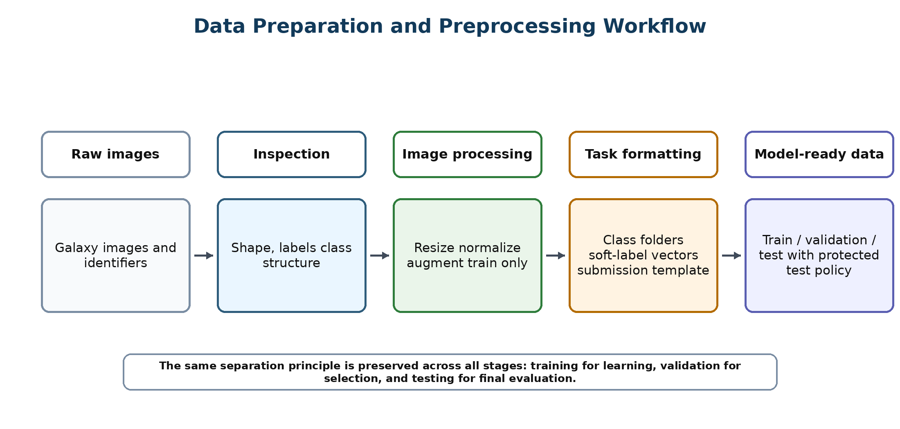
Figure ‎3.4 Data preparation and preprocessing workflow.

For the high-confidence Smooth vs Featured stage, Class1.1 and Class1.2 vote fractions were used to construct a binary hierarchy stage. A sample was retained when one of these first-level vote fractions satisfied the selected confidence threshold:
label = Smooth if Class1.1 ≥ θ; Featured if Class1.2 ≥ θ
For the full Galaxy Zoo stage, each image was associated with a 37-dimensional vote-fraction target vector:
y = [y₁, y₂, y₃, …, y₃₇]

3.3 Research Validity and Experimental Control
Research validity was controlled through a clear separation of experimental roles. Training data was used for parameter learning, validation data was used for model selection and controlled refinement, and test data was preserved for final held-out evaluation. This separation reduces the risk of data leakage and makes the reported results easier to interpret in Chapter 4.
The Galaxy Zoo official test images were treated differently from the labeled training portion. Since their ground-truth labels are not available, they cannot be used for supervised training, internal loss calculation, or validation-based selection. Their correct role is to receive final predictions after the model-development process is fixed.
Diagnostic branches, including reduced-class analysis and disagreement-based refinement, were treated as methodological tools for understanding ambiguity and error structure. They were not used to redefine the final task. This distinction is important because each experimental branch has a different methodological purpose.
Quality-control checks were applied when prediction outputs had to match a strict external format. In the Galaxy Zoo submission stage, this included checking GalaxyID consistency, expected column count, row count, missing values, and prediction format before generating the final submission file.
Once the data partitions and methodological rules were defined, they were kept fixed for the corresponding experimental stage. Validation data was used for model comparison, controlled refinement, and ensemble-related decisions, while held-out test data was reserved for final evaluation. This policy was followed to reduce the possibility of data leakage and to ensure that diagnostic or refinement steps did not indirectly depend on final test-set behavior.

3.4 Model Architecture
The methodology incorporated several model families to provide architectural diversity across the controlled classification, diagnostic, and hierarchical prediction stages. Each family is described separately according to its architectural principle and its role within the proposed galaxy morphology framework.
The model families included in this study did not all serve the same methodological role. Some models were used as baseline or early comparison architectures, some were used as diagnostic branches to study difficult morphology cases, and others were used as stronger candidate backbones for the hierarchical vote-fraction stage. This distinction is important because the purpose of the methodology was not simply to list many architectures, but to use architectural diversity to support controlled classification, ambiguity analysis, and confidence-aware morphology prediction.

3.4.1 Baseline CNN
The baseline CNN was used as an initial supervised reference model. It contains convolution, nonlinear activation, pooling, and fully connected components. Its role was to confirm the basic image-classification pipeline before moving to more advanced architectures.
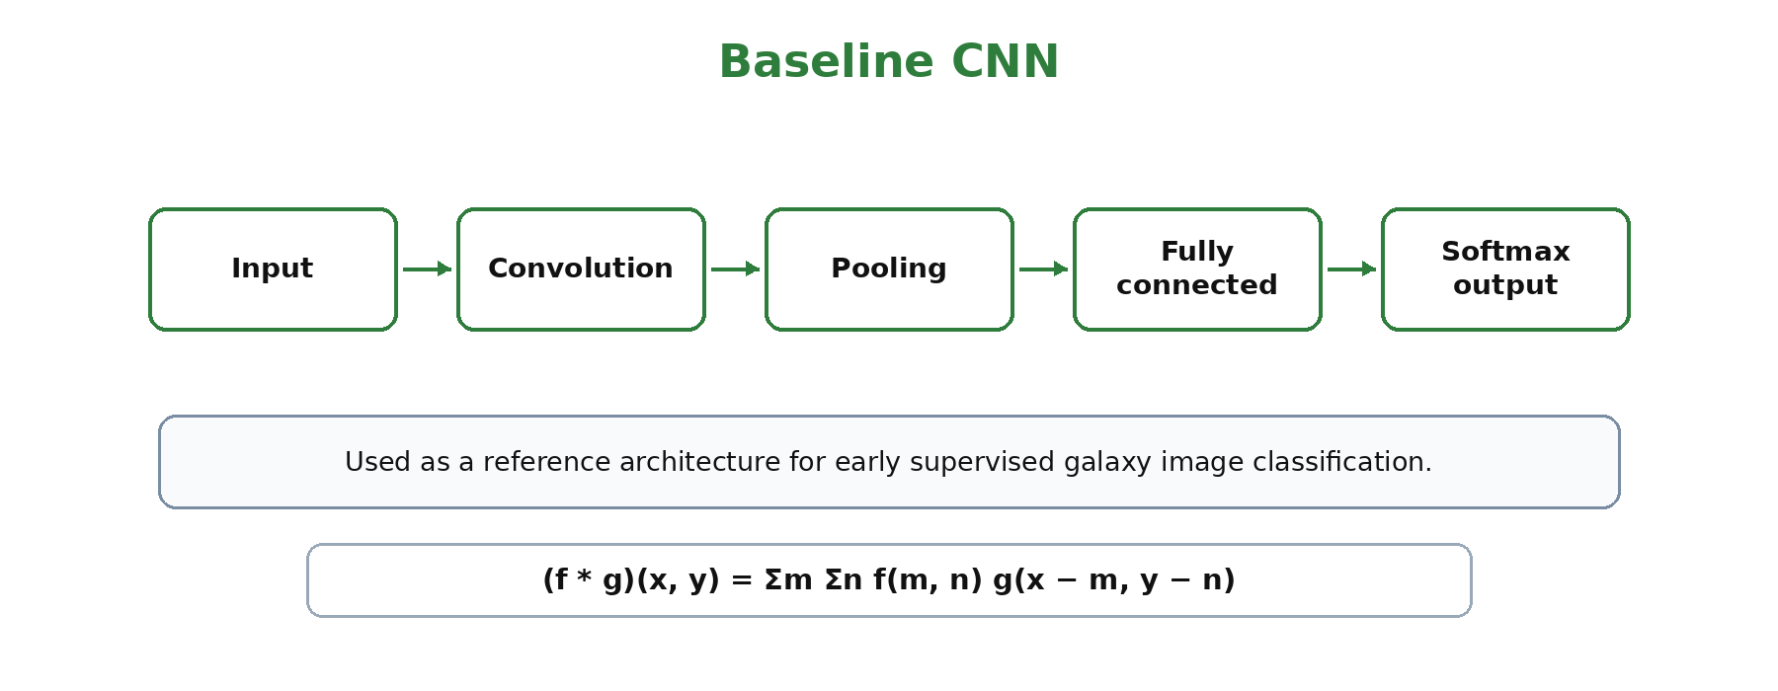
Figure ‎3.5 Baseline CNN architecture used as an initial supervised reference model.

3.4.2 Transfer-Learning Backbones
Transfer-learning backbones such as ResNet, EfficientNet, and CoAtNet-style paths were explored during early comparison stages. These models were included to evaluate whether pretrained visual representations could support galaxy morphology classification.
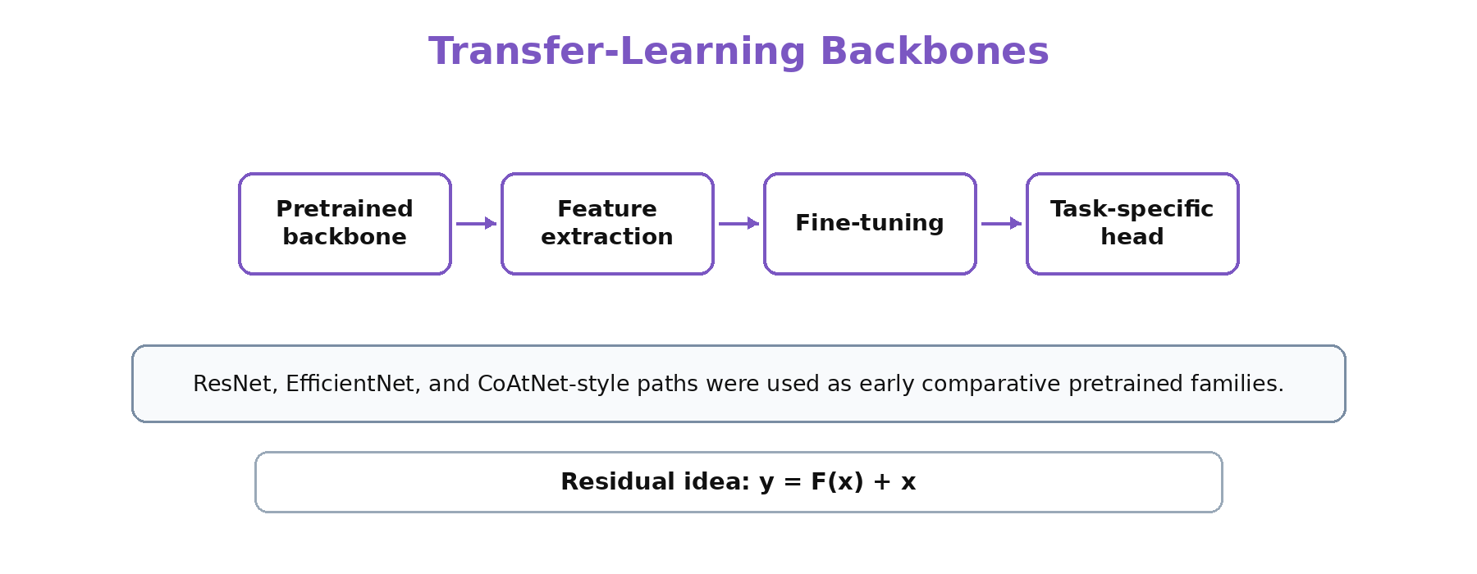
Figure ‎3.6 Transfer-learning backbones used during early comparative stages.

3.4.3 GCNN D16
The GCNN D16 family was used to represent symmetry-aware learning. Since galaxy images can appear under different rotations or reflections, group-convolutional modeling provides a useful architectural direction for astronomy images.
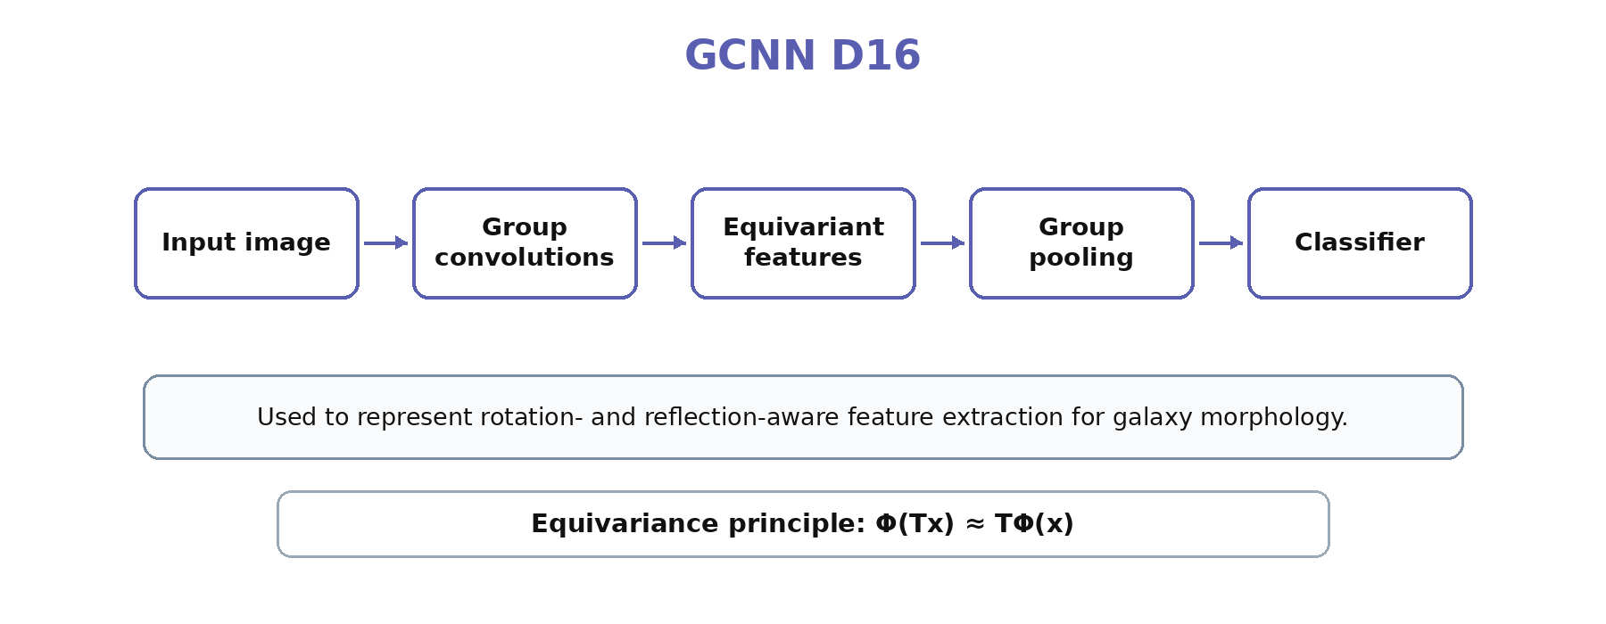
Figure ‎3.7 GCNN D16 symmetry-aware architecture concept.

3.4.4 MaxViT
MaxViT was included as a hybrid model family combining convolutional inductive bias with attention-based feature integration. This is relevant for galaxy images because both local structures and global shape information can influence morphology.
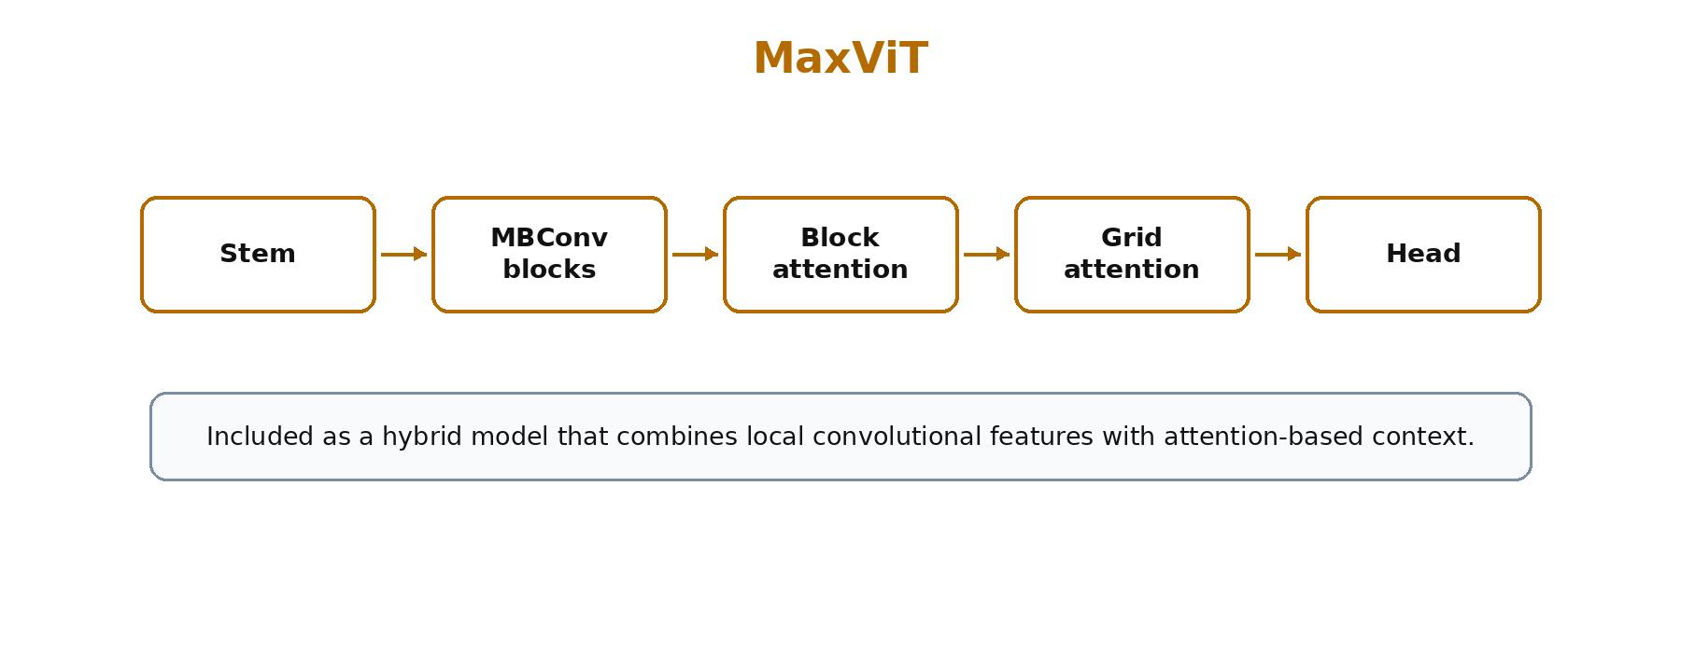
Figure ‎3.8 MaxViT hybrid convolution-attention architecture concept.

3.4.5 Swin Transformer
Swin Transformer was explored as a hierarchical transformer family based on window and shifted-window attention. It provides another way to capture image structure while reducing the computational cost of full global attention.
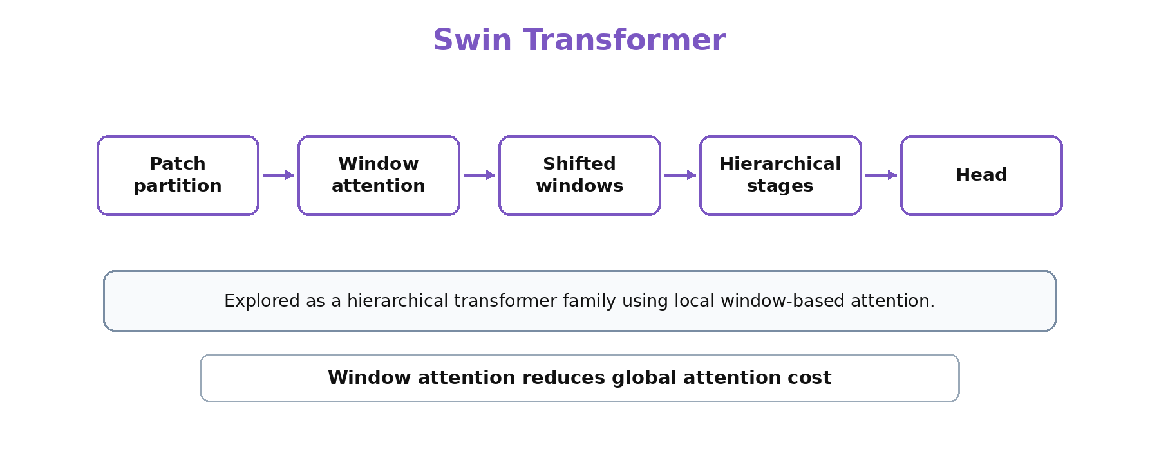
Figure ‎3.9 Swin Transformer shifted-window attention concept.

3.4.6 ConvNeXt / ConvNeXtV2
ConvNeXt and ConvNeXtV2 were used as modern convolutional backbones. They provided a strong architecture family for high-resolution morphology learning and later stages of the framework.
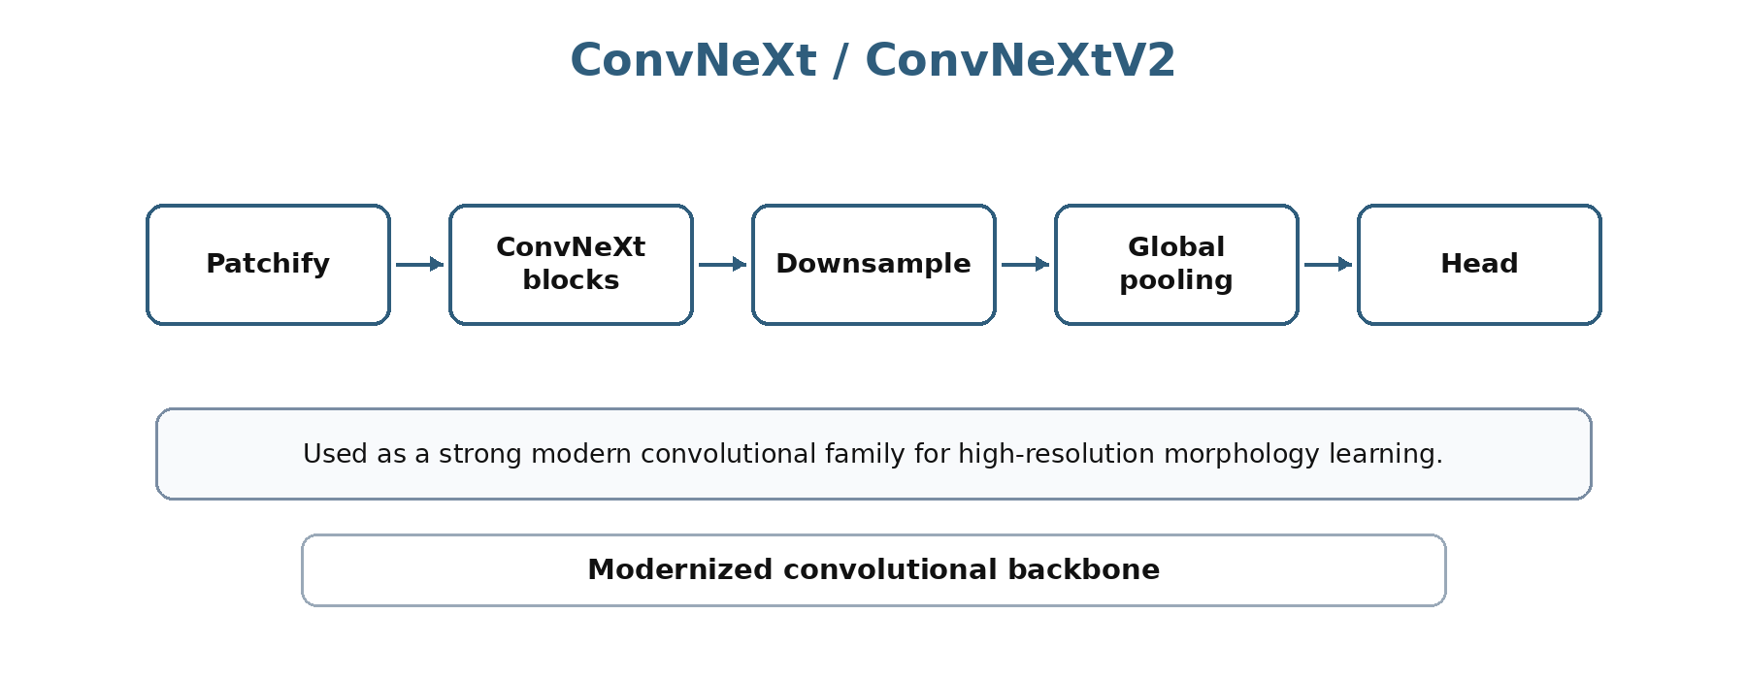
Figure ‎3.10 ConvNeXt/ConvNeXtV2 modern convolutional backbone concept.

3.4.7 YOLO Classification Family
YOLO classification models were used as an efficient classification family. They were applied to the full ten-class setting and to the high-confidence binary stage, using a classification-folder organization compatible with the YOLO pipeline.
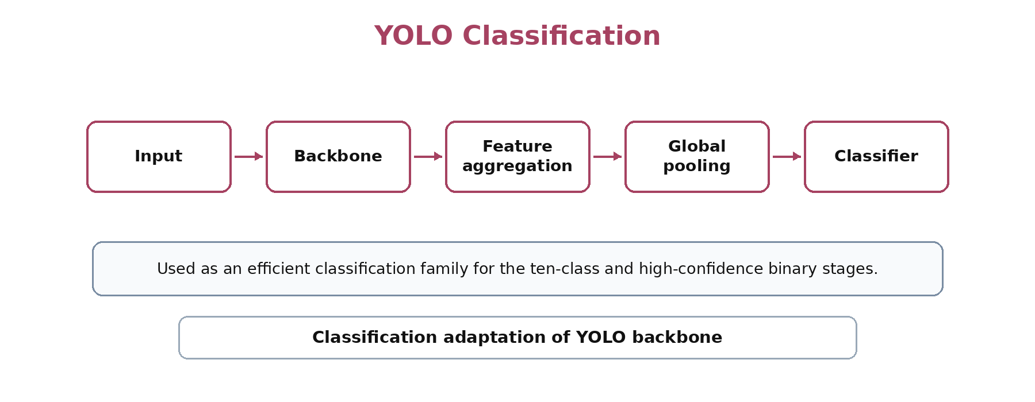
Figure ‎3.11 YOLO classification pipeline used as an efficient model family.

3.4.8 FocalNet
FocalNet was included to provide architectural diversity through focal modulation. It was particularly useful in diagnostic and reduced-class exploration where model diversity was important.
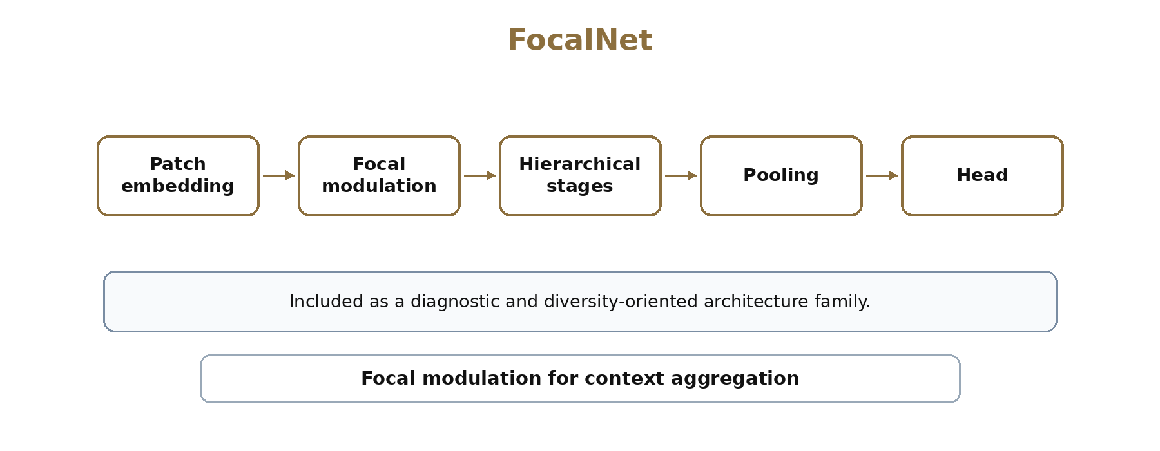
Figure ‎3.12 FocalNet focal modulation architecture concept.

3.4.9 EVA-02
EVA-02 was used as a strong transformer branch in the Galaxy Zoo vote-fraction stage. Its role was to support the final hierarchical framework with a complementary representation to convolutional branches.
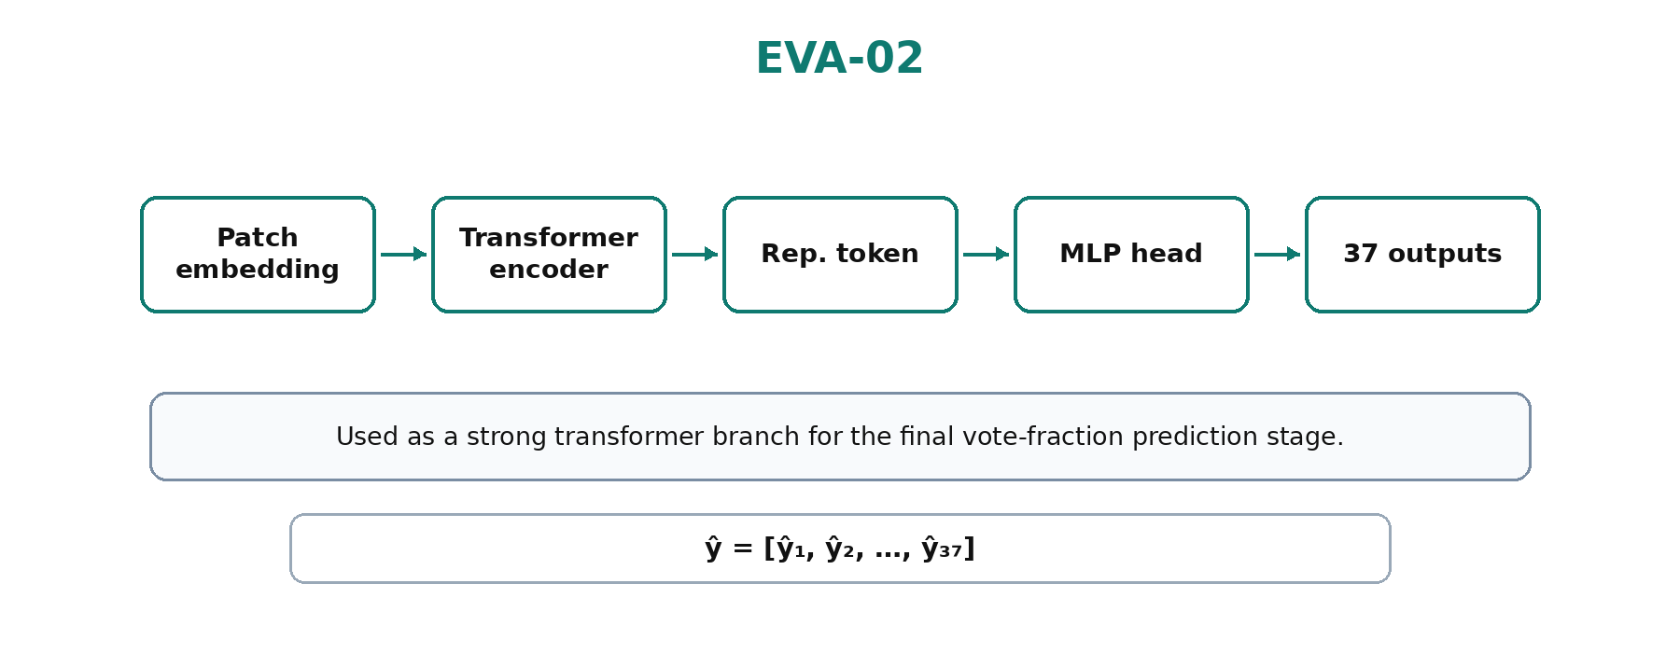
Figure ‎3.13 EVA-02 transformer branch used in the vote-fraction stage.

3.4.10 Ensemble and Hierarchical Prediction
The final methodological design also included ensemble logic. For the Galaxy Zoo hierarchy, model outputs can be combined at the question-group level rather than treated as a single unstructured vector.
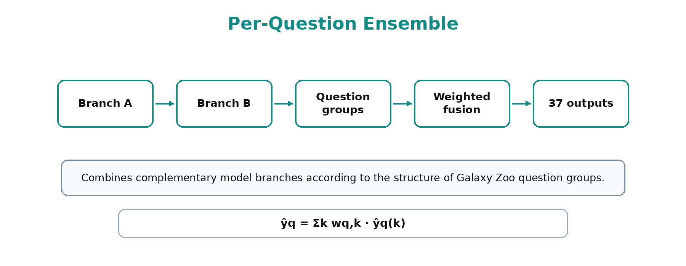
Figure ‎3.14 Per-question ensemble strategy for hierarchical vote-fraction prediction

3.5 Training and Evaluation
Training and evaluation were organized according to the type of prediction task. The Galaxy10 DECaLS experiments were treated as multi-class classification, where the model output is a probability distribution over morphology classes. The high-confidence Smooth versus Featured stage was treated as binary classification. The Galaxy Zoo Challenge stage was treated as multi-output vote-fraction prediction, where the model predicts a continuous 37-dimensional morphology vector. This separation ensured that the training objective, output representation, and evaluation strategy matched the structure of each task.
For multi-class classification, the model output was converted to class probabilities using softmax:
ŷᵢ = exp(zᵢ) / Σⱼ exp(zⱼ)
The classification objective was categorical cross-entropy:
LCE = −Σᵢ yᵢ log(ŷᵢ)
For the Galaxy Zoo 37-output prediction task, the evaluation metric is RMSE because the targets are continuous vote fractions rather than discrete class labels:
RMSE = √[(1/N) Σᵢ (yᵢ − ŷᵢ)²]
Evaluation was not limited to a single score. The classification stages used accuracy, precision, recall, F1-score, confusion matrix analysis, and qualitative inspection. The vote-fraction stage used RMSE and per-output or per-question analysis. Reliability-oriented evaluation included robustness testing, uncertainty or disagreement analysis, and interpretability using Grad-CAM or saliency maps.
H(ŷ) = −Σᵢ ŷᵢ log(ŷᵢ)
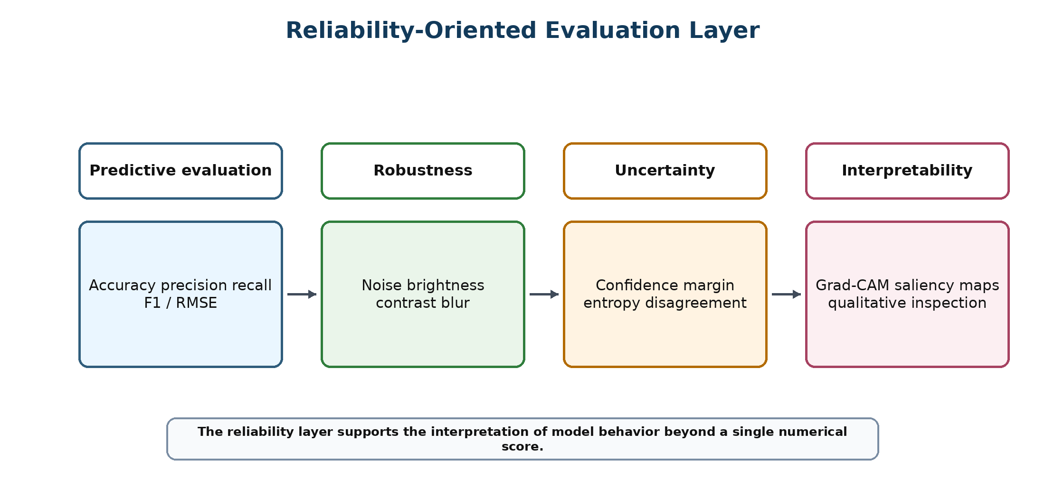
Figure ‎3.15 Reliability-oriented evaluation layer of the proposed methodology.
In summary, the methodology in this chapter connects controlled galaxy morphology classification with a broader confidence-aware hierarchical framework. The methodology described in this chapter provides the basis for the experimental evaluation and discussion presented in the following chapter.

Chapter 4: Experimental Results and Discussion

Chapter 5: Conclusion and Future Work

References
[1] [Walmsley, M., et al., 2022] Walmsley, M., Lintott, C., Galloway, M., et al. “Galaxy Zoo DECaLS: Detailed visual morphology measurements from volunteers and deep learning for 314,000 galaxies”. Monthly Notices of the Royal Astronomical Society 509(3), pp. 3966–3988, 2022. DOI:10.1093/mnras/stab2093

[2] [Dieleman, S., et al., 2015] Dieleman, S., Willett, K. W., and Dambre, J. “Rotation-invariant convolutional neural networks for galaxy morphology prediction”. Monthly Notices of the Royal Astronomical Society 450(2), pp. 1441–1459, 2015. DOI:10.1093/mnras/stv632

[3] [Bhambra, P., et al., 2022] Bhambra, P., Joachimi, B., and Lahav, O. “Explaining deep learning of galaxy morphology with saliency mapping”. Monthly Notices of the Royal Astronomical Society 511(4), pp. 5032–5041, 2022. DOI:10.1093/mnras/stac368

[4] [Hubble, E., 1936] Hubble, E. “The Realm of the Nebulae”. Yale University Press, 1936.

[5] [de Vaucouleurs, G., 1959] de Vaucouleurs, G. “Classification and Morphology of External Galaxies”. Handbuch der Physik 53, pp. 275–310, 1959. DOI:10.1007/978-3-642-45952-8_12

[6] [Lintott, C. J., et al., 2008] Lintott, C. J., Schawinski, K., Slosar, A., et al. “Galaxy Zoo: morphologies derived from visual inspection of galaxies from the Sloan Digital Sky Survey” Monthly Notices of the Royal Astronomical Society 389(3), pp. 1179–1189, 2008. DOI:10.1111/j.1365-2966.2008.13689.x

[7] [Domínguez Sánchez, H., et al., 2018] Domínguez Sánchez, H., Huertas-Company, M., Bernardi, M., Tuccillo, D., and Fischer, J. L. “Improving galaxy morphologies for SDSS with Deep Learning”. Monthly Notices of the Royal Astronomical Society 476(3), pp. 3661–3676, 2018. DOI:10.1093/mnras/sty338

[8] [Luo, Z., et al., 2025] Luo, Z., Chen, J., Chen, Z., et al. “Galaxy Morphology Classification via Deep Semi-supervised Learning with Limited Labeled Data”. The Astrophysical Journal Supplement Series 267(2), Article 45, 2025. DOI:10.3847/1538-4365/ad1f0c

[9] [Yao, H., et al., 2024] Yao, H., Liu, Y., and Zhao, D. “A Galaxy Image Augmentation Method Based on Few-shot Learning”. Research in Astronomy and Astrophysics 24(3), Article 035005, 2024. DOI:10.1088/1674-4527/acf92c

[10] [Le, T., et al., 2025] Le, T., Ibrahim, N., Nguyen, T., et al. “Enhanced Comparative Analysis of Pretrained and Custom Deep Convolutional Neural Networks for Galaxy Morphology Classification”. Engineering Proceedings 89(1), Article 36, 2025. DOI:10.3390/engproc2025089036

[11] [Xie, Y., et al., 2024] Xie, Y., Zhang, H., and Wang, L. “Galaxy Morphology Classification Based on VGG19 Deep Convolutional Neural Network”. Astrophysics and Space Science, Article 369, 2024. DOI:10.1007/s10509-024-04124-8

[12] [Cheng, T., 2022] Cheng, T. “Vision Transformer Applications for Galaxy Morphology Classification”. The Astrophysical Journal 935, Article 34, 2022. DOI:10.3847/1538-4357/ac6a52

[13] [Cao, J., et al., 2024] Cao, J., Wu, H., Zhang, Y., et al. “Galaxy morphology classification based on Convolutional Vision Transformer”. Astronomy & Astrophysics 683, A44, 2024. DOI:10.1051/0004-6361/202348544

[14] [Urechiatu, R., et al., 2024] Urechiatu, R., and Frincu, M. “Improved Galaxy Morphology Classification with Convolutional Neural Networks”. Universe 10(6), Article 230, 2024. DOI:10.3390/universe10060230

[15] [Bom, C. R., et al., 2024] Bom, C. R., Mendes de Oliveira, C., Rembold, S. B., et al. “An extended catalogue of galaxy morphology using deep learning in the S-PLUS survey”. Monthly Notices of the Royal Astronomical Society 528(3), pp. 4188–4203, 2024. DOI:10.1093/mnras/stae277

[16] [Wei, Y., et al., 2024] Wei, Y., Zhang, H., and Liu, Q. “Galaxy morphology classification using Vision Transformer architectures”. Astronomy and Computing 48, Article 100827, 2024. DOI: 10.1016/j.ascom.2024.100827

[17] [Almeida, J., et al., 2024] Almeida, J., Rodrigues, F., and Silva, P. “Transfer Learning for Galaxy Morphology Classification using Deep Convolutional Networks”. Astrophysics and Space Science 369, pp. 101–110, 2024. DOI:10.1007/s10509-024-04175-x

[18] [Zhang, Y., et al., 2024] Zhang, Y., Li, H., Chen, X., and Wang, J. “Attention-based Deep Learning Framework for Galaxy Morphology Classification”. Astronomy and Computing 47, Article 100810, 2024. DOI: 10.1016/j.ascom.2024.100810

[19] [Zhu, X.-P., et al., 2019] Zhu, X.-P., Dai, J.-M., Bian, C.-J., Chen, Y., Chen, S., and Hu, C. “Galaxy morphology classification with deep convolutional neural networks”. Astrophysics and Space Science 364, Article 55, 2019. DOI:10.1007/s10509-019-3540-1

