 | Midocean Journal for Research and Studies  https://  e-ISSN:

Enhancing Glaucoma Diagnosis Using Deep Learning Technique

Abdullah Al-Mardi

0009-0003-3777-6021

MSc in Artificial Intelligence -College of Information -Midocean University- UAE

Email: a.almardi@gmail.com

Dr. Hager Saleh 0000-0001-6184-7107 Computer Science and Artificial Intelligence, College of Information, Midocean University- UAE, Email: hager.saleh.fci@gmail.com

Abstract:
Glaucoma ranks among the top causes of permanent blindness globally, making early detection and accurate diagnosis to mitigate vision loss. Recent deep learning and machine learning growth have significantly improved glaucoma detection through medical image analysis. This study, conducted in Riyadh, Saudi Arabia, presents a novel hybrid deep learning and machine learning framework for automated glaucoma detection by integrating Convolutional Neural Networks (CNNs) for feature extraction, Principal Component Analysis (PCA) for dimensionality reduction, and eXtreme Gradient Boosting (XGBoost) for classification. The proposed approach employs two pretrained CNN models—ResNet50 and VGG-16—to extract spatial and texture-related features optimised using a two-stage PCA process. To address the class imbalance commonly found in medical datasets, the Synthetic Minority Oversampling Technique (SMOTE) was applied. The framework was evaluated using publicly available datasets (ORIGA, REFUGE, and G1020), achieving an accuracy of 97.24% with XGBoost. The findings demonstrate the potential of deep learning-based feature extraction and ensemble machine learning for enhancing diagnostic accuracy in medical imaging.

Keywords: Glaucoma detection, Deep learning, CNN, PCA, XGBoost, SMOTE

- Introduction:
Glaucoma is a degenerative eye disease that harms the optic nerve, resulting in vision impairment and possibly blindness if not treated. At present, over 79.6 million people globally are affected by glaucoma, a figure projected to increase to 111.8 million by 2040 (Tham et al., 2014). Early detection and swift treatment are essential for effectively managing this disorder. Conventional diagnostic techniques, such as measuring intraocular pressure and evaluating the optic nerve head, depend on the skills of ophthalmologists and may lead to varying interpretations in different clinical settings (Chen et al., 2021).

Recently, artificial intelligence (AI) has been recognized as a valuable resource in the field of medical image analysis, offering increased automation and improved precision in diagnosing diseases. (Gulshan et al., 2016). Deep learning methods, particularly Convolutional Neural Networks (CNNs), have shown remarkable success in medical image classification tasks. (Esteva et al., 2017). Nevertheless, these deep learning models frequently generate high-dimensional feature representations, which can lead to increased computational complexity and a heightened risk of overfitting (Shen, Wu, & Suk, 2017). To mitigate these issues, Principal Component Analysis (PCA) is often utilized for reducing dimensionality, enabling effective feature extraction while preserving essential information (Jolliffe & Cadima, 2016).

Importance of the Study:
Medical datasets frequently face class imbalance, characterized by a significantly higher number of non-glaucoma cases compared to glaucoma cases. This imbalance can lead to a bias in machine learning models towards the majority class, which can result in suboptimal generalization (He & Garcia, 2009). To address this concern, the Synthetic Minority Oversampling Technique (SMOTE) is employed to generate synthetic samples and achieve a balanced dataset (Chawla et al., 2002).

This research introduces a hybrid approach that merges deep learning with machine learning methods for the automatic detection of glaucoma. It utilizes Convolutional Neural Networks (CNN) for feature extraction, Principal Component Analysis (PCA) for reducing dimensionality, SMOTE for balancing data, and eXtreme Gradient Boosting (XGBoost) for classification. The suggested technique takes advantage of deep learning's capability for robust feature representation and applies ensemble learning to improve classification precision.

Study Objectives:
The main objective of this research is to design and evaluate a novel hybrid framework that leverages the advantages of deep learning and ensemble machine learning methods to automate the detection of glaucoma from medical images. More specifically, this study aims to develop a strong pipeline that combines CNNs for deep feature extraction, PCA for reducing dimensionality, and XGBoost for effective classification.

To enhance diagnostic precision and generalizability, this study employs pre-trained CNN models—specifically ResNet50 and VGG-16—to extract features that encapsulate both spatial and textural information from retinal images. A two-step PCA approach is utilized to improve feature representations, which not only reduces computational demands but also minimizes the risk of overfitting. To effectively address the prevalent issue of class imbalance in medical datasets, we implement the SMOTE, thereby fostering a more balanced training environment.

The framework's effectiveness is validated using publicly available datasets (ORIGA, REFUGE, and G1020), showing improved performance over traditional deep learning models. The research aims to enhance AI-assisted ophthalmology by providing a scalable and efficient solution for early glaucoma detection, with the goal of reducing vision loss and improving global public health.

Theoretical Literature of the Study:
This research is based on the theoretical combination of representation learning and ensemble learning, which are two fundamental ideas in contemporary artificial intelligence applications for medical image analysis.

Representation Learning through Deep Learning:
At the heart of this research is the concept of representation learning, where machines autonomously discover the necessary representations for feature detection or classification from raw data. Convolutional Neural Networks (CNNs) exemplify this approach by enabling a hierarchical extraction of features directly from medical images. This study leverages pretrained CNNs such as ResNet50 and VGG-16, thereby utilizing transfer learning—a well-established technique that improves model performance on small, domain-specific datasets by tapping into knowledge gained from larger datasets.
CNN learns feature maps F through convolution operations:
F = W * X + b
Where:
- W = Convolution kernel weights
- X = Input image
- b = Bias term
- ∗= Convolution operation
Dimensionality Reduction using Principal Component Analysis (PCA):
Due to the high-dimensional characteristics of features derived from Convolutional Neural Networks (CNNs), the principles of Principal Component Analysis (PCA) are crucial. PCA facilitates the transformation of intricate feature spaces into lower dimensions while preserving the maximum variance. This theoretical foundation aligns with the study's objective of retaining the discriminative power of features, while also reducing computational demands and minimizing the risk of overfitting.
PCA reduces dimensionality by projecting data onto the top k eigenvectors:
Covariance matrix:
C = (1 / (n-1)) * (X - X̄) ^ T (X - X̄)
Eigen decomposition:
C v = λ v
Where:
- v = eigenvector
- λ= eigenvalue
Transformation:
Z = X V_k​
Where:
- Vk​ = matrix of top k eigenvectors
- Z = reduced feature matrix

Ensemble Learning through eXtreme Gradient Boosting (XGBoost):
Theories of ensemble learning suggest that combining different models leads to better generalization than relying on individual models. XGBoost, a highly advanced gradient boosting framework, embodies this principle by progressively improving weaker learners while reducing both bias and variance. In this study, XGBoost functions as a robust classifier, leveraging the enhanced features obtained from PCA to attain high diagnostic accuracy.
XGBoost minimizes a regularized objective function:
Objective Function:
Where:

Class Imbalance and Data Augmentation Theory (SMOTE):
Addressing class imbalance is crucial in the analysis of medical images. The Synthetic Minority Oversampling Technique (SMOTE) generates synthetic data to address uneven class distributions by creating realistic instances of the minority class. This method helps prevent learning algorithms from becoming biased toward the majority class, thereby improving the fairness and generalisation of the model.
SMOTE generates synthetic samples along the line between examples of the minority class:

Review of Previous Studies:
Numerous research efforts have investigated the use of deep learning to detect glaucoma. Convolutional Neural Networks (CNNs) are frequently employed for automated feature extraction from retinal fundus images, demonstrating better performance than traditional methods like Grey Level Co-occurrence Matrix (GLCM) and Wavelet Transform (Christopher et al., 2018). Pretrained deep learning architectures such as ResNet50, VGG-16, and Inceptionv3 have been utilised to derive high-level visual features, assisting in the classification of glaucoma (Shankaranarayana et al., 2019).

Reducing dimensionality is vital in medical image analysis as it enhances computational efficiency and minimises redundancy in feature representations. Principal Component Analysis (PCA) is commonly applied to reduce high-dimensional feature spaces while retaining significant information (Jolliffe, 2002). Previous studies have shown that PCA can substantially boost model generalisation and training efficiency when integrated with feature extraction using deep learning (Abdi & Williams, 2010).

Medical datasets often face considerable class imbalance, where positive instances (glaucoma) are less frequent than negative instances (non-glaucoma). This discrepancy affects model predictions and diminishes the classifier’s sensitivity (Sun, Wong, & Kamel, 2009). The SMOTE method generates synthetic examples to balance class distributions, enhancing the classifier's capacity to learn from minority instances (Chawla et al., 2002). Earlier research has indicated that implementing SMOTE improves model robustness in the context of medical image classification tasks (Fernández et al., 2018).

XGBoost is a prominent ensemble learning algorithm with exceptional performance when dealing with high-dimensional data (Chen & Guestrin, 2016). Compared to traditional classifiers such as Support Vector Machines (SVM) and Random Forest, XGBoost effectively captures non-linear relationships in the dataset and reduces the risk of overfitting through its gradient boosting approach (Friedman, 2001). Research has demonstrated that XGBoost achieves leading performance in medical image classification tasks, surpassing conventional machine learning techniques (Wang et al., 2020).

Several studies have explored various AI-driven methodologies for glaucoma detection as below:
- Lenka et al. (2025) introduced a graph convolution-based multi-task model that improves segmentation and classification accuracy.
- Akter et al. (2022) utilised a multi-feature analysis approach integrating deep learning for precise diagnosis.
- Civit-Masot et al. (2020) proposed a dual machine-learning system using disc and cup feature extraction, improving classification outcomes.
- Thompson et al. (2020) reviewed deep learning applications in glaucoma screening, emphasizing CNNs’ role in retinal image analysis.
Although these studies show notable progress, issues such as computational complexity, variability in datasets, and restricted generalizability remain.
This study utilises Deep Learning to analyse retinal fundus images for glaucoma detection, emphasising the increasing importance of AI in healthcare research. Convolutional Neural Networks (CNNs) are a popular deep learning method for image recognition and classification. The research combines ensemble ML techniques with CNN models to improve classification accuracy. Specifically, it utilises three models—Random Forest, ResNet50, and VGG-16—to improve diagnostic precision. The Random Forest model evaluates texture features from retinal fundus images using the Grey-Level Co-Occurrence Matrix (GLCM) approach. A detection framework is introduced to classify retinal fundus images as glaucomatous or non-glaucomatous, facilitating reliable and efficient disease identification.

This study introduces an advanced AI-based glaucoma detection system that combines machine learning (ML), CNNs, and image processing. This hybrid method enhances performance by integrating traditional feature extraction with deep learning-based classification.
Year |  | Author(s) | Type | Methodology Employed | Key Findings | Weaknesses/Limitations
2025 | “Glaucoma detection from retinal fundus images using graph convolution based multi-task model” | Satyabrata Lenka, Zefree Lazarus Mayaluri, Ganapati Panda | Article | Multi-task deep learning model using modified U-Net architecture with MobileNetv2 encoder, GCN, decoder, and Attention Module (AM) to segment and classify glaucoma from retinal fundus images. Evaluated on ORIGA, REFUGE, and DRISTI-GS datasets. | Improve segmentation and classification with high accuracy rates: 97.43% for glaucoma detection, an AUROC of 0.985, and Dice coefficients of 97.95% for optic disc segmentation and 96.11% for optic cup segmentation. This model surpasses current methods in both segmentation and classification. | - High cost and High dependency on datasets.  - Potential overfitting to specific datasets, lacking real-world clinical validation.  - Computationally intensive, limiting real-time applicability.  - No comparison with ViTs.
2022 | “Glaucoma Detection and Classification Using Improved U-Net Deep Learning Model | Ramgopal Kashyap, Rajit Nair, Syam Machinathu Parambil Gangadharan, Miguel Botto-Tobar, Saadia Farooq, Ali Rizwan | Article | Multi-feature analysis:  Improved U-Net deep learning model for optic disc (OD) and optic cup (OC) segmentation. CNN-based classifier for glaucoma detection. Evaluated on public fundus image datasets. | Improved diagnostic accuracy  The Enhanced U-Net provides superior segmentation for OD and OC, ensuring high accuracy in glaucoma detection through an effective blend of segmentation and classification techniques. | - Complexity in feature integration  No comparison with Transformer-based models.  - Resource-intensive for immediate applications.  - Lacks real-world clinical validation.  - No explainability (XAI) mechanisms for clinical adoption.
2024 | “Glaucoma diagnosis in the era of deep learning: A survey” | Mona Ashtari-Majlan, Mohammad Mahdi Dehshibi, David Masip | Survey | CNNs, Hybrid CNN-Transformers, Vision Transformers (ViTs), RNNs, and self-supervised learning approaches.  Evaluates models on ORIGA, REFUGE, DRISTI-GS, RIM-ONE, and ACRIMA datasets. | Hybrid CNN-transformer models outperform traditional CNNs in detecting glaucoma. Self-supervised learning reduces dependence on labeled datasets. Vision Transformers (ViTs) demonstrate strong generalization capabilities in medical imaging. This highlights the essential importance of Explainable AI (XAI) in clinical applications. | - Lacks experimental validation and model benchmarking.  - Ignores the computational expenses and challenges of implementing in real-time.  - Limited discussion on regulatory and ethical issues in AI-based glaucoma dia
2020 | “Dual Machine-Learning System to Aid Glaucoma Diagnosis Using Disc and Cup Feature Extraction | J. Civit-Masot, M. J. Domínguez-Morales, S. Vicente-Díaz, A. Civit | Article | Feature Extraction by using a dual machine learning system (disc and cup)  Utilises Random Forest, SVM and Gradient Boosting for glaucoma classification.  Implements explainable AI (XAI) for interpretability. | Adept Glaucoma Classification  Achieved high accuracy in glaucoma detection using handcrafted feature extraction methods. Ensemble models like Random Forest (RF) and Gradient Boosting (GB) outperform single classifiers. These techniques also offer greater computational efficiency compared to deep learning models. Explainable AI (XAI) enhances clinical trust. | - Narrow generalisation.  Fails to compare with deep learning (CNNs, ViTs).  - Depends on manually crafted features, potentially restricting learning ability.  - Omits discussion on dataset generalisation or validation in real-world contexts.  - Does not investigate self-supervised learning or transformer architectures.

Methodology:
The proposed methodology for glaucoma detection integrates deep learning-based feature extraction, dimensionality reduction using Principal Component Analysis (PCA), synthetic data augmentation with the Synthetic Minority Oversampling Technique (SMOTE), and classification using eXtreme Gradient Boosting (XGBoost). The pipeline begins with data preprocessing, where retinal fundus images are resized to 224×224 pixels to maintain consistency with deep learning models. The images are then normalized to scale pixel values within a standard range, followed by noise removal techniques such as median filtering to enhance feature clarity.
For feature extraction, two pretrained Convolutional Neural Networks (CNNs), ResNet50 and VGG-16, are employed to extract deep spatial and texture-related features. ResNet50 generates a 2048-dimensional feature vector representing high-level structural patterns in retinal images. Meanwhile, VGG-16 initially produces a 25,088-dimensional feature vector, which is too high-dimensional for efficient model training. To reduce computational complexity and minimize overfitting risks, PCA-based dimensionality reduction is applied in two stages. First, PCA reduces the VGG-16 feature output from 25,088 to 512 dimensions, preserving the most critical feature representations. In the second stage, the combined feature vectors from ResNet50 and VGG-16 (2560 dimensions in total) undergo further PCA reduction to 1024 dimensions, ensuring optimal model performance while retaining crucial information.
Given the inherent class imbalance in medical imaging datasets, particularly in glaucoma classification, SMOTE is implemented to generate synthetic samples of underrepresented glaucoma cases. This resampling technique ensures that both classes—glaucoma and non-glaucoma—are equally represented, thereby improving the classifier’s generalization and reducing bias toward the majority class.
For classification, an ensemble learning approach is employed. Initially, a Random Forest classifier was trained on the extracted feature vectors, but it achieved only 66% accuracy, indicating its limitations in handling deep learning feature representations. To overcome these challenges, XGBoost, an advanced gradient boosting algorithm, was employed due to its ability to optimize non-linear relationships and handle high-dimensional data efficiently. The XGBoost model was trained on the optimized 1024-dimensional feature vectors, with hyperparameters tuned for log loss minimization to enhance classification performance.

Results:
Experimental setup
The hardware configuration of the experimental platform is an Intel Core i9-10850 CPU, the graphics card is RTX 2080, the memory is 8G, the operating system is Windows 11 system, and the models were implemented based on the Python and PyTorch framework.

For setting the model parameters:
- XGBoost was used as the classifier, and log loss was used as the evaluation metric along with classification error. The number of estimators was set to 1000 with early stopping rounds of 20. Learning rate was 0.01, max depth was 6, and both subsample and colsample_bytree were set to 0.8. Regularization was applied using reg_alpha=0.5 and reg_lambda=1.0. The model was trained using a batch-wise boosting approach with evaluation on both training and validation sets.

- The Random Forest Classifier was utilized: 250 estimators (trees), a random seed of 42 for reproducibility, and the model was trained using all available CPU cores (n_jobs=-1) However, when using the optimization parameters: n_estimators set to 300, max_depth set to 10, min_samples_split set to 5, min_samples_leaf set to 4, and bootstrap set to True, the accuracy of the model decreased.
We used ResNet50 as a type of ResNet. The ResNet50 model is characterized by the following architectural parameters: Number of Layers: 50, Residual Blocks: 16, Number of Filters: (64, 128, 256, 512), Kernel Size: 3x3, and Downsampling: Every 3rd Layer.

The models were trained using 80% of the total dataset, validated using 10%, and tested with 10%. The dataset was split using stratified methods, ensuring that the proportions of classes in the training, testing, and validation sets are approximately preserved. Table provides a summary of the training, validation, and testing sets after applying the resampling technique and other pre-processing steps. The reported results are based on the testing set only.

Approaches | Models | Accuracy | Precision | Recall | F1-score | AUC-PR
Pre-trained CNN | ResNet50 | 84 | 82 | 79 | 81 | 93
Pre-trained CNN | MobileNet | 63 | 66 | 92 | 77 | 34
Pre-trained CNN | Inception v2 | 65 | 67 | 95 | 79 | 27
Pre-trained CNN | EfficientNet | 66 | 68 | 92 | 79 | 37
Transformer | ViT | 63 | 67 | 91 | 77 | 32
Transformer | Swin | 66 | 68 | 93 | 78 | 32
Hybrid models | Hybrid -XGBoot | 97.2 | 95 | 100 | 97.4 | 98
Hybrid models | Hybrid - Random Forest | 96.55 | 93 | 100 | 97 | 99
Table shows the performance of different models: Based on different evaluation methods Accuracy, Precision, Recall, F1-score.
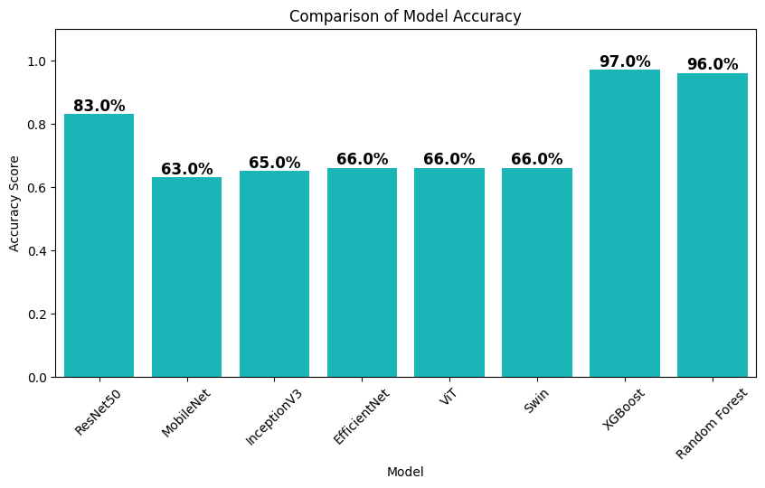
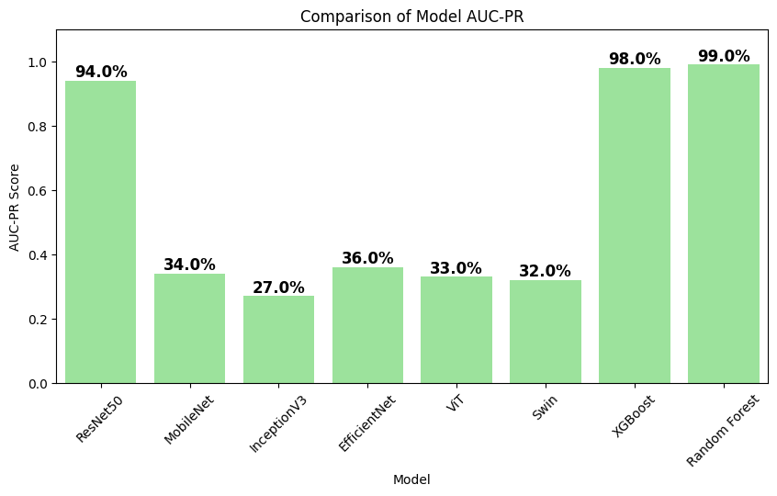
Figure (1)

Conclusion and Discussion of Results
This research presents a hybrid AI-driven glaucoma detection framework that integrates deep learning-based feature extraction (ResNet50, VGG-16), dimensionality reduction (PCA), and advanced classification (XGBoost). The proposed model achieved an accuracy of 97.24%, significantly improving upon traditional machine learning methods. The study also demonstrated the effectiveness of PCA in reducing feature dimensions and the importance of SMOTE in addressing class imbalance. XGBoost outperformed Random Forest, highlighting the significance of gradient boosting in medical image analysis.

Future research can explore the use of Vision Transformers (ViTs) for further performance improvements, self-supervised learning techniques to reduce reliance on labeled datasets, and Explainable AI (XAI) models to provide clinicians with interpretable results. In conclusion, this study demonstrates the potential of deep learning and ensemble machine learning for automated glaucoma detection, offering a reliable, high-accuracy solution for early diagnosis and improved clinical decision-making.

Recommendations
The recommendations should be relevant to the study's objectives on both scientific and practical levels, along with offering some research suggestions.

References list
- Akter, N., Fletcher, J., Perry, S., et al. (2022). Glaucoma diagnosis using multi-feature analysis and a deep learning technique. Scientific Reports, 12, 8064. https://doi.org/10.1038/s41598-022-12147-y
- Civit-Masot, J., Domínguez-Morales, M. J., Vicente-Díaz, S., & Civit, A. (2020). Dual Machine-Learning System to Aid Glaucoma Diagnosis Using Disc and Cup Feature Extraction. IEEE Access, 8, 127519-127529. https://doi.org/10.1109/ACCESS.2020.3008539
- Haja, S. A., & Mahadevappa, V. (2023). Advancing glaucoma detection with convolutional neural networks: a paradigm shift in ophthalmology. Romanian Journal of Ophthalmology, 67(3), 222-237. https://doi.org/10.22336/rjo.2023.39
- Lenka, S., Mayaluri, Z. L., & Panda, G. (2025). Glaucoma detection from retinal fundus images using graph convolution-based multi-task model. E-Prime - Advances in Electrical Engineering, Electronics and Energy, 11, 100931. https://doi.org/10.1016/j.prime.2025.100931
- Thompson, A. C., Jammal, A. A., & Medeiros, F. A. (2020). A Review of Deep Learning for Screening, Diagnosis, and Detection of Glaucoma Progression. Translational Vision Science & Technology, 9(2), 42. https://doi.org/10.1167/tvst.9.2.42

