
Midocean University
Management College
Department of MSc Risk Management Department

Impact of Risk management strategies on performance of Industrial Companies: ”Sankyu Company as Case Study

Team Leader

Eng: Othman Algarni
ID:233001399
Participants:
Eng: Abdullah Adel Jumeh
ID:233001327

Year 2024-2025

Chapter one
  - Introduction
Each firm encounter hazards that could constitutes threats to its productivity . Risk is the potential of an action and its effects. managing is the practice of utilizing operations, techniques and tools to manage these hazards. It concentrates on determining what could occur wrong, assessing which hazards should be processed with and executing practices and procedures to address those hazards (Kádárová and Durkáčová, 2012). Industrial firms accustomed to
encounter several events that can result in adverse influence, positive influence, or both. Actions or accidents with a adverse influence presents hazards, that can prevent creating value or gnaw current value. Actions or accidents with positive influence can offset negative influences or presents chances. Chances are the potential that an action will happen and positively influence the fulfilment of goals. Hazards are the potentials that actions will happen and negatively influence the fulfilment of goals. Enterprise risk management (ERM) addresses hazards and potentials influencing value creation or preservation, consequently should be a central portion of any their strategic administer. In general, it is a strategic operation that assists and supports making decision at both strategic and operational levels in a firm. Improved understanding and management of all risks potential to influence the firm will result in better performance and competitive benefits, in particular when risks and threats are determined , and the hazards evaluated and controlled, in the same way as for chances and incentives (Mark,2021).
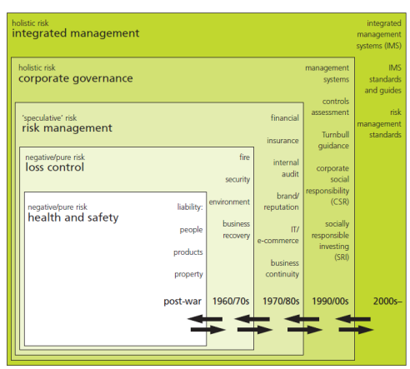
Figure 1.1 BRM Development Since 1945(Mark,2021)
This study addresses identifying potential risks in Industreial companies in Saudi Arabia in addition to develop risk management guidelines can be beneficial contribution of Industrial sector in Saudi Arabia to set emergency plan response of potential risks in the Saudi Industrial Companies and upgrade the risk management strategies in Saudi industrial Companies.

  - Problem Statement
The industrial companies is considered the basis of any country's economy and thus should be take interest to a high degree of standard to be robust, self-sustaining, and self-reliant. (Oduoza,2020) Nowadays, the manufacture is encountering numerous limitations due to competition, regulations, international standards, globalisation and technology development (Naradda et al.,2020) . Industrial companies demand to be flexible to react rapidly to incessant client requirements and respond to a dynamic production ecology .In order to attain the mentioned goals, the manufacturing field should require to have awareness and enough knowledge of a broad variety of dangers particular correlated to risks correlated in manufacturing, operating and maintenance in industrial companies(Ghouri, et al.,2020). Risk management consequently, could constitute a great limitation for business directors in particular in the industrial engineering field, and if not proactively controlled may result in poor performance and sometimes hindering activities for some firm. It is popular that poorly managed hazards can have an negative impact on performance while proactive and systematic control of major hazard variables in a business ecology could develop successful results(Oduoza,2020).
All manufacturing and operating companies encounter unfavourable and undesirable setback in daily operations. These are indicated by operational troubles in this study. The disturbances set the company at production, economic and occupational hazards and consequently this study targets Saudi industrial companies in the field of manufacturing, maintaining and operating mechanical mechanisms since the Saudi nation considers the most that depends on manufacturing and seeks to improve engineering industry and to achieve the goal of this study, establishing risk management guidelines in the field of engineering industries related to manufacture ,operating and maintenance field is mandatory to define all potential hazards in addition to establish response management plan to respond potential risks.
Sankyu Company was selected as a case study in Saudi Arabia because it represents the largest companies in various engineering services, especially in the areas of manufacturing, maintenance and operation of heavy equipment and machinery (Islam & Tedford,2012).
This study processes the research gaps by establishing risk management plan can be generalized on industrial Saudi companies in The field of manufacturing, operating and maintenance of plants and equipment in the field of engineering services in order to upgrade performance of Saudi industrial Companies and enhance industrial production
1.3 Theoretical Premises of the study
The theoretical premises of the study comprise the following Hypothesis:
- Operational risks negatively affect the quality and cost of Saudi products in the engineering industry
- Health risks negatively affect the quality and cost of Saudi products in the engineering industry
- Compliance risks negatively affect the quality and cost of Saudi products in the engineering industry
- Operational risks negatively affect the quality and cost of Saudi products in the engineering industry
- Financial risks negatively affect the quality and cost of Saudi products in the engineering industry
- Adopting efficient risk management plan positively affect the quality and cost of Saudi products in the engineering industry
  - Research Significance
Having awareness the influence of risk management on performance of industrial companies consider critical from academic and practical Aspect:
-Academic Aspect by support the Literature and academic research on risk management in industrial firms by adding beneficial contribution via discovering and ordering factors that impact risk management. It assists to develop a strong awareness of risk management strategies and their consequences.
determining the most significant potential risks impacting risk management, as operating hazards, maintenance hazards and manufacturing hazards according to several aspects comprise environmental aspects, financial aspects in addition to other factors. These visions can add academic research discussions and establish a basis for further research.
-Practical Aspect:
Upgrading enterprise Performance in which the efficient risk management positively influence performance of industrial companies. strategies as danger reduction, identification, evaluation , and controlling achieve a great role in attaining better results.
Reducing Risks: By understanding risk factors, companies can develop strategies and policies to reduce risks. This immediately influences their financial profit, operational effectivity, and productivity .Also, In the field of project management, adopting risk management strategies upgrade performance of project by reducing probable dangers. establishing efficient risk management enable the industrial companies to make decisions that can utilize risk management practices and allocate resources efficiency, and enhance the total performance of industrial companies.
Consequently, the importance of this study from a theoretical standpoint is to enrich the academic side with evidence about all the risks resulting from manufacturing, operation and maintenance in industrial companies in the Kingdom of Saudi Arabia, in addition to finding the necessary solutions and measures to mitigate the risks.
This study is also useful from an applied perspective to inform heavy equipment and machinery maintenance companies of the potential risks during operation, maintenance and manufacturing.
  - Research Objective
This study aims to evaluate the effectiveness of risk management in Saudi industrial companies specialized in the maintenance, operation, and manufacturing of heavy equipment and machinery, as it is one of the specializations that most faces many risks that negatively affect the quality and cost of the studied and implemented projects. This study also aims to achieve a number of sub-objectives, which are:
- Identifying operational risks, financial risks, strategic risks and health risks that faces industrial companies in Saudi Arabia
- Assessment risks that are identified previously in order to investigate the severity and magnitude of the risks.
- Suggesting strategic solutions in each field to treat and process the potential risks in case study company.
- Addressing impact of risks that will be identified on the cost and quality products in the industrial companies.
  - Research Question
In order to study impact of risk management on performance of industrial companies ,this study answers the following questions:
1-what are the potential risks that can be identified in Saudi Industrial companies?
2- What are the most significant risks that affect Saudi industrial companies?
3- To what extent the suggested risk management techniques reduce potential risks?
- How can risk management strategies influence the performance of industrial companies?

Chapter Two
Theoretical Framework and Literature Review
2.1 Introduction
This chapter offers extensive theoretical framework of potential risks definition in addition risk management concept and explains risk mitigation techniques .Also, This chapter discuss the prior contributions of researcher in risk management in industrial companies. Moreover, this chapter provide extensive review of potential risks in industrial companies from the following several aspects: operational risks, health risks, financial risks, strategic risks and compliance risks.
2.2 Theoretical framework
2.2.1 Risk
Enterprises encounter a wide scope of hazards every day that can influence their capacity to fulfil specific business goals and preserve their business. Risk evaluation is a significant and developed operation utilized to evaluate an organization’s hazards so that it can lessen and reduce hazards to an acceptable degree. Risk indicates the uncertainty that surrounds future accidents and results. It is expressed of the potential and influence of an event with the potential to impact the fulfilment of an enterprise's goals (Uzorh, 2017)
2.2.2 Risk Management
Two several safety management concepts can be noted: safety management based on consequence supposes that the most potential events at an installation should not include consequences external specific limits, and therefore design regimes under safety to insure this. Risk management that means risk based safety management insure that the remaining hazards must be analysed both with respect to the potential and the risk nature, and thus inform for more risk reduction. This means that unexpected events may be tolerated. Risk management is not novel instrument and a lot of leglisations and guidelines are obtainable (ACT 2004, AZ/NZS 2004, Committee 2004). It is an integral part of good management and making decisions at all organization levels. All organization departments manage hazard regularly whether they recognized it or not, sometimes more rigorously and systematically, sometimes less. Risk management happens most clearly in those sections whose basic function is to preserve the ecology and public health and safety. currently, an additional generic leglisation on hazard management is prepared as a popular ISO/IEC standard (IEC 2007) explaining a approach top down in addition a functional bottom up systemic as illustrated in Fig. 2.1 ) This leglisation aims to support current industry.
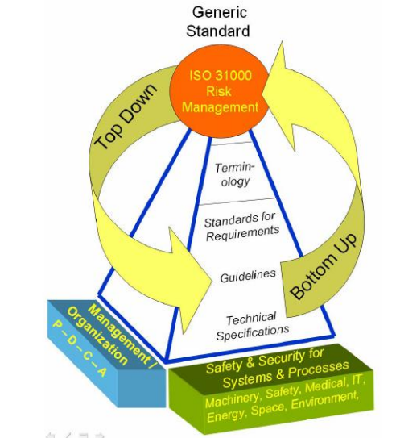
Figure 2.1 planned general leglisation approach on risk management(IEC 2007)

2.2.3 Risk Management Tools
The procedures risk management as illustrated in Fig. 2.2 are:
1. identifying objectives and context such as the risk ecology),
2. defining hazards,
3. Analysing the defined hazards,
4. hazards evaluation
5. Processing or administering the hazards,
6. Monitoring and reviewing the risks and the risk environment continuously, and
7. regular communication, consulting with stakeholders and reporting. Some tools of the risk management are explained in (IEC 2008) and (Oehmen 2005).
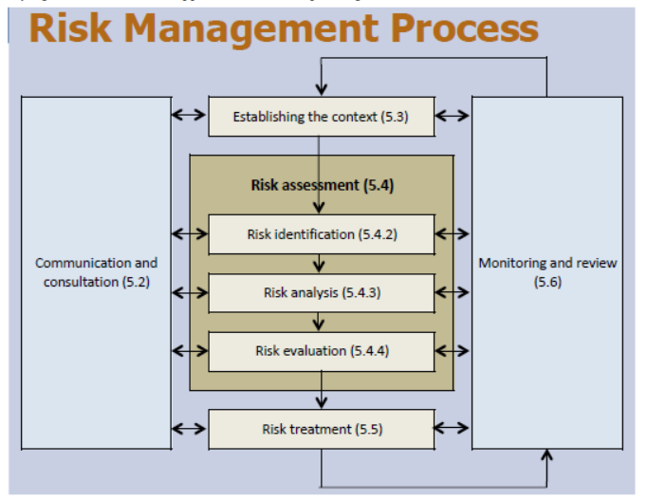
Figure 2.2 Tools of Risk Management

The procedures of risk management requires several steps are illustrated in Figure 2.3
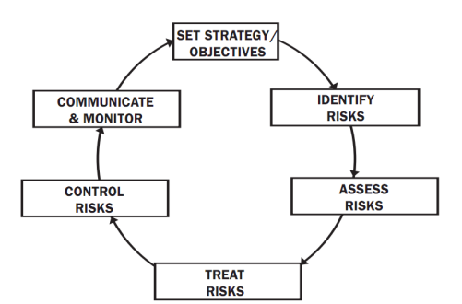

Figure 2.3 The procedures life cycle of hazards management (Paul and Willliam,2018).
This procedures include identification, assessment and control, in addition to monitor process, audit and review stages common to all efficient management systems.
Figure 2.4 shows the organization’s strategic objective through risk assessment that include :Risk assessment, Risk evaluation, Risk reporting and monitoring
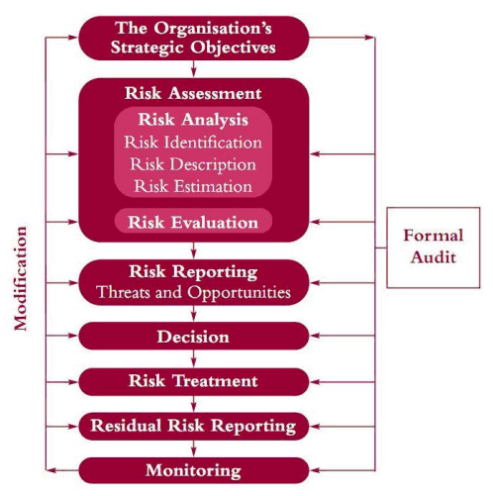
Figure 2.4 Risk Management Procedures
To create this efficient management system, all sections of the firm contribute basic views: Senior executives identify the degree of risk a firm can stand. They express their risk desire in concrete terms like profits fluctuation and possible losses of capital, equity or assets; The risk organization, in cooperation with line managers, continuously examines the possible influence of several hazards (such as strategic, business, financial and operational hazards) on the enterprise (RIGBY, D. – BILODEAU,2009). They make a decision whether to avoid the exposure fully, efficiently reduce it (for instance, via a transform to another party) or utilize the firm hazard perspective and risk management abilities as a chance to create more profit from the exposure; Line managers embed risk management concepts into everyday business decisions and activities; Managers separate risk-taking and risk monitoring responsibilities to prevent possible conflicts of interest.
Risks results from manufacturing and operating in industrial companies are categorized into the following types: strategic risks, financial risks, operational risks and compliance risks.
2.2.4 Identifying Objectives and context
This step can give knowledge of the ecology in which the respective organization operates, which indicates to comprehensive understand the exterior ecology and the interior organization culture.
The analysis is executed via:
− identifying the strategic, organizational and risk management of the enterprise, and
− defining the limitations and chances of the operating ecology.
2.2.5 risks Identification
The proper risk determination technique will based on the area of utilization (activities nature and the
hazard set), the project nature, the project stage, resources ,leglisation and client demands as to goals , desired result and the demanded level of details.
The following tools utilization and methods might further help the determination of hazards:
− Potential risk resources identification,
− List of probable business risks and cheat hazards,
− Typical hazards in phases of the procurement operation,
− Planning of Scenario as a hazard evaluation instrument,
− Process mapping, and
− Documentation, relevant audit reports, program evaluations and / or research reports.
2.2.6 risk Analyzation
Risk analysis requires taking into account the risk source , the effects and probability to evaluate the inherent .In addition, It requires determination of the controls, an assessment of their effectiveness and the resultant degree of hazard with controls in place. Often qualitative methods can be utilized for investigating hazards while more hazards are being exposed to more expensive quantitative methods as demanded. Risks can be evaluated in qualitative and quantitative method utilizing instruments as hazard matrices, hazard graphs, hazard matrices. Utilizing the hazard matrix, it is demanded to identify for each hazard its profile utilizing probability and consequences standard. Typical definitions of the likelihood and consequence are contained in the risk matrix are illustrated in Table 2.1
Table 2.1 Risk Matrix
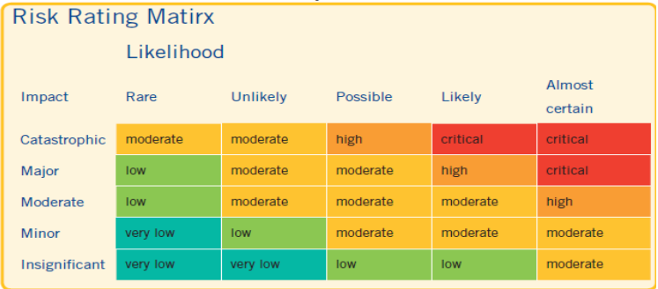
2.4 Assessment the risk
As soon as the hazards have been analysed, they can be compared versus the documented earlier and accepted tolerable hazard standard. When utilizing hazard matrices this tolerable risk is generally documented with the hazard matrix. If the protected hazard be higher than the tolerable hazard than the certain hazard requires more control procedures or enhancements in the effectiveness of the current controls.
2.2.7 The risk Treatment
An unacceptable hazard demands treatment. The goal of this phase of the hazard evaluation operation is to develop cost efficient option for addressing the hazards.
Treatment options (as illustrated in Fig. 2.5 ),which are not necessarily mutually exclusive or appropriate in all conditions, are depends on results that comprise:
− the risk avoidance,
− the risk reduction
− Transferring (sharing) the risk, and
− approving the risk.
the risk avoidance is not executing the activity that is probable to occur the hazard.
Mitigating the risk - controlling the likelihood of the risk occurring, or controlling the influence of the results if the risk happened.
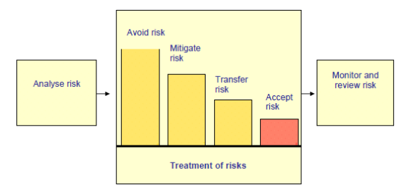
Figure 2.5 Risk Treatment
2.3 Literature review of (Operational,manufacturing ,health,financial, compliance ) Risks in industrial firms
Numerous researches have been addressed the potential risk in industrial companies:
Tupa et al., (2017) mentioned the hazards correlated to manufacturing process management that addresses information risk correlated with missing data, lack of safety and obtainable information. the risks in the field of maintenance comprise with availability and data safety correlated to maintenance. As for Operation techniques and tools utilized the most risks can be noted are mistakes data processing. Machinery and manufacturing techniques that comprise risks related to Sensitivity and vulnerability of data—trouble correlated to cyber-attacks. As for human resources, it is affected by low number of skilled labor. Machine environments: Attacks from Internet network, issues correlated to electromagnetic compatibility and electromagnetic emissions impacting fabricating equipment.

Elfaki & Tayfor, (2023) listed all financial risks that affect on industrial performance of companies and these risks are Fire ,Business Interruption, Loss of Reputation, Physical Business ,Failure to Change Employee, Environmental Risk ,Product Liability ,Computer Crime .
Moktadir et al., (2018) identified the risks faces industrial sector and these strategies include: poor of data security, High investment, shortage technological infrastructure, Unstable communication between firms, reducing job opportunity, shortage strategy towards Industry, Environmental side-impacts, Complexity in reconfiguring of production pattern, shortage skilled management team, Complexity in integrating IT and OT.
Moeuf et al.,(2020) verified the risks that faces construction industry and found that main danger is the shortage of experience in in manufacture sector. It was found that industrial companies were poorly prepared with competence in support functions. The second danger is the short-term planning of industrial firms. The third danger defined is the technological improvement speed, that carries the danger of obsolescence of an investment in technology.

2.4 Beneficial contributions of Evaluating the effectiveness of risk management in industrial companies .
In the fields of risk management in industrial organizations, several studies conducted researches in order to evaluate the effectiveness of risk management in industrial companies in addition to upgrade risk management in industrial companies:
Uzorh et al., (2017) carried out a study to explain the several procedures in the risk management operation that techniques are utilized in the several stages, and introduces some instances for hazard and control measures. In this study, Trelleborg AB has been selected as case study to show the challenges that can be found regarding to risk management in a large firm huge with several business fields. In this study, Trelleborg AB has been selected as case study to show the limitations that can be found regarding to risk management in a huge firm with many business fields. One typical challenges is accessing the staff. Another typical limitation is no system existed to control and follow up on the findings of the risk analysis that has been executed.
Nevertheless, not only manufactures but also governmental enterprises, institutes and hospitals are presently providing risk management . the findings found that the outcomes of technical hazard evaluation are one section of an overall risk or safety evaluation of an enterprise or company.
(Islam and Tedford,2012) implemented study in order to develop a conceptual model which explains the general method of risk evaluation and determines the limitations in the evaluation steps that can prevent the successful execution of risk management. An empirical verification with several examples in New Zealand has been performed to verify the model. Finally, a comprehensive framework is improved for successful execution of risk management in industry companies.
(Kádárová and Durkáčová,2012) identified the risk that occurs in industrial companies and categorized them into four types: operational risk, financial risk, strategic risk and compliance risk as illustrated in Figure 2.6
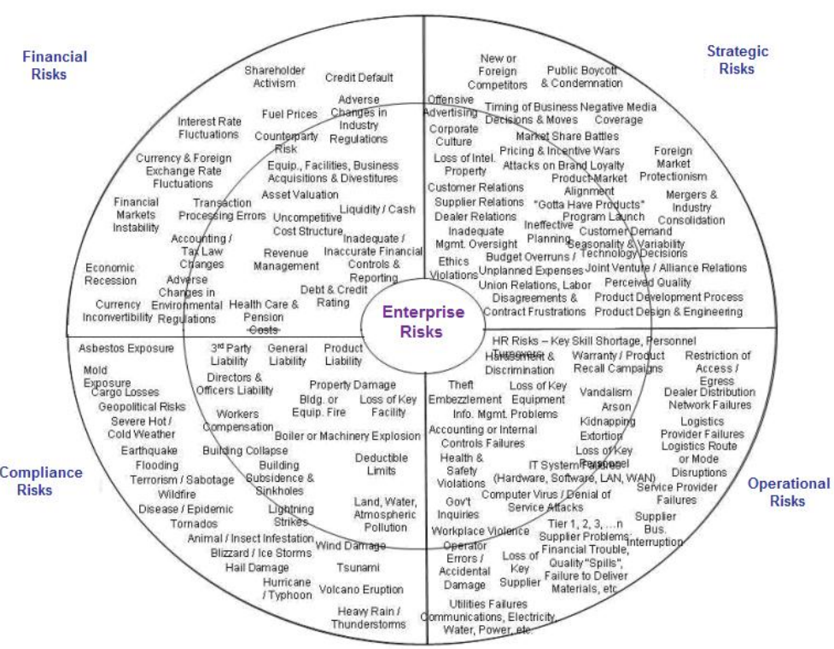
Figure 2.6 Risk Identification by (Islam and Tedford,2012)
The study identified the potential risk that may occur according to each type of risks Moreover , several methods to identify and analyze company hazards were suggested .
Oduoza,(2020) created a planning for risk management suitable for utilization particular by small and medium size companies in the fabricating field. Utilizing an integration of Bayesian Belief Network (BBN) and Analytical Hierarchical Process (AHP) search algorithms, enabled to determine major hazards indicators that can affect on business performance.
Table 2.2 provides comprehensive literature review of the Operational risks in industrial companies
Table 2.2 Review of Operational risks in Industrial Companies
CODE | Opaerational risks | Author
O1 | Failure equipment | (Santos& Oliveira, 2019),( McDonald,2017), (Islam, & Tedford, 2012),( Gander etal.,2011),( Pandey et al.,2020),( Asghar et al.,2019),( Corallo etal.,2020),( Bai et al.,2021),( Feria et al.,2016),( Kwiatkowski et al.,2021),( Czajkowska & Ingaldi,2021),( Murphy, 2017),( Gorlenko,& Murzin,2019),( Reason,2016), (Birkel et al.,2019),( Olsen et al.,2015),( Burns,2019),( Penelas et al.,2021),( Ablieieva et al.,2021)
O2 | Lack of skilled maintenance team
O3 | Operational errorssuch as incorrectly set-up of machines or mixing of materials.
O4 | Inadequate supervision
O5 | Cyber ​​attacks that may disrupt operational systems
O6 | Product spillage.
O7 | Emission of Fumes and Smoke.
O8 | Scafolding collapse.
O9 | Fire accidents
O10 | loss of raw materials
O11 | High leak of pressure.
O12 | Lack of energy sources
O13 | Damage Production/Process lines and pipes.

Table 2.3 provides comprehensive literature review of the Health risks in industrial companies
Table 2.3 Review of Health risks in Industrial Companies
CODE | Health risks | Author
H1 | Continuous exposure to high levels of noise | (Hays et al.,2017),(santos et al.,2019),( Abduladeem & Masood, 2023),( Gander et al.,2019),( Karpov et al.,2021),( Vaz,2015),( Benson et al.,2021),( Popov et al.,2016),( Agarwal et al.,2018),( Al-Omari & Okasheh,2017),( Tsang et al.,2018),( Gášová et al.,2017),(
H2 | Exposure to continuous vibrations
H3 | Weak and Strong lighting
H4 | Exposure to radiation
H5 | Exposure to harmful chemicals
H6 | Exposure to toxic vapors and gases
H7 | Working in extremely cold environments can cause hypothermia, frostbite, and circulatory problems.
H8 | Lifting heavy loads or performing repetitive movements can cause muscle and joint stress and injuries
H9 | Working in uncomfortable positions or using inappropriate tools

Table 2.4 provides comprehensive literature review of the financial risks in industrial companies
Table 2.4 Review of Financial risks in Industrial Companies
CODE | Financial Risks | Author
F1 | Raw material price fluctuations | (Nikonenko et al.,2022),( Ribeiro& Tereso,2016),( Lee & Malerba,2017),( Black & Kohser, 2017),( Trianni et al.,2016),( Godwin et al,2022),( Scheibe & Blackhurst,2018),( Zonta et al.,2020),( Mohd et al.,2022),( Rivera et al.,2016),( Birkel etal.,2019),( Amoatey et al.,2015)
F2 | Failure to keep up with technology
F3 | Faults in fabricating processes
F4 | Energy cost
F5 | Overstocking or understocking
F6 | Supply chain disruption
F7 | Regular Maintenance Costs
F8 | Unexpected equipment breakdowns
F9 | Using old equipment
F10 | Conflict information
F11 | Delay on paying to suppliers
F12 | Pricing exceeding internal estimates
F13 | Deteriorating standards of quality
F14 | Non-qualified manpower

Table 2.5 provides comprehensive literature review of the strategic risks in industrial companies

Table 2.5 Review of Strategic risks in Industrial Companies
CODE | Strategic Risks | Author
S1 | Disability to adequate to technology development | (Smith et al.,2018),( Porter et al.,2018),( McDonald ,2017),( Stark et al.,2014)
S2 | Concentrating on one product or market
S3 | Failure to achieve operational efficiency
S4 | Failure to manage the lifecycle of equipment
S5 | Failure to integrate maintenance plans with production schedules
S5 | Lack of technical skills and competencies in maintenance teams
S7 | Delay to send timesheet and leaves on time
S8 | Delay to provide the requested documents of (Office, accommodation)
S9 | Lack of support in emergencies
S10 | Request for unplanned resources

Table 2.4 provides comprehensive literature review of the compliance risks in industrial companies
Table 2.6 Review of Compliance risks in Industrial Companies
CODE | Compliance Risks | Author
C1 | Failure to comply with regulations related to gas emissions and water pollution | (Zofı́o & Prieto, 2001),( Shi et al.,2021),( Pathak & Srivastava,2017),( Amponsah et al,2016),( Anttila, & Jussila, 2017),
C2 | Improper management of industrial waste can cause legal liability.
C3 | Failure to comply with health and safety standards
C4 | Failure to comply clients needs and expectation
C5 | Fail to implement ISO standards
C6 | lack of employees that follow the policy and labor law.

2.5 Beneficial Contributions of Investigating the Effectiveness of Risk Management in Industrial Companies .
Carvalho & Rabechini Junior, (2015) executed study aimed to illustrate the relationship between risk management and project success, taking into account the contingent impact of project complexity. This methodological method required an extensive review of literature to support the conceptual framework and a surveying study for empirical verification, utilizing structural equation modelling. The assumptions were examined depend on a surveying study participating 263 projects distributed among eight manufactures. The fieldwork comprised interviews with project directors and risk managers and an analysis of internal company documents about the projects’ performance. The structural model executed offers a method for correlating the hard and soft aspects of risk management with project success, understanding the moderating impact of project complexity.
AHMED, (2021) utilized the descriptive analytical technique in executing this study and adopted questionnaire designation as the major tool to collect data, This study found that there is a positive relationship between risk management and the company performance where the research revealed that risk management strategies are applied in moderate proportions by the leaders and personnel of the Sudanese industrial companies and dominated by the reactive technique more than proactive.
Mu et al.,(2009) aimed to strength the knowledge of risk management and its utilizations to companies and to know the causes that resulted in the failure and faltering of the performance of these companies in addition finding suitable solutions .The author utilized the descriptive analytical technique in executing this study and designed a questionnaire as the major tool to collect data, This study develops through the assumption that there is a positive relationship between risk management and the fitm's performance where the study revealed that risk management practices are applied in moderate proportions by the leaders and employees of the Sudanese industrial companies and dominated by the reactive method rather than proactive.
Table 4.7 provides comprehensive literature review of the risk mitigation strategies in industrial companies
Table 2.7 Review of risk mitigation strategies in industrial companies
No. | Mitigation Strategy | Author
1 | Identify all electrical wires and sign the locations | (Can et al.,2021),( Suwanda, 2024),( Tarei et al.,2020),( Kusrini & Handayani, 2020),( Reim et al.,2016),( Taghipour et al.,2018)
2 | Frequent review of client needs and strategy
3 | Ensure following company rules
4 | develop closer relationships with key suppliers
5 | Awareness and training should be planned for all the employees.
6 | Regular monitoring & checking for the leackage.
7 | measuring & monitoring of Water consumption via BMS.
8 | Minimize the consumption of natural resources.
9 | Safe handling techniques shall be employed during such operations.
10 | Operation and maintenance as per manufacturers instructions.
11 | Ensure Scaffold or Platform are safe.
12 | Provide safety personal equipment for staff and labor
13 | Continuous investment in research and development (R&D) and adoption of new technology.
14 | conduct comprehensive market studies and develop effective marketing strategies.
15 | Strict adherence to regulations
16 | Adopt proactive maintenance strategies and update equipment periodically
17 | Develop integrated maintenance programs that align with production schedules
18 | Effective supply chain management
19 | Conduct regular internal audits to verify compliance and identify any potential issues.
20 | Raise awareness among all employees about the importance of compliance and the potential consequences of non-compliance.

