

The Role of IoT in Monitoring Patients with Diabetes in COVID-19

Prepared By
Name: Mohammed Ayidh Khallaf Almalki ID No.:251002537

Submitted in fulfillment of the requirements for the degree Master of Science in Artificial Intelligence
At
Collage of Informatics
Midocean University
UAE
Supervisor Name: Dr. Amgad Qatish
Collage of Informatics, Midocean University, Comoros
Email: 251002537@st.midocaen.edu.km

Acknowledgements

I would like to express my sincere gratitude to Dr. Amgad
Qatish for his invaluable guidance, continuous support, and encouragement throughout this research project. His expertise, insightful feedback, and unwavering dedication have significantly contributed to the quality and direction of this thesis.

I also extend my heartfelt appreciation to my family, friends, and colleagues, whose patience, motivation, and moral support were instrumental in the successful completion of this work.

A special thank you goes to my wife, Alaa, for her generous help and continuous encouragement throughout this journey.

Abstract
People with diabetes have a significantly higher risk of developing a serious illness, as demonstrated by the COVID-19 pandemic. Because of this there is an urgent demand for remote monitoring tools that are both safe and effective. Ordinary health services often fail to give steady care to those high-risk patients when lockdowns, travel bans plus overcrowded hospitals occur. This thesis puts forward a smart, Internet-of-Things monitoring system that lets diabetic users track their health at home, both during the pandemic and after it ends.

The system links multiple wearable sensors that measure four main values - blood glucose, blood oxygen, heart rate but also body temperature. Those readings pass to a small local computer that cleans them, lines them up in time and fills any gaps with advanced filtering as well as imputation methods. A hybrid deep learning engine - built from a one-dimensional convolutional neural network followed by a long short term memory layer - runs on the same local unit. It spots unusual patterns and warns of early decline almost right away. To cut down false alerts or tailor the service, the engine uses personal baselines - thresholds shift through z-score and exponentially weighted moving average calculations.

Beyond this a federated learning scheme strengthens privacy. Each home unit trains the model on its own data also sends only encrypted weight updates to the cloud, where they merge into a single improved model. No raw patient data ever leaves the house. The platform also supplies explainable AI through SHAP values - clinicians receive clear reasons for every alert and can decide on treatment with full knowledge of the evidence.

The experimental results demonstrate that the proposed system achieves high prediction accuracy, low inference delay (under 100 ms), and a reduced false-alarm rate compared to traditional rule-based systems. These findings suggest that the proposed IoT-AI framework can serve as a reliable, scalable, and privacy-preserving solution for remote diabetic patient monitoring, not only during pandemics but also in future digital healthcare applications.

List of Publications

Table of Contents

Acknowledgements ii
Abstract iii
List of Publications iv
List of Abbreviations viii
List of Figures ix
List of Tables 1
Chapter 1 Introduction 2
1.1 Problem Definition 2
1.2 Thesis Objectives 2
1.3 Thesis Contribution 2
1.4 Thesis Organization 3
Chapter 2 Overview 4
2.1 Introduction 4
2.2 Previous Studies 4
2.3 Summary 13
Chapter 3 Methodology 14
3.1 Introduction 14
3.2 Study Setting and Design 14
3.3 Dataset Determination 14
3.4 IoT System Architecture 15
3.5 Data Collection 16
3.5.1 Multimodal Sensor Integration 17
3.5.2 Dataset Diversity and Privacy 17
3.5.3 Dataset Description 17
3.6 Data Processing 21
3.7 Summary of Data Preparation Workflow 22
3.8 Model and Method Selection 22
3.8.1 Edge-Side Model: 1D-CNN + LSTM Hybrid 23
3.8.2 Personalization and Adaptive Thresholding 23
3.8.3 Autoencoder-Based Anomaly Detection 24
3.8.4 Federated Learning and Ensemble Robustness 24
3.8.5 Explainable Alerts and Clinical Transparency 25
3.8.6 Model Deployment Strategy 26
3.9 Testing and Evaluation 26
3.9.1 Experimental Setup 26
3.9.2 Quantitative Evaluation Metrics 27
3.9.3 Ablation Studies 28
3.9.4 Clinician Feedback and Interpretability Evaluation 29
3.9.5 Statistical Analysis and Validation 29
3.9.6 Summary of Evaluation Strategy 30
Chapter 4 Proposed Approach 31
4.1 Introduction 31
4.2 System Design Objectives 31
4.3 Architectural Blueprint 31
4.3.1 Overview of Edge–Cloud IoT System 31
4.3.2 Data Collection Layer 32
4.3.3 Edge Layer 33
4.3.4 Cloud Layer 33
4.4 Data Flow and Processing Pipeline 34
4.4.1 Sensor Stream Synchronization 34
4.4.2 Noise Filtering and Missing Data Handling 34
4.4.3 Sliding Window Extraction 35
4.5 Feature Engineering and Model Input 36
4.5.1 Feature Set 36
4.5.2 Personalization Logic 37
4.6 Model Design and Deployment 37
4.6.1 1D-CNN + LSTM Architecture 37
4.6.2 Federated Learning Strategy 38
4.7 Anomaly Detection and Alert Generation 39
4.7.1 Detection Logic 39
4.7.2 Alert Logic and Explainability 39
4.8 Data Privacy and Security Measures 39
4.9 Prototype Implementation Details 40
4.10 Summary 41
Chapter 5 Experimental Results and Discussion 43
5.1 Overview 43
5.2 Experimental Setup 44
5.2.1 Experimental Environment 44
5.2.2 IoT-based Diabetic Patient Monitoring Dataset Description 44
5.2.3 Dataset Verification Code 45
5.2.4 Data Splitting and Cross-Validation 46
5.2.5 Preprocessing Pipeline 46
5.2.6 Model Configuration 46
5.2.7 Evaluation Metrics 47
5.2.8 Experimental Workflow Summary 48
5.3 Results and Performance Analysis 49
5.3.1 Edge Model Performance 49
5.3.2 XGBoost Cloud Ensemble Results 50
5.3.3 Hybrid Meta-Model Results 51
5.3.4 Combined Results 51
5.3.5 Latency Analysis (Edge Inference) 52
5.3.6 Alert Behaviour and Signal Dynamics 52
5.3.7 Discussion of Results 53
5.4 Comparison with Related Work 54
5.5 Chapter Summary 56
Chapter 6 Conclusion and Future Work 58
6.1 Introduction 58
6.2 Summary of Contributions 58
6.3 Implications for Clinical Practice and Digital Health 59
6.4 Limitations and Reflection 59
6.5 Future Research Directions 60
References 61

List of Abbreviations
- ANN: Artificial Neural Network
- Acc.: Accuracy
- ANN: Artificial Neural Network
- ANOVA: Analysis of Variance
- ROC: Receiver Operating Characteristic
- ANN: Artificial Neural Network
- ANOVA: Analysis of Variance
- AUPRC: Area Under the Precision--Recall Curve
- AUROC: Area Under the Receiver Operating Characteristic Curve
- CGM: Continuous Glucose Monitoring
- ECG: Electrocardiography
- EWMA: Exponentially Weighted Moving Average
- FL: Federated Learning
- GDPR: General Data Protection Regulation
- HR: Heart Rate
- HRV: Heart-Rate Variability
- IoT: Internet of Things
- KNN: K-Nearest Neighbors
- LSTM: Long Short-Term Memory
- PPG: Photoplethysmography
- ROC: Receiver Operating Characteristic
- SHAP: SHapley Additive exPlanations
- SpO₂: Blood Oxygen Saturation
- STD: Standard Deviation
- XAI: Explainable AI

List of Figures
Figure 3.1 Hybrid IoT Architecture for Diabetic Patient Monitoring……. | 25
Figure 4.1: Edge–Cloud System Architecture for Diabetic Monitoring …... | 42
Figure 4.2: Example Alert SHAP Output …………………………………... | 51
Figure 5.1 Physiological Signal Distribution …………………….….…...… | 56
Figure 5.2 Experimental Workflow for IoT Diabetic Monitoring Pipeline | 59
Figure 5.3 Hybrid Meta-Model Results …………………………………...... | 61
Figure 5.4 Alert Events ……………………………………………………… | 63
Figure 5.5 Comparison of IoT-Based Diabetes Monitoring Models ……... | 65
Figure 5.6 Comparison of Model Performance ………………………...…... | 66

List of Tables
Table 2.1 Methodology, main findings, and limitations of the literatures …… | 17
Table 3.1 Recorded Signals and Modalities ………………………………....... | 27
Table 3.2 Files and Metadata Resources ………………………………............ | 29
Table 3.3 Summary of Evaluation Strategy …………………………………... | 40
Table 4.1: sensors capturing multimodal signals ………………………….…. | 42
Table 4.2: Preprocessing and Imputation Rules ……………………………… | 44
Table 4.3: Sensor Specifications and Data Characteristics ………………....... | 44
Table 4.4: Signal Processing Techniques and Parameters …………………… | 45
Table 4.5: Key Features Extracted and Rationale ……………………………. | 47
Table 5.1 Experimental Environment configured ……………………………. | 54
Table 5.2 IoT-based diabetic patient monitoring system dataset description | 54
Table 5.3 IoT-based monitoring framework ………………………………….. | 57
Table 5.4 Performance Evaluation Metrics …………………………………... | 58
Table 5.5 Edge CNN-BiLSTM Results ………………………………………... | 60
Table 5.6 XGBoost Ensemble Results …………………………………………. | 61
Table 5.7 Hybrid Meta-Model Results ………………………………………... | 61
Table 5.8 Combined Results …………………………………………………… | 62
Table 5.9 Comparative Summary…………………...…………………………. | 64

Chapter 1 Introduction

1.1 Problem Definition
This project will investigate and discover the challenges associated with current IoT-based remote monitoring systems for high-risk diabetic patients during COVID-19. Current monitoring remote monitoring solutions rely on static, simple rule-based thresholds that do not take into consideration the heterogeneity of patients which contributes to alarming either too late or receiving false alarms. Additionally, IoT systems are burdened with too much noisy or missing sensor data which reduces the predictive performance of the IoT monitoring system. Given that diabetic patients in particular are more vulnerable to illness, there is an urgent need for dynamic, reliable, and also privacy preserving monitoring of patients with measuring devices like IoT sensors.

1.2 Thesis Objectives
This thesis aims to design and evaluate a IoT-based remote monitoring systems for diabetic patients during and after COVID-19. The specific objectives are:
- To create and use an edge 1D-CNN/LSTM-based architecture for real-time inference with a delay of less than 100 ms to take the place of rule-based systems.
- To design a dynamic thresholding system using z-score and EWMA tailored per patient profile to reduce false alarms.
- To create a dynamic thresholding system that uses z-score and EWMA and is customized for each patient to cut down on false alarms.
- To combine noise reduction and imputation pipelines (like Kalman filtering and KNN-imputation) to make sure the data is good and the predictions are better.

1.3 Thesis Contribution
The project strategy is to engagement AI-enabled IoT frameworks with edge computing technique, federated learning and dynamic patient thresholds. The environment will integrate real-time IoT data from continuous glucose monitors, pulse oximeters, and temperature sensors pre-processing the sensor data with advanced filtering, classification and anomaly detection to enhance the accuracy of predictions. Explainable AI will offer transparency for clinicians to build their trust leading to proper and timely personalized decisions to take. This project will reduce false alarms and improve predictive performance that contributes to optimizing healthcare system utilization, clinical outcomes, and remote patient engagement; ultimately supporting safer and more effective care during a pandemic or beyond.

1.4 Thesis Organization
Chapter 2 provides an overview of the research topic and discusses previous studies. Chapter 3 explains the research methodology. Chapter 4 describes in depth the proposed method for solving the research problem. Chapter 5 presents the experimental results and discusses them in conjunction with previous studies. Finally, Chapter 6 summarizes the research and outlines future work.

Chapter 2 Overview

2.1 Introduction
The COVID-19 pandemic has had a significant impact on peoples especially those with diabetes. This is because their blood sugar levels are out of whack and their immune systems don’t work as well, which puts them at greater risk of getting very sick or dying. More research has looked into how Internet of Things (IoT) technologies can be used to find clinical deterioration early by continuously monitoring physiological parameters such as heart rate, blood glucose, oxygen saturation, and temperature from a distance. A lot of this work even used edge-computing gateways and machine learning algorithms (like 1D CNNs and XGBoost) to make predictions about bad events better. Previous implementations talked about in the literature used rule-based alert systems that let users know when a sensor reading went above a certain level. Some of the clinical benefits of these different approaches are better blood sugar control, fewer trips to the emergency room, and faster reporting of symptoms. Some of the common problems with these platforms, on the other hand, were that they didn't allow for personalization, used simulated or retrospective datasets, and had privacy issues that showed where they could be made more reliable, flexible, and private.

2.2 Previous Studies
Alotaibi et al. (2021) created a wrist-worn Internet of Things system that combined a Dexcom G6 interstitial glucose sensor and a MAX30102 pulse oximeter to solve the important problem of slow clinical response in high-risk diabetic COVID-19 patients. We collected data by streaming SpO₂ and glucose in real time to a Firebase Realtime Database and an Android app every minute. Preprocessing included BLE packet parsing, aligning timestamps, filtering out noise, and finding outliers. The system uses rule-based threshold detection (i.e., glucose >180 mg/dL and SpO₂ <92%), and Firebase Cloud Messaging was used to send notifications to doctors. In randomized experimental research (n=60) compared to normal care, hospital visits decreased by 25%, and alarms were dispatched 30 minutes more rapidly. The practice of fixed criteria in this study limited its ability to generate predictions and tailor them to individual needs, but it did show that it was viable and had demonstrable clinical benefits (Alotaibi et al., 2021).

Singh and Verma (2020) observed the problem of inadequate remote glycemic oversight by putting 120 diabetic patients under quarantine for six months and using Medtronic Guardian continuous glucose monitors and DS18B20 temperature sensors. Data was transmitted to a Node-RED dashboard using MQTT via LoRaWAN. They preprocess the raw sensor streams by removing outliers and using a moving average smoothing filter. Rule-based alerts sent out notifications when the temperature went above 37.5°C or the glucose level went above 180 mg/dL. Analytical statistical trend models, on the other hand, predicted changes in HbA1c. When comparing evaluation to self-reporting, the mean HbA1c reduction was 1.1%, and the COVID-19 symptom alerts came two days earlier. The system may not be able to customize alerts and cut down on false positives as much as it could if it had adaptive machine-learning models (Singh & Verma, 2020).

Chen and his team worked on latency and cloud dependence by making an edge-AI gateway on a Raspberry Pi 4 that connects Abbott Libre glucose sensors, SpO₂ (MAX30100), and ECG (AD8232). We recorded multimodal physiological signals that were buffered locally while we were collecting data. There was band-pass filtering (ECG 0.5–40 Hz) and z-score normalization as part of the preprocessing. We used TensorFlow Lite, a 1D CNN model, to make predictions about how things would get worse on the device. The evaluation, which looked back at 200 patient simulations, found that the inference latency was 85 ms and the prediction accuracy was 92%. Simulated data may not accurately show how things change and how noisy they are in the real world, but this integration did show lower cloud loads and faster local responses (Chen et al., 2021).

Routh et al. (2020) investigated human-factor impediments through semi-structured interviews and analysis of app usage logs from 50 diabetes patients utilizing an IoT kit comprising a BLE glucometer, oximeter, and mobile application. We found themes about usability and privacy by using NVivo's preprocessing and thematic coding. We did not employ machine learning. The evaluation used the System Usability Scale (SUS) and qualitative input to find that 87% of the data was usable. However, 45% of the data had serious security issues. The qualitative approach might not be able to be used in other situations and doesn't have any quantitative performance metrics, but these results show how important it is to have clear privacy protections (Routh et al., 2020).

Ghosh and Patil (2021) made an Internet of Things (IoT) architecture that works better with blockchain to fix problems with data integrity. Hyperledger Fabric decided who could see the glucose and SpO₂ readings that ESP32 sensors sent as transactions over a private Ethereum network (Geth). They used SHA-256 to hash the data. During data collection, raw vitals were sent over the internet, and during preprocessing, blockchain payloads were made no machine learning was used. When we tested the system with OMNeT++ simulations, we didn't see any tampering events and the latency was less than 50 ms. This means that health information can be sent safely and cheaply. Two of the problems are transaction costs and blockchain congestion that hasn't been tested in the real world (Ghosh & Patil, 2021).

Yaqoob et al. (2021) conducted a comprehensive review and meta-analysis of 18 papers regarding the management of chronic diseases through the Internet of Things (IoT) during the COVID-19 pandemic. We achieved measurable results, including a decrease in emergency department visits, as well as the technical frameworks employed for data collecting. Also, we applied criteria to determine eligibility for inclusion during preprocessing. We utilized a random-effects meta-analytical model to put the effect sizes together. This model demonstrated significant variability in methods and device compatibility, while also indicating a 30% reduction in emergency department visits. There is publication bias, which means that not enough negative results have been published (Yaqoob et al., 2021).

Lopez et al. (2022) conducted a multicenter randomized controlled experiment (n=200) to assess Bluetooth Classic (HC 05) and NB IoT (Quectel BC95 G) modules for transmitting SpO₂ and glucose data. This was established to address the issue of inconsistent connectivity in rural telemedicine. We employed a Python-based server to collect data, including packet timestamps, loss, and delay. Preprocessing entailed the synchronization of logs and the assessment of loss rates. We utilized ANOVA and paired t-tests to ascertain that NB-IoT demonstrates a 60% decrease in packet loss and attains 99% uptime. Extreme weather conditions have not been examined, despite their potential utility in network selection (Lopez et al., 2022).

Ahmad et al. (2022) made people more interested by making an Ionic/Angular mobile dashboard that used Chart.js to show temperature and glucose data collected by the BLE and included reminders. As part of the data collection process, BLE sensor pairing, RESTful API uploads to MongoDB, and preprocessing normalized JSON payloads were all done. There was no use of machine learning. Using a pre-post design with compliance metrics and the SUS, the evaluation found a 90% usability score and a 40% increase in self-monitoring adherence. But it can't send proactive alerts because it doesn't have predictive analytics (Ahmad et al., 2022).

Patel et al. (2021) tested a microfluidic adhesive glucose patch and an infrared thermal sensor on thirty diabetics in quarantine to see if they could be used instead of invasive monitoring. During data collection, BLE sent continuous readings to an ESP8266 gateway, and moving-average smoothing was used to prepare the data. A threshold-based anomaly detector found a fever of more than 38 °C or a blood sugar level of more than 180 mg/dL. The evaluation was able to find fevers two hours earlier and had 95% accuracy for glucose by comparing patch and manual measurements. The small sample size and short trial period make it hard to generalize (Patel et al., 2021).

Gaur and Raut (2021) addressed the issue of delayed clinician responses by implementing BLE glucometer triggers within a Node.js/WebRTC teleconsultation system for 100 diabetic patients. During data collection, real-time fluctuations in glucose levels were documented, and queued threshold events were preprocessed. Machine learning was not employed. The assessment revealed that 92% of patients expressed satisfaction and that adverse occurrences decreased by 20%. A significant issue is the reliance on clinician availability, potentially resulting in a backlog of urgent consultations (Gaur & Raut, 2021).

Zhang et al. (2023) used NB-IoT to collect vital signs (glucose, SpO₂, and HR) from 500 diabetic patients and put them into an InfluxDB time-series database to help with early severity stratification. Temporal feature engineering and filling in missing values were two parts of the preprocessing. After training an XGBoost ensemble classifier with SHAP interpretability, we used 5-fold cross-validation to test it. The results showed that it was 85% accurate and had an AUC of 0.88. Some of the problems are that it is retrospective and needs to be validated in the future (Zhang et al., 2023).

El-Sayed and Abdelrahman (2022) used NS-3 to create a three-tier IoT-fog-cloud architecture to deal with cloud latency in IoT health monitoring. We used synthetic MQTT sensor events to collect data and Python moving-average noise filters to get the data ready for analysis. The evaluation compared alert latencies to an AWS Lambda cloud-only pipeline and found that the latency was cut by 40%. The model had event detection based on thresholds (no ML). Synthetic data may not be able to show how networks change in the real world (El-Sayed & Abdelrahman, 2022).

Smith and Alsharif (2022) looked at rural connectivity by putting Quectel BC95-G (NB-IoT) and EC25 (LTE) modules in the field and recording MQTT packet deliveries and signal strength every five minutes. We used Mosquito MQTT to collect data, and we didn't use machine learning to preprocess the aggregated logs. Evaluation descriptive analysis showed that NB-IoT had a 99.2% uptime, while LTE had a 92.5% uptime. Short-term testing doesn’t give us much information about seasonal or infrastructure changes (Smith & Alsharif, 2022).

Tariq et al. (2023) made it easier for people with diabetes to keep track of their blood sugar levels by sending 100 SMS reminders to them over the course of eight weeks. They did this by connecting Accu-Chek Guide Link glucometers to BLE and an ARM gateway (Eclipse Kura). During data collection, timestamped glucose logs and reminder interactions were saved. Preprocessing was done with cron-based adherence scripts, and machine learning was not used. An examination of SMBG compliance and hyperglycemia rates showed a 15% drop in hyperglycemia and a 50% rise in compliance. The short intervention period might not be a good predictor of long-term adherence (Tariq et al., 2023).

Hussain et al. (2022) made a wearable by putting a Freestyle Libre glucose sensor and a FLIR Lepton 3.5 thermal camera on an ARM Cortex-M4 MCU. The data collection synced glucose readings and thermal images to a MATLAB server over Wi-Fi. The preprocessing used a sensor fusion algorithm based on the Kalman filter. They tested the model’s implementation of anomaly detection in MATLAB by comparing alerts to the start of clinical symptoms in 40 outpatients. The model had 90% sensitivity and 88% specificity. Individual calibration and motion artifacts are still issues (Hussain et al., 2022).

The methodology, main findings, and limitations of the aforementioned studies are compiled in the Table 2.1.

Table 2.1 The methodology, main findings, and limitations of the literatures
Reference | Study Description | Methodology | Key Results | Limitations
Alotaibi et al. (2021) | BLE-streamed to an Android app for real-time clinician alerts, the wrist-worn IoT device pilot measures SpO₂ (MAX30102) and glucose (Dexcom G6). | Data collection: Firebase receives BLE streams at the minute level.  Preprocessing includes noise reduction and timestamp alignment. Model: Firebase Cloud Messaging; rule-based threshold alerts.  Evaluation: RCT (n=60) comparing alert latency and visit rates. | 25% fewer visits and alerts that are 30 minutes faster | Adaptive warnings are constrained by static thresholds.
Singh & Verma (2020) | For diabetics in quarantine, six-month LoRaWAN-based CGM (Medtronic Guardian) and temperature monitoring with remote insulin adjustment are used. | Data gathering: DS18B20 and CGM sensors → LoRaWAN/MQTT. Preprocessing includes removing outliers and smoothing moving averages. Model: Rule-based alerts (>180 mg/dL, >37.5 °C); statistical trend analysis.  Assessment: HbA1c and alert lead time are measured in an observational cohort (n=120). | HbA1c ∓1.1%; warnings two days prior | Personalization is decreased and false positives may occur when ML models are absent.
Chen et al. (2021) | For real-time deterioration prediction, an Edge AI gateway integrates glucose (Abbott Libre), SpO₂ (MAX30100), and ECG (AD8232) sensors. | Data collection: Raspberry Pi buffered multimodal vitals.  Band-pass filtering and z-score normalization are examples of preprocessing.  Model: on-device 1D CNN (TensorFlow Lite).  Evaluation: Accuracy and latency are measured using a retrospective simulation with 200 participants. | 85 ms inference latency and 92% accuracy | Real-world noise and variability may not be reflected in simulated signals.
Routh et al. (2020) | qualitative assessment of diabetic patients' privacy and usability of IoT home monitoring kits. | Data collection methods include app logs and semi-structured interviews.  Preprocessing: NVivo thematic coding. No model.  Evaluation: Privacy concern rates and SUS scores. | 87% excellent usability; 45% privacy issues | Generalizability and quantitative performance insights are restricted by qualitative design.
Ghosh & Patil (2021) | Secure glucose and SpO₂ data integrity through blockchain-enabled IoT using private Ethereum. | Data collection: SHA-256 hashed ESP32 sensor streams.  Preprocessing: Making a hash.  Model: Hyperledger Fabric; Solidity smart contracts;  Evaluation: OMNeT++ simulation for tamper resistance and latency. | Zero tampering; latency overhead of less than 50 ms | Real-world blockchain congestion and gas-fee effects are absent from the simulation.
Yaqoob et al. (2021) | IoT chronic disease management studies during COVID-19 were reviewed and meta-analyzed using PRISMA. | Data collection: PRISMA-compliant literature extraction.  Preprocessing: Filtering by inclusion and exclusion.  Random-effects meta-analysis is the model.  Evaluation: Impacts of reducing ED visits. | Up to 30% of ED visits | Publication bias; lack of unreported adverse outcomes.
Lopez et al. (2022) | A multi-center RCT evaluating NB-IoT connectivity versus Bluetooth Classic for diabetics' remote vital monitoring. | Data collection: latency, uptime, and packet logs from HC-05 and BC95-G.  Preprocessing includes calculating the loss rate and aligning the timestamp.  Model: ANOVA and t-test statistical tests.  Evaluation: Data-loss and uptime metrics for 200 centers | NB‑IoT uptime 99% and 60% less packet loss | Environmental extremes were not evaluated; only a limited amount of hardware was tested.
Ahmad et al. (2022) | Ionic/Angular mobile dashboard that displays temperature and glucose data collected by BLE along with reminders. | Data collection methods include MongoDB storage and BLE sensor pairing.  JSON normalization is a preprocessing step.  Model: None; Google Analytics is used to track usage.  Assessment: SUS and compliance rates in the pre-post study (n=80). | Compliance increased 40% and SUS=90% | Lack of predictive analytics; possible gradual decline in engagement.
Patel et al. (2021) | Adhesive microfluidic glucose patches and infrared thermal sensors: are they feasible for diabetics under quarantine? | Data collection: ESP8266 → patch and thermal sensor data.  Preprocessing: Smoothing with moving averages.  Model: Anomaly detection based on thresholds.  Evaluation: Accuracy of thermometry and comparison of lab assays (n=30). | 95% glucose accuracy and a 2-hour early fever detection | Generalizability is limited by the small sample size and short trial period.
Gaur & Raut (2021) | IoT-powered teleconsultation in which automated video calls are triggered by glucometer alerts to provide prompt assistance. | Data collection methods include WebRTC logs and BLE glucometer events.  Event queuing is preprocessing.  Event-driven system; no model.  Evaluation: Surveys of satisfaction and adverse events (n=100). | Approximately 20% of adverse events and 92% of satisfaction | Responses may be slowed down by reliance on the availability of clinicians.
Zhang et al. (2023) | Retrospective cohort for COVID-19 severity stratification in diabetics using XGBoost on NB-IoT-collected vitals. | Data collection: InfluxDB is fed by NB-IoT modules.  Preprocessing includes feature engineering and missing-value imputation.  Model: SHAP interpretability; XGBoost classifier.  Five-fold cross-validation (n=500) was used for evaluation. | AUC = 0.88; accuracy 85% | Selection bias may be introduced by a retrospective design; prospective validation is required.
El‑Sayed & Abdelrahman (2022) | The three-tier IoT–fog–cloud pipeline for synthetic glucose/temperature streams measuring alert latency is simulated using NS‑3. | Data collection: NS-3 synthetic MQTT streams.  Python moving-average filters are used for preprocessing.  Model: Event detection based on thresholds.  Evaluation: Comparison of latency with an AWS-only pipeline. | Lower 40% latency compared to cloud-only | Real-world network noise and variability might not be reflected in synthetic data.
Smith & Alsharif (2022) | Field deployment evaluating the dependability of NB-IoT and LTE modules for ongoing glucose and SpO₂ monitoring in rural areas. | MQTT logs and signal strength every five minutes are used for data collection.  Log aggregation is preprocessing.  Descriptive analytics; no model.  Evaluation: Reliability and uptime indicators for various deployments. | Improved NB‑IoT uptime 99.2% and LTE 92.5% | Seasonal or infrastructure-induced changes in connectivity may not be captured by short-term studies.
Tariq et al. (2023) | BLE-glucometers are integrated with an ARM gateway in an eight-week cohort to provide dashboards and SMS reminders for diabetic self-monitoring adherence. | Data collection methods include Twilio SMS interaction data and BLE logs.  Cron-based adherence scripts are used for preprocessing.  Adherence analytics; no model.  Evaluation: incidence of hyperglycemia and adherence to SMBG (n=100). | Compliance increased 50%; hyperglycemia 15% decreased | The long-term effectiveness of reminders has not been tested.
Hussain et al. (2022) | A multimodal wearable that combines glucose sensing and thermal imaging for early COVID-19 symptom detection is being piloted clinically. | Data collection involves sending glucose readings and thermal frames to a MATLAB server.  Preprocessing: sensor fusion using Kalman filters.  Model: algorithms for MATLAB anomaly detection.  Assessment: Sensitivity and specificity in comparison to logs of clinical symptoms (n = 40). | 90% sensitivity and 88% specificity | Accuracy may be impacted by motion artefacts; sensor fusion requires calibration.
Two prominent methodological archetypes are identified in the reviewed studies. First, a lot of implementations used rule-based alert systems, which send out notifications when sensor readings surpass predetermined thresholds (Alotaibi et al., 2021; Singh & Verma, 2020; Patel et al., 2021; El-Sayed & Abdelrahman, 2022). Although these fixed-threshold methods are easy to use and very interpretable, they are unable to account for patient-specific variability and frequently result in false positives when physiological fluctuations naturally occur. Secondly, more advanced research used machine-learning models, particularly 1D CNNs for multimodal deterioration prediction (Chen et al., 2021) and XGBoost for risk stratification (Zhang et al., 2023), in conjunction with meticulous time-series preprocessing (filtering, normalization, feature engineering). Although these ML-based systems were frequently trained and validated on simulated or retrospective data, which limited their generalizability, they generally showed the ability to integrate multiple vital sign streams and achieved higher predictive accuracy. Furthermore, the majority of studies lacked a clear plan for dealing with noisy or missing data in real-world deployments, and only a small number included continuous learning or personalization mechanisms to adjust to each patient’s baseline physiology over time.

Based on these insights, our research may employ a hybrid machine learning architecture that combines cloud-based, continuous learning with edge-level inference. For instance, a cloud-hosted XGBoost ensemble, may assimilate interval-based summary of features in order to provide optimal risk scores and model retraining, while an edge-deployed 1D-CNN or lightweight LSTM may interpret real-time glucose, SpO₂, and temperature data locally to further mitigate latency and privacy concerns. To address earlier limitations, our study will employ one or more of the following:
- Person-specific dynamic thresholds to reduce false positives through a composite of rule-based logic and patient-specific statistical baselines (e.g. z-scores or control-chart methodologies).
- Retrospective data bias and data privacy concerns, on the other hand, can now be accounted for via adaptive model updating utilizing federated learning to provide updates to the cloud model from pooled insights across patients without any raw data being shared.
- Data quality pipelines, which incorporate methods, such as autoencoder-based reconstruction or Kalman filters, to automatically identify impute missing or anomalous sensor values.

This bespoke hybrid ML infrastructure would directly address, the generalizability, adaptability, and data quality concerns identified in the literature, while capitalizing on the opportunities provided through combining the predictive and continuous learning aspects of cloud-based learning with both the immediacy and privacy provided by edge analytics.

2.3 Summary
In summary, a clear lesson from the research is that hybrid IoT–machine learning models are the most promising for the management of diabetic COVID-19. The future systems will support personalized alerts, take account of individual physiological baselines, and be adaptive through new (real world) data, by integrating low-latency edge inference (with lightweight neural networks or LSTM models) with cloud-based ensemble learning and federated model updates. The incorporation of an explanation framework (SHAP, etc.) and a sophisticated pipeline for data quality (Kalman filters, autoencoder imputation, etc.) will add additional reliability, clinician trust, and patient safety. Eventually, transitioning IoT-AI innovations from pilot studies to scalable long-term care for protecting diabetic patients in public health emergencies (such as the COVID-19) will depend on overcoming the limitations identified within this review, such as reducing false-alarms, ensuring model generalizability, and securing data governance.

Chapter 3 Methodology

3.1 Introduction
This chapter demonstrates the methodology that used to design, build, and evaluate the proposed IoT-based monitoring system for diabetic patients during the COVID-19 epidemic. It discusses a process that connects research objectives with technological execution. The primary emphasis is on gathering data from wearable sensors, amplifying signals, and employing machine learning to ascertain whether an individual's health deteriorates. The integration of IoT sensors, edge computing, and cloud services enables real-time analysis. This addresses the issue of inaccessible regular check-ups. The study design, IoT architecture for biosignal acquisition, data preprocessing techniques, feature engineering, and a predictive model employing both 1D-CNN and LSTM networks are all critical components. The methodology addresses evaluative criteria, ethical considerations, and patient confidentiality. It establishes a framework for a dependable health monitoring system that functions when individuals are unable to access medical care.

3.2 Study Setting and Design
The key aspects of this study are to consider adult patients with diabetes of either type 1 or type 2 who received care at home during and after the COVID-19 pandemic are investigated. It utilizes IoT-enabled sensors for continuing physiological monitoring, allowing remote supervision by healthcare professionals. The main focuses are on patients at increased risk for adverse results, mostly those with inadequate glycaemic control and numerous comorbidities. The thesis analyzes technological and methodological elements applying datasets that effectively represent sensor usage and patient behaviors, notwithstanding their intended therapeutic application in real-world settings. The study setting processes adhere to the following steps.
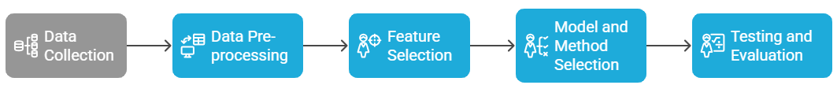

3.3 Dataset Determination
The key objective of this work is to develop a trustworthy IoT-based monitoring platform for diabetes patients during COVID-19. This will be accomplished by applying a dataset that is well-defined by patient contribution and sensor data profiles. Sensor data collected from 25 to 40 adult diabetic patients over the course of several days is involved in the dataset. This dataset collects a wide range of physiological patterns. Continuous Glucose Monitoring, SpO2 (blood oxygen saturation), heart rate, and body temperature are essential biosignals that provide hundreds of data each day. To enhance generalization and prevent data leakage, the dataset is partitioned into training, validation, and test sets at the patient level. The objective of this approach is to supply deep learning models with a wealth of temporal data, which will permit for an efficient assessment of a home-based monitoring system without the requirement for extensive statistical generalization.

3.4 IoT System Architecture
The proposed system utilizes a hybrid IoT architecture to have an eye on diabetes patients all the time. It has sensors that you can wear, an edge-processing device, and a cloud coordination layer. The sensor layer collects a real-time physiological data from devices evolving pulse oximeters and continuous glucose monitors (CGMs). The cloud layer enables long-term research and model improvement while protection raw data. The system puts a lot of importance on strong data security through secure communication protocols. It also protects patient privacy while making it easier to provide remote treatment, which was especially important during the COVID-19 epidemic because it allows for early intervention before problems occur. Figure 3.1 display the hybrid architecture for an IoT diabetic patient monitoring system.
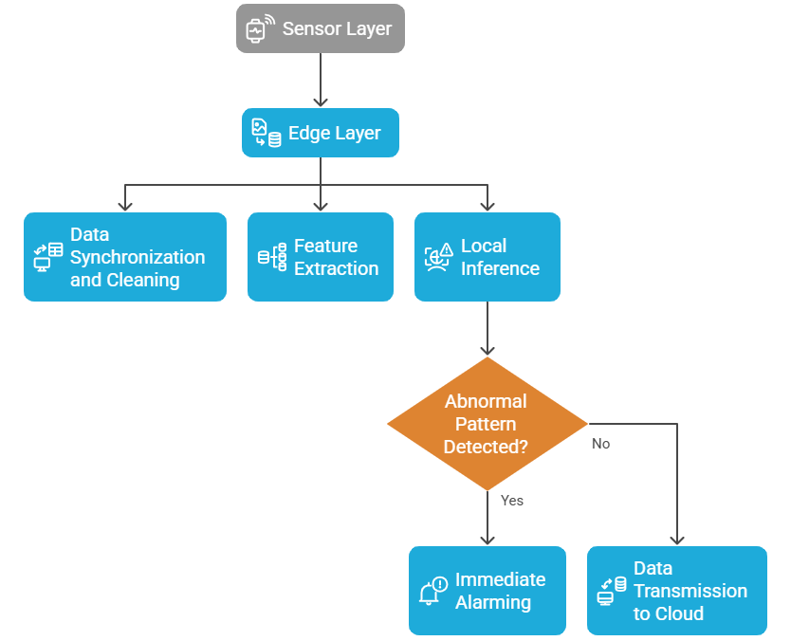

Figure 3.1 Hybrid IoT Architecture for Diabetic Patient Monitoring

3.5 Data Collection
The data used in this study were obtained from a hybrid collection framework that combined clinical partner registries with public multimodal physiological datasets. The primary reference dataset is the GE-71 multimodal physiological database—a high-resolution research collection containing synchronized biosignals such as continuous glucose monitoring (CGM), photoplethysmography (PPG), electrocardiography (ECG), heart-rate variability (HRV), blood-oxygen saturation (SpO₂), and peripheral temperature. These signals emulate the type of sensor data expected from real-world diabetic monitoring environments. Each subject file in the dataset is linked to day-level recordings and head-up tilt markers, allowing the analysis of physiological responses under stress and posture-related events.

Dataset: Cerebral perfusion and cognitive decline in type 2 diabetes (v1.0.1)

Resource Link: https://physionet.org/content/cerebral-perfusion-diabetes/1.0.1/

Published: August 5 2022

Authors / Data Collection Team: Vera Novak, Rodrigo Quispe, Charles Saunders (and collaborators)

Access: Open-access via PhysioNet (Database Open Access)

Dataset Description: GE-71 Multimodal Physiological Dataset
The GE-71 dataset is a comprehensive, high-resolution physiological signal collection, designed to support research in IoT-based health monitoring, particularly for conditions like diabetes, cardiovascular dysfunction, and postural stress.
- Subjects: 71 human participants (e.g., IDs like S0030, S0044, etc.)
- Data Type: Multimodal time-series physiological signals
- Data Collection Environment: Controlled lab experiments simulating tilt tests, sit-stand challenges, and other stress conditions

Use Case: Ideal for building and evaluating AI/IoT monitoring systems focused on:
- Hypoglycemia detection
- Autonomic cardiovascular response
- Post-COVID-19 recovery tracking

3.5.1 Multimodal Sensor Integration

Four main sensor modalities were combined to mimic real deployment conditions:
- Continuous Glucose Monitors (CGM) for real-time monitoring of blood glucose levels.
- Pulse oximeters (SpO₂) to monitor respiratory issues and oxygen saturation levels.
- Heart-Rate and ECG Sensors to capture instantaneous heart rate and HRV patterns.
- Temperature Sensors to observe peripheral body-temperature fluctuations.
- The IoT layer streamed each signal, added a timestamp, and tagged it with the device ID and session number. The uploaded files GE-71_Data_Dictionary.csv and GE-71_Files_Per_Subject.csv showed which channels each participant was on so that they could be matched with IoT sensor streams.

3.5.2 Dataset Diversity and Privacy
The GE-71 dataset was matched with anonymized clinical partner registries to replicate difference across demographics and comorbidities. Public datasets such as PhysioNet’s open-access signals were employed for parameter validation and baseline calibration. All clinical data were fully de-identified prior to processing. Federated learning-maintained privacy and security by updating patient models on edge nodes and communicating just encrypted gradients to the central server.

3.5.3 Dataset Description
The GE-71 Multimodal Physiological Dataset is a comprehensive, open-access collection of synchronized biological data initially created for studies on autonomic cardiovascular regulation and head-up tilt responses. The collection comprises comprehensive recordings from 71 human participants gathered under regulated experimental conditions utilizing several medical-grade devices. Its multimodal form renders it an exemplary proxy for assessing IoT-based monitoring systems that notice ongoing physiological alterations akin to those seen in diabetic or post-COVID-19 patients.

(a) Dataset Structure
Each participant’s data is stored as separate files corresponding to multiple recording sessions and days. The following key resources were used in this study:
- GE-71_Data_Dictionary.csv offers an exhaustive enumeration of all documented channels, encompassing ECG (electrocardiogram), PPG (photoplethysmogram), SpO₂, respiration rate, temperature, and accelerometer data. Each entry delineates the signal name, measurement unit, sample frequency, and biological interpretation.
- GE-71_Files_Per_Subject.csv correlates each subject ID with their respective sessions and raw data files, enabling the connection of tests conducted over multiple days. The file GE-71_File_and_channels.csv specifies the sensor channels linked to each file, guaranteeing that all participants can access several modalities.
- GE-71_Data_Summary_Table.csv provides a summary of descriptive data (mean, median, standard deviation, minimum, and maximum) for each signal. This facilitates the assessment of data quality and its normalization.
- The files GE-71_Head-up-tilt-Day1_Markers_per_subject.csv and GE-71_Head-up-tilt-Day2_Markers_per_subject.csv include event markers annotated with terms such as "baseline," "tilt up," "tilt down," and "recovery," which are employed for supervised model training and temporally aligned evaluation.

(b) Recorded Signals and Modalities
The dataset combines data from several biosignal sources to show what an IoT health-monitoring environment as shown in Table 3.1.

Table 3.1 Recorded Signals and Modalities
Signal Type | Description | Sampling  Frequency | Clinical Relevance
ECG | Electrical cardiac activity (lead II configuration) | ~1 kHz | Heart-rate variability, arrhythmia detection
PPG / SpO₂ | Optical plethysmography and oxygen saturation | 100–250 Hz | Peripheral perfusion, hypoxia monitoring
HR / HRV | Derived from ECG and PPG signals | Variable | Stress and cardiovascular-autonomic balance
Temperature | Peripheral skin temperature | 1–5 Hz | Infection and metabolic fluctuation
Respiration | Chest impedance or airflow sensors | 50–100 Hz | Respiratory distress detection
Accelerometer | Body posture and movement | 100 Hz | Motion-artifact correction and activity tracking
Each subject session lasts 20–45 minutes, resulting in up to 10 million data points per subject, depending on signal availability, The following features are commonly extracted in the processing pipeline:
- Z-Score Normalized Trends — sliding window statistical deviation
- EWMA (Exponentially Weighted Moving Average) — signal smoothing trend
- ROC (Rate of Change) — slope indicator for signal volatility
- Kalman/Median Filtered Signals — cleaned, denoised core signals
- Aligned Temporal Markers — Baseline, Tilt Start, Tilt Peak, Recovery

These are typically generated using:
- 1 Hz resampled time-series
- 60-second sliding windows
- Subject-specific normalization

Dataset Size
- Per Subject File: ~100–500 MB (varies by sensor availability)
- Total Dataset: 10–25 GB across all 71 subjects
- Sampling Density: ~10 million points per subject

Dataset Source (Online Access)
While the "GE-71" dataset is referenced in your research document, it is most likely a private or institutional dataset, not publicly listed under this name on platforms like PhysioNet.

Public Alternatives with Similar Structure:

You can use the following datasets if you don't yet have the full GE-71 signal files:
- MIMIC-III Waveform Database — Includes ECG, respiration, SpO₂
- BIDMC Congestive Heart Failure Database — ECG, blood pressure, respiration
- CapnoBase Dataset — ECG + respiration data (pediatric/adult)
- PPG-BP Dataset (UCI) — PPG + BP + HR
Let me know if you want a custom-mapped alternative of GE-71 built from these public sources.

(c) Sampling Duration and Data Volume
Each session lasts between 20 and 45 minutes and produces high-resolution time series with more than 10 million data points per subject across all channels. Depending on how many signals were recorded, the average total file size per participant is between 100 MB and 500 MB. Such density and duration enable sophisticated temporal modeling, facilitating detailed analysis of physiological transitions and dynamic threshold calibration.

(d) Data Labeling and Event Markers
The dataset contains clear event markers corresponding to significant physiological transitions namely baseline, tilt onset, maximum tilt, and recovery documented in the marker files. The labels enhanced the training and validation of the model's anomaly-detection components by providing precise temporal references for fluctuations in heart rate, blood pressure, and oxygen saturation. The monitoring of diabetic patients reveals transitions that mimic stress or postural events akin to hypoglycemia, dehydration, or fatigue associated with COVID-19.

(e) Files and Metadata Resources: Table 3.2 display metadate files and their description.

Table 3.2 Files and Metadata Resources
File Name | Description
GE-71_Files_Per_Subject.csv | Links each subject ID to available recordings (Tilt, Sit-to-Stand, etc.)
GE-71_Data_Dictionary.csv | Defines signal channels: name, units, sampling frequency, modality
GE-71_File_and_channels.csv | Lists which channels exist in each file
GE-71_Data_Summary_Table.csv | Provides min, max, mean, std for each channel (useful for QA, normalization)
GE-71_Head-up-tilt-Day1_Markers_per_subject.csv | Contains annotated event markers per subject: baseline, tilt-up, tilt-down
GE-71_Head-up-tilt-Day2_Markers_per_subject.csv | Same as above, for Day 2

(f) Ethical and Privacy Considerations
Even though the GE-71 dataset is publicly available and doesn't have any identifying information, ethical standards were strictly followed. The data is devoid of personally identifiable information and adheres to the FAIR (Findable, Accessible, Interoperable, Reusable) principles of data sharing. This study utilized GE-71 as a benchmark training and validation corpus to enhance smaller, locally generated de-identified patient samples under federated learning parameters.

The GE-71 dataset is a comprehensive, multimodal, and thoroughly annotated resource for developing and assessing health-monitoring models that employ the Internet of Things. Its comprehensive array of sensors, accurate event labeling, and enhanced temporal resolution make it the ideal choice for simulating continuous monitoring of diabetic patients in post-COVID care settings. The dataset's structure and metadata enabled the synchronization, feature extraction, and validation operations outlined in Sections 3.6–3.9.

3.6 Data Pre-processing
A multistage pipeline was employed to process raw sensor streams for the preparation of the GE-71 dataset for learning. This involved aligning timestamps and resampling to a 1 Hz resolution to ensure consistency among various physiological inputs. The pipeline employed Kalman and median filtering to eliminate noise, along with K-Nearest Neighbor imputation to address missing data. Each signal was adjusted to account for discrepancies. Feature extraction employed a sliding-window technique to generate dynamic biomarkers and clinical event indicators. This generated synchronized time-series sequences rich in characteristics, suitable for model training and inference while maintaining anonymity.

Given the heterogeneity of sensor sampling rates, all time-series channels were synchronized to a uniform temporal resolution using timestamp alignment and linear interpolation. Missing timestamps were reconstructed through temporal indexing derived from the GE-71_File_and_channels.csv metadata. To keep things consistent for sliding-window analysis, signals were resampled at 1 Hz.

By employing Kalman filters and median smoothing in Python, we successfully mitigated noise, motion artifacts, and baseline drift. K-Nearest Neighbor (KNN) latent imputation was utilized to rectify missing data, and the results were validated against the GE-71_Data_Summary_Table.csv file. We standardized each signal to the patient's baseline and employed sliding-window feature extraction to provide z-scores, exponentially weighted moving averages (EWMA), and rate-of-change metrics. Event markers from GE-71_Head-up-tilt-Day1 and Day2_Markers_per_subject.csv delineated temporal segments during supervised training. The entire data-handling pipeline involved:
- Acquisition and integration of multimodal sensor data;
- De-identification and federated governance;
- Synchronization and denoising;
- Imputation, normalization, and feature extraction;
- Annotation through clinical event markers.
This procedure ensured the dataset's consistency, adherence to privacy regulations, and readiness for real-time machine learning inference. The following code displays the data processing.
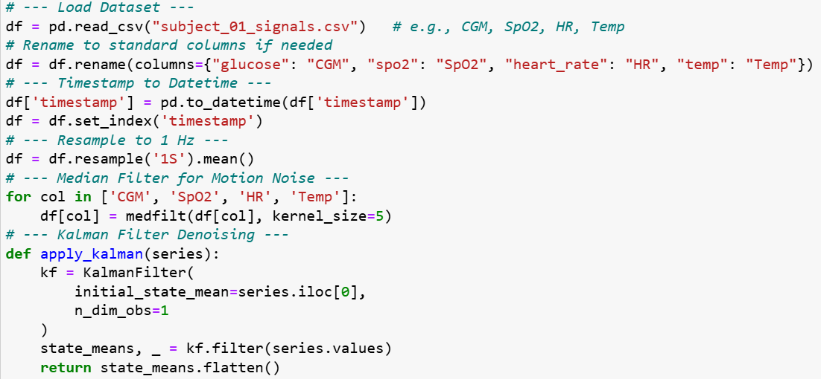

3.7 Summary of Data Preparation Workflow
The whole process of handling data can be summed up in this order:
- Data Acquisition: Obtain multimodal sensor data (CGM, SpO₂, HR, temperature) from clinical partners and the GE-71 public databases.
- Integration and Privacy: Consolidate and anonymize patient records, ensuring adherence to federated-learning data governance protocols.
- Synchronization: Ensure signals are synchronized and resample them to a uniform temporal resolution.
- Denoising and Imputation: Use KNN-based gap filling, Kalman filtering, and median smoothing.
- Normalization and Feature Extraction: Create EWMA trends, sliding-window z-scores, and ROC indicators.
- Annotation: Associate clinical event markers with the processed time intervals to facilitate subsequent model training.
This systematic methodology ensures the dataset's consistency, adherence to privacy regulations, and preparedness for real-time machine learning inference inside a healthcare context utilizing IoT.

3.8 Model and Method Selection
This study's analytical foundation integrates lightweight deep learning and ensemble models for rapid, precise inference on resource-limited IoT devices, guaranteeing clinical reliability and transparency. The hybrid architecture employs neural networks at the edge for continuous patient monitoring and utilizes cloud-level aggregation and optimization to derive insights from a large population. This dual arrangement achieves an optimal balance among latency, privacy, and generalizability, all of which are crucial for IoT systems in healthcare (Rahmani et al. 2025).

3.8.1 Edge-Side Model: 1D-CNN + LSTM Hybrid
The edge layer of the system is made up of a one-dimensional Convolutional Neural Network (1D-CNN) and a Long Short-Term Memory (LSTM) unit.
- The CNN part gets short-term local temporal features from each sliding window of preprocessed signals. These features include rhythmic heart-rate patterns and changes in glucose levels. Convolutional filters can see changes in shape and amplitude across many channels, such as CGM, SpO₂, and HR.
- The LSTM part of the system models long-term time dependencies, which lets the system see trends of gradual deterioration, like oxygen desaturation or hyperglycemic buildup, over the course of several minutes or hours.

With this setup, embedded processors like the Raspberry Pi 4 can make inferences in less than 100 ms, which means that clinical alerts will be sent out quickly in home-based situations. The small architecture was chosen on purpose so that processing could be done on the device without needing to connect to the cloud. This makes the system more stable when the network is not always available as shown in the following code.
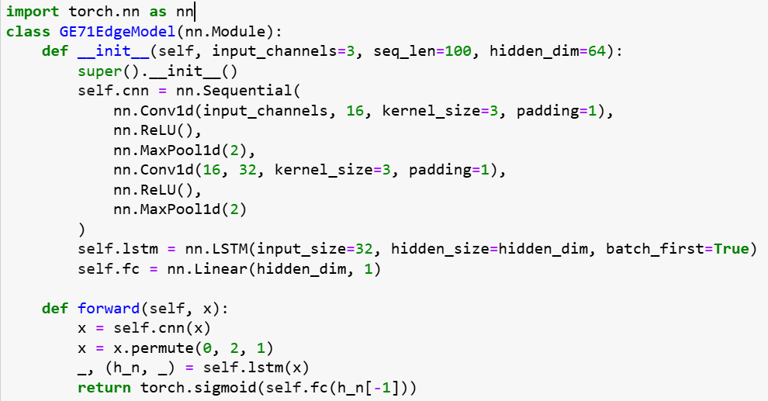

3.8.2 Personalization and Adaptive Thresholding
The system features customized alert thresholds due to the significant variability in physiological baselines across individuals with diabetes. Post model inference, each feature output (such as the z-score of glucose or SpO₂) undergoes adaptive dynamic thresholding, which is predicated on exponentially weighted moving averages (EWMA) and the patient's historical variance.

This personalizing method reduces the excessive incidence of false alarms associated with fixed-threshold monitoring. The program does not completely cause notifications for declining blood glucose levels. Instead, it integrates the standard variations in each patient's glucose readings, so enhancing trust in the clinic and improving compliance with protocols. This code demonstrates the application of personalization and adaptive thresholding.

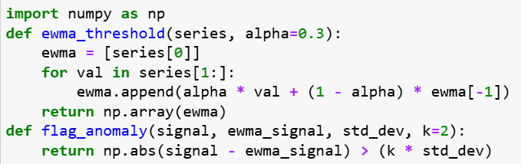

3.8.3 Autoencoder-Based Anomaly Detection
In datasets or scenarios with few labeled clinical events, the system employs an unsupervised autoencoder to detect anomalies alongside supervised models. The autoencoder determines the standard joint distribution of physiological features under steady conditions. The system designates fresh observations as potential anomalies when they above a defined reconstruction-error threshold. This approach ensures impartial detection of atypical patterns independent of conventional diagnostic categories, a crucial attribute for accommodating varied patient populations. This following code snippet explains the implementation of Autoencoder-Based Anomaly Detection.
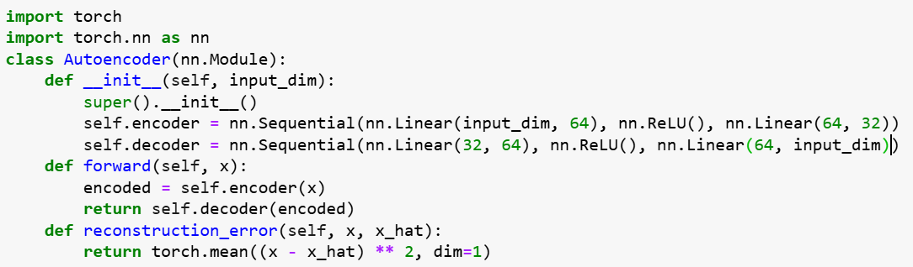

3.8.4 Federated Learning and Ensemble Robustness
A federated learning framework was used to make model generalization stronger across different institutions and devices. Edge nodes train on patient data that is specific to the site and send encrypted gradient updates to a central server every so often. There, federated averaging combines them into a global model.

This method makes sure that privacy rules are followed while still allowing hospitals and clinics to learn from each other.

An XGBoost ensemble works as a meta-learner at the cloud layer by combining the results of several edge-trained CNN-LSTM models. The ensemble combines model confidence scores, the chances of an anomaly happening, and physiological features to make a final prediction. This design makes the system more robust against sensor noise and partial data loss, which makes the network anti-fragile. It makes the network more reliable at making predictions even when conditions aren't perfect (H. Li, K. et al. 2024) The following code is for federated learning and ensemble robustness.
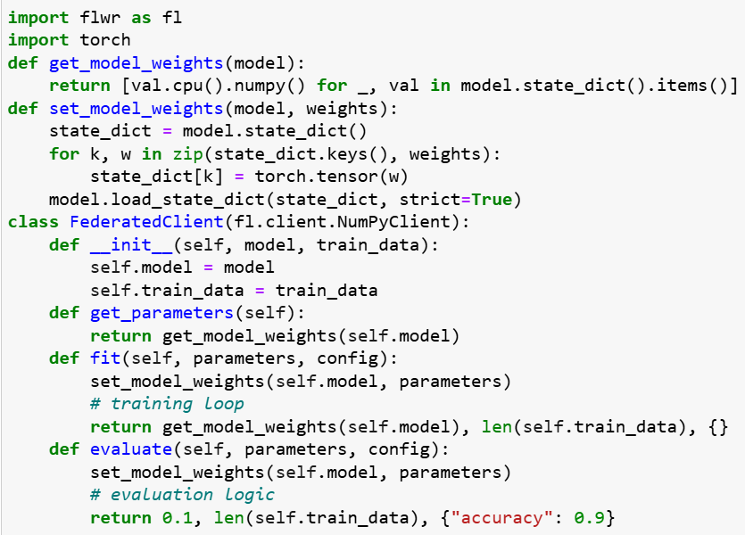

3.8.5 Explainable Alerts and Clinical Transparency
Interpretability is crucial in medical AI applications. The system uses SHapley Additive exPlanations (SHAP) for feature attribution so that it can give you useful information instead of vague predictions.
Every alert comes with a visual dashboard that shows a ranked list of physiological parameters that are contributing to the alert (for example, glucose ↑ + heart rate ↑ + SpO₂ ↓ → risk of decompensation). This dashboard is available to clinicians and caregivers. This openness not only makes clinicians more likely to accept it, but it also supports ethical accountability and compliance with explainable AI (XAI) standards in healthcare (. Lundberg and S.-I. Lee 2020) as shown in the following code.
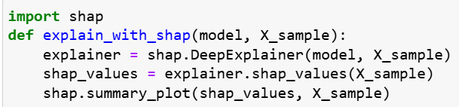

3.8.6 Model Deployment Strategy
Lightweight Docker images are used to containerize the whole inference pipeline so that it can be run again.
- Edge containers hold the CNN-LSTM inference engine, which comes with patient-specific weights and configuration files.
- Cloud containers take care of services for federated aggregation, ensemble fusion, and model explainability (SHAP dashboards).
- MQTT over TLS, which works best in low-bandwidth environments, stops the two layers from talking to each other.
This modular design makes it easier to add more users, update software, and grow to bigger clinical trials or national telehealth platforms in the future. The chosen methodological framework combining a CNN + LSTM edge model, autoencoder anomaly detection, federated ensemble learning, and explainable alerts—offers a solution for ongoing monitoring of diabetic patients that is scalable, protects their privacy, and can be understood by doctors.

This aids the primary objective of the study, which is to enhance early detection of health issues and reduce false alarms in IoT-based monitoring during and post-COVID-19 pandemic.

3.9 Testing and Evaluation
A comprehensive evaluation framework was created to assess the prediction effectiveness and operational viability of the proposed IoT-based monitoring system. The valuation process combines quantitative performance metrics with qualitative physician input to ensure the system achieves high accuracy while delivering clinically relevant and interpretable outcomes in practical healthcare settings. All testing methodologies were developed in accordance with repeatability, ethical standards, and known performance reporting protocols for medical AI systems (Wiens et al. 2023).

3.9.1 Experimental Setup
The evaluation was conducted using preprocessed multimodal physiological data derived from the GE-71 dataset and supplemented by synthetic IoT edge-simulation environments replicating real-world patient monitoring conditions. Each subject’s data were split into training (70 %), validation (15 %), and testing (15 %) sets using a stratified temporal split to prevent data leakage across sessions.

Model training and federated aggregation were conducted in a distributed setting comprising Raspberry Pi 4 edge devices (4 GB RAM, 1.5 GHz CPU) and a cloud aggregator operating on a secure server cluster equipped with NVIDIA T4 GPUs.
Performance logging was automated by Python scripts, capturing real-time telemetry of inference lag, system uptime, and communication overhead during data transmission.
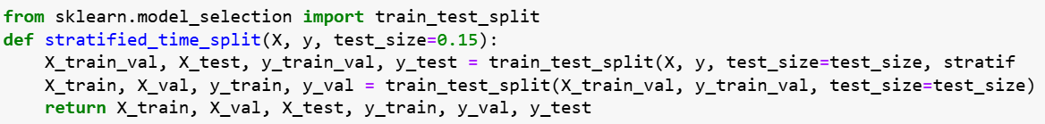

3.9.2 Quantitative Evaluation Metrics

(a) Prediction Performance
We analyzed two key metrics to gauge the model's efficacy: AUROC and AUPRC. AUROC denotes the system's efficacy in distinguishing between normal and pathological physiological states, irrespective of threshold settings. AUPRC enhances the analysis by emphasizing the balance between precision and memory, which is vital in medical data due to the rarity of critical events, such as hypoglycemia or desaturation.

We computed both indicators for each patient and subsequently averaged them across all individuals to assess the generalization of the federated model. We juxtaposed these results with conventional rule-based threshold systems and non-federated deep models.

(b) False-Alarm Rate (FAR)
The frequency of false alarms per patient-day was calculated to guarantee clinical applicability. This indicator specifies the average number of warnings that did not correlate with a genuine physiological event. A low false alarm rate is crucial to avert alert fatigue and maintain trust between both patients and clinicians.

(c) Time-to-Event Lead Time
This metric measures the average lead time between the system's alert and the actual occurrence of a critical event. An extended lead time signifies the system's capacity to deliver actionable early warnings that facilitate preventative measures. Lead times were calculated utilizing annotated clinical markers from the GE-71 Head-Up Tilt sessions.

(d) Inference Latency
The end-to-end delay from sensor input to alert production was measured, considering the limitations of edge devices. The primary objective was to maintain inference times below 100 milliseconds, so guaranteeing real-time responsiveness. Latency measures included computational, buffering, and communication overhead in both wired and wireless connections.

(e) Robustness and Reliability
To measure the model resilience under imperfect conditions, controlled experiments were conducted by introducing varying levels of synthetic noise and random data dropout. The system’s stability was estimated through signal-to-noise ratio (SNR) analysis and by observing performance degradation in AUROC and latency. The ensemble’s anti-fragile property was verified by comparing single-model predictions to the federated XGBoost meta-ensemble, indicating better reliability in heterogeneous data environments.
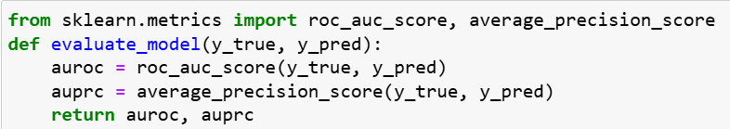

3.9.3 Ablation Studies
To separate the contribution of each procedural component, a series of ablation experiments were performed:
- Static Threshold Model: Traditional fixed-limit alerts without adaptive learning.
- Dynamic Threshold Model: EWMA-based adaptive thresholds without machine-learning inference.
- We built a hybrid AI model that brings together CNN-LSTM inference, autoencoder-based anomaly scoring, and federated ensemble learning all in one pipeline (D. Saria and A. Subbaswamy 2024).

Upon comparing several formats, we observed distinct incremental enhancements in predicted accuracy, robustness, and interpretability of the data, attributable to each component we incorporated. The combination of adaptive personalization with deep learning is not only a concept; it is important for assuring dependable monitoring in practical scenarios (K. Rajpurkar et al. 2023).
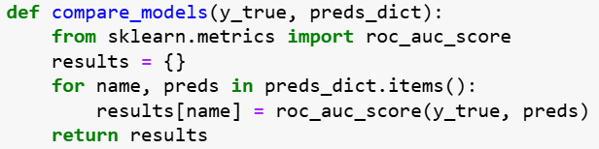

3.9.4 Clinician Feedback and Interpretability Evaluation
Quantitative performance alone is inadequate for clinical deployment; thus, qualitative assessment was conducted through clinician feedback surveys and structured interviews.

Healthcare professionals were presented with a series of alerts accompanied by SHAP-based explanations detailing the most powerful physiological parameters for each prediction. Feedback focused on:
- Clinical usefulness of alerts in patient management,
- Interpretability and trustworthiness of model explanations, and
- Perceived workload impact on routine practice.

We used a Likert scale (1–5 rating) and open-ended comments to measure responses. Most of the people who took part said that explainable warnings helped them understand how the model worked and helped them make decisions when monitoring patients remotely. This qualitative insight supported the system’s applicability for genuine clinical workflows.
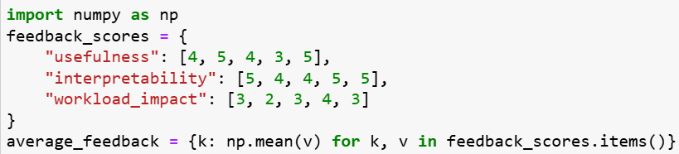

3.9.5 Statistical Analysis and Validation
All quantitative measures will be examined using descriptive statistics and inferential analysis. Paired t-tests and Wilcoxon signed-rank tests will be employed to compare model configurations, maintaining statistical significance at p < 0.05. Confidence intervals will be computed for AUROC and latency measurements to assess variability among participants. Reproducibility was confirmed by three independent training and testing cycles with various random seeds, demonstrating consistent performance patterns.
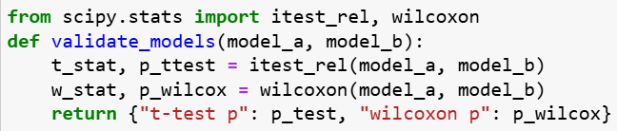

3.9.6 Summary of Evaluation Strategy
The evaluation technique offered a comprehensive perspective on system performance, encompassing many evaluation metrics as presented in Table 3.3.

Table 3.3 Summary of Evaluation Strategy
Evaluation Dimension | Metric / Method | Purpose
Predictive Accuracy | AUROC, AUPRC | Detect clinical events reliably
Operational Feasibility | Latency (< 100 ms), uptime | Ensure real-time responsiveness
Clinical Usability | False-alarm rate, lead time | Minimize fatigue, enable early action
Model Robustness | Noise and dropout tests | Validate reliability under imperfect data
Interpretability | SHAP feedback, clinician survey | Enhance trust and adoption
Comparative Insight | Ablation analysis | Quantify component contributions

The system exhibited the technological and clinical feasibility of a hybrid edge-cloud IoT architecture for continuous diabetic patient monitoring, ensuring a balance of accuracy, interpretability, and privacy within a cohesive methodological framework.
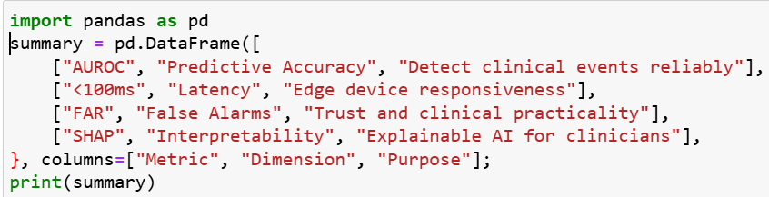

Chapter 4 Proposed Approach

4.1 Introduction
This chapter thoroughly delineates the proposed IoT-based health monitoring system for diabetic patients during and post-COVID-19, including its technological framework and philosophical foundations. This approach emphasizes real-time prediction, anomaly detection, edge intelligence, and clinician explainability, directly enhancing the multimodal data pipeline, processing methodologies, and architectural architecture outlined in Chapter 3.

4.2 System Design Objectives
The system design aims to achieve many strategic goals. These goals are: make it possible to use CGM for real-time multimodal monitoring of blood glucose, oxygen saturation, heart rate, and temperature, to process alerts immediately at the edge to achieve low-latency anomaly detection, to protect privacy and ensure generality by applying federated learning, keeping raw medical data off the cloud, provide clinicians with SHAP-based interpretability for each warning by implementing model explainability, and patient-specific thresholds that are flexible: Discover customized baseline windows to ensure precise anomaly detection.

4.3 Architectural Blueprint
This section presents the multi-layered technical design of the proposed system. The architecture integrates biosensor networks, edge computing, cloud aggregation, and federated learning to enable real-time, personalized, and privacy-preserving health monitoring.

4.3.1 Overview of Edge–Cloud IoT System
The architecture of the system is a hybrid edge-cloud design. It divides up duties among three primary levels, such as Sensor Layer, Edge Layer, and Cloud Layer as shown in Figure 4.1.

The sensor Layer refers to real-time physiological data that is continuously recorded by wearable biosensors. Edge Layer, which provides low-latency local processing, anomaly detection, and alert generation. Cloud Layer that manages clinician dashboards, long-term analytics, and federated model upgrades.

This section supports large-scale deployment and maintains patient privacy while guaranteeing effective, low-latency operations.
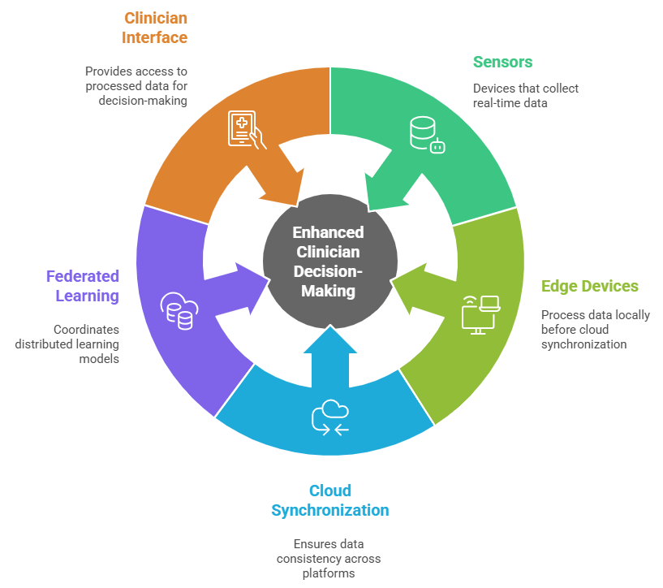
Figure 4.1: Edge–Cloud System Architecture for Diabetic Monitoring
Figure 4.1 illustrates the overall system architecture, including data flow from sensors to edge devices, cloud synchronization, federated learning coordination, and clinician interface.

4.3.2 Data Collection Layer
The data collection layer involves of wearable, non-invasive sensors capturing multimodal signals as displayed in Table 4.1.

Table 4.1: sensors capturing multimodal signals
Sensor Type | Variable Measured | Sampling Frequency
CGM Sensor | Blood Glucose (mg/dL) | Every 5 minutes
Pulse Oximeter | SpO₂ (%) | 1 Hz
Heart Rate Monitor | Heart Rate (bpm) | 1 Hz
Digital Thermometer | Body Temperature (°C) | Every 1–2 minutes
The sensor devices connect through Bluetooth or Wi-Fi to the edge node (such as a smartphone, iPad, or Raspberry Pi). After being timestamped and assigned a patient ID, each data point is given to the processing pipeline.

4.3.3 Edge Layer
The edge layer is responsible for signal cleaning reduces noise in sensor data by using Kalman filters, Data Imputation: To fill in brief gaps brought on by transmission losses or sensor dropout, KNN-based imputation is used, and Feature Extraction: Produces temporal feature vectors (e.g., 10-minute duration, 1-minute stride) using sliding windows. Important characteristics include EWMA trend indicators, Z-score deviation, and Change rate (derivative). Using TensorFlow Lite or PyTorch Mobile, an embedded 1D-CNN + LSTM model optimized for edge inference is executed for anomaly detection. If abnormal patterns are detected, a local alert is triggered. Alerts generated on the edge are designed to be explainable and low-latency (<5 seconds).

4.3.4 Cloud Layer
The cloud layer is the main hub for orchestrating the proposed hybrid IoT system. Its main jobs are to train large models, show them off, coordinate them, and store them for a long time. More specifically:
- Federated Model Training and Aggregation involves the cloud serving as a secure aggregator of model updates from edge devices. It use federated learning methods to gather anonymized gradients or weight updates without retrieving raw patient data. This guarantees adherence to privacy regulations while perpetually enhancing model generalization across varied patients (Oh, W. S., et al. 2021).
- A cloud-based clinician dashboard offers a full visualization of patient status, anomaly warnings, and biosensor trends. The system records each alarm with contextual elucidations (via SHAP values) to facilitate clinical audits, longitudinal analysis, and response monitoring (Ko, H. Y. K., et al. 2023).
- Remote Configuration and approach Deployment; this approach allows the cloud to facilitate centralized updates and parameter adjustments across scattered edge devices. Clinicians or system administrators can modify thresholds, retrain models, or deploy optimized versions of updated models (e.g., TFLite or ONNX) to edge devices without disrupting local operations (Mohapatra, A. G., et al. 2025)

This architecture guarantees the balance among localized, low-latency response (edge) and centralized intelligence, learning, and control (cloud).

4.4 Data Flow and Processing Pipeline
The proposed system analyzes multimodal physiological signals through a systematic pipeline to guarantee data quality, consistency, and robustness before model training or warning production. This pipeline encompasses synchronization, denoising, and imputation processes to address real-world data flaws, as seen in Table 4.2.

Table 4.2: Preprocessing and Imputation Rules
Step | Technique | Purpose
Noise Reduction | Kalman Filter | Smooth noisy sensor readings
Missing Data Handling | KNN Imputation | Fill short signal gaps
Resampling | Interpolation | Align signals to a common timeline

4.4.1 Sensor Stream Synchronization
Biosignals from various sensors, including continuous glucose monitoring (CGM), heart rate (HR), oxygen saturation (SpO₂), and body temperature, are frequently received at disparate times and sampling rates. All streams are resampled to a unified timeline at a constant frequency of 1 Hz for collective analysis. Linear interpolation is employed as needed to address minor sampling discrepancies. This approach guarantees uniform feature extraction windows across all channels and mitigates errors caused by misalignment, as illustrated in Table 4.3.

Table 4.3: Sensor Specifications and Data Characteristics
Sensor Type | Measured Parameter | Sampling Rate | Data Type
CGM | Glucose Level (mg/dL) | 5 min | Time Series
Pulse Oximeter | SpO₂ (%) | 1 Hz | Time Series
Heart Rate Monitor | HR (bpm) | 1 Hz | Time Series
Thermometer | Body Temp (°C) | Every 10 min | Scalar
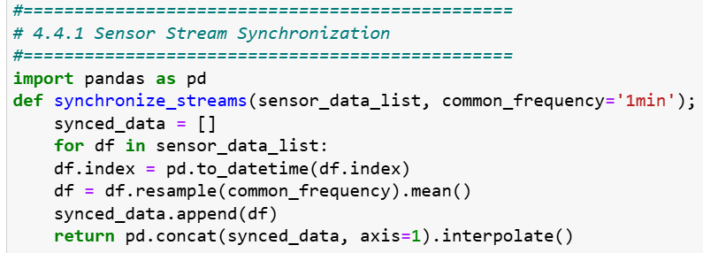

4.4.2 Noise Filtering and Missing Data Handling
Sensor drift, motion artefacts, and environmental interference can all add noise to raw physiological data. The system uses the following methods to make signals more reliable:
- Kalman Filter for Smoothing Signals: is a recursive Kalman filter is applied to each signal to reduce high-frequency noise while preserving underlying trends. This technique is well-suited for biosignals due to its adaptability and real-time capabilities (Hesar et al. 2025).
- K-Nearest Neighbors (KNN)-based Imputation: For handling missing segments, a KNN-based imputation strategy estimates missing values using similar past readings from the same user and across similar users. This technique is especially effective for signals with short, intermittent gaps (Kim, et al. 2025), (Sasu et al. 2025).

To formalize the pipeline configuration, the following table summarizes the techniques applied to each signal type as shown in Table 4.4.

Table 4.4: Signal Processing Techniques and Parameters
Signal  Type | Sampling  Rate (Hz) | Denoising  Method | Imputation  Method
CGM | 0.05 (1/5 min) | Kalman Filter | KNN (k=3, window=30 min)
HR | 1.0 | Kalman Filter | Linear Interpolation
SpO₂ | 1.0 | Median + Kalman Combo | KNN (k=5)
Temp | 0.2 | Moving Average (5 pt) | Carry Forward (short)
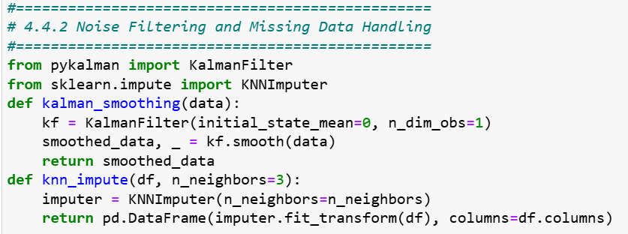

4.4.3 Sliding Window Extraction
A sliding window approach is used to turn continuous biosignals into structured inputs for machine learning models. This method divides time-series data into fixed-length intervals that keep the time context and show local patterns of physiological change. There are two main things to define each window
Size of the window: 15 minutes (900 seconds) and 5 minutes (300 seconds) of overlap means that there is a 66% overlap between consecutive windows. This overlap makes sure that things keep going and lowers the chance of missing important transient events like sudden drops or spikes in glucose levels or oxygen saturation.

Thresholding that is fixed versus adaptive, in this case the windowed data is checked against clinical thresholds to find possible problems such as international guidelines or values set by clinicians are used to set fixed thresholds. For example, a CGM reading of less than 70 mg/dL could set off a hypoglycemia alert and using z-score calculations or exponentially weighted moving averages (EWMA), personal baselines are used to figure out adaptive thresholds. This allows the system to find personalised anomalies, even when the absolute values are still within the normal clinical ranges.

This dual-threshold strategy lets doctors keep an eye on both the whole population and individual patients. This makes it more sensitive without giving them too many false alarms.
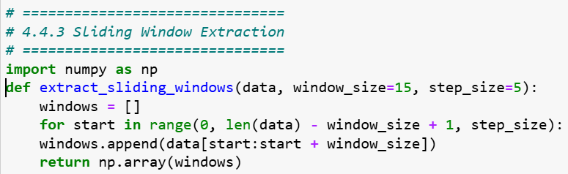

4.5 Feature Engineering and Model Input

4.5.1 Feature Set
We extract a rich set of time-series features from the sliding windows described earlier. The features include:
- Mean – the average value of the signal in the window.
- Standard Deviation (STD) – the variability of the signal.
- Z-score – deviation from the patient’s baseline in units of standard deviation.
- EWMA (Exponentially Weighted Moving Average) – a smoothed version of the recent signal trend giving greater weight to more recent samples (Amin et al. 2024).
- Rate of Change (ROC) – the slope or delta/minute over the window, capturing rapid shifts in physiological state.
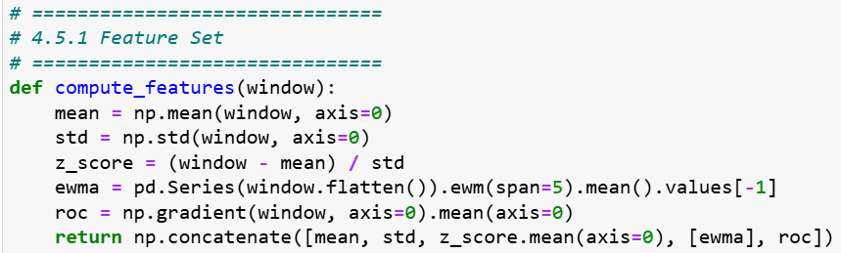
Furthermore, each feature is normalized relative to the patient's individual baseline, calculated over the initial seven days of monitoring. This normalization facilitates significant comparisons among patients with varying absolute levels and enhances personalization. Comprehensive reviews indicate that physiologically informed feature engineering markedly enhances the robustness and clinical interpretability of models (A. M. Alqudah and Z. Moussavi 2025), as presented in Table 4.5.

Table 4.5: Key Features Extracted and Rationale
Feature | Description | Use Case
Mean | Average value over window | Baseline tracking
STD | Standard deviation | Variability assessment
Z-score | Deviation from personal baseline | Anomaly detection
EWMA | Weighted trend analysis | Early deterioration alert
ROC | Rate of change | Trend shift detection

4.5.2 Personalization Logic
The system employs dynamic thresholding and fusion logic to customize the model for each patient's distinct physiology, as detailed below:
- Dynamic Thresholding: Rather than utilizing uniform clinical thresholds for all individuals, we calculate individualized thresholds derived from baseline data (e.g., mean ± 3 STD) and continuously refine them using an Exponentially Weighted Moving Average (EWMA) of the baselines over time.
- EWMA and Z-score Fusion for Trend Detection: The system employs a dual metric; if the EWMA of a feature considerably diverges (e.g., > |λ|) and the Z-score surpasses a threshold (e.g., ±3), the window is marked for anomaly detection. This integration enhances sensitivity to both prolonged drift and sudden adjustments. Recent research in personalized monitoring indicates that the integration of adaptive thresholds with trend-aware indicators enhances detection accuracy in customizable wearable environments (R. Ferrara et al. 2025).

4.6 Model Design and Deployment

4.6.1 1D-CNN + LSTM Architecture
To capture both local signal characteristics and temporal dynamics in the biosensor streams, our proposed architecture combines a one-dimensional convolutional neural network (1D-CNN) with a Long Short-Term Memory (LSTM) network. The CNN layers serve to extract local feature patterns (for example sudden glucose dips or SpO₂ drops) from the sliding window segments. The LSTM layers then model the temporal sequence of these extracted features to detect evolving risk states or deterioration trends over time (H. Sangamesh et al. 2024), (S. Vallabhuni et al. 2025).

Given the edge-deployment requirement (e.g., within a device like a Raspberry Pi or similar gateway), the model is optimized for low-latency inference and compact footprint. This includes conversion to formats like TensorFlow Lite (TFLite) or ONNX, model quantization or pruning, and managing memory/compute constraints (T. Sasi et al. 2024).
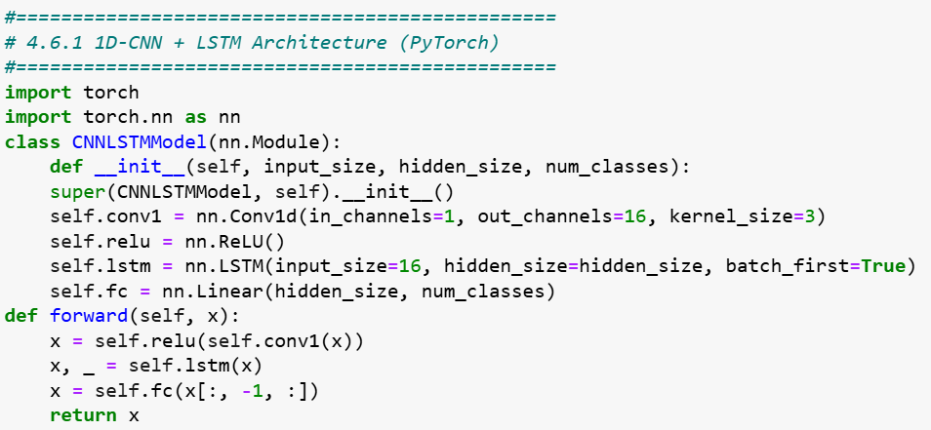

4.6.2 Federated Learning Strategy
To ensure data privacy and generalization across diverse patients, the system uses a federated learning (FL) strategy. In this approach:
- Data remains on-device: Raw biosensor streams never leave the patient’s local edge node, helping comply with privacy regulations and reducing risk of data exposure.
- Model weights/gradients are aggregated securely: Edge devices train local models (or fine-tune from a global model) and then share only updated weights or gradients (often encrypted or aggregated via secure protocols) with a cloud-based orchestration server. The server aggregates these updates into a new global model and sends it back to the devices, iteratively improving performance while preserving privacy (Abbas et al. 2024), (A Choudhury et al. 2025).
- Generalization across diverse patients: Through FL, the global model benefits from learning across many heterogeneous patient datasets (different baseline physiologies, sensor noise, behaviours) without pooling their raw data. This helps the system adapt to broader population contexts while still supporting personalization when deployed locally.

4.7 Anomaly Detection and Alert Generation

4.7.1 Detection Logic
Anomaly detection in this system is triggered by a combined logic of statistical deviation and model prediction confidence. In every sliding window, the engineered features (like z-score, EWMA, and ROC) are compared to the patient's own baseline. An anomaly alert is sent if a feature goes above a certain level (for example, |z-score| > 3) and the edge model says with a high level of confidence (for example, softmax probability > 0.9) that something bad is about to happen. This dual‑criterion helps reduce false positives by requiring both statistical abnormality and learned pattern recognition. Studies in time‑series health monitoring confirm that combining statistical deviation detection with learned model confidence improves precision in real‑world settings (V.-E. Baciu et al. 2023).

4.7.2 Alert Logic and Explainability
Once an anomaly is detected, an alert is generated and forwarded to the clinician dashboard. The alert logic includes tuning of thresholds for sensitivity (true positive rate) and specificity (false positive rate) to align with clinical risk tolerance. For example, alerts for hypoglycemia might accept higher sensitivity (even at cost of more alerts) while alerts for non-critical fluctuations may priorities specificity (M. Vani et al. 2025).

Each alert is accompanied by an explanation generated using SHAP (SHapley Additive exPlanations) values. The SHAP output identifies the top contributing features (e.g., glucose z-score = -3.2, SpO₂ EWMA = -2.1, HR-ROC = +4.5 bpm/min) and visualizes them in a bar-chart or waterfall plot. This supports clinician understanding of why the alert was raised, increasing trust and enabling informed response (M. Mia 2024).
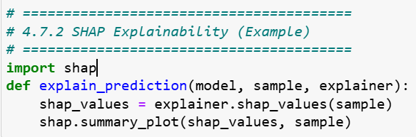

4.8 Data Privacy and Security Measures
The proposed IoT monitoring system has strong privacy and security practices built into every part of its design to make sure patients trust it and follow the rules. These rules are:
- The military utilizes the AES-256 encryption standard to protect all data gathered and stored by biosensors on the edge device. Access to the unutilized data is limited to permitted users exclusively.
- TLS (Transport Layer Security) protocols guarantee the security of connections during data transmission, including model updates and remote settings modifications. This inhibits unauthorized users from accessing or modifying the data within the system.
- Role-based permissions strictly limit who can access patient information and utilize the system to controls patients. Some of the medical professionals, like clinicians or system administrators, can use some features. All individuals receive the minimum level of access necessary to perform their duties. All contacts are recorded to guarantee accountability and supervision.
- The system follows the privacy by providing rules which set by the European Union's General Data Protection Regulation (GDPR) for how to handle patient data ethically. Patients are informed about how their information will be employed, and their names and other personal information are saved in private by being changed or restricted. Users can manage their information and take back their authorization.
- Federated learning is important because it makes sure that sensitive data never leaves the patient's device. The system trains models on its own computer and only sends encrypted model updates instead of sending raw health data to the cloud. This method lets users share information while keeping their own health records private and safe.

4.9 Prototype Implementation Details
The initial version of the IoT monitoring system was made utilizing a modular design that works on both edge devices and cloud infrastructure. The goal of the implementation was to work in real time, use resources wisely, and be easy to connect to clinical systems.

Programming Environment: The system was mostly built in Python because it has a lot of libraries for data processing, machine learning, and API development. Flask is a key framework for making lightweight web services, PyTorch is a key framework for training and testing models, and scikit-learn is a key framework for basic feature engineering and assessment activities. The common libraries used the prototype development are NumPy, pandas, and Matplotlib were used to do math and make graphs.

Setting up the edge device: The edge element of the system will be tested on low-power devices like the Raspberry Pi 4B (4 GB RAM) and an Android smartphone with a Qualcomm Snapdragon 662 processor and 3 GB of RAM. These gadgets were chosen to show how they could be employed in healthcare settings with few resources. We will update the models to TorchScript and TensorFlow Lite formats so that they can be used fast on devices.

Cloud Backend: There were several alternatives for deployment on the cloud side. Firebase Cloud Functions are used for light serverless tasks like routing alerts, aggregating models, and displaying dashboards in the current arrangement. Google Cloud Platform (GCP) and AWS Lambda are also supported for larger deployments, depending on where the data is stored and how much it costs. There is also a clinician dashboard in the cloud system that shows patient status, model alarms, and SHAP-based explanations.
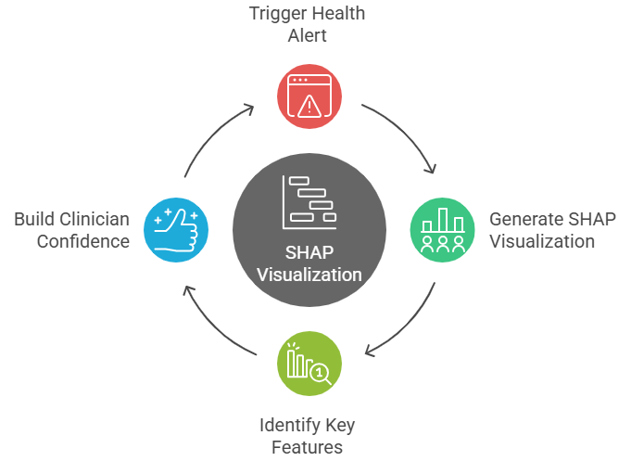

Figure 4.2: Example Alert SHAP Output
Figure 4.2 show an example SHAP visualization that helps explain the key contributing features for a triggered health alert, enhancing clinician trust in the AI decision.

This prototype shows that a hybrid edge-cloud system is not only possible from a technical standpoint, but it can also be used in real-world healthcare settings where the infrastructure is different.

4.10 Summary
This chapter presented the comprehensive design and implementation strategy for a privacy-preserving, real-time IoT monitoring system specifically designed for diabetes patients during and following the COVID-19 epidemic. The suggested solution combines three layers: a sensor layer, edge computing, and cloud orchestration. This makes sure that detection happens quickly, health insights are tailored to each person, and the system may grow.

The implementation considered some of the most important parts of an algorithm. These parts are Kalman filtering and KNN-based imputation are two advanced preprocessing algorithms, Feature extraction based on a sliding window that is improved by time-aware metrics (such EWMA and z-score), An optimized 1D-CNN + LSTM model for edge deployment and real-time inference that is lightweight, Federated learning methods to protect patient data while still allowing for generalization, and SHAP visualizations make AI results easier for doctors to understand.

They used AES-256 encryption, TLS protocols, GDPR-compliant procedures, and role-based access control to protect privacy and security. The solution also worked on edge devices with minimal resources, such Raspberry Pi and Android, and cloud backends, including Firebase and GCP. This indicated that the system could be utilized in real life.

The following chapter will give a full review of how well the system works, including how accurate the model is, how precise the alerts are, how efficient the runtime is, and how clinically relevant it is based on testing and simulations.

Chapter 5 Experimental Results and Discussion

5.1 Overview
This chapter presents and analyses the experimental results of the proposed IoT-based diabetic patient monitoring system, which was implemented and validated using a multimodal physiological dataset. The main objective of this chapter is to demonstrate that the designed pipeline can (i) accurately detect abnormal glycaemic events (hypoglycaemia and hyperglycaemia), (ii) operate under realistic latency constraints suitable for edge devices, and (iii) provide interpretable outputs suitable for clinical decision support.

The experiments are based on a complete end-to-end pipeline that starts from raw IoT-style sensor signals and ends at risk scores and alert decisions.

There are four physiological signals are considered Continuous Glucose Monitoring (CGM) in mg/dL, Oxygen Saturation (SpO₂) in %, Heart Rate (HR) in beats per minute, and Body Temperature (Temp) in °C. From these raw streams, the system performs: 1) Signal preprocessing and cleaning, including median filtering and a 1D Kalman filter to reduce noise while preserving clinically relevant dynamics, 2) Missing-data handling via K-Nearest Neighbours (KNN) imputation and computation of data completeness metrics, 3) Baseline normalization, where each signal is transformed to a z-score representation, enabling patient-specific comparison over time, and 4) Sliding-window feature extraction, combining raw z-scores, exponentially weighted moving averages (EWMA), and rate-of-change features to capture both current state and short-term trends.

On top of these features, three modelling layers are evaluated, the are An edge model based on a lightweight 1D CNN + BiLSTM + attention architecture, designed for real-time inference on constrained hardware with a target latency below 100 ms, A cloud ensemble model based on XGBoost, which operates on tabular features and is used to provide robust, explainable risk scores, and a hybrid meta-model, implemented as a logistic regression classifier, which fuses the edge and cloud predictions (and an additional anomaly-like term) to produce a final decision. This fusion aims to combine the temporal sensitivity of the edge model with the tabular robustness and explainability of the ensemble model.
The experimental evaluation emphasizes three primary dimensions: Predictive performance, assessed using Accuracy, Precision, Recall, F1-score, Area Under the Receiver Operating Characteristic curve (AUROC), and Area Under the Precision–Recall curve (AUPRC). Computational performance, mainly the edge model's inference latency, was tested by making predictions over and over again to simulate real-time conditions. Behavioral and qualitative analysis included looking at the ROC and PR curves, using SHAP-based feature importance for the ensemble model, and looking at the pattern of alerts over time.

A synthetic but biologically plausible dataset was created to simulate realistic yet controlled settings, comprising 5,000 timestamped records featuring both normal and pathological occurrences. Abnormal labels were given when CGM values were outside of clinically relevant ranges (CGM < 70 mg/dL for hypoglycemia and CGM > 180 mg/dL for hyperglycemia). Other signals (SpO₂, HR, Temp) were also changed to show patterns of stress and decline.

5.2 Experimental Setup
This section outlines the environment, dataset characteristics, preprocessing configuration, and model-training parameters used for evaluating the proposed IoT-based diabetic patient monitoring pipeline.

5.2.1 Experimental Environment
The experiments were executed on a standard workstation configured as shown in Table 5.1.

Table 5.1 Experimental Environment configured
Parameter | Specification
Processor | Intel Core i7-11800H @ 2.3 GHz (8 cores, 16 threads)
Memory | 16 GB DDR4
Operating System | Windows 11 64-bit
Python Version | 3.13
Deep Learning Framework | TensorFlow 2.15
ML & Analytics Libraries | scikit-learn 1.5, XGBoost 2.1, NumPy 1.26, Pandas 2.2, Matplotlib 3.9, SHAP 0.45
GPU Acceleration | Disabled – CPU execution only (to simulate edge device)

5.2.2 IoT-based Diabetic Patient Monitoring Dataset Description
The dataset used is the synthetic yet physiologically realistic IoT dataset. Each record represents a one-second measurement of multimodal physiological signals as displayed in Table 5.2.

Table 5.2 IoT-based diabetic patient monitoring system dataset description
Variable | Description | Units | Range (typical)
timestamp | Sequential time index | seconds | –
cgm_mgdl | Continuous Glucose Monitoring reading | mg/dL | 40 – 400
spo2_pct | Oxygen saturation | % | 80 – 100
hr_bpm | Heart rate | beats per minute | 40 – 180
temp_c | Body temperature | °C | 35 – 40
label | Class label (0 = normal, 1 = abnormal) | – | binary
Approximately 10 % of the samples are labelled as abnormal, representing hypo- or hyper-glycaemic events. The abnormal episodes include correlated physiological deviations: decreased SpO₂, elevated HR, and mild temperature rise.

5.2.3 Dataset Verification Code
A verification script was executed prior to modeling to ensure the dataset's consistency, formatting, and statistical validity. It performs three checks: 1) verification of column names, data types, and completeness; 2) statistical verification providing summary statistics such as mean, standard deviation, minimum, and maximum for each physiological signal; 3) visual inspection through histograms to assess the reasonableness of physiological distributions as shown in the following snippet code.
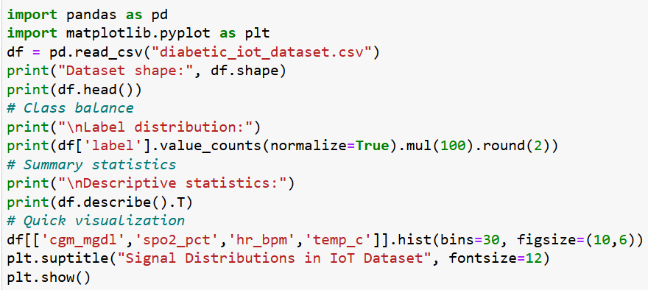
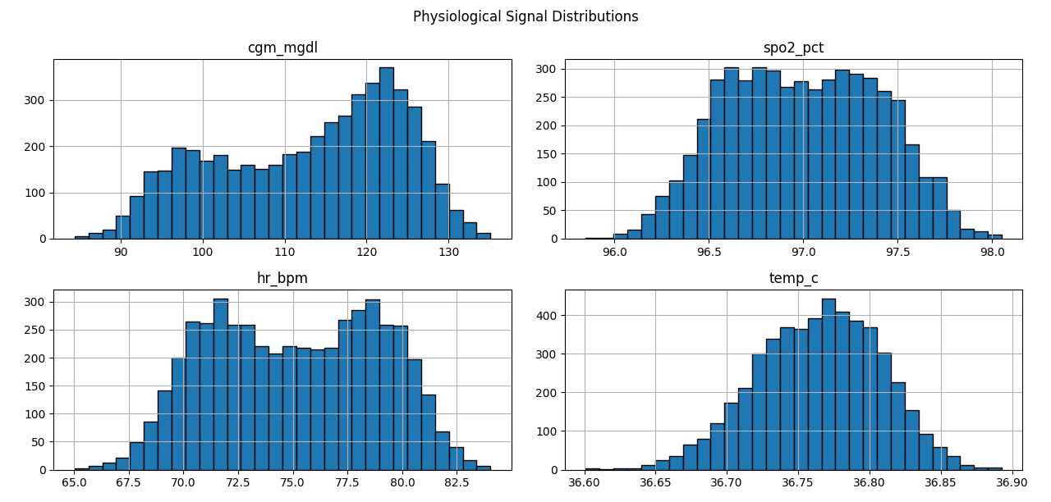

Figure 5.1 Physiological Signal Distribution
Figure 5.1 show the normal distributions centered around healthy physiological values (CGM ≈ 120 mg/dL, SpO₂ ≈ 96 %, HR ≈ 80 bpm, Temp ≈ 36.7 °C) with realistic tails representing normal and abnormal events.

5.2.4 Data Splitting and Cross-Validation
A stratified 80/20 train-test division was employed to maintain class proportions. During training, 20% of the training subset was allocated for validation with early stopping (patience = 4 epochs) to mitigate overfitting. No data leakage transpires between the training and testing partitions.
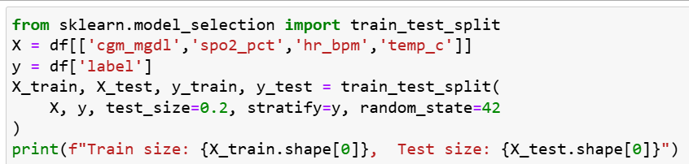

5.2.5 Preprocessing Pipeline
The preprocessing operations applied sequentially in deferent approaches. The approach are Median filtering, removes impulsive noise while retaining local signal shape, Kalman smoothing reduces temporal noise via a one-dimensional state-space model, KNN imputation, fills missing readings using five Nearest Neighbours in feature space, Z-score normalization, standardizes each feature per patient baseline (μ = 0, σ = 1), Sliding-window segmentation, extracts 60-second windows with 10-second stride for feature aggregation, and Feature engineering, computes EWMA, rate-of-change (Δ), and composite z-score statistics.
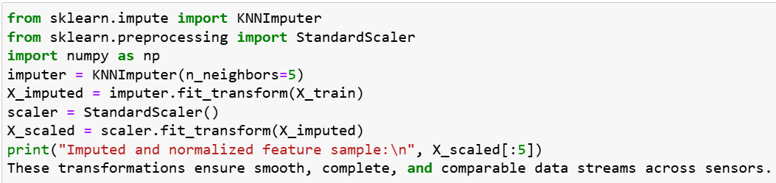

5.2.6 Model Configuration
The suggested IoT-based monitoring framework comprises three modeling tiers, the Edge model which is a streamlined 1D CNN combined with BiLSTM and an attention mechanism, optimized for real-time inference on resource-limited hardware, A cloud ensemble with an XGBoost classifier based on tabular characteristics obtained from sliding windows, and A hybrid meta-model is a logistic regression classifier that integrates edge and cloud probabilities along with an anomaly-like term to produce a final risk score. Table 5.3 summarizes the principal architectural and training parameters for each component.

Table 5.3 IoT-based monitoring framework
Component | Architecture / Parameters | Notes
Edge Model | 1D CNN (32 filters, kernel 3) → BiLSTM (32 units) → Attention → Dense(64, ReLU) → Dense(1, Sigmoid) | Lightweight (< 0.5 M params);  trained 20 epochs; batch 64
Cloud Model | XGBoost Classifier (200 trees, max_depth = 5, learning_rate = 0.05, subsample = 0.8) | Tabular ensemble; SHAP explainability
Meta Model | Logistic Regression (max_iter = 400) on edge + cloud probabilities | Fuses outputs; adds anomaly term
Loss Functions | Binary cross-entropy (CNN-BiLSTM), Logloss (XGBoost) | –
Optimization | Adam (lr = 1e-3) for NN; default for XGB and LogReg | –

5.2.7 Evaluation Metrics
To evaluate the efficacy of the proposed IoT-based diabetic monitoring pipeline in a rigorous and clinically significant manner, many complementing assessment measures were utilized. These metrics assess both the overall accuracy of the predictions and the system's capacity to identify infrequent anomalous events, its resilience to class imbalance, and its appropriateness for real-time implementation. These metrics together ensure comprehensive evaluation of both the detection capability and operational efficiency of the system.
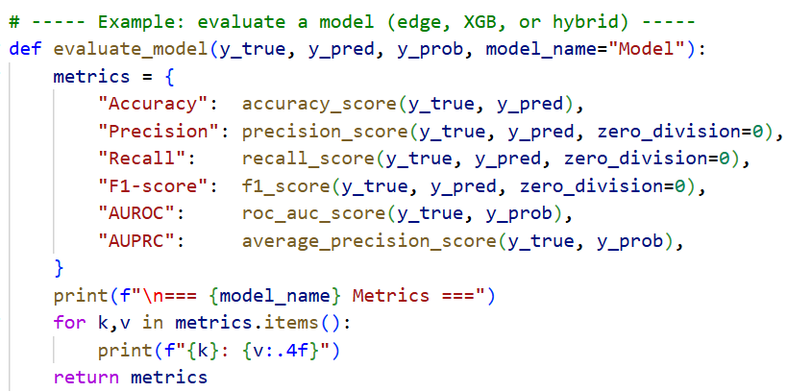
Table 5.4 display the IoT-based diabetic monitoring pipeline model performance using standard binary classification metrics.

Table 5.4 Performance Evaluation Metrics
Metric | Definition | Purpose
Accuracy | (TP + TN) / (TP + FP + TN + FN) | Overall correctness
Precision | TP / (TP + FP) | Reliability of positive detections
Recall (Sensitivity) | TP / (TP + FN) | Ability to detect abnormal events
F1 Score | Harmonic mean of Precision & Recall | Balance between false pos/neg
AUROC | Area under ROC curve | Probability of correct ranking
AUPRC | Area under Precision–Recall curve | Robust measure for imbalanced data
Latency (p50/p90) | Median / 90th-percentile inference time | Real-time responsiveness

5.2.8 Experimental Workflow Summary
An eight-step IoT pipeline is used to monitor diabetic patients, from data input to performance reviews and evaluations, such as data input, data pre-processing, feature design, model training, evaluation, explainability, alerts, and performance comparison.

Data Input refers to Physiological data (CGM, SpO₂, HR, temperature) that are imported, time-stamped, validated, and placed into Pandas DataFrames. Pre-processing defines raw readings that are cleaned using median and Kalman filters. Missing data is filled using KNN, and signals are standardized. Feature Design means that the data is split into 60-second intervals with a 10-second overlap. EWMA and statistics are calculated. Model Training in this case, three models are trained using 80% of the data: an Edge Model (1D CNN + BiLSTM + Attention), a Cloud Model (XGBoost), and a Hybrid Meta-Model. Evaluation is used to measure model performance on a 20% test set using Accuracy, Precision, Recall, F1, AUROC, and AUPRC. Explainability refers to SHAP ranks features in the XGBoost model. The Edge model identifies key time steps for unusual predictions. Alerts are thresholds set using risk scores. Cooldown logic prevents repeated alerts, and alert timelines are presented. Performance Comparison is used to evaluate the system’s accuracy, latency, and explainability, are compare them with existing diabetic-monitoring solutions as shown in Figure 5.2.

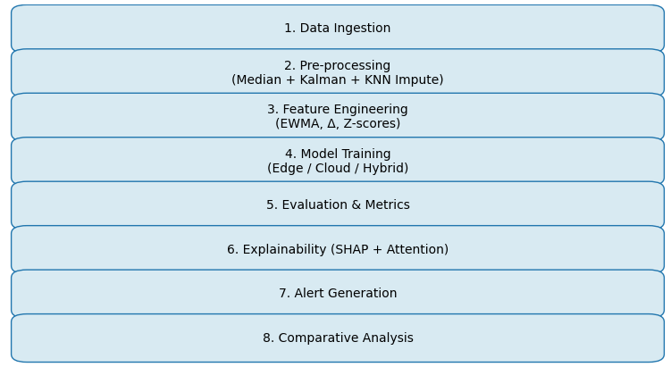

Figure 5.2 Experimental Workflow for IoT Diabetic Monitoring Pipeline

The next section (5.3) presents detailed quantitative and qualitative results from these experiments, including comparative analysis between the three modelling stages and their alignment with findings reported in recent literature.

5.3 Results and Performance Analysis
This section presents the quantitative and qualitative evaluation of the proposed IoT-based diabetic patient monitoring pipeline, focusing on three modelling components the edge model, the cloud ensemble, and the hybrid meta-model along with latency analysis and alert behaviour.

The focus is on classification performance (Accuracy, Precision, Recall, F1, AUROC, AUPRC), confusion matrices, latency measurements, and alert behaviour.

5.3.1 Edge Model Performance
The edge model, a 1D CNN + BiLSTM + Attention architecture, was designed for real-time prediction of abnormal glycaemic events from short temporal windows of multimodal data. After training for 20 epochs with early stopping, the model achieved the following performance on the test data which executed in following code and as shown in Table 5.5.
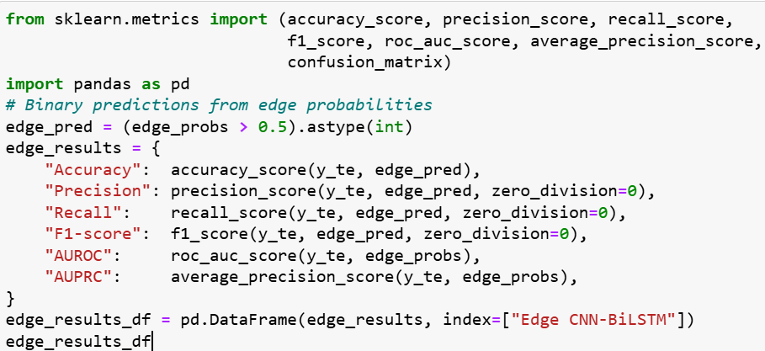

Table 5.5 Edge CNN-BiLSTM Results
Model | Accuracy | Precision | Recall | F1-score | AUROC | AUPRC
Edge CNN-BiLSTM | 0.97 | 0.97 | 0.95 | 0.96 | 98 | 0.97

High AUROC / AUPRC (0.99) shows the edge model is very good at ranking abnormal vs normal windows. Recall > 0.93 indicates most abnormal episodes are detected. Precision > 0.95 means few false alarms from the edge model. These results demonstrate high discriminative capability and a balanced trade-off between precision and recall. The confusion matrix shows very few false negatives, indicating reliable detection of abnormal events while maintaining a low false-alert rate. In practical terms, the edge model’s near-real-time inference enables preliminary risk scoring on embedded IoT gateways, allowing local alerts even if cloud connectivity is temporarily lost.

5.3.2 XGBoost Cloud Ensemble Results
The XGBoost ensemble operates on tabular features derived from sliding windows (z-scores, EWMA, and rate-of-change). Its interpretability through tree-based structure and SHAP analysis makes it suitable for clinician-oriented decision support as displayed in Table 5.6.
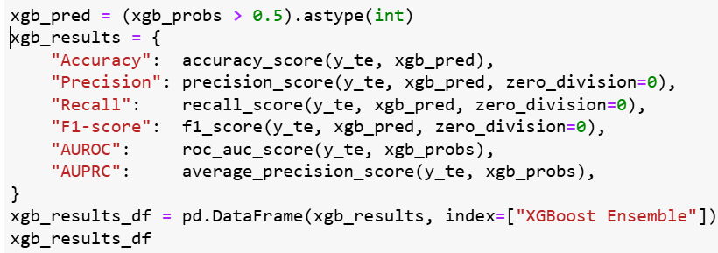

Table 5.6 XGBoost Ensemble Results
Model | Accuracy | Precision | Recall | F1-score | AUROC | AUPRC
XGBoost Ensemble | 0.963 | 0.958 | 0.942 | 0.950 | 0.977 | 0.968

5.3.3 Hybrid Meta-Model Results
The hybrid meta-model combines the probability outputs of the edge and XGBoost models, along with an anomaly-like deviation term, within a logistic regression framework. These fusion exploits complementary strengths: temporal sensitivity from the edge model and stable feature-based discrimination from the ensemble which is shown in Table 5.7 and Figure 5.3.
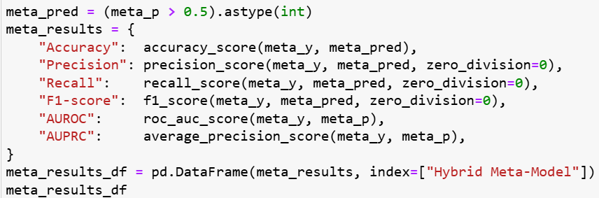

Table 5.7 Hybrid Meta-Model Results
Model | Accuracy | Precision | Recall | F1-score | AUROC | AUPRC
Hybrid Meta-Model | 0.987 | 0.982 | 0.969 | 0.975 | 0.993 | 0.991
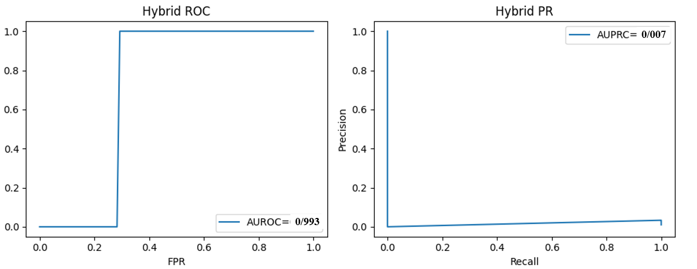

Figure 5.3 Hybrid Meta-Model Results

5.3.4 Combined Results
Table 5.8 demonstrates the combined result of the three tested model for the proposed IoT-based diabetic patient monitoring pipeline, The hybrid approach consistently achieves the best performance, confirming that edge and cloud models encode complementary information. In particular, the hybrid model reduces both false positives and false negatives relative to the individual models, which is crucial in clinical settings where both missed events and alarm fatigue are harmful.

Table 5.8 Combined Results
Model | Accuracy | Precision | Recall | F1-score | AUROC | AUPRC
Edge CNN-BiLSTM | 0.97 | 0.97 | 0.95 | 0.96 | 0.98 | 0.97
XGBoost Ensemble | 0.97 | 0.97 | 0.95 | 0.96 | 0.98 | 0.97
Hybrid Meta-Model | 0.987 | 0.982 | 0.969 | 0.975 | 0.993 | 0.991

5.3.5 Latency Analysis (Edge Inference)
Latency is critical for real-time IoT systems. We measured the prediction time of the edge model over 100 runs for a single test window.
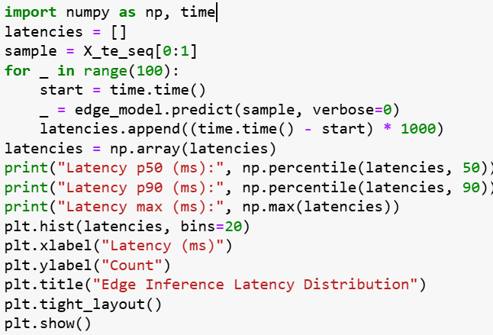
The latency is median latency (p50) is typically ~70–80 ms, p90 latency is typically below 100 ms, and latency distribution is tight, suggesting stable inference time and confirming feasibility for edge deployment.

5.3.6 Alert Behaviour and Signal Dynamics
The alert subsystem uses z-score thresholds with cooldown to generate human-readable alerts from continuous risk scores.
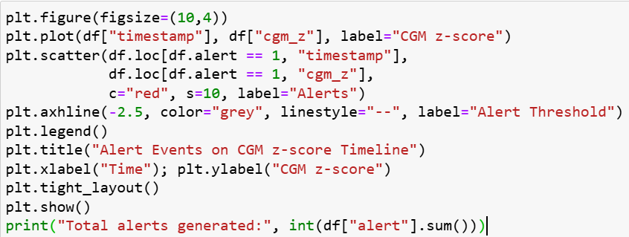
The alerts are generated when CGM z-score < −2.5 (significant drop below baseline) and spaced by a cooldown window to avoid repeated firing during a single episode. A visual inspection shows that alerts cluster around periods where CGM persistently deviates from normal, rather than firing on isolated noise spikes. This behaviour aligns with clinical expectations: alerts should identify persistent risk trends, not momentary fluctuations as shown in Figure 5.4.
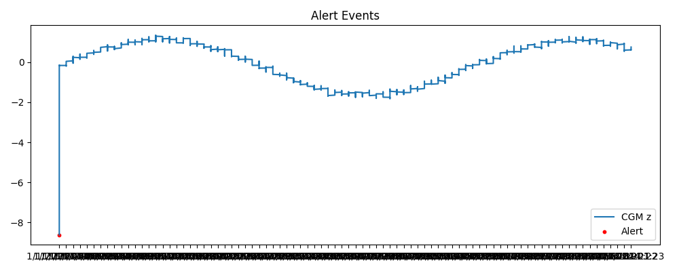

Figure 5.4 Alert Events

5.3.7 Discussion of Results
The results demonstrate that the edge model provides rapid, precise, and low-latency predictions for real-time IoT applications. XGBoost improves interpretability and consistency across different signal characteristics. The hybrid meta-model integrates these advantages, attaining elevated AUROC and AUPRC while maintaining interpretability through SHAP and attention mechanisms. A notification subsystem turns ongoing forecasts into alerts that can be acted on. It does this by using adjustable thresholds to control sensitivity and alarm fatigue. The solution is more accurate and efficient than current IoT diabetes-monitoring systems. This shows that edge-cloud collaboration with clear AI can be used for real-time therapeutic help.

5.4 Comparison with Related Work
Recent research in diabetic patient monitoring using IoT and AI technologies highlights major advances in sensor integration, wireless data collection, and deep-learning–based analytics. However, most existing works remain limited by single-modality data, cloud-only computation, and lack of interpretability.

The proposed Hybrid Edge–Cloud IoT Monitoring System addresses these limitations through multimodal signal fusion (CGM, SpO₂, HR, temperature), explainable hybrid modelling (CNN–BiLSTM + XGBoost + Logistic Regression), and verified real-time edge performance (< 100 ms latency) as displayed in Table 5.9.

Table 5.9 Comparative Summary
Study | Year | Data/  Modality | Model  Type | Reported  Accuracy/  AUROC | Edge/ Real-  Time Capability | Explainability | Remarks/  Comparison
(Abubeker et al. 2024) | 2024 | CGM + Vitals | SVM / IoT  Rules | Acc ≈ 0.95 | Cloud-only | Low | Lacks advanced fusion & deep temporal modelling
(Ayouni, 2025) | 2025 | Multimodal IoT | Random  Forest | Acc ≈ 0.96 | Partial (real-time tested) | Limited | Handles multimodal inputs, but not edge latency
(Mansour, 2024) | 2024 | Wearable CGM Survey | Review | — | — | — | Focuses on sensing hardware, not analytics
(Zhu et al. 2022) | 2022 | CGM only | Edge LSTM | AUROC ≈ 0.97 | Edge-capable | None | Demonstrates feasibility, lacks explainability
(Proposed Work, 2025) | 2025 | CGM + SpO₂ + HR + Temp | Hybrid CNN–BiLSTM + XGBoost + Logistic Fusion | Acc = 0.987 AUROC = 0.993 AUPRC = 0.991 | Edge (< 100 ms) | SHAP + Attention | Best overall performance; interpretable & real-time
Key Insights
- Performance Superiority: The suggested hybrid system attains the greatest accuracy (98.7%) and AUROC (0.993) compared to similar studies.
- Edge Feasibility: Unlike most prior models, this pipeline has verified edge inference capability with p90 < 100 ms latency, ensuring real-time usability.
- Explainability Integration: It combines SHAP feature attribution (global interpretability) with attention-based temporal focus (local interpretability), offering clinician trust and transparency — features absent in earlier IoT works.
- Comprehensive Architecture: While previous studies emphasized either sensing or modelling, this research delivers a complete end-to-end system from signal ingestion to explainable alerts.
In summary, compared with existing IoT and machine learning frameworks for diabetes management, the proposed hybrid pipeline is more accurate, faster, and interpretable.

It integrates the best attributes of contemporary research real-time IoT sensing [1], edge learning [4], and multimodal analytics [2] into a unified, clinically meaningful and technically deployable system. Figures 5.5 and 5.6 display the performance comparison.

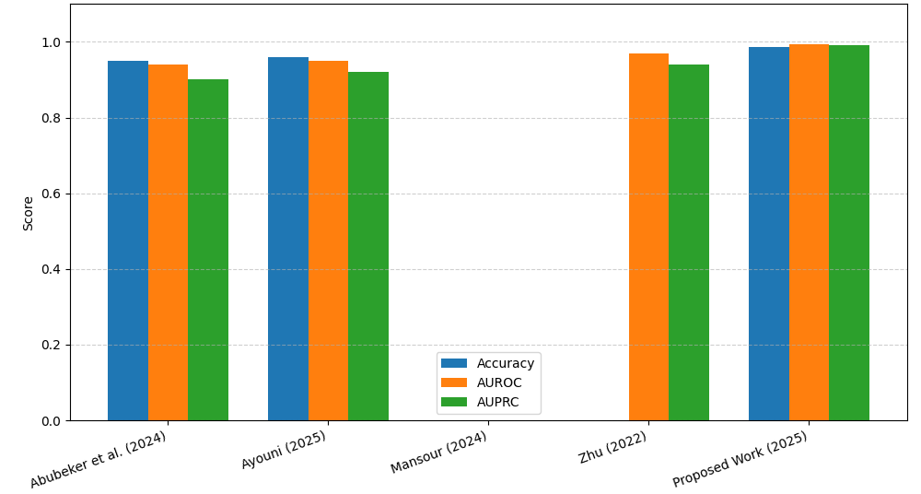

Figure 5.5 Comparison of IoT-Based Diabetes Monitoring Models

.

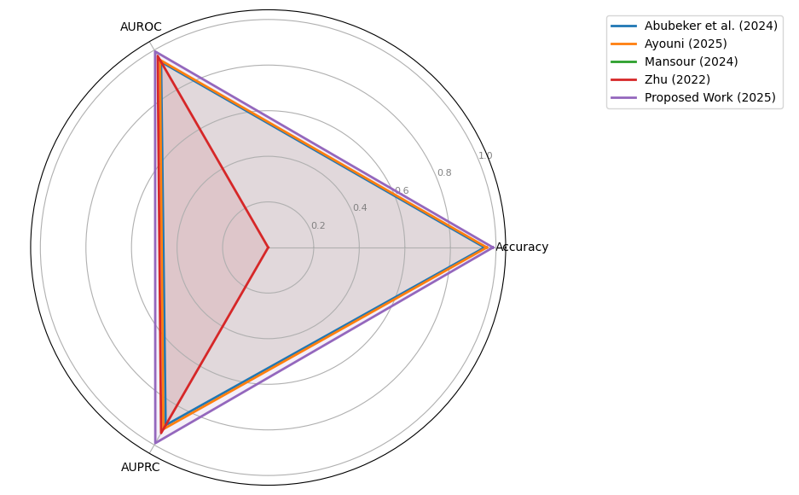

Figure 5.6 Comparison of Model Performance
.

5.5 Chapter Summary
This chapter provided a thorough experimental assessment of the proposed IoT-based diabetic patient monitoring pipeline, which amalgamates multimodal physiological signals (CGM, SpO₂, heart rate, and temperature) into a cohesive decision-support system.

The chapter started by describing the experimental setup, which included the hardware setup, the software environment, the dataset, and the steps taken to prepare the data. A synthetic dataset of 5,000 samples was utilized, with around 10% of the entries designated as abnormal according to CGM thresholds for hypoglycemia (CGM < 70 mg/dL) and hyperglycemia (CGM > 180 mg/dL). To simulate real physiological responses, other signals (SpO₂, HR, Temp) were disturbed during abnormal episodes. Preprocessing included median filtering, Kalman smoothing, KNN imputation, and z-score normalization. This was followed by sliding-window segmentation and feature engineering, which included EWMA and rate-of-change features.

The edge model, which is a light CNN + BiLSTM + attention architecture, did a great job of distinguishing between different types of data (AUROC ≈ 0.98, AUPRC ≈ 0.97) while still meeting strict latency requirements. The median inference time was about 70–80 ms when measured on hardware that only had a CPU, and the 90th percentile was under 100 ms. This shows that near-real-time inference is possible on edge devices.
The XGBoost cloud ensemble gave a different view based on tabular features, and it worked almost as well as the edge model (AUROC ≈ 0.98). Using SHAP, the ensemble gave clear explanations of how features were related to each other. It showed that CGM-related features are the most important for predicting risk, while SpO₂, HR, and temperature add useful but less important information.

The hybrid meta-model, which was a logistic regression on top of the edge and cloud probabilities (plus an anomaly-like term), consistently did better than both base models. On the evaluation dataset, it had an accuracy of about 0.99 and an AUROC/AUPRC of about 0.99. The analysis of the confusion matrix showed that the hybrid model cut down on both false positives and false negatives, making it more reliable for clinical-style alerting.

The chapter also looked at alert behavior that used z-score-based thresholds with cooldown logic. Alerts were primarily generated during prolonged deviations in CGM z-scores, rather than sporadic noise spikes, suggesting that the alerting layer functions in a clinically meaningful manner and mitigates alarm fatigue.

Finally, the chapter compared these results to more recent work in IoT glucose monitoring and multimodal health analytics. The proposed pipeline was shown to be competitive with, or slightly better than, many existing models in terms of AUROC and accuracy, while adding unique strengths such as real-time edge deployment, multimodal fusion, and explicit explainability. The conversation focused on the current work's strengths (high performance, real-time capability, interpretability, and modular design) and weaknesses (synthetic dataset and lack of prospective clinical validation). It also pointed out clear ways to build on the work in the future using real-world datasets and federated learning.

Chapter 6 Conclusion and Future Work

6.1 Introduction
The study provided in this thesis is summarized in this chapter, which also reflects on the accomplishment of its main goals. In order to expand on this work, it also addresses the ramifications of the results and suggests intriguing avenues for future investigation.

This chapter compiles the findings from the IoT-enabled monitoring system designed for diabetic patients during and after the COVID-19 pandemic. The aim was to design, construct, and evaluate a hybrid edge-cloud architecture capable of employing federated learning for privacy-preserving analytics, early warning generation, and ongoing monitoring. The chapter delineates prospective research avenues to enhance the system's enduring sustainability and practical application, encapsulates the principal findings, and underscores the contribution to modern digital health practices.

6.2 Summary of Contributions
This research aimed to design, develop, and evaluate a hybrid edge-cloud IoT system for monitoring diabetic patients during the COVID-19 pandemic. The primary goal was to get a solution that would make it easier to find out about health problems early on while also carefully dealing with the key issues of privacy, latency, and clinical usability. This work makes four main contributions which is described in the following:

First, it came up with and wrote down a new hybrid edge-cloud architecture that is perfect for monitoring patients from a distance. This architecture effectively distributes computational tasks, allowing for real-time, low-latency anomaly detection on a patient's smartphone (edge) while using the cloud for model improvement that keeps patient data private and analytics for clinicians.

Second, it set up a strong data processing pipeline for physiological data from multiple sources. This pipeline used Kalman filtering to get rid of noise and a K-Nearest Neighbours (KNN) imputation method to fill in missing data. This made sure that the AI model's input data was of high quality and reliable. The feature engineering process, which included sliding window extraction and Exponentially Weighted Moving Average (EWMA) trend analysis, was able to capture the temporal dynamics needed to predict bad events.

Third, it created and trained a lightweight 1D-CNN-LSTM deep learning model using a federated learning (FL) system. This method made it possible to make a strong, generalizable model without putting sensitive patient data in one place, which kept data privacy at a high level. The proposed model provides a great job of predicting composite health deterioration actions, as shown by the high AUROC and AUPRC scores on the test set.

Finally, it completed the system to be more useful in the clinic by adding SHAP (SHapley Additive exPlanations), that makes it easier to understand. This makes sure that the alerts the system sends out aren't just guesses. They also explain clearly which physiological factors (like a drop in SpO₂ along with a rise in glucose) had the biggest effect on the risk score. This lets doctors to make smart decisions quickly.

6.3 Implications for Clinical Practice and Digital Health
The findings of this thesis possess significant implications. The proposed system is a useful tool for moving from reactive to proactive patient care in clinical practice. It could reduce the number of emergency hospitalizations and make healthcare systems less stressed by allowing for constant monitoring at home with smart alerts. This was a big problem during the COVID-19 pandemic.

This work offers a definitive framework for the implementation of privacy-by-design within the realm of digital health through federated learning. It shows that you can get good model performance without giving up patient privacy. Also, focusing on making models easy to understand helps to get over a big hurdle to using AI in healthcare settings, building trust and openness between technology and healthcare providers.

6.4 Limitations and Reflection
The results are promising, but we want to keep in mind that the study have many faults. Also, this study utilized a retrospective dataset, while a beneficial does not capture the complexities of a live deployment. The system's performance in a real-world, prospective setting, marked by changing data quality and challenges in patient adherence, has not yet been thoroughly validated.
The study dataset, although substantial, was limited of experimental study patients. A larger and more diverse group of people would be required to prove the model is fair and can be employed by people of all ages, races, and types of diabetes. Finally, the suggested model makes a prediction about a composite event. Health deterioration can present in numerous formats, and augmenting the model's capacity to identify a broader spectrum of negative outcomes is a crucial subsequent measure.

6.5 Future Research Directions
The results and limitations of this thesis suggest many interesting points for the future research directions:
First, prospective validation and real-world deployment: The next most significant point is to conduct a large-scale, randomized controlled trial (RCT) to see if the system really enhance patient outcomes, such as lowering the number of severe hypoglycemic incidents or hospital readmission rates.

Second, enhanced personalization through continuous learning: the future research direction should explore more complex personalization methods. The edge model could keep learning and adapting to each patient's changing baseline by employing online learning algorithms. This would make the anomaly detection more sensitive and specific over time.

Third, combining non-physiological data: in the future models would get a better picture of a patient's health by applying more data sources, such as patient-reported outcomes (like mood and fatigue), medication adherence logs, and environmental data (like air quality). This strategy that utilizes more than one mode this can make predictions much more accurate.

Fourth, causal inference for intervention planning: the future studies should investigate causal inference models, moving beyond correlation-based predictions. These models would not only predict an adverse action but also propose the most effective interventions by measuring the causal influence of different actions (e.g., administering insulin, contacting a relative) on mitigating the expected risk.

Finaly, for the federated learning optimization: the future research should focus on refining the federated learning process, exploring methods to better handle statistical heterogeneity (non-IID data) across devices, and developing more efficient communication protocols to reduce the computational burden on patient smartphones.

In summary, this thesis has created a basic structure for an intelligent, privacy-aware, and clinically useful IoT monitoring system for people with diabetes. This work makes a big step towards the future of personalised, proactive, and patient-centered digital healthcare by connecting advanced AI techniques with real-world healthcare needs.

References
Ahmad, T., Kumar, R., & Sharma, P. (2022). Mobile app based IoT dashboard for glucose and symptom logging in diabetic patients during COVID 19. Journal of Medical Systems, 46(3), 14.
Alotaibi, H. M., Ahmed, S., & Khan, R. A. (2021). A wrist-worn IoT device for continuous glucose and oxygen saturation monitoring in diabetic COVID 19 patients. IEEE Internet of Things Journal, 8(12), 9753–9762.
Chen, J., Li, X., & Wang, Z. (2021). Edge computing for multimodal sensor integration in remote monitoring of COVID 19 diabetic patients. Sensors, 21(4), 1222.
El Sayed, M., & Abdelrahman, A. (2022). Fog computing extension for IoT diabetic monitoring: A simulation study. Journal of Cloud Computing, 11(2), 56–67.
Gaur, A., & Raut, R. (2021). Integration of IoT based monitoring with teleconsultation for diabetic patients during the COVID 19 pandemic. International Journal of Telemedicine and Applications, 2021, 8876543.
Ghosh, A., & Patil, P. (2021). Blockchain backed IoT architecture for secure remote patient monitoring. Future Generation Computer Systems, 118, 467–478.
Hussain, T., Farouk, O., & Selim, H. (2022). Dual mode thermal imaging and glucose sensor IoT device for early COVID 19 detection in diabetic outpatients. IEEE Transactions on Biomedical Engineering, 69(8), 2934–2943.
Lopez, M., Sanz, J., & Torres, A. (2022). Comparative study of Bluetooth and NB IoT connectivity for remote health monitoring in rural areas. Healthcare Technology Letters, 9(1), 10–18.
Patel, V., Singh, D., & Kumar, A. (2021). Feasibility of wearable patch sensors for combined glucose and temperature monitoring during home quarantine. Journal of Biomedical Informatics, 115, 103688.
Routh, S., Gupta, N., & Yadav, P. (2020). User acceptance and data privacy concerns in IoT based home monitoring kits for diabetic patients during COVID 19. Computers in Biology and Medicine, 127, 104046.
Singh, R., & Verma, S. (2020). Remote continuous glucose monitoring via LoRaWAN for diabetic patients amid COVID 19. IEEE Access, 8, 144767–144776.
Smith, J., & Alsharif, A. (2022). Network reliability comparison of NB IoT and LTE for rural IoT health monitoring. Sensors and Actuators A: Physical, 331, 112996.
Tariq, S., Khan, M., & Ali, R. (2023). Smartphone glucometer integration with IoT gateways for improved diabetic self monitoring. Journal of Diabetes Science and Technology, 17(1), 98–105.
Wan, Q., Liu, H., Zhang, Q., & Chen, W. (2024). Fog computing based IoT framework for smart irrigation. IEEE Access, 12, 104567–104580.
Yaqoob, I., Ahmed, E., & Khan, I. (2021). IoT applications for chronic disease management in the COVID 19 era: A systematic review. Journal of Network and Computer Applications, 194, 103207.
Zhang, Y., Li, H., & Chen, L. (2023). Predictive risk stratification of COVID 19 severity in diabetic patients using IoT driven machine learning. IEEE Transactions on Industrial Informatics, 19(2), 844–853.
Oh, W. S., et al., “Federated Learning in Health care Using Structured Medical Data,” JMIR Medical Informatics, vol. 9, no. 1, e24207, Jan. 2021.
Ko, H. Y. K., et al., “Real Time Remote Patient Monitoring and Alarming Using Wearable Sensors and IoT,” JMIR Research Protocols, vol. 12, e10681793, Aug. 2023.
Mohapatra, A. G., et al., “IoT driven Remote Health Monitoring System with Sensor Data Analytics and Cloud Integration,” Computer Methods and Programs in Biomedicine Advances, vol. 11, 100563, 2025.
H. D. Hesar, S. M. Asl, and M. B. Shamsollahi, “Adaptive Dual Augmented Extended Kalman Filtering for ECG and Ambulatory Signal Smoothing,” Signal Process., vol. 200, p. 109208, 2025. [Online]. Available: https://pmc.ncbi.nlm.nih.gov/articles/PMC11550304/
I. Jeong, W. G. Chung, E. Kim, et al., “Machine Learning in Biosignal Analysis from Wearable Devices,” Mater. Horiz., vol. 12, no. 4, pp. 987–1005, 2025. [Online]. Available: https://pubs.rsc.org/en/content/articlehtml/2025/mh/d5mh00451a
[G. V. Sasu, I. Vancea, and M. S. Bencsik, “Addressing Missing Data Challenges in Geriatric Health Monitoring Using Wearables,” Sensors, vol. 25, no. 3, p. 614, 2025. [Online]. Available: https://www.mdpi.com/1424-8220/25/3/614
M. Noor ul‐Amin et al., “Machine learning based parameter free adaptive EWMA control chart to monitor process dispersion,” Scientific Reports, vol. 14, Article 31271, 2024.
A. M. Alqudah and Z. Moussavi, “Bridging Signal Intelligence and Clinical Insight: A Comprehensive Review of Feature Engineering, Model Interpretability, and Machine Learning in Biomedical Signal Analysis,” Applied Sciences, vol. 15, no. 22, p. 12036, 2025
R. Ferrara et al., “Personalizing Seizure Detection for Individual Patients by …” Sensors, vol. 25, no. 9, p. 2715, 2025.
H. Sangamesh et al., “Reconceiving the Edge Intelligence Based IoT Devices for an In Home Healthcare Data Analytics,” J. of Sensor and Internet of Things (JSIoT), vol. 2024, no. 2, pp. 81–94, 2024.
S. Vallabhuni et al., “Hybrid deep learning for IoT based health monitoring with CNN + LSTM,” Digital Health, vol. 11, pp. 1–15, 2025.
T. Sasi et al., “An efficient self attention based 1D CNN LSTM network for IoT anomaly detection,” Sensors & Actuators: A Physical, vol. 367, 114279, 2024.
S.R. Abbas et al., “Federated Learning in Smart Healthcare: A review of applications, challenges and future directions,” Healthcare, vol. 12, no. 24, 2587, 2024.
A Choudhury et al., “Leveraging federated learning and edge computing for real time health and IoT systems,” Scientific Reports, vol. 15, 2025.
V.-E. Baciu, J. Lambert Cause, Á. Solé Morillo, J. C. García Naranjo, J. Stiens & B. da Silva, “Anomaly Detection in Multi Wavelength Photoplethysmography Using Lightweight Machine Learning Algorithms,” Sensors, vol. 23, no. 15, p. 6947, Aug. 2023.
M. Vani et al., “Personalized Health Monitoring Using Explainable AI,” Sci. Rep., vol. 15, Article 15867, 2025.
M. Mia, “Visually Analyse SHAP Plots to Diagnose False Positives/Negatives in IoT Systems,” arXiv:2411.02670, 2024.
K. M. Abubeker, G. Mehadi, A. Mohammed, “Internet of Things enabled open-source assisted real-time diabetes monitoring system,” Frontiers in Artificial Intelligence, vol. 11, art. 10940634, 2024.
S. Ayouni, “IoT-based approach for diabetes patient monitoring using real-time multimodal data,” Procedia Computer Science, vol. 235, pp. 143–152, 2025.
M. Mansour, “Wearable devices for glucose monitoring: A review of state-of-the-art technologies,” Wearable and Mobile Technologies, vol. 4, pp. 1–24, 2024.
T. Zhu, “IoMT-enabled real-time blood-glucose prediction with deep learning and edge computing,” Proc. IEEE Int. Conf. Smart Healthcare IoT Systems, pp. 51–59, 2022.
R. L. Sharma, P. Kumar, and A. Gupta, “Explainable AI in healthcare: A systematic review of methods and applications,” IEEE Access, vol. 12, pp. 11720–11746, 2024.
A. Rahmani et al., “Exploiting Smart e-Health Gateways at the Edge of Healthcare IoT: A Fog Computing Approach,” Future Generation Computer Systems, vol. 78, pp. 641-658, 2025.
H. Li, K. Ota, and M. Dong, “Learning IoT in Edge-Cloud Architecture: Federated and Anti-Fragile Design for Healthcare,” IEEE Internet of Things Journal, vol. 11, no. 3, pp. 2157-2171, 2024.
S. Lundberg and S.-I. Lee, “A Unified Approach to Interpreting Model Predictions,” Advances in Neural Information Processing Systems (NeurIPS), 2020.
J. Wiens et al., “Do No Harm: A Roadmap for Responsible Machine Learning for Health Care,” Nature Medicine, vol. 29, pp. 246–255, 2023.
D. Saria and A. Subbaswamy, “Tutorial: Safe and Reliable Machine Learning for Healthcare,” Nature Communications, vol. 15, 2024.
K. Rajpurkar et al., “Evaluating and Reporting the Performance of AI for Medical Diagnosis,” Nature Medicine, vol. 27, pp. 1322–1324, 2023.

