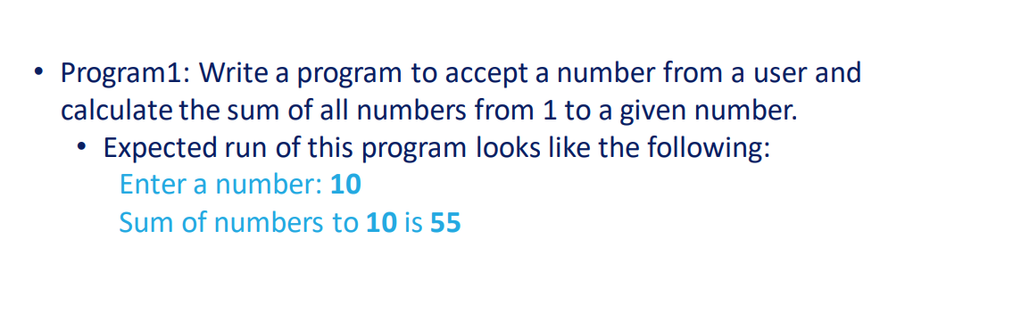

# Accept a number from the user
num = int(input('Enter a number: '))
# Initialize the sum to 0
sum = 0
# Iterate over the range from 1 to the given number
for i in range(1, num+1):
# Add the current number to the sum
sum += i
# Print the sum
print(f'Sum of numbers to {num} is {sum}')

Output:
Enter a number: 10
Sum of numbers to 10 is 55
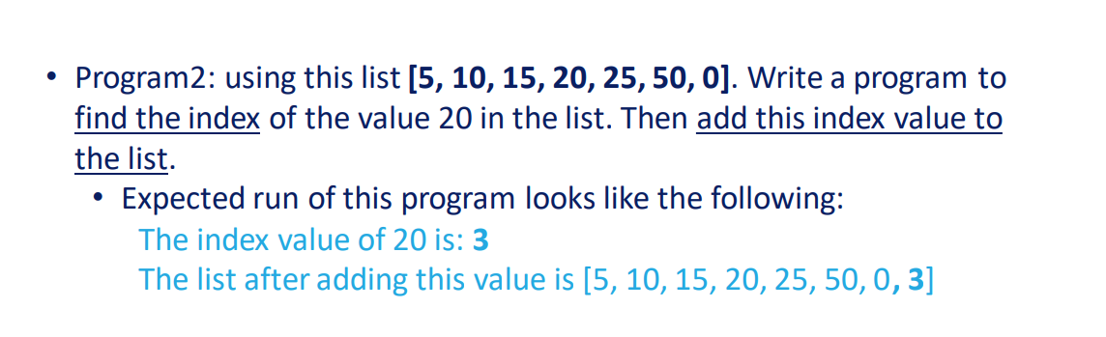

# Define the list
lst = [5, 10, 15, 20, 25, 50, 0]
# Find the index of the value 20
index = lst.index(20)
# Print the index value
print(f'The index value of 20 is: {index}')
# Add the index value to the list
lst.append(index)
# Print the modified list
print(f'The list after adding this value is {lst}')

Output:
The index value of 20 is: 3
The list after adding this value is [5, 10, 15, 20, 25, 50, 0, 3]

