

Title

Early Mental Health Risk Detection from Social Media Posts

Name: Ghurmallah Alqarni ID No.: 253000384
Name: Ahmad Hammad ID No.:261003041
Submitted in fulfillment of the requirements for the degree Master of Science in Artificial Intelligence
At
Collage of Informatics
Midocean University
UAE
Supervisor Name: Dr. Hager Saleh
Collage of Informatics, Midocean University, Comoros
Email:

Acknowledgements

Abstract

List of Publications

Table of Contents

List of Figures viii
List of Tables viii
Chapter 1 1
Introduction 1
1.2 Problem Definition 2
1.3 Thesis Objectives 2
1.4 Thesis Contribution 3
1.5 Thesis Organization 3
2.1 Background 4
2.1.1 Artificial Intelligence (AI) 4
2.1.2 Natural Language Processing (NLP) 5
2.1.2.1 NLP Pipeline 5
2.1.3 Text Preprocessing 6
2.1.3.1 Tokenization 6
2.1.3.2 Stop-word Removal 6
2.1.3.3 Stemming 7
2.1.4.1 Bag-of-Words (BoW) 8
2.1.4.2 N-grams 8
2.1.4.3 Term Frequency–Inverse Document Frequency (TF-IDF) 8
2.1.4.4 Word2Vec 8
2.1.4.5 GloVe 9
2.1.4.6 FastText 9
2.1.5 Artificial Intelligence Models 9
2.1.5.1 Machine Learning Models 10
2.1.5.2 Deep Learning Models 11
2.1.5.2.1 Convolutional Neural Network (CNN) 11
2.1.5.2.2 Long Short-Term Memory (LSTM) 11
2.1.5.2.3 Bidirectional Long Short-Term Memory (BiLSTM) 12
2.1.5.2.4 Attention Mechanism 12
2.1.5.2.5 CNN-LSTM 12
2.1.5.2.6 LSTM-Attention-CNN 12
2.1.5.3 Transformer Models 13
2.1.5.3.1 Bidirectional Encoder Representations from Transformers (BERT) 13
2.1.5.3.2 DistilBERT 13
2.1.5.3.3 RoBERTa 13
2.1.5.3.4 DeBERTa 14
2.1.6 Dataset 14
2.2 Related Work 16
Chapter 5: Experimental Results and Discussion 35
([1] Bokolo, 2023) 37

Chapter 1: Introduction and Overview......................................................................................................... 1
1.2 Problem Definition ................................................................................... 2
1.3 Thesis Objectives ..................................................................................... 3
1.4 Thesis Contribution .................................................................................. 4
1.5 Thesis Organization................................................................................... 5

Chapter 2: Background and Related Work…………………………... 31

Chapter 3: Proposed Approach ............................................................... 78
4.1 Introduction ............................................................................................ 78

Chapter 4: Experimental Results and Discussion ................................... 86

Chapter 5: Conclusion and Future Work .............................................. 127
7.1 Important Features ............................................................................... 127
7.3 Future Work ....................................................................................... 129

References .................................................................................................. 130

List of Abbreviations
- Artificial Intelligence.
- Area Under the Receiver Operating Characteristic Curve.
- Bag-of-Words.
- Convolutional Neural Network.
- Deep Learning.
- F1 Score.
- False Negative.
- False Positive.
- Logistic Regression.
- Long Short-Term Memory.
- Machine Learning.
- Naïve Bayes.
- Natural Language Processing.
- Random Forest.
- Receiver Operating Characteristic.
- Support Vector Machine.
- Term Frequency.
- Term Frequency–Inverse Document Frequency.
- True Negative.
- True Positive.
- World Health Organization.
- Global Vectors for Word Representation.
- Bidirectional Encoder Representations from Transformers.

List of Figures
Figure 2.1 | Artificial Intelligence Hierarchy | 4
Figure 2.2 | Natural Language Processing Framework | 5
Figure 2.3 | Text Preprocessing Workflow | 6
Figure 2.4 | Text Representation Techniques | 8
Figure 2.5 | Artificial Intelligence Models Classification | 10
Figure 2.6 | Accuracy Formula | 15
Figure 2.7 | Precision Formula | 15
Figure 2.8 | Recall Formula | 16
Figure 2.9 | F1-score Formula | 16
Figure 2.10 | Social Media Mental Health Risk Dataset Structure | 17

List of Tables
2.1 Comparison of Previous Studies

Chapter 1

Introduction

1.1 Overview
Mental health is a vital part of overall health, and it helps to shape an individual's thoughts, feelings and actions in everyday life. Mental illness, such as depression, anxiety, stress and suicidal thoughts have emerged as a significant global public health burden. The World Health Organization (WHO) estimates that millions of people worldwide suffer from mental health disorders annually, and often don't get diagnosed or timely intervention. Hence, the detection of persons at risk at an early stage is important for the researchers and healthcare professionals. Social media platforms like Twitter (X), Reddit, Facebook and Instagram have grown by a vast margin in recent years and have changed how people interact with each other and how they express their feelings, thoughts, and experiences. Users freely post their thoughts, feelings, experiences and more on the internet with some posts revealing signs of psychological well-being. As a result, social media is an excellent tool to gather textual data, which is useful to examine mental health conditions and their early signs of psychological distress. Natural Language Processing (NLP), along with Machine Learning (ML) and Deep Learning (DL), has been one of the key factors that has revolutionized the automatic textual information analysis process. NLP can help computers to interpret and understand human language, while machine learning and deep learning models can learn and categorize user with regard to their mental health status based on the information contained in the text. The evolution of transformer-based language models has also contributed to the success of more recent text classification, allowing them to capture contextual and semantic relations which are better than traditional approaches. There is still a long way to go, but it's difficult to accurately screen for mental health risks within social media. Social media texts tend to be brief, casual, ambiguous and include abbreviations, slang, emoji and spelling variations. Moreover, data sets are often skewed and the language usage of users can differ from platform to platform. These problems give rise to an interest in developing and evaluating computational models that would be sound and reliable tools for early detection of mental health risks. In this thesis, we investigate methods for the early detection of mental health risks in social media posts, particularly focusing on Machine Learning and Deep Learning techniques. This thesis provides a review of current approaches and evaluates different text representations and classification models, comparing their performance through benchmarking datasets. It is expected that the results will provide valuable insights about the current state of the art, and which methods can be considered the most successful in detecting early mental health risks.

1.2 Problem Definition
The increasing trend of mental disorders calls for an urgent need for appropriate measures that will allow the early detection of individuals prone to such conditions. The conventional practice of mental health assessment is dependent on clinical interview, self-rating scales, and judgment of the practitioners. While such methods have high levels of accuracy, they can be extremely time-consuming and costly. As a result, many people with mental health issues go undiagnosed or only seek treatment once it has become far more serious, limiting the potential impact of early intervention. With the proliferation of social media, new opportunities have arisen for detecting initial symptoms of mental illnesses via humans' online written expressions. But it's still hard to accurately identify mental health risks from social media. Social media posts tend to be informal, brief, very loosely structured and include words like slang, abbreviations, emojis, misspellings, and context-dependent expressions. These features make the process of accurately detecting mental health risks more difficult, and complicate text analysis. While there have been many computational methods that have been offered for the purposes of early detection of mental health risk from social media posts, there are several issues that are yet to be addressed. Past studies have used different Machine Learning and Deep Learning models, datasets, text representation and classification algorithms, thereby making it hard to decide which one to use. Furthermore, a lot of studies only look at limited models and/or at mental health disorders, and the findings differ in the literature. Hence, a holistic analysis of the computational methods for early detection of mental health risks in social media posts, especially of Machine/Deep Learning methods is requested. The present study caters to this by reviewing and comparing the existing techniques, analyzing their strengths and limitations, and finding the most effective technique that can be used for accurate and reliable early mental health risk detection.

1.3 Thesis Objectives
This thesis aims to explore the effectiveness of computational methods to identify signs of mental health problems from text posts in social media, especially using Machine Learning and Deep Learning. In order to achieve this objective, the research will do the following:
1. Investigate existing research on the use of tools that can be used in the detection of early mental health risks using social media data and state their strengths and weaknesses.
2. Examine the text processing techniques as well as the text representation techniques used in the analysis of social media posts in relation to mental health issues.
3. Assess different machine learning models and deep learning models for classification of social media posts for mental health conditions.
4. Evaluate the performance of selected models based on commonly used criteria such as accuracy, precision, recall, F1-score and AUC.
5. On the basis of empirical findings, compare and contrast the strengths and weaknesses of different approaches of early mental health risk identification and identify the best performing ones.

1.4 Thesis Contribution
The current thesis is a breakthrough in the research area of early detection of the possibility of mental illnesses based on social media content analysis, as it provides a detailed overview of computational techniques, including Machine Learning and Deep Learning. This study contributes to the literature in the following ways:
1- Performing a full-scale state of the art review of the recent studies by focusing on the current trends, challenges, and research gaps in the field of early mental health risk detection via social media data.
2. Comparatively analyzing the widely used text pre-processing techniques, text representation methods and classification models used for mental health risk detection.
3. Assessing the performance of Machine Learning and Deep Learning models using standard and benchmark datasets and evaluation metrics such as accuracy, precision, recall, F1-score, and AUC.
4. Identifying the strengths and limitations of different approaches to identify the most effective techniques to detect mental health risks early.
5. Providing practical recommendations that might help the researchers to choose the appropriate AI technique(s) for future mental health detection studies.

1.5 Thesis Organization
This thesis consists of five chapters, each of which deals with one aspect of the research.
Chapter 1. provides an overview of the research, problem definition, objectives of research, thesis contributions, and thesis organization.
The background and related work are given in Chapter 2. It covers the basic ideas of Natural Language Processing (NLP), Machine Learning (ML), Deep Learning (DL), text preprocessing and text representation techniques, and popular evaluation metrics, and summarizes recent works for early detection of mental health risk indicators from social media data.
The research methodology is explained in chapter 3. Provides the datasets that were used in the study, data pre-processing, feature extraction techniques, selected ML models, selected DL models, experimental set-up and evaluation metrics used for testing the model performance.
The results and discussion of the experiments are shown in Chapter 4. It presents a comparison of the performance of the various models used, an analysis of the experimental results, a discussion of the merits and drawbacks of the models, and a comparison of the results obtained with the results presented in previous studies.
The last chapter in the thesis will contain a summary of the major findings, the contribution of the study, its limitations, and recommendations for further studies.

Chapter 2 Background and Related Work

1 Background

1.1 Artificial Intelligence (AI)
AI refers to a field of computer science which involves creation of intelligent machines which are able to carry out activities that would typically need human intelligence such as thinking, reasoning, solving problems, making decisions, and processing natural languages. AI machines analyze information, recognize useful patterns, and make decisions and predictions through use of computational algorithms. Owing to the constant development of AI technology, it has been utilized in various areas like medicine, finance, education, computer vision, robotics, and natural language processing. Therefore, AI has become the core of various intelligent systems today ([1] Bokolo, 2023) 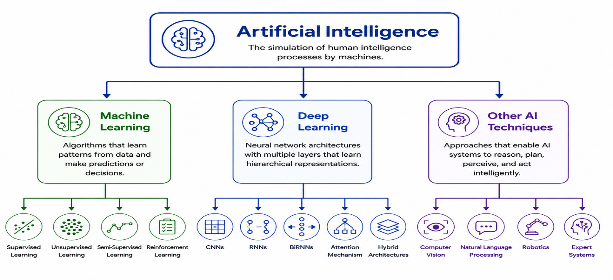
Figure 2.1 Artificial Intelligence Hierarchy

1.2 Natural Language Processing (NLP)
Natural Language Processing (NLP) is a subset of Artificial Intelligence that makes it possible for machines to process, understand, analyze, and generate natural human languages. This branch of AI incorporates the use of computational linguistics together with Machine Learning and Deep Learning algorithms to convert unstructured textual information into a structured form that can be used in automation. Natural Language Processing forms the basis for many different applications related to language analysis like text categorization, sentiment analysis, information retrieval, machine translation, question answering, and social media analysis. NLP is the key component in psychological research. ([2] S. Almutairi, 2024) 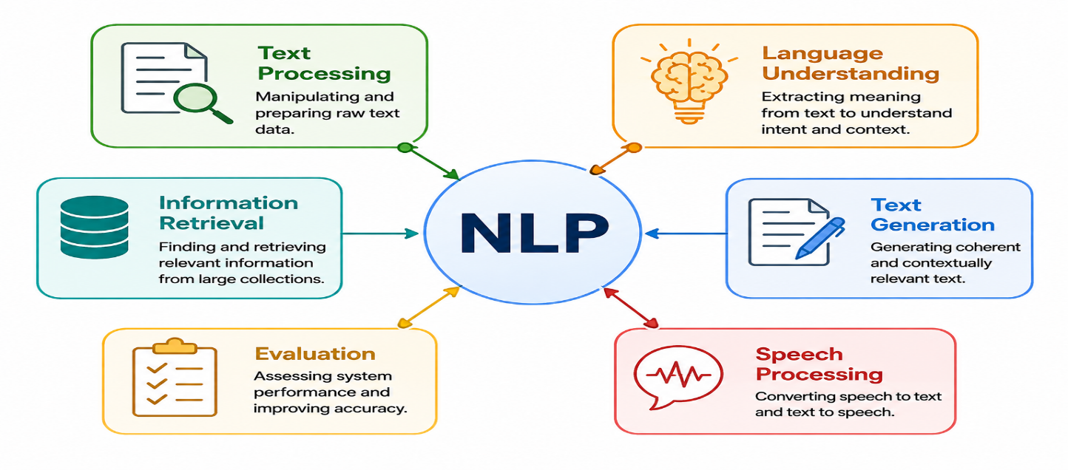
Figure 2.2 Natural Language Processing Framework, ChatGPT

1.2.1 NLP Pipeline
The Natural Language Processing Pipeline (NLP) is the pipeline process that includes the processes included in converting unstructured text data into structured data that can be used for computation purposes. The processes include data acquisition, text pre-processing, text representation, feature extraction, model training, classification, and evaluation. This process helps in improving the quality of the data as well as efficiency of the model. ([11] Renjith, n.d.).

1.3 Text Preprocessing
The term Text Preprocessing is used to denote the procedure involved in cleaning and transforming the raw text data into an analyzable format. The main objective of text preprocessing is to filter out all the noise and unnecessary data and to transform the text data in such a way that it can be utilized in feature extraction from text data in building up text classification models. Some of the most common methods used in text preprocessing include tokenization and stop-word elimination. ([4] Bae, 2021).
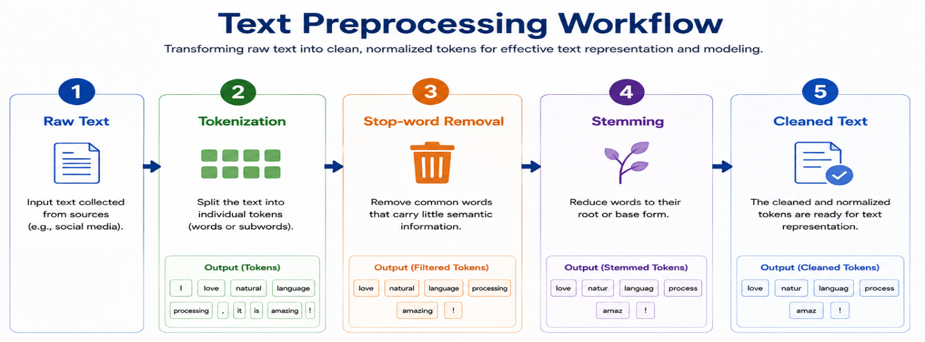
Figure 2.3 Text Preprocessing Workflow, ChatGPT

1.3.1 Tokenization
Tokenization refers to the act of breaking down the text data into small parts referred to as tokens. These tokens can be either words, subwords, sentences, or characters. Tokenization is one of the most important techniques used in preprocessing in NLP since it involves converting text data into structured tokens that can then be analyzed through machine learning and deep learning models. ([4] Bae, 2021), ([11] Renjith, n.d.).

1.3.2 Stop-word Removal
Stop-words removal is a kind of text processing where frequent words with no semantics at all are stripped from text mining. Such words are stripped from text because this process strips noise from text and decreases feature dimensions for increasing computation speed. With the help of removing such words, the quality of text representation and text classification gets better. ([4] Bae, 2021).

1.3.3 Stemming
Text Stemming is the text normalization approach that involves stripping away affixes from the inflected or derived words in order to achieve their root form. The idea behind text stemming is the grouping of morphologically related words under one single form. It leads to decreased size of the vocabulary list and better feature consistency. Thus, text stemming facilitates effective text representation and improves text classification results. ([2] S. Almutairi, 2024).

1.4 Text Representation
Text representation is the process by which textual information is converted into numeric form, which will enable the use of machine learning and deep learning techniques. Effective text representation should have the ability to capture linguistics and semantics of the text, as well as computational capabilities for finding useful patterns from the text. Various forms of text representation have been used previously, which may include old frequency-based methods and the modern embedding method. ([9] Kumar, 2022), ([2] S. Almutairi, 2024).
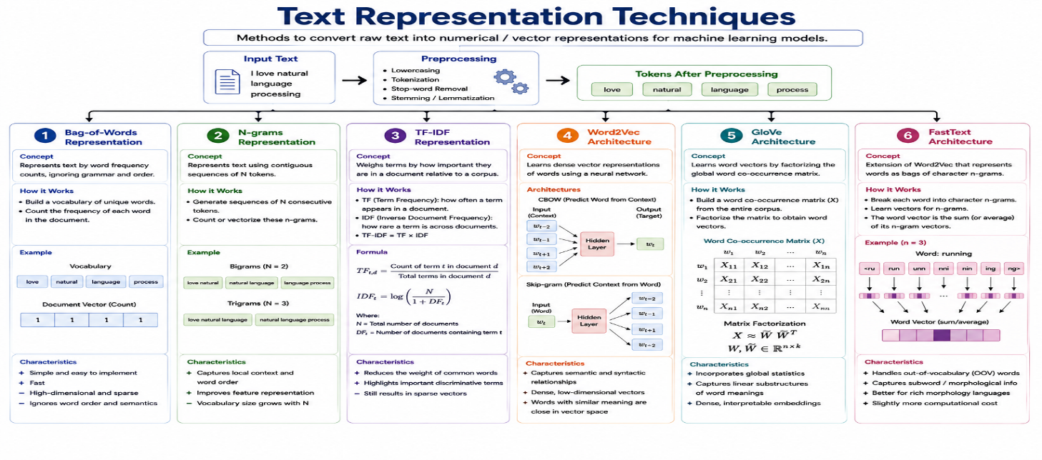
Figure 2.4 Text Representation Techniques, ChatGPT

1.4.1 Bag-of-Words (BoW)
Bag-of-Words (BoW) is one of the oldest text representation methods in Natural Language Processing. This method describes documents as vectors that contain word counts without taking into account grammar, syntax, and word order. Every single word in the corpus is considered as a separate feature with its value based on occurrences in the document. Even though BoW is very computationally efficient, it lacks the ability to represent semantics and relationships between words. ([1] Bokolo, 2023), ([11] Renjith, n.d.).

1.4.2 N-grams
N-gram consists of the units that are used for representing texts using the consecutive words within the text. On the basis of the value of N, N-gram can either be a unigram, consisting of representation of a single word; a bigram, consisting of representation of two consecutive words; or a trigram, consisting of representation of three consecutive words. Unlike the Bag of Words method, N-grams don’t consider word order but still have word order information included in them. ([4] Bae, 2021), ([11] Renjith, n.d.).

1.4.3 Term Frequency–Inverse Document Frequency (TF-IDF)
The Term Frequency–Inverse Document Frequency (TF-IDF) is a statistical approach used to represent text through calculating the significance of a term in a document against a set of documents. It considers the term frequency which refers to how many times a term appears in the document and the inverse document frequency that downplays the role of terms that appear very frequently across all the documents. The effect of TF-IDF is to increase the weight of important terms and reduce that of uninformative terms. ([4] Bae, 2021), ([15] Qasim, 2025).

1.4.4 Word2Vec
Word2Vec is an embedding algorithm that creates vector representations for words by analyzing the context of words in a textual corpus. Word2Vec works on the principle that the words that appear in a similar context share similar meanings. This helps in representing similar meanings in close proximity in the vector space which cannot be achieved with conventional frequency-based techniques used for representing text. ([2] S. Almutairi, 2024), ([11] Renjith, n.d.).

1.4.5 GloVe
Global Vectors for Word Representation, also known as GloVe, is a word embedding technique where word embeddings, which can be defined as dense vector forms of words, are gained using the global statistics of word co-occurrences in the entire corpus. Unlike predictive models of word embedding, GloVe utilizes the factorization of the word co-occurrence matrix for learning word embeddings. ([5] Roy, 2020), ([8] Figuerêdo, 2022).

1.4.6 FastText
FastText, on the other hand, is an algorithm in word representation that treats each word as a set of subwords based on its characters and not as a single token. This is because the FastText algorithm is able to learn embeddings of character n-grams in order to capture the morphological features of words. It is thus well suited for analyzing noisy data such as data from social media sites. ([5] Roy, 2020), ([8] Figuerêdo, 2022).

1.5 Artificial Intelligence Models
AI models represent computer-based methods that have been constructed to recognize patterns, learn from knowledge and make predictions or decisions based on them. Taking into account the differences between the learning process of such models and their architectural complexity, AI models may be divided into ML, DL and Transformer models. In the field of Natural Language Processing, there is a variety of applications of such models in order to work with textual data and carry out its classification. ([11] Renjith, n.d.).
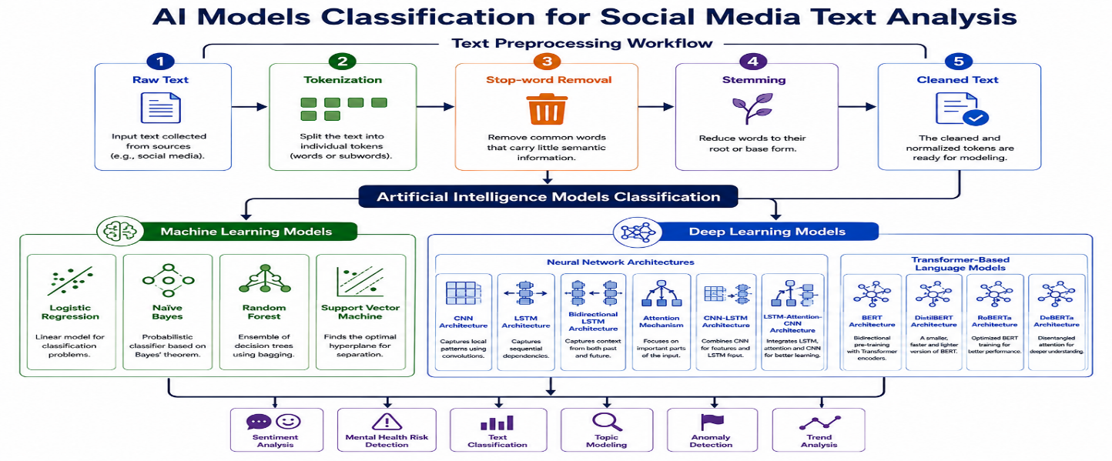
Figure 2.5 Artificial Intelligence Models Classification, ChatGPT

1.5.1 Machine Learning Models

Definition of Machine Learning (ML)
ML is an artificial intelligence field that facilitates the learning of patterns by computer systems through data without being programmed. These ML algorithms learn the connections between input and output using statistical learning. In NLP, ML models tend to use human-built features like TF-IDF and Bag-of-Words for text classification and other processes like sentiment analysis and mental health detection tasks. ([4] Bae, 2021).

1.5.1.1 Logistic Regression
Logistic Regression is a type of supervised machine learning that uses the logistic (sigmoid) function to predict the probability that an input belongs to a particular class. The algorithm builds a mapping from input features to class label probabilities via the transformation of the weighted sum of the inputs into a number between zero and one. Logistic Regression is extensively applied for binary text classification due to its efficiency and good baselines. ([1] Bokolo, 2023).

1.5.1.2 Naïve Bayes
The Naïve Bayes classifier is a Machine Learning algorithm based on probability that uses Bayes’ theorem to classify a record as belonging to a certain class. The algorithm considers the predictors to be statistically independent of each other given the output variable making calculations easier. Due to the simplicity and efficiency involved in using Naïve Bayes, it is commonly used in text mining applications. ([4] Bae, 2021).

1.5.1.3 Random Forest
Random Forest is an ensemble machine learning technique that creates multiple decision trees on the basis of random sampling of data and features. The output of each tree is considered in order to generate the final output of the ensemble model through voting. This technique helps increase the accuracy of classification tasks in the area of text classification. ([1] Bokolo, 2023).

1.5.1.4 Support Vector Machine (SVM)
Support Vector Machines (SVM) is a Supervised Machine Learning algorithm that tries to establish an optimal decision boundary by creating the maximum possible margin between the various categories. The classifier tries to establish a hyperplane that can divide the dataset with minimum possible misclassifications. SVM has been widely used in natural language processing because of its ability to operate in high-dimensional spaces. ([11] Renjith, n.d.).

1.5.2 Deep Learning Models
Deep Learning (DL) is a recent field of research in Machine Learning in which highly complex multi-layered neural networks are used for learning the hierarchal representation of features in the data set. What differentiates Deep Learning algorithms from regular Machine Learning algorithms is the fact that Deep Learning algorithms do not involve designing features manually, since the representative feature representation is learned automatically from the input data itself. This technology has been of great help to Natural Language Processing. ([9] Kumar, 2022), ([11] Renjith, n.d.).

1.5.2.1 Convolutional Neural Network (CNN)
The Convolutional Neural Network (CNN) is a deep learning model that aims at automatic extraction of discriminative features from inputs using convolution. In Natural Language Processing, the Convolutional Neural Networks are applied on word representation to find out the useful local information, such as phrases or sequences of adjacent words. The extracted features are then pooled and passed to the fully connected layer for the classification step. This model has become popular for its capability of capturing local context. ([2] S. Almutairi, 2024), ([9] Kumar, 2022).

1.5.2.2 Long Short-Term Memory (LSTM)
Long Short-Term Memory (LSTM) network refers to a particular form of recurrent neural network that has been specially designed to be able to acquire long-term dependencies within sequential data. Contrary to the traditional recurrent neural network, the LSTM network is composed of the memory cell apart from having the input, output, and forget gates. The gates are specially constructed to be able to regulate the flow of information inside the network by retaining relevant information and forgetting irrelevant one. ([7] Sharma, 2022), ([14] Hasan, 2024).

1.5.2.3 Bidirectional Long Short-Term Memory (BiLSTM)
The Bidirectional Long Short-Term Memory model (BiLSTM) is an advanced version of the traditional LSTM network in which a sequence of words is processed in two different directions; the forward direction as well as the backward direction. These two outputs are integrated to form context representations which take into account previous as well as subsequent linguistic data. ([9] Kumar, 2022), ([14] Hasan, 2024).

1.5.2.4 Attention Mechanism
One of such architectures of the neural networks is known as Attention Mechanism, which helps in giving varying levels of importance to different parts of the input sequence. Instead of giving the same level of importance to all the parts of the input sequence, attention mechanism will help in giving more importance to those parts of the textual input which are useful and ignore the other parts. ([11] Renjith, n.d.), ([14] Hasan, 2024).

1.5.2.5 CNN-LSTM
The CNN-LSTM model is an ensemble deep learning model that exploits the joint capabilities of Convolutional Neural Network and Long Short Term Memory network. The CNN is utilized in recognizing the important local features of text data whereas LSTM is employed to capture the dependencies among those features. The joint utilization of both models helps CNN-LSTM to learn the spatial and temporal structure simultaneously. ([2] S. Almutairi, 2024), ([11] Renjith, n.d.).

1.5.2.6 LSTM-Attention-CNN
Long Short Term Memory Network, Attention Mechanism and Convolutional Neural Networks have been integrated together to form what is termed as the LSTM-Attention-CNN model. The definition of the LSTM-Attention-CNN model can be defined as an architecture that utilizes the concepts of LSTM, attention mechanism and CNN together. In the LSTM-Attention-CNN model, the LSTM network is used to learn sequential information while the attention mechanism is used to select the informative features. ([11] Renjith, n.d.).

1.5.3 Transformer Models
Transformer models constitute a contemporary class of deep neural network models that mostly use the self-attention method to capture contextual dependencies between the words in a sequence. As opposed to the recurrent models, transformers are able to process all the inputs in parallel and thus capture both short and long range dependencies. The ability of the transformers to learn the context has been very beneficial to NLP. ([1] Bokolo, 2023), ([14] Hasan, 2024), ([15] Qasim, 2025).

1.5.3.1 Bidirectional Encoder Representations from Transformers (BERT)
Bert - Bidirectional Encoder Representations from Transformers is a pre-trained language model based on transformers that learns bidirectional contextual representations by looking at both previous and next words in the sentence. BERT can be used in downstream Natural Language Processing tasks after extensive training by simply adding a task-specific output layer to it. The bidirectional contextual learning ability of BERT has been a significant contribution to language models. ([6] Rastogi, 2022), ([15] Qasim, 2025).

1.5.3.2 DistilBERT
DistilBERT is a lighter version of BERT architecture acquired through knowledge distillation process. DistilBERT reduces the number of parameters in the model while retaining most of the capabilities of BERT to understand context. This technique makes the model fast, less computation intensive, and efficient. ([3] Rastogi, 2021).

1.5.3.3 RoBERTa
RoBERTa refers to an optimized transformer architecture of language model built to be a better version of BERT through the use of an improved approach to pre-training. It is able to learn more contextual features that make the language model more efficient in terms of comprehension and text classification. The ability of RoBERTa to model contexts effectively has made it one of the best transformer models in NLP. ([1] Bokolo, 2023), ([14] Hasan, 2024), ([15] Qasim, 2025).

1.5.3.4 DeBERTa
DeBERTa is a sophisticated transformer-based language model that improves context representation through disentangled attention in order to separately capture word content and position. The novel architecture allows better modeling of the relations between tokens based on their semantics and positions, leading to better language representation and increased efficiency for various NLP tasks, such as text classification and mental health risks detection. ([1] Bokolo, 2023), ([15] Qasim, 2025).

1.6 Evaluation Metrics
Evaluation metrics imply the quantitative techniques that are used for analyzing the performance of classification models based on comparison of predictions and actual labels. Evaluation metrics provide a way of quantifying the effectiveness, precision, and generalization capacity of machine learning models. Since the classification of risks of mental illnesses may be regarded as text classification, the choice of appropriate evaluation metrics becomes crucial in order to evaluate the performance of such models. In this paper, the performance of classification models will be estimated using the Confusion Matrix, Accuracy, Precision, Recall, and F1 score that are the most widely used evaluation metrics in NLP. ([2] S. Almutairi, 2024), ([15] Qasim, 2025).

1.6.1 Confusion Matrix
Confusion Matrix is a tabular representation technique that is employed for assessing the effectiveness of classification models. There are four types of results of the classification process included in a confusion matrix; they include True Positive (TP), True Negative (TN), False Positive (FP) and False Negative (FN). These are used for computing metrics like Accuracy, Precision, Recall, F1 Score, and others. ([1] Bokolo, 2023), ([15] Qasim, 2025).

1.6.2 Accuracy
Accuracy is defined as the proportion of cases that have been classified accurately from all the test cases. Accuracy serves as an indicator of the general performance of the classifier because it follows the formula of total number of correct cases divided by total number of cases. While it is easy to understand the meaning of Accuracy, it can be deceptive when the data set is imbalanced. ([1] Bokolo, 2023), ([15] Qasim, 2025).
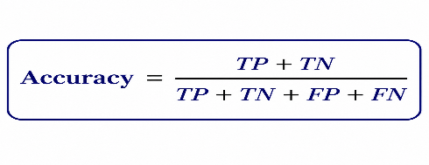​
Figure 2.6 Accuracy Formula

1.6.3 Precision
Precision relates to the proportion of correct positives to the total number of positives. Precision is used to assess how accurate the positive predictions are by determining how many of those positive predictions prove to be truly positive. ([15] Qasim, 2025).
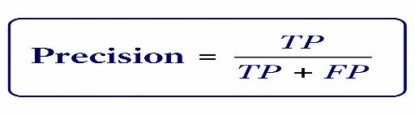
Figure 2.7 Precision Formula

1.6.4 Recall
It is also known as sensitivity and True Positive Rate. Recall is used to measure the percentage of positives detected by the classifier out of total positives. High recall implies that the classifier detects the positives well without many false negatives being predicted, which is important for risk detection of mental illnesses. ([1] Bokolo, 2023).

Figure 2.8 Recall Formula

1.6.5 F1-score
The F1 Score is the harmonic mean of Precision and Recall that is a good way to measure accuracy. The importance of the F1 Score increases with imbalance between the classes as the metric considers both errors. Hence, the F1 Score is used for the assessment of NLP models. ([15] Qasim, 2025).

Figure 2.9 F1-score Formula

1.7 Dataset

1.7.1 Dataset Overview
In this thesis, all experiments are carried out using the open source Mental Health Risk Dataset from the domain of social media, which can be downloaded from Kaggle. It is an artificial social media dataset containing 5,000 social media posts for risk assessment of mental health. All these posts have been labeled as the mental health risk category, such as depression, stress, suicide, or normal with respective risk labels. This dataset is designed to work with NLP applications including text classification and mental health risk detection, among others.
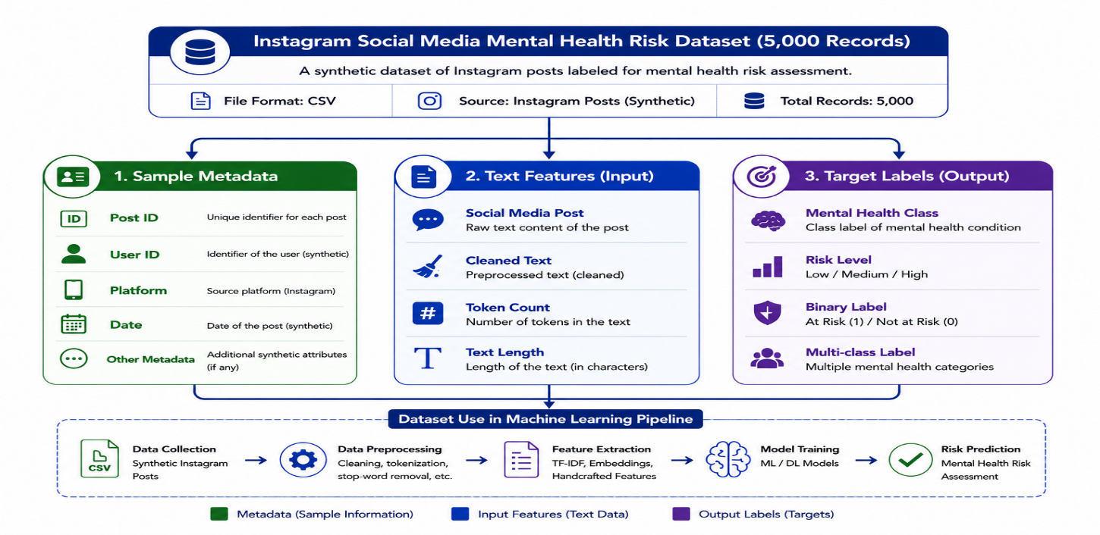
Figure 2.10 Social Media Mental Health

1.7.2 Dataset Characteristics

The dataset consists of social media postings in text format, arranged in a tabular form. An individual item in the data set is social media posting and its associated mental well-being classification. The dataset has been created for use in supervised learning problems, where examples are available that can be used to learn classifiers using machine learning, deep learning, and transformer approaches.

1.7.3 Dataset Labels
The dataset groups the postings into one of the mental health classes defined based on specific psychological disorders. The mental health classes form the ground truth necessary for the supervised classification task of the text documents. As mentioned in the dataset description, some of the primary mental health classes include:
- Depression
- Stress
- Suicide
- Normal

1.7.4 Dataset Advantages
The selected dataset offers several advantages for mental health risk detection research. First, it provides a balanced collection of labeled social media posts that can be directly used for supervised classification tasks. Second, the dataset includes multiple mental health categories, allowing comparative evaluation across different psychological conditions. Third, its public availability enables reproducibility and fair comparison with future studies. Finally, the dataset is specifically designed for Natural Language Processing applications, making it well suited for evaluating both traditional Machine Learning models and modern Transformer-based language models.

1.7.5 Dataset Limitations
Although the dataset can be used perfectly to analyze the efficiency of Artificial Intelligence systems, it has some drawbacks. Firstly, it was artificially generated and hence has no real-life posts posted by users. Secondly, the posts it contains are mostly written in English and cover predetermined topics associated with the mental health condition. That is why the results received from this dataset cannot be generalized in multilingual environment without additional research.

2 Related Work
Bokolo and Liu [ ([1] Bokolo, 2023)] introduced a comparative framework for detecting depression from social media tweets using the traditional Machine Learning (ML) models and transformer-based models. The experiments were performed on the publicly available Sentiment140 dataset, which was originally gathered about 1.6 million English tweets for sentiment analysis. The authors re-labelled these tweets using an algorithm that is based on polarity, since this is not the way the dataset was labelled for the purpose of depression detection. Following this process, 632,000 tweets were left for the experiments. The data was preprocessed, feature selected and label encoded before training the model. Textual features were represented as Term Frequency–Inverse Document Frequency (TF-IDF) for the traditional ML models and the transformer-based models were fine-tuned from the prepared tweet data set. The models evaluated were Logistic Regression, Bernoulli Naïve Bayes, Random Forest, DistilBERT, SqueezeBERT, DeBERTa and RoBERTa. The accuracy, precision, recall and F1-score along with 10-fold cross validation were used to evaluate the model performance. In the experiment, the model RoBERTa obtained the best performance in terms of the accuracy, which was 0.981, and the mean cross validation accuracy was around 0.97. The results of the study indicated that the transformation-based method is very appropriate for detecting depression-related language in social media posts and can be used to help detect potential mental health problems in time.
Almutairi et al. [ ([2] S. Almutairi, 2024)] had introduced a hybrid Deep Learning (DL) model to predict depression symptom from large scale text data. The study centered on the problems of early detection of depression based on questions posted by young users on an online platform publicly available. The experiments were performed on textual data from the Twitter, Facebook and SMILE Twitter Emotion Dataset containing 4000 depressive tweets, 7000 instances of social media and some other instances with non-depressive content. The data was preprocessed before training the model using certain steps: Data cleaning, normalization, tokenization, lemmatization, and stop-word removal. Depression-related features were extracted from the medical and psychological experts' symptom indicators and represented using Word2Vec embeddings and one-hot encoding. To enhance the extraction of features and the capturing of contextual relationships in the text, Convolutional Neural Network (CNN), Long Short-Term Memory (LSTM), its improvement (Two-State LSTM) and attention mechanism were suggested to be combined in the proposed framework. The proposed model is tested against the traditional ones. The experimental results revealed that the hybrid model produced high accuracy (97.23%), precision (98.57%), recall (97.13%), F1-score (97.84%) and specificity (97.93%) as compared to the baseline models. The study finally concluded that CNN, TS-LSTM, and attention mechanisms combined together are an effective method to predict depression symptoms from large scale social media text and can be used to contribute to early depression symptoms risk detection.
Rastogi et al. ([3] Rastogi, 2021) suggested the benchmark framework for the detection of stress from social media text utilizing traditional and transformer-based language models. Four publicly available data sets were used for the study, namely Reddit Title, Reddit Combi, Twitter Full and Twitter Non-Advert, collected from Reddit and Twitter. Stress positive and negative posts have been provided in these datasets from the official senticnet repository on GitHub and Kaggle. The data was preprocessed and automatically annotated, preparing the textual content for classification, before model training. Three categories were tested: lexicon-based, embedding-based and transformer-based. SenticNet, SO-CAL, AFINN, TensiStrength, VADER, SentiWordNet, FastText, GloVe, Word2Vec, RoBERTa, and DistilBERT were all evaluated. The accuracy and F1-score were used to evaluate the performance of the model. The experimental results indicated that the highest results were obtained by DistilBERT without the summarization of text with 98.20% accuracy and a 98.15% F1-Score on the Reddit Title dataset. Based on the results of the study, it was concluded that they were able to stress detection in social media text using transformer-based models more effectively than lexicon-based and embedding-based models.
Bae et al. ([4] Bae, 2021) developed a ML method to identify patients with schizophrenia from Reddit social media posts. The posts were pulled from the r/schizophrenia subreddit, which is a subreddit where users post about schizophrenia, and six non-mental health subreddits (fitness, jokes, meditation, parenting, relationships and teaching) served as the control group. The final data set consisted of 13,156 schizophrenia posts and 247,569 control posts between 9/2016 and 9/2020. The data were subjected to multiple preprocessing steps, such as lowercasing, tokenization, removal of punctuation and numbers, stop-word removal, lemmatization and stemming using Natural Language Toolkit (NLTK) before model training. For the study, Linguistic Inquiry and Word Count (LIWC) features, Latent Dirichlet Allocation (LDA) topic distributions, and TF-IDF were used to represent features. Four types of supervised ML algorithms were tested such as Support Vector Machine (SVM), Logistic Regression, Naïve Bayes, and Random Forest. The dataset was balanced and divided into 80/20 training and testing while hyperparameter tuning was done using 10 fold cross validation. Model performance was evaluated based on the accuracy, precision, recall, F1 score and the Area Under the Receiver Operating Characteristic Curve (AUC). From the results of the experiments, the best performance was achieved by Random Forest with 96 Percentage, 98 Precision, 94 Recall, 96 F1 Score and AUC of 0.97. Overall, the study found that the combination of ML and Natural Language Processing (NLP) techniques can be used to effectively identify linguistic patterns associated with schizophrenia in Reddit posts and can potentially be used to help detect individuals who may be at risk for developing the condition.
Roy et al. ([5] Roy, 2020) suggested an ML approach called Suicide Artificial Intelligence Prediction Heuristic (SAIPH) to predict the potential future suicidal ideation risk from the data available in twitter. The data were gathered from public Twitter posts of users who expressed suicidal ideation and a control group. There were 512,526 tweets of 283 suicidal ideation cases and 3,518,494 tweets of 2,655 control users in the training dataset. There were 277 suicidal ideators and 3,159 control events in an independent validation dataset. The proposed framework used a neural network to estimate psychological constructs such as stress, loneliness, hopelessness, insomnia, depression, anxiety, and burden. These outputs were then served as the input features of a Random Forest (RF) Classifier for predicting suicidal ideation risk. AUC and temporal prediction analysis were the methods used for the assessment of model performance. Experimental results demonstrated an AUC of 0.88 for SAIPH, and the ability of the model to identify periods of increased suicide risk. Peak-prediction scores also suggest, roughly, a 7-fold increase in the risk of suicidal ideation in the next 10 days. The study highlighted the findings that the longitudinal study of Twitter posts using ML can be effective to identify and continuously monitor individuals at risk of suicidal ideation in an early phase.
The authors of ([6] Rastogi, 2022) have come out with a ML and DL based framework for stress detection from social media interactions by employing NLP techniques. In the study, we employed two publicly available Twitter datasets. The first data set had a total of 100,042 positive and negative tweets for binary sentiment classification. The second data set contained 7,934 tweets classified in five emotion categories: joy, sadness, neutral, anger and fear. The data was pre-processed before training the model using several techniques such as tokenization, removal of unwanted patterns, discarding stop-words and stemming. The study used Bag-of-Words (BoW) as a representation of features and LDA for topic modelling. Various models including Logistic regression, Decision Tree, Random Forest, VADER and a fine-tuned Bidirectional Encoder Representations from Transformers (BERT) model for emotion classification were evaluated. The accuracy and F1-score were used to evaluate the performance of the models. For binary (positive and negative) sentiment classification, Random Forest had the highest performance with 97.78% accuracy and BERT had a five-class emotion classification with 94% accuracy and 83% macro F1-score. Finally, the study yielded that the combination of NLP techniques, topic modelling, ML, and emotion analysis using BERT is an effective method to identify stress from social media texts.

Proactive social-sensor system for mental health monitoring based on Twitter data was proposed by Sharma et al. ([7] Sharma, 2022). The researchers used Twitter users as social sensors and mined historical tweets for early detection of mental illness. A total of 2,138 initial tweets on six mental health conditions (depression, bipolar disorder, Alzheimer's disease, dementia, schizophrenia, and Asperger's syndrome) were collected. They then collected 979,466 historical tweets from 600 users for a six-month period. Based on the mental health content published, a total of 479 users (356 mental health users and 123 control users) were identified and included in the final dataset after filtering out inactive users and outliers. Regular expressions were used to perform detailed preprocessing of the data. As part of this process, usernames, URLs, special characters, repeated letters, acronyms and spelling mistakes were deleted. Using Text Blob, the researchers determined the sentiment polarity and created two new datasets, namely, User Summary dataset and User Weekly Negativity dataset. The evaluation of several models was considered such as SVM, Random Forest, Dense Neural Network (DNN), and multiple models using LSTM. Using stratification, the data were split with 70 % training data and 30 % testing data. From the experimental results, it can be seen that the DNN has the highest test accuracy of 84.31%. The single-layer LSTM with dropout and the SVM were found to be 82.92% and 73.43% accurate respectively. The study revealed that past sentiment analysis from Twitter can be used for proactive mental health monitoring and to identify users at risk.
Figuerêdo et al. ([8] Figuerêdo, 2022) suggested a DL approach for the early detection of depression from social media posts. The framework developed is using the CNN along with the context-independent word-embedding methods with both Early Fusion and Late Fusion to merge multiple representations of the text. The data for the study was obtained from the eRisk 2017 dataset, which consists of chronological English posts from Reddit users. A total of 887 users (135 depressive users and 752 non-depressive users) were included in the dataset. There were up to 2000 posts in total per user, including the title, publishing date and textual content. Prior to the model learning, title and text were concatenated and multiple pretrained word representations were tested for representing features. The authors also proposed a semantic mapping method based on emoticon expression to retain the emotion information in users' posting. The experimental results demonstrated that the proposed framework obtained a precision of 0.76. Recall and precision were improved by up to 46.3% and 32.1% by semantic emoticon mapping. There was a 14.5% improvement in recall and a 40.8% improvement in precision when compared to the baseline embedding method. The authors found that combination of CNN, embedding-fusion and emoticon-based semantic information could be beneficial to achieve early detection of depression from social-media postings.

Kumar et al. ([9] Kumar, 2022) suggested a hybrid DL approach to predict depression from Twitter posts. The proposed framework consisted of two architectures, namely feature-rich CNN and Bidirectional Long Short-Term Memory (BiLSTM) network. Local semantic features were captured by CNN and contextual information was captured in forward and backward direction by BiLSTM. A benchmark twitter data set was used which was divided in three parts: D1, D2 and D3. There were 1,402 depressed users who produced a total of 292,564 tweets in D1. D2 was made up of non-depressed users whereas D3 was comprised of 36,993 depression-candidate users and over 35 million tweets. The experiments concerned only D1 and D2 with 2,558 samples from D1 and 5,304 samples from D2. The data was preprocessed by various means before the training of the model, such as removing usernames, hashtags, URLs, numbers, duplicate records, missing values, emojis, stop words and extra spaces. Stemming, tokenization, sequence padding and word embeddings were also used. The proposed CNN-BiLSTM model was compared with CNN, RNN and other baseline models. For model performance, the accuracy, precision, recall, F1-score, specificity, and AUC were used. The experimental results proved that CNN-BiLSTM model has the highest accuracy of 94.28%, precision of 96.99%, F1-Score of 94.78%, specificity of 96.35% and AUC of 95.43%. The study found that the merging of CNN-based feature extraction with Bi-directional sequence learning can lead to a better prediction of depression in Twitter text.
Kerasiotis et al. ([10] Kerasiotis, 2024) introduced a transformer-based model to classify depression from social media content. In this study, DistilBERT embeddings are fused with auxiliary information and linguistic features to enhance depression classification. The framework has extracted contextual representations from the last transformer layers and combined it with more user-level features and then classified by means of a multilayer perceptron (MLP). To enhance the class balance and generalization, the authors also used data augmentation methods which are inspired by Easy Data Augmentation (EDA). The weighted Precision of the proposed approach was 84.26%, while the weighted Recall and F1-score were 84.18% and 84.15%, respectively, based on the experimental results. The study found that the use of transformer models combined with additional social media characteristics helps in performing depression detection when compared to text-based models.
Renjith et al. ([11] Renjith, n.d.) proposed a hybrid DL model for Identifying suicidal ideation from social media posts at an early stage. The proposed model combines LSTM, attention mechanism, and CNN to better capture the textual patterns in suicide. The University of Maryland Reddit Suicidality Dataset was used, consisting of posts from the Reddit subreddit SuicideWatch. Following data preprocessing and data annotation, 55680 posts were collected from 760 users on Reddit and classified into four levels of risk: No Risk, Low Risk, Moderate Risk, and Severe Risk. The data was pre-processed with several steps such as concatenating the post title and content, removing duplicate posts, lowercasing, removing URLs, emails, punctuation, stop words and newline symbols and then tokenization and lemmatization using tools before they were used in model training. To encode textual features, word embeddings of 300 dimensions were used by applying Word2Vec. Some basic models, such as the SVM model, CNN model, LSTM model and hybrid model LSTM-CNN were selected as basic models. Eighty percent of the data set was used for training and 20% was used for testing. The accuracy, precision, recall, and F1-score were used to assess the performance of the models. An experimental result indicated that the proposed LSTM-Attention-CNN model performed the best with accuracy, precision, recall, and F1 score 90.3%, 91.6%, 93.7% and 92.6%, respectively, as compared with all the baseline models. The study finally concluded that using the combination of LSTM, CNN, and attention mechanism is effective in capturing contextual and semantic information from the social media posts which in turn boosted the early detection of suicidal ideation.
Rabani et al. [13] came up with an Enhanced Feature Engineering Approach for Suicidal Risk Identification (EFASRI) for identification of various level of suicidality from social media post. The data used in the study was a unique data set gathered from the Twitter and Reddit platforms. To capture the informative textual features pertaining to suicidal behaviors, various Natural Language Processing (NLP) and feature engineering techniques were used. Support Vector Machine (SVM), Random Forest (RF) and the Extreme Gradient Boosting (XGB) classifiers were tested for multi-class suicidal risk classification. Performance of the proposed EFASRI framework was found to be better than other traditional feature extraction methods. Regarding the evaluation of the models, XGBoost (XGB) model has the highest overall accuracy of 96.33% which showed that the proposed feature engineering method is effective for social media content to early identify suicidal risk.
14. Improving Understanding of Depression Detection in social media through Explainability of Transformer Models https://ieeexplore.ieee.org/document/10847487 (derived from social media content).
Using transformer architectures, the researchers were able to capture linguistic patterns correlated with depression, and they ensured explainability of model decisions through the implementation of explainability mechanisms. The research emphasized the need for transparency in mental health applications and revealed that transformer models can capture the psychological signals within social media texts and also offer interpretable predictions that are suitable for real world mental health monitoring systems.
A comparative study for transformer-based and LSTM-based models to detect suicidal ideation from Reddit posts was proposed by Hasan and Saquer ([14] Hasan, 2024). The goal of this study was to investigate how well perform different state of the art models based on NLP for early detection of suicidal ideation from social media posts. To ensure the quality of the data for model development, linguistic, topic modeling and statistical analyses were conducted on the data retrieved from the various subreddits of Reddit. Data pre-processing was performed and data quality was carried out before training. The study showcased the performance of the different models, such as BERT, RoBERTa, DistilBERT, ALBERT, and ELECTRA, against different types of LSTM-based models like attention-based LSTM model with BERT embedding. The accuracy and F1-score measures were used to evaluate the model performance. From the experimental results, it is found that the highest performance is achieved by RoBERTa, which got 93.22% accuracy and 93.14% F1 score, followed by Attention-LSTM with BERT embeddings with 92.65% accuracy and 92.69% F1 score. Finally, the study showed that the trained transformer-based models performed better than traditional LSTM-based models in suicidal ideation detection and that there are strong prospects for implementing such models in the creation of reliable mental health monitoring systems based on social media data. Transformer based depression severity detection framework from social media texts was proposed by.
Qasim et al. ([15] Qasim, 2025). A two-fold objective was designed to categorize the depression into Minimum, Moderate and Severe using traditional ML approaches, Sentence transformer-based approaches and End-to-End transformer architecture. The researchers took a Reddit data, containing 24 thousand posts, in which the posts were classified based on clinical psychology assessment using the Beck Depression Inventory (BDI) and DSM-V criteria. The data was preprocessed before training the model, involving several steps such as punctuation removal, numbers removal, removal of URLs, hashtags, mentions and stop words, lowering of case, tokenization, stemming and lemmatization by using Natural Language Tool Kit (NLTK). The study has tested three sets of approaches: content-based methods based on N-grams, context-based methods taking advantage of Sentence Transformers with multiple ML classifiers and transformer-based approaches represented by BERT-base-uncased, RoBERTa-base, and Microsoft/DeBERTa-base. The data set was split into a training set of 70%, a validation set of 10% and a test set of 20%. Precision, recall and F1 score were used to evaluate model performance. The experimental results revealed that RoBERTa-base model got OVEF1=0.91, while Microsoft/DeBERTa-base model showed maximum class-wise F1 score with four digits of precision and recall in Mild, Moderate and Severe classes. The study found that the transformer-based models outperformed traditional ML and sentence transformer models greatly in identifying the severity of depression in Reddit posts and serve as effective models for a scalable mental health monitoring and early intervention system.

2.1 Research Gap

Even though considerable advances have been made in using Artificial Intelligence methods for early detection of mental disorders based on the analysis of posts made in social media, several important research issues still exist. Firstly, most of the reviewed research works concentrate on just one type of mental disorder, e.g. depression or suicidal intentions, without comparing the results across various psychological disorders. Secondly, since different datasets, preprocessing approaches, ways of representing the text and evaluation approaches are used in the reviewed studies, a direct comparison of the reported results is not possible. Moreover, traditional Machine Learning approaches heavily depend on manually crafted textual features, while Deep Learning and Transformer approaches learn context-dependent representations of the text automatically. While usually Transformer approaches yield better performance, few papers conduct a comparison of traditional Machine Learning, Deep Learning and Transformer-based methods under equal conditions. An additional limitation of the state-of-the-art approaches consists in the fact that almost all freely available datasets include data from English social media platforms only, namely Reddit and Twitter (X). Hence, the generality of the proposed approaches across various languages, cultures and social media sites is poorly investigated. Moreover, while most of the studied approaches concentrate on classification results, little attention is paid to interpretation of the results, computation costs and practical implementation of the proposed solutions. Thus, it would be desirable to conduct comprehensive comparative studies of different approaches under similar conditions.

2.2 Chapter Summary
This chapter has provided the necessary theoretical background that will help in understanding the concept of detecting mental health risks early via social media messages. The basics of Artificial Intelligence, Natural Language Processing, text pre-processing, text representation techniques, Machine Learning, Deep Learning, and transformers language model have been described in this chapter. Furthermore, an exhaustive literature review on the topic has also been provided. This includes the methodology followed by past researchers, current research trends, and research gaps. The knowledge gained from this chapter will serve as the theoretical background for the next chapter.

1 2.1 Comparison of Previous Studies
Paper | All Models | Datasets | Dataset Link | Limitation | Best model | results
Bokolo  and Liu  ([1] Bokolo, 2023) | Logistic Regression, Bernoulli Naive Bayes, Random Forest, DistilBERT, SqueezeBERT, DeBERTa, RoBERTa | Sentiment140 Twitter Dataset; 632,000 tweets were repurposed and re-labeled for depression detection. | https://www.kaggle.com/datasets/kazanova/sentiment140  Sentiment140 official dataset / Kaggle mirror | The dataset was originally designed for sentiment analysis, not clinical depression diagnosis. Depression labels were inferred from negative sentiment and polarity-based relabeling, so negative sentiment may not always indicate depression. The study is also limited to English tweets. | RoBERTa | Accuracy = 0.981; Mean Accuracy = 0.97 across 10-fold cross-validation
Almutairi et al ([2] S. Almutairi, 2024) | CNN, LSTM, Two-State LSTM, CNN-LSTM with Attention Mechanism | Large-scale textual dataset from a publicly accessible online platform for young people | https://www.kaggle.com/datasets/infamouscoder/mental-health-social-media | Dataset source is limited to text questions from young users; generalizability to other platforms such as Twitter or Reddit may require further validation. | Proposed Hybrid CNN + Attention-based TS-LSTM | Accuracy = 97.23%; Precision = 98.57%; Recall = 97.13%; F1-score = 97.84%; Specificity = 97.93%
Rastogi ([3] Rastogi, 2021) | SenticNet, SO-CAL, AFINN, TensiStrength, VADER, SentiWordNet, FastText, GloVe, Word2Vec, RoBERTa, DistilBERT | Stress Detection from Social Media Articles; Reddit and Twitter datasets for stress-positive and stress-negative classification | https://www.kaggle.com/datasets/mexwell/stress-detection-from-social-media-articles  GitHub official dataset / Kaggle mirror | The task focuses on stress detection rather than direct clinical diagnosis of depression or mental illness. Twitter posts are shorter and noisier than Reddit posts. | DistilBERT | Accuracy = 98.20%; F1-score = 98.15%
Bae et al. ([4] Bae, 2021) | SVM, Logistic Regression, Naive Bayes, Random Forest | Reddit posts: r/schizophrenia + control subreddits: fitness, jokes, meditation, parenting, relationships, teaching. Final dataset: 13,156 schizophrenia posts and 247,569 control posts | Dataset available from the corresponding author upon reasonable request. Code: GitHub repository mentioned in the paper | No clinical diagnosis confirmation for Reddit users; limited to Reddit; traditional ML only, not deep learning | Random Forest | Accuracy 96%, Precision 98%, Recall 94%, F1-score 96%, AUC 0.97
Roy et al. ([5] Roy, 2020) | Neural Networks, SVM, Random Forest, Sentiment Analysis | Twitter data: 512,526 tweets from 283 SI cases and 3,518,494 tweets from 2,655 controls; validation on 277 suicidal ideators and 3,159 control events | Not publicly available due to Twitter data-sharing policies | Limited to Twitter; code not public; outcome based on expression of suicidal ideation on social media; limited demographic data | SAIPH: Neural Networks + Random Forest | AUC = 0.88; temporal prediction showed ~7-fold increased risk within 10 days
Rastogi et al. ([6] Rastogi, 2022) | Logistic Regression, Decision Tree, Random Forest, Vader, LDA, BERT | Sentiment dataset: 100,042 tweets; Emotion dataset: 7,934 tweets with joy, sadness, neutral, anger, fear labels | Sentiment Analysis dataset: IEEE Data Port. Emotion dataset: data. World “Detecting Emotions in Text” | Does not directly diagnose clinical stress; stress is inferred from sentiment/emotion; limited to tweet text; future work suggests adding health parameters | Random Forest for sentiment; BERT for emotion classification | Random Forest accuracy = 97.78%; BERT accuracy = 94%; BERT macro F1-score = 83%
Sharma et al. ([7] Sharma, 2022) | SVM, Random Forest, Single Dense Neural Network, Single-Layer LSTM, Single-Layer LSTM with Dropout, Double-Layer LSTM, Double-Layer LSTM with Dropout | Twitter dataset. Initial set: 2,138 mental-health-related tweets. Historical set: 979,466 tweets from 600 users. Final analysis: 479 users, including 356 positive cases and 123 controls. | No public dataset link was provided. The authors created their own dataset using Twitter Search API and a custom crawler. | Small user-level sample; labels were based on self-reported posts and majority voting rather than clinical diagnosis; dataset was imbalanced; limited to Twitter; sentiment analysis may be affected by sarcasm, slang, and regional language. | Single Dense Neural Network | Accuracy = 84.31%. Single-Layer LSTM with Dropout = 82.92%. SVM = 73.43%
Figueredo et al. ([8] Figuerêdo, 2022) | CNN, individual pre-trained word embeddings, Early Fusion, Late Fusion, semantic emoticon mapping | eRisk 2017 Reddit dataset: 887 users, including 135 depressive and 752 non-depressive users; chronologically ordered English posts, with up to 2,000 posts per user. | eRisk research collection; access is generally controlled through the eRisk organizers and may require a data-use agreement. No unrestricted direct download link was provided in the paper. | Labels are based on social media evidence rather than direct clinical assessment; data are limited to Reddit and English; the dataset is imbalanced; results may depend on emoticon usage; ethical and privacy concerns limit data access. | CNN with fusion-based word embeddings and semantic emoticon mapping | Precision = 0.76; recall improvement up to 46.3%; precision improvement up to 32.1%; compared with baseline embeddings, recall gain = 14.5% and precision gain = 40.8%
Kumar et al. ([9] Kumar, 2022) | CNN, RNN, BiLSTM, CNN-BiLSTM, baseline ML/DL approaches | Twitter benchmark dataset derived from Shen et al. [54]. D1: 292,564 tweets from 1,402 depressed users. D2: non-depressed Twitter users. D3: 36,993 depression-candidate users and more than 35 million tweets. Experiments used D1 and D2 with 2,558 and 5,304 samples. | The paper cites the benchmark dataset source in Shen et al. [54], but does not provide a direct public download link in the supplied text. | Limited to English Twitter text; labels depend on self-reported depression patterns rather than confirmed clinical diagnosis; emojis and non-English content were removed; dataset description is partly inconsistent because very large raw collections were reduced to smaller experimental samples. | CNN-BiLSTM | Accuracy = 94.28%, Precision = 96.99%, F1-score = 94.78%, Specificity = 96.35%, AUC = 95.43%
Kerasiotis et al  ([10] Kerasiotis, 2024) | DistilBERT + Auxiliary Features + MLP | Social Media Depression Dataset | https://link.springer.com/article/10.1007/s13278-024-01360-4 |  |  | Precision = 84.26%, Recall = 84.18%, F1-score = 84.15%  %,
Renjith et al. ([11] Renjith, n.d.) |  | University of Maryland Reddit Suicidality Dataset; 55,680 Reddit posts from 760 users; four classes: No Risk, Low Risk, Moderate Risk, Severe Risk | No direct public dataset link was provided in the paper. The dataset is described as the University of Maryland Reddit Suicidality Dataset. | The dataset is limited to Reddit posts and lacks clinical records, validated diagnoses, and self-report questionnaires. The post-level labels were also derived from user-level labels, which may introduce labeling uncertainty and limit generalization to other platforms and languages. | LSTM-Attention-CNN
  SVM, CNN, LSTM, LSTM-CNN, LSTM-Attention-CNN
  Accuracy = 90.3%, Precision = 91.6%, Recall = 93.7%, F1-score = 92.6%
Rabani ([12] Rabani, 2023) | SVM, Random Forest (RF), XGBoost (XGB) | Novel dataset collected from Twitter and Reddit | Dataset not publicly released |  | XGBoost (XGB) | Accuracy = 96.33%
Explainable Depression | Transformer-based Models with Explainability Framework  DistilBERT, SqueezeBERT, DeBERTa, RoBERTa | Social Media Depression Dataset | https://www.kaggle.com/datasets/kazanova/sentiment140 |  | Explainable Transformer Model | Improved interpretability while maintaining competitive depression detection performance  Recall = 99%, F1-score = 98%, Mean 10-fold Cross-Validation Accuracy = 97%
Hasan and Saquer ([14] Hasan, 2024) | BERT, RoBERTa, DistilBERT, ALBERT, ELECTRA, Multiple LSTM models, Attention-LSTM with BERT embeddings | Curated Reddit dataset collected from multiple subreddits | Not specified in the paper | The study relied only on Reddit data, which may limit generalization to other social media platforms and languages. | RoBERTa | Accuracy = 93.22%, F1-score = 93.14%; Attention-LSTM with BERT embeddings achieved Accuracy = 92.65%, F1-score = 92.69%
Qasim et al. ([15] Qasim, 2025) | N-grams + RF, DT, NB, GNB, GBC, AB, MLP, KNN, SVM, LR; Sentence Transformers (multi-qa-mpnet-base-dot-v1, paraphrase-mpnet-base-v2, all-MiniLM, all-distilroberta, distiluse, etc.); BERT-base-uncased, RoBERTa-base, Microsoft/DeBERTa-base | Reddit dataset containing 24,000 clinically annotated posts labeled as Minimum, Moderate, and Severe depression | Not publicly provided in the paper | The study relies only on Reddit data and English text, which may limit generalization to other social media platforms, languages, and clinical populations. Transformer models also require substantial computational resources for training and deployment. | Microsoft/DeBERTa-base | F1-score = 0.90; Class-wise F1-scores: Mild = 0.96, Moderate = 0.95, Severe = 0.96. RoBERTa-base achieved the highest overall F1-score = 0.91 among the evaluated transformer models.

Chapter 4 Proposed Approach (Methodology)

Chapter 5: Experimental Results and Discussion

Chapter 6 Conclusion and Future Work

References

([1] Bokolo, 2023)
Bokolo, B. G., & Liu, Q. “Deep Learning-Based Depression Detection from Social Media: Comparative Evaluation of ML and Transformer Techniques.” Electronics, vol. 12, no. 21, 4396, 2023.
([2] S. Almutairi, 2024)
S. Almutairi, M. Abohashrh, H. H. Razzaq, M. Zulqarnain, A. Namoun and F. Khan, "A Hybrid Deep Learning Model for Predicting Depression Symptoms from Large-Scale Textual Dataset," in IEEE Access, vol. 12, pp. 168477-168499, 2024.
([3] Rastogi, 2021)
Rastogi, A., Liu, Q., & Cambria, E. “Stress Detection from Social Media Articles: New Dataset Benchmark and Analytical Study.” 2022 International Joint Conference on Neural Networks, IJCNN, 2022.
([4] Bae, 2021)
Bae, Yi Ji, Midan Shim, and Won Hee Lee. "Schizophrenia detection using machine learning approach from social media content." Sensors 21.17 (2021): 5924.‏
([5] Roy, 2020)
Roy, Arunima, et al. "A machine learning approach predicts future risk to suicidal ideation from social media data." NPJ digital medicine 3.1 (2020): 78.‏
([6] Rastogi, 2022)
Rastogi, K., Rani, R., Prakash, K. B., & Gupta, D. (2022). Stress detection using natural language processing and machine learning over social interactions. Journal of Big Data, 9, 33.
([7] Sharma, 2022)
Sharma, S. K., Gaur, A., Gupta, D., & Wang, L. (2022). Machine learning-based proactive social-sensor service for mental health monitoring using Twitter data. Journal of Innovation & Knowledge, 7(4)
([8] Figuerêdo, 2022)
Figuerêdo, J. S. L., Maia, A. L. L. M., & Calumby, R. T. (2022). Early depression detection in social media based on deep learning and underlying emotions. Online Social Networks and Media, 31, 100225. https://doi.org/10.1016/j.osnem.2022.100225
([9] Kumar, 2022)
Kumar, A., Sharma, A., & Arora, A. (2022). A hybrid deep learning approach for depression prediction from user tweets using feature-rich CNN and bi-directional LSTM. Multimedia Tools and Applications, 81, 23649–23685.
([10] Kerasiotis, 2024)
Kerasiotis, M., Ilias, L., & Askounis, D. (2024). Depression Detection in Social Media Posts Using Transformer-Based Models and Auxiliary Features. Social Network Analysis and Mining, 14, 196.
([11] Renjith, n.d.)
Renjith, Shini, Annie Abraham, Surya B. Jyothi, Lekshmi Chandran, and Jincy Thomson. “An Ensemble Deep Learning Technique for Detecting Suicidal Ideation from Posts in Social Media Platforms.” Journal of King
([12] Rabani, 2023)
Rabani, Syed Tanzeel, Akib Mohi Ud Din Khanday, Qamar Rayees Khan, Umar Ayoub Hajam, Ali Shariq Imran, and Zenun Kastrati. Detecting Suicidality on Social Media: Machine Learning at Rescue.” Egyptian Informatics Journal, vol. 24, no. 2, 2023, pp. 291–302. https://doi.org/10.1016/j.eij.2023.04.003
([14] Hasan, 2024)
Hasan, K., & Saquer, J. (2024). A Comparative Analysis of Transformer and LSTM Models for Detecting Suicidal Ideation on Reddit. Proceedings of ICMLA 2024.
([15] Qasim, 2025)
Qasim, A., Mehak, G., Hussain, N., Gelbukh, A., & Sidorov, G. (2025). Detection of Depression Severity in Social Media Text Using Transformer-Based Models. Information, 16(2), 114.

