

Leveraging AI to Study the Impact of Climate Change on the Spread and Severity of Plant Diseases

Prepared By
Name: Fatima Mohammad Alkaff ID No.: 251001435
Submitted in fulfillment of the requirements for the degree Master of Science in Artificial Intelligence
At
Collage of Informatics
Midocean University
UAE

Supervisor Name: Dr. Hajer Saleh
College of Informatics, Midocean University, Comoros

Acknowledgements
First and foremost, all praise and thanks are due to Allah, the Almighty, for His endless blessings, mercy, and guidance that have accompanied us throughout this research journey. Without His will, this work would not have been possible.
I extend my deepest gratitude to my esteemed supervisor, Dr. Hajar Saleh, whose support, encouragement, and invaluable guidance inspired us from the first steps of this research to its final form. Her kindness, patience, and dedication were a source of motivation throughout the process.
This work is lovingly dedicated to my parents, whose unwavering love, sacrifices, and prayers have shaped who I am. Your faith in me and your constant support have been the pillars of my strength. I am forever grateful for your encouragement and for teaching us the value of perseverance and ambition.

Abstract
The presented thesis establishes a multimodal deep learning system that identifies apple leaf diseases by integrating the features extracted from images with the structured environmental and soil data. It depends on the "Multimodal Plant Disease Dataset" by Shubham Divakar (Kaggle) and focuses on determining the diseases of the apple leaves: Apple Scab, Black Rot, Cedar Apple Rust, and Healthy leaves.
Visual features were generated by the comparison of three pretrained convolutional neural networks - MobileNetV2, ResNet50, and InceptionV3. Weather-related numerical features were processed by a Multilayer Perceptron (MLP). The fusion layer was employed to merge the two modalities for improved classification.
Results indicate that MobileNetV2 was the best-performing image-only model and therefore was able to demonstrate the effective use of a lightweight architecture in agricultural image analysis. The multimodal MobileNetV2 + MLP model achieved an accuracy of 78.25%, so it was better than the other fusion combinations. The approach demonstrated the enormous potential that exists in the integration of visual and environmental data for the purpose of classification.
Essentially, the developed multimodal model represents a move towards the next level of precision agriculture, as it offers a more holistic and climate-aware method of the diagnosis process in plant health monitoring.

Table of Contents
List of Abbreviations..................................................................................... | v
List of Figures................................................................................................. | vi
List of Tables.................................................................................................. | vii
Chapter 1: Introduction
1.1 Problem Definition.................................................................................... | 1
1.2 Thesis Objectives ...................................................................................... | 1
1.3 Thesis Contribution .................................................................................. | 2
1.4 Thesis Organization................................................................................... | 3
Chapter 2: Overview
2.1 Overview of Plant Diseases and Early Detection Challenges................... | 4
2.2 Image-Based Deep Learning for Plant Disease Classification.................. | 4
2.3 Role of Environmental and Climate Features............................................ | 5
2.4 Multimodal Learning in Agriculture.......................................................... | 6
Chapter 3: Related Work
3.1 Related Works............................................................................................ | 7
Chapter 4: Proposed Approach
4.1 Dataset Description.................................................................................... | 13
4.2 Data Preprocessing.................................................................................... | 14
4.3 Image Feature Extraction Models............................................................. | 14
4.4 Multimodal Fusion Architecture............................................................... | 15
4.5 Training Strategy....................................................................................... | 15
Chapter 5: Experimental Results and Discussion
5.1 Experimental Setup................................................................................... | 16
5.2 Image-Only Model Results....................................................................... | 16
5.3 Multimodal Fusion Model Results............................................................ | 17
5.4 Comparison Summary.............................................................................. | 19
Chapter 6: Conclusion and Future Work | 20
References..................................................................................................... | 21

List of Abbreviations
- AI: Artificial Intelligence
- DL: Deep Learning
- ML: Machine Learning
- CNN: Convolutional Neural Network
- DNN: Deep Neural Networks
- NLP: Northern Leaf Blight
- SVM: Support Vector Machine
- MLP: Multi-Layer Perceptron
- KNN: K-Nearest Neighbors
- ALDD: Apple Leaf Disease Dataset
- BF: Bilateral Filtering
- EPO: Emperor Penguin Optimizer
- N: Nitrogen content in soil
- P: Phosphorus content
- K: Potassium content

List of Figures
4.1 System Architecture of the Multimodal Deep Learning Model …………… | 7
5.2 Model Performance Comparison (Apple Disease Detection)……………… | 8
5.3 Distribution of Papers that used different attributes for PSP problem.……. | 19

List of Tables
3.1 Summary of the Related Work……………………………………………... | 7
5.1 Image-Only Model Results………………………………………………… | 8
5.2 Multimodal Fusion Model Results………………………………………… | 19

Chapter 1 Introduction

Problem Definition
Diseases of plants have become the main factors that cause the food supply system of the entire planet to be at risk. The changing climate that is continuously affecting the distribution and the severity of pathogens is making the problem worse. In fact, the diseases on the apple leaves, mostly caused by Apple Scab, Black Rot, and Cedar Apple Rust, are the factors that mainly contribute to the reduction of both the quality and the quantity of the crop. Most of the methods for disease detection that have been implemented are human character-based assessments, and they use handcrafted image processing techniques, which are not feasible since they are subjective, time-consuming, and, to some extent, their accuracy is also limited.
It is a fact that deep learning methods have played an important role in the recognition of diseases from images; however, the majority of the current models still only focus on the visual features. Actually, plant diseases should be the last ones to be identified only from the images, as they are very dependent on the environment. Taking the example of temperature, humidity, rainfall, and soil nutrient levels. Very few models even consider such factors, which is their disadvantage as they cannot provide stronger and climate-aware predictions.
As a result, the problem of selecting a multimodal method that merges image features with environmental data for disease detection at the local level is an immediate one. This study answers that question by creating and assessing a deep learning-based system that integrates climate and soil analysis with CNN-based image analysis for more accurate apple disease classification.

Thesis Objectives
Firstly, to carry out preprocessing and analysis of the apple subset of the Multimodal Plant Disease Dataset by Shubham Divakar, which features image and environmental data.
Secondly, train image-dependent deep learning models of various CNN architectures (MobileNetV2, ResNet50, and InceptionV3) and evaluate them.
Thirdly, with the help of an MLP, develop a structured data model to identify the predictive power of climate and soil attributes.
Fourth, to design and implement a multimodal fusion architecture that combines image embeddings with numerical environmental features.
Fifth, to compare the performance of unimodal and multimodal models by means of a comparative analysis to determine the effect of environmental data on classification accuracy.
Sixth, to identify the strengths, weaknesses, and potential of the model for the next multimodal plant disease detection system.

1.3 Thesis Contribution
This dissertation presents the innovative contributions of the detection of plant diseases and the use of multimodal deep learning, which are outlined below:
- A Multimodal Deep Learning Framework
This research first conceptualizes a single model that integrates the visual features extracted by CNN with the environmental features to be processed by MLP.
- Exhaustive Comparative Study of CNN Architectures
The research has performed a comparative study of MobileNetV2, ResNet50, and InceptionV3 architectures and thus opened the general understanding that these architectures also fit agricultural image datasets.
- Creation of an Intermediate Fusion Layer
The fusion scheme described here is about the connection of the image embedding with the vector coming from the climate data, hence it is a demonstration of the different data sources combining of heterogeneous data sources.

1.4 Thesis Organization
This thesis is organized into six chapters:
Chapter 1 – Introduction:
Presents the research problem, objectives, and contributions.
Chapter 2 – Overview:
Summarizes previous work on plant disease detection, deep learning methods, environmental data modeling, and multimodal fusion.
Chapter 3 – Related Works:
Summarizes previous work on plant disease detection, deep learning methods, environmental data modeling, and multimodal fusion.
Chapter 4 – Proposed Approach:
Describes the dataset, preprocessing steps, feature extraction procedures, and model development workflow.
Details the multimodal architecture, CNN models, MLP structure, and fusion strategy.
Chapter 5 – Experimental Results and Discussion:
Reports model performance, comparative evaluations, confusion matrices, and analysis.
Chapter 6 – Conclusion and Future Work:
Concludes the study and outlines potential directions for further research.

Chapter 2 Overview
This chapter unveils the closest studies to disease detection in plants, deep learning techniques, environmental data modeling, and multimodal fusion strategies. The primary goal is to establish the theoretical ground and show the need for the combination of visual and structured climatic features in identifying apple diseases.
2.1 Overview of Plant Diseases and Early Detection Challenges
Plant diseases are the primary factor of the limitation of agricultural productivity all over the world. Precise and early disease detections can be a milestone in the reduction of crop losses, pesticide usage, and the implementation of environmentally friendly farming practices. Traditional detection methods rely on the manual inspection of agricultural specialists. It is a time-consuming process, biased, and can easily result in a wrong diagnosis.
These limitations have led to the development of automated disease recognition systems, thus, the rapid advancement of datasets and machine learning technologies.

2.2 Image-Based Deep Learning for Plant Disease Classification
For the last several years, Convolutional Neural Networks (CNNs) have been the major instrumental means for the visual identification of plant diseases, mostly because of their robust feature extraction abilities. The art of CNN-based architectures like MobileNetV2, ResNet50, and InceptionV3 has been widely utilized in the agricultural sector.
2.2.1 MobileNetV2
It is possible to consider MobileNetV2 as a structurally less complex model, but still a highly efficient one that uses depth-wise separable convolutions to reduce the processor's workload while keeping accuracy intact to a large extent. This is a very suitable design, particularly for agricultural datasets that are normally small in size. The very first experiments have demonstrated that MobileNet is capable of achieving high accuracy in leaf disease classification with very little overfitting.

2.2.2 ResNet50
The major idea that ResNet50 is based on is residual connections that, therefore, give the possibility to extend the model's representations without the problem of vanishing gradients. ResNet models are excellent; however, they usually require a large number of examples for them to generalize well. ResNet performances on a small agricultural dataset are not always good due to the model's high level of complexity.

2.2.3 InceptionV3
InceptionV3 is equipped with multi-scale convolutional modules that can detect very detailed image patterns. Over time, it has proven its trustworthiness in the tasks of visual recognition, but it may find difficulties in the case of highly similar disease classes or if the number of training samples is extremely low.
In brief, CNN-based methods have made significant progress in the detection of plant diseases; however, solely image-based models may fail in situations of bad lighting, leaves being covered, or the symptoms being visually indistinguishable.
2.3 Role of Environmental and Climate Features
The beginning and spreading of plant diseases are tied tightly to environmental factors such as temperature, humidity, and rainfall. Apart from that, variables related to the soil, e.g., nitrogen (N), phosphorus (P), potassium (K), and pH, are equally important for the growth of plants.
Some of the studies that have focused on the importance of environmental features as predictors have cited the following points:
- Fungal diseases may become very fast and very aggressive in conditions that are high in humidity and have long periods of leaf wetness.
- Changes in temperature have a direct effect on pathogens' activity.
- Excess or deficiency of nutrients weakens the plant's immune system and thereby makes it less resistant.
Machine learning models fueled by climate attributes, such as Random Forest, SVM, and MLP, have been implemented in various studies for the prediction of disease risk levels. But since they do not examine visual symptoms, their performance as a standalone is not good.

2.4 Multimodal Learning in Agriculture
Multimodal learning means using different data sources to get complete information. In agriculture, the combination of pictures with either environmental or sensor data has been very effective in disease prediction accuracy.

Multimodal Fusion Types:
1. Early Fusion: The feature integration works before learning (extremely few).
2. Late Fusion: The final merging of the results from different models is done at the last stage.
3. Intermediate Fusion (Used in this thesis): The visual and environmental feature vectors are retrieved separately, then they are merged, and dense layers are applied for joint learning.

Chapter 3 Related Work
Zainab et al. [1] applied Convolutional Neural Network (CNN) models: ResNet152, VGG19, DenseNet169, and MobileNetv3 to detect plant diseases using the highly regarded PlantVillage dataset. In addition, image augmentation, Keras' Image Data Generator, was used to extend the training set. The results showed that MobileNetv3 had the best testing accuracy of 99.75%, ResNet152 accuracy of 98.86%, VGG19 accuracy of 99.07% and DenseNet169 accuracy of 99.22%.
Shoaib, Muhammad, et al. [2] applied U-Net and Modified U-Net to extract diseased tomato leaves, then they applied different CNN models from the Inception Net family, specifically InceptionNet1, InceptionNet2, and InceptionNet3, for classifying tomato leaf diseases that were trained over 18,161 segmented and non-segmented tomato leaf images from the PlantVillage dataset. In addition, an examination of the presentation of binary arrangement (healthy and diseased leaves), six-level classification (one healthy class and five distinct unhealthy classes: Fungi, Bacteria, Mould, Virus, and Mite), and ten-level classification (one healthy class and nine disease categories: Early blight, Septoria leaf spot, Target spot, Leaf mold, Bacterial spot, Late blight mold, Tomato Yellow Leaf Curl Virus, Tomato Mosaic Virus, and Two-spotted spider mite). They achieved high performance in both segmentation and classification of tomato leaf diseases. Using a modified U-Net model, it reached about 98.66% segmentation accuracy, 98.5% IoU score, and 98.73% percent on the dice.
Ahmad et al. [3] utilize transfer learning using five different pre-trained deep neural networks (DNN): InceptionV3, ResNet50, VGG16, DesneNet169, and Xception using five datasets consisting of foliar disease images in corn: namely PlantVillage, PlantDoc, Digipathos, northern leaf blight (NLB) dataset, and CD&S dataset. It was observed that using DenseNet169 resulted in the best generalization for plant disease identification, capable of achieving accuracies up to 81.60%, InceptionV3 up to 73.27%, ResNet50 up to 70.60 %, VGG16 up to 52.55% and Xception up to 78.80%.
Agarwal, Mohit, et al. [4] apply CNN: VGG16, InceptionV3, and MobileNet for disease detection and classification. Images of Tomato disease have been taken from the PlantVillage dataset, which includes over 50,000 images of 14 crops. Experimentally, they observed testing accuracy ranging from 76% to 100% for the classification. And the average testing accuracy of the model is 91.2% for the 9 diseases and 1 healthy class. Where the Custom CNN is the best accuracy up to 91.2%, VGG‑16 up to 77.2%, Inception V3 up to 63.4% and MobileNet up to 63.7%.
Chen, Junde, et al. [5] apply CNN models VGGNet, InceptionV3, ResNet50, VGGNet-19, and DesneNet201. They selected the VGGNet pre-trained on ImageNet for the identification of plant leaf diseases. Instead of starting the training from scratch, they initialize the weights using the pre-trained networks on the large, labeled dataset, ImageNet, including 500 rice images and 466 maize images. It achieves a validation accuracy of no less than 91.83% on the dataset.
DeChant, Chad, et al. [6] applied Several CNNs to detect Northern Leaf Blight (NLB) symptoms in maize. They trained CNNs to classify small regions of images containing NLB, then combined them into separate heat maps, and then fed them to a final CNN trained to classify the entire image as containing diseased plants or not. Data were used from two separate plantings, both grown at Musgrave Research Farm in Aurora, New York. Each planting consisted of two replicates, each containing 250 maize hybrids, including five experimental hybrids adapted to New York. The system achieved 96.7% accuracy.
Sharma, Rahul, et al. [7] applied DL-based computer vision techniques like CNN and ML-based image classifiers such as Support Vector Machine (SVM), K-Nearest Neighbors (KNN), Decision Tree, and Random Forest to identify plant diseases. The Rice Leaf Dataset with 5932 images and 1500 potato leaf images from PlantVillage was used. Results demonstrate that the proposed CNN model performed better when compared with other machine learning image classifiers, reaching an accuracy reach 99.58% on the rice dataset and 97.66% on the potato dataset.
Wang et al. [8] used apple black rot images in the PlantVillage dataset; a series of CNNs: VGG16, VGG19, Inception‑v3, and ResNet50 were trained to diagnose the severity of the disease. Results show that the best model is the deep VGG16 model trained with transfer learning, which yields an overall accuracy of 90.4%.
Too et al. [9] focus on fine-tuning and evaluation of deep CNN, VGG 16, Inception V4, ResNet with 50, 101, and 152 layers, and DenseNets with 121 layers for image-based plant disease classification. The data used for the experiment is 38 different classes, including diseased and healthy images of leaves of 14 plants from PlantVillage. Results proved that DenseNets tend to consistently improve in accuracy with a growing number of epochs, with no signs of overfitting and performance deterioration. Moreover, DenseNets require a considerably smaller number of parameters and reasonable computing time to achieve performance. It achieves a testing accuracy score of 99.75% to beat the rest of the architectures.
Eunice, Jennifer, et al. [10] applied CNN-based pre-trained models such as DenseNet-121, ResNet-50, VGG-16, and Inception V4 for efficient plant disease identification. They conducted experiments using the popular PlantVillage dataset, which has 54,305 image samples of different plant disease species in 38 classes. Experiments proved that DenseNet-121 achieved a classification accuracy of 99.81% and F1 score of 99.8%.
Atila, Ümit, et al. [11] proposed EfficientNet B5 and B4 models of DL architecture in plant leaf disease classification. All models were trained with the original and augmented PlantVillage datasets, having 55,448 and 61,486 images. They compared performance with other state-of-the-art DL models. The results showed that B5 and B4 models of EfficientNet architecture achieved the highest values compared to other DL models, with 99.91% and 99.97% respectively for accuracy.
Jiang, Peng, et al. [12] propose a DL approach that is based on improved CNN (AlexNet, GoogLeNet, InceptionV3, ResNet-101, ResNet-50, ResNet-34, ResNet-18, and VGGNet-16) for the real-time detection of apple leaf diseases. They used the apple leaf disease dataset (ALDD), which is composed of laboratory images and complex images under real field conditions, including 26,377 images of diseased apple leaves. Based on that, they proposed the INAR-SSD (SSD with Inception module and Rainbow concatenation) model to detect these five common apple leaf diseases. Results show that the INAR-SSD model realizes a detection performance of 78.80% mAP on ALDD, with a high-detection speed of 23.13 FPS.
Amara, J, et al. [13] use the LeNet architecture as a CNN to classify and detect two famous banana diseases, which are banana sigatoka and banana speckle, using a real dataset of banana diseases obtained from the PlantVillage. The results demonstrated with 20% training and 80% testing, they achieved: 98.61% accuracy, 98.67% precision, 98.60% recall, and 98.64% F1-score.
Ashwinkumar, S., et al. [14] propose an automated model for detecting and classifying plant leaf diseases using an optimal mobile network-based CNN (OMNCNN) on the benchmark plant leaf disease dataset. Furthermore, they involve bilateral filtering (BF) based preprocessing and Kapur’s thresholding-based image segmentation to identify the affected portions of the leaf image, and the MobileNet model is applied as a feature extraction technique in which the hyperparameters are optimized using the emperor penguin optimizer (EPO) algorithm to enhance the plant disease detection rate. The experimental outcome has shown promising results of the OMNCNN model, a maximum precision of 0.985, a recall of 0.9892, an accuracy of 0.987, an F-score of 0.985, and a kappa of 0.985.
Amartya [15] utilized the DenseNet201 neural network architecture with pre-trained ImageNet weights. Rather than assigning random weights, they initialized the model with these pre-trained weights and then trained the layers from scratch on their dataset, which consisted of five different classes of rice leaf diseases. The result shows better performance by achieving the training accuracy of 97.04 % and an accuracy of 95.44 % on the validation dataset.

Table 3.2 Summary of the Related Work
Papers | Year | Methods | Datasets | The best model | Results
[1] | 2025 | CNN models: ResNet152, VGG19, DenseNet169, and MobileNetv3 | PlantVillage | MobileNetv3 accuracy of 99.75% | MobileNetv3: 99.75% ResNet152: 98.86%  VGG19: 99.07%  DenseNet169: 99.22%
[2] | 2022 | DL, CNN and semantic segmentation models: U-Net and Modified U-Net.  Binary arrangement, six-level and ten-level classification | PlantVillage | Modified U-Net model | 98.66% segmentation accuracy, 98.5% IoU score, and 98.73% on the dice.
[3] | 2023 | DNN Models: InceptionV3, ResNet50, VGG16, DesneNet169, and Xception | PlantVillage, PlantDoc, Digipathos, NLB and CD&S dataset | DesneNet169 accuracy of 81.60%. | InceptionV3:73.27%  ResNet50:70.60 %  VGG16:52.55%  DesneNet169: 81.60 % Xception:78.80%
[5] | 2020 | VGGNet, InceptionV3, ResNet50, VGGNet-19 and DesneNet201 | Planet disease detects and ImageNet | VGGNet achieves a validation accuracy of no less than 91.83% | VGGNet 91.83%  InceptionV3 85% ResNet50 69.67% VGGNet-19 74.83% and DesneNet201 79%
[6] | 2017 | CNN | Musgrave Research Farm and NLB annotated public 2016 datasets | CNN accuracy reached 96.7% | The system achieved 96.7% accuracy
[7] | 2021 | CNN, SVM, KNN, Decision Tree and Random Forest | PlantVillage | CNN accuracy reaches 99.58% on rice and 97.66% on potato | CNN: 99.58% and 97.66%  SVM: 93.76% and 92%  KNN: 68.95% and 70%  Decision Tree: 90% and 66.66%  Random Forest: 96.83% and 85%
[8] | 2017 | CNN: VGG16, VGG19, Inception-v3 and ResNet50 | PlantVillage | VGG16 accuracy of 90.4%. | deep VGG16 model with transfer learning accuracy of 90.4%.
[9] | 2017 | CNN,VGG 16, Inception V4, ResNet with 50, 101 and 152 and DenseNets-121 | PlantVillage | DenseNet-121 achieved accuracy of 99.75% | DenseNet-121 achieved the highest testing accuracy of 99.75%, with robust performance, minimal overfitting, and fewer parameters compared to others
[10] | 2022 | Inception V4, VGG-16, ResNet-50 and DenseNet-121 | PlantVillage | DenseNet-121 achieved a classification accuracy of 99.81% and F1 score of 99.8%. | Inception V4: 97.59%  VGG-16: 82.75%  ResNet-50: 98.73%  DenseNet-121: 99.81%
[11] | 2020 | EfficientNet B5 and B4 | PlantVillage | EfficientNet achieved accuracy of 99.97% and 99.39% for precision. | EfficientNet with 99.91% and 99.97% respectively for accuracy and 98.42% and 99.39% respectively for precision.
[12] | 2019 | INAR-SSD AlexNet, GoogLeNet, InceptionV3, ResNet-101, ResNet-50, ResNet-34, ResNet-18 and VGGNet-16 | ALDD | INAR-SSD mAP 78.80% | INAR-SSD performance of 78.80% mAP with a high detection speed of 23.13 FPS.
[13] | 2017 | CNN: LeNet | PlantVillage | LeNet achieved accuracy of 98.61% | Accuracy: 98.61%, Precision: 98.67% Recall 98.60% and F1-score: 98.64%
[14] | 2021 | OMNCNN, BF, Kapur’s, EPO | Benchmark Dataset | OMNCNN accuracy of 98.70% | Maximum precision of 0.985, recall of 0.9892, accuracy of 0.987, F-score of 0.985, and kappa of 0.985.
[15] | 2021 | CNN DenseNet 201 | Balanced dataset | DenseNet 201 achieved accuracy of 97.04% | Training accuracy of 97.04 % and accuracy of 95.44 % on the validation dataset.

Chapter 4 Proposed Approach
This chapter elaborates on a multimodal deep learning system that attempts to diagnose apple leaf diseases through the combination of visual data and environmental data. The method here is entirely dependent on the Multimodal Plant Disease Dataset by Shubham Divakar (Kaggle), focusing on the apple subset. The approach integrates image feature extraction, structured data modeling, and multimodal fusion.
4.1 Dataset Description
The dataset consists of two main parts:
4.1.1 Image Dataset - Plant Leaf Images
The images are close-up shots of plant leaves of good quality, which show diseased leaves as well as the healthy ones. Images are suitable for training deep learning methods like CNNs, MobileNet, ResNet, or Inception.
Only the apple subset was used, including the following classes:
- Apple Scab
- Apple Black Rot
- Cedar Apple Rust
- Apple Healthy

4.1.2 Structured Climate Dataset
The structured dataset is the other half of the multimodal dataset from Kaggle. The environment and soil were described with the following features:
- Nitrogen (N)
- Phosphorus (P)
- Potassium (K)
- Temperature
- Humidity
- Rainfall
- pH
All these variables refer to the air and soil that surrounded the sample locations.
Since the structured data is a part of the dataset, there's no need to get external data like NASA POWER or ERA5 for this work.

4.2 Data Preprocessing
4.2.1 Image Preprocessing
- Resizing the picture size to 224×224
- Normalization (0–1 scaling)
- Data augmentation: rotation, flipping, brightness adjustment, zoom, shifting

4.2.2 Structured Data Preprocessing
- Standardization through the use of StandardScaler
- Pairing up the pictures with the correct pieces of structured data via the image_id keys
- Label encoding

4.3 Image Feature Extraction Models
The performance comparison experiment involved the consideration of three different pretrained CNN models:
- MobileNetV2
- ResNet50
- InceptionV3
For each model, the base layers were frozen, and classification was added for feature extraction.

4.4 Multimodal Fusion Architecture
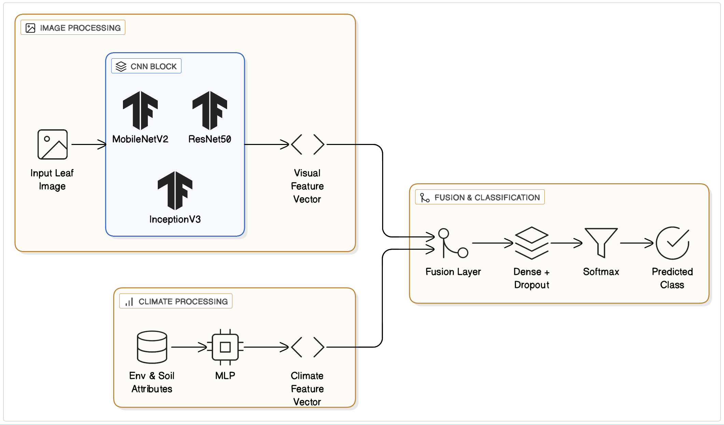
The image feature vectors obtained through CNN models and the numerical vectors produced by the MLP were concatenated, passed to the dense layers with dropout, and the classification was performed by softmax.

Figure 4.1: System Architecture of the Multimodal Deep Learning Model
The suggested layout has two parallel processing streams, one for the image feature extractor based on CNN and the other for the climate feature extractor based on MLP. The outputs of both streams are concatenated and passed through the dense layers with dropout for the final classification with Softmax.
4.5 Training Strategy
Training was done with a batch size of 32, Adam optimizer, 10 epochs, early stopping to limit overfitting, and class weights during the training of image-only models, to ease the problem of class imbalance that resulted in the differentially distributed images across the disease categories. Consequently, the model that was being biased toward the majority classes was excluded.
Chapter 5 Experimental Results and Discussion
This chapter presents the outcome of experiments on the Apple subset of the Multimodal Plant Disease Dataset by Shubham Divakar. The paper has been the performance comparison between various image-only models and a multimodal fusion model.

5.1 Experimental Setup
5.1.1 Hardware and Software Environment
The work has been done on the Mac OS platform, and the following packages have been used: Python, Jupyter Notebook, TensorFlow, NumPy, Pandas, and scikit learn.

5.1.2 Dataset Splitting
The data was divided into:
- 70% training
- 15% validation
- 15% testing

5.2 Image-Only Model Results
Model | Dataset | Accuracy | Precision | Recall | F1-Score
MobileNetV2 | Apple Disease Dataset | 0.9895 | 0.9896 | 0.9895 | 0.9895
ResNet50 | Apple Disease Dataset | 0.5490 | 0.3996 | 0.5490 | 0.4370
InceptionV3 | Apple Disease Dataset | 0.6263 | 0.5792 | 0.6263 | 0.5340
Table 5.1: Image-Only Model Results
The three image-based models whose performances differ drastically in their results. With an accuracy of 98.95% MobileNetV2 has been the one to make the most outstanding result, thus ResNet50 and InceptionV3 barely catching a glimpse. The cause of such a spectacular result can be explained by ascribing it to MobileNetV2, whose compact model, depthwise separable convolutions, and ability to extract the most efficient features make it very powerful in datasets with a small number of images and high class similarity, like apple leaf diseases.
On the other hand, ResNet50 is the one that has recorded the worst results (accuracy of 54.90%). The poor performance is a hint that ResNet50 may have overfitted the training data or is having trouble generalizing due to the limited size of the data set.
ResNet50 is a deep and complex model architecture designed for large-scale datasets like ImageNet, and, if not properly fine-tuned, it may not effectively capture the minimal features of leaf diseases.
Compared to ResNet50, InceptionV3 (accuracy 62.63%) was a bit better but still a long way behind MobileNetV2. This can be explained by the fact that even InceptionV3 was built to extract multi-scale features, the limited variability of the dataset, and the closeness of some disease classes could have forced it to identify the fine-grained patterns of the leaf.
The results, therefore, suggest that a simpler architecture like MobileNetV2 may have the potential to beat a deep model when dealing with small or medium-sized datasets from the agriculture domain. The article's findings lead to the point that the complexity of the architecture should match that of the dataset instead of just going deeper with the networks.

5.3 Multimodal Fusion Model Results
Model | Input Type | Accuracy | Precision | Recall | F1-Score
MobileNetV2 + MLP | Image +Climate | 0.7825 | 0.7858 | 0.7825 | 0.7805
ResNet50 + MLP | Image + Climate | 0.3200 | 0.1502 | 0.3200 | 0.2008
InceptionV3 + MLP | Image + Climate | 0.7400 | 0.7627 | 0.7400 | 0.7298
Table 5.2: Multimodal Fusion Model Results
Different CNNs decode differently structured climate features, as can be seen from the multimodal fusion diagrams. The MobileNetV2 + MLP model was the best performer in terms of accuracy (78.25%), and hence it was proven that a light architecture is more feature-numerical data-friendly and yields more stable fusion representations. The performance of InceptionV3 + MLP was average (74.00%), whereas that of ResNet50 + MLP was extremely poor (32.00%), which led to the conclusion that a deep network needs a lot more data to be able to align its high-dimensional visual embeddings with structured features.
The main reason that the multimodal fusion turns out to be successful is that the image encoder is compatible with tabular data. MobileNetV2 is a good illustration of a model with simpler feature representations, which can more easily merge with climate data, whereas a deep model may generate embeddings that the fusion layer cannot combine efficiently.
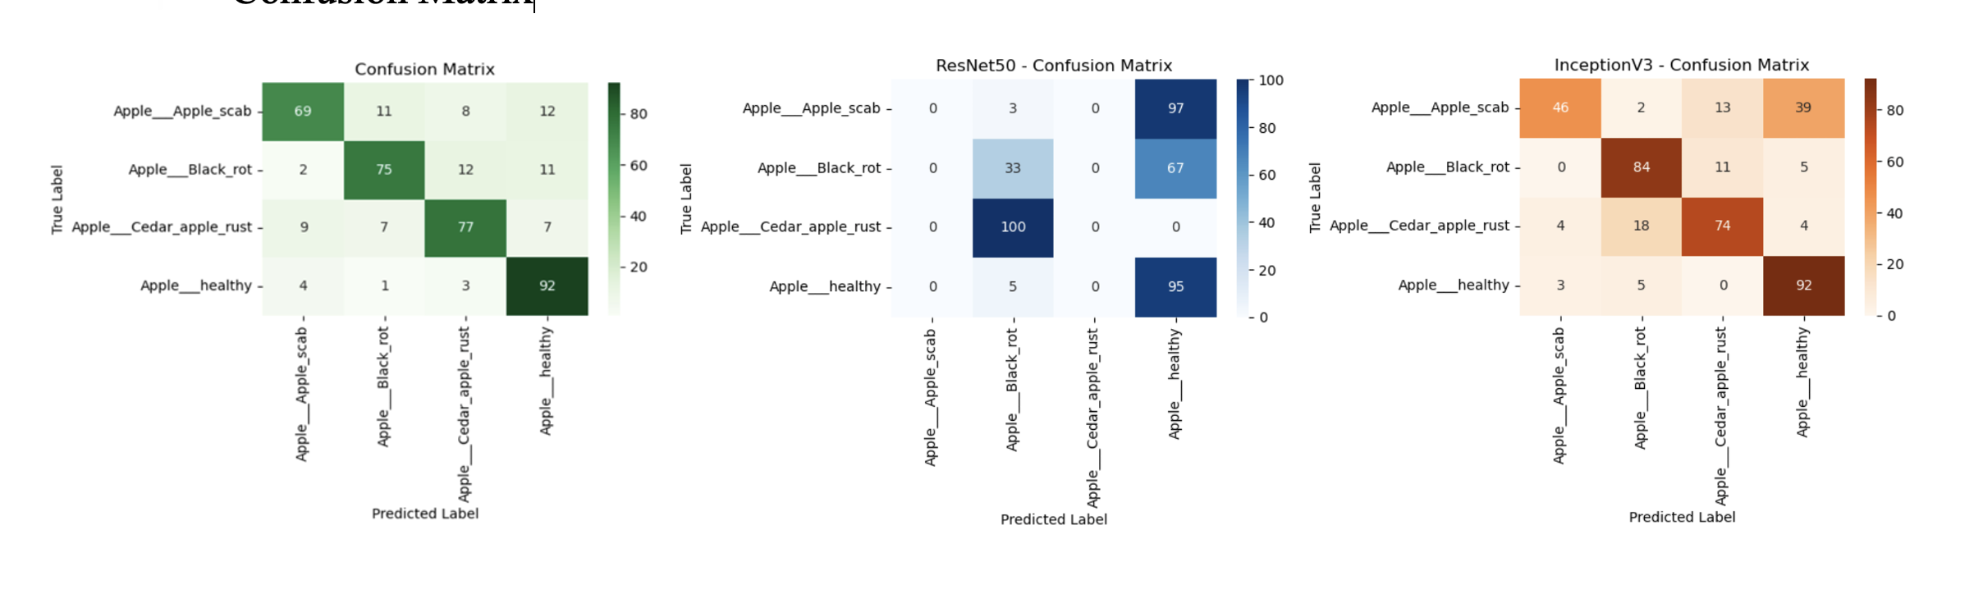

Figure 5.1 Multimodal Confusion Matrix

The confusion matrix for the fusion model MobileNetV2 + MLP is indicative of the fact that this model has made many mistakes for most of the diseases, though it has also correctly identified quite a few samples. The multimodal version showed less discrimination between classes as compared to the image-only MobileNetV2 model, which achieved almost perfect separation.
The errors are more widespread than the diagonal, which shows that adding climate and soil features did not help the visual feature representation. Instead, the fusion might have brought some noise that interfered with the already quite strong performance of the image encoder. Though informative, the structured features might not be highly correlated with the detailed visual patterns of disease, as this finding suggests.
Hence, the analysis of the multimodal confusion matrix agrees with the fact that climate features can barely contribute to the visual classification and that better methods of fusion are needed for the two modalities to agree.

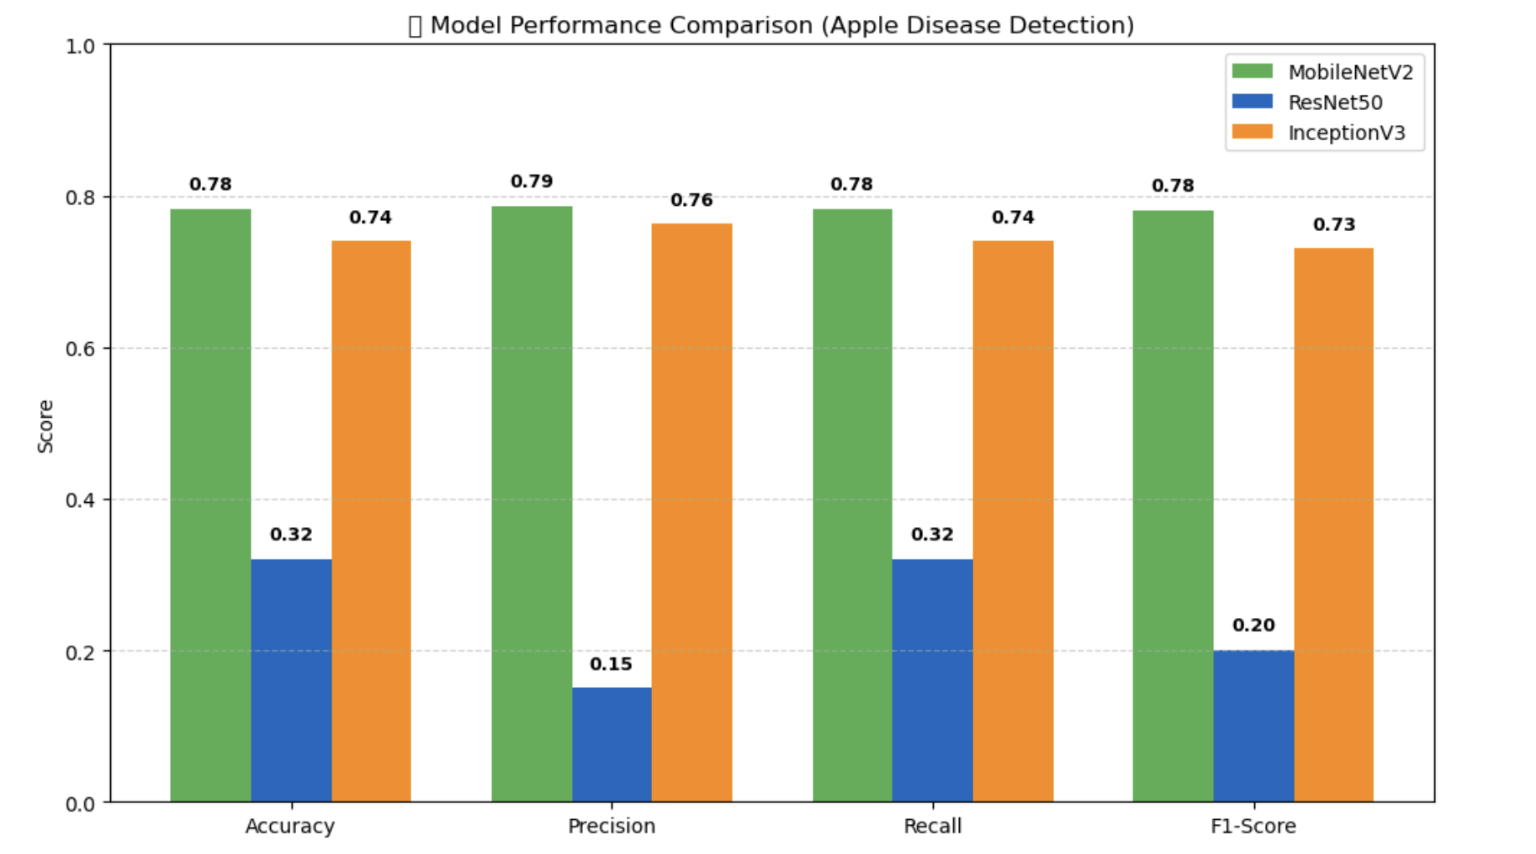
5.4 Comparison Summary
Figure 5.2 Model Performance Comparison (Apple Disease Detection)

The performance comparison figure acts as the main visual evidence for the ranking of the multimodal fusion models. The MobileNetV2 + MLP model was the top performer in all the evaluation metrics and, therefore, it represented the strongest compatibility of image-based visual features with structured climate data. The InceptionV3 + MLP model was the runner-up. It showed moderate and stable performance, but could not get to the effectiveness level of MobileNetV2.
The ResNet50 + MLP model, on the contrary, was a very strong contrasting argument and had very low metric scores throughout the entire panel. One reason for that could be that its deeper and higher-dimensional feature representations were not properly aligned with the structured environmental features during fusion.
The graph works as a tool that reveals that CNN encoders do not get the same level of benefit from multimodal integration. A light model, such as MobileNetV2, gives feature embeddings that can very easily be fused with climate and soil attributes, whereas a deep network may need more data or employ advanced fusion strategies to achieve the same level.

Chapter 6 Conclusion and Future Work
An innovative multimodal deep learning architecture is presented in this publication for the classification of apple leaf diseases. This system utilizes both noise-free image features and environmentally friendly lifestyle attributes. Thus, the documented research initially identifies and focuses on the diseases affecting apples in the "Multimodal Plant Disease Dataset" by Shubham Divakar (Kaggle), such as Apple Scab, Black Rot, Cedar Apple Rust, and Healthy leaves.
Method comparison was the point where the most energetic activity was. Challenged various image-only models (MobileNetV2, ResNet50, InceptionV3) and fused the modes to use both features. The paper gives evidence of the results of these trials, among which MobileNetV2 is the leading performer in the image-only models; hence, the demonstration of the appropriateness of lightweight architectures for the task of agricultural image analysis is made.
By investigating the multimodal fusion models scenarios, it came to light that the coordination of the visual features of the images with the environmental factors paves the way for more accurate predictions. The fusion strategies were evaluated with MobileNetV2 + MLP being the deepest integration, merge, and therefore able to yield the strongest outcomes. These results emphasize the importance of integrating several data modalities to obtain a more reliable and context-aware insight into the health of plants concept especially when different environmental factors are influenced by climate change.
The multimodal approach, by simply referring to one characteristic, can be viewed as an efficient tool to raise the level of plant disease recognition and a beneficial contribution to the major field of precision agriculture and climate-resilient crop management.

References
[1] Zainab, Z., & Mahum, R. (2025). Plant disease detection using deep learning techniques. ICCK Journal of Image Analysis and Processing, 1(1), 36-44. https://doi.org/10.62762/JIAP.2025.227089
[2] Shoaib, M., Hussain, T., Shah, B., Ullah, I., Shah, S. M., Ali, F., & Park, S. H. (2022). Deep learning-based segmentation and classification of leaf images for the detection of tomato plant disease. Frontiers in Plant Science, 13, 1031748. https://doi.org/10.3389/fpls.2022.1031748
[3] Ahmad, A., El Gamal, A., & Saraswat, D. (2023). Toward generalization of deep learning-based plant disease identification under controlled and field conditions. IEEE Access, 11, 9042-9057. https://doi.org/10.1109/ACCESS.2023.3240100
[4] Agarwal, M., Singh, A., Arjaria, S., Sinha, A., & Gupta, S. (2020). ToLeD: Tomato leaf disease detection using a convolutional neural network. Procedia Computer Science, 167, 293-301. https://doi.org/10.1016/j.procs.2020.03.225
[5] Chen, J., Chen, J., Zhang, D., Sun, Y., & Nanehkaran, Y. A. (2020). Using deep transfer learning for image-based plant disease identification. Computers and electronics in agriculture, 173, 105393. https://doi.org/10.1016/j.compag.2020.105393
[6] DeChant, C., Wiesner-Hanks, T., Chen, S., Stewart, E. L., Yosinski, J., Gore, M. A., ... & Lipson, H. (2017). Automated identification of northern leaf blight-infected maize plants from field imagery using deep learning. Phytopathology, 107(11), 1426-1432. https://doi.org/10.1094/PHYTO-11-16-0417-R
[7] Sharma, R., Singh, A., Jhanjhi, N. Z., Masud, M., Jaha, E. S., & Verma, S. (2022). Plant Disease Diagnosis and Image Classification Using Deep Learning. Computers, Materials & Continua, 71(2). https://doi.org/10.32604/cmc.2022.020017
[8] Wang, G., Sun, Y., & Wang, J. (2017). Automatic image‐based plant disease severity estimation using deep learning. Computational intelligence and neuroscience, 2017(1), 2917536. https://doi.org/10.1155/2017/2917536
[9] Too, E. C., Yujian, L., Njuki, S., & Yingchun, L. (2019). A comparative study of fine-tuning deep learning models for plant disease identification. Computers and Electronics in Agriculture, 161, 272-279. https://doi.org/10.1016/j.compag.2018.03.032
[10] Eunice, J., Popescu, D. E., Chowdary, M. K., & Hemanth, J. (2022). Deep learning-based leaf disease detection in crops using images for agricultural applications. Agronomy, 12(10), 2395. https://doi.org/10.3390/agronomy12102395
[11] Atila, Ü., Uçar, M., Akyol, K., & Uçar, E. (2021). Plant leaf disease classification using an EfficientNet deep learning model. Ecological Informatics, 61, 101182. https://doi.org/10.1016/j.ecoinf.2020.101182
[12] Jiang, P., Chen, Y., Liu, B., He, D., & Liang, C. (2019). Real-time detection of apple leaf diseases using a deep learning approach based on improved convolutional neural networks. IEEE Access, 7, 59069-59080. https://doi.org/10.1109/ACCESS.2019.2914929
[13] Amara, J., Bouaziz, B., & Algergawy, A. (2017). A deep learning-based approach for banana leaf disease classification. In Datenbanksysteme für Business, Technologie und Web (BTW 2017)-Workshopband (S. 79-88). Gesellschaft für Informatik e.V. https://dl.gi.de/items/13766147-8092-4f0a-b4e1-8a11a9046bdf
[14] Ashwinkumar, S., Rajagopal, S., Manimaran, V., & Jegajothi, B. J. M. T. P. (2022). Automated plant leaf disease detection and classification using optimal MobileNet-based convolutional neural networks. Materials Today: Proceedings, 51, 480-487. https://doi.org/10.1016/j.matpr.2021.05.584
[15] Bhattacharya, A. (2021, December). A novel deep learning-based model for the classification of rice leaf diseases. In 2021 Swedish Workshop on Data Science (SweDS) (pp. 1-6). IEEE. https://doi.org/10.1109/SweDS53855.2021.9638278
Coakley, S. M., Scherm, H., & Chakraborty, S. (1999). Climate change and plant disease management. Annual review of phytopathology, 37(1), 399-426. https://doi.org/10.1146/annurev.phyto.37.1.399
Gupta, G., & Kumar Pal, S. (2025). Applications of AI in precision agriculture. Discover Agriculture, 3(1), 61. https://doi.org/10.1007/s44279-025-00220-9
Elad, Y., & Pertot, I. (2014). Climate change impacts on plant pathogens and plant diseases. Journal of Crop Improvement, 28(1), 99-139. https://doi.org/10.1080/15427528.2014.865412
Eraser Labs, Inc. (2025). System Architecture Diagram: Multimodal Plant Disease Detection [Diagram]. Eraser.io. https://app.eraser.io/workspace/F0FQ8FKP7nlXFUvtvcqF

