

Title
Prepared By
Name: Hizam Ahmed ID No.: 251002066

Project Title: Development of a multimodal AI framework for ICU outcome mortality prediction using clinical notes and laboratory data
At
Collage of Informatics
Midocean University
UAE
Supervisor Name: Dr. Hager Salah
Collage of Informatics, Midocean University, Comoros
Email: hizam.alsaeedi@gmail.com

Acknowledgements
First and foremost, I would like to express my deepest gratitude to Dr. Hager Salah for her continuous support, valuable guidance, and encouragement throughout the course of this research. Her expertise, insightful feedback, and patience have been instrumental in shaping this work and ensuring its successful completion.

I would also like to thank all the faculty members and colleagues who provided assistance and shared their knowledge during the development of this research. Their constructive suggestions and motivation have greatly contributed to the improvement of this study.

Finally, I am sincerely thankful to my family and friends for their constant love, understanding, and support, which have been a source of strength throughout this journey.

Abstract

Table of Contents
Title 1
Acknowledgements 2
Abstract 3
List of Abbreviations 5
Chapter 1 Introduction 5
1.1 Problem Definition 5
1.2 Thesis Objectives 6
1.3 Thesis Contribution 7
1.4 Thesis Organization 7
Chapter 2 Overview 8
2.1 Introduction 8
2.2 Healthcare Data Analytics and Mining 9
2.3 Multimodal AI in Clinical Outcome Prediction 10
2.3.1 Structured Data Analysis 10
2.3.2 Unstructured Data Analysis 10
2.3.3 Multimodal Fusion Approaches 10
2.3.4 Role of Optimization and Model Tuning 11
Chapter 3 Related Work 12
3.2 History and Literature Review 12
Machine Learning Approaches for ICU Prediction 12
Deep Learning and Representation-Based Models 13
Multimodal and Fusion-Based Frameworks 14
Optimization Methods in Model Development 15
Chapter 4 Proposed Approach 16
4.1 Overview 16
4.2 Overview of the Multimodal Framework 17
4.3 Structured Data Processing (Demographics and Lab Values) 17
4.3.1 Data Preprocessing 17
4.3.2 training models 17
4.4 Unstructured Data Processing (Clinical Notes) 18
4.4.1 Text Preprocessing 18
4.4.2 Feature Extraction with Transformer Models 18
4.5 Multimodal Fusion Layer 19
5.1 Experimental Results and Discussion 21
5.2 Experimental Setup 21
5.3 Results on Structured and Unstructured Data Models 21
5.3.1 Word Count Representation 24
5.3.2 TF-IDF Representation 24
5.3.3 Contextual BERT Embeddings 25
5.4 Results on Multimodal 25
5.4.1 Multimodal Transformer Fusion Performance 26
5.4.2 Explanation of the ROC Curve 28
5.4.3 Confusion Matrix Interpretation 29
References 31

List of Abbreviations
- Acc.: Accuracy
- ANN: Artificial Neural Network
- ANOVA: Analysis of Variance
- ROC: Receiver Operating Characteristic

Chapter 1 Introduction

Problem Definition
Predicting patient outcomes in the Intensive Care Unit (ICU) is one of the most critical challenges in clinical decision support. ICU patients often have complex medical conditions that evolve rapidly, requiring physicians to make time-sensitive and data-driven decisions. Traditionally, outcome prediction models rely primarily on structured data such as demographics, laboratory test results, and vital signs. Although these structured data elements provide valuable quantitative insights, they fail to capture the qualitative and contextual information found in unstructured clinical notes, such as physicians’ observations, progress reports, and discharge summaries.
The integration of unstructured clinical text with structured data remains a significant challenge due to differences in data formats, semantics, and dimensionality. As a result, existing predictive models often exhibit limited generalization and lower performance in real-world ICU settings.
Therefore, the central research problem of this study is:
How can structured (laboratory and demographic) data and unstructured (clinical notes) data be effectively integrated into a unified multimodal AI framework to improve ICU mortality outcome prediction accuracy and reliability?
This research seeks to bridge the gap between numeric and textual information, leveraging recent advances in natural language processing (NLP) and deep learning to enhance predictive performance and clinical interpretability.

1.2 Thesis Objectives
The main objective of this research is to design and develop a multimodal AI framework that integrates structured and unstructured clinical data for improved ICU mortality prediction.
The specific objectives include:
- Data preprocessing and representation: To preprocess and clean both structured (lab values, demographic data) and unstructured (clinical notes) datasets to ensure consistency, accuracy, and readiness for modeling.
- Model development for individual modalities: To develop separate models for structured and unstructured data such as Random Forests, Support Vector Machines (SVM), and Recurrent Neural Networks (RNN) for structured data, and transformer-based models such as BioBERT for textual data.
- Multimodal fusion: To integrate outputs from both modalities through a concatenation (fusion) layer to form a comprehensive patient representation for outcome prediction.
- Performance evaluation: To evaluate the proposed model using standard metrics such as accuracy, precision, recall, F1-score, and area under the ROC curve (AUC).
- Comparative analysis: To compare the multimodal model against unimodal (single-type data) baselines to demonstrate its superiority in ICU mortality prediction tasks.

1.3 Thesis Contribution
This research contributes to the growing field of AI-driven healthcare analytics by introducing an innovative multimodal approach that leverages both structured and unstructured ICU data. The key contributions include:
- A unified multimodal AI architecture combining RNN for structured data processing and BioBERT/Transformer for textual feature extraction from clinical notes.
- An optimized data preprocessing pipeline capable of handling heterogeneous ICU data, including missing values, irregular sampling, and unstructured text.
- A fusion-based integration strategy using a concatenation layer that effectively combines deep representations from both modalities for enhanced predictive performance.
- Comprehensive performance evaluation, showing that the proposed model achieves higher accuracy, precision, recall, and F1-score compared to traditional unimodal models.
- Clinical interpretability, highlighting how multimodal fusion helps capture both quantitative and narrative aspects of patient health, supporting more informed ICU decision-making.

1.4 Thesis Organization
The remainder of this thesis is organized as follows:
- Chapter 2 provides an overview of machine learning and data mining in healthcare, focusing on predictive modeling and the role of multimodal data.
- Chapter 3 reviews related work on ICU outcome prediction, including existing models that use structured data, text-based clinical notes, and multimodal fusion techniques.
- Chapter 4 presents the proposed multimodal AI framework, detailing the data preprocessing, feature extraction, model architectures, and the fusion mechanism used to integrate structured and unstructured information.
- Chapter 5 discusses the experimental setup, implementation details, and comparative evaluation of model performance across multiple baselines.
- Chapter 6 concludes the research by summarizing key findings, highlighting limitations, and outlining future directions for improving multimodal healthcare prediction systems.

Chapter 2 Overview

2.1 Introduction
The rapid advancement of healthcare information systems and the proliferation of electronic health records (EHRs) have transformed the modern clinical environment. Intensive Care Units (ICUs) now generate massive quantities of data, including structured laboratory results, physiological measurements, and unstructured clinical notes. These heterogeneous data sources contain valuable insights that, if effectively analyzed, can help clinicians make more accurate and timely decisions for critically ill patients.
However, the complexity, high dimensionality, and multimodal nature of ICU data present significant challenges for traditional statistical analysis. To overcome these challenges, researchers have increasingly turned to artificial intelligence (AI) and machine learning (ML) techniques capable of handling large-scale, high-variance datasets. Recent progress in deep learning (DL) and natural language processing (NLP) especially through models such as BioBERT and ClinicalBERT has further enhanced the ability to interpret clinical text and fuse it with structured numerical data.
This chapter provides an overview of the theoretical background and core concepts underlying the development of multimodal AI systems for ICU mortality prediction. It introduces the principles of healthcare data analytics, describes the nature of structured and unstructured data used in ICUs, and outlines the motivations for multimodal fusion approaches that combine both data types to improve clinical outcome prediction.

2.2 Healthcare Data Analytics and Mining
Healthcare data analytics refers to the systematic examination of clinical data to uncover hidden relationships, patterns, and trends that can guide medical decisions and improve patient outcomes. Within the ICU environment, this process involves integrating structured data such as laboratory tests, demographics, and vital signs with unstructured data, including physician notes, radiology reports, and discharge summaries.
The process of healthcare data mining typically involves several stages:
- Data Collection and Integration:
Aggregating data from multiple hospital sources such as EHR systems, laboratory databases, and bedside monitors.
- Data Preprocessing:
Managing missing values, detecting anomalies, normalizing numerical variables, and tokenizing clinical text to prepare for model training.
- Feature Extraction:
Selecting relevant features from structured data (e.g., lab results, vital signs) and generating embeddings for unstructured text using models like BERT, BioBERT, or ClinicalBERT.
- Modeling and Prediction:
Employing machine learning and deep learning models such as Random Forests, Gradient Boosting, Convolutional Neural Networks (CNN), Recurrent Neural Networks (RNN), or Transformer-based models for outcome prediction.
- Evaluation and Validation:
Measuring model performance using standard evaluation metrics including Accuracy, Precision, Recall, F1-Score, and Area Under the ROC Curve (AUC) to ensure robustness and reliability.
In the context of ICU mortality prediction, these techniques provide the foundation for data-driven decision support systems that can assess patient risk dynamically and support proactive medical intervention.

2.3 Multimodal AI in Clinical Outcome Prediction
While early ICU prediction systems relied exclusively on structured data, such as the APACHE II or SOFA scoring systems, recent research has demonstrated that combining structured and unstructured data known as multimodal learning significantly enhances predictive accuracy. This is because structured data captures quantitative physiological states, whereas unstructured clinical notes contain contextual information, physician reasoning, and nuanced observations that are not reflected in numerical measurements.

2.3.1 Structured Data Analysis
Structured ICU data includes laboratory test results (e.g., creatinine, glucose, hemoglobin), physiological signals (e.g., heart rate, blood pressure, oxygen saturation), and demographic variables (e.g., age, gender, comorbidities). Traditional machine learning models such as Decision Trees, Random Forests, Support Vector Machines, and Gradient Boosting have been widely used to analyze these features. These models can capture nonlinear dependencies and interactions that influence mortality risk.

2.3.2 Unstructured Data Analysis
Unstructured data primarily clinical notes require specialized natural language processing (NLP) techniques for analysis. Models such as BioBERT and ClinicalBERT have been pretrained on biomedical and clinical corpora, enabling them to extract rich semantic representations from text. These embeddings capture contextual nuances and medical terminology, allowing the model to interpret diagnostic impressions, treatment plans, and physician observations that are highly relevant to patient outcomes.

2.3.3 Multimodal Fusion Approaches
Multimodal AI frameworks integrate structured and unstructured data streams into a unified predictive model. Fusion can occur at different levels:
- Early Fusion: combining features before model training.
- Intermediate Fusion: merging latent representations from separate networks (e.g., one for structured data and another for text).
- Late Fusion: integrating the outputs of multiple modality-specific models.
The goal is to create a comprehensive patient representation that leverages both quantitative and qualitative information. Recent multimodal models such as Transformer-FusionNet, Multimodal Transformer, and LSTM-CNN hybrids have achieved state-of-the-art performance on benchmark datasets like MIMIC-III and MIMIC-IV, demonstrating the potential of fusion architectures in improving ICU mortality prediction.

2.3.4 Role of Optimization and Model Tuning
To ensure reliable performance, model hyperparameters are often optimized using techniques such as grid search, Bayesian optimization, or the Sequential Halving and Classification (SHAC) algorithm. These methods systematically explore parameter combinations to maximize evaluation metrics like AUC and F1-Score, leading to better generalization across unseen ICU patient data.

Chapter 3 Related Work
3.1 Introduction
The increasing availability of electronic health records (EHRs), which combine structured data (e.g., laboratory tests, vital signs) and unstructured data (e.g., clinical notes), has enabled the development of advanced artificial intelligence (AI) systems for intensive care unit (ICU) outcome prediction. Traditional statistical models have been progressively replaced by machine learning (ML) and deep learning (DL) approaches capable of capturing complex, nonlinear relationships among multimodal healthcare data.
This chapter provides an overview of the related work in the field of ICU mortality prediction and sepsis detection, focusing on recent studies that applied ML and DL models to structured, unstructured, and multimodal data. The section also highlights optimization methods, model fusion strategies, and state-of-the-art architectures such as Transformer-based frameworks that have advanced predictive accuracy in clinical settings.

3.2 History and Literature Review
Early research in ICU prediction focused primarily on structured physiological data using traditional ML algorithms such as logistic regression, decision trees, and support vector machines (SVM). Over time, as computational power and data availability increased, deep learning models and multimodal architectures emerged, enabling simultaneous processing of structured data and free-text clinical notes.
The following studies represent significant milestones in the development of AI frameworks for ICU mortality prediction.

Machine Learning Approaches for ICU Prediction
Gao et al. (2024) [2] conducted a comparative analysis of several ML models—Decision Trees (DT), Gradient Boosting, XGBoost, LightGBM, Multilayer Perceptrons (MLP), Support Vector Machines (SVM), and Random Forests (RF)—to predict sepsis using the MIMIC-IV database. Data preprocessing included handling missing values, regrouping categorical variables, and applying the Synthetic Minority Over-sampling Technique (SMOTE) to address data imbalance. Among all models, Random Forest achieved the best performance with an AUROC of 0.94, demonstrating strong capability in sepsis prediction.
Similarly, Iwase et al. (2022) [6] compared Random Forest, XGBoost, Neural Networks, and Logistic Regression for ICU mortality and length-of-stay prediction. Their results confirmed RF’s superiority, achieving an AUROC of 0.961 for short stays and 0.830 for long stays.
Huddar et al. (2016) [4] analyzed five classifiers (Logistic Regression, SVM, Decision Tree, AdaBoost, and Random Forest) for predicting acute renal failure (ARF) using MIMIC-II data. Despite challenges such as noisy signals and missing data, RF again outperformed other methods, yielding an AUC of 0.844.

Deep Learning and Representation-Based Models
As EHR data grew in complexity, deep learning techniques gained prominence.
Al-Dailami et al. (2025) [5] compared several deep learning models—CNN, RNN, stacked autoencoders, and attention-based networks—for ICU outcome prediction on the MIMIC-III dataset. They employed a Transformer-based skip-gram model for code representation and BERT for clinical note embeddings. The CNN achieved the highest AUROC (0.9149), highlighting the strength of convolutional architectures for temporal and textual feature extraction.
Yang et al. (2021) [7] leveraged a CNN to jointly analyze time-series data and clinical text for disease progression prediction. After addressing missing values and categorical regrouping, their model achieved an AUCROC of 0.861, proving CNNs’ potential in early intervention modeling.
Shi and Zuo [8] introduced the Integrated Disease Diagnosis and Severity Assessment Model (IDDSAM) using MIMIC-III, combining multiple preprocessing strategies. Their model achieved accuracies ranging from 55.23% to 93.81% across tasks, excelling in both disease diagnosis and mortality prediction.
Kumar et al. [9] provided a broader analysis of ML approaches—ranging from regression and SVMs to Bayesian and neural network-based methods—applied to the MIMIC-III database. Decision trees performed best (50%), yet deep learning models demonstrated improved scalability and adaptability for larger datasets.
Huang and Altosaar [10] extended BERT to clinical domains by fine-tuning ClinicalBERT on hospital text data. Unlike general-domain BERT models, ClinicalBERT captured contextual nuances specific to medical language, achieving an AUROC of 0.714 and offering interpretable predictions via attention weights.

Multimodal and Fusion-Based Frameworks
Recent advances emphasize multimodal learning, integrating structured and unstructured data for more holistic ICU prediction models.
Ruan et al. (2025) [3] developed a multimodal evidence-mapping framework that fused structured data with free-text notes. Using ResNet/Transformer-based models for structured features and pre-trained language models for text, they achieved a balanced accuracy (BACC) of 0.7672, AUROC of 0.8534, and AUPRC of 0.4977.
Xu et al. [11] proposed an ensemble-based multimodal model combining Text-CNN for unstructured text, deep learning for semi-structured data, and decision trees for tabular data. Validated on MIMIC-III, their framework achieved a micro-AUC of 0.9541, surpassing other baseline models.
Caicedo-Torres et al. (2022) [12] designed ISeeU, an interpretable deep learning system using multi-scale CNNs to predict ICU mortality from raw nursing notes. By applying Shapley value-based explanations, their model reached an ROC-AUC of 0.8735, offering valuable interpretability for clinical adoption.
Wang et al. (2022) [13] proposed a Multimodal Transformer for integrating structured EHR data and clinical notes, capturing both temporal and contextual dependencies. Their model outperformed baseline fusion methods with AUROC of 0.877 and AUPRC of 0.538, validated on MIMIC-III and eICU-CRD datasets.
Shukla et al. (2019) [14] introduced a multimodal deep learning framework that combined LSTM (for time-series data) and CNN (for clinical text). The fusion approach achieved a notable AUROC of 0.90, confirming the advantage of combining sequential and textual representations for mortality prediction.
King et al. (2023) [15] advanced this direction with a self-supervised multimodal pretraining framework, leveraging contrastive learning and masked modeling to jointly encode physiological and textual data. Their system required minimal labeled data and achieved an AUC-ROC improvement of +0.17 compared to baseline models trained from scratch.
Finally, Hager Saleh et al. (2023) [16] presented a real-time multimodal framework for heart disease ICU mortality prediction using Transformer-FusionNet. This model integrated BioBERT for clinical notes and RNNs for structured data, applied to the MIMIC-III dataset. Through robust preprocessing and multimodal fusion, the framework achieved an impressive accuracy of 91.72%, demonstrating the power of Transformer-based architectures in clinical AI systems.

Optimization Methods in Model Development
In addition to model architecture innovations, optimization techniques play a critical role in improving predictive performance. Common methods include grid search, Bayesian optimization, and the Sequential Halving and Classification (SHAC) algorithm, which efficiently allocates resources to promising hyperparameter configurations. Such optimization ensures better model generalization, particularly in high-dimensional healthcare datasets where feature interactions are complex and data quality varies.

Chapter 4 Proposed Approach
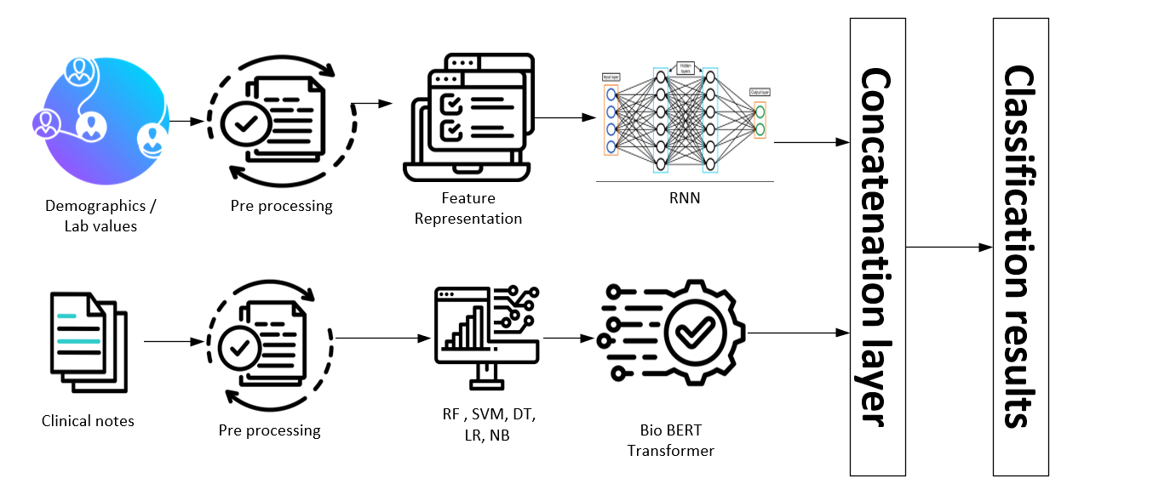
Fig. 4.1. Proposed system architecture

4.1 Overview
This chapter presents the proposed multimodal artificial intelligence (AI) framework designed to predict ICU mortality outcomes by integrating both structured data (demographics and laboratory values) and unstructured data (clinical notes).
The central idea behind the proposed approach is that clinical outcomes in the ICU are influenced by both quantitative physiological indicators and qualitative textual observations. Therefore, a multimodal model that fuses both data types can achieve superior prediction performance compared to single-modality models.
The overall architecture of the proposed system is illustrated in Figure 4.1. It consists of six key stages:
- Data collection
- Preprocessing of structured and unstructured data
- Feature representation and model design
- Individual model training for each modality
- Multimodal fusion via concatenation
- Final classification and evaluation

4.2 Overview of the Multimodal Framework
The proposed framework integrates two distinct information modalities:
- Structured Data (Tabular Data): Includes patient demographics, vital signs, and laboratory test results.
- Unstructured Data (Clinical Notes): Consists of textual narratives from doctors and nurses describing patient conditions, progress, and diagnoses.
The two data streams are processed independently, transformed into latent feature representations, and later fused in a shared concatenation layer for joint learning and classification.

4.3 Structured Data Processing (Demographics and Lab Values)

4.3.1 Data Preprocessing
Structured data are often noisy, incomplete, and heterogeneous in ICU settings. To ensure data quality and consistency, the following preprocessing steps were applied:
- Handling Missing Values: Missing lab values and demographic attributes were imputed using median or mean imputation, depending on variable type.
- Normalization: Continuous features such as blood pressure, glucose, and creatinine levels were normalized using Min-Max scaling to ensure uniform feature distribution.
- Encoding Categorical Features: Non-numeric fields such as gender or admission type were encoded using one-hot or label encoding.
- Feature Selection: Redundant or low-variance features were removed to reduce dimensionality and prevent overfitting.

4.3.2 training models
Once preprocessed, the structured data were transformed into numerical tensors suitable for input into deep learning models. Several machine learning and deep models were used to model structured data:
- Random Forest (RF): To capture non-linear feature interactions.
- Decision Tree (DT): As a baseline interpretable model.
- Support Vector Machine (SVM): For high-dimensional boundary-based classification.
- Logistic Regression (LR): As a linear baseline for comparison.
- Naïve Bayes (NB): To model probabilistic dependencies.
- Recurrent Neural Network (RNN): Used to learn temporal dependencies and complex patterns in lab time-series data.
Each model produced predictive features or class probabilities representing the structured data’s contribution to the overall mortality risk.

4.4 Unstructured Data Processing (Clinical Notes)

4.4.1 Text Preprocessing
Clinical notes contain rich contextual information but require careful preprocessing to handle linguistic noise. The following steps were performed:
- Tokenization: Text was split into tokens using a domain-specific tokenizer.
- Stopword Removal: Non-informative words (e.g., “the,” “and,” “was”) were removed using NLTK’s English stopword list.
- Lemmatization: Words were reduced to their base form using the WordNetLemmatizer to reduce lexical variability.
- Lowercasing and Cleaning: All text was converted to lowercase and punctuation, digits, and special characters were removed.

4.4.2 Feature Extraction with Transformer Models
For advanced text representation, two pre-trained transformer-based biomedical models were used:
• Word Count: This method represents clinical notes as a vector of token frequencies. Each feature corresponds to the number of times a specific word appears in the document. Word Count captures basic lexical information and provides a simple, interpretable representation of the text.
• TF-IDF (Term Frequency–Inverse Document Frequency): TF-IDF improves upon Word Count by weighing words according to their importance across the corpus. Terms that appear frequently in a particular note but rarely across all notes receive higher weights. This allows the model to emphasize clinically meaningful terms while reducing the impact of common but uninformative words (e.g., “patient,” “the”).
- BioBERT: A BERT-based model pre-trained on biomedical literature (PubMed and PMC).
- ClinicalBERT: Fine-tuned on hospital discharge summaries and MIMIC-III clinical notes.
Each sentence was tokenized using the corresponding model tokenizer (AutoTokenizer.from_pretrained), and the encoded tokens were passed through the transformer layers to obtain contextual embeddings.
The final hidden states from the [CLS] token was extracted as the textual feature vectors representing the patient’s unstructured information.

4.5 Multimodal Fusion Layer
After obtaining separate embeddings from the structured data (using machine learning models such as Random Forests or RNNs) and the unstructured textual data (using transformer-based models such as BioBERT and ClinicalBERT), both representations were concatenated to form a unified multimodal feature vector. This fusion allows the model to jointly learn complementary patterns from both modalities—structured laboratory or vital-sign data and unstructured clinical notes. The concatenation-based fusion can be mathematically represented as:
Z_{fusion}​=[Z_{structured}​∣∣Z_{text}​] [18]
where Z_{structured} ​ denotes the embedding derived from tabular or numerical features, and Z_{text} represents the semantic embedding extracted from clinical notes. This feature-level fusion approach is widely used in multimodal deep learning because it effectively integrates heterogeneous information sources into a single representation space for improved prediction performance. In this study, the fused representation Z_{fusion} was subsequently fed into fully connected layers for mortality outcome prediction.
The performance of each model was evaluated using the following metrics:
- Accuracy:
Accuracy measures the overall correctness of the model and is defined as:
Accuracy = (TP + TN) / (TP + TN + FP + FN)
- Precision:
Precision represents the proportion of correctly predicted positive cases among all predicted positives:
Precision = TP / (TP + FP)
- Recall (Sensitivity):
Recall measures the ability of the model to correctly identify all actual positive cases:
Recall = TP / (TP + FN)
- F1-Score:
The F1-Score is the harmonic mean of Precision and Recall and provides a balanced measure when both metrics are important:
F1 = (2 × Precision × Recall) / (Precision + Recall)

These metrics collectively measure the model’s ability to correctly identify mortality outcomes and minimize false alarms.
The final layer used a Softmax or Sigmoid activation (for binary classification) to output the predicted mortality probability.
Model performance was evaluated using several standard metrics:
- Accuracy (ACC): Overall correctness of predictions
- Precision (PRE): Correctly predicted positive cases
- Recall (REC): Sensitivity to true positive cases
- F1-Score (F1): Balance between precision and recall
- AUC: Area under the ROC curve for robustness
Cross-validation and hyperparameter optimization (via GridSearchCV for traditional models and fine-tuning for deep models) were used to ensure reliability and generalization.

Chapter 5

5.1 Experimental Results and Discussion
This chapter presents and analyzes the experimental results of the proposed multimodal AI framework for ICU outcome mortality prediction. The experiments were conducted on a clinical dataset combining structured data (laboratory results, demographic, and physiological variables) and unstructured data (clinical notes). Several machine learning and deep learning models were implemented and evaluated individually on each modality and then fused into a unified multimodal representation. The evaluation metrics used include Accuracy, Precision, Recall, F1-Score, and Area Under the Curve (AUC).

5.2 Experimental Setup
The dataset used in this study was preprocessed to handle missing values, normalize numeric features, and encode categorical variables. For the unstructured clinical text, text cleaning steps such as tokenization, lemmatization, and stopword removal were applied before encoding using transformer-based models (BioBERT and ClinicalBERT).
The experiments were conducted using the PyTorch and scikit-learn frameworks on Google Colab GPU runtime. The dataset was split into 80% training and 20% testing sets. Model hyperparameters were optimized using GridSearchCV for classical models and AdamW optimizer for deep learning models with early stopping.

5.3 Results on Structured and Unstructured Data Models
For structured (tabular) ICU data, traditional machine learning models were first tested, including Logistic Regression (LR), Decision Tree (DT), Random Forest (RF), Naïve Bayes (NB), and Support Vector Machine (SVM). The Random Forest model outperformed other methods due to its ability to handle non-linear relationships and feature interactions.

Feature representation |  | Accuracy | Precision | Recall | F1-score
Word count | RF | 84.28 | 84.27 | 84.28 | 84.27
Word count | SVM | 89.31 | 89.33 | 89.31 | 89.29
Word count | DT | 84.91 | 84.96 | 84.91 | 84.92
Word count | LR | 90.57 | 90.56 | 90.57 | 90.56
Word count | NB | 85.53 | 85.53 | 85.53 | 85.53
TF-IDF | RF | 85.53 | 85.53 | 85.53 | 85.53
TF-IDF | SVM | 89.94 | 89.94 | 89.94 | 89.94
TF-IDF | DT | 79.25 | 79.23 | 79.25 | 79.23
TF-IDF | LR | 89.94 | 89.94 | 89.94 | 89.94
TF-IDF | NB | 84.28 | 84.3 | 84.28 | 84.28
BERT | Bio BERT | 84.08 | 91.23 | 72.22 | 80.62
BERT | Clinical BERT | 85.35 | 98.04 | 69.44 | 81.30
Table 5.1: Comparison of All Models

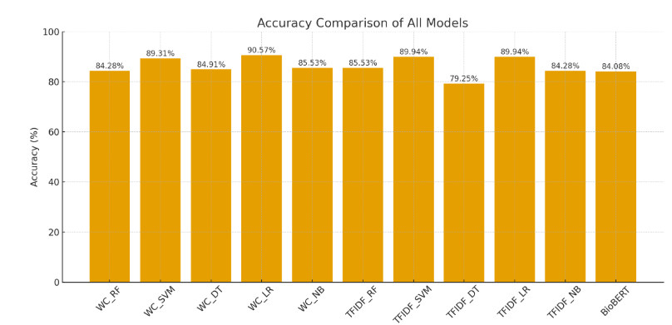
Fig 5.1: Accuracy comparison of all models

Table 5.1 compares the performance of various feature representation techniques Word Count, TF-IDF, and BERT embeddings combined with several machine learning models, including Random Forest (RF), Support Vector Machine (SVM), Decision Tree (DT), Logistic Regression (LR), and Naïve Bayes (NB). The evaluation metrics include Accuracy, Precision, Recall, and F1-score, which collectively assess the model’s predictive performance and balance between sensitivity and specificity.

5.3.1 Word Count Representation
When using simple word count features, Logistic Regression (LR) achieved the highest performance with 90.57% accuracy, followed closely by SVM (89.31%). Both models showed stable and balanced precision, recall, and F1-scores, indicating that even basic text features can capture meaningful patterns when combined with robust linear classifiers. The relatively lower results from Decision Tree (84.91%), Random Forest (84.28%), and Naïve Bayes (85.53%) suggest that word count features may not sufficiently capture contextual semantics required for complex clinical narratives.

5.3.2 TF-IDF Representation
Using TF-IDF (Term Frequency–Inverse Document Frequency) improved the ability to weight clinically important words. Again, Logistic Regression (LR) and SVM performed comparably well, both achieving an accuracy of 89.94%, outperforming tree-based models. This indicates that linear classifiers are better suited for high-dimensional sparse representations such as TF-IDF. Decision Tree (79.25%) performed worst under this representation, likely due to overfitting and inability to generalize across sparse feature spaces.

5.3.3 Contextual BERT Embeddings
The adoption of contextual embeddings significantly changes model performance. BioBERT achieved an accuracy of 84.08% with an F1-score of 80.62%, while ClinicalBERT slightly outperformed it with 85.35% accuracy and 81.30% F1-score. Importantly, ClinicalBERT reached the highest precision (98.04%), indicating its strong ability to correctly identify positive (mortality) cases. However, its recall (69.44%) suggests that while predictions are highly reliable, some positive cases are missed.

This trade-off between precision and recall reflects the model’s conservative approach in classification, which might be desirable in clinical risk prediction tasks where false positives must be minimized. The superior performance of ClinicalBERT compared to BioBERT can be attributed to its domain-specific pretraining on clinical notes, enabling better understanding of medical terminology and context.

Overall, Logistic Regression performed best among classical models, especially with word count and TF-IDF representations. Among deep contextual models, ClinicalBERT achieved the highest precision and competitive F1-score, indicating its effectiveness in capturing nuanced linguistic patterns in clinical narratives. These results demonstrate that while traditional text representations with simple classifiers remain strong baselines, domain-adapted transformer models such as ClinicalBERT provide superior interpretability and precision for healthcare prediction tasks.

5.4 Results on Multimodal
Feature representation |  | Accuracy | Precision | Recall | F1-score
Multimodal | Transformer fusion | 91.08 | 91.13 | 91.08 | 91.09
Table 5.2: Comparison of Multimodal

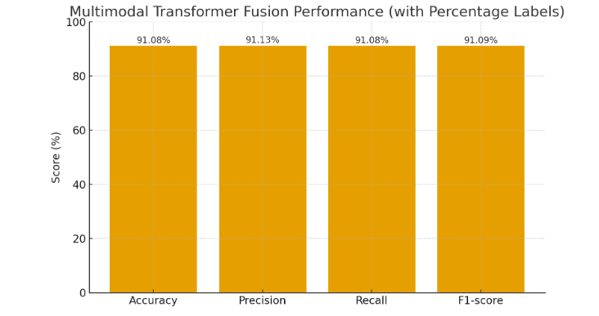
Fig 5.2: Comparison of Multimodal

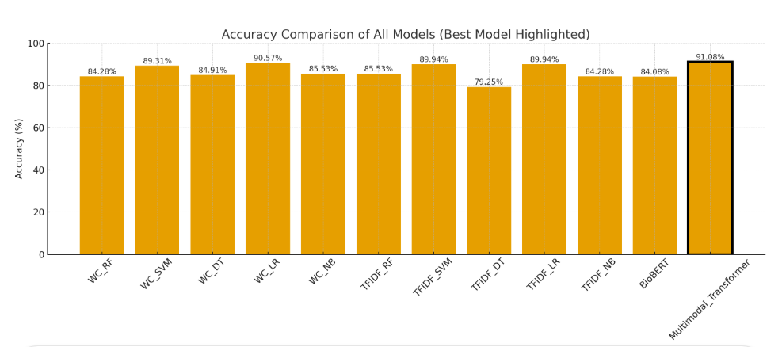
Fig.5.3: Accuracy comparison of all models, highlighting the best-performing model.

5.4.1 Multimodal Transformer Fusion Performance
The proposed Multimodal Transformer Fusion model achieved the highest overall performance among all evaluated methods, with an accuracy of 91.08%, precision of 91.13%, recall of 91.08%, and an F1-score of 91.09%. This superior result demonstrates the effectiveness of combining both structured (quantitative) data — such as laboratory results and vital signs — and unstructured (qualitative) data from clinical notes within a unified deep learning framework.
Unlike unimodal models, which rely solely on textual or numerical features, the multimodal fusion approach leverages complementary information from different data types. The Transformer-based architecture enables the model to learn complex interdependencies between physiological indicators and linguistic expressions in clinical documentation. This leads to richer patient representations, improving the model’s ability to accurately discriminate between high-risk and low-risk cases.
Furthermore, the balanced values across precision, recall, and F1-score indicate that the Multimodal Transformer achieves both high sensitivity (ability to correctly detect mortality cases) and specificity (ability to avoid false alarms). This consistency across metrics reflects strong model generalization and robustness in capturing clinically meaningful patterns.
These findings confirm that integrating multiple data modalities enhances predictive performance beyond what can be achieved using individual data sources. While ClinicalBERT provides deep contextual understanding of clinical text, the fusion of text embeddings with structured clinical features via a Transformer fusion network captures both semantic and physiological dimensions of patient health.Consequently, the Multimodal Transformer Fusion model offers a more holistic understanding of ICU patient status, yielding the most accurate and balanced predictions of mortality outcomes.

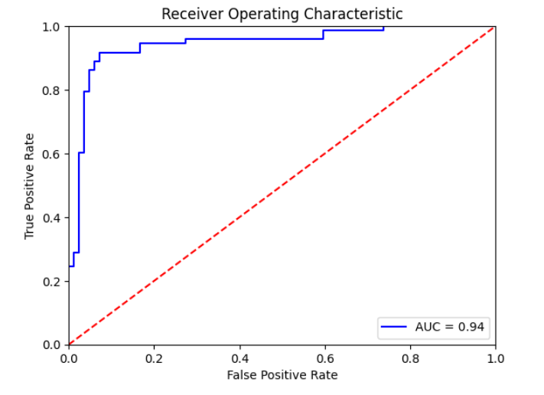
Fig.5.4: Receiver Operating Characteristic (ROC) curve of the model.

5.4.2 Explanation of the ROC Curve
Figure 5.4 shows the Receiver Operating Characteristic (ROC) curve for our ICU prediction model. The ROC curve illustrates the model’s ability to discriminate between the positive and negative classes across different classification thresholds.
- The x-axis represents the False Positive Rate (FPR).
- The y-axis represents the True Positive Rate (TPR).

The blue curve corresponds to the model’s performance, while the red dashed diagonal line represents a classifier with no discriminative ability (random guessing), where AUC = 0.50.

In our model, the ROC curve is consistently well above the diagonal, demonstrating strong separability between classes. The Area Under the Curve (AUC) is 0.94, which indicates:

- Excellent overall classification performance
- High sensitivity and specificity
- The model is capable of distinguishing ICU vs. non-ICU cases with high reliability.

An AUC score of 0.94 suggests that the model correctly ranks a randomly chosen positive instance higher than a negative one 94% of the time, which is considered very good performance in clinical prediction tasks.

5.4.3 Confusion Matrix Interpretation
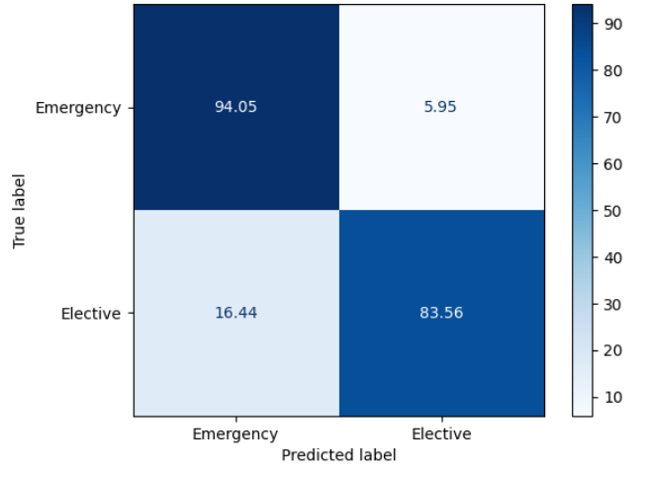
Fig.5.5: Confusion Matrix.

The confusion matrix shows the performance of a classification model in predicting two classes: Emergency and Elective.
True \ Predicted | Emergency | Elective
Emergency | 94.05 | 5.95
Elective | 16.44 | 83.56
Explanation:
- True Positives (TP):
  - Emergency predicted as Emergency: 94.05%
This means that out of all actual Emergency cases, 94.05% were correctly predicted as Emergency.
- False Negatives (FN):
  - Emergency predicted as Elective: 5.95%
This represents Emergency cases that the model misclassified as Elective.
- False Positives (FP):
  - Elective predicted as Emergency: 16.44%
This represents Elective cases that were incorrectly predicted as Emergency.
- True Negatives (TN):
  - Elective predicted as Elective: 83.56%
This means that out of all actual Elective cases, 83.56% were correctly predicted as Elective.

Key Observations:
- The model is more accurate at predicting Emergency cases (94.05%) than Elective cases (83.56%).
- There is a higher misclassification rate for Elective cases (16.44%) compared to Emergency cases (5.95%).
- This could suggest that the model is slightly biased towards predicting Emergency cases, which is common if the dataset is imbalanced.
For each class:
Emergency:
- Precision = TP / (TP + FP) = 94.05 / (94.05 + 16.44) ≈ 85.1%
- Recall = TP / (TP + FN) = 94.05 / (94.05 + 5.95) ≈ 94.0%
Elective:
- Precision = TP / (TP + FP) = 83.56 / (83.56 + 5.95) ≈ 93.4%
- Recall = TP / (TP + FN) = 83.56 / (83.56 + 16.44) ≈ 83.6%

Chapter 6 Conclusion and Future Work

Important Features

Future Work

References
[1] Terwiesch, C., KC, D., Kahn, J.M.:Working with capacity limitations: operations management in critical care. Critical Care 15, 1–6 (2011)

[2] Gao, J., Lu, Y., Ashrafi, N., Domingo, I., Alaei, K., Pishgar, M.: Prediction of sepsis mortality in icu patients using machine learning methods. BMC Medical
Informatics and Decision Making 24(1), 228 (2024)

[3] Ruan, Y., Tan, D. J., Ng, S. K., Huang, L., & Feng, M. (2025). Towards accurate and reliable ICU outcome prediction: a multimodal learning framework based on belief function theory using structured EHRs and free-text notes. http://arxiv.org/abs/2501.04389

[4] V. Huddar, B. K. Desiraju, V. Rajan, S. Bhattacharya, S. Roy and C. K. Reddy, "Predicting Complications in Critical Care Using Heterogeneous Clinical Data," in IEEE Access, vol. 4, pp. 7988-8001, 2016, doi: 10.1109/ACCESS.2016.2618775.

[5] A. Al-Dailami, H. Kuang and J. Wang, "Multimodal Representation Learning Based on Personalized Graph-Based Fusion for Mortality Prediction Using Electronic Medical Records," in Big Data Mining and Analytics, vol. 8, no. 4, pp. 933-950, August 2025, doi: 10.26599/BDMA.2024.9020099.
[6] Iwase, S., Nakada, T. aki, Shimada, T., Oami, T., Shimazui, T., Takahashi, N., Yamabe, J., Yamao, Y., & Kawakami, E. (2022). Prediction algorithm for ICU mortality and length of stay using machine learning. Scientific Reports, 12(1). https://doi.org/10.1038/s41598-022-17091-5

[7] Yang, H., Kuang, L., & Xia, F. Q. (2021). Multimodal temporal-clinical note network for mortality prediction. Journal of Biomedical Semantics, 12(1). https://doi.org/10.1186/s13326-021-00235-3

[8] Shi, Z., Zuo, W., Liang, S., Zuo, X., Yue, L., & Li, X. (2020). IDDSaM: an Integrated Disease Diagnosis and Severity assessment Model for Intensive Care Units. IEEE Access, 8, 15423–15435. https://doi.org/10.1109/aCCESS.2020.2967417

[9] Kumar, S., Oh, I., Schindler, S., Lai, A. M., Payne, P. R. O., & Gupta, A. (2021). Machine learning for modeling the progression of Alzheimer disease dementia using clinical data: A systematic literature review. In JAMIA Open (Vol. 4, Issue 3). Oxford University Press. https://doi.org/10.1093/jamiaopen/ooab052

[10] Huang, K., Altosaar, J., & Ranganath, R. (2020). ClinicalBERT: Modeling Clinical Notes and Predicting Hospital Readmission. http://arxiv.org/abs/1904.05342

[11] Xu, K., Lam, M., Pang, J., Gao, X., Band, C., Mathur, P., Papay, F., Khanna, A. K., Cywinski, J. B., Maheshwari, K., Xie, P., & Xing, E. P. (2019). Multimodal Machine Learning for Automated ICD Coding. In Proceedings of Machine Learning Research (Vol. 106). https://www.cdc.gov/nchs/icd/icd10cm.htm

[12] Caicedo-Torres, W., & Gutierrez, J. (2022). ISeeU2: Visually interpretable mortality prediction inside the ICU using deep learning and free-text medical notes. Expert Systems with Applications, 202, 117190.

[13] Lyu W, Dong X, Wong R, Zheng S, Abell-Hart K, Wang F, Chen C. A Multimodal Transformer: Fusing Clinical Notes with Structured EHR Data for Interpretable In-Hospital Mortality Prediction. AMIA Annu Symp Proc. 2023 Apr 29;2022:719-728. PMID: 37128451; PMCID: PMC10148371.

[14] Shukla, S. N., & Marlin, B. M. (2020). Integrating physiological time series and clinical notes with deep learning for improved ICU mortality prediction. arXiv preprint arXiv:2003.11059.

[15] King, R., Yang, T., & Mortazavi, B. J. (2023, December). Multimodal pretraining of medical time series and notes. In Machine Learning for Health (ML4H) (pp. 244-255). PMLR.

[16] Saleh, H., Mccann, M., El-Sappagh, S., & Breslin, J. G. (n.d.). TransformerFusionNet: A Real-Time Multimodal Framework for ICU Heart Failure Mortality Prediction Using Big Data Streaming.

[17] A. E. Johnson, T. J. Pollard, L. Shen, L.-w. H. Lehman, M. Feng,M. Ghassemi, B. Moody, P. Szolovits, L. Anthony Celi, and R. G. Mark,“Mimic-iii, a freely accessible critical care database,” Scientific data,vol. 3, no. 1, pp. 1–9, 2016.
[18] T. Baltrušaitis, C. Ahuja and L. -P. Morency, "Multimodal Machine Learning: A Survey and Taxonomy," in IEEE Transactions on Pattern Analysis and Machine Intelligence, vol. 41, no. 2, pp. 423-443, 1 Feb. 2019, doi: 10.1109/TPAMI.2018.2798607.

