


Optimized Hybrid Deep Learning and Machine Learning Approach for CKD Diagnosis Using Genetic Algorithms

Prepared By
Name: Nasser Naim Qanabta ID No.: 251003169

Submitted in fulfillment of the requirements for the degree Master of Science in Artificial Intelligence
At
Collage of Informatics
Midocean University
UAE
Supervisor Name: Wesam Ahmed
Collage of Informatics, Midocean University, Comoros
Email: wesamahmed@midocean.edu.km

Acknowledgements
I would like to thank my supervisor Dr.Wesam Ahmed for her inspiration, patience, and encouragement, your insight and mastery aided me at every point of this project.

Abstract

List of Publications

Contents
Hybrid CNN and Machine Learning Approach for Chronic Kidney Disease Classification with Genetic Algorithm-Based Model Optimization 1
Acknowledgements 2
Abstract 3
List of Publications 3
List of Abbreviations 5
List of Figures 6
List of Tables 7
Chapter 1 Introduction 8
1.1 Problem Definition 9
1.2 Thesis Objectives 10
1.3 Thesis Contribution 11
1.4 Thesis Organization 11
Chapter 2 Overview 12
2.1 Introduction 12
2.2 The Role of Artificial Intelligence in Healthcare 13
2.3 Machine Learning Techniques 15
2.3.1 Support Vector Machine (SVM) 17
2.3.2 Random Forest (RF) 18
2.3.3 XGBoost (Extreme Gradient Boosting) 18
2.3.4 Artificial Neural Network (ANN) 19
2.3.5 k-Nearest Neighbors (k-NN) 20
2.3.6 Light Gradient Boosting Machine (LightGBM) 20
2.3.7 Genetic Algorithm for Hyperparameter Tuning 21
2.4 Deep Learning Techniques 22
2.4.1 Convolutional Neural Networks (CNN) for Feature Extraction 23
2.5 Explainable Artificial Intelligence (XAI) 25
2.6 Evaluation Metrics and Confusion Matrix 25
2.7 Summary 27
Chapter 3: Related Work 28
3.1 Introduction 28
3.2 Machine Learning Studies for CKD Classification 29
3.3 Deep Learning Studies for CKD Classification 32
3.4 Summary 35
References 36

List of Abbreviations
- AI: Artificial Intelligence
- ANN: Artificial Neural Networks
- AUC: Area Under the Curve
- CKD: Chronic Kidney Disease
- DL: Deep Learning
- DNN: Deep Neural Network
- ML: Machine Learning
- RF: Random Forest
- ROC: Receiver Operating Characteristic
- SHAP: SHapley Additive exPlanations
- XAI: Explainable Artificial Intelligence
- RF: Random Forest
- SVM: Support Vector Machine
- XGBoost: Extreme Gradient Boosting
- TP: True Positive
- TN: True Negative
- FP: False Positive
- FN: False Negative
- ANN: artificial neural networks
- K-NN: k-nearest neighbors
- CNN: Convolutional Neural Networks
- LightGBM: Light Gradient Boosting Machine
- GA: Genetic Algorithm

List of Figures

2.1 Worldwide age-standardized CKD prevalence per 100,000 populations ……..… | 6
2.2 Core AI technologies between ML, DL and their role in CKD classification ...… | 8
2.3 Hierarchical taxonomy of Machine Learning…………………………………. | 9
2.3.4 ANN Diagram …………………………………………………..……….… | 13
2.4.1 Basic convolutional neural network (CNN) architecture………………..……….… | 17

List of Tables
2.3 | Comparison of ML Models for CKD Classification ……………………………… | 15
2.4 | DL Model Comparison …………………………………………………………... | 17
3.3.1 | Summary Table of Machine Learning-Based Studies…………………………. | 23
3.4.1 | Summary Table of Deep Learning-Based Studies…………………………… | 27

Chapter 1 Introduction
Chronic Kidney Disease (CKD) is a long-term condition in which the kidneys gradually lose their ability to perform essential functions removing waste, balancing electrolytes, regulating fluids, and producing hormones that control blood pressure and red blood cell production [1]. It affects more than 850 million people worldwide, a number that already surpasses the combined prevalence of diabetes and cardiovascular diseases. The impact is most severe in low- and middle-income countries, where healthcare resources are scarce and risk factors such as hypertension, diabetes, and obesity are on the rise.
One of the most challenging aspects of CKD is its silent progression. In the early stages (G1–G3), the disease often develops without noticeable symptoms, allowing it to advance undetected. By the time it is diagnosed, many patients are already in advanced stages (G4–G5) or facing End-Stage Renal Disease (ESRD), a stage that requires dialysis or transplantation and carries a high risk of cardiovascular complications. Beyond the medical impact, the economic and social costs are enormous—frequent hospital visits, expensive treatments, and reduced quality of life place a heavy burden on families and healthcare systems alike. This reality makes early detection not just a medical priority, but a global health imperative.
Historically, CKD diagnosis has relied on a small set of biomarkers, primarily serum creatinine and estimated glomerular filtration rate (eGFR). While these measures are essential, they are not enough for detecting the disease early. They overlook the complex interplay of multiple clinical factors—such as hemoglobin, blood pressure, albumin levels, and comorbidities like diabetes—that vary from one population to another [2]. This limitation reduces both sensitivity and specificity, meaning that many cases are detected too late. Differences in healthcare infrastructure across regions further complicate the issue. The growing adoption of electronic health records (EHRs) has opened the door to advanced computational methods that can detect hidden patterns in patient data, making earlier and more accurate diagnosis possible.
In recent years, Artificial Intelligence (AI) especially deep learning (DL) has transformed many areas of healthcare. DL models such as deep neural networks (DNNs) and transformer-based architectures have shown remarkable ability to capture complex, non-linear relationships in large datasets, outperforming traditional machine learning (ML) algorithms like support vector machines (SVM), random forests (RF), and XGBoost [3]. Building on this, the present work adopts a hybrid approach: convolutional neural networks (CNNs) are first used to extract informative features from clinical data, which are then fed into six ML models—SVM, RF, XGBoost, artificial neural networks (ANN), k-nearest neighbors (k-NN), and LightGBM. Each model is fine-tuned using a genetic algorithm to optimize hyperparameters and maximize performance.
From these, the model with the best performance will be chosen for potential clinical deployment. To ensure the system is not a “black box,” SHAP (SHapley Additive exPlanations) is applied to clarify the influence of each feature on the prediction [4]. For example, the system might reveal that elevated creatinine and reduced hemoglobin were the strongest indicators in labeling a patient as high risk—information that allows clinicians to interpret and trust the model’s recommendations.
This thesis proposes an integrated AI pipeline that merges the representational strength of CNN-based feature extraction with the predictive flexibility of multiple ML classifiers, all optimized through evolutionary algorithms. The goal is clear: enable early and reliable CKD detection from structured clinical data, support timely medical intervention, and ultimately improve patient outcomes, particularly in resource-limited settings.

Problem Definition
Chronic Kidney Disease (CKD) is a major global health challenge, affecting more than 850 million people worldwide, with the heaviest impact in low- and middle-income countries where healthcare access is limited and the prevalence of risk factors such as hypertension and diabetes continues to rise. The disease’s early stages (G1–G3) are often asymptomatic, leading to widespread underdiagnosis. Many patients are only detected when they have already reached advanced stages (G4–G5) or End-Stage Renal Disease (ESRD), where treatment options such as dialysis or kidney transplantation are both costly and less effective.
Traditional diagnostic approaches rely on fixed thresholds for biomarkers like serum creatinine and estimated glomerular filtration rate (eGFR). While useful, these methods often fail to identify early CKD and cannot fully capture the complex interrelationships among clinical variables such as hemoglobin, blood pressure, albumin, and comorbidities like diabetes and hypertension. These interactions differ across populations and ethnicities, further reducing diagnostic sensitivity and generalizability.
The increasing availability of electronic health records (EHRs) creates an opportunity to develop more scalable and accurate solutions for early CKD detection. However, conventional statistical and rule-based systems are limited in their ability to model subtle, nonlinear patterns in heterogeneous datasets, such as the UCI CKD dataset, which contains laboratory results, vital signs, and demographic features. Additionally, the lack of transparency in these systems often hinders clinical adoption, as healthcare professionals require interpretable outputs to build trust and support decision-making.
This study addresses the diagnostic gap by developing a binary classification model (CKD vs. non-CKD) using a publicly available clinical dataset. The approach leverages Deep Learning (DL) models specifically Deep Neural Networks (DNNs) and Transformer-based architectures and integrates SHapley Additive exPlanations (SHAP) to ensure explainability. The goal is to provide accurate and transparent predictions that highlight the contribution of each feature (e.g., the role of serum creatinine in determining CKD risk), enabling earlier interventions and improving patient outcomes across diverse healthcare settings.

Thesis Objectives
The main objective of this research is to develop a hybrid artificial intelligence framework for early Chronic Kidney Disease (CKD) detection using structured clinical data. Specifically, the framework will:
- Utilize a Convolutional Neural Network (CNN) for automated feature extraction, transforming raw clinical variables into high-quality feature representations without manual feature engineering.
- Integrate multiple machine learning classifiers (e.g., Random Forest, XGBoost, Support Vector Machine) to perform CKD classification based on CNN-derived features.
- Apply a Genetic Algorithm (GA) for hyperparameter tuning of the ML classifiers to maximize predictive performance and generalization capability.
- Evaluate and benchmark the hybrid CNN–ML approach against standalone ML models to quantify performance improvements.
The proposed framework will be trained and validated on a publicly available clinical dataset, such as the UCI CKD dataset, ensuring reproducibility and practical applicability for real-world healthcare environments.

Thesis Contribution
This research makes the following contributions toward improving early CKD detection:
- Hybrid CNN–ML Framework – Development of a hybrid approach that employs a Convolutional Neural Network (CNN) for automated feature extraction from structured clinical data, followed by multiple machine learning classifiers (e.g., SVM, Random Forest, XGBoost, LightGBM, k-NN, Artificial Neural Network) for classification.
- Genetic Algorithm Optimization – Implementation of a Genetic Algorithm (GA) to optimize hyperparameters of the ML classifiers, ensuring maximum predictive accuracy, robustness, and generalization capability.
- Comprehensive Performance Benchmarking – Comparative evaluation of the hybrid CNN–ML models against standalone ML classifiers using robust metrics such as Accuracy, Precision, Recall, F1-score, and AUC-ROC.
- Explainable AI Integration – Incorporation of SHAP (SHapley Additive exPlanations) to identify the most influential clinical features (e.g., creatinine, hemoglobin, eGFR) and provide patient-specific explanations, enhancing trust and transparency in clinical decision-making.
The outcome is a clinically relevant, explainable, and high-performing framework for early CKD classification—bridging the gap between predictive accuracy and interpretability, and supporting timely medical interventions in diverse healthcare settings.

Thesis Organization
The remainder of the thesis is structured as follows:
- Chapter 2 provides an overview of foundational concepts and techniques related to this research.
- Chapter 3 reviews related work and existing literature on CKD classification.

Chapter 2 Overview

2.1 Introduction
Chronic Kidney Disease (CKD) is a progressive and irreversible condition in which kidney function deteriorates over months or years, impairing the body’s ability to remove waste products, maintain electrolyte and acid–base balance, regulate blood pressure, and produce hormones essential for red blood cell production and bone health [5]. As kidney function declines, toxins accumulate in the bloodstream, fluid regulation becomes impaired, and patients may develop anemia, metabolic bone disorders, and a sharply increased risk of cardiovascular complications the leading cause of mortality among CKD patients. Clinically, CKD is categorized into five stages (G1–G5) according to the estimated glomerular filtration rate (eGFR). While Stage G1 represents normal or high GFR (>90 mL/min/1.73 m²), Stage G5—commonly known as End-Stage Renal Disease (ESRD) indicates severe kidney failure (eGFR <15 mL/min/1.73 m²) that typically necessitates dialysis or kidney transplantation [6].
Globally, CKD affects over 850 million people, making it more prevalent than diabetes and cardiovascular diseases combined. Its early stages (G1–G3) often progress silently without noticeable symptoms, meaning many patients are not diagnosed until advanced stages when treatments become invasive, costly, and less effective. Delayed diagnosis not only worsens patient outcomes but also increases the likelihood of life-threatening complications, particularly cardiovascular disease. In resource-limited settings, the economic impact is profound annual dialysis costs can exceed $100,000 per patient, placing immense strain on healthcare systems and families alike [7]. Without significant improvements in prevention and early detection, CKD is projected to become the fifth leading cause of death globally by 2040, fueled by population aging, growing rates of hypertension, diabetes, and obesity, and inadequate early screening programs.
The societal and economic consequences of CKD extend beyond medical costs. In low- and middle-income countries, hospitalizations, dialysis, and transplants consume a substantial portion of healthcare budgets, often pushing families into financial hardship. Patients face reduced quality of life, limited participation in the workforce, and a greater likelihood of social and health inequities—particularly in marginalized communities with poor access to preventive care [8].
Geographic variations in CKD prevalence highlight stark health disparities. Figure 2.1 illustrates that sub-Saharan Africa, Central America, and South Asia have some of the highest age-standardized prevalence rates per 100,000 population. These regions face a dual burden of high-risk factors and weak healthcare systems, while high-income areas such as North America and Western Europe benefit from broader screening programs, early intervention strategies, and better disease management [9]. Such disparities emphasize the urgent need for scalable, AI-driven diagnostic tools that can leverage structured clinical datasets such as the UCI CKD dataset to enable early detection, improve prognoses, and reduce the global burden of CKD.
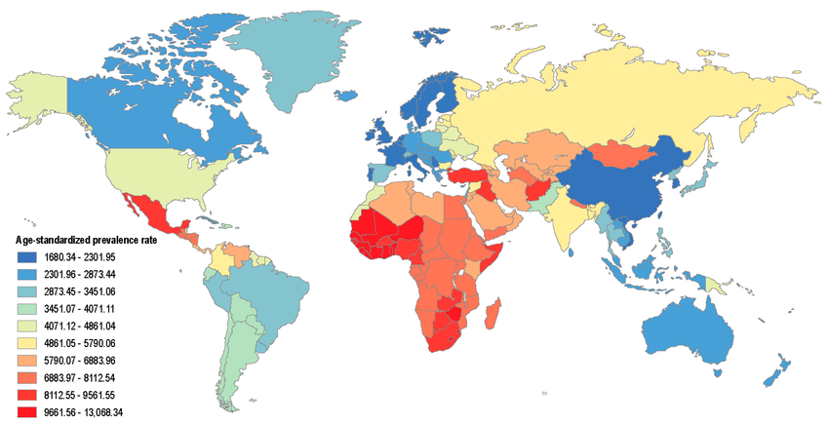
Figure 2.1: Worldwide age-standardized CKD prevalence per 100,000 populations[10].

2.2 The Role of Artificial Intelligence in Healthcare
Artificial Intelligence (AI) refers to computational systems capable of performing tasks that typically require human intelligence, such as reasoning, learning, and problem-solving [11]. It encompasses a wide range of techniques that simulate cognitive functions, allowing machines to analyze large volumes of data, detect patterns, and make informed decisions with minimal human input. The increasing digitization of healthcare—through electronic health records (EHRs), medical imaging, laboratory results, and genomic data—has created unprecedented opportunities for AI to improve diagnostic accuracy, treatment planning, and patient outcomes [12].
Unlike traditional statistical methods, which often struggle to handle heterogeneous and high-dimensional datasets, AI offers the ability to process complex relationships across multiple data sources. In healthcare, this capability enables the integration of multimodal information, such as lab test results, imaging scans, and patient demographics, into unified predictive models. Machine Learning (ML), a key subset of AI, trains algorithms on historical data to recognize patterns and predict outcomes without being explicitly programmed [13]. Deep Learning (DL), a more advanced form of ML, uses multi-layered neural networks to model highly complex, non-linear relationships, making it particularly effective for tasks like medical image analysis, natural language processing, and disease risk prediction [14].
AI technologies have demonstrated significant value across the medical spectrum—from early disease detection and treatment recommendation to clinical decision support and patient monitoring [15]. In the case of Chronic Kidney Disease (CKD), AI can analyze structured clinical variables such as blood pressure, hemoglobin, serum creatinine, and comorbidities to identify patients at risk before symptoms appear. Studies have shown that AI-driven models can outperform traditional diagnostic methods by detecting subtle patterns that human observation might miss, leading to earlier interventions and reduced healthcare costs [16].
An essential component of modern AI in medicine is Explainable Artificial Intelligence (XAI), which aims to make model predictions transparent and interpretable for clinicians. This is critical in healthcare settings, where trust and accountability are paramount. In CKD classification, for example, XAI techniques such as SHapley Additive exPlanations (SHAP) can highlight which features—like elevated creatinine or low hemoglobin—were most influential in a prediction.
To illustrate the relationships among these technologies, Figure 2.2 presents a hierarchical diagram showing the progression from AI to ML and DL, with Deep Neural Networks (DNNs) and Transformer-based architectures as major DL approaches. XAI is shown as a cross-cutting layer that spans all levels, emphasizing its role in enhancing interpretability and trust in AI-powered healthcare applications.

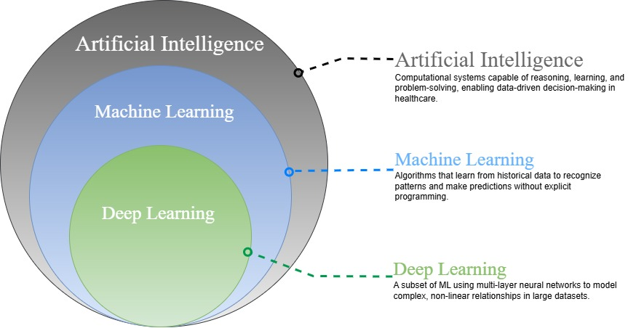
Figure 2.2: Core AI technologies between ML and DL role in classification.

2.3 Machine Learning Techniques
Machine Learning (ML) is a subfield of artificial intelligence that enables computer systems to automatically learn patterns from data and make predictions without explicit programming for each task [17]. In this research workflow, structured clinical data undergoes feature extraction using a Convolutional Neural Network (CNN). The CNN transforms raw input into compact, informative feature representations that enhance downstream classification performance. These extracted features are then used to train six different ML classifiers:
- Support Vector Machine (SVM)
- Random Forest (RF)
- XGBoost
- Artificial Neural Network (ANN)
- k-Nearest Neighbors (k-NN)
- Light Gradient Boosting Machine (LightGBM)
Each classifier is fine-tuned using a Genetic Algorithm (GA) to identify optimal hyperparameters. After tuning, the six models are evaluated and compared, with the highest-performing model selected as the final CKD classifier.
The hierarchical taxonomy in Figure 2.3 illustrates the placement of these six classifiers within the broader machine learning landscape, where all belong to the supervised learning category focused on classification tasks
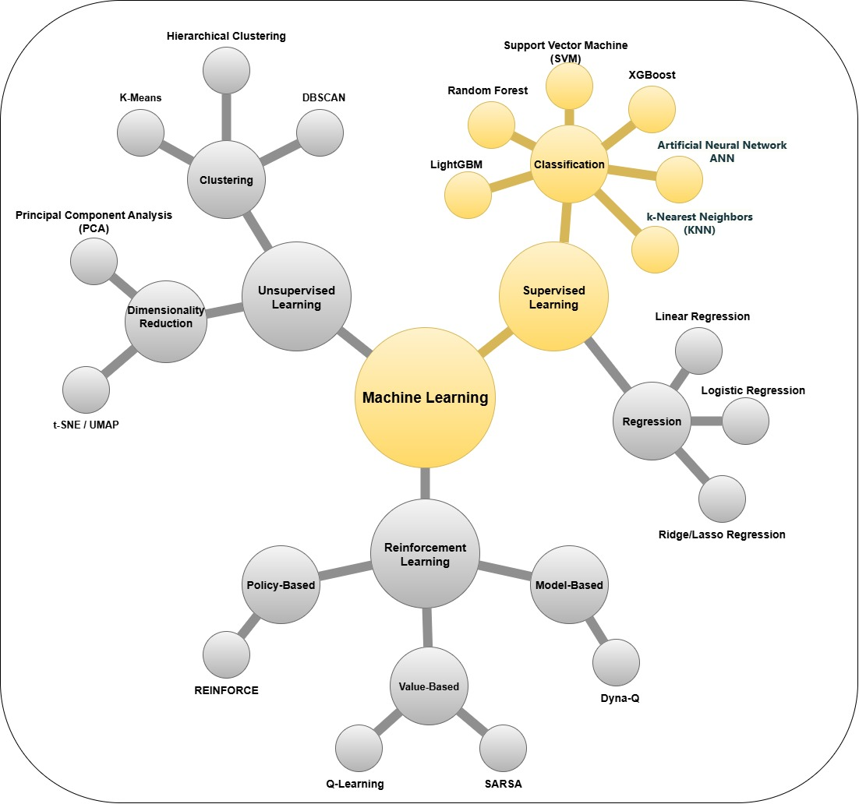
Figure 2.3: Hierarchical taxonomy of Machine Learning
At the highest level, ML can be divided into three main types:
- Supervised Learning: In this approach, models are trained on labeled datasets where the correct output is known. Supervised learning itself consists mainly of:
  - Classification: Assigning inputs to discrete categories or classes, such as differentiating between types of objects, diseases, or customer profiles. Widely used algorithms include SVM, RF, XGBoost, ANN, k-NN, and LightGBM.
  - Regression: Predicting continuous numerical values, such as prices, temperatures, or measurement results. Common methods include Linear Regression, Logistic Regression, and Ridge/Lasso Regression.
- Unsupervised Learning: Models in this category learn patterns or structures from data that lack explicit labels. Typical tasks include:
  - Clustering: Grouping similar data points together based on inherent structure in the data. Examples include K-Means, DBSCAN, and Hierarchical Clustering.
  - Dimensionality Reduction: Simplifying datasets by reducing the number of features while preserving essential relationships, using techniques such as Principal Component Analysis (PCA) and t-SNE/UMAP.
- Reinforcement Learning: Here, agents learn optimal actions through interaction with an environment, guided by rewards or penalties. Major approaches include Value-Based methods (such as Q-Learning and SARSA), Policy-Based methods (such as REINFORCE), and Model-Based techniques (such as Dyna-Q).
Below, key ML models commonly used in CKD classification are introduced, each in a dedicated subsection for clarity.

2.3.1 Support Vector Machine (SVM)
Support Vector Machine (SVM) is a powerful model for binary classification tasks, ideally suited for high-dimensional clinical data. SVM defines a decision boundary (hyperplane) that maximally separates two classes. For cases where data is not linearly separable, SVM applies kernel functions such as the Radial Basis Function (RBF) to project input features into higher dimensions [18].
The decision function for SVM can be written as:
$$f\left(x\right)=β_{0}+\sum_{i∈S}{α_{i}K\left(x_{i},x\right)}$$
Where:
- 𝛽𝑜= Bias
- S= Set of observations
- α= Model parameters that have to be learned
- K: Kernel (e.g., RBF)

The margin ($\text{M}$) is defined as the distance between the hyperplane and the closest data point from any class. SVMs are trained to maximize this margin, improving generalizability. The hinge loss function is commonly used for training SVMs.
$M= \frac{2}{||ω||}$

2.3.2 Random Forest (RF)
Random Forest (RF) is an ensemble learning method that builds a multitude of decision trees during training, each created from a random bootstrap sample of the original dataset. RF aggregates the predictions of each tree by majority voting for classification or averaging for regression, resulting in improved predictive accuracy and reduced risk of overfitting compared to individual trees [19].
The prediction function of Random Forest is given by:
$$f^{'}= \frac{1}{B} \sum_{b=1}^{B}{f_{b}}(x)$$
Where:
  - B: Total number of trees
  - $f_{b}\left(x\right)$: Output of the b-th decision tree
RF enhances model diversity and stability by randomly selecting subsets of features at each split, ensuring low correlation among individual trees [25].

2.3.3 XGBoost (Extreme Gradient Boosting)
XGBoost is a high-performance implementation of gradient boosting that builds decision trees sequentially, where each new tree is trained to correct the residual errors of the previous ones. Unlike RF, which relies on ensemble averaging, XGBoost applies a gradient descent optimization with second-order Taylor expansion, utilizing both the gradient and Hessian of the loss function for efficient and accurate model updates [20].
The objective function in XGBoost is formulated as:
$$Obj= \sum_{i=1}^{n}{l(y_{i} ,y_{i}^{^}})+ \sum_{K=1}^{K}{Ω(f_{k} })$$

Where:
  - l: Loss function (e.g., logistic)
  - 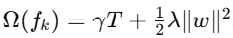: Regularization to reduce overfitting

This approach allows XGBoost to capture complex and nonlinear relationships in structured data, making it well-suited for tasks such as CKD detection.

2.3.4 Artificial Neural Network (ANN)
Artificial Neural Networks (ANNs) are computational models inspired by the structure of the human brain, consisting of interconnected layers of artificial “neurons.” Each neuron receives input signals, processes them, and passes the output to the next layer. ANNs learn patterns in data through a process called backpropagation, where the model adjusts its internal weights to minimize prediction errors.
In the context of CKD classification, ANNs can automatically capture complex relationships between features such as blood pressure, serum creatinine, hemoglobin, and patient demographics. Their flexibility makes them suitable for modeling non-linear relationships in clinical datasets [21].
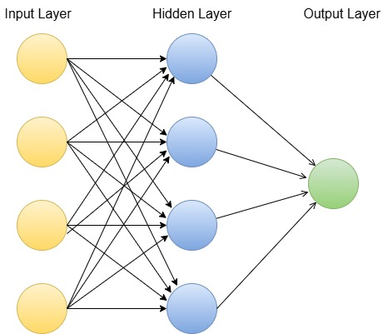
Figure 2.3.4: ANN Diagram
Figure 2.3.4 this diagram shows an ANN with three layers (input layer with patient features, hidden layer with interconnected neurons, and output layer predicting CKD or non-CKD).

2.3.5 k-Nearest Neighbors (k-NN)
k-Nearest Neighbors (k-NN) is a simple and intuitive algorithm used for classification. Instead of building an explicit model, k-NN stores all training examples and classifies new samples based on the majority class among the k most similar examples. The similarity is usually measured using distance metrics such as Euclidean distance [22].
In CKD prediction, when a new patient’s data is entered, k-NN finds the most similar patients in the historical dataset and predicts the diagnosis based on their outcomes.

2.3.6 Light Gradient Boosting Machine (LightGBM)
LightGBM is a gradient boosting framework that uses tree-based learning algorithms optimized for speed and memory efficiency [23]. It employs a histogram-based decision tree learning approach and grows trees leaf-wise rather than level-wise, which can result in better accuracy for the same number of leaves.
Its objective function follows the general gradient boosting formulation but incorporates optimizations such as Gradient-based One-Side Sampling (GOSS) and Exclusive Feature Bundling (EFB).
LightGBM is selected for this study due to its scalability, high accuracy on structured datasets, and lower training time compared to traditional gradient boosting methods.

2.3.7 Genetic Algorithm for Hyperparameter Tuning
A Genetic Algorithm (GA) is a population-based optimization technique inspired by natural selection [26]. In this research, GA is used to search the hyperparameter space for each classifier:
- Initialization – Random sets of hyperparameters are generated.
- Evaluation – Each set’s performance is scored (fitness).
- Selection – The best candidates are chosen.
- Crossover & Mutation – Parameters are recombined and altered to create new candidates.
- Termination – The process repeats until no further improvement is observed.
Using GA enables efficient exploration of complex parameter spaces, outperforming grid search and random search for model optimization.

2.3.8 Model Selection Justification
SVM was prioritized for its effectiveness in high-dimensional spaces and the interpretability of its margins and kernels.
RF offers robustness to noisy and missing EHR data, an advantage for real-world clinical datasets.
XGBoost was selected for its outstanding accuracy and computational speed on tabular data, and for its scalability with large datasets.
ANN Included for its capability to model complex nonlinear clinical patterns.
k-NN Simple yet effective for similarity-based classification in small feature spaces.
LightGBM Selected for its speed and efficiency with large-scale clinical data.

Table 2.3: Comparison of ML Models for CKD Classification
Model | Strengths | Weaknesses | Clinical Relevance
SVM | Clear margin interpretation, kernel tricks | Sensitive to hyperparameters | Interpretable decision rules
RF | Handles missing data, feature importance | Slower inference | Identifies key biomarkers
XGBoost | High accuracy, handles imbalanced data | Requires tuning | Scalable for large datasets
ANN | Captures nonlinear relationships | Requires large datasets, risk of overfitting | Models complex feature interactions
k-NN | Simple, interpretable | Sensitive to irrelevant features, slow with large datasets | Useful for small datasets
LightGBM | Fast, memory efficient | Less interpretable than RF | Suitable for large-scale EHR data

2.4 Deep Learning Techniques
Deep Learning (DL) refers to a class of machine learning methods that leverage multi-layered artificial neural networks to automatically learn hierarchical feature representations from input data. Unlike traditional ML approaches that often rely on manual feature engineering, DL models can capture complex, non-linear relationships and subtle patterns by transforming raw inputs into high-level abstract features through successive layers of computation.
In healthcare, DL has shown great success in tasks such as image analysis, signal processing, and structured data modeling, due to its ability to process high-dimensional and heterogeneous datasets [24].
In the context of this research, DL is incorporated not as the final classifier, but as a feature extraction stage preceding machine learning classification. Specifically, a Convolutional Neural Network (CNN) is employed to derive rich, compact, and discriminative representations from the raw clinical dataset [25]. These learned features are then fed into six different ML models—SVM, RF, XGBoost, ANN, k-NN, and LightGBM each of which is optimized using a Genetic Algorithm (GA) for best hyperparameter settings. This hybrid approach combines the representational power of DL with the interpretability, flexibility, and often greater data efficiency of ML classifiers.

2.4.1 Convolutional Neural Networks (CNN) for Feature Extraction
Convolutional Neural Networks are a specialized type of deep neural network originally developed for image recognition, but which have been adapted successfully for structured and tabular data. CNNs automatically learn spatial or feature correlations by applying convolutional filters to the input, enabling them to detect patterns without manual feature engineering.
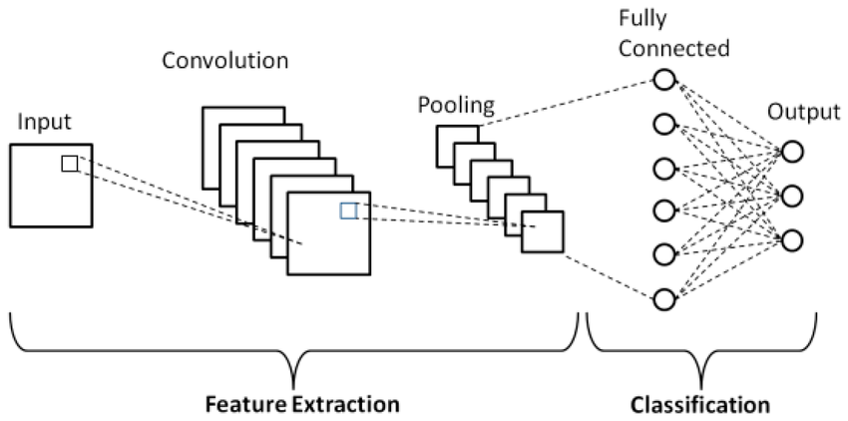
Figure 2.4.1: Basic convolutional neural network (CNN) architecture
Figure 2.4.1 shows the architecture of a Convolutional Neural Network (CNN) as implemented in this research for feature extraction from structured clinical data [26]. The architecture consists of the following components:
- Input Layer: Receives the preprocessed clinical dataset, where each variable (e.g., laboratory measurement, demographic attribute) is treated as an input feature.
- Convolutional Layers: Apply learnable filters to detect local patterns and correlations between clinical variables. In image-based applications, these filters capture edges and shapes, whereas in structured/tabular data, they identify co-occurring clinical markers and feature combinations.
- Pooling Layers: Downsample the feature maps generated by the convolutional layers, reducing dimensionality and computational complexity while retaining the most informative patterns.
- Fully Connected Layers: Take the flattened feature vector from the pooling stage and map it to higher-level abstractions, enabling the model to form a richer representation of the data.
- Output Layer: Produces the final feature representation in this study, which is then passed to six different machine learning classifiers—Support Vector Machine (SVM), Random Forest (RF), XGBoost, Artificial Neural Network (ANN), k-Nearest Neighbors (k-NN), and LightGBM—each optimized via Genetic Algorithm (GA) for CKD prediction.
This architecture allows the CNN to automatically transform raw, high-dimensional clinical input into compact, discriminative features that improve classifier performance without manual feature engineering, aligning with recent advancements in clinical predictive modeling.

2.4.2 DL vs. ML Trade-offs in the Hybrid Approach
While deep networks like CNNs can discover highly expressive features, they generally require significant computational resources and large datasets to prevent overfitting [27]. On the other hand, traditional ML models especially tree-based and kernel-based methods can perform well on smaller structured datasets and offer higher interpretability.
By using CNNs purely for feature extraction, followed by ML classifiers for prediction, this research benefits from:
- CNN's ability to automatically learn and compress complex feature relationships.
- ML models' strengths in handling structured data efficiently and producing explainable decisions (especially when combined with XAI methods like SHAP).
- Optimization via GA, ensuring each classifier is tailored to make the best use of CNN-extracted features.
Table 2.4.2: DL Model Comparison in This Study
Model | Advantages | Limitations | When to Use
CNN (as feature extractor) | Learns complex feature interactions automatically; reduces need for manual feature engineering | Requires careful preprocessing of tabular data; computationally heavier than basic ML | Pre-classification stage to produce high-quality features from structured data

2.5 Explainable Artificial Intelligence (XAI)
Focuses on making the decision-making process of machine learning models transparent and interpretable to humans. In this study, SHAP (SHapley Additive exPlanations) is applied to interpret the final Chronic Kidney Disease (CKD) classification model, which is obtained by first extracting features using a Convolutional Neural Network (CNN) and then selecting the best-performing machine learning classifier through Genetic Algorithm (GA) optimization [28].
Role of SHAP in This Study:
- Model-Agnostic: Although SHAP can be applied to any type of predictive model, in our workflow it is specifically used to explain the predictions of the selected ML classifier after CNN-based feature extraction [28].
- Local Interpretability: For each patient, SHAP identifies the clinical features—such as serum creatinine, hemoglobin, or blood pressure—that contributed most to the CKD prediction.
- Global Interpretability: By aggregating SHAP values across all patients, SHAP highlights which features are most consistently important, allowing clinicians to better understand the underlying risk factors.
By integrating SHAP into the final stage of our CNN–ML pipeline, the research ensures that predictive performance is complemented by interpretability, enabling healthcare professionals to validate and trust the model’s recommendations [29].

2.6 Evaluation Metrics and Confusion Matrix
To evaluate the performance of ML/DL models in classifying CKD, we use the following metrics derived from the confusion matrix:
- True Positive (TP): Patient has CKD and the model correctly predicts CKD.
- True Negative (TN): Patient does not have CKD and the model correctly predicts non-CKD.
- False Positive (FP): Patient does not have CKD but the model predicts CKD.
- False Negative (FN): Patient has CKD but the model predicts non-CKD.
A confusion matrix allows us to compute multiple evaluation metrics that provide a more comprehensive picture of a model’s performance [30]. Below are the key metrics derived from confusion matrix data:
 | Predicted Positive | Predicted Negative
Actual Positive | TP | FN
Actual Negative | FP | TN

Evaluation Metrics:
Accuracy: Overall correctness of the model.
Accuracy = $\frac{TP+TN}{TP+TN+FP+FN}$
- Precision: Measures how many of the positive predictions were actually correct. This metric is particularly important when minimizing false positives is crucial such as how many predicted CKD cases were actually CKD.
Precision = $\frac{TP}{TP+FP}$
- Recall (Sensitivity): Shows how well the model identifies all relevant positive cases. It is important in scenarios where missing a positive case is costly, like diagnosing diseases.
Recall = $\frac{TP}{TP+FN}$
- F1-Score: The harmonic mean of precision and recall, providing a balance between both metrics.
F1 = $2× \frac{Precision × Recall}{Precision + Recall}$
- Specificity: Measures how well the model identifies negative cases. It’s especially relevant in medical diagnosis, where we want to avoid false positives. Such as ability to correctly identify non-CKD cases.
Specificity = $\frac{TN}{TN+FP}$
- AUC-ROC: Measures the model's ability to discriminate between classes across all probability thresholds.
These metrics provide a comprehensive view of model performance, especially important when dealing with class imbalance such as in medical datasets [31].

2.7 Summary
This chapter presented a comprehensive background on Chronic Kidney Disease (CKD) and its clinical significance, followed by an in-depth overview of the machine learning and deep learning techniques adopted in this study. The hybrid approach employed in this research was detailed, where a Convolutional Neural Network (CNN) is used for automatic feature extraction from structured clinical data, and the extracted features are subsequently classified using six optimized machine learning models (SVM, RF, XGBoost, ANN, k-NN, and LightGBM) fine-tuned via a Genetic Algorithm (GA).
The chapter also introduced the Explainable AI framework SHAP, highlighting its role in improving transparency and interpretability of model predictions in clinical decision-making. Additionally, the section on evaluation metrics and the confusion matrix clarified how model performance is measured and interpreted in the context of healthcare applications.
The next chapter will present the complete methodology for data preprocessing, CNN-based feature extraction, model training, hyperparameter optimization, and validation procedures.

Chapter 3: Related Work
The purpose of this chapter is to review prior work related to Chronic Kidney Disease (CKD) classification using artificial intelligence techniques. The review is structured into two main categories:
- Machine Learning-Based Approaches, which include classical algorithms applied to structured clinical datasets such as laboratory results and patient demographics.
- Deep Learning-Based Approaches, which leverage automated feature extraction methods, including Convolutional Neural Networks (CNNs), for improved pattern recognition in clinical data.
This organization allows for a clear comparison of strengths, limitations, and methodological trends in both categories. The chapter also identifies gaps such as limited dataset diversity, class imbalance, and underutilization of hybrid frameworks that the proposed research aims to address by integrating CNN-based feature extraction with optimized machine learning classifiers via Genetic Algorithm (GA) tuning.

3.1 Introduction
Over the last two decades, CKD classification research has evolved from rule-based diagnostics to machine learning-driven models, initially applying algorithms like Support Vector Machines (SVM) and decision trees to hospital datasets. From 2020 onwards, wearable and home-monitoring devices enabled the integration of consumption and lifestyle data, supporting non-invasive early detection. In recent years, deep learning approaches have gained attention for their ability to automatically learn feature representations, although their higher data and computational requirements remain a challenge.
By synthesizing these works, this review highlights the progression of methods, identifies limitations, and establishes the foundation for the hybrid CNN–ML approach adopted in this study. The subsequent sections provide a detailed review of recent ML- and DL-based CKD classification studies, followed by a discussion of their comparative performance and gaps in applicability.

3.2 Machine Learning Studies for CKD Classification
Phuong et al. [32] This study evaluated six ML algorithms on the UCI CKD dataset, comparing SVM, RF, KNN, LR, NB, and DT. RF achieved the highest accuracy, closely followed by SVM. Key CKD predictors identified included creatinine and hemoglobin. However, the dataset’s limited size raised concerns about generalization.
Elshewey et al. [33] The authors integrated Extra Trees with Biologically-Based Feature Selection (BBFS) to improve CKD classification. This approach achieved over 99% accuracy and provided interpretable feature importance rankings. The results highlighted the value of targeted feature selection but risked overfitting due to small sample size.
Liu et al. [34] Using over 10,000 clinical EHR records, this study applied Random Forest to predict CKD risk. The model effectively handled imbalanced data and achieved high AUC values. The findings emphasized creatinine, eGFR, and age as top predictors, but lacked comparisons to other ML methods.
Metherall et al. [35] This work explored at-home creatinine monitoring data to train XGBoost, RF, and SVM models. XGBoost performed best, achieving 94% accuracy, and demonstrated potential for remote CKD screening. However, the dataset covered only a short follow-up period, limiting insights into long-term disease progression.
Ganie et al. [36] Boosting algorithms AdaBoost and Gradient Boosting were used to classify CKD based on clinical data. Both models achieved above 96% accuracy, outperforming traditional single learners. While results were promising, the models’ sensitivity to outliers remained a limitation.
Debal et sl. [37] This study compared RF, SVM, and LR for CKD classification using the UCI dataset. RF delivered the best accuracy at 98%, confirming its reliability for medical prediction tasks. The work was limited by the dataset’s small size and lack of advanced preprocessing.
Islam et al. [38] The authors trained RF, DT, and KNN models on hospital CKD data, with RF performing best at 93% accuracy. The use of real patient records increased clinical relevance. Still, single-source data reduced the model’s generalizability.
Khan et al. [39] LightGBM, CatBoost, and RF were applied to multi-center patient data for CKD prediction. LightGBM achieved the highest accuracy at 95%, leveraging gradient boosting’s strengths in handling complex feature interactions. The study noted increased computational demands as a trade-off.
Ghosh et al. [40] Evaluated multiple ML algorithms on the UCI CKD dataset, achieving top performance with Random Forest (99.2% accuracy, AUC 0.995). The study used SHAP and LIME to interpret key features, finding serum creatinine and hemoglobin as the most influential. While results were strong, reliance on a single public dataset limited real-world generalization.
Chowdhury et al. [41] Compared classical ML algorithms for CKD detection in T1DM patients, finding Random Forest most accurate (95.6%). The work offered a baseline for diabetic CKD screening and emphasized model comparison. However, its scope was limited to a specific population without external validation.

3.2.1 Summary Table of Machine Learning-Based Studies
Ref | Year | Dataset | Models | Results | Advantages | Limitations
Phuong et al. [32] | 2025 | UCI CKD dataset (400 samples, 24 features) | SVM, RF, KNN, LR, NB, DT | RF highest accuracy (~99%), SVM second (~98%), others 90–96% | - Comprehensive comparison of six popular ML algorithms on the same dataset.  - Identified creatinine, hemoglobin, and specific gravity as top predictors.  - Straightforward methodology for replication in similar datasets. | - Small dataset limits generalization.  - No external validation performed.  - Only binary classification; no CKD stage prediction
Elshewey et al. [33] | 2025 | UCI CKD dataset | Extra Trees + BBFS | Accuracy 99.2%, F1-score 0.992 | - Hybrid feature selection improved model interpretability.  - Outperformed baseline Extra Trees without BBFS.  - Identified clinically relevant features while reducing redundancy. | - Risk of overfitting due to limited sample size.  - Tested on a single dataset without external validation.  - Computational cost of BBFS may be high for large datasets.
Liu et al. [34] | 2024 | >10,000 EHR patient records | Random Forest | Accuracy ~92% | -world dataset improved robustness.  - RF handled imbalanced data effectively.  - Identified top CKD risk factors with high interpretability. | - No comparison with other ML models.  - Missing data imputation approach not deeply discussed.  - Performance on rare CKD cases less certain.
Metherall et al. [35] | 2025 | At-home monitoring dataset (short-term) | XGBoost, RF, SVM | XGBoost: ~96% accuracy; RF ~94%; SVM ~92% | - Incorporated at-home measurements (creatinine, BP) for early detection.  - Compared multiple algorithms on identical features.  - Useful in remote patient monitoring contexts. | - Short monitoring period limits ability to predict long-term progression.  - Potential sensor inaccuracies in home data.  - Limited demographic diversity in dataset.
Ganie et al. [36] | 2023 | Clinical dataset | AdaBoost, Gradient Boosting | AdaBoost ~94%, Gradient Boosting ~95% | - Boosting improved handling of complex feature interactions.  - Models robust to small feature noise.  - Provided feature importance rankings for clinical insight. | - Sensitive to outliers and noisy data.  - No testing on external datasets.  - High computational requirements for large-scale application.
Debal et al. [37] | 2022 | UCI CKD dataset | RF, SVM, LR | RF ~98%, SVM: 96%,  LR: 92% | - Straightforward preprocessing steps for reproducibility.  - RF performed consistently across folds.  - Demonstrated stability with minimal parameter tuning. | - Limited dataset size and diversity.  - Absence of advanced feature engineering.  - No inclusion of temporal or longitudinal data.
Islam et al. [38] | 2023 | Hospital CKD records | RF, DT, KNN | RF: 97%, DT: 93%, KNN: 92% | - Easy-to-implement ML methods.- RF robust against overfitting in small datasets.  - Highlighted top predictors for CKD risk. | - Data from a single hospital limits external applicability.  - No cross-validation beyond hold-out split.  - Lacked integration of lab trends over time.
Khan et al. [39] | 2024 | Multi-center patient data | LightGBM, CatBoost, RF | LightGBM: 98.5%, CatBoost: 97.9%, RF: 97% | - Large, diverse dataset improved model generalization.  - Gradient boosting models handled categorical and numerical data well.  - Fast training times compared to deep learning. | - Higher training costs than simpler ML models.  - Potential overfitting on rare feature combinations.  - Interpretability requires additional tools.
Ghosh et al. [40] | 2024 | Clinical dataset | XGBoost, RF, SVM | XGBoost: AUC ~96%,  RF: AUC ~95% , SVM: AUC ~93% | - Focused on explainable AI, providing SHAP-based insights.  - High predictive performance with interpretable results.  - Useful for clinician trust and adoption. | - Requires domain knowledge for interpreting SHAP results.  - Performance may drop if features are highly correlated.  - No multi-class classification tested.
Chowdhury et al. [41] | 2021 | Type 1 diabetes CKD dataset | RF, SVM, LR, KNN, NB | RF: ~95%, SVM: ~94%,  LR: ~92%, KNN: ~91%,  NB: ~90% | - Compared performance of multiple classic ML models.  - Dataset focused on diabetic CKD detection.  - Identified early markers in diabetic patients. | - Narrow patient population limits generalization.  - No advanced ensemble or hybrid methods tested.  - Limited to static data without time-series analysis.

3.3 Deep Learning Studies for CKD Classification
Al-Rasheed et al., [42] This study trained a dense fully-connected deep neural network to classify CKD using the UCI CKD tabular datasets (400 samples, 24 features). The optimized 3-layer network (20–15–10 neurons) with ReLU and Adamax achieved nearly perfect performance. It outperformed conventional classifiers on the same data.
Chowdhury et al. [43] proposed a TabNet model for CKD stage prediction in diabetes patients using 10-year CRIC cohort data. Two variants (31-feature "complete" and 15-feature "simplified") outperformed XGBoost/RF (94.1% accuracy, AUC≈0.95), with SHAP/LIME identifying creatinine, HbA1c, age, and sex as key predictors. While robust, performance dipped (~88%) in external validation, suggesting limited generalization beyond diabetic populations.
Rao et al. [44] proposed a graph–tabular fusion model (GNN + MLP) for CKD prediction, representing patients as nodes in a similarity-based graph. The ensemble achieved 95.1% accuracy on the UCI dataset, outperforming standalone models (MLP: 91%, GNN: 93%) by leveraging inter-patient relationships. While robust, limitations include dependency on manual graph construction and lack of validation on larger EHR datasets.
Alsekait et al. [45] proposed OptEnsemble, a stacked deep learning model (CNN + LSTM + SVM meta-learner) with mutual-information-based feature selection, achieving 99.7% accuracy on the UCI CKD datasets. While outperforming single models (DNN: 95%) and demonstrating robustness, near-perfect results suggest potential over fitting, with no external validation to assess generalization. The study highlights trade-offs between complexity and performance on small datasets.
Tian et al. [46] developed a deep radiometric model combining CNN and texture features from kidney ultrasounds that outperformed radiologists in early CKD detection (AUC 0.918 vs 0.869), particularly for stages G1-G3 where visual changes are subtle. While matching expert performance on severe CKD (G4-G5), the model's clinical utility is limited by its black-box nature and need for multi-center validation. This pioneering work demonstrates AI's potential to extract diagnostically meaningful patterns from routine ultrasounds that escape human visual assessment.
Priyadharshini et al.[47] developed "OptiNet-CKD," a deep neural network optimized via a population-based algorithm (POA) that achieved 100% accuracy on the UCI CKD datasets by escaping local minima through evolutionary weight perturbations. While demonstrating perfect performance metrics (precision, recall, F1, AUC), the model's flawless results on this well-studied datasets raise concerns about potential over fitting despite claims of improved generalization. The study highlights how advanced optimization techniques can maximize performance on limited data.

3.3.1 Summary Table of Deep Learning -Based Studies
Ref | Year | Dataset | Models | Results | Advantages | Limitations
Al-Rasheed et al., [42] | 2025 | UCI CKD dataset (400 patients, 24 features) | 3-layer DNN (20–15–10) | Accuracy: 99%,  AUC: 0.9821,  F1 = 0.99 | - Simple to implement,  - well-suited for tabular data,  - high performance on standard dataset,  - aligned well with clinical risk indicators. | - Small dataset, - risk of overfitting (100% train accuracy),  - no external validation, binary-only classification.
Chowdhury et al. [43] | 2025 | CRIC cohort (57,304 labs from 3,844 diabetic patients) | TabNet (full 31-feature and simplified 15-feature models) | Accuracy: 91–94%, AUC ≈ 0.95 | - Interpretable attention mechanism,  - effective on longitudinal lab data,  - feasible simplified model. | - Limited to diabetic cohort,  - lower performance on external data,  - depends on multiple biomarkers not always available.
Rao et al. [44] | 2023 | UCI CKD (400 patients) | GNN + DNN + late-fusion ensemble with SVM | Fusion Accuracy: 95.1%,  F1 = 0.95, AUC ≈ 0.95 | - Incorporated patient similarity networks,  - improved generalization using ensemble stacking. | - Requires expert-defined patient graphs,  - limited evaluation on real-world data, - complexity reduces interpretability.
Alsekait et al. [45] | 2023 | UCI CKD dataset (400 samples) | Stacked DNNs (CNN, RNN) + SVM meta-classifier | Accuracy: 99.69%,  F1 = 0.997, AUC: 0.999 | - Leveraged multiple model strengths,  - population based optimization,  - improved learning via feature selection. | - Possible overfitting,  - ensemble complexity hinders real-time use,  - untested on real-world EHRs.
Tian et al. [46] | 2024 | Renal ultrasound (1,049 patients, 4,365 images) | ResNet-34 CNN + radiomic features + fusion ensemble | AUC: 0.918 overall, 0.867–0.931 (G4–G5 stages) | - Outperformed physicians in early detection,  - Hybrid of CNN and expert texture features,  - Highly relevant to clinical practice. | - Single-center training,  - Low interpretability,  - Lacked integration with clinical data.
Priyadharshini et al.[47] | 2025 | UCI CKD dataset (400 instances) | 4-layer DNN with Population Optimization Algorithm (POA) | Accuracy: 100%,  F1 = 1.0, AUC = 1.000 | - Avoided local minima, robust optimizer,  - extensible to other domains. | - No external validation, overfitting risk,  - complex and computationally expensive training.

3.4 Summary
This chapter has reviewed prior research on Chronic Kidney Disease (CKD) classification using both traditional machine learning (ML) and advanced deep learning (DL) approaches, alongside explainable AI (XAI) methods. The analysis revealed that while ML models such as Random Forest, XGBoost, and Support Vector Machines have demonstrated high accuracy, they often rely on manual feature engineering and face limitations in handling complex feature interactions. DL models, particularly Convolutional Neural Networks (CNNs), have shown remarkable potential in automatically learning rich feature representations but are challenged by the need for large datasets and reduced interpretability.
A recurring gap in the literature is the limited integration of hybrid frameworks that combine the representational strengths of DL with the interpretability and robustness of ML models, especially when optimized through evolutionary algorithms like Genetic Algorithm (GA). Furthermore, many studies lack external validation and rely heavily on small or single-source datasets, reducing their generalizability.
The proposed research addresses these gaps by leveraging CNN-based feature extraction, GA-optimized ML classifiers, and SHAP-based explanations to produce a predictive framework that balances accuracy, interpretability, and clinical applicability. The next chapter will outline the methodology, including data preprocessing, model training, optimization, and validation strategies.

References
- Bikbov, B., Purcell, C. A., Levey, A. S., Smith, M., Bikbov, M., et al. (2020). Global, regional, and national burden of chronic kidney disease, 1990–2017: A systematic analysis for the Global Burden of Disease Study 2017. The Lancet, 395(10225), 709–733. https://doi.org/10.1016/S0140-6736(20)30045-3
- Chen, T. K., Knicely, D. H., & Grams, M. E. (2019). Chronic kidney disease diagnosis and management: A review. JAMA, 322(13), 1294–1304. https://doi.org/10.1001/jama.2019.14745
- Senanayake, S., Karunagoda, K., & Perera, N. (2024). Deep learning for chronic kidney disease prediction: A review. Artificial Intelligence in Medicine, 148, 102762. https://doi.org/10.1016/j.artmed.2023.102762
- Lundberg, S. M., & Lee, S.-I. (2017). A unified approach to interpreting model predictions. Advances in Neural Information Processing Systems, 30, 4765–4774.
- Webster, A. C., Nagler, E. V., Morton, R. L., & Masson, P. (2017). Chronic kidney disease. The Lancet, 389(10075), 1238–1252. https://doi.org/10.1016/S0140-6736(16)32064-5
- Kidney Disease: Improving Global Outcomes (KDIGO) CKD Work Group. (2013). KDIGO 2012 clinical practice guideline for the evaluation and management of chronic kidney disease. Kidney International Supplements, 3(1), 1–150. https://doi.org/10.1038/kisup.2012.73
- Bikbov, B., et al. (2020). Global, regional, and national burden of chronic kidney disease, 1990–2017: A systematic analysis for the Global Burden of Disease Study 2017. The Lancet, 395(10225), 709–733. https://doi.org/10.1016/S0140-6736(20)30045-3
- Luyckx, V. A., Tonelli, M., & Stanifer, J. W. (2018). The global burden of kidney disease and the sustainable development goals. Bulletin of the World Health Organization, 96(6), 414–422. https://doi.org/10.2471/BLT.17.206441
- GBD Chronic Kidney Disease Collaboration. (2020). Global, regional, and national burden of chronic kidney disease, 1990–2017: A systematic analysis for the Global Burden of Disease Study 2017. The Lancet, 395(10225), 709–733. https://doi.org/10.1016/S0140-6736(20)30045-3
- Rayner, B. L., Jones, E. S. W., Davidson, B., & Wearne, N. (2023). Advances in Chronic Kidney Disease in Africa. Applied Sciences, 13(8), 4924. https://doi.org/10.3390/app13084924
- Jiang, F., Jiang, Y., Zhi, H., Dong, Y., Li, H., Ma, S., ... & Wang, Y. (2017). Artificial intelligence in healthcare: Past, present and future. Stroke and Vascular Neurology, 2(4), 230–243. https://doi.org/10.1136/svn-2017-000101
- Razzak, M. I., Imran, M., & Xu, G. (2019). Big data analytics for preventive medicine. Neural Computing and Applications, 32(9), 4417–4451. https://doi.org/10.1007/s00521-019-04137-8
- Esteva, A., Robicquet, A., Ramsundar, B., Kuleshov, V., DePristo, M., Chou, K., ... & Dean, J. (2019). A guide to deep learning in healthcare. Nature Medicine, 25(1), 24–29. https://doi.org/10.1038/s41591-018-0316-z
- Topol, E. J. (2019). High-performance medicine: The convergence of human and artificial intelligence. Nature Medicine, 25(1), 44–56. https://doi.org/10.1038/s41591-018-0300-7
- Rajkomar, A., Dean, J., & Kohane, I. (2019). Machine learning in medicine. New England Journal of Medicine, 380(14), 1347–1358. https://doi.org/10.1056/NEJMra1814259
- Bohr, A., & Memarzadeh, K. (2020). The rise of artificial intelligence in healthcare applications. In Artificial Intelligence in Healthcare (pp. 25–60). Academic Press. https://doi.org/10.1016/B978-0-12-818438-7.00002-2
- Polat, H. (2017). Diagnosis of chronic kidney disease based on support vector machine. Journal of Medical Systems, 41(1), 11. https://doi.org/10.1007/s10916-017-0703-x
- Liu, P., Liu, Y., Liu, H., Xiong, L., Mei, C., & Yuan, L. (2024). A Random Forest algorithm for assessing risk factors associated with chronic kidney disease: Observational study. Asian/Pacific Island Nursing Journal, 8, e48378. https://doi.org/10.2196/48378
- Chen, Z., Wang, Y., Xu, Y., et al. (2024). Interpretable XGBoost model for distinguishing renal fibrosis severity in CKD patients. International Journal of Medical Informatics, 184, 104227. https://doi.org/10.1016/j.ijmedinf.2024.104227
- Elshewey, A. M., Selem, E., & Abed, A. H. (2025). Improved CKD classification based on explainable artificial intelligence with extra trees and BBFS. Scientific Reports, 15, 17861. https://doi.org/10.1038/s41598-025-02355-7
- Sattari, M. (2023). Using data mining techniques to predict chronic kidney disease. International Journal of Occupational Medicine and Environmental Health, 36, 1896–01809. https://doi.org/10.13075/ijpmeh.1896.01809
- Abdel-Fattah, M. A., Othman, N. A., & Goher, N. (2022). Predicting Chronic Kidney Disease Using Hybrid Machine Learning Based on Apache Spark. Computational intelligence and neuroscience, 2022, 9898831. https://doi.org/10.1155/2022/9898831
- Mendapara, K., Patel, N., & Shrimali, D. (2024). CKD risk prediction using Random Forest on gene expression data. Frontiers in Genetics, 14, 1409755. https://doi.org/10.3389/fgene.2024.1409755
- LeCun, Y., Bengio, Y., & Hinton, G. (2015). Deep learning. Nature, 521(7553), 436–444. https://doi.org/10.1038/nature14539
- Goodfellow, I., Bengio, Y., & Courville, A. (2016). Deep learning. MIT Press. http://www.deeplearningbook.org
- Gorishniy, Y., Rubachev, I., Khrulkov, V., & Babenko, A. (2021). Revisiting deep learning models for tabular data. Advances in Neural Information Processing Systems, 34, 18932–18943. https://arxiv.org/abs/2106.11959
- Sharma, A., Vans, E., Shigemizu, D., & Boroevich, K. (2019). DeepInsight: A methodology to transform non-image data to an image for CNN. Scientific Reports, 9, 11399. https://doi.org/10.1038/s41598-019-47765-6
- Lundberg, S. M., & Lee, S.-I. (2017). A unified approach to interpreting model predictions. Advances in Neural Information Processing Systems, 30. https://arxiv.org/abs/1705.07874
- Molnar, C. (2022). Interpretable machine learning. https://christophm.github.io/interpretable-ml-book/
- Sokolova, M., & Lapalme, G. (2009). A systematic analysis of performance measures for classification tasks. Information Processing & Management, 45(4), 427–437. https://doi.org/10.1016/j.ipm.2009.03.002
- Chicco, D., & Jurman, G. (2020). The advantages of the Matthews correlation coefficient (MCC) over F1 score and accuracy in binary classification evaluation. BMC Genomics, 21, 6. https://doi.org/10.1186/s12864-019-6413-7
- Phuong, N. D., Tuyen, N. T., Linh, V. T. T., Nguyen, N. N., & Nguyen, T. Q. (2025). Machine learning techniques in chronic kidney diseases: A comparative study of classification model performance. Bioinformatics and Biology Insights, 19, 11779322251356563. https://doi.org/10.1177/11779322251356563
- Elshewey, A. M., Selem, E., & Abed, A. H. (2025). Improved CKD classification based on explainable artificial intelligence with extra trees and BBFS. Scientific Reports, 15, 17861. https://doi.org/10.1038/s41598-025-02355-7
- Liu, P., Liu, Y., Liu, H., Xiong, L., Mei, C., & Yuan, L. (2024). A random forest algorithm for assessing risk factors associated with chronic kidney disease: Observational study. Asian/Pacific Island Nursing Journal, 8, e48378. https://doi.org/10.2196/48378
- Metherall, B., Berryman, A. K., & Brennan, G. S. (2025). Machine learning for classifying chronic kidney disease and predicting creatinine levels using at-home measurements. Scientific Reports, 15, 4364. https://doi.org/10.1038/s41598-025-88631-y
- Ganie, S. M., Dutta Pramanik, P. K., Mallik, S., & Zhao, Z. (2023). Chronic kidney disease prediction using boosting techniques based on clinical parameters. PloS one, 18(12), e0295234. https://doi.org/10.1371/journal.pone.0295234
- Debal, D. A., & Sitote, T. M. (2022). Chronic kidney disease prediction using machine learning techniques. Journal of Big Data, 9, 1–19. https://doi.org/10.1186/s40537-022-00657-5
- Islam, M. A., Majumder, M. Z. H., & Hussein, M. A. (2023). Chronic kidney disease prediction based on machine learning algorithms. Journal of pathology informatics, 14, 100189. https://doi.org/10.1016/j.jpi.2023.100189
- Khan, N., Raza, M. A., Mirjat, N. H., Balouch, N., Abbas, G., Yousef, A., & Touti, E. (2024). Unveiling the predictive power: a comprehensive study of machine learning model for anticipating chronic kidney disease. Frontiers in artificial intelligence, 6, 1339988. https://doi.org/10.3389/frai.2023.1339988
- Ghosh, S. K., & Khandoker, A. H. (2024). Investigation on explainable machine learning models to predict chronic kidney diseases. Scientific reports, 14(1), 3687. https://doi.org/10.1038/s41598-024-54375-4
- Chowdhury, N. H., Hossain, F., Rahman, K., et al. (2021). Performance analysis of conventional machine learning algorithms for identification of chronic kidney disease in type 1 diabetes mellitus patients. Diagnostics, 11(12), 2267. https://doi.org/10.3390/diagnostics11122267
- Al-Rasheed, A., Saqib, S. M., Asghar, M. Z., Mazhar, T., Osman, A. S. A., Shahid, M., Iqbal, M., & Khan, M. A. (2025). Classifying kidney disease using a dense layers deep learning model. SLAS technology, 33, 100324. https://doi.org/10.1016/j.slast.2025.100324
- Chowdhury, M. N. H., Bin Ibne Reaz, M., Ali, S. H. M., Crespo, M. L., Ahmad, S., Salim, G. M., Haque, F., Ordóñez, L. G. G., Islam, M. J., Mahdee, T. M., Zaman, K. S., Hemel, M. S. K., & Bhuiyan, M. A. S. (2025). Deep learning for early detection of chronic kidney disease stages in diabetes patients: A TabNet approach. Artificial intelligence in medicine, 166, 103153. https://doi.org/10.1016/j.artmed.2025.103153
- Rao, P. K., Chatterjee, S., Nagaraju, K., Khan, S. B., Almusharraf, A., & Alharbi, A. I. (2023). Fusion of Graph and Tabular Deep Learning Models for Predicting Chronic Kidney Disease. Diagnostics, 13(12), 1981. https://doi.org/10.3390/diagnostics13121981
- Alsekait, D. M., Saleh, H., Gabralla, L. A., Alnowaiser, K., El-Sappagh, S., Sahal, R., & El-Rashidy, N. (2023). Toward Comprehensive Chronic Kidney Disease Prediction Based on Ensemble Deep Learning Models. Applied Sciences, 13(6), 3937. https://doi.org/10.3390/app13063937
- Tian, S., Yu, Y., Shi, K., Jiang, Y., Song, H., Wang, Y., Yan, X., Zhong, Y., & Shao, G. (2024). Deep learning radiomics based on ultrasound images for the assisted diagnosis of chronic kidney disease. Nephrology (Carlton, Vic.), 29(11), 748–757. https://doi.org/10.1111/nep.14376
- Priyadharshini, M., Murugesh, V., Samkumar, G. V., Chowdhury, S., Panigrahi, A., Pati, A., ... Sahu, B. (2025). A population based optimization of convolutional neural networks for chronic kidney disease prediction. Scientific Reports, 15, 14500. https://doi.org/10.1038/s41598-025-99270-8

