

Title

AI Impact on Crowd Management Using CCTV Footage in Riyadh Metro Operations

Prepared By
Name: Waleed ABDELGAWAD
ID No.: 253002839
Submitted in fulfillment of the requirements for the degree Master of Science in AI
At
College of Informatics
Midocean University
UAE
Supervisor Name: …Dr.Amjad Qataish…………..
College of Informatics, Midocean University, Comoros
Email:…………………….

Acknowledgements

Special thanks to Dr.Amjad Qataish

Table of Contents

Chapter 1 Introduction 1
Chapter 1 introduces the research topic, including background, problem definition, objectives, and the study's expected contributions. 4
Chapter 2 presents a review of the existing literature on crowd management, computer vision techniques, artificial intelligence applications in surveillance, and intelligent transportation systems. 4
Chapter 3 describes the research methodology used in this study, including the mixed-methods approach, data sources, and analytical techniques for evaluating AI-based crowd-monitoring systems. 4
Chapter 4 presents the analysis and findings from the research, including evaluations of AI models and their effectiveness in detecting crowd congestion. 4
Chapter 5 discusses the implications of the research findings and introduces the proposed framework for integrating AI-based crowd monitoring systems into metro operations. 4
Chapter 6 concludes the thesis by summarizing the key findings, outlining the study's limitations, and suggesting directions for future research. 4
Chapter 2 Background and Related Work 5
Chapter 1: Introduction and Overview............................................................................... 1
1.2 Problem Definition ................................................................................... 2
1.3 Thesis Objectives ..................................................................................... 3
1.4 Thesis Contribution .................................................................................. 4
1.5 Thesis Organization................................................................................... 5
Chapter 2: Background and Related Works……... 31
2.1 Introduction
2.2 Artificial Intelligence in Metro Systems
2.3 Computer Vision and CCTV Analytics
2.4 Machine Learning and Deep Learning Techniques
2.5 Explainable AI and Decision Support
2.6 Crowd Management Challenges in Metro Systems
Chapter 3: Proposed Approach ............................................................... 78
4.1 Introduction ............................................................................................ 78

Chapter 4: Experimental Results and Discussion ................................... 86
Chapter 5: Conclusion and Future Work .............................................. 127
7.1 Important Features ............................................................................... 127
7.3 Future Work ....................................................................................... 129
References .................................................................................................. 130

Chapter 1 Introduction

1.1 Overview

Urban metro systems have expanded significantly over the past decade, particularly in fast-growing cities such as Riyadh. This growth has introduced new operational pressures, especially during peak hours where crowd density can directly impact safety, service reliability, and passenger experience. From an operational perspective, managing these crowd dynamics is no longer optional but a core requirement for metro authorities.

Traditionally, crowd management in metro systems relies heavily on manual observation using closed-circuit television (CCTV) systems and the presence of operational staff in stations. While CCTV infrastructure enables continuous monitoring of passenger movement, video stream analysis is typically performed by human operators. This manual approach has several limitations, including delayed response times and the difficulty of monitoring multiple video feeds simultaneously.

Recent advancements in artificial intelligence (AI), particularly in computer vision and deep learning, offer new opportunities to improve crowd monitoring and management. AI-based video analytics can automatically process CCTV footage to detect crowd density, monitor movement patterns, and identify abnormal situations in real time. These technologies have the potential to help metro operators make faster, more informed operational decisions.

The Riyadh Metro system represents one of the largest public transportation projects in the Middle East and is equipped with a comprehensive CCTV infrastructure. However, the current use of CCTV is mainly limited to manual monitoring and post-incident analysis. This research investigates how AI-based analytics can enhance the effectiveness of crowd management in Riyadh Metro operations and support safer and more efficient metro services.

1.2 Problem Definition
In practice, monitoring remains heavily dependent on human operators who are required to observe multiple CCTV streams simultaneously. This creates a practical limitation, as human attention is finite and often leads to delayed detection of congestion or abnormal situations, particularly in high-density environments.
Manual monitoring often results in delayed detection of crowd congestion and reduced situational awareness for operations control centers. In high-density environments such as metro platforms, delays in identifying abnormal crowd movement can pose safety risks, cause operational inefficiencies, and lead to passenger discomfort. Furthermore, human monitoring is limited by attention span, fatigue, and the inability to process large volumes of visual data simultaneously.
Although artificial intelligence technologies can automatically analyze video streams and detect patterns related to crowd density and movement, integrating them into metro operations is still evolving. Several concerns remain regarding system reliability, operational usability, privacy protection, and governance of AI-driven surveillance systems.
As a result, there is a need to systematically investigate the potential of AI-based CCTV analytics to support crowd management in metro environments, particularly in Riyadh Metro operations.

1.3 Thesis Objectives
The primary objective of this thesis is to examine the impact of artificial intelligence on crowd management in Riyadh Metro operations using CCTV footage.
The specific objectives of this research are:
- To analyze how AI-based CCTV analytics can improve monitoring and operational awareness in metro environments.
- To evaluate the effectiveness of AI techniques in detecting crowd density, movement patterns, and potential congestion in real time.
- To assess the operational benefits and technical limitations associated with AI-enabled crowd monitoring systems.
- To examine ethical, privacy, and governance considerations related to the deployment of AI-based surveillance technologies in public transportation.
- To develop a practical framework that supports the responsible integration of AI-driven crowd monitoring systems into metro operational environments.

1.4 Thesis Contribution
This research is expected to contribute to both academic research and practical metro operations. From an academic perspective, the study provides insights into the application of artificial intelligence and computer vision technologies in intelligent transportation systems and crowd analysis.
From an operational perspective, the research will examine how AI technologies can support metro operators in improving crowd monitoring and decision-making processes. The findings will help identify key challenges associated with implementing AI-based surveillance systems, including technical integration, system reliability, and governance considerations.
Also, the research aims to propose a practical framework for transportation authorities to guide the implementation of AI-enabled crowd-monitoring systems. This framework will consider operational requirements, ethical considerations, and long-term sustainability within metro environments.

1.5 Thesis Organization
This thesis is organized into several chapters to present the research in a structured manner.

Chapter 1 introduces the research topic, including background, problem definition, objectives, and the study's expected contributions.

Chapter 2 presents a review of the existing literature on crowd management, computer vision techniques, artificial intelligence applications in surveillance, and intelligent transportation systems.

Chapter 3 describes the research methodology used in this study, including the mixed-methods approach, data sources, and analytical techniques for evaluating AI-based crowd-monitoring systems.

Chapter 4 presents the analysis and findings from the research, including evaluations of AI models and their effectiveness in detecting crowd congestion.

Chapter 5 discusses the implications of the research findings and introduces the proposed framework for integrating AI-based crowd monitoring systems into metro operations.

Chapter 6 concludes the thesis by summarizing the key findings, outlining the study's limitations, and suggesting directions for future research.

Chapter 2 Background and Related Work

2.1 Introduction
Urban metro systems have become a fundamental component of modern transportation infrastructure, particularly in rapidly growing cities. With increasing passenger numbers, managing crowd flows efficiently and safely has become a critical operational requirement. Traditional crowd-monitoring approaches, which rely on manual observation and conventional CCTV systems, are often reactive and limited in their ability to predict congestion before it occurs.
In recent years, AI has introduced new capabilities that enable metro operators to move from reactive monitoring to proactive, data-driven decision-making. By leveraging computer vision, machine learning, and deep learning, AI systems can analyze real-time video streams, detect crowd patterns, and issue early warnings of potential risks. This chapter presents the foundational AI concepts relevant to metro systems, followed by a review of related work in AI-based crowd management.

2.2 AI in Metro Systems
AI refers to computational systems that can perform tasks that typically require human intelligence, such as pattern recognition, decision-making, and prediction. In the context of metro systems, AI is primarily applied to improve operational efficiency, enhance passenger safety, and support real-time decision-making.
Unlike traditional systems that depend on predefined rules, AI systems learn from historical and real-time data. This allows them to identify patterns in passenger movement, detect anomalies, and predict congestion levels. In metro environments such as Riyadh Metro, where passenger flow can vary significantly over time due to events or disruptions, AI provides a scalable solution for handling dynamic conditions.

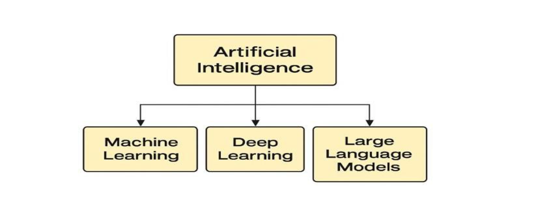

2.3 Computer Vision and CCTV Analytics
Computer vision is one of the most important AI technologies used in crowd management. It enables machines to interpret and analyze visual data obtained from CCTV cameras. Modern AI-enabled CCTV systems are no longer limited to passive recording; instead, they actively process video streams to extract meaningful information.
Through techniques such as object detection, crowd density estimation, and motion tracking, computer vision systems can:
- Count the number of passengers in a specific area
- Detecting overcrowding situations
- Track movement patterns within stations and platforms
- Identify abnormal behavior or safety risks

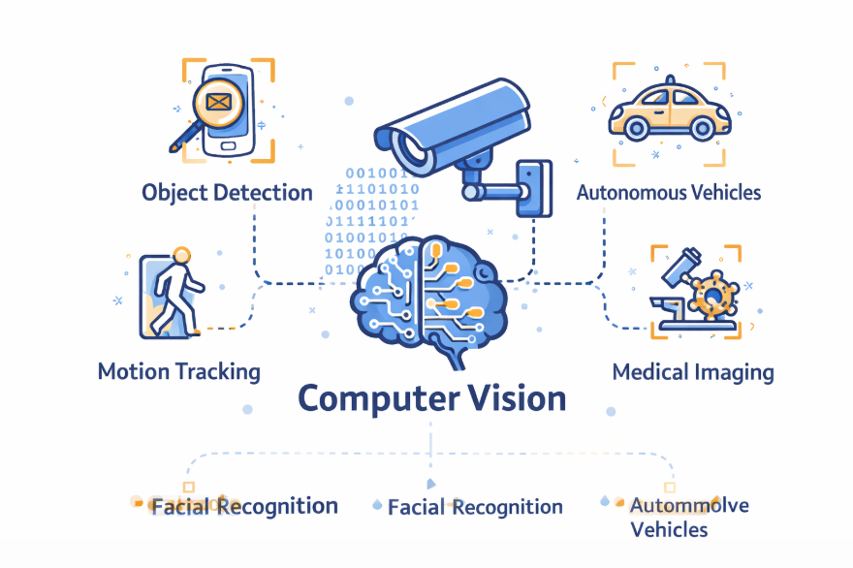

2.4 Machine Learning and Deep Learning Techniques
Machine Learning (ML) is a subset of AI that focuses on learning patterns from data without explicit programming. In metro systems, ML models can analyze historical passenger data to predict future crowd conditions.
Deep Learning (DL), a more advanced branch of ML, relies on neural networks with multiple layers to capture complex patterns in large datasets. In crowd management applications, DL models are widely used due to their high accuracy in processing visual data.
Common techniques include:
- Convolutional Neural Networks (CNNs): Used for image processing and crowd density estimation
- Recurrent Neural Networks (RNNs): Used for analyzing time-based patterns such as passenger flow over time
- Hybrid Models: Combining multiple approaches to improve prediction accuracy
These techniques enable metro systems to move beyond simple monitoring toward predictive analytics, which is essential for proactive crowd management.

2.5 Explainable AI and Decision Support
While AI models can achieve high accuracy, their decisions are often difficult to interpret. In critical environments such as metro systems, transparency is essential. This is where Explainable AI (XAI) becomes important.
Explainable AI provides insights into how and why a model produces certain predictions. For example, it can explain which factors contributed to the detection of a congestion event. This improves trust among operators and supports better decision-making.
In metro operations, XAI plays a key role in:
- Enhancing operators’ confidence in AI systems
- Supporting accountability and governance
- Ensuring compliance with safety and ethical standards

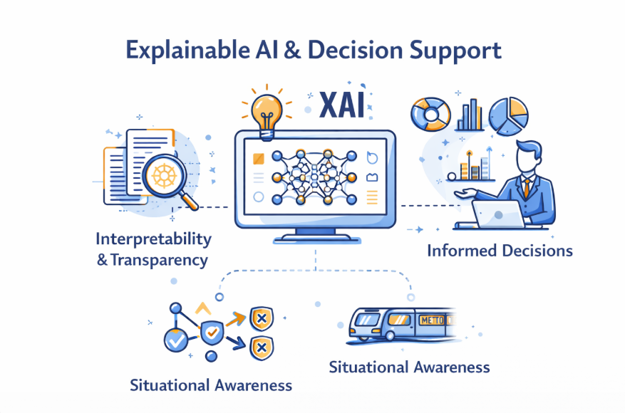

2.6 Crowd Management Challenges in Metro Systems
Metro environments are complex and dynamic. Several challenges make crowd management difficult:
- High passenger density during peak hours
- Limited physical space in stations and platforms
- Unpredictable events such as delays or emergencies
- Human limitations in monitoring multiple CCTV feeds simultaneously

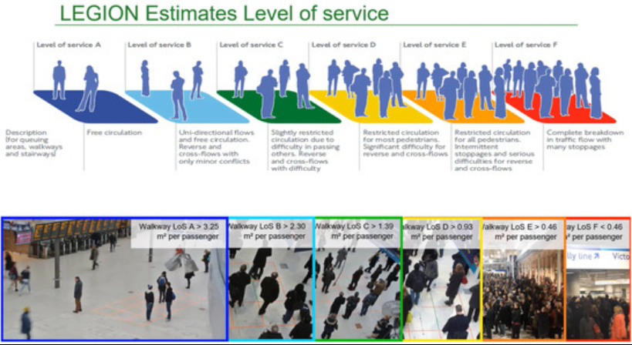

Summary research papers:

Paper 1: A novel approach for crowd video monitoring of subway platforms (2013). This paper explores subway platform monitoring. It uses improved background modeling + weighted area features for platform video analysis. A key contribution lies in that it is the first transit-focused work to show that CCTV can estimate crowd conditions on subway platforms using perspective-aware features. For this thesis, the paper is important. It is directly relevant to platform surveillance in rail traffic settings. The limitation is that the classical vision pipeline is less robust than modern deep learning under severe density and occlusion.

Paper 2: Multi-Column Atrous Convolutional Neural Network for Counting Metro Passengers (2020). This paper explores passenger counting in the metro. It uses an atrous multi-column CNN tailored to metro passenger images. A key contribution lies in that it demonstrates that scale-aware deep models can improve passenger counting in metro scenes with varying density. For this thesis, the paper is important. It is highly relevant to Riyadh Metro, as it addresses metro-specific counting rather than generic crowd scenes. A notable limitation, however, is that it is primarily focused on counting, with limited discussion of deployment governance and system integration.
Paper 3: Convolutional Neural Network for Crowd Counting on Metro Platforms (2021). This paper explores platform crowd counting. It uses a specialized CNN trained on metro platform imagery. A key contribution lies in that it reports improved counting accuracy on metro platform scenes and highlights the importance of scene-specific calibration. For this thesis, the paper is important because it is a very strong fit for Riyadh Metro platforms, where camera angles and density patterns vary by station. A notable limitation, however, is that performance is sensitive to dataset quality, camera placement, and local calibration.

Paper 4: A Deep Fusion Network for Crowd Counting in High-Density Crowd Scenes (2021). This paper explores high-density crowd counting. It uses deep fusion of multi-scale convolutional features into density maps. A key contribution lies in that it improves dense-scene counting by efficiently combining shallow and deep visual features. This paper is important because it applies to peak-hour metro environments, where dense platform scenes challenge basic detectors. A notable limitation, however, is that it is not rail-specific and is still focused on counting rather than broader operational decision support.

Paper 5: Crowd Meter: Gauging congestion level in railway stations using smartphones (2019). This paper explores the estimation of railway station congestion. It uses participatory sensing using smartphones and contextual passenger behavior features. A key contribution lies in that it shows congestion can be inferred from location and activity patterns even with a limited number of active users. This thesis paper is important because it serves as a complementary data source alongside CCTV for validating crowd states. A notable limitation, however, is that it depends on passenger device participation and is not purely CCTV-based.

Paper 6: Dynamic flow analysis and crowd management for transfer stations: a case study of Suzhou Metro (2024). This paper explores the optimization of transfer station flow. It uses dynamic flow analysis, CCTV-informed observations, and intervention assessment. A key contribution lies in that it reports reductions in maximum queue length, average time consumption, and average standing density under an improved management scheme. This thesis is extremely relevant because it studies metro transfer stations and translates analysis into actionable operating strategies. A notable limitation, however, is that case-study specificity may limit direct transfer without local calibration.

Paper 7: Deep-learning-based model for prediction of crowding in a public transit system (2024). This paper explores the prediction of crowding for transit information systems. It uses clustered time-series prediction and LSTM-based modeling with ticketing data. A key contribution lies in integrating crowding prediction with passenger information to support route choice and proactive crowd management. This paper is important because it supports moving from real-time detection to proactive forecasting in Riyadh Metro. A notable limitation, however, is that it relies on transit demand data rather than CCTV alone.

Paper 8: SIMCD: Simulated crowd data for anomaly detection and prediction (2022). This paper explores synthetic datasets for anomaly detection. It uses mass motion simulation to generate crowd-anomaly datasets and severity features. A key contribution lies in that it addresses dataset scarcity by creating synthetic data for high-density and contraflow anomaly scenarios. For this thesis, the paper is important because it is where real abnormal-event footage from metro stations is rare, sensitive, or difficult to label. A notable limitation, however, is that synthetic data may not fully capture the real-world noise, behavior, and environmental complexity observed in CCTV.

Paper 9: A Review of Abnormal Crowd Behavior Recognition (2024). This paper explores the recognition of abnormal crowd behavior. This is a review of computer vision approaches for detecting abnormal crowd behavior. A key contribution lies in its emphasis on real-time recognition, prediction, and intervention for public safety risks in dense crowds. This paper is important for this thesis because it supports the anomaly-detection dimension of the Riyadh Metro framework. A notable limitation, however, is that the review article lacks evidence of station-specific implementation.

Paper 10: Efficient Crowd Anomaly Detection Using Sparse Feature Tracking and Neural Networks (2024). This paper explores efficient anomaly detection. It uses sparse local feature extraction, tracking, and neural classification. A key contribution lies in an efficiency-oriented anomaly detector that preserves consistent tracking while reducing computational burden. For this thesis, the paper is important because it is valuable for near-real-time monitoring where metro control rooms need fast alerts. A notable limitation, however, is that the general surveillance context needs to be validated in metro CCTV environments.

Paper 11: Multimodal Video Analysis for Crowd Anomaly Detection (2024). This paper explores multimodal anomaly detection. It uses time-series extraction from video with multimodal modeling for anomaly detection. A key contribution lies in that it shows that combining multiple information streams can strengthen anomaly recognition beyond single-feature pipelines. This paper is important because it helps design richer CCTV analytics that combine motion, temporal, and contextual signals. A notable limitation, however, is that it is not specific to metro stations and needs integration testing with operational workflows.

Paper 12: Video analytics using deep learning for crowd analysis: a review (2022). This study reviews deep learning for crowd analysis. It uses a literature review covering crowd counting, density estimation, and abnormal behavior detection. A key contribution lies in that it synthesizes major deep-learning approaches and highlights the challenge of adapting generic methods to very dense religious and public-event settings. This paper is important because it helps position Riyadh Metro within the broader surveillance analytics literature. A notable limitation, however, is that the survey paper lacks an original experiment or a metro deployment.

Paper 13: Improving safety management in railway stations through a simulation-based digital twin approach (2024). This paper explores railway station safety and decision support. It uses a simulation-based digital twin that integrates station data and predictive crowd analysis. A key contribution lies in that it shows digital twins can support early warnings, evacuation planning, and intelligent gate management in railway stations. This paper is important because it is very high, as it links analytics with operational intervention and management decisions. A notable limitation, however, is that it is prototype-oriented and requires substantial effort in interoperability and data engineering.

Paper 14: Recent trends in crowd management using deep learning techniques: a systematic literature review (2024). This paper explores a systematic review of dl crowd management. It uses a review of 45 studies from 2010 to 2023. A key contribution lies in that it finds both supervised and unsupervised deep-learning methods effective, while identifying gaps in local and culturally specific crowd research. This paper is particularly relevant to the Saudi context because it discusses Hajj and the regional gaps in crowd management research. The limitation is that it does not directly test methods in metro operations.

Paper 15: A Review of Passenger Counting in Public Transport Concepts with Solution Proposal Based on Image Processing and Machine Learning (2024). This paper explores passenger counting technologies. It uses a comparative review of 43 APC studies across public transport modes. A key contribution lies in that it concludes that CCTV, combined with machine learning, offers high accuracy but requires stronger hardware and careful privacy management. This paper is important because it is useful for implementation planning and technology trade-off analysis in metro operations. A notable limitation, however, is the broad scope of public transport, which extends beyond metro stations.

Critical Synthesis of the Fifteen Papers
Across the fifteen studies, several patterns emerge. First, metro-oriented research increasingly favors deep learning over classical computer vision because dense crowd scenes, occlusion, and perspective variation are difficult to handle using handcrafted features alone. This is evident in the transition from early platform-monitoring approaches to metro-specific CNN and fusion-based counting models. Second, high-performing algorithms alone are not sufficient for operational use. Studies on digital twins, transfer-station management, and passenger-counting system design show that deployment requires interoperability with existing station systems, reliable data pipelines, and practical decision-support dashboards. Third, anomaly detection research is moving toward multimodal, computationally efficient designs, but most published work is still evaluated on generic surveillance datasets rather than in real metro control-room environments.
Another important observation is that CCTV analytics is only one part of an effective crowd-management framework. Smartphone sensing, ticketing data, and simulation models can enrich situational awareness and improve forecasting accuracy. This is particularly relevant for Riyadh Metro, where CCTV can provide real-time state estimation while ticketing, station layout, and operational schedules can support prediction and response planning. Finally, privacy and governance remain underdeveloped compared with algorithmic performance. Although several recent studies mention privacy-aware designs or regulatory constraints, fewer papers explain how to operationalize those safeguards in public-transport environments. As a result, the literature supports a hybrid thesis: the strongest future solution for Riyadh Metro is not a stand-alone counting model but an integrated operational framework that combines CCTV analytics, anomaly alerts, forecasting, privacy controls, and human decision support.

2.9 Cross-Paper Comparison Table
Table 2.1 compares all fifteen papers using consistent academic criteria: study aim, method, principal result, operational relevance, and major limitations.

No. | Year | Paper / Study | Primary Aim | Method | Key Result | Relevance to Riyadh Metro | Main Limitation
1 | 2013 | A novel approach for crowd video monitoring of subway platforms | Subway platform monitoring | Improved background modeling + weighted area features for platform video analysis | Early transit-focused work showing CCTV can estimate crowd conditions on subway platforms using perspective-aware features. | Directly relevant because it targets platform surveillance in rail traffic settings. | Classical vision pipeline; lower robustness than modern deep learning under severe density and occlusion.
2 | 2019 | Crowd Meter: Gauging congestion levels in railway stations using smartphones | Railway station congestion estimation | Participatory sensing using smartphones and contextual passenger behavior features | Show congestion can be inferred from location and activity patterns even with a limited number of active users. | Useful as a complementary data source beside CCTV for validating crowd states. | It depends on passenger device participation and is not purely CCTV-based.
3 | 2020 | Multi-Column Atrous Convolutional Neural Network for Counting Metro Passengers | Metro passenger counting | Atrous multi-column CNN tailored to metro passenger images | Demonstrates that scale-aware deep models can improve passenger counting in metro scenes with varying density. | Highly relevant to Riyadh Metro because it addresses metro-specific counting rather than generic crowd scenes. | Primarily counting-focused; limited discussion of deployment governance and system integration.
4 | 2021 | Convolutional Neural Network for Crowd Counting on Metro Platforms | Platform crowd counting | Specialized CNN trained on metro platform imagery | Reports improved counting accuracy on metro platform scenes and highlighting the importance of scene-specific calibration. | It is a very strong fit for Riyadh Metro platforms, where camera angles and density patterns vary by station. | Performance is sensitive to dataset quality, camera placement, and local calibration.
5 | 2021 | A Deep-Fusion Network for Crowd Counting in High-Density Crowd Scenes | High-density crowd counting | Deep fusion of multi-scale convolutional features into density maps | Improves dense-scene counting by efficiently combining shallow and deep visual features. | Applicable to peak-hour metro environments where dense platform scenes challenge basic detectors. | Not rail-specific and still focused on counting rather than broader operational decision support.
6 | 2022 | Video analytics using deep learning for crowd analysis: a review | Review of deep learning for crowd analysis | Literature review covering crowd counting, density estimation, and abnormal behavior detection | Synthesizes major deep learning approaches and highlights the challenge of adapting generic methods to highly dense religious and public-event settings. | Useful for positioning Riyadh Metro within the broader surveillance analytics literature. | Survey paper with no original experiment or metro deployment.
7 | 2022 | SIMCD: Simulated crowd data for anomaly detection and prediction | Synthetic datasets for anomaly detection | Mass Motion simulation used to generate crowd anomaly datasets and severity features | Addresses dataset scarcity by creating synthetic data for high-density and contraflow anomaly scenarios. | Real abnormal-event footage from metro stations must be rare, sensitive, or difficult to label. | Synthetic data may not fully capture the real-world noise, behavior, and environmental complexity observed in CCTV.
8 | 2024 | Improving safety management in railway stations through a simulation-based digital twin approach | Railway station safety and decision support | Simulation-based digital twin integrating station data and predictive crowd analysis | Shows digital twins can support early warnings, evacuation planning, and intelligent gate management in railway stations. | Very high, because it links analytics with operational intervention and management decisions. | Prototype-oriented and requires substantial interoperability and data engineering effort.
9 | 2024 | Recent trends in crowd management using deep learning techniques: a systematic literature review | Systematic review of DL crowd management | Review of 45 studies from 2010-2023 | Finds both supervised and unsupervised deep-learning methods effective, while identifying gaps in local and culturally specific crowd research. | Particularly relevant to the Saudi context, as it discusses Hajj and regional gaps in crowd management research. | Does not test methods directly in metro operations.
10 | 2024 | Dynamic flow analysis and crowd management for transfer stations: a case study of Suzhou Metro | Transfer station flow optimization | Dynamic flow analysis with CCTV-informed observations and intervention assessment | Reports reductions in maximum queue length, average time consumption, and average standing density under an improved management scheme. | Extremely relevant because it studies metro transfer stations and translates analysis into actionable operating strategies. | Case-study specificity may limit direct transfer without local calibration.
11 | 2024 | A Review of Passenger Counting in Public Transport Concepts with a Solution Proposal Based on Image Processing and Machine Learning | Passenger counting technologies | Comparative review of 43 APC studies across public transport modes | Concludes that CCTV, combined with machine learning, offers high accuracy but requires stronger hardware and careful privacy management. | Useful for implementation planning and technology trade-off analysis in metro operations. | Broad public-transport scope; not limited to metro stations.
12 | 2024 | A Review of Abnormal Crowd Behavior Recognition | Abnormal crowd behavior recognition | Review of computer-vision approaches for abnormal crowd behavior detection | Emphasizes real-time recognition, prediction, and intervention for public-safety risks in dense crowds. | Supports the anomaly-detection dimension of the Riyadh Metro framework. | Review article without station-specific implementation evidence.
13 | 2024 | Efficient Crowd Anomaly Detection Using Sparse Feature Tracking and Neural Networks | Efficient anomaly detection | Sparse local feature extraction + tracking + neural classification | Presents an efficiency-oriented anomaly detector designed to preserve consistent tracking while lowering computational burden. | Valuable for near-real-time monitoring where metro control rooms need fast alerts. | General surveillance context; requires validation in metro CCTV environments.
14 | 2024 | Multimodal Video Analysis for Crowd Anomaly Detection | Multimodal anomaly detection | Time-series extraction from video with multimodal modeling for anomaly detection | Shows that combining multiple information streams can strengthen anomaly recognition beyond single-feature pipelines. | Helpful for designing richer CCTV analytics that combine motion, temporal, and contextual signals. | Not specific to metro stations and needs integration testing with operational workflows.
15 | 2024 | Deep-learning-based model for the prediction of crowding in a public transit system | Crowding prediction for transit information systems | Clustered time-series prediction using ticketing data and LSTM-based modeling | Integrates crowding prediction with passenger information to support route choice and proactive crowd management. | Important for moving from real-time detection to proactive forecasting in Riyadh Metro. | Rely on transit demand data rather than CCTV alone.

2.10 Methodological Comparison by Theme
Table 2.2 groups the reviewed studies by methodological role to facilitate discussion of the literature in the thesis chapter.

Theme | Papers | What the literature shows | The gap remaining for this thesis
Counting and density estimation | Hu (2013), Zhang (2020), Zhang et al. (2021), Khan et al. (2021) | Deep learning improves counting accuracy in dense metro scenes and is more robust than classical vision pipelines. | Most studies stop at measurement and do not link counts to station decisions, governance, or operator workflows.
Congestion sensing and forecasting | Elhamshary et al. (2019), Zhang et al. (2024), Shrivastava et al. (2024) | Crowd states can be inferred and predicted using smartphone, station-flow, and ridership data, enabling proactive control. | Forecasting models are often outside CCTV pipelines and need integration with real-time station operations.
Anomaly detection | Bamaqa et al. (2022), Zhao et al. (2024), Altowairqi et al. (2024), Dionis-Ros et al. (2024) | Anomaly detection is essential for identifying unsafe patterns such as contraflow, panic, or abnormal congregation. | Few studies validate anomaly detection on real metro CCTV footage with operational thresholds and low false alarms.
Deployment and governance | Bhuiyan et al. (2022), Padovano et al. (2024), Alasmari et al. (2024), Radovan et al. (2024) | Implementation requires architecture, privacy compliance, infrastructure sizing, and human-centered decision support. | The literature still under-explains practical governance in public metro environments, especially in regional contexts.

References
Hu, X., Zheng, H., Wang, W., & Li, X. (2013). A novel approach for crowd video monitoring of subway platforms. Optik, 124(22), 5301-5306.

Elhamshary, M., Youssef, M., Uchiyama, A., Yamaguchi, H., Higashino, T., & others. (2019). Crowd Meter: Gauging congestion levels in railway stations using smartphones.

Zhang, J., Zhu, G., & Wang, Z. J. S. (2020). Multi-Column Atrous Convolutional Neural Network for Counting Metro Passengers. Symmetry, 12, 682.

Zhang, J., et al. (2021). Convolutional Neural Network for Crowd Counting on Metro Platforms. Symmetry, 13(4), 703.

Khan, S. D., Ullah, H., & others. (2021). A Deep-Fusion Network for Crowd Counting in High-Density Crowd Scenes.

Bhuiyan, M. R., et al. (2022). Video analytics use deep learning for crowd analysis: a review. Multimedia Tools and Applications.

Bamaqa, A., et al. (2022). SIMCD: Simulated crowd data for anomaly detection and prediction. Expert Systems with Applications.

Padovano, A., Longo, F., Manca, L., & Grugni, R. (2024). Improving safety management in railway stations through a simulation-based digital twin approach. Computers & Industrial Engineering, 187, 109839.

Alasmari, A. M., Farooqi, N. S., & Alotaibi, Y. A. (2024). Recent trends in crowd management using deep learning techniques: a systematic literature review. Journal of Umm Al-Qura University for Engineering and Architecture, 15, 355-383.

Zhang, J., Ai, Q., Ye, Y., & Deng, S. (2024). Dynamic flow analysis and crowd management for transfer stations: a case study of Suzhou Metro. Public Transport, 16(2), 619-653.

Radovan, A., Mršić, L., Đambić, G., & Mihaljević, B. (2024). A Review of Passenger Counting in Public Transport Concepts with Solution Proposal Based on Image Processing and Machine Learning. Eng, 5(4), 3284-3315.

Zhao, R., et al. (2024). A Review of Abnormal Crowd Behavior Recognition. Applied Sciences, 14(21), 9758.

Altowairqi, S., et al. (2024). Efficient Crowd Anomaly Detection Using Sparse Feature Tracking and Neural Networks. Applied Sciences, 14(9), 3928.
Dionis-Ros, A., et al. (2024). Multimodal Video Analysis for Crowd Anomaly Detection. Applied Sciences, 14(23), 11075.

Shrivastava, A., Rawat, N., & Agarwal, A. (2024). Deep-learning-based model for the prediction of crowding in a public transit system. Public Transport, 16, 449-484.

