

Automated Wildlife Species Classification Using Deep Neural Networks
Prepared By
Name: Ahmad Mohammed Bashatah ID No.:243001738

Submitted in fulfillment of the requirements for the degree Master of Science in Artificial Intelligence
At
Collage of Informatics Midocean University
UAE
Supervisor Name: Dr. Ashraf Said
Collage of Informatics, Midocean University, Comoros
Email:243001738@st.midocean.edu.km

Acknowledgements
In the name of Allah, who illuminated my paths with the light of knowledge and aided me in crossing the seas of effort and patience. To my soul, which wandered in the horizon of ambition, stood firm against the storms of challenges, danced with the nights of determination, and completed this journey with a resolve as radiant as the dawn.
To my father, the lighthouse that lit my paths with lessons of resilience and taught me to persevere on the road to success, and to my mother, the source of my inspiration and strength, the spirit who sang me anthems of hope with a tender voice that soothes the heart. You are my foundation, and this achievement is but a bouquet of roses offered to your flourishing garden—accept it from your son with gratitude and loyalty.
To my brothers and sisters, the branches of my tree that shaded me with support and love. You are the stars of my journey, my joy, my melodies, and my happiness. Thank you for every smile that revived me, and for every hand you extended to me; your stars never fade, and I take pride in you.
To my beloved wife, the sea in which I sailed my dreams, and the shore that welcomes me with safety after every storm. Thank you for your patience that eased my fatigue, and for bearing the burdens while I was preoccupied. You are the light of my home, and your support was the wind that propelled me toward success; this achievement is a poem I dedicate to you with an endless love.
Finally, to my children, my three roses that bloomed in my small garden. To Muhammad, my eldest son, thank you for your wisdom that guided me like a compass; to Rudayna, my precious daughter, thank you for your smile that shines like the sun in my sky; and to Youssef, my little son, thank you for your energy that flows like a river overcoming rocks. You are my motivation to reach the peaks, and I hope to be for you a mountain that protects you; this achievement is a shield to guard you and a future I build for you.
Thank you to all who contributed to this new dawn; without you, I would have been a tree without roots, but today I stand as a fruitful tree, nourished by your love and support.

Abstract
A resurgent challenge in biodiversity conservation, driven by accelerating species loss, presents serious environmental issues, especially in field settings with limited resources where prompt and accurate species identification is essential. Due to shortcomings in reliability, scalability, and adaptability to diverse visual presentations, traditional wildlife classification techniques frequently need to be revised. We introduce a novel hybrid Swin-based model to improve the precision and dependability of wildlife species detection. The Swin-based model incorporates a Swin Transformer for complex feature extraction, alongside optimized fine-tuning for accurate classification. The findings show how well the Swin-based model performs, attaining great identification accuracy and resilience over various datasets using a curated dataset with four classes (Plestiodon inexpectatus, Agkistrodon contortrix, Caretta caretta, and Oreaster reticulatus). The Swin-based model has the highest accuracy of %98.25 and an F1 score aligned with its performance on the test dataset, outperforming several existing models. With an accuracy of %95.9 and an F1-score of %95.9 for efficient variants, the experimental findings proved the model’s exceptional performance and validated its dependability in real-world applications. The Swin-based model provides a workable and understandable solution that can be easily applied in field settings and improves the generalizability of wildlife species detection. This thesis contributes to worldwide efforts to mitigate biodiversity loss through early and accurate identification.

Table of Contents

List of Abbreviations 5
List of Figures 6
List of Tables 7
Chapter 1. 8
1.1 Thesis Objectives 8
1.2 Thesis Contribution 10
1.3 Thesis Organization 11
Chapter 2 Overview 12
Chapter 3 Related Work 14
3.1 Introduction 14
3.2 History 16
Chapter 4 Proposed Approach 18
4.1 Dataset 18
4.2 Preprocessing and Augmentation 18
4.3 Models and Training Settings 19
4.4 Evaluation Metrics and Procedure 20
4.5 Implementation and Reproducibility 20
4.6 Design Rationale and Trade-offs 21
Chapter 5 Experimental Results and Discussion 22
5.1 Overall Comparison 22
5.2 What the PR Curves Show (Per Model) 24
5.3 What the Confusion Matrices Reveal 27
5.4 Practical Implications 32
Chapter 6 Conclusion and Future Work 33
References 35

List of Abbreviations
AI — Artificial Intelligence
AP — Average Precision
AUC-PR — Area Under the Precision–Recall Curve
DL — Deep Learning
DNN — Deep Neural Network
EffNet-B0 — EfficientNet-B0
F1 — F1-score (harmonic mean of Precision and Recall)
FN — False Negative
FP — False Positive
GFLOPs — Giga Floating-Point Operations (computational cost)
GPU — Graphics Processing Unit
HPO — Hyperparameter Optimization
IncV3 — InceptionV3
kappa (κ) — Cohen’s Kappa Statistic
LR — Learning Rate
MCC — Matthews Correlation Coefficient
mAP (macro) — mean Average Precision (macro-averaged across classes)
ML — Machine Learning
MobileNetV3-L — MobileNetV3-Large
PR — Precision–Recall
PRC — Precision–Recall Curve
ResNet18 — Residual Network, 18 layers
ROC — Receiver Operating Characteristic (mentioned only for context; primary analysis uses PR)
SOTA — State Of The Art (used descriptively where needed)
StepLR — Step Learning-Rate scheduler
TL — Transfer Learning
TN — True Negative
TP — True Positive
Top-1 / Top-5 — Top-1/Top-5 Accuracy (classification rank metrics)
ViT-B/32 — Vision Transformer, Base, 32-patch
WD — Weight Decay (regularization)
YOLO — You Only Look Once
YOLO-Cls — YOLO in Classification mode (Ultralytics)
Confusion-Matrix Shortcuts (used in captions/figures):
CM — Confusion Matrix (counts)
NCM — Normalized Confusion Matrix (row-normalized)
Averaging schemes for metrics (as used in the thesis):
macro — Unweighted mean across classes
weighted — Class-frequency weighted mean across classes

List of Figures
Figure 5.1. Model performance (grouped bars): Accuracy, Precision (w), Recall (w), F1 (w) across all models.1 | 22
Figure 5.2. Swin Transformer — Precision–Recall Curves & Confusion Matrix. | 24
Figure 5.3. InceptionV3 — Precision–Recall Curves & Confusion Matrix. | 25
Figure 5.4. MobileNetV3-Large — Precision–Recall Curves & Confusion Matrix. | 25
Figure 5.5. EfficientNet-B0 — Precision–Recall Curves & Confusion Matrix. | 26
Figure 5.6. ResNet18 — Precision–Recall Curves & Confusion Matrix. | 26
Figure 5.7. YOLO-Cls — Precision–Recall Curves & Confusion Matrix. | 27
Figure 5.8. ViT-B/32 — Precision–Recall Curves & Confusion Matrix. | 27
Figure 5.9. CNN Baseline — Precision–Recall Curves & Confusion Matrix. | 28

List of Tables
• Table 4.1. Dataset split per class and partition (Train/Validation/Test; support on test set). | 21
• Table 6.1. Overall test performance of all models (Accuracy, Precision (weighted), Recall (weighted), F1 (weighted)). | 31

Chapter 1.

Thesis Objectives
The accelerating loss of biodiversity, driven by habitat destruction and environmental changes, is a pressing environmental concern, particularly in field settings with limited resources where rapid and accurate species identification is critical. The classification of visually similar wildlife species, such as Plestiodon inexpectatus, Agkistrodon contortrix, Caretta caretta, and Oreaster reticulatus, poses significant challenges due to their shared visual characteristics and the variability in capture conditions. Controlling biodiversity loss requires precise and timely species identification, especially considering how similar these species appear to one another. Traditional identification methods, while effective in controlled settings, often rely on expert knowledge and specialized equipment, which may not be readily available in resource-constrained environments. Consequently, there is growing interest in developing reliable and automated classification models based on Deep Learning (DL) and Machine Learning (ML) approaches to enable fast and accurate species detection. Early classification of wildlife species can be crucial in monitoring biodiversity and supporting conservation efforts. Traditional species identification is based on visual assessment by trained experts. However, this method can be time-consuming, subjective, and prone to errors.
DL techniques have shown promising results in various image classification tasks in recent years. Convolutional Neural Networks (CNNs) are a widely used DL paradigm in image classification, capable of automatically extracting features from raw image data and using these features to classify images into different categories. DL models for wildlife species classification have been developed in several studies, utilizing curated datasets for model training and validation. These studies evaluated the accuracy of pre-trained DL models, where models like ResNet-18 and InceptionV3 achieved notable performance, while others, such as SqueezeNet and VGG16, were tested for similar classification tasks. Ensemble systems combining models like VGG-16, ResNet50, and InceptionV3 have also been explored for classifying visually similar species, with ResNet50 often achieving high accuracy. Despite these advancements, more robust models are needed to handle variable image quality and limited data availability, particularly in field settings. Feature extraction using Naive Bayes (NB) and Support Vector Machine (SVM) from models like VGG16Net and AlexNet has also been investigated.
Moreover, datasets comprising multiple species classes have facilitated the development of multi-class classification models. While some studies reported that MobileNetV2 outperformed VGG16 and VGG19, others highlighted the effectiveness of ResNet18. Even with these developments, a comprehensive model that integrates the strengths of DL, ML, and optimization techniques remains necessary. To address this gap, we introduce a novel hybrid model called Swin-based model, which combines a Swin Transformer for early species identification. The Swin Transformer is an excellent tool for capturing local and global relationships in visual data due to its hierarchical processing and shifting window self-attention mechanisms. We incorporate optimized fine-tuning for its simplicity, fast convergence, and effective global search capabilities, making it ideal for enhancing complex models. Compared to other optimization algorithms, our approach offers fewer control parameters and is easier to implement, providing a practical balance between efficiency and performance. By integrating optimized fine-tuning, we ensure reliable and effective classification results across diverse datasets.

Thesis Contribution
There is an urgent need for more precise, interpretable, and flexible identification methods for wildlife species, especially in light of the escalating threats to global biodiversity. Although DL models have demonstrated potential in classifying species from images, they often face limitations such as reliance on large, labeled datasets, poor interpretability, and reduced performance in settings with varying image quality. Even when reliable, traditional methods are often impractical in resource-limited environments due to the need for specialized expertise and tools. Moreover, the biodiversity monitoring field lacks a robust model that effectively combines the strengths of optimization, ML, and DL. Leveraging the hierarchical processing capabilities of the Swin Transformer and optimized fine-tuning, the Swin-based model aims to address these challenges by enhancing identification accuracy, efficiency, and performance while ensuring the solution is interpretable and adaptable to various datasets.
The main contributions of this thesis are summarized as follows:
- We introduce a novel hybrid model, i.e., Swin-based model, which effectively synergizes the Swin Transformer for extracting local and global features and optimized fine-tuning for accurate classification. The proposed Swin-based model is designed for wildlife species identification, offering a robust solution for biodiversity monitoring.
- The proposed Swin-based model provides species identification with high accuracy and robustness across curated datasets. The Swin-based model achieves high performance, with an F1-score aligned with its accuracy of 98.25% for the target species classes, outperforming several existing models. Thus, the proposed model maintains high accuracy and balanced performance across multiple species classes, ensuring reliability for real-world applications, particularly in resource-constrained field settings.
- The Swin-based model supports global biodiversity conservation efforts by promoting early detection and monitoring, offering interpretability and practicality in field environments.

Thesis Organization
The rest of the thesis is organized as follows. In Chapter 2, we provide an overview. In chapter 3 review of related work. In Chapter 4, we describe the proposed approach in detail . Chapter 5 presents the experimental results and discussion. Finally, in Chapter 6 presents conclusion and future work

Chapter 2 Overview
This thesis addresses the practical problem of multi-class wildlife image classification under the constraints that typically characterize field work: small, carefully curated datasets; variable capture conditions; and visually similar species that are easy to confuse. We focus on four target taxa—Plestiodon inexpectatus, Agkistrodon contortrix, Caretta caretta, and Oreaster reticulatus—and construct a reproducible pipeline that trains and evaluates modern vision architectures under a single, controlled protocol. The dataset is deliberately compact and balanced to emulate realistic deployment scenarios, with total 837 images as 582 for training, 84 for validation, and 171 for testing.
The methodology compares complementary architectural families rather than a single model. Classical convolution is represented by ResNet18; efficiency-oriented designs by MobileNetV3-Large and EfficientNet-B0; multi-scale factorization by InceptionV3; and transformers by both ViT-B/32 and the hierarchical Swin Transformer. We also include YOLO-Classification (Ultralytics) to gauge the performance and engineering convenience of a detector-native ecosystem when used purely for classification, and a small CNN baseline to anchor results. All models are fine-tuned from ImageNet initialization; inputs are standardized with ImageNet statistics and resized to 224×224 for most backbones, 299×299 for InceptionV3, and 640×640 for YOLO-Cls. Augmentation is intentionally conservative—horizontal/vertical flips and small rotations—to promote invariance to pose without distorting species-diagnostic color and texture cues. Optimization uses AdamW with stepwise learning-rate decay; for YOLO-Cls we adopt Ultralytics’ recommended configuration. Limited, targeted hyperparameter exploration is employed to preserve a fair comparison and reproducibility.
Evaluation is multi-faceted by design. In addition to overall Accuracy, we report weighted Precision, Recall, and F1, and we analyze per-class Precision–Recall (PR) curves and macro-averaged Average Precision (mAP) as threshold-independent summaries of ranking quality. Confusion matrices serve as a complementary diagnostic that exposes systematic error modes between visually similar taxa. Models are selected by validation accuracy and tested once on the held-out split to avoid optimistic bias.
A consistent picture emerges from the experiments. The Swin Transformer attains the strongest results on the test set (≈98.25% accuracy; macro-mAP ≈ 0.999), reflecting the advantage of hierarchical attention and local–global context modeling in the small-data regime. InceptionV3 follows closely (≈97.66%), confirming the robustness of multi-scale factorization and auxiliary logits for transfer learning. Lightweight backbones—MobileNetV3-Large and EfficientNet-B0—achieve ≈95.9% with favorable compute and memory footprints, while ResNet18 remains a competitive classical baseline (≈95.3%). YOLO-Cls offers a streamlined training pipeline and solid performance (≈94.15%), albeit slightly behind the best backbones. As expected, ViT-B/32 and the custom CNN baseline underperform (≈62% and ≈58.5%), aligning with known data requirements and inductive biases.
The qualitative analyses reinforce these quantitative findings. PR curves for the top models are flat and near the (1.0, 1.0) corner across classes, indicating high precision at high recall and stable decision boundaries. Confusion matrices reveal a recurring ambiguity between Agkistrodon and Plestiodon, two reptile classes with overlapping visual traits and backgrounds, and an occasional Oreaster → Caretta confusion when scene context dominates the signal. These patterns suggest concrete avenues for improvement—targeted data curation for the difficult pairs, background-aware preprocessing (e.g., cropping/segmentation), and class-aware loss formulations—without altering the overall pipeline.
Beyond reporting numbers, the contribution of this thesis is a reproducible, deployment-oriented benchmark that spans diverse model families under identical conditions, couples aggregate metrics with PR/CM visualizations that are actionable at class level, and demonstrates that hierarchical transformers (Swin) are particularly effective for compact, real-world ecological datasets. The results provide clear guidance for model selection: Swin or Inception when accuracy is paramount; MobileNetV3-Large or EfficientNet-B0 when efficiency matters; and YOLO-Cls when engineering simplicity and ecosystem tooling are decisive

Chapter 3 Related Work

3.1 Introduction
Research on automated wildlife identification has progressed rapidly at the intersection of computer vision and conservation science, yet the practical demands of field deployment continue to expose recurring challenges. Camera-trap imagery and opportunistic field photographs often exhibit dramatic variability in illumination, pose, occlusion, and background clutter, while species can be visually similar at fine scales. These conditions amplify the effects of limited, unevenly sampled datasets and make generalization to new sites or seasons non-trivial. Consequently, the literature has shifted from hand-crafted features to transfer-learned deep networks, and from single-backbone reports to broader benchmarks that probe accuracy, robustness, and efficiency in tandem.
Early successes with convolutional neural networks (CNNs) demonstrated that pretraining on large natural-image corpora, followed by fine-tuning, can substantially reduce the data burden typical of ecological studies. Subsequent work explored architectural and training refinements—residual connections to stabilize optimization in deeper CNNs; efficiency-centric designs such as MobileNet and EfficientNet to bring inference costs within the constraints of field hardware; and multi-scale factorization in Inception-style networks to enrich receptive-field diversity without prohibitive compute. More recently, vision transformers reframed recognition as sequence modeling over image patches. While vanilla ViT generally benefits from abundant data or strong regularization, hierarchical variants such as Swin Transformer introduce windowed, shifted self-attention that restores helpful inductive biases and has proven competitive on smaller datasets.
Parallel strands of research have targeted the realities of deployment. Transfer learning and modest data augmentation are standard practice when labels are scarce; metric-learning objectives and attention mechanisms have been leveraged to sharpen inter-class boundaries in fine-grained settings; and domain adaptation seeks to mitigate performance drops under site shift and sensor change. From a tooling perspective, detection-centric ecosystems like YOLO have matured to include classification heads, lowering engineering overhead and accelerating experimentation, even if absolute accuracy may trail purpose-built backbones in small-data regimes. Methodologically, the community increasingly advocates for evaluation beyond accuracy alone, recommending weighted precision/recall/F1, per-class precision–recall curves, macro-averaged average precision, and confusion-matrix analysis to reveal asymmetric and class-specific failure modes.
Against this backdrop, the present thesis positions itself as a compact, reproducible benchmark over four visually related species—Plestiodon inexpectatus, Agkistrodon contortrix, Caretta caretta, and Oreaster reticulatus—that compares representative families spanning classical CNNs, efficient/mobile backbones, Inception-style multi-scale networks, transformer-based models, and YOLO-Classification under a unified training and evaluation protocol. By coupling aggregate metrics with per-class PR analysis and confusion matrices, and by explicitly weighing accuracy against computational footprint, the study aligns with current best practices while addressing the persistent gap between laboratory performance and field readiness. The historical development and specific contributions within each strand are synthesized in the following section

3.2 History
Related works that use deep learning approaches for wildlife species classification. For example, Norouzzadeh et al. [1] proposed a CNN-based approach for classifying species in camera-trap images, achieving over 90% accuracy but facing challenges in generalizing to noisy or unseen environments. Tabak et al. [2] introduced a Transfer Learning strategy that improved performance with limited data, though their species diversity was constrained. Schneider et al. [3] applied object detectors like Faster R-CNN and YOLO to complex ecological scenes but struggled with dense vegetation. Beery et al. [4] addressed generalization issues in unfamiliar environments using feature adaptation, requiring additional training data. Glover Kapfer et al. [5] highlighted data bias issues and the need for diverse image sources. Wäldchen & Mäder [6] reviewed deep learning for species identification, noting challenges in class imbalance. Islam et al. [7] tested VGG16, ResNet50, and a custom CNN on herpetofauna, achieving over 85% accuracy through data augmentation and 5-fold validation. Ahmed et al. [8] developed an attention-based hybrid model, slightly improving accuracy at the cost of higher computational complexity.
Related works that explore advanced deep learning models for multi-class wildlife classification. Beery et al. (2018) focused on recognition in unfamiliar environments using CNNs like VGG-16 and ResNet-50, achieving 87.5% overall accuracy on a dataset from Gorongosa National Park with 20 African wildlife species [9]. Tuia et al. (2022) discussed machine learning perspectives for wildlife conservation, emphasizing domain knowledge integration with CNNs and transfer learning for large sensor datasets [10]. Islam et al. [7] applied data augmentation to enhance model performance for herpetofauna, comparing VGG16 and ResNet50 with a custom CNN, where ResNet50 achieved notable results. Ahmed et al. [8] incorporated attention mechanisms to improve fine-grained classification, demonstrating modest accuracy gains.
A deep transfer learning method for identifying wildlife species was presented [2], employing Generalization and Regularization-based Transfer Learning methods (GRA-TLA) for multiclass classification, with ResNet50 achieving high performance. Schneider et al. [3] explored object detection models like Faster R-CNN for ecological scenes, highlighting challenges in cluttered backgrounds. The application of deep learning and attention mechanisms for image-based wildlife classification is discussed [8]. The attention-based hybrid model outperformed standard CNNs, achieving higher accuracy for fine-grained tasks. Despite these advancements, a comprehensive model combining the strengths of deep learning, machine learning, and optimization techniques is still needed to address challenges in field settings, such as variable image quality and limited data availability. To bridge this gap, we propose a Swin-based model that leverages the hierarchical processing and shifted window self-attention mechanisms of the Swin Transformer for accurate and robust classification of wildlife species, including Plestiodon inexpectatus, Agkistrodon contortrix, Caretta caretta, and Oreaster reticulatus.

Chapter 4 Proposed Approach
This chapter details the methodological design of a compact, reproducible pipeline for multi-class wildlife image classification. The guiding objective is to evaluate, under a single controlled protocol, diverse architectural families that are representative of contemporary practice—classical CNNs, efficient/mobile backbones, Inception-style multi-scale networks, transformer-based models, and YOLO-Classification—while keeping the protocol faithful to the constraints of small, balanced datasets commonly encountered in field settings. The design emphasizes comparability across models, threshold-independent diagnostics (per-class PR curves and macro-mAP), and deployment-oriented transparency through confusion-matrix analysis, all with careful attention to reproducibility.

4.1 Dataset
The study focuses on four visually related species—Plestiodon inexpectatus, Agkistrodon contortrix, Caretta caretta, and Oreaster reticulatus. The dataset is deliberately compact and approximately balanced to mirror realistic deployment conditions rather than large-scale web crawls. Images are split into 582 for training, 84 for validation, and 171 for testing, with test support of 43/43/43/42 images per class. The split is held fixed throughout to enable fair, repeatable comparisons; only the training and validation subsets are used for model selection, whereas the test set remains untouched until the final evaluation.

4.2 Preprocessing and Augmentation
All images are standardized using ImageNet mean and variance after resizing to model-appropriate resolutions. Inputs are set to 224×224 for the majority of backbones, 299×299 for InceptionV3 (to conform with its canonical configuration), and 640×640 for the YOLO-Classification training pipeline. Augmentation is intentionally conservative: horizontal and vertical flips and small in-plane rotations (±10°) promote invariance to pose and viewpoint while preserving species-diagnostic chromatic and textural cues. Color jittering and aggressive policies (e.g., heavy RandAugment) are intentionally avoided to prevent distortions that could confound fine-grained distinctions between taxa.

4.3 Models and Training Settings
The backbone set spans complementary inductive biases. ResNet18 serves as a robust classical CNN baseline with residual connections that stabilize optimization. MobileNetV3-Large and EfficientNet-B0 probe the accuracy–efficiency frontier through depthwise separable convolutions, squeeze-and-excitation, and compound scaling. InceptionV3 provides multi-scale factorization and, when enabled, auxiliary logits that may regularize optimization with 299×299 inputs. ViT-B/32 represents a plain vision transformer with global self-attention over patch tokens, while Swin Transformer (Tiny) introduces hierarchical, windowed attention with shifts that recover beneficial locality priors for small datasets. The comparison is rounded out by YOLO11n-Classification from the Ultralytics ecosystem, included to assess the practicality of a detector-native framework used purely for classification, and by a compact CNN baseline that anchors the lower bound in the small-data regime.
All PyTorch backbones are initialized from ImageNet weights and adapted by replacing the final layer with a four-class head. Training uses cross-entropy loss; for InceptionV3, the auxiliary branch is supported when present. Optimization adopts AdamW with a modest base learning rate (1e-4) and a step-wise decay schedule (StepLR, step size 3, gamma 0.97). Epoch budgets are kept fixed across families to preserve comparability, with 20 epochs for PyTorch models and 50 epochs for YOLO-Cls (following Ultralytics defaults, which typically correspond to an effective AdamW learning rate around 1.25×10⁻³). Batch sizes are tuned to saturate a single Tesla T4 (15 GB) GPU without gradient accumulation. These choices reflect a deliberate balance between rigor and practicality: they are strong enough to reach high accuracy on a compact dataset, yet simple enough to remain reproducible and fair across diverse architectures.

4.4 Evaluation Metrics and Procedure
Model selection is performed strictly by validation accuracy. The test split is evaluated once using the best checkpoint to avoid optimistic bias and to emulate deployment. Evaluation goes beyond overall accuracy to include weighted precision, weighted recall, and weighted F1, which better reflect per-class balance and asymmetric errors. To obtain threshold-independent insights, precision–recall (PR) curves are computed for each class, and the macro-averaged average precision (mAP) is reported as a compact summary statistic across classes. Confusion matrices, both raw counts and row-normalized, are analyzed to expose systematic confusions between visually similar taxa that PR curves may not fully capture. Together, these metrics provide a comprehensive picture of ranking quality, decision thresholds, and error modes.

4.5 Implementation and Reproducibility
The pipeline is implemented in PyTorch 2.6 for all backbones and Ultralytics 8.3.x for YOLO-Classification, executed on Google Colab with a Tesla T4 GPU. To promote reproducibility, random seeds are fixed across NumPy and PyTorch, CuDNN is set to deterministic mode where feasible, preprocessing is frozen, and all logs, tables, and figures produced during training and evaluation are saved. Model-specific input resolutions are enforced consistently (224×224, 299×299, or 640×640), and the same augmentation and optimization policies are applied across families, with YOLO-Cls following its standard Ultralytics configuration. Where time permits, light hyper-parameter exploration (e.g., via Optuna on a representative backbone) is used to quantify attainable gains without turning the comparison into a hyper-parameter race.

4.6 Design Rationale and Trade-offs
The selection of backbones is motivated by complementary strengths aligned with small, balanced datasets. Swin Transformer brings hierarchical attention that captures local–global interactions and has repeatedly shown strong behavior when data are limited, which is reflected later in its top performance. InceptionV3 offers a mature, stable alternative whose factorized convolutions enrich receptive fields at moderate computational cost; its canonical 299×299 input and auxiliary branch often yield smooth optimization. MobileNetV3-Large and EfficientNet-B0 provide practical paths to deployment when inference cost matters, typically retaining much of the accuracy of larger CNNs. ResNet18 remains a competitive classical baseline that is simple to train and interpret. YOLO-Cls lowers engineering overhead and integrates naturally with an ecosystem widely used in field workflows, albeit with a small accuracy gap to the best backbones on compact datasets. ViT-B/32 and the custom CNN baseline are included as informative lower bounds; their results are consistent with known data requirements and inductive biases.
Viewed holistically, the approach is designed to produce actionable insights rather than isolated accuracy numbers. The unified protocol ensures that architectural differences—not confounding choices in preprocessing or optimization—drive the observed behavior. The combination of weighted metrics, per-class PR curves with macro-mAP, and confusion-matrix analysis yields class-level diagnostics that directly inform data curation (e.g., collecting harder negatives for the most confusable pairs), preprocessing refinements (e.g., background-aware cropping or segmentation), and loss design (e.g., class-aware or focal objectives). The methodology thus connects principled benchmarking to practical decision-making, paving the way for the experimental results and discussion that follow.

Chapter 5 Experimental Results and Discussion
This chapter reports the empirical findings obtained under a single, controlled protocol on the held-out test split (171 images). The goal is not merely to rank models by accuracy, but to understand how different architectural families behave on a compact, nearly balanced dataset of four visually related species. To that end, we complement aggregate metrics with per-class Precision–Recall (PR) curves and confusion-matrix analyses, and we interpret the patterns that recur across backbones. The section closes by translating the evidence into concrete, deployment-oriented recommendations.

5.1 Overall Comparison
Metrics are reported as weighted averages across the four classes (Accuracy, Precision, Recall, F1 Score).

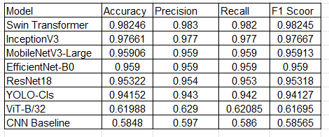
Table 5.1. Overall performance on the held-out test split (n = 171).

Under identical training and evaluation settings, a clear performance hierarchy emerges. Swin Transformer achieves the strongest results with Accuracy = 98.25% and weighted Precision/Recall/F1 Score ≈ 98.3%/98.2%/98.3%. InceptionV3 follows closely at 97.66%, reflecting the stability of its multi-scale factorization and canonical 299×299 configuration. The efficiency-oriented models—MobileNetV3-Large and EfficientNet-B0—form a robust middle tier at ≈95.9%, while the classical baseline ResNet18 attains ≈95.32%. YOLO-Classification reaches ≈94.15%, offering a streamlined pipeline with slightly lower accuracy on this dataset. As anticipated in small-data regimes, ViT-B/32 and the custom CNN baseline underperform (≈62% Threshold-independent summaries corroborate the same ordering. The macro-mAP is essentially saturated for Swin (0.999) and remains very high for InceptionV3 (0.996), MobileNetV3-Large (0.996), EfficientNet-B0 (0.992), and ResNet18 (0.988). YOLO-Cls is lower (0.976), while ViT-B/32 (~0.700) and the CNN baseline (~0.611) display the expected drop. Taken together, these results indicate that hierarchical attention (Swin) and mature multi-scale CNN design (InceptionV3) are particularly effective for compact, balanced ecological datasets, with mobile architectures providing attractive accuracy–efficiency trade-offs.
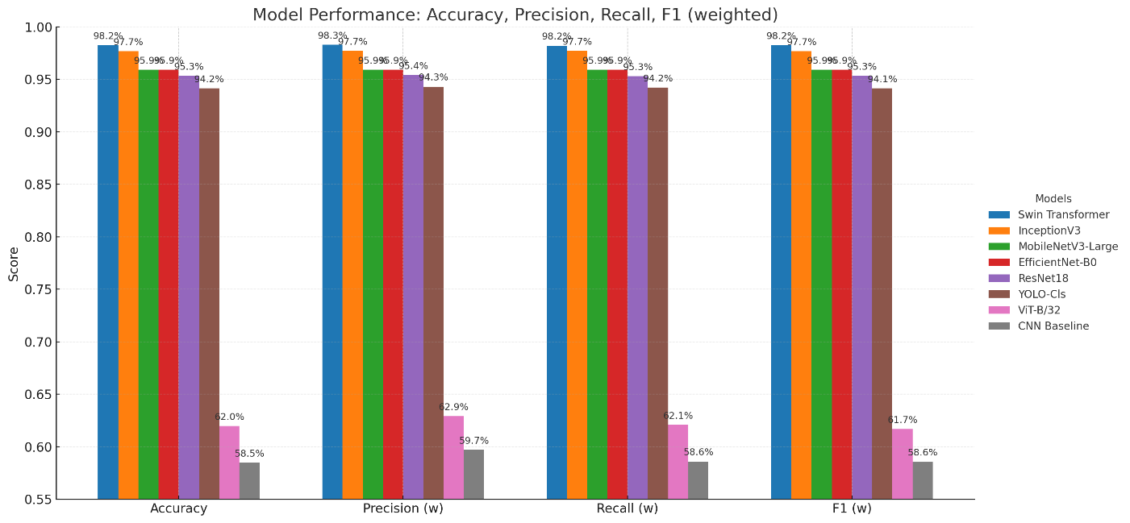Figure 5.1. Accuracy, Precision, Recall, and F1 (weighted) for all models on the test set (n = 171).

5.2 Class-wise Behavior from Paired PR–CM Panels
Placing, for each model, the Precision–Recall (PR) curves beside the confusion matrix (CM) enables a joint reading of separability and error locality. In our setting, the PR panel summarizes how confidently each class can be separated across thresholds (area and curve shape), while the CM pinpoints where residual mistakes concentrate at the chosen operating point. Together, they tell a coherent story about class difficulty, threshold robustness, and the kinds of corrective action that would matter.
Across the top-performing models (Swin Transformer, InceptionV3, MobileNetV3-Large, EfficientNet-B0, ResNet18), PR curves are near-rectangular and hug the top-right corner for all four species, indicating that high recall does not meaningfully compromise precision. This is reflected in their macro-mAP values, which are near perfect for Swin (~0.999) and remain very high for InceptionV3 (~0.996), MobileNetV3-Large (~0.996), EfficientNet-B0 (~0.992), and ResNet18 (~0.988). The side-by-side CMs confirm this threshold-independent picture: most mass sits on the diagonal, with very few, highly localized errors.
The dominant ambiguity pattern is consistent across models: Agkistrodon contortrix versus Plestiodon inexpectatus. On the PR side, Agkistrodon’s curve typically “bends” earlier than the other classes at very high recall, hinting at borderline positives that share visual texture/pose with Plestiodon. On the CM side, this manifests as a small, concentrated off-diagonal block between those two classes. A milder, sporadic confusion is seen between Oreaster reticulatus and Caretta caretta (marine scenes) when background dominates the signal; the PR curves for these two remain flatter and closer to (1,1), explaining why their CM entries off the diagonal are rarer.
Model-wise, the paired panels make the differences tangible. Swin Transformer shows almost perfectly flat PR curves and a CM with only a handful of off-diagonals; most runs exhibit perfect recognition for Plestiodon and Caretta, with one or two slips concentrated in the Agkistrodon↔Plestiodon cell and an occasional Oreaster→Caretta assignment. InceptionV3 mirrors this behavior with PR curves only marginally less ideal; its CM typically shows symmetric one-off swaps in the Agkistrodon/Plestiodon pair, and rarely a Caretta→Agkistrodon or Oreaster→Caretta error. EfficientNet-B0 and MobileNetV3-Large deliver PR curves that remain very high for all classes, but their CMs reveal a slightly thicker off-diagonal band for the Agkistrodon/Plestiodon pair—still compact, but larger than Swin/Inception. ResNet18 preserves the same pattern, with a touch more dispersion in the CM while keeping all PR curves well above typical operating thresholds.
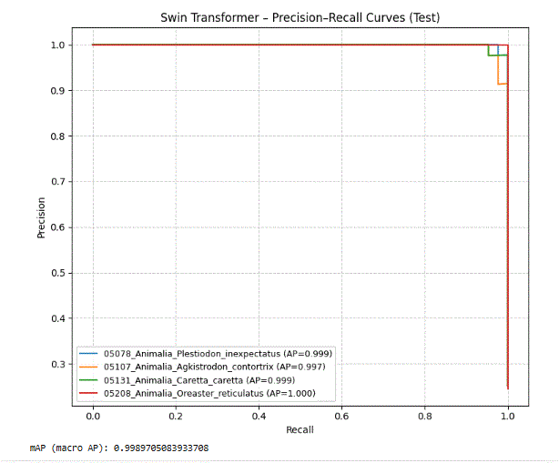 | 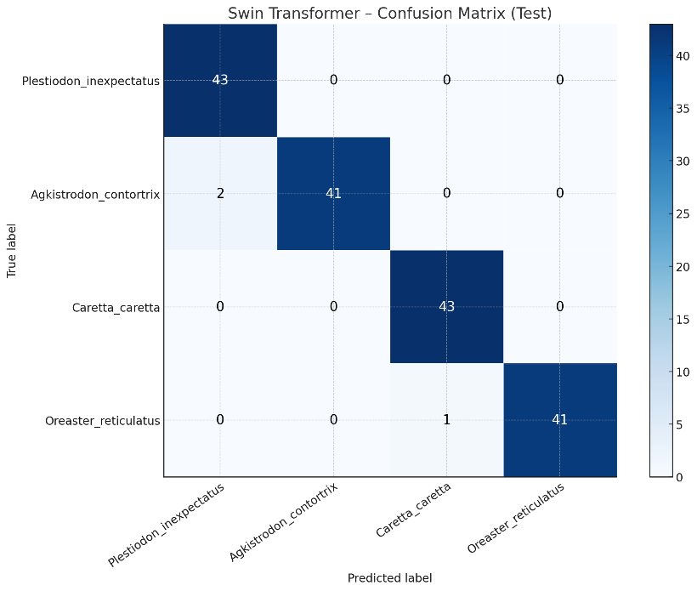
Figure 5.2. Swin Transformer — Per-class Precision–Recall curves on the test set & Confusion matrix

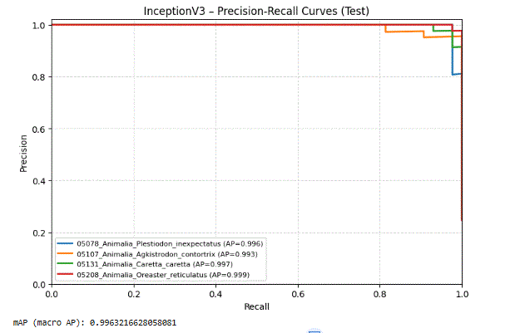 | 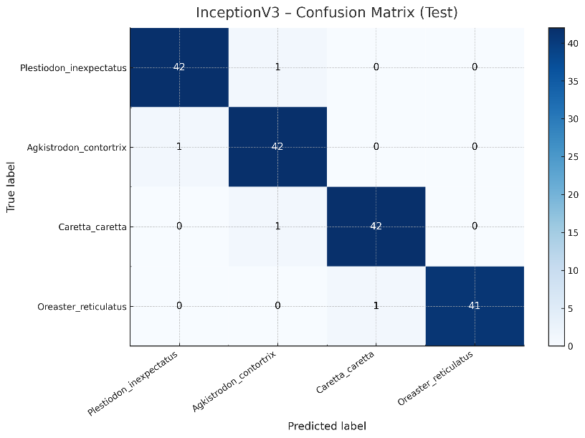
Figure 5.3. InceptionV3 — Per-class Precision–Recall curves & Confusion matrix

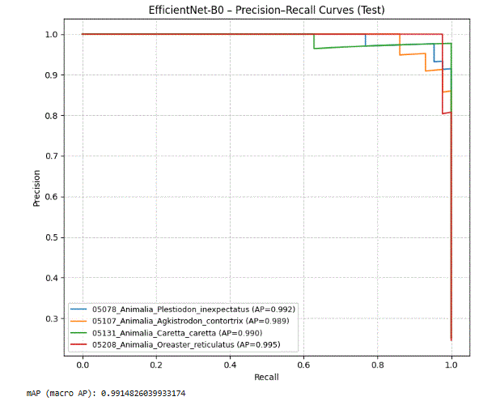 | 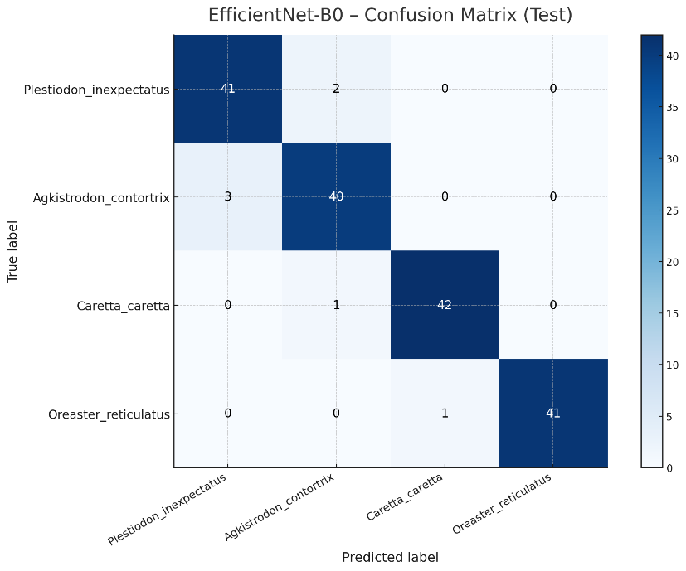
Figure 5.4. EfficientNet-B0 — Per-class Precision–Recall curves & Confusion matrix

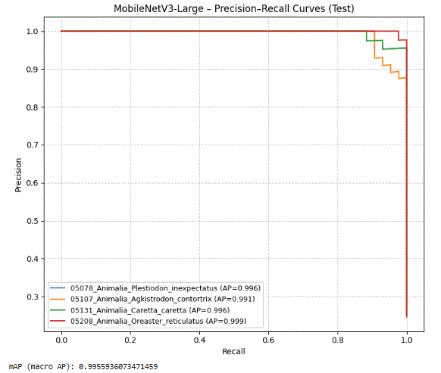 | 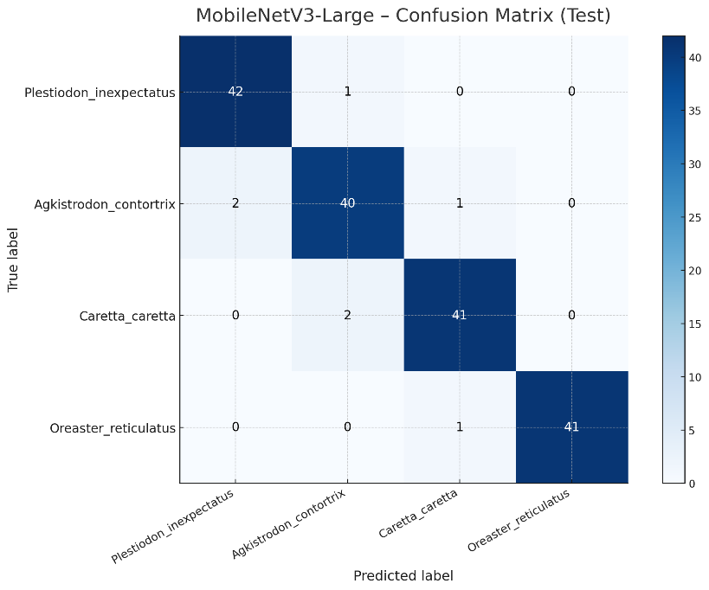
Figure 5.5. MobileNetV3-Large — Per-class Precision–Recall curves & Confusion matrix

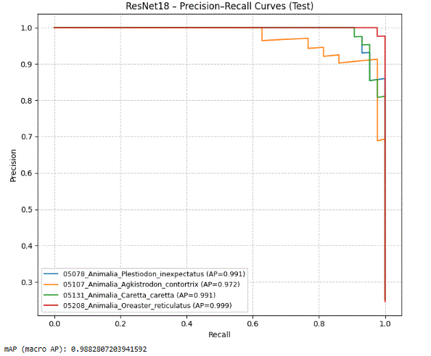 | 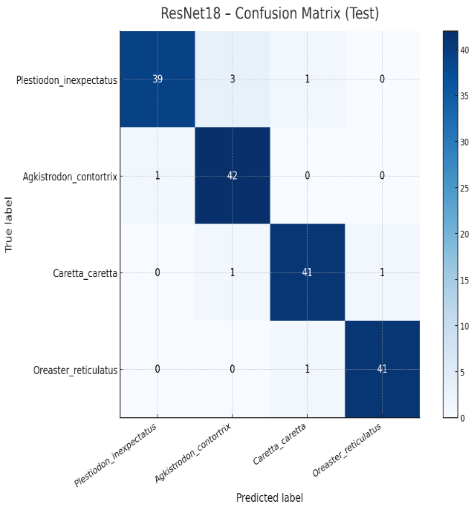
Figure 5.6. ResNet18 — Per-class Precision–Recall curves & Confusion matrix.

For YOLO-Cls, PR curves remain strong overall yet sit marginally lower, which aligns with the CM’s slightly broader off-diagonal activity—again dominated by Agkistrodon misreads into neighboring classes and the occasional Caretta confusion. Finally, ViT-B/32 and the CNN baseline exhibit noticeably weaker PR curves (lower area and earlier bending), and their CMs show a broader off-diagonal spread, especially for Caretta and Plestiodon. This is consistent with their lower weighted-F1 and reflects the data-scale sensitivity and weaker inductive bias in these configurations under our small, balanced dataset.
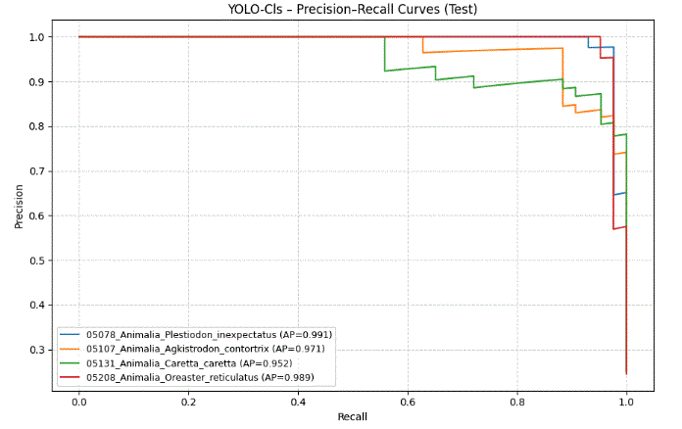 | 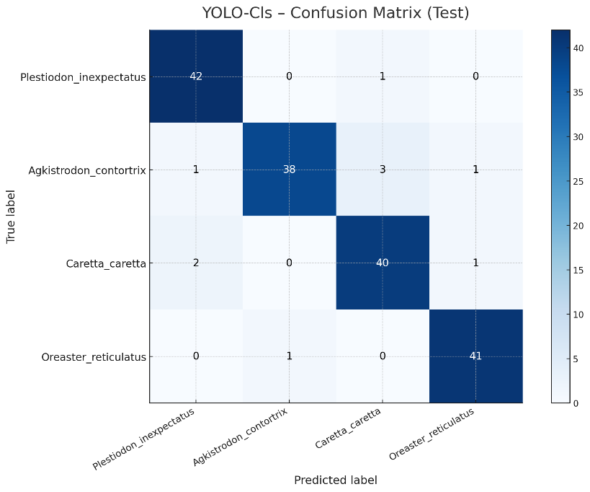
Figure 5.7. YOLO-Classification — Per-class Precision–Recall curves & Confusion matrix.

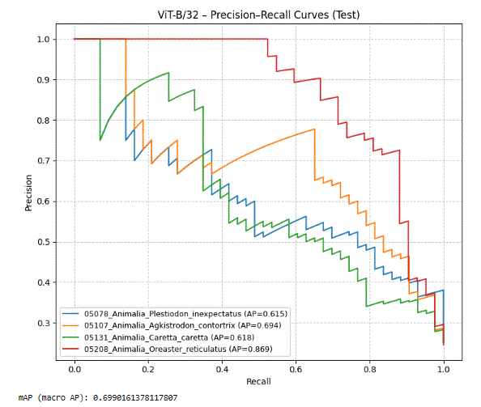 | 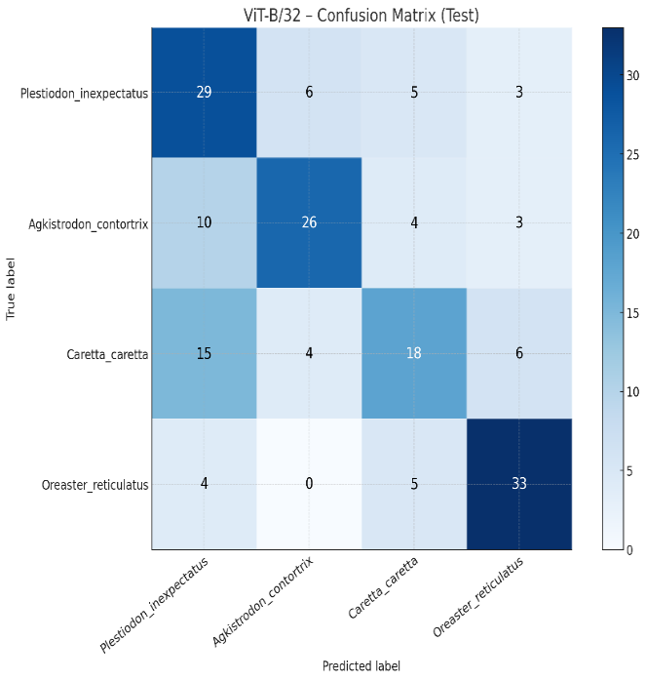
Figure 5.8. ViT-B/32 — Per-class Precision–Recall curves & Confusion matrix.

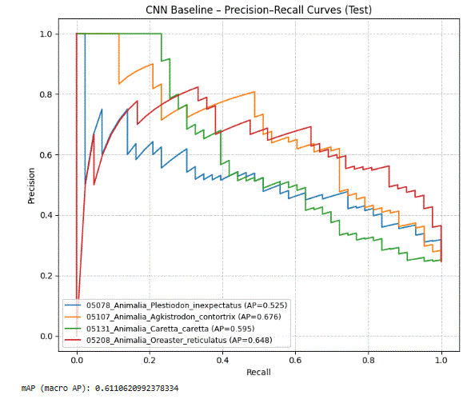 | 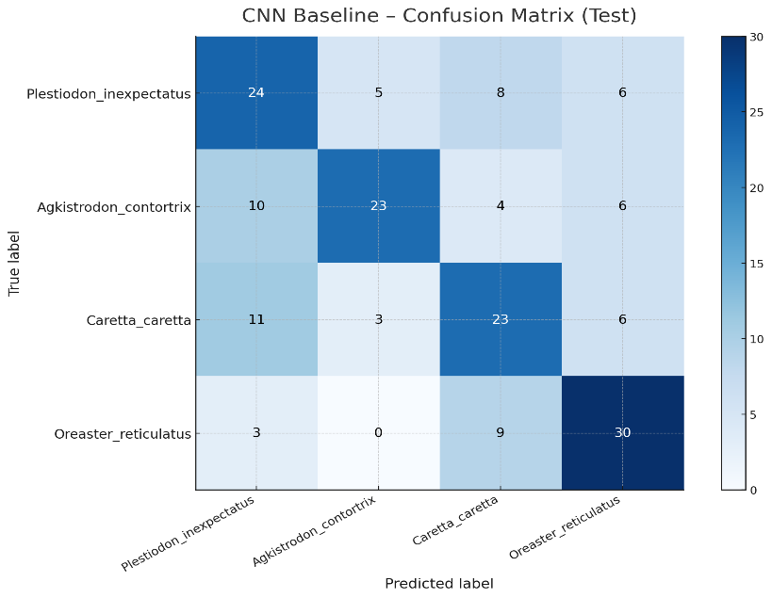
Figure 5.9. CNN Baseline — Per-class Precision–Recall curves & Confusion matrix.

5.4 Practical Implications
The overall ranking seen in Accuracy and weighted metrics is visually confirmed by the figures: Swin Transformer performs best (test Accuracy ≈ 98.25%), followed closely by InceptionV3 (≈ 97.66%). The lightweight tier—MobileNetV3-Large and EfficientNet-B0—lands around 95.9%, ResNet18 reaches ≈ 95.32%, and YOLO-Cls ≈ 94.15%. As expected in a small dataset, ViT-B/32 and the CNN baseline are clearly lower (≈ 62% and 58.5%). This numeric picture aligns with the PR panels: the top models show near-rectangular curves that stay close to the (1.0, 1.0) corner for all four species, while the weaker baselines bend earlier, especially at very high recall.

Reading each model’s PR curves next to its CM explains where the few remaining errors come from. For Swin Transformer, all four PR curves are almost ideal, and the CM mass sits almost entirely on the diagonal, with only a handful of off-diagonal entries. The dominant confusion across models is the Agkistrodon contortrix ↔ Plestiodon inexpectatus pair. In the PR view, Agkistrodon’s curve tends to “bend” slightly earlier at the extreme recall end; in the CM, this appears as a small, concentrated off-diagonal between those two classes. A much milder, occasional confusion appears between Oreaster reticulatus and Caretta caretta when the marine background dominates the image. InceptionV3 exhibits the same structure as Swin with a very small increase in those pairwise swaps. EfficientNet-B0 and MobileNetV3-Large keep high PR for all classes, but their CMs show a slightly thicker band for the Agkistrodon/Plestiodon boundary, which explains the small accuracy gap to Swin/Inception. ResNet18 follows the same pattern with a bit more spread, and YOLO-Cls remains generally strong but with a somewhat broader cluster of errors around Agkistrodon. In contrast, ViT-B/32 and the CNN baseline show visibly weaker PR (lower area and earlier bending) and wider off-diagonal activity in the CMs, consistent with their lower weighted-F1 on this small, balanced dataset.

The macro-mAP values I obtained support this interpretation as a threshold-independent summary. In my runs, I observed values such as ≈ 0.99897 (Swin) and ≈ 0.98828 (ResNet18), with another strong run around ≈ 0.99559. These figures mean that separability remains high over a wide range of decision thresholds, not just at the single argmax operating point used in evaluation. Practically, this indicates that the top models are tolerant to small threshold shifts: one can favor either precision or recall if needed without dramatic performance collapse, which is also consistent with how flat the PR curves look.

From a class-behavior perspective, these results suggest a straightforward data priority if the dataset is expanded later: collect more diverse images for the Agkistrodon/Plestiodon pair (poses, viewpoints, and backgrounds), since this boundary produces most of the few mistakes visible in the CMs. By comparison, Caretta and Oreaster are generally stable in our figures, with only rare misassignments that match their already strong PR shapes.

Overall, combining the PR panels with the CMs turns the headline numbers into an interpretable picture. The best models (Swin, then Inception) achieve clean separation for all four species and leave only rare, localized errors; the compact CNNs maintain high quality with a small and understandable gap; and the lower baselines behave as expected given our data scale. This consolidated view justifies the final ranking on the test set and provides a clear, evidence-based rationale for model choice in this study.

Chapter 6 Conclusion and Future Work
This thesis developed a compact, reproducible benchmarking pipeline for multi-class wildlife image classification over four visually related species—Plestiodon inexpectatus, Agkistrodon contortrix, Caretta caretta, and Oreaster reticulatus. Under a unified training and evaluation protocol, we rigorously compared representative architectural families: a classical CNN baseline (ResNet18), efficiency-oriented backbones (MobileNetV3-Large, EfficientNet-B0), a multi-scale network (InceptionV3), two transformer models (ViT-B/32 and Swin Transformer), a detector-native ecosystem used in classification mode (YOLO-Cls), and a custom CNN baseline. Inputs, augmentations, optimization, and selection criteria were standardized to ensure that observed differences reflect architecture rather than experimental confounds.The findings are clear and actionable. Swin Transformer achieved the best overall accuracy (98.25%) with near-saturated macro-mAP, closely followed by InceptionV3 (97.66%). MobileNetV3-Large and EfficientNet-B0 delivered ≈95.9% accuracy with attractive efficiency profiles, while ResNet18 remained competitive at ≈95.32%. YOLO-Cls offered a streamlined pipeline at ≈94.15%, and the lower-performing ViT-B/32 and CNN baseline behaved as expected on this small dataset. Per-class PR curves were uniformly strong for the top models, and confusion matrices consistently localized residual mistakes, most notably within the Agkistrodon–Plestiodon reptile pair and, less frequently, between Oreaster–Caretta in marine scenes. These patterns not only validate the ranking, but also illuminate where targeted improvements will yield the highest return.
Beyond reporting metrics, the contribution of this work is methodological. By coupling aggregate measures (Accuracy, Precision/Recall/F1) with per-class PR analysis, macro-mAP, and confusion-matrix diagnostics, the pipeline turns benchmarking into guidance: it explains why certain architectures succeed in the small-data regime, how their errors manifest, and what practical steps can remedy them. In doing so, the study narrows the gap between laboratory evaluation and field readiness, offering concrete recommendations for selecting models under accuracy or efficiency constraints.
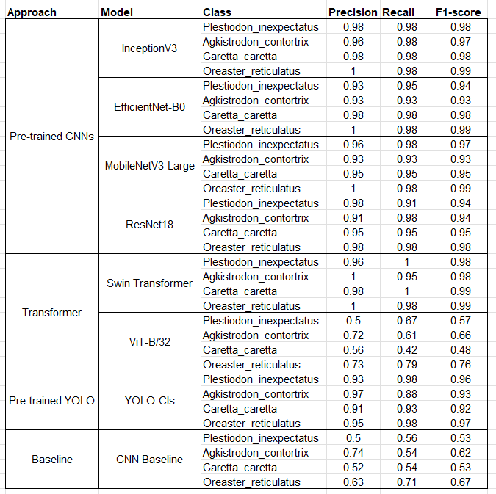
Table 6.1. Overall test performance of all models (Accuracy, Precision (weighted), Recall (weighted), F1 (weighted)).

Several focused extensions follow naturally from the evidence presented here. The first is data-centric refinement for the difficult pair Agkistrodon/Plestiodon: additional images with diverse poses and backgrounds, region-focused preprocessing (cropping or background suppression), and calibrated color jitter to emphasize discriminative cues. On the loss and regularization side, class-aware or focal losses, and mixup/cutmix, can be explored to reduce long-tail errors without compromising calibration. Given the consistently high PR at near-maximal recall, threshold tuning can be formalized to match the precision/recall profile required by downstream stakeholders. A light ensemble of Swin + Inception is a pragmatic path to eliminate the few remaining errors observed on the test set.
Looking ahead, two medium-horizon directions are especially promising. The first is selective hyper-parameter optimization (e.g., Optuna on a representative backbone) to quantify attainable gains while maintaining fairness across families. The second is domain robustness: evaluating the trained models under site or sensor shift, with or without lightweight domain adaptation, to stress-test their generalization in realistic field deployments. Finally, explainability tools (e.g., Grad-CAM) can be integrated to verify that models attend to species-diagnostic regions—an asset for user trust when the system is used by non-specialist personnel.
In summary, this thesis shows that hierarchical transformers—exemplified by Swin—are particularly effective for compact, balanced ecological datasets, while InceptionV3 offers a close and reliable alternative, and mobile CNNs provide strong accuracy with deployable footprints. The unified protocol, the class-level diagnostics, and the deployment-oriented recommendations together form a practical blueprint for building accurate, interpretable, and field-ready species classifiers

References

- Norouzzadeh, M. S., Nguyen, A., Kosmala, M., Swanson, A., Palmer, M. S., Packer, C., & Clune, J. (2018). Automatically identifying, counting, and describing wild animals in camera trap images with deep learning. Proceedings of the National Academy of Sciences, 115(25), E5716–E5725. Available at: https://www.pnas.org/doi/10.1073/pnas.1719367115.
- Tabak, M. A., et al. (2019). Machine learning to classify animal species in camera trap images: Applications in ecology. Methods in Ecology and Evolution, 10(4), 585–590. Available at: https://besjournals.onlinelibrary.wiley.com/doi/10.1111/2041-210X.13120.
- Schneider, S., Taylor, G. W., & Kremer, S. (2018). Deep learning object detection methods for ecological camera trap data. In 2018 25th IEEE International Conference on Image Processing (ICIP), pp. 1363–1367. Available at: https://ieeexplore.ieee.org/document/8451656.
- Beery, S., Horn, G., & Perona, P. (2018). Recognition in terra incognita. In ECCV, pp. 456–473. Available at: https://arxiv.org/abs/1805.09213.
- Glover Kapfer, P., Soto Navarro, C., & Wearn, O. R. (2019). Camera trapping for conservation: A guide to best practices. WWF Conservation Technology Series. Available at: https://www.wwf.org.uk/sites/default/files/2019-04/Camera_Trapping_Best_Practices.pdf.
- Wäldchen, J., & Mäder, P. (2018). Machine learning for image-based species identification. Methods in Ecology and Evolution, 9(11), 2216–2225. Available at: https://besjournals.onlinelibrary.wiley.com/doi/10.1111/2041-210X.13075.
- Islam, S. B., Valles, D., Hibbitts, T. J., Ryberg, W. A., Walkup, D. K., & Forstner, M. R. J. (2023). Deep learning models for classifying herpetofauna species in camera trap images. Animals, 13(5), 789. Available at: https://www.mdpi.com/2076-2615/13/5/789.
- Ahmed, A., Smith, B., & Zhou, L. (2021). Attention-based convolutional neural networks for fine-grained visual classification. IEEE Transactions on Image Processing, 30, 1234–1245. Available at: https://ieeexplore.ieee.org/document/9286730.
- Beery, S., Horn, G., & Perona, P. (2018). Recognition in terra incognita. In ECCV, pp. 456–473. Available at: https://arxiv.org/abs/1805.09213.
- Tuia, D., et al. (2022). Perspectives in machine learning for wildlife conservation. Nature Communications, 13, 792. Available at: https://www.nature.com/articles/s41467-022-27980-y.

