

Operating System Home work
PAGE ALLOCATION AND LOAD IT
Page Allocation
- In Operating System :

Is the process of allocating Physical memory pages to processes. And it’s usually done when a process is created or when it requested more memory

- In Computing :
Is the assignment of physical memory pages to virtual memory addresses as it’s a form of memory management .

- Linux uses the Buddy algorithm to effectively allocate and deallocate blocks of pages. The page allocation code
attempts to allocate a block of one or more physical pages. Pages are allocated in blocks which are powers of 2 in size as the figure below :

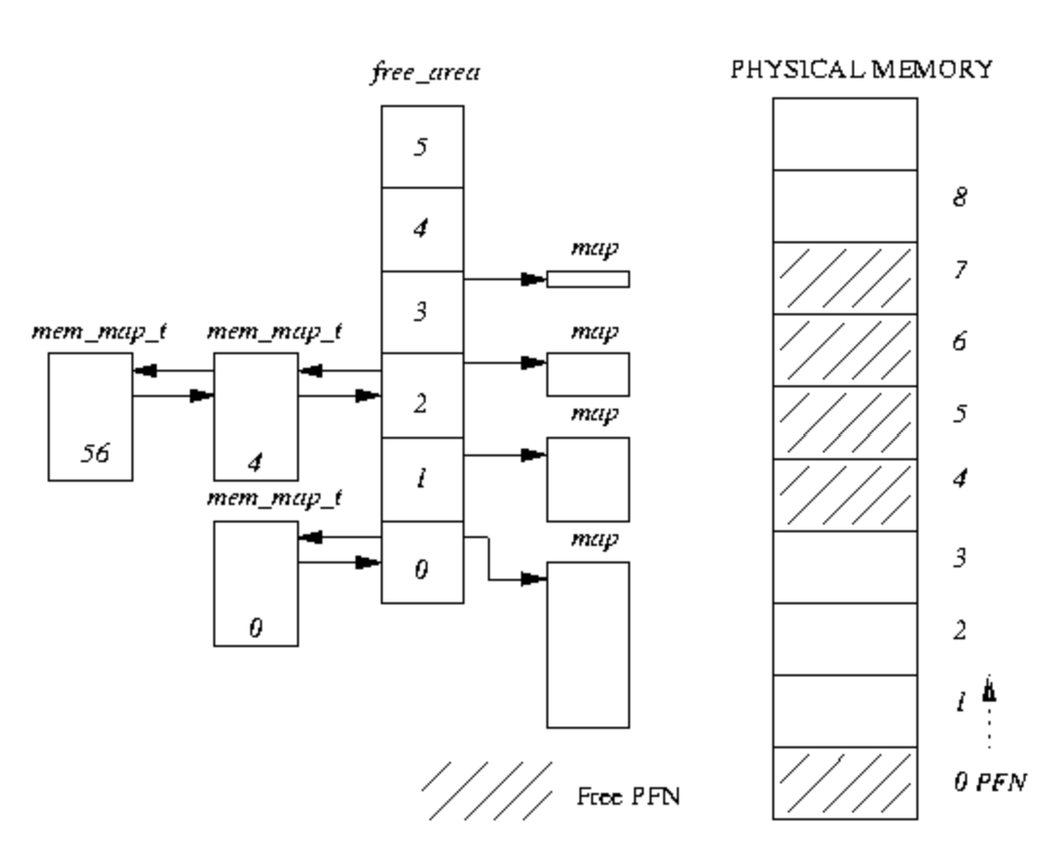
When an image is executed, the contents of the executable image must be brought into the processes virtual address space. The same is also true of any shared libraries that the executable image has been linked to use. The executable file is not actually brought into physical memory, instead it is merely linked into the processes virtual memory. Then, as the parts of the program are referenced by the running application, the image is brought into memory from the executable image. This linking of an image into a processes virtual address space is known as memory mapping

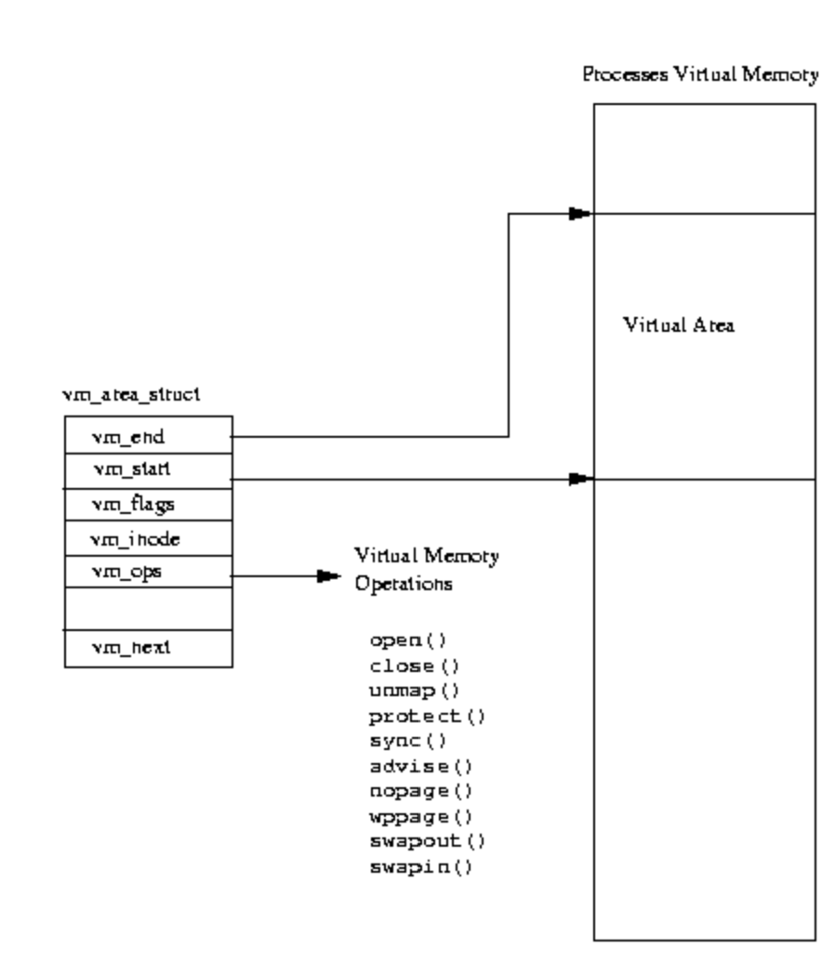

very processes virtual memory is represented by an mm struct data structure. This contains information about the image that it is currently executing (for example bash) and also has pointers to a number of vm_area_struct data structures. Each vm_area_struct data structure describes the start and end of the area of virtual memory, the processes access rights to that memory and a set of operations for that memory. These operations are a set of routines that Linux must use when manipulating this area of virtual memory. For example, one of the virtual memory operations performs the correct actions when the process has attempted to access this virtual memory but finds (via a page fault) that the memory is not actually in physical memory. This operation is the no page operation. The no page operation is used when Linux demand pages the pages of an executable image into memory.

MARYAM HUSSAIN
26-11-2022

