

Drive Guard: AI-Powered Driver Monitoring System for Drowsiness Detection and Road Safety.

Prepared By
Name: Raghad AbdulAlem Hassan Muammar
ID No.: 243000043

Submitted in fulfillment of the requirements for the degree Master of Science in Artificial Intelligence
At
Collage of Informatics
Midocean University
UAE
Supervisor Name: Yasser Abdelhamid
Collage of Informatics, Midocean University, Comoros

Acknowledgements
I would like to extend my special thanks to Dr. Yasser Abdelhamid for his exceptional guidance, valuable insights, and unwavering support throughout the course of this project.

His expert advice and continuous encouragement have played a vital role in the successful completion of this thesis.

I am truly grateful for the time, effort, and dedication he has invested in helping me achieve my goals.

Abstract
Drowsiness and syncope are considered the most significant risk factors for severe traffic accidents. To address these safety problems, this project presents "Drive Guard", an intelligent, AI-based driver monitoring system that actively analyzes facial expressions, eye movement and objective measures of relevant behaviors through a high-definition camera in the vehicle, detecting driver drowsiness and syncope. Drive Guard also provides an acoustic alarm of drowsiness to the driver, intervening with an alert to prevent true accidents, and if evidence of syncope is detected, it can provide an automatic response:
“Drive Guard” immediately sends an emergency alert to local services so security of the driver can then be guaranteed. “Drive Guard”, a qualitative leap in safeguards for drivers and other highway users, is the most complete solution for reducing accidents on the road due to fatigue and impairment.

List of Publications

Raghad AbdulAlem Hassan Muammar. Dr. Yasser Abdelhamid. “Drive Guard: AI-Powered Driver Monitoring System for Drowsiness Detection and Road Safety”. Manuscript in preparation for submission to *MidOcean Journal for Research and Studies*.

Drive Guard: AI-Powered Driver Monitoring System for Drowsiness Detection and Road Safety. ii
Acknowledgements iii
Abstract iv
List of-Publications v
List of-Abbreviations viii
List of-Figures ix
List of Tables ix
Chapter 1: Introduction 2
1.1 Problem Definition 3
1.2 Thesis Objectives 4
1.3 Thesis Contribution 5
1.4 Thesis Organization 5
Chapter 2: Background 7
Chapter 3: Related Work 15
3.1 Related Work-Summary 17
Chapter 4: Proposed Approach 19
4.1 Introduction 19
4.2 Dataset Description 19
4.5 System Workflow 21
Chapter 5: Experimental Results and Discussion 24
5.1 Experimental Setup 24
5.3 Results 27
5.4 Real-Time Testing 28
5.5 Discussions 29
5.6 Summary 30
Chapter 6 Conclusion and Future Work 31
6.1 Conclusion 31
6.2 Future-Work 32
References 33
Appendix A: Source Code for DriveGuard System 35
A.1 Model Architecture 35
A.2 Training Procedure 35
A.3 Model Saving 36
A.4 After Training 36
A.5 Model Loading 36
A.6 Single Image Prediction 36
A.7 37
A.8 Live Camera Detection 37

List of Abbreviations

- AI: Artificial Intelligence
- API: Application Programming Interface
- CNN: Convolutional Neural Network
- DDD: Driver Drowsiness Detection
- DL: Deep Learning
- DMS: Driver Monitoring System
- ECG: Electrocardiogram
- EEG: Electroencephalography
- EMG: Electromyography
- FPS: Frames Per Second
- GAN: Generative Adversarial Network
- GCN: Graph Convolutional Network
- GPS: Global Positioning System
- IR: Infrared
- JPG: Joint Photographic Experts Group
- LBP: Local Binary Pattern
- LSTM: Long Short-Term Memory
- ML: Machine Learning
- NHTSA: National Highway Traffic Safety Administration
- OPM: Oculomotor Parameters Monitoring
- RGB: Red Green Blue
- SOS: Save Our Souls (universal distress signal)
- SSD: Single Shot Multibox Detector
- SVM: Support Vector Machine

List of Figures
Figure 1Sample image showing the “open eyes” 1 21
Figure 2Sample image showing the “open eyes” 2 21
Figure 3Sample image showing the “open eyes” 3 21
Figure 4Sample image showing the “close eyes" 4 21
Figure 5Sample image showing the “close eyes" 5 21
Figure 6Sample image showing the “close eyes" 6 21
Figure 7System Workflow Diagram 23
Figure 8 CNN Model Architecture 25
Figure 9Accuracy & Loss Function 26
Figure 10 Confusion matrix 27
Figure 11Real-Time Output 28
Figure 12 WhatsApp emergency Message with driver location 29

List of Tables

Table 1Related Work Summary 17
Table 2 Dataset 19

Chapter 1: Introduction
Artificial Intelligence is the progress of computer systems that are capable of doing things which until now required human intelligence. AI is capable of learning, reasoning, and self-correction that enables machines to perform tasks which typically require human intelligence (Russell, 2020). AI has been applied in many fields like medicine, robotics, financial market forecasting or voice/image recognition or gaming but firing use specially can be found in functions of autonomous vehicles.
AI has become a key part of the transportation sector, improving safety and efficiency. We have been largely dependent on the likes of AI in this particular space with one of the top applications being Driver Monitoring Systems (DMS). Drive AI also has its own set of transporters to use AI algorithms in order to monitor behavior behind those wheels for signs of potential impairment, alerting drivers and avoiding tragedies. (Babu, 2021)

There are nearly automatic feelings of tiredness and fatigue to which lead to any extent, a lo ss of reaction time and alertness in those drivers who drive too much for too long.
In addition, research has indicated that the cause of fatal-to-the-driver crashes is driver fatigue in 31% of the crashes. (Williamson, 2013) ((NHTSA), 2015)

Common approaches to drowsiness detection focus on vehicle behavior (like lane deviations and sudden breaking) (Desai, 2015). These approaches, however, cannot offer immediate contextual assessments of a driver's state. These advancements in AI have enabled systems to use sensors and cameras to assess physiological expressions such as eye movements, facial expression, and head position to identify early signs of drowsiness (Zhao, 2020). These systems can, on detection, warn the driver via auditory or visual signals, thereby reducing the likelihood of fatigue-related accidents. (Abdar, 2021).
Next to drowsiness, distraction is the other top safety risk for drivers. Drowsiness could be detected in a millisecond when done correctly by an AI, unlike the DMS (Driver Monitoring System) which can only keep track of some basics indicators like the driver's face or position, while they are not driving next to our location (AP) (Sivaraman, 2013). If the system notices driver distraction of any kind, it can provide feedback to the driver about maintaining attentiveness to the road. (Dasgupta, 2019)

DMS is not the without challenges in AI implementation. This is an important concern that needs to be controlled considering the lack of homogeneity of the road Vs driver types in the real world (Awais, 2017). Also, privacy concerns regarding driving habits need to be tackled before it can be widely accepted. Nevertheless, we must be careful that the technology is not abused and that any personal and confidential information gathered is safely stored.

The monitoring of driver behavior through AI is undoubtedly an important technological door closer that needs to be opened for automotive safety. With the correlated results of real-time physiological changes in a driver (drowsiness and distraction) while operational, this DMS is AI-enabled.

Problem Definition
Accidents cause by impaired drivers caused by drowsiness and fainting is a big issue today due to insufficient road safety. Numerous studies have established that less alertness of drivers is causatively linked to road accidents, and are highly concerned regarding preventing these situations from ever reaching the point of crisis.

The Drive Guard project is an AI-powered platform, which addresses these concerns. Traditional systems are only capable of providing warnings about drowsiness, whereas "Drive Guard" can detect the earliest signs of fatigue, as well as even fainting.

The platform takes advantage of high-resolution cameras and sophisticated machine learning algorithms, calibrated to recognize the most subtle variances in a person body language appropriateness, facial expressions, eye movement and other behavior cues to provide people with real time feedback and alerts about their monitored behavior. This idea, which can significantly help curb accidents stemming from fatigue, can make the roads safer for us all and potentially save lives.
Drive Guard is a unique way to enhance driver monitoring and road safety by integrating real-time AI-based monitoring systems with an automated emergency handling response action system, allowing us to explore a systematically improvement of accident risk from driver impairment, utilizing proactive measures to prevent crash induced accidents in the first place and also speed up response time when a response to an incident is required.

1.2 Thesis Objectives
This project intends to make a driver monitoring system that enhances road safety by detecting drowsiness and medical emergencies, and then mitigates them. The objectives are:
Create a real time AI model whereby we can identify facial gestures, eye movements,
and body language to detect deviations in the driver state such as drowsiness and
unconsciousness.
Be able to distinguish between drowsiness and fainting by identifying unique
behavioral and physiological profiles which distinguishes the two states.
We can suggest the build of a real-time alarm to sound the driver to their mapping
capabilities when he/she becomes drowsy, thereby stopping a total loss of what the driver is truly doing while on the highway.
Create an automated emergency response which:
• Will send an SOS Distress Signal to emergency services
• Will send the drivers GPS location which enables a faster response from rescuers
The system robustness and accuracy across conditions (day vs night, different illuminations, different driving speeds)
Gain insights into creating solutions for AI driver safety technologies by addressing some the current gaps in research.

1.3 Thesis Contribution
This thesis highlights some significant contributions to the area of driver drowsiness detection using deep learning methods:
Eye State Detection Using CNN
The project is a real-time eye state detection system using Convolutional Neural Network (CNN), which is an efficient behavioral cue for drowsiness.
The use of dataset
Training the dataset includes real human face-eyes from subjects with a wide range of ages, races, and view angles, and also synthetic images made with cutting edge AI algorithms. This is to obtain model robustness and generalization for different driver profiles to increase diversity in the dataset and maintained density of the dataset.
Optimized CNN architecture
A custom CNN model for eye state classification in different lighting and environmental challenges, achieving a pleasant accurate and stable output
Real-Time Alert and Decision System
Based on the classification of the eye state, the proposed system sends timely alerts to identify early signs of drowsiness.
Simple and Practical Implementation
With the use of camera input and CNN-based analysis, it is possible to build scalable and feasible systems for adoption in cars without expensive hardware.

1.4 Thesis Organization
The thesis has six chapters, which convey the primary aspects of developing an intelligent system for detecting driver drowsiness and syncope based on computer vision and deep learning methods. The thesis will attempt to encompass the research in a coherent and logical manner, from the definition of the problem to the evaluation of the solution.
The first chapter provides a general overview of the issue of drowsiness and syncope while driving and its importance for road safety. It details the objectives of the research and underlying major contributions and presents the general thesis structure.
In the second chapter presents the theoretical background to driver monitoring technologies with a concentration on managing fatigue and drowsiness. It further covers the most common methods and sensors applied and justifies the need for vision-based solutions.
In the third chapter, we present a literature review on studies on drowsiness detection. It reviews behavioral and physiological signal-based techniques, focusing on machine learning and computer vision applications, and highlights specific research areas for future work that this research may fill.
The fourth chapter describes the proposed CNN-based method. It presents data acquisition, image preprocessing, model architecture design, and a classification mechanism to recognize the driver's states.
The fifth chapter divulges the results of the training and testing of the CNN model, and evaluates the model's performance while comparing related metrics. This chapter is concluded with a critique of the merits and shortcomings of the study and a comparison to the literature.
The last chapter will summarize the key take-aways and contributions of the study for driver safety systems, as well as summarize possible future avenues for enhancing the robustness and viability of the model in a variety of environments and situations.

Chapter 2: Background
Accidents caused by drowsy driving and people suffering from cardiac disease are the top causes of injury, and death in all over the world.
Drowsiness slows reaction time and therefore, a motorist’s ability to make good decisions, leading to a drastically higher chance of an accident. In extreme cases, this can result in loss of control of the vehicle, and therefore greatly increases the risk of fatal crashes. Current driver monitoring systems are mainly focused on detecting whether a driver has dozed off yet are unable to accurately recognize a fainting driver or manage state-level emergency response, putting driver and passenger safety at significant risk.
To tackle the dangers which lie from driver drowsiness and fainting, this project proposes “Drive Guard”, an artificial intelligence-based driver monitoring system which aims to improve road safety by analyzing the driver’s facial expressions and behaviors in real-time. Napping drunk drivers stop the car with the closing of the eyes alone; “Drive Guard”
employs advanced computer vision and machine learning algorithms to process a range of drowsiness signals that include eye movement patterns, the facial expression of the driver, head tilt angles and body purses.
There are two primary modes of action:
Drowsiness detection - If the system detects drowsiness, it issues immediate aural alarms to the driver when they detect symptoms such as slow eye movements, prolonged blink duration, and nodding or head buckling to help refocus the driver.
Fainting detection & Emergency reaction: The system detects symptoms of drowsiness and dismisses it after prolonged closing (> 15s) and subsequently an absence of valid facial expressions, and there was no input of moving. The system will label it as a probable faint event. In such cases, “Drive Guard”:
• Sends an emergency notification to the medical services automatically
• Supports live GPS of the driver for quick response
“Drive Guard” integrates real-time AI-based monitoring systems with an automated emergency response system providing a novel approach to reduce accident risks caused by driver impairment through a proactive approach, preventing crashes and accelerating emergency response when necessary.
The following key questions are addressed in this research:
- What are the most reliable physiological and behavioral correlates for drowsiness detection and fainting in drivers?
- What kind of performance does AI-based driver-monitoring systems provides compared to traditional methods of detecting drowsiness?
- How accurately can we differentiate between states of fainting/drowsiness using deep learning techniques?
- How effective is the integration of real-time alert mechanisms and emergency response features in driver safety systems?
- What are the main technical barriers to deploying AI-powered driver monitoring systems across a multitude of driving scenarios?
In recent years, detecting drowsy driving has provided much attention, and has become an important issue due to the serious safety issues posed by tired and drug-intoxicated drivers.
At first, systems simply used relatively basic techniques to monitor what the driver was doing and how their physiological signs were behaving. Early methods tried to handcraft vehicle features, including steering and lane shifts and speed variations, to estimate fatigue. These behavioral cues might signal reduced attention or inhibition, and thus drowsiness. (Patel, 2011)
Similarly, physiological sensing techniques began to emerge whereby the state of a driver is directly assessed by collecting measures of cardiovascular activity, skin conductance, and electrical activity generated by the brain using EEG devices. While these metrics provided direct indications of fatigue, their applications were constrained by sensor intrusions and challenges in obtaining clean signals in on-the-move scenario. (Wang, 2020)
Simple camera systems also began to be used, which, by means of image processing with simple thresholds, could detect eye closure, yawning, or nodding the head. Early vision-based systems employed ad-hoc features (e.g., eye aspect ratio or blinking duration) to detect the presence of fatigue.
Yet they were generally sensitive to environmental conditions such as lighting, face pose, and occlusions, which made them not very robust. (Abtahi, 2014)
Computer vision and machine learning have improved systems' ability to automate complex visual feedback. The level of detail in faces was also well captured by high-resolution video recording cameras, and machine learning-based classifiers (such as support vector machines and decision trees) trained on manually derived features to discriminate between alertness states. Although these methods could have better detection performance than just using simple thresholding, they still require for the features to be designed manually and do not scale well over different scenarios. (Picot, 2012).
The inflection points really came with deep learning, specifically Convolutional Neural Networks (CNNs), which were capable of automatically learning hierarchical features directly from raw images. Convolutional Neural network (CNNs) is a model inspired by the human visual system and have 2 or more convolutional layers; we can add fully connected layer to achieve classification.
(e.g. edges, textures, and complex facial structures). This facilitates to detect eye states (open, close, blink), facial landmarks and micro-expression for fatigue automatically without any hand-crafted features by CNNs. In addition, contemporary CNNs such as ResNet and MobileNet have been designed to provide real-time computation on embedded systems, which is suitable for in-vehicle installation. (Zhang Z. Z., 2021)
Acknowledging that driver fatigue occurs gradually, temporal models such as the Long Short-Term Memory (LSTM) networks were used. LSTMs are a type of RNN capable of learning long-term dependencies in sequential data, which makes them appealing for processing video sequence or physiological signals, in which temporal patterns such as long-lasting eye closure or repetitive nodding indicate drowsiness. Such hybrid architectures that use CNNs for extracting spatial features and LSTMs for temporal dynamics are effective in developing early and timely fatigue detection. (Jiao, 2023)
In order to resolve data paucity issues, GANs have recently been introduced. GANs consist of two neural networks, a generator and a discriminator, which play a zero-sum game to produce realistic images of drivers or physiological signals. It is important to add synthetic examples of rare events like fainting or drowsiness that would be rare in programmatic data so that the model learns them conservatively leading to generalization and temporal robustness. (Zhang Y. W., 2022)
The Graph Convolutional Network (GCN) uses graphs instead of grid data to generalize convolutions.
Facial landmarks may be represented as nodes in a graph in driver monitoring and spatial and functional relationships as edges. The learned representation in GCNs utilizes such relational characteristics meaning that it can accurately recognize facial movements or subtle variations in head pose and occlusion. (Wang, 2020)
Commonly modern driver monitoring systems utilize a suite of data sources, including video, physiological signals, and contextual information (e.g. environmental conditions, time of day, etc.). The usage of multimodal fusion techniques combines complementary inputs for greater reliability and to minimize false positives. For example, each facial video analysis integrated with heart rate variability gives a better understanding of driver state than either modality on its own. (Patel, 2011)
There are also advantages to context-centric systems that adapt sensitivity of the system based on context and driver (e.g., alertness detection sensitivity is increased when the driver is driving in darkness or after sustained driving). There are enhancements to the user interface to reduce driver distraction due to false alarms and is more acceptable to the user. (Picot, 2012)
Nevertheless, in the on-road context of further deployment the robust development of good drowsiness detection systems to various driver profiles has encountered substantial challenges. Different facial characteristics, social practices, lighting, and position and placement of the sensors all hinder model generalizability. Practical issues also exist with limited computational resources, concerns about data privacy and the need for real-time systems. (Wang, 2020)
Now research is also looking at interpretability of deep learning models to ease and increase understanding for consumers and regulators.
There are also looking at adapting the system to adjust the detection thresholds based on individual driving profiles and driver habits. Development of vehicle control systems with pre-emptive measures to enhance safety, e.g., adaptive cruise control or automated braking is also an exciting future direction. (Zhang Z. Z., 2021)
Overall, the history of drowsy driver detection systems has transformed from passive developments in simply behavior monitoring, to intelligent, proactive systems with advanced Ai algorithm and multimodal data fusion technologies, which promise to save lives Vetter than serious injury from fatigue and fatigue-related crashes and can make the world roads safer.
In recent years, the urgent public safety concerns and advancements in intelligent transportation systems, have resulted - so far - in driver monitoring system from conception to a merger of great technological advances. Early on - Driver monitoring had a focus on explicitly observable external behaviors of driving like general lane-keeping, patterns and correcting steering to remain in lane, because these are very easy to collect from existing data the car gives, but does not always capture the more subtle but equally damaging - internal driver states (e.g., tiredness, cognitive distraction). The next iteration of driver-monitoring systems went to in-cabin monitoring with cameras and bio-sensors to directly provide insights into the driver's perceived physiological or mental well-being.
These technologies and improvements of hardware, such as IR based night vision cameras and multi-function EEG headbands, have advanced sensors for monitoring the user in the vehicle. This was one of the limiting factors with historic systems while today's technologies allow for data collection, even in low-lighting and noisy environments. Further, the availability of richer annotations has allowed better models to be developed for modeling both on-road rider and environmental behavior allow for modeling across population groups, vehicles, and scenarios.
In a similar fashion, multimodal data has been recognized as another powerful mechanism to improve the resiliency of a system. For example, we can look at combinations of facial landmarks with vital signals like heart rate variability (HRV) or respiration rate and increase sensitivity for subtle fatigue changes that may not be captured through facial data alone. By fusing signals across all these modalities, the system is responsive to different use cases where one of the modalities may be more reliable based on lighting, head orientation, or some other driver specific features. This absolutely improves user acceptability as it increases the potential for adaptation and makes erroneous false positives less likely.
Another interesting area of research is about the personalization, or individualization, of driver monitoring systems. Because each person's behavior in response to muscle fatigue is highly dynamic, typical static thresholds for monitoring behavior usually don't capture intersubject variability effectively. To address this, adaptive systems are being designed and will learn an individual's baseline over time and adapt sensitivity accordingly. If a driver has a higher natural blinking frequency for example, their individual characteristics may not fall outside of typical parameters unless they blink above a critical unique threshold. Having that individualized calibration makes the system much more trustworthy, and probably accurate.
At the same time, there is research into processing AI in-vehicle running from edge computing and low-power embedded devices to enable real-time inference. Edge computing has enabled instantaneous latency and better privacy compared to cloud systems that require that biometric data be sent to the cloud for processing. Optimized deep learning models too (for example, Mobile Net, Squeeze Net and Tiny-YOLO) are reducing barriers for viable solutions. Surely much of the attention has focused on driver drowsy and inattentive monitoring and as a response there have been some attempts that either became timely or fall into the category of either (unobtrusive but preparative).
Researchers note that a warning could become a false positive and drivers soon learn to ignore them or develop alert fatigue. Therefore, increasing numbers of intelligent alert systems are being designed to measure the ramifications of the driver's reaction, and regulate the level and frequency of feedback. A first sign of fatigue could generate a gentle chime; at other severe levels, a loud alarm or even vibrating padding in the seat.
One major challenge for good drowsiness detection system design is to find the balance between sensitivity and specificity. An extremely sensitive system, while able to identify every incident of fatigue, is likely to produce too many false positives which may disturb the driver and/or cause him/her to disable the system. An extremely specific system, on the other hand, may not deliver false positives but will perform poorly in identifying the first signs of drowsiness. This is the arduous part, and you need a lot of testing for feasible labeled datasets that employs proper handling of driving scenarios.
However, producing a decoder accurately is not always simple. Individuals incorporate cultural norms, age, gender and driving habits A younger driver may display more noticeable facial features in comparison to an older driver or eye contact and posture vary between cultures. Therefore, the combination of cross-cultural studies and the data can be a useful tool to make sure it is not bias training sets and to ensure that the models developed in those sets will act reasonably similarly for all individuals.
Additionally, simulation-based training and testing platforms are increasingly becoming main components in the process of developing and deploying these types of systems.
Virtual driving simulators give researchers the opportunity to recreate hazardous scenarios where they can induce fatigue and record the event. Researchers will acquire not only better data but can also keep adding additional algorithms in a place for testing in parallel conditions. Also, these virtual simulators are being increasingly leveraged in driver educational programs to educate the occurrence and risks of drowsy driving and to teach drivers knowledge of how best to respond to fatigue warnings as well.
There is also driver aspects that are of concern when using emotional state analysis in driver monitoring. Stress, anger, or anxiety can plague and compromise our driving performance on their own, and how these dramaturgic states relate to one's fatigue state is not only complicated, it could also be incredibly dangerous too. We see every day, efforts from AI systems attempting to be trained to identify emotional responses via facial expressions, vocal intonation for mood or even physiology changes. Integrating this context within an episodic drowsiness detection framework will add useful context that may lend to earlier identification of these high risk’s states.
Not to mention unsupervised and semi-supervised learning have shown promise in making use of unlabeled data and in reducing the cost of labeled data, while always laborious and a costly acquisition. These strategies allow the model to pick out patterns in these unlabeled forms of driving behaviors and improve as it sees more real-world data over time. This kind of learning strategy, may be especially relevant in the case of personalized systems depending on the demands of the driver, since its an unrealistic assumption too much calibration phase would be warranted.
As the development and adoption of autonomous and semi-autonomous vehicles rises this decade, so will the requirement for better driver state monitoring. Many vehicles must ALWAYS expect the operator to take over (Level 2 and Level 3 Automation). Therefore, platforms such as Drive Guard could act as a sentinel for the operator, ensuring they are ready to take control should danger arise. This will be critical to ensure that failures and misjudgments associated with system-induced ambiguities are eliminated, as we transition to human control to machine.
In sum, the growing body of research and development in artificial intelligence driver monitoring fits very well into a global maturation of thinking from humans, and organizations, being the responsible party for road safety. The organizations sponsoring these systems are early-stage components in this broad maturation of not only technical and technological solutions, but communities with a more capable, safer, and responsible transportation ecosystems. Importantly, the combination of advanced algorithms with real-time sensing and user-centered place, is increasing the likelihood of “Driver Drowsiness Detection Systems” becoming a standardized safety feature in the cars of the future.
The last decade has also experienced a paradigm shift in computer vision, with the recent rise of deep learning, particularly with Convolutional Neural Networks (CNNs), which allows systems to efficiently automatically extract significant spatial features from images or frames with low human intervention. CNNs are very useful for this problem, because while trying to classify driver drowsiness from video (the containment of changes to corners of the eye, mouth and eyebrows that vary in turn with fatigue) is complex, it does require some good features to accomplish this. CNNs are trained with large datasets that classify the alert and drowsiness facial expressions that can sometimes be too subtle for human recognition.
In contrast to standard machine learning methods that require thorough feature engineering, CNNs learn a hierarchy of features that allow abstraction from the raw visual information (lines that lead to facial line structures). Due to the hierarchical approach provided in CNNs the proposed data driven methods would be robust for even partial occlusions (sunglasses) or changes in illumination and pose. Furthermore, even more recent CNN architectures such as ResNet, Inception and Efficient Net have provided better accuracy under reduced computation costs—a sweet point for purpose designed real-time embedded automotive systems.

Chapter 3: Related Work
Drowsy and unconscious drivers are regarded as a significant factor in fatal accidents on a global scale. Many researchers have developed different countermeasures to help detect and ultimately prevent these occurrences over the past decade and these approaches can be better understood. This chapter provided an overview of various previous works and technologies for detecting impairments and fatigue.
It indicates that "driver drowsiness" is a significant factor in road casualties and contributing to about 20% of all accidents, resulting in 1200 deaths on average yearly. It also highlights the importance of effective drowsiness detection technology for improving vehicle safety overall.
It also classifies the detection methods as either effectiveness, vehicle-based, behavioral-based or physiological based methods that all detect and have different indicators of drowsiness.
Vehicle-based measures are designed to monitor driving actions, and behavioral measures to measure physical signs such as yawning, blinking, and eye movements through camera. Physiological measures detect signals under ECG and EEG to indicate drowsiness through variations in heartbeats and periodic patterns of brain activity. This review also highlights several technological developments such as real-time monitoring platforms, smartphone applications and classification algorithms to assess driver alertness, etc. This document, therefore, serves as a compendium to the existing knowledge on fatigue detection methods, and recommendations for improvement. Overall, it serves as a comprehensive survey of the challenges and solutions surrounding driver drowsiness detection technologies. (Saini, 2014)

Presents a research study to develop a real-time system to detect driver drowsiness using deep learning techniques such as Convolution neural networks (CNN). The aim is to reduce the severe issue of driver fatigue which is a major cause of motor vehicle accidents and death all over the world. Outline System: The proposed system using the Mobile Net architecture and a Single Shot Multibox Detector is used to detect if driver eyes are opened or closed on a real-time video stream. To train the model, they created a dataset of about 4,500 images of drivers in different states of alertness.
The work documented in this approach to authenticity is also similar to one they describe in which the accuracy, computational efficiency, and cost allow for such a solution to be applied with inexpensive hardware (e.g. a Raspberry Pi or generic cameras) in a much broader application of drowsiness detection technology, particularly in automobiles without sophisticated safety systems. It provides an overview of the methods used in the research from obtaining the data, to algorithm design, and a review of evaluation metrics with the goal of learning to contribute to ongoing efforts in reduction (Dipu, 2021)
Focuses on the development of deep CNN–LSTM network for the identification of driver fatigue through EEG signals. The EEG data applied by the model is based on driving simulation with 11 participants with data filtering and standardization. The model trains the classification of tabular data using a neural network combination of CNN and LSTM layers.
Experimental results show that the algorithm can accurately detect driver fatigue and has better robustness against the environmental noise. This method has potential application in driver fatigue detection systems. (Sheykhivand, 2022)

Propose a new approach to automatically detect driver fatigue using EEG signals that are driven by deep learning techniques, the use of Fusion of GAN and GCN. The article addresses some of the shortcomings in previous research, which have mainly used binary classifications for measuring levels of fatigue and highly relied on self-reported data to measure. (Ardabili, 2024)

Describes in detail real-time Driver Face Monitoring System to detect the driver fatigue and distraction based on the machine vision technologies. They propose a new detection method of hypo vigilance, which is based on features beyond just the facial region itself and the eye region symptoms including eye closure percentages as well as head rotation. Contributions include a simple detection method for head yaw rotation without relying on explicit eye detection, model-agnostic symptom extraction that is adaptive to the current video frame, and symptom normalization respectively for each driver by a brief calibration phase of training.
To determine driver's conditions based on the symptoms is used fuzzy expert system It has serious implications for measuring fatigue and attention, both important in enhancing public safety, and reducing road accidents associated with driving while sleepy or distracted. The system can reduce accidents by analyzing facial and eye symptoms, and notifying drivers of their hypo vigilance state. The paper provides a detailed review of previous work on driver monitoring systems (DMS), and a description of methodology and experimental results, which strongly suggest likely positive implications for driver safety. (Sigari, 2013)
Focused on driver distraction, and drowsiness, based on data collected by two driver monitoring systems (DMS).
The research investigates retrospective data of 330 drivers, in which reveals result of detailed analysis of driver profiles (short-distance vs long-distance drivers) and trip characteristics (driving time, speed, break frequency) shows on inattention. The study uses probit models to evaluate the risk factors of the alerts for distraction and drowsiness emitted by the systems. (Lobo, 2020)

3.1 Related Work Summary
Table 1Related Work Summary
References | Datatype: | Training Model | Accuracy | Dataset
1 | Image data (facial features, eye state)  Physiological signals (EEG, ECG, EOG) | -Haar Cascade Classifiers  -Fuzzy Wavelet-Packet-Based Feature  -Extraction  Hybrid approaches combining image processing and bio-signals | 80% To 95% | Custom datasets created from simulation driving tests and real-time monitoring system
2 | RGB images in -JPEG or -PNG format, annotated with bounding boxes for object detection. | TensorFlow Object Detection API, specifically the MobileNet_SSD_v1 | over 90% | around 4500 training images and 700 testing images
3 | EEG signals | A deep CNN–LSTM network | 99.23% | A comprehensive dataset of EEG signals
4 | -EEG signals (Electroencephalography)  -ECG signals (Electrocardiography)  -EMG signals (Electromyography)  -Respiratory effort signals | -Generative Adversarial Networks (GAN)  -Graph Convolutional Networks (GCN) | 91.7% To 99.4% | 20 participants in five different classes
5 | Image data from video sequences of drivers' faces. | Fuzzy expert system combined with horizontal projection analysis for eye and face features. | 90.8% | 27 video sequences
6 | 2 Driver Monitoring Systems (DMS)  -an embedded system installed in commercial vehicles and a smartphone-application available to the public. | Ordered probit models (OPM) | 93% | 1,658 sub-journeys and 11,034 distraction events and 6,949 drowsiness events

Chapter 4: Proposed Approach

4.1 Introduction
This chapter explains how the methodologies used in designing the Drive Guard system were, firstly, selected datasets, secondly, the system workflow, and finally the real-time system design that provides an alert and action system which will allow for effective and intelligent driver monitoring system that will be able to detect drowsiness and fainting accurately and respond in time to prevent accidents.

4.2 Dataset Description
One of the publicly available datasets in Dataset table that has been selected is "Closed Eyes In The Wild (CEW)", which was selected, as it was the best fit to meet the criteria for this project, which was facial expression, age, and lights variability. This selected dataset was combined with an AI generated images dataset. The combined dataset was used to train and test the Drive Guard system.
Table 2 Dataset
Dataset Name | Link | Biomarker | Size | Limitations
-Driver Drowsiness Dataset- | -https://www.kaggle.com/datasets/ismailnasri20/driver-drowsiness-dataset-ddd/data | Facial landmarks, eye movement, blink rate | 2.76 GB  5000+ Records | limited to certain drowsiness conditions.
-Drowsy Detection Dataset- | -https://www.kaggle.com/datasets/yasharjebraeily/drowsy-detection-dataset | Eye, mouth features, videos. | 13.43 MB  8000+ records | focus on specific driver scenarios.
-Drivers-drowsy- | -https://www.kaggle.com/datasets/khanh14ph/driver-drowsy | Eye movement, facial landmarks, video data. | 3.02 GB  10,000 records | focused on specific age group, video processing required.
-Drowsiness dataset- | -https://www.kaggle.com/datasets/dheerajperumandla/drowsiness-dataset | Eye blink, heart rate, facial landmark | 175.84 MB  5000+ Records | Imbalanced data,  some missing entries.
-Frame Level Driver Drowsiness Detection (FL3D)- | -https://www.kaggle.com/datasets/matjazmuc/frame-level-driver-drowsiness-detection-fl3d | facial features, frame level video data | 645.01 MB  5000+ Records | Requires high quality video data.
-Drowsiness Detection Dataset- | -https://www.kaggle.com/datasets/prasadvpatil/mrl-dataset | Video, facial cues, physiological signals | 22.85 MB  5000+ Records | Limited data on environmental factors.
-Closed Eyes In The Wild (CEW)- | -https://parnec.nuaa.edu.cn/_upload/tpl/02/db/731/template731/pages/xtan/ClosedEyeDatabases.html | facial images, Closed Eyes, Open Eyes | 20MB2428 Image | Limited data size, Lack of diversity in lighting.


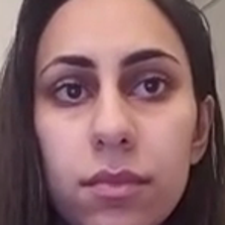
Sample Images from the Dataset (Awake)
Figure 1Sample image showing the “open eyes” 1
Figure 2Sample image showing the “open eyes” 2
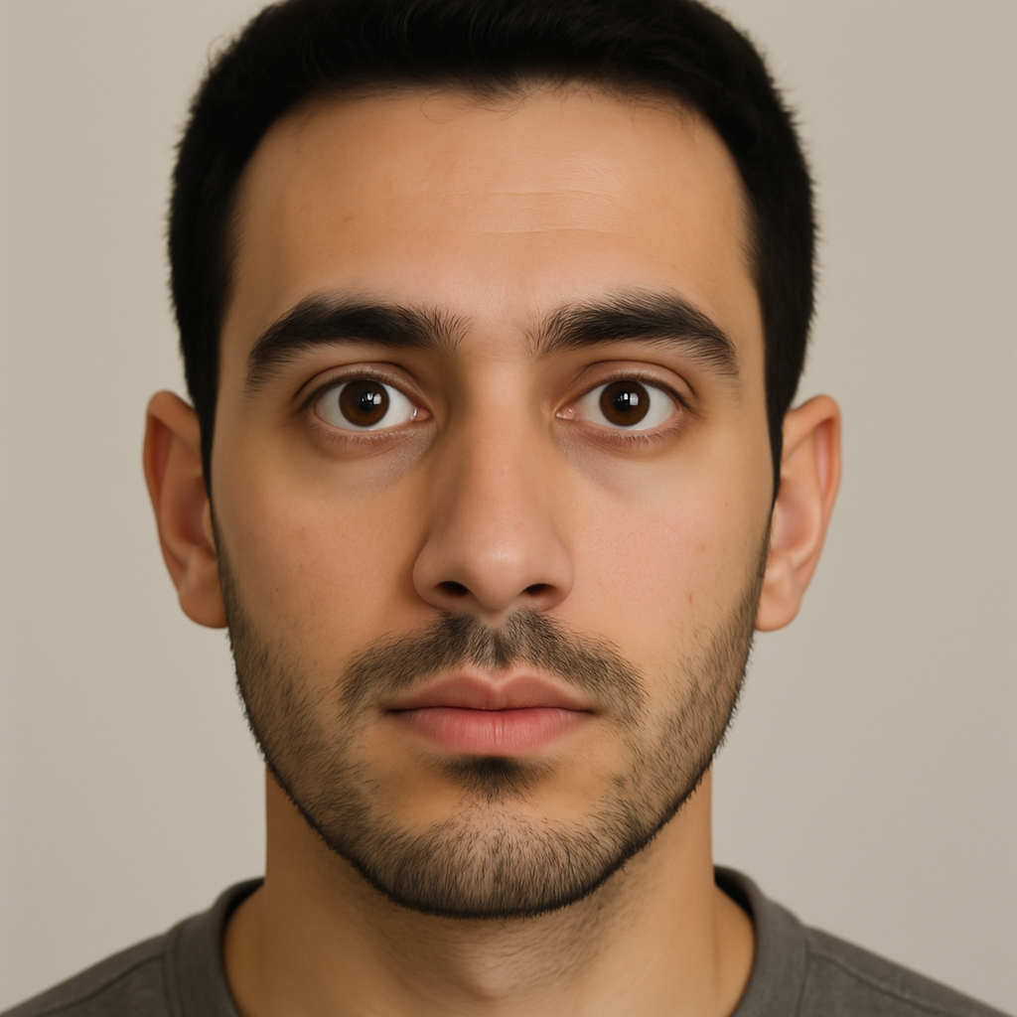
Figure 3Sample image showing the “open eyes” 3
Sample Images from the-Dataset (Drowsy)
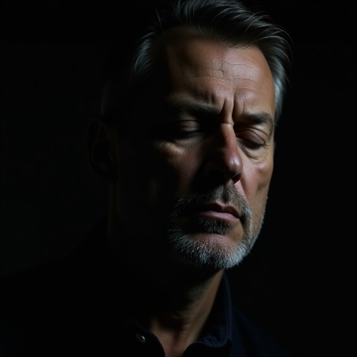


Figure 4Sample image showing the “close eyes" 4
Figure 5Sample image showing the “close eyes" 5
Figure 6Sample image showing the “close eyes" 6

4.5 System Workflow
- Camera Input → Captures live video frames of the face via webcam.
- Face and Eye Detection: Uses MediaPipe FaceMesh to extract facial landmarks and isolate eye regions from each frame.
- Preprocessing: The images are converted to (grayscale, equalized, resized) to 150×150 pixels, and normalized.
- Eye State Prediction (CNN Model): The preprocessed eye images are fed into a trained CNN to classify the eye state as Awake or Drowsy.

Drowsiness Monitoring Logic:

If Drowsy state persists for more than 2 seconds, an audio alarm is triggered.
If drowsiness continues beyond 5 seconds, the system classifies the state as fainted.

Emergency Actions:

Upon fainting detection, the system automatically sends an emergency WhatsApp message including the driver's GPS location using geocoder and pywhatkit.
An emergency alarm sound plays, and the monitoring system terminates.

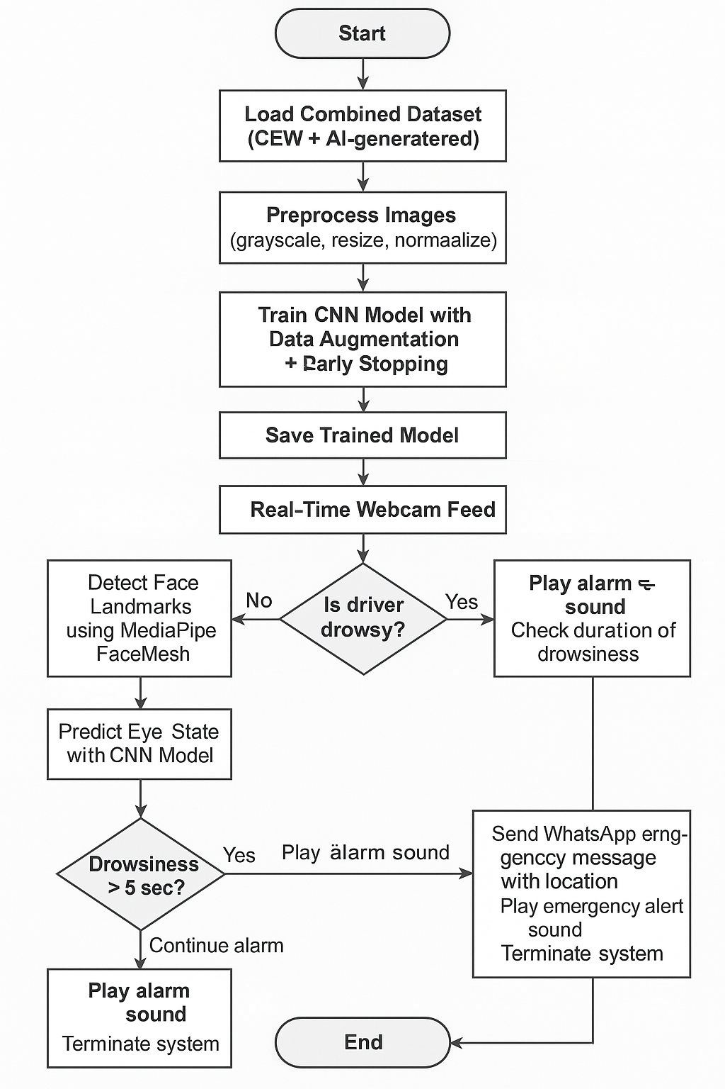

Figure 7System Workflow Diagram

Chapter 5: Experimental-Results and Discussion

5.1 Experimental-Setup

In order to execute this project, -Jupiter Notebook- was used, and it was working on Windows OS. The Python libraries used were:

TensorFlow: to construct and train the model of CNN.
Scikit-learn: for splitting of data and evaluation.
OpenCV: for loading and preprocessing of the images.
Matplotlib: for visualization.
TQDM: for monitoring the task progress while training 2 From a generalizability context, our proposed architecture has several advantages compared to the state of the art.

Dataset:

The dataset is composed of “Awake/Drowsy”-labeled images.
Image Source Path:
“C:\Users\X1 YOGA\Downloads\All_data\Train_Data”
Image Size: 150 ppi (pixels per inch)
Classes:
Awake → Label 0
Drowsy → Label 1

Preprocessing Steps:
The sized of all the images were re-sized in to 150x150 pixel.
pixel values between [0, 1] were normalized
All class labels were expanded into one-hot vectors with to_categorical().

Train/Test Split:
For training and testing, 80% and 20% of the data set was used, respectively.
Data was randomized before division.
A fixed random_state = 42 was applied for reproducibility.
Model Architecture (Convolutional Neural Network)
Conv2D (32 filers, 3x3 kernel, ReLU) followed by MaxPooling2D
Conv2D (64 filtros, ReLU) + MaxPooling2D
Flatten
Dense (128 units, ReLU)
Dropout (0.5)
Dense (2 units, Softmax activation).

Training Configuration:
Loss Function: (Categorical-Crossentropy)
Optimizer: (Adam)
Metrics: (Accuracy)
Epochs: 50.
Batch Size: 32.
Callback: EarlyStopping was used for (monitor training loss) and (prevent overfitting)
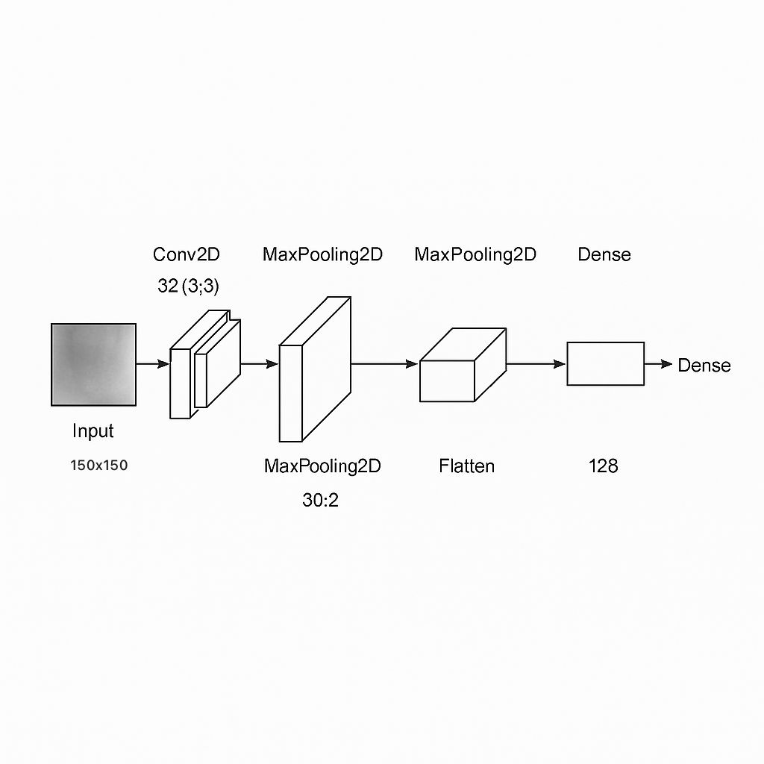
Figure 8 CNN Model Architecture

5.2 Evaluation Metrics

The model was assessed with conventional classification statistics to determine the performance of the model on the test set with typical statistics:
Accuracy: Overall valid accuracy of model
predictions Precision: percentage of true positives in the sum of positive predicted values
Recall (also called Sensitivity): ratio of true positives to actual positives
F1-Score: a balance between precision and recall in that it is the harmonic mean of the two Precision and Recall
Confusion Matrix: a matrix that counts true positives, true negatives, false positives, and false negatives.
Evaluation: was conducted using classificationreport() and confusionmatrix() functions.

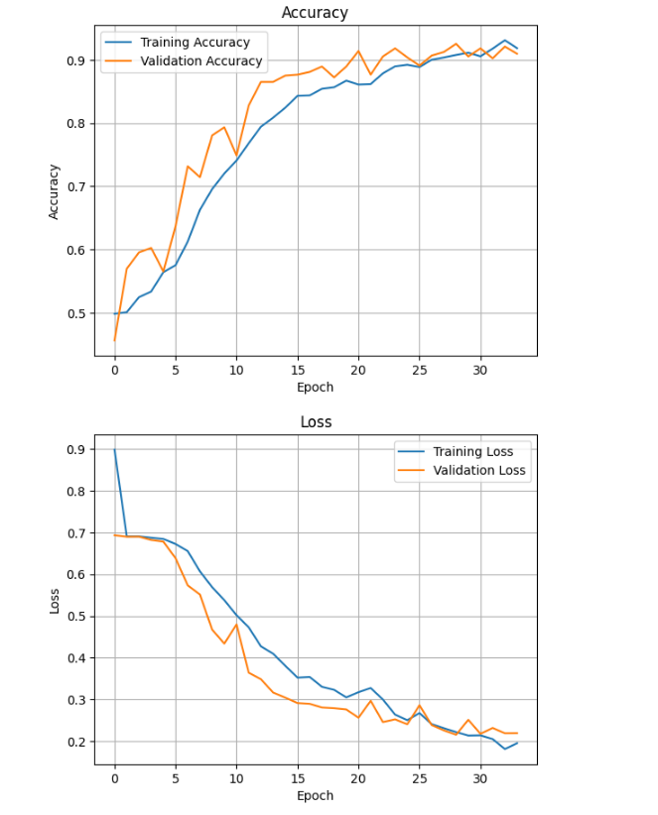

Figure 9Accuracy & Loss Function

5.3 Results

Model training was executed for 34 epochs out of 50 epochs that were planned. It was tested on a 20% unseen test set after completing training. The results are as follows:
The confusion matrix clearly defined “Awake” and “Drowsy” mention states.
Class-wise Precision, Recall, F1-Score, and Support.
The model achieved accuracy 93% correct generalization.
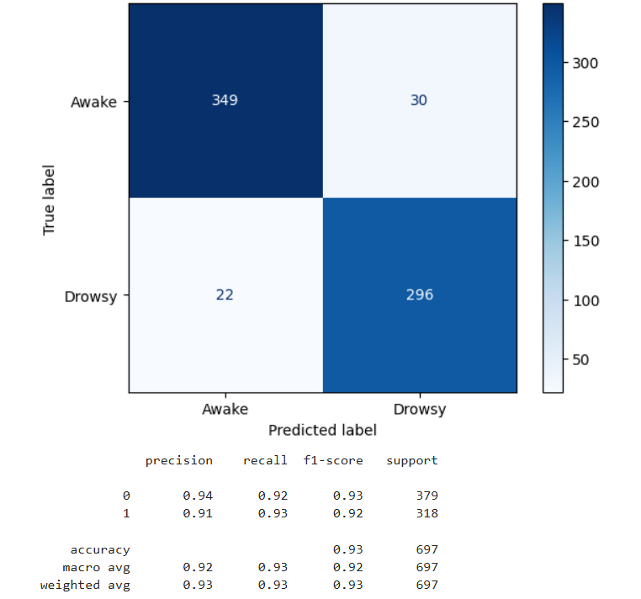
Figure 10 Confusion matrix

5.4 Real-Time Testing
Finally, we deployed the trained CNN model in a real-time drowsiness detection system using a webcam.
Main Features:
Eye detection occurred using the Mediapipe face mesh solution
Eyes were randomly cropped from frame images in real-time and resized to 150×150 pixels.
The cropped eyes were sent through on the CNN model to predict the eye state (Awake or Drowsy).
The model was characterized by:

Audio warning of drowsiness for over 2 seconds
Status tracking logic: If the user remained awake for more than 7 seconds after a sleep attempt (i.e., after a drowsy), the system categorized the user as “Fainted”.

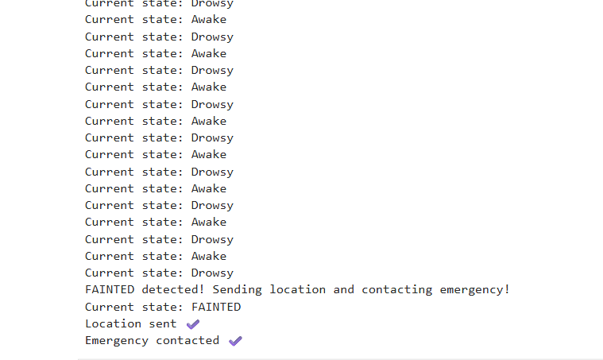
Emergency response: If fainting was detected, the system fetched the current geolocation using geocoder and sent it via WhatsApp using pywhatkit, this demonstrated the practical utility of the model beyond offline testing and into real-world safety scenarios
Figure 11Real-Time Output

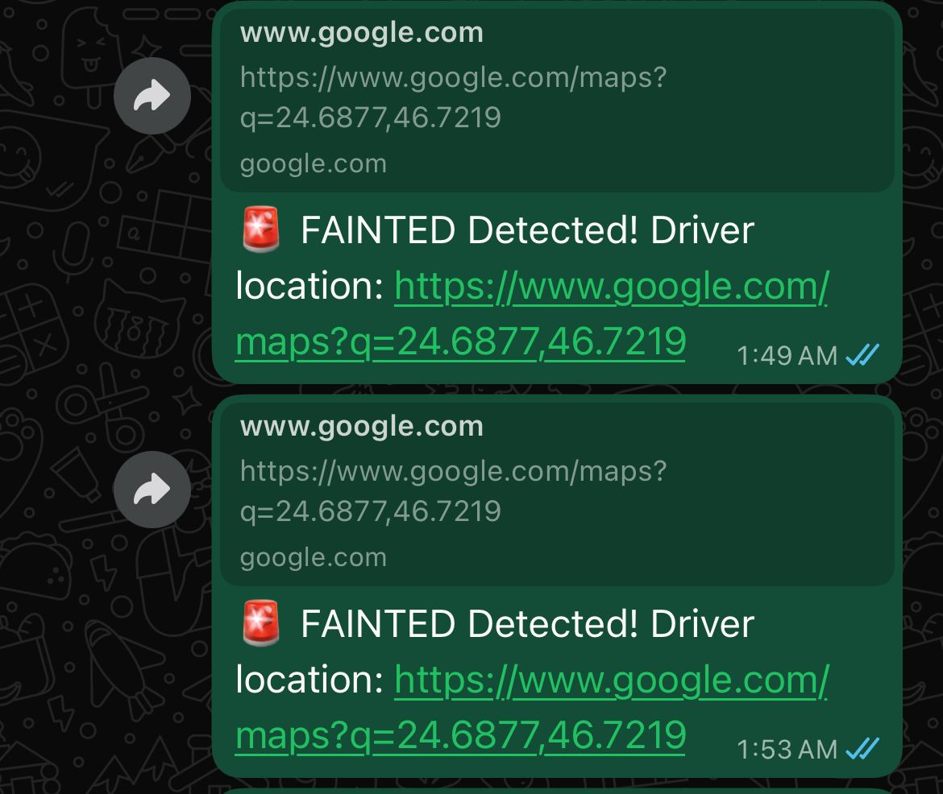
Figure 12 WhatsApp emergency Message with driver location

5.5 Discussions
Results show that the CNN model can successfully identify open vs. closed eyes and hence awake vs. drowsy states.

Strengths:
The model trained and tested well.
Real-time merging was achieved with low-latency phases.
Single frame accuracy was significantly higher for Mediapipe than traditional technique for eye detection.

Limitations:
Model accuracy is limited in low-light conditions or when the user wears glasses.
The model might need to be fine-tuned for other camera resolutions or angles.

Comparison with Other Studies:
In contrast to conventional Haar Cascade-based systems, CNN + Mediapipe is a much more robust and less error-prone eye detector.

5.6 Summary
In this chapter, we have provided the complete experimental analysis of our CNN-based drowsiness detection system. The method was trained and tested on a hybrid specific data set of face images and performed well on its classification task.

Real-time trials with a standard laptop webcam were conducted successfully and indicated the real-world feasibility of the proposed model in controlled settings. The implementation of auditory warnings, positional trace, and WhatsApp emergency warnings contributed to the feasibility of being integrated in the system for future safe driving.

The results reinforce the validity and effectiveness of our proposed method and demonstrate the potential to be considered in safety-critical contexts such that is the application in driver monitoring systems, smart transport, which opens avenues for real-world interaction.

Chapter 6 Conclusion and Future Work

6.1 Conclusion
This research project entails the implementation of an AI-Driver Monitoring System, that detects drowsiness and fainting in real-time, via a camera. In utilizing Convolutional Neural Networks (CNN), the system, trained with a host of real human face images of various ages and AI generated images of human faces viewed at various angles. Having a variety of training data for the system increases the robustness of the system learn to generalize in real-world environments.

The system is focused on monitoring the movements and states of the eyes in order to signify the detection of fatigue in the state of the eyes, whether they are open and closed. Also, the system, has an active response function of detecting abnormal inactive longest inactivity, or fainting events. The notification of event detection results in a dual-emergency system alert sequencing that occurs: (1) a real-time, audible emergency alert for the driver; and (2) an alert to emergency services with the GPS position of the vehicle for rapid deployment.

This proposed project demonstrates a real-world use of deep learning and computer vision for a form of Intelligent Transportation System (ITS). This proposed study demonstrates the impending uses of AI as a benefit, in resolving a major, important public safety issue, through predicting in-real time, safety alert notification and automatic emergency assistance.

The results from this study provide further possibilities for development, such as adding multimodal sensors applications, field applications of real-world deployment and scaling to larges commercial vehicle application and other relevant issues. Ultimately, this process seeks to contribute towards the ultimate goal of decreasing the fatality rates associated with road traffic crashes yielded by fatigue-based and medical-related incidents and to support humanity. And, seek to satisfy, and be a fundamental part of the AI for Social good method.

6.2 Future Work

While the Drive Guard system functionalities have been shown for drowsiness and fainting detection based on visual analysis using convolutional neural networks (CNN), much room for improvement in the future exists. Incorporating device-based physiological sensors (e.g., heart rate sensors, steering wheel grip) would add a multimodal approach which could improve detection accuracy when facial-based visibility is adversely affected due to lighting conditions and/or occlusion factors.

Similarly, augmenting and vary training data with other driving real-world conditions, illumination situations and diversity of ages would likely be advantageous in increasing the generalization of the model in response, and for the reliability of this project, in the future. There is also interest in studying the improvement of real-time attention mechanisms versus transformer-based architecture to improve response and reduce the false positive, fatigue and fainting detection in a future study.

From a deployment point of view, optimizing the model for edge devices that possess constrained computational resources, such as in-car embedded systems, is essential for real-world use. Finally, field testing in simulated environments with actual drivers allows the system’s performance to be verified under real dynamic conditions, as well as fine-tuning the emergency response process to meet local safety standards.

From these future directions, the system may become a complete and reliable solution that significantly contributes to improving road safety with the aid of artificial intelligence.

References
(NHTSA), N. H. (2015). Drowsy Driving Research. www.nhtsa.gov.
(2025, 5 27). Retrieved from drawio: https://www.drawio.com/
(2025). Retrieved from leonardo.ai: https://leonardo.ai/
(2025, 6 13). Retrieved from generated.photos: https://generated.photos/datasets
Abdar, M. Z.-M. (2021). A Survey on Deep Learning-Based Driver Drowsiness Detection Systems. Sensors, 1991.
Abtahi, S. O. (2014, 9 5). YawDD: A yawning detection dataset. Retrieved from https://doi.org/10.1145/2557642.2563670
Ardabili, S. Z. (2024). A novel approach for automatic detection of driver fatigue using EEG signals based on graph convolutional networks. Sensors, 364.
Awais, M. B. (2017). “A Hybrid Approach to Detect Driver Drowsiness Utilizing Physiological Signals to Improve Road Safety”. Sensors, 1991.
Babu, C. M. (2021). AI in Transportation: A Review of Safety and Monitoring Systems. IEEE Transactions on Intelligent Transportation Systems, 3124-3135.
Closed Eyes In The Wild (CEW). (2025, 7 11). Retrieved from parnec.nuaa: https://parnec.nuaa.edu.cn/_upload/tpl/02/db/731/template731/pages/xtan/ClosedEyeDatabases.html
Dasgupta, A. G. (2019). “A Review on AI-Based Solutions for Driver Health Monitoring and Road Safety”. IEEE Access, 157237-157256.
Desai, M. &. (2015). “Vehicle-Based Detection of Driver Fatigue Using Steering Behavior Analysis”. Transportation Research Part C: Emerging Technologies, 218-230.
Dipu, M. T. (2021). Real-time Driver Drowsiness Detection using Deep Learning. International Journal of Advanced Computer Science and Applications, 8.
Jiao, W. Y. (2023). A hybrid CNN-GRU model for real-time driver drowsiness detection. Neural Computing and Applications, 847–859.
Lobo, A. a. (2020). Exploring Monitoring Systems Data for Driver Distraction and Drowsiness Research. Sensors, 3836.
Patel, M. L. (2011). Applying neural network analysis on heart rate variability data to assess driver fatigue. Expert Systems with Applications, 7235–7242.
Picot, A. C. (2012). On-line detection of drowsiness using brain and visual information. IEEE Transactions on Systems, Man, and Cybernetics - Part A: Systems and Humans, 764–775.
Russell, S. &. (2020). Artificial Intelligence: A Modern Approach. Pearson Education.
Saini, V. a. (2014). Driver drowsiness detection system and techniques: a review. International Journal of Computer Science and Information Technologies, 4245--4249.
Sheykhivand, S. a. (2022). Automatic detection of driver fatigue based on EEG signals using a developed deep neural network. Electronics, 2169.
Sigari, M.-H. a. (2013). A driver face monitoring system for fatigue and distraction detection. International journal of vehicular technology, 263983.
Sivaraman, S. &. (2013). Active Head Tracking and Pose Estimation in Intelligent Vehicles. IEEE Transactions on Intelligent Transportation Systems, 776-787.
Wang, C. L. (2020). A survey of deep learning-based methods for drowsiness detection using physiological signals. IEEE Access, 107016–107029.
Williamson, A. &. (2013). The Impact of Sleep Deprivation on Driving Performance. Accident Analysis & Prevention, 438-445.
Zhang, Y. W. (2022). GAN-based data augmentation for driver drowsiness detection with limited datasets. Computers in Biology and Medicine.
Zhang, Z. Z. (2021). Driver fatigue detection based on facial expression recognition and EEG signals. Journal of Intelligent Transportation Systems, 245-257. Retrieved from Journal of Safety Research: https://doi.org/10.1016/j.jsr.2013.05.002
Zhao, C. W. (2020). “Facial Landmark-Based Detection of Driver Drowsiness Using Deep Learning”. Expert Systems with Applications, 113198.

Appendix A: Source Code for DriveGuard System

A.1 Model Architecture
import os
import numpy as np
import cv2
import matplotlib.pyplot as plt
from sklearn.model_selection import train_test_split
from tensorflow.keras.utils import to_categorical
from tensorflow.keras.preprocessing.image import ImageDataGenerator
from tensorflow.keras.models import Sequential
from tensorflow.keras.layers import Conv2D, MaxPooling2D, Flatten, Dense, Dropout
from tensorflow.keras.callbacks import EarlyStopping
from sklearn.metrics import confusion_matrix, classification_report, ConfusionMatrixDisplay
# Files Path
data_dir = r"C:\Users\X1 YOGA\Downloads\All_data\Train_Data"
img_size = 150
def load_images(folder_path):
images = []
labels = []
classes = ['Awake', 'Drowsy']
for idx, cls in enumerate(classes):
class_folder = os.path.join(folder_path, cls)
for file in os.listdir(class_folder):
img_path = os.path.join(class_folder, file)
img = cv2.imread(img_path, cv2.IMREAD_GRAYSCALE)ana
if img is not None:
img = cv2.resize(img, (img_size, img_size))
images.append(img)
labels.append(idx)
return np.array(images), np.array(labels)
#Data Load
X, y = load_images(data_dir)
X = X / 255.0
X = np.expand_dims(X, axis=-1)
y = to_categorical(y)
# Data Spilt
X_train, X_val, y_train, y_val = train_test_split(X, y, test_size=0.2, shuffle=True, random_state=42)

A.2 Model training
model = Sequential([
Conv2D(32, (3,3), activation='relu', input_shape=(img_size, img_size, 1)),
MaxPooling2D(2, 2),
Dropout(0.25),
Conv2D(64, (3,3), activation='relu'),
MaxPooling2D(2, 2),
Dropout(0.25),
Flatten(),
Dense(128, activation='relu'),
Dropout(0.5),
Dense(2, activation='softmax')
])
model.compile(optimizer='adam', loss='categorical_crossentropy', metrics=['accuracy'])
# Stop early
early_stop = EarlyStopping(monitor='val_loss', patience=5, restore_best_weights=True)
# Augmentation at trining
datagen = ImageDataGenerator(
rotation_range=5,
zoom_range=0.05,
width_shift_range=0.05,
height_shift_range=0.05
)
datagen.fit(X_train)

A.3 Model Saving
history = model.fit(
datagen.flow(X_train, y_train, batch_size=32),
validation_data=(X_val, y_val),
epochs=50,
callbacks=[early_stop]
)

A.4 After Training
#Save model after the Train
import pickle
model.save('eye_model.h5')
with open('history.pkl', 'wb') as f:
pickle.dump(history.history, f)

A.5 Model Loading
#Load Trained model
from keras.models import load_model
model = load_model('eye_model.h5')

A.6 Single Image Prediction
# Predictions
y_pred = model.predict(X_val)
y_pred_classes = np.argmax(y_pred, axis=1)
y_true = np.argmax(y_val, axis=1)
# Confusion matrix
cm = confusion_matrix(y_true, y_pred_classes)
disp = ConfusionMatrixDisplay(confusion_matrix=cm, display_labels=["Awake", "Drowsy"])
disp.plot(cmap="Blues")
plt.show()
# Performance report
print(classification_report(y_true, y_pred_classes))

A.7
import cv2
import numpy as np
from keras.models import load_model
# Load the trained model
model = load_model('eye_model.h5')
# Load Image and Covert it to grayscale
image_path = r"C:\Users\X1 YOGA\Downloads\test9.jpeg"
img = cv2.imread(image_path, cv2.IMREAD_GRAYSCALE)
# Change Image Size
resized = cv2.resize(img, (150, 150))
resized = resized / 255.0
resized = np.expand_dims(resized, axis=-1)
resized = np.expand_dims(resized, axis=0)
# Pridect
prediction = model.predict(resized)
pred_class = int(prediction[0][0] > 0.5)
#Print Result
label = 'Drowsy ' if pred_class == 0 else 'Awake '
print(f'Prediction: {label}')

A.8 Live Camera Detection
import cv2
import mediapipe as mp
import numpy as np
from tensorflow.keras.models import load_model
import time
import pygame
import geocoder
import pywhatkit as kit
# Initialize sound system
pygame.mixer.init()
alarm_sound = r"C:\Users\X1 YOGA\Downloads\alert.mp3.wav"
# Load trained CNN model
model = load_model('eye_model.h5')
IMG_SIZE = 150 # Input image size for the model
# Initialize Mediapipe Face Mesh
mp_face_mesh = mp.solutions.face_mesh
face_mesh = mp_face_mesh.FaceMesh(static_image_mode=False,
max_num_faces=1,
refine_landmarks=True,
min_detection_confidence=0.5,
min_tracking_confidence=0.5)
# Start webcam
cap = cv2.VideoCapture(0)
# Preprocess eye image to feed into CNN model
def preprocess_eye(eye_img):
gray = cv2.cvtColor(eye_img, cv2.COLOR_BGR2GRAY)
gray = cv2.equalizeHist(gray)
resized = cv2.resize(gray, (IMG_SIZE, IMG_SIZE))
normalized = resized / 255.0
return np.expand_dims(normalized, axis=(0, -1))
# Send location via WhatsApp in case of fainting
def send_emergency_message():
try:
g = geocoder.ip('me')
location = g.latlng
if location:
message = f" FAINTED Detected! Driver location: https://www.google.com/maps?q={location[0]},{location[1]}"
else:
message = " FAINTED! Driver location not available."
kit.sendwhatmsg_instantly("+9660000000000", message, wait_time=10, tab_close=True)
print("Location sent ✔️")
print("Emergency contacted ✔️")
except Exception as e:
print("WhatsApp/send error:", e)
# Timing control
drowsy_start = None
alarm_playing = False
fainted_triggered = False
last_state = None
# Main loop
while True:
ret, frame = cap.read()
if not ret:
break
rgb = cv2.cvtColor(frame, cv2.COLOR_BGR2RGB)
results = face_mesh.process(rgb)
label = "No face"
if results.multi_face_landmarks:
for face_landmarks in results.multi_face_landmarks:
h, w, _ = frame.shape
left_eye_idx = [362, 385, 387, 263, 373, 380]
right_eye_idx = [33, 160, 158, 133, 153, 144]
# Extract eye region from landmarks
def extract_eye(eye_points):
x_coords = [int(face_landmarks.landmark[i].x * w) for i in eye_points]
y_coords = [int(face_landmarks.landmark[i].y * h) for i in eye_points]
x_min, x_max = max(min(x_coords) - 5, 0), min(max(x_coords) + 5, w)
y_min, y_max = max(min(y_coords) - 5, 0), min(max(y_coords) + 5, h)
return frame[y_min:y_max, x_min:x_max]
# Get both eyes
left_eye_img = extract_eye(left_eye_idx)
right_eye_img = extract_eye(right_eye_idx)
if left_eye_img.size != 0 and right_eye_img.size != 0:
# Resize right eye to match left eye
right_eye_img = cv2.resize(right_eye_img, (left_eye_img.shape[1], left_eye_img.shape[0]))
both_eyes = cv2.hconcat([left_eye_img, right_eye_img])
eye_input = preprocess_eye(both_eyes)
# Predict state using model
prediction = model.predict(eye_input, verbose=0)
label = "Awake" if np.argmax(prediction) == 0 else "Drowsy"
color = (0, 255, 0) if label == "Awake" else (0, 0, 255)
# Print state only if changed
if label != last_state:
print("Current state:", label)
last_state = label
now = time.time()
if label == "Drowsy":
if drowsy_start is None:
drowsy_start = now
elif (now - drowsy_start) > 2 and not alarm_playing:
# Start alarm if drowsy > 2 sec
pygame.mixer.music.load(alarm_sound)
pygame.mixer.music.play(-1)
alarm_playing = True
# Consider as FAINTED if drowsy > 5 sec
if (now - drowsy_start) > 5 and not fainted_triggered:
print("FAINTED detected! Sending location and contacting emergency!")
print("Current state: FAINTED")
send_emergency_message()
fainted_triggered = True
pygame.mixer.music.load(alarm_sound)
pygame.mixer.music.play()
time.sleep(15) # Play alert for 15 seconds
pygame.mixer.music.stop()
cap.release()
cv2.destroyAllWindows()
break
elif label == "Awake":
drowsy_start = None
if alarm_playing:
# Stop alarm when awake
pygame.mixer.music.stop()
alarm_playing = False
# Display state on screen
cv2.putText(frame, f"Status: {label}", (30, 40),
cv2.FONT_HERSHEY_SIMPLEX, 1.2, color, 3)
# Draw rectangle around both eyes
x_min = min([int(face_landmarks.landmark[i].x * w) for i in left_eye_idx + right_eye_idx]) - 5
x_max = max([int(face_landmarks.landmark[i].x * w) for i in left_eye_idx + right_eye_idx]) + 5
y_min = min([int(face_landmarks.landmark[i].y * h) for i in left_eye_idx + right_eye_idx]) - 5
y_max = max([int(face_landmarks.landmark[i].y * h) for i in left_eye_idx + right_eye_idx]) + 5
x_min = max(x_min, 0)
y_min = max(y_min, 0)
x_max = min(x_max, w)
y_max = min(y_max, h)
cv2.rectangle(frame, (x_min, y_min), (x_max, y_max), color, 2)
# Show video frame
cv2.imshow("Driver Monitor", frame)
if cv2.waitKey(1) & 0xFF == ord('q'):
break
# Release resources
cap.release()
cv2.destroyAllWindows()

