Accuracy and Efficiency Learning Models for Plant Leaf Disease Classification
Mahmoud Al Ra’e – Hussein Mudeheg
ORCID ID : 0009-0007-2118-5592
Artificial Intelligence – College of Informatics – Midocean University
(mahmoudalrae@gmail.com - h.mudeheg@gmail.com )

Supervisor: Dr. Hager Saleh (hager.saleh@insight-centre.org)

1. Introduction
Plant diseases reduce crop quality and early diagnosis remains difficult when disease symptoms are visually similar. Conventional diagnosis usually depends on human inspection and specialist experience. This approach can be slow, subjective and difficult to scale across large farms. Image based artificial intelligence offers a practical alternative by learning visual patterns associated with healthy and diseased leaves. Deep learning has become a dominant approach for visual recognition because convolutional neural networks can learn hierarchical features directly from images. Transfer learning further reduces the data and computation required by reusing representations learned from large-scale image datasets. In plant pathology, transfer-learning architectures such as ResNet, EfficientNet, and MobileNet have frequently demonstrated strong classification performance. A controlled comparison using the same dataset split, preprocessing, classification head, optimizer, and evaluation protocol is applied.

This paper compares ResNet50, EfficientNetB0, and MobileNetV2 under a unified transfer-learning protocol using 20,638 PlantVillage images across 15 plant health and disease classes. In addition, it makes three contributions. First, it provides a controlled comparison of three widely used architectures. Second, it evaluates predictive performance together with model size and training time. Third, it analyzes class-level errors to identify disease categories that remain difficult to separate visually.

2. Research Problem

Plant diseases are among the major concerns affecting the quality and production levels of crops. The farmers often determine the occurrence of diseases in the plant through experience which may be unreliable. Early symptoms of plant disease may be difficult to recognize leading to delay in diagnosis, thus causing more damage to the plant. Some diseases in plants look alike. Therefore, it could lead to a false conclusion in the diagnosis. Detecting the diseases of plants in their natural environment becomes very difficult owing to many factors including illumination, occlusion, and leaf orientation of the plant. Normally, checking of the plants requires manual labor. The detection of diseases from each individual plant becomes time consuming particularly when dealing with many of them or a larger piece of farm. It is necessary to develop a system which will enable farmers to diagnose the diseases automatically. Artificial Intelligence and deep learning would help the farmers detect diseases faster and make informed decisions concerning the crops. Plant diseases account for about 40% annual losses globally. Plant diseases lead to huge financial losses annually, and they have been estimated to cost about 220 billion dollars annually globally.

3. Review of Previous Studies

Too et al. applied multiple types of pertained models such as VGG16, InceptionV4, ResNet50, and DenseNet121 which classify 38 different classes of plant diseases. The public dataset so called PlantVillage was used from KAGGLE, which has 54,306 images with 38 classes. The preprocessing steps included image resizing in order to match the required input size of the CNN architecture, and rotation, flipping, and scaling were applied to increase dataset variability and reduce overfitting. The result has shown that DenseNet121 achieved the highest classification accuracy among the evaluated models. Transfer learning significantly improved performance compared to training from scratch. The models demonstrated very high accuracy under laboratory conditions. [7]
The study examines the use of Vision Transformers (ViT) for plant disease classification to determine whether attention-based architectures can perform better than the traditional convolutional neural networks (CNNs) or not. A pre-trained VIT model on ImageNet was improved for plant disease detection and compared with CNN models such as ResNet50 and DenseNet121. The model utilizes five public plant datasets that include the famous PlantVillage dataset, which contains 54,306 images from 38 classes that were collected under controlled conditions. The preprocessing involved resizing the images to 244X244 pixels, patch embedding preparation, pixel normalization, and data augmentation such as rotation and flipping. The final results demonstrate that VIT achieved approximately 99% accuracy, which outperforms several models. [8]
The research proposed a lightweight deep learning model, so called Dise-Efficient which is built on EfficientNetV2 to identify plant diseases and pest identification. The study focused on improving model efficiency while ensuring strong recognition performance. The model was trained and evaluated using plant image datasets, using steps such as image resizing, normalization, and data augmentation for preprocessing, which were applied to enhance performance and generalization. The results show that the proposed model has achieved high accuracy of classification as well as reduced the computational complexity. [9]

The authors have proposed an integrated Internet of Things (IoT) solution that has combined deep learning techniques to detect plant diseases. Leaf images were captured through cameras along with environmental data collected from IoT sensors such as temperature and humidity. The purpose of the preprocessing techniques is to improve image quality prior to applying deep learning models for disease classification. The system includes training and evaluation stages that measure the performance of the model, which resulted in high accuracy. In addition, the framework supports real-time monitoring and feedback, allowing continuous tracking of crop conditions and early detection of diseases. [10]
Aldakheel et al. proposed a real time plant leaf disease detection system based on the YOLOv4 object detection framework. In contrast to the traditional classification models that only predict disease categories, YOLOv4 enables simultaneous detection of diseased regions within leaf images. The methodology involved training the YOLOv4 model to identify and classify multiple plant diseases directly from leaf images by bounding box coordinates and class probabilities in a single detection process. The model was trained on annotated plant leaf disease datasets that contain multiple disease categories in several environments. The preprocessing steps included image resizing to match the YOLOv4 input dimensions, image normalization, and data augmentation such as rotation, scaling, and flipping to improve robustness and at the same time to reduce the overfitting. The result of the experimentation demonstrated that YOLOv4 achieved higher accuracy with fast inference speed which making it suitable for real time agricultural applications. [11]
Duhan et al. have designed a real-time plant disease diagnosis based on mobile and edge devices. The authors have combined the RTR_Lite framework with MobileNetV2, a compact convolutional neural network known for its use of separable convolutions, which significantly reduce computational cost and still maintain strong performance. The goal was to develop a model that balances between accuracy and speed, which makes it very practical for field deployment where the computational resources are always limited. The model was trained on available public plant disease datasets that include various crops and disease categories which were captured under different environmental conditions. Prior to commencing the training the images were resized to match the input size required by MobileNetV2, and pixel values were normalized. Data augmentation techniques such as rotation, flipping, and scaling were applied to improve the ability of the models to generalize. The results showed that RTR_Lite_MobileNetV2 achieved high classification accuracy and at the same time has maintained a small model size and fast inference speed. [12]
Bhola and Kumar have designed a CNN model that automatically learns the important visual features from leaf images which eliminates the need for manual feature extraction. The main objective was to support farmers in detecting diseases at an early stage so that timely treatment can reduce crop damage and yield loss. Pre-trained CNN models such as VGG16, ResNet-50, and Inception-v3 were used. The model was trained and tested on a dataset of vegetable leaf images that included several disease categories, collected under both controlled and natural environmental conditions. Before starting the training, the images were resized to fit the input requirements of the network and normalized to standardize pixel values. Data augmentation techniques such as rotation, flipping, and brightness adjustment were also applied to increase dataset diversity and accordingly improve the ability of the models to generalize. The results showed that the proposed model achieved high accuracy and performed well in recognizing early symptoms of the disease. [13]

Kheir et al. have proposed a hybrid model combined of Vision Transformer (ViT) and MobilePlantViT, the lightweight design generalized plant disease image classification and balance both accuracy and efficiency for mobile and edge deployment. Traditional deep learning models for plant disease recognition often struggle on resource limited devices caused by high computational costs. MobilePlantViT combines efficient convolutional operations with a Vision Transformer backbone to capture local and global features while maintain the architecture compact. The model was evaluated across multiple diverse plant disease datasets that has shown a strong generalization and test accuracies ranging from around 80% to over 99% depending on the dataset. Preprocessing consisted of the usual image resizing and normalization, along with data augmentation to improve its reliability and prevent overfitting. The outcomes from the experiments highlight the potential that MobilePlantViT holds for practical disease detection in plants. [14]
Thanjaivadivel developed EnConv which is an improved CNN, meant to accurately classify plant leaves and their diseases using more efficient feature extraction techniques. The objective is to use ML and DL to detect diseases in plants which does not need extensive knowledge in the field . EnConv uses deep convolutional layers, which optimize calculations and retain crucial properties such as leaf colors and shapes. Instead of having a flattening layer as in most CNNs, EnConv has global pooling layers that can reduce overfitting and improve performance. After testing EnConv on data from a total of 39 diseases from different crops, it had a maximum accuracy rate of 99.87%. This clearly indicates that EnConv is more accurate than other machine learning and deep learning models. [15]
In this research, we have proposed a deep learning and IoT-based framework for detecting plant leaf diseases in real-time. The proposed framework relies on a CNN algorithm to analyze leaf images and determine whether the plant is healthy or unhealthy. For improving the efficiency of pre-trained models such as MobileNetV2, ResNet50, and VGG16, transfer learning technology is used, along with datasets including PlantVillage. An IoT camera is used for taking images from the leaves and performing operations such as removing noise, adjusting size, and applying data augmentation techniques to enhance reliability irrespective of the weather conditions. Furthermore, the developed model is capable of executing at edge computing devices including Raspberry Pi or Jetson Nano. The model has an accuracy rate of more than 90%. [16]
The paper explains a framework that utilizes DL techniques to identify and classify plant leaf diseases is introduced. A custom model named CropLeafNet is constructed using reliable backbone architectures ResNet50, MobileNetV2, and VGG16 to enhance feature detection and classification processes. Using the concept of transfer learning, the proposed framework identifies not only the local characteristics such as the leaf textures but also the global features including the leaf colors and patterns found all around the world. This makes it possible to diagnose a variety of diseases through one single model. For training purposes, datasets such as PlantVillage as well as photographs from the field are employed to guarantee a wide range of leaf environments. Image preprocessing consists of resizing and normalizing operations along with some augmentation operations including rotation, flipping, and contrast changing. From the experimental results, it is clear that the developed model named CropLeafNet (CNN architecture for agricultural problems) is able to classify the diseases with high accuracy and performs better than other standard CNN models. [17]
In this study, an ML approach is proposed to detect plant disease in pigeon pea leaves, intending to provide assistance for early diagnosis for farmers. This paper explicitly uses no deep neural network nor other recent large-scale models called black boxes. The researchers propose a novel ML solution to the problem by combining classical computer vision techniques and classical classifiers. Dense SIFT (DSIFT) and Bag of Visual Words (BoVW) techniques are used as feature extractors that have proven themselves to be robust and invariant to noise and rotations in previous works. This framework tests several classifiers, including SVM, KNN, Random Forest, Decision Tree, Gradient Boosting, and a CNN classifier, in order to classify the pigeon pea leaf disease categories using their extracted descriptors. The dataset consists of 900 wild images of pigeon pea leaves (diseased and healthy). The preprocessing stage involved image size adjustment and enhancement of quality. It was discovered that the CNN classifier and the LightGBM classifier were efficient in classifying pigeon pea leaves into categories. [18]
PlantDoc was designed as a real-life dataset, which is supposed to aid in improving the abilities of artificial intelligence to recognize plant diseases under non-laboratory circumstances. As such, all the images used in PlantDoc come from a variety of farms, thus being quite messy, with lots of background information, inconsistent illumination, and pictures shot from a wide range of perspectives.A series of deep learning models were chosen by the authors to see how successfully they would be able to recognize plant diseases. Prior to the training phase, all the images were processed, having been resized, cropped using bounding boxes for disease localization, normalized, and subjected to various augmentations, like images' flip and adjustment of brightness levels. This yielded some positive results, as PlantDoc-trained models demonstrated higher robustness when applied to real farm conditions than other models, which were trained exclusively based on laboratory data. At the same time, it resulted in somewhat worse performance overall due to the nature of real-life data. [19]

In this work, it was examined how EfficientNet, which is known for scaling depth, width, and resolution together, performs regarding recognizing plant diseases. Researchers used different versions of EfficientNet, from its smaller version B0 to a larger one, B7. Transfer learning was performed based on existing plant disease recognition datasets such as PlantVillage. The data was processed thoroughly before entering the training phase. Specifically, the images were resized according to the requirements of the model, normalized, and augmented using techniques like rotation, flipping, zooming, and others.It easily beat the performance of the previous versions of CNNs, like ResNet and Inception, while being even more efficient due to using less number of parameters. The classification accuracy exceeded 99%. It should be noted that these tests were conducted using clean datasets. [20]
This paper describes ResNet, which is a deep convolutional neural network using residual learning to solve the problem of degradation in extremely deep models. Designed for generalized image recognition, ResNet has shown impressive performance in plant disease classification due to its efficient image feature extraction capabilities. One of the main concepts covered in the paper is the skip connection, which helps retain the continuity of gradient flow during training and enables ultra-deep neural nets, including ResNet50, ResNet101, and ResNet152.
ResNet is fine-tuned using transfer learning on platforms like PlantVillage. This process involves preprocessing the images which includes resizing, normalizing the data and using data augmentation to increase the size of the dataset. In various research studies, the model has consistently achieved impressive accuracy rates, as seen in reference [21].

4. Methodology

Figure 1 presents the framework used for plant leaf disease classification starting from image collection, preprocessing and data augmentation, training of the three models (ResNet50, EfficientNetB0, and MobileNetV2), Evaluation of each model on the test set and Final disease classification output across the 15 classes.
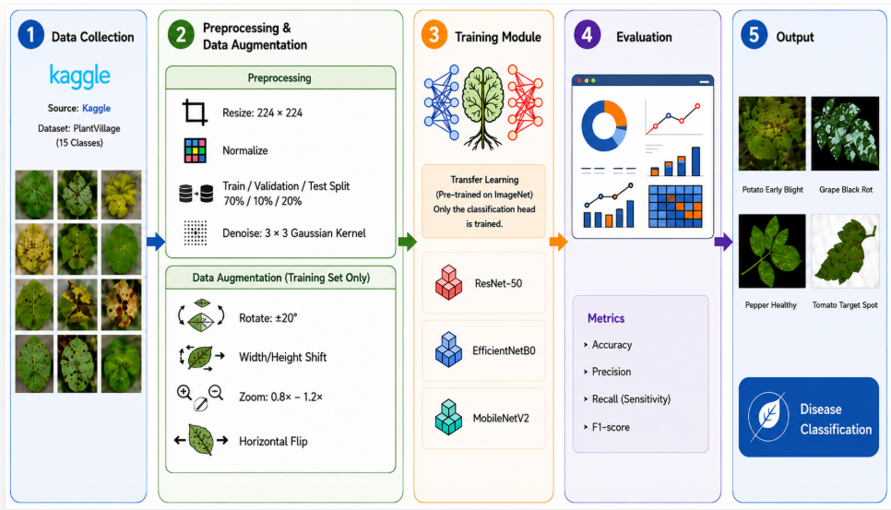
Figure 1 The Steps of Method

4.1 Data Collection
The PlantVillage dataset is being used as the main folder which includes both healthy and diseased leaves across three crops pepper, potato and tomato. It contains the following 15 subfolder classes: Pepper contributes two classes, Bacterial Spot and healthy. Potato contributes three classes, Early Blight, Late Blight, and healthy. Tomato contributes ten classes, Bacterial Spot, Early Blight, Late Blight, Leaf Mold, Septoria Leaf Spot, Spider Mites Two-Spotted Spider Mite, Target Spot, Yellow Leaf Curl Virus, Mosaic Virus, and healthy.
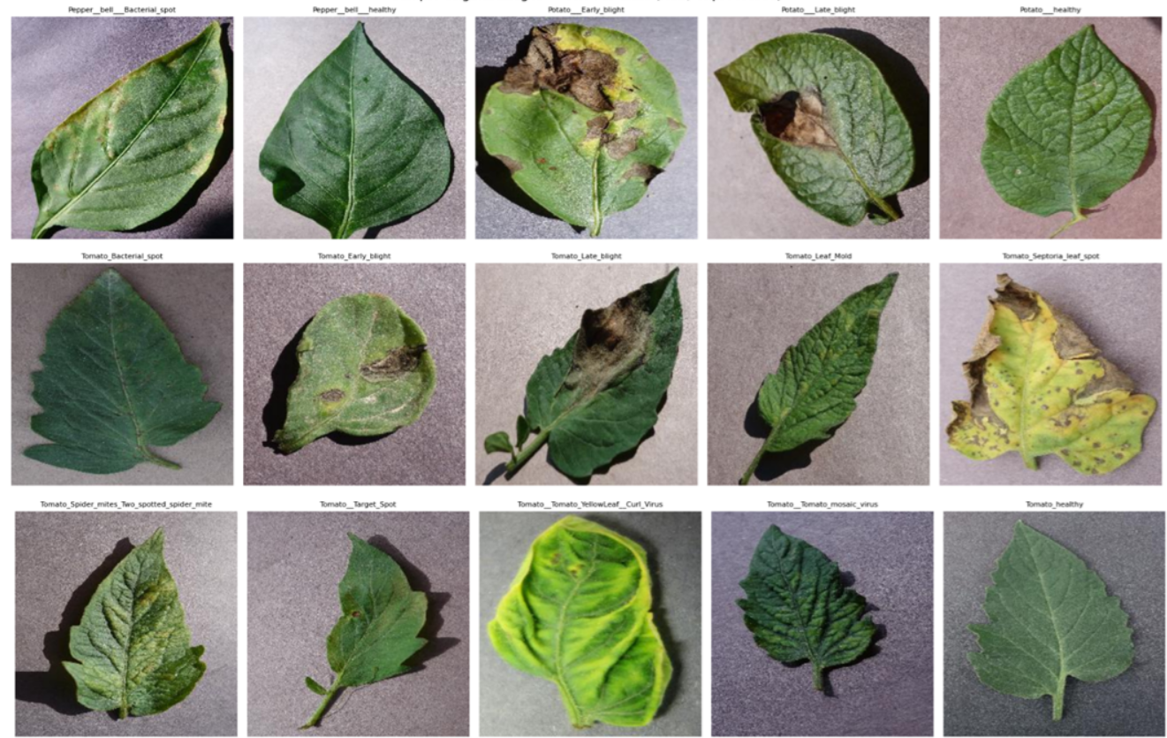
Figure 2 Sample image from each class

4.2 Data Splitting

We split the images into training, validation, and test sets using a fixed ratio of 70% for training, 10% for validation, and 20% for testing. This split was applied separately within each of the 15 classes .Also, the random seed was fixed at 42 therefore the same images fall into the same set every time the notebook is run, and all three models are trained and evaluated on identical data.

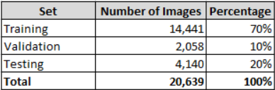
Figure 3, Number of image per split

4.3 Data Augmentation and Preprocessing

We build two separate image generators, one for training and one for validation and testing. The training generator applies each model's own preprocessing function together with data augmentation, randomly rotating, shifting, zooming, and flipping images to increase variability in the training data. The validation and test generator applies preprocessing only with no augmentation since these sets are used to measure the model's real performance rather than to help it learn. All three generators resize every image to the fixed input size required by the model and load images in fixed size batches. Figure 4 and 5 displays the applied augmentation and preprocessing

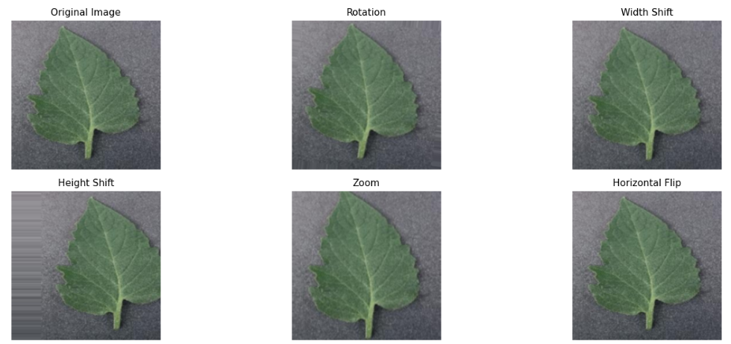
Figure 4, Augmentation Techniques Applied
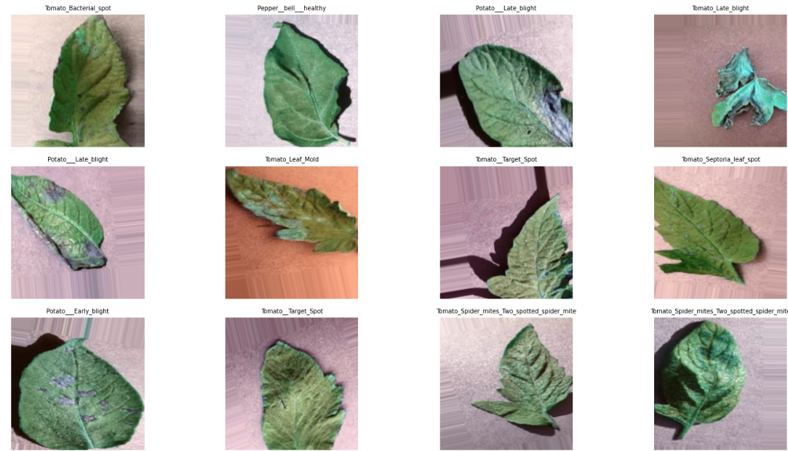
Figure 5, Sample Training of image (Preprocessed)

4.4 Training and Configuration

We trained all three models the same way to be fair to compare. Adam method was used with each and trained in batches of 32 images for up to 20 epochs. Two safety checks were used, one stops training early if it stops improving and keeps the best version while the other saves the best performing model to Google Drive. All three models used identical settings, so any difference in results comes from the models themselves. Every model was tested on unseen images matching predictions correctly to the real answers then we measured accuracy, precision, recall, and F1-score

5. Results and Discussion

5.1 Experimental setup

This section presents the results obtained by applying the methodoloy to the three transfer learning models ResNet50, EfficientNetB0, and MobileNetV2. The experiments implemented using Python, Google Colab with GPU acceleration for PlantVillage dataset contains 20,638 leaf images across 15 healthy and diseased classes from pepper, potato, and tomato plants.

All three models, ResNet50, EfficientNetB0, and MobileNetV2 were compiled with the Adam optimizer for training with learning rate equal to 0.001 and trained with a batch size of 32 upto 20 epochs. An EarlyStopping callback monitored validation loss with a patience of 5 epochs and restored the best weights .

5.2 Overall Performance Comparison

Figure 6 displays the overall performance comparison, ResNet50 records the highest accuracy of the three models at 96.47% followed by EfficientNetB0 at 95.97% and then MobileNetV2 at 92.13%. EfficientNetB0 achieves accuracy less by 0.5% of ResNet50 (95.97% vs. 96.47%) . This makes EfficientNetB0 the best tradeoff between accuracy and size among the three models. MobileNetV2 is the smallest model with fewer than 2.6 million parameters, but records the lowest accuracy and more than four points behind ResNet50. Training time is similar for all three models between 63 and 66 minutes

Model | Accuracy | Precision (Macro) | Recall | F1-score | Parameters | Training time
ResNet50 | 96.47% | 96.55% | 96.20% | 96.33% | 24,116,111 | 63.5 min
EfficientNetB0 | 95.97% | 95.80% | 95.74% | 95.67% | 4,381,362 | 66.0 min
MobileNetV2 | 92.13% | 92.08% | 91.75% | 91.69% | 2,589,775 | 63.2 min
Figure 6, Overall performance comparison

5.3 Confusion Metrics Analysis

The confusion matrices of ResNet50, EfficientNetB0 and MobileNetV2 are presented in the Figure 7 where all three models record high overall accuracy, but the confusion matrices show consistent misclassification patterns among visually similar tomato diseases.

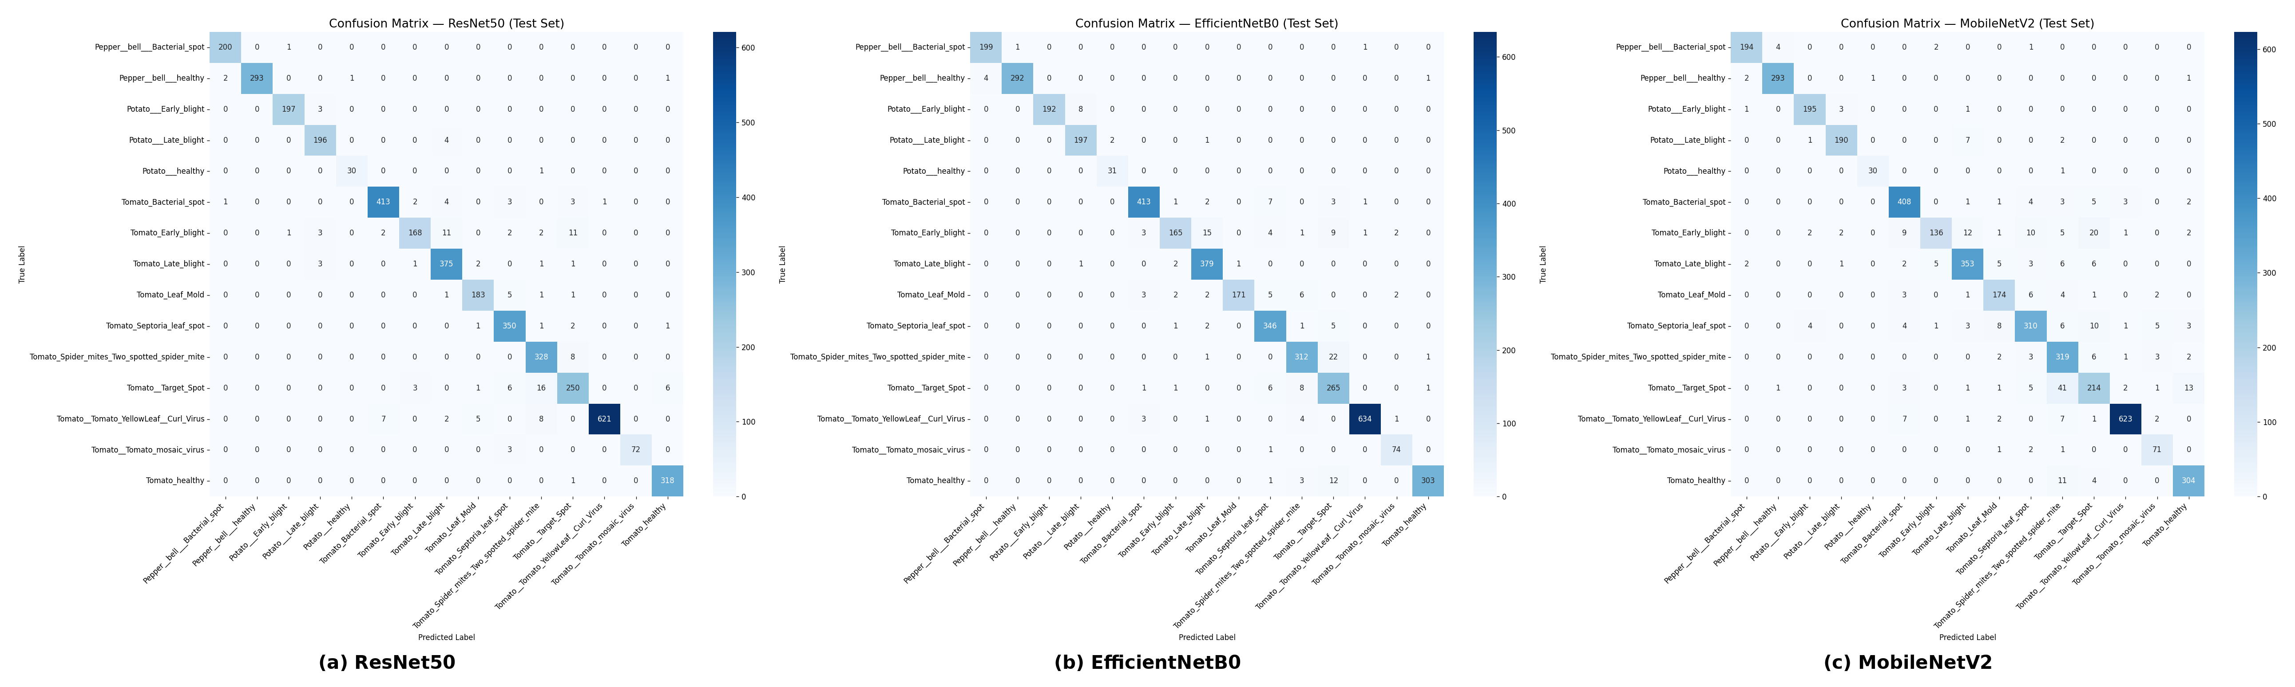
Figure 7, Comparison Matrix Analysis

ResNet50 produces the fewest misclassifications across nearly all disease pairs, EfficientNetB0 shows slightly more confusion between Spider Mites and Target Spot and MobileNetV2 produces considerably more errors, particularly among the tomato diseases. The largest confusion is MobileNetV2 classifying 41 Target Spot samples as Spider Mites compared with only 16 for ResNet50 and 22 for EfficientNetB0. This suggests that the higher capacity architectures may capture more discriminative features for these visually similar diseases.

Disease Pair | ResNet50 | EfficientNetB0 | MobileNetV2
Target Spot → Spider Mites | 16 | 22 | 41
Early Blight → Late Blight | 11 | 15 | 12
Early Blight → Target Spot | 11 | 8 | 20
Figure 8, Number of test-set misclassifications for the three most frequent confusion pairs, compared across models.

5.4 Discussion

ResNet50 gives the highest classification performance across all evaluation metrics and produces the lowest number of misclassifications in the confusion matrix. EfficientNetB0 gives comparable performance while needing about one fifth of the parameters which makes it a practical choice for deployment in resource constrained environments. MobileNetV2 gives lower classification accuracy and more confusion among visually similar tomato diseases. its small size remains attractive for edge computing applications where computing resources are limited.
A consistent pattern appears across all three confusion matrices. The same group of tomato diseases, Target Spot, Spider mites, Early blight and Late blight accounts for most of the misclassifications in every model and Tomato Target Spot and Tomato Early blight are among the two lowest F1-score classes for all three models. This matches the underlying plant pathology rather than a weakness of one architecture: Target Spot, Early blight, Late blight, and Septoria leaf spot are all necrotic-lesion diseases that produce similar brown to dark, roughly circular spotting on the leaf surface, and Spider mite damage can produce similar leaf discoloration and stippling at the resolution of the PlantVillage images. Since even the highest-capacity model in this comparison (ResNet50) could not fully resolve this confusion, the difficulty appears to come from the visual similarity between these disease categories rather than from model capacity.

6. Conclusion
In this paper, a comparative analysis of transfer learning models for classifying plant leaf diseases was performed using the PlantVillage dataset. Three popular deep learning models, ResNet50, EfficientNetB0, and MobileNetV2, were studied using the same experimental setup to ensure the comparability of the experiments. All models were trained and tested with the same transfer learning approach, optimization method, and evaluation criteria, with each backbone using its own required preprocessing function. In addition to predictive accuracy, the performance of each model was estimated using precision, recall, F1-score, training duration, and model size. Experimental results show that all three architectures can provide good performance in classifying plant diseases. ResNet50 showed the best results and may be considered when maximal predictive accuracy is required. EfficientNetB0 showed an acceptable compromise between predictive accuracy and computational cost, while MobileNetV2 had the lowest model size and shortest training time among the three compared architectures. Therefore, it can be concluded that the choice of model should depend not only on accuracy but also on the hardware limitations of the target platform.
The main contribution of this work is a comparative study of transfer learning models under identical experimental conditions, isolating architectural characteristics from the training process itself. Such an analysis can support the development of intelligent agricultural monitoring systems.

References
[1] S. Russell and P. Norvig, Artificial Intelligence: A Modern Approach, 4th ed. Pearson, 2021.
[2] S. Mohanty, D. Hughes, and M. Salathé, “Using deep learning for image-based plant disease detection,” Frontiers in Plant Science, vol. 7, p. 1419, 2016
[3] Y. LeCun, Y. Bengio, and G. Hinton, “Deep learning,” Nature, vol. 521, no. 7553, pp. 436–444, 2015.
[4] A. Dosovitskiy et al., “An Image is Worth 16x16 Words: Transformers for Image Recognition at Scale,” International Conference on Learning Representations (ICLR), 2021.
[5] X. Zhang et al., “A Multitask Learning-Based Vision Transformer for Plant Disease Classification,” Springer, 2024.
[6] K. Rose, S. Eldridge, and L. Chapin, “The Internet of Things: An Overview – Understanding the Issues and Challenges of a More Connected World,” Internet Society, 2015.
[7] S. Too, L. Yujian, S. Njuki, and L. Yingchun, “A comparative study of fine-tuning deep learning models for plant disease identification,” 2019.
[8] X. Chen et al., “Vision Transformer for Plant Disease Classification in the Wild: A Multimodal Approach,” 2022.
[9] X. Xie et al., “A lightweight model for efficient identification of plant diseases and pests based on deep learning,” 2023.
[10] F. M. Talaat and M. Ibrahim, “IoT-Integrated Robotic System for Automated Plant Disease Detection and Environmental Monitoring,” 2023.
[11] M. Rahman et al., “Detection and Identification of Plant Leaf Diseases Using YOLOv4,” 2024.
[12] A. Duhan et al., “RTR_Lite_MobileNetV2 for Plant Disease Detection,” 2025.
[13] R. Bhola and A. Kumar, “Deep Learning Model for Early Vegetable Disease Detection,” 2025.
[14] M. Kheir et al., “MobilePlantViT: A Mobile-Friendly Hybrid Vision Transformer for Generalized Plant Disease Image Classification,” 2025.
[15] M. Thanjaivadivel, “Enhanced CNN for Leaf Disease Classification,” 2025.
[16] “A Real-Time Monitoring System for Accurate Plant Leaves Disease Detection Using Deep Learning,” 2024.
[17] “Conditional Mutual Information Constrained Deep Learning for Classification,” 2023.
[18] S. Rajput and S. Doddamani, “Pigeon Pea Leaf Disease Classification Using BoVW and DSIFT,” 2024.
[19] D. Singh et al., “PlantDoc: A Dataset for Visual Plant Disease Detection,” 2020.
[20] M. Tan and Q. Le, “EfficientNet: Rethinking Model Scaling for Convolutional Neural Networks,” 2019.
[21] K. He et al., “Deep Residual Learning for Image Recognition,” 2016.

