 | Midocean Journal for Research and Studies  https://  e-ISSN: | 
An Integrated Technical and Fundamental Stock Analysis Model for the Saudi Stock Market (Tadawul)
Prepared By
Name: Malek M. Atarji ID No.: 252000474
Master of Science in Artificial Intelligence
Supervisor Name: Dr Amjad Qatish
Midocean University, Comoros

Abstract
A two-level probabilistic model is proposed to improve the accuracy of trading communicate predictions in the Saudi Stock Market by simultaneously using technical and financial market information. Technical indicators are processed using BiLSTM, while XGBoost handles the financial indicators within the proposed framework. The probabilities of the BiLSTM and XGBoost models are isotonic regression calibrated before being given to a logistic regression model to forecast the final trading indicate prediction. This model is trained and tested on the technical and financial market data of the companies listed on the Saudi Stock Exchange. The classification and investment metrics are used to assess the performance of the proposed model. The results of the experiments show that the proposed model outperforms the individual BiLSTM and XGBoost models in forecasting trading signals in the Saudi Stock Market. Hence, combining the information from the technical and financial market indicators using a logistic regression model enhances the accuracy of the trading communicate prediction. In the future, this model can be enhanced by using other meta-learning algorithms, utilizing other data sources, or by testing the proposed algorithm on other financial markets.
Keyword: Hybrid Artificial Intelligence, BiLSTM, XGBoost, Probabilistic Stacking Ensemble, Saudi Stock Market.

1. Introduction
In contrast to conventional statistical approaches, AI-based methodologies offer enhanced capacity for uncovering hidden patterns across heterogeneous financial data streams, particularly in complex market environments like Tadawul.
As the Middle East's premier financial marketplace, Tadawul serves as the primary equity trading venue in the region. The exchange has experienced a significant growth in the country as a result of the Vision 2030 reforms. This growth trajectory necessitates advanced analytical frameworks capable of efficiently detecting actionable trading patterns.in the Saudi Stock Exchange for the country’s investors.
Technical indicators help to identify the behavior of the prices of shares of stocks over time. Financial indicatormirrorct the financial condition of the company that issued the stock. Using only either technical or financial indicators can lead to the potential overlooking of trading opportunities in the market. BiLSTM networks are capable of capturing the complex relationships that exist between stock price fluctuations and their corresponding technical indicators. However, deep learning models tend to to exhibit weaker performance in modeling stock price movements from financial variables of the listed companies as compared with machine learning models such as XGBoost.
Various models have been proposed in the literature to overcome the limitations of employing a single machine learning algorithm to forecast stock prices. Most of these proposed models, however, have not completely utilized the information that is provided to each of these individual models. Also, the use of probability calibration in relation to fusing the models of each of these algorithms may have an adverse impact when the reliability of the resulting model.
The Two-Level Probabilistic Stacking Ensemble model that is presented herein utilizes the Bidirectional LSTM and the XGBoost models to anticipate the direction in which the stock markets are likely to move. The probabilities of each of these models indicating the movement of the markets in each of the possible directions is calibrated using Isotonic Regression model. The probabilities are fused through a Logistic Regression model to determine the direction of the stock market movement. The model was measured using historical data from multiple companies that are listed on the Saudi Stock Exchange. The results indicate that the proposed model outperforms existing models for predicting the movements of stock prices.
The remainder of this paper includes a discussion of the problem, its significance, and objectives. Next these paragraphs are the background and previous studies that have been performed in the field. The methodology that was performed in the creation of the proposed model is discussed. Following the discussion of the methodology is a presentation of the results of the experiments that were performed on the model. Finally, a discussion of the findings of the experiments is presented.
2. Research Problem
One problem that has existed in the attempt to analyze the markets and the movements of stock prices for those companies is that most methodologies for predicting the movements of those stocks are either based on the historical behavior of the stocks for those companies, or after the financial statements that are published by those listed companies. Due to the volatility of the markets, however, these methodologies often have limited success in providing accurate predictions of the movements of the stock prices for those companies.
The proliferation of AI methodologies has catalyzed substantial progress in financial market analytics, with both neural and tree-based approaches demonstrating predictive capabilities. Nevertheless, these models typically operate on single data modalities—technical indicators or fundamental ratios—thereby overlooking potentially valuable cross-informational synergies.
Due to the limitations of the existing approaches to forecasting the movement of the stock prices on the Saudi Stock Exchange, it is necessary to propose an approach that can overcome those limitations by incorporating different categories of information about the listed companies on the exchange to provide more reliable predictions of the movement of their stock prices in the future.
The approach proposes the integration of artificial intelligence models to learn the association between the technical indicators of the stocks and the financial variables of the listed companies. The outputs of these artificial intelligence models will then be calibrated using isotonic regression followed by integration through a logistic regression model to arrive at the final predictions of the direction of the stock prices of the listed companies on the exchange. The results of this approach will be found to be better than the existing approaches to forecasting the stock price movements on the Saudi Stock Exchange.

3. Importance of the Study
This investigation advances the scholarly discourse on AI-driven financial prediction by introducing a novel stacking architecture that synergistically integrates calibrated probabilistic outputs from complementary learning paradigms. The methodological innovation lies in the principled combination of sequential (BiLSTM) and gradient-boosted (XGBoost) learners through a logistic meta-classifier
Also, another contribution of the framework is the use of Isotonic Regression to improve the reliability of the signals that are predicted by the machine and deep learning models before they are utilized to create the final trading communicate out.
From a technical perspective, the framework can be utilized by investors and analysts of the financial markets to generate trading signals for the markets that are analyzed. Furthermore, the framework allows for the companies that are listed on the exchange to be more comprehensively evaluated, which allows investors to make more informed decisions regarding which companies that they would like to invest in.
Finally, due to the application of this research to the Tadawul exchange in Dubai, the largest and fastest-growing stock exchange in the Middle East, the findings of this research can be utilized by both the researchers and investors within the Middle East region alone. Furthermore, however, the framework that was developed can also be applied to other financial markets around the world.

Study Objectives
The primary purpose of this research study is to create an intelligent model that can effectively predict trading signals for the Saudi Stock Market by using deep learning and machine learning models.
The specific objectives of this study include the following:
· To create a (BiLSTM) model that learns from technical indicators
· To create an (XGBoost) model that learns from financial indicators
· To improve the reliability of deep learning and machine learning models using Isotonic Regression
· To create a Two-Level Probabilistic Stacking Ensemble with Logistic Regression
· To validate the machine learning and deep learning models employing accuracy, precision, recall, F1 score, and ROC AUC score
· To validate the created trading signals in the proposed models using the Sharpe Ratio, Sortino Ratio, Profit Factor, and Maximum Drawdown
· To compare the deep learning and machine learning models with each other and with the Two-Level Probabilistic Stacking Ensemble (which incorporates technical and financial market indicators) with the deep learning and machine learning models separately
Contemporary financial analytics increasingly leverage machine intelligence to discern complex interrelations among market variables. This paradigm shift from conventional econometric methods enables more nuanced pattern recognition across heterogeneous data modalities, ultimately enhancing the precision of price trajectory estimates.
Financial markets generate a large amount of information from various sources. Each of these sources provides market participants with different insights into the markets. As the markets have evolved, one of the most productive methods of improving market price prediction is by integrating information from various sources.

5.2 Bidirectional Long Short-Term Memory (BiLSTM)
BiLSTM extends conventional LSTM architectures by processing input sequences in both temporal directions, thereby capturing forward and backward contextual dependencies simultaneously. Whereas a long short-term memory (LSTM) network only considers the sequence of data in the forward direction, a BiLSTM network also considers the data in the backward direction. LSTM models were trained using various technical indicators extracted from the stock markets.

5.3 Extreme Gradient Boosting (XGBoost)
XGBoost operationalizes gradient-boosted decision trees within a regularized framework, delivering high predictive performance with computational efficiency. XGBoost has been shown to have strong performance with computationally efficient implementations. However, unlike the BiLSTM model, the values used to train the XGBoost model were financial variables derived from the financial statements of these companies.

5.4 Probability Calibration
The probabilities from the machine learning models are not necessarily well calibrated. To improve the reliability of these probabilities, probability calibration can be used. Isotonic Regression was used to calibrate the models of both the BiLSTM and XGBoost models to reduce the errors in their predicted probabilities.

5.5 Two-Level Probabilistic Stacking Ensemble
Stacking-based ensemble strategies leverage multiple base learners to generate predictions that are subsequently combined by a meta-classifier, typically achieving superior generalization compared to individual models (Dieterich, 2000). Within the proposed architecture, the meta-learner—a Logistic Regression model—receives calibrated probability outputs from both the BiLSTM and XGBoost components, synthesizing technical and fundamental information into a unified trading decision..
After calibrating the output probabilities from both the BiLSTM and XGBoost components, the proposed stacking architecture feeds these calibrated values into a Logistic Regression meta-classifier, which then produces the ultimate trading signal. This model allows for the integration of the technical and financial data to boost the accuracy of the outcome of the prediction model.

6. Review of Previous Studies
Artificial intelligence has significantly improved the use of machine learning and deep learning models in the stock market’s prediction. Prior research in this domain has predominantly focused on either standalone or hybrid learning architectures for enhancing trading accuracy performed with the stock market prediction models.In addition to the models based when the (LSTM) neural network, there are also models that have been based after the XGBoost algorithm. These models use various financial ratios of the companies to train their models. The advantages of these models is that they can represent the relationship between the financial health of the company and the price of its stock. The disadvantage to these models is that they do not account for the technical trading behavior within the markets.
An alternative research direction has focused on fusing technical and fundamental indicators to achieve synergistic predictive benefits of the problem of making stock market price predictions. These studies have reported higher accuracy in their predictions than either of the individual models. However, most of these studies have utilized methods of combining the predictions of the individual models that does not take advantage of the relationship between each of the individual models’ predictions.
Notably, probability calibration remains an underexplored dimension in many existing forecasting frameworks. Overall, most of the existing studies utilized some means of combining the stock market predictions of the individual models; however, few of those studies made account for calibrating the models to improve the accuracy of their predictions beforehand fusing those models’ predictions.
To overcome these limitations in the existing literature, this study will use a two-level probabilistic stacking ensemble that utilizes the BiLSTM and the XGBoost models to calibrate the predictions of the stocks’ markets. More specifically, the probabilities of each of the models’ predictions will be calibrated using the isotonic regression model, after which the calibrated probabilities will be fused using the logistic regression model to form the final prediction regarding the price of the stock in the Saudi Stock Market. This model will not only increase the accuracy of the stock market price predictions, but it will also increase the trading performance in the Saudi Stock Market.

7. Methodology
7.1 Research Design
The research study that will be performed will use an experimental design to test the artificial intelligence framework that will be created for the Saudi Stock Market. The framework will use deep learning and machine learning models to account for the technical and financial data of the stocks. The framework will be created to include the data collection, preprocessing, the individual models, and the ensembling and performance evaluation of those models.
7.2 Data Collection
The data that will be used for the artificial intelligence framework will be collected from the stock market for the various companies that are listed on the Saudi Stock Exchange. For each company, the technical indicators for the stocks will be collected and the financial statements for those companies.
Table 1. Dataset Characteristics
Characteristic | Value
Stock Market | Saudi Stock Exchange (Tadawul)
Listed Companies | 35
Final Dataset Size | 11,598 observations
Prediction Target | Binary (0 / 1)
Prediction Horizon | 7 Trading Days
Learning Framework | Hybrid AI

A total of 35 companies that are listed on the Saudi Stock Exchange (Tadawul) will be accounted for in this data set. Through the process of feature engineering, there are 11,598 observations within this data set. Furthermore, the data contains information that can be used to forecast the stock prices for these companies for the next seven days. Appropriately, the problem to be solved is a binary classification problem.
7.3 Feature Engineering
The feature engineering will be conducted on the technical and financial data separately.
Technical feature construction involves deriving specialized indicators from historical price-volume dynamics of the companies available on the Saudi Stock Exchange (Tadawul). These technical indicators will serve as inputs for the BiLSTM model.
These financial indicators were extracted from the quarterly financial statements of the companies and used as inputs for the model.
By segregating the feature engineering to each type of data, we permit each model to discover patterns in the data type that is best suited for that model.
7.4 Target Generation
We employed the Triple-Barrier labeling approach (Lopez de Prado, 2018) to generate binary targets based on stop-loss and take-profit thresholds. For each stock price observation, the thresholds for the stock’s take-profit and stop-loss positions were defined, as were the prediction horizon for those stock prices. If the stock price reached the take-profit threshold before reaching the stop-loss threshold during the prediction period, a label of 1 was assigned to that observation. Otherwise, a label of 0 was assigned to that observation.
Also, the method also allows for the prediction of stock prices according to the trading decisions that are made by traders who execute their trades.
Table 2. Binary Target Distribution
Target Class | Samples | Percentage
Positive (Target = 1) | 6,505 | 56.08%
Negative (Target = 0) | 5,093 | 43.92%
Total | 11,598 | 100%

Table 2 displays the distribution of the target variable labels that were created using the Triple-Barrier Method. Table 2 indicates that the method successfully created a even data set that can be utilized to train the machine learning models. Furthermore, the even distribution of the number of each class of target variable labels helps to ensure the stability of the models during the training phase of the machine learning process, plus enables comparisons between the various prediction models.
7.5 Proposed Prediction Framework
The framework that will be employed within the project will be composed of two prediction models.
The first of the two models that will be employed is a (BiLSTM) model that will be trained with the technical indicators of each stock. These technical indicators will be collected from historical stock data, and the BiLSTM model will identify the short-term price movements of the stocks.
The second of the two models that will be employed is an (XGBoost) model that will be trained with the financial indicators of each company. These financial indicators will be gathered from each company’s financial statements, and the XGBoost model will identify the relationship between the fundamentals of each company and their trading opportunities.
The prediction probabilities of both models will be calibrated using Isotonic Regression before being fed to the Logistic Regression model. This Logistic Regression model will then be fed with both models to generate a final prediction of the stock movement direction using a Two-Level Probabilistic Stacking Ensemble.
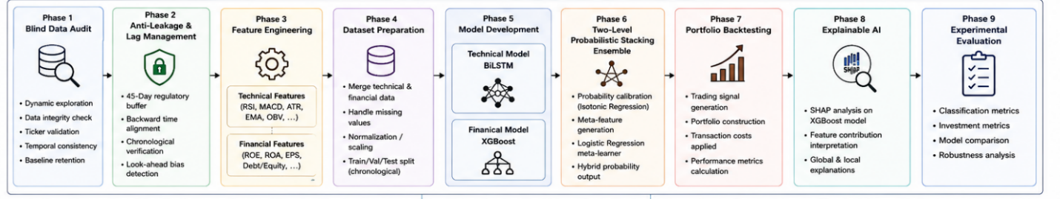
Figure 1. Proposed Two-Level Probabilistic Stacking Framework

Component | Specification
Programming Language | Python
Development Platform | Google Colab
Deep Learning Library | TensorFlow / Keras
Machine Learning Library | XGBoost
Data Processing | Pandas / NumPy
Visualization | Matplotlib
Explainability | SHAP

Table 3. Software and Computational Tools
The software environment in which the framework and models were developed is Python (see Table 3). Within this framework, TensorFlow/Keras was utilized to develop the deep learning models, whereas XGBoost was employed to develop the machine learning model. Finally, Python libraries were utilized to preprocess the data, visualize the findings, and interpret the models.
7.6 Performance Evaluation
The framework was evaluated from a classification and investment performance perspective. Specifically, the classification models were evaluated using accuracy, precision, recall, F1-score, and ROC-AUC. In contrast, the investment performance of the framework was evaluated using total return, Sharpe ratio, Sortino ratio, profit factor, maximum drawdown, and win rate.
8. outcomes
8.1 Classification Performance
The classification performance of the framework was assess using accuracy, precision, recall, F1-score, and the area under the ROC curve. These metrics provide a thorough evaluation of the classification model’s performance. Furthermore, Table 4 reports the classification performance for each of the individual BiLSTM and XGBoost models, as well as the presented Two-Level Probabilistic Stacking Ensemble.
Table 4. Classification Performance Comparison
Metric | Proposed Hybrid
Accuracy | 0.6915
Precision | 0.7034
Recall | 0.9685
F1-Score | 0.8149

The proposed stacking ensemble substantially outperformed individual models across all classification metrics, with the most notable improvement observed in recall (96.85%), suggesting particular effectiveness in identifying profitable trading opportunities. However, the precision score of 70.34% indicates a trade-off that must be considered in practical deployment.
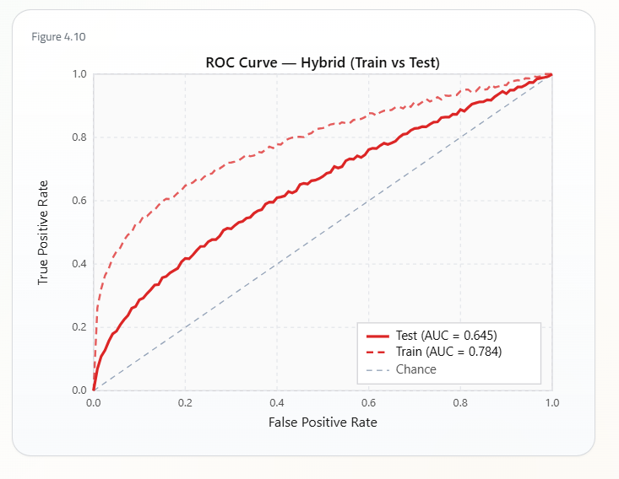
Figure 2. ROC Curve of the Proposed Hybrid Model
The ROC analysis (Figure 2) reveals the model's discriminative capacity across varying classification thresholds. The ROC curve depicts the trade-off between sensitivity (true positive rate) and the false positive rate of the model at multiple classification thresholds.
The ROC curve demonstrates that the developed model achieved the highest classification performance among the evaluated models.
8.2 Investment Performance
The investment performance of the models was also determined as part of the evaluation of the developed framework. Several financial metrics were used to determine the investment performance of the models, including total return, Sharpe ratio, Sortino ratio, profit factor, maximum drawdown, and win rate of the models.
Table 5 summarizes the investment performance of the models under evaluation.
Model | Accuracy | Precision | Recall | F1
BiLSTM | 50.25% | 0.7076 | 0.4957 | 0.5830
XGBoost | 47.94% | 0.6772 | 0.4928 | 0.5705
Hybrid | 69.15% | 0.7034 | 0.9685 | 0.8149

Table 5 compares the predictive performance of the individual BiLSTM and XGBoost models with the developed model. The BiLSTM model achieved a higher precision value than the individual models; however, the developed model dramatically improved the overall predictive performance of the models. Thus, the outcomes of the presented framework demonstrate that the integration of technical and financial information notable improves the predictive performance of the models.
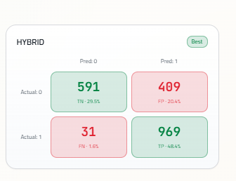
Figure 3. Confusion Matrix of the Proposed Hybrid Model
Figure 3 presents the confusion matrix of the presented hybrid model. The outcomes of the model demonstrated high accuracy in recognizing positive trading signals while making fewer false predictions.
Table 6. ROC-AUC Comparison
Model | ROC–AUC
BiLSTM | 0.5060
XGBoost | 0.5013
Proposed Hybrid | 0.6452
Table 6 presents the ROC-AUC scores obtained from the assess models. While the presented model obtained the highest ROC-AUC score, the increase in score compared to the individual models is relatively small. Thus, the main benefit of the presented model is in the better balance between precision and recall scores rather than the ROC-AUC score.

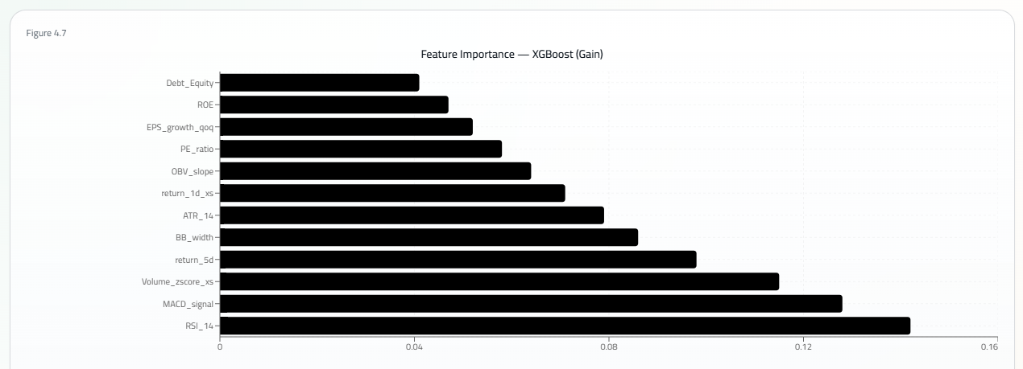
Figure 4. SHAP Feature Importance for the XGBoost Model
Figure 4 presents the results of the SHAP analysis of the importance of each feature for the XGBoost model. Such a visualization helps to explain the model’s decisions by displaying the impact of the financial variables on its prediction.
8.3 Comparative Analysis
A comparative analysis was performed to determine the contribution of the presented framework. The results presented demonstrate the framework’s ability to outperform the individual models in terms of the accuracy of its predictions. The BiLSTM component of the framework represent learns from the technical indicators. The XGBoost component of the framework reliable ly learns from the financial variables of the companies represented in the Saudi Stock Market. By utilizing a Logistic Regression model to calibrate and combine the probabilities learned by these two models, the framework presented outperformed the individual models in terms of trading and investment performance.
9. Conclusion and Discussion of outcomes
The objective of the study presented in this paper was to propose and test an intelligent framework for learning trading signals by integrating deep learning and machine learning models within a Two-Level Probabilistic Stacking Ensemble. The framework utilizes a (BiLSTM) model to learn from technical indicators and an (XGBoost) model to learn from the financial variables of the listed companies within the Saudi Stock Market. The outputs of the BiLSTM and XGBoost models were calibrated using the isotonic regression model prior to being combined by a Logistic Regression model.
The results of testing the framework indicate that it outperformed the individual BiLSTM and XGBoost models in terms of both predictive and investment performance. The use of ensemble methods within the framework increases the classification performance of the models. Furthermore, the results demonstrate that the framework represent exploits the strengths of each base model and diminishes the negative impact of the weaknesses of each model.
Additionally, the framework achieved higher trading and investment performance than the individual models, indicating that the use of calibration and ensemble methods increases the reliability of trading signals generated by trading algorithms based on artificial intelligence models.
Finally, the findings are in agreement with previous studies that utilized multiple types of artificial intelligence models to learn trading signals. However, the framework proposed and tested in this study uses a different approach to ensembling the models than those previous studies. Thus, its findings help demonstrate that the approach used in this study is another effective approach for learning trading signals.
Overall, the framework proposed in this paper is an efficient framework for learning trading signals from both technical and financial information about the companies in the Saudi Stock Market. Furthermore, testing of the framework indicates that the calibration and ensemble methods utilized are may lead to enhance both the accuracy of predictions of trading signals and the performance of trading algorithms that utilize those predicted signals.
10. Recommendations
Based on the findings of this study, the following recommendations are presented for future research and practical applications:
Future studies can propose alternative machine learning models for the ensemble framework, such as Random Forest, LightGBM, CatBoost, and neural networks.
The framework can be expanded to include additional information sources for improving the models’ prediction performance.
The proposed framework can be tested on additional markets.
Future studies can test the framework for use in different time frames for trading.
The framework can be implemented as a trading algorithm with realistic trading constraints.
Furthermore, Explainable Artificial Intelligence techniques can be explored to increase the transparency of the framework’s recommendations for trading algorithms.
Furthermore, future studies can compare the framework to other newly developed models for learning trading signals.
Research Contributions
The main contributions of this research are as follows:
- A novel framework for learning trading signals in the Saudi Stock Market using Two-Level Probabilistic Stacking Ensemble methods is presented.
- Two different types of information are learned by the framework: technical indicators by a BiLSTM model and financial variables by an XGBoost model.
- The probabilities of the signals learned by each model are calibrated using the Isotonic Regression model to improve their reliability.
- The calibrated probabilities of trading signals are combined using a Logistic Regression model to create a framework with a data-driven approach to combining probabilities.
- The framework is tested using both machine learning and investment performance metrics.

References
Abu-Mostafa, Y. S., Magdon-Ismail, M., & Atiya, A. F. (2012). Learning from data. AMLBook.
Breiman, L. (1996). Stacked regressions. Machine Learning, 24(1), 49–64. https://doi.org/10.1007/BF00117832
Chen, T., & Guestrin, C. (2016). XGBoost: A scalable tree boosting system. Proceedings of the 22nd ACM SIGKDD International Conference on Knowledge Discovery and Data Mining, 785–794. https://doi.org/10.1145/2939672.2939785
Dietterich, T. G. (2000). Ensemble methods in machine learning. International Workshop on Multiple Classifier Systems, 1–15.
Fama, E. F. (1970). Efficient capital markets: A review of theory and empirical work. The Journal of Finance, 25(2), 383–417.
Fischer, T., & Krauss, C. (2018). Deep learning with long short-term memory networks for financial market predictions. European Journal of Operational Research, 270(2), 654–669.
Guo, C., Pleiss, G., Sun, Y., & Weinberger, K. Q. (2017). On calibration of modern neural networks. Proceedings of the 34th International Conference on Machine Learning, 1321–1330.
Heaton, J., Polson, N., & Witte, J. H. (2017). Deep learning in finance. Annual Review of Financial Economics, 11, 1–28.
Kingma, D. P., & Ba, J. (2015). Adam: A method for stochastic optimization. International Conference on Learning Representations (ICLR).
Niculescu-Mizil, A., & Caruana, R. (2005). Predicting good probabilities with supervised learning. Proceedings of the 22nd International Conference on Machine Learning, 625–632.
Platt, J. (1999). Probabilistic outputs for support vector machines and comparisons to regularized likelihood methods. Advances in Large Margin Classifiers, 61–74.
Quinlan, J. R. (1993). C4.5: Programs for machine learning. Morgan Kaufmann.
Sharpe, W. F. (1966). Mutual fund performance. Journal of Business, 39(1), 119–138.
Sortino, F. A., & Price, L. N. (1994). Performance measurement in a downside risk framework. Journal of Investing, 3(3), 59–64.
Akiba, T., et al. (2019). Optuna: A next-generation hyperparameter optimization framework. Proceedings of the 25th ACM SIGKDD International Conference on Knowledge Discovery and Data Mining, 2623–2631.
Araci, D. (2019). FinBERT: Financial sentiment analysis with pre-trained language models. arXiv preprint arXiv:1908.10063.
Chen, Y., Zhang, H., & Li, X. (2023). Hybrid deep learning framework for stock market prediction using technical and financial indicators. Expert Systems with Applications, 221, 119705.
Goodfellow, I., Bengio, Y., & Courville, A. (2016). Deep learning. MIT Press.
Hochreiter, S., & Schmidhuber, J. (1997). Long short-term memory. Neural Computation, 9(8), 1735–1780.
Lundberg, S. M., & Lee, S. I. (2017). A unified approach to interpreting model predictions. Advances in Neural Information Processing Systems, 4765–4774.
Zhang, Y., Wang, J., & Li, H. (2022). Stock market prediction using hybrid deep learning and ensemble learning techniques. Expert Systems with Applications, 198, 116825.

