Midocean University

College of Management
Department of Master of Business Administration

Optimizing Supply Chain Management in Saudi Arabia's Construction Industry

Prepared by: Hazem Almadani
Student ID:251000521

Supervised by: : د. الفيصل عبد الحميد
د.فايز جراد

Year:
2025


Acknowledgments
We would like to say a few words to tell you that we would like to thank Midocean University with all our hearts; these words give us an opportunity to continue further with our education and to fulfill this great aim. Special credit goes to the founder, Mr. Nasser Al-Muhaimeed, and the Director, Dr. Mohamed Ahmed, who have not given up on us.
We want to give a warm thank you to [Name] and [Name], who have been of immeasurable help and consistent assistance to us in the process of this research and have so far given valuable guidance.
We would also like to mention the contribution that all the faculty members gave to us, as they did not hide their knowledge and expertise from us but shared it with us, enriching our academic experience and personal growth.
And, last but certainly not least, we owe it to a great extent to our families and everyone who supported, encouraged, or counseled us in doing this work. You have assisted in bringing about the actualization of this study.

Name: Hazem Almadani

Abstract
The dissertation will address the problem of logistical delays, ineffective communication, and resource allocation in the Saudi Arabian construction industry to solve the issues and problems in Supply Chain Management (SCM). It also addresses the methods of how the activities of SCM can be improved through technological advances, such as Construction Information Modeling (BIM), Internet of Things (IoT), and Blockchain. The study uses the mixed design process, and the data collection was also done with the aid of qualitative interviews of the key players in the industry and a survey. The highest delay comes with logistics, and second in line is ineffective communication among the stakeholders, and then third in line is inefficient allocation of resources. The study also gives indications that there is a high propensity among industry practitioners to adopt new technologies, but there are barriers such as cost, cultural resistance, and expertise. The research provides viable recommendations to improve SCM in the Saudi construction sector with the aim of ensuring that the latest innovations, integrated communication, and better management of resources are implemented. The research study proves helpful to the literature and practice in the sphere of SCM with the thorough analysis of the SCM issues and solutions concerning the rapidly evolving construction market.
Keywords:
Supply Chain Management, Saudi Arabia, Construction Industry, Logistical Delays, Communication, Resource Allocation, Technology Adoption, Building Information Modeling (BIM), Internet of Things (IoT), Blockchain.

List of Figures
Figure 1: Logistical Delays - Survey Responses ------------------------------------------------------- 33
Figure 2: Poor Communication Between Stakeholders - Survey Responses ----------------------- 34
Figure 3: Resource Allocation Issues - Survey Responses ------------------------------------------- 35
Figure 4: Lack of Inventory Management - Survey Responses -------------------------------------- 36
Figure 5: Inadequate Technology Adoption - Survey Responses ------------------------------------ 36
Figure 6: Willingness to Adopt New Technologies for SCM - Survey Responses ----------------- 37
Figure 7: Technologies Most Beneficial for SCM in Construction - Survey Responses --------- 38
Figure 8: Impact of SCM Inefficiencies on Project Timelines and Costs - Survey Responses -- 39
Figure 9: Frequency of Supply Chain Disruptions - Survey Responses --------------------------- 40
Figure 10: Most Significant SCM Performance Challenge - Survey Responses ----------------- 41
Figure 11: Current Use of Technology in SCM - Survey Responses ----------------------------- 42
Figure 12: Technologies Most Beneficial for SCM in Construction - Survey Responses ---- 43

List of Tables
Table 1: Demographic Characteristics ------------------------------------------------------------------ 31

Chapter 1: Introduction
Chapter 1 presents the study on the Supply Chain Management (SCM) in the construction industry in Saudi Arabia. The construction industry is one of the sectors that contributes to the Kingdom's economy, whereby there are massive investments being made to modernize infrastructure under Saudi Vision 2030 (Haque, 2024). Nevertheless, the industry encounters a lot of SCM challenges, among them being logistical backlog, poor communication, and inefficiencies in resource allocation, all of which affect project timelines, cost, and quality. This paper will examine these issues and provide possible solutions to address them specifically through the implementation of such technologies as Building Information Modeling (BIM), Internet of Things (IoT), and Blockchain (Baghalzadeh Shishehgarkhaneh et al., 2022). The research aims are to measure the current practice of SCM, evaluate existing weaknesses, and investigate how the technology would enhance efficiency. In the conducted research, the authors also explore whether industry stakeholders are willing to use the new technologies. With their solution, the research should be helping to offer practical solutions to the improvement of SCM and be helpful in the successful execution of massive construction projects in Saudi Arabia.

1.1 Overview of the Construction Industry in Saudi Arabia
The Saudi Arabian construction business is central to the economic development and growth of the country. The sector is experiencing a time of quick change as a component of the Kingdom Vision 2030. Saudi Arabia is working to diversify its economy, and construction is considered to be one of the main drivers of the industry (DERENDINGER & FRANK, 2023). A big part of the country's development is given by Vision 2030, which will involve major infrastructural development like NEOM, a futuristic city that will be intensive in terms of advanced technology, and the Red Sea Project, which targets to promote tourism and economic diversification. The construction industry plays an important role in the GDP of Saudi Arabia, and the real estate, residential, and infrastructural projects are the main areas contributing to the growth (Ahmed et al., 2024). The government has committed billions of dollars to improving the infrastructure of the country, which has given the people development opportunities in both government and commercial sectors. The construction industry will be among the most vibrant sectors in the Kingdom, as part of the growth trajectory of the construction sector as part of Vision 2030 (AlNemer, 2024). Nonetheless, this growth has brought forth a number of challenges. The Saudi construction industry has high levels of inefficiency in its supply chain activities despite the fast infrastructural developments. Several large-scale projects are losing their success due to problems with logistical delays, inefficient allocation of resources, and the absence of integration between stakeholders (Scheepers & Whelpton, 2018). Inefficiency of the construction supply chain directly impacts on the project timelines, cost, and quality; and thus, efficient Supply Chain Management (SCM), is a key to the further prosperity of this field.

1.2 Importance of Supply Chain Management in the Construction Sector
SCM within the construction industry is the appropriate handling of the materials, labor force, equipment, and information relating to all levels of a construction project. With regards to the timely completion of the project, cost management, and quality, the SCM is an important element of the process within the fast, dynamic construction industry in Saudi Arabia (Alnaser et al., 2023). The implication of an effective SCM structure also implies that the materials are delivered where they are required and where they are needed, there is good coordination of resources, coordination of contractors and subcontractors, and project delays and cost overruns are reduced. Ware is expensive in the CM construction industry. The operation of a supply chain is efficiently managed to accomplish the project completion within the set time, budget, and quality. SCM is focused on the complexities surrounding the management of different stakeholders like the contractors, suppliers, project managers, and subcontractors, among others, which have massive roles to play in the delivery of the project (Heaton et al., 2022). Any delays in supplying materials, equipment failures, or improper logistical planning would make a tremendous impact on project completion, which would entail the loss of not only the revenue but also a bad reputation in all the markets. The project costs and schedule can be affected by project inefficiency in the Saudi Arabian construction industry in SCM (Alshammari and Ghazali, 2024). The research takes the logistical delays as one of the principal issues of the business. Such delays can be triggered by numerous factors, and they may include a deficiency in communication among the concerned parties, an inability to synchronize the various parts of the supply chain, and poor distribution of resources. In addition, the existence of obsolete management approaches, the lack of incentives to deploy the latest tools and technologies, such as Building Information Modeling (BIM) or Internet of Things (IoT) systems, are also factors in the problems. These are but some of the inefficiencies that should be explored to give the Saudi construction industry a high level of competitiveness and sustainable approach.

1.3 Research Problem
Despite the importance of the already attained SCM, the construction industry in Saudi Arabia continues to face severe supply chain challenges. The general research question is the definition and the understanding of these issues, particularly in the performance of inefficiency in the supply chain. A significant gap in the literature on the particular SCM issues hindering the Saudi construction sector is observed in terms of the contribution of technology, resource distribution, and the coordination of the stakeholders (Iqbal et al., 2025). One of the major problems that persist in bedeviling construction projects within the Kingdom is the logistical delays. The sheer size of Saudi Arabia in terms of land and the harsh climatic conditions are logistical challenges in the movement of pertinent materials and machinery to the construction sites. Also, the fact that individual manufacturers greatly depend on foreign sourcing of raw materials increases the issue since the delay at customs and inefficiencies in shipping cause a lead-time to last longer (Al-Abri, 2023). The second problem is the ineffective management of resources. The Saudi construction sector is facing a problem of resource forecasting and control, such as labor, materials, and equipment. This variation in supply and demand creates either excess stock or a lack of materials, which causes a further delay and increase in costs. The lack of integration between contractors, suppliers, and subcontractors also contributes to the same issues (Noganta, 2019). In addition, the reluctance to employ technological solutions in a contemporary manner also contributes to the inefficiencies in SCM. The technologies that can make the construction supply chain run more efficiently are BIM, IoT, and blockchain; these technologies enable the monitoring of the materials in real time and improve the communication and coordination between the stakeholders. However, the Saudi construction sector has not been quick in adopting these technologies and hence missed the chances to improve productivity.

1.4 Research Objectives
- To establish the SCM practices that are presented in the current Saudi construction industry and whether they are succeeding in addressing the challenges faced by the industry.
- To assess any form of inefficiencies in the construction supply chain, one would consider such areas as logistical delays, resource management, and non-use of technology.
- To recommend actions on the way to optimize SCM, e.g., the implementation of new-age technologies, including BIM, IoT, and blockchain, boosting communication and cooperation between stakeholders.
- To establish the significance of technology in enhancing SCM practices in the Saudi construction industry, it would be relevant to examine how new technologies can be applied to enhance the current inefficiencies.

1.5 Research Questions
- What are the major challenges affecting supply chain efficiency in the Saudi construction industry?
- How can SCM be improved with technology adoption?

1.6 Research Hypotheses
The research hypotheses are based on the identified challenges and the potential solutions to overcome them. These hypotheses will be tested through both qualitative and quantitative research methods:
- H1: Inefficiencies in SCM significantly affect project costs and timelines in Saudi construction projects.
- H2: Adoption of new technologies (e.g., BIM, IoT, blockchain) can reduce SCM inefficiencies in construction projects.
- H3: Collaboration between stakeholders in the construction supply chain enhances overall project performance.

1.7 Structure of the Dissertation
The following chapter breakdown will guide the reader through the study:
- Chapter 1: Introduction: Chapter 1 presents the problem being studied, the purpose and research questions of the research, and a general overview of the Saudi Arabian construction industry.
- Chapter 2: Literature Review: Chapter 2 will include the literature review of the SCM that is applicable in Saudi Arabia, the challenges and opportunities in the SCM, and the possibilities that technology can bring to revolutionize SCM. The chapter will also signify the gaps in the existing research, besides stating the theoretical framework of the study.
- Chapter 3: Methodology: Chapter 3 will be the methodology chapter; it will outline the method design, data collection procedures, sampling plan, and data analysis that would be applied in this research. It will also address some ethical issues and limitations of the study.
- Chapter 4: Results: Chapter will include results of surveys and interviews, which will entail the comparison of qualitative and quantitative data and conclusion will be made on the SCM inefficiencies and level of technological application in the Saudi industry of construction.
- Chapter 5: Conclusion: The conclusion will bring out the key findings, comment on how this research has contributed and propose further research.

Chapter 2: Literature Review
Chapter 2 presents a thorough literature review on the current research on Supply Chain Management (SCM) practices within the construction industry in Saudi Arabia, challenges, opportunities, and the application of technology. The main problem areas detected are logistical delays, inadequate communication, and inefficiency in resource allocation, which all undermine project timelines, cost effectiveness, and quality (Omoegun et al., 2024). According to the literature, Building Information Modeling (BIM), Internet of Things (IoT), and Blockchain have a great potential to enhance the efficiency of SCM, but people adopt technologies poorly because cultural resistance and high costs of implementation, and lack of technical skills impede adoption. Case studies of international constructions highlight how lean construction, collaborative contracting models, and integration of technology have contributed to the better performance of the supply chain (Evans et al., 2023). Nevertheless, the existing literature also depicts any gaps unique to Saudi Arabia, including the logistical issues in the region, and cultural aspects related to the implementation of the modern SCM technologies. The review demonstrates the necessity of a unified mechanism that would combine technology and help streamline communication and manage resources better.

2.1 Current Supply Chain Management Practices in Saudi Arabia
SCM in the construction business is a multi-stakeholder process, which involves supply chain activities of procurement and supply chain, materials and logistics, scheduling and coordination of the project, as well as contractors, subcontractors, suppliers, and logistics. The construction industry in the Saudi context is experiencing significant changes due to Saudi Vision 2030, which focuses on infrastructure development, mega-projects, and economic diversification (Alotaibi et al., 2023). In this context, the SCM practices in Saudi Arabia are changing, but still, they are associated with structural, institutional, and cultural issues. Some of the studies show how the Saudi construction companies are today organizing their supply chains. As an illustration, the procurement is in most cases dominated by long lead time imports, a lack of integration between the supplier and contractors, and a hierarchical decision-making structure (Chenini et al., 2021). Such practices illustrate the heritage systems brought by the old construction paradigms, which make use of heavy manual coordination, paper documentation, and few digital connections in the chain. Due to the characteristics of the timelines of work of numerous companies that depend on the national infrastructure programmes, increased pressure on the SCM is observed. In this respect, it can be considered that the Saudi industry has been characterized by a mix of traditional SCM approaches to construction (e.g., centralized procurement, sequential workflows), as well as novel requirements towards quicker, more connected supply chains (Ali, 2025). In practical terms, companies tend to divide the supply chain into distinct steps, such as procurement, delivery, storage, and installation, where there are few feedback loops in between the steps. Such segmentation may result in sub-optimal chain visibility, such as delayed deliveries not being reported upstream or storage centres not being taken into consideration when planning. A few more expansive Saudi contractors are, however, embarking on digital systems: enterprise resource planning (ERP) modules, vendor portals, and other logistics tracking systems (Alharthi, 2022). However, its adoption has not been even, particularly among small to medium subcontractors and suppliers that constitute a significant portion of the Saudi supply chain ecosystem. In general, the analysis of the existing SCM practices in Saudi Arabia demonstrates that it is a sector that is in a state of transition: conventional models still dominate, yet external forces (mega projects, Vision 2030 goals, global supply-chain shock) are compelling companies to reconsider practices. The literature proposes an increasing awareness of the usefulness of SCM, but also implies that in most firms, there is still little evidence of putting the advanced practices into operation.

2.2 Challenges and Opportunities
Moving beyond description of practices, the literature identifies a number of distinct challenges in Saudi construction SCM, which also present opportunities for performance improvement. communication/coordination, and resource allocation inefficiencies. Resource allocation inefficiencies, communication/coordination, and resource allocation inefficiencies. The long lead times are caused by importation delays, clearance conditions at the ports, and the restriction of access to the sites, as well as the transportation of materials in the unique geographical environment of Saudi Arabia (Asiri & Odularu, 2020). These logistical burdens increase with the operations of mega projects in remote areas (e.g., special economic zones, NEOM). These delays lead to overlapping of schedules, wastage of labor, higher storage expenses, and eventually higher project expenses. Conventional hierarchical contracting arrangements and designs tend to cause the siloing of information among the main contractors, subcontractors, suppliers, and logistics providers (Ekeskär et al., 2022). The information on the availability of materials, delivery, and installation preparedness may not flow properly in the absence of proper integration. Such inability to integrate leads to mismatched schedules, twice-handling, and reactive instead of proactive supply-chain response. The Saudi Arabian construction projects have problems related to the proper forecasting of materials, labour, and equipment (Abdellatif & Alshibani, 2019). Excessive orders and insufficient orders of materials, unnecessary warehouses, and idle machinery are losses. In many cases, this is based on the inadequacy of demand forecasting ability, poor inventory management, and the absence of real-time monitoring. Due to the large size of most projects and the rapid development nature of the environment, it is essential to allocate resources on time.
Furthermore, these areas of challenge also have opportunities. As an illustration, lead times can be minimized by improving logistics optimization by enhancing routing, supplier diversification, and regional warehousing. Better flows of information and material can be realized through the improvement of communication and coordination through integrated ICT systems and collaborating contracting structures (Eliwa et al., 2022). Improving resource allocation through implementing demand forecasting, just-in-time delivery, and inventory reduction will provide savings on costs and schedule stability. Overall, literature demonstrates that the Saudi construction supply chain has serious inefficiencies that could be improved, but these issues are complicated by the dynamism of the industry and the impetus of government programs.

2.3 Role of Big Data Analysis and Managerial Analytical Skills
Analytics, managerial decision-making, and the ability to grow have become more of a focus in modern supply chains, as more data and digital tools become available. In SCM studies, big data analytics (BDA) is considered the process of collecting, processing, and utilizing enormous, diversified, and dynamic data to derive actionable results (Lai et al., 2018). In SCM of construction, this consists of information about changes in procurement requirements, delivery times, usage on-site, equipment bestowal, workforce execution, and logistics circulation. Numerous studies all over the world prove that BDA capabilities positively affect the performance of the supply chain. As an example, one study discovered that companies exhibiting stronger big data analytics processes had superior resilience of the supply chain, and innovation resulted in improved performance (Bahrami et al., 2022). A systematic review of big data in SCM also uncovers that optimizing processes in the supply chain through analytics would make forecast errors less frequent, trace and track better, and reduce the cost of operations. Saudi Arabian-based research is starting to indicate the interconnection between the adoption of BDA and the enhancement in the performance of the supply chain. For example, a case study of Saudi Arabia consisting of medium and large-sized supply chain organizations discovered that environmental pressures, organizational capability, and readiness to use technology determine the adoption of big data analytics (Aldossari et al., 2025). A second Saudi investigation of the role of big-data analysis in tourism companies (not in construction) reveals that data proficiency, technological support, and leadership congruence are important determinants of performance. In the case of the construction industry within Saudi Arabia, the implication is that analytical skills of managers (i.e., skills in data interpretation, making forecasting decisions, coordinating various data streams, etc.), along with big data tools, can turn SCM into proactive (Aseeri, 2023). As an illustration, material deliveries, real-time tracking, equipment downtime predictive analytics, driver routing analytics (logistics), and supplier performance dashboards can all help to run a supply chain more smoothly. Nevertheless, serious obstacles are reported in the literature as well. These are a shortage of qualified staff, change resistance, data quality problems, and incomplete data systems. Finally, the literature reveals that big-data analytics and managerial analytical proficiency have a high potential of enhancing SCM in Saudi construction, but its implementation is still in its infancy.

2.4 Strategies for Enhancing Supply Chain Performance
Enhancing efficiency, cost, and completion of projects at the right time depends on the improvement of supply chain performance in the construction sector. Some of these strategies have been suggested and employed in different construction markets, all over the world, and they apply quite well in the construction industry of Saudi Arabia (Bin Judai, 2022). Incorporation of technology throughout all supply chain stages is one of the most important initiatives to improve the performance of the supply chain. A notable case is the adoption of Building Information Modeling (BIM), which enables the stakeholders to coordinate and collaborate. BIM allows building complex 3D models, which can be used to simulate how the construction will take place, and allow a real-time view of the project advancement (Bhatarai et al., 2025). Such technology has the potential to minimize mistakes, optimize resource use and waste, thus contributing to the efficiency of the project, in general. Just-in-time (JIT) inventory management is another important strategy that focuses on minimizing wastage and delivering materials at the exact time when they are required. JIT reduces inventories of materials, thus minimizing costs that are related to the excess inventory, like storage costs and degradation of materials. Nevertheless, it needs proper forecasting and stable suppliers, which is why it can be applied to a company that is well acquainted with the suppliers and can be sure that they will deliver on time (Rane, 2023). Another important aspect of improving the performance of the supply chain is supplier relationship management. Good relations with the suppliers will result in the improvement of communication and the delivery, which can be considered more reliable and flexible. In a Saudi world where construction projects are frequently dependent on international suppliers, one way to address the problem of logistical challenges and delays is to build a strategic partnership with the major suppliers. Integrated Project Delivery (IPD) and Construction Management at Risk (CMAR) are also collaborative contracting models that are in demand in the world construction sector (Sanboskani, 2024). These models focus on the need to involve all project stakeholders, such as contractors, suppliers, and subcontractors, early in the planning and design of a project. Collaborating at the earliest stage, the project team might identify possible problems, coordinate goals, and simplify the decision-making process, which will result in an efficient project delivery. Finally, there is the increased application of data-driven decision-making to enhance SCM. Through the use of big data analytics, the construction companies will be able to predict possible disruptions, trends, and optimize the schedule. Predictive analytics may also predict delays because of weather, stock shortages, or a machine breakdown, so that project managers can take proactive steps to counter these problems before they affect the project schedule.

2.5 Review of International Supply Chain Practices in Construction
Supply chain management in the construction industry has taken a different dimension internationally due to the adoption of superior technologies and increased cooperative approaches. The high-level developed construction industries of countries like the United States, Germany, and the United Kingdom have created and perfected SCM strategies applicable to the situation in Saudi Arabia (Azmi et al., 2022). The lean construction approach has been popular in the United States. The goals of lean construction include waste reduction and maximum value to the client. Such an approach entails a process of holistic oversight of the whole supply chain procedure in order to recognize and do away with inefficiencies. The processes are also made lean with the use of techniques like the last planner systems, value stream mapping, and continuous improvement, which make sure that resources are utilized in the best way possible (Patel et al., 2021). Likewise, Building Information Modeling (BIM) has become a prime contributor to the improvement of SCM in the United Kingdom. BIM is also used to increase the transparency in the supply chain, not just improving the design coordination and visualizations. Moreover, procurement systems have also been integrated into the UK construction sector, whereby the emphasis is placed on the significance of the involvement of suppliers early in the project and coordinated planning. By keeping suppliers engaged at the early stages of the design and planning, UK construction projects can feed in the different issues that may emerge, and this will lead to reduced delays and an enhanced project schedule (Arefazar et al., 2022). The SCM strategy in Germany is strongly oriented towards combined logistics and supply chain partnership. Lean logistics has been a great success because it aims at minimizing the inefficiencies in material delivery and handling. Additionally, German construction companies are more inclined to apply real-time material and resources monitoring, which enables them to organize inventory, decreasing the storage expenses, and delivering the materials to their location on time. Smart construction practice is being employed to improve SCM in such countries as Singapore and South Korea. Internet of Things (IoT) sensors, drones, and autonomous vehicles are technologies applied to smart construction to enhance logistics and monitor materials in real-time (Kayembe & Obadire, 2025). These technologies, when incorporated together, enable enhanced visibility and control of the supply chain, which in turn results in improved decision-making and performance. The lessons learnt by these international practices are important to the Saudi construction industry, as there is an increasing pressure to embrace more effective, open, and participatory supply chain practices. Through the achievement of these states, Saudi Arabia could investigate alternative methods of rationalizing its building operations, delays, and enhancing the general efficiency of its chain of supply.

2.6 Existing Gaps in the Literature on Saudi SCM Practices
Although much attention has been paid to supply chain management in the construction sector, there are multiple gaps in the literature, especially regarding the challenges that are peculiar to the construction sector in Saudi Arabia. These gaps indicate that more research is required in the future to comprehend and resolve SCM inefficiencies within the country. The regionally specific issues of the Saudi Arabian supply chain are one of the biggest gaps. The geographical characteristics, extreme climate, and remoteness of the country pose logistical complexities, which are not sufficiently addressed in the available literature (Touloumidis et al., 2025). Most literature on SCM in the construction industry targets well-infrastructure urbanized regions, and therefore, the results are hard to generalize to projects in less accessible parts of Saudi Arabia. Such regional factors and their effect on transportation delays, material availability, and project schedules are not well studied within the present literature (Nguyen et al., 2019). The other significant disconnection is the cultural factors that affect the Saudi Arabian activities connected to the supply chain. The construction industry in Saudi Arabia is predominantly dependent on subcontractors, most of whom are foreign workers. This brings about problems regarding communication, coordination, and quality compliance. Informal networks and personal relations are also steps that should be considered in the context of contributing to making decisions in the supply chain (Saikouk et al., 2021). The literature does not pay much attention to the cultural dynamics involved, and they may have great effects on the viability of the SCM practices.
Furthermore, technological adoption in the Saudi Arabian construction industry is low, and the issue is not sufficiently addressed in the existing literature. The SCM context can be subjected to Building Information Modelling (BIM), Internet of Things (IoT), and Blockchain in order to revolutionize the transparency, communication, and real-time data tracking. The technology adoption barriers, such as resistance to change, the lack of technical knowledge, and the high initial cost of the technology implementation, have not been properly researched in the context of Saudi Arabia, though (D AL-TAYYAR et al., 2021). Lastly, another area where the literature is insufficient is the integration of the stakeholders in the supply chain of the Saudi Arabian construction industry. Many projects are still being made on the siloed format, and there is minimal cooperation amongst the contractors, suppliers, and subcontractors. The use of collaborative contracting models and potentially more integrated supply chains in Saudi construction projects is an area that needs to be pursued.

Chapter 3: Methodology
This chapter elaborates on the research design, data collection procedures, sampling, analysis of data, and ethical issues that this study has factored in. The analysis will aim to discuss and name the issues in the supply chain management (SCM) of the Saudi construction industry with explicit references to inefficiencies and the use of technology. The research design that will be adopted in the research is the mixed research design that integrates both the qualitative research design and the quantitative research design to provide a holistic picture of the supply chain practices in the industry.

3.1 Research Design
The paper in question implies the implementation of the mixed-methodology, i.e., providing the qualitative and quantitative research approach to outline the entire picture of the supply chain issues of the Saudi construction industry and the prospects of the technology to be implemented to improve the performance. The qualitative component is based on a wide range of information obtained with some of the core stakeholders within the industry, including contractors, project managers, and suppliers, via semi-structured interviews (Khargh et al., 2023). Such interviews will be directed to gain the perception, experience, and opinion of the interviewees on the SCM practices and SCM inefficiencies, and how the technological solution to the problem can be introduced. The qualitative data will provide both the contextual and rich data of the ills and the remedies available in the minds of those who are either directly affected by the industry. Its quantitative aspect, in turn, resorts to questionnaires and surveys to collect numerical data on a larger sample of stakeholders (Kelley-Quon, 2018). This facilitates the study to determine trends, patterns, and relationships between practices of SCM, the influence of inefficiencies on the cost and schedule of a project, and the level of technology utilization in the industry. Using both methods, the study will be in a good position to savor the specifics and the context of data that is qualitative, as well as generalizing and statistically verifying the information captured by the data that are quantitative, functioning in essence, as a moderated view of SCM practices in the Saudi construction industry.

3.2 Data Collection Methods
In this study, the collection of data will be unionized into qualitative and quantitative methods, which will collect the necessary information of a specific nature. In the qualitative part, key stakeholders in the Saudi construction industry, among which are the project managers, contractors, suppliers, and logistics providers, shall be interviewed using a semi-structured interview technique (Azmi et al., 2022). These interviews will aim for in-depth information on supply chain management (SCM) challenges, practices, and opportunities. Semi-structured format permits flexibility, and the respondents will develop their experiences well, but at the same time, the kernels of areas pertaining to the aims of the research are addressed. The interviews will allow for the development of themes, including logistical delays, lack of coordination, resource allocation concerns, the use of technology in increasing SCM (e.g., BIM, IoT, blockchain), and how this can be improved in Saudi construction projects. The interviews will be performed either face-to-face or through video conferencing and recorded (the participants will be asked) and transcribed to be analyzed. In the quantitative phase, a questionnaire will be issued to a more elaborate group of respondents in the construction sector, with the focus being on contractors, project managers, suppliers, logistical providers, and subcontractors (Alkilani & Loosemore, 2025). The survey will be administered by closed-ended questions that will be used to measure such key variables of SCM as the frequency of logistical delays, the effect of inefficiencies on project costs, and the technology adoption level in SCM. The level of agreement with statements considering SCM challenges and technological effects will be measured with Likert-based questions. The survey will be sent using electronic tools such as Google Forms that allow a wide reach of participants and are easy to use.

3.3 Research Sample and Data Sources
The two major choice strategies that shall be used in the research paper shall be the purposive sampling of the qualitative information and the random sampling of the quantitative information. Purposive sampling will be implemented in the example of the qualitative phase, where individuals possessing some knowledge and experience that is relevant to the study of the issue under consideration will be chosen (Nyimbili & Nyimbili, 2024). This will bring the participants aware of the supply chain management (SCM) practice of the Saudi construction industry in detail. These stakeholders will include the project managers, contractors, suppliers, and logistics providers. The selection criteria will include five years of working in the Saudi construction market and the role being directly related to SCM or project implementation, and an interest in providing exhaustive information relating to SCM practices and challenges.
The construction industry comprises a diverse range of views, which will be sampled randomly in the case of the quantitative phase. The survey will target a total of 86 respondents in order to ensure that the results are statistically significant and representative of the larger industry. A sample will be selected from a collection of Saudi Arabian industry professionals that includes the members of the Saudi Arabian professional construction associations, contractors, and suppliers (Shaawat et al., 2023). The sample will be based on the total number of potential respondents, which will be further used to generalize the results, and a representative sample will be obtained with different stakeholder groups in the construction industry.

3.4 Data Analysis and Interpretation.
The thematic analysis is a common technique of identifying, examining, and reporting trends in the qualitative data, and that is the way the qualitative data collected in interviews will be analyzed. The process will begin with data familiarization, during which the interview transcripts will be read multiple times to ensure a thorough understanding of the content. Subsequently, the first coding will be conducted, i.e., the identification of important phrases or words, or parts that indicate the particular themes associated with the practices and challenges of supply chain management (SCM) (Mirzaei & Shokouhyar, 2023). These codes will be put under their general themes, which would embody the predominant challenges, opportunities, and insights regarding SCM in the Saudi construction industry. Interpretation will be the last step, whereby the themes will be interpreted with regard to the research questions to make meaningful conclusions regarding SCM inefficiencies and improvement opportunities. In the case of the quantitative data, the analysis of the responses in a survey will be carried out with the help of statistical tools like SPSS. Analysis will start with data cleaning, whereby the data set is free of any missing data and outliers. The summarization of the basic characteristics of the data in terms of frequencies and percentages will be based on descriptive statistics. Inferential statistics, including Chi-square tests and ANOVA, will be employed to investigate the relationship between variables, where SCM inefficiencies and project costs are to be examined (Muthuswamy & Al-ameryeen, 2022). The relationship between the use of technology and the efficiency of SCM will be investigated by correlation analysis. Such a quantitative analysis will offer a statistical basis for the research results.

3.5 Research Limitations
This paper recognizes various constraints that can affect the results. To begin with, the qualitative interviews might be subject to problems in the generalizability of the results due to sample size and representation. There is a possibility that the study fails to reflect the views of every stakeholder in the Saudi construction industry, especially the small contractors or subcontractors. Secondly, the responses provided may be biased, especially where the survey respondents are not always telling the truth on the issues they are grappling with in SCM. Additionally, the accessibility of the interviewees may also be a problem, particularly in the case of the interviewing the top in rank within the industry who may be too busy or combative to give any proprietary or sensitive information. However, such contagions can be reduced through a mixed-methodology research since data are triangularized. The fact that such a strategy is accepted positively complements the findings produced through the merging of the qualitative and quantitative information to present a more balanced and consistent image of the SCM practices within the Saudi construction sector.

3.6 Ethical Considerations
The ethical problem that would be taken into account is the integrity of this research. The study will be done based on good ethical principles to ensure there are no instances where the rights and privacy of the subjects are infringed. The individuals taking part in the interviews and surveys would be informed, and they would be well conversant with the aim and purpose of the research. The degree of participation is voluntary, and they may pull out at any time without any consequences. Confidentiality will be taken into account in the entire research process. No personal information will be included to ensure that the identity of the respondents is preserved by ensuring that all data collected is anonymous. Besides, the members will be treated with respect and their input valued and handled appropriately. It will also state all the potential sources of conflict of interest, and the research will be conducted in the best ethical standards. The ethical concerns play a critical role in facilitating trust and transparency to the extent that the research process becomes professional and understanding of the rights of research participants.

Chapter 4: Results
Chapter 4 of the study summarizes the findings of the quantitative and qualitative data that were gathered during this research and provides a general picture of the supply chain management (SCM) practices in the Saudi construction industry. The quantitative data shows what kind of issues should be considered, such as the 57% of the surveyed individuals who agreed or partially agreed that the SCM challenges that need to be considered are the delays in the procurement and transportation of the materials. It was also remarkable that communication issues between the stakeholders had flown as 45% of the respondents said that there is a problem related to poor communication, although others were not specific or disagreed. The qualitative data references also extended these findings and focused on the negative impact of the logistical delay and the need to have a better means of communication (Pacheco-Velazquez et al., 2024). The interviewees also embodied the responses of the survey, and they also identified the shortcomings of the resource allocation as one of the problems. The survey as well as the interview also revealed a strong wish to adopt new technologies, but obstacles such as high cost, poor training, and cultural barriers were still there. Among the technologies that can potentially become more efficient in SCM, BIM, IoT, and blockchain have also been mentioned, although interviewees also highlight that these are technologies that cannot be implemented on a large scale due to their financial and technical challenges (Pinto Varela Alberte & de Oliveira Novelli, 2024). The results point to the continuing inefficiency of SCM within the Saudi Arabian construction industry and have also suggested a possible solution through technology, but challenges to it will need to be tackled.

4.1 Presentation of Quantitative Data
Based on the survey answers, significant data on the challenges in supply chain management (SCM) and technology adoption in Saudi Arabian construction enterprises can be obtained. The most important issue seemed to be the issue of logistical delays, with 57% of the respondents stating that it is so, or emphatically that it is indeed so, that final delivery and procurement delays are a major concern in the SCM efficiency. A very small percentage (7% disagreed) of the logistical challenges, and this validated the hegemony of the logistical challenges. Cases of bad communication among the stakeholders also came out as an issue, with 45% of the respondents agreeing or strongly agreeing (Austin et al., 2019). Nonetheless, 21% were ambivalent, and 20% opposed that, which means that the problems of communication are, perhaps, not so widespread as delays on the logistic side. In the allocation of resources, the responses were more even, with half of them agreeing that the problems of resource allocation, including material shortages and labor inefficiency, are problematic, 13% disagreed and strongly disagreed, and there was a less coherent experience across various projects.
Another major issue was the problem of poor technology adoption, where 70% of respondents conceded that it was a deadly problem. It means that there is a clear understanding of the technological deficiencies in the industry, especially the application of the BIM, IoT, and blockchain tools. However, to address the question about the willingness to implement new technology, responses were more positive, and three-quarters of the involved entities said that they wanted or highly wanted to adopt new technology in SCM (Bodendorf et al., 2023). At least 5% of those who had not prepared to invest in technology meant that these people were largely ready to invest in technology despite the challenges. These results demonstrate that the lack of efficiency in the SCM is a universal problem, and the industry is eager to address it by implementing the technologies.

4.2 Presentation of the Qualitative Data
The qualitative data collected, including the interviews, provided a profound, comprehensive insight into the opportunities and challenges in supply chain management (SCM) in the Saudi construction industry. The interviews were analyzed so as to determine several themes, and some of them included: log ratio slacks, misplaced allocation of resources, and potential effects of technology on an upgraded SCM (Tu, 2018). John referred to the problem of logistical delays of different players. One of the most infamous problems that led to the slowness of the project completion was the delays in delivery and supply of the material, as well as the receipt of the custom in the interviews, especially in huge projects in remote areas. It was even worsened by the fact that most stakeholders pointed out that there were no real-time shipment following systems. The second similarity was that communication between the contractors, suppliers, and subcontractors was not established. The primary reason behind errors, time loss, and resource wastage, according to interviewees, was incomplete channels of communication that were based on the inability of various actors in the supply chain to integrate effectively (Hao, 2025). The use of technology was also addressed as a possible way out of these problems. Participants willingly shared their wish to have BIM and IoT more popular among them, and most of them referred to their possibilities of enhancing coordination, resource distribution, and general supply chain visibility. Nonetheless, it was understood that these technologies were not fully adopted because of cultural resistance and prohibitive prices.

4.3 Comparative Analysis of Findings
The quantitative and qualitative results demonstrate similarity and dissimilarity of the research data with each other when compared and contrasted, respectively. The survey and interview found delays at the logistical level to be the main SCM issue, and the survey respondent pointed out the issue as the most widespread in the industry. The interviews endorsed this as industry experts gave specifics on how delays in supply materials and transportation typically cause setbacks and escalated costs in projects. Both datasets encountered poor communication as a secondary issue. Though the survey data indicated that a considerable share of respondents support communication as a challenge, the interviews helped to present more specific insights, as the absence of real-time data sharing and integrated communication tools was identified as the main barrier, but the two approaches improved the way technology is adopted. The survey data showed a vast desire to embrace new technologies; nevertheless, the interviews proved that the participants were more conservative. Most of the professionals admitted the prospects of such technologies as BIM and IoT, but attributed cost, training requirements, and cultural opposition as the reasons that prevent their widespread implementation. Such a contrast highlights a difference between the intention expressed in the surveys and the realities seen in the interviews.

4.4 Implications of Findings
The study has both practical and theoretical implications for the Saudi Arabian construction industry. In real-life scenarios, the research emphasizes the need for enhanced logistics management and communication solutions in the construction supply chain as an imminent need. The sustainability of logistic delays and derailment of communication are evidence of the need to incorporate novel technologies like BIM and IoT to create more visibility in the supply chain, reduce delays, and optimize resource use (Najafi et al., 2024). The implications of it will be that the construction companies will have to invest in the technology to rectify these inefficiencies, though it will probably be amenable to a change management plan to overcome the barriers of adopting the technology. In theory, the paper will contribute to the literature on the use of technology in improving the operation of a supply chain, particularly in emerging economies like Saudi Arabia (Amin et al., 2022). It gives a focus to the barriers to technological integration, such as cultural opposition and the cost of implementation, something the previous literature did not take into account. Moreover, the outcomes of the research approach the classical models of SCM, meaning that a more cooperative and integrative answer is sought, which will unite the contractors, suppliers, and the providers of logistics to one platform, where shared platforms and real-time data exchange are provided. These observations are a starting point where other studies may be established on the interface among SCM, technology adoption, and organizational behavior in the construction industry.

4.5 Findings of Field Survey and Analyses
The survey will provide a comprehensive view of the stakeholders of the construction supply chain in Saudi Arabia. The survey questionnaire sample was well represented by individuals working in the industry, and the largest group of people taking part in the survey was males (83% of the surveyed), and between 20 years and 40 years (83% of the respondents). This is in line with the working age in the construction industry, where the decision-making process is controlled by experts (having at least 5 years of experience). In the category of the roles in the construction supply chain, the sample was composed of the representatives of project managers (21%), contractors (10%), suppliers (17%), and logistics suppliers (16%). The data indicates that it represents a wide segmentation of the diverse elements of the supply chain that can provide a balanced view of the SCM practices in the industry.
Table 1: Demographic Characteristics
Demographic Variable | Category | Frequency
Gender | Male | 83
 | Female | 3
Age Group | 20-30 years | 71
 | 31-40 years | 12
 | 41-50 years | 2
 | 51+ years | 2
Years of Experience in the Construction Industry | 0-5 years | 75
 | 6-10 years | 5
 | 11-20 years | 4
 | 21+ years | 3
Role in the Construction Supply Chain | Project Manager | 21
 | Contractor | 10
 | Supplier | 17
 | Subcontractor | 2
 | Logistics Provider | 16
 | Other (Specify) | 19

Below are the survey questions along with corresponding charts that illustrate the feedback received from participants.
Challenges in Supply Chain Management
1. Logistical Delays
Figure 1: Logistical Delays - Survey Responses
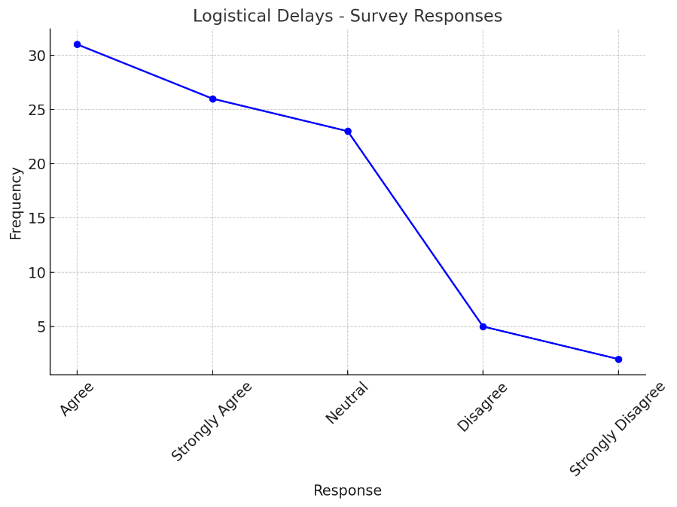
The logistical delays line chart demonstrates that most of the respondents, 65% agreed or strongly agreed that the problem of logistical delays is a major problem in the Saudi Arabian construction industry. This underscores the fact that the slow pace of procurement and transportation of materials is a common problem. Only a minority, 6%, did not agree with it, and 2% strongly did not agree, and neutral 27% stating that delays are generally accepted as an issue, but not necessarily encountered in all projects.
2. Poor Communication Between Stakeholders
Figure 2: Poor Communication Between Stakeholders - Survey Responses
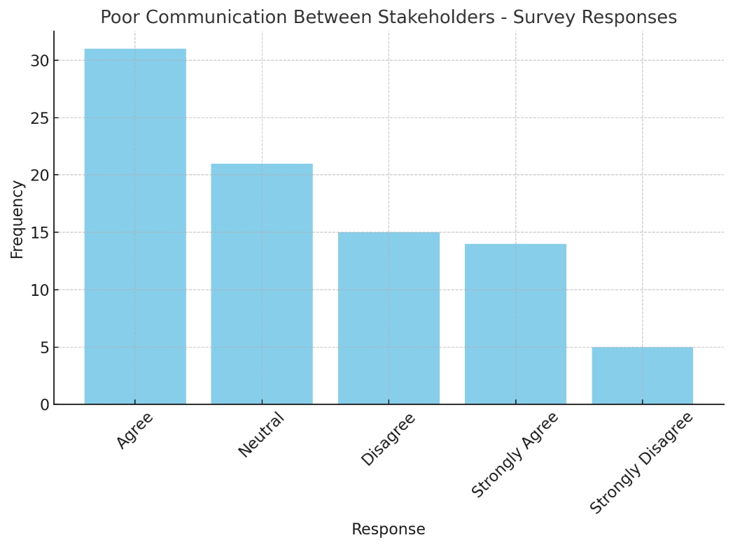
The bar chart of poor communication among the stakeholders shows that 52% of the respondents concurred or strongly agreed that there is a serious problem of communication in the construction industry in Saudi Arabia. Nevertheless, 25% were neutral and 23% disagreed and strongly disagree on the statement which indicates that communication may be a problem but the degree of the problem may differ among projects. This shows that there should be better communication and coordination of the supply chain.
3. Resource Allocation Issues (e.g., Material Shortages, Labor Shortages)
Figure 3: Resource Allocation Issues - Survey Responses
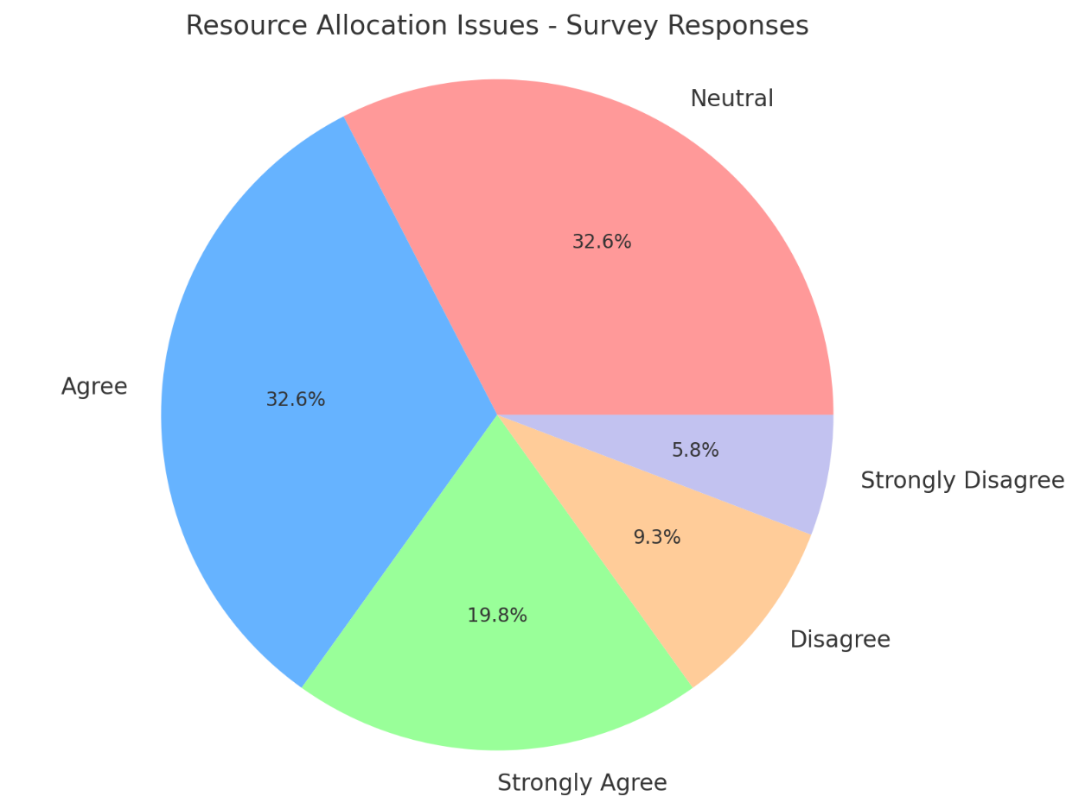
The pie chart on the resource allocation issues indicates that 33% of the respondents agreed and 33% were neutral when it comes to the influence of material and labor shortages in SCM. 20% strongly agreed, 9% disagreed, and 5% strongly disagreed. This means that the problem of resource allocation i.e. lack of materials and labor is an established problem in the Saudi construction industry, but the severity of the problem will be different in different projects and stakeholders.
4. Lack of Inventory Management
Figure 4: Lack of Inventory Management - Survey Responses
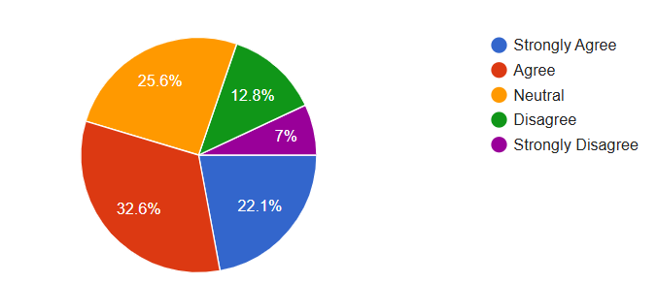
The pie chart for lack of inventory management shows that 33% of respondents agreed that inventory management is a significant issue, while 25% were neutral. 22% strongly agreed, indicating a higher level of concern, while 13% disagreed and 7% strongly disagreed. These results suggest that inventory management challenges, such as stock shortages or mismanagement, are widely recognized in the Saudi construction industry, though opinions on their severity vary.
5. Inadequate Technology Adoption (e.g., BIM, IoT, Blockchain)
Figure 5: Inadequate Technology Adoption - Survey Responses
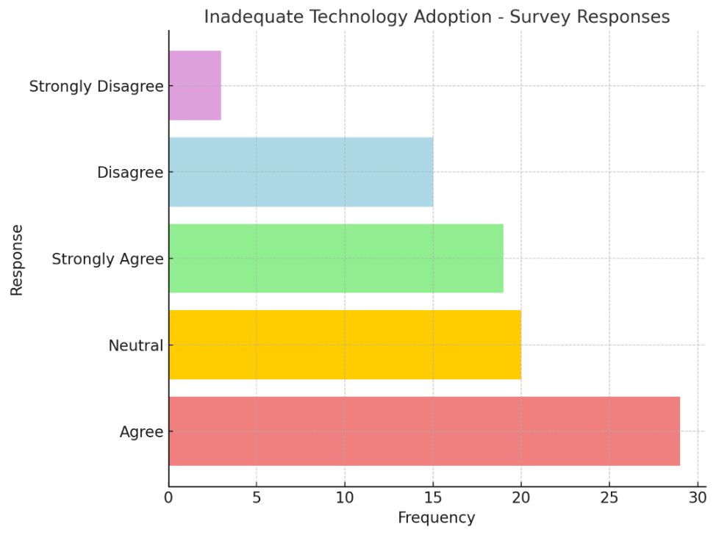
The horizontal bar chart for inadequate technology adoption shows that 56% of respondents agreed or strongly agreed that technology adoption is insufficient in Saudi construction SCM. 23% were neutral, and 21% disagreed or strongly disagreed, indicating that while a significant portion acknowledges technological gaps, opinions on the issue’s severity vary. Technologies like BIM, IoT, and blockchain are recognized as underutilized, reflecting a clear opportunity for improvement in SCM practices.
6. Fragmentation of Supply Chain (Multiple Contractors, Suppliers)
Figure 6: Willingness to Adopt New Technologies for SCM - Survey Responses
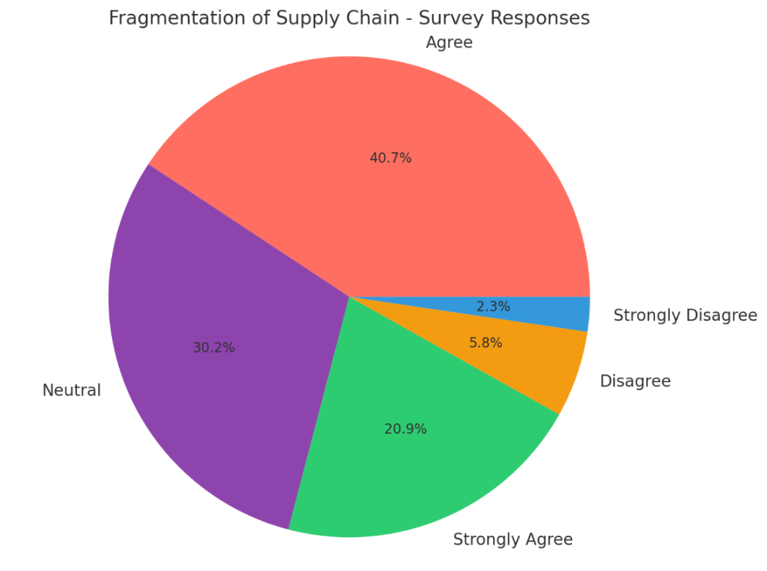
The pie chart for fragmentation of the supply chain shows that 62% of respondents agreed or strongly agreed that the involvement of multiple contractors and suppliers leads to fragmentation in the construction supply chain. 30% were neutral, and 8% disagreed or strongly disagreed. This suggests that while fragmentation is recognized as a challenge by many, opinions vary on its impact, with some stakeholders feeling it is less of an issue.
Impact of SCM Inefficiencies
1. How frequently do supply chain disruptions occur in your projects?
Figure 7: Technologies Most Beneficial for SCM in Construction - Survey Responses
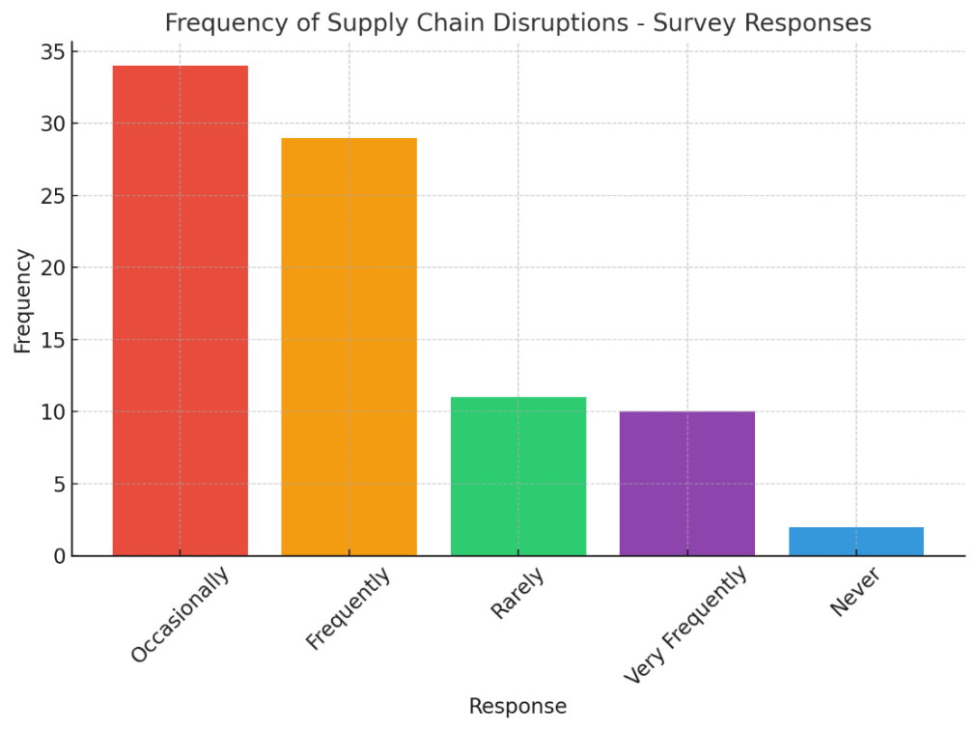
The bar chart for supply chain disruptions shows that 45% of respondent’s experience frequent disruptions in their projects, while 40% report occasional disruptions. A smaller percentage, 13%, experience them rarely, and 2% indicate that disruptions do not occur at all. This indicates that supply chain disruptions are a common issue in Saudi Arabia’s construction industry, with many projects facing frequent challenges, affecting timelines and efficiency.
2. To what extent do inefficiencies in SCM affect project timelines and costs?
Figure 8: Impact of SCM Inefficiencies on Project Timelines and Costs - Survey Responses
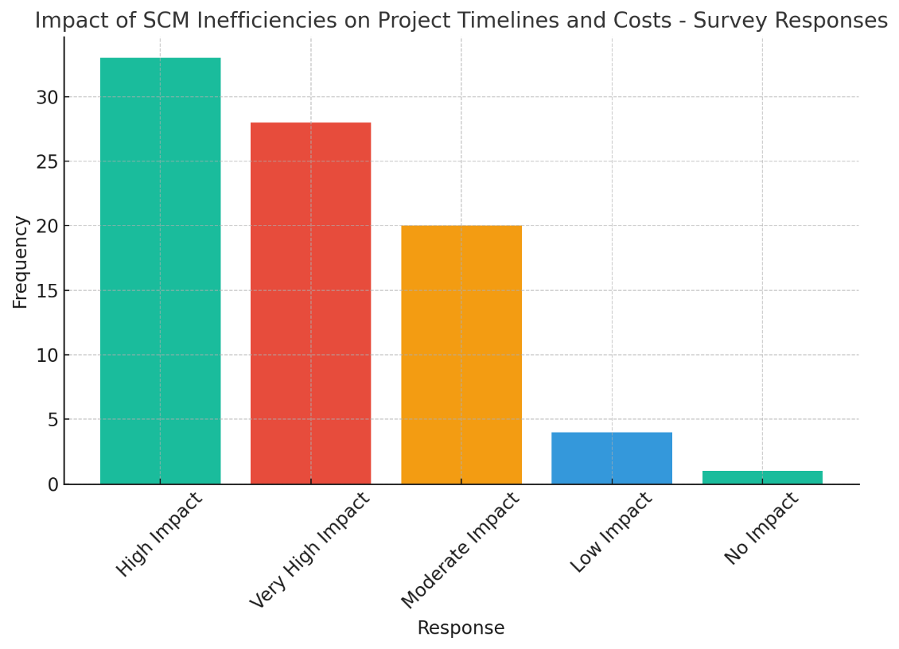
The bar chart for SCM inefficiencies' impact on project timelines and costs shows that 71% of respondents believe inefficiencies significantly affect project performance, with a large portion indicating moderate impacts 23%. About 5% reported minimal effects, and a smaller group, 1%, stated that inefficiencies have no significant impact. This suggests that inefficiencies in the supply chain are widely acknowledged as a major factor affecting both the timelines and costs of construction projects.
3. What is the most significant challenge affecting SCM performance?
Figure 9: Frequency of Supply Chain Disruptions - Survey Responses
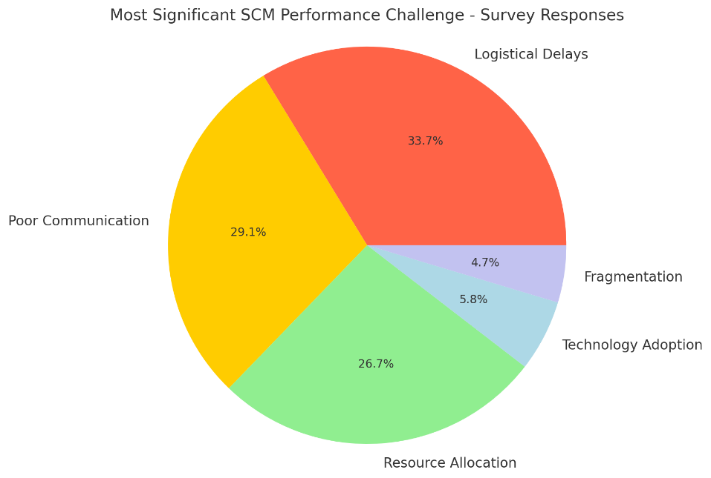

The pie chart for the most significant SCM performance challenge reveals that logistical delays are the leading issue, with the largest portion of respondents identifying this as the primary challenge. Resource allocation problems and communication inefficiencies also stand out as significant concerns. These findings emphasize that logistical issues, along with poor coordination and resource management, remain the most critical factors impacting the performance of the supply chain in Saudi Arabia’s construction industry.
Technology and SCM Improvement
1. How would you rate the current use of technology in supply chain management in the Saudi construction industry?
Figure 10: Most Significant SCM Performance Challenge - Survey Responses
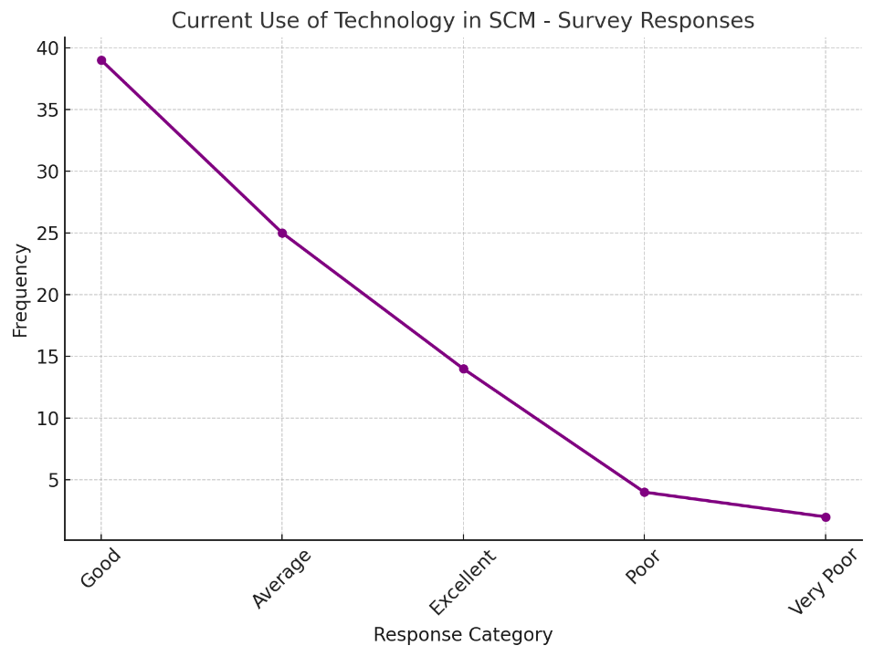
The line chart for current use of technology in SCM reveals that 30% of respondents rated the current technology adoption in SCM as neutral, suggesting a mixed perception of its adequacy. 46% agreed that technology usage is somewhat adequate, while 17% strongly agreed, indicating some recognition of its positive impact. However, 5% disagreed, and 2% strongly disagreed reflecting that a small portion of respondents feel that technology adoption in SCM is insufficient or not properly integrated in Saudi construction projects.
2. Which technology do you believe would most benefit SCM in construction?
Figure 11: Current Use of Technology in SCM - Survey Responses
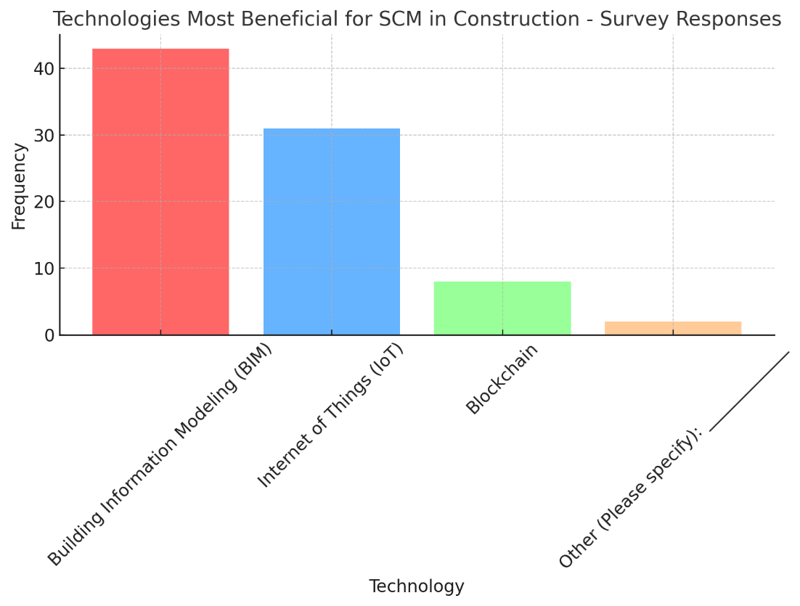
The bar chart illustrates the technologies that respondents believe would most benefit SCM in construction. Building Information Modeling (BIM) was the most popular choice, with 51% of respondents selecting it. Internet of Things (IoT) followed with 37%, and Blockchain was chosen by 10%. A smaller portion, 2%, selected other technologies. This distribution shows a clear preference for BIM and IoT, highlighting their perceived importance in improving SCM efficiency in Saudi Arabia's construction industry.
3. How willing is your organization to adopt new technologies for SCM?
Figure 12: Technologies Most Beneficial for SCM in Construction - Survey Responses
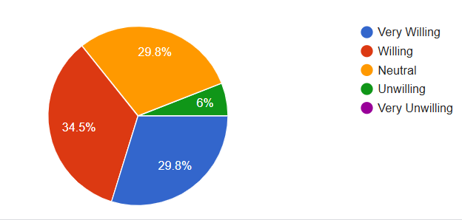
The pie chart shows the willingness of respondents to adopt new technologies for SCM. 34.5% of participants are very willing, while 29.8% are willing and another 29.8% are neutral. A smaller portion, 6%, are unwilling, and 6% are very unwilling to adopt new technologies. This indicates that the majority of respondents are either willing or open to adopting new technologies, with only a small fraction expressing reluctance.

Chapter 5: Conclusion
The key findings of the study are also summarized in this chapter, and the study's contribution to the academic knowledge and practice of supply chain management (SCM) within the Saudi Arabian construction sector is highlighted. It includes conclusions about the results of the conducted research, providing an answer to the major problems that were identified, such as the insufficiency of time in logistic delays, poor communication, unsuitable allocation of resources, and the low adoption of the technology. The other strength associated with the chapter is that it contributes to the academic literature through its empirical evidence regarding the inefficiency of SCM in a comparatively virgin environment, and its practical recommendations regarding the industry players. It also identifies drawbacks about the study, including potential constraints on data coverage and generalisability, and includes certain suggestions on how SCM can be enhanced by increasing coordination, forecasting, and technology integration. Finally, the chapter includes future research directions, which encourage further study of the digital transformation and innovation in an attempt to improve the construction supply chain and help to develop the sector in Saudi Arabia in a sustainable way.

5.1 Summary of Key Findings
The primary objective of the research was to seek the supply chain management (SCM) concerns of the construction industry in Saudi Arabia and assess the analysis of how, with the tools of technology, SCM practices may be augmented. The research was done using the assistance of the mixed-methodology approach that combined interviews with key stakeholders with the assistance of survey data gathered among the representatives of the construction industry, showing several critical issues. One issue that became substantial was that there were logistical delays, as 57% of those asked mentioned the problems with procurement, transporting materials, and clearance at customs, particularly in large or remote projects. Poor communication and coordination were also cited because 45 percent of the respondents said that there was an absence of coherence among contractors, suppliers, and subcontractors, which adversely affected the efficiency of various projects. Equipment wastage and insufficient supplies of materials, the necessity for excessive human labor, and poor distribution of resources were linked to a lack of good forecasting and real-time scrutiny. Besides, the study also discovered that the technology adoption level is low, which led 70% of them to acknowledge that they are experiencing this high as a big problem, yet 79% also confessed that they were ready to adopt such innovations as BIM, IoT, and blockchain. Consideration of cultural resistance, high costs, and ignorance in the technical sphere are the cardinal barriers. Nevertheless, the overall willingness to implement digital solutions is a favorable prospect to empower the Saudi construction sector to improve coordination, reduce inefficiencies, and update its supply chain operations.

5.2 Contributions of the Study
In this study, the research contributions to the construction industry in Saudi Arabia have been quite comprehensive to both academic and practical supply chain management (SCM). Academically, it contributes to the general knowledge of the SCM inefficiency in the Saudi construction niche, which is already saturated with the lack of studies in the previous period, bringing empirical data to the problematic fields and issues. It also discusses how these inefficiencies can be eliminated, and in this regard, one can mention technology solutions, such as Building Information Modeling (BIM), the Internet of Things (IoT), and blockchain, which will create the basis on which the future studies of how technology can be used in construction SCM can be performed. The research in real-life practice may offer practical guidance to the matters to enhance the carrying out of the logistical coordination, communication, and collaboration of the parties in the industry. It also underlines the need to do more of the utilization of technology and reports the specific barriers to innovation. The strategic guiding lessons are of strategic interest to the construction companies, contractors, and policymakers in order to optimize and streamline operations and ensure the sustainable development of the Saudi Arabian construction industry, which remains in the transformational phase.

5.3 Recommendations for Practice
Based on the findings, several strategic recommendations can be made to improve SCM in Saudi Arabia’s construction industry.
- Improve Communication and Collaboration: The type of collaboration has to be established, and, in this case, the stakeholders of the supply chain are to be engaged with the use of collaborative tools and real-time communication tools. This would fight the problem of fragmented correspondence and would ensure that there is more coordination of contractors, subcontractors, suppliers, and logistics providers. In society, cloud-based project management can be used to share information and make decisions efficiently to eradicate inefficiencies.
- Embrace Technology Adoption: The Saudi construction industry should enhance the use of digital technology, such as BIM, IoT, and blockchain. The technologies can improve the supply chain and communication tracking as well as economy. The cost and resistance of change are very grave factors which can be overcome with the help of the training programs and pilot projects. The policy makers should also force the companies to invest in technology by offering subsidies or providing tax exemption to companies that invest in digital solutions.
- Enhance Resource Allocation and Forecasting: The industry should acquire better and effective resource allocation which uses the predictive analytics to see to the better purchasing of materials, recruiting of employees and equipment repair. Such technology as IoT sensors and AI-based predictive tools integration can be used to monitor the level of supply and demand in real-time, prevent both excessive and insufficient stocking of goods or services, and, therefore, make the project more efficient.
- Foster a Culture of Innovation: The barrier to adopting technology is huge. To this, culture of innovation and excellence should be codified in Saudi construction industry. This can be done via leadership commitment, training, and industry-wide awareness creation regarding the benefits of technology adoption and optimization of SCM.
- Focus on Logistical Optimization: Saudi construction companies should invest in logistics optimization solutions such as AI-based route maps and real-time supply chain trackers due to the enormous challenges in the framework of logistics. It would reduce wastage of time, increase the accuracy of deliveries, and improve the project timelines.
Using this research, significant data is provided regarding the SCM problems in the Saudi Arabian construction industry. The biggest problems that should be improved are logistical delays, poor communication, and resource distribution, yet the opportunity exists, and with the new technologies introduced, it can be realized. As a country with strong intentions towards the introduction of new technologies, Saudi construction firms are in a good place to enhance the SCM practices, reduce inefficiencies, and optimize project performance. However, the application of technological, cultural, and infrastructural barriers will also form an influential aspect in persuading changes to work. By addressing these problems, the construction industry in Saudi Arabia can be driven further into the technological era of working more efficiently. Nevertheless, the use of technological, cultural, and infrastructural barriers will be an important element in convincing changes to be successful. By solving these issues, the construction sector in Saudi Arabia can be propelled towards a more technological age in terms of working efficiently.

Appendices

Appendix A: Survey
Section A: Demographic Information
- Gender:
  - ☐ Male
  - ☐ Female
- Age Group:
  - ☐ 20-30 years
  - ☐ 31-40 years
  - ☐ 41-50 years
  - ☐ 51+ years
- Years of Experience in the Construction Industry:
  - ☐ 0-5 years
  - ☐ 6-10 years
  - ☐ 11-20 years
  - ☐ 21+ years
- Role in the Construction Supply Chain:
  - ☐ Project Manager
  - ☐ Contractor
  - ☐ Supplier
  - ☐ Subcontractor
  - ☐ Logistics Provider
  - ☐ Other (Please specify): ________
Section B: Challenges in Supply Chain Management
Please indicate your level of agreement with the following statements regarding supply chain management challenges in the Saudi construction industry.
- Logistical Delays
  - ☐ Strongly Agree
  - ☐ Agree
  - ☐ Neutral
  - ☐ Disagree
  - ☐ Strongly Disagree
- Poor Communication Between Stakeholders
  - ☐ Strongly Agree
  - ☐ Agree
  - ☐ Neutral
  - ☐ Disagree
  - ☐ Strongly Disagree
- Resource Allocation Issues (e.g., Material Shortages, Labor Shortages)
  - ☐ Strongly Agree
  - ☐ Agree
  - ☐ Neutral
  - ☐ Disagree
  - ☐ Strongly Disagree
- Lack of Inventory Management
  - ☐ Strongly Agree
  - ☐ Agree
  - ☐ Neutral
  - ☐ Disagree
  - ☐ Strongly Disagree
- Inadequate Technology Adoption (e.g., BIM, IoT, Blockchain)
  - ☐ Strongly Agree
  - ☐ Agree
  - ☐ Neutral
  - ☐ Disagree
  - ☐ Strongly Disagree
- Fragmentation of Supply Chain (Multiple Contractors, Suppliers)
- ☐ Strongly Agree
- ☐ Agree
- ☐ Neutral
- ☐ Disagree
- ☐ Strongly Disagree
Section C: Impact of SCM Inefficiencies
- How frequently do supply chain disruptions occur in your projects?
- ☐ Very Frequently
- ☐ Frequently
- ☐ Occasionally
- ☐ Rarely
- ☐ Never
- To what extent do inefficiencies in SCM affect project timelines and costs?
- ☐ Very High Impact
- ☐ High Impact
- ☐ Moderate Impact
- ☐ Low Impact
- ☐ No Impact
- What is the most significant challenge affecting SCM performance?
- ☐ Logistical Delays
- ☐ Poor Communication
- ☐ Resource Allocation
- ☐ Technology Adoption
- ☐ Fragmentation
Section D: Technology and SCM Improvement
- How would you rate the current use of technology in supply chain management in the Saudi construction industry?
- ☐ Excellent
- ☐ Good
- ☐ Average
- ☐ Poor
- ☐ Very Poor
- Which technology do you believe would most benefit SCM in construction?
- ☐ Building Information Modeling (BIM)
- ☐ Internet of Things (IoT)
- ☐ Blockchain
- ☐ Other (Please specify): ________
- How willing is your organization to adopt new technologies for SCM?
- ☐ Very Willing
- ☐ Willing
- ☐ Neutral
- ☐ Unwilling
- ☐ Very Unwilling
Section E: General Feedback
- In your opinion, what strategies can be implemented to improve SCM in Saudi Arabia’s construction industry?
- Please provide any additional comments or suggestions regarding SCM challenges and improvements in your projects.

