Cover Page

Midocean University
Program: Master of Entrepreneurship
Course Name: Research_Project_ENT636_T3_ME_Second Trimester 2025

Research Title: The Impact of Data Analysis and Artificial Intelligence in Building and Managing Startups
أثر تحليل البيانات والذكاء الاصطناعي في بناء وإدارة الشركات الناشئة

Student: Mahmoud Fathi Abusharkh
Academic ID: 243000251
Academic Supervisor: Dr. Ahmad Rajeh

Table of Contents

Contents
Cover Page 1
Table of Contents 2
List of Tables and Figures 3
Tables: 3
Figures: 3
1. Introduction 4
2. Research Problem, gaps and Objectives 5
3. Previous Studies 6
4. Theoretical Framework 7
5. Hypotheses 9
6. Research Methodology: 10
6.1 Research Design and Sample 10
6.2 Data Collection Tools and Analytics 10
6.3 Key Performance Indicators (KPIs) and Metrics 11
7. Study Results 12
7.1 Survey Methodology 12
8. Study Summary and Recommendations: 22
8.1 Key Summary Points: 22
8.2 Recommendations 22
9. References 24
10. Study Appendices 25
9.1 Survey Form 25
11. Study Summary in English: 30
12. Study Summary in Arabic: 32

List of Tables and Figures

Tables:
No. | Table Name | Page No.
1 | Hypotheses Descriptions | 9
2 | Metrics Descriptions | 11

Figures:
No. | Figure Name | Page No.
1 | Familiarity Result Distribution | 13
2 | AI Impact Area | 14
3 | Challenges in Adoption | 15
4 | Strategic Decision-Making Styles | 16
5 | Likelihood to Invest in AI/Data Tools | 16
6 | Team Expertise in AI and Data | 17
7 | Frequency of Data Usage | 18
8 | Tools and Platforms Used | 19
9 | Perceived Benefits of AI and Data Analysis | 20
10 | Belief in AI/Data as Essential for Future Success | 21

Introduction
Combining data analysis and artificial intelligence has become a main driver for transforming entrepreneurships in recent years. They have become critical enablers to make faster, reliable and accurate decisions and encourage more success and sustainability. Accessible AI and open-source tools have made startups overcome traditional challenges allowing more automation of manual procedures, derive market and customer insights and drive calculated risks and opportunities. In today’s market, there are thousands of startups that have started to explore the use of AI and many started to notice performance, revenue and operational improvement. This research will explore how the transition from classic entrepreneurial startup to an AI and data-based startup will impact the success rate and more efficiencies in business operations.
My interest in this research comes from my 15 years of experience in data analysis across multiple corporations and startups in addition my sincere belief in the powerful impact of artificial intelligence and data analytics to help avoid common bottlenecks, plan solid strategies, save resources, effort and time and ultimately increase the potential for success. This paper will offer a quantitative analysis of the use of AI and data-driven methodologies amongst startups with focus on information technology and healthcare sectors in Saudi Arabia in addition to a sample of global markets. The study will analyze a number of adoption strategies and challenges startups normally face by deep diving in common limitations, ambiguities, success factors and methodologies. A number of recent academic research will be discussed including studies of Giuggioli & Pellegrini (2023), Uriarte et al. (2025), Schiavone et al. (2023), Pati et al. (2024), and Lee et al. (2024) as well as discussing theories such as the Lean AI Growth Loop, Operational Efficiency Engine, and Democratization of AI.

Research Problem, gaps and Objectives
The research is established based on the following objectives:
- AI/Data Integration and adoption: To analyze the use of AI and data analysis by startups in all stages from ideation to maturity.
- Identification of success factor: To analytically identify which AI practices and tools are most associated with startup success leading to growth, efficiency, scalability, and customer satisfaction.
- Develop, improve and drive actionable methodologies for startups to build unique challenges and opportunities of data-driven and AI-driven entrepreneurship.
Research Questions
The study investigates five core areas:
- What are the key challenges facing startups to adopt AI and data analysis?
- Which AI and data analysis tools are most commonly used? What are the key differences?
- What KPIs and performance indicators startups use to evaluate success and ROI of AI investments and initiatives?
- What are the methods to calculate and validate the ROI of AI initiatives?
- What frequent technical, financial and legal issues startups face and how can they be avoided or mitigated when used data analysis and AI tools?

Previous Studies
• Giuggioli & Pellegrini (2023): Their review explains the role of AI as an enabler in the entrepreneurial structure, opportunity creation, decision-making, performance enhancement, and education. It focuses on “AI-enabled entrepreneurial process” as sequential and iterative process.
• Schiavone et al. (2023): This study explains the impact of AI adoption and outcomes particularly in the healthcare sector showing, ethical, privacy and regulatory restrictions due to sensitive data and compliance such as patient records and personal information.
• Pati et al. (2024): In this study, the researcher explores how AI-enabled market entry strategies are shaped by governmental innovation policies specifically in the middle east including Saudi Arabia, other gulf countries and Asia-Pacific regions.
• Lee et al. (2024): This study focuses on AI adoption in startup ecosystems particularly the impact of collaborative learning and bridging knowledge gaps to elevate entrepreneurship success.
By reviewing previous studies, this paper should combine findings from both, local and global landscapes by analyzing common cases and experiences.

Theoretical Framework
This analysis is central to three connecting theoretical frameworks:
1. The Lean AI Growth Loop
This framework is Inspired by Lean Startup principles and validated in environments adopting AI. The Lean AI Growth Loop represents an iterative approach to deploy AI for better scalability as following:
Build: Start with an individual theory, implement a minimum viable AI solution customized to deal with the most critical business issues such as high costs, low productivity or other inefficiencies.
Measure: Track the impact based on a number of identified KPIs related to business outcomes such as revenue, orders, margins or retention.
Learn: Quickly analyze the outcomes, improve the theories, measure what worked and iterate the procedure. The goal here is to validate the lessons learned rather than act or react randomly.
2. Operational Efficiency Engine
This framework focuses on using AI to optimize internal processes to drive cost saving, efficiency, and quality without expanding headcount and resources which typically include:
- Automation of recurring tasks such as data entry, reporting, and analytics.
- Enhance resource allocation methods.
- Apply predictive modelling techniques for forecasting, risk assessment and maintenance operations.
- Apply efficient knowledge sharing management.
By focusing on utilizing existing resources and minimal improvement, this framework can help startups overcome the resource shortage issues and establish practical and efficient workflows.

3. Democratization of AI
This framework aims at making the use of AI from being voluntary to become enforced and highly accessible based on the principles of Giuggioli & Pellegrini (2023) and industry best practices.
Which includes the following practices:
- Use of no-code or low-code AI tools such as Zapier, Canva AI and Power BI that reduces difficulties of learning for non-technical users.
- Standardize organizational routines to build AI learning across all roles and not limit the learning to technical staff.
- Appoint super users, champions to promote learning-by-doing to empower and encourage experimentation within a clear governance model to limit privacy exposure.
Democratization framework is crucial when technical talent hiring is limited which offers an alternative road for startups in developing markets to overcome budgetary and technical limitations.

Hypotheses
The research tests the following hypotheses, aligned with the main study objectives:

Table 1: Hypotheses Descriptions
Hypothesis ID | Description
1 | AI-enabled startups express superior growth metrics such as sales, revenue, market gain and customer satisfaction compared to classic startups.
2 | Strategic decision-making is significantly greater in startups.
3 | AI adoption is associated with higher rate of operational efficiency.
4 | Knowledge gaps, cost, and resource limitation are significant obstacles in AI adoption.
5 | AI-enabled startups that adopt strong privacy and ethical code of conduct will achieve higher user trust and legal compliance particularly in healthcare and finance sectors.

Each of the above hypothesis can be measured by a number of indicators such as the following:
- Growth rates.
- Successful resource allocation patterns.
- Number of reported compliance incidents

Research Methodology:

6.1 Research Design and Sample
Primarily, a quantitative approach was used in addition to qualitative illustrations that consist of the following:
- An online survey of 10–25 regional startups with a careful sampling of 8 Saudi Arabian startups aged 1–5 years covering technology, marketing and healthcare industries.
- The survey includes a number of items on AI tool usage, adoption challenges, performance metrics, and return on investment.

6.2 Data Collection Tools and Analytics
Platforms Used:
- Google Forms for survey distribution.
- Power BI for measurement, metric calculation and visual analysis)
- Excel for raw data databases and benchmarking.
Quantitative Analysis:
- Statistics (means, medians, frequencies)
- Failure analysis to identify predictors of success.
- Calculation of ROI on AI initiatives.

6.3 Key Performance Indicators (KPIs) and Metrics
The following KPIs can be systematically tracked by startups:
Table 2: Metrics Descriptions
Metric | Description
Return of Investment (ROI) | Gain from AI investment versus total costs
Cost per Prediction | Average cost per AI-based decision
Accuracy of AI Model | Correct predictions versus total predictions
Customer Satisfaction Score CSAT | User feedback on AI-driven interactions
Engagement Rate | Post AI adoption metrics
Compliance Score | Privacy and compliance mitigation effort and cost

This approach ensures that both technical and business outcomes of AI adoption are captured and measured to enable tracking, monitoring and benchmarking.

Study Results
I will present here the quantified survey results based on 10 questions answered by a group of startup founders and entrepreneurs. The survey focused on identifying key trends, challenges, and opportunities in AI and data analysis adoption using percentage distributions to provide clarity and analytical depth. The reporting framework aligns with best practices for academic results sections, providing objective, data-driven insights with sufficient narrative context for interpretation while reserve broader illustrations in the discussion section.

Survey Methodology
A group of founders and entrepreneurs participated in the study. Each participant responded to a set of 10 questions focused on AI and data analysis practices, techniques, opportunities, and key outcomes within their organizations. Multiple choice questions were mainly provided to enable quantification where metrics are calculated directly from the survey data.
Dimension 1. Familiarity with Data Analysis Tools
Almost a combined 100% of participants stated being either very familiar (57%) or somewhat familiar (43%) with data tools.
Following are the key insights:
- The results suggest a common data knowledge in today’s startup ecosystem.
- Many of the participants at least have some knowledge about Excel but not advanced analytics.

Image 1: Familiarity Result Distribution
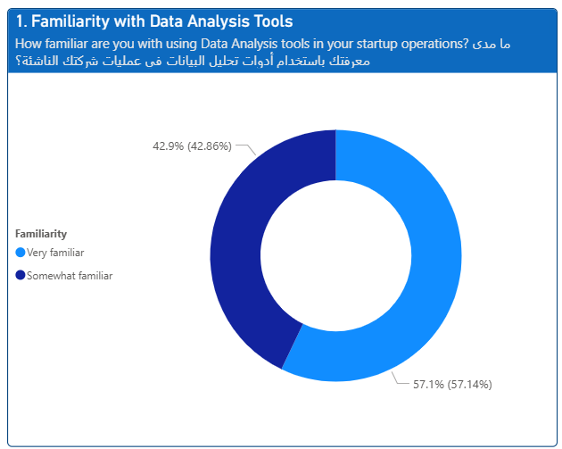

Dimension 2. Impact Areas Benefiting Most from AI and Data analysis
Marketing and customer insights dominate by (57%), with finance, operations, and product development each at 14%.
Following are the key insights:
- Customer-facing functions dominate since data is more accessible and ROI is more visible.
- An opportunity would be to develop some case studies on startups that transition from marketing to operations AI to measure improvements of adoption AI.

Image 2: AI Impact Area
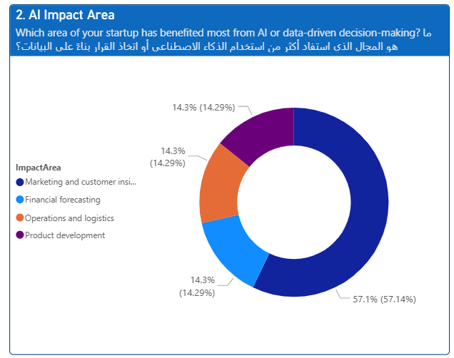

Dimension 3. Challenges in Adoption
Lack of technical expertise (43%) leads, followed by implementation cost (29%), data quality (14%), and unclear ROI (14%).
Following are the key insights:
- Lack of projects and revenue for startups could be a justification to delay hiring experts.
- An opportunity would be to deploy low cost no-code AI and Data tools to see if they mitigate both skill and budget issues.

Image 3: Challenges in Adoption
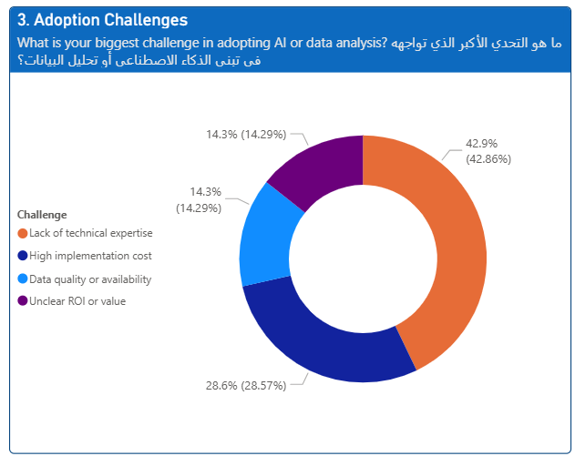

Dimension 4. Strategic Decision-Making Styles
Advanced analytics & AI tools (43%) tie with basic metrics (43%) and intuition and experience (14%).
Following are the key insights:
- This distribution shows some participants rely on AI while others still feel comfortable to use spreadsheets.
- The minority using intuition exclusively might be very experienced, overconfident or lack access to AI tools.
- An important opportunity would be to develop hybrid dashboards that blend simple KPIs with AI-driven forecasts for smoother transition.

Image 4: Strategic Decision-Making Styles
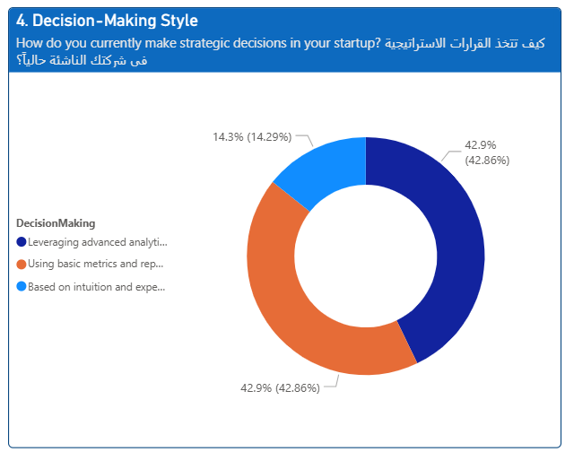

5. Investment Intentions (Likelihood to Invest in AI/Data Tools):
Somewhat likely to invest (71%), with 14% already on board and none “very likely.”
Following are the key insights:
- “Somewhat likely” indicates cautious enthusiasm.
- An important opportunity would be to search for proof-of-concept pilot initiatives to overcome unwillingness.
Image 5: Likelihood to Invest in AI/Data Tools
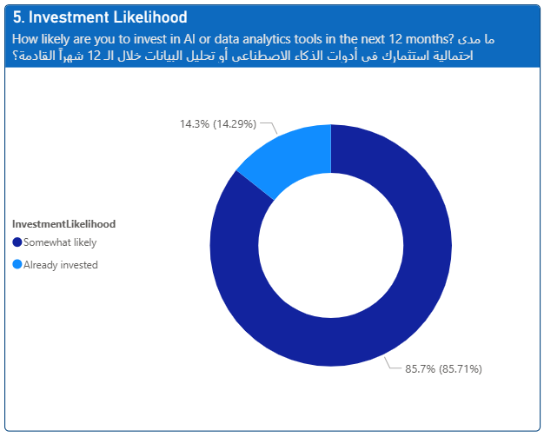
6. Team Expertise in AI/Data
In-house experts are rare (14%); 43% outsource, 29% plan to train, and 14% aren’t planning anything.
Following are the key insights:
- Outsourcing will solve short-term needs but delays competency building.
- 29% planning to train indicates admitting the existence of a gap.
- An important opportunity here would be to track startups that invest in internal training vs. those that don’t.
Image 6: Team Expertise in AI and Data
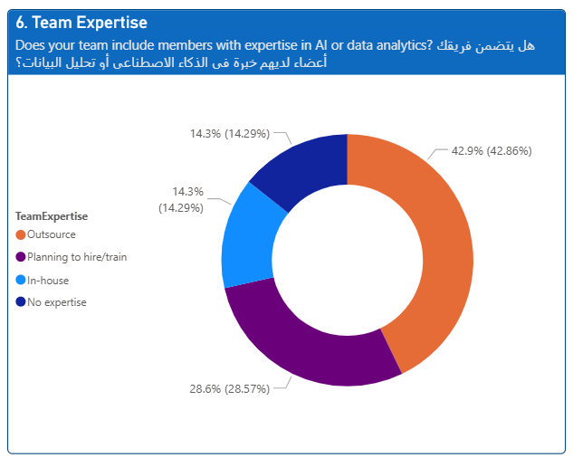

7. Frequency of Data Usage
Daily usage stands at 71% while 29% use data rarely.
Following are the key insights:
- Daily users are likely to integrate data into routine workflows; rare users might only check dashboards for quarterly reviews.
- More understanding is required to explore what “rare” segment is lacking. Is it time, interest or tool that can lead to more usage of AI and data tools.
- An important opportunity here to identify the type of decisions daily users make that rare users are skipping.
Image 7: Frequency of Data Usage
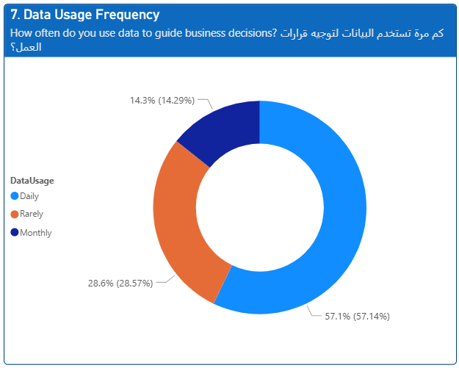

8. Tools and Platforms Used
Excel leads (43%), followed by Google Analytics (29%) and Power BI (14%). No Python/R or specialized tools.
Following are the key insights:
- Participants preference for familiar and accessible tools indicates the importance of a identifying a clear learning curve.
- Absence of Python/R signals a potential missed opportunity for automation and deeper modeling.
- An important opportunity here is to explore some Python apps personalized for non-programmers.
Image 8: Tools and Platforms Used
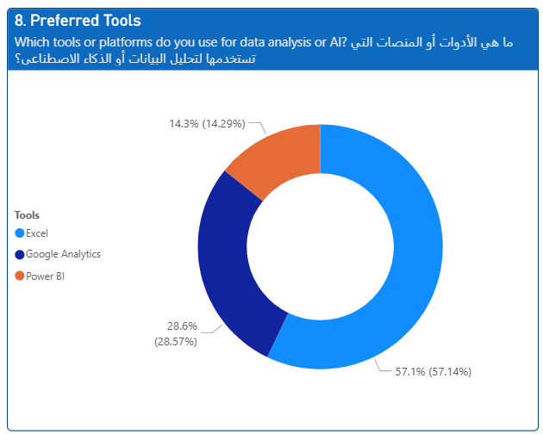

9. Perceived Benefits of AI/Data
Improved decision-making is dominantly leading by (86%), with 14% selecting better customer understanding.
Following are the key insights:
- Quality of decision making is the main value driver in this context.
- Although customer insight was less refer to, it might be the another key aspect of significant growth.
- An important opportunity here is to conduct in-depth interviews to classify the top five decisions startup will give credit to data analysis and use of AI.
Image 9: Perceived Benefits of AI and Data Analysis
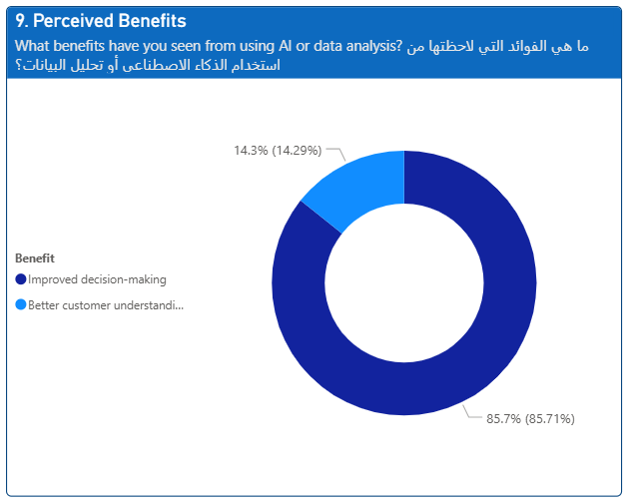

10. Belief in AI/Data as Essential for Future Success
A unanimous 100% agree and strongly agree on the importance of AI and data analysis tools.
Following are the key insights:
- This consent underlines an important cultural shift that data analytics and AI are optional anymore.
- The missing part is proceeding for actual execution and real adoption of AI and data analytics tool
- An important opportunity here is to follow committed entrepreneurs that share insights around the benefits of adopting AI and Data analytics tools.

Image 10: Belief in AI/Data as Essential for Future Success
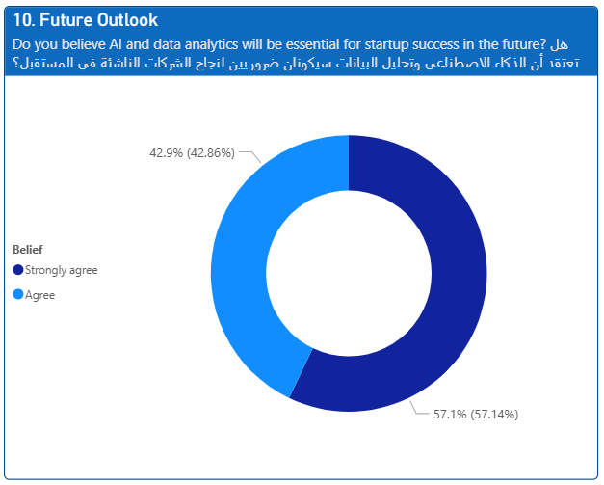

Study Summary and Recommendations:

8.1 Key Summary Points:
- There’s a clear data-driven desire across all participants however execution gaps remain and key factor to achieve full adoption.
- Skill, cost, and clarity are the key barriers that need coordinated solutions such as training programs, navigating for pricing solutions and better ROI structure.
- The contrast between basic metrics users and advanced AI adopters suggests an opportunity for transitional tools and methodologies.

8.2 Recommendations
Based on the study analysis, the following recommendations can be implemented by startups to achieve full adoption:
- Startups should prioritize a single high-impact, measurable business use case for AI then test, and refine in sprints before full-scale investment.
- Startups should start establishing the foundation to record and collect structured and well-governed data around all pipelines related to customers, market, production, sales and other departments before modeling and analysis since poor data is a leading cause of project failure.
- Startups should use valid frameworks to reduce barriers for non-technical teams and reduce development timelines and costs.
- Startups should focus on upskilling their teams, adopt internal data and AI champions and encourage learning-by-doing in a lean, supportive, and blame free environment.
- Startups should use structured KPIs, dashboards, and regular audits to track progress in order to realize the value of adopting AI and data solutions.
- Startup should carefully Plan for Ethics/Privacy from Day One by documenting and monitoring transparency, fairness, and bias mitigation. Compliance should be treated as a driver of trust and value.

References
- Giuggioli & Pellegrini (2023), “Artificial intelligence as an enabler for entrepreneurs
- Uriarte et al. (2025), “Artificial intelligence technologies and entrepreneurship: a hybrid literature review”.
- Schiavone et al. (2023), “Designing AI implications in the venture creation process.
- Pati et al. (2024), “The Impact Of Artificial Intelligence On Startup Business Models: A Comparative Analysis”.
- Lee et al. (2024), “Enhancing the Competitiveness of AI Technology-Based Startups in the Digital Era”.

Study Appendices

9.1 Survey Form
Dear Entrepreneur,
I am conducting research on the impact of using data analysis tools and artificial intelligence (AI) on the success of founding and managing startups. Your opinion is valuable in helping me understand the key challenges and opportunities in this field. With sincere thanks.
عزيزي رائد الأعمال، اجري بحثًا حول تأثير استعمال ادوات تحليل البيانات والذكاء الاصطناعي على النجاح في تأسيس وإدارة الشركات الناشئة. رأيك يهمني في فهم التحديات الرئيسية والفرص في هذا المجال. مع جزيل الشكر

1. Familiarity with Data Analysis Tools
How familiar are you with using Data Analysis tools in your startup operations? ما مدى معرفتك باستخدام أدوات تحليل البيانات في عمليات شركتك الناشئة؟
Very familiar / على دراية كبيرة
Somewhat familiar / على دراية إلى حد ما
Not familiar / لست على دراية
I don’t use data analysis tools / لا أستخدم أدوات تحليل البيانات
2. AI Impact Area
Which area of your startup has benefited most from AI or data-driven decision-making? ما هو المجال الذي استفاد أكثر من استخدام الذكاء الاصطناعي أو اتخاذ القرار بناءً على البيانات؟
Marketing and customer insights / التسويق وفهم العملاء
Product development / تطوير المنتج
Financial forecasting / التنبؤ المالي
Operations and logistics / العمليات واللوجستيات
We haven’t used AI or data analysis yet / لم نستخدم الذكاء الاصطناعي أو تحليل البيانات بعد
3. Adoption Challenges
What is your biggest challenge in adopting AI or data analysis? ما هو التحدي الأكبر الذي تواجهه في تبني الذكاء الاصطناعي أو تحليل البيانات؟
Lack of technical expertise / نقص الخبرة التقنية
High implementation cost / تكلفة التنفيذ العالية
Unclear ROI or value / عدم وضوح العائد أو القيمة
Data quality or availability / جودة البيانات أو توفرها
No challenge—we’re fully integrated / لا يوجد تحدي – نحن مندمجون بالكامل
4. Decision-Making Style
How do you currently make strategic decisions in your startup? كيف تتخذ القرارات الاستراتيجية في شركتك الناشئة حالياً؟
Based on intuition and experience / بناءً على الحدس والخبرة
Using basic metrics and reports / باستخدام مؤشرات وتقارير بسيطة
Leveraging advanced analytics and AI tools / باستخدام تحليلات متقدمة وأدوات الذكاء الاصطناعي
Outsourcing to consultants or advisors / الاستعانة بمستشارين أو خبراء خارجيين
5. Investment Likelihood
How likely are you to invest in AI or data analytics tools in the next 12 months? ما مدى احتمالية استثمارك في أدوات الذكاء الاصطناعي أو تحليل البيانات خلال الـ 12 شهراً القادمة؟
Very likely / من المحتمل جداً
Somewhat likely / من المحتمل إلى حد ما
Not likely / غير محتمل
Already invested / تم الاستثمار بالفعل
6. Team Expertise
Does your team include members with expertise in AI or data analytics? هل يتضمن فريقك أعضاء لديهم خبرة في الذكاء الاصطناعي أو تحليل البيانات؟
Yes, we have in-house experts / نعم، لدينا خبراء داخليون
No, but we outsource / لا، لكننا نستعين بمصادر خارجية
No, and we don’t plan to / لا، ولا نخطط لذلك
Planning to hire or train soon / نخطط للتوظيف أو التدريب قريباً
7. Data Usage Frequency
How often do you use data to guide business decisions? كم مرة تستخدم البيانات لتوجيه قرارات العمل؟
Daily / يومياً
Weekly / أسبوعياً
Monthly / شهرياً
Rarely / نادراً
Never / أبداً
8. Preferred Tools
Which tools or platforms do you use for data analysis or AI? ما هي الأدوات أو المنصات التي تستخدمها لتحليل البيانات أو الذكاء الاصطناعي؟
Excel / إكسل
Power BI / باور بي آي
Google Analytics / تحليلات جوجل
Python or R / بايثون أو R
Other / أخرى
None / لا شيء
9. Perceived Benefits
What benefits have you seen from using AI or data analysis? ما هي الفوائد التي لاحظتها من استخدام الذكاء الاصطناعي أو تحليل البيانات؟
Improved decision-making / تحسين اتخاذ القرار
Increased efficiency / زيادة الكفاءة
Better customer understanding / فهم أفضل للعملاء
Cost reduction / تقليل التكاليف
No noticeable benefit / لا توجد فائدة واضحة
10. Future Outlook
Do you believe AI and data analytics will be essential for startup success in the future? هل تعتقد أن الذكاء الاصطناعي وتحليل البيانات سيكونان ضروريين لنجاح الشركات الناشئة في المستقبل؟
Strongly agree / أوافق بشدة
Agree / أوافق
Neutral / محايد
Disagree / لا أوافق
Strongly disagree / لا أوافق بشدة

Study Summary in English:
The aim of this research is to explore the role of data analysis and artificial intelligence (AI) in the founding and management of startups in both local and global markets. Despite widespread praise for the capabilities and strategic value of data analytics and AI, many entrepreneurs encounter challenges and obstacles that demand continuous technological upgrades, financial investment, and collaboration with technical and analytical experts. At the heart of these challenges lies uncertainty around implementation costs and the actual return on investment of these technologies.
To investigate these issues, I conducted a quantitative survey of entrepreneurs operating in the technology, healthcare, and advertising sectors. The survey gathered data on their experience level; their interest in and familiarity with data analysis and AI tools; the barriers hindering tool adoption; the business areas most in need of analytical intervention; and the impact of these tools on decision-making, investment opportunities, team organization, and the development of their organizational infrastructure.
Using a primarily quantitative methodology with select qualitative interpretations we found that most participants already possess knowledge of both basic and advanced data analysis tools. The largest share of entrepreneurs reported using these tools for marketing and customer-insight purposes. Conversely, a lack of technical skills and high implementation costs emerged as the two principal reasons for not adopting advanced analytical solutions.
Although there is unanimous agreement on the importance of AI, significant gaps remain in both its implementation and adoption. Accordingly, our key recommendations are to launch targeted training programs and free-trial initiatives, and to foster a collaborative, information-sharing environment within organizations. These measures will help bridge skill shortages and budget constraints, enabling startups to harness the full potential of data and AI. Finally, we recommend establishing clear performance indicators for regular evaluations of adoption success and for measuring the impact of these tools on operational structure, planning, and management.

Study Summary in Arabic:

تهدف دراسة البحث الى التعرف على دور استخدام التحليل البياني والذكاء الاصطناعي في تأسيس وإدارة الشركات الناشئة في الأسواق المحلية والعالمية. بالرغم من الإشادة الواسعة بقدرات وقيمة تحليل البيانات والذكاء الاصطناعي، يواجه العديد من رواد الاعمال عدد من التحديات والعقبات التي تتطلب المواكبة التقنية والاستثمار والعمل مع خبراء في المجال التقني والتحليلي والمشكلة الأساسية تكمن في معرفة التكلفة التنفيذية والعائد الفعلي المنطوي على هذا النمط من الاستثمار.
لقد قمت بعمل مسح بياني شمل مجموعة من رواد الاعمال في المجال التقني والصحي والدعائي لجمع معلومات عن خبرتهم وتقييم مستوى الاهتمام والالمام بأدوات التحليل البياني والذكاء الاصطناعي والعقبات الي تؤثر على التبني هذه الأدوات والمجالات التي تتطلب التدخل التحليلي ومدى تأثيرها على صناعة القرار وتعزيز فرص الاستثمار وتنظيم فريق العمل وتطوير بنية العمل المؤسسي.
تم استخدام منهجية التحليل الكمي مع مراعاة بعض التفسيرات الكيفية فتبين ان اغلب المشاركين لديهم معرفة مسبقة بأدوات التحليل البياني البسيطة والمتطورة. تبين أيضا ان الشريحة الأكبر من رواد الاعمال يستخدمون الأدوات في مجال التسويق وفهم العملاء. تبين أيضا ان قلة المهارات التقنية والتكلفة الباهظة كانتا سببان رئيسيان في عدم تبني الأدوات التحليلية المتطورة بشكل أساسي.
بالرغم من الإجماع على أهمية الذكاء الاصطناعي، لا تزال هناك فجوات عديدة من نواحي التنفيذ والتبني لذا التوصيات الأساسية تشمل المبادرة بعمل برامج تدريبية وبرامج تجارب مجانية وتفعيل بيئة تعاونية وتشاركية للمعلومات داخل المؤسسة لسد فجوات المهارة ومحدودية الميزانية مما يمكن الشركات الناشئة من الاستفادة من البيانات والذكاء الاصطناعي. التوصية الأخيرة هي العمل على وضع مؤشرات لعمل تقييم دوري لمدى النجاح في تبني الأدوات وتأثير استعمالها في تطوير بنية التشغيل والتخطيط والإدارة.

