Midocean Journal for Research and Studies  https://orcid.org/0009-0008-1766-6825 | 

A Comparative Study of Convolutional and Transformer-Based Deep Learning Models for Pneumonia Detection from Chest X-Ray Images, with a Proposed CNN–Transformer Hybrid
Name: Hussamalden Abushalha
MSc in Artificial Intelligence, College of Informatics, Midocean University
Name: Abdulaziz Dhafer Al Obud
MSc in Artificial Intelligence, College of Informatics, Midocean University
Dr. Hagar Salah
Computer Science and Artificial Intelligence, College of Informatics, Midocean University

Abstract
Objectives: In this study develops and compares deep-learning models for the automated detection of pneumonia from chest X-ray images and proposes a hybrid model that fuses a convolutional network with a transformer to combine local and global feature extraction.
Study Location: This is an experimental computational study. All models were developed and evaluated in the Google Colab environment using the publicly available Chest X-Ray Pneumonia dataset hosted on Kaggle.
Methodology: Five pre-trained models were fine-tuned through transfer learning: three CNN (MobileNetV2, EfficientNetB0 and ResNet50) and two transformer-based models (the Vision Transformer ViT and the Swin Transformer). All chest X-ray images were resized to 224 × 224 pixels, normalized, and augmented on the training set only. The dataset was divided into training, validation, and testing subsets, and every model was assessed using accuracy, precision, recall, F1-score, the confusion matrix, and the area under the ROC curve. Based on these baselines, a hybrid model was constructed by concatenating the features of EfficientNetB0 and the Swin Transformer before a shared classification head.
Results: the individual models the Vision Transformer achieved the highest accuracy of 96.87% closely followed by the Swin Transformer at 96.67%, while ResNet50 led the convolutional networks at 96.09%. The hybrid model matched the best single model on accuracy and F1-score (96.87%) and obtained the highest area under the ROC curve of all models (0.9921), indicating the strongest overall separation between the two classes. A working web application was also developed to serve the trained models for interactive chest X-ray classification.
Recommendations: The results suggest the use of transformer-based hybrid architecture for computer- aided pneumonia screening. research should validate the models on larger multi-center datasets and incorporate explainability methods to support clinical adoption.
Keywords: Pneumonia detection, Deep Learning Chest X-ray, Vision Transformer Hybrid model.

1. Introduction
Pneumonia is among the most serious conditions affecting the respiratory system worldwide, and it remains a leading cause of death among children under five and adults over sixty-five. In lower-resource settings the burden is heavier still, as access to trained radiologists becomes more difficult and the gap between well-resourced and under-resourced health systems continues to widen. Reaching a correct diagnosis in the early stages of infection is difficult, yet it is precisely the step that most influences the chances of recovery.
Chest radiography is the primary imaging method used for pneumonia because it is effective, widely available, and affordable. However, interpreting a chest X-ray depends heavily on the experience and judgement of the reading specialist. The same radiograph can lead different clinicians to different conclusions, and disagreement of this kind causes delays or missed cases. Staffing shortages further slow the analysis of the daily volume of images. There is therefore a practical need for a solution that can support diagnosis quickly and consistently, without depending entirely on the availability of a specialist.
The difficulty of visual diagnosis is that the indicators of disease are often subtle. For this reason, deep learning has become the main approach adopted by researchers in this area. Several studies report that the accuracy of automated pneumonia detection can exceed ninety-eight percent, and architectures such as ResNet, EfficientNet, and more recently transformer-based networks have proven capable of recognizing the relevant patterns in medical images. The appeal of using artificial intelligence for diagnosis is that it can surface patterns a tired reader may overlook, while producing reproducible results. In this study is motivated by that goal: to build and compare deep-learning classifiers that recognize the signs of pneumonia in chest X-ray images, and to examine whether combining convolutional and transformer models in a single hybrid architecture can improve on either family alone.

2. Research Problem
This research addresses the difficulty of achieving fast, consistent, and objective detection of pneumonia from chest X-ray images. Manual interpretation is subject to inter-observer variability and is constrained by the limited availability of expert radiologists, particularly in resource-limited settings where the disease burden is greatest. While CNN has been applied successfully to this task, the single-architecture models can struggle to represent local detail and global context simultaneously both of which are important for distinguishing pneumonia from healthy lungs. The problem this research studies is therefore twofold: how the leading convolutional and transformer architectures compare on a common pneumonia-detection benchmark and whether a hybrid model that fuses the two families can deliver more reliable classification.

3. Importance of Study
The study contributes a controlled comparison of five widely used deep-learning architectures under a single consistent experimental protocol so that differences in reported performance reflect the models themselves rather than differences in data preparation or evaluation. It further proposes and evaluates a CNN Transformer hybrid adding to the growing body of work on feature-fusion architectures for medical imaging. Practically an accurate and reproducible automated classifier can be used as a decision-support tool that reduces diagnostic delay eases the workload on radiology departments and extends screening capacity to settings where specialist interpretation is scarce. The results are therefore relevant both to researchers building medical-imaging systems and to health services seeking scalable diagnostic support.

4. Study Objectives
The main objective of this study is to develop an end-to-end classifier that takes a chest X-ray as input and predicts whether it shows pneumonia, using a deep-learning approach. From this aim, several specific objectives follow: to fine-tune and compare three convolutional networks (MobileNetV2, EfficientNetB0, and ResNet50) and two transformer models (ViT and Swin) under identical conditions; to improve generalization through transfer learning and data augmentation used as a regularize; to evaluate every model using accuracy, precision, recall, F1-score, the confusion matrix, and the area under the ROC curve; and to design a hybrid model that fuses convolutional and transformer features and to assess whether it improves on the individual baselines.

5. Theoretical Background

5.1 Deep Learning and Convolutional Neural Networks
Machine learning is the branch of artificial intelligence in which a model learns its own rules from examples rather than being programmed with explicit if–then conditions. In supervised learning, the setting used in this study, the model is given inputs together with their correct labels and learns a mapping that it can then generalize to unseen data. Deep learning extends this idea with multi-layer neural networks that learn hierarchical representations directly from raw data.
A Convolutional Neural Network (CNN) is a deep-learning model designed for grid-structured data such as images. Its defining property is that it learns the relevant visual features automatically, without a human specifying which cues matter. A CNN is built from convolutional layers that scan the input to extract features, pooling layers that reduce dimensionality, and fully connected layers that produce the final output. Because the earliest layers learn simple patterns such as edges and textures while deeper layers combine them into more complex shapes, a CNN forms a visual hierarchy that is well suited to medical-imaging tasks such as pneumonia detection

5.2 ResNet, EfficientNet, and MobileNet
ResNet is a deep convolutional network designed to overcome the difficulty of training very deep models. It introduces residual connections that let the network learn the difference between its input and output which allows gradients to propagate more efficiently and makes it possible to train networks with hundreds of layers. ResNet has become a default choice in computer vision and medical imaging.
EfficientNet represents a family of convolutional networks that scale the model using a compound strategy rather than increasing depth, width, or input resolution in isolation. It scales all three proportionally. This balanced scaling yields strong accuracy with comparatively few parameters, and the network has performed well across many image-classification benchmarks, including medical ones. Its blocks combine mobile inverted bottleneck convolutions with squeeze-and-excitation modules.
MobileNet is a lightweight convolutional network intended for devices that cannot support heavy computation. Its efficiency comes from depth wise separable convolutions split a standard convolution into a depth wise convolution applied to each channel independently followed by a pointwise convolution that combines the channels. This substantially reduces computation while preserving discriminative power making the model suitable for real-time or resource-constrained deployment.

5.3 Vision Transformer and Swin Transformer
The (ViT) adapts the transformer architecture originally developed for text to image classification. Instead of using convolutions it splits an image into a grid of fixed-size patches and treats each patch as a token in a sequence. The patches are converted into embeddings combined with positional embeddings that preserve spatial arrangement and passed to a transformer encoder built from multi-head self-attention and multi-layer perceptron blocks. Self-attention allows the model to relate patches regardless of their distance in the image capturing both local detail and global context, a property that is valuable in chest X-ray analysis where abnormalities may appear in different regions.
The Swin Transformer (Swin) is a hierarchical vision transformer that improves the efficiency of the transformer approach. Rather than computing self-attention across all patches at once, it computes attention within local windows that shift between consecutive layers, allowing information to be exchanged across neighboring regions while reducing computational cost. As the network deepens maps are progressively merged with multi-scale representations, which helps the model identify pneumonia-related abnormalities that vary in size and location.

5.4 Evaluation Metrics
Model performance is reported using four standard metrics. Accuracy is the proportion of correct predictions over all cases given by (TP + TN) / (TP + TN + FP + FN). Precision considers only the cases predicted positive and measures how many were genuinely positive TP / (TP + FP). Recalling measures how many of the actual positive cases the model found TP / (TP + FN). The F1-score is the harmonic mean of precision and recall 2 × (Precision × Recall) / (Precision + Recall) and balances the two when both false positives and false negatives matter. The confusion matrix and the area under the ROC curve (AUC) are used to give a fuller picture of classification behavior.

6. Review of Previous Studies
Recent research on automated pneumonia detection from chest X-rays spans convolutional networks, transformer-based models, hybrid designs, and ensembles. The studies reviewed below are drawn mainly from work evaluated on publicly available benchmarks, most often the Kaggle Chest X-Ray Pneumonia dataset, and are followed by a comparative summary that highlights the research gap this study addresses.
Singh et al. (2024) implemented a Vision Transformer based on the pre-trained DeiT-Base variant alongside several convolutional baselines (AlexNet, VGG, ResNet, DenseNet and InceptionNet) evaluated under identical conditions on the Kaggle dataset. The Vision Transformer outperformed the convolutional baselines reaching 97.61% accuracy with a sensitivity of 95% and specificity of 98%. Mustapha et al. (2025) tested a hybrid model combining a convolutional backbone with modified Swin Transformer blocks against CNN-only and pure ViT approaches on the same dataset and reported that the hybrid achieved 98.72% accuracy exceeding either component alone.
Shomsomi et al. (2026) compared MobileNetV2 and ViT under two training strategies freezing the network except the classification head and partial fine-tuning. MobileNetV2 reached 97.63% without fine-tuning but did not improve further where as ViT improved to 98.59% after fine-tuning becoming the top model. Kareem et al. (2024) took a different direction, using a federated-learning framework in which institutions train local CNNs and share only model updates; the aggregated model reached 93% accuracy which the authors noted was lower than typical centralized studies on public benchmarks. Alghamdi et al. (2024) evaluated VGG16, ResNet50 and ViT across three benchmarks and applied class weighting, augmentation, and a semi-supervised Mean Teacher algorithm to handle imbalance; ViT reached 97.61% on the Kaggle data, though performance declined on the other datasets.
Several works pursued more elaborate architectures. Boukhe et al. (2025) proposed a network combining convolutional layers a gated recurrent unit a spiking neural network layer, and a spatial-attention mechanism, reaching 99.35% accuracy on the Kaggle dataset. Ridouane et al. (2025) introduced PELM, a feature-level ensemble that fuses the penultimate-layer features of (InceptionV3, VGG16, ResNet50 and ViT) before a shared classifier trained on roughly fifty thousand images from four benchmarks and reported that the ensemble outperformed each component. Devaux et al. (2024) fine-tuned EfficientNet-B4 on a large multi-source collection and validated it prospectively against radiologist interpretation and follow-up CT finding performance broadly comparable to experienced radiologists.
Other studies emphasized preprocessing, segmentation and established convolutional families. Buriboev et al. (2025) applied a modified CLAHE contrast-enhancement technique before a CNN and reached 98.7% accuracy showing that improving input quality performance independently of the architecture,
Saber et al. (2025) combined ResNet backbones with a lightweight transformer in a TransUNet pipeline that jointly performed lung segmentation and pneumonia detection achieving a Dice score of 95.68% for segmentation. Bundea et al. (2024) compared DenseNet121and DenseNet169 and DenseNet201 under a common protocol with the best variant reaching about 97% accuracy. An et al. (2024) fused EfficientNetB0 and DenseNet121 with multi-head self-attention and channel-attention feature fusion reporting 95.19% accuracy with high precision. Usman et al. (2025) applied transfer learning with AlexNet, ResNet18, DenseNet201and SqueezeNet with the best model reaching 98% accuracy. Ahmed et al. (2023) trained a deep CNN to recognize several lung diseases including pneumonia and COVID-19 reporting around 98.7% accuracy and AlReshan et al. (2023) compared convolutional classifiers built around MobileNet reaching approximately 95% accuracy.
Table 1 summaries these studies. Overall, they show that both transformer-based models and hybrid or ensemble designs tend to lead the field. but they also vary widely in datasets, preprocessing, and evaluation protocol, which makes direct comparison difficult. This variation is the gap the present study addresses; it evaluates the leading convolutional and transformer architectures under one consistent protocol and then proposes a hybrid that fuses the two families.
Table (1): Summary of previous studies on pneumonia detection
Study | Models | Dataset(s) | Best Accuracy | Best Performer
Singh et al. (2024) | ViT (DeiT); CNN baselines | Kaggle CXR | 97.61% | Vision Transformer
Mustapha et al. (2025) | Hybrid CNN + Swin; CNN; ViT | Kaggle CXR | 98.72% | Hybrid CNN–Swin
Shomsomi et al. (2026) | MobileNetV2; ViT | Kaggle CXR | 98.59% | ViT (fine-tuned)
Kareem et al. (2024) | Federated CNNs | Multi-institutional (private) | 93% | Federated CNN
Alghamdi et al. (2024) | VGG16; ResNet50; ViT | Kaggle; BRAX; CheXpert | 97.61% | ViT (Kaggle)
Boukhe et al. (2025) | CNN + GRU + SNN + Attention | Kaggle CXR | 99.35% | Hybrid attention model
Ridouane et al. (2025) | PELM feature-level ensemble | NIH; CheXpert; PadChest; Kaggle | Best of all | PELM ensemble
Devaux et al. (2024) | EfficientNet-B4 | CheXpert; MIMIC-CXR; ChestX-ray14 | ≈ radiologists | EfficientNet-B4
Buriboev et al. (2025) | CNN + modified CLAHE | Kaggle CXR | 98.7% | CNN + contrast
Saber et al. (2025) | TransUNet + ResNet | Kermany; Cohen | 96.04% | Transformer–ResNet
Bundea et al. (2024) | DenseNet121/169/201 | Kaggle CXR | 97% | DenseNet
An et al. (2024) | EfficientNetB0 + DenseNet121 + attention | Kaggle CXR | 95.19% | Attention ensemble
Usman et al. (2025) | AlexNet; ResNet18; DenseNet201; SqueezeNet | RSNA | 98% | Transfer learning
Ahmed et al. (2023) | Deep CNN (multi-disease) | Kaggle CXR | 98.7% | Deep CNN
Al-Reshan et al. (2023) | CNN; MobileNet | Kaggle CXR | ≈95% | MobileNet

7. Methodology
This study follows an experimental quantitative methodology. Its aim is to build fine-tune and compare five deep-learning models for binary pneumonia classification and to propose and evaluate a hybrid model under the same conditions. The workflow consists of five stages: collecting the image dataset preprocessing and augmentation model implementation through transfer learning, training, and evaluation. Each stage is described below.

7.1 Dataset Description
The study uses the publicly available Chest X-Ray Pneumonia dataset hosted on Kaggle. The collection contains 5,850 chest radiographs in two categories: 1,575 normal images and 4,275 pneumonia images. The images are organized into folders by class labels that allow the data-loading framework to assign each image to its correct category automatically. The binary classification task requires the models to distinguish healthy (Normal) chest X-rays from those showing signs of pneumonia. To match the input requirements of the selected architectures every image was resized to 224 × 224 pixels before training and evaluation.

7.2 Dataset Splitting
The dataset was divided into three subsets: approximately 70% for training, 10% for validation and 20% for testing. The training subset is used to learn the model parameters the validation subset is used to monitor training and tune hyperparameters, and the testing subset is reserved for the final evaluation of each model on unseen data. Table 2 reports the number of images per class in each subset.
Table (2): Number of images per class in each data subset
Dataset | Normal | Pneumonia | Total
Training | 1,073 | 3,108 | 4,181
Validation | 268 | 777 | 1,045
Testing | 234 | 390 | 624
Total | 1,575 | 4,275 | 5,850

7.3 Preprocessing and Augmentation
The original chest X-rays varied in size and resolution all images were resized to 224 × 224 pixels to match the input requirements of the convolutional and transformer architectures. Pixel values were normalized to stabilize and accelerate training and to ensure that all images shared a common distribution. Data augmentation was then applied to the training set only using random rotation, zooming and horizontal flipping. These transformations generate slightly varied versions of the original images while preserving their diagnostic characteristics increases the diversity of the training data improves robustness and reduces overfitting. The validation and testing sets were resized and normalized but not augmented so that evaluation reflected performance on unmodified images under consistent conditions.

7.4 Models and Transfer Learning
Rather than training networks from scratch transfer learning was used throughout: each model was initialized with weights pre-trained on the large-scale ImageNet dataset and its original classification layer was replaced with a binary head for the Normal and Pneumonia classes. The network was then fine-tuned on the chest X-ray training set to adapt the learned visual representations to the pneumonia-detection task. Five models were evaluated: three CNN MobileNetV2, EfficientNetB0 and ResNet50 and two transformer models the VIT and the Swin Transformer. The convolutional models were implemented using TensorFlow and Keras the transformer models were implemented using PyTorch, whose flexibility and support for modern transformer architectures made it well suited to ViT and Swin.

7.5 Proposed Hybrid Model
Based on the individual baselines, a hybrid model was designed to combine the complementary strengths of the two families. Convolutional networks are strong at capturing local texture, while transformer models are strong at modelling global context through self-attention. The proposed hybrid uses two parallel backbones EfficientNetB0 and the Swin Transformer to process the same input image. Each backbone produces a pooled feature vector (1,280 dimensions from EfficientNetB0 and 1,024 from the Swin Transformer) and the two vectors are concatenated into a single 2,304-dimensional representation. This fused vector is passed to a compact classification head consisting of a dense layer with ReLU activation dropout for regularization and a final SoftMax layer over the two classes. To make training efficient and stable, the hybrid is warm started from the already fine-tuned EfficientNetB0 and Swin checkpoints; the fusion head is trained first with the backbones frozen after which the whole network is fine-tuned end-to-end at a low learning rate. Figure 1 illustrates the architecture of the proposed hybrid model.
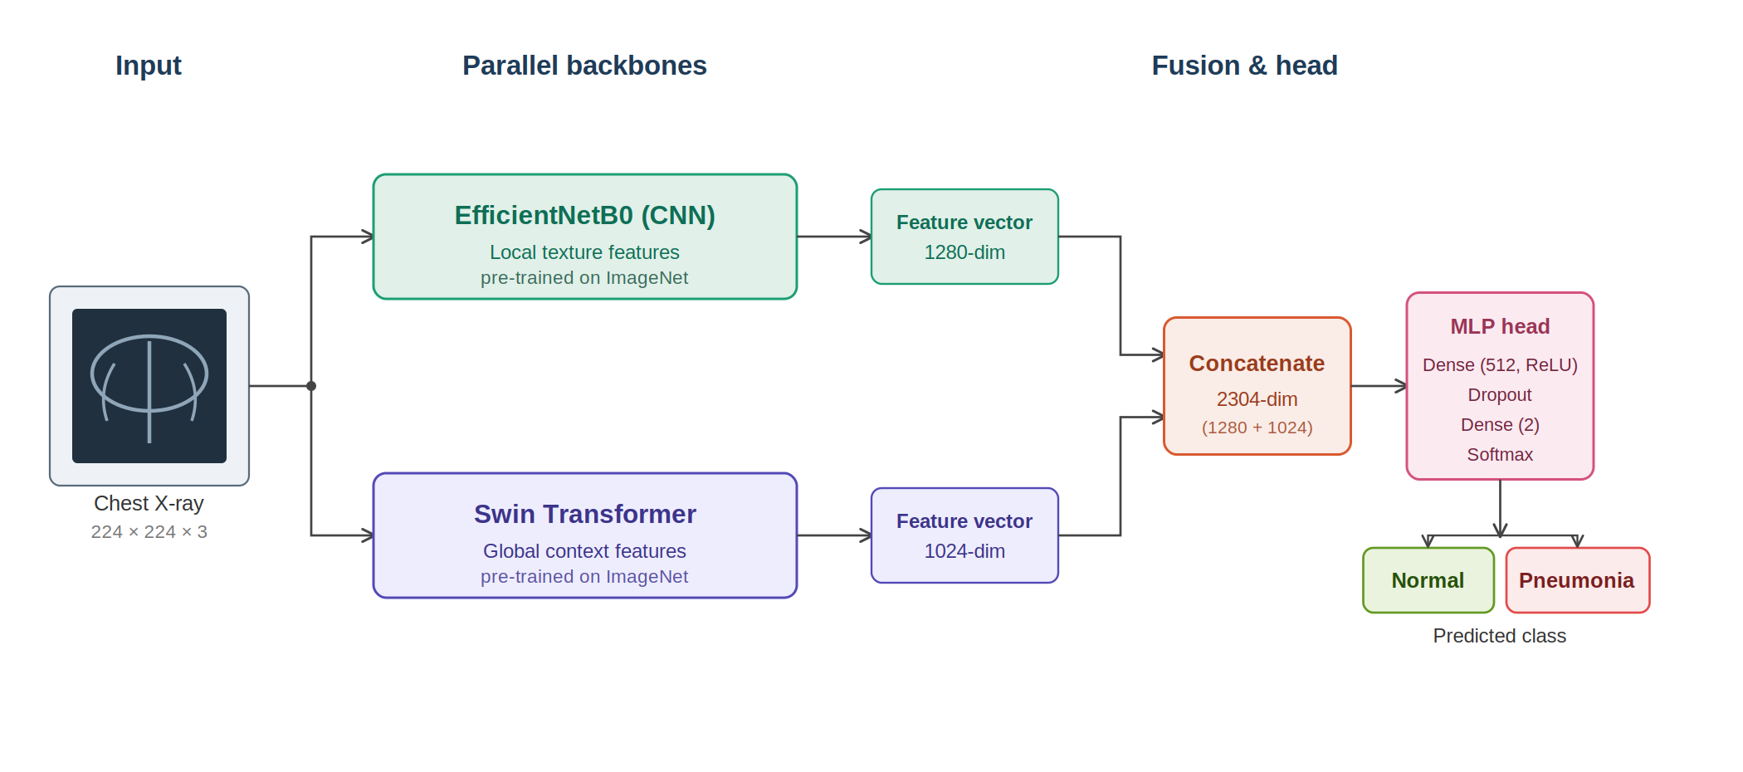
Figure (1): Architecture of the proposed CNN–Transformer hybrid model

7.6 Experimental Setup
All experiments were conducted in the Google Colab environment, providing GPU acceleration to improve training efficiency and reduce computation time. The models were trained using the Adam optimizer with binary cross-entropy as the loss function a batch size of 32 and a maximum of 15 epochs. Early stopping was used to halt training when validation performance stopped improving guarding against overfitting. Standard Python libraries is NumPy Pandas, Matplotlib and Scikit-learn were used for data handling, visualization and evaluation. Table 3 summarizes the experimental configuration.
Table (3): Experimental configuration
Parameter | Value
Programming language | Python 3
Frameworks | TensorFlow / Keras (CNNs); PyTorch (Transformers)
Convolutional models | MobileNetV2, EfficientNetB0, ResNet50
Transformer models | Vision Transformer, Swin Transformer
Image size | 224 × 224
Batch size | 32
Epochs | 15 (with early stopping)
Optimizer | Adam
Loss function | Binary cross-entropy
Data split | ≈70% training / 10% validation / 20% testing
Evaluation metrics | Accuracy, Precision, Recall, F1-score, ROC-AUC

8. Results

8.1 Overall Performance
Table 4 reports the overall performance of the evaluated models in terms of accuracy, precision recall, F1-score and the area under the ROC curve (AUC). Of the convolutional networks, ResNet50 achieved the highest accuracy at 96.09% followed by EfficientNetB0 at 95.30% and MobileNetV2 at 94.72%. Of the transformer-based models ViT produced the best individual accuracy of 96.87%, while Swin reached a comparable 96.67%. The hybrid model matched ViT on accuracy, precision, recall, and F1-score (96.87%), and it obtained the highest AUC of all models at 0.9921. Because AUC measures how well a model separates the two classes across all decision thresholds rather than at a single operating point this result indicates that the hybrid achieved the strongest overall class separation, even where its headline accuracy was level with the best single model. Figure 2 presents the same comparison visually.
Table (4): Overall performance of the evaluated models
Approach | Model | Accuracy | Precision | Recall | F1-score | AUC
Pre-trained CNN | MobileNetV2 | 0.9472 | 0.9471 | 0.9472 | 0.9470 | 0.9814
 | EfficientNetB0 | 0.9530 | 0.9530 | 0.9530 | 0.9530 | 0.9904
 | ResNet50 | 0.9609 | 0.9610 | 0.9609 | 0.9607 | 0.9879
Transformer | ViT | 0.9687 | 0.9687 | 0.9687 | 0.9687 | 0.9910
 | Swin | 0.9667 | 0.9667 | 0.9667 | 0.9667 | 0.9884
Proposed | Hybrid (EfficientNetB0 + Swin) | 0.9687 | 0.9687 | 0.9687 | 0.9687 | 0.9921

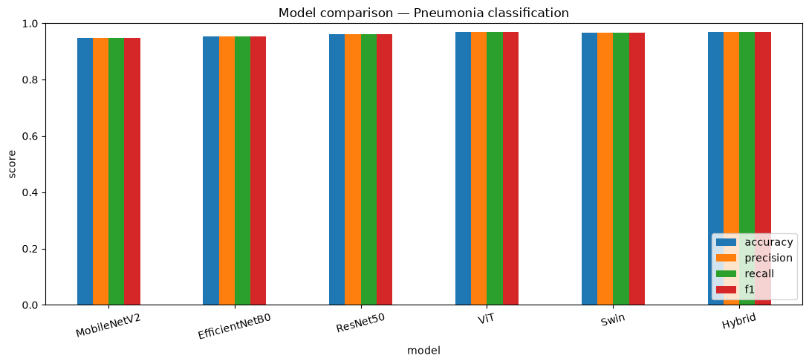
Figure (2): Accuracy, precision, recall, and F1-score across all models
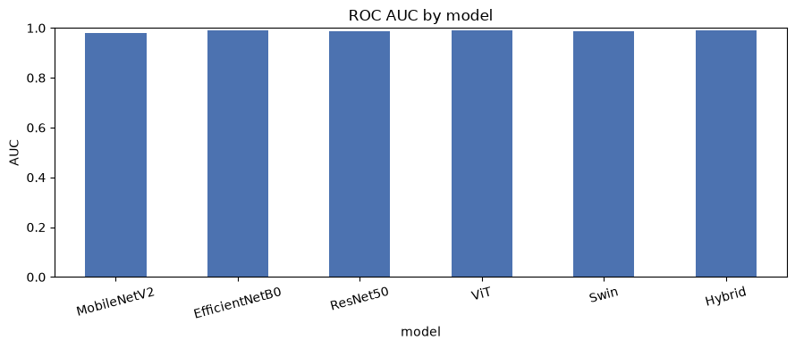
Figure (3): Area under the ROC curve (AUC) by model

8.2 Per-Class Performance
Table 5 presents a per-class breakdown of precision, recall and F1-score for the Normal and Pneumonia classes. All models achieved consistently high scores on both classes confirming their ability to classify chest X-rays correctly. The transformer-based models and the proposed hybrid produced the most balanced performance across the two classes, while the convolutional models showed only minor variations. For the hybrid model the per-class values were obtained directly from its confusion matrix (Figure 5): for the Normal class precision 0.97, recall 0.98, and F1-score 0.97; and for the Pneumonia class precision 0.96, recall 0.95 and F1-score 0.96. These findings indicate that every evaluated model is a reliable binary classifier for this task.
Table (5): Per-class performance of the evaluated models
Approach | Model | Class | Precision | Recall | F1-score
Pre-trained CNN | MobileNetV2 | Normal | 0.95 | 0.97 | 0.96
 |  | Pneumonia | 0.94 | 0.92 | 0.93
 | EfficientNetB0 | Normal | 0.96 | 0.97 | 0.96
 |  | Pneumonia | 0.94 | 0.93 | 0.94
 | ResNet50 | Normal | 0.96 | 0.98 | 0.97
 |  | Pneumonia | 0.97 | 0.93 | 0.95
Transformer | ViT | Normal | 0.97 | 0.98 | 0.97
 |  | Pneumonia | 0.96 | 0.95 | 0.96
 | Swin | Normal | 0.97 | 0.97 | 0.97
 |  | Pneumonia | 0.96 | 0.95 | 0.96
Proposed | Hybrid | Normal | 0.97 | 0.98 | 0.97
 |  | Pneumonia | 0.96 | 0.95 | 0.96

8.3 Training Behavior
Figure 4 shows the training and validation accuracy and loss curves for all six models across the training epoch. In every case the training and validation curves rise and fall together and converge without a widening gap between them which indicates that the models learned steadily and did not overfit. The transfer-learning strategy is visible in the curves which begin at a high accuracy from the first epoch because the backbones were initialized with pre-trained weights. The hybrid model trained in two stages (fusion headfirst then full fine-tuning) also converges smoothly and stably.
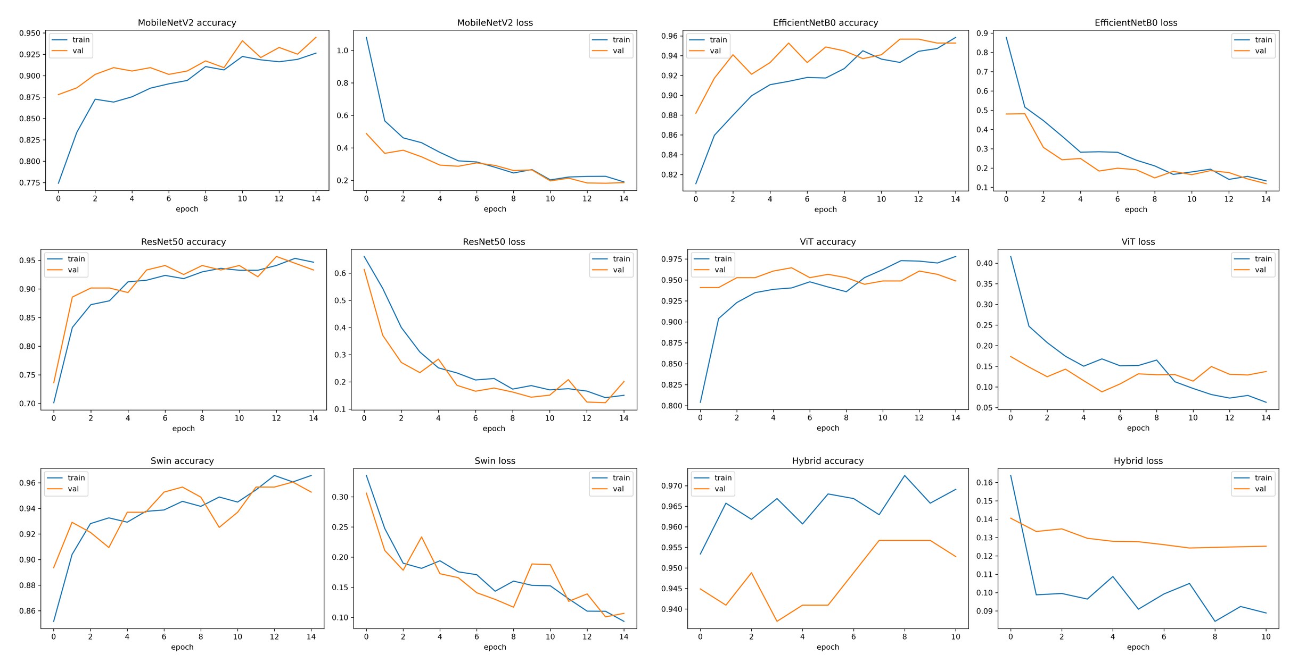
Figure (4): Training and validation accuracy and loss for the evaluated models

8.4 Confusion Matrices and ROC Curves
The confusion matrices in Figure 5 compare the predicted labels with the true labels for each model on the held-out test set. In every case, the diagonal entries are substantially larger than the off-diagonal entries indicating that most images were classified correctly with only a small number of errors. The hybrid model correctly classified 309 of 316 Normal cases and 186 of 195 Pneumonia cases with only seven and nine errors respectively among the lowest error counts of all models. Figure 6 shows the corresponding per-model ROC curves, each of which rises steeply toward the top-left corner and stays well above the chance diagonally. The area under the curve exceeds 0.98 for every model and reaches its highest value 0.992 for the hybrid confirming the strong and reliable discrimination it achieves between the two classes.
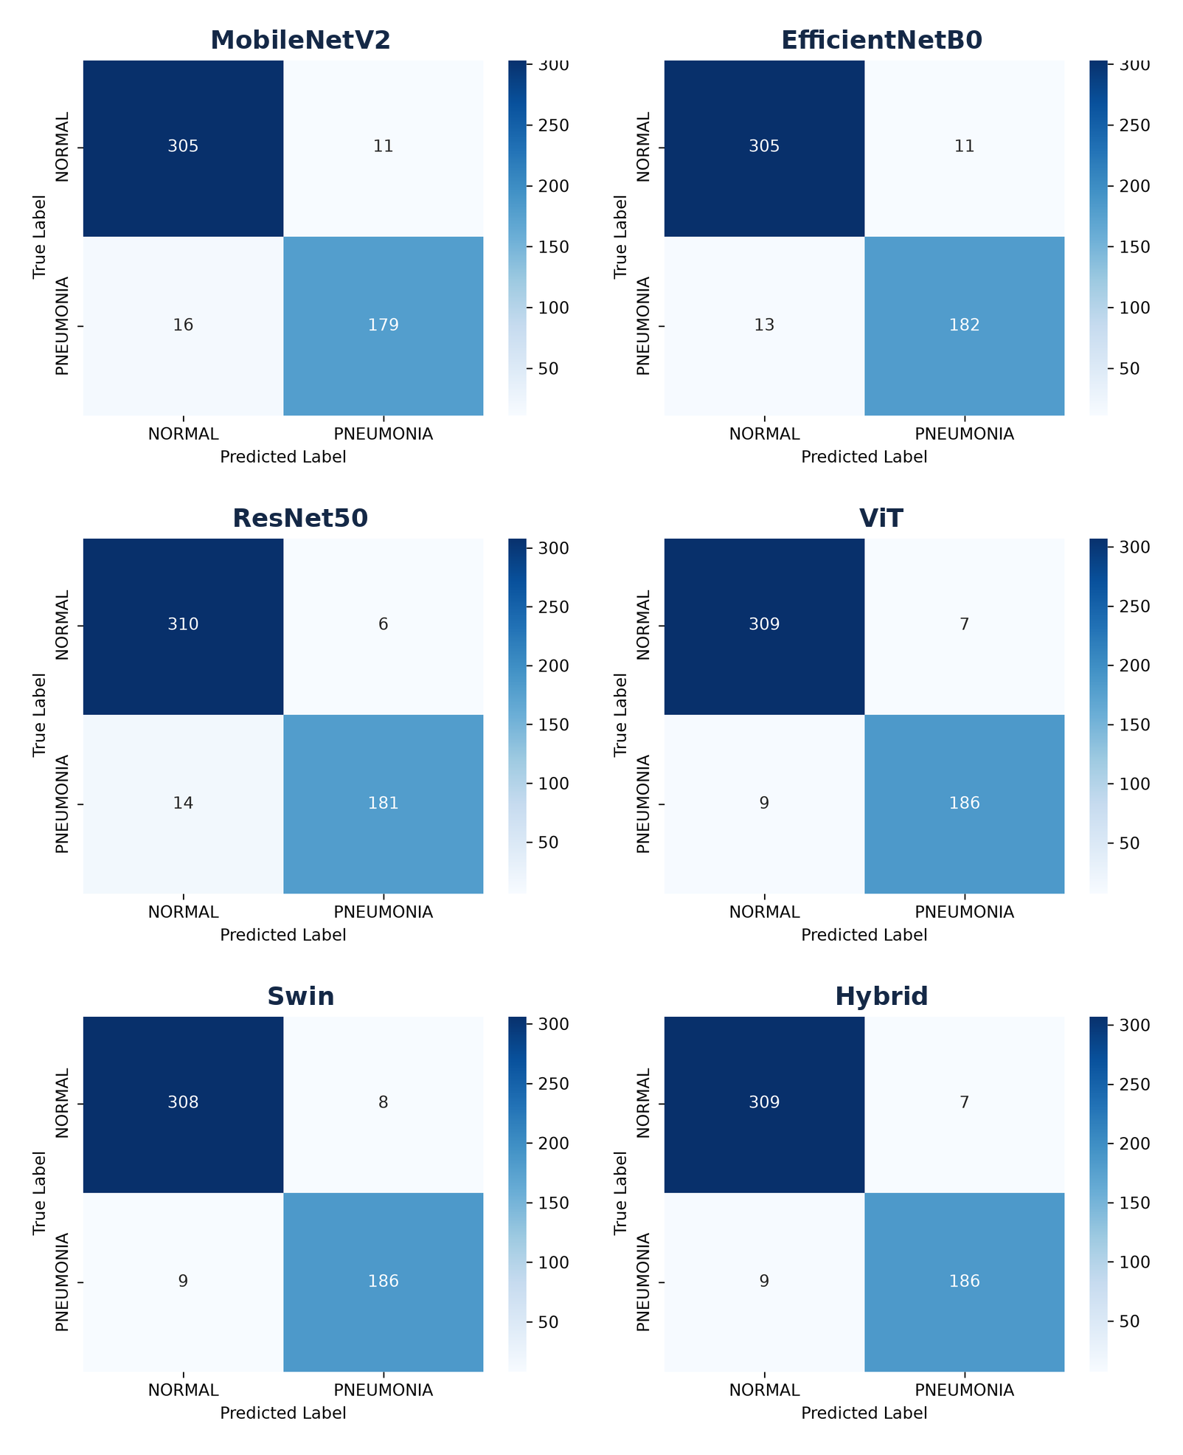
Figure (5): Confusion matrices of the evaluated models
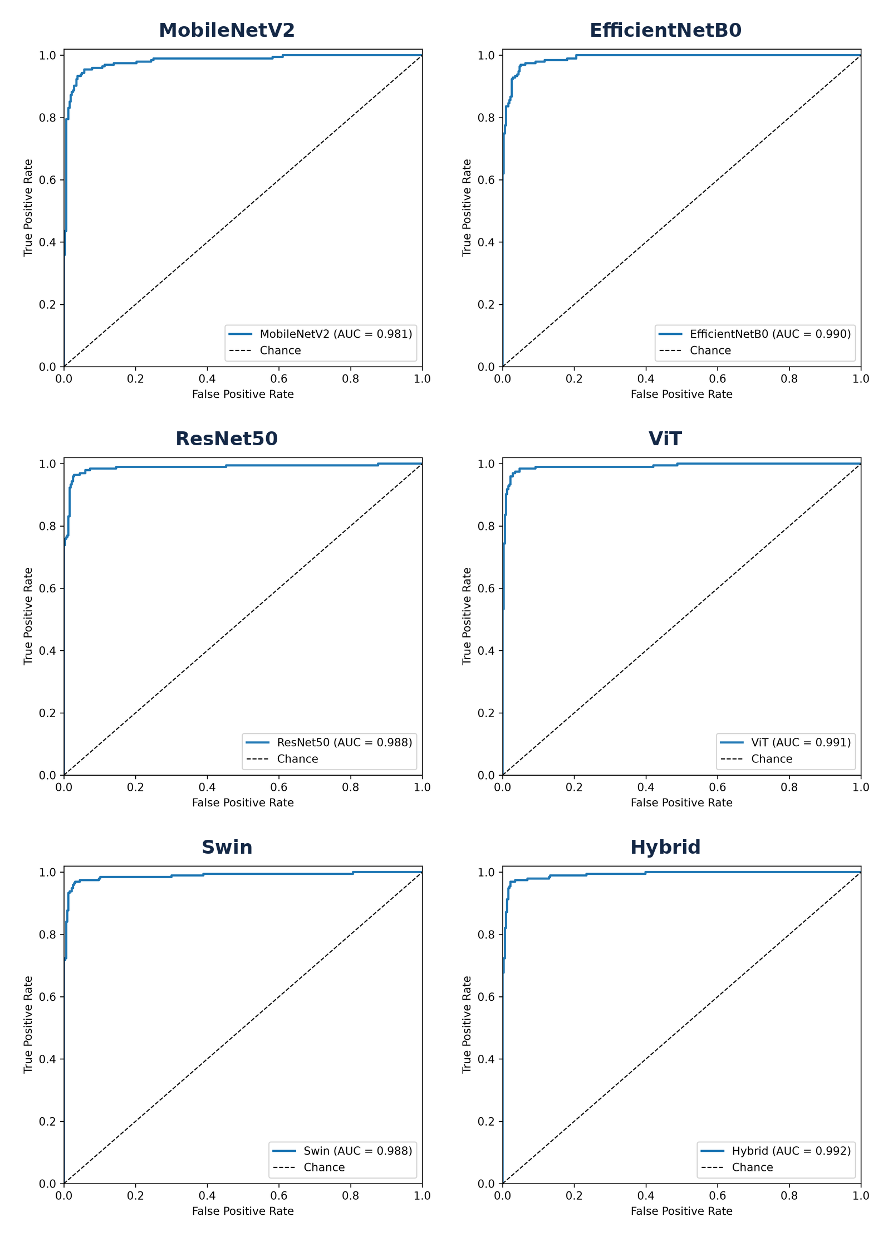
Figure (6): ROC curves of the evaluated models

8.5 System Implementation
To evaluate the practical applicability of the trained models a lightweight web application was developed to serve them for interactive use. The application runs locally and presents a simple interface in which the user selects one of the trained models uploads a chest X-ray image and receives a prediction. For each image the system returns the predicted class (normal or pneumonia) the model's confidence a per-class probability breakdown and the inference time. The trained model weights are loaded on demand and cached so that switching between models and classifying successive images is fast. This converts the trained models into a usable decision-support prototype and clarify how the approach could be integrated into a screening workflow. Figure 7 shows the interface classifying a pneumonia case. It is important to note that the application is a research and educational prototype and is not a certified medical device; any clinical use would require validation and regulatory approval and predictions should always be confirmed by a qualified radiologist.
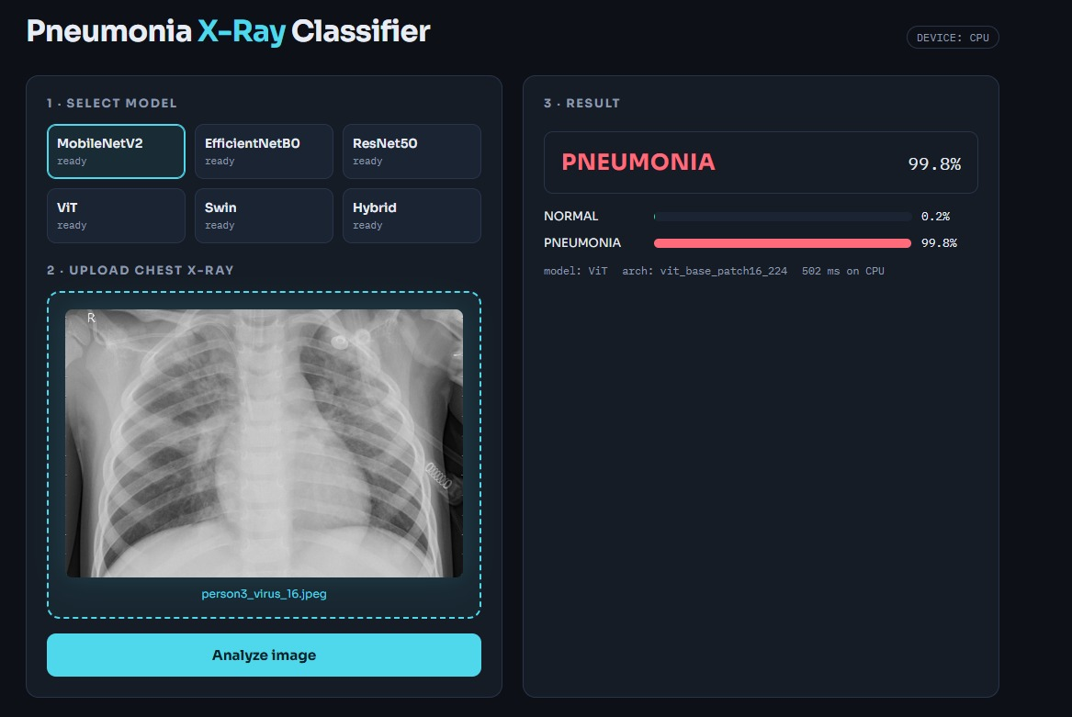
Figure (7): The web application classifying a chest X-ray image

9. Conclusion and Discussion of Results
This study developed and compared five deep-learning models for the automated detection of pneumonia from chest X-ray images and proposed a hybrid model that fuses convolutional and transformer features. All five models achieved high classification performance, which can be attributed to transfer learning which allowed the networks to reuse feature representations learned from large-scale image datasets, and to preprocessing, normalization, and augmentation, which improved the quality and diversity of the training data and reduced overfitting.The transformer-based models slightly outperformed the convolutional models. It achieved the best individual accuracy of 96.87% with Swin close behind at 96.67% while ResNet50 led the convolutional networks at 96.09%.This advantage is consistent with the self-attention mechanism used by transformer models, which captures both local image detail and global contextual information, a combination that is beneficial for identifying pneumonia, whose signs may appear in different regions of the lung. The hybrid model united these strengths explicitly by fusing the local features of EfficientNetB0 with the global features of Swin. It matched the best single model on accuracy and F1-score (96.87%) and achieved the highest area under the ROC curve of all models (0.9921) indicating the most reliable separation between the two classes across decision thresholds. In addition, the trained models were deployed in a local web application turning the experimental results into a usable prototype for interactive chest X-ray classification. These results are broadly in line with the literature reviewed earlier, where transformer-based and hybrid or ensemble models tend to lead the field. Furthermore, the study contributes a controlled comparison under a single consistent protocol which makes the differences between architectures easier to interpret than comparisons drawn across studies that use different data preparation and evaluation choices.The hybrid model performed at the level of the best single model on accuracy, precision, recall and F1-score (all 96.87%) and it produced the highest area under the ROC curve of any model evaluated 0.9921. A McNemar test confirmed that the difference between the hybrid and the best single model was not statistically significant (p = 0.617) meaning the two classify essentially the same images correctly. The hybrid's contribution is therefore best described as matching the strongest single model while achieving a marginally higher AUC, rather than as a significant gain in accuracy. This is a meaningful outcome: fusing the local features of EfficientNetB0 with the global features of Swin produces a classifier that is at least as good as the best individual model and ranks cases slightly more reliably across thresholds, a property that can be valuable in a screening context where the operating threshold may be tuned to favor sensitivity. It also suggests that on a dataset of this size where the individual models already perform strongly there is limited headroom for a fusion model to improve further a finding that itself helps frame where hybrid approaches are and are not likely to help. To test whether the hybrid's performance differed significantly from the best single model, McNemar's test was applied to the paired predictions of the hybrid and Swin on the same test set. Of the 511 test images, both models classified 494 correctly and 13 incorrectly: the hybrid was correct on one image that Swin misclassified the Swin was correct on three images that the hybrid misclassified. The test gave a chi-square statistic of 0.25 with a p-value of 0.617 is well above the 0.05 threshold. The difference between the hybrid and the best single model is therefore not statistically significant: the two models classify essentially the same set of images correctly. This is an honest and useful finding on this dataset the hybrid does not make significantly fewer errors than the strongest individual model and its advantage lie mainly in its marginally higher AUC indicating slightly more reliable ranking of cases across thresholds rather than a step change in accuracy.

10. Recommendations
Given the strong performance of the evaluated models, several directions are recommended for future work. First, the models should be validated on larger multi-center chest X-ray datasets that capture greater variation in equipment patient populations and image quality so that their generalization can be assessed more rigorously. Second, explainability methods such as Grad-CAM or SHAP should be incorporated so that clinicians can see which regions of an image drive a prediction which would help build trust and support clinical validation. Third, the proposed hybrid architecture should be deployed and tested in a practical decision-support setting through a user-friendly web or mobile interface moving the work closer to real screening use. extending the task from binary classification to distinguishing bacterial from viral pneumonia or to multi-disease screening would broaden the clinical value of the approach.

References
Ahmed, M. S., et al. (2023). Joint diagnosis of pneumonia and other lung diseases using deep learning from chest X-ray images. Diagnostics, 13(15), 2562. https://doi.org/10.3390/diagnostics13152562
Alghamdi, H. S., et al. (2024). Pneumonia detection from chest X-ray images using deep learning and transfer learning for imbalanced datasets. Biomedical Engineering Letters.
Al-Reshan, M. S. A., et al. (2023). Detection of pneumonia from chest X-ray images utilizing MobileNet model. Healthcare, 11(11), 1561. https://doi.org/10.3390/healthcare11111561
An, et al. (2024). Deep convolutional neural network for pneumonia detection using chest X-ray images. Diagnostics, 14(4), 390. https://doi.org/10.3390/diagnostics14040390
Boukhe, M., et al. (2025). Trustworthy pneumonia detection in chest X-ray imaging through attention-guided deep learning. Scientific Reports. https://doi.org/10.1038/s41598-025-23664-x
Bundea, M., et al. (2024). Pneumonia image classification using DenseNet. Information, 15(10), 611. https://doi.org/10.3390/info15100611
Buriboev, A. S., et al. (2025). Binary classification of pneumonia in chest X-ray images using convolutional neural networks. Sensors, 25(13), 3976. https://doi.org/10.3390/s25133976
Devaux, M., Lacombe, J.-N., Debray, M.-P., Claessens, Y.-E., & Duval, X. (2024). Validating the accuracy of deep learning for the diagnosis of pneumonia on chest X-ray against a robust multimodal reference diagnosis. European Radiology Experimental, 8, 20. https://doi.org/10.1186/s41747-023-00416-y
Dosovitskiy, A., et al. (2020). An image is worth 16×16 words: Transformers for image recognition at scale. arXiv:2010.11929.
He, K., Zhang, X., Ren, S., & Sun, J. (2016). Deep residual learning for image recognition. Proceedings of the IEEE Conference on Computer Vision and Pattern Recognition (CVPR).
Howard, A. G., et al. (2017). MobileNets: Efficient convolutional neural networks for mobile vision applications. arXiv:1704.04861.
Huang, G., Liu, Z., Van Der Maaten, L., & Weinberger, K. Q. (2017). Densely connected convolutional networks. Proceedings of the IEEE Conference on Computer Vision and Pattern Recognition (CVPR).
Kareem, O., et al. (2024). Pneumonia detection using pretrained networks and federated learning on real-time datasets. Biomedical Engineering Letters.
LeCun, Y., Bottou, L., Bengio, Y., & Haffner, P. (1998). Gradient-based learning applied to document recognition. Proceedings of the IEEE, 86(11), 2278–2324.
Liu, Z., et al. (2021). Swin: Hierarchical vision transformer using shifted windows. Proceedings of the IEEE/CVF International Conference on Computer Vision (ICCV).
Mitchell, T. M. (1997). Machine learning. McGraw-Hill.
Mustapha, B., et al. (2025). Enhanced pneumonia detection in chest X-rays using hybrid convolutional and vision transformer networks. Current Medical Imaging. https://doi.org/10.2174/0115734056326685
Powers, D. M. W. (2011). Evaluation: From precision, recall and F-measure to ROC, informedness, markedness and correlation. Journal of Machine Learning Technologies, 2(1), 37–63.
Ridouane, F. L., et al. (2025). PELM: A deep learning model for early detection of pneumonia in chest radiography. Applied Sciences, 15(12), 6487. https://doi.org/10.3390/app15126487
Saber, A., et al. (2025). Efficient and accurate pneumonia detection using deep learning. Sensors, 25(23), 7233. https://doi.org/10.3390/s25237233
Sandler, M., Howard, A., Zhu, M., Zhmoginov, A., & Chen, L.-C. (2018). MobileNetV2: Inverted residuals and linear bottlenecks. arXiv:1801.04381.
Shomsomi, M., Triawan, W., & Purwadi. (2026). Classification of pneumonia using CNN and vision transformer. Journal of Artificial Intelligence and Engineering Applications (JAIEA), 5(2), 2495–2504. https://doi.org/10.59934/jaiea.v5i2.1906
Singh, S., Kumar, M., Kumar, A., Verma, B. K., Abhishek, K., & Selvarajan, S. (2024). Efficient pneumonia detection using ViTs on chest X-rays. Scientific Reports, 14, 2487. https://doi.org/10.1038/s41598-024-52703-2
Sokolova, M., & Lapalme, G. (2009). A systematic analysis of performance measures for classification tasks. Information Processing & Management, 45(4), 427–437.
Tan, M., & Le, Q. V. (2019). EfficientNet: Rethinking model scaling for convolutional neural networks. Proceedings of the International Conference on Machine Learning (ICML).
Usman, C., et al. (2025). Pneumonia disease detection using chest X-rays and machine learning. Algorithms, 18(2), 82. https://doi.org/10.3390/a18020082
World Health Organization. (2023). Pneumonia. https://www.who.int/news-room/fact-sheets/detail/pneumonia

