 | Midocean Journal for Research and Studies  https://  e-ISSN: | 

Deep Learning-Based Monkeypox Detection: A
Hybrid Approach Using DenseNet121 and
MobileNetV2
Omar AbuAmra – Ali Mohamed – Mahmoud Slaem
0009-0004-8279-1383 – 0009-0003-1206-1302- 0009-0000-1542-5229
MSc in Artificial Intelligence - College of Informatics – Midocena University – UAE Email amooore05@gmail.com, eng3li.911@gmail.com, eng.m77mod@gmail.com
Dr. Hager Saleh- Computer Science and Artificial Intelligence, College of Informatics, Midocena University – UAE
Abstract
Due to recent outbreaks outside of endemic areas, Monkeypox is a newly developing zoonotic disease that has drawn international attention. As a result, early and precise lesion detection is crucial for effective containment and treatment. To overcome this difficulty, we suggest a hybrid deep-learning method that combines DenseNet121 and MobileNetV2 for reliable monkeypox identification from skin lesion photos using the Monkeypox Skin Lesion Dataset (MSLD) and the Monkeypox Skin Lesion Dataset V2.0 (MSLDV2.0). The accuracy of the proposed model was 98% on the MSLD2.0 dataset and 99.18% on the MSLD dataset. The confusion matrix further validated the model's robustness, which outperformed current techniques and demonstrated exceptional precision for both the Monkeypox and non-monkeypox classes. The hybrid model makes it clinically feasible for environments with restricted resources by carefully balancing the computational efficiency of MobileNetV2 with the hierarchical feature extraction of DenseNet121. This work advances AI-driven diagnostics by providing a high-accuracy, deployable solution that supports international efforts to stop the spread of Monkeypox through dependable early identification.
Keywords: Monkeypox, deep learning, DenseNet121, MobileNetV2, diagnostic accuracy.

Introduction
Monkeypox, a re-emerging zoonotic disease of the Orthopoxvirus genus, garnered unprecedented global attention following its multi-country outbreak in 2022. The World Health Organization (WHO) declared it a Public Health Emergency of International Concern (PHEIC) due to its rapid spread, symptomatic similarity to other pox-like diseases, and the challenges posed in timely and accurate diagnosis (Fleck, 2022; WHO, 2025). Characterized by fever, lymphadenopathy, and distinctive pustular skin lesions, Monkeypox can often be misdiagnosed—particularly in early stages—due to symptom overlap with diseases such as Chickenpox and Measles.
Though reliable, traditional diagnostic approaches, including Polymerase Chain Reaction (PCR) tests and clinical examinations, are time-intensive and require access to well-equipped laboratories and expert personnel. This poses a significant barrier in low-resource or outbreak-heavy settings. Consequently, artificial intelligence (AI), particularly deep learning (DL) techniques, have emerged as promising alternatives for rapid and scalable diagnosis (Akin et al., 2022; Sitaula et al., 2022). Convolutional Neural Networks (CNNs) have shown substantial potential in analyzing dermatological imagery for various infectious diseases. However, despite these advancements, many existing CNN-based models exhibit limitations in effectively balancing global contextual understanding and local feature sensitivity, which are both critical in distinguishing subtle visual differences among similar skin diseases (Kumar et al., 2023).
We propose a hybrid deep learning model that integrates DenseNet-121 and MobileNetV2 architectures to address these limitations. DenseNet-121, known for its dense connectivity and feature reuse, enhances the model’s capacity to capture global interdependencies. At the same time, MobileNetV2 contributes to lightweight and efficient local feature extraction, making the system suitable for real-time diagnostic scenarios. By leveraging transfer learning from pre-trained ImageNet weights, the proposed model achieves high accuracy even when trained on Monkeypox datasets MSDL and MSDLv2.0.
Related Work
The monkeypox virus spreads quickly. Therefore, prompt and precise diagnosis is essential. Although the primary diagnostic technique is polymerase chain reaction (PCR) testing, the accuracy of this test is dependent on the pathologist's experience. Differences between and among observers may impact it. To overcome these constraints, researchers have created several AI-based methods to distinguish between skin lesions brought on by Monkeypox and other illnesses. Essential advancements in AI-based monkeypox detection are reviewed in this section.

  - CNN-Based Approaches
Convolutional Neural Networks (CNNs) have emerged as the dominant architecture for medical image analysis, including monkeypox detection. (Dihan et al., 2024) Proposed MpoxSLDNet, a lightweight CNN evaluated against VGG16, ResNet50, and DenseNet121 for Monkeypox versus non monkeypox skin-lesion classification; the results showed that MpoxSLDNet attained a validation accuracy of 94.56 %. (Pal et al., 2023a) proposed a monkeypox image-classification framework that fine-tunes VGG19, DenseNet121, DenseNet201, Inception V3, Xception, and MobileNet CNNs; the results showed that Inception V3 attained the best accuracy of 94.99 %. (AKIN et al., 2022) Proposed an explainable-AI-assisted decision support system that evaluates 12 transfer-learning CNNs—ResNet-18, ResNet-50, VGG-16, Densenet-161, EfficientNet B7, EfficientNet V2, GoogLeNet, MobileNet V2, MobileNet V3, ResNeXt-50, ShuffleNet V2, and ConvNeXt—for Monkeypox versus Normal skin-lesion classification; the results showed that MobileNet V2 achieved the highest accuracy of 98.25 %.
  - Transfer Learning Approaches
Transfer learning has proven particularly effective for medical image classification tasks where large annotated datasets are scarce. (Pal et al., 2023a) proposed a monkeypox image classification framework using data augmentation and pre-trained CNN models, VGG-16, ResNet50, and Inception V3. The results showed that Inception V3 achieved an accuracy of 94.99%. (Shashikala et al., 2024a) In this study, EfficientNet-B7 has demonstrated superior performance in Monkeypox detection, achieving up to 97.4% accuracy, which highlights the potential of transfer learning in medical image classification.
.
(Islam et al., 2022) proposed a deep-learning framework that fine-tunes seven CNNs—ResNet50, DenseNet121, Inception-V3, SqueezeNet, MnasNet-A1, MobileNet-V2, and ShuffleNet-V2—combined via majority-voting ensemble for multi-pox lesion classification; the results showed that the ensemble attained an accuracy of 83 %. (Ahsan et al., 2022) Proposed a modified VGG16 network augmented with Local Interpretable Model-Agnostic Explanations (LIME) for classifying Monkeypox 2022 skin-lesion images; the results showed that the model achieved 97 % accuracy. (Vuran et al., 2025) Proposed a multi-class, fast, and reliable autonomous disease diagnosis model using transformer-based deep learning architectures (ViT, MAE, DINO, and SwinTransformer) with self-supervised learning, self-distillation, and shifted window techniques on the Mpox Skin Lesion Dataset Version 2.0. The results showed that the SwinTransformer achieved the highest classification success with 93.71% accuracy.
  - Ensemble and Hybrid Approaches
Ensemble and hybrid approaches combine multiple models or techniques to improve classification performance. (Pal et al., 2023b) proposed an AI-based framework that fine-tunes VGG19, DenseNet121, DenseNet201, Inception V3, Xception, and MobileNet CNNs with custom ReLU and Softmax layers for monkeypox image classification. The results showed that Inception V3 achieved 94.99 % testing accuracy. (Shashikala et al., 2024b) Proposed deep-learning skin-lesion classification using pre-trained VGG-16, ResNet50, and InceptionV3 models combined in an ensemble with data augmentation. The results showed that the approach achieved an average accuracy of 97 %. (C. Sitaula & Shahi, 2022) proposed a Monkeypox virus detection approach that fine-tunes 13 pre-trained models—including Xception, DenseNet-169, InceptionResNetV2, EfficientNet-B1, and ResNet-101—with common custom layers and ensembles of the top performers via majority voting. The results showed that the ensemble achieved 87.13 % accuracy. (Almutairi, 2022) proposed DL-MDF-OH2, an optimized diagnostic framework that fine-tunes pre-trained CNNs—VGG19, VGG16, Xception, MobileNet, and MobileNetV2—using the Harris Hawks Optimizer and ensembles their features with machine-learning classifiers via majority voting. The results showed that the framework achieved 97.67 % accuracy on the Monkeypox Skin Images Dataset. (Huan & Dun, 2024) proposed MSMP-Net, a multi-scale neural network using ConvNeXt backbone with inverse bottleneck layers, large convolution kernels, and a multi-scale feature fusion structure for end-to-end monkeypox virus skin lesion classification. The results showed that it achieved an accuracy of 87.03 %.
(Sahin et al., 2022) developed a mobile Android system that applies a low-modified MobileNetV2 deep-learning model converted to TensorFlow Lite for on-device classification of monkeypox skin-lesion images; the results showed that it achieved 91.11 % accuracy.
  - Limitations of Existing Approaches
Various AI-based approaches for monkeypox detection have shown promising findings; however, the existing literature still has several drawbacks. Moreover, the datasets that were utilized have a significant constraint. The majority of research uses artificial data augmentation or comparatively tiny datasets. These datasets may not adequately represent the variety of real-world monkeypox representations. There is frequently insufficient representation of variations across different skin types, lesion stages, and lighting conditions. One of the significant drawbacks is efficiency and model complexity. A lot of high-performing models require a lot of computing power. Single-architecture models often struggle to represent both local and global aspects simultaneously. Robust feature type extraction is necessary to differentiate monkeypox lesions from comparable skin diseases. Due to generalization difficulties, models trained on particular datasets may not effectively generalize to new, unknown data, especially when there are differences in image quality, patient demographics, or clinical presentations.

By fusing the complementary advantages of the DenseNet121 and MobileNetV2 architectures, our proposed hybrid approach overcomes these drawbacks and permits effective global and local feature extraction while preserving computational efficiency appropriate for various deployment scenarios. The models used in related work, and their reported accuracy are compiled in Table 1. This comparison demonstrates the variety of methods and the disparities in performance attained by various architectures.
Table (1): List of Models Utilized by Researchers in the Related Work and Accuracies Obtained
Ref. | Methods | Accuracy | Dataset
(Dihan et al., 2024) | MpoxSLDNet | 94.56% | MSLD
(Pal et al., 2023a) | Inception V3 | 94.99% | MSLD and MSID
(AKIN et al., 2022) | MobileNet V2 | 98.25% | MSID
(Islam et al., 2022) | Ensemble of 7 CNNs | 83% | MSLDV2.0
(Ahsan et al., 2022) | Modified VGG16 + LIME | 97% | MSLDV2.0
(Almutairi, 2022) | DL-MDF-OH2 | 94.99% | MSLD
(Shashikala et al., 2024b) | VGG16, ResNet50, InceptionV3 | 97% | Image Lesion Dataset
(C. Sitaula & Shahi, 2022) | 13 CNNs incl. Xception, DenseNet169, InceptionResNetV2, EfficientNetB1, ResNet101 | 87.13% | MSID
(Sahin et al., 2022) | MobileNetV2 (TFLite) | 91.11% | MSLD
(Huan & Dun, 2024) | ConvNeXt | 87.03 % | MSLDV2.0
(Vuran et al., 2025) | ViT, MAE, DINO, and SwinTransformer | 93.71% | MSLDV2.0

Methodology
The procedure has six primary steps, as shown in Figure 1, including collecting image datasets, data augmentation, model training, and model evaluation.
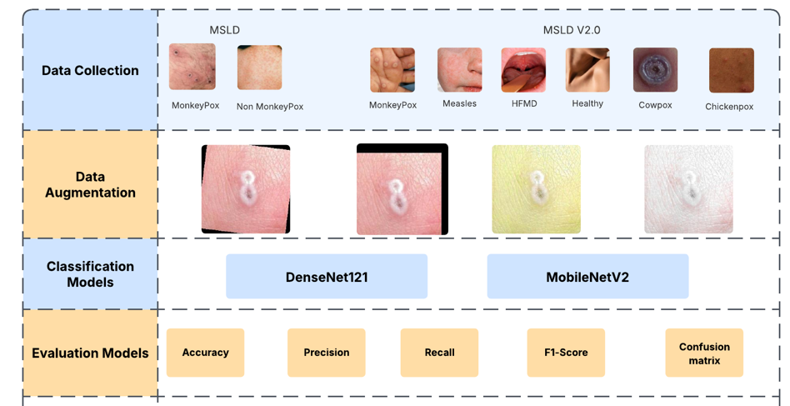
Figure (1): Illustration of the Steps of the Method

3.1 Dataset Description
The Mpox Skin Lesion Dataset v2.0 (MSLD v2.0) (Joydip Paul, 2023) and MSLD (Ali, 2022) are used in our research. 10570 skin lesion images from 541 people make up the MSLD v2.0 dataset. These images include 3976 Mpox, 1050 Chickenpox, 770 Measles, 924 Cowpox, 2254 Hand, Foot, and Mouth Disease, and 1596 Healthy images. The Monkeypox and non-Monkeypox classes are included in the second dataset, the Monkeypox Skin Lesion Dataset (MSLD). There are 2630 images in this dataset, including 1165 photos of skin disorders other than Monkeypox and 1465 photos of Monkeypox lesions. The images were meticulously curated to represent diverse manifestations of Monkeypox across various body regions, infection stages, and skin types. Figure 2 shows sample images from the datasets that highlight the specific visual characteristics of monkeypox lesions compared to non-monkeypox lesions.
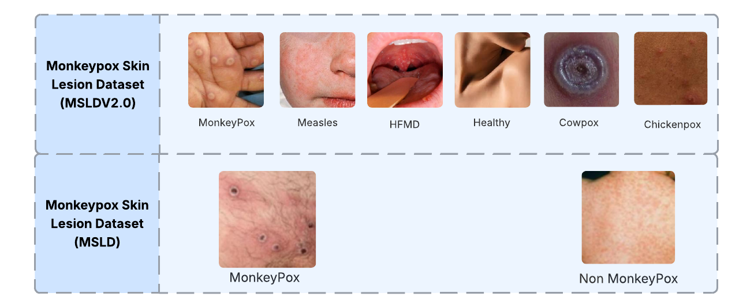
Figure )2(: Sample images from the dataset

3.2 Image Augmentation
A thorough image augmentation technique was used on the training data to improve the model's capacity for generalization and reduce the possibility of overfitting. The model was made more resilient to orientation changes by adding horizontal flipping and mirroring the images along the vertical axis. These augmentation approaches were used on the training dataset to maintain the consistency and integrity of the commonly normalized validation and test sets. (Garcea, 2023). Figure 3 illustrates Sample images from the dataset after augmentation.

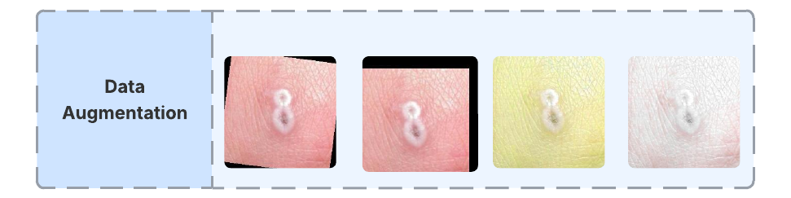
Figure (3): Sample Images from the Dataset after Augmentation

3.3 Proposed Model
The proposed system employs a hybrid deep learning architecture that integrates DenseNet121 and MobileNetV2 for image classification, implemented using TensorFlow and Keras. The model leverages transfer learning by utilizing pre-trained weights from ImageNet, followed by feature fusion and dense layers for final classification. Figure 4 illustrates the hybrid model.

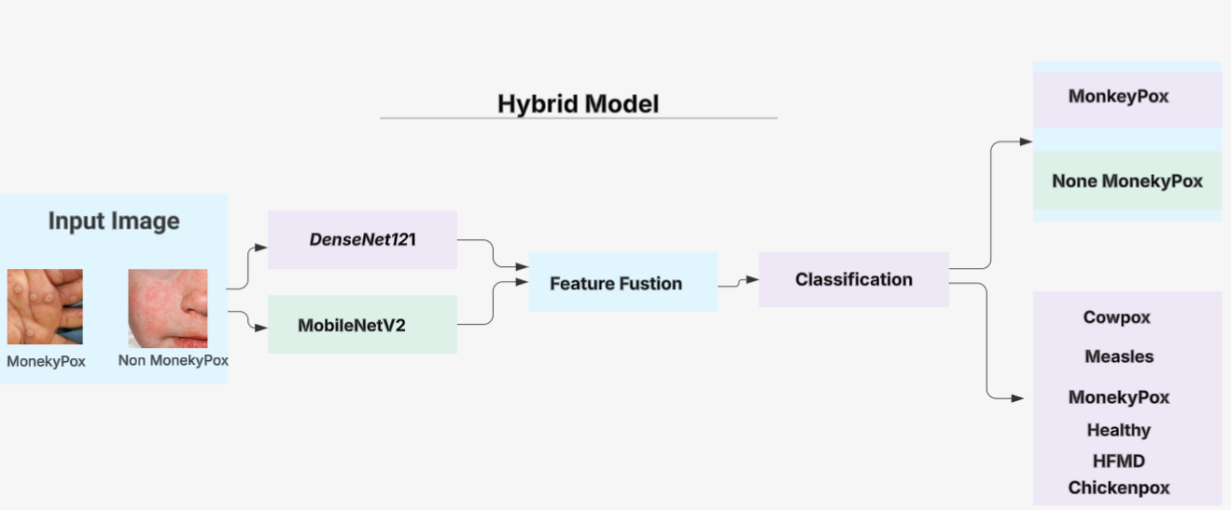
Figure (4): Illustration of the Hybrid Model

3.3.1 DenseNet121
A densely linked convolutional neural network (CNN) architecture is used by DenseNet 121 to improve feature propagation and significantly reduce parameter redundancy. To facilitate substantial feature reuse and allow the network to learn richer, more complicated representations, each layer within each dense block receives the concatenated outputs of all previous levels. This allows DenseNet 121 to achieve accuracy on par with other top CNN models using fewer parameters. In this study, we use DenseNet 121 in our methodology to take advantage of its strong feature propagation and reuse processes, which will increase model robustness and classification accuracy in identifying Monkeypox lesions. (Arumugam et al., 2024).

3.3.2 MobileNetV2
MobileNet is one kind of computationally efficient convolutional neural network that lowers inference costs by using depthwise separable convolutions (Howard et al., 2017). Our model used the MobileNetV2 variant (Sandler et al., 2018), which consists of an average pooling layer, thirteen depthwise separable convolution blocks at the end, a standard convolution layer at the beginning, and a standard convolution layer at the end. Complex feature representations can be learned in a lightweight model thanks to the architecture's inverted residual blocks with linear bottlenecks, which also ease information flow. Additionally, MobileNetV2 pairs each depthwise convolution with a 1×1 pointwise convolution to rectify channel dimensionality. MobileNetV2 drastically lowers processing overhead without sacrificing predictive performance using these inverted bottleneck structures for conventional 2D convolutions(Jaradat et al., 2023) (Sehgal & Saini, 2024).

3.3.3 Feature Concatenation
The suggested fusion network builds two concurrent feature-extraction models to process the same input image. This concatenation enhances the representation and produces a more discriminative feature embedding for further classification by integrating complementary global and local descriptors.
3.3.4 Classification Layer
The fused feature vector is passed to a compact classification head consisting of Dense(256, ReLU), Dropout, and Dense(NNN, Softmax). The complete model is compiled with the Adam optimizer and trained using the categorical cross-entropy loss, with classification accuracy monitored as the primary metric.

Results
4.1 Evaluation Metrics
The results for the MSLD and MSLDV2.0 datasets are presented in two dedicated subsections, each reporting the confusion matrix alongside per-class recall, precision, and F1-score. In addition, the overall precision, recall, accuracy, and F1-score for each dataset are summarized in Section V. Here, TP, TN, FP, and FN denote the numbers of true positives, true negatives, false positives, and false negatives, respectively.
Accuracy = (TP + TN) / (TP + TN + FP + FN)
Recall = TP / (TP + FN)
Precision = TP / (TP + FP)
F1-score = 2 * (Precision * Recall) / (Precision + Recall)
4.2 Experimental Setup
The experiments were performed on a high-performance computing workstation powered by an Intel Xeon E5-2680 v4 processor (14 cores at 2.40 GHz) and an NVIDIA Tesla V100 GPU with 16 GB of VRAM, supported by 64 GB of DDR4 main memory and a 1 TB solid-state drive. Details the number of images per class employed during training, validation, and testing. All networks were trained and evaluated exclusively on the augmented dataset, with 70 % of the images allocated for training, 15 % for validation, and 15 % for testing. A summary of the hybrid model's parameter settings for optimal feature selection is presented in Tables 2 & 3.

Table (2): Number of Images in Each Class for MSLD and MSLDV2.0
Dataset | Class label | Training | Testing | Validation | Total
MSDL | MonkeyPox | 818 | 175 | 175 | 1168
MSDL | None MonkeyPox | 1007 | 216 | 216 | 1439
MSDL | Total | 1825 | 391 | 391 | 2607
MSDLV2.0 | MonkeyPox | 2783 | 596 | 596 | 3976
MSDLV2.0 | Chickenpox | 735 | 156 | 156 | 1051
MSDLV2.0 | Measles | 539 | 116 | 116 | 771
MSDLV2.0 | Cowpox | 647 | 139 | 139 | 924
MSDLV2.0 | HFMD | 1578 | 338 | 338 | 2254
MSDLV2.0 | Healthy | 1117 | 239 | 239 | 1596
MSDLV2.0 | Total | 7399 | 1584 | 1584 | 10572

Table (3): Parameters of the Hybrid Model
Parameter | Value
Input shape | (224, 224, 3)
Fusion-dense layer units | 256
 | relu
  Fusion Dense activation
Dropout rate | 0.5
Output activation | SoftMax
Optimizer | Adam
  Learning rate
  1e-4
Epochs | 30
Model Checkpoint | True

4.3 Performance Hybrid Model in MSLD Dataset:
The proposed hybrid model, which integrates DenseNet-121 and MobileNetV2, was applied to the MSLD dataset and demonstrated outstanding performance in classifying Monkeypox and Non-Monkeypox cases. This dual-architecture approach capitalizes on the dense connectivity of DenseNet and the lightweight efficiency of MobileNetV2, enabling the model to extract rich and diverse features with minimal redundancy. The hybrid model achieved precision, recall, and F1-score values of 98.6%, 99.5%, and 99.1%, respectively, for the Monkeypox class and 99.6%, 98.8%, and 99.3% for the Non-Monkeypox class—surpassing all other benchmarked models in every metric. Compared to individual models such as ResNet50, VGG-19, DenseNet-121, and MobileNetV2, which showed notable variations and limitations, particularly in recall and F1-score for the Non-Monkeypox class, the hybrid approach consistently outperformed them across both categories. As shown in Table 4, these results demonstrate the efficacy and resilience of integrating DenseNet121 and MobileNetV2, underscoring the importance of architectural fusion in attaining higher classification accuracy in medical image analysis tasks.
Table (4): Performance of the Hybrid Model in Each Class for the MSLD Dataset
Approach | Model | Class Name | Precision | Recall | F1-score
Pre-trained CNN | ResNet50 | Monkeypox | 40.33 | 80.43 | 54.47
Pre-trained CNN | ResNet50 | Non-Monkeypox | 61.81 | 46.22 | 52.11
Pre-trained CNN | MobileNetV2 | Monkeypox | 92.17 | 86.30 | 89.42
Pre-trained CNN | MobileNetV2 | Non-Monkeypox | 76.07 | 68.05 | 72.03
Pre-trained CNN | DenseNet-121 | Monkeypox | 82.08 | 91.46 | 86.16
Pre-trained CNN | DenseNet-121 | Non-Monkeypox | 93.22 | 68.00 | 79.42
Pre-trained CNN | VGG-19 | Monkeypox | 61.07 | 91.00 | 73.29
Pre-trained CNN | VGG-19 | Non-Monkeypox | 53.89 | 21.00 | 35.03
Pre-trained CNN | VGG-19 | Non-Monkeypox | 88.00 | 86.02 | 86.07
The Proposed Hybrid Model | DenseNet-121, MobileNetV2 | Monkeypox | 98.60 | 99.52 | 99.10
The Proposed Hybrid Model | DenseNet-121, MobileNetV2 | Non-Monkeypox | 99.64 | 98.83 | 99.35

Figure 5 displays six confusion matrices that illustrate the performance of different models when asked to classify data into two groups: Monkeypox and others. In each confusion matrix, the color intensity indicates the number of samples classified into each class; darker colors indicate bigger counts.

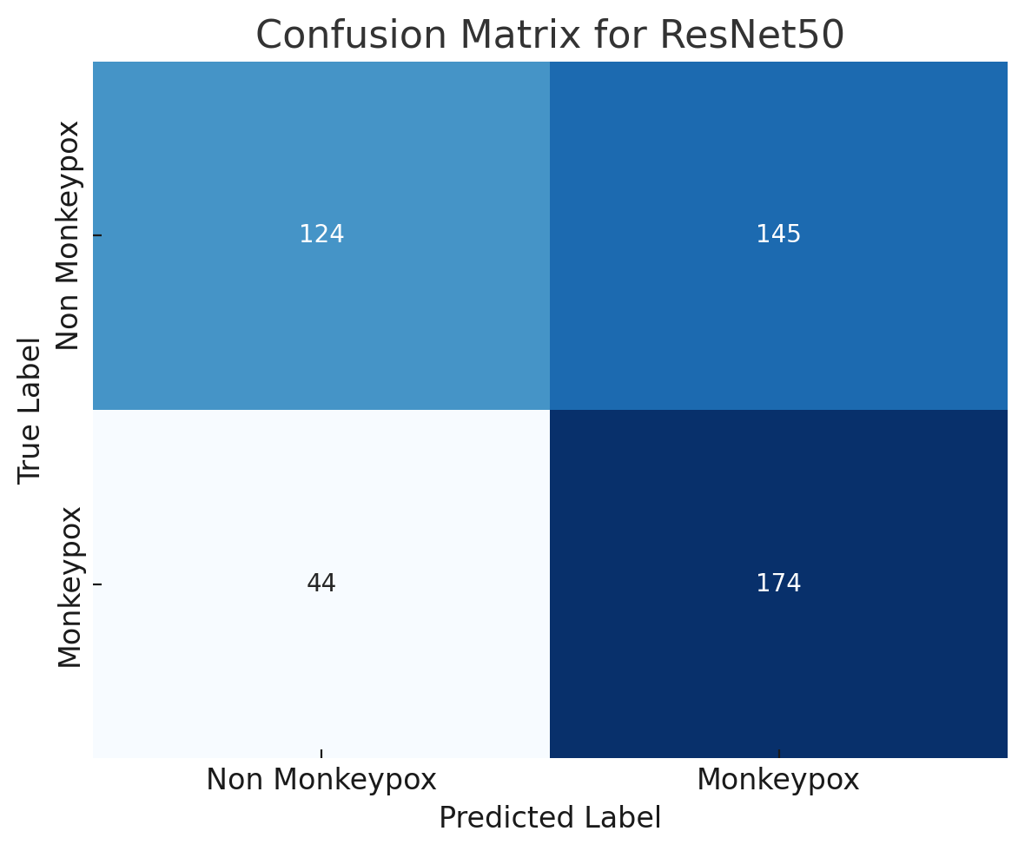 | 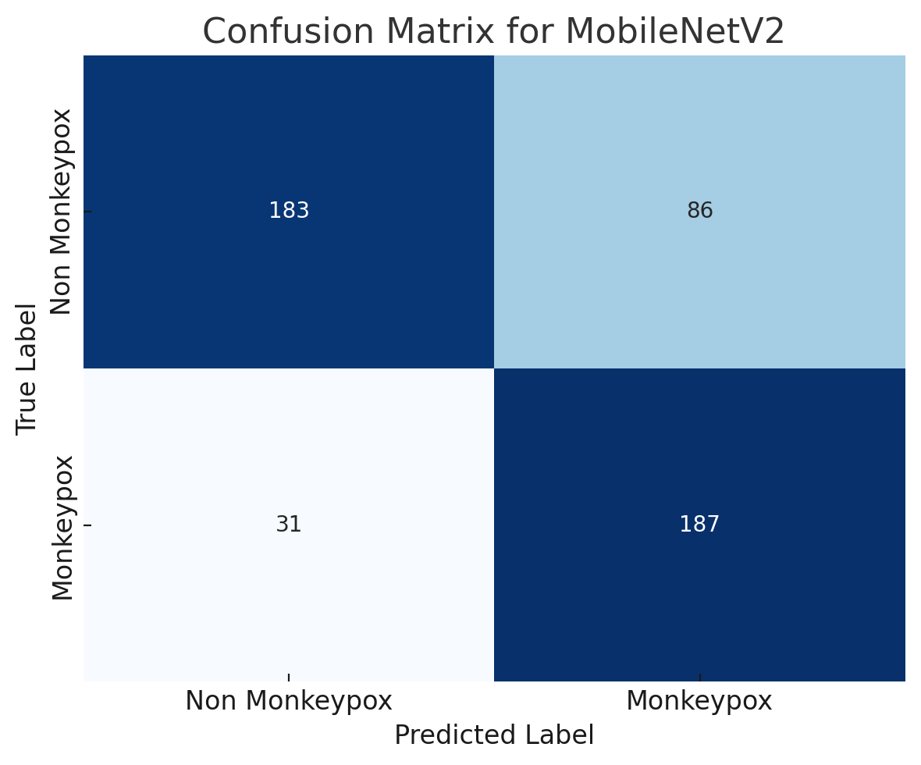

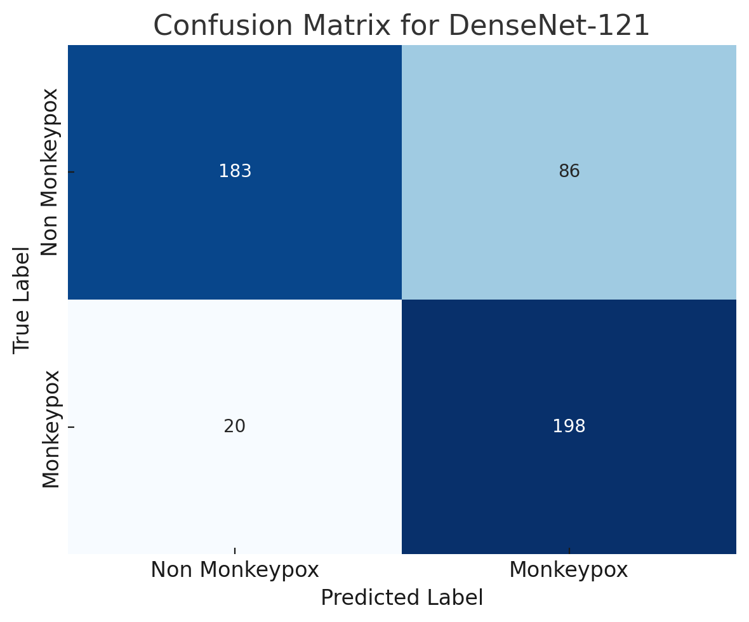 | 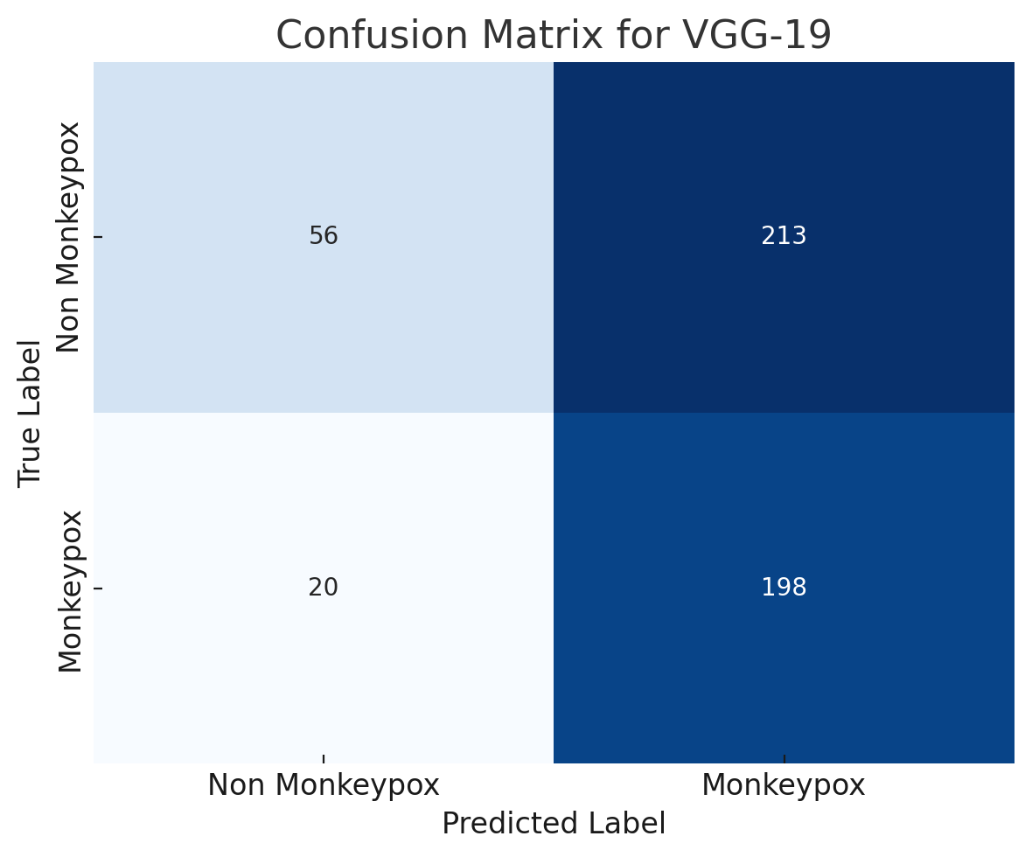

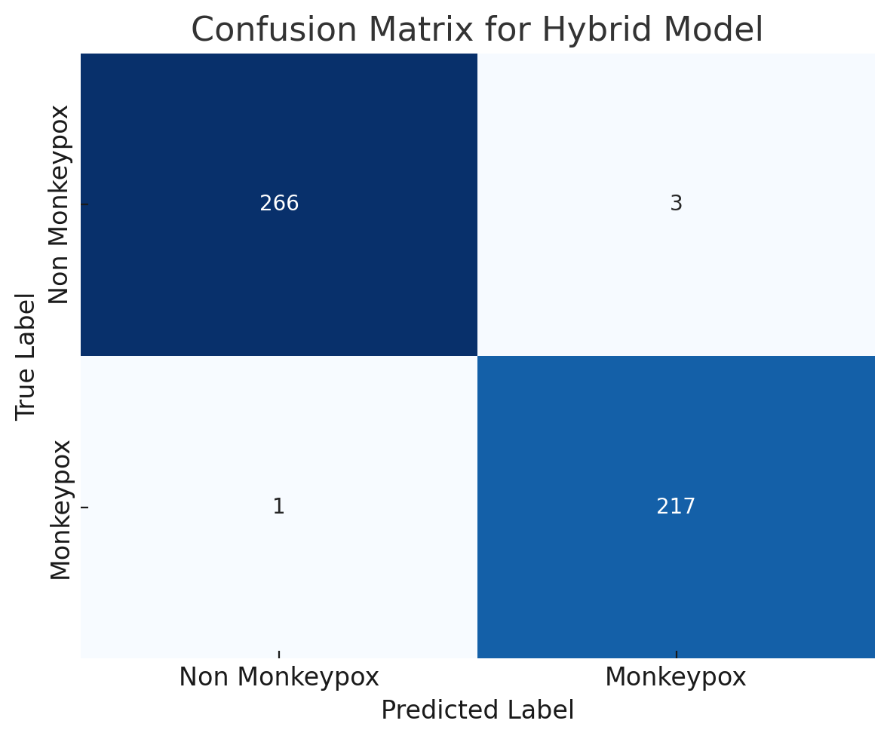
Figure (5): Confusion Matrices of Models for the MSLD Dataset
4.4 Performance Hybrid Model in MSLDV2.0 Dataset
The proposed hybrid model, which combines DenseNet-121 and MobileNetV2, showed excellent classification performance across several illness classes, according to the study done using the MSLDV2.0 dataset. For the Monkeypox class in particular, this model outperformed all other pre-trained convolutional neural networks (CNNs) and transformer-based models with exceptional precision, recall, and F1-scores (99%, 98%, and 99%, respectively). As presented in Table 5, traditional CNN models such as ResNet50, MobileNetV2, and VGG-19 exhibited significantly lower performance, with ResNet50 yielding only a 48% F1-score for Monkeypox. While DenseNet-121 performed better (91% and 93% F1-score for Monkeypox, respectively), the results were still inferior to those of the hybrid approach. Moreover, the hybrid model also recorded high performance for other critical classes, such as Chickenpox (F1-score: 97%) and Measles (F1-score: 95%), indicating its robust generalization ability. These findings highlight the advantage of combining DenseNet's feature reuse with MobileNet's lightweight structure, resulting in a more expressive and efficient architecture for fine-grained classification tasks. The hybrid model's superior metrics highlight how important architectural fusion is to improving model accuracy and dependability for multi-class illness diagnosis in medical imaging.
Table (5): Performance of the Hybrid Model in Each Class for the MSLDV2.0 Dataset

Approach | Model | Class Name | Precision | Recall | F1-score
Pre-trained CNN | ResNet50 | Monkeypox | 65.01 | 51.46 | 48.39
Pre-trained CNN | ResNet50 | Chickenpox | 61.08 | 73.07 | 79.02
Pre-trained CNN | ResNet50 | Measles | 70.01 | 81.19 | 86.01
Pre-trained CNN | ResNet50 | Cowpox | 72.40 | 77.45 | 79.01
Pre-trained CNN | ResNet50 | HFMD | 70.01 | 69.10 | 71.01
Pre-trained CNN | ResNet50 | Healthy | 80.28 | 81.40 | 79.01
Pre-trained CNN | MobileNetV2 | Monkeypox | 81.16 | 83.25 | 85.01
Pre-trained CNN | MobileNetV2 | Chickenpox | 70.50 | 74.28 | 78.15
Pre-trained CNN | MobileNetV2 | Measles | 78.41 | 74.16 | 77.47
Pre-trained CNN | MobileNetV2 | Cowpox | 89.01 | 88.01 | 87.01
Pre-trained CNN | MobileNetV2 | HFMD | 69.14 | 75.42 | 71.24
Pre-trained CNN | MobileNetV2 | Healthy | 77.01 | 75.01 | 71.01
Pre-trained CNN | DenseNet-121 | Monkeypox | 88.22 | 90.12 | 91.36
Pre-trained CNN | DenseNet-121 | Chickenpox | 96.01 | 97.34 | 95.36
Pre-trained CNN | DenseNet-121 | Measles | 91.01 | 89.01 | 94.01
Pre-trained CNN | DenseNet-121 | Cowpox | 91.01 | 88.01 | 86.01
Pre-trained CNN | DenseNet-121 | HFMD | 74.04 | 70.06 | 73.28
Pre-trained CNN | DenseNet-121 | Healthy | 90.16 | 88.01 | 85.01
Pre-trained CNN | VGG-19 | Monkeypox | 62.01 | 60.19 | 66.39
Pre-trained CNN | VGG-19 | Chickenpox | 76.14 | 72.01 | 77.29
Pre-trained CNN | VGG-19 | Measles | 69.39 | 65.01 | 65.32
Pre-trained CNN | VGG-19 | Cowpox | 81.41 | 77.37 | 72.01
Pre-trained CNN | VGG-19 | HFMD | 61.01 | 60.01 | 60.24
Pre-trained CNN | VGG-19 | Healthy | 66.33 | 62.30 | 64.05
The Proposed Hybrid Model | DenseNet-121 and MobileNetV2 | Monkeypox | 99.41 | 98.43 | 99.42
The Proposed Hybrid Model | DenseNet-121 and MobileNetV2 | Chickenpox | 99.05 | 95.04 | 97.36
The Proposed Hybrid Model | DenseNet-121 and MobileNetV2 | Measles | 91.03 | 99.07 | 95.08
The Proposed Hybrid Model | DenseNet-121 and MobileNetV2 | Cowpox | 100 | 98.22 | 99.33
The Proposed Hybrid Model | DenseNet-121 and MobileNetV2 | HFMD | 99.01 | 100 | 99.35
The Proposed Hybrid Model | DenseNet-121 and MobileNetV2 | Healthy | 99.11 | 100 | 99.01

Figure 6 displays six confusion matrices that illustrate the performance of different models when asked to classify data into two groups: Monkeypox and others. In each confusion matrix, the color intensity indicates the number of samples classified into each class; darker colors indicate bigger counts.

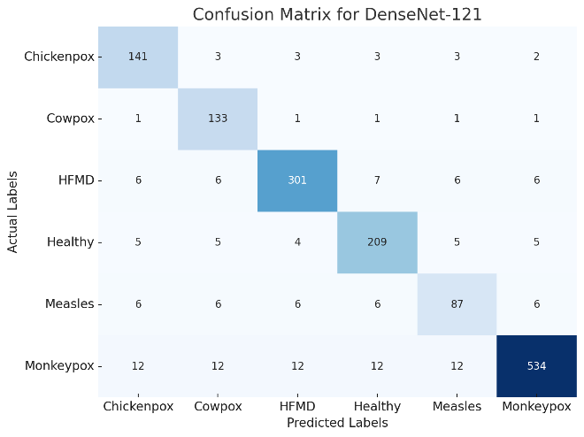 | 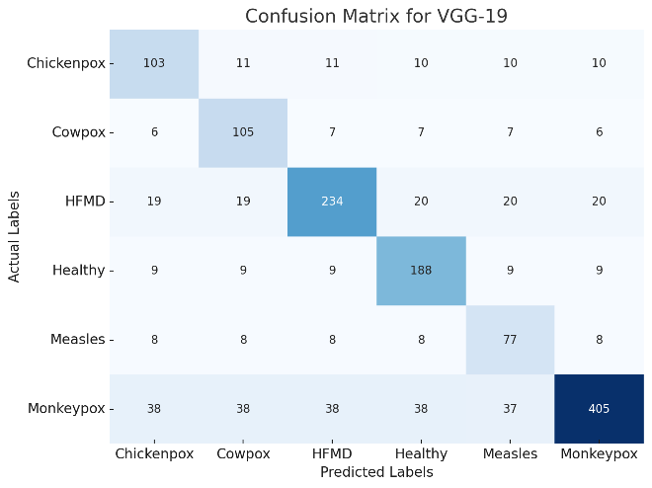

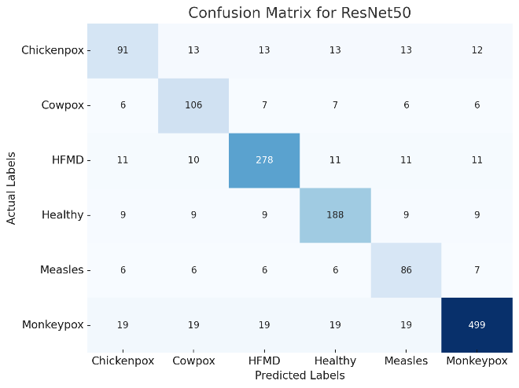 | 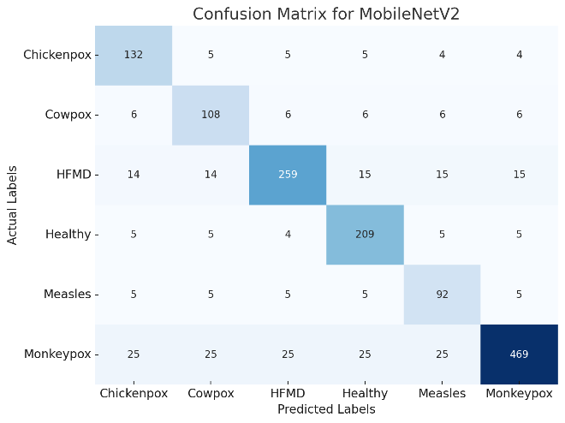

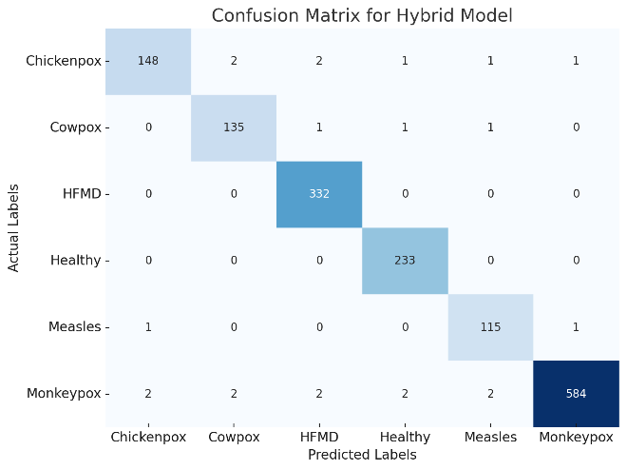

Figure (6): Confusion Matrices of Models for the MSLDV2.0 Dataset
Discussion
The proposed hybrid model, which blends DenseNet-121 and MobileNetV2, performs significantly better than earlier studies on the MSLD and MSLDV2.0 datasets. The hybrid model outperformed all other models described in similar publications, achieving an overall accuracy of 99.18% on the MSLD dataset and 98% on the MSLDV2.0 dataset, as indicated in Table 6. On the MSLD dataset, existing methods such as MpoxSLDNet (Dihan et al., 2024), Inception V3 (Pal et al., 2023a), and MobileNetV2 (Sahin et al., 2022) Reported accuracy values ranging from 91.11% to 94.99%. Moreover, none surpassed the proposed model's 99.18%, indicating the effectiveness of integrating DenseNet's dense feature propagation with MobileNetV2's lightweight efficiency.
Additionally, the results of the MSLDV2.0 dataset support the hybrid model's resilience. Competing approaches, such as an ensemble of 7CNNs (Islam et al., 2022) and (Huan & Dun, 2024), produced significantly lower accuracies of 83% and 87.03%, respectively. Advanced transformer-based techniques, including ViT, MAE, DINO, and SwinTransformer (Vuran et al., 2025), reached only 93.71%. The closest performance came from a Modified VGG16 with LIME (Ahsan et al., 2022), achieving 97%, still falling short of the hybrid model's 98%.
Particularly for complicated, fine-grained classification tasks in medical imaging, the proposed model's outstanding accuracy margins across two dataset versions demonstrate its powerful feature extraction and outstanding generalization capabilities. The model utilizes deep hierarchical representations and computational performance thanks to integrating two complementary architectures. In addition to confirming the efficacy of architectural fusion, these results offer a viable path forward for future deep learning-based disease detection and diagnosis solutions.
Table (6): Comparison with Existing Work and the Proposed Models Based on Models and Performance for the MSLD and MSLDV2.0 Datasets
Ref. | Methods | Accuracy | Dataset
(Dihan et al., 2024) | MpoxSLDNet | 94.56% | MSLD
(Pal et al., 2023a) | Inception V3 | 94.99% | MSLD
(Almutairi, 2022) | DL-MDF-OH2 | 94.99% | MSLD
(Sahin et al., 2022) | MobileNetV2 (TFLite) | 91.11% | MSLD
Proposed Model | Hybrid Model Densenet121 and MobilenetV2 | 99.18% | MSLD
(Islam et al., 2022) | Ensemble of 7 CNNs | 83% | MSLDV2.0
(Ahsan et al., 2022) | Modified VGG16 + LIME | 97% | MSLDV2.0
(Huan & Dun, 2024) | ConvNeXt | 87.03 % | MSLDV2.0
(Vuran et al., 2025) | ViT, MAE, DINO, and SwinTransformer | 93.71% | MSLDV2.0
Proposed Model | Hybrid Model Densenet121 and MobilenetV2 | 98% | MSLDV2.0

Conclusion
This study proposed a hybrid deep learning model that combines DenseNet-121 and MobileNetV2 to improve the detection accuracy of Monkeypox and related diseases using the MSLD and MSLDV2.0 datasets. The experimental findings show that the suggested model routinely achieves higher classification accuracy than current state-of-the-art methods. In particular, the model outperformed earlier benchmarks, including MpoxSLDNet (94.56%) (Dihan et al., 2024), Inception V3 (94.99%) (Pal et al., 2023a), and ensemble-based models (up to 97%) (Ahsan et al., 2022), with 99.18% accuracy on the MSLD dataset and 98% accuracy on the MSLDV2.0 dataset. The combined designs' beneficial features are responsible for the improvements: Performance and computational efficiency are improved by MobileNetV2's lightweight depthwise separable convolutions and DenseNet-121's effective feature reuse through densely connected layers. These results validate the significance of architecture fusion in deep learning, particularly for multi-class medical image classification tasks, where subtle inter-class variations pose considerable challenges. The results demonstrate the hybrid model's scalability, resilience, and diagnostic capacity, which makes it a promising option for practical use in telemedicine and automated illness screening systems.
Given the model's high performance and generalizability, it is recommended that future research focus on deploying this hybrid architecture in clinical environments through user-friendly mobile or web-based platforms. Furthermore, using explainability methods like Grad-CAM or SHAP would improve the interpretability of the model and help doctors validate diagnoses made using AI. The model's dependability and preparedness for widespread implementation in public health systems would be further enhanced by testing it across various demographic groups and growing the dataset with various real-world samples.
References

Ahsan, M. M., Uddin, M. R., Farjana, M., Sakib, A. N., Momin, K. Al, & Luna, S. A. (2022). Image Data collection and implementation of a deep learning-based model in detecting Monkeypox disease using modified VGG16. http://arxiv.org/abs/2206.01862
AKIN, K. D., GURKAN, C., BUDAK, A., & KARATAŞ, H. (2022). Classification of Monkeypox Skin Lesion using the Explainable Artificial Intelligence Assisted Convolutional Neural Networks. European Journal of Science and Technology. https://doi.org/10.31590/ejosat.1171816
Ali, S. N. ; A. M. T. ; P. J. ; J. T. ; S. S. M. S. ; N. N. ; A. A. N. ; H. T. (2022, April 1). Monkeypox Skin Lesion Dataset - Kaggle. https://www.kaggle.com/datasets/nafin59/monkeypox-skin-lesion-dataset
Almutairi, S. A. (2022). DL-MDF-OH2: Optimized Deep Learning-Based Monkeypox Diagnostic Framework Using the Metaheuristic Harris Hawks Optimizer Algorithm. Electronics (Switzerland), 11(24). https://doi.org/10.3390/electronics11244077
Arumugam, M., Arun, G., & Tharun Vikas, S. S. (2024). Detection of Monkeypox Disease Using Deep Learning Techniques. 2024 OPJU International Technology Conference on Smart Computing for Innovation and Advancement in Industry 4.0, OTCON 2024. https://doi.org/10.1109/OTCON60325.2024.10688010
Dihan, F. J., Murad, S. A., Muzahid, A. J. M., Uddin, K. M. A., Alenazi, M. J. F., Bairagi, A. K., & Biswas, S. (2024). MpoxSLDNet: A Novel CNN Model for Detecting Monkeypox Lesions and Performance Comparison with Pre-trained Models. http://arxiv.org/abs/2405.21016
Fleck, A. (2022, April 4). Where Has Monkeypox Spread To? https://www.statista.com/chart/27537/countries-with-monkeypox-cases
Garcea, F. ; S. A. ; L. F. ; M. L. (2023). Data augmentation for medical imaging: A systematic literature review. Computers in Biology and Medicine, 152, 106391–106391.
Howard, A. G., Zhu, M., Chen, B., Kalenichenko, D., Wang, W., Weyand, T., Andreetto, M., & Adam, H. (2017). MobileNets: Efficient Convolutional Neural Networks for Mobile Vision Applications. http://arxiv.org/abs/1704.04861
Huan, E., & Dun, H. (2024). MSMP-Net: A Multi-Scale Neural Network for End-to-End Monkeypox Virus Skin Lesion Classification. Applied Sciences (Switzerland), 14(20). https://doi.org/10.3390/app14209390
Islam, T., Hussain, M. A., Chowdhury, F. U. H., & Islam, B. M. R. (2022). Can Artificial Intelligence Detect Monkeypox from Digital Skin Images? https://doi.org/10.1101/2022.08.08.503193
Jaradat, A. S., Al Mamlook, R. E., Almakayeel, N., Alharbe, N., Almuflih, A. S., Nasayreh, A., Gharaibeh, H., Gharaibeh, M., Gharaibeh, A., & Bzizi, H. (2023). Automated Monkeypox Skin Lesion Detection Using Deep Learning and Transfer Learning Techniques. In International Journal of Environmental Research and Public Health (Vol. 20, Issue 5). MDPI. https://doi.org/10.3390/ijerph20054422
Joydip Paul. (2023, April 1). Mpox Skin Lesion Dataset Version 2.0 (MSLD v2.0). https://www.kaggle.com/datasets/joydippaul/mpox-skin-lesion-dataset-version-20-msld-v20?resource=download
Kumar, B. N., Mahesh, T. R., Geetha, G., & Guluwadi, S. (2023). Redefining Retinal Lesion Segmentation: A Quantum Leap with DL-UNet Enhanced Auto Encoder-Decoder for Fundus Image Analysis. IEEE Access, 11, 70853–70864. https://doi.org/10.1109/ACCESS.2023.3294443
Pal, S., Mishra, A. K., & Kriti. (2023a). Artificial Intelligence-Based Framework for Predicting Monkeypox Disease. 2023 International Conference on Computer Science and Emerging Technologies, CSET 2023. https://doi.org/10.1109/CSET58993.2023.10346841
Pal, S., Mishra, A. K., & Kriti. (2023b). Artificial Intelligence-Based Framework for Predicting Monkeypox Disease. 2023 International Conference on Computer Science and Emerging Technologies, CSET 2023. https://doi.org/10.1109/CSET58993.2023.10346841
Sahin, V. H., Oztel, I., & Yolcu Oztel, G. (2022). Human Monkeypox Classification from Skin Lesion Images with Deep Pre-trained Network using Mobile Application. Journal of Medical Systems, 46(11). https://doi.org/10.1007/s10916-022-01863-7
Sandler, M., Howard, A., Zhu, M., Zhmoginov, A., & Chen, L.-C. (2018). MobileNetV2: Inverted Residuals and Linear Bottlenecks. http://arxiv.org/abs/1801.04381
Sehgal, D., & Saini, I. (2024). GAN-Based Image Augmentation and Comparative Analysis of Various CNN Models for Monkeypox Detection. Proceedings - 1st International Conference on Electronics, Communication and Signal Processing, ICECSP 2024. https://doi.org/10.1109/ICECSP61809.2024.10697992
Shashikala, S. V., Anil Kumar, K. T., & Chaithra, K. N. (2024a). Deep Learning Solutions for Enhanced Detection of Skin Lesions. 2nd IEEE International Conference on Networks, Multimedia and Information Technology, NMITCON 2024. https://doi.org/10.1109/NMITCON62075.2024.10699030
Shashikala, S. V., Anil Kumar, K. T., & Chaithra, K. N. (2024b). Deep Learning Solutions for Enhanced Detection of Skin Lesions. 2nd IEEE International Conference on Networks, Multimedia and Information Technology, NMITCON 2024. https://doi.org/10.1109/NMITCON62075.2024.10699030
Sitaula, C. ; S. T. B. (2022). Monkeypox Virus Detection Using Pre-trained Deep Learning-based Approaches. Journal of Medical Systems, 46(11).
Sitaula, C., & Shahi, T. B. (2022). Monkeypox virus detection using pre-trained deep learning-based approaches. https://doi.org/10.1007/s10916-022-01868-2
Vuran, S., Ucan, M., Akin, M., & Kaya, M. (2025). Multi-Classification of Skin Lesion Images Including Mpox Disease Using Transformer-Based Deep Learning Architectures. Diagnostics, 15(3). https://doi.org/10.3390/diagnostics15030374
World Health Organization. (2025, April 1). Mpox (Monkeypox). 2022. https://www.who.int/news-room/fact-sheets/detail/mpox

