Midocean Journal Reviewer Notes
Design and Implementation of an Intelligent AI Chatbot with an Integrated Product Recommendation System for E-Commerce Platforms

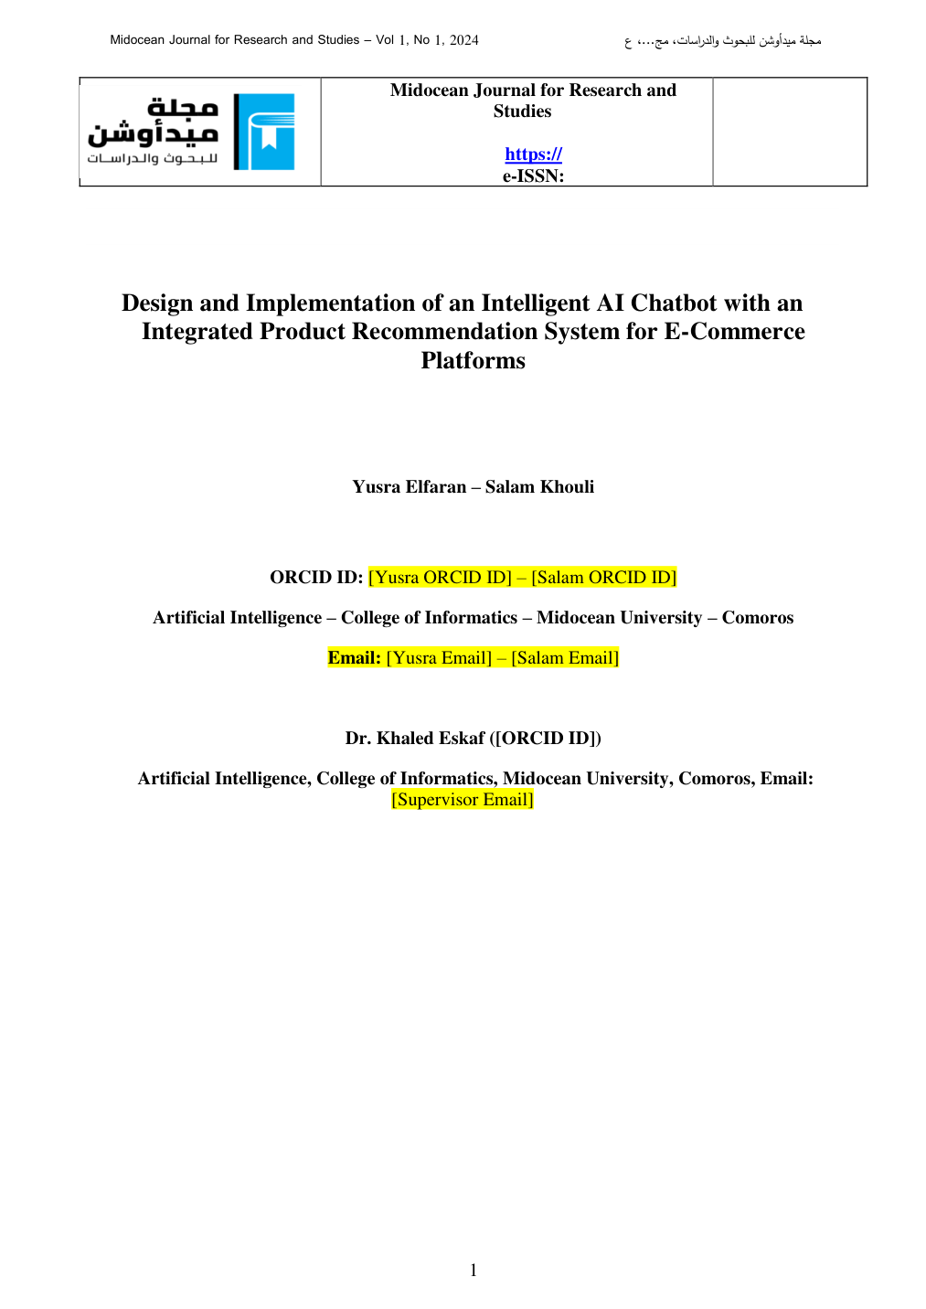 | Reviewer Notes - Page 1  1. Correction: Complete all placeholder metadata before publication: journal URL/e-ISSN, both students' ORCID IDs, both student emails, Dr. Khaled Eskaf's ORCID ID, and supervisor email.  Dr. Khaled Eskaf  khaledeskaf@midocean.edu.km

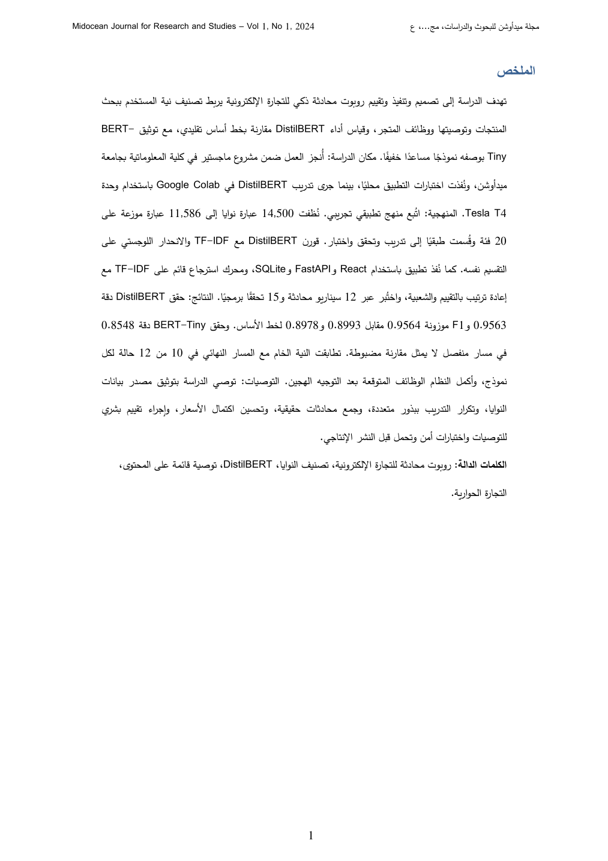 | Reviewer Notes - Page 2  1. Correction: The Arabic abstract is generally strong, but it needs final proofreading to fix spacing, punctuation, and broken Arabic word forms caused by PDF/formatting conversion.  2. Reviewer Comment: Please ensure consistency between the Arabic abstract and the English abstract, especially the exact values of dataset size, GPU type, model accuracy, F1-score, and number of verification scenarios.  3. Correction: Use one consistent Arabic translation for key terms such as intent classification, baseline, reranking, and conversational commerce.

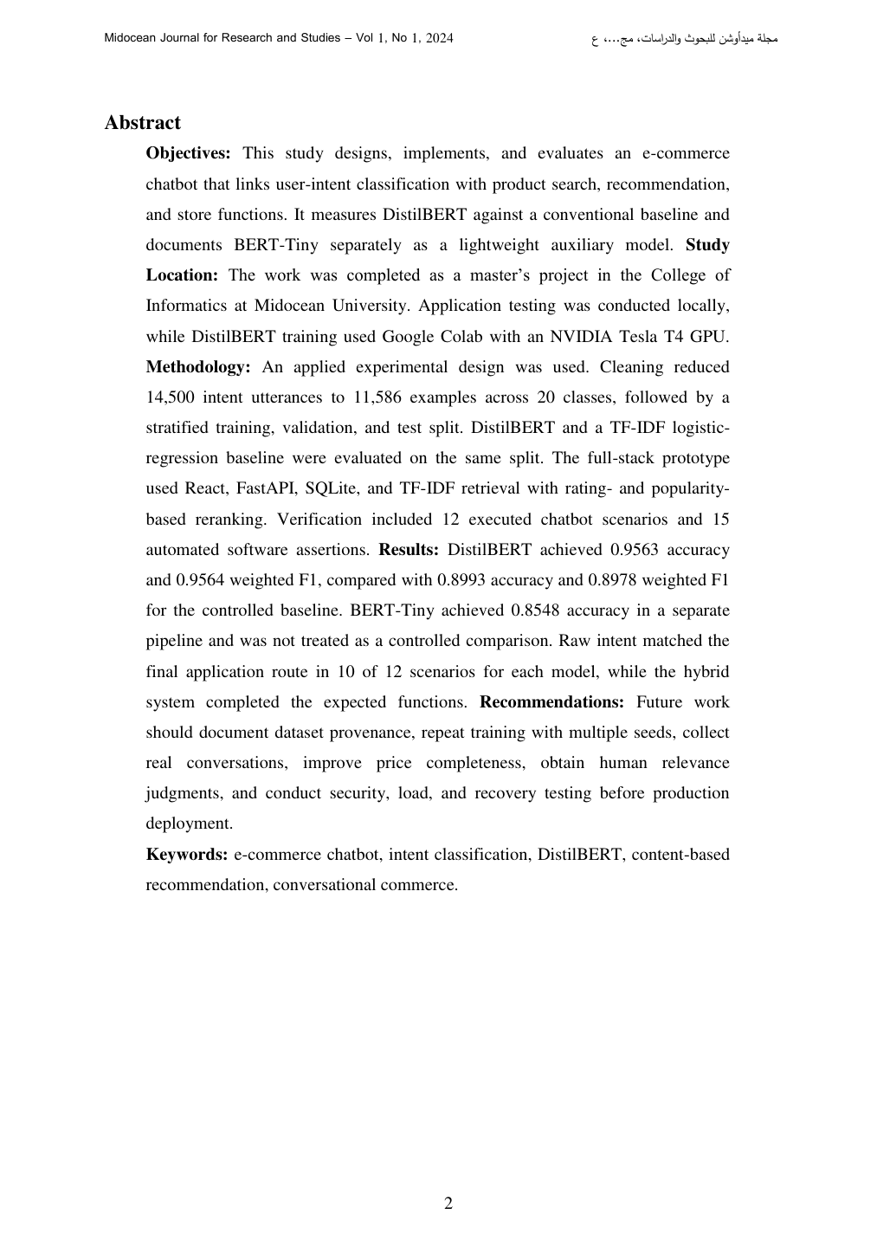 | Reviewer Notes - Page 3  1. Reviewer Comment: The English abstract is well structured (objectives, location, methodology, results, recommendations). Please keep this structure, but reduce length slightly if required by the journal template.  2. Correction: Replace 'BERT-Tiny' and 'DistilBERT' formatting consistently across the manuscript. Use the same hyphenation and capitalization in title, abstract, tables, and results.  3. Reviewer Comment: Add one sentence in the abstract clarifying that the recommendation evaluation used proxy diagnostics only, not human relevance judgments or real user interaction logs.

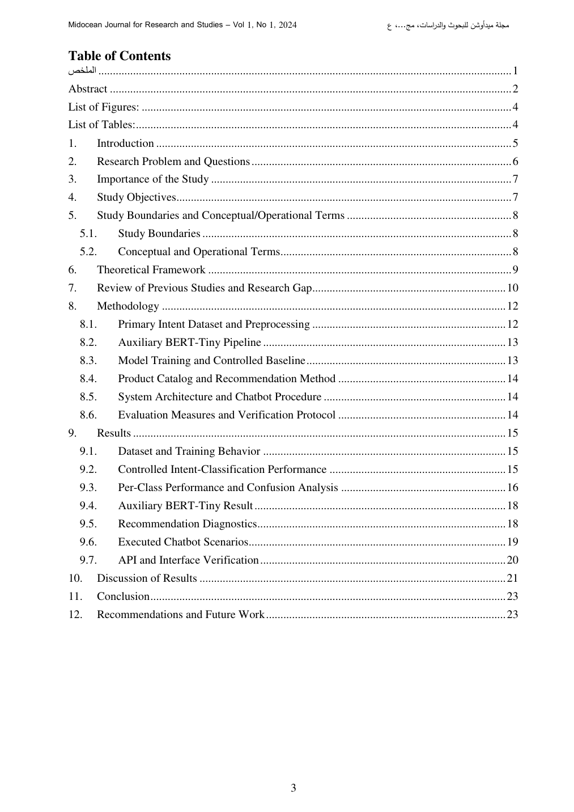 | Reviewer Notes - Page 4  1. Correction: A table of contents is not normally required in a journal article unless specifically requested by MidOcean Journal. Please confirm journal requirements; otherwise remove it for the final article version.  2. Reviewer Comment: If the TOC is retained, ensure page numbers update correctly after final editing and after adding the missing metadata and references.

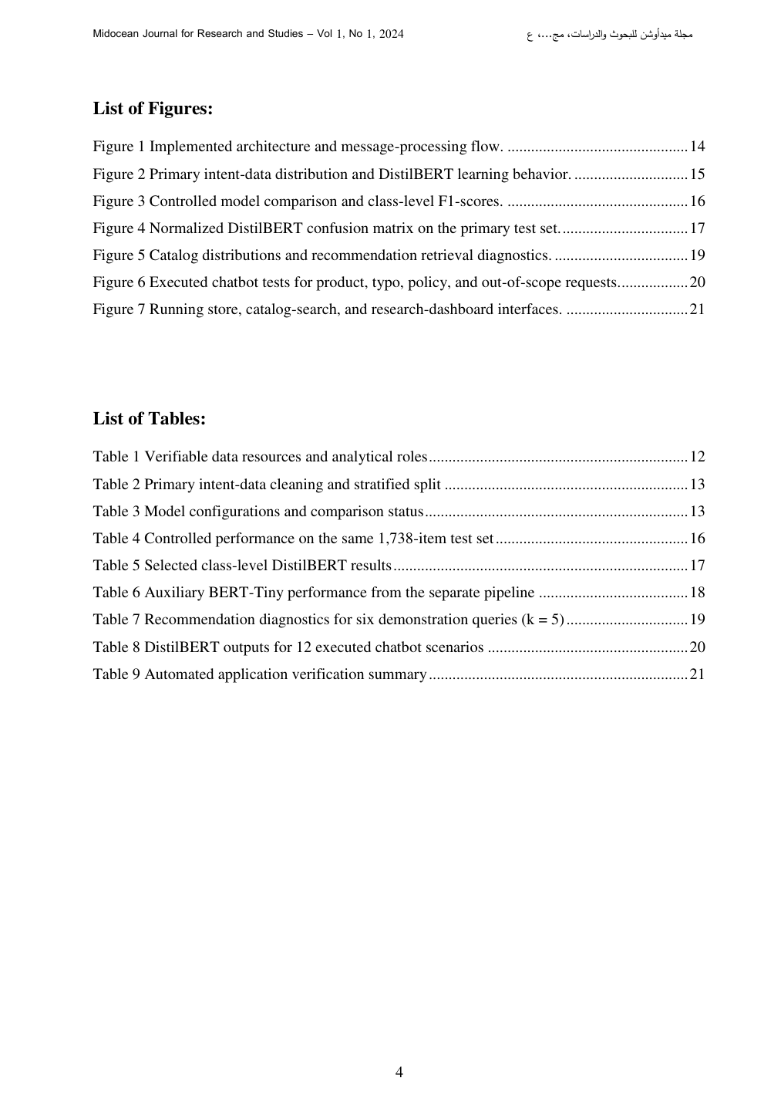 | Reviewer Notes - Page 5  1. Correction: The lists of figures and tables are useful for a thesis-style document, but may be unnecessary for a journal article. Please confirm MidOcean formatting requirements.  2. Reviewer Comment: Figure and table titles are informative. Maintain sequential numbering after any additions or deletions.

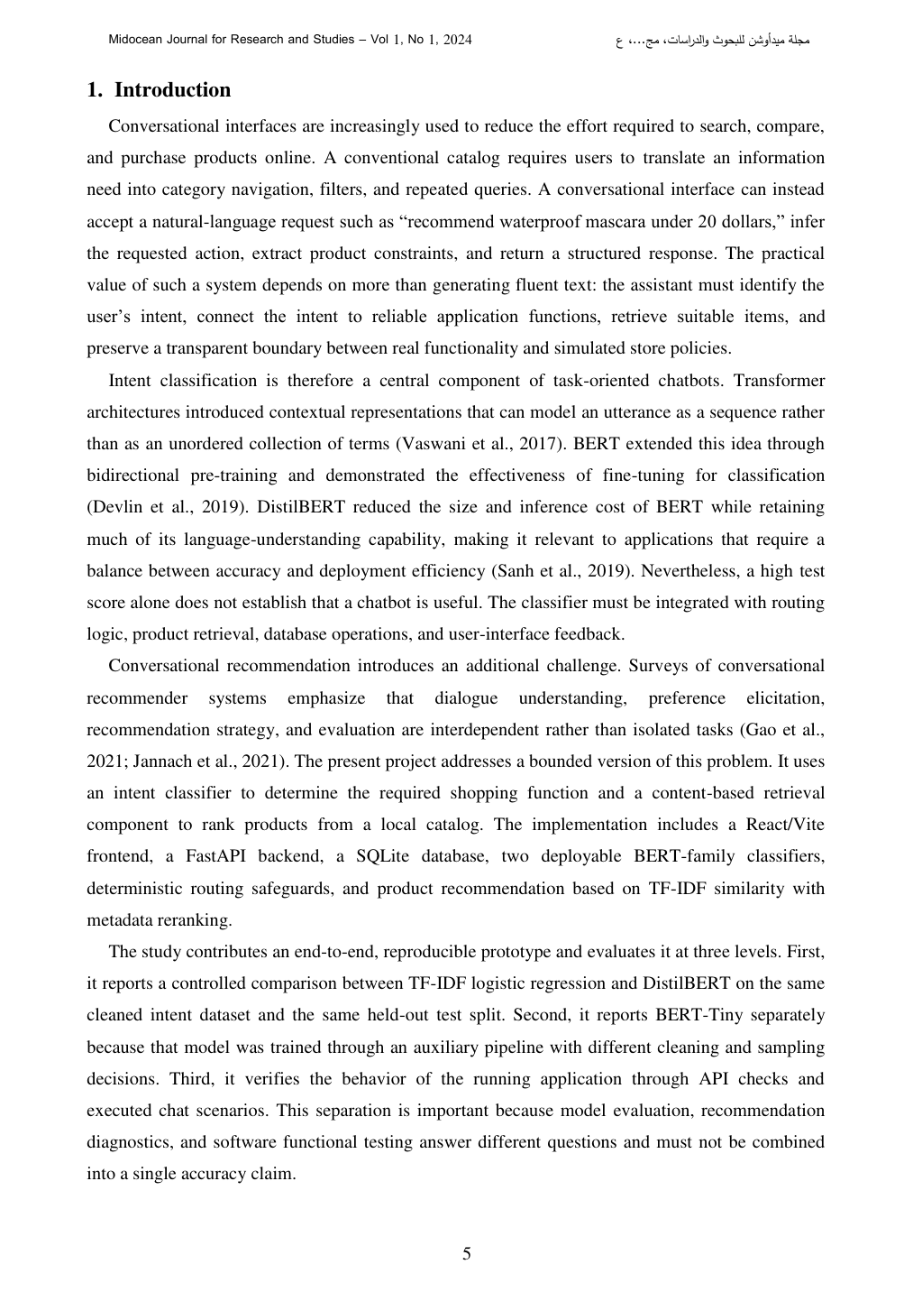  [ADD IN INTRODUCTION - RED IN-TEXT CITATION]  Previous applied chatbot work by Mohamed, Badawy, Eskaf, and Zaghloul [15] demonstrates that domain-specific virtual assistants require an explicit knowledge structure, interaction interface, and response-routing mechanism. This supports the present study's design choice to connect learned intent classification with deterministic routing and application functions rather than evaluating the chatbot as a standalone text classifier. | Reviewer Notes - Page 6  1. Reviewer Comment: The Introduction is professional and well connected to task-oriented chatbots and conversational recommendation. Add a short statement on the practical risk of confusing classifier accuracy with real application behavior.  2. Inserted in-text citation: Add the red citation sentence shown on the left side of this review page inside the Introduction after the paragraph describing the implemented architecture.  3. Reference note: Add Mohamed, Badawy, Eskaf, and Zaghloul (2020) to the references list as a relevant Khaled Eskaf chatbot paper.

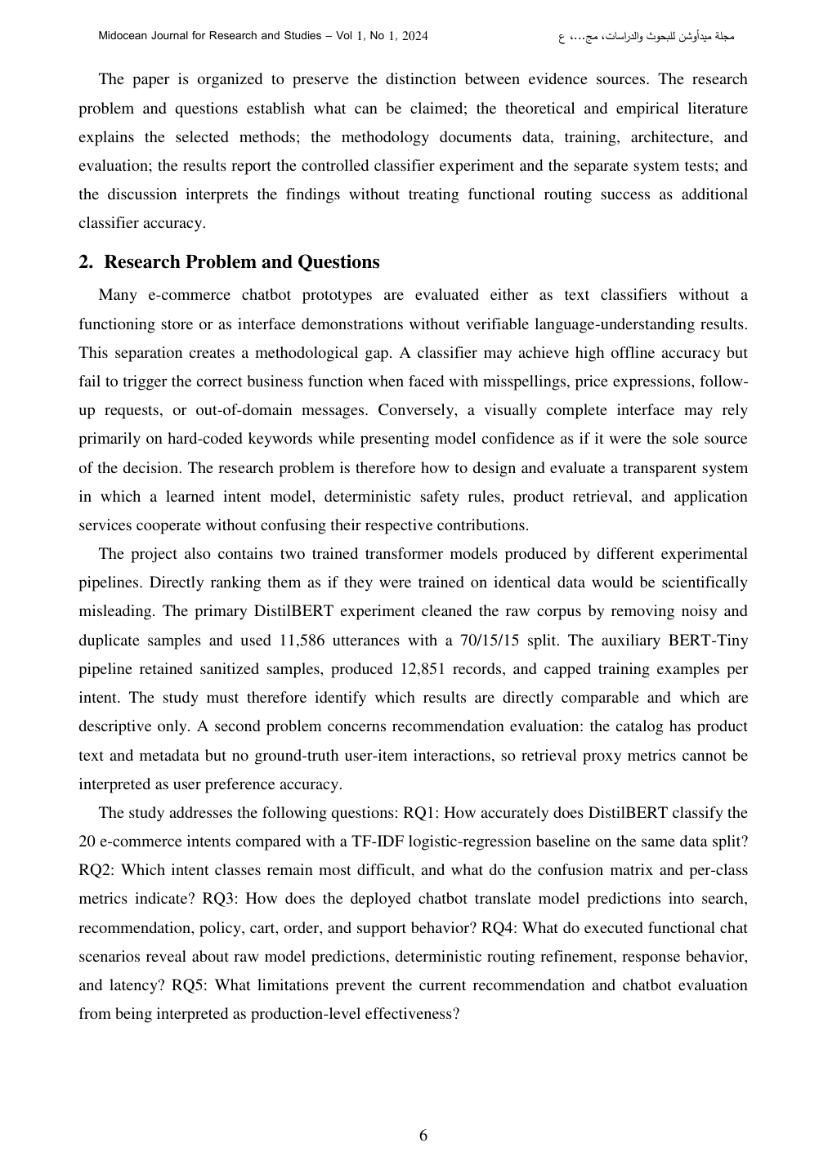 | Reviewer Notes - Page 7  1. Reviewer Comment: The research problem is clearly defined and shows strong methodological awareness. This section correctly separates model accuracy, application routing, and recommendation evaluation.  2. Correction: Consider presenting RQ1-RQ5 as a numbered list for easier readability in the journal format.

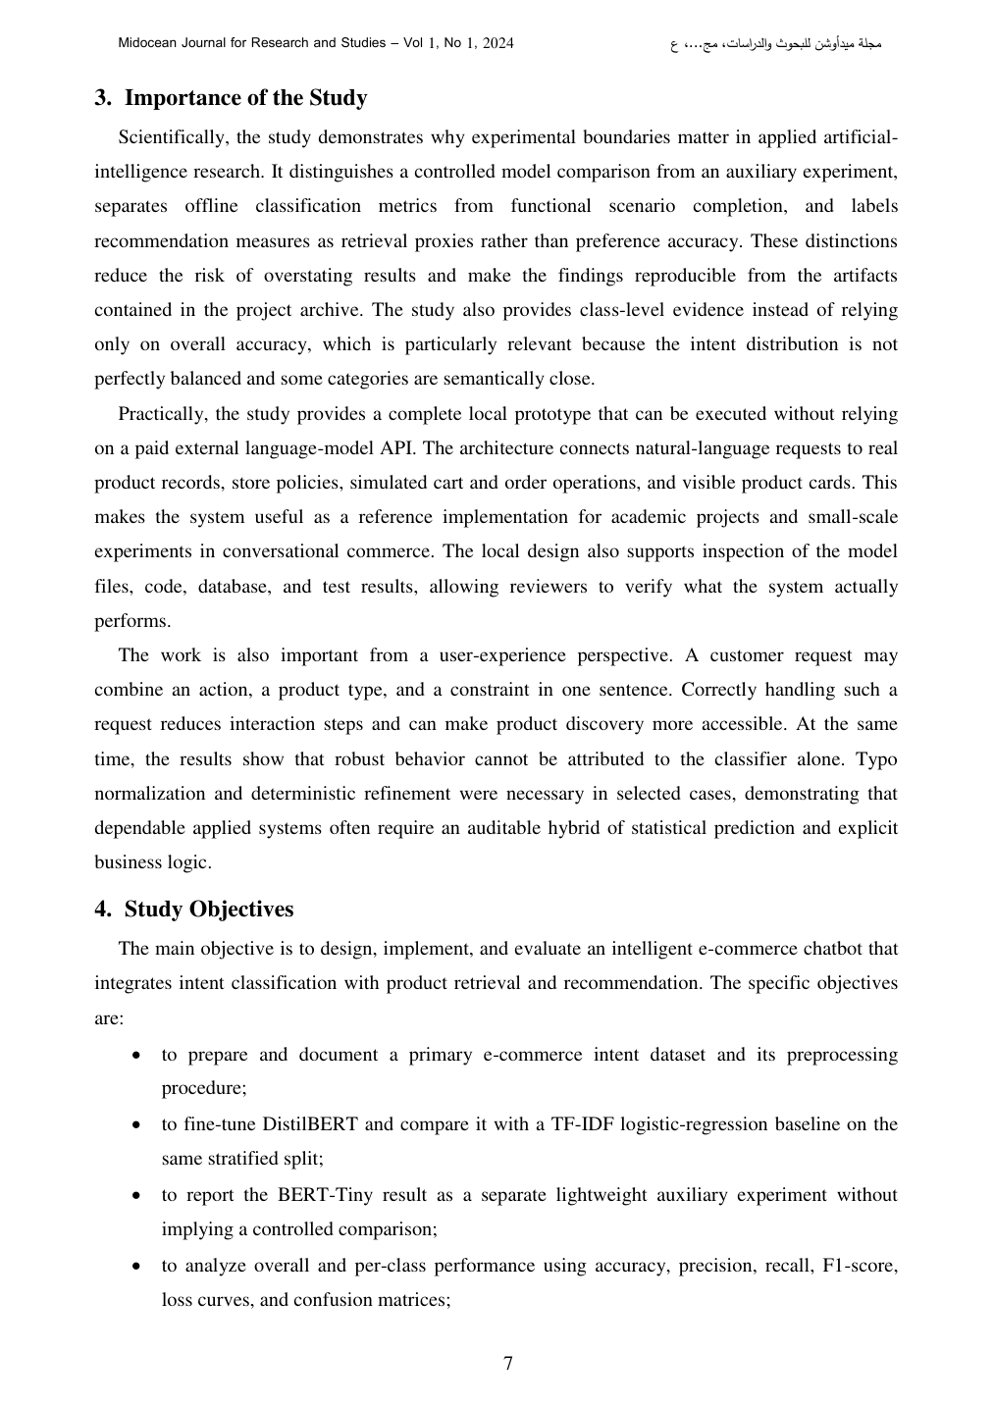 | Reviewer Notes - Page 8  1. Reviewer Comment: The Importance of the Study and Study Objectives are strong. The paper clearly distinguishes scientific contribution from prototype implementation.  2. Correction: In the objectives, ensure every objective is later addressed explicitly in the Results or Discussion section.

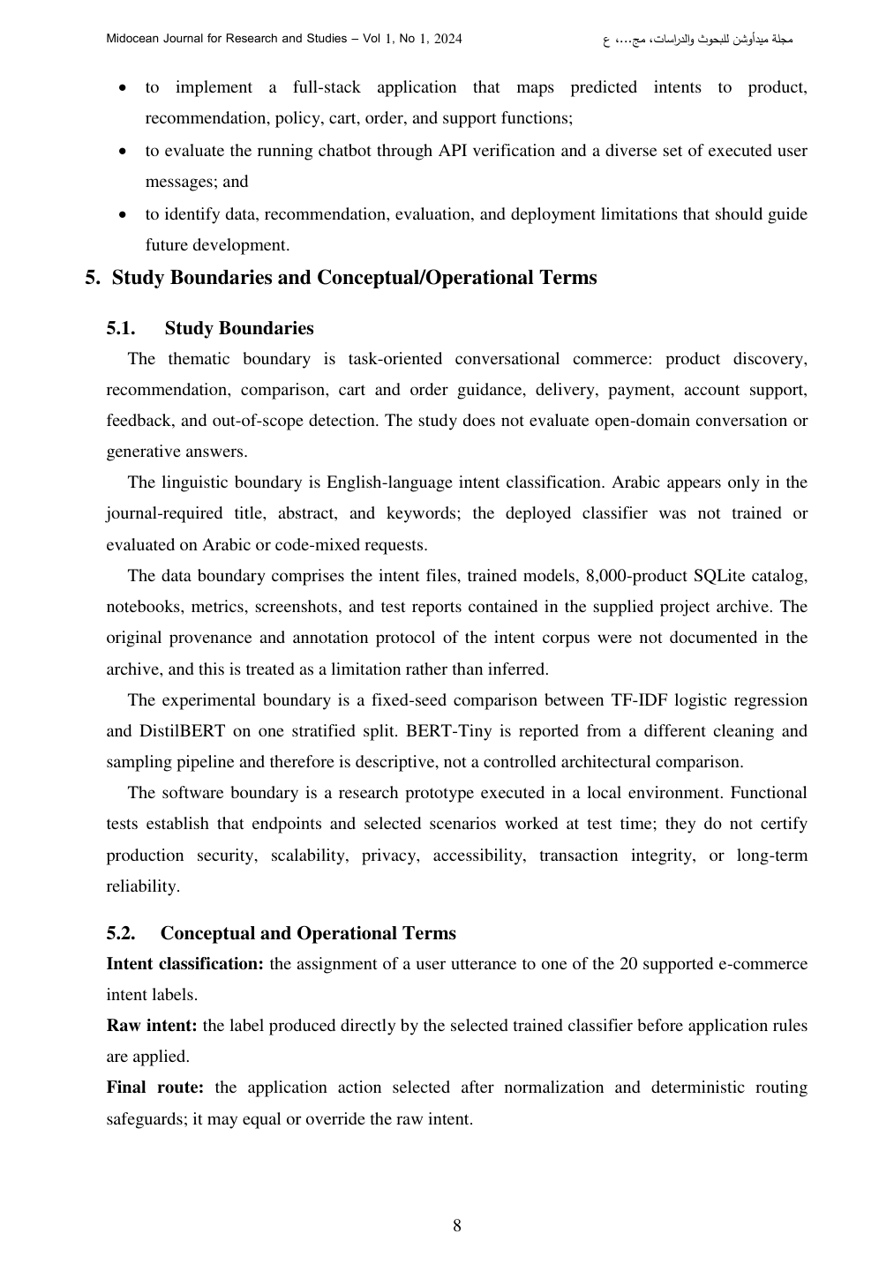 | Reviewer Notes - Page 9  1. Reviewer Comment: The study boundaries and operational terms are a major strength. They prevent overclaiming and improve reproducibility.  2. Correction: Consider adding a brief ethical/privacy note because the prototype handles e-commerce-like user requests, model confidence, and user interaction data.

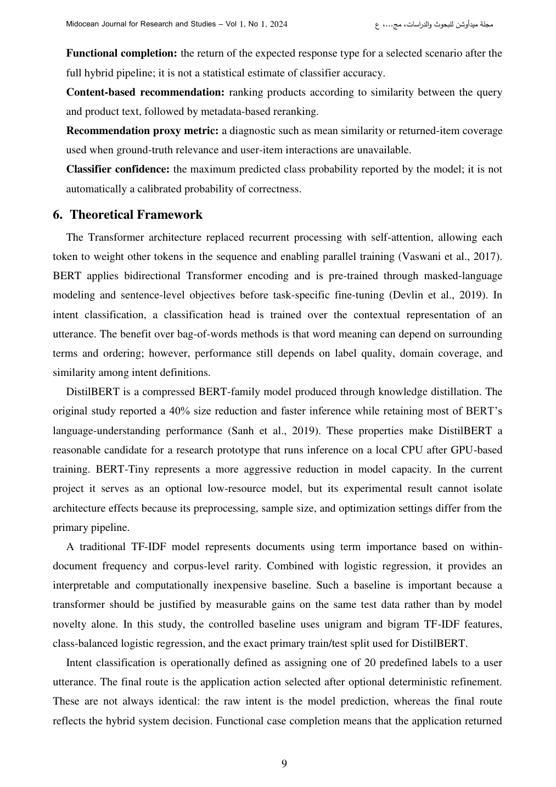  [ADD IN THEORETICAL FRAMEWORK - RED IN-TEXT CITATION]  Aly, Eskaf, and Selim [16] also show the value of intelligent expert-system design in decision-support applications, where rule-based reasoning and structured knowledge help translate user inputs into actionable recommendations. This supports the present study's use of transparent routing safeguards alongside statistical intent prediction. | Reviewer Notes - Page 10  1. Reviewer Comment: The theoretical framework is relevant. The explanation of DistilBERT, BERT-Tiny, TF-IDF, and routing is clear and appropriate for the paper.  2. Inserted in-text citation: Add the red citation sentence shown on the left side of this review page inside the Theoretical Framework where expert/AI assistant systems and routing logic are discussed.  3. Reference note: Add Aly, Eskaf, and Selim (2017) to support intelligent expert-system design and rule-based decision logic.

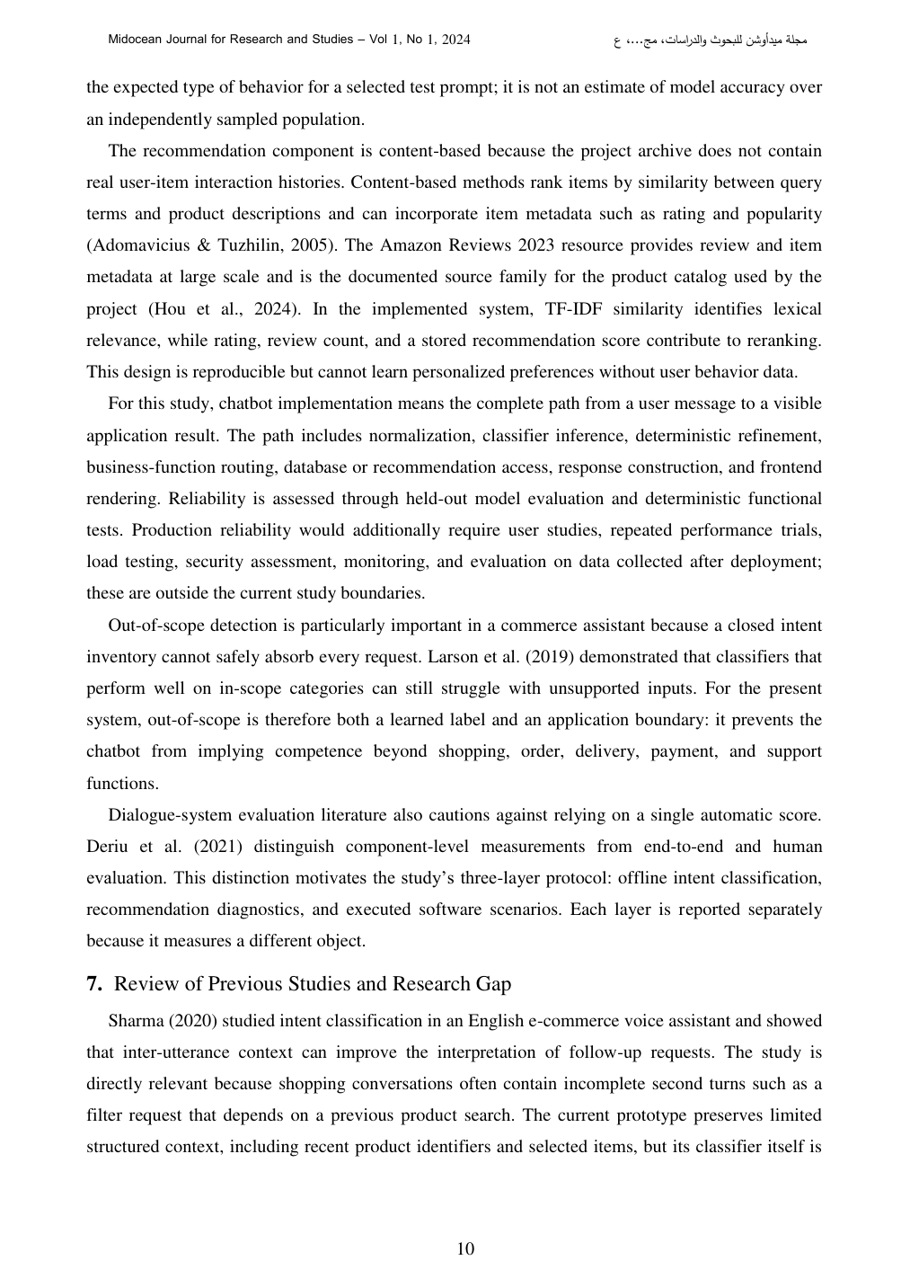 | Reviewer Notes - Page 11  1. Reviewer Comment: The section correctly states that the system is content-based and cannot learn personalized preferences without user behavior data. This limitation should also appear in the abstract and conclusion.  2. Correction: Ensure Adomavicius & Tuzhilin (2005), Hou et al. (2024), and other sources are consistently formatted in the reference list.

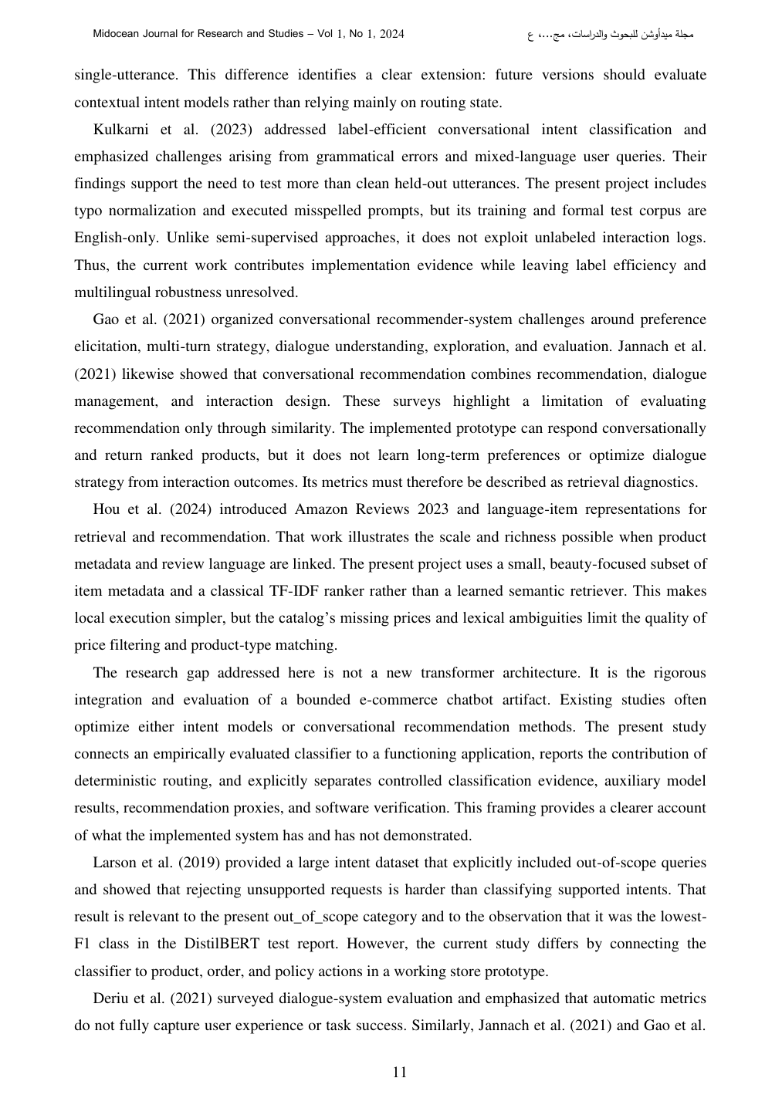  [ADD AT END OF RESEARCH GAP - RED IN-TEXT CITATION]  The present study extends this applied direction by combining chatbot-routing principles reflected in Mohamed et al. [15] with structured decision-support logic consistent with Aly et al. [16], while applying them to the e-commerce chatbot and recommendation context. | Reviewer Notes - Page 12  1. Reviewer Comment: The related-work review is well focused and avoids unnecessary textbook explanation. The research gap is clearly positioned as integration and auditable evaluation rather than a new transformer architecture.  2. Inserted in-text citation: Add the red citation sentence shown on the left side of this review page at the end of the research-gap paragraph.  3. Correction: Do not cite the Smartphone Recommendation System paper as a Khaled Eskaf reference unless authorship is independently verified; the verified Eskaf CCECE 2017 paper is Fuzzy Mobile Expert System for Academic Advising.

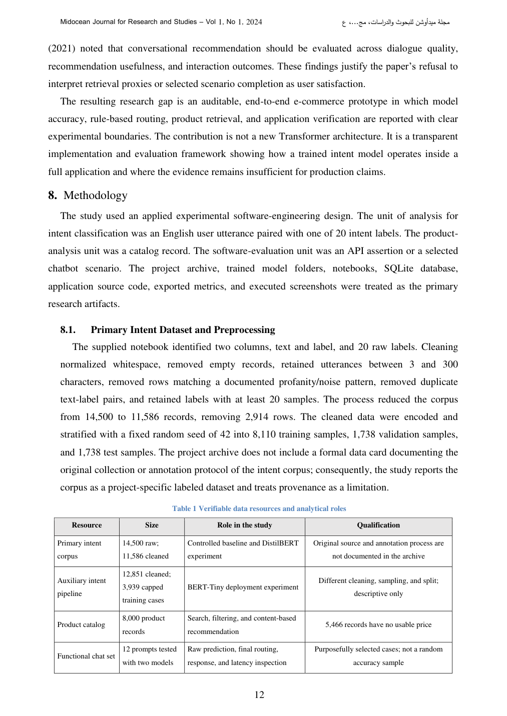 | Reviewer Notes - Page 13  1. Reviewer Comment: The methodology is strong and unusually transparent. It documents artifact boundaries, dataset cleaning, and the limits of provenance very clearly.  2. Correction: Table 1 is valuable, but the formatting should be checked after final conversion to make sure all columns fit neatly in the journal template.

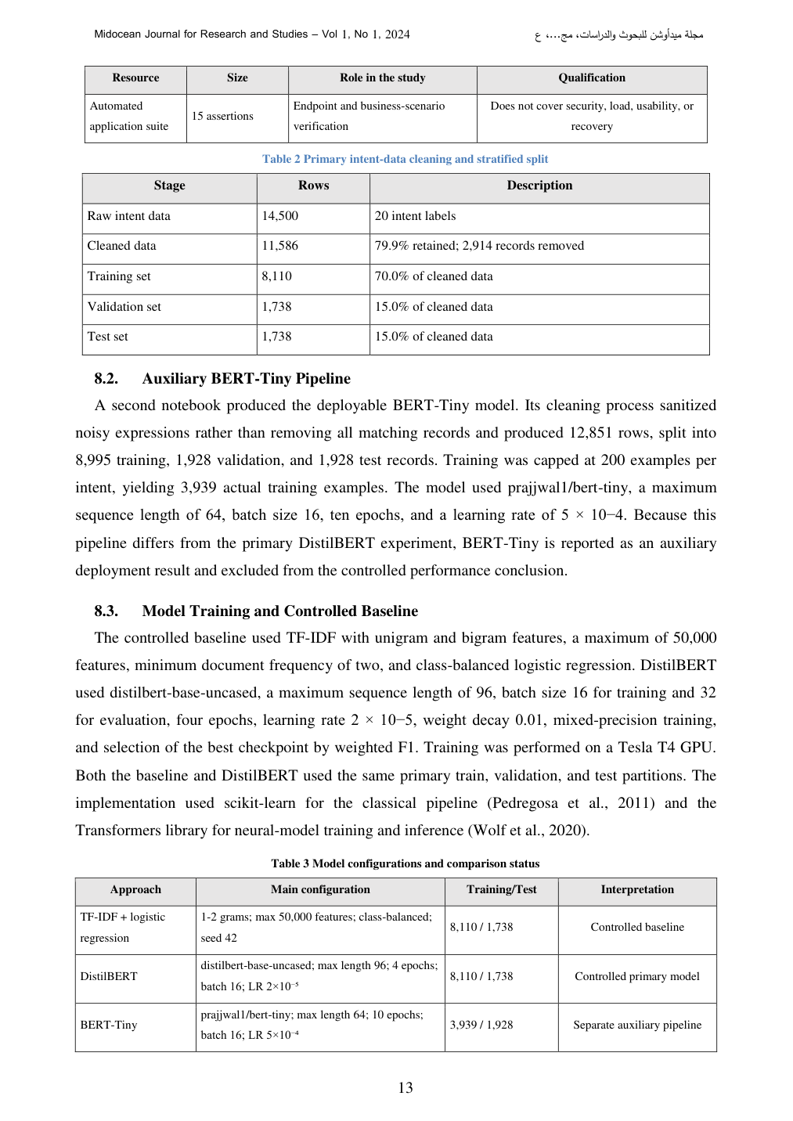 | Reviewer Notes - Page 14  1. Reviewer Comment: The separation between DistilBERT and BERT-Tiny is scientifically correct. The paper should preserve this distinction and avoid language implying a controlled architecture comparison.  2. Correction: Confirm the random seed, exact library versions, and whether the training notebooks and model files can be archived or linked for reproducibility.

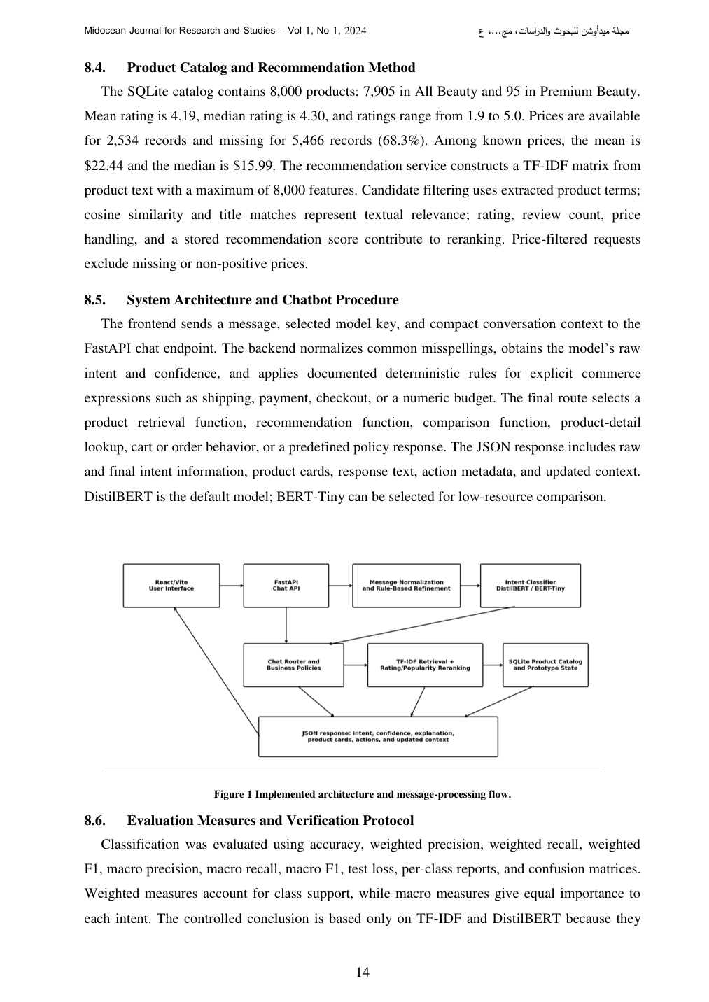  [ADD IN PRODUCT CATALOG / RECOMMENDATION METHOD - RED IN-TEXT CITATION]  The use of structured records and explicit decision logic for recommendation and support functions is consistent with prior Eskaf-related work on intelligent assistant and expert-system applications [15], [16]. | Reviewer Notes - Page 15  1. Reviewer Comment: The recommendation method is clear, but it remains a content-based retrieval prototype. Please avoid calling it a personalized recommender unless user-item histories or preference feedback are included.  2. Inserted in-text citation: Add the red sentence shown on the left side of this page where the paper discusses routing, product metadata, and decision support.  3. Correction: Figure 1 is readable, but confirm that it is in high resolution and that all arrows and labels remain clear in the final journal PDF.

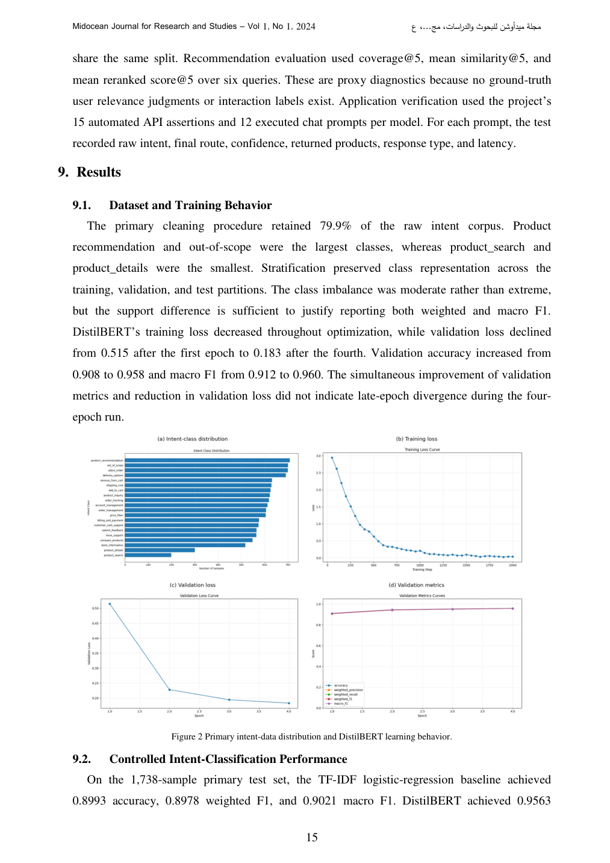 | Reviewer Notes - Page 16  1. Reviewer Comment: The evaluation protocol is one of the strongest parts of the paper. It correctly distinguishes weighted metrics, macro metrics, recommendation proxies, and functional scenario checks.  2. Correction: For Figure 2, enlarge labels in the class distribution and learning curves so they remain readable after journal formatting.

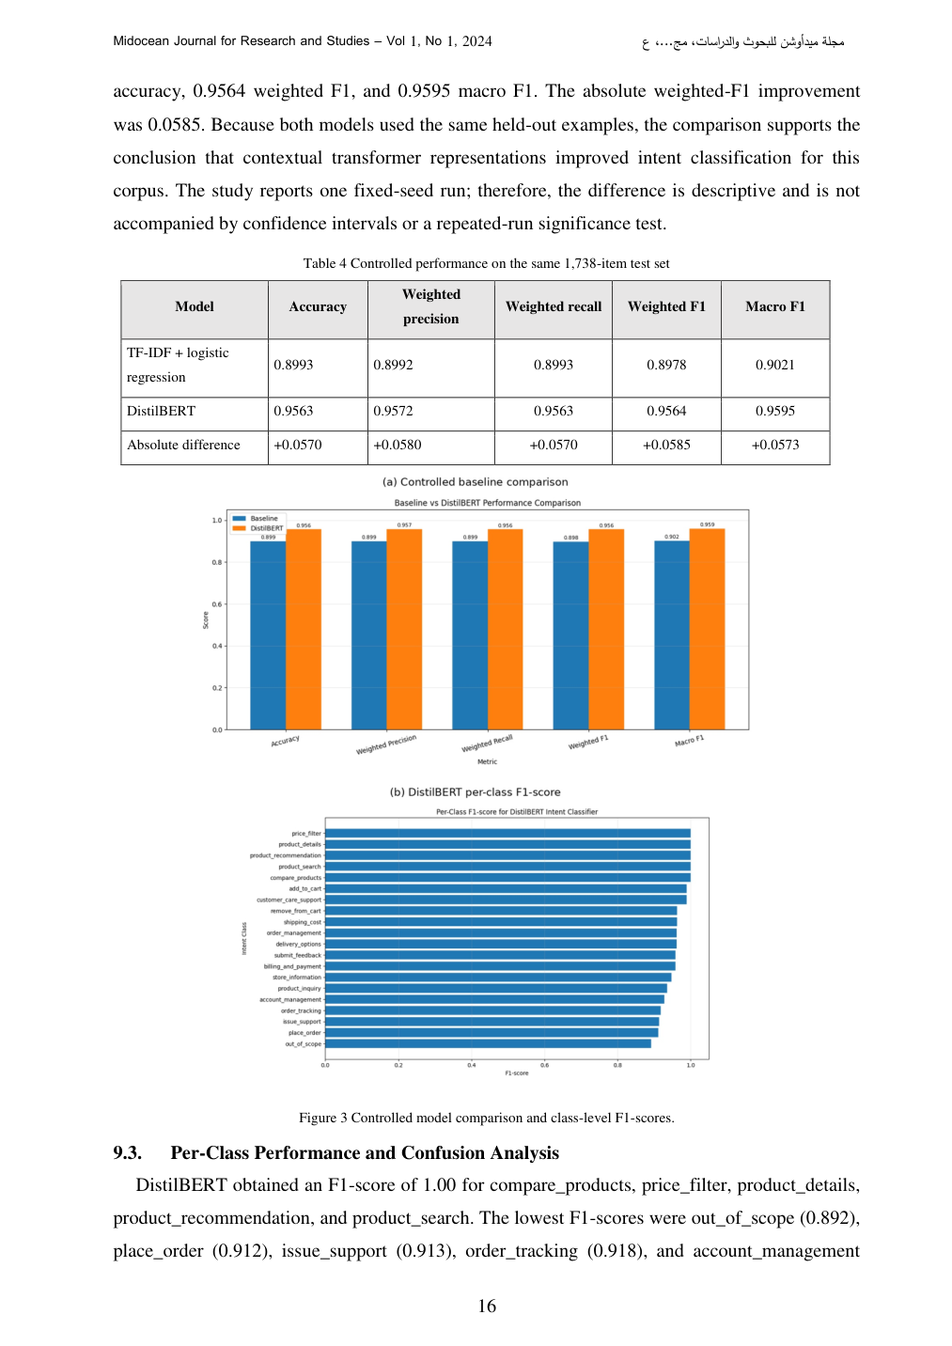 | Reviewer Notes - Page 17  1. Reviewer Comment: The controlled performance comparison is strong. The reported absolute weighted-F1 improvement of 0.0585 is clear and scientifically useful.  2. Correction: Because the experiment uses one fixed seed, keep the limitation about no confidence intervals or repeated-run significance testing. This improves credibility.

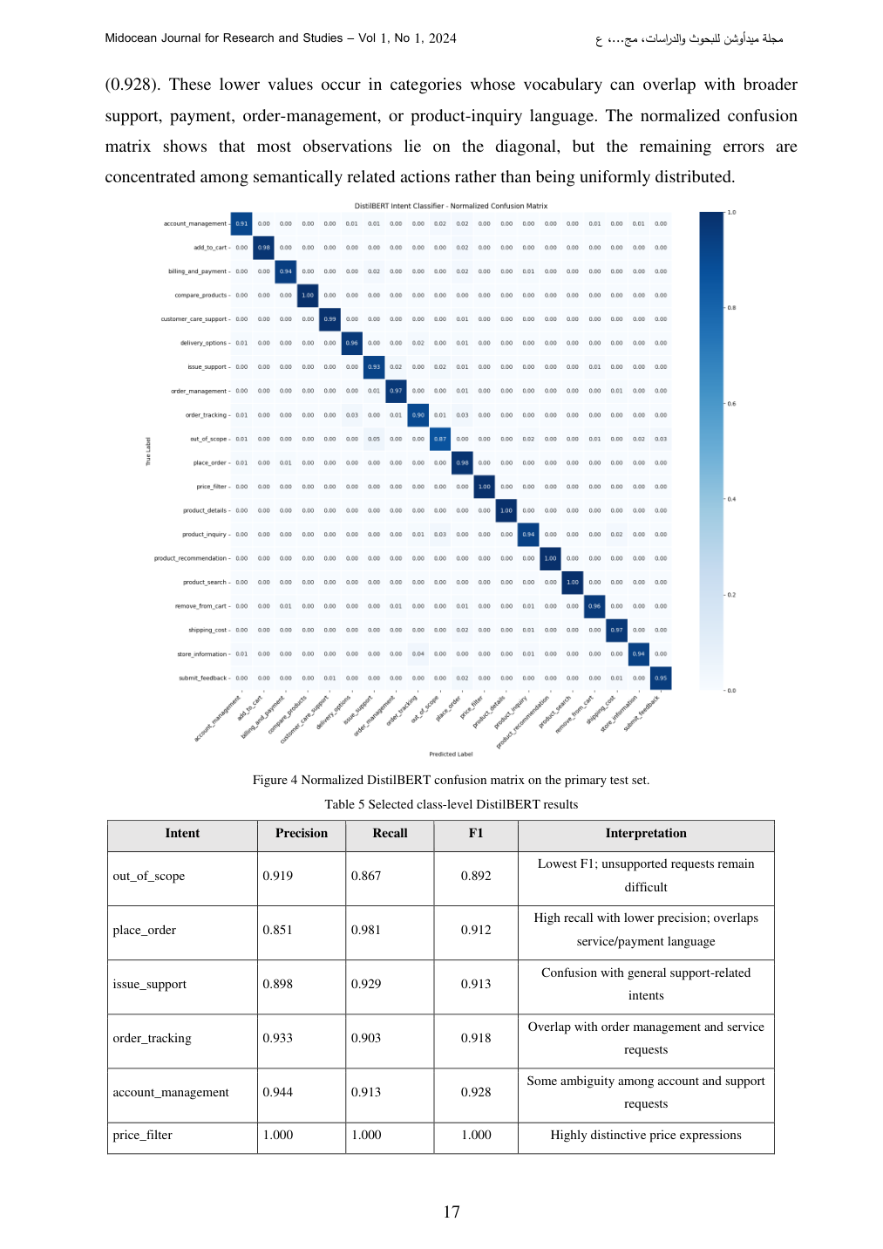 | Reviewer Notes - Page 18  1. Reviewer Comment: The per-class analysis is helpful. The discussion of lower-performing intents such as out_of_scope, place_order, and issue_support should be kept because it gives the paper analytical depth.  2. Correction: The confusion matrix labels are very small. Increase resolution/font size or provide a simplified matrix/table for publication.

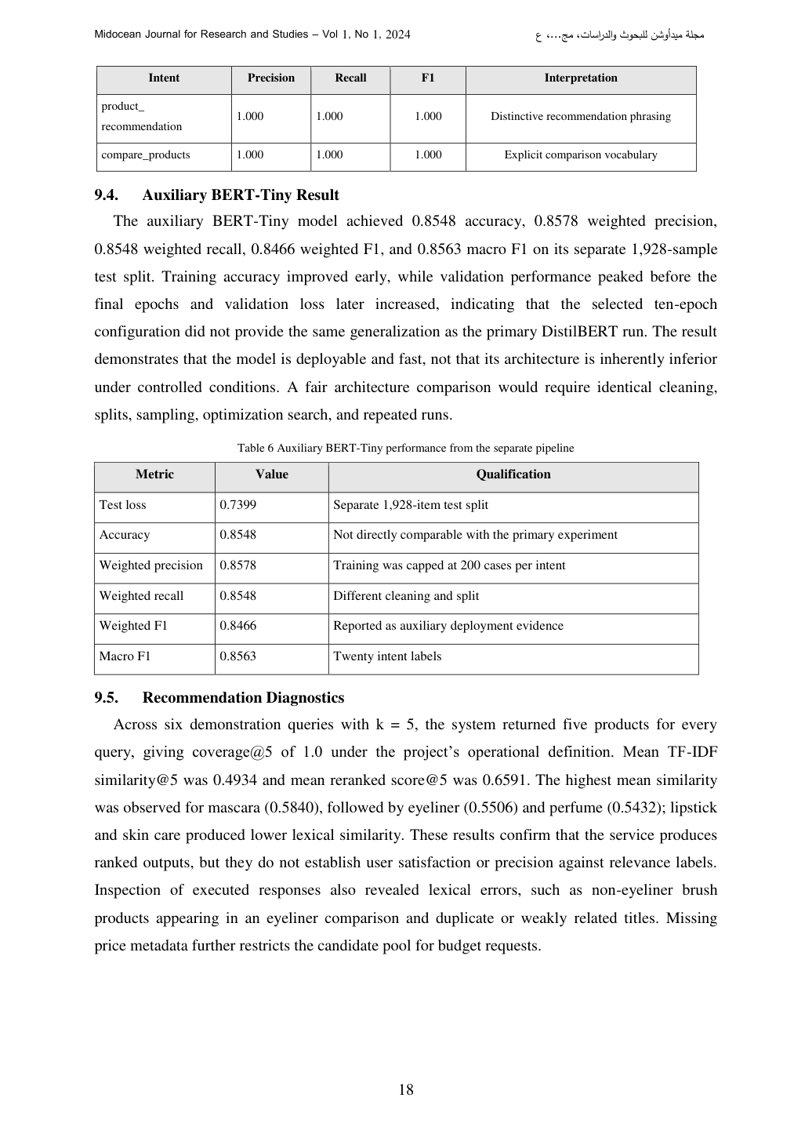 | Reviewer Notes - Page 19  1. Reviewer Comment: The auxiliary BERT-Tiny result is responsibly reported as a separate pipeline. This should not be merged with the controlled comparison.  2. Correction: In the recommendation diagnostics, add a sentence explaining why lexical similarity alone may fail for semantically related products or product synonyms.

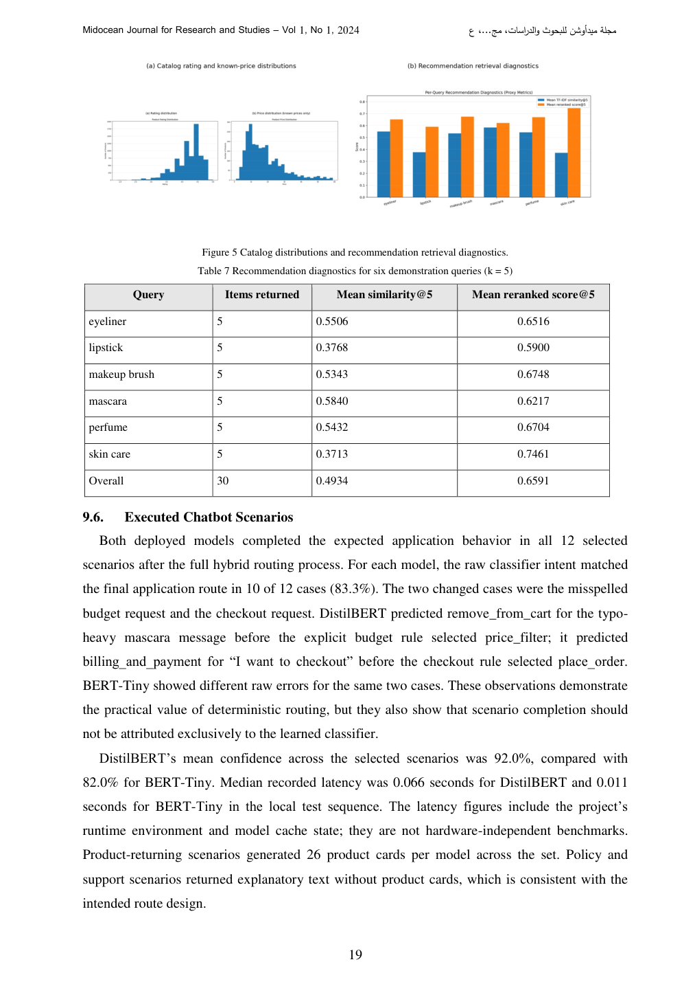 | Reviewer Notes - Page 20  1. Reviewer Comment: The recommendation diagnostics are useful but limited. State clearly that coverage@5 and mean similarity@5 are system diagnostics, not measures of actual user satisfaction.  2. Correction: Improve Figure 5 readability by increasing axis labels and legends before final submission.

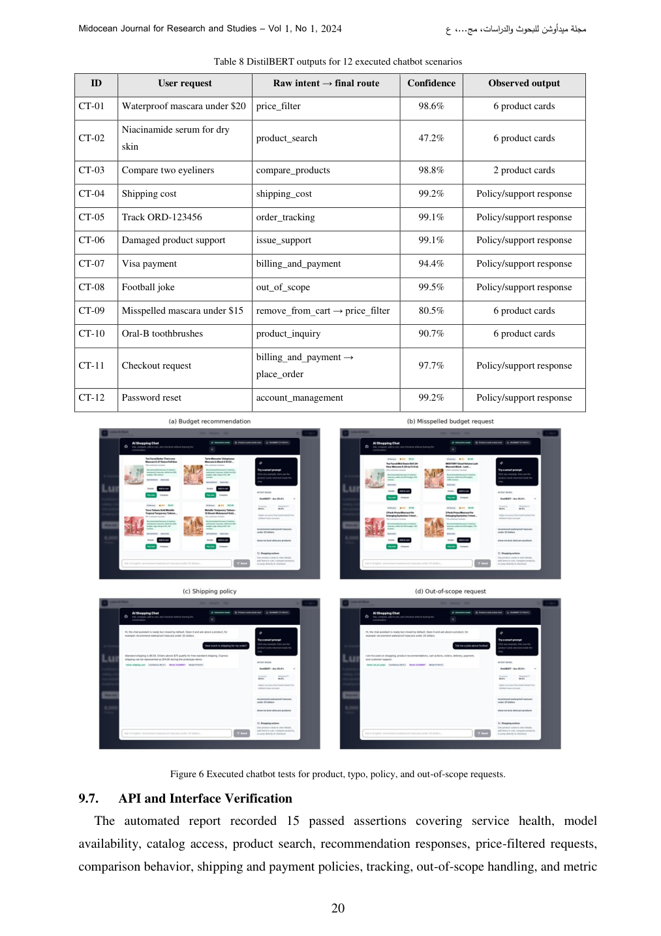 | Reviewer Notes - Page 21  1. Reviewer Comment: The executed chatbot scenarios provide useful application-level evidence. The raw intent to final route distinction is excellent and should be preserved.  2. Correction: Table 8 is crowded. Consider splitting it or reducing text in the observed-output column so it fits the journal page cleanly.

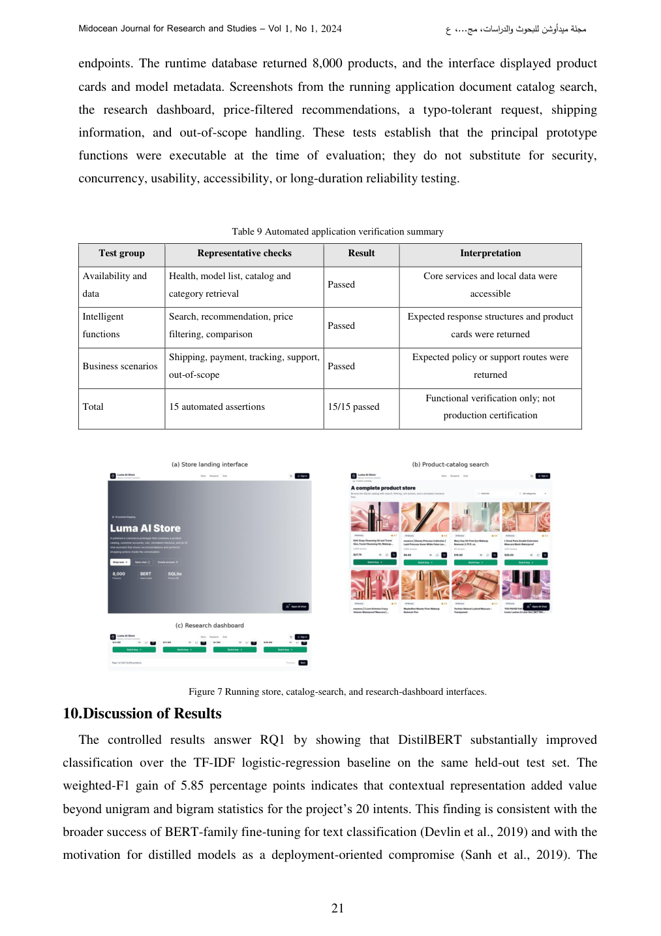 | Reviewer Notes - Page 22  1. Reviewer Comment: The API/interface verification section is strong because it does not overclaim production readiness. This professional caution should remain in the final version.  2. Correction: Figure 7 screenshots may become too small in print. Either enlarge them or present selected key screenshots only.

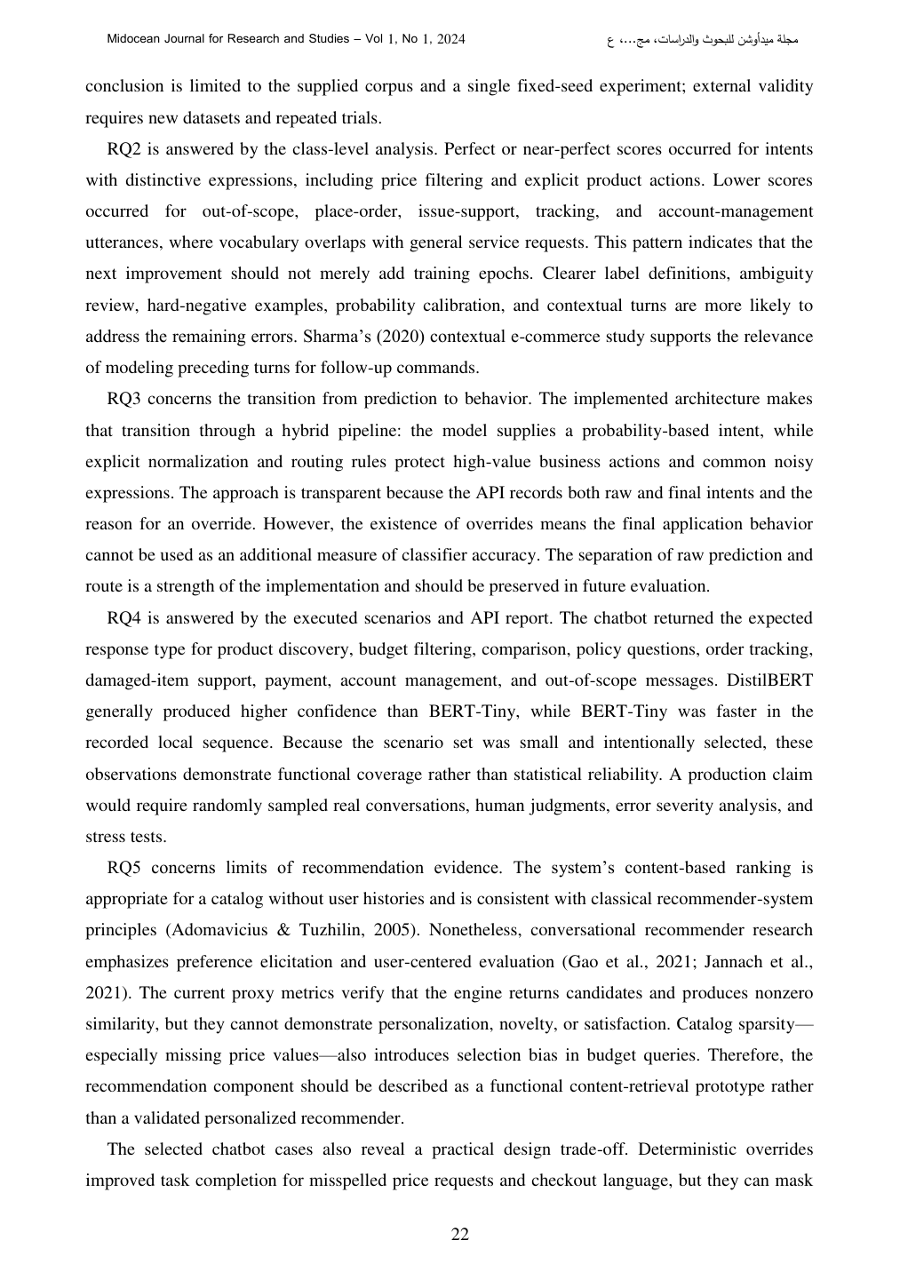 | Reviewer Notes - Page 23  1. Reviewer Comment: The discussion answers the research questions clearly. It is one of the most mature sections of the paper.  2. Correction: Consider adding direct cross-references to the exact tables/figures supporting RQ1-RQ5 for easier reviewer navigation.

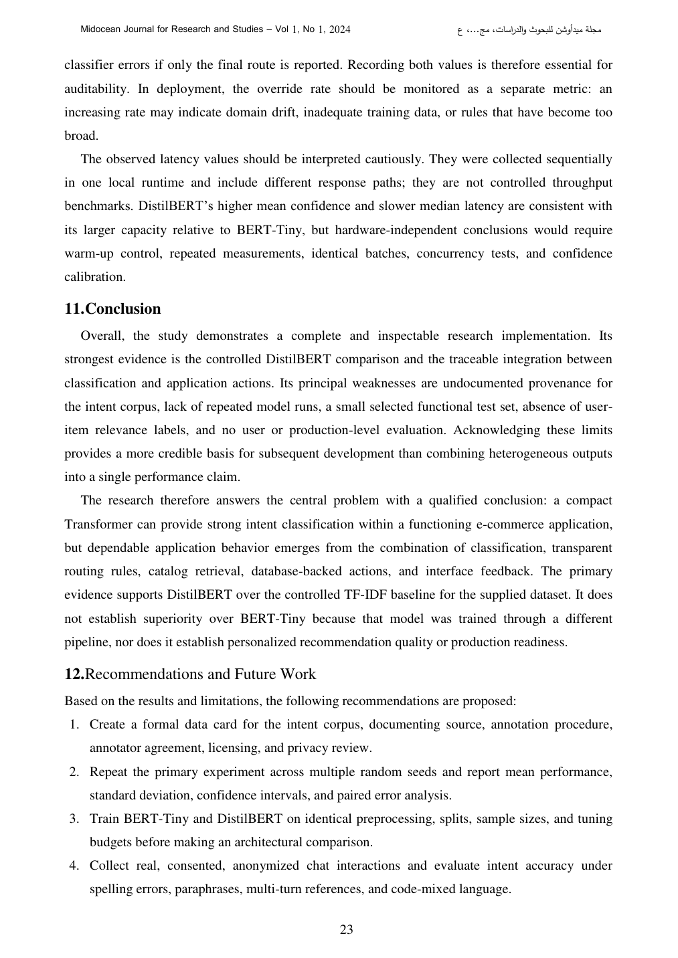 | Reviewer Notes - Page 24  1. Reviewer Comment: The discussion of deterministic overrides is important. The statement that final application behavior cannot be used as additional classifier accuracy is scientifically correct.  2. Correction: Add a recommendation to monitor override rate during deployment as a model drift indicator; this is already mentioned and should be highlighted as a practical contribution.

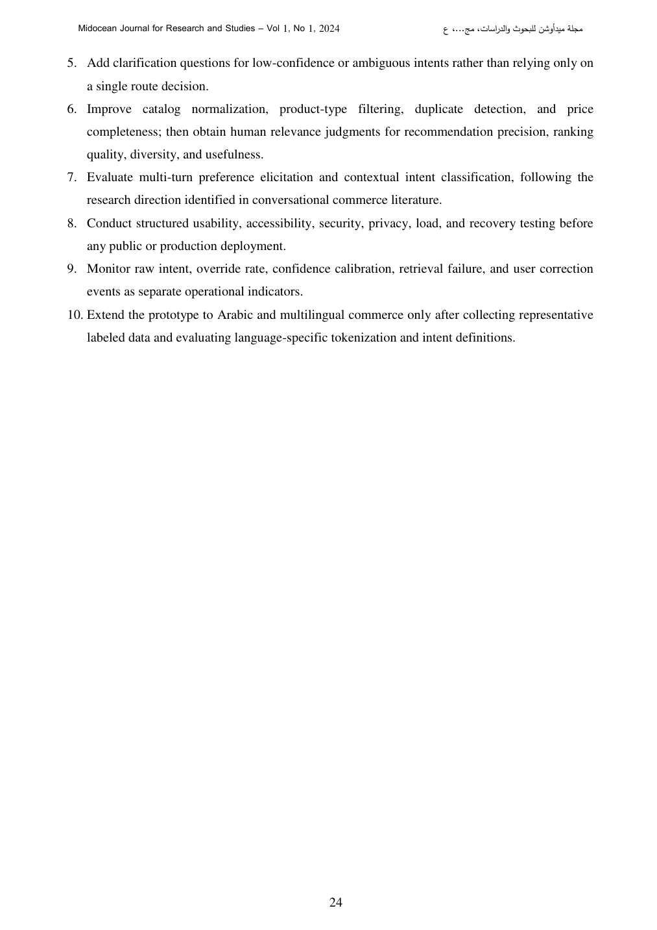 | Reviewer Notes - Page 25  1. Reviewer Comment: The conclusion is balanced and credible. It clearly identifies strengths and weaknesses without overstating the prototype.  2. Correction: The recommendations are strong. Consider grouping them into Data, Modeling, Recommendation, Deployment, and Multilingual Extension categories for readability.

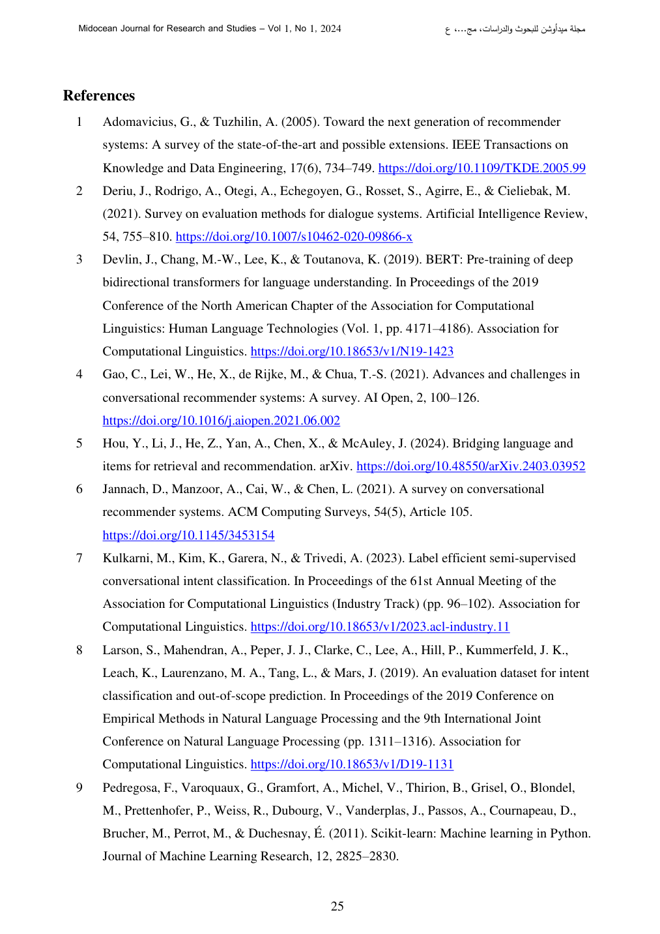  [ADD TO REFERENCES - RED]  [15] Mohamed, H., Badawy, O., Eskaf, K., & Zaghloul, M. S. (2020). A virtual assistant chatbot for college advising system. In M. Smys, J. M. R. S. Tavares, V. E. Balas, & A. M. Iliyasu (Eds.), Second International Conference on Computer Networks and Communication Technologies (ICCNCT 2019). Springer. https://doi.org/10.1007/978-3-030-37051-0_70  [16] Aly, W. M., Eskaf, K. A., & Selim, A. S. (2017). Fuzzy mobile expert system for academic advising. In 2017 IEEE 30th Canadian Conference on Electrical and Computer Engineering (CCECE) (pp. 1-5). IEEE. https://doi.org/10.1109/CCECE.2017.7946846 | Reviewer Notes - Page 26  1. Correction: Insert the two verified Khaled Eskaf references shown on the left side of this review page as references [15] and [16].  2. Reviewer Comment: After adding these references, update all numbering/citation order according to the journal style.  3. Important correction: The earlier Smartphone Recommendation System title should not be attributed to Khaled Eskaf unless the student can verify authorship from a reliable source.

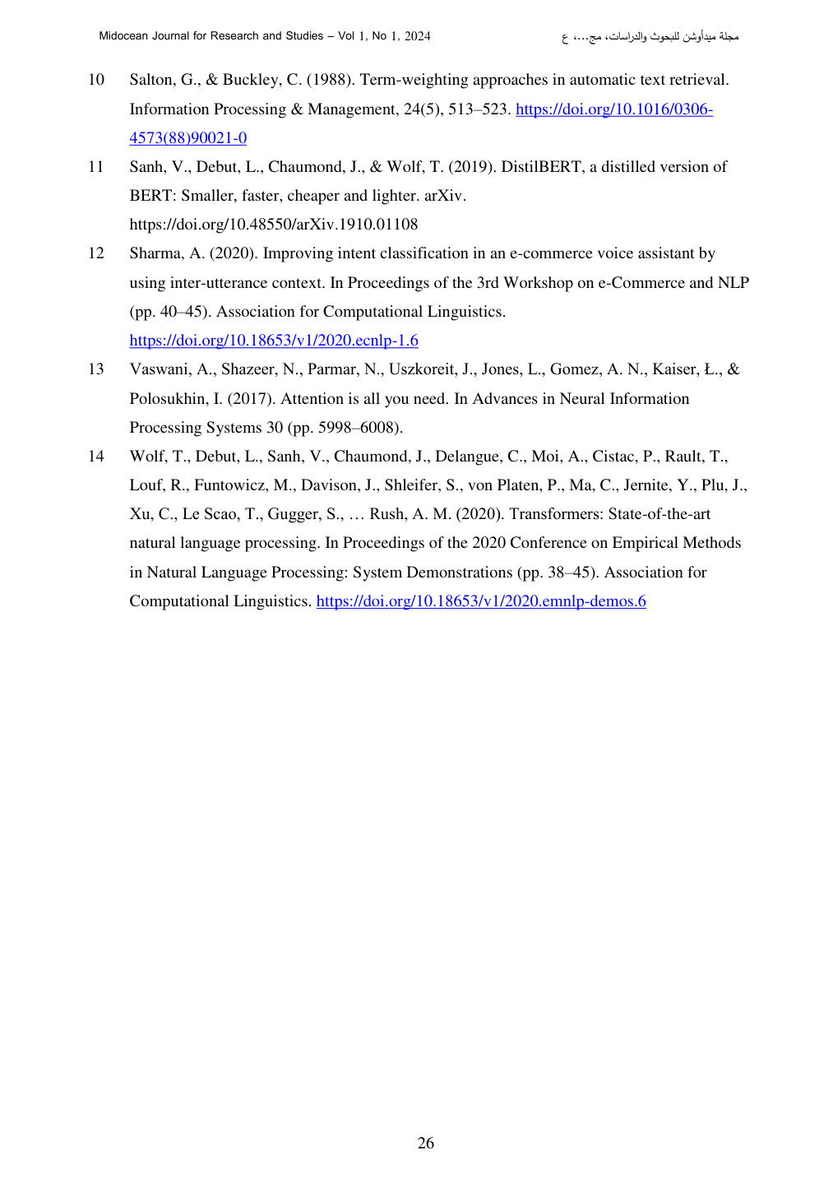 | Reviewer Notes - Page 27  1. Reviewer Comment: Conduct a final reference audit. Every in-text citation must appear in the reference list, and every reference must be cited in the text.  2. Correction: If the journal uses numbered references, insert the Eskaf references in the correct numerical order and update all citation numbers automatically or manually.

